Review Article
Innovations in Pollination Methods: Transition Towards Modern Pollination in Precision Agriculture

Abstract:
Pollination is a critical ecological process that directly influences global food production, biodiversity, and ecosystem stability. Traditional pollination methods—primarily reliant on natural pollinators such as bees, butterflies and manual human-assisted techniques—have supported agriculture for centuries. However, rapid declines in pollinator populations, intensification of farming systems, and the growing demand for higher crop yields have accelerated the shift toward innovative and technologically advanced pollination strategies. This review examines the evolution of pollination approaches from conventional practices to modern precision agriculture techniques. The present review was conducted using secondary sources derived from existing academic literature, including peer-reviewed journal articles, books, and conference proceedings. It highlights recent advancements including mechanical pollinators, drone-assisted pollination, artificial intelligence–based flower detection, robotic micro-pollinators, and controlled-environment pollination systems used in protected cultivation. Furthermore, the abstract synthesizes insights on the efficacy, scalability, ecological impacts, and economic feasibility of these innovations. By integrating traditional knowledge with cutting-edge technologies, precision pollination offers promising avenues for sustainable crop production, climate resilience, and enhanced food security. Future advancements are expected to focus on reducing research and development costs while enhancing the supporting infrastructure of pollination systems to achieve greater cost-effectiveness. The integration of image sensors with diverse pollination technologies is improving adaptability and efficiency across a wide range of greenhouse crops. These technological developments are accelerating the pollination process while simultaneously addressing economic constraints, thereby supporting the broader adoption of automated pollination solutions in modern agriculture. Overall, this review underscores the need for interdisciplinary research, farmer-friendly innovations, and policy support to ensure the future of pollination in modern agriculture.
Key words: Pollination, Mechanization, Smart pollination, UAV assisted, Precision farming.
Graphical Abstract:
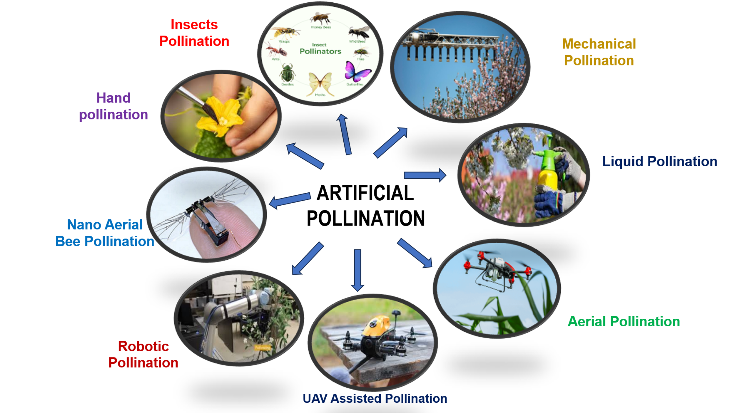
Fig 1: Types of the Artificial Pollination
Introduction
In agriculture, pollination constitutes a critical input to crop production, comparable in importance to other agronomic factors such as fertilisers, labour, and plant protection measures. It involves the transfer of pollen grains from the male reproductive organ (anther) to the female reproductive organ (stigma) of a flower, thereby enabling fertilisation. This biological process is fundamental not only for sustaining natural ecosystems but also for ensuring stable and productive agricultural systems. Moreover, pollination exerts a substantial economic influence by improving both the yield and quality of agricultural produce (Dey & Laskar, 2025).
From a biological perspective, reproduction is an essential function of all living organisms, including plants, to ensure species continuity. In flowering plants, successful seed formation depends on the effective transfer of pollen between flowers of the same species (Sharma and Kaur, 2019). Pollination may occur through abiotic agents such as wind and water, or via biotic agents, particularly animals. Among these, animal-mediated pollination is the most efficient and reliable, accounting for approximately 87.5% of pollination in flowering plants worldwide (Adit et al., 2024). This underscores the pivotal role of biotic pollinators in maintaining both biodiversity and global food security. Pollination is an essential biological process responsible for fertilization in flowering plants, directly affecting nearly 75% of global food crops. The Food and Agriculture Organization (FAO) estimates that approximately one-third of global food production depends to some degree on pollinators such as bees, butterflies, birds, and bats. Recent technological innovations—ranging from AI-powered drones to robotic pollinators—have opened new frontiers in pollination science. In recent years, the concept of employing robots as pollinators has gained traction as a response to the decline in bee populations (Singh et al., 2025; Ferreira et al., 2026; Priyambodo et al., 2026). These advancements are collectively aligned with the global momentum toward precision agriculture, which aims to optimize inputs and maximize output using data-driven tools. This review explores these innovations in depth, comparing their advantages, limitations, and future potential.
Pollination:
Pollination means transfer of viable pollen from mature anther to receptive stigma. Flowers are fully dependent on vector to move pollen. These vectors may be wind, water, birds, butterflies, bats and other animals that visit flowers. An abundance of pollinators sets a greater proportion of early flowers, results in an earlier and more uniform crop with higher quantity as well as quality of fruit. Insects contribute between 15% and 30% of global food production (Halder et al. 2019).
Pollination is the biological process involving the transfer of pollen grains from the anthers to the stigma, a prerequisite for fertilisation and subsequent seed formation in flowering plants. Adequate pollination significantly enhances both the yield and quality of primary agricultural commodities, which constitute essential components of the human diet, including cereals, fruits, and vegetables (Smith *et al*., 2022). Consequently, pollination represents a fundamental ecological service underpinning global food production systems.

Pollinators also play a pivotal role in maintaining biodiversity and ecological stability. By facilitating plant reproduction, they support the persistence and regeneration of plant communities that provide habitat, food, and shelter for a wide range of animal species. This complex network of interactions, driven by pollination processes, sustains ecosystem functionality and resilience, thereby contributing directly to human well-being and environmental balance (Meeuse, 2023).

Based on the source of pollen transfer, pollination is categorised into self-pollination and cross-pollination. Self-pollination refers to the transfer of pollen from the anther to the stigma of the same flower or another flower on the same plant, whereas cross-pollination involves the transfer of pollen between flowers of different plants of the same species. Cross-pollination generally results in greater genetic variability and often produces more vigorous and adaptable offspring, highlighting its evolutionary and agronomic significance (Sharma and Kaur, 2019).
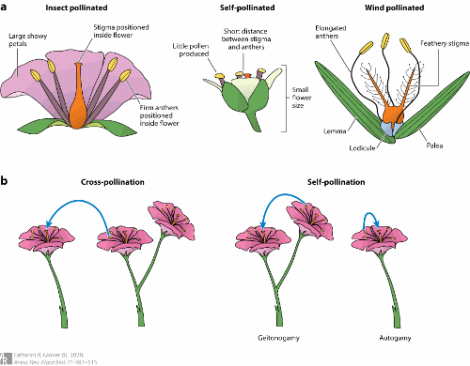‎ Fig 2. Mechanism of Pollination (Fattorini and Glover, 2020)
Pollination syndrome traits:
A pollination syndrome refers to a set of floral traits that have evolved in association with the attraction of a particular group of pollinators. These traits—including flower morphology, colour, scent, timing of anthesis, and the type and availability of floral rewards—collectively enhance reproductive success by facilitating effective pollinator visitation and pollen transfer (Hermann and Kuhlemeier, 2011). Such trait combinations are considered adaptive responses shaped by selective pressures imposed by specific pollinator groups. Over the past century and a half, the concept of pollination syndromes has been progressively developed and refined as a broad conceptual framework for interpreting the diversity of floral forms and functions. From a pollination-ecological perspective, it provides a valuable basis for understanding plant–pollinator interactions and for classifying floral diversity according to functional relationships with pollinators (Ollerton et al., 2009; Rosas-Guerrero et al., 2014).

Pollination syndromes are generally regarded as manifestations of convergent evolution, wherein unrelated plant lineages develop similar floral traits in response to selection pressures imposed by specific functional groups of pollinators (Smith & Kriebel, 2018; Dellinger et al., 2019c). These syndromes reflect adaptive strategies that enhance pollination efficiency through repeated evolutionary patterns across diverse taxa.
However, there is no universally accepted framework for defining or delimiting pollination syndromes, particularly with respect to the selection of diagnostic traits and the categorisation of pollinator groups. Consequently, different authors have proposed varying classification systems over time, reflecting both conceptual and methodological differences (Fenster et al., 2004; Ollerton et al., 2009). Floral characteristics such as type, shape, colour, odour, nectar production, and structural attributes play a critical role in determining pollinator visitation patterns. These traits collectively constitute pollination syndromes and can be utilised to predict the likely pollinator assemblages responsible for effective pollen transfer (Halder et al., 2019).
Beyond their ecological and evolutionary significance, pollination syndromes also have practical applications in conservation biology. They provide a useful framework for large-scale assessments of how environmental changes and anthropogenic disturbances influence plant–pollinator interactions and functional diversity within ecosystems (Dellinger, 2020).
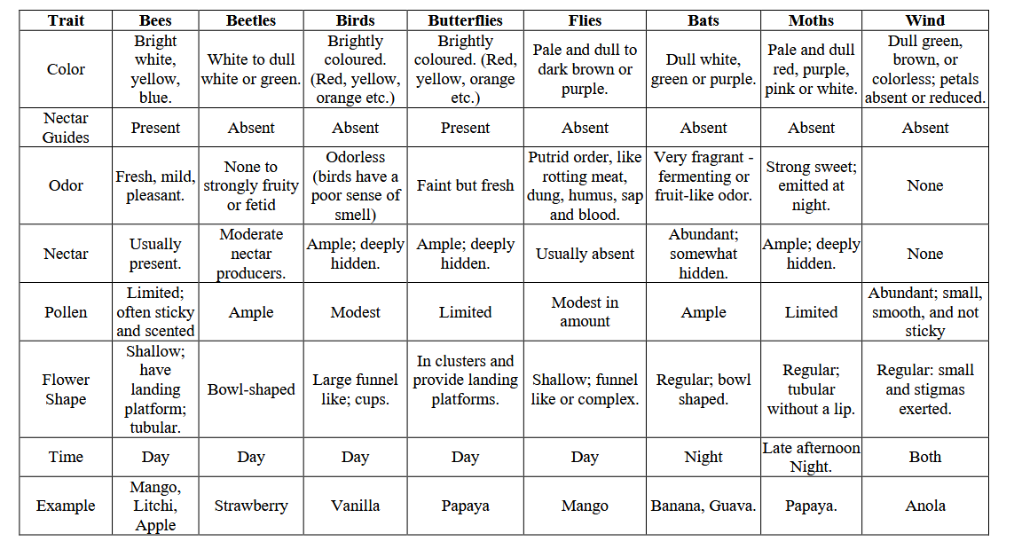
Fig 3. Pollination syndrome traits (Halder et al. 2019)
Artificial Pollination:
Artificial pollination has been increasingly employed to mitigate yield losses arising from inadequate natural pollination and was originally practised as a labour-intensive manual technique (Broussard et al., 2023; Wurz et al., 2021). It provides an effective solution for crops that are unable to set fruit under natural conditions, such as vanilla, where human intervention is essential to achieve successful fertilisation (Sharma and Kaur, 2019). By ensuring the transfer of pollen to the stigma, artificial pollination facilitates fruit set, seed development, and overall crop productivity.
Traditional manual approaches—including hand pollination, brush pollination, and rope pollination—have been utilised for centuries to enhance agricultural output. In contemporary agriculture, however, these methods are primarily confined to controlled applications such as plant breeding programmes, where precise parental lineage must be maintained, as well as in subsistence farming systems and among smallholder producers (Toledo-Hernández et al., 2017). Despite their effectiveness, these techniques are often labour-intensive and time-consuming, limiting their scalability in large commercial operations.
Recent technological advancements have led to the development of innovative pollination systems and devices, including autonomous platforms capable of flower detection, task planning, and precise pollen delivery. Such systems are gaining increasing attention as potential alternatives to traditional pollination methods, particularly in the context of declining pollinator populations (He et al., 2025). In this regard, artificial pollination serves as a viable substitute for entomophily (insect-mediated pollination), wherein pollen is deliberately transferred—often by mechanical or manual means—to the stigma to ensure fertilisation, thereby supporting crop multiplication, seed formation, and fruit production (Sharma and Kaur, 2019).
Types
- Hand pollination
- Insects’ pollination
- Mechanical pollination
- Liquid pollination
- Aerial Pollination
- UAV Assisted pollination
- Nano Aerial vehicle
- Robotic Pollination
- Nano Aerial bee
Hand pollination:
Hand pollination is a labour-intensive practice carried out manually using simple tools such as paintbrushes, sticks, or feather brushes to transfer pollen. It represents one of the oldest and most widely adopted methods of artificial pollination, involving the deliberate transfer of pollen to the receptive (female) parts of flowers in order to replicate natural pollination processes (Hiraguri et al., 2023a; Zhang et al., 2022). This technique is particularly valuable in situations where natural pollinators are scarce or where controlled pollination is required.
Although manual methods remain effective, they are often time-consuming and demand considerable labour input. In contexts where mechanisation is available, even in relatively simple forms such as vibratory wands, pollination can be performed more efficiently and cost-effectively compared with purely manual approaches (Broussard et al., 2023). Consequently, the integration of mechanised tools offers a practical means of improving the scalability and economic viability of artificial pollination practices.
Insects Pollination:
Animal-mediated pollination constitutes a vital ecological process underpinning fruit and seed set, as well as enhancing the quality of produce in many pollinator-dependent crops (Gazzea et al., 2023; Siopa et al., 2024). Among animal pollinators, insects represent the dominant group globally, encompassing bees, wasps, flies, and moths, all of which contribute significantly to agricultural productivity (Rader et al., 2016). To ensure reliable pollination services, farmers frequently employ managed pollinators, particularly bees and, in some cases, flies, to supplement or stabilise natural pollination (Osterman et al., 2021a). The western honeybee (Apis mellifera) is the most widely utilised managed pollinator due to its efficiency, adaptability, and ease of management (Osterman et al., 2021b).
In addition to managed species, wild pollinators play a crucial complementary role in crop pollination and can significantly enhance both yield and stability of production systems (Reilly et al., 2024). Honeybees are often the most abundant floral visitors in commercial orchards, a trend also observed across a range of other crop systems (Dymond et al., 2021; Eeraerts et al., 2023a). Within the assemblage of wild bees, bumblebees and mining bees are frequently reported as among the most abundant and taxonomically diverse groups, particularly in spring-flowering crops (Eeraerts et al., 2023a).
Among dipteran pollinators, hoverflies (family Syrphidae) are commonly recorded as the predominant group; however, this pattern may partly reflect sampling biases, as some studies have focused primarily on this family. Other insect groups, including wasps, butterflies, and beetles, are comparatively less represented in pollination studies and, when documented, generally exhibit lower visitation frequencies (Osterman et al., 2023). Collectively, these findings highlight the diverse assemblage of insect pollinators contributing to crop production and underscore the importance of conserving both managed and wild pollinator communities.
Mechanical pollination:
Mechanical pollination encompasses the use of manual, semi-mechanised, or fully mechanised systems—ranging from hand application to drones and other engineered devices—to facilitate pollen transfer. In contrast, biological approaches to artificial pollination may involve innovative materials such as ionic liquid gels (ILGs), which can enhance pollen adhesion and delivery efficiency (Sharma and Kaur, 2019). These approaches collectively aim to supplement or replace natural pollination processes, particularly under conditions of pollinator limitation. Mechanical pollination technologies can be broadly categorised into several groups, including traditional hand pollination, handheld and backpack-assisted devices, vehicle-mounted systems, unmanned aerial vehicles (UAVs), and advanced robotic or autonomous pollinators (Broussard et al., 2023). Each category varies in terms of scale, precision, and operational efficiency, offering a range of solutions suited to different cropping systems and management contexts. A variety of studies have evaluated the use of mechanical sprayers for artificial pollination, although results have been inconsistent, reflecting challenges related to pollen viability, dispersal efficiency, and deposition accuracy. More recently, electrostatic technologies have been explored to improve pollen adherence and targeting during application, particularly in crops such as date palm, where mechanised pollination is increasingly being adopted (Sharma and Kaur, 2019). These advancements highlight the ongoing evolution of pollination technologies aimed at improving reliability and efficiency in modern agricultural systems.
Liquid pollination
Liquid pollination (LP) is an emerging artificial pollination technique in which female flowers are sprayed with a suspension of pollen grains in water, typically using knapsack or motorised sprayers. This method offers significant advantages over conventional hand pollination, being faster, more cost-effective, and operationally efficient. Moreover, it reduces labour requirements and minimises occupational hazards, such as the risk of climbing-related accidents among farm workers (Raisi et al., 2018).
Liquid spray pollination generally employs industrial nozzles to atomise the pollen suspension and deliver it uniformly onto target flowers. As the method does not require direct contact with the stigma, it can utilise lower quantities of pollen while maintaining relatively high application precision. This approach has demonstrated considerable potential, particularly in crops such as kiwifruit, including its integration into robotic pollination systems. However, despite these advantages, it has yet to fully meet the performance and reliability standards required for large-scale commercial adoption (Li et al., 2022a).
Recent innovations include the development of ionic liquid gels with semi-permanent adhesive properties that mimic the efficiency of insect-mediated pollination, thereby enhancing pollen transfer and retention (Chechetka et al., 2017). Furthermore, advanced precision liquid pollinators designed for crops such as kiwifruit offer additional benefits, including vibration-free operation and improved targeting accuracy, thereby supporting the development of automated pollination technologies (Hao et al., 2023).
Economically, liquid pollination has been shown to substantially reduce production costs. Studies have reported reductions of approximately 89.05% in pollination costs and 56.48% in total variable costs per hectare compared with manual pollination methods (Dhehibi et al., 2018). In crops such as date palm, a key advantage of liquid pollination is the efficient use of pollen, as the concentration of pollen in the suspension can be adjusted according to factors such as bunch thinning requirements and plant age (Torres et al., 2024).
Despite these promising developments, further research is required to optimise formulation, delivery mechanisms, and field-level performance in order to enhance the effectiveness and scalability of liquid spray pollination in diverse cropping systems.
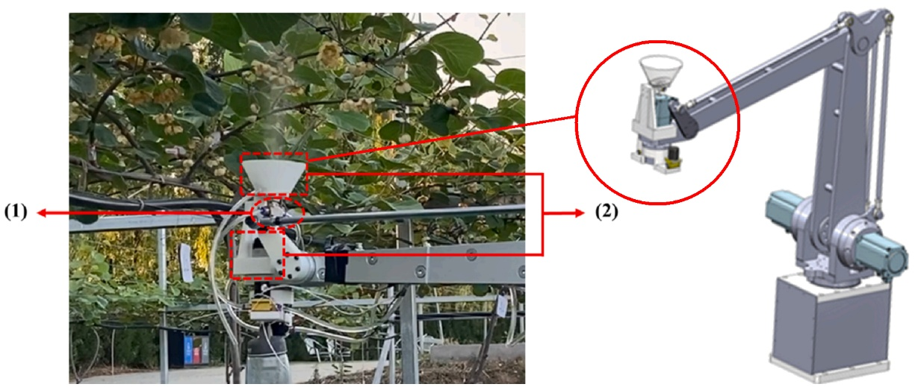
Fig 4. Air–liquid spray pollinator (1) Air-liquid nozzle, and (2) Nozzle mounting brackets
(Gao et al, 2023)
Aerial pollination
Drone pollination represents an advanced form of artificial pollination in which unmanned aerial vehicles (UAVs) equipped with specialised dispensing or spray systems are used to distribute pollen over crop canopies. By mechanically releasing pollen in a controlled manner, drones can mimic the functional role of natural pollinators, thereby facilitating fertilisation without reliance on biotic agents such as insects or abiotic vectors such as wind (Aruna et al., 2024). This approach is particularly relevant in the context of declining pollinator populations and increasing demand for precision agriculture technologies. Drones offer distinct advantages in tall and large-canopy cropping systems, where conventional pollination methods are often labour-intensive and less efficient. Their capacity to operate above the canopy enables uniform pollen distribution across extensive areas, making them especially suitable for tree crops. In addition to commercial production, drone-based pollination has demonstrated potential in plant breeding programmes by enabling controlled pollen delivery. Promising applications have been reported in wind-pollinated nut crops, including hazelnut, pistachio, and walnut, where UAV-assisted pollination has shown encouraging results in experimental trials (Broussard et al., 2023). Despite these advantages, further refinement in drone navigation, pollen delivery mechanisms, and environmental adaptability is required to optimise their efficiency and ensure consistent performance under field conditions.
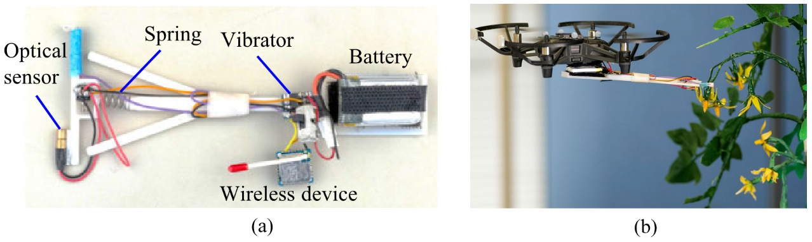
Fig 5. Drone and vibrator based pollinator. (a) Vibratory pollinator, and (b) Vibrator mounted on the drone for tomato flower pollination (Hiraguri et al, 2023b).
Unmanned Aerial Vehicle (UAV) assisted pollination
The application of drones for crop pollination has emerged as a promising and innovative approach, owing both to their conceptual similarity to natural airborne pollinators such as bees and to the relatively low technological barriers associated with drone deployment compared to other robotic systems. These aerial platforms can be operated in multiple modes, including manual control by a pilot, pre-programmed flight paths based on orchard configurations, or advanced navigation using three-dimensional environmental models generated through prior scouting missions. Such flexibility enhances their adaptability across diverse agricultural landscapes.
Many pollination drones are adapted from commercially available platforms originally designed for agrichemical spraying, although an increasing number of systems are being specifically engineered for pollination purposes. For instance, a prototype developed by Arun Sekhar et al. (2022) incorporates a pollen delivery mechanism with autonomous obstacle detection and avoidance capabilities, enabling it to adjust its flight trajectory dynamically. The system demonstrated stable flight performance at low altitudes (approximately 2–3 feet above the crop canopy), which is conducive to targeted pollen application.
Despite these technological advancements, operational challenges remain. While drone systems have shown the capacity to reliably detect and approach flowers, achieving effective and consistent pollination has proven more complex. Experimental studies have reported high flower survival rates following drone interaction; however, successful fertilisation could not always be confirmed, highlighting limitations in pollen deposition efficiency and delivery precision (Craigie et al., 2021). These findings indicate that, although drone pollination holds substantial potential, further technological refinement is necessary to enhance its effectiveness under practical field conditions.
Nano Aerial Vehicle (NAV)
The nano-drone class represents a particularly suitable platform for precision pollination tasks, typically characterised by a mass range of 3–50 g and a wingspan of approximately 2.5–15 cm. Despite their clear potential, nano-drones remain comparatively underutilised in agricultural pollination systems, even though they offer superior manoeuvrability and task accuracy relative to conventional unmanned aerial vehicles (UAVs) (Aruna et al., 2024). These systems are capable of fully autonomous operation, encompassing the detection, localisation, approach, and physical interaction with floral structures.
The present 10 cm prototype has been trained specifically for sunflower pollination; however, the underlying methodological framework is adaptable and can be retrained for a wide range of floral morphologies and crop species (Hulens et al., 2022). In a related advancement, Hiraguri et al. (2023) developed compact drone systems designed to emulate the ecological role of pollinators such as bees, enabling autonomous navigation, flower detection, and targeted pollination. These systems typically operate through distinct functional modes, including flower-search and pollination phases, thereby enhancing operational efficiency.
Given that the primary objective of nano-drones in this context is effective pollination, robust flower recognition capabilities are essential. This is achieved through advanced perception algorithms that process visual data captured by onboard imaging sensors (Pinherio et al., 2023). The outputs of these perception systems serve as critical inputs to downstream modules, including path planning algorithms, which determine optimal trajectories, and flight control systems, which execute precise manoeuvres (Rice et al., 2022). Collectively, the integration of perception, planning, and control modules underpins the development of fully autonomous and efficient pollination platforms.
Nano drones hold significant promise for revolutionizing precise pollination in agriculture. These miniature aerial vehicles offer the potential to enhance crop production by efficiently identifying flowers, navigating to them, and conducting pollination while also facilitating cooperation among multiple drones. To optimize pollination success, the development of diverse end effectors customized for different flower types is essential (Aruna et al. 2024). An insect sized drone capable of artificial pollination. They are coated with a blotch of horse hair bristles and an ionic liquid gel, these pint-sized robots have the ability to collect and transfer pollen from one plant to another (Sharma and Kaur, 2019).
Robotic Pollination
Autonomous robotic pollinators integrated with expert-informed targeting systems have the potential to selectively identify and service flowers with the highest likelihood of producing superior fruit, thereby enabling more intelligent and yield-optimised pollination strategies. This concept is exemplified by Verdant Robotics’ patented apple pollinator and flower-thinning system (US11308323B2), which incorporates decision-guided targeting to enhance crop outcomes (Broussard et al., 2023). Such approaches move beyond uniform pollination by incorporating biological and agronomic knowledge into operational algorithms, allowing prioritisation of high-value floral targets.
Empirical evidence supporting the feasibility of autonomous pollination has been demonstrated in field trials conducted in 2019 using a research prototype robotic platform. The system successfully pollinated more than 670 export-quality ‘Hayward’ kiwifruit in the absence of insect pollinators while operating at a speed of approximately 2.5 km h⁻¹. Notably, key performance indicators, including fruit set, seed count, and fruit weight, were comparable to those observed in insect-pollinated control treatments, indicating the functional equivalence of robotic intervention under controlled conditions.
Advances in machine vision, particularly those leveraging deep learning architectures, have significantly enhanced the capability of robotic systems to detect and localise floral structures, achieving accuracy levels of 90% or higher with processing rates of up to 100 frames per second. However, operational constraints remain, particularly in systems reliant on robotic manipulators. For instance, tomato pollination robots employing articulated arms have reported pollination times of approximately 15–20 seconds per flower, a rate that is insufficient for large-scale commercial deployment. Consequently, further optimisation of actuation mechanisms and system throughput is required to ensure the scalability and economic viability of robotic pollination technologies in intensive agricultural systems.
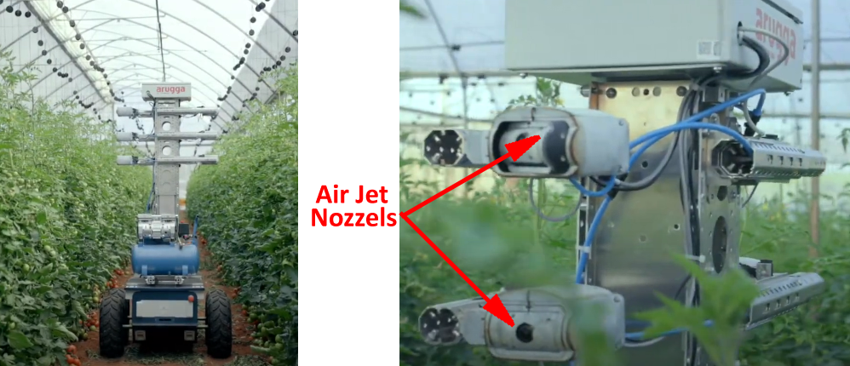
Fig 6. Multiple Air-Jet based pollination system mounted on the mobile platform. The system is already implemented in the Israel greenhouses for commercial purpose (Arugga, 2022).
Nano Aerial Bee (NAB)
The Nano Aerial Bee (NAB) represents a novel open-source nano aerial vehicle (NAV) designed for autonomous flight and targeted tree pollination, with the primary objective of supplementing, rather than replacing, natural pollinators such as bees (Pinherio et al., 2023). The development of the NAB facilitates continuous pollination services that are less susceptible to environmental constraints—such as adverse weather conditions or diurnal activity patterns—that typically limit biological pollinators. In this context, artificial pollination systems are envisaged as complementary tools that enhance the efficiency, consistency, and reliability of the natural pollination process.
To enable autonomous operation, an algorithmic framework was developed to generate control commands based on the spatial position of detected flowers within the visual field of the onboard imaging system (Li et al., 2022). This approach allows real-time interpretation of visual inputs and subsequent navigation decisions, thereby supporting precise flower targeting and interaction. The associated software architecture was initially validated using video datasets captured via a smartphone, simulating the flight dynamics and visual perspective of the NAB platform (Pinherio et al., 2023). Such preliminary testing provides a cost-effective means of refining perception and control algorithms prior to deployment on physical aerial systems, thereby accelerating the development and optimisation of autonomous pollination technologies.
Conclusion
Pollination sits at the intersection of biology, ecology, and technology. As natural pollinators face growing threats, innovations in pollination methods—from drones to robots and AI-driven systems—offer promising solutions for sustainable agriculture. Yet, these technologies should supplement rather than replace natural pollinators. The future lies in harmonizing traditional ecological knowledge with precision agriculture tools to ensure food security, biodiversity conservation, and resilient agricultural systems. Advanced pollination innovations represent a transformative shift in global agriculture, but their success will depend on responsible implementation, economic accessibility, and continued efforts to restore and protect natural pollinator populations.
Future prospects
The market for robotic pollination remains at a nascent stage of development; however, it exhibits considerable growth potential, particularly within controlled-environment agriculture such as greenhouse systems. Future advancements are expected to focus on reducing research and development expenditures while simultaneously strengthening the supporting technological infrastructure to enhance overall cost-effectiveness and scalability. A key trajectory in this domain is the integration of advanced image sensing technologies with diverse pollination mechanisms, enabling greater adaptability across a wide range of crop species and floral architectures. Such sensor-driven systems facilitate precise flower detection, selective targeting, and optimised pollination strategies, thereby improving operational efficiency. Collectively, these innovations are anticipated to accelerate pollination processes while addressing economic constraints, ultimately contributing to the broader adoption of robotic pollination solutions in intensive horticultural production systems.
Disclaimer (Artificial intelligence)

Author(s) hereby declare that NO generative AI technologies such as Large Language Models (ChatGPT, COPILOT, etc.) and text-to-image generators have been used during the writing or editing of this manuscript.

References
- Arugga. 2022. AI farming: Robots treating every plant. https://wwwaruggacom.
- Aruna, T.N., B.A.Anand, Amith Kumar Gupta, Kishan Kumar, Utkarsh Dwivedi and Bhojyareddy Rohit Gaddamwar. 2024. Artificial Pollination by Nano drone Technology: A review. International Journal of Research in Agronomy.,7(2): 551-564.
- Arun Sekar. R., Dhinesh Kumar and Divakar Prabhu. 2022. Novel Pollination Drone for Agricultural Assistance. International Journal for Research in Applied Science & Engineering Technology (IJRASET) ISSN: 2321-9653; 10:VII.
- Broussard, M.A. M. Coates and P. Martinsen. 2023. Artificial Pollination Technologies: A Review. Agronomy 13: 1351. https://doi.org/10.3390/agronomy13051351.
- Chechetka, S,A., Y. Yu and M. Tange. 2017. Materially engineered artificial pollinators. Chem 2(2):224–239. doi:10.1016/j.chempr.2017.01.008.
- Craigie, C., P. Guglielmino, Z.Şeker and N.Stallings. 2021. Autonomous Drone Pollination. WPI;1-51.
- Dellinger, A.S., S.Artuso, S.Pamperl, F.A. Michelangeli, D.S. Penneys D.M.Fernández-Fernández, M. Alvear, F.Almeda, W.S.Armbruster and Y. Staedler. 2019c. Modularity increases rate of floral evolution and adaptive success for functionally specialized pollination systems. Nature Communications Biology 2: doi: 10.1038/s42003-019-0697-7.
- Dellinger, A.S. 2020. Pollination syndromes in the 21st century: where do we stand and where may we go? New Phytol., 228(4):1193-1213. doi: 10.1111/nph.16793.
- Dhehibi, B., M.Ben-Salah, A. Frija, A.Aw-Hassan, Y. M. Al Raisi, I. Al Bousaidi, S. Al Amri, S.Al Sobahi and K. Al Shoaili. 2018. Predicting Farmers’ Willingness to Adopt Liquid Pollination and Polycarbonate Drying House Technologies: A Case Study from the Date Palm Growers in the Sultanate of Oman. Sustainable Agriculture Research, 7(4), 18–30. https://doi.org/10.5539/sar.v7n4p18.
- Dymond, K., J.L. Celis‐Diez, S.G. Potts, B.G. Howlett, B.K. Willcox and M.P. Garratt. 2021. The role of insect pollinators in avocado production: A global review. Journal of Applied Entomology, 145(5), pp.369-383.
- Eeraerts, M., L.W. DeVetter, P.Batáry, J.J. Ternest, R. Mallinger, M. Arrington, F.E Benjamin, B.R.Blaauw, J.W. Campbell, P. Cavigliasso, and Daniels. 2023. Synthesis of highbush blueberry pollination research reveals region‐specific differences in the contributions of honeybees and wild bees. Journal of Applied Ecology, 60(12), pp.2528-2539.
- Fenster, C.B., W.S.Armbruster, P.Wilson, M.R. Dudash, J.D.Thomson. 2004. Pollination syndromes and floral specialization. Annual Review of Ecology, Evolution, and Systematics 35: 375–403.
- Fattorini, R. and B.J. Glover, 2020. Molecular Mechanisms of Pollination Biology. Annu Rev Plant Biol., 29:71:487-515.
- Gao, C., L.He, W. Fang. 2023. A novel pollination robot for kiwifruit flower based on preferential flowers selection and precisely target. Computers and Electronics in Agriculture 207:107762. doi:10.1016/j.compag.2023.107762.
- Gazzea, E., P. Batary and L.Marini. 2023. Global meta-analysis shows reduced quality of food crops under inadequate animal pollination. Nature Communications, 14(1), p.4463.
- Halder, S., Subham Ghosh, Rajesh Khan, Arju Ali Khan, Tamanna Perween, Md. A Hasan. 2019. Role of pollination in fruit crops: A review. Pharma Innovation., 8(5):695-702.
- Hao, W., Xinting Ding, Zhi He, Kai Li, Weixin Gong, Zixu Li, Zhen Yang, Yongjie Cui. 2023. Development and evaluation of precision liquid pollinator for kiwifruit, Computers and Electronics in Agriculture., 213: 2023-108193, ISSN 0168-1699, https://doi.org/10.1016/j.compag.2023.108193.
- Hermann, K. and Cris Kuhlemeier, 2011. The genetic architecture of natural variation in flower morphology, Current Opinion in Plant Biology,14(1): 60-65, ISSN 1369-5266,
- He, L., Liu. Xiaojuan Liu, Yusong Ding, Xudong Jing, Haojie Dang, Bryan Gilbert Murengami, Lamin L. Janneh, Rui Li, Spyros Fountas, Jayme Garcia Arnal Barbedo, Longsheng Fu, Advancements in artificial pollination of crops: from manual to autonomous. Computers and Electronics in Agriculture, Volume 231,2025,110067,ISSN 0168-1699,
- Hiraguri, T., H.Shimizu, T.Kimura, T.Matsuda, K.Maruta and Y.Takemura. 2023. Autonomous drone-based pollination system using ai classifier to replace bees for greenhouse tomato cultivation. IEEE Access,11: 99352–99364.
- Hiraguri, T., H.Shimizu T. Kimura 2023b. Autonomous drone-based pollination system using ai classifier to replace bees for greenhouse tomato cultivation. IEEE Access doi:10.1109/ACCESS.2023.3312151
- Hulens, D., W. Van Ranst, Y. Cao and T. Goedemé. 2022. Autonomous Visual Navigation for a Flower Pollination Drone. Machines., 10(5), 364. https://doi.org/10.3390/machines10050364.
- Li, K., L. Zhai, H.Pan, Y. Shi, X. Ding and Y. Cui. Identification of the operating position and orientation of a robotic kiwifruit pollinator. Biosyst. Eng. 2022. 222, 29–44.
- Meeuse BJd. 2023. Pollination Ecology. Brittanica. Available from: https://www.britannica.com/science/pollination.
- Ollerton, J., R.Alarcón, N.M. Waser, M.V.Price, S. Watts, L. Cranmer, A. Hingston C.I.Peter and J. Rotenberry J. 2009. A global test of the pollination syndrome hypothesis. Annals of Botany 103: 1471–1480.
- Osterman, J., M.A. Aizen, J.C. Biesmeijer, J. Bosch, B.G. Howlett, D.W. Inouye, C. Jung, D.J. Martins, R. Medel, A. Pauw and C.L. Seymour. 2021a. Global trends in the number and diversity of managed pollinator species. Agriculture, Ecosystems & Environment, 322, p.107653.
- Osterman, J., P. Landaverde-González, M.P. Garratt, M. Gee, Y. Mandelik, A. Langowska, M. Miñarro, L.J. Cole, M. Eeraerts, D. Bevk and O. Avrech. 2021b. On-farm experiences shape farmer knowledge, perceptions of pollinators, and management practices. Global Ecology and Conservation, 32, p.e01949.
- Osterman, J., F. Benton, S. Hellström, M. Luderer‐Pflimpfl, A.K. Pöpel‐Eisenbrandt, A.K., B.S. Wild, P. Theodorou, C. Ulbricht and R.J. Paxton. 2023. Mason bees and honey bees synergistically enhance fruit set in sweet cherry orchards. Ecology and evolution, 13(7), p.e10289.
- Pinheiro, I. A. Aguiar, A. Figueiredo and T. Pinho. Nano aerial vehicles for tree pollination. Appl Sci. 2023;1-26. 18.
- Rader, R. I. Bartomeus, L.A. Garibaldi, M.P.D. Garratt, B.G. Howlett, R. Winfree, S.A. Cunningham, M.M. Mayfield, A.D. Arthur and G.K.S.Andersson. 2016. Non-bee insects are important contributors to global crop pollination. Proc. Natl. Acad. Sci. USA 2016, 113, 146–151.
- Raisi Al. Y., M. Ben-Salah, S. Al-Sabahi, S. Al Amri, I. Al Bousaidi and B. Dhehibi. 2018. Liquid Pollination Technology as New Technology to Ameliorate Date Palm Pollination and Facilitate Date Palm Field Operations. Paper presented at the Sixth International Date Palm Conference (SIDPC), Abu Dhabi, UAE. Retrieved from https://hdl.handle.net/20.500.11766/9858.
- Reilly, J., I. Bartomeus, D. Simpson, A. Allen‐Perkins, L. Garibaldi and R. Winfree. 2024. Wild insects and honey bees are equally important to crop yields in a global analysis. Global Ecology and Biogeography, 33(7), p.e13843.
- Rice, R.C., S.T. McDonald, Y. Shi, H. Gan, W.S. Lee and C. Yang. 2022. Perception, path planning, and flight control for a drone enabled autonomous pollination system. Robotics. 1- 32.
- Rosas-Guerrero, V., R. Aguilar, S. Martén-Rodríguez, L. Ashworth, M. Lopezaraiza-Mikel, J.M. Bastida and M.Quesada. 2014. A quantitative review of pollination syndromes: do floral traits predict effective pollinators? Ecology Letters 17: 388–400.
- Sharma, A and S.Kaur. 2019. Future Prospects of Artificial Pollination In Tree Crop Production: A Review. Int. Arch. App. Sci. Technol; Vol 10 [2]: 181-187.
- Siopa, C., L.G. Carvalheiro, H. Castro, J.Loureiro, and S.Castro. 2024. Animal‐pollinated crops and cultivars—a quantitative assessment of pollinator dependence values and evaluation of methodological approaches. Journal of Applied Ecology, 61(6), pp.1279-1288.
- Smith, S.D and R. Kriebel. 2018. Convergent evolution of floral shape tied to pollinator shifts in Iochrominae (Solanaceae). Evolution 72: 688–697.
- Smith, G., R. Raguso, and C. Kim. 2022. Pollen accumulation on hawkmoths varies substantially among moth-pollinated flowers. Journal of Pollination Ecology, 32, 201–211. https://doi.org/10.26786/1920-7603(2022)701
- Torres,S., R., Acosta-Pérez, J. A., Krueger, R. R., Gutiérrez-Pacheco, M. M., Ruisánchez-Ortega, Y., Oihabi, A., Abul-Soad, and A. Zaid. 2024. Influence of pollination in liquid suspension on the date palm (Phoenix dactylifera L.) Mejhoul cultivar in the Mexicali Valley, Mexico. Emirates Journal of Food and Agriculture, 36, 1-8. https://doi.org/10.3897/ejfa.2024.120425.
- Wurz, A., I. Grass and T. Tscharntke. Hand pollination of global crops - A systematic review. Basic and Applied Ecology, 2021; 56: 299–321.
- Zhang, K., C. He, S. Wang and X.Hu. 2022. Influence of pollination methods on fruit development, fruit yield and oil quality in oil tree peony. Scientia Horticulturae 295(6):110877.
- Dey, A., & Laskar, N. (2025). Nature’s Matchmakers: Insects and their Pollination Services for Crops. Journal of Agriculture and Ecology Research International, 26(1), 22–34. https://doi.org/10.9734/jaeri/2025/v26i1662
- Adit, A., Singh, V. K., Tandon, R., & Shivanna, K. R. (2024). Pollination research in India: Current status, future vision and conservation implications. Integrative Conservation, 3(4), 330-341.
- Singh, R., Seneviratne, L., & Hussain, I. (2025). A comprehensive review of current robot-based pollinators for crop pollination. Artificial Intelligence Review, 59(1). https://doi.org/10.1007/s10462-025-11409-1
- Ferreira, A. I. S., Da Silva, N. F. F., Rosa, T. C., & Mesquita-Neto, J. N. (2026). Beyond Taxonomic-Based Assessments: AI-Based Acoustic Assessment of Bee Pollination Function. Smart Agricultural Technology, 102015.
- Priyambodo, P., Rustiati, E. L., Parabi, M. I., Permatasari, N., & Aliyah, S. H. (2026). The Application of Artificial Intelligence for Predicting Genetic and Population Dynamics of Coffee Pollinators: A Comprehensive Global Insights. In BIO Web of Conferences (Vol. 213, p. 01019). EDP Sciences.

