Review Article
Stereotactic Body Radiotherapy for Oligometastatic Cancer: Evidence, Patient Selection, and Clinical Decision-Making
Abstract
Background:
Oligometastatic disease represents an intermediate biological state between localized cancer and widely disseminated metastases. Increasing evidence suggests that aggressive local treatment directed at limited metastatic deposits may improve disease control in selected patients. Stereotactic body radiotherapy (SBRT), which delivers highly conformal ablative radiation doses over a small number of fractions, has emerged as a key modality for metastasis-directed therapy. However, important questions remain regarding optimal patient selection, integration with systemic therapy, and the strength of existing clinical evidence.
Methods:
A narrative review of the current literature was performed focusing on prospective trials, randomized studies, and major clinical series evaluating SBRT in oligometastatic disease. Particular emphasis was placed on landmark trials including SABR-COMET, ORIOLE, STOMP, and studies evaluating local consolidative therapy in oligometastatic non-small cell lung cancer. Evidence relating to site-specific outcomes, treatment planning considerations, and emerging systemic therapy combinations was also examined.
Results:
Prospective clinical trials have demonstrated encouraging outcomes with SBRT in carefully selected patients with limited metastatic disease. Randomized phase II studies such as SABR-COMET have reported improvements in overall survival and progression-free survival when ablative radiotherapy is delivered to all metastatic sites. In oligometastatic prostate cancer, metastasis-directed therapy has been shown to delay disease progression and postpone initiation of systemic treatment. Similar benefits have been observed in selected patients with oligometastatic non-small cell lung cancer receiving local consolidative therapy after systemic treatment. Nevertheless, the available evidence remains heterogeneous, and most trials are limited by small sample sizes and varying definitions of oligometastatic disease.
Conclusions:
SBRT represents an important component of the evolving management of oligometastatic cancer. While early clinical trials support its use in carefully selected patients, optimal patient selection, treatment sequencing, and integration with modern systemic therapies remain active areas of investigation. Ongoing randomized trials and translational research are expected to further clarify the role of SBRT within multimodality treatment strategies for metastatic cancer.

Key Clinical Insights
- Oligometastatic disease represents a potentially treatable state between localized and widely metastatic cancer.
- Randomized phase II trials such as SABR-COMET, ORIOLE, and STOMP suggest that metastasis-directed SBRT may improve progression-free survival and delay systemic therapy in selected patients.
- Careful patient selection—including limited disease burden, controlled primary tumor, and good performance status—is critical for achieving meaningful benefit.
- Ongoing trials and emerging biomarkers may further refine patient selection and integration with systemic therapy.

Keywords: Oligometastatic disease; stereotactic body radiotherapy; SBRT; metastasis-directed therapy; stereotactic ablative radiotherapy; oligorecurrence

INTRODUCTION
The management of metastatic cancer has historically been guided by the assumption that once distant spread occurs, the disease is uniformly systemic and therefore incurable with local therapies alone. Over the past two decades, however, the concept of oligometastatic disease has challenged this traditional paradigm. First proposed by Hellman and Weichselbaum in 1995, oligometastasis describes a transitional biological state between localized and widely disseminated disease in which the number and distribution of metastatic lesions remain limited (1). In such cases, aggressive local therapy directed at all sites of disease may alter the natural history of cancer and potentially prolong survival.
Advances in imaging and radiotherapy technology have played a central role in the evolution of this concept. Improvements in cross-sectional imaging and functional modalities such as positron emission tomography (PET) have increased the detection of limited metastatic disease at earlier stages (2). At the same time, modern radiation techniques—including image-guided radiotherapy, motion management strategies, and intensity-modulated treatment planning—have enabled highly conformal delivery of ablative radiation doses with minimal damage to surrounding normal tissues.
Stereotactic body radiotherapy (SBRT) has emerged as one of the most important local treatment modalities for oligometastatic disease. SBRT allows the delivery of high radiation doses over a limited number of fractions with steep dose gradients, resulting in excellent local control rates for many metastatic sites. Early clinical experience with SBRT demonstrated durable local control in metastatic lesions involving the lung, liver, spine, and adrenal glands (3,4).
More recently, prospective randomized trials have begun to evaluate the clinical impact of metastasis-directed therapy. Studies such as SABR-COMET, ORIOLE, and STOMP have provided early evidence that ablative radiotherapy directed to all known metastatic sites may improve progression-free survival and delay systemic therapy in selected patients (5–7). Similarly, randomized trials in oligometastatic non-small cell lung cancer have shown that local consolidative therapy following systemic treatment can significantly prolong progression-free survival and overall survival (8).
Despite these promising results, several key questions remain unresolved. Definitions of oligometastatic disease vary widely across studies, ranging from one to five metastatic lesions in most clinical trials. Furthermore, optimal patient selection criteria—including the role of disease-free interval, tumor biology, and molecular profiling—remain an area of active investigation. Importantly, much of the current evidence supporting SBRT in oligometastatic disease is derived from phase II trials, and ongoing phase III studies are expected to provide more definitive evidence regarding its long-term benefits (9).
In parallel, the rapid evolution of systemic therapies—including targeted therapies and immune checkpoint inhibitors—has transformed the treatment landscape of metastatic cancer. The potential synergy between SBRT and systemic therapies, particularly immunotherapy, has generated considerable interest in combining local ablative treatments with modern systemic agents.
Given these developments, a comprehensive evaluation of the available evidence is essential to guide clinical decision-making. This review aims to summarize current evidence supporting the use of SBRT in oligometastatic disease, examine important considerations in patient selection and treatment planning, and highlight emerging research directions that may further refine the role of metastasis-directed radiotherapy in contemporary oncology practice.
Despite growing interest in metastasis-directed therapy, several uncertainties remain regarding the clinical application of SBRT in oligometastatic disease. Published trials vary substantially in their definitions of oligometastasis, inclusion criteria, and integration with systemic therapy. Furthermore, the expanding availability of advanced imaging modalities and modern systemic treatments has further complicated clinical decision-making. A critical synthesis of current evidence focusing on patient selection, treatment strategy, and integration with contemporary systemic therapy is therefore essential for guiding clinical practice.
Literature Search Methodology
A narrative literature review was conducted using PubMed, MEDLINE, Google Scholar, and Scopus databases. Relevant articles published primarily between 2000 and 2025 were identified using search terms including “oligometastatic disease,” “stereotactic body radiotherapy,” “SBRT,” “stereotactic ablative radiotherapy,” “metastasis-directed therapy,” and “oligorecurrence.” Priority was given to prospective studies, randomized clinical trials, landmark reviews, and major consensus guidelines relevant to the role of SBRT in oligometastatic cancer. Only English-language articles were included.

Biological Basis of Oligometastasis
The biological basis of oligometastatic disease remains an area of active investigation. The oligometastatic state is hypothesized to represent a transitional stage in the metastatic cascade, in which tumor cells possess limited metastatic potential compared with widely disseminated disease (Figure 1). This concept challenges the conventional binary classification of cancer as either localized or metastatic and instead suggests a spectrum of metastatic capability (10).
Molecular studies have provided insights into the biological heterogeneity underlying metastatic dissemination. Differences in tumor cell clones, genomic instability, and tumor–microenvironment interactions may influence metastatic behavior. Certain tumors may acquire the ability to seed only a limited number of metastatic deposits before further dissemination occurs (11). Experimental data have also suggested that specific microRNA expression profiles may distinguish oligometastatic tumors from polymetastatic disease, supporting the hypothesis that oligometastasis may represent a distinct biological entity (12).
Advances in molecular profiling and circulating tumor DNA analysis may further refine patient selection in the future. Identifying biomarkers that predict limited metastatic potential could allow clinicians to better select patients who may benefit from aggressive local therapy such as SBRT. While these approaches remain investigational, they highlight the increasing integration of molecular oncology with local treatment strategies.

Advanced Imaging in Oligometastatic Disease
Advances in imaging technologies have significantly improved the detection and characterization of oligometastatic disease. Functional imaging modalities, particularly positron emission tomography-computed tomography (PET-CT), have enhanced the sensitivity of metastatic lesion detection compared with conventional imaging techniques (13,14). In prostate cancer, prostate-specific membrane antigen (PSMA) PET imaging has demonstrated superior accuracy in identifying occult metastatic deposits, thereby improving patient selection for metastasis-directed therapy.
The ORIOLE trial highlighted the clinical significance of comprehensive lesion identification using PSMA PET imaging (6). Patients in whom all PSMA PET-avid lesions were treated experienced improved progression-free survival compared with those who had untreated occult disease. These findings suggest that advanced imaging may reduce geographic miss and improve the effectiveness of SBRT in oligometastatic settings.
Whole-body magnetic resonance imaging (MRI) has also emerged as a promising modality for detecting bone and soft tissue metastases with high sensitivity (14). Diffusion-weighted imaging techniques may further improve detection of small metastatic lesions while avoiding radiation exposure associated with repeated CT imaging.
The increasing availability of advanced imaging has important implications for staging and treatment planning. More sensitive imaging modalities may lead to stage migration by identifying metastatic lesions that would otherwise remain undetected on conventional imaging. Consequently, accurate imaging is critical for selecting patients most likely to benefit from aggressive local ablative therapy.
Image-guided radiotherapy techniques also play an important role during SBRT delivery. Cone-beam CT, fiducial marker guidance, respiratory gating, and motion management strategies enhance treatment precision while minimizing exposure to surrounding normal tissues (15,16). These technological advances have contributed significantly to the safety and efficacy of modern SBRT.

Evidence from Randomized Clinical Trials

Table 1 Presented the Comparison of Landmark Randomized Trials for SBRT in Oligometastatic Disease

SABR-COMET Trial
The SABR-COMET trial represents one of the most influential studies evaluating stereotactic ablative radiotherapy in patients with oligometastatic disease. In this multicenter randomized phase II trial, patients with controlled primary tumors and one to five metastatic lesions were randomized to receive either standard systemic therapy alone or systemic therapy combined with SBRT to all metastatic sites (5).
The addition of SBRT resulted in a significant improvement in overall survival, with a five-year overall survival rate of approximately 42% compared with 17% in the control group. Progression-free survival was also significantly prolonged. These results suggested that aggressive local therapy directed to all sites of disease may alter the natural history of metastatic cancer in carefully selected patients.
However, several limitations should be considered when interpreting these findings. The study included a heterogeneous population of primary tumor types, and the relatively small sample size limits definitive conclusions regarding individual disease sites. Furthermore, a higher incidence of treatment-related toxicity was observed in the SBRT arm, including rare treatment-related deaths (6). These findings emphasize the importance of careful patient selection and meticulous treatment planning.

ORIOLE Trial
The ORIOLE trial evaluated the role of metastasis-directed SBRT in men with oligometastatic prostate cancer. In this randomized phase II study, patients with recurrent prostate cancer and up to three metastatic lesions were assigned to either observation or SBRT directed to all detectable metastases (6).
The study demonstrated a significant improvement in progression-free survival among patients receiving SBRT. An important exploratory analysis incorporating PSMA PET imaging revealed that untreated occult lesions were associated with earlier disease progression, suggesting that comprehensive treatment of all metastatic deposits may improve outcomes.
These findings highlight the importance of accurate staging and support the role of advanced imaging in the identification of patients most likely to benefit from metastasis-directed therapy.

STOMP Trial
The STOMP trial further investigated metastasis-directed therapy in oligorecurrent prostate cancer. Patients with limited metastatic recurrence were randomized to surveillance or metastasis-directed therapy using either SBRT or surgical metastasectomy (7).
Patients treated with metastasis-directed therapy experienced significantly longer androgen deprivation therapy–free survival compared with those undergoing surveillance. This delay in systemic therapy may be clinically meaningful, as it allows patients to avoid the adverse effects associated with long-term androgen deprivation.
Together, the ORIOLE and STOMP trials suggest that metastasis-directed therapy may delay disease progression and postpone systemic treatment initiation in selected patients with oligometastatic prostate cancer.

Local Consolidative Therapy in NSCLC
Randomized evidence supporting local therapy in oligometastatic non–small cell lung cancer has also emerged. In a phase II randomized trial conducted by Gomez and colleagues, patients with limited metastatic disease who did not experience progression following initial systemic therapy were randomized to receive either local consolidative therapy—including radiotherapy or surgery—or maintenance systemic therapy or observation (8).
The study demonstrated significantly improved progression-free survival and overall survival in patients receiving local consolidative therapy. These findings support the integration of local treatment strategies in carefully selected patients with oligometastatic lung cancer.
More recently, ongoing randomized studies such as SABR-COMET-10 are investigating the role of SBRT in patients with a higher number of metastatic lesions, which may further expand the potential indications for metastasis-directed therapy (17).

Site-Specific Evidence for SBRT

Lung Metastases
The lung represents one of the most common sites treated with SBRT in oligometastatic disease. Several prospective and retrospective studies have demonstrated excellent local control rates, often exceeding 80–90% at two to three years (3).
Typical dose-fractionation schedules range from 48 to 60 Gy delivered in three to five fractions, depending on tumor size and location. Peripheral lesions are generally associated with lower toxicity risk, whereas central lung lesions require more cautious fractionation schedules to reduce the risk of bronchial injury.

Liver Metastases
SBRT has also emerged as an effective treatment option for liver metastases, particularly in patients who are not candidates for surgical resection or radiofrequency ablation. Prospective studies have reported local control rates ranging from 70% to 90% depending on tumor size and delivered radiation dose (4).
Preservation of adequate uninvolved liver volume remains essential to reduce the risk of radiation-induced liver disease. Careful treatment planning and adherence to dose constraints are therefore critical when treating hepatic lesions.

Spine Metastases
Spine metastases present unique challenges due to proximity to the spinal cord. SBRT enables delivery of highly conformal radiation doses while maintaining strict spinal cord dose constraints. Single-fraction treatments of 16–24 Gy or hypofractionated regimens are commonly used (18).
High local control rates exceeding 85% have been reported in several series. However, potential complications include vertebral compression fractures and, rarely, radiation-induced myelopathy.

Adrenal Metastases
Adrenal metastases represent another clinical scenario in which SBRT has demonstrated promising results. Retrospective series have reported local control rates exceeding 80% following SBRT for adrenal metastases (19). In medically inoperable patients, SBRT provides a non-invasive alternative to surgical adrenalectomy.

Patient Selection
Appropriate patient selection remains a critical factor in determining the success of SBRT for oligometastatic disease. Most clinical trials have defined oligometastatic disease as the presence of one to five metastatic lesions, although the optimal threshold remains debated (9) (Figure 2).
Several clinical factors have been associated with improved outcomes following metastasis-directed therapy. These include controlled primary tumor, good performance status, limited total tumor burden, and a longer disease-free interval between primary treatment and metastatic recurrence.
Advanced imaging techniques may also improve patient selection. The use of PET-based imaging, particularly PSMA PET in prostate cancer, has been shown to identify additional occult metastases that may influence treatment planning.

Integration with Systemic Therapy
The treatment of oligometastatic disease increasingly involves integration of local therapies with systemic treatment strategies. SBRT is rarely used in isolation; instead, it is commonly combined with systemic therapies to enhance disease control.
Several studies have suggested that SBRT may augment antitumor immune responses through mechanisms such as increased antigen presentation and modulation of the tumor microenvironment. Early clinical trials combining SBRT with immune checkpoint inhibitors have demonstrated encouraging activity (20).
For example, studies combining SBRT with pembrolizumab in metastatic non-small cell lung cancer have reported improved response rates compared with immunotherapy alone. While these findings remain exploratory, they highlight the potential synergy between radiotherapy and immunotherapy.

Immunotherapy and SBRT: Emerging Synergy
The integration of SBRT with immunotherapy represents one of the most promising areas of contemporary oncologic research (21,22). High-dose hypofractionated radiotherapy has been shown to stimulate antitumor immune responses through mechanisms including enhanced antigen presentation, increased tumor infiltration by cytotoxic T lymphocytes, and modulation of the tumor microenvironment.
Radiotherapy may also induce the so-called “abscopal effect,” in which localized irradiation results in regression of distant, non-irradiated metastatic lesions through immune-mediated mechanisms. Although historically considered rare, the increasing use of immune checkpoint inhibitors has renewed interest in exploiting this phenomenon therapeutically.
Several early-phase clinical trials have evaluated combinations of SBRT with immune checkpoint inhibitors in metastatic malignancies (20,23). In metastatic non-small cell lung cancer, pembrolizumab combined with SBRT demonstrated encouraging response rates and improved progression-free survival in selected patients (20,23).
Despite promising preliminary results, several unanswered questions remain regarding optimal sequencing, dose fractionation, and patient selection for combined immunotherapy and SBRT strategies. Concerns also exist regarding the potential for enhanced toxicity, including pneumonitis and immune-related adverse events.
Ongoing randomized studies are expected to clarify the role of combined modality treatment in oligometastatic disease (24). As systemic therapies continue to evolve, integration of SBRT with immunotherapy may further expand the role of metastasis-directed therapy within precision oncology.

Toxicity and Safety Considerations
Although SBRT is generally well tolerated, the delivery of high radiation doses per fraction can lead to clinically significant toxicity if not carefully planned. The risk of toxicity varies depending on the treated organ and proximity to critical structures.
Radiation pneumonitis remains a potential complication of thoracic SBRT, particularly in patients with compromised baseline pulmonary function. Similarly, hepatic SBRT requires careful attention to uninvolved liver volume to minimize the risk of radiation-induced liver disease.
In spine SBRT, vertebral compression fractures represent a recognized complication, particularly when high single-fraction doses are delivered (18). Careful patient selection and adherence to established dose constraints are therefore essential to minimize treatment-related toxicity.

Technological Advances in SBRT Delivery
Technological innovations have contributed substantially to the evolution of SBRT in modern radiation oncology practice (15,16). Advances in treatment planning systems, image guidance, and motion management have enabled delivery of highly conformal ablative doses with improved accuracy and reduced toxicity.
Four-dimensional computed tomography (4D-CT) has become an essential component of thoracic and upper abdominal SBRT planning by accounting for respiratory motion during target delineation (15). Motion management strategies such as respiratory gating, abdominal compression, breath-hold techniques, and tumor tracking help minimize target motion and improve treatment precision.
Magnetic resonance-guided radiotherapy (MR-LINAC) represents another important technological advancement (13,21). MR-guided systems provide superior soft tissue visualization and facilitate adaptive radiotherapy, allowing treatment plans to be modified according to daily anatomical variations. This approach may be particularly beneficial for abdominal and pelvic oligometastatic lesions located near critical organs.
Artificial intelligence and automated treatment planning algorithms are also increasingly being integrated into radiotherapy workflows (14,21). These technologies may improve planning efficiency, consistency, and contouring accuracy while reducing interobserver variability.
As radiotherapy technology continues to evolve, further improvements in treatment accuracy and personalization are expected to enhance the therapeutic ratio of SBRT in oligometastatic disease.

Controversies and Limitations
Despite encouraging results from early trials, several controversies remain regarding the role of SBRT in oligometastatic disease. One major challenge lies in the lack of a universally accepted definition of oligometastasis. Different clinical trials have used varying thresholds for the number of metastatic lesions, making direct comparisons difficult.
Additionally, much of the current evidence supporting SBRT is derived from phase II trials with relatively small patient populations. Larger phase III trials are required to confirm the survival benefits observed in early studies.
Another important concern relates to potential overtreatment. In patients with indolent disease biology, aggressive local therapy may not translate into meaningful survival benefit. Identifying biomarkers that can distinguish patients most likely to benefit from metastasis-directed therapy therefore represents an important area of ongoing research.
Another limitation across existing studies is the heterogeneity of primary tumor histologies, systemic therapy backbones, and imaging modalities used for staging, which complicates interpretation and generalization of trial outcomes.

Future Directions
Several ongoing studies are expected to further clarify the role of SBRT in oligometastatic disease. Trials such as SABR-COMET-10 are evaluating the use of stereotactic radiotherapy in patients with a larger number of metastatic lesions, which may expand the definition of oligometastatic disease (17). Recent international guidelines and contemporary reviews have further emphasized the growing role of biomarker-driven patient selection, advanced imaging, adaptive radiotherapy, and integration with systemic therapy in the management of oligometastatic disease (25,26).
In addition, advances in molecular profiling and liquid biopsy technologies may enable more precise identification of patients with limited metastatic potential. Integration of SBRT with modern systemic therapies—including immunotherapy and targeted therapies—also represents an important area of investigation.

Conclusion
Stereotactic body radiotherapy has emerged as an important treatment modality in the management of carefully selected patients with oligometastatic disease. Prospective clinical trials have demonstrated improvements in progression-free survival and, in certain settings, overall survival when SBRT is used to ablate limited metastatic deposits.
Nevertheless, the benefits of SBRT depend heavily on appropriate patient selection, meticulous treatment planning, and multidisciplinary decision-making. Ongoing clinical trials and translational research are expected to further refine the role of metastasis-directed therapy in the evolving landscape of metastatic cancer treatment.

Disclaimer (Artificial intelligence)

Author(s) hereby declare that NO generative AI technologies such as Large Language Models (ChatGPT, COPILOT, etc.) and text-to-image generators have been used during the writing or editing of this manuscript.

References
- Hellman S, Weichselbaum RR. Oligometastases. J Clin Oncol. 1995;13:8–10.
DOI: 10.1200/JCO.1995.13.1.8
- Lievens Y, Guckenberger M, Gomez D, et al. Defining oligometastatic disease from a radiation oncology perspective. Radiother Oncol. 2020;148:157–166.
DOI: 10.1016/j.radonc.2020.04.003
- Rusthoven KE, Kavanagh BD, Cardenes H, et al. Multi-institutional phase I/II trial of SBRT for lung metastases. J Clin Oncol. 2009;27:1579–1584.
DOI: 10.1200/JCO.2008.19.6386
- Rusthoven KE, Kavanagh BD, Cardenes H, et al. SBRT for liver metastases. J Clin Oncol. 2009;27:1572–1578.
DOI: 10.1200/JCO.2008.19.6329
- Palma DA, Olson R, Harrow S, et al. SABR-COMET trial. Lancet. 2019;393:2051–2058.
DOI: 10.1016/S0140-6736(18)32487-5
- Phillips R, Shi WY, Deek M, et al. ORIOLE trial. JAMA Oncol. 2020;6:650–659.
DOI: 10.1001/jamaoncol.2020.0147
- Ost P, Reynders D, Decaestecker K, et al. STOMP trial. J Clin Oncol. 2018;36:446–453.
DOI: 10.1200/JCO.2017.75.4853
- Gomez DR, Tang C, Zhang J, et al. Local consolidative therapy in oligometastatic NSCLC. J Clin Oncol. 2016;34:2047–2054.
DOI: 10.1200/JCO.2016.66.6533
- Guckenberger M, Lievens Y, Bouma AB, et al. Characterisation of oligometastatic disease. Lancet Oncol. 2020;21:e18–e28.
DOI: 10.1016/S1470-2045(19)30718-1
- Weichselbaum RR, Hellman S. Oligometastases revisited. Nat Rev Clin Oncol. 2011;8:378–382.
DOI: 10.1038/nrclinonc.2011.44
- Gupta GP, Massagué J. Cancer metastasis: building a framework. Cell. 2006;127:679–695.
DOI: 10.1016/j.cell.2006.11.001
- Lussier YA, et al. MicroRNA expression profiles distinguish oligometastatic progression. PLoS One. 2011;6:e28650.
DOI: 10.1371/journal.pone.0028650
- Tree AC, Khoo VS, van As NJ, et al. Stereotactic body radiotherapy for oligometastases. Lancet Oncol. 2022;23(1):e28–e37.
- Franzese C, Franceschini D, Di Brina L, et al. Role of stereotactic body radiotherapy in oligometastatic disease: current evidence and future directions. Crit Rev Oncol Hematol. 2021;157:103183.
- Benedict SH, Yenice KM, Followill D, et al. Stereotactic body radiation therapy: The report of AAPM Task Group 101. Med Phys. 2010;37(8):4078–4101.
- Timmerman RD, Herman J, Cho LC. Emergence of stereotactic body radiation therapy and its impact on current and future clinical practice. J Clin Oncol. 2014;32(26):2847–2854.
- Palma DA, et al. SABR-COMET-10 trial protocol. Radiother Oncol. 2019.
DOI: 10.1016/j.radonc.2019.09.024
- Sahgal A, et al. Stereotactic body radiotherapy for spinal metastases. Lancet Oncol. 2014;15:e548–e559.
DOI: 10.1016/S1470-2045(14)70428-1
- Casamassima F, et al. SBRT for adrenal metastases. Radiother Oncol. 2012;102:107–111.
DOI: 10.1016/j.radonc.2011.08.036
- Theelen W, et al. Pembrolizumab after SBRT in metastatic NSCLC. JAMA Oncol. 2019;5:1276–1282.
DOI: 10.1001/jamaoncol.2019.1478
- Lehrer EJ, Singh R, Wang M, et al. Safety and survival rates associated with ablative stereotactic radiotherapy for patients with oligometastatic cancer. JAMA Oncol. 2021;7(1):92–106.
- Tang C, Welsh JW, de Groot P, et al. Ipilimumab with SBRT in metastatic NSCLC. Lancet Oncol. 2017;18(10):1307–1316.
- Theelen WSME, Peulen HMU, Lalezari F, et al. Pembrolizumab with or without radiotherapy for metastatic NSCLC: updated analyses and clinical implications. JAMA Oncol. 2021;7(9):1346–1354.
- Palma DA, Olson R, Harrow S, et al. SABR-COMET-10 trial update and ongoing investigations in oligometastatic disease. Radiother Oncol. 2023;182:109539.
- Guckenberger M, Alheit H, Allgäuer M, et al. ESTRO clinical practice guideline for oligometastatic disease. Radiother Oncol. 2023;182:109565.
- Tree AC, Ost P, Loblaw A, et al. Metastasis-directed therapy in oligometastatic cancer: current evidence and future directions. Nat Rev Clin Oncol. 2024;21:145–160.

Table 1: Comparison of Landmark Randomized Trials for SBRT in Oligometastatic Disease

Trial | Phase | Patient Population | Intervention | Key Outcomes
SABR-COMET | II | Multiple primaries; 1–5 metastases | Standard of care (SOC) vs. SOC + SABR to all sites | 5-year OS: 42% (SABR) vs. 17% (Control); improved PFS.
ORIOLE | II | Oligometastatic Prostate Cancer | Observation vs. SBRT | Significantly improved PFS with SBRT; improved outcomes when all PSMA-PET lesions treated.
STOMP | II | Oligorecurrent Prostate Cancer | Surveillance vs. MDT (SBRT or Surgery) | Prolonged ADT-free survival in the MDT arm.
Gomez et al. | II | Oligometastatic NSCLC (post-systemic therapy) | Maintenance/Observation vs. Local Consolidative Therapy (LCT) | Significantly prolonged PFS and OS benefit in long-term follow-up.

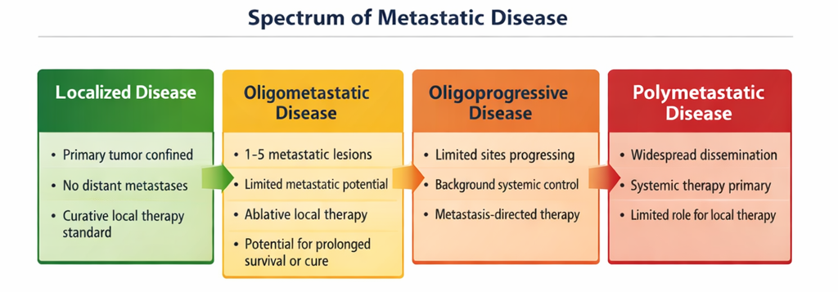
Figure 1: Spectrum of metastatic disease

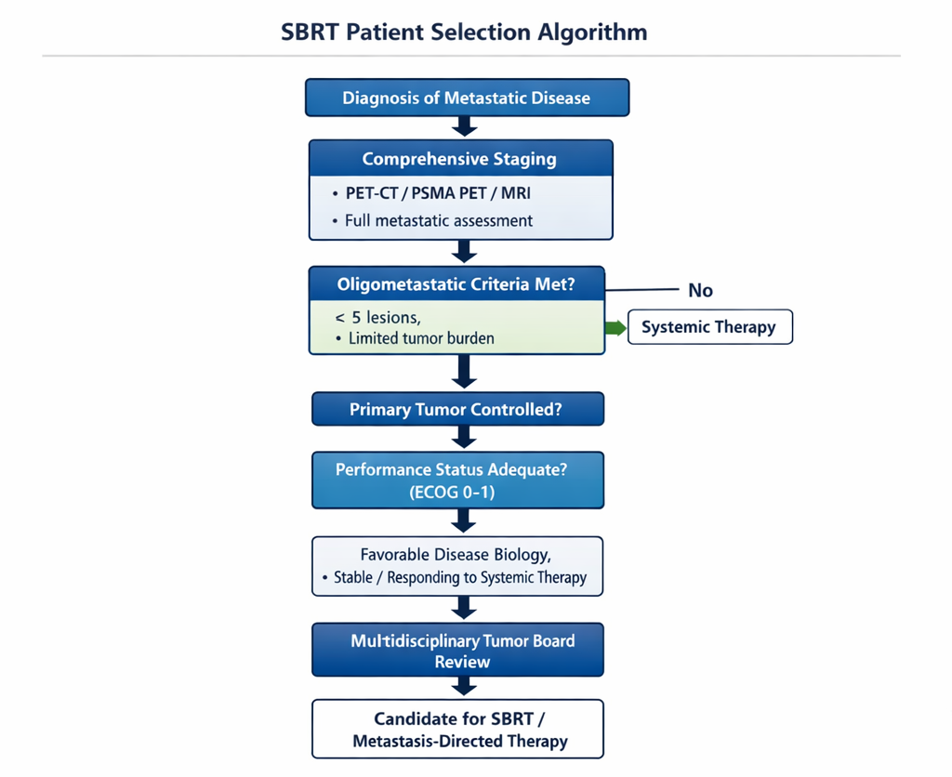
Figure 2: SBRT Patient Selection Algorithm

