Case report
Digital Workflow-Assisted Lithium Disilicate Resin-Bonded Fixed Dental Prosthesis for Missing Maxillary Lateral Incisor: A CARE-Compliant Case Report

ABSTRACT
Background: Resin-bonded fixed dental prostheses (RBFDPs) represent a minimally invasive solution for replacing missing anterior teeth. The evolution of ceramic materials, particularly lithium disilicate, combined with digital CAD-CAM workflows has significantly enhanced the clinical predictability and aesthetic outcomes of these restorations.
Case Presentation: A 33-year-old male patient presented with a missing maxillary left lateral incisor (#12) and multiple missing mandibular anterior teeth following trauma. A lithium disilicate RBFDP was planned and fabricated using intraoral scanning and CAD-CAM technology for the maxillary arch. Abutment preparation was conservative, with supragingival shoulder finish lines created on teeth #11 and #13. The prosthesis was cemented with self-adhesive resin cement following acid etching protocols.
Conclusion: This case demonstrates that lithium disilicate RBFDPs fabricated through a digital workflow provide a reliable, aesthetic, and minimally invasive alternative to conventional fixed partial dentures and implant-supported prostheses for selected patients. Meticulous case selection, surface preparation, and adhesive protocol adherence are pivotal to long-term success.
Keywords: Resin-bonded fixed dental prosthesis; Maryland bridge; Lithium disilicate; CAD-CAM; Intraoral scanner; Minimally invasive dentistry; Anterior tooth replacement

1. INTRODUCTION
Anterior tooth loss, particularly of the maxillary lateral incisor, is a common sequela of trauma in young adults and presents a distinct restorative challenge. Conventional fixed partial dentures require preparation of adjacent sound teeth, while implant-supported crowns demand surgical intervention and are generally deferred until skeletal maturity. Resin-bonded fixed dental prostheses (RBFDPs) — popularly known as Maryland bridges — represent a compelling minimally invasive alternative: they conserve abutment tooth structure, avoid surgical morbidity, and can be placed in a single or double appointment, making them particularly suitable for young patients with intact adjacent dentition. Despite their appeal, conventional metal-framed RBFDPs have historically been limited by aesthetic concerns related to metallic framework show-through. The advent of high-strength all-ceramic materials — principally lithium disilicate — has addressed this limitation by offering both adequate flexural strength (approximately 400 MPa) and outstanding optical characteristics that closely mimic natural enamel. Concurrently, the integration of digital workflows comprising intraoral scanning and CAD-CAM fabrication has further improved the precision and reproducibility of ceramic RBFDP construction. However, clinical case documentation employing a fully digital, all-ceramic RBFDP approach with systematic reporting remains sparse. This report addresses that gap by presenting a CARE-guideline compliant case of a lithium disilicate RBFDP for replacement of a traumatically lost maxillary lateral incisor, fabricated through an entirely digital workflow.
The concept of the RBFDP was first described by Rochette in 1973, who proposed a perforated metal retainer bonded to enamel using composite resin for the temporary splinting of periodontally compromised anterior teeth.¹ The subsequent refinement of electrochemical etching of nickel-chromium alloys in the early 1980s led to the development of the Maryland bridge as a more definitive restoration.² Over the following decades, concerns about the metallic framework compromising enamel translucency and aesthetics drove the development of all-ceramic alternatives.
Kern et al. introduced the first metal-free, all-ceramic RBFDP in 1991.³ Since then, glass-ceramic materials — particularly leucite-reinforced and lithium disilicate-reinforced systems — have gained clinical traction owing to their superior translucency, ability to be etched with hydrofluoric acid for micro-mechanical bonding, and their high flexural strength.⁴ Lithium disilicate ceramics offer a flexural strength of approximately 400 MPa, far exceeding the load demands of anterior restorations, while simultaneously providing outstanding optical characteristics that closely mimic natural dentition.⁵
The parallel advancement of digital dentistry — specifically intraoral scanning technology and computer-aided design and computer-aided manufacturing (CAD-CAM) — has brought a further dimension of precision and reproducibility to the fabrication of ceramic RBFDPs.⁶ Digital impressions eliminate the distortions inherent to conventional elastomeric impressions, and milling or pressing of lithium disilicate ingots ensures consistent material microstructure and marginal accuracy.⁷
This case report, prepared in accordance with the CARE (CAse REport) guidelines, documents the clinical management of a missing maxillary lateral incisor using a lithium disilicate RBFDP fabricated through an entirely digital workflow. The report additionally discusses the material rationale, adhesive protocol, and available evidence regarding long-term outcomes.

2. CASE PRESENTATION

2.1 Patient Information
A 33-year-old male patient of South Asian origin presented to the Department of Prosthodontics, Crown and Bridge at Bapuji Dental College and Hospital, Davangere, Karnataka, India, with the chief complaint of missing teeth in the maxillary and mandibular anterior regions, affecting his appearance and chewing function. The patient reported a history of trauma one year prior, during which the maxillary left lateral incisor and mandibular anterior teeth became mobile and were subsequently extracted two to four days after the injury. He was in good general health, reported no significant medical history, and had no known drug allergies. He was a non-smoker with no parafunctional habits.

2.2 Clinical Findings
Extraoral examination revealed a mesocephalic facial form with a Class II jaw relationship, no lymphadenopathy, and no temporomandibular joint signs or symptoms. The patient demonstrated competent lip closure, and the facial midline was coincident with the maxillary dental midline.
Intraoral examination confirmed the absence of the maxillary left lateral incisor (#12) and mandibular incisors (#31, #32, #41, and #42). The edentulous ridge at site #12 was well-formed with adequate width and showed no significant resorption. The mesiodistal space measured 7 mm, buccolingual dimension 4 mm, and gingivio-occlusal dimension 7 mm. The adjacent abutment teeth — maxillary right central incisor (#11) and maxillary left canine (#13) — were unrestored, vital, and caries-free. A Class II occlusal relationship was recorded with an overjet of 5 mm and overbite of 4 mm.

2.3 Diagnostic Assessment
Both a periapical radiograph (RVG) and an orthopantomogram (OPG) were obtained for complementary diagnostic purposes: the periapical RVG provided high-resolution detail of the periodontal status, root morphology, and bone levels of the abutment teeth (#11 and #13), while the OPG offered a panoramic overview of the entire dentition and jaws, confirming the absence of occult pathology in the edentulous mandibular anterior region and facilitating treatment planning for the staged implant-supported mandibular prosthesis. Together, these radiographs demonstrated adequate bone levels around the abutment teeth with no evidence of periapical pathology. Articulated diagnostic study casts were fabricated following irreversible hydrocolloid impressions (Algitex Alginate Impression Material, Dental Products of India). Type III dental stone (Goldstone, Asian Chemicals, Rajkot, India) was used to pour the casts. A facebow transfer was performed using a Hanau Spring facebow, and the casts were mounted on a Hanau Wide Vue semi-adjustable articulator. A diagnostic wax-up was conducted for the missing teeth with arbitrary preparation of the abutment teeth simulated on the cast.

2.4 Treatment Plan
Following comprehensive discussion of the available options — including a conventional three-unit fixed partial denture, an implant-supported single crown, and an RBFDP — the patient selected the RBFDP for the maxillary arch on account of minimal tooth preparation requirement and cost-effectiveness. Given his age (33 years), absence of parafunctional habits, Class II occlusion with increased overjet providing favourable load distribution, and unrestored abutment teeth with adequate enamel, the clinical situation was well-suited for an all-ceramic RBFDP. For the mandibular anterior region, the patient consented to an implant-supported hybrid prosthesis, planned separately.

2.5 Treatment Progress
Step 1 — Preparation of Abutment Teeth: Tooth preparation was performed under local anaesthesia (2% lignocaine with 1:80,000 adrenaline). A supragingival shoulder finish line was created at a depth of 1 mm on the palatal and proximal surfaces of teeth #11 and #13 — the distal surface of #11 and the mesial surface of #13. The incisal extent was maintained 1 mm cervical to the incisal edge to avoid incisal interference. All margins were confined to enamel as a prerequisite for optimal resin bonding. The average palatal enamel thickness of maxillary incisors is reported to range from 0.8 to 1.3 mm; given that the preparation was limited to 1 mm at the cervical shoulder and shallower in the body of the preparation, a residual enamel thickness of at least 0.3–0.5 mm was ensured, sufficient for reliable acid-etch bonding. The retaining wing design incorporated proximal wrap-around extensions to engage the mesial and distal line angles of both abutments, providing additional macro-mechanical resistance to lateral displacement. Mild horizontal grooves (0.3 mm depth) were placed in the middle third of the preparation on each abutment to enhance resistance form without compromising enamel integrity, as recommended by Kern et al.⁸
Step 2 — Intraoral Scanning and CAD Design: A digital impression was obtained using the Prime Scan intraoral scanner (Dentsply Sirona, Germany). The digital STL files were uploaded to CAD software, where preparation margins were delineated and the pontic was designed with optimal emergence profile and gingival convexity compatible with oral hygiene access. Retaining wings were designed with a minimum thickness of 0.6 mm at the margins, increasing to 0.8 mm at the mid-body, as recommended for lithium disilicate frameworks. It is important to clarify that the 1 mm preparation depth refers to the shoulder finish line at the cervical margin, which accommodates the marginal bulk of the retaining wing; the overlying flat palatal surface of the wing is designed at 0.6–0.8 mm, consistent with published guidelines for lithium disilicate RBFDPs where a preparation depth of 0.8–1.0 mm at the shoulder ensures marginal integrity without over-contouring the restoration. The CAD software’s colour-coded occlusal contact analysis feature was used to map static centric contacts and simulate eccentric movements based on the opposing arch scan, ensuring freedom from premature contacts. Although a fully integrated virtual articulator was not employed, this digital contact verification was supplemented by clinical confirmation with 12-micron articulating paper at the try-in appointment.⁹
Step 3 — Laboratory Fabrication: Following CAD design approval, a wax pattern was milled and subsequently pressed using lithium disilicate ingots (IPS e.max Press, Ivoclar Vivadent, Schaan, Liechtenstein). The pressed ceramic prosthesis was then characterised with ceramic stains and glazed in a dental furnace to achieve final aesthetics and a smooth surface compatible with the opposing natural dentition.
Step 4 — Try-in and Evaluation: The prosthesis was initially assessed on the articulated casts for marginal fit, contacts, and aesthetics, then evaluated intraorally. Marginal integrity was confirmed using an explorer tip and digital pressure. Occlusal contacts were verified in centric occlusion and lateral excursions using 12-micron articulating paper (Bausch). No adjustments to the occlusal surface were required.
Step 5 — Surface Conditioning and Cementation: The intaglio surfaces of the prosthesis were etched with 9.5% hydrofluoric acid (IPS Ceramic Etching Gel, Ivoclar Vivadent) for 20 seconds, rinsed, and dried. A silane coupling agent (Monobond Plus, Ivoclar Vivadent) was applied and allowed to react for 60 seconds. On the tooth side, the prepared enamel surfaces were etched with 37% phosphoric acid for 30 seconds, rinsed, and gently air-dried. A bonding agent was applied and lightly air-thinned. The prosthesis was loaded with self-adhesive universal resin cement (RelyX Unicem 2, 3M ESPE, USA), seated with firm digital pressure, and excess cement removed prior to light curing for 20 seconds per surface (LED unit, 800 mW/cm²). Occlusion was re-verified after cementation.¹⁰

2.6 Follow-up and Outcomes
The patient was reviewed at one week, one month, and three months post-cementation. At each recall, the prosthesis was assessed for marginal integrity, gingival health, surface continuity, and patient satisfaction. The prosthesis remained firmly seated with no evidence of debonding or fracture. Gingival tissues around the abutments and in the pontic region showed no signs of inflammation or recession. The patient reported satisfactory aesthetics and comfortable function, with a marked improvement in self-confidence compared to the pre-treatment presentation. No adverse events were recorded during the observation period.

3. DISCUSSION
This case illustrates several important clinical and technical considerations that underpin the successful use of a lithium disilicate RBFDP for anterior tooth replacement. The RBFDP remains a viable and scientifically supported treatment option for carefully selected patients, and its clinical application has been bolstered by the development of high-strength ceramic materials and refined adhesive techniques.
Case selection is the most critical determinant of RBFDP success. Ideal candidates are patients with unrestored abutment teeth, short edentulous spans, adequate enamel volume at the proposed preparation sites, absence of parafunctional habits, and Class I or Class II occlusion with sufficient overjet to minimise lateral loading on the retaining wings.¹¹ The patient in this report fulfilled all of these criteria. The Class II occlusal relationship with an overjet of 5 mm was particularly favourable, as it reduces the risk of retainer debonding compared to a deep vertical overbite in Class II Division 2 cases.
From a materials science perspective, the selection of lithium disilicate was scientifically justified. Lithium disilicate glass-ceramics contain interlocking crystals of Li₂Si₂O₅ embedded in a glassy matrix, conferring a flexural strength of approximately 400 MPa and a fracture toughness of approximately 2.75 MPa·m½.¹² The silica content enables effective etching with hydrofluoric acid, creating a micro-retentive surface topography that, when silanised, forms a durable chemical and micromechanical bond with resin cement.¹³ Published data from a retrospective study by Sailer et al. demonstrated a 100% survival rate for single-retainer cantilever lithium disilicate RBFDPs at a mean follow-up of six years.¹⁴ A literature review by van Dalen et al. reported a 95% success rate for two-unit cantilevered resin-bonded restorations over a two-year observation period.¹⁵
The digital workflow adopted in this case contributed significantly to prosthesis precision. Intraoral scanning with the Dentsply Sirona Prime Scan offers documented trueness of less than 10 µm and repeatability within 5 µm for full-arch scans, substantially outperforming conventional elastomeric impression techniques.⁶ The CAD design environment additionally permitted pre-operative simulation of pontic morphology and retainer wing dimensions, reducing the likelihood of intraoral adjustments and preserving the integrity of the glazed surface.
The cementation protocol is equally important to long-term performance. Hydrofluoric acid etching dissolves the glassy matrix of lithium disilicate and exposes the crystalline infrastructure, creating micro-porosity for resin infiltration.¹⁶ Silanisation further enhances this bond through covalent linkages between the ceramic surface and the resin matrix. The use of RelyX Unicem 2 (3M ESPE) was appropriate; MDP-containing self-adhesive resin cements achieve adequate bond strengths to acid-etched and silanised ceramic surfaces without a separate primer or bonding agent.¹⁷
Evidence suggests that single-retainer cantilever RBFDPs demonstrate superior clinical performance compared to two-retainer designs, since the latter are susceptible to differential movement of abutment teeth generating debonding forces at one retainer.¹⁸ In this case, the two-retainer design was selected based on the patient's specific occlusal characteristics and the need to distribute functional loads across two abutments.
It is important to acknowledge the limitations of this modality and of the present report. RBFDPs do not prevent alveolar bone resorption at the edentulous site, as there is no osseointegrated implant transmitting functional loads to the supporting bone. Progressive ridge resorption may eventually compromise pontic aesthetics and require prosthetic adjustment. Debonding remains the most common biological complication, with reported rates of 5–20% over five years in two-retainer designs; while rebonding is possible, each episode of debonding risks micro-fracture of the ceramic retaining wing. The follow-up period reported here (three months) is insufficient to draw conclusions about long-term durability; extended follow-up at one, three, and five years is planned and will be reported separately. Additionally, this is a single case report, which limits the generalisability of findings. Randomised or prospective cohort data with longer follow-up periods are required to confirm the durability of digital-workflow lithium disilicate RBFDPs relative to conventional fabrication approaches. Furthermore, the absence of a virtual articulator in the workflow, while clinically compensated by intraoral occlusal verification, represents a methodological limitation that future cases should address by incorporating full virtual articulation for pre-fabrication occlusal planning.¹⁹ ²⁰ Patient education regarding avoidance of excessive anterior loading and the importance of regular recall appointments is therefore non-negotiable.

4. CONCLUSION
This case demonstrates that a lithium disilicate resin-bonded fixed dental prosthesis, fabricated through a fully digital workflow incorporating intraoral scanning and CAD-CAM technology, provides an aesthetically superior, minimally invasive, and clinically reliable solution for replacing a missing maxillary lateral incisor in a carefully selected patient. The digital impression protocol eliminated impression-related distortions and facilitated precise prosthesis design and pre-fabrication occlusal verification, while the superior optical and mechanical properties of lithium disilicate — combined with a rigorous adhesive cementation protocol involving hydrofluoric acid etching, silanisation, and self-adhesive resin cement — underpin the durability of the restoration. Adequate residual enamel following preparation, supplemented by proximal wrap-around retainer design and resistance grooves, ensures both structural integrity and long-term bonding reliability. Long-term outcomes are contingent upon meticulous case selection, strict adherence to tooth preparation principles within enamel, and fidelity to established surface conditioning and cementation guidelines. RBFDPs should be considered an evidence-based, conservative alternative to implant-supported prostheses, particularly in young patients for whom preservation of bone and tooth structure is paramount. Extended longitudinal follow-up and prospective comparative studies are warranted to further validate the clinical performance of fully digital, all-ceramic RBFDP workflows.
Consent: Written informed consent was obtained from the patient for the publication of this case report and accompanying clinical photographs. The patient's identity has been anonymised in accordance with institutional and journal requirements.
Ethical Approval: This case report was prepared in accordance with the CARE (CAse REport) guidelines. Institutional ethics committee approval was obtained prior to submission.
Conflict of Interest: The authors declare no conflicts of interest.

6. TABLES
Table 1. Indications and Contraindications for Resin-Bonded Fixed Dental Prostheses
Indications | Contraindications
Replacement of missing anterior teeth in children and adolescents | Parafunctional habits (bruxism, clenching)
Short edentulous span | Long edentulous span
Unrestored abutment teeth | Restored or structurally compromised abutments
Single posterior tooth replacement | Severely compromised enamel volume
Adequate clinical crown length | Significant pontic width discrepancy
Excellent moisture control achievable | Deep vertical overbite (Class II Division 2)
Nickel allergy (favour ceramic alternative) | Poor patient compliance or oral hygiene

Table 2. Advantages and Disadvantages of Resin-Bonded Fixed Dental Prostheses
Advantages | Disadvantages
Minimal removal of tooth structure | Relatively reduced longevity compared to implants
Minimal risk of pulpal trauma | Enamel modification of abutments still required
Anaesthesia often not required | Space discrepancies are difficult to correct
Supragingival margins achievable | Good abutment alignment is essential
Simplified impression and fabrication | Aesthetics may be compromised posteriorly
No interim prosthesis usually required | Debonding is the most frequent complication
Reduced chair time and patient cost | Does not prevent alveolar ridge resorption
Rebonding is possible on failure | Strict moisture control during cementation required

7. FIGURES
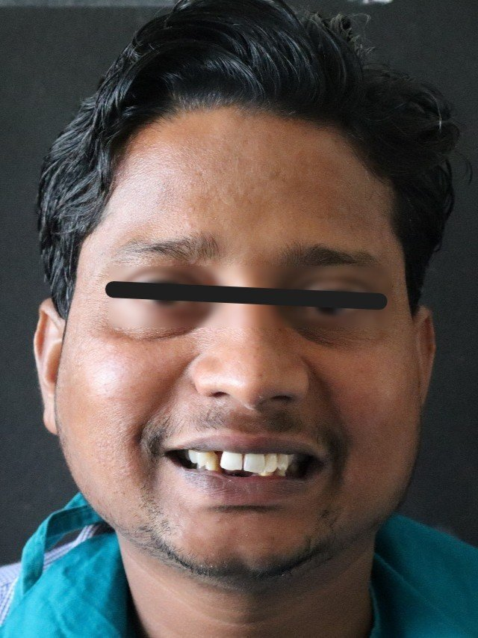
Figure 1:preoperative frontal view of patient

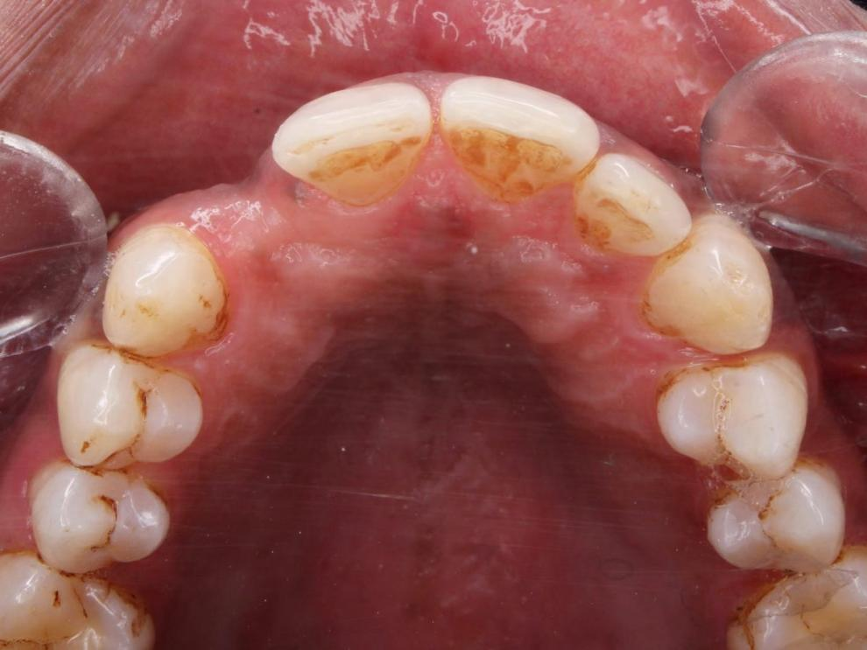
Figure 2:preopeparative occlusal view
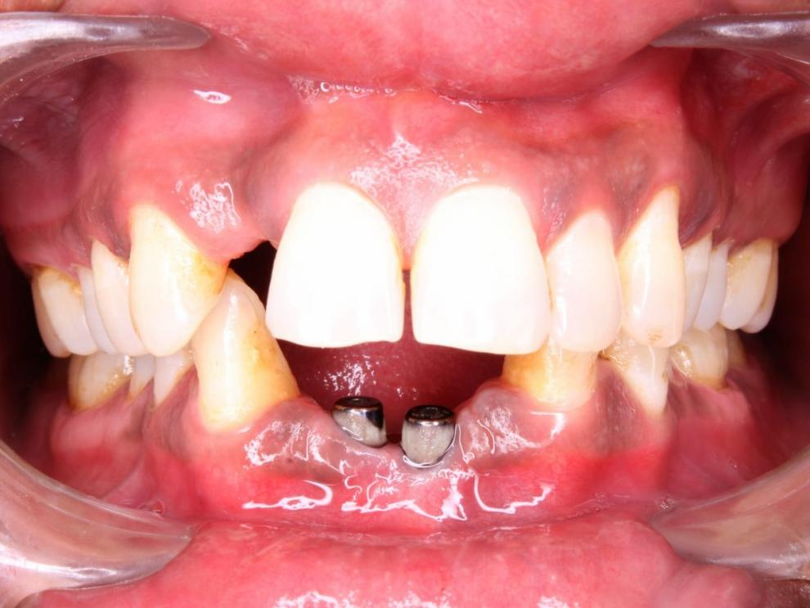
Figure 3:preoperative occlusion

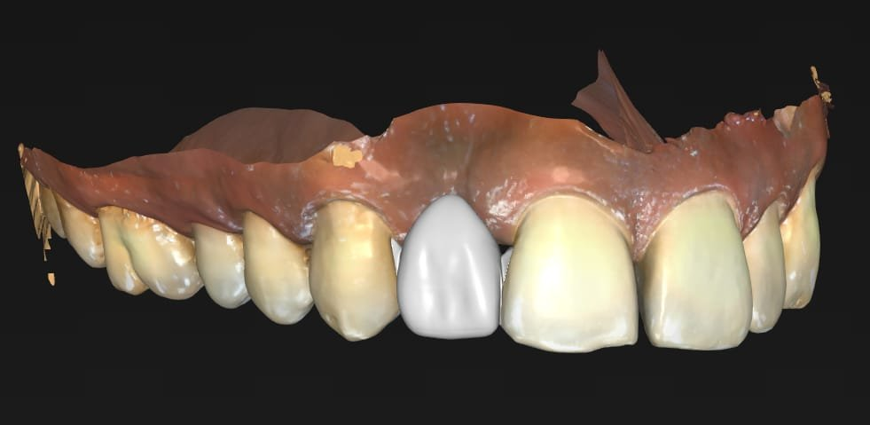

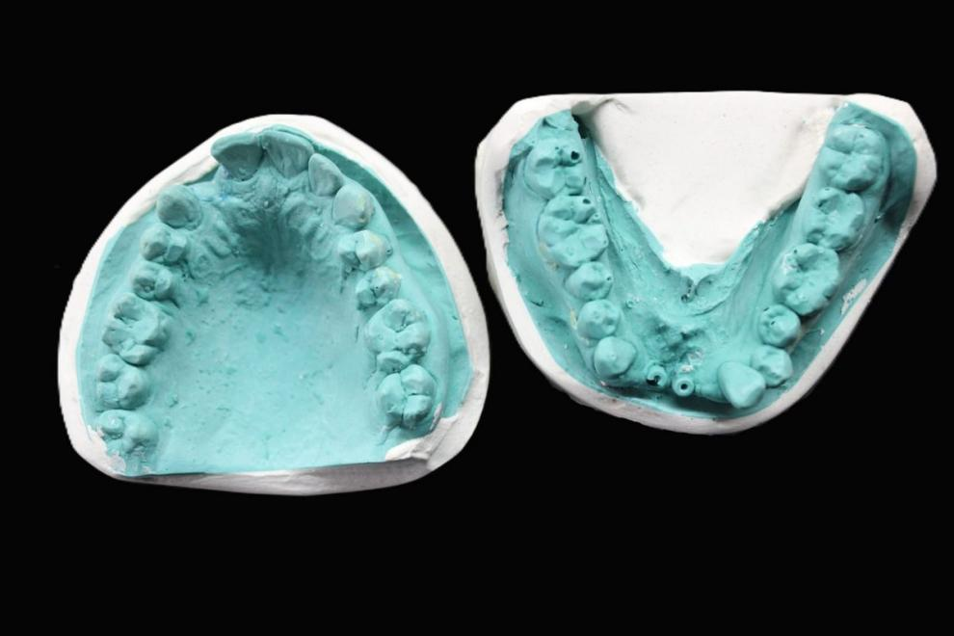
Figure 4:diagnostic casts
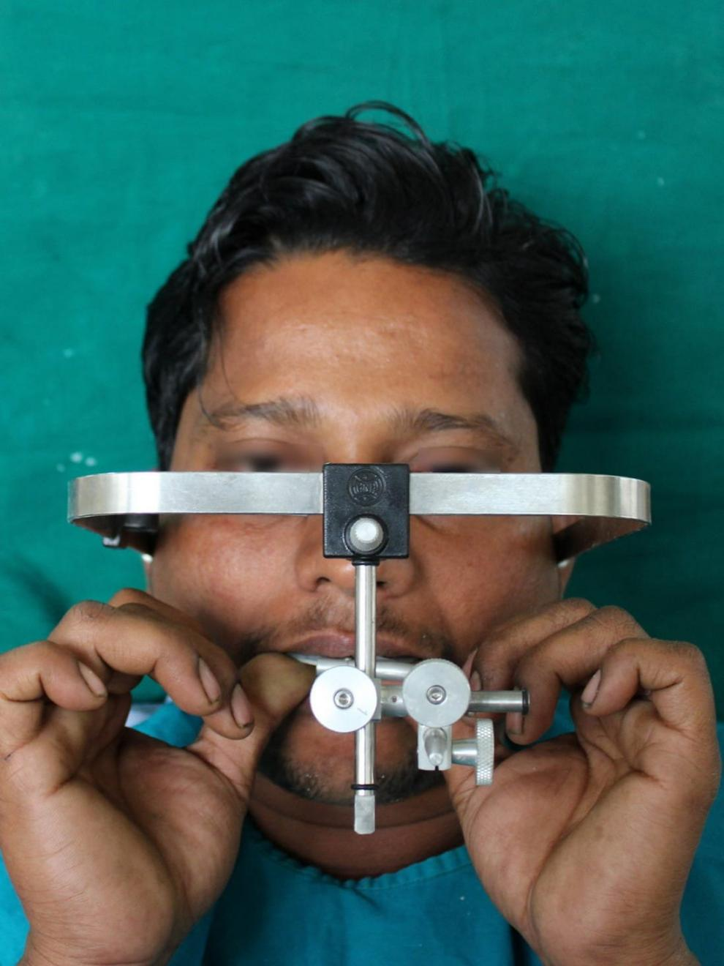
Figure 5: facebow transfer

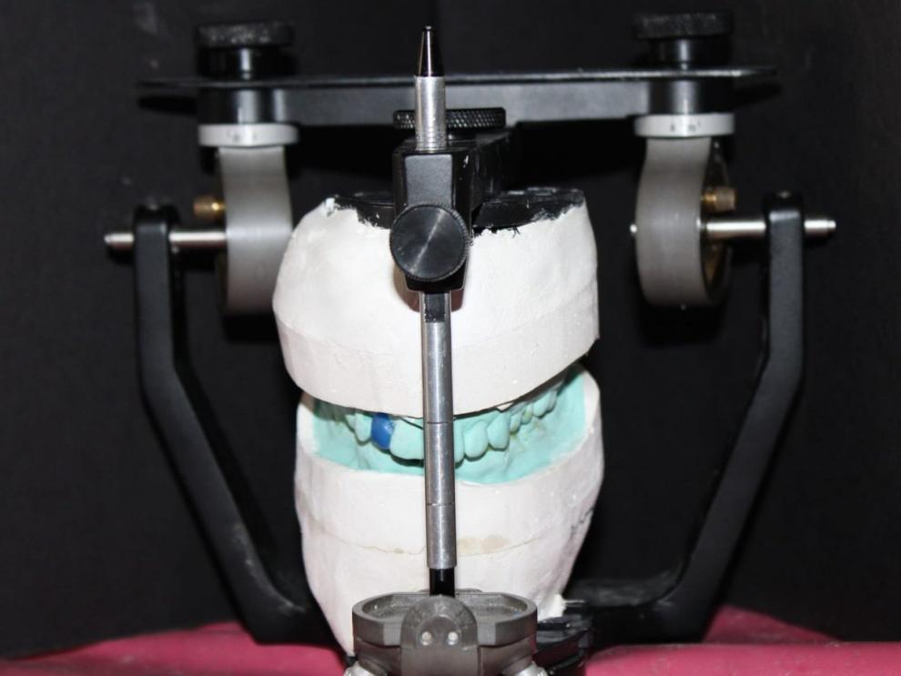
Figure 6:diagnostic mounting in hanau articulator
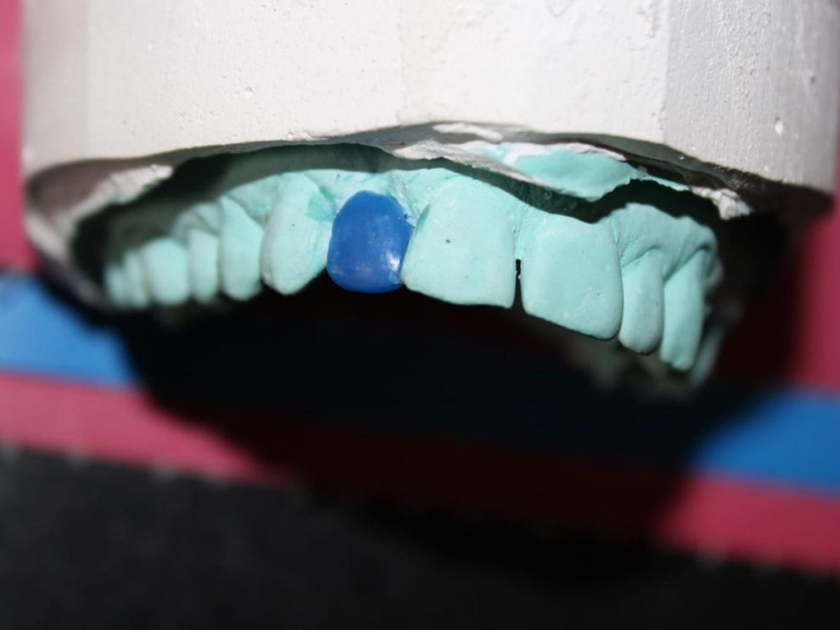
Figure 7:wax up of pontic region in relation to 12
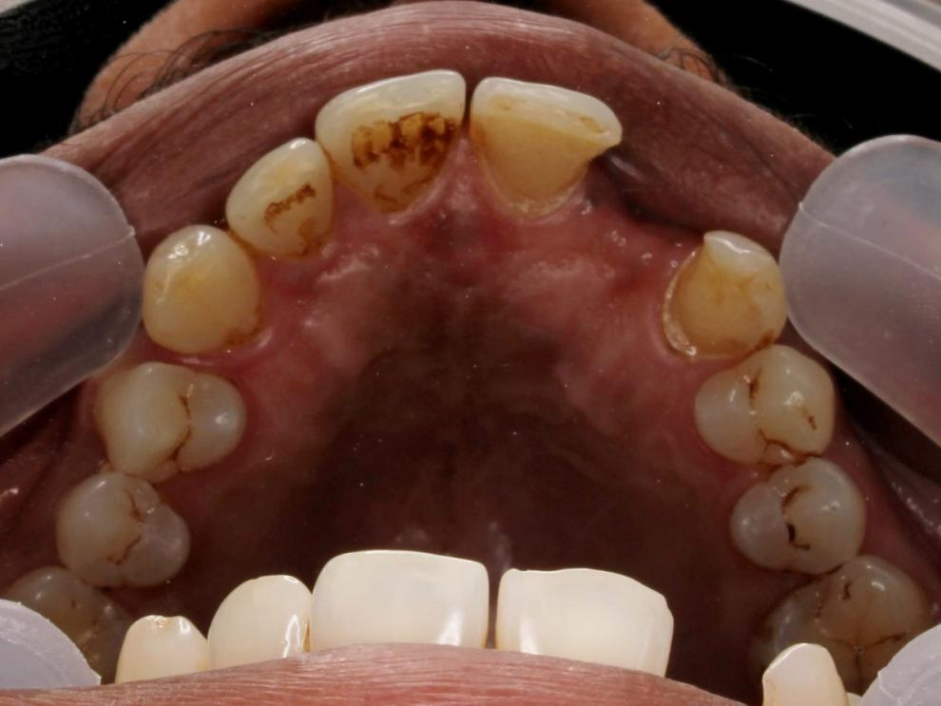
Figure 8:intral oral tooth preparation in relation to 11 and 13

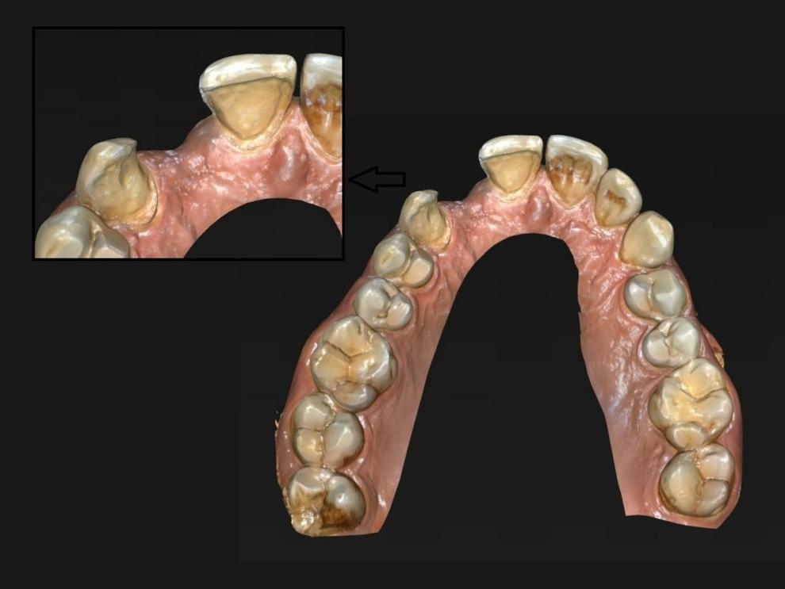
Figure 9: scanning of prepared tooth using intral oral scanner
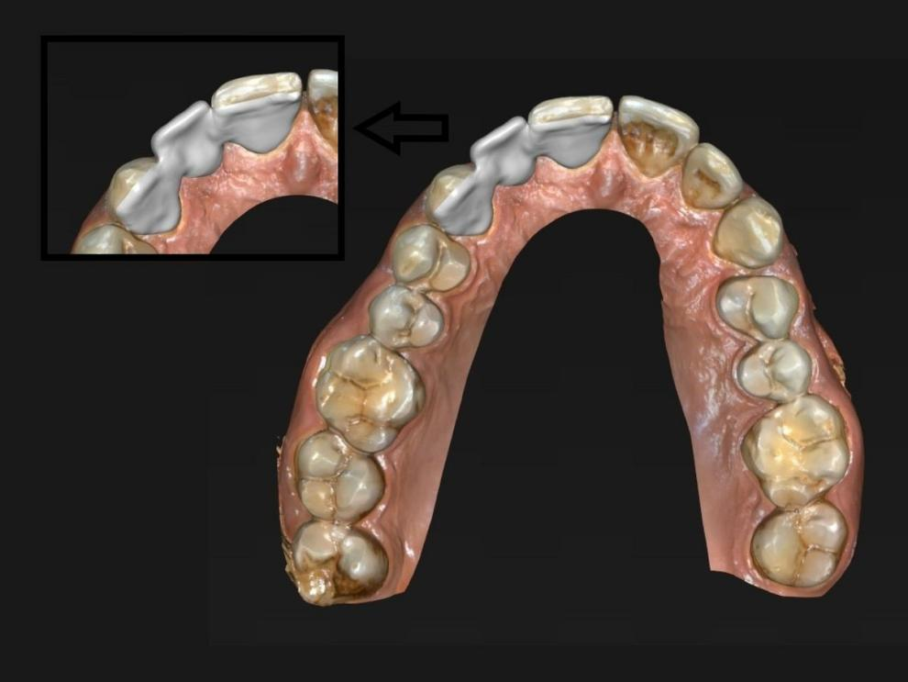
Figure 10:designing of maryland prosthesis using software

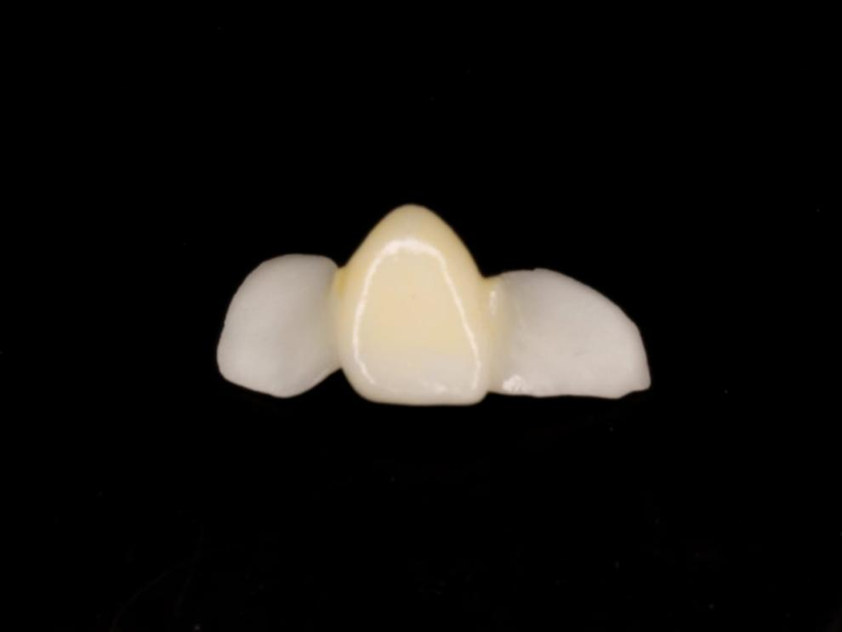
Figure 11:final prosthesis finished and polished
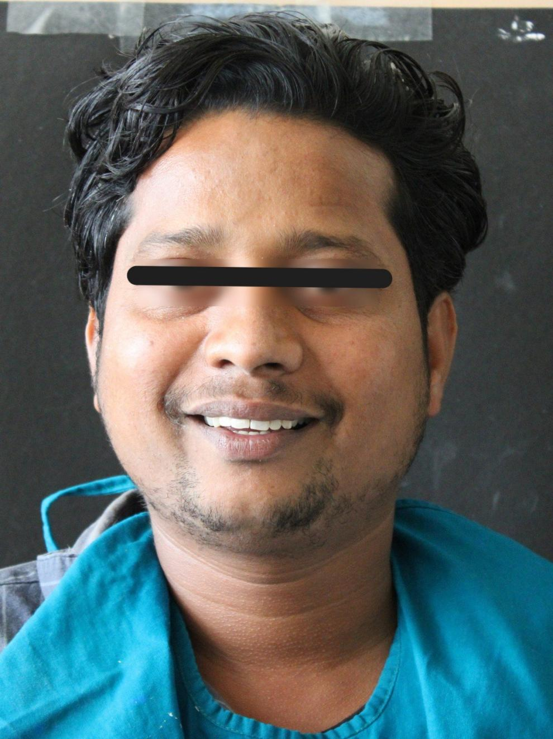
Figure 12: Happy patient

Disclaimer (Artificial intelligence)

Author(s) hereby declare that NO generative AI technologies such as Large Language Models (ChatGPT, COPILOT, etc.) and text-to-image generators have been used during the writing or editing of this manuscript.

REFERENCES
1. Rochette AL. Attachment of a splint to enamel of lower anterior teeth. J Prosthet Dent. 1973;30(4):418–23.
2. Livaditis GJ, Thompson VP. Etched castings: an improved retentive mechanism for resin-bonded retainers. J Prosthet Dent. 1982;47(1):52–8.
3. Kern M, Knode H, Strubb JR. The all-porcelain, resin-bonded bridge. Quintessence Int. 1991;22(4):257–62.
4. Habibzadeh S, Khamisi F, Mosaddad SA, Fernandes GVO, Heboyan A. Full-ceramic resin-bonded fixed dental prostheses: a systematic review. J Appl Biomater Funct Mater. 2024;22. doi:10.1177/22808000241250118.
5. Guzelce E, Bassi F, Karacer O. Restoring congenitally missing mandibular central incisor using lithium disilicate based resin bonded prostheses: a case report. Oral Health Dent Sci. 2018;2(2):1–3.
6. Ender A, Mehl A. Accuracy of complete-arch dental impressions: a new method of measuring trueness and precision. J Prosthet Dent. 2013;109(2):121–8.
7. Mangano FG, Veronesi G, Hauschild U, Mijiritsky E, Mangano C. Trueness and precision of four intraoral scanners in oral implantology: a comparative in vitro study. PLoS One. 2016;11(9):e0163107.
8. Kern M. Resin-bonded bridges: the state of the art. Quintessence Int. 2017;48(5):370–7.
9. Sailer I, Strasding M, Valente NA, Zwahlen M, Liu S, Pjetursson BE. A systematic review of the survival and complication rates of zirconia-ceramic and metal-ceramic multiple-unit fixed dental prostheses. Clin Oral Implants Res. 2018;29 Suppl 16:184–98.
10. van Meerbeek B, Yoshihara K, Yoshida Y, Mine A, De Munck J, Van Landuyt KL. State of the art of self-etch adhesives. Dent Mater. 2011;27(1):17–28.
11. Kinzer GA, Kokich VO Jr. Managing congenitally missing lateral incisors. Part II: tooth-supported restorations. J Esthet Restor Dent. 2005;17(2):76–84.
12. Guess PC, Schultheis S, Bonfante EA, Coelho PG, Ferencz JL, Silva NR. All-ceramic systems: laboratory and clinical performance. Dent Clin North Am. 2011;55(2):333–52.
13. Blatz MB, Sadan A, Kern M. Resin-ceramic bonding: a review of the literature. J Prosthet Dent. 2003;89(3):268–74.
14. Sailer I, Bonani T, Brodbeck U, Hammerle CH. Retrospective clinical study of single-retainer cantilever anterior and posterior glass-ceramic resin-bonded fixed dental prostheses at a mean follow-up of 6 years. Int J Prosthodont. 2013;26(5):443–50.
15. van Dalen A, Feilzer AJ, Kleverlaan CJ. A literature review of two-unit cantilevered FPDs. Int J Prosthodont. 2004;17(3):281–4.
16. Matinlinna JP, Lung CYK, Tsoi JKH. Silane adhesion mechanism in dental applications and surface treatments: a review. Dent Mater. 2018;34(1):13–28.
17. Mante FK, Osei-Ansah B, Mante EO, Flinton R. Effect of surface treatments and adhesive systems on the bond strength of resin cement to IPS e.max CAD ceramic. J Adhes Dent. 2014;16(4):357–62.
18. Kern M, Passia N, Sasse M, Yazigi C. Ten-year outcome of zirconia ceramic cantilever resin-bonded fixed dental prostheses and the influence of the reasons for missing incisors. J Dent. 2016;50:93–8.
19. Ahmad M, Naim H, Adawi AM, Siddiq A, Mayidi HM, Hakami YH. A conservative approach to replace missing teeth in the aesthetic zone with Maryland bridge: a case report. Dent Oral Craniofac Res. 2017;3:1–3.
20. Jain A, Mustaffa HG. All ceramic resin-bonded bridge: an esthetic alternative to conventional fixed prosthesis. Int J Sci Res. 2016;5(9):760–1.
21. Habibzadeh S, Khamisi F, Mosaddad SA, Fernandes GVO, Heboyan A. Full-ceramic resin-bonded fixed dental prostheses: a systematic review. J Appl Biomater Funct Mater. 2024;22. doi:10.1177/22808000241250118.
22. Kern M, Sasse M, Wolfart S. Ten-year outcome of anterior cantilever resin-bonded fixed dental prostheses. J Am Dent Assoc. 2012;143(10):1169–74. Updated in: Kern M. Fifteen-year survival of anterior resin-bonded fixed partial dentures with one retainer. J Dent. 2023;128:104371.
23. Chochlidakis K, Papaspyridakos P, Tsigarida A, Romeo D, Chen YW, Ercoli C. Digital versus conventional implant impressions: a systematic review and meta-analysis. J Prosthodont. 2023;32(2):135–48.
24. de Oliveira GR, Queiroz JRC, Benetti P, Dal Piva AMO, Tribst JPM. Effect of preparation design on marginal adaptation and stress distribution of lithium disilicate resin-bonded fixed dental prostheses. J Prosthet Dent. 2024;131(5):873–80.
25. Edelhoff D, Liebermann A, Beuer F, Stimmelmayr M, Guth JF. Minimizing tooth preparation in fixed prosthodontics through the use of ceramic veneers and resin-bonded fixed dental prostheses. Quintessence Int. 2023;54(1):8–22.

