A case report of orthokeratinized odontogenic cyst with giant cells: Rare histopathological variant

Abstract:
Orthokeratinized odontogenic cyst (OOC) is a rare developmental odontogenic cyst of the jaws with an uncertain etiology. Formerly considered a variant of the odontogenic keratocyst, OOC is now recognized as a distinct pathological entity because of its characteristic histopathological features and comparatively less aggressive biological behavior. It most commonly occurs in the posterior mandible and demonstrates a male predilection. Clinically, OOC is usually asymptomatic, although pain and swelling may occur secondary to infection. Radiographically, it commonly presents as a well-defined unilocular radiolucency, often associated with impacted teeth, and may resemble a dentigerous cyst despite differences in pathogenesis and clinical behavior. We report a rare case of OOC in a 40-year-old female who presented with swelling in the left vestibular region. Radiographic examination revealed a multilocular radiolucency. Histopathological analysis demonstrated orthokeratinized epithelium with focal areas of non-keratinization in inflamed regions, along with the presence of multinucleated giant cells. This case emphasizes the importance of careful clinical, radiographic, and histopathological evaluation for accurate diagnosis, appropriate management, and favorable prognosis.
Keywords: Odontogenic Keratocyst, Orthokeratinized odontogenic keratocyst, Multinucleated giant cells, diagnosis
Introduction:
The orthokeratinized odontogenic cyst (OOC) is a comparatively infrequent developmental odontogenic cyst of the jaws and first identified by Wright in 1981 (Wright, 1981). The World Health Organization (WHO) has defined Orthokeratinized odontogenic cyst (OOC) as the uncommon orthokeratinized type of odontogenic keratocyst (OKC) (WHO 2022) OOC differs from developmental odontogenic cysts, especially dentigerous cysts and OKCs. (Sandhu SV et al.,2012). Other than OKC, many other odontogenic cysts also produce ortho-keratin such as sebaceous cyst, pilar cyst and trichilemmal cyst. (Thompson L 2006) In 1927, OOC was first described as an ortho-keratinized variant of the formerly called OKC, which is known as the keratocystic odontogenic tumour (KCOT) by Schultzas. Accounting for only 0.4% of cystic lesions of odontogenic origin, OOC is considered relatively rare. (Diniz MG et al., 2011) OOC is observed predominantly in adult Caucasian males, its peak incidence is found between the third and fourth decades of life (MacDonald DS & Li TK 2010) This cyst generally presents as a single, asymptomatic, radiolucent lesion, localized predominantly in the posterior mandible. (Ramos-Perez FM et al.,2014) Ortho-keratinized odontogenic keratocyst (OOK) is a distinct histopathological variant of the odontogenic keratocyst (OKC), accounting for approximately 10% of all OKCs. OOKs are distinct from OKCs as they recur less frequently, with a recurrence rate of less than 2% compared to a recurrence rate as high as 28% for OKCs. (Crane H et al., 2020)
OOC is characterized by an ortho-keratinized stratified squamous epithelial lining and a prominent basal cell layer without the typical palisading seen in para-keratinized variants. Healthy tissues such as placenta, bone and skeletal muscle contain populations of multinucleated cells. In contrast, the presence of multinucleated cells in other tissues is considered pathologic. Multinucleated giant cells (MGCs), derived from the fusion of monocyte-lineage cells, are frequently observed in association with foreign bodies, such as exogenous materials, or as part of the tissue’s immune response to infection. (Brooks PJ et al., 2019). MGCs are occasionally observed in odontogenic lesions, such as central giant cell granulomas and aneurysmal bone cysts. However, the occurrence of MGCs in OOK is sporadic and sparsely documented in the literature. The presence of MGCs in an odontogenic lesion raises questions regarding its histogenesis and possible implications on lesion behaviour and recurrence. Hence, we present a case of OOK’s with multinucleated giant cell in a 40 years female.
Case Report:
A 40-year-old female attended département of Oral Pathology in a dental institution with asymptomatic swelling on the left side of the mandibular body, angle and ascending ramus six months. (Fig 1)
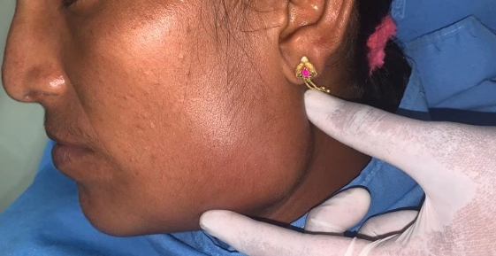

Fig 1: Extraoral photograph of swelling on the left side of the face.
The swelling started six months back as small swelling extra orally and attain the present size. There was no history of trauma or pus discharge. On intraoral examination showed obliteration of the left vestibular area extending from left first premolar to distal to second molar with firm, non-tender of size 2 X 3 mm. The mucosa over the swelling was normal. Mild paraesthesia was present in the left lower mandible region. On palpation the swelling of was hard in consistency with intact buccal and lingual cortical plates. (Fig 2)
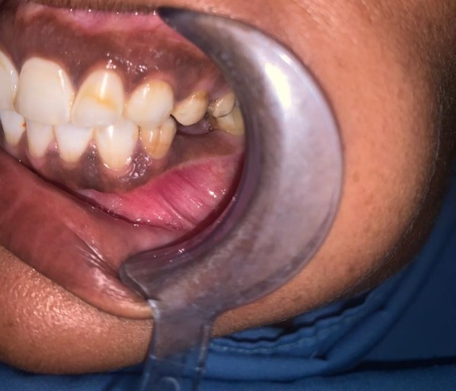

Fig 2: Intraoral photograph showing vestibular obliteration in relation with lower left premolar region.
Orthopantomographic revealed a well-defined, unilocular radiolucency surrounded impacted second premolar extending anteroposteriorly from apices of firs premolar till ramus of the mandible, superoinferiorly from apices of 35-38 till the lower border of the mandible. (Fig 3)
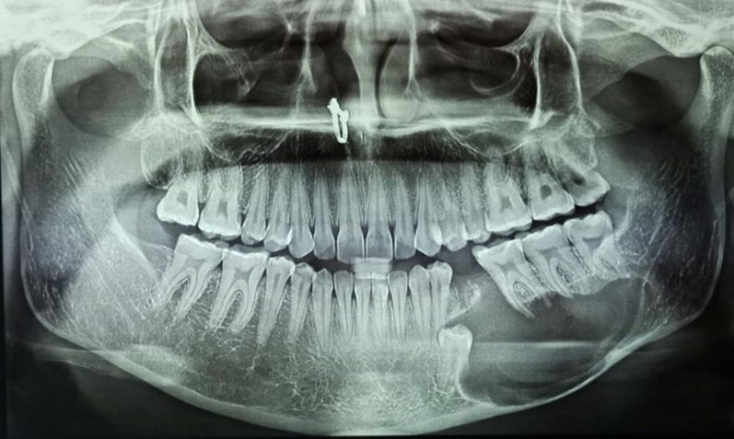

Fig 3: Orthopantomogram showing a well-defined unilocular radiolucency with smooth border in the left premolar region
Based clinical, radiographic features the clinical differential diagnosis was given as Ameloblastoma, central giant cell granuloma and odontogenic myxoma. Before taking the biopsy explained the procedure obtained the consent form from the patient. The lesion was enucleated under local anaesthesia and received specimen for histopathological examination. Gross specimen showed multiple bits of specimen brownish to white tissues. (Fig 4)
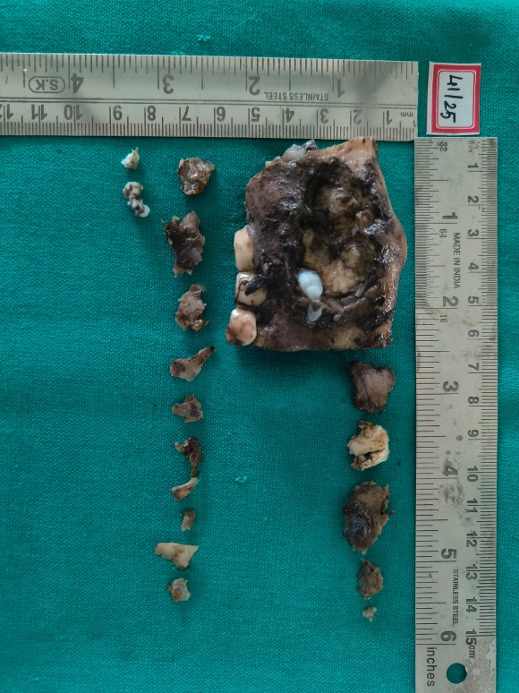

Fig 4: Gross specimen showing multiple bits of brown to black in collar with impacted second premolar
Microscopically revealed a cystic lesion lined by orthokeratinized stratified squamous epithelium with hyperkeratosis and the epithelium is 3-5-layer thickness with prominent keratohyalin granular below the hyperkeratosis. The basal layer showed palisading with epithelial-mesenchymal interaction was flat. (Fig 5a)
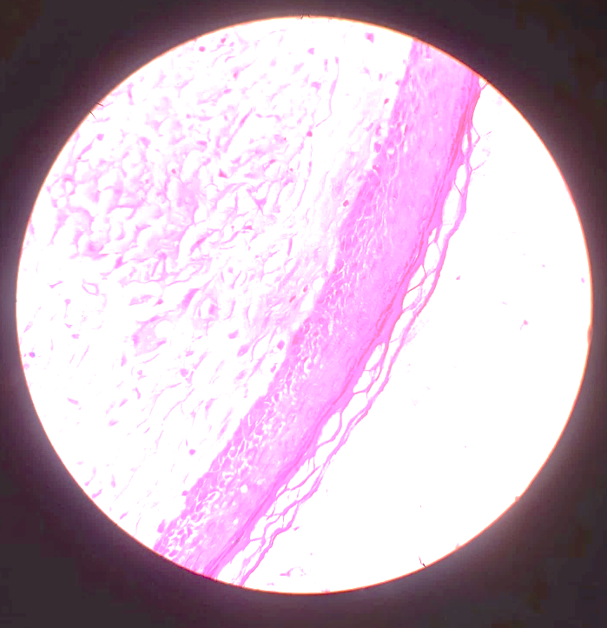

Fig 5 a: Photomicrograph showing atrophic hyper orthokeratinized stratified squamous cystic epithelium with fibrous connective tissue capsule.
In the underlying fibrotic connective tissue stroma wall showed chronic inflammatory cell infiltration, predominantly lymphocytes and plasma cells. Diffuse multinucleated giant cells with areas of haemorrhage in a fibrovascular connective tissue stroma. (Fig 5 b)
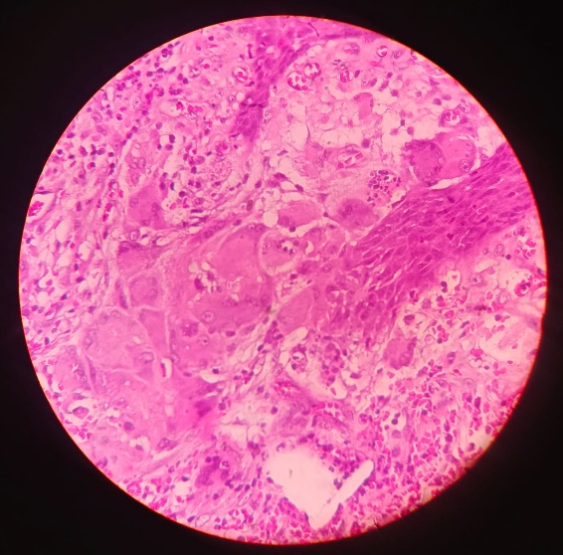

Fig 5 b: Photomicrograph showing multinucleated giant cells with in fibrous connective tissue capsule.
Discussion:
The orthokeratinized odontogenic keratocyst uncommon developmental cyst with unknown etiological factors, but some of the literature explained about etiopathogenesis of orthokeratinized odontogenic keratocyst. The etiopathogenesis of WHOs is believed to be associated with a mutation of the Patched gene (PTCH). (Dong Q et al., 2005) Ortho keratinised odontogenic keratocyst was locally aggressive with predisposed to recurrence and also associated with basal cell nevoid basal carcinoma syndrome (NBCS) (De Souza LB et al., 2010) The orthokeratinized odontogenic keratocyst was predominantly present in the posterior mandibular followed by anterior region. Patient will be asymptomatic unless it was secondary infection. Normally these cysts with have anteroposterior extension with 1-3 cm, however these ae few cases reported with more than 10 cm. (Carvalho CH et al., 2012) Radiographic features of Ortho keratinised odontogenic keratocyst was well defined radiolucent with unilocular or multilocular, predominantly unilocular radiolucency and this may be associated with impacted tooth, this may be confused with dentigerous cyst.( McNally AK & Anderson JM 2011) There are few literatures explained that this radiolucency may be associated with radiopaque spicules that may be confused with calcifying epithelial odontogenic tumour, calcifying epithelial odontogenic cyst and ameloblastic fibro odontoma.( Mahdavi N 2021) However, due to the radiographic features which was similar to these lesions, it is very important that we have to give conclusive diagnosis based on clinical, radiographic and histopathological diagnosis. (Vignery A 2005)
Histopathological features of Ortho keratinised odontogenic keratocyst will show uniform epithelial thickness with prominent keratohyalin granular layer. (Boffano P & Gallésio C 2012) The same features were present in our case also along with these features presence of multinucleated giant cells was observed with haemorrhagic areas. Presence of multinucleated giant cells considered as uncommon feature in orthokeratinized odontogenic keratocyst. (Wright, 1981) Presence of multinucleated giant cells could be because of fusion of macrophages, represent a last stage of differentiation and this will be associated with chronic inflammatory cell infiltration from the continues presence of a non phagocytable materials. (Elvamani M et al., 2014). In this case there was no trauma or pus discharge from the cystic area but the presence of multinucleated giant cells (MGCs) in OOK is an uncommon finding and raises questions about their origin and role.
According to Ramos – Perez et al., in 2014 explained about mechanism of formation of giant cells in orthokeratinized odontogenic keratocyst could be because of extravasation of haemorrhagic in the cystic area, thus causing inflammatory reaction that triggered tissue necrosis with activation of multinucleated giant cells (MGC) (Ramos-Perez FM et al., 2014). The MGCs identified in this case resemble osteoclast-like cells, suggesting a possible response to inflammatory mediators released during cyst expansion or remodelling of the surrounding bone. Alternatively, these giant cells may arise from a foreign body reaction or as part of a reparative response within the fibrous capsule. Role of multinucleated giant cells may be seen this could be because of a secondary inflammatory reaction, often related to factors like keratin spillage or prior infection. In such cases, they act as part of a foreign body reaction rather than directly contributing to the initiation or progression of the cyst itself. (Ramos-Perez FM et al., 2014).
Differential diagnosis:
Based on radiographic features of orthokeratinized odontogenic keratocyst should include the dentigerous cyst if it is associated with impacted tooth, if it is not associated with impacted tooth then we can consider as paradental cyst. Based on histopathological features epidermoid cyst can be considered as one of the differential diagnoses.
Treatment and potential for recurrence:
The primary treatment of orthokeratinized odontogenic keratocyst will be conservative surgical excision with complete enucleation and curettage. This odontogenic keratocyst may show 2.2% recurrence rate according to Crowley et al., in 1992, according to Gonzalez et al., in 2013 showed 4% recurrence rate. (Crowley TE et al., 1992 & Gonzalez et al., in 2013)
Malignant transformation of orthokeratinized odontogenic keratocyst:
Malignant transformation of orthokeratinized odontogenic keratocyst is still unknown, there was no existing evidence how this cyst will be transforming into malignancy. According to existing literature suggesting that there are some triggering factors such as chronic inflammation, exon 6 of the TP53 gene mutation, pr some of oncogenic virus may trigger to cause orthokeratinized odontogenic keratocyst (Vera-Sirera B et al., 2018).
Clinical Implications:
Although OOK has a lower recurrence rate compared to parakeratinized OKC, the presence of MGCs may suggest localized bone remodelling, possibly impacting the biological behaviour of the lesion. However, no definitive correlation between MGCs and aggressive behaviour in OOK has been established.
Conclusion:
The study presents a rare case of orthokeratinized odontogenic keratocyst with multinucleated giant cells, a histopathological entity seldom reported in the literature. While the presence of MGCs within OOK is an uncommon finding, it underscores the need for careful histopathological evaluation to distinguish it from other giant cell-rich jaw lesions. Long-term follow-up is essential to monitor for any recurrence or potential aggressive behaviour.
Ethical Approval:
As per international standards or university standards written ethical approval has been collected and preserved by the author(s).
Consent
As per international standards or university standards, patient(s) written consent has been collected and preserved by the author(s).
References:

Byatnal A, Natarajan J, Narayanaswamy V, Radhakrishnan R (2013) Orthokeratinized odontogenic cyst critical appraisal of a distinct entity. Braz J Oral Sci 12,1- 10.
Brooks PJ, Glogauer M, McCulloch CA. (2019) An Overview of the Derivation and Function of Multinucleated Giant Cells and Their Role in Pathologic Processes. Am J Pathol. 189(6),1145-1158.
Carvalho CH, Aquino AR, Nonaka CFW, Pereira SJS, Germano Rocha GA, Pereira PL (2012) Infected orthokeratinized odontogenic cyst: a rare cause of facial cellulitis. Braz Dent J. 23(5), 612-6.
Crane H, Da Forno P, Kyriakidou E, Speight PM, Hunter KD (2020) Multiple Orthokeratinized Odontogenic Cysts: A Report of Two Cases and Review of the Literature. Head Neck Pathol. 14(2), 381-385.
Crowley TE, Kaugars GE, Gunsolley JC (1992) Odontogenic keratocysts: A clinical and histologic comparison of the parakeratin and orthokeratin variants. J Oral Maxillofac Surg. 50, 22- 26.
De Souza LB, Gordón-Nuñez MA, Nonaka CFW, De Medeiros MC, Torres TF, Emiliano GB. (2010) Odontogenic cysts: demographic profile in a Brazilian population over a 38-year period. Med Oral Patol Oral Cir Bucal.15(4), 583-90.
Dong Q, Pan S, Sun LS, Li TJ (2005) Orthokeratinized odontogenic cyst: a clinicopathologic study of 61 cases. Arch Pathol Lab Med. 2010;134(2):271-5. Vignery A. Macrophage fusion: the making of osteoclasts and giant cells. J Exp Med.202(3), 337-40.
Diniz MG, Galvão CF, Macedo PS, Gomes CC, Gomez RS (2011) Evidence of loss of heterozygosity of the PTCH gene in orthokeratinized odontogenic cyst. J Oral Pathol Med. 40(3), 277-80.
Elvamani M, Devi AY, Basandi PS, Madhushankari GS (2014) Prevalence and clinicopathological comparison of kerotocystic odontogenic tumor and orthokeratinized odontogenic cyst in South Indian sample population: a retrospective study over 13 years. J Pharm Bioallied Sci.6(1), 127-30.
González Galván Mdel C, García-García A, Anitua-Aldecoa E, Martinez-Conde Llamosas R, Aguirre-Urizar JM (2013) Orthokeratinized odontogenic cyst: A report of three clinical cases. Case Rep Dent 67, 23 – 25.
MacDonald DS, Li TK (2010) Ortho keratinized odontogenic cyst in a Hong Kong community: the clinical and radiological features. Dento maxillofac Radiol.39(4),240-5.
McNally AK, Anderson JM (2011) Foreign body-type multinucleated giant cells induced by interleukin-4 express select lymphocyte co-stimulatory molecules and are phenotypically distinct from osteoclasts and dendritic cells. Exp Mol Pathol.91(3), 673-81.
Mahdavi N, Zavarei M, Derakhshan S, Nasab MH (2021). Orthokeratinized odontogenic cyst:Report of eight cases and review of literature regarding its malignant transformation. J Oral Maxillofac Pathol. 25: S11–7
Ramos-Perez FM, Pontual AA, França TR, Pontual ML, Beltrão RV, Perez DE. (2014) Mixed periapical lesion: an atypical radicular cyst with extensive calcifications. Braz Dent J 25(5), 447 50.
Sandhu SV, Rao SK, Brar RS, Kakkar T (2012) Orthokeratinized odontogenic cyst of the mandible: A case report. Int J Oral Maxillofac Pathol 3, 69 73.
Thompson L (2006) World Health Organization classification of tumours:Pathology and genetics of head and neck tumours. Ear Nose Throat J. 85 : 74 – 78.
Vignery A (2005) Macrophage fusion: the making of osteoclasts and giant cells. J Exp Med. 202(3), 337-40.
Vera-Sirera B, Rubio-Martínez L, Forner-Navarro L, Vera-Sempere F (2018) Orthokeratinized odontogenic cysts: A Spanish tertiary care centre study based on HPV DNA detection. Head Face Med. 14, 10.
Wright JM (1981) The odontogenic keratocyst: Orthokeratinized variant. Oral Surg Oral Med Oral Pathol. 51, 609–18.
WHO Classification of Tumours Editorial Board. (2022). WHO classification of tumours: Head and neck tumours (5th ed.). Lyon, France: International Agency for Research on Cancer.

