Integrating Guided Bone Regeneration with Digital Implant Surgery and Delayed Loading for Anterior Maxillary Tooth Replacement: A Case Report

ABSTRACT
Guided bone regeneration (GBR) is a well-established technique for managing alveolar ridge deficiencies, particularly in the esthetic anterior maxilla region. Various graft materials, including autografts, allografts, xenografts and alloplastic materials, are used in guided bone regeneration technique. Among these, deproteinized bovine bone mineral (Bio-Oss®) provides an osteoconductive scaffold that preserves ridge volume and supports implant stability.
This report describes a 23-year-old male patient with missing maxillary incisors (12, 11 and 21) who underwent guided implant surgery followed by simultaneous GBR using Bio-Oss® and a resorbable collagen membrane (T-Gen membrane). Delayed loading protocols were employed to enhance osseointegration and long-term functional outcomes. Digital planning and surgical guides ensured precise implant placement. Clinical and radiographic evaluation demonstrated successful ridge augmentation, stable peri-implant bone levels and favorable esthetic outcomes. This case highlights the predictability of GBR combined with guided implant surgery and delayed loading in restoring both function and esthetics in the anterior maxilla region.
KEYWORDS: Guided Tissue Regeneration; Dental Implants; Alveolar Ridge Augmentation; Maxilla; Bone Substitutes; Treatment Outcome

INTRODUCTION
Rehabilitation of the anterior maxilla is challenging due to post-extraction alveolar ridge resorption and high esthetic demands¹,². Guided bone regeneration (GBR) is a predictable technique for restoring deficient ridges by promoting bone growth within the defect while preventing soft tissue invasion³,⁴.
Deproteinized bovine bone mineral (Bio-Oss®) combined with resorbable collagen membranes serves as an osteoconductive scaffold and preserves ridge dimensions⁵,⁶. Digital workflows and guided implant surgery enhance placement accuracy and prosthetic outcomes²,⁷. Delayed loading protocols further support osseointegration and long-term implant stability⁸,⁹.
Ridge morphology and defect type are critical determinants of regenerative success¹⁰,¹¹. Clinical evidence suggests that delayed loading protocols improve functional and esthetic outcomes in grafted anterior sites⁷,⁸. This case illustrates the integration of guided implant surgery, GBR and delayed loading in the rehabilitation of a young adult with anterior maxillary tooth loss⁶,¹¹.
Rehabilitation of the anterior maxilla can be achieved using various treatment modalities, including removable prostheses, fixed partial dentures, and implant-supported restorations. Among these, implant-supported rehabilitation offers superior esthetic and functional outcomes. In implant dentistry, different loading protocols such as immediate, early and delayed loading are employed depending on bone quality, primary stability, and clinical conditions. Delayed loading is often preferred in grafted sites to allow adequate osseointegration and improve long-term stability.
Recent advances in biomaterials and digital implant planning have significantly improved the predictability of guided bone regeneration procedures. The integration of digital workflows allows precise implant positioning and enhances esthetic outcomes, particularly in the anterior maxilla. These developments have made GBR a more reliable approach in complex clinical scenarios.
The aim of this case report is to evaluate the clinical outcome of guided implant surgery combined with guided bone regeneration and delayed loading in the rehabilitation of anterior maxillary tooth loss. It is hypothesized that this integrated approach can provide predictable functional and esthetic outcomes.
CASE DESCRIPTION
A 23-year-old male presented with missing maxillary anterior teeth (12, 11 and 21) to the Department of Periodontics and Oral Implantology, Sri Venkateswara Dental College and Hospital, Chennai, Tamil Nadu, India, in 2025. The patient reported compromised esthetics. Radiographic examination revealed horizontal ridge deficiency, indicating the need for guided implant placement and bone augmentation. The patient was informed about the treatment procedure and consent was obtained. The surgical procedure was performed under local anesthesia under strict aseptic conditions. A full-thickness mucoperiosteal flap was elevated to expose the alveolar ridge. Guided implant placement was carried out using a surgical template to ensure accurate three-dimensional positioning. Implants were placed in sites 12 and 21 achieving good primary stability. Simultaneously, guided bone regeneration was performed using deproteinized bovine bone mineral (Bio-Oss®), which was placed over the buccal defect and covered with a resorbable collagen membrane (T-Gen membrane). The membrane was stabilized, and primary closure was achieved using resorbable sutures.
Post-operative care included administration of antibiotics, analgesics, and chlorhexidine mouth rinse. The patient was instructed to maintain oral hygiene and avoid trauma to the surgical site. Healing was uneventful with no post-operative complications.
Pre-operative clinical and radiographic assessment was performed before implant planning. Figure 1A shows the intraoral view of missing maxillary anterior teeth (12 and 21), while Figure 1B depicts the orthopantomogram (OPG) confirming edentulous spaces with associated horizontal alveolar ridge deficiency in the anterior maxilla (Figure 1).

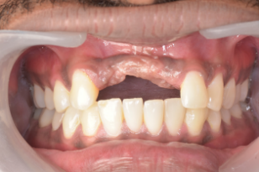
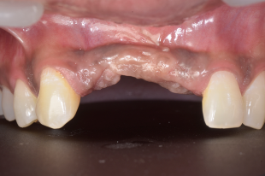
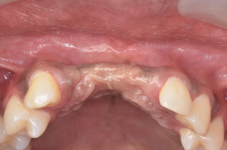
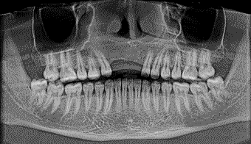

Figure 1. Pre-operative Assessment

Guided implant surgery was performed using a surgical template to ensure accurate three-dimensional implant positioning. Figure 2A shows the implant pilot guide positioned in sites 12 and 21. Figure 2B illustrates sequential drilling and osteotomy site preparation using the surgical guide. Figure 2C shows placement of a NORIS implant (4.2 × 13 mm) in site 12 achieving primary stability greater than 40 Ncm, while Figure 2D shows placement of a NORIS implant (4.2 × 13 mm) in site 21 achieving primary stability greater than 45 Ncm. Figure 2E confirms final implant positioning in both sites following guided implant placement (Figure 2).
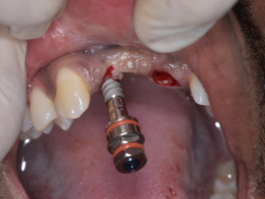
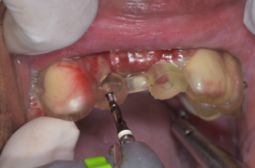
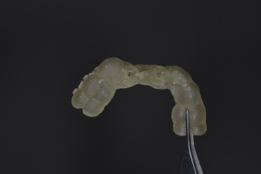
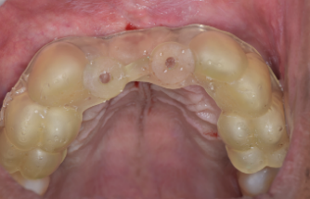
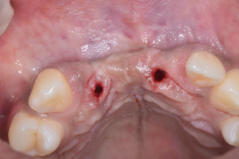
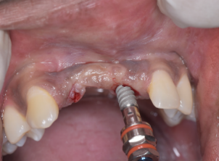
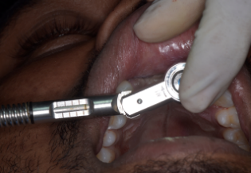
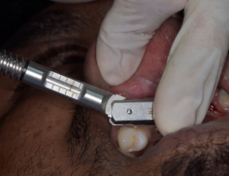
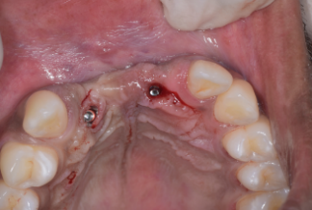
FIG 2A IMPLANT PILOT GUIDE IN 12 AND 21
FIG 2B SEQUENTIAL DRILLING AND OSTEOTOMY SITE PREPARED
FIG 2C NORIS IMPLANT 4.2× 13MM IN 12 PRIMARY STABILITY > 40 NCM

FIG 2D NORIS IMPLANT 4.2× 13MM IN 21 PRIMARY STABILITY > 45 NCM

FIG 2E IMPLANT PLACED IN 12 AND 21

Figure 2. Guided Implant Surgery

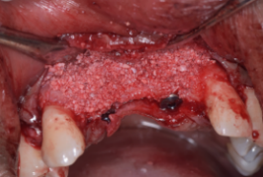
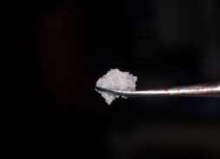
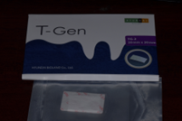
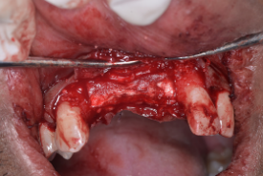
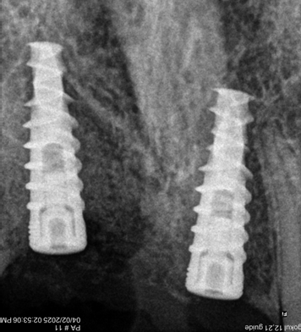
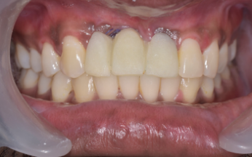
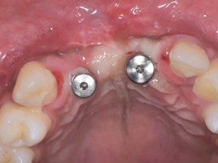
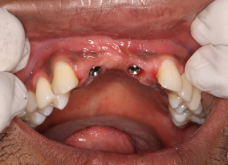
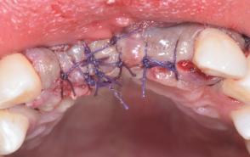
Guided bone regeneration was performed simultaneously after implant placement to augment the horizontal ridge deficiency. Figure 3A shows elevation of a full-thickness mucoperiosteal flap with placement of Bio-Oss® bone graft in the buccal defect area and coverage with a T-Gen resorbable collagen membrane stabilized using palatal sutures. Figure 3B illustrates flap approximation achieved with 4-0 Vicryl sutures. Figure 3C shows the immediate post-operative radiovisiograph, while Figure 3D depicts immediate temporization. Figure 3E shows placement of the healing abutment after 5 months of healing, and Figure 3F demonstrates a well-developed emergence profile following soft tissue maturation (Figure 3).
FIG 3A FULL THICKNESS MUCOPERIOSTEAL FLAP ELEVATED BIO OSS BONE GRAFT PLACED IN DEFECT AREA AND T GEN MEMBRANE PLACED AND STABILISED WITH PALATAL SUTURE

FIG 3B FLAP APPROXIMATED WITH 4.0 VICRYL SUTURE

FIG 3C IMMEDIATE POST OP RVG

FIG 3D IMMEDIATE

TEMPORIZATION

FIG 3E HEALING ABUTMENT PLACED AFTER 5 MONTHS

FIG 3F EMERGENCE PROFILE

Figure 3. Guided Bone Regeneration

After 5 months of healing, the prosthetic phase was initiated following successful osseointegration and soft tissue maturation. Figure 4A shows the open-tray impression coping with jig trial performed for accurate prosthetic impression. Figure 4B depicts placement of the screw-retained porcelain-fused-to-metal crown, and the post-operative radiovisiograph confirms proper prosthetic fit and stable peri-implant bone levels (Figure 4).
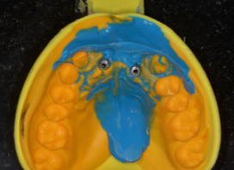
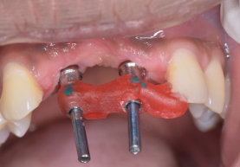
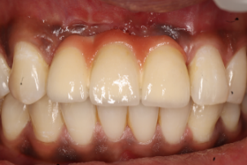
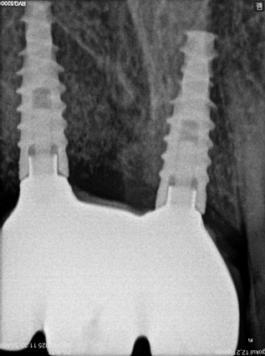

FIG 4B SCREW RETAINED PFM CROWN PLACED AND POST OP RVG

FIG 4A OPEN TRAY COPING IMPRESSION AND JIG TRIAL DONE

Figure 4. Prosthetic Phase – Delayed Loading
A comparison of the pre-operative and post-operative clinical outcomes demonstrated significant improvement in esthetics and function. Figure 5A shows the pre-operative intraoral view of missing maxillary anterior teeth, while Figure 5B demonstrates the post-operative intraoral view highlighting successful restoration following guided implant surgery, guided bone regeneration, and delayed prosthetic rehabilitation (Figure 5).

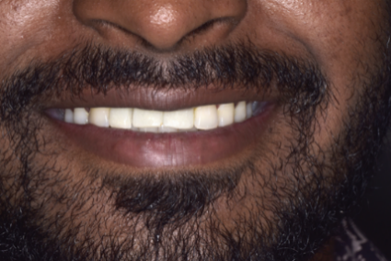
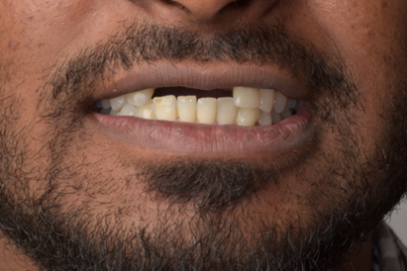

FIG 5B POST OP

FIG 5A PRE OP

Figure 5. Pre- and Post-operative Comparison
Table 1: The clinical outcomes observed in this case
Parameter | Observation
Implant stability | >40–45 Ncm
Bone regeneration | Adequate horizontal augmentation achieved
Healing | Uneventful
Soft tissue outcome | Good emergence profile
Esthetic outcome | Satisfactory
Radiographic findings | Stable peri-implant bone levels

These findings were further analyzed and compared with existing literature.

DISCUSSION
This case demonstrates that the combination of guided implant surgery and GBR can achieve predictable functional and esthetic outcomes in the anterior maxilla region¹,³. GBR restores ridge volume by guiding the osteogenic cells into the defect and preventing the soft tissue interference³,⁴.
Bio-Oss® provides a stable osteoconductive scaffold that maintains the alveolar ridge dimensions and supports long-term bone preservation⁴,⁵. Collagen membranes, such as T-Gen, enhance regenerative outcomes by stabilizing the graft and controlling soft tissue ingress⁵,¹¹. Experimental and clinical studies confirm that this combination promotes bone formation and maintains the alveolar ridge contours in esthetically critical regions⁴,⁵.
Precise implant positioning is critical for both esthetic and functional success²,⁶. Digital planning and guided surgical templates facilitate accurate three-dimensional implant placement, reducing surgical errors and ensuring prosthetic-driven positioning²,⁶.
Delayed loading was employed to improve the implant stability and osseointegration⁷,⁸. Clinical studies show that delayed loading in grafted sites reduces marginal bone loss and enhances soft tissue outcomes⁹,¹⁴. Preoperative evaluation of ridge width and defect morphology allows proper graft adaptation, which is essential for the successful horizontal augmentation⁹,¹⁰.
Long-term follow-up in this case demonstrated stable peri-implant bone levels, healthy soft tissue contours and favorable esthetics³,⁶,¹⁵. The results align with existing literature showing predictable outcomes when GBR is combined with guided implant surgery and delayed loading²,³,⁷.
Overall, this case highlights that careful planning, appropriate material selection and adherence to GBR principles enable predictable anterior maxillary rehabilitation with excellent functional and esthetic results¹,³,⁵. These findings are consistent with recent studies reporting improved implant stability and peri-implant bone preservation using GBR in conjunction with digital implant placement and delayed loading protocols⁶,⁷,⁹. The findings of the present case are in agreement with previous studies demonstrating the effectiveness of guided bone regeneration in improving ridge dimensions and implant stability⁴,⁵,¹⁰. Recent literature also supports the use of digital implant planning and delayed loading protocols for achieving predictable esthetic and functional outcomes in the anterior maxilla⁷,¹³,¹⁴.
CONCLUSION
Guided implant surgery combined with guided bone regeneration using Bio-Oss® and T-Gen collagen membrane represents a predictable and effective approach for anterior maxillary rehabilitation. Delayed loading supports stable osseointegration and favorable peri-implant tissue response. Proper case selection, digital planning and meticulous surgical execution contribute significantly to long-term functional and esthetic success.
LIMITATIONS
This case report represents a single clinical case, and the findings cannot be generalized to a larger population. Long-term follow-up and studies with larger sample sizes are required to validate the outcomes. Future research should focus on comparative studies evaluating different graft materials and loading protocols to further optimize treatment outcomes in the anterior maxilla.
Disclaimer (Artificial intelligence)

Author(s) hereby declare that NO generative AI technologies such as Large Language Models (ChatGPT, COPILOT, etc.) and text-to-image generators have been used during the writing or editing of this manuscript.

REFERENCES
1. Dahlin C, Sennerby L, Lekholm U, Linde A, Nyman S. Generation of new bone around titanium implants using a membrane technique. Int J Oral Maxillofac Implants. 1989;4(1):19–25.
2. Urban IA, Monje A, Lozada JL, Wang HL. Principles for vertical ridge augmentation in the atrophic posterior mandible: A technical review. Int J Periodontics Restorative Dent. 2017;37(5):639–645.
3. Minetti E, Inchingolo AM, Inchingolo AD, Ferrante L, Marinelli G, Palermo A, Dipalma G. Six-year implants follow-up after guided bone regeneration using autologous tooth graft: Innovative biomaterial for bone regeneration Tooth Transformer®. J Funct Biomater. 2025;16(5):172.
4. Kasuya S, Inui S, Kato-Kogoe N, Omori M, Yamamoto K, Inoue K, Ito Y, Nakajima Y, Hirata A, Ueno T. Evaluation of guided bone regeneration using the bone substitute Bio-Oss® and a collagen membrane in a rat cranial bone defect model. J Hard Tissue Biol. 2018;27(1):79–86.
5. Duarte ND, Frigerio PB, Amaya Chica GE, Okamoto R, Buchaim RL, Buchaim DV, Messora MR, Issa JP. Biomaterials for guided tissue regeneration and guided bone regeneration: A review. Dent J (Basel). 2025;13(4):179.
6. Todaro C, Cerri M, Rodriguez y Baena R, Lupi SM. Full-arch guided restoration and bone regeneration: A complete digital workflow case report. Healthcare (Basel). 2023;11(9):1301.
7. Peitsinis PR, Blouchou A, Chatzopoulos GS, Vouros I. Optimizing implant placement timing and loading protocols for successful functional and esthetic outcomes: A narrative literature review.
J Clin Med. 2025;14(5):1442.
8. Chen J, Cai M, Yang J, Aldhohrah T, Wang Y. Immediate versus early or conventional loading dental implants with fixed prostheses: A systematic review and meta-analysis of randomized controlled clinical trials. J Prosthet Dent. 2019;122(6):516–536.
9. Sekar S, Suthanthiran T, Thangavelu A, Karupannan SK, Prem F, Rajendran D. Clinical and radiological evaluation of delayed and early loading of single-tooth implant placement: A 6-month prospective randomized clinical study. J Pharm Bioallied Sci. 2019;11(Suppl 2): S304–S309.
10. Gan LM, Zhou QR, Zhang Y, Yu YC, Yu ZZ, Sun Y, Li RX, Wu XW, Yang F. Alveolar bone morphologic predictors for guided bone regeneration outcome in anterior maxilla. Clin Implant Dent Relat Res. 2019;21(5):929–936.
11. Mutthineni RB. Third generation barrier membranes: Role in periodontal regeneration.
IP Int J Periodontol Implantol. 2024;9(1):45–50.
12. Botros KH, Adel-Khattab D, Eldabe AK, Abuel Ela HA. Early versus conventional loading for fully guided immediate implant placement in molar sites: A randomized controlled clinical study. Int J Implant Dent. 2025; 11:24.
13. Ma F, Wei T, Du Y, Wu B, Sun F. Accuracy of dynamic navigation for immediate and delayed anterior dental implant placement: A retrospective study. BMC Oral Health. 2025; 25:1858.
14. Thoma DS, Gil A, de Bruyckere T, Jung RE, Fukuba S, Ickroth A, Strauss FJ, Cosyn J.
Early implant placement versus ridge preservation and delayed implant placement: Analysis of profilometric, clinician- and patient-reported outcomes from a two-centre RCT.
Clin Oral Implants Res. 2018;29(9):895–906.
15. Esposito M, Grusovin MG, Willings M, Coulthard P, Worthington HV.
Interventions for replacing missing teeth: different times for loading dental implants.
Cochrane Database Syst Rev. 2013;(3):CD003878.

