Case report

A Two-Visit Regenerative Endodontic Approach for a Necrotic Immature Mandibular Molar Using 3D Ultrasonic Activation and Bioceramic Putty: A Case Report

Abstract
Revascularization, as a component of regenerative endodontic procedures (REPs), is increasingly important in immature molars because it offers a biological alternative that aims to stimulate continued root lengthening and wall thickening, restoring the biological functions of the pulp-dentin complex, including immune defense, proprioception, and sensory responses, which are lost in traditional root canal therapy. While conventional root canal treatment (RCT) is the standard, it often results in tooth brittleness and an increased risk of future fractures or reinfection because the pulp is replaced with inorganic material. In molars, this controversy is compounded by anatomical complexities and varied canal configurations that make achieving the imperative sterile environment significantly less predictable than in anterior teeth.
This case report presents a successful two-visit approach, using revascularization for an immature necrotic mandibular left molar. An 8-year-old female was referred with severe pain in her left mandibular molar. The extraoral examination revealed a swelling related to the lower left molar area. Intraorally, a badly decayed lower left molar and an opened pulp chamber. Clinical and radiographic examinations revealed pulp necrosis, symptomatic apical periodontitis, and a large periapical lesion. A two-visit protocol was performed; the root canal was disinfected. At 12-month follow-up, the tooth was asymptomatic, responded to sensibility tests, and exhibited complete root formation.
KEY WORDS: Apical periodontitis, NonVital Pulp, Pulp Regeneration, Pulp Revascularization.

1. Introduction
The management of immature permanent teeth with necrotic pulp remains one of the most formidable challenges in contemporary endodontics, representing a critical intersection between biological necessity and clinical limitations (Adel & Asgari, 2025).
Traditionally, the endodontic specialty has been defined by its ability to eliminate infection and preserve the physical presence of a tooth through root canal therapy or apexification (Wei et al., 2022). However, in the context of a developing tooth, these conventional approaches often lead to a biological "dead end" where the absence of a vital pulp precludes further root maturation, leaving behind a brittle structure with thin dentinal walls and a poor crown-to-root ratio (Lee, 2020). This real-world issue is not merely technical but existential for the tooth; without continued development, the likelihood of a cervical root fracture increases significantly, often leading to premature extraction in young patients (Alothman et al., 2024).
The problem statement centers on the profound shortfall between our clinical ideals and the reality of traditional treatment outcomes. Ideally, endodontic intervention in a necrotic immature tooth should not only eliminate pathology but also re-establish the tooth’s biological functions while stimulating the completion of root morphogenesis (Alothman et al., 2024).
In reality, the "gold standard" of apexification falls drastically short of this situation (Alothman et al., 2024; Lee, 2020). Whether utilizing long-term calcium hydroxide dressings or modern mineral trioxide aggregate (MTA) apical plugs, these techniques are essentially palliative regarding the root’s structural integrity; they create an artificial barrier but do nothing to reinforce the fragile root walls or restore true vitality. Consequently, the tooth is preserved in a "non-vital" state, devoid of the physiological capacity to resist functional stress or future microbial challenges (Lee, 2020).
Previous attempts to resolve this predicament have focused on refining apexification protocols, yet these studies reveal inherent flaws (Adel & Asgari, 2025). The prolonged use of calcium hydroxide has been shown to weaken root dentin, increasing fracture risk. While MTA apical barriers reduced treatment duration, they failed to solve arrested root development (Eugenia Marcela Castro-Gutiérrez et al., 2021). Furthermore, early regenerative endodontic procedures (REPs) highlighted a "disinfection dilemma": high-concentration irrigants needed for biofilm eradication prove cytotoxic to mesenchymal stem cells necessary for regeneration (Adel & Asgari, 2025).
A knowledge gap persists in managing mandibular molars, which present anatomical complexities, varied canal configurations, and difficulty achieving sterile environments. Thus, making regenerative outcomes less predictable than anterior teeth (Tong et al., 2017). While bio-engineering's role in REPs is established, better integration of bioactive calcium silicate materials is needed in treatment protocols. Unlike inert materials, hydraulic calcium silicate cements like MTA, Biodentine, and newer calcium silicate-based mixtures provide superior biocompatibility, stimulate reparative dentinogenesis, and enhance growth factor release from the dentin matrix. This case addresses these gaps through a structured two-visit approach in a mandibular molar that leverages these bioactive properties for hermetic seal and stem cell proliferation (Adel & Asgari, 2025).
This study follows the "tissue engineering triad" model, which states that successful regeneration needs stem cells (mobilized from the apical papilla), a scaffold (the induced blood clot), and signaling molecules (Alothman et al., 2024). In this case, bioactive calcium silicates serve as more than a coronal seal; they act as a catalyst within the triad by releasing calcium ions and inducing odontogenic differentiation markers. Using a two-visit approach, this research shows the need for cell-friendly disinfection to prime the canal for biological scaffold induction, demonstrating how calcium silicate integration can facilitate structural and functional rehabilitation of complex molar types (Adel & Asgari, 2025).

2. Case Presentation
An 8-year-old female patient was referred for severe pain and swelling related to the lower left molar area. She reported severe localized pain associated with tooth #36 and a facial swelling; otherwise, her medical history is clear. Due to the extent of the swelling, indicating a spreading odontogenic infection, operative treatment was initially deferred. In line with the Scottish Dental Clinical Effectiveness Programme, antibiotics were prescribed: metronidazole 500 mg and amoxicillin 500 mg every 8 hours for 5 days with Ibuprofen 200 mg for pain management. The patient was advised to return for follow-up and definitive treatment once the swelling subsided. Clinical examination revealed extensive caries with pulp exposure. Pulp sensibility testing and a cold test with ethyl chloride were negative. Percussion and palpation tests elicited severe pain. Periodontal examination revealed a normal range of pocket depth (1-2 mm) and no tooth mobility.
2.1 Radiographic Findings
A periapical radiograph demonstrated an open apex with a periapical radiolucent lesion. Based on the clinical and radiographic findings, the diagnosis was pulpal necrosis with symptomatic periapical periodontitis. The diagnosis, along with potential treatment options (including revascularization and MTA apexification), was meticulously explained to the patient and her parent, including the associated procedural steps, benefits, risks, and possible complications. Following these consultations, a multi-visit regenerative endodontic procedure (revascularization) followed by a stainless-steel crown was agreed upon, and informed consent was obtained from the patient’s parent.
First visit:
- The molar was anesthetized using 3% mepivacaine (Scandonest Septodont; Cedex, France) without a vasoconstrictor and isolated with a rubber dam. Soft carious tissue was removed with a round bur, and the access cavity was prepared, revealing three canal orifices with no evidence of vital tissue. The canal lengths were initially estimated from a periapical radiograph and subsequently confirmed using a size 45 K-file. Minimal instrumentation was performed with a K-file 1 mm shorter than the working length. A 27-gauge side-vented needle attached to a 5 mL syringe was adjusted to be 2 mm shorter than the working length and employed in a back-and-forth motion during canal irrigation. Copious, gentle irrigation with 20 mL NaOCl (1.25%) was conducted using an irrigation system designed to minimize the risk of irrigant extrusion into the periapical space combined with ultrasonic activation using ultrasonic tip E4D for 30 seconds (Guilin Woodpecker Medical Instrument Co., Ltd., Guilin, China), repeated 3-6 times for a total of 60 to 180 seconds, with fresh irrigant added between cycles. Usually between 25 and 40 kHz. Generally low to medium power (e.g., 5/10 on the device) to avoid dentin damage. Tip Position: 1–2 mm short of the working length (WL), kept "passive" (not binding to the walls) to allow free oscillation. After ensuring the canals were dried using paper points, Ca (OH)₂ was prepared and delivered into the canal system via syringe. Finally, the orifices were covered with a small cotton pellet and sealed with a temporary filling of 3-4 mm. The entire procedure was conducted under a surgical operating dental microscope (Zumax Medical Co., Ltd., Suzhou, China).
Second visit:
After two weeks, the patient presented with an asymptomatic tooth. The molar was anesthetized using 3% mepivacaine (Scadonest Septodont; Cedex, France) without a vasoconstrictor to facilitate bleeding. Then, the molar was isolated using rubber dam. Under a surgical microscope, the temporary filling was removed, and the canals were irrigated with 20 mL NaOCl (1.25%) followed by 20 mL of 17% EDTA. Then, the canals were dried using paper points, and a size 25 H-file with an apical bend was used to lacerate the periapical tissue and initiate bleeding in the canals. After clot formation, the orifices were filled with 3-5 mm of bioactive calcium silicate (Bio-C-Repair), and a periapical radiograph was taken to confirm the proper application of the calcium silicate. At the end, the access cavity was restored with glass ionomer during the same visit, followed by a stainless-steel crown, size 6.
Follow-up visits:
The patient was monitored closely, with follow-up evaluations at 3 months, 6 months, 9 months, and 1 year, including clinical assessment of pain, swelling, and percussion sensitivity, as well as radiographic evaluation of periapical healing and root maturation. At the 1-year follow-up, the patient’s tooth was symptom-free and was not tender to percussion or palpation. The probing depth was also within the normal range. Furthermore, her tooth was responsive to the cold test. Radiographic examination showed complete periapical healing, apical closure, increased root length, and increased dentin thickness.
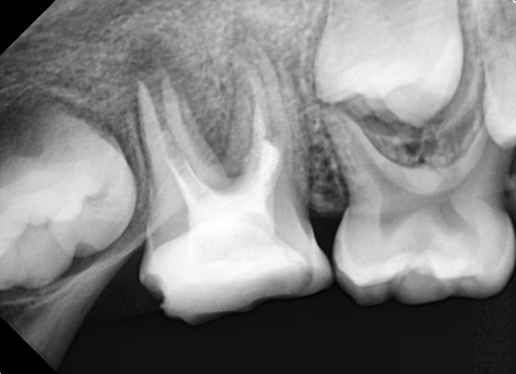
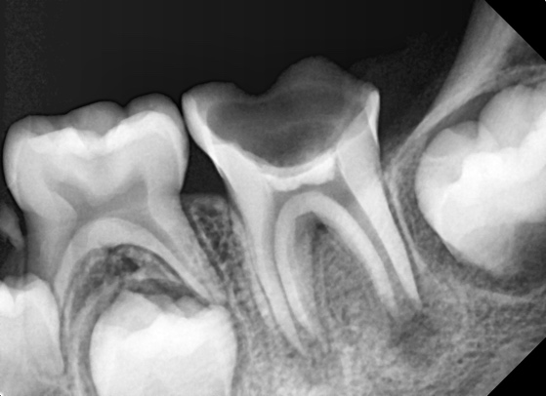
A
B

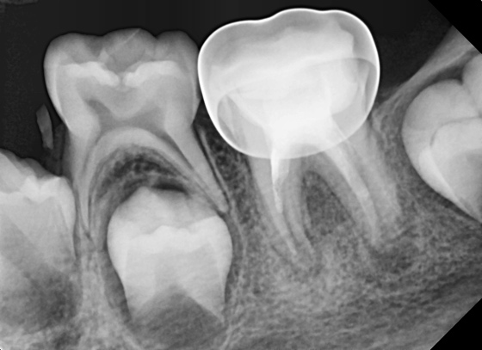
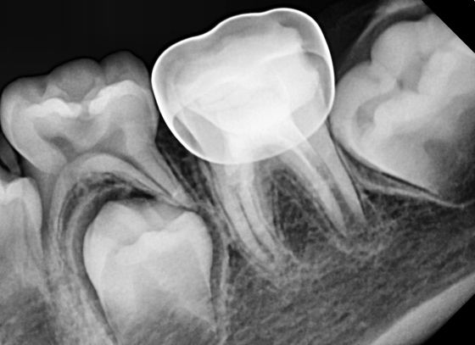
D
C

Fig 1.(A) Preoperative periapical radiograph of tooth #36. The immaturity of the root is well observed with a periapical lesion related to the distal root. (B) After placing MTA on the blood clot and temporary filling. (C) After completion of the regenerative endodontic procedure and permanent coronal restoration and a one-month follow-up. Note the periapical radiolucent lesion. (D) After a one-year follow-up. The healing of the periapical lesion was observed with complete closure of the mesial root.

3. Discussion
Revascularization constitutes a significant paradigm shift in the treatment of immature permanent teeth with necrotic pulp. The procedure takes advantage of the fact that stem cells of the apical papilla (SCAP) typically withstand pulpal necrosis and infection, owing to their proximity to the periapical blood supply. These cells show high proliferative capacity and strong potential to differentiate into odontoblast-like cells, crucial for continued root development (Martin et al., 2014; Pulyodan etal.,2020). In the presented case, pulp revascularization was selected based on the patient’s young age and the immature stage of root development, both of which are known to favor regenerative outcomes, preserving the tooth and encouraging root growth. Younger patients exhibit greater biological resilience with regenerative endodontic procedures, demonstrating the highest efficacy, and optimal outcomes are typically observed between 9 and 13 years due to increased stem cell viability and activity (Zhang et al., 2025). This is attributed to their more robust immune response and the presence of a wider apical foramen, which enhances pulpal blood flow and supports greater healing potential. An apical diameter approaching or exceeding 1 mm provides a permissive pathway for vascular and cellular ingrowth, facilitating the migration of undifferentiated mesenchymal cells and the establishment of a biological scaffold for tissue regeneration (Ariwala & Calcuttawala, 2025).
The patient was an 8-year-old child at the time of treatment and was classified as ASA I according to the American Association of Anesthesiologists physical status classification, indicating a medically healthy condition (“American Society of Anesthesiologists Statement on ASA Physical Status Classification System,” 2025). Radiographic evaluation indicated that the roots were at an immature developmental stage corresponding to Cvek stage 3, with both roots exhibiting a wide apical diameter (Cvek, 1992). The apical diameter was estimated to be approximately 0.70 mm, approaching 1 mm, which is considered favorable for regenerative procedures. In light of these clinical and biological considerations, and after evaluating the potential benefits of available treatment options, regenerative endodontic therapy was proposed and subsequently accepted by the patient’s parent.
The procedure followed a phased approach that separates infection control from the induction of tissue regeneration, in line with the biological principles of tissue engineering. This strategy relies on the coordinated interaction of stem cells, scaffolds, and signaling molecules to promote root development in immature permanent teeth (Babel et al., 2024; Wei et al., 2022). By separating the treatment into different phases, we can transform an infected, pro-inflammatory environment into a sterile, bioactive site conducive to regeneration (Kharchi et al., 2020).
Effective disinfection represents the first critical phase of this approach and is fundamental to both clinical and biological success. While traditional endodontics uses high concentrations of sodium hypochlorite (NaOCl), regenerative protocols favor lower concentrations (1.5%–3%). Martin et al. (2014) demonstrated that 1.5% NaOCl enhanced dentin sialophosphoprotein expression in stem cells, whereas 6% NaOCl substantially reduced the survival and odontogenic differentiation of stem cells from the apical papilla (Adel & Asgari, 2025; Martin et al., 2014). Final irrigation with 17% EDTA is essential, as it helps neutralize the cytotoxic effects of sodium hypochlorite (NaOCl), conditions the dentin surface to enhance cell attachment, and acts as a chelating agent to release endogenous growth factors embedded within the dentin matrix. Conventional needle irrigation, however, may fail to adequately penetrate the complexities of the root canal system, particularly in wide or irregular canals. To optimize disinfection, irrigant activation techniques such as passive ultrasonic irrigation (PUI) or the XP-endo Finisher should be employed. These methods improve the distribution and effectiveness of the irrigant throughout the entire canal space, significantly enhancing antimicrobial and antibiofilm action and aiding in the elimination of resistant microorganisms such as E. faecalis, even when lower concentrations of NaOCl are used (Lee, 2020).
To ensure sustained antimicrobial control while maintaining a biologically favorable environment, calcium hydroxide was selected as the intracanal medication in the presented case (Adel & Asgari, 2025). While TAP significantly decreases the survival of stem cells of the apical papilla (SCAP), Ca (OH)₂ stimulates their proliferation and attachment to dentinal walls (Geisler, 2012). It avoids the coronal discoloration caused by TAP's minocycline, aligning with ESE guidelines to minimize staining and antibiotic resistance. Ca (OH)₂ also promotes the release of endogenous growth factors like TGF-β1, which are linked to higher percentages of apical closure (Geisler, 2012; Manoharan et al., 2025). In addition, it is easier to remove and causes a lesser reduction in dentin microhardness than acidic pastes, preserving the structural integrity of fragile roots (Wei et al., 2022).
Following effective disinfection and intracanal medication, regeneration is governed by the principles of the tissue engineering triad: stem cells, scaffolds, and signaling molecules. Mesenchymal stem cells (MSCs), mobilized into the disinfected canal space, are central to this process (Yang et al., 2016). A biological scaffold is required to support their attachment and proliferation, with the induced blood clot serving as the gold-standard fibrin matrix for tissue ingrowth (Algan & Kocak, 2025; Eugenia Marcela Castro-Gutiérrez et al., 2021; Junaid et al., 2025). Concurrently, growth factors such as TGF-β1 and BMP, which are released from the dentin matrix through EDTA irrigation or stimulated by bioactive calcium silicate materials, regulate stem cell recruitment and differentiation (Lee, 2020; Wei et al., 2022).
In the present case, particular attention was given to stabilization of the induced blood clot to optimize scaffold integrity. Following Turk et al., a 15-minute wait allowed fibrin formation, after which a collagen sponge compacted the scaffold (Turk et al., 2020). This controlled hemostasis prevented calcium silicate displacement and supported scaffold stability. Turk’s work suggested that a stable blood–dentin interface is critical for maintaining the long-term hermetic seal necessary for pulp regeneration (Turk et al., 2015). In this concept, the Bioactive calcium silicate (Bio-C-Repair) functioned as a critical catalyst in the regenerative triad, inducing reparative dentinogenesis, facilitating the continued root lengthening and wall thickening necessary to reinforce the structural integrity of the immature tooth (Adel & Asgari, 2025).
According to Su-Min Lee’s study, failed cases were frequently associated with coronal leakage due to a non-intact coronal seal, such as fractured restorations or early inflammatory root resorption (Lee, 2020). This highlighted the critical role of a robust coronal seal, which is essential to prevent microbial ingress into the root canal, the primary cause of treatment failure. Success requires a coronal plug of calcium silicate-based materials such as MTA, Biodentine, or CEM. These provide biocompatibility, a hermetic seal, and calcium ion release to promote odontogenic differentiation of stem cells (Adel & Asgari, 2025; Alothman et al., 2024).
Treatment outcomes are evaluated according to hierarchical criteria established by the American Association of Endodontists (AAE). The Primary Goal (Essential) focuses on the complete elimination of clinical signs and symptoms, such as pain and soft tissue swelling, alongside radiographic evidence of periapical healing. The secondary goal (Desirable) involves continued root maturation, specifically an increase in wall thickness or length, typically observed 12 to 24 months post-treatment. The tertiary goal is neurogenesis, indicated by a positive response to pulp vitality testing (Geisler, 2012).
Although emerging evidence supports single-visit protocols, multiple-visit regenerative procedures continue to demonstrate higher odds of clinical success (Babel et al., 2024). By separating infection control from tissue induction, the phased approach allows the scaffold to remain uncontaminated, facilitating long-term root maturation, wall thickening, and apical closure (Almutairi et al., 2019; Alothman et al., 2024). This rationale is supported by the presented case, in which revascularization did produce favorable clinical and radiographic outcomes. Follow-up evaluation demonstrated increased root length and dentinal wall thickness, with complete apical closure observed relative to the initial presentation and the contralateral tooth.
Conclusion
In conclusion, the presented case is demonstrating that revascularization can effectively promote continued root development, apical closure, and increased dentinal wall thickness in immature necrotic teeth. These outcomes reflected the combined effects of thorough disinfection, calcium hydroxide intracanal medication, stabilization of the blood clot, and a hermetic coronal seal, which collectively created a biologically favorable environment for stem cell-mediated tissue regeneration. By adopting a phased, two-visit approach, this protocol also balanced microbial control with host-mediated tissue repair, supporting predictable tissue healing and functional restoration in immature teeth.
Consent
As per international standards, parental written consent has been collected and preserved by the author(s).

Ethical Approval:

As per international standards or university standards written ethical approval has been collected and preserved by the author(s).
Disclaimer (Artificial intelligence)
Author(s) hereby declare that NO generative AI technologies such as Large Language Models (ChatGPT, COPILOT, etc.) and text-to-image generators have been used during the writing or editing of this manuscript.

References:
Adel, M., & Asgari, Z. (2025). Regenerative Endodontic Treatment in an Immature Permanent Tooth With Necrotic Pulp and Periradicular Lesion. Clinical Case Reports, 13(10). https://doi.org/10.1002/ccr3.70941
Algan, B. B., & Kocak, M. M. (2025). Regenerative endodontic treatment in permanent immature teeth: Case series. Turkish Endodontic Journal, 10(3), 241–246. https://doi.org/10.14744/TEJ.2025.97659
Almutairi, W., Yassen, G. H., Aminoshariae, A., Williams, K. A., & Mickel, A. (2019). Regenerative Endodontics: A Systematic Analysis of the Failed Cases. Journal of Endodontics, 45(5), 567–577. https://doi.org/10.1016/j.joen.2019.02.004
Alothman, F. A., Hakami, L. S., Alnasser, A., AlGhamdi, F. M., Alamri, A. A., & Almutairii, B. M. (2024). Recent Advances in Regenerative Endodontics: A Review of Current Techniques and Future Directions. Cureus. https://doi.org/10.7759/cureus.74121
American Society of Anesthesiologists Statement on ASA Physical Status Classification System. (2025). Anesthesiology Open, 1(1), e0002. https://doi.org/10.1097/ao9.0000000000000002
Ariwala, Dr. F., & Calcuttawala, Dr. M. (2025). Rooted in Regeneration: An Overview on Regenerative Endodontics. Medical Research Archives, 13(10). https://doi.org/10.18103/mra.v13i10.6981
Babel, S., Akinsanya, O., Babel, D., & Vinay, V. (2024). Comprehensive Review on Effectiveness of Single and Multiple Visit Regenerative Endodontics and Comparative Evaluation of Patient Reported Outcomes in Single Visit and Multiple Visit Regenerative Endodontics in Permanent Teeth: A Systematic Review and Me…. International Journal of Innovative Science and Research Technology (IJISRT), 3336–3346. https://doi.org/10.38124/ijisrt/ijisrt24jul1658
Cvek, M. (1992). Prognosis of luxated non-vital maxillary incisors treated with calcium hydroxide and filled with gutta-percha. A retrospective clinical study. Endodontics & Dental Traumatology, 8(2), 45–55. https://doi.org/10.1111/j.1600-9657.1992.tb00228.x
Eugenia Marcela Castro-Gutiérrez, M., Argueta-Figueroa, L., Fuentes-Mascorro, G., Moreno-Rodríguez, A., Torres-Rosas, R., & Benito Juárez, A. (2021). Novel Approaches for the Treatment of Necrotic Immature Teeth Using Regenerative Endodontic Procedures: A Systematic Review and Meta-Analysis. https://doi.org/10.3390/11115199
Geisler, T. M. (2012). Clinical Considerations for Regenerative Endodontic Procedures. Dental Clinics of North America, 56(3), 603–626. https://doi.org/10.1016/j.cden.2012.05.010
Junaid, M., Alyami, S., Alkayraan, F. S., Aljari, A. A., Alaajam, N. A., Alzamanan, M. M., Alshehri, A. A., & Al-Hutaylah, M. H. M. (2025). Advancements in Regenerative Endodontics: A Systematic Literature Review of Stem Cell-Based Therapies, In Vitro and In Vivo Evidence, Clinical Relevance, and Future Prospects. Journal of Pioneering Medical Sciences, 14(Special Issue 1), 218–224. https://doi.org/10.47310/jpms202514s0128
Kharchi, A. S., Tagiyeva-Milne, N., & Kanagasingam, S. (2020). Regenerative Endodontic Procedures, Disinfectants and Outcomes: A Systematic Review. Primary Dental Journal, 9(4), 65–84. https://doi.org/10.1177/2050168420963302
Lee, S. M. (2020). How Do Regenerative Endodontic Procedures Work for Immature Necrotic Teeth? Online Journal of Dentistry & Oral Health, 2(5). https://doi.org/10.33552/ojdoh.2020.02.000549
Manoharan, I., Goutham, P. A. J., Kalaivani, M., Madhavan, H., Balaji, D., K, S., & Shanmugam, S. (2025). Comparative Evaluation of the Effects of Calcium Hydroxide Intracanal Medicament and Antibiotic Paste on Dentin Microhardness: A Systematic Review. Cureus, 17(2), e78886. https://doi.org/10.7759/cureus.78886
Martin, D. E., De Almeida, J. F. A., Henry, M. A., Khaing, Z. Z., Schmidt, C. E., Teixeira, F. B., & Diogenes, A. (2014). Concentration-dependent Effect of Sodium Hypochlorite on Stem Cells of Apical Papilla Survival and Differentiation. Journal of Endodontics, 40(1), 51–55. https://doi.org/10.1016/j.joen.2013.07.026
Pulyodan, M. K., Mohan, S. P., Valsan, D., Divakar, N., Moyin, S., & Thayyil, S. (2020). Regenerative Endodontics: A Paradigm Shift in Clinical Endodontics. Journal of Pharmacy & Bioallied Sciences, 12(Suppl 1), S20. https://doi.org/10.4103/jpbs.JPBS_112_20
Tong, H. J., Rajan, S., Bhujel, N., Kang, J., Duggal, M., & Nazzal, H. (2017). Regenerative Endodontic Therapy in the Management of Nonvital Immature Permanent Teeth: A Systematic Review—Outcome Evaluation and Meta-analysis. In Journal of Endodontics (Vol. 43, Number 9, pp. 1453–1464). Elsevier Inc. https://doi.org/10.1016/j.joen.2017.04.018
Turk, T., Cicconetti, A., Di Nardo, D., Gabriele, M., Coppola, S., Bhandi, S., Seracchiani, M., Testarelli, L., & Gambarini, G. (2020). Nonsurgical Retreatment Using Regenerative Endodontic Protocols: A Case Report. Journal of Contemporary Dental Practice, 21(11), 1275–1278. https://doi.org/10.5005/jp-journals-10024-2909
Turk, T., Ozisik, B., & Aydin, B. (2015). Time-dependent effectiveness of the intracanal medicaments used for pulp revascularization on the dislocation resistance of MTA. BMC Oral Health, 15(1). https://doi.org/10.1186/s12903-015-0117-4
Wei, X., Yang, M., Yue, L., Huang, D., Zhou, X., Wang, X., Zhang, Q., Qiu, L., Huang, Z., Wang, H., Meng, L., Li, H., Chen, W., Zou, X., & Ling, J. (2022). Expert consensus on regenerative endodontic procedures. In International Journal of Oral Science (Vol. 14, Number 1). Springer Nature. https://doi.org/10.1038/s41368-022-00206-z
Yang, J., Yuan, G., & Chen, Z. (2016). Pulp regeneration: Current approaches and future challenges. In Frontiers in Physiology (Vol. 7, Number MAR). Frontiers Media S.A. https://doi.org/10.3389/fphys.2016.00058
Zhang, Q., Zhang, F., & Sun, M. (2025). Comparative success rates of regenerative endodontic procedures versus traditional root canal therapy: a meta-analysis of long-term clinical outcomes. British Dental Journal. https://doi.org/10.1038/s41415-025-8816-y

