Spatial Variability and GIS-Based Mapping of Soil Physico-Chemical Properties under Different Land Use Systems in Pilibhit District, Uttar Pradesh, India
Abstract
Spatial variability of soil properties is a common phenomenon in alluvial landscapes due to variations in parent material, topography, land use, drainage conditions, and anthropogenic interventions. Land Use and Land Cover (LULC) analysis provides valuable information regarding the utilization of natural resources and their impact on soil properties and environmental sustainability. The present investigation was carried out to evaluate the spatial variability and GIS-based distribution of soil physico-chemical properties under different land use systems of Pilibhit District. A total of 200 geo-referenced surface soil samples (0–15 cm depth) were collected from seven development blocks, namely Amaria, Barkhera, Bilsanda, Bisalpur, Lalaurikheda, Marauri, and Puranpur. Land use and land cover (LULC) analysis was performed using ArcGIS 10.3 and remote sensing techniques. GIS-based spatial interpolation of soil properties was carried out using the Inverse Distance Weighting (IDW) method to generate thematic distribution maps. The study area was dominated by agricultural land (71.75%), followed by forest area (18.58%). Soil samples were analyzed for texture, bulk density, porosity, pH, electrical conductivity, organic carbon, cation exchange capacity, and available macro- and micronutrients. The soils varied from sandy loam to clay loam in texture, with loam soils being dominant. Soil pH ranged from 6.2 to 7.4, indicating slightly acidic to neutral reaction, while electrical conductivity remained within non-saline limits (<1 dS m⁻¹). Organic carbon content ranged from 0.20 to 1.26%, indicating moderate to high variability. Available nitrogen and zinc were identified as the major limiting nutrients, whereas phosphorus and potassium showed medium fertility status. Secondary nutrients and most micronutrients were generally adequate. GIS-based spatial distribution maps clearly demonstrated considerable heterogeneity in soil properties across different blocks due to variations in parent material, land use, management practices, and depositional environments. The findings highlight the importance of site-specific nutrient management, balanced fertilization, and zinc supplementation for improving soil fertility, sustaining crop productivity, and supporting precision agriculture-based land use planning in Pilibhit district.
Keywords: Soil fertility, GIS mapping, spatial variability, land use system, physico-chemical properties, nutrient index, Pilibhit district, soil health.
1. Introduction
Soil is one of the most important natural resources governing agricultural sustainability, ecosystem functioning, and environmental quality. The physico-chemical properties of soil directly influence nutrient availability, microbial activity, water retention, aeration, and crop productivity (Brady and Weil, 2017). Evaluation of soil properties is therefore essential for understanding soil fertility status and for developing sustainable land management strategies under intensive agricultural systems.
Spatial variability of soil properties is a common phenomenon in alluvial landscapes due to variations in parent material, topography, land use, drainage conditions, and anthropogenic interventions (Wilding and Drees, 1983). In the Indo-Gangetic Plains of India, continuous cultivation, imbalanced fertilizer application, and changing land use patterns have significantly influenced soil quality and nutrient dynamics (Tiwari et al., 2016; Verma et al., 2023). Assessment of soil variability at regional scale has therefore become increasingly important for site-specific nutrient management and precision agriculture.
Soil physico-chemical properties, including soil reaction (pH), electrical conductivity (EC), organic carbon, bulk density, cation exchange capacity and nutrient availability, play a decisive role in governing soil fertility, structural stability and crop performance. Among these properties, soil salinity—commonly expressed through EC - has emerged as a major global constraint, particularly in irrigated and intensively managed agricultural systems. Excess soluble salts adversely affect soil structure by inducing clay dispersion, reducing infiltration and root penetration, and imposing osmotic stress on plants, ultimately resulting in reduced crop yields (Rhoades, 1982; Maas & Hoffman, 1977).
Land Use and Land Cover (LULC) analysis provides valuable information regarding the utilization of natural resources and their impact on soil properties and environmental sustainability (Lillesand et al., 2015). Different land use systems strongly influence soil organic matter, nutrient cycling, bulk density, and biological activity (Lal and Stewart, 2018). Agricultural expansion and increasing anthropogenic pressure often lead to soil degradation, nutrient depletion, and decline in soil health if proper conservation measures are not adopted.
Remote sensing and Geographic Information System (GIS) techniques have emerged as efficient tools for spatial assessment and digital mapping of soil resources (Burrough and McDonnell, 1998). GIS-based thematic mapping helps in understanding the spatial distribution of soil fertility parameters and identifying nutrient-deficient zones for sustainable crop management (Mishra et al., 2025). Integration of geo-referenced soil sampling with GIS techniques provides accurate information regarding soil variability and supports precision farming approaches.
Pilibhit district of Uttar Pradesh lies in the Terai region of the Indo-Gangetic alluvial plains and is characterized by fertile soils, intensive agricultural activities, and substantial forest cover. The district supports diversified cropping systems; however, continuous cultivation and intensive input use may alter soil physico-chemical properties and nutrient balance over time. Despite the agricultural importance of the region, comprehensive GIS-based information regarding spatial variability of soil properties under different land use systems remains limited.
Therefore, the present investigation entitled “Spatial Variability and GIS-Based Mapping of Soil Physico-Chemical Properties under Different Land Use Systems in Pilibhit District, Uttar Pradesh” was undertaken to evaluate land use patterns, assess soil physico-chemical characteristics, analyze nutrient variability, and generate GIS-based spatial distribution maps for sustainable soil fertility management and agricultural planning.
2. Materials and Methods
2.1 Study Area and Methodology
2.1.1 Study Area
The present investigation was conducted in Pilibhit District, situated in the Terai region of western Uttar Pradesh between 28°06′–28°53′ N latitude and 79°57′–80°27′ E longitude. The district is characterized by fertile alluvial soils, subtropical monsoonal climate, and intensive agricultural activities. The region experiences three distinct seasons, namely winter, summer, and monsoon, with average annual rainfall ranging from 1250–1400 mm.
2.1.2 Database and GIS Analysis
Geo-referenced soil sampling locations were recorded using GPS-enabled mobile applications during field investigations. Topographic sheets (1:50,000 scale) were used for preparation of the base map and spatial referencing. Ancillary datasets related to land use, climatic conditions, and cropping systems were also compiled. Spatial database generation, digitization, thematic mapping, and geospatial analysis were performed using ArcGIS 10.3.
2.1.3 Soil Sampling and Processing
A total of 200 surface soil samples (0–15 cm depth) were collected from different development blocks of Pilibhit district during 2024–25 following standard soil sampling procedures. The geographical coordinates of each sampling site were recorded using GPS devices. Collected samples were air-dried, ground, sieved through a 2 mm sieve, and stored in labeled polyethylene bags for laboratory analysis.
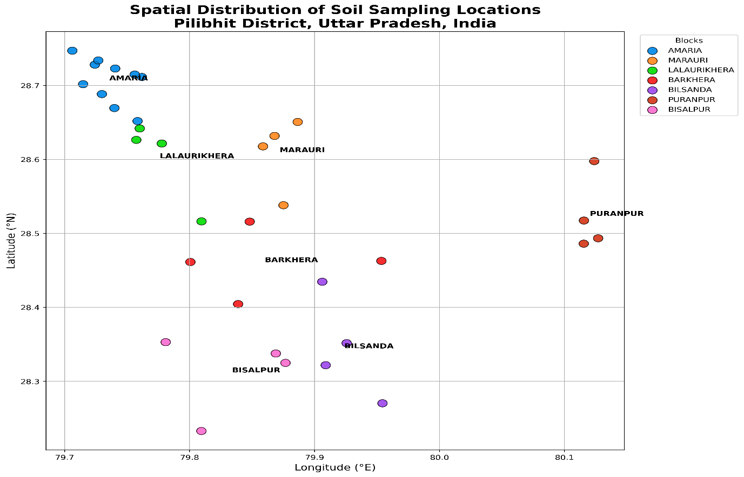
Fig. 1.

2.2 Laboratory Analysis of Soil Samples
2.2.1 Soil Texture
Soil texture was determined by the hydrometer method (Bouyoucos, 1962). The percentages of sand, silt, and clay were calculated using the following expressions:
$$\text{Sand (\%)}=\frac{\text{Weight of sand}}{\text{Weight of soil sample}}×100$$
$$\text{Silt (\%)}=\frac{\text{Weight of silt}}{\text{Weight of soil sample}}×100$$
$$\text{Clay (\%)}=\frac{\text{Weight of clay}}{\text{Weight of soil sample}}×100$$
Textural classes were identified using the USDA textural triangle.
2.2.2 Bulk Density
Bulk density was determined using the core method (Black, 1965).

Bulk Density(ρb​) = ​Ms​​
Vt
Where:
- $ρ_{b}$= Bulk density
- $M_{s}$= Mass of oven-dry soil
- $V_{t}$= Total volume of soil core
​
2.2.3 Soil Porosity
Soil porosity was calculated according to Danielson (1986):
$$\text{Porosity (\%)}=\left(1 − \frac{\text{Bulk Density}}{\text{Particle Density}}\right)×100$$
2.2.4 Soil pH and Electrical Conductivity
Soil pH and electrical conductivity (EC) were determined in 1:2.5 soil-water suspension following Jackson (1973).
2.2.5 Soil Organic Carbon
Organic carbon content was estimated by the Walkley and Black wet oxidation method (Jackson, 1973).
$$\text{Organic Carbon (\%)}=\frac{(B-S)×0.003×10×100}{B×W}$$
where B = blank titration value, S = sample titration value, and W = weight of soil sample.
2.2.6 Calcium Carbonate
Calcium carbonate was determined by rapid titration method (Singh et al., 2007).
$$\%CaCO_{3}=\frac{(B-S)×N×0.05×100}{W}$$
2.2.7 Cation Exchange Capacity (CEC)
CEC was determined using 1N ammonium acetate extraction method (Jackson, 1973).
$$CEC [cmol(p^{+}) kg^{-1}]=\frac{C×D.F.×V×100}{W×1000}$$
2.3 Determination of Available Nutrients
2.3.1 Available Nitrogen
Available nitrogen was estimated using the alkaline potassium permanganate method (Subbiah and Asija, 1956).
$${\text{Available N (kg ha}}^{-1}\text{)}=\frac{(S-B)×N×0.014×2.24×{10}^{6}}{\text{Weight of soil sample}}$$
2.3.2 Available Phosphorus
Available phosphorus was determined by Olsen’s method (Olsen et al., 1954).
$${\text{Available P (kg ha}}^{-1}\text{)}=R×\text{Dilution Factor}×2.24$$
2.3.3 Available Potassium
Available potassium was estimated using neutral ammonium acetate extraction method (Hanway and Heidel, 1952).
$${\text{Available K (kg ha}}^{-1}\text{)}=\text{ppm K}×\text{Dilution Factor}$$
2.3.4 Available Sulphur
Available sulphur was determined using calcium chloride extraction method (Chesnin and Yien, 1950).
2.3.5 Exchangeable Calcium and Magnesium
Exchangeable Ca and Mg were estimated through EDTA titration method following Sparks (1996).
2.4 Micronutrient Analysis
2.4.1 DTPA Extractable Micronutrients
Available Zn, Fe, Mn, and Cu were extracted using DTPA solution following Lindsay and Norvell (1978) and quantified using Atomic Absorption Spectrophotometer (AAS).
$$\text{Micronutrient concentration (ppm)}=\text{AAS reading}×\text{Dilution Factor}$$
2.4.2 Available Boron
Available boron was determined by Azomethine-H method (Bingham, 1982).
2.5 Nutrient Index and Statistical Analysis
The nutrient index (NI) was computed according to Ghosh and Hasan (1980):
$$NI=\frac{\left(N_{L}×1)+(N_{M}×2)+(N_{H}×3\right)}{N_{T}}$$
3. Results and Discussion
3.1 Land Use and Land Cover Pattern
The LULC analysis revealed that agriculture was the dominant land use category occupying 269893 ha (71.75%) of the total geographical area. Forest area covered 69884.7 ha (18.58%), indicating ecological significance of the district. Habitation and river areas occupied 3.54% and 3.51%, respectively. The dominance of agricultural land clearly indicates intensive cultivation and dependence of the regional economy on agriculture. The substantial forest cover contributes toward biodiversity conservation and soil protection.
Table 1. Land Use and Land Cover Pattern of Pilibhit District
LULC Category | Area (ha) | Percentage
Agriculture | 269893 | 71.75
Forest | 69884.7 | 18.58
Habitation | 13304.7 | 3.54
River | 13214 | 3.51
Miscellaneous | 4271.76 | 1.14
Dam | 3223.59 | 0.86
Water bodies | 1085 | 0.29
Canal | 950.28 | 0.25
Brick kiln | 261.54 | 0.07
Nala | 92.39 | 0.02
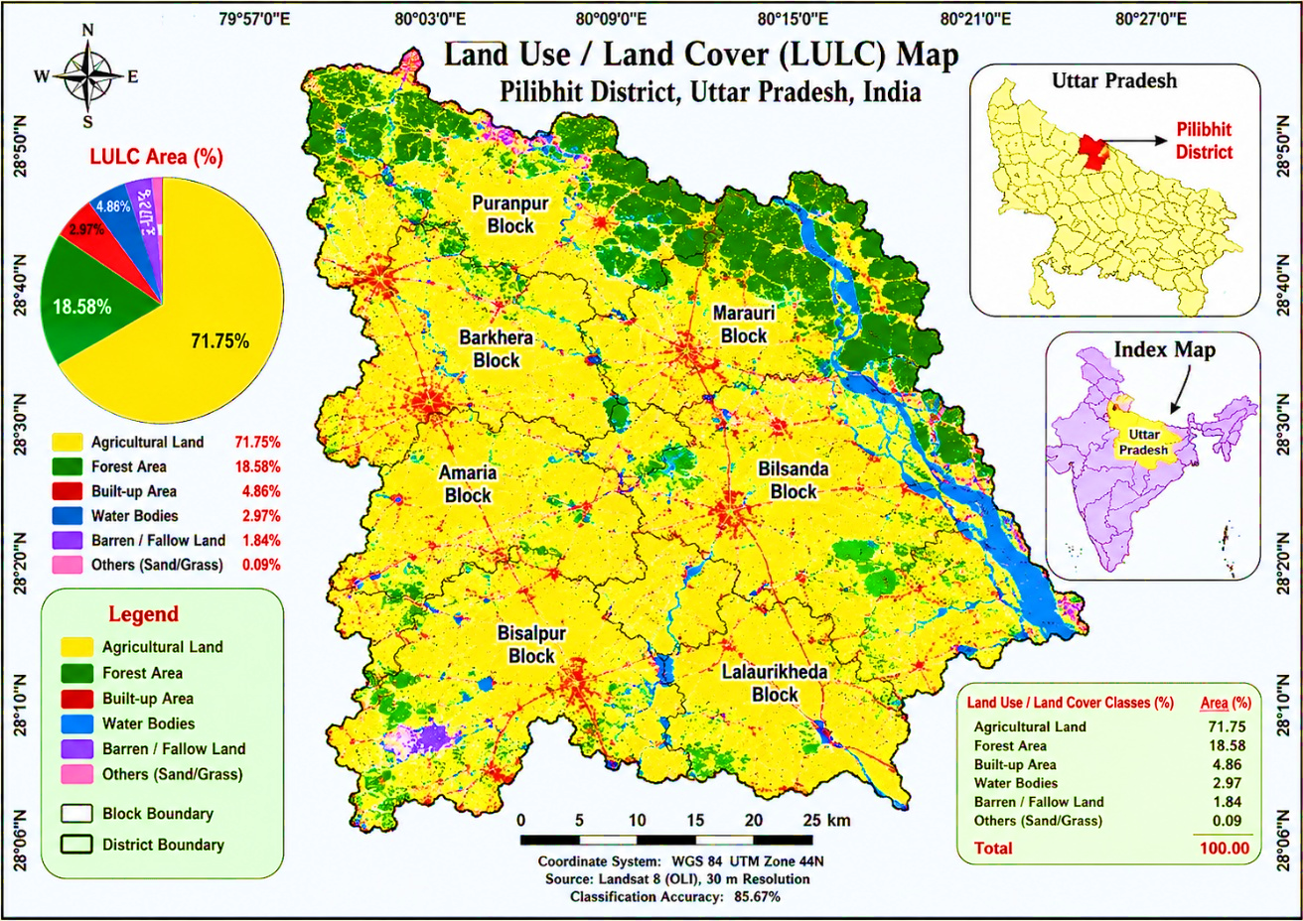
Fig. 2.
3.2 Physical Properties of Soils of Pilibhit District
Soil physical properties such as texture, colour, bulk density, and porosity govern water retention, aeration, root penetration, and overall productivity. In the present study, these properties were evaluated across seven blocks of Pilibhit district to understand their spatial variability, with results interpreted using descriptive statistics.
3.2.1 Soil Texture
Analysis of 200 soil samples revealed that loam was the dominant textural class (41%), followed by sandy loam (31%), clay loam (19%), sandy clay loam (5.5%), and silty loam (3.5%). Block-wise distribution showed that clay loam dominated Amaria, while loam and sandy loam predominated in Barkhera and Bilsanda. Bisalpur was characterized by loam with moderate sandy loam and silty loam, whereas Lalaurikheda exhibited higher sandy loam content. Marauri showed loam dominance with appreciable sandy loam and clay loam, and Puranpur consisted mainly of loam and clay loam. The predominance of loam and sandy loam across most blocks indicates favorable physical conditions for agricultural production. The variation in texture among blocks reflects differences in alluvial deposition, drainage, topography, and parent material—a pattern consistent with observations from the Indo-Gangetic Plains, where fluvial sorting and depositional energy create pronounced textural heterogeneity (Mishra et al., 2025; Kanhaiya et al., 2017). Higher clay loam occurrence in certain blocks suggests greater accumulation of finer particles and enhanced water-holding capacity.
Sand (%) ranged from 25.2% (Mirapur Ratanpur, Bilsanda) to 64.6% (Dhundani, Amaria), with a district mean of 44.99% (CV = 24.53%). Higher mean sand content in Bilsanda (47.93%) and Barkhera (47.27%) indicates coarser-textured soils formed under high-energy depositional environments, while lower sand in Puranpur (39.39%) reflects finer texture under low-energy conditions—a trend paralleling findings from similar alluvial landscapes (Reza et al., 2023; Srivastava et al., 2016).
Silt (%) ranged from 16.1% (Rambojha, Barkhera) to 59.70% (Mirapur Ratanpur, Bilsanda), with a mean of 34.97% (CV = 21.42%). Higher mean silt in Bisalpur (36.71%) suggests finer texture, whereas lower proportions in Bilsanda and Barkhera indicate coarser fractions. This distribution reflects sediment sorting and fluvial energy conditions typical of the Terai alluvial plain, consistent with earlier reports from the Indo-Gangetic Plains where floodplain stratification plays a dominant role (Sinha & Sarkar, 2009; Tandon et al., 2008).
Clay (%) ranged from 8.5% (Aimi, Lalaurikheda) to 38.7% (Gulaw Dande, Puranpur), with a mean of 20.05% (CV = 37.64%). Higher mean clay in Amaria (21.76%) and Marauri (19.11%) indicates finer-textured soils formed under low-energy deposition, while lower clay in Bilsanda (17.79%) and Barkhera (18.25%) suggests coarser alluvial deposits. The high spatial variability observed aligns with studies from the Indo-Gangetic Plains, where fluvial sorting and geomorphic position govern clay distribution (Gautam et al., 2024; Kumar et al., 2021).
3.2.2 Soil Colour
Munsell colour analysis of 200 surface samples (0–15 cm) revealed nine distinct groups. The Dark Yellowish-Brown group (10YR 4/4, 10YR 3/4, 10YR 4/6) was most prevalent (68 samples, 34.0%), closely followed by the Brown group (10YR 4/3, 10YR 5/3) in 63 samples (31.5%). Together, these comprised 65.5% of samples. Other groups included Dark Brown (9.0%), Yellowish Brown (10.50%), Dark Grayish Brown (7.5%), Very Dark Grayish Brown (3.5%), and minor occurrences of Grayish Brown and Very Dark Gray (2.0% each).
The predominance of Dark Yellowish Brown and Brown hues indicates moderately well-drained conditions with balanced organic matter and oxidized iron compounds. Brownish hues (10YR) suggest hydrated ferric oxides and moderate organic matter under well-aerated environments, while darker hues (Dark Grayish Brown, Very Dark Gray) signify higher organic matter accumulation and comparatively poor drainage. These spatial variations reflect heterogeneity in topography, moisture regime, and sediment deposition—a pattern consistent with alluvial soils of the Indo-Gangetic Plains, where Brown to Dark Yellowish-Brown hues commonly dominate due to redox processes and organic matter interactions (Gautam et al., 2023; Singh et al., 2021; Ghode, 2021).
3.2.3 Bulk Density
Bulk density ranged from 1.01 g/cm³ (Laukha, Marauri) to 1.39 g/cm³ (Mohanpur Jabti, Puranpur), with a district mean of 1.20 g/cm³ (CV = 6.10%). Higher mean bulk density in Puranpur (1.26 g/cm³) and Bilsanda (1.24 g/cm³) is attributed to finer texture, higher clay, and compaction from intensive cultivation. Lower values in Amaria (1.16 g/cm³) and Marauri (1.15 g/cm³) suggest better aggregation and higher organic matter, contributing to improved porosity and aeration. Comparable bulk density ranges in alluvial and floodplain soils have been reported by earlier researchers, confirming that medium to moderately high compaction is typical of such environments (Kingsley et al., 2020; Hayatu et al., 2018).
3.2.4 Porosity
Porosity ranged from 47.55% (Mohanpur Jabti, Puranpur) to 61.89% (Laukha, Marauri), with a mean of 54.65% (CV = 5.07%). Higher porosity in Marauri (56.80%) and Amaria (56.28%) reflects higher organic matter, better aggregation, and lower bulk density, while lower porosity in Puranpur (52.52%) and Bilsanda (53.09%) indicates compaction effects associated with fine texture and intensive cultivation. These findings align with porosity ranges reported from alluvial soils of different regions, where soil texture, structure, and organic matter jointly influence aeration and water movement (Sharu et al., 2025; Prajapat et al., 2023; Meera Devi et al., 2023).

Table 2. Distribution of Soil Physical Properties in Pilibhit District
Parameter | Distribution / Range | Mean | CV (%) | Interpretation
Textural classes | Loam (41.0%), Sandy loam (31.0%), Clay loam (19.0%), Sandy clay loam (5.5%), Silty loam (3.5%) | — | — | Dominance of loam and sandy loam indicated favourable physical conditions for agricultural production across the district.
Sand (%) | 25.2–64.6 | 44.99 | 24.53 | Higher sand content in Bilsanda and Barkhera reflected coarser-textured alluvial deposits formed under high-energy depositional environments.
Silt (%) | 16.1–59.70 | 34.97 | 21.42 | Higher silt content in Bisalpur suggested finer floodplain deposits and sediment sorting processes.
Clay (%) | 8.5–38.7 | 20.05 | 37.64 | Higher clay content in Amaria and Puranpur indicated finer-textured soils with greater water-holding capacity.
Soil colour groups | Dark Yellowish Brown (34.0%), Brown (31.5%), Dark Brown (9.0%), Yellowish Brown (10. .50 %), Dark Grayish Brown (7.5%), Very Dark Grayish Brown (3.5%), Grayish Brown (2.0%), Very Dark Gray (2.0%) | — | — | Predominance of Dark Yellowish Brown and Brown hues indicated moderately well-drained soils with balanced organic matter and oxidized iron compounds.
Bulk density (g cm⁻³) | 1.01–1.39 | 1.20 | 6.10 | Higher bulk density in Puranpur and Bilsanda reflected finer texture and compaction due to intensive cultivation, whereas lower values in Amaria and Marauri suggested better aggregation and aeration.
Porosity (%) | 47.55–61.89 | 54.65 | 5.07 | Higher porosity in Marauri and Amaria reflected improved aggregation and organic matter status, while lower porosity in Puranpur and Bilsanda indicated compaction effects in finer-textured soils.

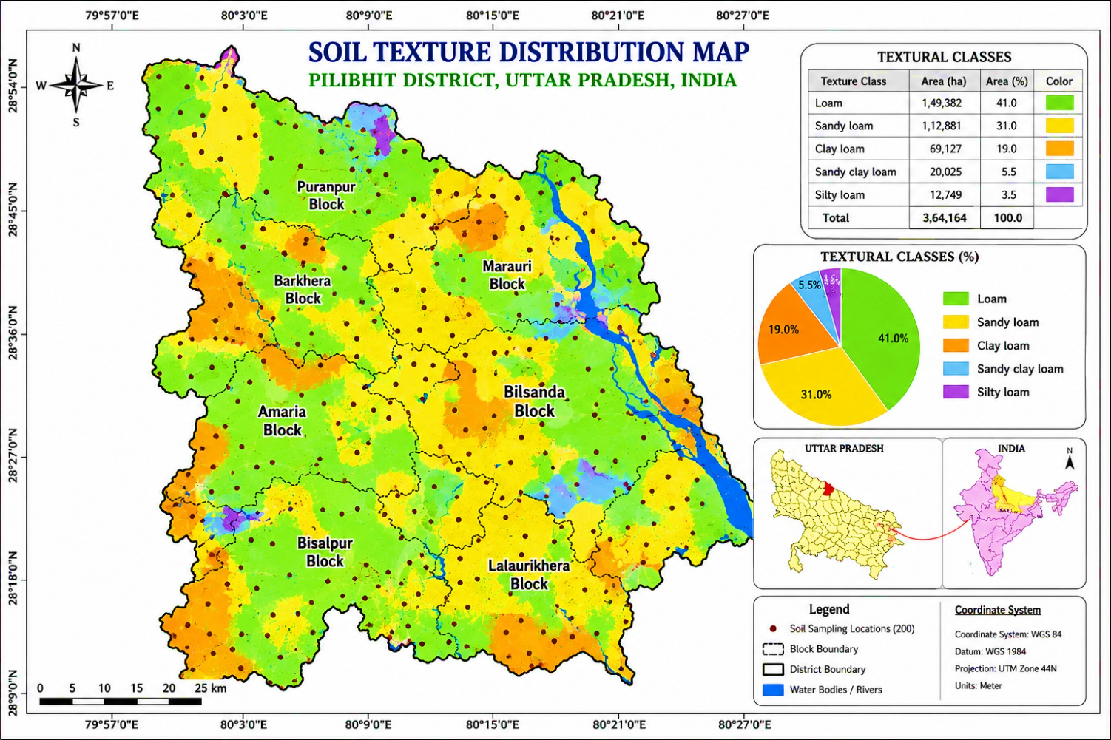
Fig. 3. Soil texture distribution in Pilibhit District

3.3 Chemical Properties of Soils of Pilibhit District
3.3.1 Soil pH
Soil pH ranged from 6.2 to 7.4, with a mean of 6.87 (CV = 3.77%). Neutral soils dominated (95.5%), with only 4.5% slightly acidic. Puranpur (7.07) and Bisalpur (7.03) showed slightly higher mean pH, indicating mild alkalinity due to basic cation accumulation and limited leaching. Amaria (6.69), Marauri (6.72), Lalaurikheda (6.66), and Bilsanda (6.84) exhibited lower pH under slightly acidic conditions, reflecting better leaching and higher organic matter decomposition. These variations highlight the influence of parent material, drainage, and management practices—a pattern consistent with observations from different agro-ecological regions of India (Ingle et al., 2018; Sonkar et al., 2023; Devi et al., 2023).
3.3.2 Electrical Conductivity (EC)
EC ranged from 0.09 to 0.60 dS m⁻¹, with a mean of 0.17 dS m⁻¹ (CV = 33.30%). All 200 samples fell under the normal category (<1 dS m⁻¹), confirming non-saline conditions. Amaria (0.19), Lalaurikheda (0.20), and Marauri (0.18) showed slightly higher mean EC, indicating better nutrient solubility, while lower EC in Bilsanda (0.156), Puranpur (0.16), and Bisalpur (0.16) reflects well-drained, non-saline conditions. Comparable EC ranges have been reported from various agro-ecological regions, supporting the present findings (Verma et al., 2023; Akhand et al., 2024; Devi et al., 2023).
3.3.3 Organic Carbon (OC)
Organic carbon ranged from 0.2% to 1.26%, with a mean of 0.65% (CV = 33.90%). The distribution included low (15.5%), moderate (28.5%), moderately high (25.5%), high (29%), and very high (1.5%) categories. Lalaurikheda (0.88%), Marauri (0.83%), and Amaria (0.78%) showed higher mean OC, indicating better organic matter management, while Barkhera (0.37%) and Bisalpur (0.48%) exhibited lower levels due to poor residue return and coarse texture. These spatial variations highlight differences in land use and management practices, consistent with trends reported from different agro-ecological regions of India (Bal Krishna et al., 2019; Diwakar et al., 2023; Akhand et al., 2024).
3.3.4 Calcium Carbonate (CaCO₃)
Analysis of 200 surface samples revealed that CaCO₃ was almost absent in surface soils, indicating predominantly non-calcareous nature. Only a limited number of samples from Amaria, Lalaurikheda, and Puranpur showed detectable amounts. Vertical distribution examined through representative soil profiles showed that subsurface layers exhibited distinct effervescence with dilute HCl, while surface layers did not. This depth-wise variation indicates downward translocation (leaching and illuviation) of CaCO₃ from surface to lower horizons—a common pedogenic process in humid to sub-humid regions. The present observations confirm that CaCO₃ in Pilibhit soils is predominantly confined to subsurface layers.
3.3.5 Cation Exchange Capacity (CEC)
CEC ranged from 8.36 to 28.4 cmol(p⁺) kg⁻¹, with a mean of 15.77 cmol(p⁺) kg⁻¹ (CV = 31.54%). Most samples fell under medium (66.5%), followed by low (27%) and high (6.5%) categories. Puranpur (18.45), Amaria (17.27), and Marauri (15.79) exhibited higher mean CEC, indicating better nutrient holding capacity, while Barkhera (13.48) and Bisalpur (14.32) showed lower CEC, reflecting reduced fertility. Similar findings of low to medium CEC in alluvial soils have been widely reported (Raman & Sathiyanarayanan, 2009; Malavath & Mani, 2018; Gadisa & Hailu, 2020), confirming that CEC variability is largely controlled by soil organic matter and texture.
Table 3. Chemical Properties of Soils of Pilibhit District
Parameter | Distribution / Range | Mean | CV (%) | Interpretation
Soil pH | 6.2–7.4; Neutral (95.5%), Slightly acidic (4.5%) | 6.87 | 3.77 | Slightly higher mean pH in Puranpur (7.07) and Bisalpur (7.03) indicated mild alkalinity due to accumulation of basic cations, whereas lower pH in Amaria (6.69), Marauri (6.72), Lalaurikheda (6.66), and Bilsanda (6.84) reflected greater leaching and organic matter decomposition.
Electrical conductivity (dS m⁻¹) | 0.09–0.60; Normal category (<1 dS m⁻¹) in all samples | 0.17 | 33.30 | Slightly higher EC in Amaria (0.19), Lalaurikheda (0.20), and Marauri (0.18) suggested better nutrient solubility, while lower EC in Bilsanda, Puranpur, and Bisalpur indicated well-drained non-saline soils.
Organic carbon (%) | 0.20–1.26; Low (15.5%), Moderate (28.5%), Moderately high (25.5%), High (29.0%), Very high (1.5%) | 0.65 | 33.90 | Higher OC in Lalaurikheda (0.88%), Marauri (0.83%), and Amaria (0.78%) reflected better organic matter management, whereas lower OC in Barkhera (0.37%) and Bisalpur (0.48%) was associated with coarse texture and poor residue incorporation.
Calcium carbonate (CaCO₃) | Mostly absent in surface soils; detectable in limited samples of Amaria, Lalaurikheda, and Puranpur | — | — | Soils were predominantly non-calcareous. Subsurface horizons exhibited CaCO₃ accumulation due to leaching and illuviation processes under humid to sub-humid conditions.
Cation exchange capacity [cmol(p⁺) kg⁻¹] | 8.36–28.4; Low (27.0%), Medium (66.5%), High (6.5%) | 15.77 | 31.54 | Higher CEC in Puranpur (18.45), Amaria (17.27), and Marauri (15.79) indicated better nutrient retention capacity, whereas lower CEC in Barkhera (13.48) and Bisalpur (14.32) reflected relatively lower fertility status.

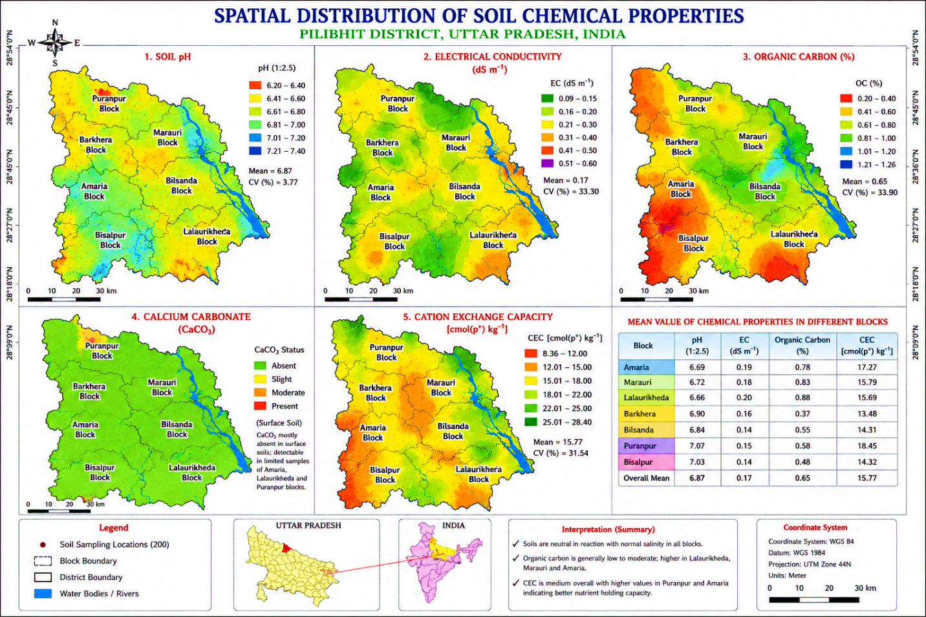
Fig.4
3.4 Assessment of Soil Fertility Status
3.4.1 Primary Macronutrients (N, P, K)
Available Nitrogen ranged from 47.24 to 283.5 kg ha⁻¹, with a mean of 151.47 kg ha⁻¹ (CV = 33.51%). Very low (43%) and low (56.5%) categories dominated, indicating overall nitrogen deficiency. Lalaurikheda (203.88), Marauri (189.61), and Amaria (184.47) showed higher mean N, while Barkhera (93.53) and Bisalpur (114.22) recorded low N, reflecting poor organic matter status. Similar low available nitrogen has been widely reported from alluvial regions of Uttar Pradesh (Kumar et al., 2018; Verma et al., 2023; Sonkar et al., 2023).
Available Phosphorus ranged from 4.4 to 81.0 kg ha⁻¹, with a mean of 21.27 kg ha⁻¹ (CV = 63.08%). Moderate P dominated (38%), followed by moderately high (19.5%) and very high (15%). Barkhera (26.73), Marauri (23.57), and Bisalpur (23.09) showed higher levels, while Lalaurikheda (14.79) and Bilsanda (16.02) indicated localized deficiency. These distribution patterns are consistent with reports from different agro-ecological regions of India (Kumar et al., 2021; Majhi et al., 2023; Bharteey et al., 2017).
Available Potassium ranged from 29.25 to 708.3 kg ha⁻¹, with a mean of 196.85 kg ha⁻¹ (CV = 45.75%). Moderate (41.5%) and moderately high (29.5%) categories dominated. Bilsanda (224.83), Puranpur (208.59), and Bisalpur (198.33) showed higher mean K, while Barkhera (174.97) and Amaria (182.03) showed lower values. The wide variation signifies pronounced spatial heterogeneity influenced by texture, cropping intensity, and management—trends similar to those reported from various agro-ecological regions (Demiss et al., 2020; Pal, 2021; Ambhure et al., 2025).
3.4.2 Secondary Macronutrients (Ca, Mg, S)
Available Calcium ranged from 3.41 to 7.25 cmol(p⁺) kg⁻¹, with a mean of 5.67 cmol(p⁺) kg⁻¹ (CV = 16.64%). High category dominated (74%), followed by medium (26%). Marauri (6.29), Lalaurikheda (6.25), and Amaria (6.18) showed higher levels, while Barkhera (4.87) was lowest. These findings align with reports of adequate to high calcium status in soils (Hota et al., 2022; Meena et al., 2025; Verma et al., 2023).
Available Magnesium ranged from 1.49 to 3.35 cmol(p⁺) kg⁻¹, with a mean of 2.52 cmol(p⁺) kg⁻¹ (CV = 17.84%). High (82%) and very high (17.5%) categories dominated. Amaria (2.71), Marauri (2.65), and Lalaurikheda (2.65) showed higher levels, while Barkhera (2.21) was lowest. Similar adequate magnesium status has been reported by several researchers (Verma et al., 2023; Sonkar et al., 2023; Shelke et al., 2024).
Available Sulphur ranged from 14.58 to 23.87 kg ha⁻¹, with a mean of 18.62 kg ha⁻¹ (CV = 11.15%). Moderately high (76.5%) and high (22.5%) categories dominated. Marauri (19.21), Bilsanda (18.96), and Amaria (18.67) showed higher levels. The narrow range across blocks suggests uniform distribution, consistent with reports from alluvial soils of Uttar Pradesh (Bharteey et al., 2017; Verma et al., 2023) and Madhya Pradesh (Singh et al., 2017).
3.4.3 Micronutrients (Zn, Fe, Cu, Mn, B)
Available Zinc ranged from 0.25 to 1.46 mg kg⁻¹, with a mean of 0.62 mg kg⁻¹ (CV = 33.44%). Low (51.5%) and moderate (44.5%) categories dominated. Puranpur (0.76) showed the highest mean, while Barkhera (0.48) and Bisalpur (0.53) recorded lower values. Widespread zinc deficiency (78.9% samples <0.78 mg kg⁻¹) aligns with reports from intensively cultivated alluvial soils (Takni Tagung, 2023; Malla et al., 2020; Kashiwar et al., 2018).
Available Iron ranged from 2.21 to 16.52 mg kg⁻¹, with a mean of 8.39 mg kg⁻¹ (CV = 37.48%). Moderate (50%) and moderately high (41%) categories dominated. Amaria (9.70) and Puranpur (9.40) showed adequate Fe availability. These findings are consistent with observations by Thakur (2018), Jain et al. (2023), and Singh (2021), indicating overall adequate iron status in alluvial soils.
Available Copper ranged from 0.12 to 1.98 mg kg⁻¹, with a mean of 0.92 mg kg⁻¹ (CV = 37.66%). High (42.5%), very high (21.0%), and moderately high (29.0%) categories dominated. Marauri (1.17) and Amaria (1.06) showed higher levels. Similar trends have been reported by Atwal et al. (2025), Sengar et al. (2022), and Jena et al. (2022), confirming sufficient copper availability.
Available Manganese ranged from 2.15 to 17.88 mg kg⁻¹, with a mean of 9.28 mg kg⁻¹ (CV = 29.17%). High (70.5%) and moderately high (25.5%) categories dominated. Bisalpur (11.22) and Barkhera (10.43) showed highest levels. These results align with reports of moderate to high Mn availability from alluvial regions (Diwakar et al., 2023; Kumar et al., 2021; Kumar & Babel, 2011).
Available Boron ranged from 0.51 to 0.85 mg kg⁻¹, with a mean of 0.63 mg kg⁻¹ (CV = 11.85%). Moderate category dominated (94.5%). The narrow range indicates uniform distribution, consistent with reports from intensively cultivated alluvial soils (Chikkaramappa et al., 2021; Bal Krishna et al., 2019; Jagtap et al., 2018).
3.4.4 Overall Soil Fertility Status Based on Nutrient Index Values
Nutrient index–based evaluation revealed that nitrogen (NIV = 1.01) is the most limiting primary nutrient, followed by zinc (NIV = 1.47) as the second major limiting nutrient. Phosphorus (NIV = 1.96) and potassium (NIV = 1.89) showed medium fertility status. Among secondary nutrients, sulphur (NIV = 2.23) was adequate, while calcium (NIV = 2.74) and magnesium (NIV = 2.99) exhibited very high status. Among micronutrients, copper (NIV = 2.61) and manganese (NIV = 2.72) showed high to very high status, iron (NIV = 1.91) was marginal, and boron (NIV = 2.00) was adequate.
The low NIV for nitrogen reflects low organic carbon, rapid mineralization under intensive cropping, and continuous nitrogen removal without adequate replenishment. Low zinc fertility is associated with neutral to slightly alkaline soil reaction, low organic matter, and intensive fertilizer use without zinc supplementation. These nutrient index–based fertility patterns are consistent with reports from alluvial soils of Uttar Pradesh, Madhya Pradesh, and other regions of India (Ingle et al., 2018; Bharteey et al., 2017; Verma et al., 2023). Overall, the assessment highlights that nitrogen and zinc are the most critical nutrients limiting soil fertility in Pilibhit district, whereas most other nutrients are sufficiently available for sustainable agricultural production.
Table 4. Fertility Status and Nutrient Distribution in Soils of Pilibhit District
Parameter | Distribution / Range | Mean | CV (%) | Interpretation
Available Nitrogen (kg ha⁻¹) | 47.24–283.5; Very low (43.0%), Low (56.5%) | 151.47 | 33.51 | Overall nitrogen deficiency prevailed across the district. Higher N in Lalaurikheda, Marauri, and Amaria reflected relatively better organic matter status, whereas Barkhera and Bisalpur showed poor nitrogen availability.
Available Phosphorus (kg ha⁻¹) | 4.4–81.0; Moderate (38.0%), Moderately high (19.5%), Very high (15.0%) | 21.27 | 63.08 | Higher P in Barkhera, Marauri, and Bisalpur indicated comparatively better phosphorus availability, while localized deficiency occurred in Lalaurikheda and Bilsanda.
Available Potassium (kg ha⁻¹) | 29.25–708.3; Moderate (41.5%), Moderately high (29.5%) | 196.85 | 45.75 | Higher K in Bilsanda, Puranpur, and Bisalpur reflected favourable mineral reserves and management practices, whereas lower K in Barkhera and Amaria suggested nutrient depletion.
Available Calcium [cmol(p⁺) kg⁻¹] | 3.41–7.25; High (74.0%), Medium (26.0%) | 5.67 | 16.64 | Predominantly high calcium status indicated adequate base saturation and favourable nutrient balance in most soils.
Available Magnesium [cmol(p⁺) kg⁻¹] | 1.49–3.35; High (82.0%), Very high (17.5%) | 2.52 | 17.84 | Adequate to very high magnesium status prevailed across the district, particularly in Amaria, Marauri, and Lalaurikheda.
Available Sulphur (kg ha⁻¹) | 14.58–23.87; Moderately high (76.5%), High (22.5%) | 18.62 | 11.15 | Relatively narrow variability indicated uniform sulphur distribution under alluvial conditions.
Available Zinc (mg kg⁻¹) | 0.25–1.46; Low (51.5%), Moderate (44.5%) | 0.62 | 33.44 | Zinc deficiency was widespread, especially in Barkhera and Bisalpur, likely due to intensive cultivation and low organic matter status.
Available Iron (mg kg⁻¹) | 2.21–16.52; Moderate (50.0%), Moderately high (41.0%) | 8.39 | 37.48 | Adequate iron availability was observed in most soils, with comparatively higher Fe in Amaria and Puranpur.
Available Copper (mg kg⁻¹) | 0.12–1.98; High (42.5%), Very high (21.0%), Moderately high (29.0%) | 0.92 | 37.66 | Sufficient copper availability prevailed throughout the district, particularly in Marauri and Amaria.
Available Manganese (mg kg⁻¹) | 2.15–17.88; High (70.5%), Moderately high (25.5%) | 9.28 | 29.17 | Moderate to high manganese availability was characteristic of the alluvial soils, with higher levels in Bisalpur and Barkhera.
Available Boron (mg kg⁻¹) | 0.51–0.85; Moderate (94.5%) | 0.63 | 11.85 | Narrow variability indicated comparatively uniform boron distribution across the district.
Nutrient Index Values (NIV) | N (1.01), P (1.96), K (1.89), S (2.23), Ca (2.74), Mg (2.99), Zn (1.47), Fe (1.91), Cu (2.61), Mn (2.72), B (2.00) | — | — | Nitrogen and zinc emerged as the major limiting nutrients, whereas most secondary and micronutrients showed adequate to high fertility status suitable for sustainable crop production.

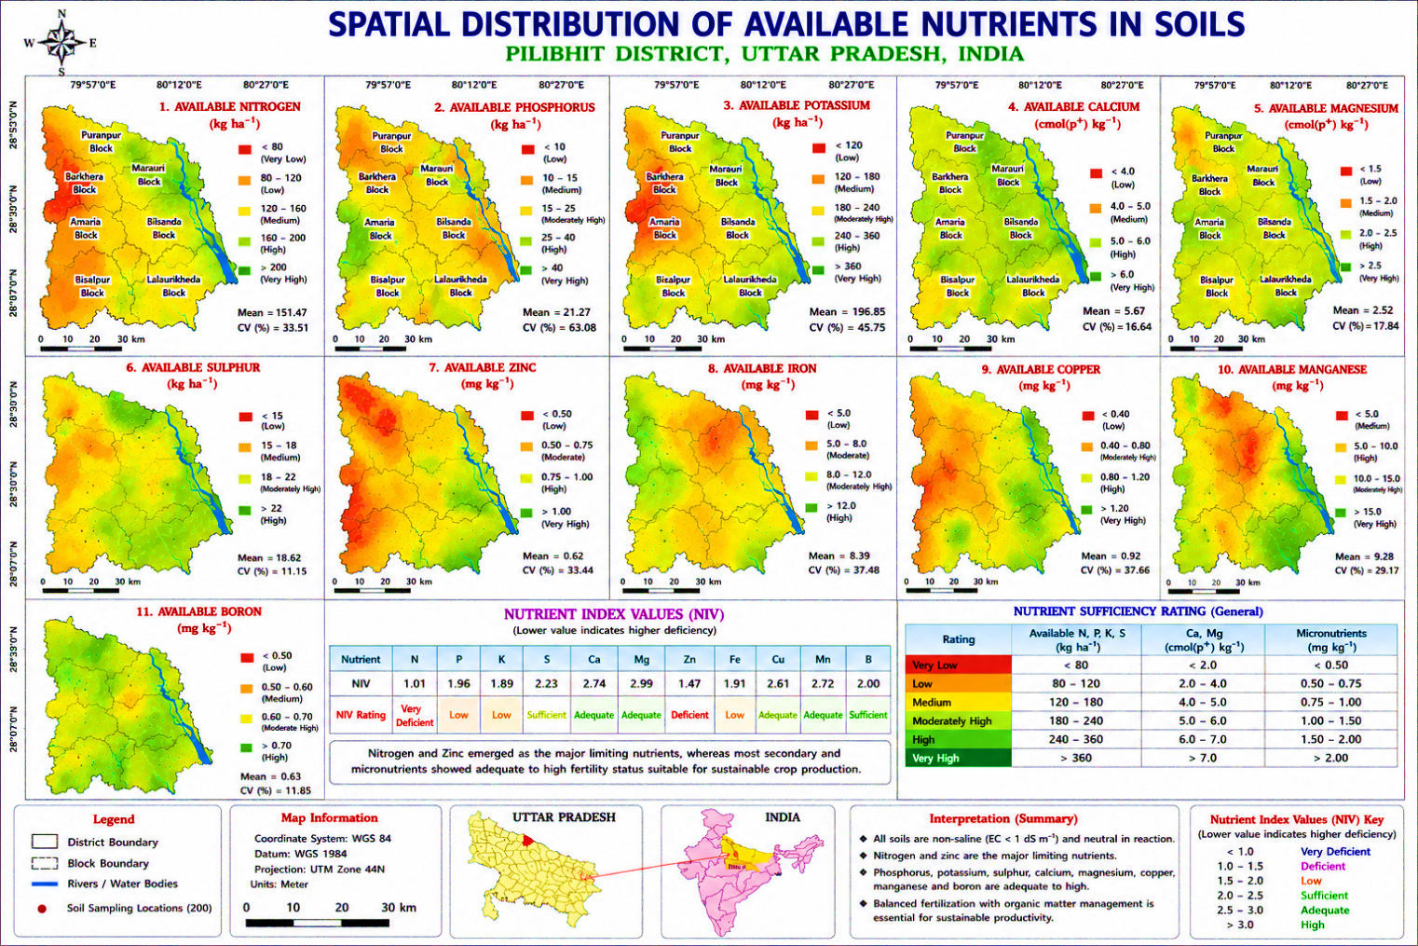
Fig.5

4. Conclusion
The study revealed that Pilibhit district is predominantly agriculture-based with extensive cultivated land and substantial forest cover. The soils varied from sandy loam to clay loam with generally favorable physical conditions for crop cultivation. Chemical analysis indicated slightly acidic to neutral soil reaction with non-saline conditions. Organic carbon and CEC showed moderate variability, whereas nitrogen and zinc emerged as major limiting nutrients. Phosphorus and potassium were present in moderate quantities, while secondary nutrients and most micronutrients were adequate. GIS-based spatial mapping effectively demonstrated the heterogeneity of soil properties under different land use systems. The findings emphasize the need for balanced fertilization, organic matter management, zinc supplementation, and site-specific nutrient management strategies to sustain soil fertility and agricultural productivity in Pilibhit district.

Disclaimer (Artificial intelligence)

Author(s) hereby declare that NO generative AI technologies such as Large Language Models (ChatGPT, COPILOT, etc.) and text-to-image generators have been used during the writing or editing of this manuscript.

Reference
Akhand, A., Kumar, R., & Singh, P. (2024). Assessment of soil fertility status and variability under different land use systems. Journal of Soil and Water Conservation, 23(2), 145–154. https://doi.org/10.60151/envec/UCPI2827
Bhagwan, P. V., Anjaiah, T., Ravali, C., et al. (2025). Delineating soil fertility management zones using geostatistics and fuzzy clustering in semi-arid maize systems in India. Environmental Monitoring and Assessment, 197, 1230.
DOI: https://doi.org/10.1007/s10661-025-14608-z
Barman, M., Datta, S. P., Rattan, R. K., & Meena, M. C. (2019). Critical limits of deficiency of nickel in intensively cultivated alluvial soils. Journal of Soil Science and Plant Nutrition, 20, 284–292.
DOI: https://doi.org/10.1007/s42729-019-00132-4
Balkrishna, A., Ghosh, S., Banerjee, S. et al. (2026). Evaluation of region-specific organic farming suitability in the Indo-Gangetic basin using the geographical information system-based soil quality index and machine learning approach. Discov. Soil 3, 58 https://doi.org/10.1007/s44378-026-00211-2
Prem Kumar Bharteey, Bipul Deka, Marami Dutta, Jonali Goswami and Rituparna Saikia (2023). Geospatial variability of soil physico-chemical properties of Moridhal watershed in Dhemaji district of Assam, India using Remote sensing and GIS. Annals of Plant and Soil Research 25 (1): 99-109 https://doi.org/10.47815/apsr.2023.10242
Bingham, F. T. (1982). Boron. In A. L. Page (Ed.), Methods of soil analysis: Part 2. Chemical and microbiological properties (2nd ed., pp. 431–448). American Society of Agronomy. ASA-CSSA-SSSA Link
Black, C. A. (1965). Methods of soil analysis (Vol. 2). American Society of Agronomy. Wiley Online Library
Bouyoucos, G. J. (1962). Hydrometer method improved for making particle size analyses of soils. Agronomy Journal, 54(5), 464–465. https://doi.org/10.2134/agronj1962.00021962005400050028x
Brady, N. C., & Weil, R. R. (2017). The nature and properties of soils (15th ed.). https://www.researchgate.net/publication/301200878_The_Nature_and_Properties_of_Soils_15th_edition#:~:text=This%20book%20provides%20both%20an,will%20want%20to%20keep%20for
Burrough, P. A., & McDonnell, R. A. (1998). Principles of geographical information systems.https://global.oup.com/academic/product/principles-of-geographical-information-systems-9780198233654
Chesnin, L., & Yien, C. H. (1950). Turbidimetric determination of available sulphates. Soil Science Society of America Proceedings, 15, 149–151. https://doi.org/10.2136/sssaj1951.036159950015000C0032x
Danielson, R. E. (1986). Porosity. In A. Klute (Ed.), Methods of soil analysis: Part 1 (2nd ed., pp. 443–461). American Society of Agronomy. https://doi.org/10.2136/sssabookser5.1.2ed.c18
Mondal, B. P., & Sekhon, B. S. (2019). Geostatistical assessment of spatial variability of soil available potassium under different land uses of a part of Ludhiana district of Punjab. International Journal of Chemical Studies, 7(3), 5802–5807.
International Journal of Chemical Studies Article
Devi, M., Kumar, V., & Singh, R. (2023). Soil reaction and salinity variability in Indo-Gangetic alluvial soils. International Journal of Plant & Soil Science, 35(18), 94–103. https://journalijpss.com/index.php/IJPSS/issue/archive
Hanway, J. J., & Heidel, H. (1952). Soil analysis methods as used in Iowa State College Soil Testing Laboratory. Iowa Agriculture, 57, 1–31. Iowa State University Repository
Jackson, M. L. (1973). Soil chemical analysis. Prentice Hall of India Pvt. Ltd. https://www.scirp.org/reference/referencespapers
Lindsay, W. L., & Norvell, W. A. (1978). Development of a DTPA soil test for zinc, iron, manganese, and copper. Soil Science Society of America Journal, 42(3), 421–428. https://doi.org/10.2136/sssaj1978.03615995004200030009x
Lillesand, T., Kiefer, R. W., & Chipman, J. (2015). Remote sensing and image interpretation (7th ed.). Wiley. Wiley
Maas, E. V., & Hoffman, G. J. (1977). Crop salt tolerance—Current assessment. Journal of the Irrigation and Drainage Division, 103(2), 115–134. ASCE Library
Olsen, S. R., Cole, C. V., Watanabe, F. S., & Dean, L. A. (1954). Estimation of available phosphorus in soils by extraction with sodium bicarbonate (USDA Circular No. 939). United States Department of Agriculture. Internet Archive
Rhoades, J. D. (1982). Soluble salts. In A. L. Page (Ed.), Methods of soil analysis: Part 2 (2nd ed., pp. 167–179). American Society of Agronomy. Wiley Online Library
Sparks, D. L. (1996). Methods of soil analysis: Part 3—Chemical methods. Soil Science Society of America. Wiley Online Library
Subbiah, B. V., & Asija, G. L. (1956). A rapid procedure for the estimation of available nitrogen in soils. Current Science, 25(8), 259–260. Current Science PDF
Wilding, L. P., & Drees, L. R. (1983). Spatial variability and pedology. In L. P. Wilding, N. E. Smeck, & G. F. Hall (Eds.), Pedogenesis and soil taxonomy (pp. 83–116). https://www.sciencedirect.com/science/article/abs/pii/S0166248108705993

