Climate-Resilient Cultivation of Rice under Agronomic Bio-fortification with Iron and Zinc

Abstract
Iron and zinc deficiencies are the major global public health challenges, in rice-dependent regions. The nutritional intakes fall short of the Recommended Dietary Allowances due to deficiencies in two important micronutrients, leading to low productivity, widespread malnutrition, impaired cognitive development, and weakened immunity. Rice is a staple food for most of the Asian continent, but conventional practice like the transplanted method leads to higher environmental pollution. Hence, direct-seeded rice is a more sustainable alternative. Bio-fortification of rice offers a sustainable and cost-effective strategy to enhance grain micronutrient quantity and improve nutritional security among people with limited access to diverse foods. Among the various bio-fortification pathways, agronomic bio-fortification has emerged as a practical approach that can be readily integrated into the prevailing production systems. This review highlights about nutri-priming which enhances early seedling vigour and micronutrient uptake, soil fertilisation which helps in creating baseline nutrient reserves , foliar application which is essential for guarantee micronutrient delivery at critical growth stages and microbial inoculants, such as iron and zinc solubilizing bacteria to improve micronutrient availability through biochemical transformation.Optimization of the agronomic bio-fortification protocols along with their integration with the recommended dose of fertilizers can substantially contribute to reducing micronutrient deficiency and achieving long-term nutritional resilience.
Keywords: Bio-fortification, Nutri-priming, Direct-seeded rice, Microbe-mediated enhancement, Foliar application, Iron deficiency, Zinc deficiency
1. Introduction
Human civilization has long been confronted with hunger and disease, rendering the provision of adequate nutrition and the prevention of malnutrition-related disorders an enduring global challenge (Magazine 2020). Nutrition is the basic form of living organisms which can be obtained by consuming food for their nourishment and sustenance (Sharma et al. 2020).. Food constitutes the primary source of a wide range of nutrients essential for the proper functioning of the human body. Repeated neglect in making appropriate dietary choices may lead to various nutritional health disorders. Micronutrients are vitamins and minerals required by the human body in minute quantities, typically measured in milligrams (mg) or micrograms (µg) per day (Singh and Prasad 2023).Plants rely on iron (Fe) and zinc (Zn) to support key cellular functions involved in metabolism and overall physiology. Their unpaired electrons allow these transition metals to easily engage in redox reactions (Pierre and Fontecave 1999). Fe plays a vital role in chlorophyll formation, nitrogen fixation, DNA replication, detoxification of reactive oxygen species (ROS) and electron transport chains of mitochondria and chloroplasts (Nouet et al. 2001; Yruela 2013). Similar to Fe, Zn a divalent cation participates in numerous cellular activities and pathways (Ishimaru et al. 2011). Zn plays a major role in the metabolic processes of proteins, nucleic acids, carbohydrates and lipids (Rhodes and Klug 1993). Zinc-containing metalloenzymes catalyze the rapid interconversion of CO₂ and H₂O into bicarbonate (HCO₃⁻) ions (Yruela 2013). According to the National Academies of Sciences, Engineering and Medicine, the Recommended Dietary Allowance (RDA) for iron is 8 mg day ⁻¹ for adult men and 18 mg day⁻¹ for adult women who are neither pregnant nor post-menopausal, for zinc the RDA is 15 mg day⁻¹ for adult men and 12 mg day⁻¹ for adult women. Nutritional anaemia, mostly iron deficiency, is widespread among developing countries (Gregorio et al. 1999). In general, iron (Fe) deficiency and anaemia exert substantial adverse effects on human health and development, including reduced cognitive performance during childhood and compromised immune function (Gregorio et al. 1999). The era of the “Green Revolution” was primarily directed towards enhancing staple cereal production, namely rice, wheat and maize, in order to satisfy the energy demands of a rapidly expanding global population. Nevertheless, the introduction of high-yielding crop varieties was subsequently associated with the emergence of micronutrient deficiencies in numerous regions worldwide (Jan et al. 2020). Iron chlorosis represents a multifaceted nutrient deficiency disorder (Liesch et al. 2011). Attempts to mitigate or rectify iron deficiency through soil-based management strategies have, in general, yielded only limited effectiveness (Hagstrom et al. 1984). One adaptive mechanism employed by plants to alleviate iron chlorosis involves the exudation of hydrogen ions (H⁺) or organic acid anions through the root membrane (Römheld 1987).
India has one of the increasing rates of Zn deficiencies in soils from 49 to 63% by 2025 as most of the marginal soils brought under cultivation show Zn deficiency which affects the diet of people (Mishra et al. 2025; IZA 2014). Globally, more than 30% of soils are low in plant-available Zn (Welch et al. 2002), with a very small proportion of the total zinc being available in soil solution (Alloway 2008). Nearly 50% of the cereal-grown areas in the world have soils with low plant available Zn, its concentrations reported are too low to meet daily human requirement, especially for those consuming a high proportion of cereal-based diets (Cakmak 2002). Zinc deficiencies and related abnormalities (Table 1) are commonly observed among individuals consuming diets rich in strong chelators, high in cereal-based phytates, and low in protein content (Brown et al. 2001; Tapiero and Tew 2003).The major soil factors that reduce zinc availability to plants include low total Zn content, high soil pH and elevated levels of calcite and organic matter. Additionally, high concentrations of sodium (Na), calcium (Ca), magnesium (Mg), bicarbonate, and phosphate in the soil solution or in their labile forms further limit the availability of Zn to plant roots (Alloway 2009). Transient rise in bicarbonate concentration and organic acids in the soil solution after soil submergence can induce temporary zinc deficiency in plants (Forno et al. 1975. As an essential micronutrient for physiological functions and immune defence, zinc supplementation has shown strong and consistent effects in reducing the incidence and severity of infectious diseases, thereby contributing to a significant reduction in child mortality, including a decrease in pneumonia incidence by about 19% and reductions in deaths due to diarrhoea and pneumonia by 13% and 20%, respectively (Black et al. 2003; Penny 2013).
This manuscript addresses the dual challenge of climate-resilient rice cultivation and micronutrient malnutrition, particularly iron and zinc deficiencies in rice-dependent populations. The review provides a comprehensive overview of agronomic bio-fortification strategies, including nutripriming, soil and foliar fertilization, and microbial approaches, for sustainable rice production under changing climatic conditions. It also highlights the importance of direct-seeded rice as an environmentally sustainable alternative to conventional transplanted systems due to its lower water requirement and reduced methane emissions. The information compiled in this review may serve as a valuable resource for researchers, agronomists, nutritionists, and policymakers working toward sustainable crop production, nutritional security, and climate-smart agriculture.
1.1 Literature Search Strategy
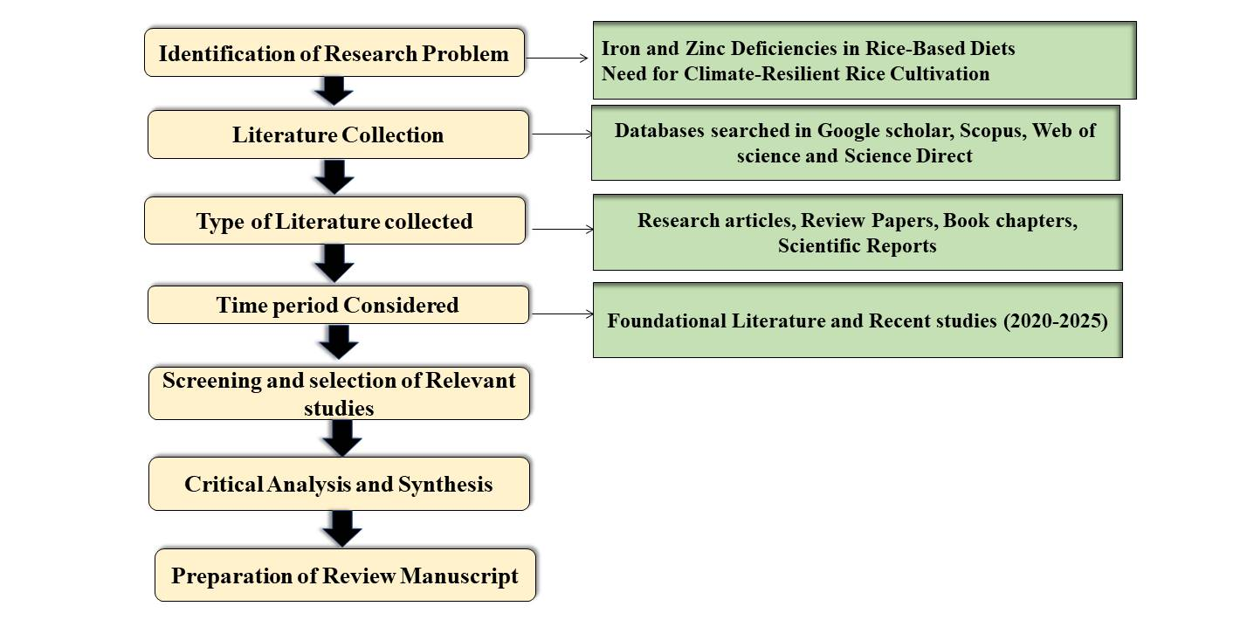
Fig. 1. Literature Search Strategy
2. Rice bio-fortification
The global population continues to rise, accompanied by a corresponding increase in food demand. Consequently, agricultural production is projected to require an increase of approximately 70% in order to meet global food requirements by 2050 (Muthayya et al. 2014).
Rice (Oryza sativa L.) production is a key to world food security as rice constitutes principal staple food for >50% of world population (Dass et al. 2015). Future horizontal expansion of rice area is restricted by the on-going reduction in cultivable land. Thus enhancing productivity becomes essential to meet future increases in rice production. Key constraints to enhancing production are shortages of water and labour, escalating wage rates and input costs, progressive soil and environmental degradation. The predominant lowland rice cultivation system in Asia involves transplanting seedlings into fields that are maintained under continuous flooding, typically with a water depth of 5–10 cm throughout the growing season. Land preparation generally includes soaking, ploughing, and puddling—defined as repeated harrowing under saturated conditions until a soft, muddy soil layer of approximately 10–15 cm is formed (Bouman and Tuong 2001).Submerged rice cultivation induces a cascade of physical, chemical, and microbiological changes in the soil that profoundly influence nutrient availability and uptake, while prolonged flooding also promotes degeneration of rice root systems, reducing the effective feeding zone, restricting optimal crop growth, and increasing the risk of lodging and plant mortality after water recession (Ghildyal 1978 ; Chaturvedi et al. 1995).
3. Climate Impact of Conventional Rice Transplanting
Historical records indicate that over the past 250 years, atmospheric CO₂, CH₄, and N₂O concentrations have increased by 30%, 145%, and 15%, respectively, contributing significantly to global warming (Mosier 1998). Human-induced climate change intensified markedly in 2024, which is likely the first calendar year to record a global mean near-surface temperature more than 1.5°C above the pre-industrial baseline. The average temperature reached 1.55 ± 0.13°C above the 1850–1900 mean, making 2024 the warmest year in the entire 175-year observational record (WMO 2024). Globally, puddled rice soils are a major source of methane (CH₄) emissions, contributing nearly 30% of the total methane released worldwide (Karthik et al. 2025). CH₄ emissions from paddy fields constitute a major source of greenhouse gases and significantly contribute to climate change (Roy et al. 2025). Anaerobic decomposition of organic matter in flooded rice fields leads to the production of methane (CH₄), which is released into the atmosphere mainly through diffusive transport via rice plants throughout the growing season (Fig.1.). Jia et al. (2001) reported that methane emissions were consistently higher in planted than in unplanted soils, with the tillering stage showing the greatest flux, as rice plants acted as the primary conduit for CH₄ release accounting for nearly 90–95% of total emissions while lower rhizospheric oxidation at tillering compared to panicle initiation further contributed to the elevated emissions, a portion of methane dissolves in soil water and can leach into groundwater, therefore, a reduction in soil CH₄ concentration does not necessarily indicate that all of it was emitted to the atmosphere. Continuous flooding in paddy fields results in lower N₂O emissions but leads to higher CH₄ emissions (Wang et al. 2017). Consequently, the flooding of rice fields restricts the diffusion of atmospheric oxygen into the rhizosphere, leading to anaerobic decomposition processes and the emission of methane (CH₄) from submerged soils to the atmosphere via the aerenchymatous tissues of rice plants (Susilawati et al. 2019).Table 2 and Fig. 2. provide insights into the CH₄ emissions associated with different rice varieties.

4. Alternate option for Transplanted rice
The need to adopt economically viable and water management strategies that maximize water-use efficiency is increasingly evident under present rice production systems (Das et al. 2014). Direct seeded rice (DSR) is one of the options to reduce CH₄ emission because it uses less water during initial cropping. Direct-seeded rice can be established using three primary approaches: wet seeding, dry seeding and water seeding (Banik et al. 2020). Wet seeding (Wet-DSR) is typically used where labour is scarce and is prevalent in Malaysia, Thailand, Vietnam, the Philippines, and Sri Lanka (Pandey and Velasco 2002; Weerakoon et al. 2011). Dry seeding (Dry-DSR), on the other hand, is better suited to water-limited areas, particularly rainfed uplands in several Asian nations. Micronutrient deficiencies in cereal crops, particularly rice, arising from the depletion of soil micronutrient reserves, have become a significant concern, contributing to malnutrition and a range of associated disorders, especially in developing countries (Aarthi et al. 2025). Moreover, the rice endosperm—the starchy and most widely consumed portion of the grain—is inherently limited in several essential nutrients, including vitamins, proteins, and micronutrients (Birla et al. 2017).Sona Masoori is a highly cultivated rice variety in India, particularly in the states of Telangana and Andhra pradesh, known locally as Bangaru theegalu. Its Fe and Zn content is relatively low in polished form, with polished rice containing an average of about 2 mg kg⁻¹ of iron and 16-17 mg kg⁻¹ of zinc, while unpolished (brown) rice contains significantly more iron and zinc content (Maganti et al. 2020). As rice crop is major constituent of staple diet and calorific intake of more than half of humanity, lower Zn content in rice grains results in severe Zn malnutrition (Yogi et al. 2023). Increased cropping intensity and accompanying changes in the soil and fertilizer management options have changed the iron status and availability, especially in the Indo-Gangetic plains of India where on large areas rice-wheat cropping system is being practiced (Kumar et al. 2018).
Rice endosperm, embryo and bran contain 32%, 13% and 55% of Fe respectively and they also contain 57%, 9% and 34% of Zn respectively. During de-hulling, polishing and cooking about 20.7%, 17.05% and 36.61% Zn loss occurs (Jena et al. 2018). Zn deficiency affects rice most severely during the seedling stage, following transplanting, when plant mortality may occur (Nanda and Wissuwa 2016). Under rainfed upland conditions rice crop often suffers from iron deficiency during the seedling stage due to aerobic conditions, which favours the oxidation of Fe²⁺ (Ferrous) to Fe³⁺ (Ferric) (Brown, 1961).
5. Strategies for alleviating zinc and iron deficiencies
Developing effective strategies to alleviate Fe and Zn deficiencies is critical for ensuring both food security and nutritional quality (Fig. 3.).
A. Change of Diet: It is essential that individuals are aware of the importance of a diversified diet and avoid restricting their food intake to a limited range of staple crops, as such dietary practices may result in various forms of malnutrition and adversely affect both biochemical and physiological processes (Jena et al. 2018).

B. Supplementation: A range of packaged food products enriched with micronutrients such as iron (Fe), zinc (Zn), and iodine is now available in the market to supplement human diets; however, these products are relatively expensive and are therefore seldom accessible to populations from economically disadvantaged backgrounds (Jena et al. 2018).

C. Bio-fortification: This approach refers to the nutrient enrichment of commonly consumed food crops by the population (Jena et al. 2018). Ferti-fortification, a term introduced by Rajendra Prasad (2009), denotes the application of micronutrient fertilisers to crops in order to enhance their nutritional composition.
D. Fortification: Nutrients are added to the foods as they are being processed (Nestel et al. 2006).
6. Ways to improve micronutrient levels through bio-fortification
Micronutrient deficiencies, particularly of iron and zinc, affect billions of people worldwide and are largely attributed to low micronutrient content in staple cereal crops. Bio-fortification seeks to address this issue by enhancing the concentration and bioavailability of essential micronutrients in the edible parts of crops. This can be achieved through agronomic, genetic interventions (Fig. 4.).
Nutripriming: The nutrient seed priming technique involves soaking seeds in macro or micronutrient solutions (Farooq et al. 2012). Seed priming has been widely employed to improve germination performance, promote root system development, enhance seedling establishment, and ultimately increase yield (Farooq et al. 2019). However, priming may adversely affect seed longevity, thereby necessitating optimal storage conditions or the prompt use or sowing of treated seeds (Murphy 2017).
Soil application: Soil application of micronutrients helps in replenishing the micronutrients in the soil on which a crop or plant is grown. This is a conventionally used technique. Soil application is the most common method of micronutrient application to crops, it has mostly been tested for crop productivity improvement rather than bio-fortification (Martens et al. 1991).
Foliar application: Application of a micronutrient containing mineral fertilizer to plant leaves to improve the micronutrient quality of the edible portion of food crops is called foliar application (Jan et al. 2020). Compared with soil application, foliar application ensures lower micronutrient losses and delivers nutrients straight into plant tissues for quicker absorption (Johnson et al. 2005). Foliar application at a later stage is more beneficial for grain bio-fortification than foliar application at the early vegetative stages (Yilmaz et al. 1997).
7. Foliar iron transport mechanism (Malhotra et al. 2020)
After foliar application, iron initially encounters the leaf cuticle, which represents the primary barrier to entry. Penetration occurs mainly through hydrophilic pores, microcracks, and to a lesser extent, through stomata when they are open. The chemical form of iron strongly influences this process, with chelated and soluble iron sources facilitating greater penetration compared to poorly soluble inorganic forms. This is because Chelated and soluble iron sources enhance foliar penetration by maintaining iron in a dissolved and chemically stable form, preventing surface precipitation and oxidation, and facilitating diffusion through hydrophilic cuticular pores, whereas poorly soluble inorganic iron rapidly precipitates on the leaf surface, limiting its availability for internal uptake. Once iron enters the leaf, it moves through the apoplast, where its mobility is constrained by the low solubility of ferric iron (Fe³⁺), necessitating stabilization through complexation with organic ligands such as citrate, malate or synthetic chelators. A critical step in foliar iron utilization is the reduction of Fe³⁺ to the physiologically active ferrous form (Fe²⁺) by plasma membrane localized ferric chelate reductases, which enables subsequent uptake into mesophyll cells via iron-regulated transporters belonging to the ZIP and IRT families. Following cellular entry, iron is tightly regulated to prevent oxidative damage and is transiently bound to chelators such as nicotianamine (NA) or sequestered in ferritin for safe storage. Intracellular trafficking directs iron to organelles with high metabolic demand, particularly chloroplasts and mitochondria, where specialized transporters facilitate iron import to support essential processes including chlorophyll biosynthesis, photosynthetic electron transport, respiration and redox metabolism.
From Fig. 5. we can understand that Fe⁺² enters into vacuole through VIT1 (vacuolar iron transport) transporter. Within the vacuole, iron may be chelated by ferritin or phytate and sequestered as complexes within vacuolar globoids. Members of the NRAMP (natural resistance-associated macrophage protein) family facilitate the mobilisation of iron from stored pools and its export from the vacuole. The YSL (yellow stripe-like) transporters perform a dual function, mediating both the uptake and efflux of vacuolar iron.
In chloroplasts, iron is imported in the ferric (Fe³⁺) form via an as-yet unidentified transporter. Ferric-chelate reductase oxidase (FRO), localised on the inner envelope membrane, reduces Fe³⁺ to Fe²⁺, which is subsequently transported into the stroma by carriers such as PIC (permease in chloroplast), the NiCo (nickel–cobalt transporter) family, NAP14 (non-intrinsic ABC transporter protein), MAR1 (multiple antibiotic resistance protein 1), and MFL (mitoferrin-like) transporters. The FDR3 (iron deficiency-related 3) protein, localised in the stroma or thylakoid lumen, is implicated in iron delivery to thylakoids. Ferritin also serves as a principal iron storage protein within chloroplasts.
In mitochondria, iron uptake across the outer membrane is mediated by an unidentified transporter, followed by transport into the inner mitochondrial membrane via the mitochondrial iron transporter (MIT), subsequent to reduction by FRO localised on the inner membrane. Within the organelle, iron is either stored as ferritin-bound iron or utilised for the biosynthesis of iron–sulphur (Fe–S) clusters in association with frataxin (FH). Iron efflux from mitochondria to the cytosol occurs via ATM or MIE (mitochondrial ATP-binding cassette transporters or mitochondrial iron exporters), enabling export across the outer mitochondrial membrane.

8. Microbe mediated bio-fortification
Bio-fertilisers comprise microbial inoculant formulations containing microorganisms that enhance host plant growth and productivity (Sahoo et al., 2013). They are advantageous owing to their low cost, ease of production, sustainability in agricultural systems, and wide availability. These microorganisms contribute to improved nutrient supply and bioavailability, thereby augmenting the overall nutrient content accessible to plants (Bhardwaj et al., 2014).
9. Agronomic interventions for bio-fortification
The major agronomic approaches to bio-fortification include ferti-fortification, tillage practices, and the use of plant growth promoting rhizobacteria (PGPR).
Bhanvadia et al. (2023) highlighted that nutripriming of direct seeded rice with 0.5% zinc and iron sulphate plus foliar application of 0.5% iron and zinc sulphate along with recommended dose of fertilizer have recorded higher iron (215 mg kg⁻¹) and zinc content (39 mg kg⁻¹) in grain of rice. Sharanappa et al. (2023) demonstrated soil application of ZnSO₄ @ 15 kg ha⁻¹ and FeSO₄ @ 10 kg ha⁻¹ + foliar application of 0.5% ZnSO₄ and FeSO₄ at 30 and 45 DAS recorded significantly higher zinc (692.30 g ha⁻¹) and iron (2797.5 g ha⁻¹) uptake by plant. Similarly, Yogi et al. (2023) demonstrated that foliar application of 0.5% Zn at panicle initiation and peak flowering was an effective strategy for improving grain Zn bio-fortification, recording 37.9 mg kg⁻¹ zinc in grain, which was 29% higher than the control. Accumulation and bioavailability of iron in rice grains via agronomic interventions was studied by Zulfiqar et al. (2021) and concluded that highest grain Fe concentration was achieved through foliar-applied Fe (0.3% Fe solution) and it was 37% over control Kirttiranjan et al. (2019) performed an experimental work on effect of zinc oxide nanoparticles embedded NPK fertilizer on zinc concentration and uptake of aromatic rice (Oryza sativa) and concluded 100% NPK + 7.5 g ZnO Nps ha⁻¹ (33 mg kg⁻¹) and 75% NPK + 7.5 g ZnO Nps ha⁻¹ (32.47 mg kg⁻¹) recorded at par Zn concentration in grain and highest Zn concentration in straw was recorded with application of 100% NPK + 7.5 g ZnO Nps/ha (61.47 mg kg⁻¹).
Application of ZnSO₄ @ 25 kg ha⁻¹ as basal + foliar spray @ 0.5 % at tillering, panicle initiation and milk stage revealed significantly highest Zn content in grain (35.09 mg kg⁻¹) and brown rice (28.31mg kg⁻¹) Barua and Saikia (2018).According to Kumar et al. (2018) Zn fertilization schedule consisting of 6 kg Zn ha⁻¹ as a basal application followed by a foliar application of 6 kg Zn ha⁻¹ resulted in higher K uptake by the grain (31.63 mg kg⁻¹) and straw (54.25 mg kg⁻¹). Zinc application on the productivity and bio-fortification of fine-grain aromatic rice has been demonstrated across contrasting production systems and locations: at Faisalabad, foliar application consistently produced the highest or statistically similar grain Zn concentrations over two years in both dry-seeded and puddled transplanted systems, in contrast at Sialkot soil-applied zinc proved more effective, resulting in the highest or equal highest grain Zn concentrations across years and production systems Farooq et al. (2018). Highest zinc content (~ 36 mg kg⁻¹) and uptake (0.145 kg ha⁻¹) in grain were recorded with application of 0.3% ZnSO₄ at dough stage, followed by 0.3% ZnSO₄ at early milking stage (Meena et al. 2018). When zinc is applied as basal application @ 4.5 kg Zn ha⁻¹ + foliar application twice at maximum tillering and flowering @ 0.25% aqueous solution each of ZnSO₄·7H₂O (1320 l ha⁻¹) highest zinc in cooked rice (18.2 mg kg⁻¹) and bioavailability Zn (mg) in 300 g cooked rice (2.1) was recorded (Saha et al. 2017). Basal soil application of RDF + FYM 10 t ha⁻¹ + ZnSO₄ 50 kg ha⁻¹ resulted in higher uptake of zinc (399.5 g ha⁻¹) and it was on-par with RDF + urban compost 10 t ha⁻¹ + ZnSO₄ 50 kg ha⁻¹ as basal (SA) , RDF + FYM @ 10 t ha⁻¹ + foliar application of ZnSO₄ 0.5% at 20 and 40 DAS and RDF + urban compost 10 t ha⁻¹ + Foliar application of ZnSO₄ 0.5 % at 20 and 40 DAS (Jayasankar et al. 2017). Rakesh et al. (2017), working with aerobic rice, reported that iron uptake increased progressively from active tillering to harvest across all treatments.
The highest Fe uptake 30.9 g ha⁻¹ at active tillering, and 15.6 g ha⁻¹ and 27 g ha⁻¹ in grain and straw at harvest, respectively was achieved with the application of 180:90:60 kg NPK along with 25 kg Fe ha⁻¹. Similarly application of 10.0 mg kg⁻¹ Fe recorded significantly higher iron content in grain (147.6 mg kg⁻¹) and application of 5.00 mg kg⁻¹ Zn significantly increased Zn content in grain (84 mg kg⁻¹) of rice (Gohil et al. 2017). Field studies have shown that applying micronutrients through foliar spraying on plant surfaces enhances their absorption, specifically zinc and iron. Kumar et al. (2017) conducted an experiment at the ICAR Institute of Agricultural Research Institute that demonstrated using three applications of either 2.0% ferric sulfate or 0.5% ferrous chelate by means of a spray during active growth periods will increase amounts of iron uptake to the plant. In this case, a statistically significant increase was observed with regard to total (grain + straw) Fe uptake, reaching values of 496.18 kg ha⁻¹ in grains and 3034.82 kg ha⁻¹ in straw. Similar findings were supported by the work of Meena and Fathima (2017), who conducted an experiment to measure zinc and iron (Zn + Fe) uptake as a function of different cultivation systems with respect to different types of micronutrient management strategies. In their study, the conventional system achieved greater grain Zn and grain Fe uptake compared to both SRI and aerobic cultivation systems. They also found that using seed treatment and foliar application of ZnSO₄ and FeSO₄ (0.5%) at boot leaf stage and during panicle initiation resulted in higher grain zinc and grain iron uptake than any other management practice evaluated. Ghoneim (2016) investigated the effects of various zinc application methods on nutrient dynamics in plants and reported that foliar spray of ZnSO₄·H₂O at 2.50 kg ha⁻¹ resulted in the highest increase in total zinc content in grain (32.1 mg kg⁻¹). Highest Fe content in milled rice was observed under three foliar spray of Fe at 40,60 and 75 DAS (3%) and it was 3.48% higher compared to soil application of 67 mg FeSO₄.7H₂O kg⁻¹ (Meena et al. 2016).
An evaluation reported by Shivay et al. (2016) demonstrated that the use of NPK along with 0.5% Zn–EDTA applied foliar at tillering, booting, and grain filling stages resulted in substantially higher zinc concentrations in rice grain (29.8 mg kg⁻¹) and straw (96 mg kg⁻¹). Complementary findings were presented by Sudha and Stalin (2015), who observed that zinc application enhanced zinc content in whole grain by 30–53%, in brown rice by 6–54%, and in polished rice by 6.1–16.9 mg kg⁻¹ compared to the control. Their results also revealed considerable zinc loss during processing, as the removal of the hull (brown rice) and both hull and bran (polished rice) significantly reduced zinc levels relative to whole grain. An experimental work was performed on efficacy of zinc application methods for concentration and estimated bioavailability of zinc in grains of rice grown on a calcareous soil by Imran et al. (2015) and inferred that application of 20 kg Zn ha⁻¹ (soil application) plus sprays of 0.25% (w/v) Zn each at tillering and heading stages (foliar application) indicated significantly greater whole grain Zn concentration and it was increased from 22 to 29 mg kg⁻¹ from control. Similarly foliar application of 0.3 % Zn HEDP (1-Hydroxyethylidene-1,1-diphosphonic acid) L (3 g L⁻¹ of water) at active tillering and panicle initiation stage recorded higher Zn content in grain (29.83 mg kg⁻¹) Stalin et al. (2014). In direct-seeded rice, Mahajan and Khurana (2014) reported that seven foliar applications of Fe and KNO₃ applied single or in combination at different growth stages resulted in comparable iron uptake across treatments (0.28–0.30 kg ha⁻¹), all markedly higher than the untreated control (0.22 kg ha⁻¹). Supporting the effectiveness of early nutrient interventions, Mohsin et al. (2014) demonstrated substantial increases in maize grain Zn content, where seed treatment with 1.0% and 2.0% zinc solutions for 16 hours enhanced zinc levels by 43.61% and 36.56% in Pioneer 30-Y-87 and DK-919 hybrids, respectively. Similarly, Singh et al. (2013), in a study conducted at Ludhiana, observed that foliar application of FeSO₄·7H₂O (0.5% and 1%) significantly boosted grain iron content in five rice cultivars, with the PR113 variety showing the highest response to the 1% spray. Increases in grain Fe content over the control were substantial, reaching 89.2% in PR113, 61.9% in PR116, 59.4% in PR118, 124.4% in PR120, and 96.7% in PAU 201.In rice, Prom-u-thai et al. (2012) found that seed priming with zinc sulfate for 60 minutes at concentrations from 0 to 25 mM led to an increase of 0.26 mg plant⁻¹ in grain Zn content relative to the untreated control. Dhaliwal et al. (2010) further highlighted the effectiveness of foliar feeding, noting that three sprays of FeSO₄·7H₂O at 0.5% elevated iron content in brown rice to 21.3–28.9 mg kg⁻¹ across cultivars, compared to 17.3–21.2 mg kg⁻¹ in untreated plots. Similarly, Cakmak et al. (2010) reported marked improvements in grain zinc concentration, with foliar ZnSO₄ applications elevating Zn content from 11 to 22 mg kg⁻¹, and a combined soil-plus-foliar treatment further increasing it to 27 mg kg⁻¹. Complementing these results, Fu et al. (2010) observed that Zn and Fe fertilization substantially enhanced micronutrient concentrations in rice grains, noting that increasing zinc sulphate levels from 0 to 0.2% raised Zn content in brown rice, with an even more pronounced increase evident in the grain hull.
Evidence from soil-based zinc interventions also highlights their significant contribution to grain enrichment. Phattarakul et al. (2009) reported that applying Zn-KCl (1.5% w/v Zn) at 125 kg ha⁻¹ increased grain zinc concentration by 6.7% over the control, while soil application of ZnSO₄·7H₂O at 50 kg ha⁻¹ resulted in an even greater improvement of 13.9%. Complementing these findings, Shivay et al. (2008) demonstrated the effectiveness of zinc-coated urea, showing that urea prills coated with 2% ZnSO₄ produced the highest zinc concentrations in both grain (44 mg kg⁻¹) and straw (88.5 mg kg⁻¹), outperforming other coating treatments. Jin et al. (2008) demonstrated that foliar spraying with a mixed fertilizer containing 0.1% FeSO₄·7H₂O, 0.4% amino acids, and 0.2% urea markedly improved iron accumulation in brown rice, increasing Fe content to 10.28 mg kg⁻¹ compared with 6.52 mg kg⁻¹ in the control. Consistent results were reported by Zhang et al. (2008), who found that foliar feeding with 0.1% FeSO₄ supplemented with 0.4% amino acids significantly enhanced Fe concentration in polished rice of the japonica cultivar ‘Bing 98110’, reaching 4.7 mg kg⁻¹ an 88% increase over the control (2.5 mg kg⁻¹). Beyond foliar nutrition, Tariq et al. (2007) highlighted the role of plant growth-promoting rhizobacteria, noting that soaking rice seedling roots in a PGPR-based biofertilizer inoculum (Bio Power) elevated grain zinc concentration by 14.4% compared to untreated plots. Inoculation with zinc-solubilizing strains significantly enhanced grain zinc concentration, with higher Zn contents recorded in Basmati-385 (28.4 and 29.2 mg kg⁻¹) and Super Basmati (29.7 and 30.5 mg kg⁻¹) when plants were treated with the bacterial consortium (Shakeel et al. 2024). Sarangi et al. (2006) demonstrated that combining basal application of 15 kg FeSO₄ ha⁻¹ with a 1.0% foliar spray at 35 DAS produced the highest iron uptake in direct-seeded upland rice, reaching 1.83 kg ha⁻¹ in grain and 1.37 kg ha⁻¹ in straw. Large genotypic differences were reported by Wen et al. (2005), who found that across 208 rice lines, iron levels in brown rice ranged from 14.49 to 38.06 mg kg⁻¹ and zinc from 11.64 to 42.39 mg kg⁻¹, with both micronutrients being substantially higher in brown rice than in polished rice. Beyond rice, Ajouri et al. (2004) recorded 708% increase in grain Zn content in barley through seed priming with ZnSO₄ (10 mg kg⁻¹), while Imran et al. (2018) reported a 600% enhancement in maize following priming with 4 mM ZnSO₄ for 24 hours. In soil-based nutrition studies, Abid et al. (2002) observed that applying 10 mg Zn kg⁻¹ soil along with NPK + Mn yielded the highest rice grain Zn concentration (46.53 mg kg⁻¹), whereas maximum Fe content (166.1 mg kg⁻¹) occurred with 5 mg Zn kg⁻¹ plus NPK + Fe. Srivastava et al. (1999) showed that among various zinc sources including ZnSO₄, Zn-FYM, Zn(NH₃)₄-FYM, and Zn-EDTA the Zn-EDTA treatment produced the highest grain zinc concentration (40.7 g pot⁻¹) in lowland rice, underscoring the clear advantage of chelated forms for enhancing zinc availability.
10. Limitations and Practical Challenges of Agronomic Bio-fortification
The effectiveness of agronomic bio-fortification varies across different soil types, climatic conditions, and rice production systems, limiting the universal applicability of nutrient management recommendations. In addition, factors such as high input costs, limited farmer awareness, inconsistent micronutrient availability, and lack of long-term field validation may restrict large-scale adoption. Further research focusing on economic feasibility, region-specific nutrient management strategies and integration with climate-smart agricultural practices is essential for improving sustainability and farmer-level implementation.
11. Conclusion
The conventional puddled transplanted rice cropping systems, which are highly productive, are gradually being limited due to the intensifying challenges posed by the high levels of methane emission, water requirement, and susceptibility to climate variability. In response to growing climate change challenges, the shift towards direct seeded rice practices assumes a climate-smart approach, considering the potential associated with the reduction in greenhouse gas emission, water, and labor under the escalating climate change considerations. Nevertheless, along with the transition from transplanted rice to DSR, there are also changes in the soil physic-chemical properties. In fact, it has been noted that these transitions tend to increase the difficulty of iron and zinc micronutrient accessibility in the rice soil, which has been recognized as a wide-scale limitation in rice crop growth environments worldwide. Perhaps because of this concern in micronutrient accessibility, there have been developments in iron and zinc micronutrient fertilizer innovation in these environments. Agronomic bio-fortification has emerged as a practical, scalable and farmer friendly approach for improving Fe and Zn content of rice while offering a direct pathway to reduce micronutrient malnutrition among vulnerable populations. Well-timed soil, seed and foliar applications of Fe and Zn alone or in combination evidently have the potential to significantly improve nutrient uptake, enrichment in grains and overall nutrition in crops. While genetic approaches and dietary diversification are also important, agronomic interventions offer immediate and affordable gains in areas with widespread soil micronutrient deficiencies.
Despite significant progress in agronomic bio-fortification and climate-resilient rice cultivation, important research gaps still exist. Most studies are short term and location specific, limiting the wider applicability of nutrient management practices across diverse agro climatic conditions. Further long term research integrating agronomic, microbial, and precision nutrient management approaches is needed to enhance iron and zinc enrichment, nutrient use efficiency, and environmental sustainability in direct seeded rice systems. Strengthening collaboration among researchers, extension agencies and policymakers is essential for promoting climate smart and nutritionally secure rice production.

Disclaimer (Artificial intelligence)
Author(s) hereby declare that NO generative AI technologies such as Large Language Models (ChatGPT, COPILOT, etc.) and text-to-image generators have been used during the writing or editing of this manuscript.

References
Aarthi, S. S. T., Sudha Rani, J. S., Sreedevi, B., & Sukruth Kumar, T. (2025). Unlocking growth potential: The role of iron and zinc in dry direct seeded rice (Oryza sativa L.). Plant Archives, 25(Supplement 2), 3228–3232. https://doi.org/10.51470/PLANTARCHIVES.2025.v25.supplement-2.414
Abid, M., Ahmad, N., Jahangir, M., & Ahmad, I. (2002). Effect of zinc, iron and manganese on growth and yield of rice (Oryza sativa L.). Pakistan Journal of Agricultural Sciences, 39, 177–180.
Ajouri, A., Asgedom, H., & Becker, M. (2004). Seed priming enhances germination and seedling growth of barley under conditions of P and Zn deficiency. Journal of Plant Nutrition and Soil Science, 167(5), 630–636. https://doi.org/10.1002/jpln.200420425
Alloway, B. J. (2008). Zinc in soils and crop nutrition. International Zinc Association.
Alloway, B. J. (2009). Soil factors associated with zinc deficiency in crops and humans. Environmental Geochemistry and Health, 31(5), 537–548. https://doi.org/10.1007/s10653-009-9255-0
Altuntaş, B., Filik, B., Ensari, A., Zorlu, P., & Teziç, T. (2000). Can zinc deficiency be used as a marker for the diagnosis of celiac disease in Turkish children with short stature? Pediatric International, 42(6), 682–684. https://doi.org/10.1046/j.1442-200x.2000.01313.x
Banik, N. C., Kumar, A., Mohapatra, B. K., Kumar, V., Sreenivas, C., Singh, S., Panneerselvam, P., & Kumar, V. (2020). Weed management approaches in direct-seeded rice in eastern Indian ecologies: A critical and updated review. Indian Journal of Weed Science, 52(1), 1–9. https://doi.org/10.5958/0974-8164.2020.00001.5
Bao, B., Prasad, A. S., Beck, F. W. J., Fitzgerald, J. T., Snell, D., Bao, G., Singh, T., & Cardozo, L. J. (2010). Zinc decreases C-reactive protein, lipid peroxidation, and inflammatory cytokines in elderly subjects: potential implication of zinc as an atheroprotective agent. The American Journal of Clinical Nutrition, 91(6), 1634–1641. https://doi.org/10.3945/ajcn.2009.28556
Barua, D., & Saikia, M. (2018). Agronomic biofortification in rice varieties through zinc fertilization under aerobic condition. Indian Journal of Agricultural Research, 52(1), 89–92. https://doi.org/10.18805/IJARe.A-4733
Bhanvadia, A.S., Yadav, S.L., Singh, D.P. and Birla, D., 2023. Response of direct seeded rice to iron and zinc fertilization strategies under Middle Gujarat conditions. Int J Plant Soil Sci, 35, pp.1116-1124. https://doi.org/10.9734/IJPSS/2023/v35i183378
Bhardwaj, A. K., Chejara, S., Malik, K., Kumar, R., Kumar, A., & Yadav, R. K. (2022). Agronomic biofortification of food crops: An emerging opportunity for global food and nutritional security. Frontiers in Plant Science, 13, 1055278. https://doi.org/10.3389/fpls.2022.1055278
Bhardwaj, D., Ansari, M. W., Sahoo, R. K., & Tuteja, N. (2014). Biofertilizers function as key players in sustainable agriculture by improving soil fertility, plant tolerance and crop productivity. Microbial Cell Factories, 13, 66. https://doi.org/10.1186/1475-2859-13-66
Birla, D. S., Malik, K., Sainger, M., Chaudhary, D., Jaiwal, R., & Jaiwal, P. K. (2017). Progress and challenges in improving the nutritional quality of rice (Oryza sativa L.). Critical Reviews in Food Science and Nutrition, 57(11), 2455–2481. https://doi.org/10.1080/10408398.2015.1084992
Black, R. E. (2003). Zinc deficiency, infectious disease and mortality in the developing world. The Journal of Nutrition, 133(5), 1485S–1489S. https://doi.org/10.1093/jn/133.5.1485S
Bouman, B. A. M., & Tuong, T. P. (2001). Field water management to save water and increase its productivity in irrigated lowland rice. Agricultural Water Management, 49(1), 11–30. https://doi.org/10.1016/S0378-3774(00)00128-1
Brown, J. C. (1961). Iron chlorosis in plants. Advances in Agronomy, 13, 329–369. https://doi.org/10.1016/S0065-2113(08)60947-5
Brown, K. H., Wuehler, S. E., & Peerson, J. M. (2001). Handbook on toxicology of metals. Food and Nutrition Bulletin, 22, 113–125.
https://doi.org/10.1177/02601060211015594
Cakmak, I. (2002). Plant nutrition research: Priorities to meet human needs for food in sustainable ways. Plant and Soil, 247(1), 3–24. https://doi.org/10.1023/A:1021141804377
Cakmak, I., Kalayci, M., Kaya, Y., Torun, A. A., Aydin, N., Wang, Y., Arisoy, Z., Erdem, H., Yazici, A., Gokmen, O., & Ozturk, L. (2010). Biofortification and localization of zinc in wheat grain. Journal of Agricultural and Food Chemistry, 58(16), 9092–9102. https://doi.org/10.1021/jf101197h
Chaturvedi, G. S., Mishra, C. H., Singh, O. N., Pandey, C. G., Yadav, P. V., Singh, A. K., Dwivedi, J. L., Singh, B. B., & Singh, R. K. (1995). Physiological basis and screening for tolerance for flash flooding. In K. T. Ingram (Ed.), Rainfed lowland rice agricultural research in high risk environment (pp. 790–796). International Rice Research Institute.
Corona, C., Masciopinto, F., Silvestri, E., Viscovo, A., Lattanzio, R., Sorda, R., Ciavardelli, D., Goglia, F., Piantelli, M., Canzoniero, L. M. T., & Sensi, S. L. (2010). Dietary zinc supplementation of 3xTg-AD mice increases BDNF levels and prevents cognitive deficits as well as mitochondrial dysfunction. Cell Death & Disease, 1(10), e91. https://doi.org/10.1038/cddis.2010.57
Das, A., Patel, D. P., Munda, G. C., Ramkrushna, G. I., Kumar, M., & Ngachan, S. V. (2014). Improving productivity, water and energy use efficiency in lowland rice (Oryza sativa) through appropriate establishment methods and nutrient management practices in the mid-altitude of north-east India. Experimental Agriculture, 50(3), 353–375. https://doi.org/10.1017/S0014479713000608
Dass, A., Kaur, R., Choudhary, A. K., Pooniya, V., Raj, R., & Rana, K. S. (2015). System of rice (Oryza sativa) intensification for higher productivity and resource use efficiency: A review. Indian Journal of Agronomy, 60(1), 1–19.
Dhaliwal, S. S., Sadana, U. S., Khurana, M. P. S., Dhadli, H. S., & Manchanda, J. S. (2010). Enrichment of rice grains with zinc and iron through ferti-fortification. Indian Journal of Fertilisers, 6(4), 28–35. https://doi.org/10.5555/20103236091
Farooq, M., Ullah, A., Rehman, A., Nawaz, A., Nadeem, A., Wakeel, A., Nadeem, F., & Siddique, K. H. (2018). Application of zinc improves the productivity and biofortification of fine grain aromatic rice grown in dry-seeded and puddled transplanted production systems. Field Crops Research, 216, 53–62. https://doi.org/10.1016/j.fcr.2017.11.004
Farooq, M., Usman, M., Nadeem, F., Rehman, H. U., Wahid, A., Basra, S. M. A., & Siddique, K. H. (2019). Seed priming in field crops: Potential benefits, adoption and challenges. Crop & Pasture Science, 70(9), 731–771. https://doi.org/10.1071/CP18604
Farooq, M., Wahid, A., & Siddique, K. H. M. (2012). Micronutrient application through seed treatments: A review. Journal of Soil Science and Plant Nutrition, 12(1), 125–142. https://doi.org/10.4067/S0718-95162012000100011
Fathi, F., Ektefa, F., Tafazzoli, M., Rostami, K., Nejad, M. R., Fathi, M., Rezaei-Tavirani, M., Oskouie, A. A., & Zali, M. R. (2013). The concentration of serum zinc in celiac patients compared to healthy subjects in Tehran. Gastroenterology and Hepatology from Bed to Bench, 6(2), 92–95. https://doi.org/10.4013/ghfbb.2013.62.05
Forno, D. A., Yoshida, S., & Asher, C. J. (1975). Zinc deficiency in rice: I. Soil factors associated with the deficiency. Plant and Soil, 42(3), 537–550. https://doi.org/10.1007/BF00010039
Fu, L. C., Wang, R. M., Meng, J., & Wan, J. L. (2010). Effect of foliar application of zinc and iron fertilizers on distribution of zinc and iron, quality and yield of rice grain. Scientia Agricultura Sinica, 43(24), 5009–5018. https://doi.org/10.3864/j.issn.0578-1752.2010.24.004
Ghildyal, B. P. (1978). Effect of method of planting and puddling on soil properties and rice growth. In Soil and rice (pp. 317–336). International Rice Research Institute.
Ghoneim, A. M. (2016). Effect of different methods of Zn application on rice growth, yield and nutrients dynamics in plant and soil. Journal of Agriculture and Ecology Research International, 6(2), 1–9. https://doi.org/10.9734/JAERI/2016/25395
Gilca-Blanariu, G. E., Diaconescu, S., Ciocoiu, M., & Ştefănescu, G. (2018). New insights into the role of trace elements in IBD. BioMed Research International, 2018, 1813047. https://doi.org/10.1155/2018/1813047
Gohil, N. B., Patel, D. P., Patel, B. A., & Patha, O. I. (2017). Effect of soil application of Fe and Zn on nutrient content and uptake by two rice varieties. International Journal of Chemical Studies, 5(2), 396–400.
Gregorio, G. B., Senadhira, D., & Htut, T. (1999). Improving iron and zinc value of rice for human nutrition. CIRAD Open Repository. https://agritrop.cirad.fr/
Hagstrom, G. R. (1984). Current management practices for correcting iron deficiency in plants with emphasis on soil management. Journal of Plant Nutrition, 7(1–5), 23–46. https://doi.org/10.1080/01904168409363244
Imran, M., Boelt, B., & Mühling, K.-H. (2018). Zinc seed priming improves salt resistance in maize. Journal of Agronomy and Crop Science, 204(4), 390–399. https://doi.org/10.1111/jac.12272
Imran, M., Kanwal, S., Hussain, S., Aziz, T., & Maqsood, M. A. (2015). Efficacy of zinc application methods for concentration and estimated bioavailability of zinc in grains of rice grown on a calcareous soil. Pakistan Journal of Agricultural Sciences, 52(1), 169–175.
International Zinc Association. (2014). International Zinc Association (IZA) database. International Zinc Association.
Ishimaru, Y., Bashir, K., & Nishizawa, N. K. (2011). Zn uptake and translocation in rice plants. Rice, 4(1), 21–27. https://doi.org/10.1007/s12284-011-9061-3
Islam, S. M., Gaihre, Y. K., Islam, M. N., Suvo, T. P., Sander, B. O., Habib, M. A., Islam, A., Nayak, S., Singh, U., Hasegawa, T., & Islam, M. R. (2025). Reducing greenhouse gas emissions and improving rice yield: The influence of cultivars, soil salinity, and nitrogen management. Science of the Total Environment, 997, 180192. https://doi.org/10.1016/j.scitotenv.2024.180192
Jan, B., Bhat, T. A., Sheikh, T. A., Wani, O. A., Bhat, M. A., Nazir, A., Fayaz, S., Mushtaq, T., Farooq, A., Wani, S., & Rashid, A. (2020). Agronomic biofortification of rice and maize with iron and zinc: A review. International Research Journal of Pure and Applied Chemistry, 21, 28–37. https://doi.org/10.9734/IRJPAC/2020/v21i130150
Jayasankar, M., Lakshmi, N. V., Venkateswarlu, B., & Prasad, P. R. (2017). Productivity and nutrient uptake of semi dry rice (Oryza sativa L.) as influenced by different sources of fertilizers and zinc application. Journal of Research ANGRAU, 45(4), 55–61.
Jena, J., Sethy, P., Jena, T., Misra, S. R., Sahoo, S. K., Dash, G. K., & Palai, J. B. (2018). Rice biofortification: A brief review. Journal of Pharmacognosy and Phytochemistry, 7(1), 2644–2647.
Jia, Z., Cai, Z., Xu, H., & Li, X. (2001). Effect of rice plants on CH₄ production, transport, oxidation and emission in rice paddy soil. Plant and Soil, 230(2), 211–221. https://doi.org/10.1023/A:1010355326873
Jin, Z., Minyan, W., Lianghuan, W., Jiangguo, W., & Chunhai, S. (2008). Impacts of combination of foliar iron and boron application on iron biofortification and nutritional quality of rice grain. Journal of Plant Nutrition, 31(9), 1599–1611. https://doi.org/10.1080/01904160802208745
Johnson, S. E., Lauren, J. G., Welch, R. M., & Duxbury, J. M. (2005). A comparison of the effects of micronutrient seed priming and soil fertilization on the mineral nutrition of chickpea (Cicer arietinum), lentil (Lens culinaris), rice (Oryza sativa), and wheat (Triticum aestivum) in Nepal. Experimental Agriculture, 41(4), 427–448. https://doi.org/10.1017/S0014479705002861
Jurowski, K., Szewczyk, B., Nowak, G., & Piekoszewski, W. (2014). Biological consequences of zinc deficiency in the pathomechanisms of selected diseases. Journal of Biological Inorganic Chemistry, 19(7), 1069–1079. https://doi.org/10.1007/s00775-014-1139-0
Karthik, M. N., Parasuraman, P., Thavaprakaash, N., Poornimmal, R., & Vincent, S. (2025). Resource conservation technologies for mitigating climate change impacts in agriculture: A review. Communications in Soil Science and Plant Analysis. https://doi.org/10.1080/00103624.2025.2489107
Kirttiranjan, B. (2019). Evaluation of ZnO nanoparticles embedded N:P:K complex fertilizer in aromatic rice (Oryza sativa L.) (Doctoral dissertation, ICAR–Indian Agricultural Research Institute, New Delhi, India).
Kumar, S., & Verma, S. K. (2018). Crop establishment methods and zinc fertilization affect nutrient content and uptake of direct-seeded rice. International Journal of Current Microbiology and Applied Sciences, 7(12), 655–661. https://doi.org/10.20546/ijcmas.2018.712.081
Kumar, V., Kumar, D., Singh, Y. V., & Raj, R. (2017). Water productivity, nutrient uptake and quality of aerobic rice as influenced by varieties and iron nutrition. Paddy and Water Environment, 15(4), 821–830. https://doi.org/10.1007/s10333-017-0587-4
Kumar, V., Kumar, D., Singh, Y. V., Raj, R., & Singh, N. (2018). Effect of iron nutrition on plant growth and yield of aerobic rice. International Journal of Chemical Studies, 6, 999–1004.
Liesch, A. M. (2011). Interpreting and managing soybean iron chlorosis in Western Kansas (Doctoral dissertation, Kansas State University).
Maganti, S., Swaminathan, R., & Parida, A. (2020). Variation in iron and zinc content in traditional rice genotypes. Agricultural Research, 9(3), 316–328. https://doi.org/10.1007/s40003-020-00479-3
Magazine, A. M. (2020). Indian farmer (Management, 295, p. 301).
Mahajan, G., & Khurana, M. P. S. (2014). Enhancing productivity of dry-seeded rice (Oryza sativa L.) in north-west India through foliar application of iron and potassium nitrate. Vegetos, 27(2), 301–306. https://doi.org/10.5958/j.2229-4473.27.2.056
Malhotra, H., Pandey, R., Sharma, S., & Bindraban, P. S. (2020). Foliar fertilization: Possible routes of iron transport from leaf surface to cell organelles. Archives of Agronomy and Soil Science, 66(3), 279–300. https://doi.org/10.1080/03650340.2019.1618844
Martens, D. C., & Westermann, D. T. (1991). Fertilizer applications for correcting micronutrient deficiencies. In J. J. Mortvedt, F. R. Cox, L. M. Shuman, & R. M. Welch (Eds.), Micronutrients in agriculture (2nd ed., pp. 549–592). Soil Science Society of America, Inc. https://doi.org/10.2136/sssabookser4.2ed.c15
Meena, B. L., Rattan, R. K., Datta, S. P., & Meena, M. C. (2016). Effect of iron application on iron nutrition of aerobic rice grown in different soils. Journal of Environmental Biology, 37(6), 1377–1382.
Meena, N., & Fathima, P. S. (2017). Nutrient uptake of rice as influenced by agronomic biofortification of Zn and Fe under methods of rice cultivation. International Journal of Pure and Applied Biosciences, 5(5), 456–459. https://doi.org/10.18782/2320-7051.3054
Meena, R. P., Prasad, S. K., Layek, A., Singh, M. K., & Das, M. (2018). Nitrogen and zinc scheduling for zinc biofortification in direct seeded rice (Oryza sativa). The Indian Journal of Agricultural Sciences, 88(5), 805–808. https://doi.org/10.56093/ijas.v88i5.81902
Mitra, S., Jain, M. C., Kumar, S., Bandyopadhyay, S. K., & Kalra, N. (1999). Effect of rice cultivars on methane emission. Agriculture, Ecosystems & Environment, 73(3), 177–183. https://doi.org/10.1016/S0167-8809(99)00041-2
Mohsin, A. U., Ahmad, A. U. H., Farooq, M., & Ullah, S. (2014). Influence of zinc application through seed treatment and foliar spray on growth, productivity and grain quality of hybrid maize. Journal of Animal & Plant Sciences, 24(5), 1384–1392.
Mosier, A. R. (1998). Soil processes and global change. Biology and Fertility of Soils, 27(3), 221–229. https://doi.org/10.1007/s003740050401
Murphy, D. J. (2017). Seed treatments. In D. Thomas, B. G. Murray, & D. J. Murphy (Eds.), Encyclopedia of applied plant sciences (2nd ed., Vol. 1, pp. 564–569). Elsevier. DOI 10.1016/b978-0-12-394807-6.00013-7
Muthayya, S., Sugimoto, J. D., Montgomery, S., & Maberly, G. F. (2014). An overview of global rice production, supply, trade, and consumption. Annals of the New York Academy of Sciences, 1324(1), 7–14. https://doi.org/10.1111/nyas.12540
Nanda, A. K., & Wissuwa, M. (2016). Rapid crown root development confers tolerance to zinc deficiency in rice. Frontiers in Plant Science, 7, 428. https://doi.org/10.3389/fpls.2016.00428
National Research Council. (1989). Recommended dietary allowances. National Academies Press.
Nestel, P., Bouis, H. E., Meenakshi, J. V., & Pfeiffer, W. (2006). Biofortification of staple food crops. The Journal of Nutrition, 136(4), 1064–1067. https://doi.org/10.1093/jn/136.4.1064
Nouet, C., Motte, P., & Hanikenne, M. (2011). Chloroplastic and mitochondrial metal homeostasis. Trends in Plant Science, 16(7), 395–404. https://doi.org/10.1016/j.tplants.2011.05.005
Palai, J. B., Sarkar, N. C., & Jena, J. (2017). Effect of zinc on growth, plant yield, NPK uptake and economics. International Journal of Bio-resource and Stress Management,8(5),698–702. https://doi.org/10.23910/IJBSM/2017.8.5.1848b
Pandey, S., & Velasco, L. (2002). Economics of direct seeding in Asia: Patterns of adoption and research priorities. In Direct seeding: Research strategies and opportunities (pp. 3–14). IRRI / FAO Publication.
Penny, M. E. (2013). Zinc supplementation in public health. Annals of Nutrition and Metabolism, 62(Suppl. 1), 31–42. https://doi.org/10.1159/000353285
Phattarakul, N., Çakmak, I., Boonchuay, P., Jumniun, W., & Rerkasem, B. (2009, May). Role of Zn fertilizers in increasing grain zinc concentration and improving grain yield of rice. In Proceedings of the International Plant Nutrition Colloquium XVI. Department of Plant Sciences, University of California, Davis. Retrieved from https://escholarship.org/uc/item/4h59c4sc
Pierre, J. L., & Fontecave, M. (1999). Iron and activated oxygen species in biology: The basic chemistry. Biometals, 12(3), 195–199. https://doi.org/10.1023/A:1009238801316
Prom-U-Thai, C., Rerkasem, B., Yazici, A., & Cakmak, I. (2012). Zinc priming promotes seed germination and seedling vigor of rice. Journal of Plant Nutrition and Soil Science, 175(3), 482–488. https://doi.org/10.1002/jpln.201100332
Qi, Z., Guan, S., Zhang, Z., Du, S., Li, S., & Xu, D. (2024). Effect and mechanism of root characteristics of different rice varieties on methane emissions. Agronomy, 14(3), 595. https://doi.org/10.3390/agronomy14030595
Rajendra Prasad, R. P. (2009). Ferti-fortification of grains-An easy option to alleviate malnutrition of some micronutrients in human beings. Indian Journal of Fertilisers, 5(12), 19–28.
Rakesh, D., Reddy, R. R. P., Pasha, L., & Sreedhar, T. V. (2017). Study of aerobic rice under varying fertility levels in relation to iron application. International Journal of Current Microbiology and Applied Sciences, 6(10), 2928–2943. https://doi.org/10.20546/ijcmas.2017.610.346
Rhodes, D., & Klug, A. (1993). Zinc fingers. Scientific American, 268(2), 56–65.
Römheld, V. (1987). Different strategies for iron acquisition in higher plants. Physiologia Plantarum, 70(2), 231–234. https://doi.org/10.1111/j.1399-3054.1987.tb02496.x
Roy, S., Dutta, S., Barman, T., Rahaman, A. O., Saha, S., Bera, R., & Das, S. (2025). Methane emission from paddy fields: Role in climate change and possible mitigation strategies. In Innovations in climate resilient agriculture (pp. 417–446). Cham: Springer Nature Switzerland. https://doi.org/10.1007/978-3-031-23456-7_19
Saha, S., Chakraborty, M., Padhan, D., Saha, B., Murmu, S., Batabyal, K., Seth, A., Hazra, G. C., Mandal, B., & Bell, R. W. (2017). Agronomic biofortification of zinc in rice: Influence of cultivars and zinc application methods on grain yield and zinc bioavailability. Field Crops Research, 210, 52–60. https://doi.org/10.1016/j.fcr.2017.05.008
Sahoo, R. K., Bhardwaj, D., & Tuteja, N. (2013). Biofertilizers: A sustainable eco-friendly agricultural approach to crop improvement. In Plant acclimation to environmental stress (pp. 403–432). Springer, New York, NY, USA. https://doi.org/10.1007/978-1-4614-4967-4_15
Sarangi, S. K., Sharma, H. C., Singh, K. A. L. Y. A. N., Singh, Y., Singh, C. S., & Singh, K. K. (2006). Studies on the mode of iron application and growth regulators on the performance of direct seeded upland rice (Oryza sativa L.) varieties under rainfed condition. Annals of Agricultural Research, 27(3), 375–381.
Shakeel, M., Hafeez, F. Y., Malik, I. R., Rauf, A., Jan, F., Khan, I., Ijaz, I., Elsadek, M. F., Ali, M. A., Rashid, K., & Muzammal, M. (2024). Zinc solubilizing bacteria synergize the effect of zinc sulfate on growth, yield and grain zinc content of rice (Oryza sativa). Cereal Research Communications, 52(3), 961–971. https://doi.org/10.1007/s42976-024-00381-1
Sharanappa, A. S., Narappa, G., Balanagoudar, S. R., & Amaregouda, A. (2023). Effect of zinc and iron biofortification on nutrient availability, uptake and yield of dry direct seeded rice under aerobic condition. International Journal of Advanced Biochemistry Research, 7(2), 463–467. https://doi.org/10.33545/26174693.2023.v7.i2Sg.251
Sharma, K., Tayade, A., Singh, J., & Walia, S. (2020). Bioavailability of nutrients and safety measurements. In Functional foods and nutraceuticals: Bioactive components, formulations and innovations (pp. 543–593). Cham: Springer International Publishing. https://doi.org/10.1007/978-3-030-32545-6_17
Shivay, Y. S., Kumar, D., Prasad, R., & Ahlawat, I. P. S. (2008). Relative yield and zinc uptake by rice from zinc sulphate and zinc oxide coatings onto urea. Nutrient Cycling in Agroecosystems, 80(2), 181–188. https://doi.org/10.1007/s10705-007-9134-0
Shivay, Y. S., Prasad, R., Kaur, R., & Pal, M. (2016). Relative efficiency of zinc sulphate and chelated zinc on zinc biofortification of rice grains and zinc use-efficiency in Basmati rice. Proceedings of the National Academy of Sciences, India Section B: Biological Sciences, 86(4), 973–984. https://doi.org/10.1007/s40011-016-0732-5
Singh, P., & Prasad, S. (2023). A review on iron, zinc and calcium biological significance and factors affecting their absorption and bioavailability. Journal of Food Composition and Analysis, 123, 105529. https://doi.org/10.1016/j.jfca.2023.105529
Singh, P., Dhaliwal, S. S., & Sadana, U. S. (2013). Iron enrichment of paddy grains through ferti-fortification. Journal of Research Punjab Agricultural University, 50, 32–38.
Srivastava, P. C., Ghosh, D., & Singh, V. P. (1999). Evaluation of different zinc sources for lowland rice production. Biology and Fertility of Soils, 30(1), 168–172. https://doi.org/10.1007/s003740050456
Stalin, P., Gayathri, D., Muthumanickam, D., & Chitdeshwari, T. (2014). Effect of newly developed zinc chelates on productivity and quality of rice. Advances in Applied Research, 6(2), 143–150. https://doi.org/10.5958/2349-2104.2014.00006.0
Sudha, S., & Stalin, P. (2015). Effect of zinc on yield, quality and grain zinc content of rice genotypes. International Journal of Farm Sciences, 5(3), 17–27.
Susilawati, H. L., Pramono, A., Setyanto, P., & Inubushi, K. (2019). Soil amelioration on peat and its effect on methane (CH4) emission and rice yield. In Tropical wetlands—Innovation in mapping and management (pp. 109–116). CRC Press. https://doi.org/10.1201/9780429449917-12
Tapiero, H., & Tew, K. D. (2003). Trace elements in human physiology and pathology: zinc and metallothioneins. Biomedical Pharmacotherapy, 57(9), 399–411. https://doi.org/10.1016/S0753-3322(03)00108-4
Tariq, M., Hameed, S., Malik, K. A., & Hafeez, F. Y. (2007). Plant root associated bacteria for zinc mobilization in rice. Pakistan Journal of Botany, 39(1), 245.
Tomat, A. L., Costa Mde, L., & Arranz, C. T. (2011). Zinc restriction during different periods of life: influence in renal and cardiovascular diseases. Nutrition, 27(4), 392–398. https://doi:10.1016/j.nut.2010.09.010
Tubek, S. (2007a). Role of zinc in regulation of arterial blood pressure and in the etiopathogenesis of arterial hypertension. Biological Trace Element Research, 117(1–3),39–51.
Tubek, S. (2007b). Selected zinc metabolism parameters in premenopausal and postmenopausal women with moderate and severe primary arterial hypertension. Biological Trace Element Research, 116(3), 249–256.
Vo, T. B. T., Johnson, K., Wassmann, R., Sander, B. O., & Asch, F. (2024). Varietal effects on greenhouse gas emissions from rice production systems under different water management in the Vietnamese Mekong Delta. Journal of Agronomy and Crop Science, 210(1), e12669. https://doi.org/10.1111/jac.12669
Wang, C., Lai, D. Y., Sardans, J., Wang, W., Zeng, C., & Peñuelas, J. (2017). Factors related with CH4 and N2O emissions from a paddy field: Clues for management implications. PLoS ONE, 12(1), e0169254. https://doi.org/10.1371/journal.pone.0169254
Weerakoon, W. M. W., Mutunayake, M. M. P., Bandara, C., Rao, A. N., Bhandari, D. C., & Ladha, J. K. (2011). Direct-seeded rice culture in Sri Lanka: Lessons from farmers. Field Crops Research, 121(1), 53–63. https://doi.org/10.1016/j.fcr.2010.12.014
Welch, R. M. (2002). The impact of mineral nutrients in food crops on global human health. Plant and Soil, 247, 83–90. https://doi.org/10.1023/A:1021225302340
Wen, J. C., Zhang, Z. L., Jin, S., Tang, L., Xu, J., & Tan, X. (2005). Iron and zinc contents in Japonica hybrid rice based on CMS-D1 system. Scientia Agricultura Sinica, 38(6), 1182–1187.
Yang, T., Wang, M., Wang, X., Xu, C., Fang, F., & Li, F. (2022). Product type, rice variety, and agronomic measures determined the efficacy of enhanced-efficiency nitrogen fertilizer on the CH4 emission and rice yields in paddy fields: A meta-analysis. Agronomy, 12(10), 2240. https://doi.org/10.3390/agronomy12102240
Yilmaz, A., Ekiz, H., Torun, B., Gultekin, I., Karanlik, S., Bagci, S. A., & Cakmak, I. (1997). Effect of different zinc application methods on grain yield and zinc concentration in wheat grown on zinc-deficient calcareous soils in Central Anatolia. Journal of Plant Nutrition, 20(3), 461–471. https://doi.org/10.1080/01904169709365236
Yogi, A. K., Bana, R. S., Bamboriya, S. D., Choudhary, R. L., Laing, A. M., Singh, D., Godara, S., Babu, S., & Chaudhary, A. (2023). Foliar zinc fertilization improves yield, biofortification and nutrient-use efficiency of upland rice. Nutrient Cycling in Agroecosystems, 125(3), 453–469. https://doi.org/10.1007/s10705-023-10246-8
Yruela Guerrero, I. (2013). Transition metals in plant photosynthesis. Metallomics, 5(9), 1110–1120. https://doi.org/10.1039/c3mt00086a
Zhang, J., Wu, L. H., & Wang, M. Y. (2008). Iron and zinc biofortification in polished rice and accumulation in rice plant (Oryza sativa L.) as affected by nitrogen fertilization. Acta Agriculturae Scandinavica Section B: Soil and Plant Science, 58(3), 267–272. https://doi.org/10.1080/09064710802303791
Zhang, W., Du, B., Duan, X., Liang, Z., Tang, Y., Li, J., & Yao, X. (2024). Effects of different rice varieties and water management practices on greenhouse gas (CH4 and N2O) emissions in the ratoon rice system in the upper Yangtze River region, China. Agriculture, 14(12), 2251. https://doi.org/10.3390/agriculture14122251
Zulfiqar, U., Hussain, S., Maqsood, M., Zamir, S. I., Ishfaq, M., Ali, N., Ahmad, M., & Maqsood, M. F. (2021). Enhancing the accumulation and bioavailability of iron in rice grains via agronomic interventions. Crop and Pasture Science. https://doi.org/10.1071/CP21036.

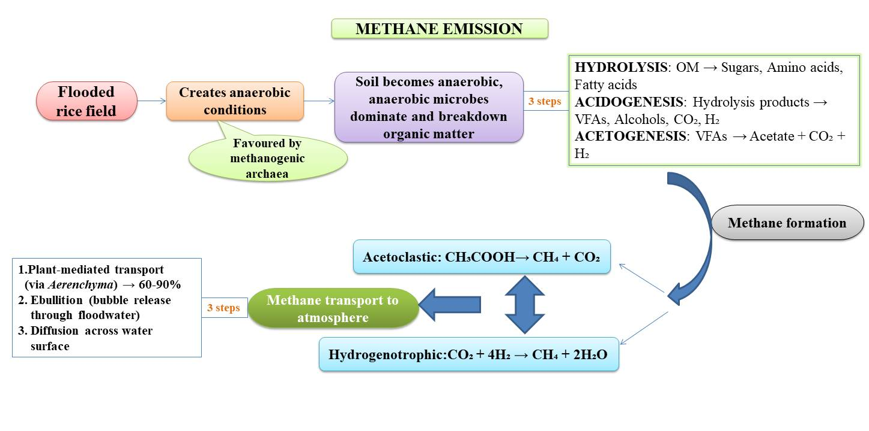
Fig. 2. Methane emission from rice field
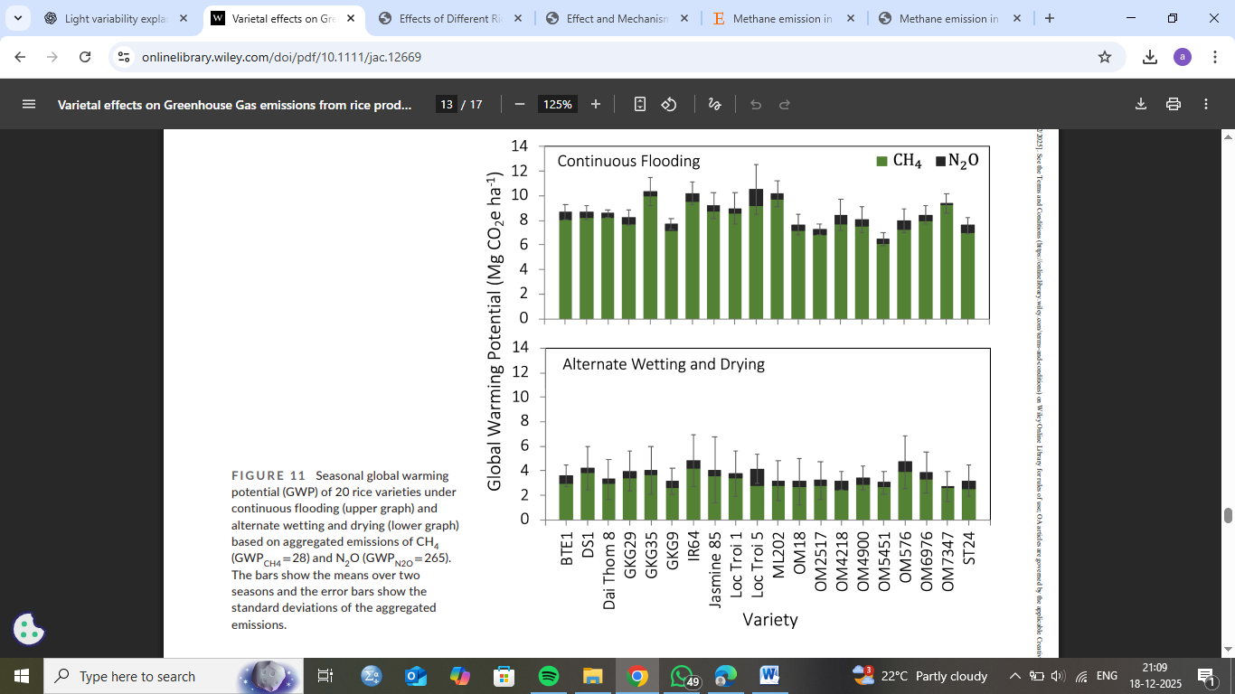
Fig. 3. Seasonal global warming potential (GWP) of 20 rice varieties under continuous flooding and alternate wetting and drying based on aggregated emissions of CH₄ (GWP_{CH4}= 28) and N₂O (GWP_{N2O} = 265) (Vo et al. 2024).
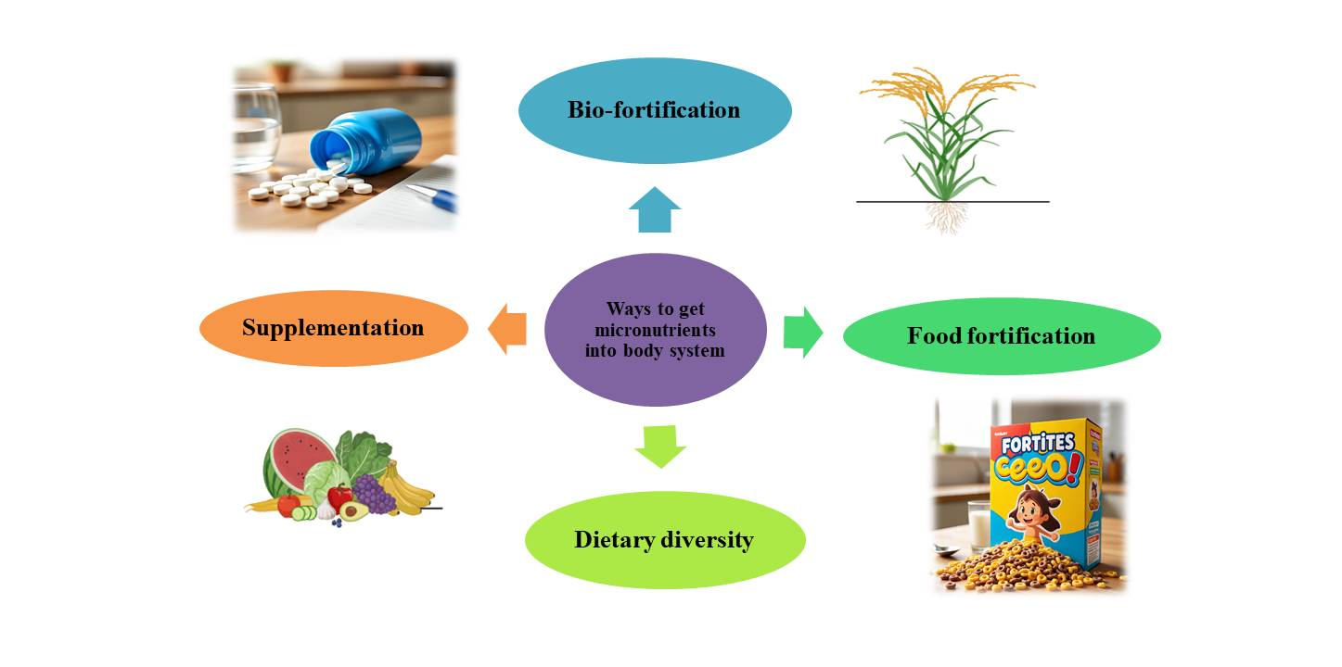
Fig. 4. Strategies for getting micronutrients into the body system
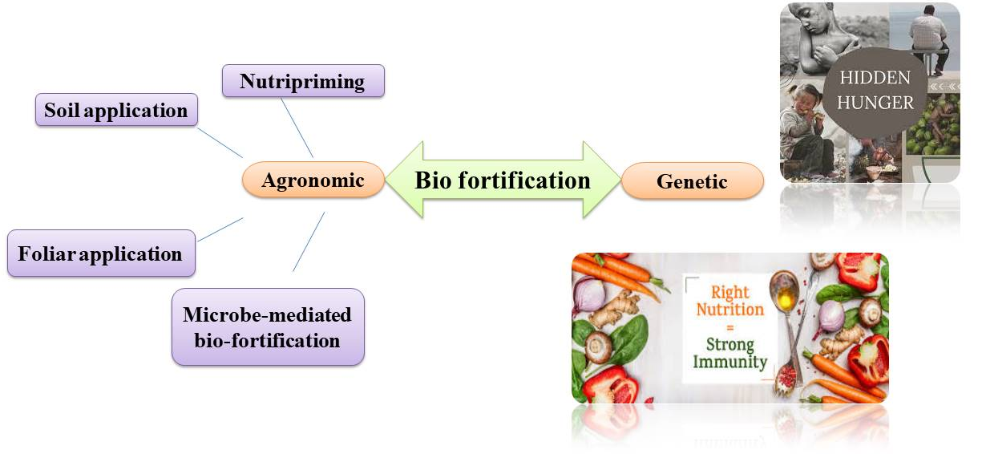
Fig. 5. Conventional and advanced bio-fortification techniques used in crop production and improvement programs.
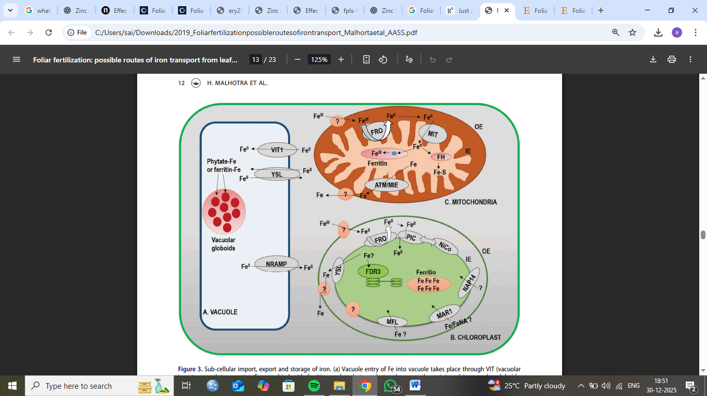
Fig. 6. Sub-cellular import, export and storage of iron.

Table 1. Adverse effects of zinc deficiency
Disease | Effect of zinc deficiency | References
Inflammatory bowel syndrome | Influences multiple signaling and cellular pathways involved in oxidative stress and alters gut microbiota composition. | Gilca-Blanariu et al. 2018
Hypogonadal dwarf syndrome | Growth retardation, hypogonadism accompanied by dysosmia and dysgeusia, anemia, and impaired wound healing. | Jurowski et al. (2014)
Celiac disease | Decreased growth rate and anorexia, accompanied by reduced serum zinc concentration. Insoluble zinc complexes are lost through binding with phosphate and fat. | Fathi et al. 2013; Altuntaş et al. 2000
Cardiovascular | Arterial hypertension, atherosclerosis, and sudden death due to heart attack or heart failure have been associated with zinc deficiency. In children, extremely low serum zinc levels may lead to congestive heart failure. This condition is linked to zinc deficiency resulting from reduced dietary intake, decreased absorption, impaired intestinal motility, enhanced zinc loss, and excessive urinary excretion. | Tomat et al. 2011; Tubek 2007; Little et al. 2010; and Cohen and Golik 2006
Renal disease | Zinc status influences renal function, and severe deficiency reduces renal blood flow and glomerular filtration rate, whereas hypozincaemia increases urinary zinc excretion. | Bao et al. 2010
Wilson’s disease | It is an autosomal recessive inherited inborn disorder caused by abnormal hepatic handling of copper and is characterized by neuropsychiatric symptoms. | Corona et al. (2010)

Table 2. Cultivars and total methane emission in kg ha⁻¹
Plant cultivars | CH₄ Emission kg ha⁻¹ | References
BRRI dhan 92 | 184.5 | Islam et al. 2025
Longjing 20 | 457.5 | Qi et al. 2024
YX 203 | 470.7 | Zhang et al. 2024
Ciherang | 56.4 | Yang et al. 2022
Pusa Basmati | 26.31 | Mitra et al. 1999
Pusa 1019 | 26.97 | Mitra et al. 1999

