Isolation and Characterization of Native Fluorescent Pseudomonas Isolates from Uttarakhand Hills and Their Biocontrol Potential against Tomato Fusarium Wilt
ABSTRACT
Pseudomonas spp. are recognized as efficient plant growth-promoting rhizobacteria (PGPR) with significant potential for the biological management of soil-borne phytopathogens. However, limited information is available regarding the diversity and biocontrol efficacy of native Pseudomonas isolates from the mid and high hill ecosystems of Uttarakhand. Therefore, the present investigation was undertaken during 2025–26 to isolate, characterize, and evaluate native fluorescent Pseudomonas isolates for their antagonistic potential against major soil-borne pathogens. A total of seventy rhizospheric soil samples were collected from seven districts of Uttarakhand covering altitudes ranging from 1370 to 3200 m above mean sea level. Twenty-three fluorescent Pseudomonas isolates were recovered on King’s B medium and characterized through morphological and biochemical assays. All isolates exhibited positive reactions for catalase activity, KOH solubility, and ammonification tests, whereas twelve isolates showed starch hydrolysis activity. In vitro antagonistic evaluation through dual culture assay revealed considerable variability among isolates against Fusarium oxysporum f. sp. lycopersici, Rhizoctonia solani, and Sclerotium rolfsii. Isolates PB1, PB4, and PS40 exhibited more than 75% inhibition of F. oxysporum f. sp. lycopersici, while PU2 showed maximum inhibition against R. solani (94.44%). Screening for biocontrol traits indicated that thirteen isolates produced hydrogen cyanide, whereas ten isolates exhibited phosphate solubilization and siderophore production. Under glasshouse conditions, seed biopriming with isolate PB1 significantly enhanced seed germination (93.33%) and reduced fusarium wilt disease incidence in tomato by 90% over the negative control. The study highlights the potential of native fluorescent Pseudomonas isolates, particularly PB1, as eco-friendly and sustainable biocontrol agents for the management of tomato Fusarium wilt and their possible future exploitation in integrated disease management programmes.
Keywords: Biocontrol; Pseudomonas; Rhizospheric soil; Antagonistic activity; Tomato wilt; Fusarium oxysporum f.sp. lycopersici
Introduction
Beneficial microorganisms inhabiting the soil play a vital role in sustainable agriculture through improvement of soil health, enhancement of nutrient availability, and suppression of plant pathogens. Among these, plant growth-promoting rhizobacteria (PGPR) have attracted considerable attention owing to their ability to colonize the rhizosphere and promote plant growth through diverse mechanisms (de Sosa et al., 2023). PGPR enhance crop growth, productivity, and stress tolerance by facilitating nutrient uptake and through several direct and indirect mechanisms, including phosphate solubilization, siderophore production, biological nitrogen fixation, phytohormone production, antifungal activity, and induction of systemic resistance (Abd El-Mageed et al., 2022). Among the various PGPR, species belonging to the genus Pseudomonas constitute an important group of rhizobacteria recognized for their ability to stimulate plant growth and impart tolerance against both biotic and abiotic stresses through multiple mechanisms.
Pseudomonas spp., a group of ubiquitous Gram-negative, rod-shaped bacteria belonging to the family Pseudomonadaceae, are widely recognized for their effectiveness in the biological control of plant diseases (Kumaran et al., 2010). Fluorescent Pseudomonas spp. are known to solubilize phosphate and produce several hydrolytic enzymes such as amylase, protease, cellulase, and chitinase, along with important metabolites including hydrogen cyanide (HCN), siderophores, and indole acetic acid (Khalil et al., 2022). Members of this genus also secrete extracellular enzymes that help suppress pathogen invasion. Among the various antifungal metabolites produced, 2,4-diacetylphloroglucinol has been identified as a major factor contributing to the biocontrol potential of Pseudomonas spp. (Delany et al., 2000). In addition to pathogen suppression, the genus has been reported to enhance the growth and yield of several crops such as canola, wheat, rice, maize, soybean, cucumber, brinjal, and tomato (Cattelan et al., 1999) through mobilization of nutrients such as phosphorus and potassium into plant-available forms (Wang et al., 2020). In tomato, Pseudomonas spp. have been extensively investigated for their ability to manage both soil-borne and foliar pathogens, thereby improving plant health and crop productivity.
Solanum lycopersicum (tomato) is one of the most important solanaceous vegetable crops cultivated worldwide, ranking after potato and sweet potato in terms of area under cultivation, while also being the most extensively processed vegetable crop (Tamburino et al., 2020). Tomato is susceptible to several fungal diseases, including early blight (Alternaria solani), late blight (Phytophthora infestans), Septoria leaf spot (Septoria lycopersici), leaf mold (Passalora fulva), buckeye rot (Phytophthora parasitica), anthracnose (Colletotrichum coccoides), and Fusarium wilt caused by Fusarium oxysporum f. sp. lycopersici (Ketelaar and Kumar, 2002). Among these, Fusarium wilt is considered one of the most destructive diseases of tomato, causing yield losses ranging from 10 to 100% (Haq and Ijaz, 2020). In India, the disease has been reported to cause yield losses of up to 47.94% (Choudhary et al., 2023). Management of the disease remains difficult because of the soil-borne nature and persistent survival ability of the pathogen. Conventional management strategies primarily rely on synthetic fungicides, which are often expensive, environmentally hazardous, and associated with risks to human health (Jaiswal et al., 2016). Therefore, the development and adoption of eco-friendly and sustainable management approaches for tomato Fusarium wilt have become imperative. In this regard, seed biopriming has emerged as an effective and widely accepted strategy for enhancing plant health and tolerance against biotic stresses (Haruna et al., 2024).
Seed biopriming, defined as the treatment or coating of seeds with beneficial microorganisms (Mathre et al., 1999), has been recognized as an efficient approach for improving seed germination, seedling vigour, and tolerance to both biotic and abiotic stresses (Harman and Taylor, 1988). Furthermore, it enhances plant resistance against pathogens and improves overall plant performance under stress conditions (Rawat et al., 2016). In this context, bacterial biocontrol agents such as Pseudomonas spp. have gained considerable importance for disease management and plant growth promotion. Considering the immense potential of native rhizobacterial resources, the present investigation was undertaken to manage tomato Fusarium wilt in the hill regions of Uttarakhand through seed biopriming using effective fluorescent Pseudomonas isolates

Material and Methods
The study was carried out in the Biological Control Laboratory of the Department of Plant Pathology, College of Hill Agriculture, Campus- Ranichauri, Tehri Garhwal, V.C.S.G., Uttarakhand University of Horticulture and Forestry, Uttarakhand.

Source of Materials (Soil, Pathogen, Plant material) and Isolation of Pseudomonas spp.

Soil Samples
Survey and collection of rhizospheric soil samples was done from seven districts (viz., Tehri, Nainital, Pauri, Bageshwar, Uttarkashi, Almora and Chamoli) of Uttarakhand from various crops. Seventy rhizospheric soil samples were collected covering altitudes from 1370 m to 3200 m above mean sea level. The soil attached to secondary roots was gently removed using a brush, thoroughly mixed and about 10 g of composite soil was collected per field in properly labelled sample bags for further analysis.

Fungal Plant Pathogens
Fungal plant pathogens viz., Fusarium oxysporum f.sp. lycopersici, Rhizoctonia solani and Sclerotium rolfsii. were obtained from the microbial repository of the Department of Plant Pathology, College of Hill Agriculture, Campus- Ranichauri, Tehri Garhwal, V.C.S.G., Uttarakhand University of Horticulture and Forestry, Uttarakhand.

Seed Material
The seed material for the present investigation, comprised of the local tomato variety “S-21” (Solanum lycopersicum) was obtained from the local market of Ranichauri, Tehri Garhwal.

Isolation of Pseudomonas spp.
For the selective isolation of Pseudomonas isolates, 'serial dilution' technique was used on KB (King’s B) media plates followed by incubation at 28± 2 °C for 48 hr. After incubation, plates were examined under UV light and colonies giving yellow-green fluorescence were isolated on Nutrient Agar Medium. Mother cultures were then maintained at 4 °C for further study.

In vitro characterization of isolated Pseudomonas isolates
Morphological and Biochemical characterization of bacterial isolates
The Pseudomonas isolates form characteristic colonies on the King’s B media, which was taken as a tool for preliminary identification. Cultural characterization of isolates was observed by different characteristics of colonies such as shape, nature, and colour pigmentation of the colony (Srinivasa et al., 2015). Biochemical characterization of bacterial isolates was performed using various test like Gram’s staining Catalase test, KOH test, Starch hydrolysis and Ammonification test (Bagul et al., 2023).
In vitro evaluation for biocontrol and other traits of Pseudomonas isolates (Antagonistic activity, HCN production, Phosphate solubilization and Siderophore production)

Evaluation for Antagonistic Activity
In vitro antagonistic activity of Pseudomonas isolates against R. solani, S. rolfsii and F. oxysporum f.sp. lycopersici was studied using dual culture technique (Jishma et al., 2021). A three-to-four-day old culture of bacterial isolate was streaked at one side of petri dish (1 cm away from the edge) and 5 mm mycelial plug from three to four-day old cultures of pathogens were placed at the opposite side of the petri dish perpendicular to the bacterial streak on PDA medium. Petri dishes were then incubated at 28± 2 °C for 7 days. Petri dishes inoculated with sole fungal discs were served as a control. Each treatment was replicated five times. Observations on the width of mycelial growth of tested pathogens were recorded and the percent inhibition of pathogen growth was calculated using the following formula (Kamaruzzaman et al., 2021).
The percent fungal growth inhibition was estimated by I =$\frac{C-T}{C}$×100,
Where:
I = percent mycelial growth inhibition of the test pathogen.
C = mycelial growth of the pathogen in the control plate
T = mycelial growth of the pathogen in the test plate.

Evaluation for HCN production, Phosphate solubilization and Siderophore production
The isolates were evaluated for biocontrol and plant growth-promoting traits, namely hydrogen cyanide (HCN) production, siderophore production, and phosphate solubilization. HCN production was determined by the modified method (Miller and Higgins, 1970) where a colour change from white to yellow-orange, brown, or brick red indicated a positive reaction. Siderophore production was assessed using the Chrome Azurol S (CAS) agar plate assay (Schwyn and Neilands, 1987) after incubation at 28 ± 2 °C for 72 hours, and the appearance of an orange halo zone confirmed the production. Phosphate solubilization was tested on Pikovskaya’s agar medium (Linu et al., 2019) incubated at 28 ± 2 °C for 48 hours, where the formation of clear halo zone around bacterial colonies indicated tricalcium phosphate solubilization.
Developing bioformulations of promising Pseudomonas isolates exhibiting broad action properties

Putative candidates of fluorescent Pseudomonas spp., PS1, PS2, PS10, PB1, and PB4, were selected for preparing talc-based bioformulation based on their preliminary screening & performance in the above studied traits. Sterilized King’s broth was inoculated with the selected isolates separately and incubated at 28 ± 2°C for 48–72 hrs on an incubator shaker at 150 rpm. (Sendhilvel et al., 2007). After 72 hrs, the inoculated broth was mixed with pre-sterilized raw talc (1:2 v/w) having 1.0 % carboxymethyl cellulose (CMC). The talc-based bioformulation was dried and the final CFU value was maintained at 10⁻⁷ g⁻¹. Talc-based bioformulation with calculated CFU value (Gupta and Dohroo, 2014) was packed in pre-autoclaved bags and stored at -20 °C till further use.
Evaluation of biocontrol potential of selected Pseudomonas isolates against tomato wilt disease caused by F. oxysporum f. sp. lycopersici under glass house conditions
Fusarium inoculum preparation
Fresh Inoculum of F. oxysporum f. sp. lycopersici was prepared on sterilized barnyard millet grains and incubated at 28 °C for 12 days (Saber et al., 2015). Colonized grains were air-dried and grained to obtain a fine powder, which was passed through 80 mesh sieves to obtain a pure spore powder.

Pot preparation
Soil was prepared by adding mixture of Soil: Sand: Farmyard manure (3:1:1), then transferred (5 kg/pot) into sterilized plastic pots (30 cm diameter). Infestation was done by thoroughly mixing 10 g of prepared fresh fungal inoculum per pot up to 5 cm depth and incubating under warm, humid conditions for eight days, except for T₁(Positive control) as described by (Saber et al., 2015).

Seed biopriming and seed sowing
Seeds were bioprimed with talc-based bioformulations of five putative fluorescent Pseudomonas isolates separately by incubating the treated seeds under warm and moist conditions until just prior to radicle emergence. Treatments T₁ (positive control) and T₂ (negative control) consisted of non-bioprimed seeds. Ten seeds were sown in each pot. The details of the treatments used in the present study is given in Table 1.

Observations
Percent Disease Incidence (PDI) was calculated, first after 30 days of sowing and was next calculated 60 days after sowing when all plants in T₂ (Negative control) wilted, by using the following formula (Shiva et al., 2020).
No. of plants wilted
PDI % = X 100
Total number of plants examined

Percent Disease Reduction (PDR) over T₂ (Negative control) was recorded according to Alwathnani et al., (2012).
DIC -DIT
PDR % = X 100
DIC

Where:
DIC = Disease incidence in Negative control
DIT = Disease incidence in treatment

Statistical Analysis
The replicated data of each treatment obtained in laboratory observations were statistically analysed using a Complete Randomised Design (CRD), using MS-Excel and OPSTAT. The mean value of the data was subjected to analysis of variance, as accepted by (Gomez and Gomez, 1984).
Results and Discussion
Isolation of Pseudomonas isolates from rhizospheric soil samples
Out of 70 soil samples tested, 23 soil samples harboured Pseudomonas isolates (Table 2). The number of Pseudomonas isolates isolated from soil samples varied across seven different districts. Maximum number of Pseudomonas isolates (six) were isolated from Tehri district followed by Nainital and Pauri district (four isolates from each). Similar approach for the isolation of Pseudomonas from rhizospheric soils has earlier been documented where the respective researchers successfully employed serial dilution technique, highlighting its reliability and widespread applicability in microbial studies (Suman et al., 2018; Joshi et al., 2018; Kipgen et al., 2021).

In vitro characterization of fluorescent Pseudomonas isolates
Morphological and Biochemical Characterization
A total of 23 fluorescent Pseudomonas isolates were morphologically characterized on King’s B medium and exhibited considerable variation in colony traits. All isolates produced characteristic fluorescence under UV light (Fig. 1). Six bacterial isolates (PS1, PS32, PS40, PS43, PS45 and PU2) showed spreading type growth and remaining 17 showed non- spreading type growth (Fig. 2a). Colony colour ranged from cream white to white, pale yellow and white pink (Fig. 2b and Fig. 3). These observations are in agreement with the findings of Soesanto et al., (2010).
Further, biochemical characterization revealed that all isolates were Gram negative, rod shaped and tested positive for Catalase and KOH tests, indicating typical Pseudomonas characteristics (Table 4 and Fig. 4). In Starch hydrolysis test, 12 isolates exhibited positive results, and the rest 11 showed negative results. All the isolates showed positive results for Ammonification test (Table 4). These findings are consistent with earlier reports by Behrendt et al., (2003) and (Hugh and Leifson, 1953) confirming the identity and functional diversity of fluorescent Pseudomonas isolates.

In vitro evaluation for biocontrol and other traits of fluorescent Pseudomonas isolates (Antagonistic activity, HCN production, Phosphate solubilization and Siderophore production)

All 23 rhizobacterial isolates were evaluated for their antagonistic efficacy against major soil-borne fungal pathogens viz., F. oxysporum f. sp. lycopersici, R. solani and S. rolfsii using the dual culture assay with four-days-old pathogen cultures, which revealed significant variability among fluorescent Pseudomonas isolates. Isolates PB1, PB4 and PS40 showed strong inhibition (>75%) against F. oxysporum f. sp. lycopersici while PU2 exhibited maximum inhibition (94.44%) against R. solani. PS40 also recorded high inhibition (86.67%) against S. rolfsii, whereas PU1, PA1, PS45, PB4 and PS43 showed moderate inhibition (>50%) indicating their potential as effective biocontrol agents as shown in Table 3. These findings are in agreement with Singh et al., (2019) who earlier reported that Pseudomonas fluorescens and Pseudomonas aeruginosa exhibited maximum mycelial inhibition against F. oxysporum and also suppressed R. solani. Further screening of plant growth-promoting traits revealed that 13 isolates showed positive results for hydrogen cyanide (HCN) production, indicated by a colour change from yellow to orange or brick red to brown with increasing intensity from day 4 to day 7 (Table 4 and Fig. 5).
In the phosphate solubilisation assay 10 isolates showed clear zone formation on Pikovskaya’s agar (Fig. 6) and also produced siderophores on Chrome Azurol S medium (Table 4). These results are consistent with earlier findings by Kipgen et al., (2021) and Kamei and Simon (2018) indicating that HCN production, siderophore production and phosphate solubilisation contributes significantly to the antagonistic and plant growth-promoting potential of fluorescent Pseudomonas isolates.

Biocontrol potential of Pseudomonas isolates against tomato wilt caused by F. oxysporum f. sp. lycopersici under glass house conditions

The antagonistic activity of putative Pseudomonas isolates against F. oxysporum f. sp. lycopersici in tomato was evaluated using selected Pseudomonas isolates (PS1, PS2, PB1, PS10, and PB4) applied through seed biopriming. The bioprimed treatments performed significantly better than T₂ (Negative control) in terms of wilt suppression and seed germination. Germination ranged from 53.33% to 100% with maximum germination (100%) recorded in T₁(Positive control), while Percent Disease Incidence ranged from 0% to 100% with the highest disease incidence in T₂ (Negative control). Among treatments, T₅ (Fusarium inoculated soil +Seeds bioprimed with PB1) recorded the highest Percent Disease Reduction (90%) over Negative control, indicating strong antagonistic efficiency (Table 5). The reduction in wilt may be attributed to the production of secondary metabolites such as siderophores, antibiotics, volatile compounds and lytic enzymes by Pseudomonas isolates. Similar findings were reported by Saraf et al., (2014) who demonstrated that Pseudomonas spp. inhibits phytopathogens by producing antimicrobial metabolites and detoxifying enzymes that degrade fungal cell walls and neutralize toxins. Shiva et al., (2020) observed significant suppression of tomato wilt caused by F. oxysporum f.sp. lycopersici where Pseudomonas isolates reduced disease incidence to 7.8% and achieved 85.6% control in artificially inoculated pots. These results confirm the potential of Pseudomonas isolates as effective biocontrol agents for managing Fusarium wilt disease through seed biopriming in tomato.

Conclusion
The present investigation demonstrated the immense biocontrol potential and functional diversity of native fluorescent Pseudomonas isolates recovered from the rhizosphere of crops grown in the mid and high hill regions of Uttarakhand. The study successfully established that several isolates possessed strong antagonistic activity against major soil-borne fungal pathogens, namely Fusarium oxysporum f. sp. lycopersici, Rhizoctonia solani, and Sclerotium rolfsii, along with important plant growth-promoting and biocontrol attributes such as hydrogen cyanide production, phosphate solubilization, siderophore production, catalase activity, and ammonification. Among the evaluated isolates, PB1 emerged as the most promising candidate, exhibiting superior suppression of tomato Fusarium wilt under glasshouse conditions when applied through seed biopriming. The substantial reduction in disease incidence coupled with enhanced seed germination clearly indicates its potential role in promoting early plant establishment and suppressing pathogen development in a sustainable manner.
The findings of the present study provide valuable insights into the unexplored microbial diversity of Uttarakhand hill ecosystems and emphasize the importance of native rhizobacterial resources in developing environmentally safe alternatives to chemical fungicides. The identified isolates, particularly PB1, may serve as potential candidates for the development of bioformulations and integrated disease management strategies in tomato cultivation. Furthermore, this work lays a scientific foundation for future molecular characterization, metabolite profiling, formulation development, and multilocational field evaluation of promising isolates for their commercial exploitation in sustainable agriculture and biological disease management programmes.

Acknowledgements
The authors thank the Dean, College of Forestry, Ranichauri, the Director of Research, and the Hon’ble Vice-Chancellor, Veer Chandra Singh Garhwali Uttarakhand University of Horticulture and Forestry, Ranichauri, Tehri Garhwal–249199, Uttarakhand, India, for providing the necessary research facilities and support for the successful completion of this study.

Disclaimer (Artificial intelligence)

Author(s) hereby declare that NO generative AI technologies such as Large Language Models (ChatGPT, COPILOT, etc.) and text-to-image generators have been used during the writing or editing of this manuscript.

References
Abd El-Mageed, T. A., Abd El-Mageed, S. A., El-Saadony, M. T., Abdelaziz, S., & Abdou, N. M. (2022). Plant growth-promoting rhizobacteria improve growth, morph-physiological responses, water productivity, and yield of rice plants under full and deficit drip irrigation. Rice, 15(1), 16. https://doi.org/10.1186/s12284-022-00564-6
Alwathnani, H. A., Perveen, K., Tahmaz, R., & Alhaqbani, S. (2012). Evaluation of biological control potential of locally isolated antagonist fungi against Fusarium oxysporum under in vitro and pot conditions. African Journal of Microbiology Research, 6(2), 312–319. DOI: 10.5897/AJMR11.1367
Bagul, V., Magar, S., Markad, H., & Khillare, P. (2023). Isolation and characterization of Pseudomonas fluorescens isolates from different rhizospheric soils of Latur district of Maharashtra.
Behrendt, U., Ulrich, A., & Schumann, P. (2003). Fluorescent pseudomonads associated with the phyllosphere of grasses; Pseudomonas trivialis sp. nov., Pseudomonas poae sp. nov. and Pseudomonas congelans sp. nov. International Journal of Systematic and Evolutionary Microbiology, 53(5), 1461–1469. https://doi.org/10.1099/ijs.0.02567-0
Cattelan, A. J., Hartel, P. G. and Fuhrmann, J. J. (1999). Screening for plant growth-promoting rhizobacteria to promote early soybean growth. Soil Science Society of America Journal. 63(06), 1670-1680. https://doi.org/10.2136/sssaj1999.6361670x
Choudhary, S., Bagri, R. K., Chaurasiya, D. K., Moond, V., & Choudhary, R. (2023). Physiological Studies of the Fusarium oxysporum f. sp. lycopersici causing Tomato Fusarium Wilt. In Biological Forum–An International Journal, 15(1), 582–587.
de Sosa, L. L., Sánchez-Pinero, M., Girón, I., Corell, M., & Madejón, E. (2023). Addition of compost changed responses of soil-tree system in olive groves in relation to the irrigation strategy. Agricultural Water Management, 284, 108328. https://doi.org/10.1016/j.agwat.2023.108328
Delany, I, Sheehan, M.M., Fenton, A., Bardin, S., Aarons & S., O’Gara, F. (2000). Regulation of production of the antifungal metabolite 2,4-diacetylphloroglucinol in Pseudomonas fluorescens F113: genetic analysis of ph1F as a transcriptional repressor. Microbiology Reading 146, 537–546. https://doi.org/10.1099/00221287-146-2-537
Gomez, K. A., & Gomez, A. A. (1984). Statistical procedures for agricultural research. John Wiley & Sons.
Gupta, M., and Dohroo, N. P. (2014). Shelf-life study of formulations of fungal and bacterial antagonists as bioinoculants. Agricultural Science Digest-A Research Journal. 34(04), 281–284. http://dx.doi.org/10.5958/0976-0547.2014.01020.9
Haq, I. U., & Ijaz, S. (Eds.). (2020). Plant disease management strategies for sustainable agriculture through traditional and modern approaches. Springer Nature, 13.
Harman, G. E., and Taylor, A. G. (1988). Improved seedling performance by integration of biological control agents at favourable pH levels with solid matrix priming. Phytopathology, 78(05), 520–525.
Haruna, S. G., Muhammad, A. I., Adamu, S. H., and Ahmed, S. (2024). Efficacy of Fungicides and Plant Extracts against Fusarium oxysporum f. sp. batatas Incitant of Fusarium Wilt of Sweet Potato (Ipomeae batatas L.). Asian Journal of Agricultural and Horticultural Research, 11(02), 160–167. https://doi.org/10.9734/ajahr/2024/v11i2323
Hugh, R., & Leifson, E. (1953). The taxonomic significance of fermentative versus oxidative metabolism of carbohydrates by various gram-negative bacteria. Journal of Bacteriology, 66(1), 24–26.
Jaiswal, D. K., Verma, J. P., & Yadav, J. (2016). Microbe induced degradation of pesticides in agricultural soils. In Microbe-induced degradation of pesticides Cham: Springer International Publishing, 167–189. https://doi.org/10.1007/978-3-319-45156-5_8
Jishma, P., Shad, K. S., Athulya, E. C., Sachidanandan, P., & Radhakrishnan, E. K. (2021). Rhizospheric Pseudomonas spp. with plant growth promotion and antifungal properties against Sclerotium rolfsii mediated pathogenesis in Vigna unguiculata. Plant Biotechnology Reports. 15(4), 483–491. https://doi.org/10.1007/s11816-021-00687-0
Joshi, M. L., Tewari, R., Tripathi, R., & Adhikari, R. S. (2018). Potentialities of Pseudomonas fluorescens for management of Fusarium wilt disease of tomato in Central Himalayas. International Journal of Current Microbiology and Applied Sciences, 7(7), 1167–1174. https://doi.org/10.20546/ijcmas.2018.707.141
Kamaruzzaman, M., Islam, M. S., Mahmud, S., Polash, S. A., Sultana, R., Hasan, M. A., Wang, C., & Jiang, C. (2021). In vitro and in silico approach of fungal growth inhibition by Trichoderma asperellum HbGT6-07 derived volatile organic compounds. Arabian Journal of Chemistry, 14(9), 103290. https://doi.org/10.1016/j.arabjc.2021.103290
Kamei, D., & Simon, S. D. (2018). Comparison of selected fungicides and Pseudomonas fluorescens on brown spot disease incidence and plant growth parameters of paddy. The Pharma Innovation, 7(5), 702.
Ketelaar, J. W. and Kumar, P. (2002). Vegetable integrated production and pest management: the case for farmers as IPM experts. In International Conference on Vegetables. 1-14
Khalil, M. S. M., Hassan, M. H. A. R., Mahmoud, A. F., & Morsy, K. M. M. (2022). Involvement of secondary metabolites and extracellular lytic enzymes produced by plant growth promoting rhizobacteria in inhibiting soilborne pathogens in faba bean plants. Journal Hama dan Penyakit Tumbuhan Tropika, 22(2), 100–108. https://doi.org/10.23960/jhptt.222100-108
Kipgen, T. L., Bora, L. C., Goswami, G., Barooah, M., Borah, P. K., & Puzari, K. C. (2021). Isolation and characterization of fluorescent Pseudomonas with biocontrol potential against Ralstonia solanacearum. Indian Phytopathology. 74(4), 1055–1064. https://doi.org/10.1007/s42360-021-00400-9
Kumaran, S., Deivasigamani, B., Alagappan, K. M., Sakthivel, M., & Guru Prasad, S. (2010). Isolation and characterization of Pseudomonas sp. KUMS3 from Asian sea bass (Lates calcarifer) with fin rot. World Journal of Microbiology and Biotechnology. 26(2), 359–363. https://doi.org/10.1007/s11274-009-0158-4
Linu, M. S., Asok, A. K., Thampi, M., Sreekumar, J., & Jisha, M. S. (2019). Plant growth promoting traits of indigenous phosphate solubilizing Pseudomonas aeruginosa isolates from chilli (Capsicum annuum L.) rhizosphere. Communications in Soil Science and Plant Analysis, 50(4), 444–457. https://doi.org/10.1080/00103624.2019.1566469
Mathre, D. E., Cook, R. J., and Callan, N. W. (1999). From discovery to use: traversing the world of commercializing biocontrol agents for plant disease control. Plant Disease.,83(11), 972–983. https://doi.org/10.1094/PDIS.1999.83.11.972
Miller, R. L., & Higgins, V. J. (1970). Association of cyanide with infection of birds’ foot trefoil by Stemphylium loti. Phytopathology, 60(1), 104–110.
Rawat, L., Bisht, T. S., Kukreti, A., and Prasad, M. (2016). Bioprospecting drought tolerant Trichoderma harzianum isolates promote growth and delay the onset of drought responses in wheat (Triticum aestivum L.). Molecular Soil Biology, 7.
Saber, F. M., Abdelhafez, A. A., Hassan, E. A., & Ramadan, E. M. (2015). Characterization of fluorescent pseudomonads isolates and their efficiency on growth promotion of tomato plant. Annals of Agricultural Sciences, 60(1), 131–140. https://doi.org/10.1016/j.aoas.2015.04.007

Saraf, M., Pandya, U., & Thakkar, A. (2014). Role of allelochemicals in plant growth promoting rhizobacteria for biocontrol of phytopathogens. Microbiological Research, 169(1), 18–29. https://doi.org/10.1016/j.micres.2013.08.009
Schwyn, B., & Neilands, J. B. (1987). Siderophores from agronomically important species of the Rhizobiaceae.
Sendhilvel, V., Marimuthu, T. and Samiappan, R. (2007). Talc-based formulation of Pseudomonas fluorescens induced defence genes against powdery mildew of grapevine. Archives of Phytopathology and Plant Protection. 40(02), 81–89. https://doi.org/10.1080/03235400500321677
Shiva, B., Srinivas, P., & Khulbe, D. (2020). Evaluation of rhizosphere bacterial antagonists for management of Fusarium wilt in tomato plants. Current Journal of Applied Science and Technology, 39(15), 147–154. https://doi.org/10.9734/cjast/2020/v39i1530777
Singh, N., Sharma, D. P., Kumari, S., & Kaushal, R. (2019). Characterization of fluorescent Pseudomonas sp. from rhizospheric soil of declining apple orchards of Shimla and Sirmaur districts of Himachal Pradesh. Agricultural Research Journal, 56(4), 688–697. DOI No. 10.5958/2395-146X.2019.00107.8
Soesanto, L., Mugiastuti, E., & Rahayuniati, R. F. (2010). Study on antagonistic mechanism of Pseudomonas fluorescens P60 against Fusarium oxysporum f. sp. lycopersici in tomato (in vivo). Jurnal Hama dan Penyakit Tumbuhan Tropika, 10(2), 108–115. https://doi.org/10.23960/j.hptt.210108-115
Srinivasa, N., Rymbai, H., Rajesh, A. M., Ganeshamoorthi, P., Ramanujam, B., & Yathish, K. R. (2015). Morphological and biochemical characterization of antagonist Pseudomonas isolates. International Journal of Agricultural Sciences, 9, 14–23.
Suman, B., Gopal, A. V., Reddy, R. S., & Triveni, S. (2018). Cultural and morphological characterization of native Pseudomonas fluorescens isolates from Telangana. International Journal of Pure and Applied Bioscience, 6(4), 592–597. http://dx.doi.org/10.18782/2320-7051.6910
Tamburino, R., Sannino, L., Cafacco, D., Cantarella, C., Orru, L., Cardi, T., Cozzolino, S., D’Agostino, N., Scotti, N. (2020) Cultivated tomato (Solanum lycopersicum L.) suffered a severe cytoplasmic bottleneck during domestication: Implications from cytoplast genomes. Plants, 29 (11), 1443. https://doi.org/10.3390/plants9111443

Wang, J., Li, R., Zhang, H., Wei, G., & Li, Z. (2020). Beneficial bacteria activate nutrients and promote wheat growth under conditions of reduced fertilizer application. BMC Microbiology, 20(1), 38. https://doi.org/10.1186/s12866-020-1708-z

Table 1. Details of treatments used in the present study to assess biocontrol potential of selected Pseudomonas isolates against tomato fusarium wilt
Symbol | Treatment
T₁ | Positive control (Untreated control): Non-Fusarium inoculated soil + Non bioprimed seeds
T₂ | Negative control: Fusarium inoculated soil+ Non bioprimed seeds
T₃ | Fusarium inoculated soil + Seeds bioprimed with Pseudomonas isolate PS1
T₄ | Fusarium inoculated soil + Seeds bioprimed with Pseudomonas isolate PS2
T₅ | Fusarium inoculated soil + Seeds bioprimed with Pseudomonas isolate PB1
T₆ | Fusarium inoculated soil + Seeds bioprimed with Pseudomonas isolate PS10
T₇ | Fusarium inoculated soil + Seeds bioprimed with Pseudomonas isolate PB4

Table 2. Details of the rhizospheric soil samples collected from mid and high hills of Uttarakhand
S. No. | Soil sample  code | Crop | Location  (Village) | District | Elevation  (m) | Harboured Pseudomonas | Pseudomonas isolate code
1 | S1 | Cabbage | Ranichauri | Tehri | 1950 | Yes | PS1
2 | S2 | Brinjal | Ranichauri | Tehri | 1950 | Yes | PS2
3 | S3 | Chilli | Ranichauri | Tehri | 1950 | No | -
4 | S4 | Capsicum | Ranichauri | Tehri | 1950 | No | -
5 | S5 | Potato | Salamkhet | Tehri | 2300 | No | -
6 | S6 | Rye | Salamkhet | Tehri | 2300 | No | -
7 | S7 | Rajma | Salamkhet | Tehri | 2300 | No | -
8 | S8 | Beans | Salamkhet | Tehri | 2300 | No | -
9 | S9 | Amaranth | Salamkhet | Tehri | 2300 | No | -
10 | S10 | Cabbage | Salamkhet | Tehri | 2300 | Yes | PS10
11 | S11 | Rajma | Ruichanu | Tehri | 1930 | No | -
12 | S12 | Maize | Ruichanu | Tehri | 1930 | No | -
13 | S13 | Barnyard | Ruichanu | Tehri | 1930 | No | -
14 | S14 | Finger millet | Ruichanu | Tehri | 1930 | Yes | PS14
15 | S15 | Rajma | Kainchu | Tehri | 1918 | No | -
16 | S16 | Barnyard | Kainchu | Tehri | 1918 | No | -
17 | S17 | Soybean | Kainchu | Tehri | 1918 | No | -
18 | S18 | Rajma | Kotdwara | Tehri | 1948 | No | -
19 | S19 | Barnyard | Kotdwara | Tehri | 1931 | No | -
20 | S20 | Maize | Kotdwara | Tehri | 1931 | No | -
21 | S21 | Tomato | Kotdwara | Tehri | 1900 | Yes | PS21
22 | S22 | Chilli | Kotdwara | Tehri | 1900 | No | -
23 | S23 | Amaranth | Kotdwara | Tehri | 1880 | No | -
24 | S24 | Rye | Maun | Tehri | 1950 | No | -
25 | S25 | Raddish | Maun | Tehri | 1950 | No | -
26 | S26 | Potato | Maun | Tehri | 1950 | No | -
27 | S27 | Barnyard | Maun | Tehri | 1950 | No | -
28 | S28 | Amaranth | Maun | Tehri | 1900 | No | -
29 | S29 | Chilli | Maun | Tehri | 1900 | Yes | PS29
30 | S30 | Rajma | Guriyali | Tehri | 1868 | No | -
31 | DG | Pea | Guriyali | Tehri | 1868 | No | -
32 | S32 | Chilli | Pangot | Nainital | 2250 | Yes | PS32
33 | S33 | Okra | Pangot | Nainital | 2250 | Yes | PS33
34 | S34 | Maize | Sigri | Nainital | 2200 | No | -
35 | S35 | Turmeric | Sigri | Nainital | 2200 | Yes | PS35
36 | S36 | Pumpkin | Sigri | Nainital | 2200 | No | -
37 | S37 | Bitter gourd | Sattal | Nainital | 1370 | Yes | PS37
39 | S38 | Sponge gourd | Sattal | Nainital | 1370 | No | -
40 | S39 | Cucumber | Sattal | Nainital | 1370 | No | -
41 | S40 | Barnyard millet | Kaproli | Pauri | 2200 | Yes | PS40
42 | S41 | Pumpkin | Kaproli | Pauri | 2180 | No | -
43 | S42 | Maize | Kaproli | Pauri | 2180 | Yes | PS42
44 | S43 | Rice | Kaproli | Pauri | 2150 | Yes | PS43
45 | S44 | Finger millet | Mursheti | Pauri | 1770 | No | -
46 | S45 | Amaranth | Mursheti | Pauri | 1800 | Yes | PS45
47 | S46 | Urad | Mursheti | Pauri | 1800 | No | -
48 | S47 | Amaranth | Buranshi | Pauri | 1650 | No | -
49 | S48 | Maize | Buranshi | Pauri | 1700 | No | -
50 | B1 | Soybean | Kafligair | Bageshwar | 1245 | Yes | PB1
51 | B2 | Colocasia | Kafligair | Bageshwar | 1245 | No | -
52 | B3 | Barnyard | Bharadi | Bageshwar | 1522 | No | -
53 | B4 | Ginger | Vijaypur | Bageshwar | 1530 | Yes | PB4
54 | B5 | Marigold | Vijaypur | Bageshwar | 1530 | No | -
55 | B6 | Raddish | Vijaypur | Bageshwar | 1520 | No | -
56 | B7 | Urad | Sama | Bageshwar | 2500 | No | -
57 | U1 | Soybean | Purola | Uttarkashi | 1500 | Yes | PU1
58 | U2 | Rajma | Purola | Uttarkashi | 1500 | Yes | PU2
59 | U3 | Beefsteak plant | Mainjni | Uttarkashi | 2059 | No | -
60 | A1 | Beans | Kausani | Almora | 1890 | Yes | PA1
61 | A2 | Cabbage | Kausani | Almora | 1890 | No | -
62 | A3 | Summer squash | Ranikhet | Almora | 1869 | No | -
63 | A4 | Pumpkin | Ranikhet | Almora | 1869 | No | -
64 | A5 | Cucumber | Jageshwar | Almora | 1870 | Yes | PA5
65 | CH1 | Torai | Bhadura | Chamoli | 1500 | No | -
66 | CH2 | Pumpkin | Bhadura | Chamoli | 1500 | Yes | PCH2
67 | CH3 | Brinjal | Malari | Chamoli | 3050 | Yes | PCH3
68 | CH4 | Cucumber | Malari | Chamoli | 3050 | No | -
69 | CH5 | Okra | Mana | Chamoli | 3200 | Yes | PCH5
70 | CH6 | Bottle gourd | Mana | Chamoli | 3200 | No | -

Table 3. Antagonistic activity and performance of fluorescent Pseudomonas isolates against F. oxysporum f. sp. lycopersici, R. solani and S. rolfsii
S. No. | Pseudomonas  isolate code | % Inhibition of F. oxysporium  f. sp. lycopersici | % Inhibition of  R. solani | % Inhibition of  S. rolfsii | F. oxysporum f. sp. lycopersici | R.  solani | S.  rolfsii
1 | PS1 | 59.26*± 0.98 | 55.19*± 0.37 | 19.26*± 1.61 | ++^{ve} | ++ ^{ve} | + ^{ve}
2 | PS2 | 67.04*± 0.98 | 55.93*± 0.37 | 13.33*± 1.11 | ++^{ve} | ++ ^{ve} | + ^{ve}
3 | PB1 | 75.93*± 0.98 | 77.04*± 0.74 | 17.41*± 0.74 | +++ ^{ve} | +++ ^{ve} | + ^{ve}
4 | PS10 | 29.63*± 0.98 | 44.82*± 0.37 | 31.85*± 0.98 | + ^{ve} | ++ ^{ve} | ++ ^{ve}
5 | PS14 | 42.59*± 0.98 | 50.00*± 1.28 | 22.22*± 1.28 | ++ ^{ve} | ++ ^{ve} | + ^{ve}
6 | PB4 | 79.26*± 0.74 | 87.04*± 0.98 | 55.19*± 0.98 | +++ ^{ve} | +++ ^{ve} | ++ ^{ve}
7 | PS21 | 10.37*± 0.74 | 61.48*± 1.61 | 41.11*± 1.28 | + ^{ve} | ++ ^{ve} | ++ ^{ve}
8 | PS29 | 12.22*± 0.64 | 57.41*± 0.37 | 33.33*± 1.28 | + ^{ve} | ++ ^{ve} | ++ ^{ve}
9 | PS32 | 36.67*± 0.64 | 56.30*± 0.74 | 11.85*± 0.74 | ++ ^{ve} | ++ ^{ve} | + ^{ve}
10 | PS33 | 32.59*± 0.74 | 60.74*± 0.98 | 15.93*± 0.74 | ++ ^{ve} | ++ ^{ve} | + ^{ve}
11 | PS35 | 65.56*± 0.64 | 51.11*± 0.64 | 13.33*± 1.28 | ++ ^{ve} | ++ ^{ve} | + ^{ve}
12 | PS37 | 42.59*± 0.98 | 71.48*± 0.74 | 31.85*± 0.98 | ++ ^{ve} | +++ ^{ve} | ++ ^{ve}
13 | PS40 | 77.04*± 0.74 | 54.82*± 0.74 | 86.67*± 1.70 | +++ ^{ve} | ++ ^{ve} | +++ ^{ve}
14 | PS42 | 49.26*± 0.74 | 52.22*± 1.28 | 21.85*± 0.98 | ++ ^{ve} | ++ ^{ve} | + ^{ve}
15 | PS43 | 67.04*± 0.37 | 53.33*± 1.28 | 53.33*± 1.70 | ++ ^{ve} | ++ ^{ve} | ++ ^{ve}
16 | PS45 | 32.96*± 0.37 | 50.00*± 1.70 | 64.07*± 1.61 | ++ ^{ve} | ++ ^{ve} | ++ ^{ve}
17 | PU1 | 51.85*± 0.98 | 56.67*± 1.11 | 77.04*± 0.74 | ++ ^{ve} | ++ ^{ve} | +++ ^{ve}
18 | PU2 | 67.04*± 0.98 | 94.44*± 3.21 | 21.11*± 0.64 | ++ ^{ve} | +++ ^{ve} | + ^{ve}
19 | PA1 | 11.85*± 0.74 | 52.22*± 1.11 | 75.56*± 1.28 | + ^{ve} | ++ ^{ve} | +++ ^{ve}
20 | PA5 | 37.04*± 0.98 | 60.74*± 0.98 | 34.07*± 0.74 | ++ ^{ve} | ++ ^{ve} | ++ ^{ve}
21 | PCH2 | 66.30*± 0.37 | 75.56*± 1.28 | 13.33*± 1.28 | ++ ^{ve} | +++ ^{ve} | + ^{ve}
22 | PCH3 | 60.37*± 0.74 | 65.19*± 0.98 | 26.30*± 0.98 | ++ ^{ve} | ++ ^{ve} | + ^{ve}
23 | PCH5 | 11.85*± 0.74 | 52.59*± 1.61 | 42.59*± 0.98 | + ^{ve} | ++ ^{ve} | ++ ^{ve}
24 | Control | 0.00± 0.00 | 0.00± 0.00 | 0.00± 0.00
 | SE (d) | 1.11 | 1.69 | 1.61
 | C.D_{(0.05)} | 2.23 | 3.42 | 3.24
Key words: + <30 %, ++ 30-70 %, +++ >70 %, *Significant at 5% level of significance as compared to Control
Table 4. Performance of fluorescent Pseudomonas isolates towards different biochemical tests (Gram's staining, catalase test, KOH test, starch hydrolysis, and ammonification test), along with evaluation for biocontrol traits including HCN production, phosphate solubilization, and siderophore production.
S. No. | Pseudomonas  isolate code | Biochemical Tests |  |  |  |  | Biocontrol Traits
S. No. | Pseudomonas  isolate code | Gram's straining | Catalase  test | KOH  test | Starch  hydrolysis | Ammonification  test | HCN  production | Phosphate solubilisation | Siderophore production
1 | PS1 | -ve | +ve | +ve | -ve | +ve | -ve | -ve | -ve
2 | PS2 | -ve | +ve | +ve | +ve | +ve | +ve | +ve | +ve
3 | PB1 | -ve | +ve | +ve | +ve | +ve | +ve | +ve | +ve
4 | PS10 | -ve | +ve | +ve | -ve | +ve | +ve | -ve | -ve
5 | PS14 | -ve | +ve | +ve | -ve | +ve | +ve | -ve | -ve
6 | PB4 | -ve | +ve | +ve | +ve | +ve | +ve | +ve | +ve
7 | PS21 | -ve | +ve | +ve | -ve | +ve | +ve | -ve | +ve
8 | PS29 | -ve | +ve | +ve | +ve | +ve | -ve | -ve | -ve
9 | PS32 | -ve | +ve | +ve | +ve | +ve | -ve | +ve | -ve
10 | PS33 | -ve | +ve | +ve | -ve | +ve | +ve | +ve | +ve
11 | PS35 | -ve | +ve | +ve | -ve | +ve | -ve | +ve | -ve
12 | PS37 | -ve | +ve | +ve | -ve | +ve | +ve | +ve | -ve
13 | PS40 | -ve | +ve | +ve | +ve | +ve | -ve | -ve | +ve
14 | PS42 | -ve | +ve | +ve | -ve | +ve | +ve | +ve | -ve
15 | PS43 | -ve | +ve | +ve | -ve | +ve | -ve | -ve | -ve
16 | PS45 | -ve | +ve | +ve | +ve | +ve | -ve | -ve | +ve
17 | PU1 | -ve | +ve | +ve | +ve | +ve | -ve | -ve | -ve
18 | PU2 | -ve | +ve | +ve | +ve | +ve | +ve | +ve | +ve
19 | PA1 | -ve | +ve | +ve | -ve | +ve | +ve | -ve | -ve
20 | PA5 | -ve | +ve | +ve | -ve | +ve | -ve | -ve | -ve
21 | PCH2 | -ve | +ve | +ve | +ve | +ve | +ve | +ve | +ve
22 | PCH3 | -ve | +ve | +ve | +ve | +ve | -ve | -ve | -ve
23 | PCH5 | -ve | +ve | +ve | +ve | +ve | +ve | -ve | +ve
+ = Positive reaction, - = Negative reaction

Table 5. Evaluation of Pseudomonas isolates applied through seed biopriming for wilt disease suppression in tomato caused by Fusarium oxysporium f. sp. lycopersici under glass house conditions
S. No. | Treatments | Germination  (%) | PDI (%) |  | PDR (%)
 |  | Germination  (%) | 30 DAS | **60 DAS
1 | T₁ | 100.00*± 0.00 | 0.00± 0.00 | 0.00± 0.00 | 100.00*± 0.00
2 | T₂ | 53.33*± 3.33 | 60.00*± 5.57 | 100.00*± 0.00 | 0.00± 0.00
3 | T₃ | 76.67*± 3.33 | 20.00*± 0.00 | 30.00*± 0.00 | 70.00*± 0.00
4 | T₄ | 83.33*± 3.33 | 23.33*± 3.33 | 26.67*± 3.33 | 73.33*± 3.33
5 | T₅ | 93.33*± 3.33 | 06.67*± 3.33 | 10.00*± 0.00 | 90.00*± 0.00
6 | T₆ | 70.00*± 0.00 | 16.67*± 3.33 | 33.33*± 3.33 | 66.67*± 3.33
7 | T₇ | 86.67*± 3.33 | 13.33*± 6.66 | 16.67*± 3.33 | 83.33*± 3.33
SE(d) |  | 3.98 | 5.63 | 3.09 | 3.09
C.D_{(0.05)} |  | 8.63 | 12.20 | 6.68 | 6.68
Where, PDI = Percent Disease Incidence, PDR = Percent Disease Reduction over Negative control
*Significant at 5% level of significance

DAS=Days after sowing
**60 DAS= All plants in T₂ (Negative control) wilted/died









PCH3
PCH2
PS43
PB1
PS2
PU1
PB4
PS37

Fig. 1 Bacterial isolates exhibiting green fluorescence under UV light on King’s B medium

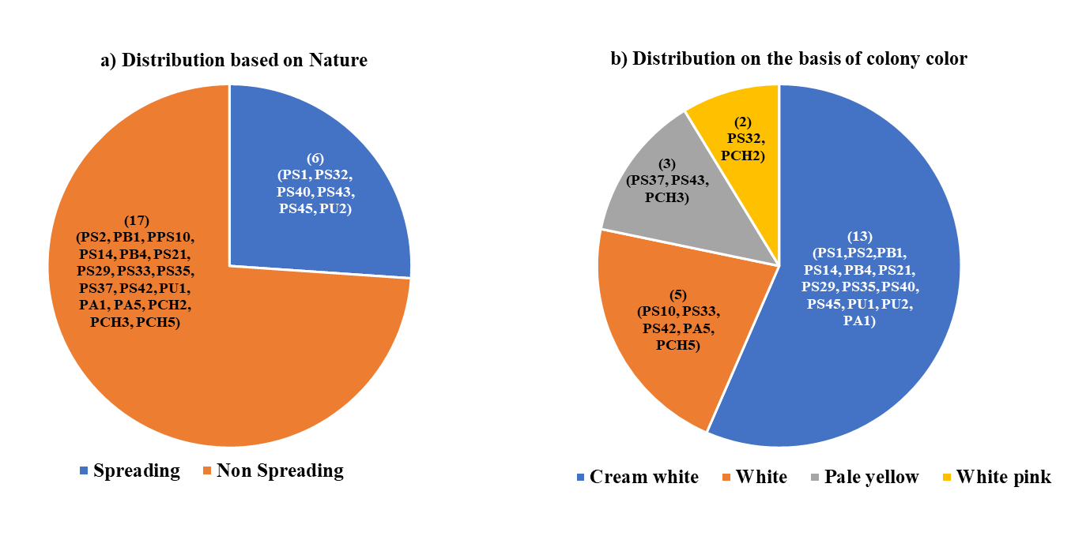
Fig. 2 Morphological characteristics of Pseudomonas isolates; a) Distribution based on spreading and non-spreading type; b) Distribution based on colony colour

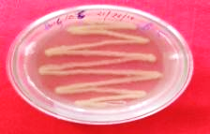
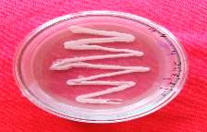
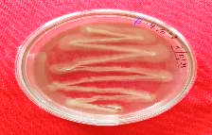
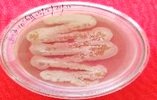
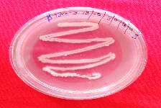
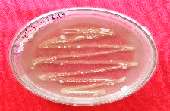
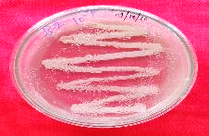
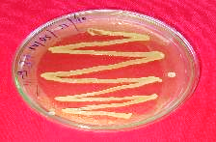
PCH3
PCH2
PS43
PB1
PS2
PU1
PB4
PS37

Fig. 3 Pure culture of Pseudomonas isolates producing slimy, white, cream white, pale yellow and white pink colonies on King’s B medium.















A
B
PCH3
PS2
PCH2
PB4
PS43
PS2
PCH3

PU1
PCH2
PU1

PS43
PB40

PS37
PB1
PB1
PS37
Fig. 4 Biochemical characterization of fluorescent Pseudomonas isolates; (A) KOH test, (B) Catalase test

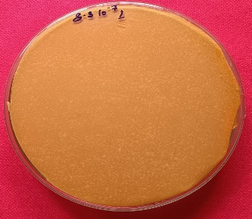
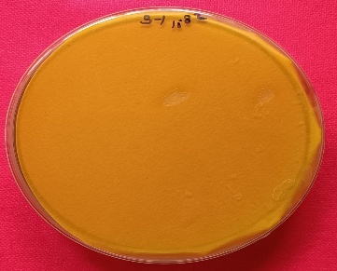
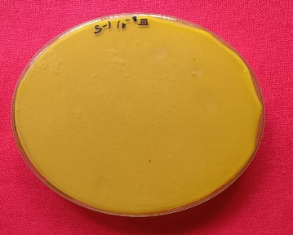
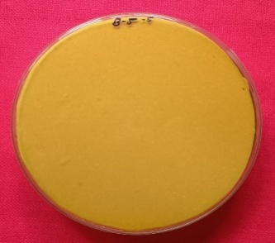
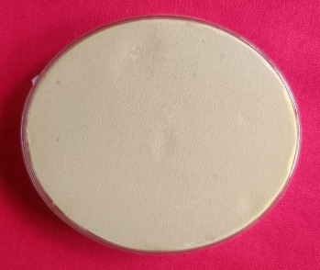
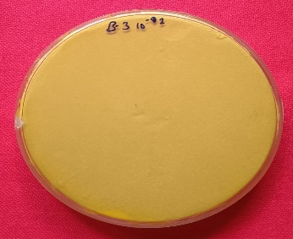
PB1
PB4
PS1
PS10
Control
PS10

Fig. 5 Evaluation of fluorescent Pseudomonas isolates for HCN production. Change of white coloured filter paper from yellow to orange indicates positive reaction.

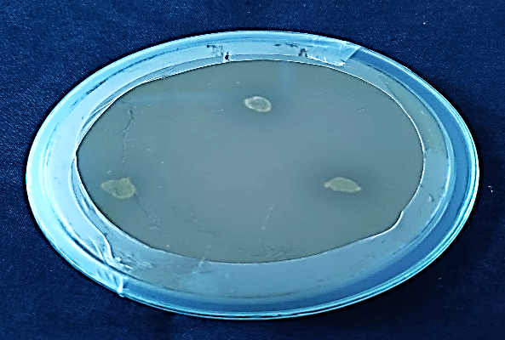
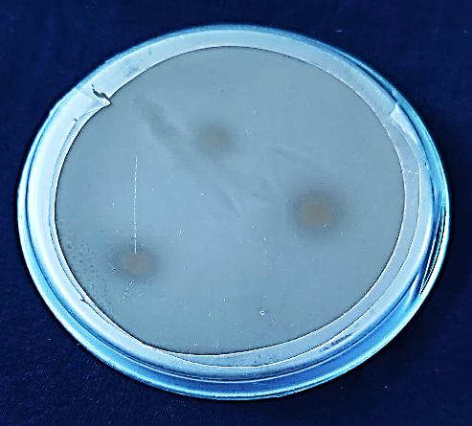
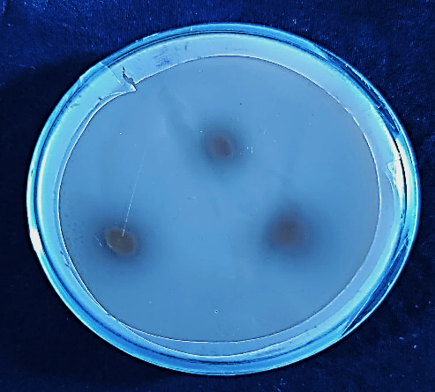
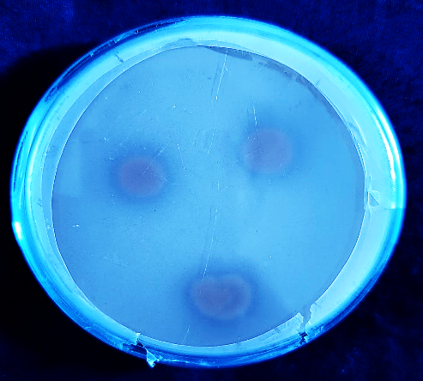
PB1
PB4
PS40
PS2

Fig. 6 Evaluation of fluorescent Pseudomonas isolates for phosphate solubilization on Pikovskaya's agar medium. A clear zone of solubilization around the bacterial growth indicates positive response

