Original Research Article

Seroprevalence of Hepatitis C Virus Among HIV-Infected Adults attending the Bamenda Regional Hospital in Cameroon: A Cross-Sectional Study

Abstract
Background: Hepatitis C virus (HCV) infection is a major cause of chronic liver disease worldwide and may substantially worsen outcomes in people living with HIV (PLHIV). Data on HIV/HCV co-infection in Cameroon particularly in the North West Region, are limited.
Aim: This study assessed the seroprevalence of HCV, comorbidities, liver enzyme abnormalities, and possible risk factors among HIV-infected adults attending the Bamenda Regional Hospital.
Methods: A hospital-based cross-sectional study was conducted among 132 HIV-positive adults. Sociodemographic, clinical, comorbidity, and behavioural data were collected using structured questionnaires. Participants were screened for anti-HCV antibodies using rapid diagnostic tests and confirmed with ELISA. Serum alanine aminotransferase (ALT) and aspartate aminotransferase (AST) levels were measured using a RANDOX MONACO automated biochemistry analyzer. Associations were assessed using appropriate statistical tests, with significance set at p<0.05.
Results: Two participants out of 132 HIV-positive adults screened were positive for HCV, hence, seroprevalence of HCV among HIV-infected participants was 1.5% (95% CI: 0.3–4.6). All HIV/HCV seropositive individuals were females aged ≥ 40 years. Mean AST levels were higher in HIV/HCV seropositive participants compared with HIV mono-infected individuals (105.0±13.4 U/L vs 95.9±39.5 U/L), while mean ALT levels were comparable between groups. However, these differences were not statistically significant (p > 0.05). No comorbidities or possible risk factors showed any significant association with HIV/HCV seropositivity.
Conclusions: HCV seroprevalence was low among HIV-infected adults in this setting, with no significant liver enzyme derangements or comorbidities detected. Routine HCV screening among people living with HIV and larger multicentre studies are necessary to guide policy and optimize care.

Keywords: HIV/HCV co-infection; seroprevalence; comorbidities; liver enzymes;

Introduction
Hepatitis C virus (HCV) and human immunodeficiency virus (HIV) infections are major global public health problems. An estimated 50 million people live with HCV infection worldwide, while approximately 40.8 million individuals are living with HIV (WHO, 2024; UNAIDS, 2024). This co-infection complicates disease management, enhances the risk of severe liver disease, and amplifies overall morbidity and mortality rates (Lu et al., 2026, Koziel and Peters, 2007). HIV is a retrovirus that primarily attacks the immune system, particularly CD4+ T cells, leading to progressive immunosuppression and the potential development of Acquired Immuno-deficiency Syndrome (AIDS). Without antiretroviral therapy (ART), HIV can lead to various opportunistic infections and cancers (Vidya Vijayan et al., 2017; Shaw and Matin 2022). Similarly, HCV, a member of the Flavivirus family, primarily affects the liver, often leading to chronic hepatitis, cirrhosis, and hepatocellular carcinoma (Kim and Chang 2013). HIV and HCV are both RNA viruses and share common transmission routes including parenteral exposure, sexual contact, and vertical transmission (Tovo et al., 2016). HIV infection accelerates the natural history of HCV through impaired immune control, resulting in higher HCV viral loads, more rapid progression to liver fibrosis and cirrhosis, increased risk of hepatocellular carcinoma, and higher liver-related mortality (Graham et al., 2015; Maggi P et al., 2015). The life expectancy among people living with HIV (PLHIV) has improved substantially, as a result of widespread access to antiretroviral therapy (ART), hence shifting morbidity and mortality towards non-AIDS-related conditions, particularly chronic liver disease (Grzeszczuk et al., 2015). Sub-Saharan Africa bears the highest burden of HIV infection, accounting for more than two-thirds of the global population of people living with HIV (UNAIDS, 2024). In Cameroon, adult HIV prevalence is estimated at 3.7%, with marked regional variation, disparities in awareness as well as access to ART and HCV treatment considerably impacting patient outcomes (Marceline et al., 2018). HCV prevalence and HIV/HCV co-infection rates vary widely across the country, ranging from negligible to over 7% depending on population and setting (Luma et al., 2016; Eboumbou et al., 2014). The rise of comorbidities with increased rates of progression to cirrhosis, liver disease, hepatocellular carcinoma, and eventually death are still a critical challenge (Munyemana et al., 2021). Additionally, elevated aspartate aminotransferase (AST) and alanine aminotransferase (ALT) levels and accelerated liver fibrosis progression has been reported among HIV/HCV co-infected patients as compared to HIV-mono-infected patients (Lu et al., 2026). Despite the clinical importance of co-infection, routine HCV screening among PLHIV remains inconsistently implemented due to financial and infrastructural constraints (Thomas et al., 2011). Local epidemiological data essential for guiding screening strategies and resource allocation are limited in the North West region of Cameroon. This study aimed to determine the seroprevalence of HCV among HIV-infected adults at the Bamenda Regional Hospital, assess possible comorbidities, selected liver enzyme levels, and identify potential risk factors for HIV/HCV co-infection.
Methods
Study design and setting
A hospital-based cross-sectional study was conducted with consecutive sampling from February to May 2025, at the Bamenda Regional Hospital, a major referral facility in the North West Region of Cameroon, providing comprehensive HIV care services. This hospital runs a large HIV treatment centre which caters to over 4,000 HIV patients coming for routine care, including follow-up by doctors and other health personnel. The hospital also runs many other specialized services that cut across the board.
Study population
The study included HIV-positive adults receiving antiretroviral therapy (ART), aged 21 years and above, attending the HIV clinic of the Bamenda Regional Hospital for routine follow-up visits during the study period. Eligible participants included any persons living with HIV aged 21 years and above, attending the HIV treatment centre of the Bamenda Regional Hospital. The simple random sampling approach was used to enrol eligible study participants. Every eligible participant had an equal chance to take part in the study provided their hospital records were complete and intact. Individuals who declined consent were excluded. Sample size for this study was determined using the single population proportion formula; n = [Z² x p(1-p)] / d² where Z = the desired confidence level, p = the expected prevalence from previous studies around Cameroon, and d = margin of error. A total of 132 eligible participants were consecutively enrolled during the study period from February to May 2025.
Data collection
Sociodemographic characteristics, clinical history, comorbidities, and potential risk factors previously known to be associated with HCV (including history of surgery, blood transfusion before 1992, alcohol consumption, circumcision, unprotected sex, tooth removal, sharing injections/needles, drawing tattoos and having skin piercings, working in healthcare settings, travel to countries with high HCV prevalence, family history of liver disease, and regular exercise) were captured using a structured questionnaire/data forms adapted from Munyemana et al. (2021) and pretested with 5% of the study sample size. Data on patients’ clinical history and comorbidities were abstracted from the hospital medical records of study participants. The clinic staff abstracted data from patients’ medical records and interviewed study participants to complete the forms.
Laboratory procedures
Venous blood samples (5 mL per participant) were collected by staff of the treatment centre under aseptic conditions into sterile EDTA and dry tubes. About 2 mL of serum was obtained from each dry tube after clotting while samples in the EDTA tubes were immediately centrifuged at 3000 x g for 15 minutes to obtain plasma. Sera and plasma samples were used on the same day of collection for analyses and remaining samples were stored at -20 °C. Anti-HCV antibodies were detected using the Anti-HCV Rapid Diagnostic Test kits (LabAcon®), and confirmed using the Accu-Tell® HCV ELISA Test Kit following the manufacturers’ instructions. Since antibody testing alone was done, active HCV infection could not be confirmed. Serum ALT and AST levels were measured using Randox ALT assay and AST assay kits (Randox Laboratories, Crumlin, UK) in a Randox Monaco automated biochemistry analyser (Randox Laboratories, Crumlin, UK) according to manufacturer’s instructions. A known control was run for each batch to ensure accuracy, and the reference ranges was noted according to the manufacturer’s manual. Internal quality controls were also ran at normal and abnormal levels, and calibration of the analyser was performed as well. The reference range for AST was: males < 40 U/L and females < 32 U/L. For ALT, it was: males < 44 U/L and females < 33 U/L.
Statistical analysis
Data were entered into a Microsoft Excel spread sheet, checked for completeness and coded. International Business Machine Statistical Software Package for Social Sciences (IBM SPSS) version 23 was used for analysis. Continuous variables were summarized as means ± standard deviations, while categorical variables were expressed as frequencies and percentages. Differences between subgroups for demographic characteristics such as the age, gender, marital status, occupation, education level and clinical characteristics like comorbidities were assessed using Fisher’s exact test. The mean AST and ALT liver enzyme levels for HIV/HCV seropositive and HIV mono-infected persons were compared using the Mann-Whitney U test. All tests were conducted at a 95% confidence level, with statistical significance set at p < 0.05.
Ethical considerations
This study was ethically cleared by an appropriate institutional review board. Ethical clearance (No. 2025/04/50/CERSH-NW) to carry out this study was issued by the North West Regional Ethics Committee for Human Health Research (CERSH), located at the Regional Delegation of Public Health in Bamenda, Cameroon. Additionally, an administrative authorization was also obtained from the Director of the hospital where participants were enrolled. The study was conducted in accordance with the Declaration of Helsinki. Participants voluntarily enrolled into this study after they had been educated on the study objectives, methods, risks and benefits using a participant information sheet. Written informed consent was obtained from all participants, and confidentiality was strictly maintained. Participants were enrolled at the HIV clinic only by the clinic staff, and all blood samples and data were collected by the staff of the HIV clinic. The data collected in this study was safely kept in a locker at the HIV clinic and only made available to the research team.

Results
General characteristics of study population
A total of 132 participants were enrolled into this study, out of which 103 (78%) were females and 29 (22%) were males. The distribution of participants according to their age group, gender, level of education, marital status, monthly family income, occupation and residence is shown in Table 1. The median age of participants was 52 years (IQR; 46 – 60.3) with the largest proportion of them (31.8%) in the age group 30 - 39 years.
Table 1: Sociodemographic characteristics of study participants
Variables | Categories | Frequency (n) | Percent (%)
Age group | 21 - 29 | 4 | 3.1
Age group | 30 - 39 | 9 | 6.8
Age group | 40 - 49 | 42 | 31.8
Age group | 50 - 59 | 37 | 28
Age group | 60 - 69 | 32 | 24.2
Age group | ≥ 70 | 8 | 6.1
Sex | Male | 29 | 22.0
Sex | Female | 103 | 78.0
Educational level | Primary | 91 | 68.9
Educational level | Secondary | 34 | 25.8
Educational level | Tertiary | 7 | 5.3
Marital status | Single | 20 | 15.2
Marital status | Married | 63 | 47.7
Marital status | Divorced | 6 | 4.5
Marital status | Widow/Widower | 43 | 32.6
Monthly family income | < 75,000 CFA | 54 | 40.9
Monthly family income | ≥ 75,000 CFA | 78 | 59.1
Occupation | Skilled workers | 11 | 8.3
Occupation | Unskilled workers | 121 | 91.7
Residence | Rural | 25 | 18.9
Residence | Urban | 107 | 81.1
Total |  | 132 | 100
Seroprevalence of HCV
Two participants (2/132) tested positive for anti-HCV antibodies, yielding a seroprevalence of 1.5%. The two participants with HIV/HCV seropositivity were females aged 40 years and above.
Liver enzyme levels
Mean AST levels were higher among HIV/HCV seropositive participants compared with HIV mono-infected individuals (p > 0.05), while the mean ALT levels were similar between these groups. The average AST enzyme level in HIV/HCV seropositive cases was 105 ± 13.36 U/L, while in HIV mono-infection cases, this was 95.93 ± 39.51 U/L (Fig 1). It was also observed that for both females and males, the mean AST values were higher than their normal ranges (F < 32 U/L and M < 40 U/L). When participants were grouped as HIV mono-infected or HIV/HCV seropositive individuals, the mean AST level was higher in the HIV/HCV seropositive group although this difference was not statistically significant (p = 0.48) (Figure 1).
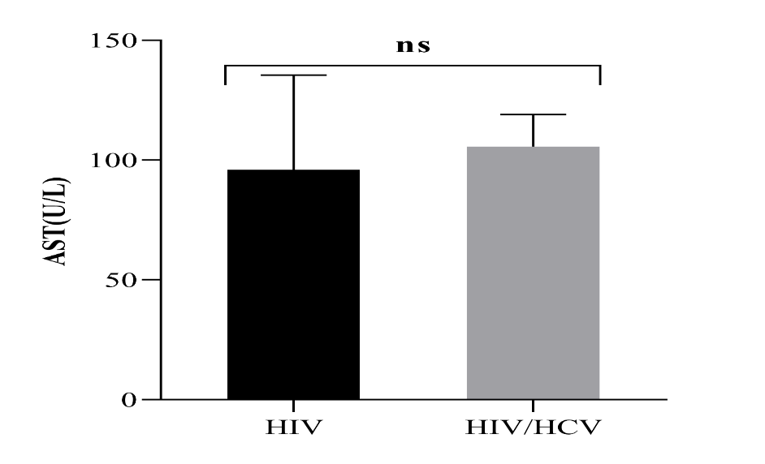
Fig 1: Serum AST levels of patients with HIV/HCV seropositivity and HIV mono-infection with error bars of standard deviation.
Serum ALT levels of patients with HIV/HCV seropositivity and HIV mono-infection
The average ALT enzyme level in HIV mono-infection cases was 30.66 ± 13.38 U/L, while in HIV/HCV seropositive cases, this average was 28.7 ± 3.96 U/L with no statistical significance observed between both groups (P > 0.05) (Figure 2). Females and males had mean ALT values of 29.9 U/L and 33.4 U/L respectively, which were within the normal ranges for each corresponding gender (F < 33 U/L and M < 44 U/L). No statistical difference was observed for mean ALT levels between both sexes (P > 0.05).
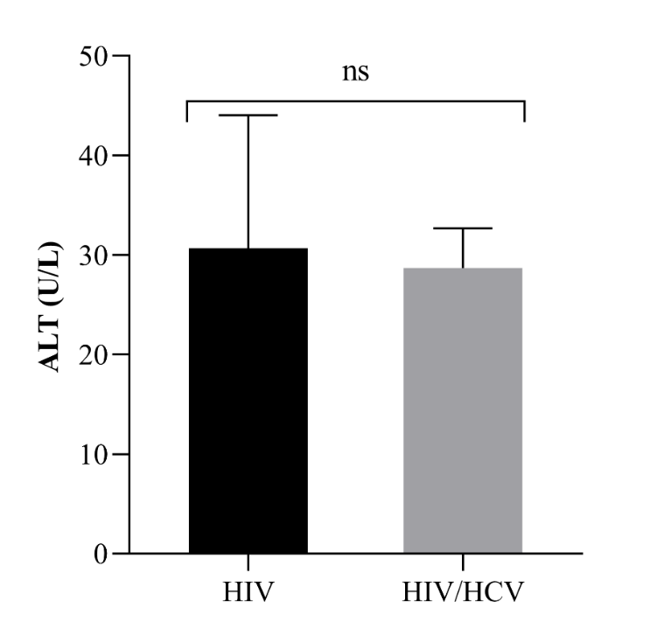
Fig 2: Serum ALT levels of patients with HIV/HCV seropositivity and HIV mono-infection with error bars of standard deviation
Assessment of potential risk factors of HIV/HCV seropositivity
Despite the fact that there were only 2 positive HIV/HCV seropositive cases, we decided to assess any potential risk factors for HIV/HCV seropositive. No statistically significant associations were observed with demographic factors like gender, age group, marital status, educational level, and occupation (p- values > 0.05).

Clinical and behavioural parameters related to HCV seropositivity among study participants
In this study, the two (1.5%) patients with HCV were currently on HIV medication. Other clinical and behavioural parameters related to HCV such as: history of surgery, blood transfusion before 1992, alcohol consumption, circumcision, unprotected sex, tooth removal, sharing injections/needles, drawing tattoos and having skin piercings, working in healthcare settings, travel to countries with high HCV prevalence, family history of liver disease, and regular exercise were also assessed (Table 2). Because the number of HIV/HCV seropositive cases in this study was too small (n = 2) making the statistical power to be extremely low, statistical associations between these parameters and HCV seropositivity could not be reliably assessed. However, Fisher’s exact test was still used due to the sparse data, and no statistically significant associations were observed (all p > 0.05).
Table 2: Clinical and behavioural parameters related to HCV among study participants
Variable | Categories | HCV Negative  n (%) | HCV Positive  n (%)
Currently on ARTs | Yes | 129(98.5) | 2(1.5)
Currently on ARTs | No | 1(100) | 0(0)
Any history of surgery | Yes | 39(97.5) | 1(2.5)
Any history of surgery | No | 91(98.9) | 1(1.1)
Alcohol consumption | Yes | 85(97.7) | 2(2.3)
Alcohol consumption | No | 45(100) | 0(0)
Circumcised | Yes | 25(100) | 0(0)
Circumcised | No | 105(98.1) | 2(1.9)
Received blood transfusion before 1992 | Yes | 27(96.4) | 1(3.6)
Received blood transfusion before 1992 | No | 103(99) | 1(1)
Unprotected sex | Yes | 52(100) | 0(0)
Unprotected sex | No | 78(97.5) | 2(2.5)
Tooth removed | Yes | 56(100) | 0(0)
Tooth removed | No | 74(97.4) | 2(2.6)
Sharing injections/needles | Yes | 8(100) | 0(0)
Sharing injections/needles | No | 122(98.4) | 2(1.6)
Tattooing or skin piercing | Yes | 5(100) | 0(0)
Tattooing or skin piercing | No | 125(98.4) | 2(1.6)
Working in healthcare setting | Yes | 40(97.6) | 1(2.4)
Working in healthcare setting | No | 90(98.9) | 1(1.1)
Travelled to country with high HCV prevalence | Yes | 3(100) | 0(0)
Travelled to country with high HCV prevalence | No | 127(98.4) | 2(1.6)
Family history of liver disease | Yes | 7(100) | 0(0)
Family history of liver disease | No | 123(98.4) | 2(1.6)

Assessment of comorbidities among study participants
Most participants had no documented chronic comorbidities as revealed by their hospital records. No statistically significant associations were observed (all Fisher’s exact p-values approximately = 1.000) in the prevalence of comorbid conditions between the very small number of HIV/HCV seropositive cases and the HIV mono-infected cases (Table 3).
Table 3: Comorbidities between HIV/HCV seropositive and HIV mono-infected patients
Variable | Categories | HIV mono-infected cases n (%) | HIV/HCV seropositive cases n (%)
Diabetes | Yes | 14(100) | 0(0)
Diabetes | No | 116(98.3) | 2(1.7)
Hypertension | Yes | 36(100) | 0(0)
Hypertension | No | 94(97.9) | 2(2.1)
Heart attack | Yes | 3(100) | 0(0)
Heart attack | No | 127(98.4) | 2(1.6)
Stroke | Yes | 7(100) | 0(0)
Stroke | No | 123(98.4) | 2(1.6)
Chronic skin disease | Yes | 10(100) | 0(0)
Chronic skin disease | No | 120(98.4) | 2(1.6)
Tuberculosis | Yes | 21(100) | 0(0)
Tuberculosis | No | 109(98.2) | 2(1.8)
Any other liver infections | Yes | 4(100) | 0(0)
Any other liver infections | No | 126(98.4) | 2(1.6)

Discussion
This study evaluated the seroprevalence of HCV, associated comorbidities and risk factors among HIV infected adults at the Bamenda Regional Hospital in the North West Region of Cameroon. Since we did not perform a method like quantitative PCR to actually confirm the presence of any HCV RNA after screening for total HCV antibodies, we could not report active HCV infection among participants. The overall seroprevalence of HIV/HCV seropositivity in this study was 1.5% (95%CI: 0.003 – 0.046) among HIV adults. This finding of a very low HCV prevalence is in line with a global systematic review that reported 2.4% HIV/HCV co-infection prevalence rates. Previous studies have reported varying HIV/HCV co-infection rates of 1.7% in the South West region of Cameroon (Agbor et al., 2018), 4.7% in Nigeria, (Nnakenyi et al., 2020) 8.6% in Ethiopia (Ayelign et al., 2021) 12.5% in Rwanda (Munyemana et al., 2021), 16.1% in Malaysia (Akhtar et al., 2022). These prevalence rates vary significantly depending on the geographic region and may be linked to lifestyle practices. The low prevalence observed in this study may reflect limited injection drug use, improvements in blood transfusion safety, and differences in dominant transmission pathways within the study population.
Seropositivity for both HIV and HCV in this study was observed exclusively among female participants aged 40 years and above. Reports from studies carried out in Rwanda showed higher co-infection prevalence in female subjects as compared to male subjects. However, reports from a study carried out in Malaysia showed higher prevalence in males participants compared to the females (Munyemana et al., 2021; Akhtar et al., 2022). These differences may be due to varying sample sizes, and geographical distribution of recruited participants. Increased age has interestingly been highlighted in previous studies as one of the factors which possibly influences HCV infection (Umutesi et al., 2017; Munyemana et al., 2021).
Although AST levels were higher among HIV/HCV seropositive participants, this difference was not statistically significant. Metabolic factors and medication side-effects could have contributed to the high AST levels. ALT levels were comparable between groups. The lack of significance may simply reflect the fact that there were only two HIV/HCV seropositive participants in our study. The small number of HCV seropositive cases in this study likely limited the statistical power to detect any significant differences. However, similar findings to ours have been reported in other African cohorts, where co-infected individuals often present with minimal or subclinical biochemical liver abnormalities (Munyemana et al., 2021). Contrary to these findings, elevated AST levels were reported among HIV/HCV co-infected participants as compared to HIV mono-infected individuals in a study carried out in Yaounde, Cameroon (Dobseu et al., 2020).
No significant associations were observed between HIV/HCV seropositivity and assessed comorbidities or behavioural risk factors in this study. A major limitation to this finding was the low number of positive cases which limited the statistical power. Contrarily, diabetes mellitus, hypertension, liver damage, renal failure, and active TB disease were some of the observed comorbidities in a study carried out in Rwanda, where the HIV/HCV co-infected group showed an increased risk of having comorbidities as compared to the group of HIV mono-infected individuals (Munyemana et al., 2021). The absence of such associations here may be attributable to early-stage infection, effective ART, or under diagnosis of subclinical disease. The emergence of comorbidities with an increased rate of progression to cirrhosis, decompensated liver disease, hepatocellular carcinoma, and death remains a critical challenge as far as global public health is concerned (Maggi et al., 2015; Koziel and Peters, 2007).
Despite the low prevalence identified in this study, co-infection with HIV and HCV remains clinically relevant due to its established association with accelerated liver disease progression and increased mortality (Chen et al., 2014; Debes et al., 2016). Integration of routine HCV screening into HIV care services is therefore warranted, particularly as access to direct-acting antiviral therapy expands.
This study is limited by its single-centre design and modest sample size, which may restrict generalizability. Another important limitation in this study is that antibody testing alone could not confirm active HCV infection. Additionally, possible risk factors for HIV/HCV co-infection were not identified probably due to the low statistical power of the positive HCV cases. Nevertheless, the study provides valuable baseline data for the North West Region of Cameroon and underscores the need for larger, multicentre studies.

Lay Summary
Hepatitis C viral antibodies were uncommon among adults living with HIV at the Bamenda Regional Hospital. The study did not find a clear difference in liver test results in HIV patients with and without hepatitis C. Regular hepatitis C testing in people living with HIV can help support early detection and long-term liver health.
Conclusions
HIV/HCV seroprevalence was low among HIV-infected adults attending the Bamenda Regional Hospital in Cameroon, with no significant liver enzyme abnormalities or possible comorbidities identified, most likely limited by the low statistical power from the very few HCV positive cases. A large-scale multi-center study is needed to better estimate nation-wide prevalence rates. Continued integration of HCV screening into routine HIV care, and expanded surveillance are highly recommended.
CONSENT
Written informed consent was obtained from all participants, and confidentiality was strictly maintained.
ETHIC APPROVAL
Ethic approval was carried out Ethical clearance (No. 2025/04/50/CERSH-NW) was issued by the North West Regional Ethics Committee for Human Health Research (CERSH), located at the Regional Delegation of Public Health in Bamenda, Cameroon.

Data availability statement
The data supporting the findings of this study are not publicly available because of ethical and privacy restrictions related to participant confidentiality, but are available from the corresponding author on reasonable request.

Disclaimer (Artificial intelligence)

Author(s) hereby declare that NO generative AI technologies such as Large Language Models (ChatGPT, COPILOT, etc.) and text-to-image generators have been used during the writing or editing of this manuscript.

References
Agbor, V. N., Tagny, C. T., Kenmegne, J. B., Awazi, B., Ngansop, C., Mbanya, D., & Ndembi, N. (2018). Prevalence of anti-hepatitis C antibodies and its co-infection with HIV in rural Cameroon. BMC research notes, 11(1), 459. https://doi.org/10.1186/s13104-018-3566-4
Akhtar, A., Fatima, S., Saeed, H., Soo, C. T., & Khan, A. H. (2022). HIV-HCV Co-infection: Prevalence and Treatment Outcomes in Malaysia. Intervirology, 65(2), 87–93. https://doi.org/10.1159/000518836
Ayelign, M., Aynalem, M., & Berhane, N. (2021). Hepatitis and HIV Co-infection at University of Gondar Specialized Referral Hospital: Northwest Ethiopia. Hepatic medicine: evidence and research, 13, 113–120. https://doi.org/10.2147/HMER.S337817
Chen, J. Y., Feeney, E. R., & Chung, R. T. (2014). HCV and HIV co-infection: mechanisms and management. Nature reviews Gastroenterology & Hepatology, 11(6), 362-371. https://doi.org/10.1038/nrgastro.2014.17
Debes, J. D., Bohjanen, P. R., & Boonstra, A. (2016). Mechanisms of accelerated liver fibrosis progression during HIV infection. Journal of Clinical and Translational Hepatology, 4(4), 328.
Dobseu, R., Nanfack, A., Kowo, M., Ambada, G., Kamgaing, R., Chenwi, C., Fainguem, N., Ka'e, A., Ngangoum, E., Sosso, S., Tchiegang, C., & Ndjolo, A. (2020). Evaluation of hepatic fibrosis in HIV/HCV co-infected individuals in Yaoundé, Cameroon: usefulness of APRI score in resource-constrained settings. BMC infectious diseases, 20(1), 758. https://doi.org/10.1186/s12879-020-05477-7
Eboumbou Moukoko, C. E., Ngo Sack, F., Essangui Same, E. G., Mbangue, M., & Lehman, L. G. (2014). HIV, HBV, HCV and T. pallidum infections among blood donors and Transfusion-related complications among recipients at the Laquintinie hospital in Douala, Cameroon. BMC hematology, 14(1), 5. https://doi.org/10.1186/2052-1839-14-5
Grzeszczuk, A., Wandalowicz, A. D., Jaroszewicz, J., & Flisiak, R. (2015). Prevalence and Risk Factors of HCV/HIV Co-Infection and HCV Genotype Distribution in North-Eastern Poland. Hepatitis monthly, 15(7), e27740. https://doi.org/10.5812/hepatmon.27740v2
Kim, C. W., & Chang, K. M. (2013). Hepatitis C virus: virology and life cycle. Clinical and molecular hepatology, 19(1), 17–25. https://doi.org/10.3350/cmh.2013.19.1.17
Koziel, M. J., & Peters, M. G. (2007). Viral hepatitis in HIV infection. New England Journal of Medicine, 356(14), 1445-1454.
Lu, L., Zhou, C., Qi, X., Wang, L., Hu, T., Chen, F., Han, C., Li, H. & Zhou, X. (2026). Hepatitis B virus or (and) hepatitis C virus infection promotes hepatic fibrosis in HIV/AIDS patients in Jiangxi, China. Journal of Clinical Virology Plus, p.100248.
Luma, H. N., Eloumou, S. A., Ekaney, D. S., Lekpa, F. K., Donfack-Sontsa, O., Ngahane, B. H., & Mapoure, Y. N. (2016). Sero-prevalence and Correlates of Hepatitis B and C Co-infection Among HIV-infected Individuals in Two Regional Hospitals in Cameroon. The open AIDS journal, 10, 199–208. https://doi.org/10.2174/1874613601610010199
Maggi, P., Altizio, S., DI Biagio, A., Nicolini, L., Volpe, A., Tancorre, T., Leone, A., Bellacosa, C., Ladisa, N., & Angarano, G. (2015). Prevalence and Risk Factors for Significant Liver Fibrosis in Patients with HIV Infection. In vivo (Athens, Greece), 29(6), 771–775.
Marceline, D. N., Marlene, G. T. I., Cyriaque, A. A., Armelle, F. K. G., & Moundipa, F. P. (2018). Current status of human immunodeficiency virus and hepatitis C virus (HIV/HCV) co-infection in Cameroon: Sero-prevalence, risk factors and correlation with markers of liver function and CD4 cells rate in patients diagnosed in three hospital settings. Journal of AIDS and HIV Research, 10(3), 22-30. https://doi.org/10.5897/JAHR2017.0456
Matthews, P. C., Geretti, A. M., Goulder, P. J., & Klenerman, P. (2014). Epidemiology and impact of HIV co-infection with hepatitis B and hepatitis C viruses in Sub-Saharan Africa. Journal of clinical virology, 61(1), 20-33.
Munyemana, J. B., Mukanoheli, E., Nsabimana, T., & Niringiyumukiza, J. D. (2021). HCV Seroprevalence among HIV Patients and Associated Comorbidities at One Primary Health Facility in Rwanda. The American Journal of Tropical Medicine and Hygiene, 104(5), 1747–1750. https://doi.org/10.4269/ajtmh.20-0500
Nnakenyi, I. D., Uchechukwu, C., & Nto-Ezimah, U. (2020). Prevalence of hepatitis B and C virus co-infection in HIV positive patients attending a health institution in southeast Nigeria. African health sciences, 20(2), 579–586. https://doi.org/10.4314/ahs.v20i2.5
Shaw, J., & Matin, N. (2022). Opportunistic infections in HIV. Medicine, 50(5), 294-297.
Thomas, D. L., Leoutsakas, D., Zabransky, T., & Kumar, M. S. (2011). Hepatitis C in HIV-infected individuals: cure and control, right now. Journal of the International AIDS Society, 14, 22. https://doi.org/10.1186/1758-2652-14-22
Tovo, P. A., Calitri, C., Scolfaro, C., Gabiano, C., & Garazzino, S. (2016). Vertically acquired hepatitis C virus infection: Correlates of transmission and disease progression. World journal of gastroenterology, 22(4), 1382–1392. https://doi.org/10.3748/wjg.v22.i4.1382
Umutesi, J., Simmons, B., Makuza, J. D., Dushimiyimana, D., Mbituyumuremyi, A., Uwimana, J. M., Ford, N., Mills, E. J., & Nsanzimana, S. (2017). Prevalence of hepatitis B and C infection in persons living with HIV enrolled in care in Rwanda. BMC Infectious Diseases, 17(1), 315. https://doi.org/10.1186/s12879-017-2422-9
UNAIDS 2024; Global HIV & AIDS statistics — Fact sheet. accessed March 2025 https://www.unaids.org/en/resources/fact-sheet
Vidya Vijayan, K. K., Karthigeyan, K. P., Tripathi, S. P., & Hanna, L. E. (2017). Pathophysiology of CD4+ T-Cell Depletion in HIV-1 and HIV-2 Infections. Frontiers in immunology, 8, 580. https://doi.org/10.3389/fimmu.2017.00580
WHO, Global Hepatitis C report 2024, accessed March 2025 https://www.who.int/news-room/fact-sheets/detail/hepatitis-c

