Spatio-Seasonal Distribution of Water Quality Parameters and Heavy Metals in Plankton along the Mangaluru Coast, Southeastern Arabian Sea

Abstract
Aquatic ecosystems are increasingly polluted by heavy metals due to urbanisation, industrialisation, and poor waste management, especially in coastal regions. These metals accumulate in plankton and marine food chains, causing ecological damage and posing serious risks to human health through bioaccumulation and biomagnification. The current study examined the relationship between heavy metal accumulation in plankton and the physicochemical properties of coastal waters throughout a one-year period, from February 2024 to January 2025. The levels of selected heavy metals (Iron, Nickel, Zinc, Lead, Cadmium, Copper, Mercury, and Arsenic) were determined in plankton collected from six sites along the Mangaluru coast using an Atomic Absorption Spectrophotometer (AAS), the Thermo Scientific iCE 3300 series. The physicochemical indices of water quality, as well as heavy metal concentrations, varied dramatically among seasons and sites. The concentration of metals in plankton was in the same order: Fe > Zn > Ni > Cu > Pb > As > Cd > Hg. Throughout the monsoon season, Fe was the most prevalent metal, with a maximum concentration of 41.42 ± 10.54 µg g⁻¹ at station S1. In contrast, Cd and Hg had relatively lower quantities, with Hg remaining undetectable throughout the pre-monsoon. Ni, Pb, Hg, and As showed significant seasonal fluctuations (p < 0.05), whereas Fe, Ni, Pb, and Cu showed significant geographical differences. The study underlines the necessity of ongoing monitoring of coastal ecosystems throughout the Mangaluru coast and underscores the impact of anthropogenic inputs and monsoon-driven processes on heavy metal dynamics.
Keywords: Bioaccumulation, Coastal pollution, Heavy metals, Mangaluru coast, Plankton, Seasonal variation, Water quality.
- Introduction
Aquatic ecosystem contamination is acknowledged as a major environmental issue. Aquatic pollution has been seen as a major hazard to the environment and the world. However, the water quality of aquatic resources has drastically decreased due to the fast expansion of urbanisation and industrialisation as well as inadequate sewage disposal methods, endangering the socioeconomic development of countries (Divakaran et al., 2025). Coastal areas sustain varied and productive marine ecosystems, which are vital sources of food and revenue for local communities worldwide. However, due to numerous human activities, these places rapidly deteriorate (Chevrollier et al., 2022). From an environmental, economic, and public health standpoint, metal pollution poses a threat to marine ecosystems, especially in areas like the Mangaluru coastal area where local populations depend on marine resources. Seafood may get contaminated by metals that enter the marine food system through plankton. Phytoplankton and zooplankton make up plankton, which are essential to marine food webs and biogeochemical cycles and are important markers of ocean health. They create various ocean regimes, support marine life, and promote primary productivity (Chowdhury et al., 2026). Both humans and the natural ecology are severely harmed by heavy metal pollution. Certain heavy metals have the potential to change into very hazardous persistent metal complexes. Additionally, these heavy metals build up in living things, get into the food chain, and eventually have an impact on human health. Because of their traits including persistence, high toxicity, and bioaccumulation, heavy metals become significant pollutants once they get into rivers, seas, or aquatic ecosystems (Li et al. 2020; Widiastuti et al., 2023). Fish and zooplankton are vital parts of aquatic food webs in these habitats, making substantial contributions to biogeochemical processes and ecological equilibrium. Toxic metals like mercury, cadmium, and lead accumulate in aquatic species, including fish, crustaceans, and plankton, through sediments, soil erosion, air deposition, and wastewater, posing serious ecological and health risks as they bio-magnify through the food chain (Ngoc et al., 2020). Because plankton is frequently the only food source for many predators and may significantly aid in the transmission of heavy metals to higher trophic levels, assessing the amounts of heavy metals in plankton is crucial (Bahnasawy et al., 2011). The current study aims to assess the connection between heavy metal buildup in plankton along the Mangaluru coast and the physicochemical characteristics of coastal waters.
- Materials and methods
  - Study Area
To evaluate the seasonal fluctuation in heavy metal accumulation in plankton and physico-chemical characteristics during a one-year period from February 2024 to January 2025, six sample stations were logically identified along the coastal waters off Mangaluru. The Fisheries College, Mangalore vessel, R.T.V. Nethravathi, was used to collect samples at each station. The stations were chosen based on their ecological importance, the extent of human impact, and their proximity to industrial processes, urban outfalls, and estuary discharges. All sample stations' geographic locations (latitude and longitude) are shown in Table 1 and Fig. 1. Station 1 (S1), a dynamic estuary mixing zone influenced by tidal exchange and riverine inputs, is situated close to the confluence of the Netravathi and Gurupura rivers. Estuary mixing and nearby fishing harbor activities have an influence on Station 2 (S2), which is situated off Bengre. The coastal waters surrounding Thannirbhavi, an area known for recreational activities and minimal human participation, are monitored by Station 3 (S3). The coastal region off Panambur, close to the New Mangalore Port Trust, is represented by Station 4 (S4), which is strongly impacted by the maritime and industrial sectors. Station 5 (S5) was situated between residential and small-scale industrial areas off the coast of Chitrapura. Although Station 6 (S6) was situated north of major port activities off the coast of Surathkal, it was never exposed to coastal currents or urban runoff.
Table 1. Geographical Coordinates and Locations of Sampling Stations.
Station | Latitude | Longitude | Area of Location
S1 | 12°50’41” N | 74°49’39” E | Netravathi-Gurupura bar mouth region
S2 | 12°51’46” N | 74°48’25” E | Coastal waters off Bengre
S3 | 12°53’18” N | 74°48’03” E | Coastal waters off Thannirbhavi
S4 | 12°56’14” N | 74°47’28” E | Coastal waters off Panambur
S5 | 12°57’19” N | 74°47’17” E | Coastal waters off Chitrapura
S6 | 12°59’37” N | 74°46’48” E | Coastal waters off Surathkal

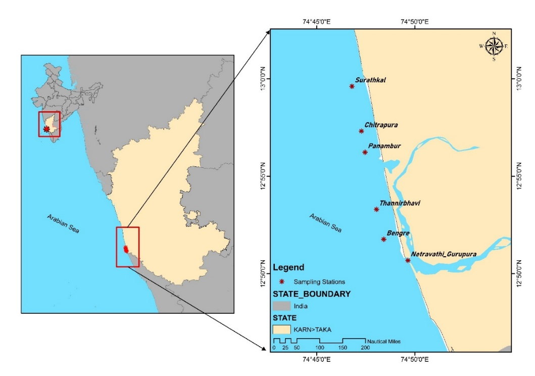
Fig. 1. Map of the Study Area and Sampling Stations
  - Sample Collection and Preparation
A total of three samplings were carried out in the present study on a seasonal basis: pre-monsoon, monsoon, and Post-monsoon to understand the basic water quality characteristics and heavy metals accumulation in plankton. Both surface and subterranean water quality measures were examined. To depict the general state of the water column, mean values were also computed. Using a plankton net (mesh size: 55μm), samples of plankton (zoo- and phytoplankton) were taken by vertical hauls from the top layer of 10 cm. Plankton samples that had been filtered were acidified with HCl and stored for analysis. Plankton samples were prepared for heavy metal analysis according to the method described by Kalay et al. (1999).
  - Analysis
An aquatic ecosystem's health depends on both biodiversity and the often-shifting physico-chemical characteristics of the water system. The water temperatures were recorded immediately after the collection using a standard mercury centigrade thermometer, and Mohr's method was followed for the determination of salinity in the water sample (Strickland and Parsons, 1972). The pH of water samples from different sampling stations was estimated using a EUTECH digital pH meter 700, and Winkler's method (Strickland and Parsons, 1972) was followed for estimation of DO. The Nitrate-N, Silicate-Si and Phosphate-P were estimated following standard methods described by Strickland and Parsons (1972). Absorbance of the developed colour was read using Spectronic 21 with a 1 cm path length cuvette. Standard methods were used for the estimation of water quality parameters (APHA, 2005).
The concentration of Heavy Metals (Iron, Nickel, Zinc, Lead, Cadmium, Copper, Mercury and Arsenic) in plankton was determined by using an Atomic Absorption Spectrometer (AAS); Thermo Scientific iCE 3300 series Atomic Absorption Spectrophotometer (AAS). Pearson's correlation between the concentration of different heavy metals in plankton and water quality parameters was evaluated statistically using the correlation coefficient by SPSS computer software package. Two-way ANOVA was employed to find the significant differences in heavy metal concentrations in plankton among sites and seasons. The significance was set at 0.05.
- Results and Discussion
  - Seasonal Variation of Physicochemical Parameters
Temperature
The intensity of incoming solar radiation, evaporation, freshwater influx and cooling, and mixing with the ebb and flow from adjacent neritic seas are the main variables affecting the surface water temperature (Divakaran et al., 2025). As anticipated, the dry and rainy seasons had the greatest and lowest water temperatures, respectively. The pre-monsoon season had the highest water temperature (28.49 ± 1.48°C to 29.21 ± 0.57°C), followed by the post-monsoon (28.13 ± 0.79°C and 28.62 ± 0.50°C), and the monsoon season (28.13 ± 0.79°C and 28.62 ± 0.50°C) (Fig.2) which is quite similar to the trend noted in the previous findings by Kavitha (2019), Nandan (2022) and Narshivudu (2023) at Mangalore coast. Station 5 had the greatest temperature (28.94 ± 0.77°C) and Station 1 had the lowest (28.16 ± 0.24°C) throughout the pre-monsoon season (Fig 1). The lowest temperature of 28.13°C was recorded at Stations 2 and 4 during the monsoon season, most likely due to freshwater inflow and increasing cloud cover. Station 5 had the greatest temperature (28.94 ± 0.77°C), and Station 1 had the lowest (28.16 ± 0.24°C) during the post-monsoon season. The seasonal southwest monsoon was responsible for the monsoon period's lowest water temperature. The strong land-sea wind and the corresponding underwater currents of the water bodies are the causes of the lower value in the post-monsoon period. Intense sun radiation may have a good contribution to the highest value during the pre-monsoon period (Rathore et al., 2022; Manickam et al., 2018).

Fig. 2. Seasonal variation in water temperature at the study stations.
Salinity
One significant abiotic factor affecting aquatic organisms' physiology is salinity (Rocker et al., 2026). Anthropogenic activities are the most significant factor influencing salinity. In the pre-monsoon season, salinity levels were greater, ranging from 26.99 ± 0.89 PSU (S1) to 35.33 ± 0.78 PSU (S6). In the post-monsoon season, salinity values rose once again, ranging from 28.80 ± 2.54 PSU (S1) to 33.44 ± 3.15 PSU (S5). While not all stations reported full restoration, the majority did show a return to pre-monsoon levels. Salinity dropped dramatically at every station during the monsoon season, ranging from 28.71 ± 1.74 PSU (S1) to 31.12 ± 2.42 PSU (S6) (Fig. 3). High rainfall rates, freshwater influx, river discharge, and surface runoff all contribute to the dilution of saltwater during the monsoon season. On the other hand, an increase in salinity was triggered longitudinally during the non-monsoon season due to excessive evaporation, decreased freshwater intake, and enhanced tidal effect (Ruciński et al., 2026). Alkawri and Ramaiah (2010), Chethan (2012), Madhavi (2014), Sulochanan et al. (2019), and Kavitha (2019) saw a similar trend in salinity readings in several areas of India's southwest coast. The bar-mouth section of the River Netravathi-Gurupura, or S1, was regularly found to have the lowest salinity and was shown to be significantly impacted by freshwater intrusion. Similar observations were also reported by Narshivudu (2023) in the bar-mouth area of the River Netravathi-Gurupura of the same study area.

Fig. 3. Seasonal variation in water salinity at the study stations.
pH
pH is vital for aquatic life because it governs chemical reactions and influences the solubility and bioavailability of many substances such as metals, nutrients, and other compounds in aquatic systems (Ahamad et al., 2026). The present study accounts for the pH during the pre-monsoon season; values ranged from 7.08 ± 0.57 (S3) to 7.42 ± 0.42 (S5). Further, the highest pH was during the post-monsoon season; pH values showed a noticeable increase, ranging from 7.76 ± 0.33 (S1) to 8.25 ± 0.62 (S6). Most stations recorded higher pH values (>8.0), which can be well correlated to the high photosynthetic activity, including the bicarbonate degradation by carbonic anhydrase, leading to the removal of CO₂ from water (Abubakari et al., 2026). In the monsoon season, pH values varied between 7.18 ± 0.37 (S1) and 7.65 ± 0.74 (S4) (Fig. 4), a slight fluctuation in pH was observed compared to the pre-monsoon season, which may be attributed to freshwater influx, organic matter input, and increased microbial activity during the monsoon (Raj et al., 2026). Similar seasonal trends were reported by Satpathy et al. (2010), who observed a pH range of 7.8 to 8.2 in Kalpakkam coastal waters, east coast of India, during southwest to northeast monsoon. Nobi et al. (2010) reported pH values ranging from 7.7 to 8.6 in different coastal areas of Andaman Islands, India. Fernandes et al. (2012) observed pH values between 7.14 and 8.39 along the Mumbai coast, while Venkateswarlu et al. (2019) observed a range of 7.67 to 7.88, which corroborated the high rate of photosynthesis by dense phytoplankton blooms. Nandan (2022) documented pH values of 7.6 to 8.2 in the coastal water of Panambur and Thannirbhavi. Narshivudu (2023) reported that the pH of water ranged from 7.23 to 8.62 with a variation of 1.39 in the same study area.
Fig. 4. Seasonal variation in water pH at the study stations.
DO
Aquatic biodiversity, nutrient biogeochemistry, and greenhouse gas emissions all depend on dissolved oxygen (DO), a measure of a body of water's health (Rajalekshmi et al., 2026). Seasonal variations were observed in dissolved oxygen (DO) levels, which ranged from 7.06 ± 1.72 mg/L (S3) to 8.21 ± 2.15 mg/L (S2) in the premonsoon season, 8.21 ± 1.23 mg/L (S5) to 8.99 ± 1.57 mg/L (S6) in the monsoon season, and 8.21 ± 1.23 mg/L (S5) to 8.99 ± 1.57 mg/L (S6) in the post-monsoon season (Fig. 5). Elevated DO concentrations during the monsoon season may result from the combined effects of rising wind speeds, rainfall, and freshwater mixing (Bharthi et al., 2017). High salinity and temperature may be linked to the low DO content observed in the late post-monsoon (Prashanth, 2010; Lallu et al., 2022; Lingadhal et al., 2023). Satpathy et al. (2010) reported that the DO values ranged between 3.3 and 7.1mg/L of coastal waters of Kalpakkam, southeast coast of India. Similarly, Pitchaikani et al. (2010) reported the DO levels in the range of 3.7 and 6.1 mg/l along Tuticorin coastal waters, south east coast of India. Andrade et al. (2011) found the DO levels ranging from 2.60 to 7.30 mg/L in coastal waters of Mangalore.
Fig. 5. Seasonal variation in water dissolved oxygen at the study stations.
Nitrate-Nitrogen
The most oxidised and thermodynamically stable form of nitrogen in the aquatic environment is nitrate (Zhang et al., 2026). Nitrate–nitrogen concentrations varied from 2.72 ± 0.28 µg-at/L (S6) to 4.56 ± 1.63 µg-at/L (S1) over the pre-monsoon season. Nitrate concentrations varied somewhat over the monsoon season, ranging from 2.86 ± 0.42 µg-at/L (S2) to 3.79 ± 0.47 µg-at/L (S1) and 3.78 ± 1.20 µg-at/L (S6). Nitrate–nitrogen concentrations decreased considerably in all sites throughout the post-monsoon season, ranging from 1.25 ± 0.82 µg-at/L (S6) to 3.41 ± 1.25 µg-at/L (S1) (Fig. 6). The findings show that the pre-monsoon and monsoon seasons had comparatively greater nitrate-nitrogen concentrations, whereas the post-monsoon season had the lowest values. Freshwater inflow and nutrient-rich runoff from the Netravathi-Gurupura estuary system during the peak monsoon season may have directly contributed to the maximum concentration observed in the current investigation at station S1 in July 2025. Nitrates in these aquatic bodies are likely to come from complicated industrial effluents, fertiliser inputs, and domestic sewage discharge composites (Divakaran et al., 2025). During the monsoon season, freshwater input, terrestrial runoff, and organic decomposition all contribute to the elevated nitrate levels (Ali et al., 2026). In a comparable research location, Narshivudu (2023) reported nitrate concentrations ranging from 0.15 to 4.25 µg-at NO3-N/l and whilst Nandan (2022) reported nitrate concentrations ranging from 1.05 to 10.70 μg-at/l, which was quite higher than the current findings.
Fig. 6. Seasonal variation in water nitrate-nitrogen at the study stations
  - Seasonal Distribution of Heavy Metals in Plankton
The accumulation of heavy metals in plankton emphasises how important they are as useful "bioindicators" of pollution along the shore (Madunil and Wijesinghe, 2025). Since plankton is the base of the marine food chain, the buildup of metals like Pb, Ni, and As can have negative effects, including biomagnification at higher trophic levels and possible health concerns to people and fish. There was significant spatiotemporal variation in the content of heavy metals in plankton between sites along the Arabian Sea coast close to Mangaluru. Fe had the greatest quantities of any metal examined, whereas Cd and Hg were consistently low, and Hg was not detected (ND) during the pre-monsoon season (Table 2). Iron (Fe) was the most abundant metal among all analysed elements. Higher concentrations were recorded during the monsoon and post-monsoon seasons, particularly at stations S1 and S4. For instance, Fe reached its maximum value of 41.42 ± 10.54 µg/g at station S1 during the monsoon, while the lowest value (6.71 ± 4.71 µg/g) was recorded at S5 during the pre-monsoon (Fig. 7a). Similarly, Zn exhibited elevated concentrations during the monsoon, with a maximum of 30.21 ± 21.72 µg/g at S1, whereas the lowest concentration (10.77 ± 10.52 µg/g) occurred at S5 during pre-monsoon (Fig. 7b). The observed concentration of Fe was slightly higher than those reported by Nayak (2015), but markedly lower compared to the findings of Rejomon et al. (2008), who recorded Fe levels ranging from 1125.2 to 50999.3 µg/g in zooplankton from the western Bay of Bengal. In parallel, Arunpandi et al. (2020) found Zn concentrations ranging from 10.1 to 47.3 µg/g in zooplankton in Kochi backwaters in the south-west coast of India. Chinnaraja et al. (2015) detected Zn levels in plankton from Cuddalore coast of Tamil Nadu in the range of 2.85 to 118.25 ppm. Nickel showed a distinct decreasing trend from pre-monsoon to post-monsoon, with the highest value (6.68 ± 8.55 µg/g at S1 during pre-monsoon) (Fig. 7c) and extremely low concentrations during post-monsoon, including 0.02 ± 0.04 µg/g at S1, and ND at S5, indicating strong seasonal dilution effects. Rejomon et al. (2008) reported Ni in planktons ranging between 15.1 and 66.5 ppm in the western Bay of Bengal. Achary et al. (2017) observed average Ni concentration varied from 10.4 to 52.3 mg/kg in zooplankton from nearshore coastal water of Kalpakkam. Lead (Pb) exhibited marked variability, with the highest concentration (5.77 ± 2.93 µg/g at S1 during post-monsoon) and comparatively lower levels during monsoon (0.34–1.12 µg/g range across stations) (Fig. 7d), suggesting both seasonal input and dilution patterns. Chinnaraja et al. (2015) recorded the Pb concentration range between 0.1 and 1.6 ppm in zooplankton from coastal waters off Cuddalore in Tamil Nadu. Cadmium (Cd) remained low across all stations and seasons, with the maximum value (0.83 ± 0.15 µg/g at S3 during monsoon) (Fig. 7e) and several near-zero values during post-monsoon. Copper concentrations peaked during the monsoon, with a maximum of 6.83 ± 5.07 µg/g at S1, while the lowest values (0.91 ± 0.55 µg/g) were observed at S6 during post-monsoon (Fig. 7f). Mercury was absent during the pre-monsoon but appeared in low concentrations during monsoon and post-monsoon, with the highest value (0.20 ± 0.07 µg/g at S1 during post-monsoon) (Fig. 7g). Arsenic showed comparatively higher values during monsoon, reaching a maximum of 1.14 ± 0.56 µg/g at S1, while the lowest concentration (0.11 ± 0.02 µg/g) was recorded at S6 during pre-monsoon (Fig. 7h).
The sequence of the heavy metal bioaccumulation trend in plankton was Fe > Zn > Ni > Cu > Pb > As > Cd > Hg. In line with earlier coastal research works, this trend emphasises the dominance of critical trace metals over harmful and non-essential elements. Nandan (2022) and Nayak (2015) also reported dominance of trace metals over non-essential elements, with the accumulation pattern showing Cu > Zn > Ni > Pb > Cd in the study area. Santhanam (2011) reported findings fairly close to the current investigation, with the accumulation pattern Zn > Co > Ni > Pb > Cd supporting the present findings. Ismail and El Zokm (2023) reported very close to current findings with similarity in values as well as in accumulation pattern with Fe > Zn > Pb > Cu > Mn > Cd in Alexandria coast, Egypt. El-Metwally et al. (2022) observed heavy metal patterns in the sequences: Fe > Zn > Cu > Mn > Ni > Pb > Cd > Co, especially in zooplankton from the Hurghada coast, emphasising the predominance of Fe and Zn. Santhanam (2011) reported an accumulation trend of heavy metals mainly Zn > Co > Ni > Pb > Cd in plankton along the Coromandel coast, south-east coast of India. Achary et al. (2017) observed Fe > Zn > Mn > Pb >Cr > Cu > Ni > Cd> Co in zooplankton from coastal waters of Kalpakkam, southeast coast of India.
Statistical analysis revealed that Ni, Pb, Hg, and As exhibited significant seasonal variation (p < 0.05), highlighting the strong influence of seasonal hydrological processes such as runoff, freshwater influx, and sediment resuspension. In contrast, Fe, Zn, Cd, and Cu did not show significant seasonal differences (p > 0.05). Spatially, Fe, Ni, Pb, and Cu showed significant variation (p < 0.05) among stations, indicating localised sources of contamination. Stations S1 and S2 consistently recorded higher metal concentrations, whereas S5 and S6 exhibited comparatively lower levels, suggesting reduced anthropogenic influence at these locations. The interaction between station and season was not statistically significant (p > 0.05) for most metals, indicating that seasonal and spatial factors independently control metal distribution. The elevated concentrations observed during the monsoon season can be attributed to increased terrestrial runoff, industrial discharge, and resuspension of contaminated sediments, while lower values during pre-monsoon may result from higher salinity and reduced external inputs (Mahanty et al., 2026). Increased turbidity and nutrient input during the monsoon likely enhance metal adsorption onto suspended particles, facilitating their uptake by plankton (Patra et al., 2016).

Table 2. Seasonal variation of heavy metal concentrations (mean ± SD) in plankton at different sampling stations along the Mangaluru coast with two-way ANOVA results.
Metal | Seasons | Station |  |  |  |  |  | ANOVA
Metal | Seasons | S1 | S2 | S3 | S4 | S5 | S6 | Factor | df | F-value | Sig.
Fe | Pre-monsoon | 30.93±  13.94 | 25.33±  16.86 | 15.42±  12.29 | 18.72±  10.07 | 6.71±  4.71 | 11.66±  7.26 | Season | 2 | 0.938 | 0.398
Fe | Monsoon | 41.42±  10.54 | 23.53±  16.27 | 26.37±  22.50 | 22.38±  16.61 | 15.95±  16.01 | 13.33±  16.27 | Station | 5 | 5.508 | 0.000
Fe | Post-monsoon | 40.49±  10.80 | 24.74±  18.88 | 16.84±  17.31 | 23.018±  16.90 | 11.47±  9.35 | 8.91±  10.71 | Station× Season | 10 | 0.204 | 0.995
Ni | Pre-monsoon | 6.68±  8.55 | 0.88±  0.85 | 1.23±  1.24 | 0.44±  0.40 | 0.84±  1.39 | ND | Season | 2 | 3.625 | 0.033
Ni | Monsoon | 4.72±  4.43 | 2.09±  2.58 | 2.52±  3.85 | 0.71±  0.47 | 1.00±  1.18 | 0.48±  0.51 | Station | 5 | 2.431 | 0.046
Ni | Post-monsoon | 0.02±  0.04 | 0.17±  0.33 | 0.09±  0.19 | 0.16±  0.25 | ND | 0.19±  0.37 | Station× Season | 10 | 0.760 | 0.666
Zn | Pre-monsoon | 20.03±  20.21 | 26.79±  12.40 | 14.56±  9.64 | 13.41±  12.29 | 10.77±  10.52 | 11.98±  7.97 | Season | 2 | 1.911 | 0.158
Zn | Monsoon | 30.21±  21.72 | 25.13±  15.26 | 28.70±  16.53 | 20.04±  8.65 | 16.05±  3.86 | 15.90±  5.74 | Station | 5 | 0.920 | 0.475
Zn | Post-monsoon | 22.64±  14.04 | 14.36±  9.96 | 24.17±  9.39 | 22.52±  4.60 | 20.91±  8.40 | 23.67±  6.61 | Station× Season | 10 | 0.774 | 0.774
Pb | Pre-monsoon | 4.07±  4.01 | 1.49±  0.77 | 0.47±  0.41 | 1.02±  1.68 | 0.50±  0.67 | 0.54±  0.70 | Season | 2 | 10.58 | 0.000
Pb | Monsoon | 1.12±  0.72 | 0.46±  0.51 | 0.34±  0.41 | 0.46±  0.52 | 0.44±  0.52 | 0.43±  0.68 | Station | 5 | 4.664 | 0.001
Pb | Post-monsoon | 5.77±  2.93 | 2.93±  2.74 | 0.89±  0.49 | 2.67±  3.00 | 0.66±  0.44 | 1.34±  0.98 | Station× Season | 10 | 1.200 | 0.312
Cd | Pre-monsoon | 0.76±  1.09 | 0.24±  0.44 | 0.08±  0.00 | 0.04±  0.00 | 0.33±  0.47 | 0.06±  0.40 | Season | 2 | 2.238 | 0.116
Cd | Monsoon | 0.30±  0.09 | 0.36±  0.36 | 0.83±  0.15 | 0.60±  0.37 | 0.13±  0.13 | 0.32±  0.44 | Station | 5 | 0.264 | 0.931
Cd | Post-monsoon | 0.09±  0.00 | 0.03±  0.00 | 0.01±  0.00 | 0.17±  0.23 | 0.03±  0.04 | 0.46±  0.62 | Station× Season | 10 | 1.022 | 0.438
Cu | Pre-monsoon | 3.28±  2.45 | 2.25±  1.37 | 1.48±  1.26 | 1.90±  1.01 | 0.98±  0.04 | 1.04±  0.16 | Season | 2 | 1.455 | 0.242
Cu | Monsoon | 6.83±  5.07 | 4.96±  3.59 | 2.07±  2.25 | 1.53±  1.39 | 3.56±  4.64 | 1.60±  0.57 | Station | 5 | 3.620 | 0.007
Cu | Post-monsoon | 4.65±  4.54 | 3.83±  4.76 | 1.81±  0.83 | 1.89±  1.96 | 1.28±  1.30 | 0.91±  0.55 | Station× Season | 10 | 0.290 | 0.981
Hg | Pre-monsoon | ND | ND | ND | ND | ND | ND | Season | 2 | 11.403 | 0.000
Hg | Monsoon | 0.02±  0.01 | 0.02±  0.02 | 0.02±  0.006 | 0.02±  0.00 | 0.03±  0.00 | 0.01±  0.005 | Station | 5 | 1.011 | 0.420
Hg | Post-monsoon | 0.20±  0.07 | 0.10±  0.08 | ND | 0.14±  0.13 | 0.11±  0.08 | 0.04±  0.01 | Station× Season | 10 | 0.973 | 0.477
As | Pre-monsoon | 0.42±  0.12 | 0.38±  0.48 | 0.21±  0.23 | 0.30±  0.20 | 0.34±  0.42 | 0.11±  0.02 | Season | 2 | 9.958 | 0.000
As | Monsoon | 1.14±  0.56 | 0.79±  0.41 | 1.03±  0.005 | 1.05±  0.22 | 0.73±  0.00 | 1.05±  0.95 | Station | 5 | 2.240 | 0.063
As | Post-monsoon | 1.005±  0.54 | 0.91±  0.31 | 0.85±  0.25 | 0.90±  0.72 | 0.63±  0.37 | 0.52±  0.19 | Station× Season | 10 | 0.611 | 0.798
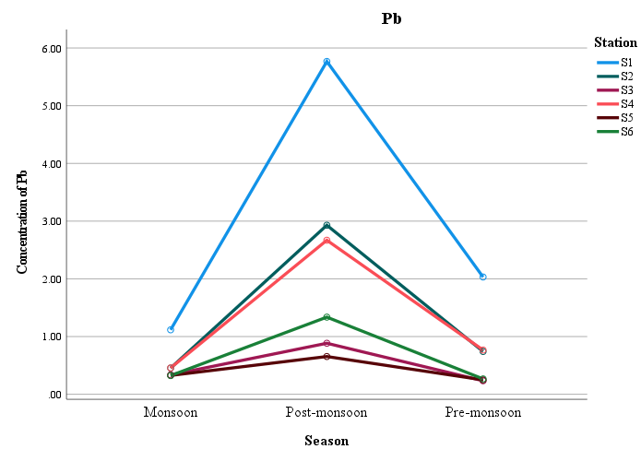
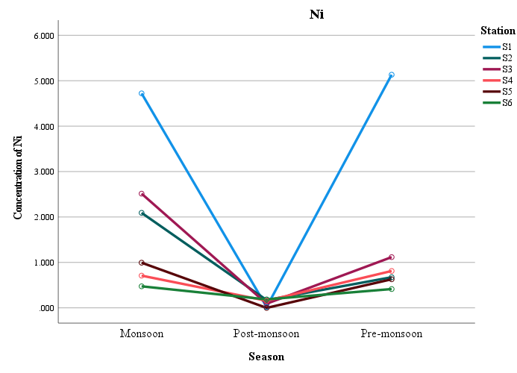
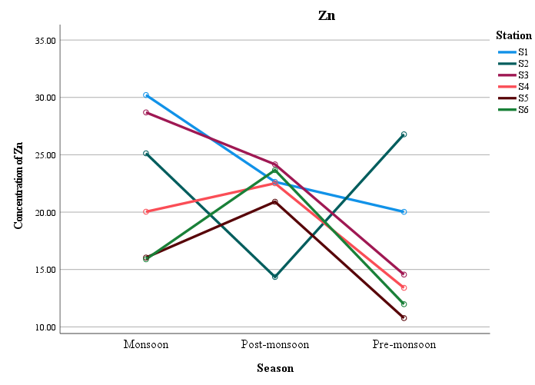
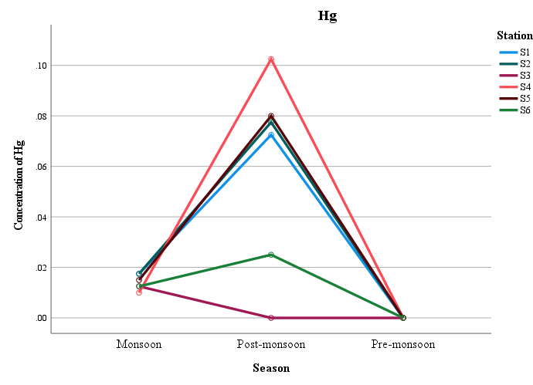
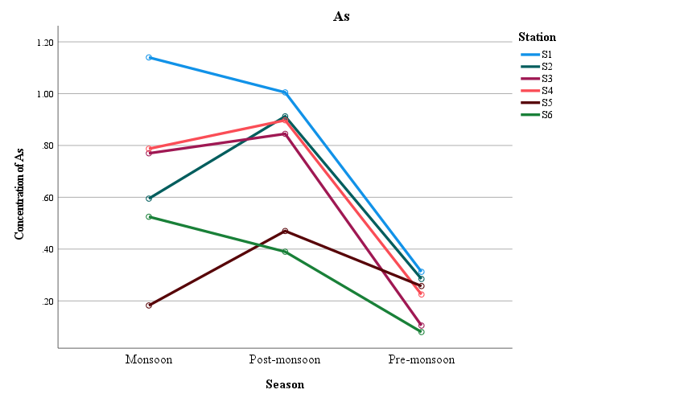
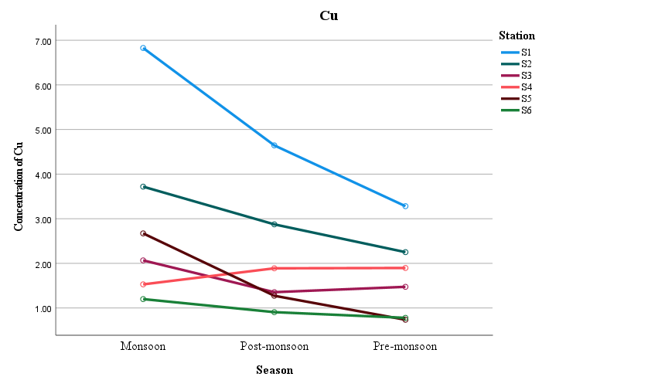
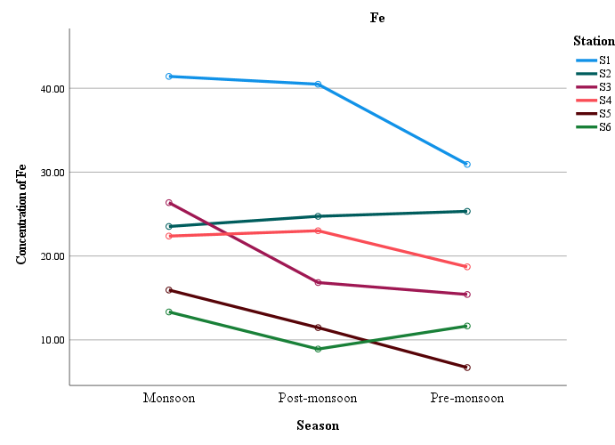
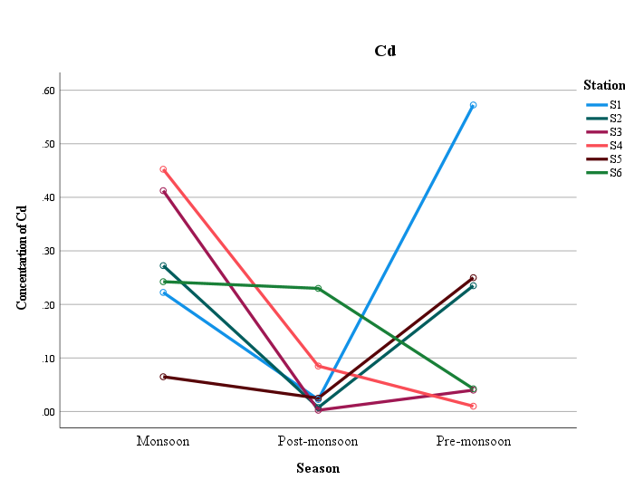
h.
g.
f.
e.
d.
c.
b.
a.
Fig. 7. Seasonal distribution of heavy metal concentrations (mean) in plankton: (a) Fe, (b) Ni, (c) Zn, (d) Pb, (e) Cd, (f) Cu, (g) Hg, and (h) As.
  - Correlation between physicochemical parameters and heavy metal accumulation in plankton
Pearson's correlation analysis indicated clear correlations between physicochemical factors and heavy metal concentrations in plankton (Fig. 8). Temperature had a substantial positive association with salinity (r = 0.718), showing that these parameters vary similarly seasonally. Temperature had a substantial negative connection with Fe (r = -0.590), Cu (r = -0.574), and As (r = -0.712), indicating higher accumulation of these metals under lower temperatures, especially during monsoon and post-monsoon periods. Hu et al. (2010) showed similar connections between temperature and salinity.
Strong negative correlations were found between salinity and nitrate (r = −0.622) and a number of heavy metals, such as Fe (r = −0.770), Ni (r = −0.724), Cu (r = −0.686), Cd (r = −0.570), and Zn (r = −0.522). This suggests that lower salinity linked to freshwater influx during the monsoon may improve metal solubility, mobility, and subsequent uptake by planktonic organisms (Hong et al., 2024). Hong et al. (2024) have shown similar inverse associations between salinity and trace metal accumulation. Seasonal changes in biological productivity and nutrient dynamics were reflected in the pH's significant negative association with dissolved oxygen (r = −0.765) and nitrate (r = −0.728) (Zhang et al., 2014). On the other hand, a substantial positive correlation (r = 0.652) was found between pH and mercury (Hg). This suggests that when pH rises (becomes more alkaline), mercury (Hg) accumulation likewise rises. This is a typical result in certain research where high pH settings improve Hg retention. Higueras et al. (2003) found similar correlations between pH and mercury accumulation.
Dissolved oxygen was positively correlated with nitrate (r = 0.650), Ni (r = 0.402), and Cd (r = 0.462), while it was negatively correlated with Hg (r = −0.596) and Pb (r = −0.387), suggesting that oxygen-mediated transformations may have an impact on the distribution of these metals in coastal waters (Liu et al., 2019). Strong positive associations between nitrate and Ni (r = 0.717), Fe (r = 0.530), and Cd (r = 0.507) indicate that nutrient enrichment may increase plankton productivity, which would improve metal absorption and bioaccumulation (Albarico et al., 2022). Among the metals under analysis, there were also notable positive inter-metal correlations. Cu (r = 0.809), Pb (r = 0.616), Zn (r = 0.580), Ni (r = 0.524), and As (r = 0.511) all had significant positive correlations with Fe. Similarly, Zn had a positive connection with As (r = 0.531), while Ni had positive correlations with Cd (r = 0.617) and Cu (r = 0.507). These robust inter-metal correlations point to shared origins and comparable geochemical behaviour, which may be the result of human activities such as port operations, industrial effluents, urban runoff, and sediment resuspension (Farjana et al., 2025).
 | Temp | Salinity | pH | DO |  | Nitrate | Fe | Ni | Pb | Zn | Cd | Cu | Hg | As
Temp | --
Salinity | 0.718 | --
pH | 0.03 | 0.264 | --
DO | -0.285 | -0.42 | -0.765 |  | --
Nitrate | -0.207 | -0.622 | -0.728 |  | 0.65 | --
Fe | -0.59 | -0.77 | -0.208 |  | 0.175 | 0.53 | --
Ni | -0.297 | -0.724 | -0.47 |  | 0.402 | 0.717 | 0.524 | --
Pb | -0.287 | -0.452 | 0.22 |  | -0.387 | 0.218 | 0.616 | 0.169 | --
Zn | -0.378 | -0.522 | 0.193 |  | 0.104 | 0.125 | 0.58 | 0.346 | 0.115 | --
Cd | -0.441 | -0.57 | -0.191 |  | 0.462 | 0.507 | 0.198 | 0.617 | -0.03 | 0.372 | --
Cu | -0.574 | -0.686 | -0.253 |  | 0.249 | 0.344 | 0.809 | 0.507 | 0.371 | 0.446 | 0.007 | --
Hg | -0.204 | 0.051 | 0.652 |  | -0.596 | -0.42 | 0.19 | -0.342 | 0.491 | 0.094 | -0.309 | 0.131 | --
As | -0.712 | -0.49 | 0.236 |  | 0.129 | -0.043 | 0.511 | 0.064 | 0.155 | 0.531 | 0.22 | 0.488 | 0.397 | --
Fig. 8. Pearson’s correlation heatmap relationship between physicochemical parameters and heavy metal concentrations in plankton.
Positive correlations are represented by green shades, while negative correlations are represented by red shades.
- Conclusion
The present investigation revealed significant seasonal and spatial variations influenced by monsoonal hydrography and anthropogenic activities. Physico-chemical parameters such as temperature, salinity, pH, dissolved oxygen, and nitrate exhibited clear seasonal fluctuations governed by solar radiation, freshwater influx, river discharge, nutrient-rich runoff, and coastal mixing processes. During the monsoon, lower salinity coupled with elevated dissolved oxygen and nutrient levels at Station S1–located near the bar-mouth–signalled a pronounced freshwater influx. Throughout the study, pH values remained mildly alkaline, indicative of conditions conducive to aquatic productivity. Heavy metal analysis of plankton revealed a clear bioaccumulation gradient (Fe > Zn > Ni > Cu > Pb > As > Cd > Hg), underscoring the predominance of essential trace elements over non-essential toxic metals.
Higher metal concentrations at stations S1 and S2, especially during the monsoon season, suggest the influence of terrestrial runoff, industrial discharge, urban inputs, and sediment resuspension. Pearson’s correlation analysis further confirmed that hydrographic conditions, nutrient dynamics, and anthropogenic inputs collectively regulate heavy metal accumulation in plankton, emphasising their suitability as reliable bioindicators for coastal environmental monitoring and pollution assessment.
- Disclaimer (Artificial Intelligence)
Author(s) hereby declare that no generative AI technologies such as Large Language Models (ChatGPT, COPILOT, etc.) and text-to-image generators have been used during the writing or editing of this manuscript.
- References
Abubakari, S.A., Helal, A. and Khalil, A.B., 2026. A Review on CO₂ Mitigation by Modified Microbial Carbonic Anhydrase Enzyme (CA). Arabian Journal for Science and Engineering, 51(1), pp.341-351.
Achary, M.S., Satpathy, K.K., Panigrahi, S., Mohanty, A.K., Padhi, R.K., Biswas, S., Prabhu, R.K., Vijayalakshmi, S. and Panigrahy, R.C., 2017. Concentration of heavy metals in the food chain components of the nearshore coastal waters of Kalpakkam, southeast coast of India. Food Control, 72: 232-243.
Ahamad, Taufiq, Rohit Singh Sajwan, Manoj Kumar Jindal, and Shubham Sharma. "Understanding the Combined Effects of Multiple Water Quality Parameters." In Water Quality-Uranium Solubility Nexus: Unlocking the Secrets of Uranium Solubility: Uranium Chemistry in Water, pp. 237-269. Cham: Springer Nature Switzerland, 2026.
Albarico, F.P.J.B., Chen, C.W., Lim, Y.C., Wang, M.H., Chuang, Y. and Dong, C.D., 2022. Driving factors of phytoplankton trace metal concentrations and distribution along anthropogenically-impacted estuaries of southern Taiwan. Regional Studies in Marine Science, 56, p.102610.
Ali, L., Julfikar Ali, M. and Maidul Islam, M., 2026. Evaluating urban wastewater potential for sustainable agriculture in East Kolkata wetlands. Environment, Development and Sustainability, pp.1-33.
Alkawri, A.A.S. and Ramaiah, N., 2010. Spatio-temporal variability of dinoflagellate assemblages in different salinity regimes in the west coast of India. Harmful Algae, 9(2): 153-162.
Andrade, F., Aravinda, H.B. and Puttaiah, E.T., 2011, Studies on Mangalore coastal water pollution and its sources. Ind. J. Sci. Tech., 4(5): 553-557.
APHA (American Public Health Association), 2005. Standard Methods for the Examination of Water and Wastewater. Washington, D.C.
Arunpandi, N., Jyothibabu, R., Jagadeesan, L., Parthasarathi, S., Albin, K.J. and Pandiyarajan, R.S., 2020. Impact of a large hydraulic barrage on the trace metals concentration in mesozooplankton in the Kochi backwaters, along the Southwest coast of India. Mar. Pollut. Bull., 160: 111568.
Bahnasawy, M., Khidr, A.A. and Dheina, N., 2011. Assessment of heavy metal concentrations in water, plankton, and fish of Lake Manzala, Egypt. Turkish Journal of Zoology, 35(2), pp.271-280.
Bharathi, M.D., Patra, S., Sundaramoorthy, S., Madeswaran, P. and Sundaramanickam, A., 2017. Elucidation of seasonal variations of physicochemical and biological parameters with statistical analysis methods in Puducherry coastal waters. Mar. Pollut. Bull., 122(1-2): 432-440.
Chethan, N., 2012. Temporal variability of phytoplankton assemblage in the coastal waters of Mangalore. Ph.D. Thesis, Karnataka Veterinary, Animal and Fisheries Science University, Bidar.
Chevrollier, L.A., Koski, M., Søndergaard, J., Trapp, S., Aheto, D.W., Darpaah, G. and Nielsen, T.G., 2022. Bioaccumulation of metals in the planktonic food web in the Gulf of Guinea. Marine pollution bulletin, 179, p.113662.
Chinnaraja, V., Santhanam, P. and Dinesh Kumar, S., 2015. Impact of thane cyclone on the heavy metal distribution in water, sediment, plankton and fish (Mugil cephalus) in selected areas along the Tamil Nadu, Southeast coast of India. Indian J. Geo-Marine Sci., 44(10): 1613-1621.
Chowdhury, P., Khan, S.J., Sumon, M.A.A., El-Regal, M.A.A., Tayyamath, K. and Van Doan, H., 2026. The role of planktons in sustaining the function and diversity of marine ecosystems: a systematic review. Discover Animals, 3(1), p.9.
Divakaran, D., Dayala, V.T. and Sujatha, C.H., 2025. Spatio-temporal evaluation and phytoplankton abundance and their influencing drivers in the estuarine waters of Kochi, Kerala. Journal of Aquatic Biology & Fisheries, 13(1), pp.50-65.
El-Metwally, M.E., Abu El-Regal, M.A., Abdelkader, A.I. and Sanad, E.F., 2022. Heavy metal accumulation in zooplankton and impact of water quality on its community structure. Arab. J. Geosci., 15(1): 117.
Farjana, S.J., Sarker, B.S., Hossain, M.K., Riya, K.K., Rahman, M.A., Al Jubaer, A., Arai, T., Yu, J., Ngah, N. and Hossain, M.B., 2025. Rare earth elements in a highly industrialized South Asian estuary: Enrichment patterns, geochemical behaviors, contamination status and multi-index risk evaluation. Science of the Total Environment, 1002, p.180628.
Fernandes Azevedo, B., Barros Furieri, L., Peçanha, F.M., Wiggers, G.A., Frizera Vassallo, P., Ronacher Simões, M., Fiorim, J., Rossi de Batista, P., Fioresi, M., Rossoni, L. and Stefanon, I., 2012. Toxic effects of mercury on the cardiovascular and central nervous systems. BioMed Res. Int., 2012(1): 949048.
Higueras, P., Oyarzun, R., Biester, H., Lillo, J. and Lorenzo, S., 2003. A first insight into mercury distribution and speciation in soils from the Almadén mining district, Spain. Journal of Geochemical Exploration, 80(1), pp.95-104.
Hong, C., Suman, T.Y., Ji, C.W., Kong, D.S. and Kwak, I.S., 2024. Heavy metal bioaccumulation based on seasonal monsoon impact in benthic macroinvertebrates of Korean streams. Chemosphere, 368, p.143749.
Hu, M., Li, Q. and Li, L., 2010. Effect of salinity and temperature on salinity tolerance of the sea cucumber Apostichopus japonicus. Fisheries Science, 76(2), pp.267-273.
Ismail, M.M. and El Zokm, G.M., 2023. Evaluation of the response of phytoplankton communities to heavy metal stresses using multi-statistical approaches, Alexandria coast, Egypt. Int. J. Environ. Sci. Technol., 20(12): 13595-13608.
Kalay, M., Ay, O. and Canli, M., 1999. Heavy metal concentrations in fish tissues from the Northeast Mediterranean Sea. Bull. Environ. Contam. Toxicol., 63(5): 673–681.
Kavitha., 2019. Biodiversity of Macro-benhtic infauna community in the inshore waters off Mangaluru. M.F.Sc. Thesis, Karnataka Veterinary, Animal and Fisheries Science University, Bidar.
Lallu, K.R., John, S., Muraleedharan, K.R., Gireeshkumar, T.R., Udayakrishnan, P.B., Mathew, D., Mathew, S., Revichandran, C., Nair, M., Parameswaran, P.S. and Balachandran, K.K., 2023. Input-export fluxes of heavy metals in the Cochin estuary, southwest coast of India. Environ. Sci. Pollut. Res., 30(2): 771-2786.
Li, L. Q., Hu, H., Lv, X. L. & Liu, Q. 2020 Contents and ecological risk assessment of heavy metals in surface sediments of the Central Bohai Sea and the Northern Yellow Sea. Trans. Oceanol. Limnol. 1, 84–92.
Lingadhal, C., Padmanabha, A., Rajaννα, Κ.Β., Αννappaswamy, T.S. and Lakshmipathi, M.T., 2023. Hydrographical studies in the nearshore waters of Keni and Belekeri, Ankola, Uttara Kannada district, Southwest coast of India. J. Pharm. Innov., 12(4): 227-236.
Liu, J.J., Diao, Z.H., Xu, X.R. and Xie, Q., 2019. Effects of dissolved oxygen, salinity, nitrogen and phosphorus on the release of heavy metals from coastal sediments. Science of the Total Environment, 666, pp.894-901.
Madhavi, K., Gowda, G., Jayaraj, E.G., Lakshmipathi, M.T. and Sree, C.S., 2014. Distribution of diatoms in riverine, estuarine and coastal waters off Mangalore, Karnataka. J. Acad. Ind. Res., 3(3): 142-147.
Madunil, S.L. and Wijesinghe, J., 2025. Toxicological techniques for coastal and marine pollution monitoring. Coastal and Marine Pollution: Source to Sink, Mitigation and Management, pp.269-303.
Mahanty, B., Pani, S., Srinivasan, S., Jena, B. K. and Ramakrishnan B., 2026. A multi-variable regression approach for predicting total suspended solids from turbidity in tropical coastal waters. Regional Studies in Marine Science, 97, 104977.
Manickam, N., Bhavan, P.S., Santhanam, P., Bhuvaneswari, R., Muralisankar, T., Srinivasan, V., Asaikkutti, A., Rajkumar, G., Udayasuriyan, R. and Karthik, M., 2018. Impact of seasonal changes in zooplankton biodiversity in Ukkadam Lake, Coimbatore, Tamil Nadu, India, and potential future implications of climate change. J. Basic Appl. Zool., 79(1): 15.
Nandan, Y.A., 2022. Studies on bioaccumulation of heavy metals in selected crabs off Mangaluru coast. M. F. Sc. Thesis, Karnataka Veterinary, Animal and Fisheries Sciences University, Bidar, India.
Narshivudu, Daggula 2022. Carbon Sequestration by Phytoplankton in the Coastal water off Mangaluru. Ph. D. Thesis, Karnataka Veterinary, Animal and Fisheries Sciences University, Bidar, India.
Nayak, H., 2015. Heavy metal concentration in commercially important finfishes exploited at Mangalore and Malpe Fishing harbours, Karnataka. Ph.D. Thesis, Karnataka Veterinary, Animal and Fisheries Science University, Bidar.
Ngoc, N.T.M., Chuyen, N.V., Thao, N.T.T., Duc, N.Q., Trang, N.T.T., Binh, N.T.T., Sa, H.C., Tran, N.B., Ba, N.V., Khai, N.V. and Son, H.A., 2020. Chromium, cadmium, lead, and arsenic concentrations in water, vegetables, and seafood consumed in a coastal area in Northern Vietnam. Environmental health insights, 14, p.1178630220921410.Nobi, E.P., Dilipan, E., Thangaradjou, T., Sivakumar, K. and Kannan, L., 2010. Geochemical and geo-statistical assessment of heavy metal concentration in the sediments of different coastal ecosystems of Andaman Islands, India. Estuar. Coast. Shelf Sci., 87(2): 253-264.
Patra, S., Raman, A.V., Ganguly, D., Robin, R.S., Muduli, P.R., Kanuri, V., Abhilash, K.R., Charan Kumar, B. and Subramanian, B.R., 2016. Influence of suspended particulate matter on nutrient biogeochemistry of a tropical shallow lagoon, Chilika, India. Limnology, 17(3), pp.223-238.
Pitchaikani, J.S., Ananthan, G. And Sudhakar, M., 2010. Studies on the effect of coolant water effluent of tuticorin thermal power station on hydro biological characteristics of Tuticorin Coastal Waters, South East Coast of India. Curr. Res. J. Biol. Sci., 2(2): 118-123.
Prashanth, J.M., 2010. Study on distribution of top snail Telescopium telescopium in Mangrove along Nethravathi estuary, Mangalore. M.F.Sc. Thesis, Karnataka Veterinary, Animal and Fisheries Science University, Bidar.
Raj, V.T., Gayathri, J.A., Sreelash, K., Sharma, R.K., Maya, K. and Padmalal, D., 2026. Hydrochemical processes and pCO2 dynamics in a tropical mountainous catchment: insights from the Bhavani River, Attappadi CZO. Hydrological Sciences Journal, pp.1-21.
Rajalekshmi, R., Lal, A., Joy, S., Ganugapenta, S., Vishnu Maya, T.M., John, B., Krishnakumar, A. and Krishnan, K.A., 2026. Water Quality Index (WQI) Modelling and Biogeochemical Assessment of Kanjirakkottu Kayal, Ashtamudi Lake, Southwest Coast of India. In Coastal Biogeochemistry and Ecosystem Shifts: Tracing the Impact of Human Activities (pp. 187-206). Cham: Springer Nature Switzerland.
Rathore, S., Goyal, R., Jangir, B., Ummenhofer, C.C., Feng, M. and Mishra, M., 2022. Interactions between a marine heatwave and Tropical Cyclone Amphan in the Bay of Bengal in 2020. Front. Clim., 4: 861477.
Rejomon, G., Balachandran, K.K., Nair, M. and Joseph, T., 2008. Trace metal concentrations in marine zooplankton from the western Bay of Bengal. App. Eco. Environ. Res., 6(1): 107-116.
Rocker, M.M., Yoshioka, R.M., Johnston, K.E., Record, N.R., Small, H.J. and Groner, M.L., 2026. Salt in the wound: consequences of changing salinities on marine disease. Philosophical Transactions of the Royal Society B: Biological Sciences, 381(1945).
Ruciński, M., Ruiz, L.E., Campos, H., Mateus, O., Fernandes, P., Vilas-Boas, M., Atfy, H.E. and Werneburg, I., 2026. Palaeoenvironments, stratigraphy and taphonomy of an Upper Triassic vertebrate-bearing unit, Silves Group, central Algarve, southern Portugal. Lethaia, 59(3), pp.1-31.
Santhanam, P., 2011. An investigation on heavy metals accumulation in water, sediment and small marine food chain (plankton and fish) from Coromandel Coast, Southeast Coast of India. IJONS, 976: 0997.
Satpathy, K.K., Mohanty, A.K., Natesan, U., Prasad, M.V.R. and Sarkar, S.K., 2010. Seasonal variation in physicochemical properties of coastal waters of Kalpakkam, east coast of India with special emphasis on nutrients. Environ. Monit. Assess., 164: 153-171.
Strickland, J.D.H. and Parsons, T.R., 1972. A practical handbook of seawater analysis. Bulletin of the Fisheries Research Board of Canada, 167: 71-75.
Venkateswarlu, V., Seshaiah, P.V., Arun, P. and Behra, P.C., 2019. A study on water quality parameters in shrimp L. vannamei semi-intensive grow out culture farms in coastal districts of Andhra Pradesh, India. Int. J. Fish. Aquat., 7(4): 394-399.
Widiastuti, E.L., Afifa, A.D., Tugiyono, T., Umar, S., Mumtazah, D.F. and Hadi, S., 2023. Plankton diversity and its heavy metal content in Ratai Bay of Pesawaran district, Lampung, Indonesia. Journal of Water and Health, 21(6), pp.663-675.
Zhang, L., Wang, S. and Wu, Z., 2014. Coupling effect of pH and dissolved oxygen in water column on nitrogen release at water–sediment interface of Erhai Lake, China. Estuarine, Coastal and Shelf Science, 149, pp.178-186.
Zhang, W., Guo, F., Gong, W., Yang, D., Yin, X., Jia, F., Wei, W., Yao, Y. and Zhang, L., 2026. Electrochemical Shortcut Denitrification Coupled with Chemical Diazotization for Low‐Carbon Nitrate Wastewater Treatment. Angewandte Chemie, 138(3), p.e16226.

