Original Research Article
Population assessment and conservation of Paris polyphylla, A threatened medicinal plant in North East India
ABSTRACT
Background: Paris polyphylla thrives in semi-evergreen forests of subtropical regions, often found in bamboo forests, rocky slopes, thickets, stream-sides, and other shady, moist areas. Although Paris polyphylla is recognised as an important medicinal and ethnobotanical plant in the Himalayan and North-Eastern regions of India, most existing studies have primarily focused on its phytochemical composition, pharmacological properties, and ethnomedicinal applications. Limited research has been conducted on its ecological status, population structure, and habitat characteristics, particularly in Manipur.
Aims: To study the ecological parameters, population assessments and interactions with traditional local people to learn about the P. polyphylla 's ethno-medicinal applications in Manipur, which is known for its rich biodiversity and cultural diversity.
Study design: Assessment of population and ecological parameters for the conservation strategies.
Place and Duration of Study: Three different habitat sites of P. polyphylla in Manipur: Makhel (Senapati), Purul Akutpa (Senapati) and Langdang Village (Ukhrul) during February, 2022 to January, 2023.
Methodology: Field surveys were carried out in the habitat sites of P. polyphylla at different intervals during February, 2022 to January, 2023. Vegetation sampling was done using the Quadrat method, with fifteen 1x1 m quadrats placed randomly at 2–3 m intervals. Physicochemical properties and soil of the soil are studied using the soil testing kit. Moreover, climatic parameters of the study areas are also added.
Results: The present study shows the highest population density (2.4 individual m⁻²) and frequency (60%) in Makhel village, Senapati District and the lowest density (1.3 individual m⁻²) and frequency (26.67%) in Purul akutpa village, Senapati District, Manipur. The species prefers shady and swampy habitats with acidic soil (pH 4.3–4.7). However, overexploitation and illegal export have severely threatened its survival.
Conclusion: Makhel Village in Senapati District, Manipur showed the highest P. polyphylla density and frequency in this study. However, it is found rarely in the human occupied areas. Different factors like unsustainable and over-harvesting, urbanization, grazing, etc. has led to gradual decline of the plant population. To address this, conservation efforts such as rhizome and seed propagation, ecological niche models, and awareness programmes are essential.

Keywords: Population assessment, Conservation, Manipur, North east India, Paris polyphylla Smith.

Graphical Abstract:
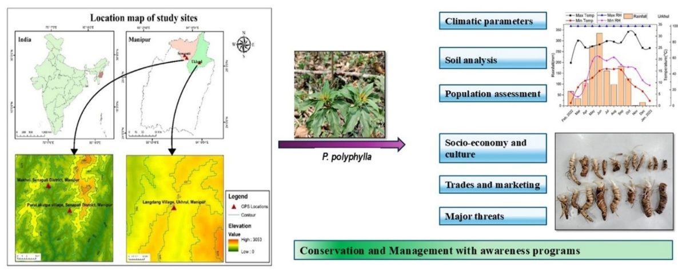

- INTRODUCTION
The North-Eastern region of India has rich biodiversity of flora and fauna. Manipur, a north-eastern state of India, falls within the Indo-Burma hotspot region, which ranks 8th among the 34 biodiversity hotspots of the world (Jain and Das, 2022). Medicinal plants are also abundantly available in these areas. Paris polyphylla Smith, locally known as Singpan, is found abundantly in the Senapati District and the Ukhrul District of Manipur, which lies in the North-Eastern region of India. It thrives in semi-evergreen forests of subtropical regions, often found in bamboo forests, rocky slopes, thickets, stream-sides, and other shady, moist areas (Madhav et al., 2010). It is a rhizomatous herb belonging to the family Melanthiaceae, which has been medicinally used in the Himalayan region (Long et al., 2003). It is an erect plant with spider-like flowers that produce long, thread-like, yellowish-green petals (Shah et al., 2012). They are found in China, India, Bhutan, Laos, Myanmar, Nepal, Thailand, and Vietnam (Long et al., 2003). In India, the species is found in the Himalayan states like Manipur (Gogoi, 2010), Meghalaya (Mao et al., 2009; Mir et al., 2014), Arunachal Pradesh (Chowdhery et al., 2009), Mizoram (Lalsangluaii et al., 2013), Nagaland (Jamir et al., 2012), Sikkim (Maity et al., 2004), Himachal Pradesh (Goraya et al., 2013) and Uttarakhand (Paul et al., 2015).
Because of its medicinal properties, it has been used extensively in the treatment of diseases. A root decoction of P. polyphylla is used for treating various infections, inflammatory conditions, and cancers of the breast, liver, stomach, nose, lung, and throat (Kavita, 2015) while the rhizome is widely used in ethnomedicine to treat tumors, fever, inflammation, pain, immune disorders, wounds, snake bites, diarrhoea, dysentery, vomiting, headache, and helminthic infections, and is also administered to cattle for gastrointestinal ailments (Baral and Kurmi, 2006; Dutta, 2007; Lee et al., 2005; Paul et al., 2015; Pfoze et al., 2013; Sharma et al., 2015; Sharma et al., 2017) and also used to treat headache, vomiting and worms (Uprety et al., 2010). From the saponin extract of P. polyphylla, Gong Xue Ning (GXN) capsule, a drug used for the treatment of abnormal uterine bleeding was developed (Zhao and Shi, 2005; Guo et al., 2008).
P. polyphylla rhizome extract has the potential to serve as a natural remedy for colon cancer (Kshetrimayum et al., 2023a) and diabetes (Kshetrimayum et al., 2023b). The main reason responsible for the potency of high medicinal values is because of the presence of saponins in P. polyphylla which constitute more than 80% of the total compounds. The major compound among them is diosgenin, followed by Paris saponin II, Paris saponin III, polyphyllin VI and VII (Sharma et al., 2015; Puwein et al., 2020; Wu et al., 2004).
The plant is heavily exploited for its medicinal properties, especially in the Indo-China and Indo-Myanmar regions, leading to its endangerment due to overharvesting, human activities, and natural disasters. Other human activities responsible for the species’ habitat destruction include urbanization, industrialization, road construction, and tourist development, which place tremendous pressure on the species' survival (Mao et al., 2009). Another reason for the species’ population decline is the unsustainable methods of harvesting. Hence, the plant species is listed as “vulnerable” by the IUCN (Barman et al., 2026). So, designing effective strategies to conserve and meet the increasing demand of this plant is needed (Raomai et al., 2015).
To assess species distribution, habitat preference, and conservation status, population structure must be studied using ecological parameters such as density and relative frequency. Across the Indian Himalayan region, the availability of P. polyphylla relies on various environmental factors (Kalita et al., 2024). Comparative studies across different geographical regions have revealed significant variations in these parameters (Madhav et al., 2010; Paul et al., 2015). Thus, these regional ecological variations emphasizes the critical need for region-specific conservation and management strategies.
Manipur, a well-known region for its rich biodiversity and cultural heritage, is currently witnessing a severe threat to P. polyphylla due to overexploitation, pushing it toward endangerment. Despite this critical situation, no prior study has assessed its population dynamics in the region. To address this gap, the present study focuses on evaluating the plant’s population status, influencing ecological factors, traditional knowledge and ethnomedicinal uses. Simultaneously, it also addresses its threatened status and potential conservation strategies. The investigation was conducted on Makhel village and Purul akutpa village of Senapati District, Langdang Village of Ukhrul District, Manipur, North East India.
- MATERIALS AND METHODS
2.1 Survey and Assessment
Field surveys were carried out in the habitat sites of P. polyphylla at different intervals during February, 2022 to January, 2023. The climatic profiles of the study sites during the survey exhibit a typical subtropical monsoonal pattern featuring distinct wet and dry seasons (Fig.1). The plant's life cycle, including sprouting, maturation, and fruit ripening, was studied, as illustrated in Fig.2. During the survey, data on growth period, habitat, phenology and fruiting period were recorded. Interaction programs were conducted with local villagers on suitable climatic conditions, life spans, growth patterns, and the common plants associated with them. Additionally, the traditional uses and trading systems were noted down.
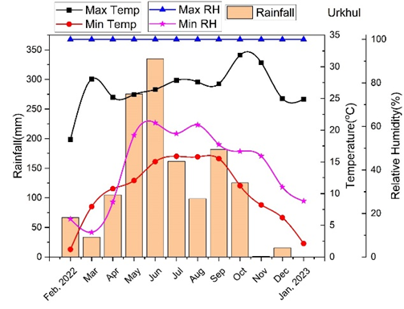
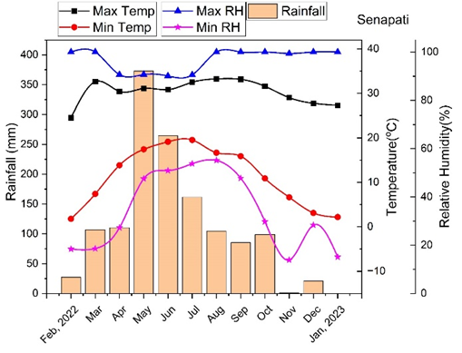
B
A

Fig. 1: The mean monthly macro-climatic variables from February 2022 to January 2023 for the primary study locations (two districts of Manipur, Northeast India): (A) Senapati District and (B) Ukhrul District. Vertical bars denote total monthly precipitation (mm, left Y-axis). Line plots track monthly temperature variations (°C, inner right Y-axis) across maximum (black squares) and minimum (red circles) limits. Relative humidity trends (%, outer right Y-axis) are depicted for maximum (blue triangles) and minimum (magenta stars) thresholds.
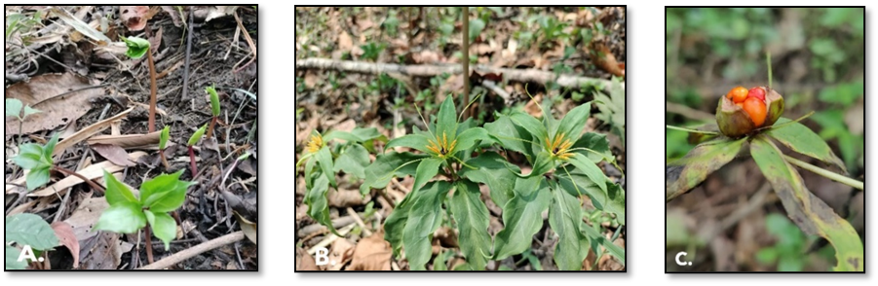
Fig. 2: Distinct phenological growth stages and morphological traits of Paris polyphylla documented across the study sites in Manipur, Northeast India: (A) Young shoot, (B) Flowering stage, (C) Fruiting stage
To assess the population status of P. polyphylla in Manipur, three different sites (Fig. 3) were studied: Makhel (Senapati), Purul Akutpa (Senapati) and Langdang Village (Ukhrul). Vegetation sampling was done using the Quadrat method, with fifteen 1x1 m quadrats placed randomly at 2–3 m intervals. In each quadrat, the number of P. polyphylla and associated plants was recorded. Then, frequency and population density were then calculated ((Mueller-Dombois & Ellenberg, 1974).
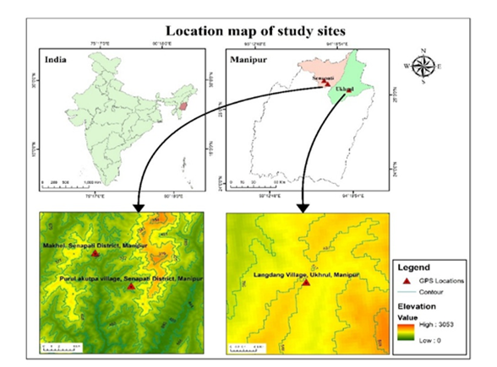
Fig. 3: Geographical location map of study sites showing the target zones from the map of India (top left) down to the district levels of Manipur state (top right). The lower panels show topographically mapped of Makhel village and Purul Akutpa village of Senapati District, and Langdang village of Ukhrul District, Manipur.
2.2 Sample Collection and Identification
Plant samples were collected from each site for identification, propagation, and other further research purposes. Identification of the plant species was conducted at the Botanical Survey of India (BSI), Shillong, Meghalaya, with specimen number BSI/ERC/Tech/2023-24/1372/100402. Additionally, 100-gram soil samples were collected at a 25 cm depth from each site. Available nitrogen, phosphorous, potassium, magnesium, calcium contents and pH of the collected soils were determined using Palintest soil kit (United Kingdom). GPS readings were recorded for latitude, longitude and altitude of the studied sites. The collected plants were identified at the Botanical Survey of India (BSI), Shillong, Meghalaya.
3. RESULTS AND DISCUSSION
3.1 P. polyphylla in Manipur
In the study, three naturally occurring habitats were documented. The species is found at altitudes between 1500 and 1800 m above sea level (ASL). The precise GPS coordinates, altitude, occurrence frequencies of P. polyphylla across these sites are illustrated in Table 2. Based on the survey report, it prefers humus-rich, well-drained soils, especially in riparian and swampy habitats. The plant sprouts in March–April, matures by September–October, and its seed-bearing fruits are harvested in November–December. The region experiences a distinct subtropical climate, characterized by temperatures ranging from 1.2°C in February to 33.24°C in June. Rainfall peaks in May–June and is lowest in November. The morphology of the plant is depicted in Fig. 2. The species is a perennial herb of 30–70 cm tall, with rhizomes 1–2.5 cm in diameter and 3–5 cm long. They have 5–10 whorled leaves (6–15 cm long) with long petioles and spider-like yellow-green flowers with leafy bracts. Leaves are simple, green, and reticulate with three main veins. The fruit is a red, oval or round berry containing 25–40 seeds per pod. Individual seeds measure 0.3–0.5 cm in diameter and are enveloped by a conspicuous, brilliant red, fleshy aril designed to facilitate biotic dispersal. The moisture content of the propagation material is notable, with fresh seed weigh about 85–100 mg, which reduce to a dry mass of 55–60 mg.
3.2 Physico-chemical properties of Soil
The physico-chemical properties and pH of soil may influence the plant's survival. As shown in table 1, nitrogen and magnesium content were found to be the highest in Makhel Village followed by Purul akutpa Village. Phosphorus, Potassium, and Calcium content were found to be maximum in Langdang Village. The soil pH of the study sites ranged from 4.2 – 4.6 (Modification to Lepcha, 2019).
The soil physicochemical properties influences the survival and distribution of the plant species across the study sites. The soil pH across all study sites is strongly acidic. Such acidic soils can influence nutrient solubility and availability, often increasing the availability of certain micronutrients while limiting others. The narrow pH range suggests that the plant is well adapted to acidic environments, and this acidic condition may be a key ecological factor governing its natural habitat preference (Wan et al., 2020).

Table 1: Physiochemical properties of soil collected from study sites of Paris polyphylla.
Collection site | pH | Nitrogen (mg/L) | Phosphorous  (mg/L) | Potassium  (mg/L) | Magnesium  (mg/L) | Calcium  (mg/L)
Makhel, Senapati District, Manipur | 4.3 | 2.3 | 3 | 95 | 150 | 750
Purul akutpa village, Senapati District, Manipur | 4.2 | 2.2 | 3 | 90 | 143 | 750
Langdang Village, Ukhrul, Manipur | 4.6 | 1.6 | 11 | 325 | 110 | 1250

3.3 Population assessment
The study area's varied climatic conditions have led to a diversity of vegetation types. These variations in altitude and ecological parameters may result in differences in frequency and density of P. polyphylla. Quantitative phytosociological analysis (summarized in Table 2) revealed distinct gradients in population structures across the study sites. Among the studied sites, the highest demographic performance was observed in Makhel village of Senapati District with a peak density of 2.4 Individuals m⁻² and a frequency of 60% while the lowest density (1.3 Individual m⁻²) and frequency (26.67%) were recorded in Purul akutpa village of Ukhrul District, Manipur. The frequency % observed in the present study is almost similar with the frequency (60.83 %) reported by Madhu et al., 2010 while density of the present study is higher than the reported record (1.78) from Nepal (Madhu et al.,2010). A comparative study table is also represented in table 3. The associated plants of P. polyphylla were predominantly herbaceous across all study sites. Ageratum conyzoides, Bidens pilosa, Drymaria cordata, Eupatorium adenophorum, Anemone canadensis, Melastoma sp., Litsea monopetala, Oplismenus undulatifolius, Triumfetta rhomboidea, Arisaema serratum (Thunb.) Schott, Crytomium sp., Viburnum erubescens, Dryopteris sp., Costus sp., Urena lobata, Sellaginella sp., Alternanthera sp., Centella aciatica, Desmodium sp., Galium sp. etc. are the associated plants growing in the present study sites.

Table 2: Frequency and density of P. polyphylla in the study sites of Manipur with GPS and altitude
Study Sites | GPS | Altitude |  | Frequency (%) |  | Density  (Ind. m⁻²)
Makhel, Senapati District, Manipur | N25°16’24.13’’  E94°5’27.56’’ | 1521m |  | 60.00 |  | 2.4
Purul akutpa village, Senapati District, Manipur | N25°13’29.17’’  E94°8’2.27’’ | 1701m |  | 26.67 |  | 1.3
Langdang Village, Ukhrul, Manipur | N25°6’42.15’’  E94°24’28.15’’ | 1792m |  | 33.33 |  | 1.6

Table 3: Comparative profile of population density and relative frequency of Paris polyphylla Smith from the present investigation, compared with documented historical benchmarks across diverse Himalayan phytogeographical regions.
SL. No. | Density  (Ind. M⁻²) | Relative Frequency (%) | Place of Study | References
1 | 0.45 to 3.89 | 2.14 to 4.85 | Sikkim | Lepcha et al., 2019
2 | 1.17 | - | Nepal | Madhu et al., 2010
3 | 1.07 | - | Arunachal Pradesh | Paul et al., 2015
4 | 0.50 to 2.00 | - | Uttarakhand | Tariq et al., 2021
5 | 8.2 to 2.48 | - | Arunachal Pradesh | Kalita et al., 2024
6 | 2.4 | 60 | Makhel, Senapati, Manipur | Present study
7 | 1.3 | 26.67 | Purul Akutpa Village, Senapati, Manipur | Present study
8 | 1.6 | 33.33 | Ukhrul,  Manipur | Present study
*(—) denote parameters that were not reported or quantified in the respective baseline studies.
3.4 Socio-economy and culture
The ethno-demographic fabric of the study sites plays a foundational role in shaping the traditional botanical knowledge associated with Paris polyphylla. The major community inhabited in the Makhel village is the Mao Naga tribe, Poumai Naga tribe in the Purul Akutpa village and Tangkhul tribe in the Ukhrul areas of Manipur. Their main occupation is cultivation. Their deep-rooted connection is reflected in the nomenclature to P. polyphylla, locally known as Singpan in Manipuri, Kazeapai in Tangkhul (Ukhrul), and Kotu pa in Naga (by Senapati villagers), which has high medicinal importance. The plant holds an important place in local traditional medicine, particularly for its versatile therapeutic applications. This herb was used in external wound healing and swelling. The rhizome is crushed and applied to the affected areas. They also added that chewing 2-3 leaves of the plant helps in the treatment of diarrhoea. They use it for fever, headache, burns, wounds and many livestock diseases mainly to neutralise poison when the livestock feed on poisonous herbs. Historically, the ethnobotanical knowledge has been preserved and transmitted across generations through oral traditions. The use of P. polyphylla in Northeast India was strictly confined to indigenous traditional healers for localized healthcare (Kshetrimayum et al., 2023a). However, rather than using this inherited ecological knowledge solely for community-based treatments, the recognition of the plant’s immense global commercial value has driven the continuity of an aggressive harvesting system. Since the underground rhizome is the main economic component, excessive extraction pushed the species to the verge of localized extinction (Phurailatpam & Choudhury, 2022).
3.5 Trades and marketing
Based on interactions with the villagers, P. polyphylla has been illegally exported to China via Myanmar in recent times. They reported that trading of the rhizome has been going on through Indo-Myanmar border by the local traders in the name of ‘Ginseng’ without knowing its actual properties and medicinal uses. They have been selling the fresh rhizome at Rs 800/- upto Rs 1300/- per kg. (Fig.4) while dried rhizomes at Rs 2500/- upto Rs 3000/- per kg. Nowadays, they are cultivating the plant for economic and commercial purposes. While, Paul et al. (2015) reported that P. polyphylla rhizome are traded from Arunachal Pradesh to Mynamar and South East countries through Assam and Manipur illegally. Similarly, illegal exportation from Arunachal Pradesh to China was also reported (Basar, 2014). Mao et al. (2009) revealed that the rhizome of P. polyphylla has been exported illegally from North-Eastern Indian States to Myanmar.
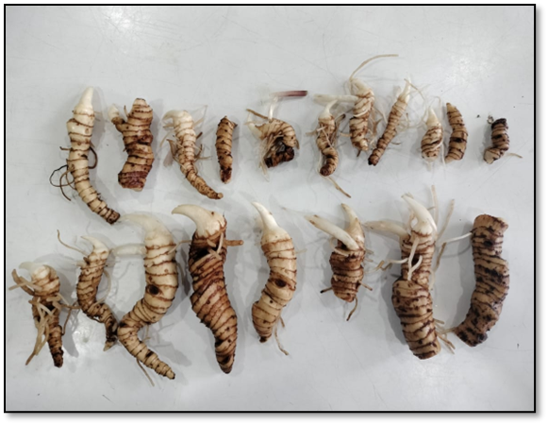
Fig. 4: Freshly excavated and washed rhizomes of Paris polyphylla prepared for cross-border commercial export.
3.6 Major threats
According to the social interactions with the local people done in this study, P. polyphylla population has gradually declined as compared to a decade ago where the plant grew in the wild as weeds, unnoticed by humans. As the popularity of the plant grew in recent years, it has become a challenge to find it even in its natural habitat. Information was gathered in this study from the inhabitants in the study sites of Manipur that the herb is being illegally exported to China through Myanmar. The plant species is highly depleted due to overexploitation driven by market demand. To meet the commercial demands, it is overly extracted in an unsustainable manner. Arunachal Pradesh (Paul et. al., 2015) and Sikkim (Lepcha et al., 2019) have also reported the decline in P. polyphylla population due to illegal extraction and export of the plant rhizome to meet its commercial demands. They have also mentioned other human activities responsible for the species’ habitat destruction, including urbanization, industrialization, road construction, tourist development, etc., which causes tremendous pressure on the survival of the species. Another reason for the species’ population decline is the unsustainable methods of harvesting. The present study also confirms the unsustainable harvesting methods used by local inhabitants at the study sites for P. polyphylla. Uprooting of whole plant and harvesting of plant before maturity may cause serious population decline if not controlled at the earliest. Studies have also mentioned the same methods followed while harvesting the species by inhabitants of Arunachal Pradesh, India and Ghandruk Village, Nepal which has caused failure of regeneration to the species (Paul et. al., 2015; Madhav et al., 2010).
3.7 Conservation and Management
To overcome the issues faced by the herb, community leaders need to organize awareness programmes to help impart more knowledge about the species’ medicinal values. This would help the local inhabitants to conserve the herb and to avoid illegal trading in international borders. Knowledge about sustainable harvest techniques should also be introduced to the harvesters so that the plant can successfully regenerate in the next growing season. To boost P. polyphylla populations, Ecological Niche Models (ENMs) can identify new suitable habitats. This study recorded key environmental factors such as climate, altitude (1521–1792 m), and soil properties. The species thrives in shady, swampy, high-altitude areas with acidic soils (pH 4.3–4.6).These factors can be referred upon for identifying successful ENM of new habitats in Manipur. ENMs are already available from Sikkim (India) (Lepcha et al., 2019) and Nepal (Kunwar et al., 2020) for suitable new locations. The scientific committee needs to expand and apply this modelling technique in other P. polyphylla growing regions of the state and introduce the species to new suitable habitats to be save it from extinction.
Government officials and other leaders should closely monitor the status of plant species listed as vulnerable and endangered before it is too late. These highly valuable plants, including P. polyphylla, need to be prioritized, as the nation's economy can also be greatly affected if they become extinct before fully realizing their potential. Other P. polyphylla growing regions of the world have already taken up steps to conserve and repopulate the plant species. A study in Nepal mentioned that people used to trade large amounts of P. polyphylla collected from the wild areas to other commercial areas of the country, but this has been discontinued recently because the area is protected as a conservation area (Madhav et al., 2010). This not only protects the herb from human interference but also from cattle grazing and trampling which was listed as one of the threats faced by the species according to some studies (Paul et al., 2015; Madhav et al., 2010). Also, large scale cultivation of the plant has already begun in other countries like Nepal (Kunwar et al., 2020) and China (Long et al., 2003). Steps have also been taken up in India where the Arunachal Pradesh State Medicinal Plants Board (APSMPB) has recommended that the local government monitor the species' exploitation before it becomes extinct in the state. As a part of this study, the survey team organised an awareness cum training programmes for the villagers of the Makhel village, Senapati, Manipur for conservation and plantation. To conserve the species in its natural habitat, the survey team also sets up a proper fencing for in-situ conservation in Makhel Village, Manipur, where the frequency and density of the plant are highest. These steps taken for the conservation of P. polyphylla are the first of their kind in Manipur. More initiatives should be taken to do the same in other P. polyphylla growing regions of the state. Conservation and cultivation of the plant, along with in vitro micropropagation, would help the species’ population to increase from its present vulnerable state. Government officials, scientific committees, and community leaders must take significant steps to prevent the loss of this plant from the region.
4. Conclusion
Based on the present study, it is evident that P. polyphylla thrives in shady, swampy areas with acidic soils at high altitudes. This study highlights its morphology, seed traits, and the ecological conditions favorable for its growth in the region. Among the studied sites, Makhel Village in Senapati District, Manipur showed the highest P. polyphylla density and frequency in this study. The study also documents the traditional uses of the plant among the region's indigenous peoples. However, P. polyphylla is rarely found in human-occupied areas, indicating the need to explore additional sites in the state and other North-Eastern regions of India where the species may naturally occur. Such investigations would help in better understanding the ecological requirements and distribution of the species. This will help in establishing the favourable conditions for in vitro propagation or greenhouse cultivation, which will help in conserving the plant species. Ecological Niche Modeling can also be employed using the ecological factors recorded in this study to identify the suitable habitats.
Several anthropogenic factor including unsustainable and over-harvesting, urbanization, grazing, etc. has led to gradual decline of the plant population. Therefore, there is also an urgent need to organize awareness and interaction programs with local people in the area to educate them about the medicinal importance of the herb and its sustainable harvesting methods. Conservation of P. polyphylla requires a multifaceted approach that includes habitat protection, sustainable harvesting, propagation techniques, genetic studies, and community involvement. These strategies aim to balance the plant's economic value with ecological sustainability, ensuring its survival and availability for future generations.
The present study was limited to selected areas; therefore, the findings cannot be generalized to the entire distribution range of the species. Further studies on the ecological and economical aspects of the plant are needed to develop sustainable harvesting and cultivation strategies. In addition, the community leaders also require regulating the collection and minimizing the harvest. It will help conserve and sustainably utilize valuable species for future generations by implementing appropriate conservation measures and sustainable harvesting regulations.
AcknowledgEments
The authors are thankful to the village heads of the study areas for their consent and cooperation during the field survey. We are also grateful to the villagers for sharing their valuable traditional knowledge and hospitality. All authors thank the Department of Environment and Climate Change, Government of Manipur for sharing the climatic parameters of the study areas. The authors extend their gratitude to the Botanical Survey of India (BSI), Shillong, Meghalaya, for the identification of the specimen.
Competing interests
The authors declare no conflict of interest.

Funding
This work is funded by the Department of Science and Technology, Government of India [Grant No.: DST/WOS-B/2018/1207(G)] and Department of Biotechnology, Government of India (Grant No.: BT/PR4524/NER/95/1926/2022).
Declaration of Generative AI and AI-assisted technologies in the writing process: No
Data availability
Open access
Ethical approval and Consent
The study was deemed exempt from formal ethics committee approval because it involved only non-invasive interviews and the documentation of traditional knowledge. In accordance with the Institute of Bioresources and Sustainable Development (IBSD) protocol, prior informed consent was obtained from the village heads and participants during the survey.
Consent for publication: Not applicable. No identifiable individual data are included in this manuscript.
Disclaimer (Artificial intelligence)
Author(s) hereby declare that NO generative AI technologies such as Large Language Models (ChatGPT, COPILOT, etc.) and text-to-image generators have been used during the writing or editing of this manuscript.
References
Baral, S. R., & Kurmi, P. P. (2006). Compendium of medicinal plants in Nepal. Rachana Sharma.

Barman, T., Lata, S., Das, T., Sharma, S., Paul, S., Kumari, P., & Rana, D. (2026). Paris polyphylla Sm. A threatened herb of the Himalayas: traditional knowledge, therapeutic significance and conservation urgency. Genetic Resources and Crop Evolution, 73(1), 70.

Chowdhery, H. J., Giri, G. S., & Pramanik, A. (2009). Materials for the flora of Arunachal Pradesh (Vol. 3). Botanical Survey of India.

Deb, C. R., Jamir, S. L., & Jamir, N. S. (2015). Studies on vegetative and reproductive ecology of Paris polyphylla Smith: A vulnerable medicinal plant. American Journal of Plant Sciences, 6, 2561–2568.

Dutta, I. C. (2007). Non-timber forest products of Nepal: Identification, classification, ethnic uses and cultivation. Institute of Forestry.

Gogoi, R. (2010). The family Liliaceae in Manipur, India. Bulletin of Arunachal Forest Research, 26, 73–81.

Goraya, G. S., Jishtu, V., Rawat, G. S., & Ved, D. K. (2013). Wild medicinal plants of Himachal Pradesh: An assessment of their conservation status and management prioritisation. Himachal Pradesh Forest Department.

Guo, L., Su, J., Deng, B. W., Yu, Z. Y., Kang, L. P., Zhao, Z. H., & Cong, Y. W. (2008). Active pharmaceutical ingredients and mechanisms underlying phasic myometrial contractions stimulated with the saponin extract from Paris polyphylla Sm. var. yunnanensis used for abnormal uterine bleeding. Human Reproduction, 23, 964–971.

Jain, A., & Das, A. (2022). North-East India: A unique biodiversity paradise unexplored or lost? International Journal of Scientific Research and Publications, 12, 112–119.

Jamir, N. S., & Lanusunep, P. N. (2012). Medico-herbal medicine practiced by the Naga tribes in the state of Nagaland (India). Indian Journal of Fundamental and Applied Life Sciences, 2, 328–333.

Kalita, B., Sarma, K., Bawri, A., & Tanti, B. (2024). Assessing population density and regeneration potential of Paris polyphylla Sm. in the Arunachal Himalaya, India: implications for conservation. Vegetos, 39(1), 181-192.

Kavita, K. D., Adhikari, R. S., Pande, V., Kumar, M., & Pratibha, P. R. (2015). Vegetative propagation of an endangered medicinal plant of Himalayan region, Paris polyphylla Smith. International Journal of Current Microbiology and Applied Sciences, 4, 660–665.

Kshetrimayum, V., Heisnam, R., Keithellakpam, O. S., Radhakrishnanand, P., Akula, S. J., Mukherjee, P. K., & Sharma, N. (2023a). Paris polyphylla Sm. induces reactive oxygen species and caspase 3-mediated apoptosis in colorectal cancer cells in vitro and potentiates the therapeutic significance of fluorouracil and cisplatin. Plants, 12, 1–22.

Kshetrimayum, V., Chanu, K. D., Ghosh, S., Haldar, P. K., Mukherjee, P. K., & Sharma, N. (2023b). Paris polyphylla Sm. extract enriched with diosgenin as an antidiabetic agent: In vitro and in vivo study. Phytomedicine Plus, 3, 1–9.

Kunwar, R. M., Adhikari, Y. P., Sharma, H. P., Rimal, B., Devkota, H. P., Charmakar, S., ... & Jentsch, A. (2020). Distribution, use, trade and conservation of Paris polyphylla Sm. in Nepal. Global Ecology and Conservation, 23, 1–14.

Lalsangluaii, F., Chinlampianga, M., & Shukla, A. C. (2013). Efficacy and potency of Paris polyphylla Smith, an ethno-medicinal plant of Mizoram. International Journal of Science Research Technology, 1, 36–40.

Lee, M. S., Chan, J. Y. W., Kong, S. K., Yu, B., Eng-Choon, V. O., Nai-Ching, H. W., Mak, C. W. T., & Fung, K. P. (2005). Effects of polyphyllin D in growth inhibition of human breast cancer cells and in xenograft. Cancer Biology & Therapy, 4, 1248–1254.

Lepcha, D. L., Pradhan, A., & Chhetri, D. R. (2019). Population assessment and species distribution modeling of Paris polyphylla in Sikkim Himalaya, India. Biodiversitas, 20, 1299–1305.

Long, C. L., Li, H., Ouyang, Z., Yang, X., Li, Q., & Trangmar, B. (2003). Strategies for agrobiodiversity conservation and promotion: A case from Yunnan, China. Biodiversity and Conservation, 12, 1145–1156.

Madhav, K. C., Phoboo, S., & Jha, P. K. (2010). Ecological study of Paris polyphylla Sm. Ecoprint, 17, 87–93.

Maity, D., Pradhan, N., & Chauhan, A. S. (2004). Folk uses of some medicinal plants from North Sikkim. Indian Journal of Traditional Knowledge, 3, 66–71.

Mao, A. A., Hynniewta, T. M., & Sanjappa, M. (2009). Plant wealth of Northeast India with reference to ethnobotany. Indian Journal of Traditional Knowledge, 8, 96–103.

Mir, A. H., Upadhaya, K., & Choudhury, H. (2014). Diversity of endemic and threatened ethnomedicinal plant species in Meghalaya, North-East India. International Research Journal of Environmental Sciences, 3, 64–78.

Mueller-Dombois, D., & Ellenberg, H. (1976). Aims and methods of vegetation ecology. Wiley.

Paul, A., Gajurel, P. R., & Das, A. K. (2015). Threats and conservation of Paris polyphylla. Biodiversitas, 16, 295–302.

Pfoze, N. L., Kumar, Y., & Myrboh, B. (2013). Screening of bioactive phytochemicals. Pleione, 7, 489–490.

Phurailatpam, A., & Choudhury, A. (2022). Paris polyphylla: An important endangered medicinal plants of Himalayan foothills. In Medicinal Plants. IntechOpen. https://doi.org/10.5772/intechopen.102920

Puwein, A., Thomas, K. A., & Bordoloi, D. (2020). Anti-proliferative activity of Paris polyphylla. Current Cancer Therapy Reviews, 17, 82–86.

Raomai, S., Kumaria, S., Kehie, M., & Tandon, P. (2015). Plantlet regeneration of Paris polyphylla. Plant Growth Regulation, 75, 341–353.

Shah, S. A., Mazumder, P. B., & Choudhury, M. D. (2012). Medicinal properties of Paris polyphylla: A review. Journal of Herbal Medicine and Toxicology, 6, 27–33.

Sharma, A., Kalita, P., & Tag, H. (2015). Distribution and phytomedicinal aspects of Paris polyphylla. Tang (Humanitas Medicine), 5, 15.1–15.12.

Sharma, P., & Samant, S. S. (2017). Diversity and conservation of orchids. International Journal of Biodiversity and Endangered Species, 5, 1–5.

Tariq, M., Nandi, S. K., Bhatt, I. D., Bhavsar, D., Roy, A., & Pande, V. (2021). Phytosociological study of Paris polyphylla. Tropical Ecology, 62, 163–173.

Uprety, Y., Asselin, H., Boon, E. K., Yadav, S., & Shrestha, K. K. (2010). Indigenous use and bio-efficacy of medicinal plants. Journal of Ethnobiology and Ethnomedicine, 6, 1–10.

Wan, W., Tan, J., Wang, Y., Qin, Y., He, H., Wu, H., Zuo, W., & He, D. (2020). Responses of the rhizosphere bacterial community to pH. Science of the Total Environment, 700, 134418.

Wu, S. S., Gao, W. Y., & Duan, H. Q. (2004). Advances in chemical constituents of Rhizoma Paridis. Chinese Traditional and Herbal Drugs, 35, 344–346.

Zhao, L., & Shi, Q. (2005). Therapeutic effect on colporrhagia treated by Gongxuening. Journal of Practical Traditional Chinese Medicine, 21, 455–456.

