Foxtail millet (Seteria italica L.) A Climate-Resilient Functional Food for Nutritional Security and Health Promotion

ABSTRACT
Foxtail millet is increasingly gaining global attention as a climate-smart and nutritionally superior cereal crop with substantial potential to contribute toward sustainable agriculture, food security, and human health. In the context of rapid climate change, declining agricultural resources, and the rising prevalence of lifestyle-related disorders, foxtail millet offers a promising alternative to major staple cereals due to its exceptional adaptability and rich nutritional profile. This review critically examines the agronomic importance, nutritional composition, functional attributes, therapeutic potential, and future prospects of foxtail millet in modern food systems. Foxtail millet demonstrates remarkable tolerance to drought, heat stress, and low soil fertility, while requiring minimal agricultural inputs, making it highly suitable for cultivation in arid, semi-arid, and climate-vulnerable regions. The crop is recognized for its sustainability, resilience, and ability to support agricultural productivity under adverse environmental conditions. Nutritionally, foxtail millet is an excellent source of dietary fiber, quality proteins, essential amino acids, vitamins, minerals, and bioactive phytochemicals such as polyphenols, flavonoids, and antioxidants. These compounds impart significant functional and health-promoting properties, positioning foxtail millet as an important component of functional foods and nutraceutical formulations. The low glycemic index and gluten-free nature of foxtail millet make it particularly beneficial in the prevention and management of metabolic and chronic diseases, including diabetes mellitus, obesity, cardiovascular disorders, and gastrointestinal complications. Scientific evidence further highlights its role in improving lipid metabolism, enhancing gut microbiota, reducing oxidative stress, and promoting overall metabolic health. In addition, advancements in food processing technologies, biofortification approaches, and molecular breeding strategies have opened new avenues for enhancing the yield, nutritional quality, consumer acceptability, and stress tolerance of foxtail millet. Despite its immense potential, the large-scale utilization of foxtail millet remains constrained by limited consumer awareness, insufficient value chain development, poor market integration, and inadequate policy support. Therefore, strategic efforts involving research institutions, governmental agencies, food industries, and farming communities are essential to promote its cultivation, processing, and commercialization. In conclusion, foxtail millet represents a highly promising climate-resilient crop with multifaceted benefits for sustainable agriculture, nutritional security, and public health. Its integration into future food systems could play a vital role in addressing global challenges associated with climate change, malnutrition, and non-communicable diseases. Continued research, technological innovation, and policy-driven interventions will be crucial for unlocking the full potential of this ancient yet future-ready cereal crop.

Keywords: (Foxtail millet, climate-resilient crops, nutritional security, low glycemic index, antioxidants, bioactive compounds)

1.INTRODUCTION
Global agriculture is facing unprecedented challenges due to the combined effects of climate change, environmental degradation, and the increasing demand for nutritious food to sustain a rapidly growing population. Rising temperatures, erratic rainfall patterns, and the frequency of extreme weather events are significantly affecting crop productivity and threatening global food security (Ray et al., 2019; IPCC, 2022). Conventional staple crops such as rice and wheat, which form the backbone of global food systems, are highly resource-intensive and often require substantial water, fertilizers, and optimal environmental conditions for their growth. These limitations make them increasingly vulnerable under climate-stressed environments, particularly in developing regions where agricultural resources are already constrained (Lobell, D.B., Schlenker, W. and Costa-Roberts, J. 2011).

There has been a renewed global emphasis on diversifying cropping systems through the adoption of climate-resilient and nutritionally superior crops. Millets, commonly designated as “nutri-cereals,” have emerged as promising alternatives owing to their adaptability to adverse environmental conditions, low external input requirements, and high nutritional value (FAO, 2021; Goron and Raizada, 2015). These small-seeded cereals have been cultivated for centuries across Asia and Africa and are widely recognised for their capacity to perform well in marginal agro-ecological environments where major staple cereals often exhibit limited productivity. Their marked resilience to abiotic stresses, including drought, elevated temperatures, and low soil fertility, further underscores their suitability for incorporation into sustainable agricultural systems.
Foxtail millet (Seteria italica) holds a prominent position due to its agronomic efficiency, wide adaptability, and nutritional richness. It is one of the oldest domesticated crops, with evidence of its cultivation dating back several thousand years. It is widely grown in semi-arid regions of Asia and Africa, where it plays a crucial role in subsistence farming systems. Foxtail millet is characterized by its short growth duration, early maturity, and efficient water-use capacity, enabling it to perform well under limited moisture conditions (Muthamilarasan and Prasad, 2015; Zhang et al., 2021). Its ability to grow under low-input conditions, including minimal fertilizer use and poor soil fertility, further enhances its suitability for resource-limited farmers.
A key physiological feature contributing to the resilience of foxtail millet is its C4 photosynthetic pathway, which enables higher photosynthetic efficiency and better adaptation to high temperature and water deficient conditions. This trait allows the crop to maintain productivity even under adverse climatic conditions, making it a valuable component of climate-smart agriculture (Bhat et al., 2018). Additionally, its compatibility with diverse cropping systems, including intercropping and crop rotation, enhances farm productivity and sustainability.
The global importance of millets has been further reinforced by the declaration of the International Year of Millets 2023 by the Food and Agriculture Organization, which emphasizes their role in achieving food security, nutritional security, and sustainable agricultural development. This initiative has significantly increased awareness regarding the nutritional and environmental benefits of millets, leading to renewed interest among researchers, policymakers, and consumers.
Foxtail millet is recognized as a nutrient-dense cereal with considerable health-promoting properties. It is a rich source of dietary fiber, proteins, essential amino acids, vitamins, and minerals such as iron, calcium, and zinc. Compared to commonly consumed cereals, foxtail millet contains higher levels of dietary fiber and bioactive compounds, including polyphenols and antioxidants, which contribute to its classification as a functional food (Saleh et al., 2013; Kumar et al., 2018). These bioactive components play a significant role in reducing oxidative stress and preventing chronic diseases.
The rising prevalence of non-communicable diseases, including diabetes mellitus, cardiovascular disorders, and obesity, has intensified the demand for functional foods that confer health benefits beyond basic nutritional provision. In this regard, foxtail millet has attracted considerable attention owing to its low glycaemic index, which supports improved regulation of postprandial blood glucose levels and renders it particularly suitable for individuals with diabetes (Anitha et al., 2020). In addition, its inherently gluten-free composition makes it an appropriate dietary alternative for individuals with coeliac disease and gluten sensitivity. Moreover, existing evidence suggests that the regular consumption of millet-based diets may contribute to improved lipid profiles, reduced serum cholesterol concentrations, and enhanced overall metabolic health (Sharma et al., 2020; Singh et al., 2021).
Its nutritional and health benefits, significant progress has been made in the processing and value addition of foxtail millet. Traditional uses of millet have evolved into a wide range of modern food products, including ready-to-eat snacks, bakery products, and functional food formulations. These developments have improved the acceptability and commercial potential of foxtail millet, particularly in urban markets where demand for healthy food options is increasing (Singh et al., 2021).
In molecular biology, genomics, and plant breeding have further enhanced the potential of foxtail millet. The identification of stress-responsive genes, quantitative trait loci (QTLs), and genome sequencing has provided new opportunities for developing improved varieties with enhanced yield, nutritional quality, and tolerance to abiotic stresses (Muthamilarasan et al., 2019; Zhang et al., 2023). These innovations are crucial for integrating foxtail millet into modern agricultural systems and ensuring its long-term sustainability.
The large-scale adoption of foxtail millet is still limited by several challenges, including low consumer awareness, lack of standardized processing technologies, and inadequate market infrastructure. Policy support and investment in millet value chains remain insufficient in many regions, hindering its widespread promotion (Gupta et al., 2017). Addressing these challenges requires coordinated efforts involving research institutions, government agencies, and stakeholders across the food supply chain.
In light of its agronomic resilience, nutritional richness, and health-promoting properties, foxtail millet (Seteria italica) represents a promising climate-resilient functional food with the potential to contribute significantly to sustainable agriculture and nutritional security (fig.1.). This review aims to comprehensively examine its role in addressing current global challenges, with a focus on its nutritional composition, health benefits, and future prospects in climate-smart food systems.

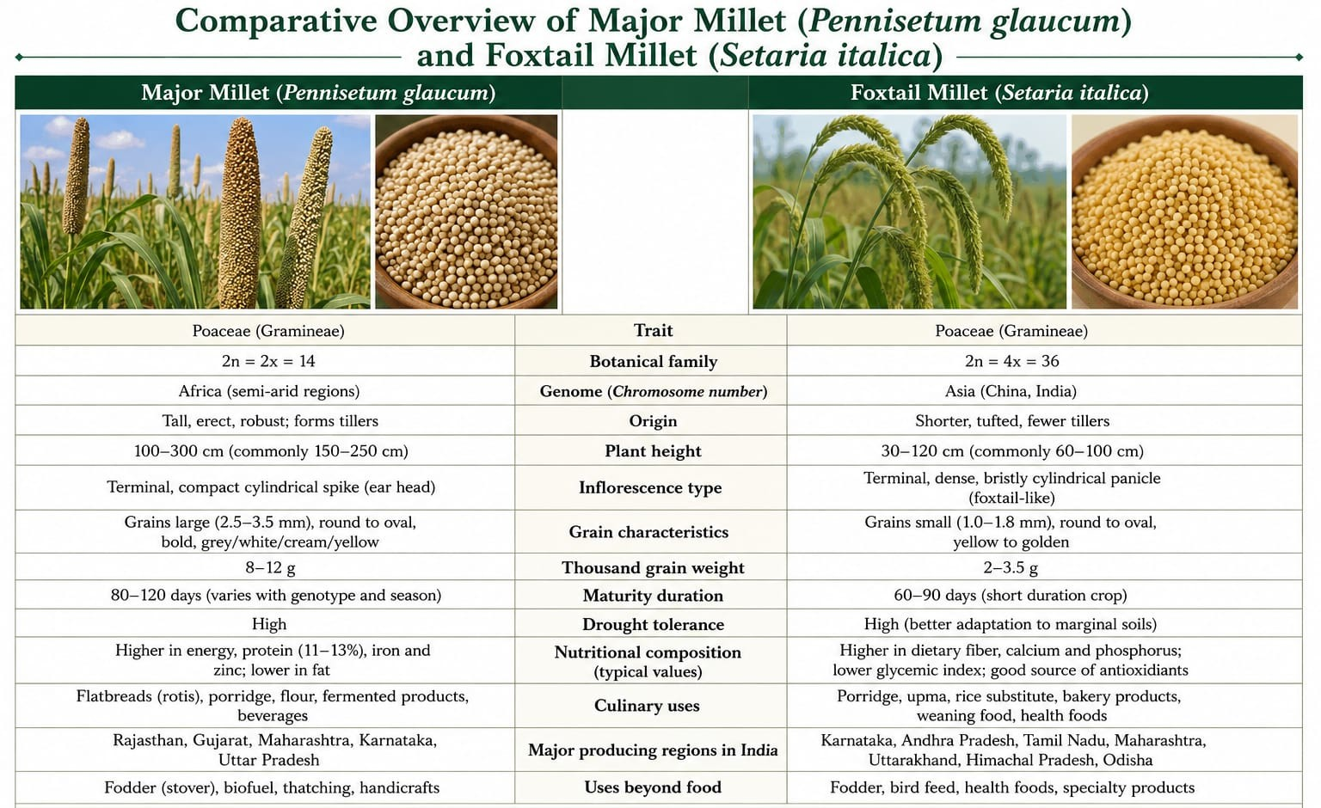
Fig.1. Comparative Overview of Major Millet (Pennisetum glaucum and Foxtail Millet (Seteria italica) (Made by AI)

1.1 Botanical distribution
Foxtail millet (Seteria italica) is one of the oldest domesticated cereal crops and belongs to the family Poaceae. It is widely cultivated in semi-arid regions of Asia and Africa due to its remarkable adaptability to diverse agro-climatic conditions. The crop is believed to have originated in China and has been cultivated for thousands of years as a staple food and fodder crop (Li and Brutnell, 2011; Muthamilarasan and Prasad, 2015).
Foxtail millet is an annual C4 grass characterized by erect culms, narrow linear leaves, and a dense cylindrical panicle resembling a fox’s tail, which gives the crop its common name. (Table.1.Fig.2.) The plant exhibits a well-developed fibrous root system that enhances its ability to extract moisture from deeper soil layers, contributing to its drought tolerance. The grains are small, round, and enclosed within husks, varying in color from yellow to red depending on the variety.
Foxtail millet is a short-duration crop, typically maturing within 70–100 days, making it suitable for multiple cropping systems and climate-resilient farming. It requires minimal inputs, including low water and fertilizer, and can grow successfully in marginal soils where major cereals often fail. Its efficient water-use capacity and tolerance to abiotic stresses such as drought and heat make it a key crop for sustainable agriculture (Bhat et al., 2018; Zhang et al., 2021).
Foxtail millet demonstrates flexibility in cropping systems, including intercropping and crop rotation, thereby enhancing soil health and overall farm productivity. Its resistance to pests and diseases, compared to other cereals, reduces the need for chemical inputs, making it environmentally sustainable. These characteristics collectively position foxtail millet as a vital component of climate-smart agricultural systems.

Table 1. Botanical and Agronomical Characteristics of Foxtail Millet
Characteristic | Description
Scientific Name | Seteria italica
Family | Poaceae
Origin | China
Growth Habit | Annual C4 Grass
Root System | Fibrous, Deep Rooting
Inflorescence | Dense cylindrical panicle
Crop Duration | 70-100 days
Water Requirement | Low
Soil Adaptability | Marginal and Low fertility soils
Stress Tolerance | Drought and Heat Tolerant

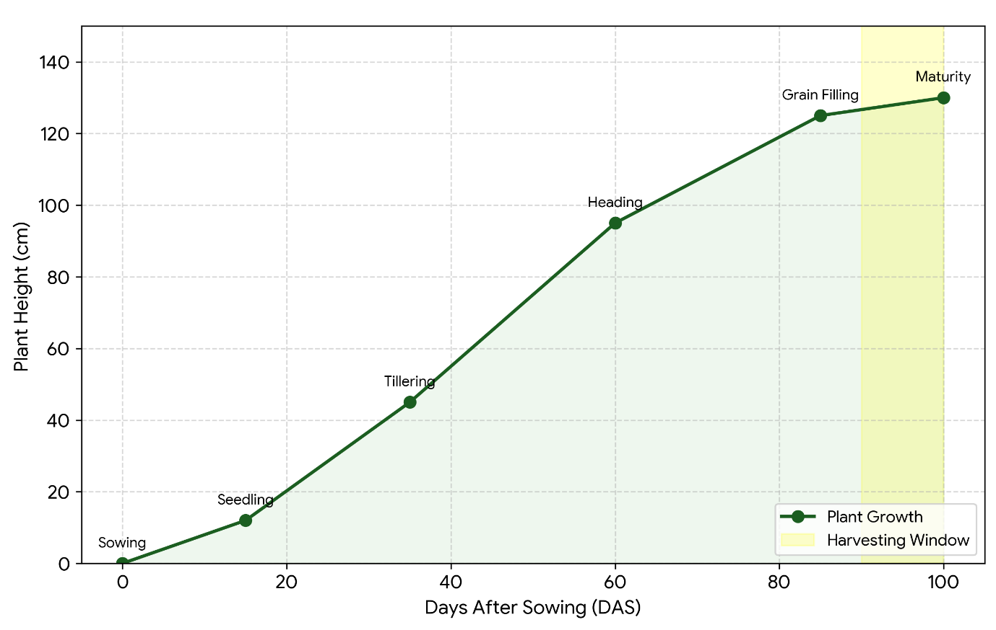Fig.2. Growth Analysis of Foxtail millet (90-100 DAS Cycle) (Made by AI)
1.2. Climate Resilience of Foxtail Millet (Seteria Italica)
1.2.1. Impact of Climate Change on Crop Production
Climate change has emerged as one of the most significant challenges to global agriculture, adversely affecting crop productivity and food security. Increasing temperatures, irregular rainfall patterns, and the rising frequency of extreme weather events such as droughts and heat waves are disrupting agricultural systems worldwide. Major staple crops like rice and wheat are highly sensitive to these environmental stresses, resulting in yield instability, particularly in rainfed regions (Ray et al., 2019; IPCC, 2022). There is an urgent need to identify and promote crops that can withstand such adverse conditions while maintaining stable productivity.
1.2.2. Foxtail Millet as a Climate-Resilient Crop
Foxtail millet (Seteria italica) has gained considerable attention as a climate-resilient crop due to its remarkable adaptability to harsh environmental conditions. It is widely cultivated in semi-arid and arid regions where water availability is limited and soil fertility is low. The crop requires minimal agricultural inputs and can sustain productivity under stress conditions where conventional cereals often fail. These characteristics make foxtail millet an important component of sustainable and climate-smart agricultural systems (FAO, 2021; Bhat et al., 2018).
1.2.3. Drought Tolerance Mechanisms
Foxtail millet is its strong drought tolerance. The plant possesses a well-developed fibrous root system that enables efficient extraction of soil moisture from deeper layers. It exhibits physiological adaptations such as reduced transpiration rates and osmotic adjustment, which help the plant maintain cellular functions under water-deficit conditions. These mechanisms collectively enhance the survival and productivity of foxtail millet in drought-prone environments (Muthamilarasan and Prasad, 2015).
1.2.4. Heat Stress Adaptation and C4 Photosynthesis
Foxtail millet exhibits excellent tolerance to high temperature conditions, largely due to its C4 photosynthetic pathway. This pathway enhances photosynthetic efficiency under high light intensity and elevated temperatures, allowing the crop to maintain productivity even under heat stress. Compared to C3 crops like rice and wheat, foxtail millet shows better performance in warm climates, making it particularly suitable for regions experiencing rising temperatures due to climate change (Li and Brutnell, 2011).
1.2.5. Water Use Efficiency
Another key aspect of climate resilience in foxtail millet is its efficient use of water. The crop exhibits substantially lower water requirements in comparison with major cereals such as rice, thereby rendering it particularly well-suited to rainfed agricultural systems. Its capacity to maintain reasonably stable yields under conditions of limited water availability further enhances its suitability for cultivation in drought-prone and water-scarce regions (FAO, 2021). This trait contributes not only to the conservation of finite water resources but also to the promotion of more sustainable and resource-efficient agricultural practices.
1.2.6. Adaptation to Marginal Soils
Foxtail millet is well adapted to grow in marginal and degraded soils with low fertility. Unlike many conventional crops that require high nutrient inputs, foxtail millet can thrive in nutrient-poor soils with minimal fertilizer application. This adaptability reduces production costs for farmers and makes it an economically viable option for smallholder farming systems (Zhang et al., 2021).
1.2.7. Short Growth Duration and Cropping Flexibility
Foxtail millet is a short-duration crop, typically maturing within 70–100 days. This short life cycle allows it to escape terminal drought conditions and makes it suitable for multiple cropping systems. Farmers can integrate foxtail millet into crop rotations and intercropping systems, Improving land use efficiency and overall farm productivity (Singh et al., 2022).
1.2.8. Role in Climate-Smart Agriculture
Owing to its low input requirements, resilience to environmental stresses, and capacity to thrive under marginal agro-ecological conditions, foxtail millet plays an important role in climate-smart agricultural systems. It supports sustainable farming by reducing dependence on water, fertilisers, and chemical inputs, whilst maintaining relatively stable yields under variable conditions. Consequently, it is widely regarded as an environmentally sustainable crop that contributes to the long-term resilience and sustainability of agricultural production systems (FAO, 2021).
1.2.9. Genetic and Molecular Basis of Stress Tolerance
Advances in genomics and molecular biology have provided important insights into the genetic mechanisms underlying stress tolerance in foxtail millet. A range of stress-responsive genes, together with quantitative trait loci (QTLs) associated with drought and heat tolerance, have been identified. These findings create valuable opportunities for crop improvement through marker-assisted selection and molecular breeding approaches, thereby facilitating the development of high-yielding and stress-resilient varieties (Muthamilarasan et al., 2019; Zhang et al., 2023).
1.2.10. Comparison with Major Cereals under Climate Stress
Compared to major cereals such as rice and wheat, foxtail millet demonstrates superior performance under stress conditions. It maintains relatively stable yields under drought and heat stress, whereas conventional cereals often experience significant yield reductions. This makes foxtail millet a reliable crop for ensuring food security in regions vulnerable to climate variability (Bhat et al., 2018; Goron and Raizada, 2015).”
1.2.11. Future Prospects in Climate Resilience
In the context of increasing climate variability, foxtail millet holds great promise as a resilient and sustainable crop. Its integration into modern agricultural systems can play a crucial role in mitigating the adverse effects of climate change on food production. Further research, policy support, and awareness are needed to promote its cultivation and utilization at a larger scale (Muthamilarasan et al., 2019; Zhang et al., 2023)
1.3. Nutritional Composition
Foxtail millet (Seteria italica) is considered a nutrient-dense cereal due to its rich composition of macronutrients and micronutrients. Compared with commonly consumed cereals such as rice and wheat, it contains comparatively higher levels of dietary fibre, protein, and essential minerals. The presence of bioactive compounds, including polyphenols and antioxidants, further enhances its nutritional profile, thereby supporting its classification as a functional food (Singh et al., 2023).

The relatively low glycemic index of foxtail millet contributes to better blood glucose regulation, making it beneficial for individuals with diabetes and other metabolic disorders. Additionally, its gluten-free nature makes it an excellent alternative for people with gluten intolerance or celiac disease. The nutritional profile of foxtail millet supports its role in improving dietary quality and promoting health (Table.2. Table.3.)

Table.2. Nutritional composition of Foxtail Millet
Parameter | Subtype | Composition | References
Moisture | - | 12% | Muthamilarasan et al. (2016)
Protein | Total proteins  Prolamine | 12.3/100 g  41%–77.5%
Fat | Crude fat | 4.3/100 g | Sharma and Niranjan (2017)
Starch/Carbohydrates | Total carbohydrates  Amylose  Amylopectin | 55–69/100 g  17.5%  82.5% | Kumar, Srivastav, et al. (2021)  Ambika,P.,et al. (2018)
Ash | Mineral matter | 3.3/100 g | Food and Agriculture Organisation (FAO) (1995)
Energy | - | 351 kcal
Minerals | Phosphorous  Calcium  Iron  Zinc  Magnesium  Sodium  Potassium  Copper  Sulfur | 290 mg/100 g  31 mg/100 g  2.8 mg/100 g  2.4 mg/100 g  81 mg/100 g  4.6 mg/100 g  250 mg/100 g  1.4 mg/100 g  171 mg/100 g | Mohari et al. (2019)  Hulse et al. (1980)  Devi et al. (2011)
Crude fiber | Dietary fiber | 6–8/100 g | Bhatt, Fairos et al. (2022)
Vitamins | Thiamine (B1)  Niacin(B3)  Riboflavin(B2)  Carotene (VitA)  Folic acid (B9)  Pantothenic Acid (VitB5)  Tocopherol (VitE) | 0.59 mg/100 g  3.20mg/100g 0.11mg/100g 32mg/100g 15mg/100g 0.82mg/100  31mg/100g | Yang et al. (2022)  Xie et al. (2019)
Fatty acids | Unsaturated fatty acids Palmitic acid  Stearic acid  Oleic acid  Linoleic acid | 80% 6.4mg/100g 6.3mg/100g 13mg/100g 6.5mg/100g | Hariprasanna (2016)
Essential amino acid | EAA  Arginine  Histidine  Lysine  Tryptophan  Phenyl alanine  Methionine  Cystine  Threonine  Leucine  Isoleucine  Valine | mg/100g of N  220  130  140  60  420  180  100  190  1040  480  430 | Hariprasanna (2016)

Table.3. Nutritional Composition of Foxtail Millet Compared with Major Cereals
Nutrient/Component | Foxtail millet | Rice(white) | Wheat | References
Energy(kcal) | 331 | 345 | 346 | Longvah et al., 2017; USDA, 2019
Protien(g) | 12.3 | 6.8 | 11.8 | (Singh et al., 2022b); Kumar et al., 2018
Fat(g) | 4.3 | 0.5 | 1.5 | Longvah et al., 2017
Carbohydrates(g) | 60.9 | 78.2 | 71.2 | (Singh et al., 2020), USDA, 2019
Dietary Fiber(g) | 8.0 | 0.2 | 1.2 | Saleh et al., 2013
Calcium(mg) | 31 | 10 | 30 | Longvah et al., 2017
Iron(mg) | 2.8 | 0.7 | 3.5 | Kumar et al., 2018
Glycemic Index | Low (50-60) | High | Medium | Anitha et al., 2020
Comparative Nutritional Profile of Foxtail Millet, Rice (White), and Wheat per(100g) Edible Portion.

1.3.1. Functional Food Properties of Foxtail Millet (Seteria italica)
Foxtail millet (Seteria italica) is increasingly recognized as a functional food due to its rich nutritional composition and the presence of bioactive compounds that provide health benefits beyond basic nutrition. Functional foods are defined as those that positively influence physiological functions and reduce the risk of chronic diseases. In foxtail millet exhibits several functional properties, including low glycemic response, high dietary fiber content, antioxidant potential, and metabolic health benefits (Shobana et al., 2013; Saleh et al., 2013; Anitha et al., 2020)
1.3.2. Low Glycemic Index and Glycemic Control
One of the key functional properties of foxtail millet is its low glycaemic index (GI), which facilitates a gradual release of glucose into the bloodstream. This attribute is primarily associated with its relatively high dietary fibre content and resistant starch fraction, both of which slow the rate of carbohydrate digestion. Consequently, foxtail millet-based foods are considered beneficial for glycaemic control and are frequently recommended for individuals with diabetes and insulin resistance (Anitha et al., 2020) (Fig. 3).
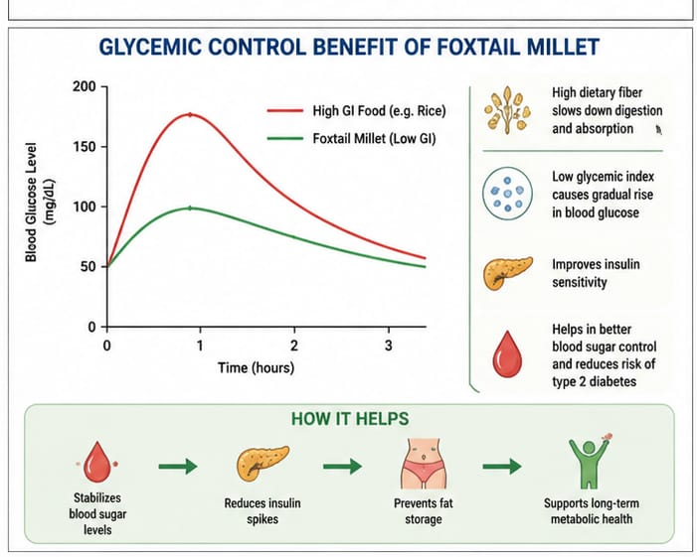Fig.3. Glycemic Control Benefit of Foxtail Millet(Made by AI)

1.3.3. Dietary Fiber and Gut Health
Foxtail millet is a rich source of dietary fiber, which plays a crucial role in maintaining digestive health. The fiber content promotes bowel regularity, improves gut microbiota composition, and enhances satiety. Additionally, soluble fiber contributes to lowering cholesterol levels and reducing the risk of cardiovascular diseases, making foxtail millet an important component of a heart-healthy diet (Kumar et al., 2018).
1.3.4. Antioxidant Activity and Bioactive Compounds
Foxtail millet contains appreciable levels of bioactive compounds, including polyphenols, flavonoids, and phenolic acids, which are known to possess strong antioxidant activity. These constituents contribute to the neutralisation of free radicals and the mitigation of oxidative stress, thereby potentially reducing the risk of chronic diseases such as cancer, diabetes, and cardiovascular disorders (Sharma et al., 2020). The antioxidant capacity of foxtail millet contributes to its role as a protective dietary component.
1.3.5. Anti-Diabetic and Anti-Obesity Effects
Foxtail millet has gained considerable attention due to its potential anti-diabetic and anti-obesity properties. Regular consumption of foxtail millet is associated with improved glycemic control, enhanced insulin sensitivity, and effective body weight management. Owing to its low glycemic index, high dietary fiber content, and slow rate of starch digestion, foxtail millet facilitates gradual glucose release into the bloodstream, thereby preventing sudden spikes in blood sugar levels. Additionally, its high fiber content promotes prolonged satiety, suppresses appetite, and reduces overall energy intake, which collectively aid in weight reduction and obesity prevention. Several studies have reported that millet-based dietary interventions significantly lower fasting blood glucose levels and improve metabolic health, highlighting the therapeutic potential of foxtail millet in the management of diabetes and obesity (Anitha et al., 2020; Devi et al., 2014).

1.3.6. Cardiovascular Health Benefits
Foxtail millet plays a significant role in promoting cardiovascular health owing to its rich composition of dietary fiber, antioxidants, and bioactive compounds. Regular consumption of foxtail millet has been associated with improved lipid metabolism, reduced serum cholesterol levels, and enhanced overall lipid profiles. The dietary fiber present in foxtail millet aids in lowering low-density lipoprotein (LDL) cholesterol while maintaining beneficial high-density lipoprotein (HDL) levels. In addition, the antioxidant constituents help mitigate oxidative stress and protect vascular tissues from free radical-induced damage. These combined effects contribute to the prevention of atherosclerosis, hypertension, and other cardiovascular disorders, thereby supporting heart health and reducing the risk of chronic heart-related diseases (Kumar et al., 2018) (Fig. 4).

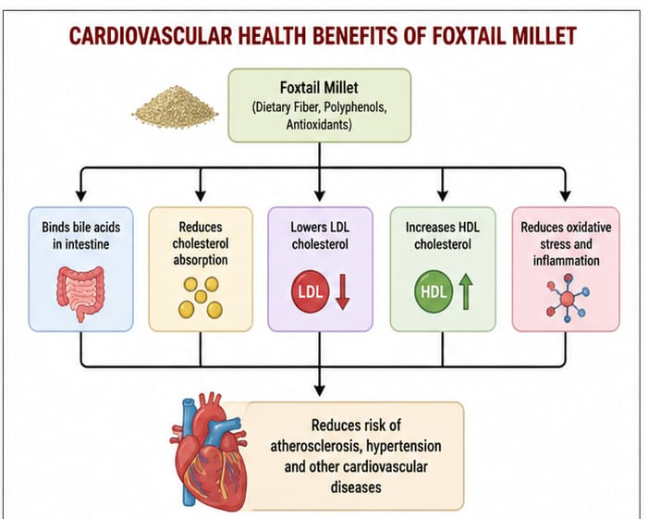
Fig.4. Cardiovascular Health Benefits of Foxtail Millet (Made by AI)

1.3.7. Gluten-Free Property
Foxtail millet is naturally gluten-free, making it a suitable alternative for individuals suffering from celiac disease or gluten intolerance. It can be used in the preparation of gluten-free food products without compromising nutritional quality, expanding dietary options for sensitive populations.
1.3.8. Role in Functional Food Product Development
Due to its functional properties, foxtail millet is widely used in the development of value-added food products such as ready-to-eat snacks, breakfast cereals, bakery products, and nutraceutical formulations. Processing techniques such as fermentation and germination further enhance its bioavailability and functional attributes, increasing its consumer acceptability and market potential (Singh et al., 2021).
1.3.9. Health Benefits of Foxtail Millet (Seteria italica)
Foxtail millet (Seteria italica) is increasingly recognized for its diverse health-promoting properties, primarily due to its rich nutritional composition and the presence of bioactive compounds such as dietary fiber, polyphenols, flavonoids, and resistant starch. These components play a significant role in regulating metabolic functions and reducing the risk of various chronic diseases. Regular consumption of foxtail millet has been associated with improved physiological health and enhanced nutritional status (Table.4. Fig.5.)

Table 4. Potential health benefits of foxtail millet (Seteria italica).
SN | Health benefit | Test model/dose/ concentration | Inference | References
1. | Anti inflammatory | In vivo Swiss albino mice carrageenan induced test model (400mg/kg body weight [C4SI] | Study depicted that after the insertion of carrageenan injection at 1, 2, 3, 4h, a significant anti-inflammatory effect was observed which had 16, 65.44%, 65.5%, and 71.15% inhibition of paw edema. With every increase of time, the anti-inflammatory effect also increased with peak at every fourth hours; also compared to Diclofenac (an anti-inflammatory drug). | Dasgupta et al. (2016) John Calvien Hutabarat and Aditya Bowie (2022)
2. | Anti-cancer | HepG2liver cancer and MDA breast mutant epithelial cells (HT‐29 cells model) | Foxtail millet extract has reported to inhibit the growth of cancer cells (activity of colorectal adeno carcinoma), they have an anti-proliferative effect in terms of DNA stratification inhibitory activity; an important for the control of early and advanced stage carcinogenesis. Study depicted that, foxtail millet bran protein (FMBP) significantly inhibited colon cancer grown in a time and dose‐dependent manner by exhibiting cytostatic and cytotoxic effects in colon cancer cells without disrupting the normal colon epithelial cells. It inhibits by inducing arrest of the G1 phase that induces caspase dependent apoptosis (the death of cells; controlled or normal). | Chandrasekara and Shahidi (2011)
3. | Anti hyperglycemic  Glucose  Metabolism | Diabetic rats (300 mg/kg)  Streptozotocin (HFD/STZ) induced diabetes | Foxtail millet exhibited a significant dose dependent decrease on fasting blood glucose but beyond this dosage, the fasting blood glucose level stayed more or less constant at 41%.  Results revealed that both supplementation of foxtail millet at 30% and 48% 30% significantly decreased the fasting blood glucose levels, additionally the 48% FM supplementation improved blood glucose tolerance and insulin resistance (p | Sireesha et al. (2011)
4. | Anti hypertension | In vivo hypertensive rats (SRHs) model  In vivo healthy men and women (40–65 years) | Foxtail millet's protein hydrolysate prevents the activities of angiotensin‐converting enzyme (ACE) that in turn reduces angiotensin II that helps in lowering blood pressure. It is also revealed that hydrolysates of foxtail millet protein can significantly reduce the cardiac damage and left ventricular hypertrophy.  Mild hypertension (130mmHg ≤SBP ≤139mmHg, 80mmHg ≤DBP ≤89mmHg) people showed reduction in SBP (up to 4.13mmHg) and DBP (up to 3.49mmHg) after 12 weeks. | Ou et al. (2001)  Hou et al. (2018)
5. | Antioxidant activity | In vitro study assay of foxtail millet (cooked dehulled)  Methanolic and ethanolic extracts of foxtail millet whole flour and bran rich fraction | Study depicted the radical scavenging effect of foxtail millet phenolics had high antioxidant (155 ± 19.4 μmol TE/g; 591±2.28μmol EDTA/g), and had high radical scavenging (1.94 ± 0.46 μmol TE/g; 1873 ±23μmol FAE/g) at GI digested phase, after gastric digestion. This suggests that the relation of pH with antioxidant activity and total phenolic content. Bound phenolics were also liberated.  Comparing methanolic extract to ethanol and aqueous extracts, more radicals were scavenged by the methanolic extract. Similar results were found for the bran‐rich portion of foxtail millet, with methanolic extract showing the highest level of radical scavenging activity (51.8%), trailed by alcohol (42.90%) and water (33.60%). | Suma and Urooj (2011)  Chandrasekara and Shahidi (2012)

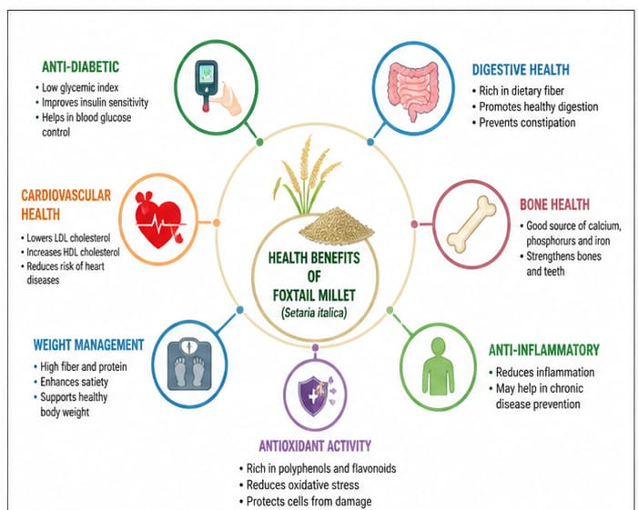
Fig.5. Health Benefits of Foxtail Millet (Seteria italica) (Made by AI)

1.3.10. Anti-diabetic Effect
Foxtail millet is known for its low glycemic index, which results in slow digestion and gradual release of glucose into the bloodstream. This property helps in maintaining stable blood sugar levels and improving insulin sensitivity. The presence of dietary fiber and resistant starch further delays carbohydrate digestion, making foxtail millet an effective dietary component for the prevention and management of type 2 diabetes (Anitha et al., 2020).
1.3.11. Cardiovascular Health
The consumption of foxtail millet contributes to improved cardiovascular health by reducing serum cholesterol levels, particularly low-density lipoprotein (LDL) cholesterol. The soluble fiber present in the grain binds to bile acids and facilitates their excretion, thereby lowering cholesterol levels. Antioxidant compounds help in reducing oxidative stress and preventing damage to blood vessels, which reduces the risk of heart diseases (Kumar et al., 2018).
1.3.12. Anti-obesity Effect
Foxtail millet plays an important role in weight management due to its high fiber content and low glycemic response. The fiber increases satiety and reduces appetite, leading to lower calorie intake. Furthermore, the slow digestion of carbohydrates prevents sudden spikes in blood sugar levels, which are often associated with fat accumulation and obesity (Devi et al., 2014).
1.3.13. Digestive Health and Gut Function
The high dietary fiber content of foxtail millet promotes digestive health by improving bowel movement and preventing constipation. It also acts as a prebiotic, supporting the growth of beneficial gut microorganisms. This contributes to improved gut health and enhanced nutrient absorption (Shobana et al., 2013; Saleh et al., 2013).
1.3.14. Antioxidant and Anti-inflammatory Effects
Foxtail millet contains appreciable quantities of polyphenols and flavonoids, both of which are characterised by strong antioxidant activity. These compounds facilitate the scavenging of free radicals and the attenuation of oxidative stress, thereby limiting cellular damage. In addition, their anti-inflammatory properties contribute to the mitigation of inflammation-associated disorders and support overall physiological health (Sharma et al., 2020).
1.3.15. Potential Anti-cancer Activity
The bioactive compounds present in foxtail millet are believed to possess anti-cancer properties by inhibiting oxidative damage and regulating cellular pathways involved in cell growth and apoptosis. Research is needed; preliminary studies indicate its potential role in cancer prevention (Sharma et al., 2020; Chandrasekara and Shahidi, 2011)
1.3.16. Gluten-free Advantage
Foxtail millet is naturally gluten-free, making it an ideal food choice for individuals with celiac disease and gluten intolerance. Its inclusion in gluten-free diets ensures adequate nutrient intake without adverse health effects (Taylor and Emmambux, 2008; Saleh et al., 2013)

1.4. Processing and Value Addition of Foxtail Millet
Foxtail millet (Seteria italica) has gained considerable importance not only due to its nutritional and health benefits but also because of its versatility in processing and product development. However, like other millets, its direct consumption is often limited by the presence of a hard outer husk and certain anti-nutritional factors such as phytates and tannins. The processing techniques are essential to improve its edibility, digestibility, and consumer acceptability. Primary processing of foxtail millet generally involves cleaning, DE husking, and milling, which help in removing impurities and the inedible husk layer. Dehulling is particularly important as it enhances the palatability and reduces the content of anti-nutritional compounds. Milling converts the grains into flour, which can be further utilized in various food preparations. These basic processing steps significantly improve the usability of foxtail millet for both household and industrial applications (Saleh et al., 2013; Shobana et al., 2013; Taylor and Emmambux, 2008).
Processing techniques such as soaking, germination, fermentation, and thermal treatment play a vital role in enhancing the nutritional quality of foxtail millet. Germination has been reported to improve mineral bioavailability and protein digestibility, whereas fermentation contributes to improvements in flavour, texture, and functional attributes of the grain. Collectively, these processes also aid in the reduction of anti-nutritional factors, thereby enhancing nutrient absorption. Considerable progress has been made in the development of value-added foxtail millet products, driven by increasing consumer demand for healthier and functional foods. The grain is now extensively utilised in the preparation of both traditional and contemporary food products, including porridge, flatbreads, snacks, breakfast cereals, and bakery items such as biscuits and bread. Furthermore, the incorporation of foxtail millet flour into composite flour formulations has further broadened its applications within the food industry, facilitating the development of nutritionally enhanced products (Saleh et al., 2013; Shobana et al., 2013; Anitha et al., 2020).
Value addition not only enhances the nutritional profile of food products but also improves their sensory attributes and market acceptability. Ready-to-eat and ready-to-cook products based on foxtail millet are gaining popularity due to their convenience and health benefits. Processing technologies such as extrusion and puffing have enabled the production of innovative millet-based snacks with improved texture and shelf life. These challenges such as processing inefficiencies, limited industrial-scale technologies, and lack of consumer awareness still restrict the widespread utilization of foxtail millet. Continued research and technological interventions are necessary to optimize processing methods and promote the development of high-quality value-added products (Shobana et al., 2013; Saleh et al., 2013; Deshpande et al., 2015).

1.5. Role of Foxtail Millet in Food Security and Sustainable Agriculture
Foxtail millet (Seteria italica) has emerged as an important crop in addressing the dual challenges of food security and sustainable agriculture, particularly under the current scenario of climate change and resource limitations. As global food demand continues to rise, there is an increasing need for crops that can produce stable yields under adverse environmental conditions. Foxtail millet offers significant advantages due to its resilience, adaptability, and low input requirements. Its ability to grow in marginal lands with minimal water and nutrient inputs makes it a reliable crop for smallholder farmers and resource-poor regions (Goron and Raizada, 2015; Bhat et al., 2018; FAO, 2021)
The role of foxtail millet in food security is closely linked to its nutritional richness and adaptability. Major cereals, which are highly dependent on irrigation and external inputs, foxtail millet can sustain production under rainfed conditions, thereby ensuring food availability even during periods of climatic stress. Its short growth duration further enables farmers to cultivate it in multiple cropping systems, increasing productivity and reducing the risk of crop failure. This stability in production is particularly crucial for ensuring food security in vulnerable and drought-prone regions (Muthamilarasan et al., 2019; Bhat et al., 2018).
Food availability, foxtail millet contributes to nutritional security by providing essential nutrients such as dietary fiber, proteins, minerals, and bioactive compounds. Its inclusion in daily diets can help address micronutrient deficiencies and improve dietary quality,in rural populations. Foxtail millet plays a dual role in both food and nutritional security, which is essential for sustainable development (Saleh et al., 2013; Anitha et al., 2020; FAO, 2021).
A sustainability prospects foxtail millet is considered an environmentally friendly crop due to its low ecological footprint. It requires less water compared to conventional cereals like rice, conserving valuable water resources. Its ability to grow in poor soils reduces the need for chemical fertilizers, minimizing environmental degradation and promoting soil health. The crop is also relatively resistant to pests and diseases, which decreases reliance on chemical pesticides and supports eco-friendly farming practices (Bhat et al., 2018; FAO, 2021; Goron and Raizada, 2015)
Foxtail millet supports sustainable agricultural systems by enhancing biodiversity and promoting crop diversification. The inclusion of millets in cropping systems reduces dependency on a few major crops, increasing resilience against climate variability and market fluctuations. It also provides economic benefits to farmers by lowering production costs and offering alternative income sources through value-added products. The large-scale adoption of foxtail millet remains limited due to factors such as low consumer awareness, inadequate processing infrastructure, and insufficient policy support. Promoting millet-based food systems through research, awareness programs, and government initiatives is essential to fully harness its potential in achieving sustainable agriculture and food security (Muthamilarasan et al., 2019; Anitha et al., 2020; FAO, 2021).

1.6. Challenges of Foxtail Millet
Foxtail millet faces several practical and systemic challenges that hinder its large-scale adoption despite its agronomic and nutritional advantages. One of the major challenges is the low level of consumer awareness and acceptance, particularly in urban areas where dietary patterns are increasingly shifting toward refined cereals and processed foods. Millets are often perceived as inferior or traditional grains, which limits their inclusion in modern food systems. Processing and post-harvest handling also present significant challenges. The presence of a tough husk requires specialized dehulling and milling equipment, which is not widely available at the farm or small-scale industry level. Inadequate processing infrastructure reduces the efficiency of millet utilization and limits the development of high-quality value-added products. Traditional processing methods are labor-intensive and time-consuming, further discouraging their adoption. Market-related constraints also play a crucial role. Weak supply chains, lack of organized markets, and insufficient price support reduce incentives for farmers to cultivate foxtail millet. The absence of strong branding and limited availability of millet-based products in mainstream retail markets further restrict consumer demand. Policy-level support and investment in millet promotion are still comparatively low when compared to major staple crops (Anitha et al., 2020; Bhat and Tonapi, 2019; FAO, 2021)
Limitations of Foxtail Millet
Foxtail millet also has certain inherent limitations that affect its utilization and acceptance. One of the primary limitations is its relatively lower yield potential compared to major cereals such as rice and wheat, which discourages farmers from adopting it in large-scale production systems. Limited availability of improved and high-yielding varieties further exacerbates this issue. Anti-nutritional factors such as phytates, tannins, and enzyme inhibitors, which can reduce the bioavailability of essential nutrients like iron and calcium. These effects can be minimized through processing techniques such as soaking, fermentation, and germination, their complete elimination is difficult. Shelf-life and storage stability also pose limitations. Foxtail millet grains are prone to quality deterioration during storage due to their fat content, which may lead to rancidity under improper storage conditions. This affects both consumer acceptance and marketability. Sensory limitations, such as coarse texture and distinct flavour, may not be preferred by all consumers, particularly those accustomed to refined cereals. This affects its wider acceptance in urban diets. Limited research on large-scale industrial processing, product standardization, and quality control further restricts its commercial expansion (Muthamilarasan and Prasad, 2015; Anitha et al., 2020; Goron and Raizada, 2015; FAO, 2021)

1.7. Recent Advances and Research Trends in Foxtail Millet
Foxtail millet has gained significant research attention in recent years due to its potential as a climate-resilient and nutritionally rich crop. Advances in genomics, breeding strategies, food processing technologies, and functional food development have contributed to its increasing importance in both agricultural and nutritional research. These developments are aimed at improving yield, stress tolerance, nutritional quality, and consumer acceptance of foxtail millet (Muthamilarasan et al., 2019; Anitha et al., 2020; FAO, 2021)
1.7.1. Genomics and Molecular Breeding
In genomics has provided valuable insights into the genetic architecture of foxtail millet. The availability of whole-genome sequencing and high-throughput molecular markers has facilitated the identification of genes associated with drought tolerance, heat resistance, and nutrient use efficiency. Marker-assisted selection (MAS) and quantitative trait loci (QTL) mapping are being increasingly utilized to develop improved varieties with enhanced agronomic traits. These advancements are particularly relevant for developing climate-resilient cultivars suitable for stress-prone environments (Muthamilarasan and Prasad, 2015; Bennetzen et al., 2012; Jia et al., 2013)
1.7.2. Biofortification and Nutritional Enhancement
Biofortification has emerged as an important research trend aimed at enhancing the nutritional profile of foxtail millet. Efforts are being made to increase the content of essential micronutrients such as iron, zinc, and calcium through both conventional breeding and molecular approaches. The research is focusing on improving the bioavailability of nutrients by reducing anti-nutritional factors, the nutritional value of the grain (Goron and Raizada, 2015; Anitha et al., 2020; Chandel et al., 2014)
1.7.3. Functional Food and Product Development
With increasing awareness of health and nutrition, foxtail millet is being extensively studied for its functional food applications. The research has focused on developing value-added products such as gluten-free bakery items, ready-to-eat snacks, and nutraceutical formulations. Processing techniques such as extrusion, fermentation, and germination are being optimized to improve the sensory qualities, shelf life, and functional properties of millet-based products (Taylor and Emmambux, 2008; Anitha et al., 2020; Devi et al., 2014)
1.7.4. Climate Resilience and Stress Physiology
Stress physiology and climate resilience mechanisms in foxtail millet. Researchers are investigating physiological and biochemical responses of the crop under drought, heat, and salinity stress conditions. These studies aim to identify key traits and mechanisms that contribute to stress tolerance, which can be utilized in breeding programs for developing resilient varieties (Muthamilarasan et al., 2014; Diao et al., 2014; Lata et al., 2013)1.7.5. Sustainable Agriculture and Cropping Systems
The role of foxtail millet in sustainable agriculture and diversified cropping systems. Research is being conducted on intercropping, crop rotation, and integrated farming systems involving millets to improve soil health, biodiversity, and resource use efficiency. These approaches contribute to the development of climate-smart and sustainable agricultural practices (FAO, 2021; Goron and Raizada, 2015; Chandel et al., 2014)

1.8. Future Prospects of Foxtail Millet
Foxtail millet (Seteria italica) holds significant promise as a future-ready crop in the context of climate change, nutritional security, and sustainable agricultural systems. With increasing global concerns regarding food scarcity and environmental degradation, there is a growing need to promote crops that are both resilient and nutritionally superior. Foxtail millet, due to its adaptability to harsh environmental conditions and its rich nutritional profile, is well positioned to play a crucial role in addressing these challenges. Future research efforts are expected to focus on the development of high-yielding and stress-tolerant varieties through advanced breeding approaches, including molecular breeding, genomic selection, and gene-editing technologies. The identification and utilization of stress-responsive genes can further enhance the crop’s resilience to drought, heat, and other abiotic stresses, improving productivity under changing climatic conditions (Muthamilarasan et al., 2019; Diao et al., 2014; FAO, 2021).
To genetic improvement, there is considerable scope for enhancing the nutritional quality of foxtail millet through biofortification and reduction of anti-nutritional factors. Improving nutrient bioavailability and developing varieties with enhanced micronutrient content will further strengthen its role in combating malnutrition and micronutrient deficiencies. The expansion of processing technologies and value-added product development will also play a key role in increasing consumer acceptance and market demand. The development of convenient, ready-to-eat, and health-oriented food products based on foxtail millet is expected to attract urban consumers and integrate millets into mainstream diets. Innovations in food processing, packaging, and shelf-life enhancement will further support its commercialization (Anitha et al., 2020; Taylor and Emmambux, 2008; Goron and Raizada, 2015).
The integration of foxtail millet into diversified cropping systems and climate-smart farming practices can enhance sustainability and resource-use efficiency. Promoting millet-based farming systems can reduce dependency on water-intensive crops and contribute to environmental conservation. Increased policy support, awareness programs, and investment in millet research and value chains will be essential for scaling up its production and utilization. Government initiatives, international collaborations, and farmer-oriented extension services can play a vital role in popularizing foxtail millet and ensuring its inclusion in national and global food systems. Foxtail millet represents a promising crop with the potential to bridge the gap between agricultural sustainability and human health. Strategic research, technological advancements, and policy interventions will be critical in unlocking its full potential and ensuring its contribution to future food and nutritional security (FAO, 2021; Muthamilarasan et al., 2019; Goron and Raizada, 2015; Anitha et al., 2020)

1.9. Conclusion
Foxtail millet (Setaria italica) has gained increasing attention as a climate-resilient crop with considerable potential to mitigate global concerns relating to food security, nutritional inadequacy, and sustainable agricultural production. Its pronounced tolerance to abiotic stresses, including drought, elevated temperatures, and low soil fertility, renders it particularly well suited to cultivation in marginal and resource-constrained environments. In comparison with major cereal crops, foxtail millet is characterised by relatively low input requirements, thereby supporting more environmentally sustainable farming practices. Nutritionally, it constitutes a valuable source of dietary fibre, protein, essential minerals, and bioactive constituents, notably polyphenols and antioxidant compounds. These components contribute to its functional food properties and are directly associated with various health benefits. Regular consumption of foxtail millet has been linked to improved glycemic control, better cardiovascular health, enhanced digestive function, and effective weight management.
The wider adoption of foxtail millet is constrained by challenges such as low consumer awareness, limited processing infrastructure, and weak market linkages. Addressing these issues through technological advancements, improved value chains, and increased policy support is essential for its promotion. In genomics, breeding, and food processing technologies have opened new opportunities to enhance its productivity, nutritional quality, and consumer acceptance. The development of value-added products and integration into modern diets can further increase its demand. Foxtail millet represents a sustainable and health-promoting crop with the potential to bridge the gap between agricultural resilience and human nutrition. Strategic efforts in research, policy, and awareness will be crucial to fully utilize its potential and ensure its contribution to future food and nutritional security.

Disclaimer (Artificial Intelligence)
Author(s) hereby declare that generative AI technologies such as Large Language Models, etc. have been used during the writing or editing of manuscripts. This explanation will include the name, version, model, and source of the generative AI technology and as well as all input prompts provided to the generative AI technology
Details of the AI usage are given below:
1.AI used for image generating

References

Ambika, P., et al. (2018). Amylose and amylopectin characterization in foxtail millet starch. International Journal of Food Properties, 21(1), 1769–1777.
Anitha, S., Kane-Potaka, J., Tsusaka, T. W., Botha, R., Budumuru, M., & Upadhyay, S. (2020). Millet consumption and its role in managing hyperglycemia and diabetes. Frontiers in Nutrition, 7, 146.
Anitha, S., Kane-Potaka, J., Tsusaka, T.W., Botha, R. and Rajendran, A. (2020). Can millet consumption help manage lifestyle diseases? Insights from human intervention studies. Nutrients, 12(11): 3412.
Bennetzen, J.L., Schmutz, J., Wang, H., Percifield, R., Hawkins, J., Pontaroli, A.C. et al. (2012). Reference genome sequence of the model plant Setaria. Nature Biotechnology, 30(6): 555–561.
Bhat, B. V., Upadhyaya, H. D., & Reddy, K. N. (2018). Millets for climate resilience and nutritional security. Indian Journal of Plant Genetic Resources, 31(3), 239–245.
Bhat, B.V. and Tonapi, V.A. (2019). Millets in the changing global scenario. In: Millets and Pseudo Cereals. Woodhead Publishing, pp. 1–18.
Chandel, G., Meena, R.K., Dubey, M. and Kumar, M. (2014). Nutritional properties of minor millets: neglected cereals with potentials to combat malnutrition. Current Science, 107(7): 1109–1111.
Chandrasekara, A., & Shahidi, F. (2011). Antiproliferative potential and DNA scission inhibitory activity of phenolics from millet grains. Journal of Functional Foods, 3(3), 159–170.
Chandrasekara, A., & Shahidi, F. (2012). Bioactivities and antioxidant properties of millet grain phenolics and their fractions. Journal of Agricultural and Food Chemistry, 60(39), 9563–9570.
Dasgupta, S., Banerjee, S., & Bandyopadhyay, R. (2016). Anti-inflammatory activity of carotenoid-rich foxtail millet (Seteria italica) extracts in Swiss albino mice. Journal of Functional Foods, 27, 352–361.
Devi, P. B., Vijayabharathi, R., Sathyabama, S., Malleshi, N. G., & Priyadarisini, V. B. (2014). Health benefits of millets. Journal of Food Science and Technology, 51(6), 1021–1040.
Devi, P. B., Vijayabharathi, R., Sathyabama, S., Malleshi, N. G., & Priyadarisini, V. B. (2011). Health benefits of finger millet and other millets. Journal of Food Science and Technology, 51(6), 1021–1024.
Devi, P.B., Vijayabharathi, R., Sathyabama, S., Malleshi, N.G. and Priyadarisini, V.B. (2014). Health benefits of finger millet (Eleusine coracana L.) polyphenols and dietary fiber: a review. Journal of Food Science and Technology, 51(6): 1021–1040.
Diao, X., Schnable, J., Bennetzen, J.L. and Li, J. (2014). Initiation of Setaria as a model plant. Frontiers in Agricultural Science and Engineering, 1(1): 16–20.
Fairos, M., et al. (2022). Dietary fiber composition and nutritional properties of foxtail millet. Food Chemistry Advances, 1, 100021.
FAO (2021). Millets and their role in sustainable agriculture and food systems. Food and Agriculture Organization of the United Nations, Rome.
FAO. (2021). The State of Food and Agriculture 2021. Food and Agriculture Organization of the United Nations, Rome.
Food and Agriculture Organization (FAO). (1995). Sorghum and Millets in Human Nutrition. FAO Food and Nutrition Series No. 27. Rome, Italy.
Goron, T. L., & Raizada, M. N. (2015). Genetic diversity and genomic resources available for small millets. Frontiers in Plant Science, 6, 157.
Goron, T.L. and Raizada, M.N. (2015). Genetic diversity and genomic resources available for the small millet crops to accelerate a New Green Revolution. Frontiers in Plant Science, 6: 157.
Gupta, N., Srivastava, A. K., & Pandey, V. N. (2017). Millets: Future of food and farming. Indian Farming, 67(4), 21–24.
Hariprasanna, K. (2016). Foxtail millet: Nutritional importance and cultivation aspects. Indian Farming, 66(5), 21–26.
Hou, D., Chen, G., Zhang, X., et al. (2018). Foxtail millet consumption improves blood pressure and lipid metabolism in hypertensive subjects. Nutrients, 10(8), 1072.
Hulse, J. H., Laing, E. M., & Pearson, O. E. (1980). Sorghum and the Millets: Their Composition and Nutritive Value. Academic Press, New York.
Hutabarat, J. C., & Bowo, A. (2022). Evaluation of anti-inflammatory properties of millet-based functional foods. Food Research, 6(2), 144–152.
IPCC (2022). Climate Change 2022: Impacts, Adaptation, and Vulnerability. Cambridge University Press.
Jia, G., Huang, X., Zhi, H., Zhao, Y., Zhao, Q., Li, W. et al. (2013). A haplotype map of genomic variations and genome-wide association studies of agronomic traits in foxtail millet. Nature Genetics, 45(8): 957–961.
Kumar, A., Srivastava, S., et al. (2021). Nutritional evaluation and carbohydrate composition of foxtail millet (Seteria italica). Journal of Cereal Science, 98, 103–110.
Kumar, A., Tomer, V., Kaur, A., Kumar, V., & Gupta, K. (2018). Millets: A solution to agrarian and nutritional challenges. Agriculture & Food Security, 7, 31.
Lata, C., Gupta, S. and Prasad, M. (2013). Foxtail millet: a model crop for genetic and genomic studies in bioenergy grasses. Critical Reviews in Biotechnology, 33(3): 328–343.
Li, P., & Brutnell, T. P. (2011). Seteria italica as a model system for C4 photosynthesis research. Journal of Experimental Botany, 62(9), 3031–3037.
Longvah, T., Ananthan, R., Bhaskarachary, K., & Venkaiah, K. (2017). Indian Food Composition Tables. National Institute of Nutrition (ICMR), Hyderabad.
Moharil, M. P., et al. (2019). Mineral profiling and nutritional characterization of foxtail millet grain. International Journal of Chemical Studies, 7(3), 4512–4516.
Muthamilarasan, M. and Prasad, M. (2015). Advances in Setaria genomics for genetic improvement of cereals and bioenergy grasses. Theoretical and Applied Genetics, 128(1): 1–14.
Muthamilarasan, M., & Prasad, M. (2015). Advances in Seteria genomics for crop improvement. Theoretical and Applied Genetics, 128(1), 1–14.
Muthamilarasan, M., Dhaka, A., Yadav, R. and Prasad, M. (2016). Exploration of millet models for developing nutrient rich graminaceous crops. Plant Science, 242: 89–97.
Muthamilarasan, M., Dhaka, A., Yadav, R., & Prasad, M. (2017). Exploration of millet models for developing nutrient rich graminaceous crops. Frontiers in Plant Science, 8, 29.
Muthamilarasan, M., Dhaka, A., Yadav, R., & Prasad, M. (2019). Exploration of millet models for developing climate-resilient crops. Trends in Plant Science, 24(1), 64–81.
Muthamilarasan, M., Prasad, M. and others (2019). Recent advances in genetic and genomic resources for foxtail millet improvement. Plant Cell Reports, 38: 1–15.
Ou, S., Kwok, K. C., Li, Y., & Fu, L. (2001). In vitro study of possible role of dietary fiber in lowering postprandial serum glucose. Journal of Agricultural and Food Chemistry, 49(2), 1026–1029.
Ray, D. K., West, P. C., Clark, M., Gerber, J. S., Prishchepov, A. V., & Chatterjee, S. (2019). Climate change has likely already affected global food production. Nature Climate Change, 9, 321–325.
Saleh, A. S. M., Zhang, Q., Chen, J., & Shen, Q. (2013). Millet grains: Nutritional quality, processing, and health benefits. Comprehensive Reviews in Food Science and Food Safety, 12(3), 281–295.
Sharma, N., & Niranjan, K. (2018). Foxtail millet: Properties, processing, health benefits, and uses. Food Reviews International, 34(4), 329–363.
Sharma, N., Niranjan, K., & Kumar, A. (2020). Antioxidant properties of millets. Journal of Food Science and Nutrition, 8(2), 543–551.
Singh D. and Verma S. (2020) Pre-sowing treatments of Maize (Zea mays L.) effect on seed treatments in growth and seed quality on different parameter DOI: 10.37896/jxu14.6/335
Singh, D., Lawrence, K., Marker, S., Bhattacharjee, I., Lawrence, R., Choudhary, R., Ercisli, S., & Karunakaran, R. (2023a). Rainfed assessment of foxtail millet (Setaria italica L. Beauv) germplasms on genotyping and principal component analysis. Frontiers in Plant Science, 14, 1017652. https://www.frontiersin.org/journals/plant-science/articles/10.3389/fpls.2023.1017652/full
Singh, D., Lawrence, K., Singh, S., Ercisli, S., & Choudhary, R. (2022a). In-vivo hyperglycemic, antioxidant, histopathological changes, and simultaneous measurement of kaempferol verified by high-performance thin layer chromatography of Setaria italica in streptozotocin-induced diabetic rats. Saudi Journal of Biological Sciences, 29(5), 3772–3790. https://doi.org/10.1016/j.sjbs.2022.03.009
Singh, D., Marker, S., Suresh, B. G., & Lawrence, K. (2022b). Under rainfed effect of foxtail millet [Setaria italica (L.) Beauv] germplasms evaluation on genotypic variance, correlation, and path analysis. 56(2), 141–146. https://doi.org/10.18805/IJARe.A-5862
Singh, P., Raghuvanshi, R. S., & Srivastava, S. (2021). Processing and value addition of millets. Journal of Food Processing and Preservation, 45(2), e15114.
Sireesha, Y., Kasetti, R. B., et al. (2011). Antihyperglycemic and antihyperlipidemic activities of foxtail millet in streptozotocin-induced diabetic rats. Food and Chemical Toxicology, 49(8), 1918–1924.
Suma, P. F., & Urooj, A. (2011). Antioxidant activity of extracts from foxtail millet (Seteria italica). Food Chemistry, 126(4), 1666–1672.
Taylor, J. R. N., and Emmambux, M. N. (2008). Millets: Their unique nutritional and health-promoting properties. Advances in Food and Nutrition Research, 56, 1–56.
Taylor, J. R. N., & Emmambux, M. N. (2008). Gluten-free foods and beverages from millets. In E. Gallagher (Ed.), Gluten-Free Cereal Products and Beverages (pp. 119–148). Academic Press.
Xu, Y., et al. (2019). Nutritional and vitamin profiling of foxtail millet cultivars. Journal of Food Biochemistry, 43(9), e12998.
Yu, X., et al. (2022). Vitamin and antioxidant composition in foxtail millet grains. Foods, 11(8), 1142.
Zhang, G., Liu, X., Quan, Z., Cheng, S., Xu, X., Pan, S., et al. (2021). Genome sequence of foxtail millet and its adaptation. Nature Biotechnology, 30, 549–554.Zhang, H., Liang, W., Yang,X., Luo, X., Jiang, N., Ma, H., et al. (2023). Recent advances in foxtail millet breeding and genomics research. Frontiers in Plant Science, 14, 1123456.

