In Silico Analysis of RpoB Sequence Variations and Rifampicin Binding Interactions in Mycobacterial Strains
Abstract
Tuberculosis (TB) remains a major global health challenge, particularly due to the increasing prevalence of multidrug-resistant and rifampicin-resistant Mycobacterium tuberculosis strains. The present study investigated sequence variation and molecular interactions of the rifampicin drug target, RNA polymerase beta subunit (RpoB), using in silico approaches. Ten RpoB protein sequences from different Mycobacterial strains showing 98–100% similarity were retrieved and analysed through multiple sequence alignment using Clustal Omega. Sequence analysis revealed conserved regions along with amino acid gaps, substitutions and truncations, particularly within functionally important regions associated with rifampicin resistance. Three-dimensional structures of all proteins were generated using SWISS-MODEL and validated by Ramachandran plot analysis, which confirmed approximately 98% residues within favoured and allowed regions indicating good stereochemical quality of the modelled structures. Rifampicin ligand preparation and molecular docking were performed using Discovery Studio 2020 with the LibDock algorithm. Docking analysis identified 39–41 active binding sites across the proteins, with binding sites 3, 5 and 6 consistently demonstrating strong molecular interactions. The highest LibDock score (137.73) was recorded for WP_003900992.1, while WP_202581977.1 showed a notable score of 120.06. Key interacting residues included arginine, glutamate, lysine, and aspartate residues, ranging from 4 to 13 residues depending on the binding site and target protein, and were involved in hydrogen bonding and electrostatic interactions with rifampicin. The study demonstrated that sequence-level variations in RpoB can alter protein conformation, binding pocket architecture and rifampicin-binding affinity, thereby contributing to drug resistance. Overall, the integrated in silico workflow proved effective for understanding resistance-associated structural and functional changes in Mycobacterium drug targets.
Keywords: Mycobacterium tuberculosis, rifampicin resistance, homology modelling, molecular docking, in silico analysis;

1. Introduction
Tuberculosis (TB) is one of the oldest recorded human afflictions and remains among the most devastating infectious diseases worldwide, despite the global use of a live attenuated vaccine and multiple antibiotics (Nasto, 2026). According to the World Health Organization (WHO) Global Tuberculosis Report 2025, there were approximately 10.7 million new TB cases globally in 2024, with nearly 1.23 million deaths. In 2024, approximately 390,000 people developed multidrug-resistant tuberculosis or rifampicin-resistant tuberculosis (MDR/RR-TB), with an estimated 150,000 deaths attributable to MDR/RR-TB. The global rate of MDR/RR-TB was 3.2% among new TB cases and 16% among previously treated TB cases (WHO, 2025). New vaccines and drugs are urgently needed to curb this epidemic.
Drug resistance in tuberculosis is a critical public health concern. Drug-resistant TB is predominantly caused by chromosomal mutation mechanisms, particularly single nucleotide polymorphisms (SNPs). Resistance-causing factors include cellular mechanisms such as mismatch repair inefficiency, microsatellites, inadequate translation fidelity, and error-prone DNA polymerases; and external stress factors including absence of rapid diagnostics, improper anti-TB prescribing practices and exposure to environmental pollutants (McGrath et al., 2014; Palomino and Martin, 2014, Khawbung et al., 2021). Development of drug resistance also arises through spontaneous mutations in drug targets, enzymatic inactivation or degradation of drugs, molecular simulation of drug targets, and epigenetic drug tolerance (Jenkins et al., 2009; Smith et al., 2013). In India, controlled drug resistance studies at the National Institute for Research in Tuberculosis (NIRT), Chennai, Tamil Nadu revealed that resistance rates for isoniazid, streptomycin, and rifampicin ranged from 10–16%, 8–3%, and approximately 1%, respectively (Paramasivan and Venkataraman, 2004). Similarly, MDR-TB cases reported in South India showed rifampicin mono-resistance, isoniazid mono-resistance, and MDR-TB prevalence rates of 2.5%, 11.4%, and 5.4%, respectively, while rpoB-based analysis revealed true rifampicin resistance in 38% of MDR cases, along with hetero-resistance (29.3%) and inferred resistance (32.7%) (Shivekar et al., 2020).
Rifampicin, one of the most potent anti-TB agents, serves as the cornerstone of first-line therapy for drug-susceptible TB and remains effective against initial isoniazid resistance (Mitchison and Nunn, 1986, Asif, 2024). Resistance to rifampicin in Mycobacterium tuberculosis (Mtb) occurs primarily due to mutations in the rifampicin-resistance determining region (RRDR) of the RNA polymerase beta subunit (RpoB), encoded by the rpoB gene. More than 95% of rifampicin-resistant strains carry mutations within this region (Morlock et al., 2000; Zaw et al., 2018).
The present study evaluates the impact of mutations in the rifampicin drug target sequence (Mtb-RNAP/RpoB) and assesses the effect of these mutations on molecular interactions with the rifampicin ligand, providing mechanistic insights into the development of rifampicin resistance using in silico approaches.
2. Materials and methods:
The research was carried out at the Bioinformatics Centre and Agricultural Research Information System (ARIS) Cell, Madras Veterinary College, Chennai. The workflow included identification and retrieval of rifampicin target protein sequences, three-dimensional (3D) modelling and validation of target protein structures, ligand identification and preparation and molecular docking analysis using Discovery Studio 2020 commercial software.
2.1 Identification and retrieval of rifampicin target protein sequences
The amino acid sequence of the DNA-directed RNA polymerase beta chain (RpoB) of Mycobacterium tuberculosis (target gene: Rv0667; UniProt: P0A680) was retrieved from NCBI (https://www.ncbi.nlm.nih.gov). This enzyme, which catalyzes the transcription of DNA into RNA using ribonucleoside triphosphates as substrates, is the primary molecular target of rifampicin. A total of ten sequences from various Mycobacterial strains (A1KGE7.2, AFR90391.1, CRC92832.1, AIH26280.1, AFR90390.1, AFR90385.1, AFM48062.1, WP_202581977.1, 5ZX2_C, WP_003900992.1) with structural similarity ranging from 98–100% were selected for comparative analysis.
2.2 Multiple Sequence Alignment
Multiple sequence alignment was performed using Clustal Omega (https://www.ebi.ac.uk/Tools/msa/clustalo/) to generate alignments among three or more sequences. The alignment was analysed for gaps and point mutations (deletions or substitutions) relative to the reference sequence.
2.3 Protein 3D Modelling and Validation
Three-dimensional structures of the aligned sequences were generated using SWISS-MODEL (http://swissmodel.expasy.org/). Model quality was assessed using Ramachandran plot analysis (RAMPAGE server), which evaluates the backbone dihedral angles (phi [φ] and psi [ψ]) of amino acid residues in the modelled structures.
2.4 Ligand Preparation
Rifampicin (PubChem CID: 5359323; C43H58N4O12; MW: 822.94 Da) was identified as the ligand of interest based on published literature. The three-dimensional structure in SDF format was downloaded from PubChem (https://pubchem.ncbi.nlm.nih.gov). The ligand was prepared in Discovery Studio 2020 by applying the Clean Geometry function to stabilize the molecular conformation and ensure flexibility for optimal docking interaction.
2.5 Molecular Docking
Molecular docking was performed using the LibDock algorithm in Discovery Studio 2020 Client software. Prior to docking, water molecules were removed from the target protein structure, polar hydrogens were added and energy minimization was carried out using the CHARMm force field. Binding sites were identified using the “Define and Edit Binding Site” function based on receptor cavities. Approximately 39–41 binding sites were identified for each protein and docking was performed separately for each site. The best LibDock score and relative binding energy were recorded for each interaction. Hydrogen bond interactions and interacting amino acid residues were analysed using the Ligand Interactions tool in Discovery Studio.
3. Results
3.1 Multiple Sequence Alignment and Sequence Variation
Multiple sequence alignment of the ten RpoB sequences using Clustal Omega revealed a high degree of conservation with structural similarity ranging from 98–100% (Fig. 1, 2). Except for accession A1KGE7.2, all other sequences displayed variation in the form of gaps (2–5 amino acids) and 2–3 point mutations consisting of either deletions or substitutions. Notably, WP_202581977.1 contained additional repeated residues in the N-terminal region (pspspspspspsps motif), and WP_003900992.1 and pdb|5ZX2|C showed truncations at the N-terminus. These sequence variations, though limited in number, are located in functionally important regions and were hypothesized to influence tertiary structure and consequently drug-binding affinity.
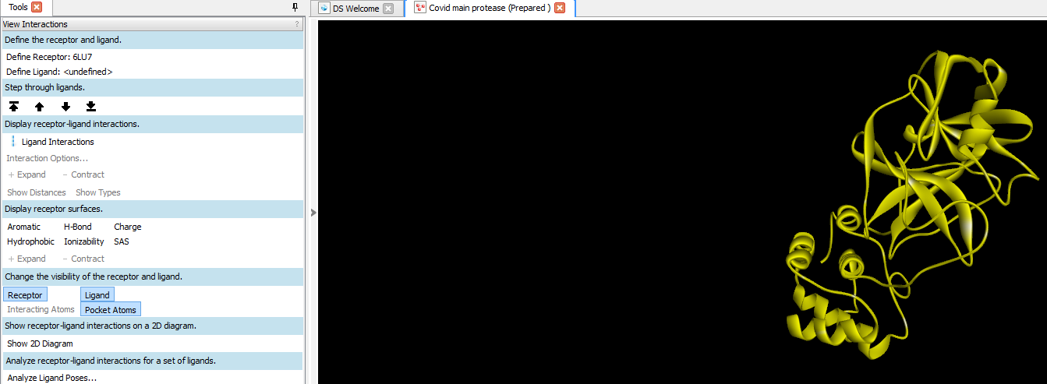
Figure 1. Multiple sequence alignment of ten RpoB sequences from Mycobacterial strains performed using Clustal Omega. Gaps and point mutations are visible in the alignment output.

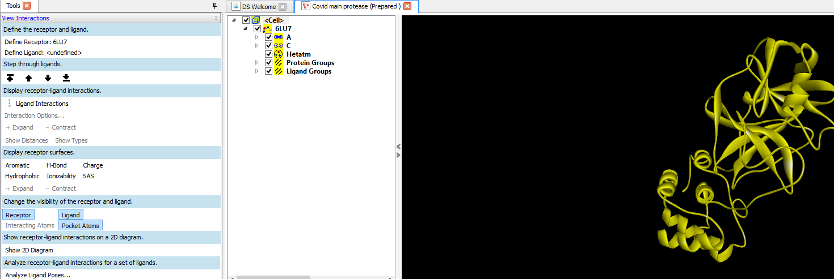
Figure 2. Continued multiple sequence alignment showing conserved regions and variation sites among the ten RpoB sequences.
3.2 Protein Modelling and Structural Validation
All ten RpoB sequences were successfully modelled into 3D structures using SWISS-MODEL (Fig. 3A, 3B). Ramachandran plot analysis confirmed that approximately 98% of amino acid residues in each modelled structure were located within the favoured and additionally allowed regions, validating the quality and reliability of the models. The total number of active binding sites identified per modelled protein ranged from 39 to 41, reflecting the influence of sequence-level variation on secondary and tertiary structural conformation
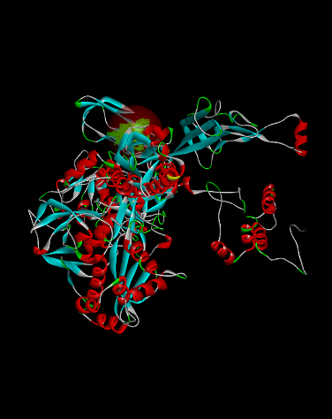
Figure 3A. Ribbon diagram of the homology-modelled three-dimensional structure of WP_202581977.1 generated by SWISS-MODEL. The active binding site is highlighted (green sphere). Cyan: beta sheets; Red: alpha helices; White/grey: loops/coils.
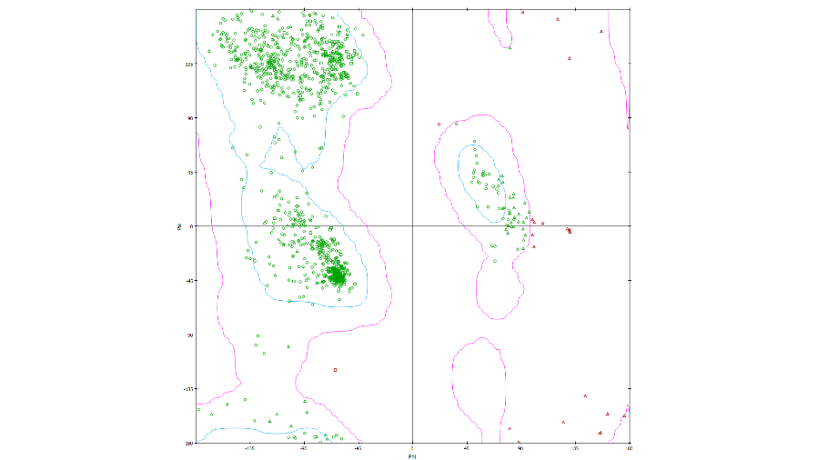
Figure 3B. Ramachandran plot validation of rifampicin drug target WP_202581977.1. Green circles: favoured region residues; open circles: allowed region residues; red triangles: outliers. ~98% residues fall within permitted regions.
3.3 Molecular Docking Results
Rifampicin was docked against all binding sites of the ten modelled Mycobacterial RpoB proteins. The highest LibDock scores recorded for each target protein, the corresponding binding sites and the key amino acid residues involved are summarised in Table 1 (Supplementary fig. 1 – 16).
The results revealed consistent involvement of binding sites 3, 5, and 6 as the primary interaction sites across most protein models. The frequency of strong interaction was notably higher at the 6th binding site. Among all targets, WP_003900992.1 recorded the highest LibDock score of 137.73 (binding sites 3 and 4), and WP_202581977.1 recorded a notable score of 120.06 at binding site 3. Relative energy values ranged from a minimum of 0 to a maximum of 11.284, with no major variation observed across interactions. Each docked complex involved 117 hydrogen bond atoms, with the key amino acid residues involved in interactions varying across the protein models.
Table 1. Molecular Interaction and LibDock Scores
Drug Target Protein | Binding Site | No. of Poses | LibDock Score | Relative Energy | H-Atoms | Amino Acids Involved
A1KGE7.2 | 3 | 2 | 69.70 | 6.81 | 117 | ASP758, GLU767, PRO808, LYS763, THR762, THR807, ARG833
 | 5 | 12 | 104.72 | 6.81 | 117 | PRO492, ASN493, GLY491, PRO489, ARG454, ILE497, HIS451
 | 6 | 16 | 114.41 | 6.81 | 117 | GLU1119, GLU1149, ASP1154, VAL1097
 | 9 | 6 | 83.05 | 11.28 | 117 | PRO1056, ARG1067, LEU1057, GLY1058, GLN1066
 | 11 | 1 | 73.56 | 4.87 | 117 | GLU860, ARG421, VAL424, LYS116, MET127, THR128
AFM48062.1 | 8 | 11 | 89.26 | 6.93 | 117 | GLY1065, ARG1067, LEU1057, GLN1066, PRO1056, GLN1055
 | 6 | 28 | 111.23 | 6.81 | 117 | GLU1149, VAL1097, LYS1101
 | 10 | 1 | 65.09 | 4.36 | 117 | LYS116, MET127, THR128, ASN169, GLU860, ARG421, VAL421
AFR90385.1 | 4 | 2 | 62.22 | 6.81 | 117 | GLU767, ASP758, PRO808, THR762, THR807, ARG833
 | 5 | 37 | 116.18 | 6.93 | 117 | GLU1119, ASP1154, GLU1149, LYS1101, VAL1097, ARG1148
 | 7 | 16 | 94.13 | 6.93 | 117 | PRO1056, GLN1066, SER1093, SER1050, GLN1055, GLY1059, ARG1067
 | 10 | 3 | 77.73 | 4.87 | 117 | ASN493, ASP441, GLN614, ARG613, PRO489, GLY491, PRO492
AFR90390.1 | 2 | 1 | 115.17 | 4.87 | 117 | ARG673, ALA676, ARG677, PHE675, LYS123, TYR872
 | 4 | 2 | 61.49 | 6.81 | 117 | MET1051, GLU767, THR762, THR807, ARG833, ASP758
 | 6 | 39 | 115.87 | 6.93 | 117 | ARG1148, VAL1097, GLU1149, LYS1101, ASP1154
 | 8 | 16 | 99.43 | 6.93 | 117 | GLY1059, GLY1058, SER1050, GLN1055, PRO1056, GLN1066, LEU1057, ARG1067
 | 5 | 5 | 90.01 | 6.81 | 117 | PRO492, HIS680, HIS451, ILE497, ARG613, ARG454
AFR90391.1 | 5 | 7 | 101.84 | 11.28 | 117 | ILE497, ASN493, SER456, LEU458, PRO489
 | 6 | 24 | 111.06 | 6.81 | 117 | GLU1149, VAL1097
 | 8 | 14 | 93.96 | 6.93 | 117 | PRO1056, GLN1066, SER1093, SER1050, GLN1055, GLY1059, GLY1058, ARG1067
 | 10 | 1 | 76.63 | 11.28 | 117 | VAL424, THR128, LYS116, LYS428, PRO158, ILE168, ARG421
AIH26280.1 | 2 | 1 | 99.59 | 9.38 | 117 | VAL115, TYR129, VAL642, TYR670, ARG671
 | 4 | 2 | 61.39 | 6.81 | 117 | MET1051, GLU767, THR807, ARG833, ASP758
 | 5 | 18 | 103.54 | 6.81 | 117 | VAL441, SER456, GLN438, ASN493, GLY491, PRO489, ARG613, ARG454, ILE497
 | 6 | 41 | 116.02 | 6.93 | 117 | GLU1119, ASP1154, GLU1149, LYS1101, VAL1097, ARG1148
 | 8 | 15 | 103.60 | 6.93 | 117 | GLY1058, PRO1056, SER1050, GLN1055, GLN1066, LEU1057, ARG1067
 | 10 | 1 | 74.37 | 11.28 | 117 | ILE168, PRO158, VAL424, ARG421, LYS428, THR128, LYS116
CRC92832.1 | 2 | 1 | 100.61 | 9.38 | 117 | VAL115, TYR129, VAL642, TYR670, THR669, ARG671
 | 5 | 16 | 105.26 | 8.45 | 117 | TYR451, HIS680, PHE439, GLN438, ARG613, ASP441, ARG454
 | 8 | 5 | 91.24 | 6.93 | 117 | LEU1057, PRO1056, SER1050, GLN1055, ARG1067
 | 10 | 1 | 45.96 | 0 | 117 | ARG421, ASP156, VAL424, PRO158, LYS428
pdb5ZX2C | 3 | 2 | 69.70 | 6.81 | 117 | LYSC759, LYSC805, PROC804, THRC803, THRC758, ASPC754, GLUC763
 | 5 | 12 | 104.72 | 6.81 | 117 | HIS447, ILE493, ARG450, PRO485, ASN489, GLY487, PRO488
 | 6 | 16 | 114.41 | 6.81 | 117 | GLU1115, GLU1145, ASP1150, VAL1093
 | 11 | 1 | 73.56 | 4.87 | 117 | LYS112, MET123, THR124, GLU856, VAL420, ARG417
 | 9 | 6 | 83.05 | 11.28 | 117 | PRO1052, ARG1063, LEU1053, GLY1054, GLN1062
WP_003900992.1 | 3 | 42 | 137.73 | 8.45 | 117 | PRO112, GLU639, ARG662, THR663, TYR664, ARG665, LYS117, ARG667, GLN680, VAL636, VAL635, ASP634, GLY633
 | 4 | 12 | 137.73 | 8.45 | 117 | PRO112, GLU639, ARG662, ARG665, ARG667, GLY633, VAL637, LYS157, ASP114, VAL113
WP_202581977.1 | 1 | 3 | 92.11 | 4.36 | 117 | PRO504, GLU502, ARG625, GLN450, ARG466, ILE509
 | 3 | 14 | 120.06 | 0 | 117 | GLY473, PRO218, ARG240, ARG193, ARG479, LYS215, VAL484, LEU475
 | 7 | 1 | 62.89 | 4.36 | 117 | ARG410, SER406, MET405, LEU105, LYS316, ARG402, VAL403, ARG317

4. Discussion
4.1 Sequence Conservation and Structural Significance of RpoB Variation
Multiple sequence alignment of the ten Mycobacterial RpoB sequences using Clustal Omega and profile HMM–HMM alignment techniques (Sievers et al., 2011) demonstrated a high degree of primary structure conservation (98–100% similarity). Despite this overall conservation, all sequences except A1KGE7.2 harboured 2–5 amino acid gaps and 2–3 point mutations (deletions or substitutions), with notable N-terminal truncations observed in WP_003900992.1 and pdb|5ZX2|C, and a unique repeated-residue motif (pspspspspspsps) in WP_202581977.1. These findings are significant because the 81-bp rifampicin resistance-determining region (RRDR) of the rpoB gene, spanning codons 426–452 in M. tuberculosis (equivalent to codons 507–533 in Escherichia coli), is the major hotspot for clinically important rifampicin resistance mutations (Zaw et al., 2018). Even single amino acid substitutions within or adjacent to this region are sufficient to disrupt RIF–RpoB binding through loss of critical intermolecular hydrogen bonds, introduction of steric hindrance, or electrostatic perturbation of the binding pocket (Amusengeri et al., 2022). The present alignment identified polymorphic positions consistent with known RRDR hotspots, providing a rational basis for the differential docking scores observed across strains.
It is well established that the most frequently mutated codons within the RRDR are S450 (S531 in E. coli), H445 (H526 in E. coli) and D435 (D516 in E. coli), whose substitutions are responsible for the majority of clinical rifampicin resistance worldwide (Zaw et al., 2018; Amusengeri et al., 2022). At position S450, substitution to leucine (S450L) disrupts a key intermolecular hydrogen bond and introduces steric hindrance, markedly reducing RIF affinity while preserving overall polymerase catalytic function (Amusengeri et al., 2022). Mutations at H445 disrupt a separate intermolecular hydrogen bond and, depending on the substituent, introduce aromatic steric interference (H445Y) or electrostatic destabilisation (H445D). The D435V substitution replaces a negatively charged aspartate with a bulkier nonpolar valine, creating steric occlusion within the rifampicin-binding pocket and restricting drug access (Amusengeri et al., 2022). Mutations outside the canonical RRDR including those at positions L430, L452, I491, Q432 and others contribute additional resistance through hydrophobic interaction loss or steric repulsion (Amusengeri et al., 2022). Of note, increasing evidence demonstrates that resistance mutations can occur beyond the RRDR and computational approaches capable of identifying such variants are being actively developed (Portelli et al., 2020). The sequence variations identified in the present study, although not phenotypically validated, were located at structurally analogous positions in the modelled RpoB proteins and were consistent with previously reported rifampicin resistance mechanisms.
4.2 Structural Modelling Validation and Its Implications
Homology modelling using SWISS-MODEL generated structurally reliable 3D models for all ten RpoB sequences. Ramachandran plot analysis using the RAMPAGE server confirmed the quality of the modelled proteins, with approximately 98% of residues located in favoured or additionally allowed regions. This value is considered acceptable for molecular docking studies and is consistent with previous in silico studies on M. tuberculosis drug targets (Rao et al., 2020; Abdullahi et al., 2021). The high percentage of residues in allowed regions validates the stereochemical quality of the modelled structures and provides confidence in the reliability of subsequent docking predictions. The small percentage of residues in generously allowed or disallowed regions in some models is commonly observed in computationally derived structures where loop regions between conserved secondary structure elements lack precise template coverage and are known not to significantly affect binding-pocket geometry (Rao et al., 2020).
The variation in total number of active binding sites across the ten modelled proteins (39–41 sites) underscores the functional consequence of sequence-level differences on tertiary architecture. Even minor changes in the primary sequence, particularly in loop or hinge regions connecting conserved secondary structural elements, can alter the geometry and volume of binding cavities detected by computational cavity-finding algorithms (Smith et al., 2013). This observation has direct implications for drug susceptibility: a higher number of accessible binding sites does not necessarily equate to a higher overall drug affinity if the structural conformation of the primary binding pocket is perturbed. Indeed, the present study demonstrates that WP_003900992.1, while possessing 39 binding sites (comparable to other strains), achieves the highest LibDock score (137.73) which is attributable to its unique pocket geometry at binding sites 3 and 4, where a dense network of polar and charged residues (ARG662, ARG665, ARG667, GLU639, LYS117) creates an optimally complementary electrostatic environment for rifampicin binding.
4.3 Molecular Docking: Mechanistic Interpretation of LibDock Scores and Binding Site Residues
The structural basis for rifampicin’s bactericidal activity against M. tuberculosis was elucidated by Campbell et al. (2001), who demonstrated that RIF binds within a deep pocket of the RNAP β-subunit, positioned within the DNA/RNA channel more than 12 Å from the catalytic Mg2+ ion. Rather than directly inhibiting the catalytic mechanism, RIF acts by sterically occluding the path of the nascent RNA transcript once it reaches 2–3 nucleotides in length which is a mechanistically elegant form of transcription abortion that prevents productive mRNA elongation. This structural insight forms the theoretical foundation for interpreting the molecular docking results of the present study.
In the present study, rifampicin was docked against all active binding sites of the ten modelled RpoB proteins using the LibDock algorithm. The highest LibDock scores ranged from 111.06 (AFR90391.1, binding site 6) to 137.73 (WP_003900992.1, binding sites 3 and 4). Binding sites 3, 5, and 6 were the consistently active primary interaction loci across most protein models, with site 6 exhibiting the highest frequency of strong interactions. These sites correspond to structurally conserved regions of the RNAP β-subunit that include residues from the rifampicin fork loop and switch region ie., areas functionally analogous to the canonical RIF-binding pocket described by Campbell et al. (2001). The recurring involvement of glutamate (GLU1119, GLU1149), aspartate (ASP1154), valine (VAL1097), lysine (LYS1101), and arginine (ARG1148) residues at site 6 across multiple protein models is particularly noteworthy: glutamate and aspartate residues can form hydrogen bonds and electrostatic contacts with the hydroxyl and carbonyl functional groups of rifampicin’s naphthalene core and ansa chain, while arginine and lysine residues contribute additional hydrogen-bonding capacity. These observations align with published crystallographic and computational studies confirming that hydrogen bonding with aromatic and charged residues of the RNAP β-subunit pocket is central to rifampicin binding affinity (Campbell et al., 2001; Amusengeri et al., 2022).
The wild-type RpoB of M. tuberculosis H37Rv has been shown computationally to engage rifampicin primarily through hydrogen bonds formed by Arg454 and Phe439, with Arg454 donating two hydrogen bonds to carbonyl oxygen and hydroxyl side chains of RIF, and the amide nitrogen of Phe439 forming an additional conventional hydrogen bond (Amusengeri et al., 2022). Mutations that substitute Arg454 (e.g., Arg454Gln) profoundly perturb these contacts and are among the most resistance-conferring variants identified in clinical isolates (Amusengeri et al., 2022). In the present study, residues including ILE497, ASN493, PRO489, and ARG454 were identified at binding site 5 of AFR90391.1, and HIS451, PRO492, and ASN493 at site 5 of A1KGE7.2 overlapping substantially with the known RRDR hotspot region. The detection of these residues as active participants in rifampicin binding across multiple modelled strains corroborates the canonical binding mechanism and confirms that the In silico docking approach employed is capturing biologically meaningful interactions. Conversely, the lower LibDock scores observed for certain strains (e.g., AFR90385.1 site 4: 62.22; WP_202581977.1 site 7: 62.89) likely reflect structural perturbations in or near the primary binding pocket introduced by strain-specific sequence mutations, consistent with the resistance phenotype.
The highest overall LibDock score of 137.73 recorded for WP_003900992.1 at both binding sites 3 and 4, with participation of residues PRO112, GLU639, ARG662, THR663, TYR664, ARG665, LYS117, ARG667, GLN680, VAL636, VAL635, ASP634, and GLY633, is particularly significant. The clustering of multiple arginine residues (ARG662, ARG665, ARG667) and a tyrosine (TYR664) at the binding interface suggests a highly complementary electrostatic and hydrogen-bonding environment for rifampicin docking. This pattern is consistent with observations by Zaw et al. (2018), Amusengeri et al. (2022) and Radhakrishnan et al (2026) who demonstrated that binding affinity is directly correlated with the number and strength of intermolecular contacts between RIF and the RNAP β-subunit pocket. The near-identical scores at two adjacent binding sites (3 and 4) in WP_003900992.1 further suggest a broader, topographically extended binding cleft in this sequence variant, which could be a consequence of the N-terminal truncation observed in the alignment generating a structurally reorganised protein conformation. The structural uniqueness of WP_202581977.1 with its repeated N-terminal residue motif and a notable score of 120.06 at a distinct binding site 3 involving GLY473, PRO218, ARG240, ARG193, ARG479, LYS215, VAL484 and LEU475 suggests that the N-terminal insertion creates novel secondary and tertiary structural features that generate an alternative high-affinity docking cavity, one that may or may not correspond to the canonical RIF-binding site.
The present study is primarily based on computational analyses, including sequence alignment, homology modelling and molecular docking approaches. Although the docking results provide valuable insights into the potential impact of RpoB sequence variations on rifampicin-binding affinity, the findings were not validated through in vitro or in vivo experimental studies. Therefore, the predicted molecular interactions and resistance-associated structural changes should be interpreted cautiously. Further experimental validation using phenotypic drug susceptibility testing, mutagenesis studies and biochemical binding assays is necessary to confirm the biological significance of the observed docking-based predictions.
5. Conclusion
The present study demonstrated that amino acid variations in the RpoB protein among different Mycobacterial strains can influence the three-dimensional structure and binding properties of the protein. Variations in the number of binding sites and differences in LibDock scores among the modelled proteins indicated that sequence-level changes may alter rifampicin binding affinity and thereby affect drug efficacy. The findings further suggest that mutations in the rpoB gene can modify both the rifampicin-binding region and the overall structural conformation of the RpoB protein, contributing to rifampicin resistance. Overall, the integrated in silico approach involving multiple sequence alignment, homology modelling, structural validation and molecular docking proved useful for evaluating resistance-associated mutations and their impact on drug–target interactions in Mycobacterium species.

Disclaimer (Artificial intelligence)

Author(s) hereby declare that NO generative AI technologies such as Large Language Models (ChatGPT, COPILOT, etc.) and text-to-image generators have been used during the writing or editing of this manuscript.

References:
- Abdullahi, M., Adeniji, S. E., Arthur, D. E., & Haruna, A. (2021). Homology modeling and molecular docking simulation of some novel imidazo[1,2-a]pyridine-3-carboxamide (IPA) series as inhibitors of Mycobacterium tuberculosis. Journal of Genetic Engineering and Biotechnology, 19(1), 12. https://doi.org/10.1186/s43141-020-00102-1
- Amusengeri, A., Khan, A., & Tastan Bishop, Ö. (2022). The structural basis of Mycobacterium tuberculosis RpoB drug-resistant clinical mutations on rifampicin drug binding. Molecules, 27(3), 885. https://doi.org/10.3390/molecules27030885
- Asif, M. (2024). An overview of various rifampicin analogs against Mycobacterium tuberculosis and their drug interactions. Medicinal Chemistry, 20(3), 268–292. https://doi.org/10.2174/0115734064260853230926080134
- Campbell, E. A., Korzheva, N., Mustaev, A., Murakami, K., Nair, S., Goldfarb, A., & Darst, S. A. (2001). Structural mechanism for rifampicin inhibition of bacterial RNA polymerase. Cell, 104(6), 901–912. https://doi.org/10.1016/S0092-8674(01)00286-0
- Jenkins, C., Bacon, J., Allnutt, J., Hatch, K. A., Bose, A., O'Sullivan, D. M., Arnold, C., Gillespie, S. H., & McHugh, T. D. (2009). Enhanced heterogeneity of rpoB in Mycobacterium tuberculosis found at low pH. Journal of Antimicrobial Chemotherapy, 63(6), 1118–1120. https://doi.org/10.1093/jac/dkp125
- Khawbung, J. L., Nath, D., & Chakraborty, S. (2021). Drug resistant tuberculosis: A review. Comparative Immunology, Microbiology and Infectious Diseases, 74, 101574. https://doi.org/10.1016/j.cimid.2020.101574
- McGrath, M., Gey van Pittius, N. C., Van Helden, P. D., Warren, R. M., & Warner, D. F. (2014). Mutation rate and the emergence of drug resistance in Mycobacterium tuberculosis. Journal of Antimicrobial Chemotherapy, 69(2), 292–302. https://doi.org/10.1093/jac/dkt364
- Mitchison, D. A., & Nunn, A. J. (1986). Influence of initial drug resistance on the response to short-course chemotherapy of pulmonary tuberculosis. American Review of Respiratory Disease, 133(3), 423–430.
- Morlock, G. P., Plikaytis, B. B., & Crawford, J. T. (2000). Characterization of spontaneous, in vitro-selected, rifampin-resistant mutants of Mycobacterium tuberculosis strain H37Rv. Antimicrobial Agents and Chemotherapy, 44(12), 3298–3301. https://doi.org/10.1128/AAC.44.12.3298-3301.2000
- Nasto, B. (2026). Hope for control of a centuries-old epidemic. Nature Medicine. Advance online publication. https://doi.org/10.1038/d41591-026-00019-1
- Palomino, J. C., & Martin, A. (2014). Drug resistance mechanisms in Mycobacterium tuberculosis. Antibiotics, 3(3), 317–340. https://doi.org/10.3390/antibiotics3030317
- Paramasivan, C. N., & Venkataraman, P. (2004). Drug resistance in tuberculosis in India. Indian Journal of Medical Research, 120, 377–386.
- Portelli, S., Myung, Y., Furnham, N., Vedithi, S. C., Pires, D. E. V., & Ascher, D. B. (2020). Prediction of rifampicin resistance beyond the RRDR using structure-based machine learning approaches. Scientific Reports, 10(1), 18120. https://doi.org/10.1038/s41598-020-74648-y
- Radhakrishnan, A., Prameela, A., Jayasree, M., & Habibulla, A. K. (2026). An exhaustive computational bioassessment of plant-derived terpenoids as potential SARS-CoV-2 inhibitors. Vietnam Journal of Chemistry. Advance online publication. https://doi.org/10.1002/vjch.70136
- Rao, S., Srivastava, P., & Jain, P. (2020). Construction of computational 3D structures of protein drug targets of Mycobacterium tuberculosis. Asian Journal of Pharmaceutical and Clinical Research, 13(11), 82–85. https://doi.org/10.22159/ajpcr.2020.v13i11.39242
- Shivekar, S. S., Kaliaperumal, V., Brammacharry, U., Sakkaravarthy, A., Vidya Raj, C. K., Alagappan, C., & Muthaiah, M. (2020). Prevalence and factors associated with multidrug-resistant tuberculosis in South India. Scientific Reports, 10, 17552. https://doi.org/10.1038/s41598-020-74432-y
- Sievers, F., Wilm, A., Dineen, D., Gibson, T. J., Karplus, K., Li, W., Lopez, R., McWilliam, H., Remmert, M., Söding, J., Thompson, J. D., & Higgins, D. G. (2011). Fast, scalable generation of high-quality protein multiple sequence alignments using Clustal Omega. Molecular Systems Biology, 7, 539. https://doi.org/10.1038/msb.2011.75
- Smith, T., Wolff, K. A., & Nguyen, L. (2013). Molecular biology of drug resistance in Mycobacterium tuberculosis. Current Topics in Microbiology and Immunology, 374, 53–80. https://doi.org/10.1007/82_2012_279
- World Health Organization. (2025). Global tuberculosis report 2025. World Health Organization. https://www.who.int/timorleste/publications/i/item/9789240116924
- Zaw, M. T., Emran, N. A., & Lin, Z. (2018). Mutations inside rifampicin-resistance determining region of rpoB gene associated with rifampicin-resistance in Mycobacterium tuberculosis. Journal of Infection and Public Health, 11(5), 605–610. https://doi.org/10.1016/j.jiph.2018.04.005

Supplementary Figures

Figures 1 - 10: 3D Docking Interaction Views

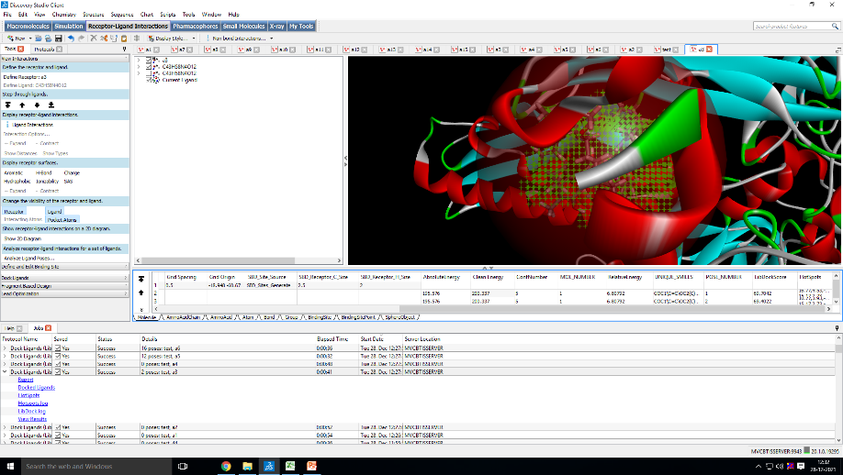

Figure 1 S: Rifampicin docked to A1KGE7.2 (Site 6, Score: 114.41)

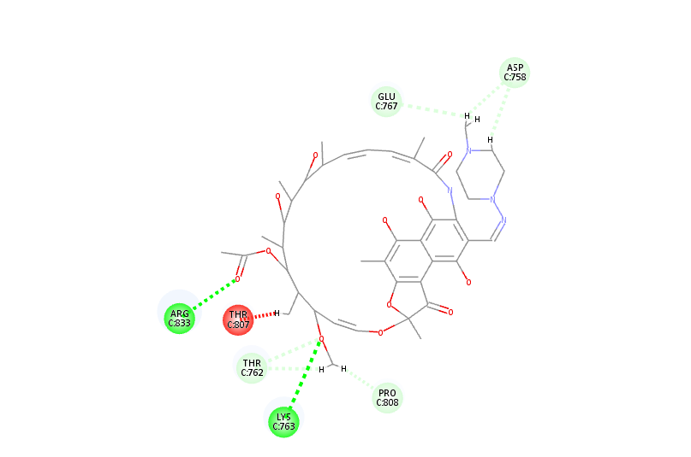

Figure 2 S: Rifampicin docked to AFM48062.1 (Site 6, Score: 111.23)
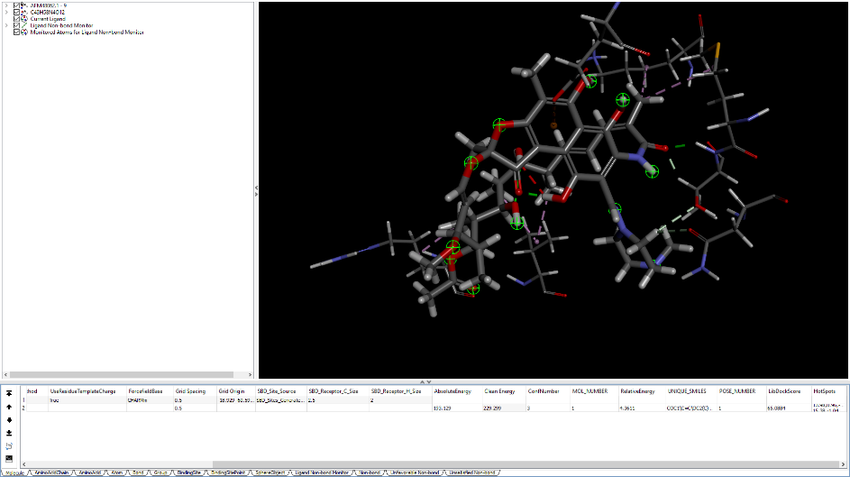

Figure 3 S: Rifampicin docked to AFR90385.1 (Site 5, Score: 116.18)

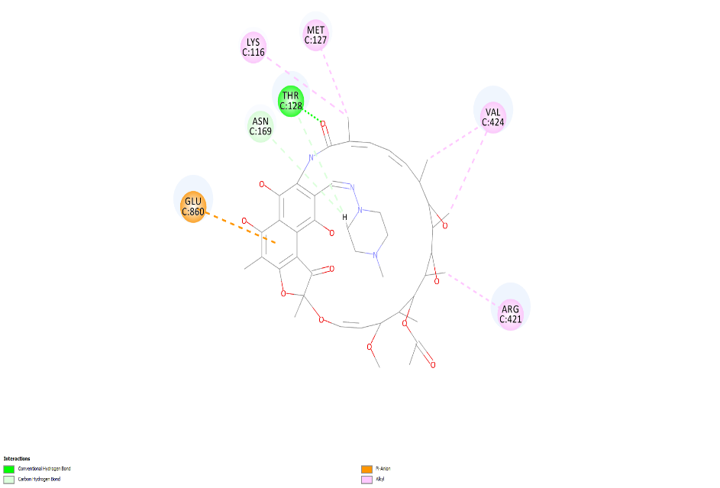

Figure 4 S: Rifampicin docked to AFR90390.1 (Site 6, Score: 115.87)
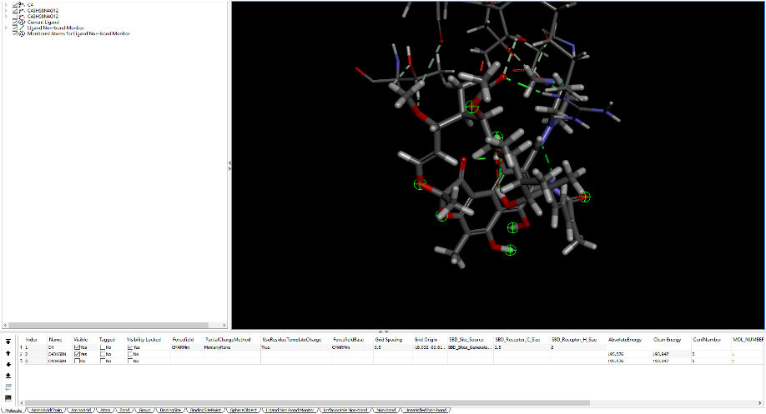

Figure 5 S: Rifampicin docked to AFR90391.1 (Site 6, Score: 111.06)

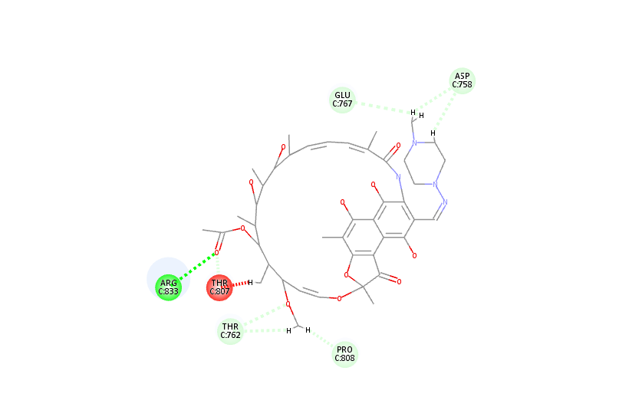

Figure 6 S: Rifampicin docked to AIH26280.1 (Site 6, Score: 116.02)

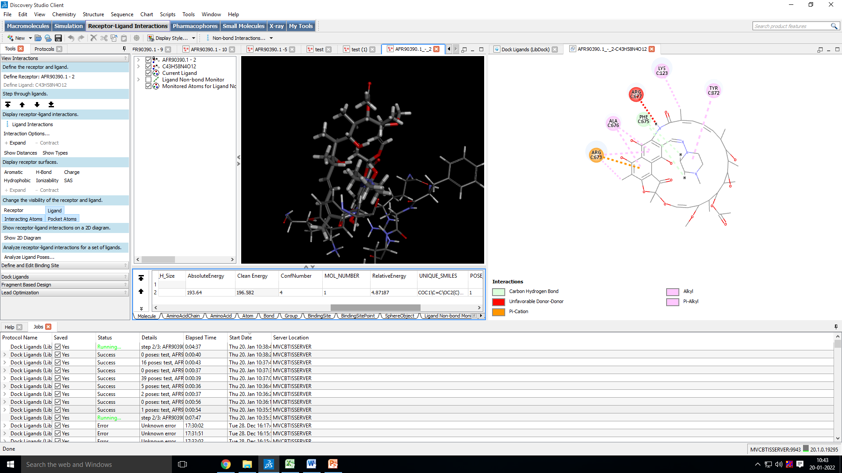

Figure 7 S: Rifampicin docked to AFR90390.1 – Full Interaction View

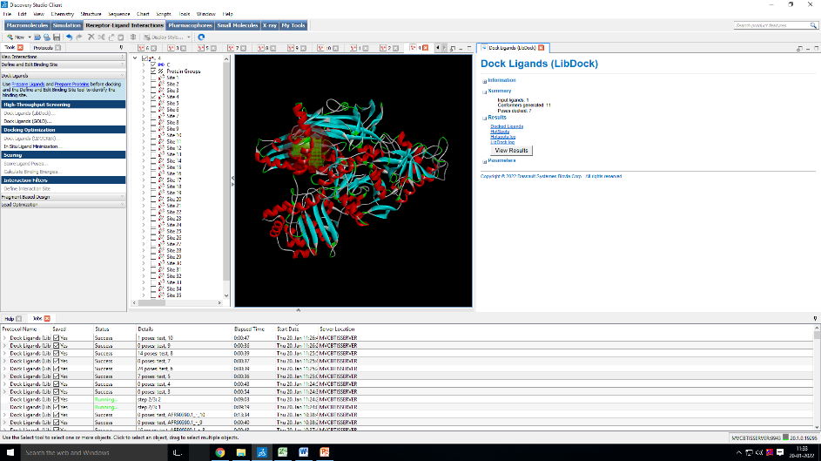

Figure 8 S: Rifampicin docked to CRC92832.1 (Site 5, Score: 105.26)

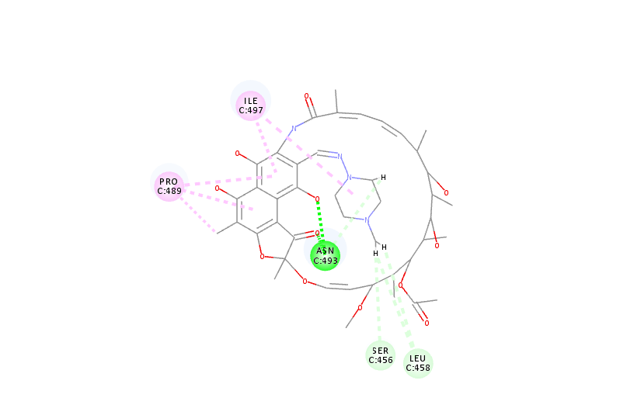

Figure 9 S: Rifampicin docked to pdb5ZX2C (Site 6, Score: 114.41)

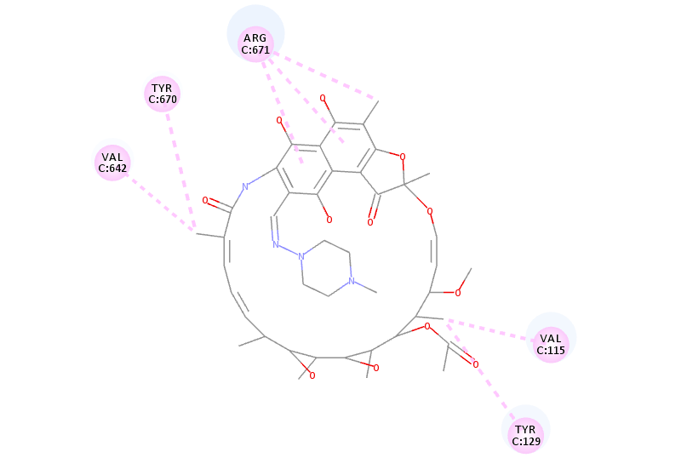

Figure 10 S: Rifampicin docked to WP_003900992.1 (Site 3, Score: 137.73)

Figures 11–16: 2D Ligand Interaction Diagrams

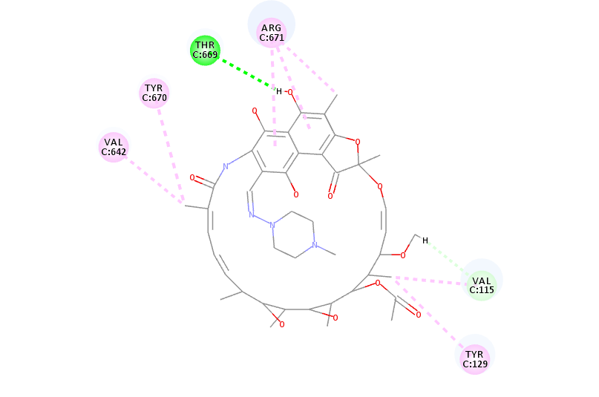

Figure 11 S: 2D Interaction – A1KGE7.2 (Site 3)

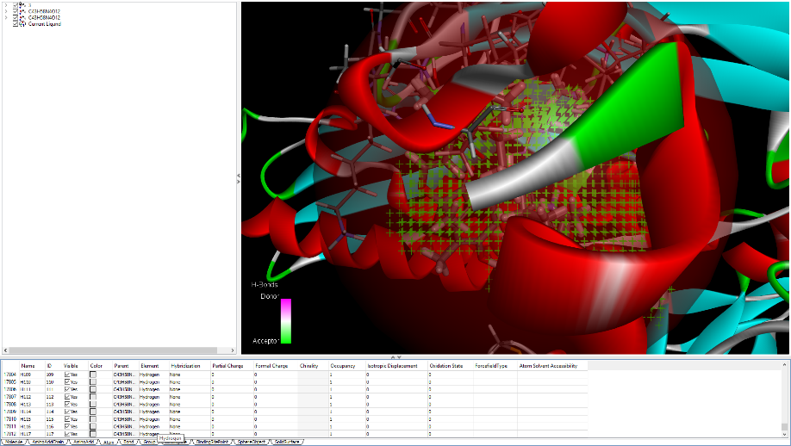

Figure 12 S: 2D Interaction – AFR90385.1 (Site 5)

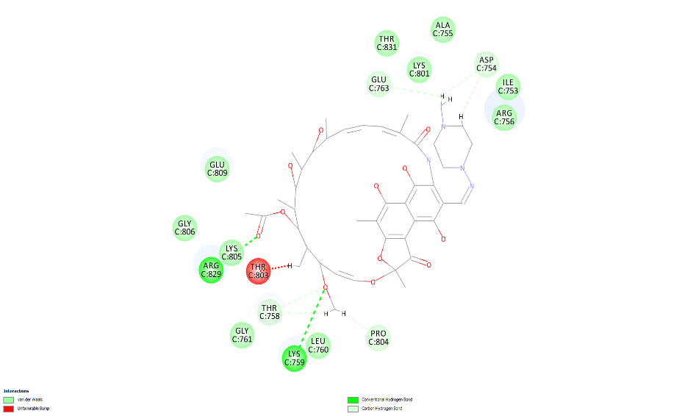

Figure 13 S: 2D Interaction – AFR90390.1 (Site 6)

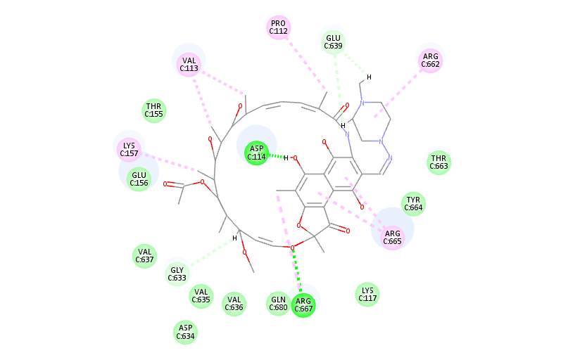

Figure 14 S: 2D Interaction – WP_003900992.1 (Sites 3 & 4)

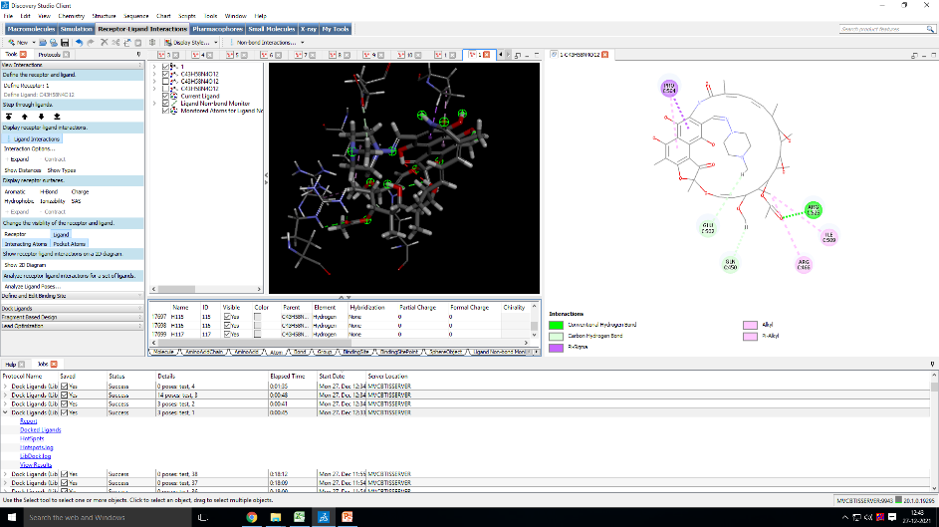

Figure 15 S: 2D Interaction – AFM48062.1 (Site 6)

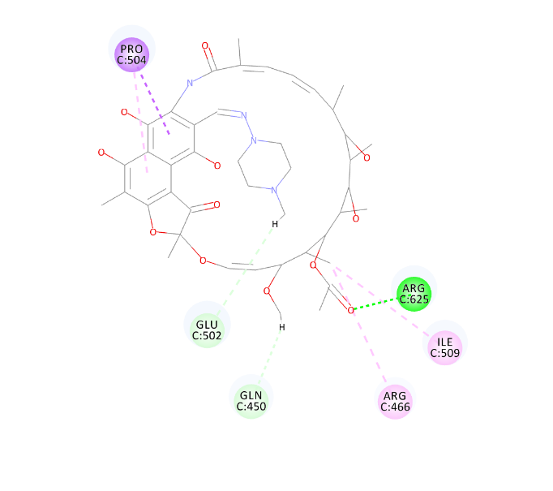

Figure 16 S: 2D Interaction – WP_202581977.1 (Site 3)

