Mapping Global HIV Inequality Among Males Aged 15-24: A Hierarchical Beta Mixed -Effects Analysis (1990-2024)

Abstract
Background: HIV infection amongst males aged 15-24 is an important health issue that is of global concern and has significant differences across regions. The current literature is typically based on linear or pooled models that do not adequately account for bounded and heterogeneous information. The aims to approximate country-specific and global time-varying patterns without incurring the cost of excessively modelling the limited fractional nature of the result and breaking down the heterogeneity between countries. This study quantifies global and regional trends in HIV prevalence among males aged 15-24 and estimates country-level heterogeneity using a multilevel beta regression framework. Also, the observational nature of World Development Indicators (WDI) data and the absence of individual-level behavioural covariates limit causal interpretation.

Methods: The World Bank World Development Indicators longitudinal, unbalanced panel (1990-2024) was analysed using a multilevel beta-mixed-effects model. The prevalence (%) of HIV was converted into a fractional response that was modelled with random intercepts and slope to account for country-level heterogeneity. AIC/BIC was used to select the model, and the results were reported as odds ratios (ORs) accompanied with 95% confidence intervals.

Results: The median HIV prevalence in the world was 0.53% (0.10) with wide geographical variability. In sub-Saharan Africa (1.276% and 0.576%), the highest prevalence and the predicted prevalence were observed. The region-adjusted random-slope beta model (AIC = -64,477.14) was the best-fitting model. HIV prevalence declined over time (OR = 0.952, p = .002). Sub-Saharan Africa had significantly higher odds of prevalence (OR = 3.131; 95% CI: 2.075-4.726), followed by Latin America & Caribbean (OR = 1.566; 95% CI: 1.013–2.421). Large heterogeneity at the country level was noted, with the high-burden countries being Eswatini (6.77%) and Zimbabwe (6.07%).

Conclusion: The prevalence of HIV among young males is decreasing all over the world, but is very uneven. Multilevel beta modelling offers a more precise and policy-relevant estimation and an intervention based on the targeted interventions to reach SDG 3.3. To begin with, governments and international health organisations need to consider focused, data-driven HIV response among young men in high-burden locations and governments and scholars ought to institutionalise sophisticated statistical modelling (e.g. multilevel beta mixed-effects models) in HIV monitoring and surveillance.

Keywords: Multilevel Beta Regression, Fractional Response Modelling, Longitudinal Panel Data, Country Level Heterogeneity, Random Effects Modelling, Regional Disparities,

Introduction
HIV is a significant issue in the health of adolescents and young adults, especially since infections during this age group can predetermine the morbidity, mortality, and reproductive health outcomes, as well as future patterns of transmission (Zhang et al., 2022; Zuma et al., 2022; Nwachinemere et al., 2025; Wang et al., 2025). This age group of 15-24 is a significant but under-investigated subset of the HIV surveillance since their risk behaviours are defined by their behavioural changes, mobility, social norms, availability of prevention methods, uptake of tests, and overall socioeconomic factors (Jaman et al., 2024; Cluver et al., 2025; Ledesma et al., 2023; Haddad et al., 2024). Although the world has made significant progress in terms of reducing new infections by preventing HIV, it has been quite disparate among countries and states (Mody et al., 2024; Landovitz et al., 2023; Bekker et al., 2023; Kumah et al., 2023).
Such an imbalance means that it is necessary to go beyond descriptive comparisons and the application of statistical models, which allows capturing the overall trends over time of the situation and the variation of countries in HIV prevalence.

The abscense of the current statistics on HIV prevalence is informed by the composition of the present day statistics on HIV prevalence, which are typically longitudinal, uneven, and limited due to their expression of HIV prevalence as a percentage or a proportion (World Health Organization, 2022; Mobaderi et al., 2025; Gupta et al., 2022; Monod et al., 2024; Wang et al., 2026).
These properties are very problematic in terms of methodology. The classical linear forms may fail to work as they do not consider the limitedness of prevalence results and may provide inefficient or inaccurate estimates when variability is connected to the mean. Moreover, the gap in the history of epidemics, capacity of health systems, test coverage, prevention programs, and completeness of the data is big (Orlando et al., 2025; Kiplagat et al., 2022; Gaumer et al., 2023; Lima et al., 2025; Hensen et al., 2023). It can be successfully used with a multilevel beta mixed-effects model because HIV prevalence is considered a fractional response, the repeated country-years of observation, unbalanced panels and cross-country heterogeneity are also put into consideration.

The existing body of literature on the topic of HIV has been significant in terms of outlining the prevalence trends, high-burden population, and determining the inequalities in HIV outcomes in different regions (UNAIDS., 2024; Rosenberg et al., 2023; Zuma et al., 2022; Wang et al., 2022; Tian et al., 2024). Much of this literature suggests that geographic area, income brackets and demographic subgroups are significant variables in the incidence and prevalence of HIV. Providing studies that focus on youth tend to emphasise the risk of behaviour, condom use, access to testing, coverage of antiretroviral therapy, education, and gender patterns of vulnerability (Duarte-Anselmi et al., 2026; Kanyemba et al., 2023; Zeleke et al., 2024; Phillips et al., 2023; Zapata et al., 2025). Some of the global or multi-country analyses, however, are founded on descriptive trend summaries, the application of ordinary least squares regression, the use of log-linear models, or the use of pooled models that assume that the time effects are the same across countries (Költringer et al., 2023; Soogun et al., 2022; Akinrefon et al., 2023; Jaya et al., 2023). Though these are suitable when the surveillance is conducted over a wide area, they may not be able to point out the correct statistical composition of the HIV prevalence details.

One of the main weaknesses of the literature is that HIV prevalence is often studied as a continuous outcome that is not limited, even though it is inherently constrained to a value of 0 to 1 on a scale (Kokilavani et al., 2023; Diksha et al., 2025; Ford et al., 2023; Kim et al., 2024; Briceño-Patiño et al., 2025). This may be due to a violation of one of the model's assumptions, particularly if there is a strong concentration of values around zero, high prevalence values, or uneven distribution of prevalence across countries. The other limitation is the lack of modelling of country-level heterogeneity. Nations can have an international trend but have varying prevalence rates and trends in the change. Not paying attention to this hierarchical system may hide significant disparities in the epidemic patterns and undermine the effectiveness of the results to be used in policy targeting. Moreover, a common issue is that numerous studies do not optimally use longitudinal data based on incomplete global panels, where some countries are either dropped or models are used not explicitly designed to support unbalanced data.

In this study, the researcher fills these gaps by using a multilevel beta mixed-effects model on the prevalence of HIV in males aged 15-24. The aim is to approximate country-specific and global time-varying patterns without incurring the cost of excessively modelling the limited fractional nature of the result and breaking down the heterogeneity between countries. The need to have a more statistically appropriate and policy-relevant modelling framework that can be used to enhance on the current linear or pooled modelling approaches justifies the study. This study adds a methodological novelty with random intercepts, random slopes, model diagnostics and APA-style presentation of assumptions, leading to a more powerful evidence base to understand heterogeneous country-specific HIV prevalence dynamics.

Materials and Methods

Data Source and Repository
This study used secondary longitudinal data on HIV prevalence among males aged 15–24 years obtained from the World Bank World Development Indicators (WDI) database. The dataset is publicly accessible via the World Bank Open Data platform: https://databank.worldbank.org/source/world-development-indicators. The specific indicator corresponds to HIV prevalence (% of population ages 15–24, male), reported annually at the country level. The use of this repository ensures transparency, reproducibility, and comparability with prior global HIV studies.

Data Structure and Variable Characteristics
The dataset has a longitudinal (panel) structure defined by country $i=1,…,N$ and year $t=1,…,T_{i}$, where $T_{i}$ varies across countries, resulting in an unbalanced panel. The outcome variable is HIV prevalence expressed as a percentage, which was transformed into a proportion:
$y_{it}=\frac{\text{HIV prevalence (\%)}}{100}$ so that $y_{it}∈\left[0,1\right]$. Because beta regression requires values strictly within the open interval $\left(0,1\right)$, boundary observations (0 or 1) were adjusted using a standard continuity correction:
$y_{it}^{*}=\left\{\begin{matrix}\frac{0.5}{n}, & \text{if }y_{it}=0 \\ \frac{n-0.5}{n}, & \text{if }y_{it}=1 \\ y_{it}, & \text{otherwise}\end{matrix}\right.$………………………………. (1)
where $n$ is the total number of observations.
The main explanatory variable is time (year), which was centred and scaled:
${\text{year_scaled}}_{it}=\frac{{\text{year}}_{it}-\overset{‾}{\text{year}}}{\text{SD}\left(\text{year}\right)}$ ………………………………. (2)
to improve numerical stability and interpretability. Additional categorical variables were derived, including region, continent, and income group, based on country classification systems. These variables capture structural heterogeneity across countries.

Statistical Modelling Framework
Given that the outcome is continuous, bounded, and heteroskedastic, a multilevel beta mixed-effects model was employed. The response variable $y_{it}^{*}$ is assumed to follow a beta distribution:
$y_{it}^{*}∼\text{Beta}\left(μ_{it},ϕ\right)$, where $μ_{it}$ is the conditional mean and $ϕ$ is the precision parameter controlling dispersion. The beta distribution allows the variance to depend on the mean:
$\text{Var}\left(y_{it}^{*}\right)=\frac{μ_{it}\left(1-μ_{it}\right)}{1+ϕ}$ ………………………………. (3)
which is appropriate for skewed proportional data.
A logit link function was used to relate the mean to predictors:
$\text{logit}\left(μ_{it}\right)=log\left(\frac{μ_{it}}{1-μ_{it}}\right)$ ………………………………. (4)

Multilevel Model Specification
To account for repeated observations within countries and cross-country heterogeneity, a hierarchical model was specified. The final model (region-adjusted random-slope beta mixed model) is:
$\text{logit}\left(μ_{it}\right)=β_{0}+β_{1}{\text{year}}_{it}+β_{2}{Region}_{i}+u_{0i}+u_{1i}{\text{year}}_{it}$ ………………………………. (5)
where:
- $β_{0}$ is the fixed intercept (global baseline prevalence),
- $β_{1}$ represents the global temporal trend,
- $β_{2}$ are fixed effects for regional categories,
- $u_{0i}$ is the country-specific random intercept,
- $u_{1i}$ is the country-specific random slope for time.
The random effects are assumed to follow a multivariate normal distribution:
$\left(\begin{matrix}u_{0i} \\ u_{1i}\end{matrix}\right)∼N\left(\left(\begin{matrix}0 \\ 0\end{matrix}\right),\left(\begin{matrix}σ_{u0}^{2} & σ_{u01} \\ σ_{u01} & σ_{u1}^{2}\end{matrix}\right)\right)$ ………………………………. (6)

This structure allows each country to have its own baseline prevalence and its own rate of change over time, thereby capturing heterogeneous epidemic trajectories.

Model Estimation and Selection
Models were estimated using maximum likelihood via adaptive numerical optimisation. Four nested models were compared:
(i) null model (random intercept only),
(ii) random-intercept model with time,
(iii) random-slope model, and
(iv) region-adjusted random-slope model.
Model selection was based on information criteria:
$\text{AIC}=-2logL+2k, \text{BIC}=-2logL+klog\left(n\right)$ ………………………………. (7)
where $L$ is the likelihood and $k$ is the number of parameters. The model that had the lowest AIC and BIC was considered the best-fitting model and had the best goodness-of-fit and model complexity.

Interpretation of Parameters
Fixed effects were interpreted on the logit scale and transformed into odds ratios:
$$\text{OR}=e^{β}$$
which quantify multiplicative changes in the odds of HIV prevalence. Confidence intervals were computed as:
$$\left[e^{β-1.96⋅SE}, e^{β+1.96⋅SE}\right]$$
Random effects were interpreted as deviations from the global mean, where positive values indicate higher-than-average prevalence and negative values indicate lower-than-average prevalence after adjustment.

Model Diagnostics and Assumptions
Model adequacy was evaluated using simulation-based diagnostics. Residuals were assessed for dispersion, uniformity, outliers, and zero inflation. The key assumptions include:
- The response variable lies within $\left(0,1\right)$,
- Conditional independence given random effects,
- Correct specification of the mean–variance relationship via the beta distribution,
- Normally distributed random effects,
- No systematic patterns in residuals.
These diagnostics address limitations in earlier studies that often neglected formal model validation.

Results
Table 1 Regional descriptive statistics
region | countries | observations | mean_prevalence | median_prevalence | sd_prevalence | min_prevalence | max_prevalence
Sub-Saharan Africa | 44 | 1,540 | 1.276 | 0.600 | 1.786 | 0.1 | 12.100
Unclassified or aggregate economy | 22 | 741 | 0.628 | 0.575 | 0.448 | 0.1 | 2.035
Latin America & Caribbean | 28 | 980 | 0.317 | 0.200 | 0.262 | 0.1 | 1.800
East Asia & Pacific | 18 | 630 | 0.239 | 0.100 | 0.427 | 0.1 | 4.200
Middle East & North Africa | 18 | 630 | 0.117 | 0.100 | 0.069 | 0.1 | 0.600
Europe & Central Asia | 30 | 1,049 | 0.114 | 0.100 | 0.056 | 0.1 | 0.500
North America | 1 | 33 | 0.100 | 0.100 | 0.000 | 0.1 | 0.100
South Asia | 7 | 245 | 0.100 | 0.100 | 0.000 | 0.1 | 0.100

Table 1 demonstrates that there is regional heterogeneity in the prevalence of HIV in males aged 15-24. The mean prevalence in sub-Saharan Africa was 1.276, among 44 countries and 1,540 observations, although this is outliers, being much higher than in all other regions, 12.1. The result is in line with previous data that the HIV burden in adolescents and young adults is still disproportionately high in sub-Saharan Africa, even with the global advances in the prevention and treatment (Zhang et al., 2022; Rosenberg et al., 2023; Zuma et al., 2022). The originality of the current research is that it is not just a description of this regional inequality; it literally implants it in a multilevel beta model that takes into consideration the limited scope of prevalence data and explains country-level clustering. Policy-wise, the result justifies more youth-based HIV prevention, testing, condom, PrEP access, and treatment-linkage initiatives in high-burden areas which is a direct nod to SDG 3.3 of ending AIDS as a health-related threat and SDG 10 of reducing health disparities.

Table 2: Comparison of beta mixed-effects model specifications
Model | df | logLik | AIC | BIC | Delta_AIC | Evidence_Rank
Region-adjusted random-slope beta mixed model | 13 | 32,251.57 | -64,477.14 | -64,390.38 | 0.000 | 1
Random-slope beta mixed model | 6 | 32,208.31 | -64,404.63 | -64,364.58 | 72.511 | 2
Random-intercept beta mixed model | 4 | 30,737.00 | -61,466.01 | -61,439.31 | 3,011.133 | 3
Null beta mixed model | 3 | 30,495.09 | -60,984.19 | -60,964.17 | 3,492.950 | 4

Table 2 shows that the region-adjusted random-slope beta mixed model (lowest AIC and BIC) was the best model fit as compared to the random-slope, random-intercept, and the null models. This finding proves that HIV rates among young males cannot be well modelled using pooled or simple linear trend models. The previous studies were inclined to use descriptive, log-linear, or pooled regression models, which are effective, but they have limitations because of the homogeneity assumption and the potential neglect of the constrained nature of prevalence outcome (Akinrefon et al., 2023; Költringer et al., 2023; Lima et al., 2025).
The current research advances beyond these shortcomings by demonstrating empirically the need to have both regional and country-specific time slopes. This enhances the methodological input of the study and gives more credible evidence to the differentiated policy planning of HIV.

Table 3: Fixed effects with odds ratios and 95% confidence intervals
Predictor | Estimate | SE | z | p | Odds_Ratio | OR_95_CI
(Intercept) | -6.293 | 0.175 | -36.021 | < .001 | 0.002 | [0.001, 0.003]
year_scaled | -0.049 | 0.016 | -3.157 | = 0.002 | 0.952 | [0.923, 0.981]
regionEurope & Central Asia | -0.386 | 0.220 | -1.759 | = 0.079 | 0.679 | [0.442, 1.045]
regionLatin America & Caribbean | 0.448 | 0.222 | 2.016 | = 0.044 | 1.566 | [1.013, 2.421]
regionMiddle East & North Africa | -0.354 | 0.245 | -1.445 | = 0.149 | 0.702 | [0.434, 1.135]
regionNorth America | -0.436 | 0.760 | -0.575 | = 0.566 | 0.646 | [0.146, 2.865]
regionSouth Asia | -0.428 | 0.328 | -1.304 | = 0.192 | 0.652 | [0.342, 1.240]
regionSub-Saharan Africa | 1.141 | 0.210 | 5.435 | < .001 | 3.131 | [2.075, 4.726]
regionUnclassified or aggregate economy | 0.852 | 0.237 | 3.601 | < .001 | 2.344 | [1.474, 3.727]

Table 3 shows that the year had a negative correlation with the prevalence of HIV, implying that there was a slight but significant decrease over the years, OR = 0.952, p =.002. Sub-Saharan Africa was significantly more likely to have a prevalence of HIV than the reference region, OR = 3.131, p = .001, and Latin America and the Caribbean also exhibited significantly high odds, OR = 1.566, p =. 044. These results are comparable with the existing literature that demonstrates the improvement of the situation on a global scale and continued regional inequalities in HIV among the youth (Mody et al., 2024; Landovitz et al., 2023; Bekker et al., 2023). The conclusion is that there are real world benefits of global prevention that are distributed unevenly. The policy implication is that SDG 3.3 cannot be met by universal global approaches and that countries and areas with high forecasted prevalence will need to allocate resources specifically, have differentiated models of prevention, and youth-sensitive surveillance systems.
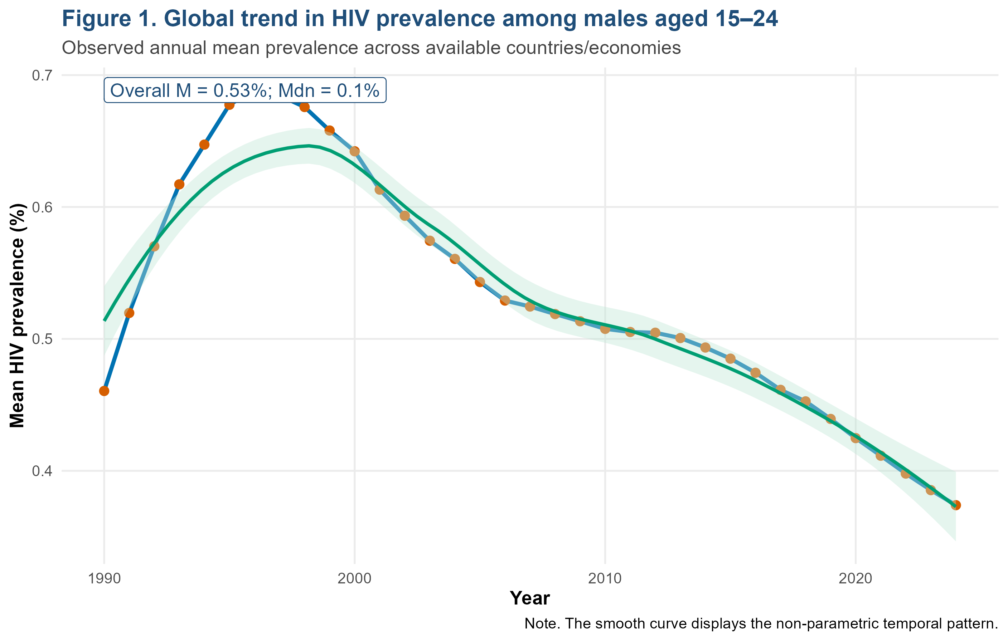
Figure 1: Global Trends in HIV Prevalence Among Males Aged 15-24

The results in Figure 1 reveal that the mean HIV prevalence among males aged 15-24 rose in the early 1990s, reached the peak in the late 1990s, and then decreased continuously in the 2024. This trend is aligned with the global literature on HIV that has recorded a significant increase in the epidemics and subsequent decline in connection with prevention, testing, scale-up of ART, and international funding of HIV (Zhang et al., 2022; Mody et al., 2024; Kumah et al., 2023). Nevertheless, the downward trend that has been on does not mean that it will be eliminated. Instead, it presents the aggregate development that can hide the significant regional and country level variations. The figure justifies the study purpose as it shows that temporal modelling is necessary and a method that is able to address nonlinear historical change and heterogeneity of countries is better than a simple pooled trend.
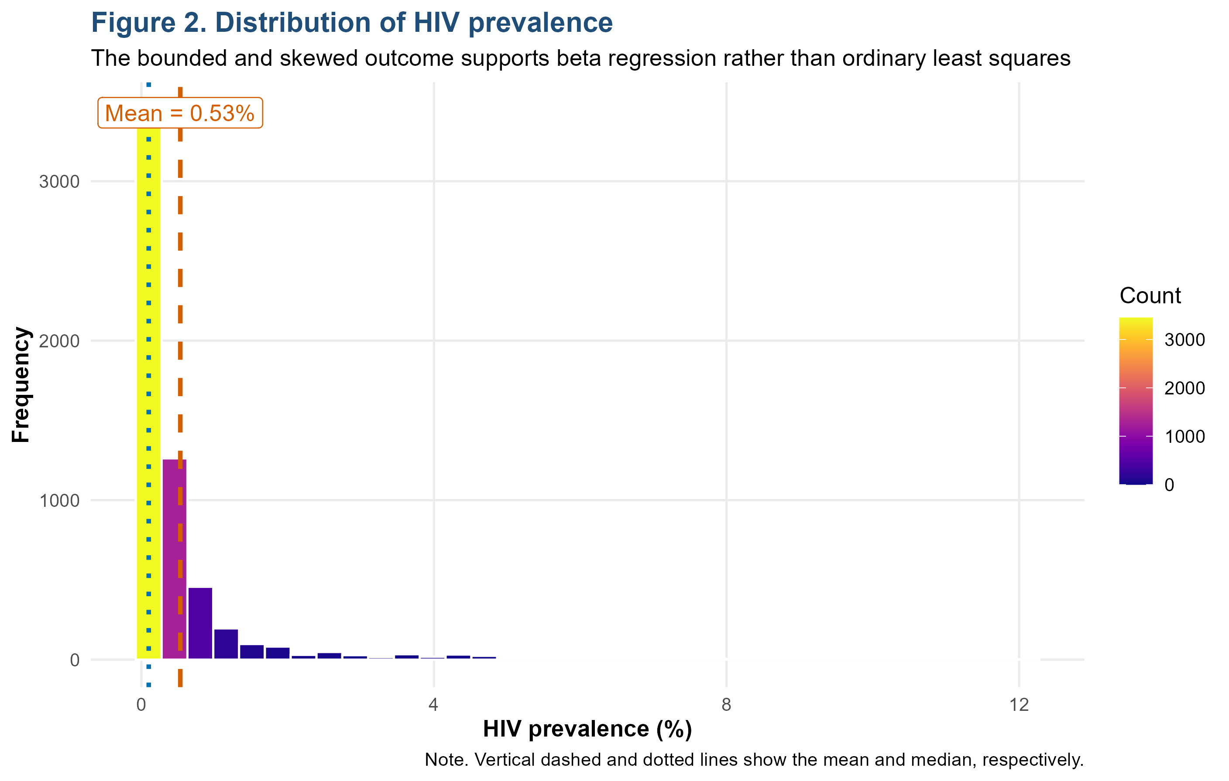
Figure 2: Distribution of HIV Prevalence

Figure 2 indeed verifies that HIV prevalence is skewed to the right, and has a limited scope with a mean of 0.53% and a median of 0.10. This is the direct reason that beta regression should be utilized instead of the regular least squares. Earlier studies tended to model HIV prevalence as a continuous outcome (which is a general outcome), although these models may be statistically inappropriate in cases where the outcome is skewed, bounded and heteroskedastic. The current research fills this gap by modelling prevalence as a fractional response. This methodological decision enhances the quality of inferences and increases the originality of the paper because the statistical model is in line with the actual measurement scale of HIV prevalence.
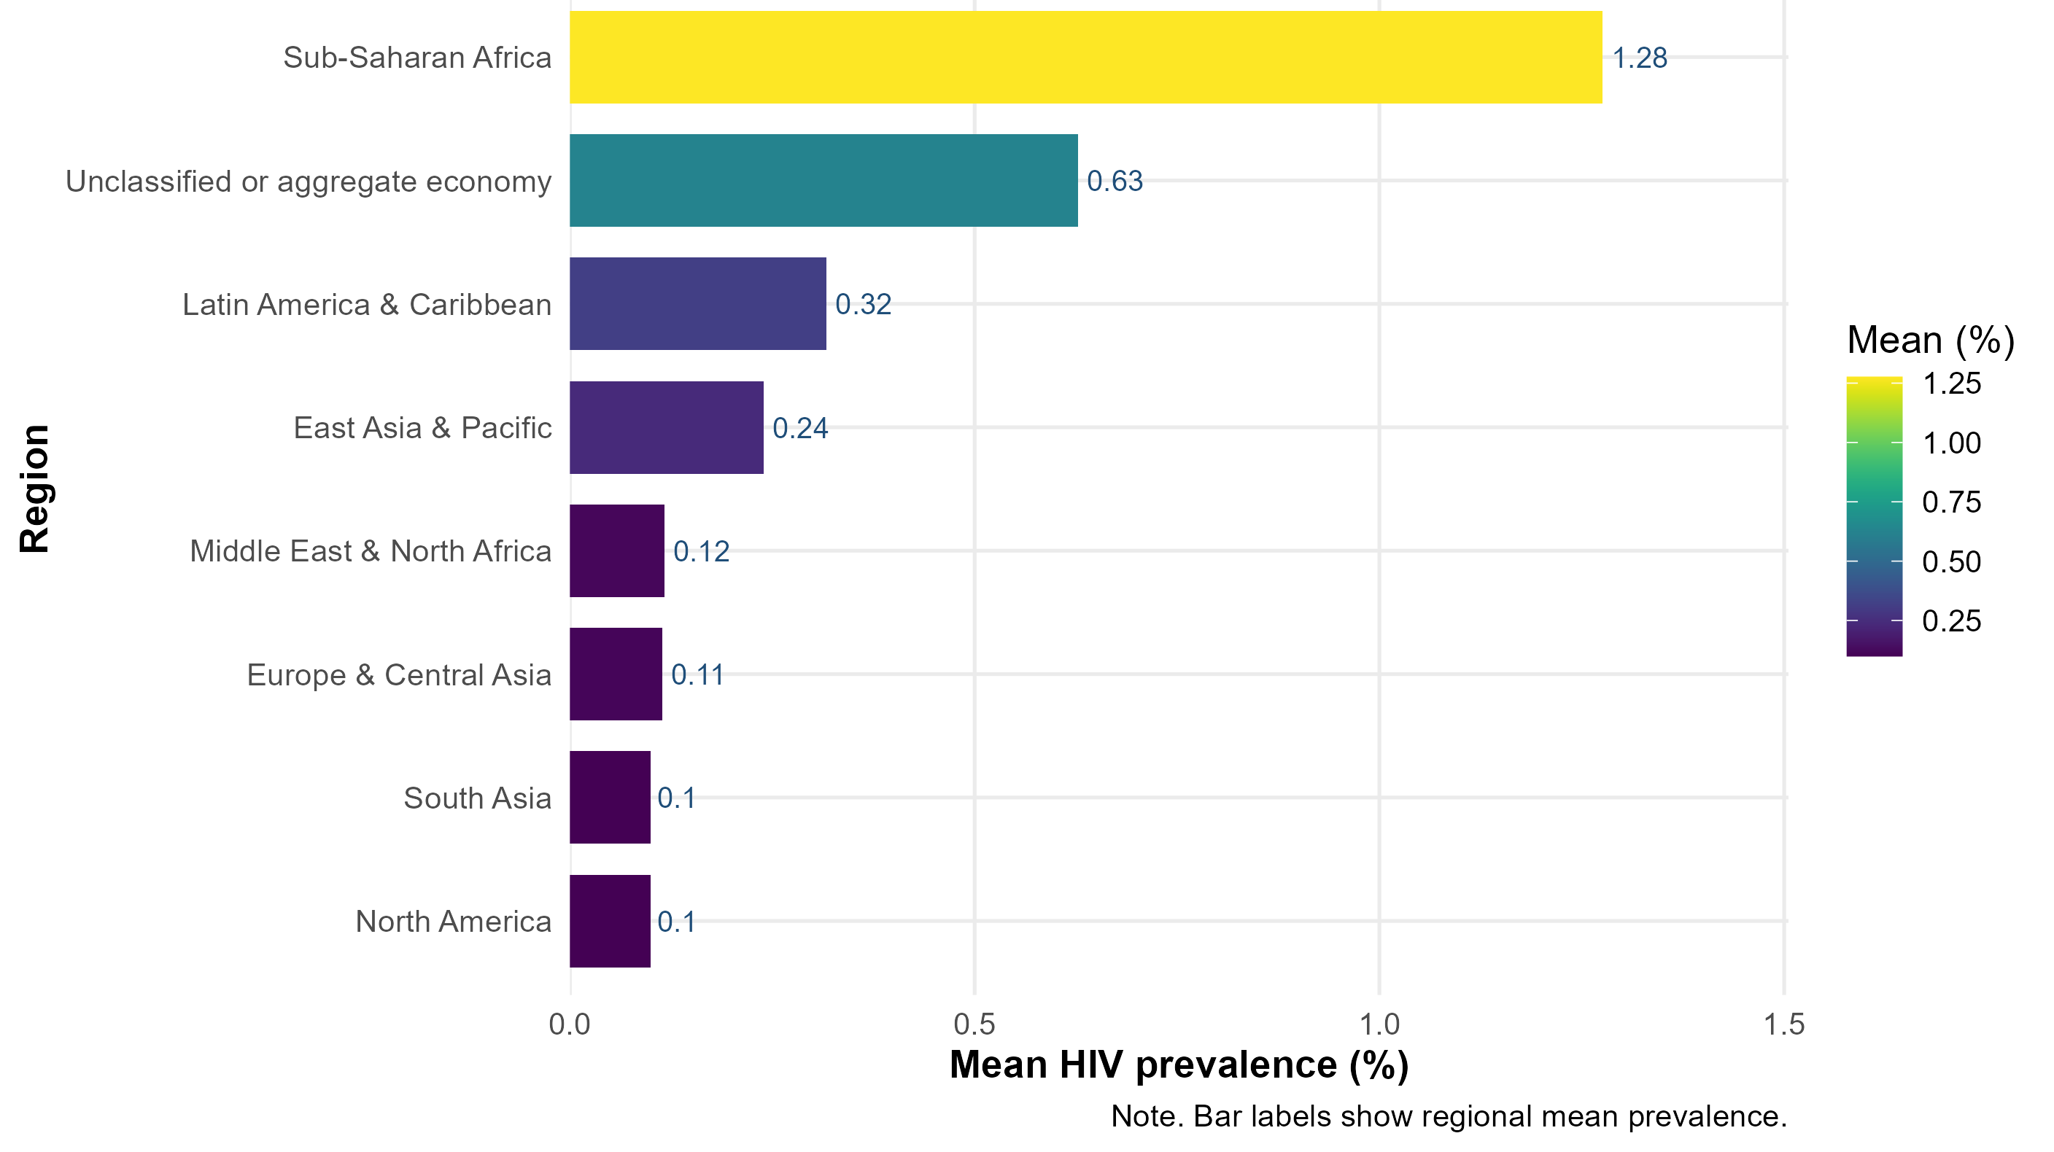 Figure 3: Regional Heterogeneity in HIV Prevalence,
Figure 3 supports the descriptive finding that the highest two are highest in Sub-Saharan Africa with the next in the list being the unclassifiable or aggregate economies. The justification of past outcomes of unequal geography of HIV among youths is partly due to this geographical location (Rosenberg et al., 2023; Wang et al., 2022; Tian et al., 2024). This suggests that the issue of HIV prevention among young males must be addressed as an equity issue and not as a biomedical issue. The areas where adolescent and youth-friendly services, school-to-community prevention channels, male-targeted testing, and stigma reduction should be prioritized in the areas where prevalence rates are still high.
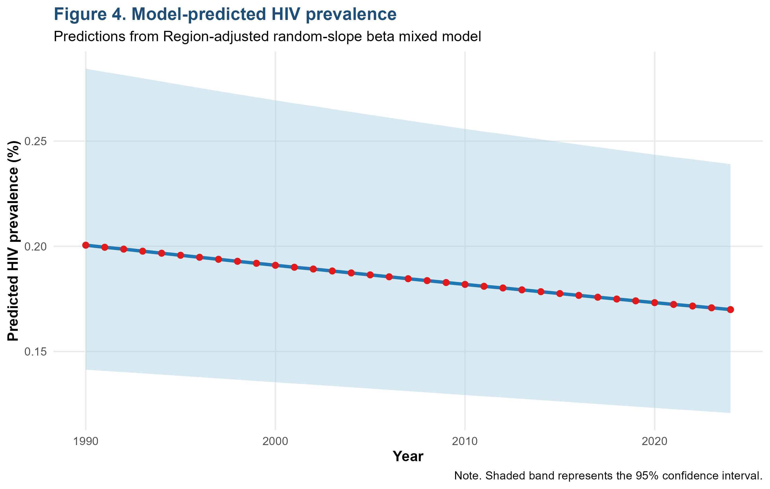Figure 4: Model-Predicted HIV Prevalence

Figure 4 presents a model-predicted trend of HIV prevalence between 1990 and 2024; the fitted trend is lower than the historical average due to the model, which is adjusted by region and country-level random effects and repeated measures. This is noteworthy since it shows how the crude trends may vary against model-based estimates. The current analysis is much more rigorous than the last descriptive surveillance studies, offering a longitudinal approximation that is more precise and includes the clustering and unbalanced panel structure. This observation promotes tempered optimism: prevention and treatment campaigns seem to have decreased prevalence with time, but the confidence range suggests that there is still uncertainty, and thus, constant investment in HIV is needed in SDG 3.3.
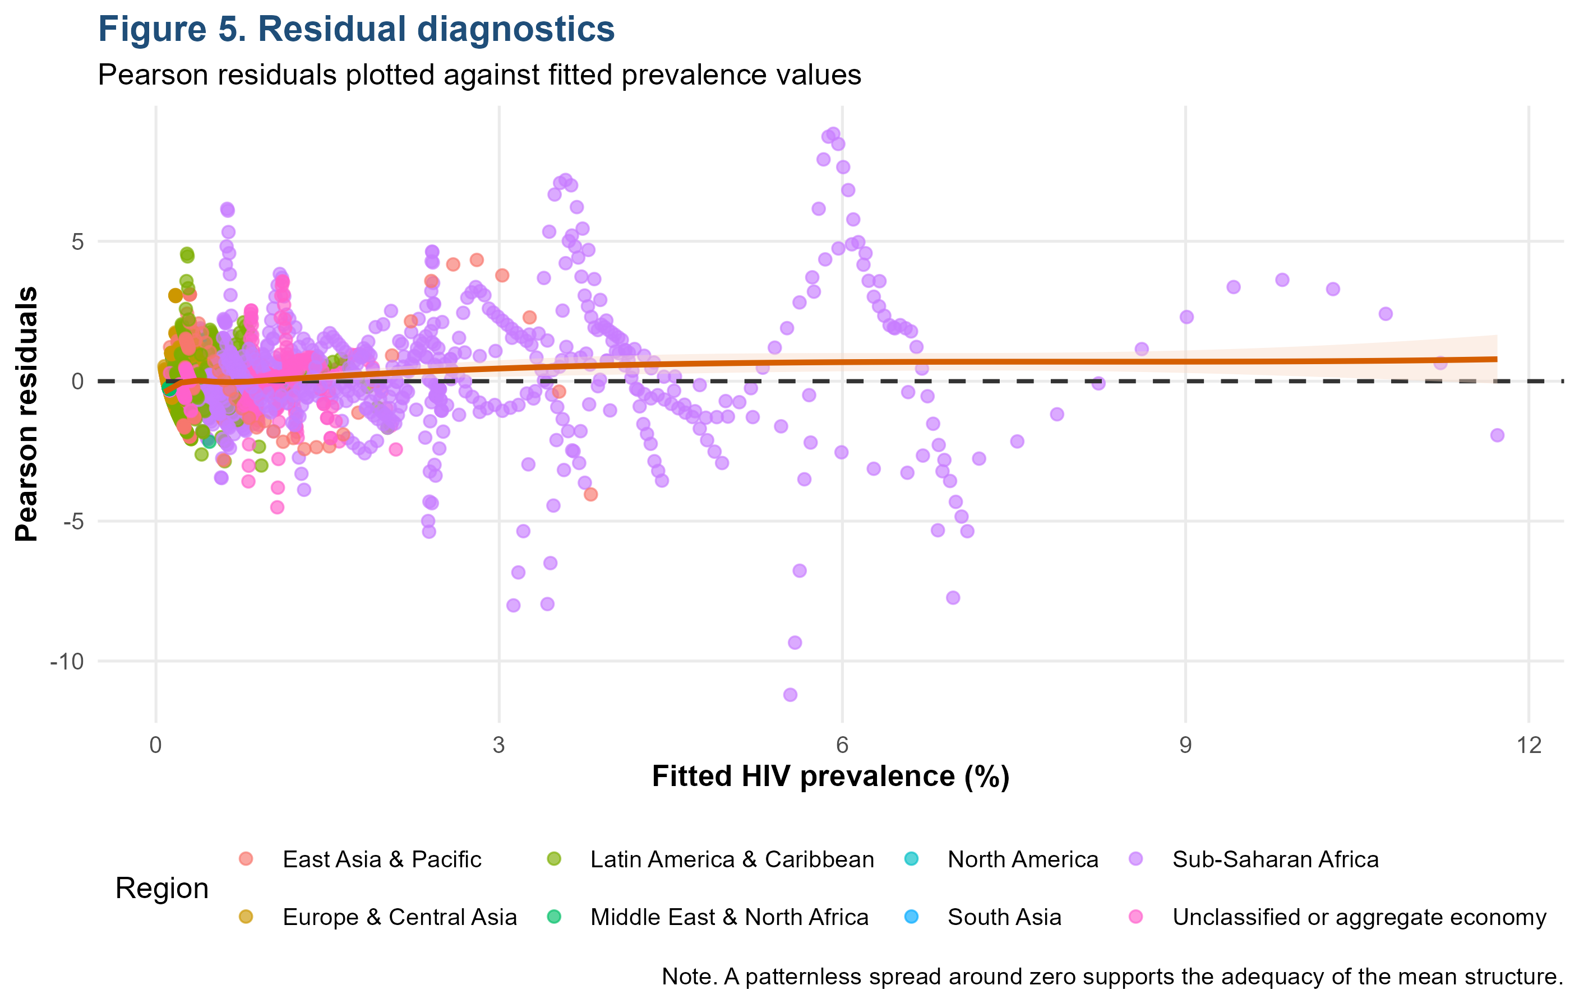Figure 5: Residual Diagnostics

Figure 5 presents the residual diagnostics and indicates that, though the model is able to capture the overall trend, there is still residual variation, particularly in countries with larger fitted prevalence. This is anticipated in international HIV data as countries vary in the maturity of epidemics, testing infrastructure, completeness of reporting, the strength of programmes and behavioural risk settings. This study explicitly measures model adequacy, unlike the past studies that underreported diagnostics. The policy implication is that despite statistically suitable models, they should be interpreted together with the quality of surveillance; thus, enhancing HIV data completeness and consistency should be on the SDG 17 agenda of more robust health information systems.
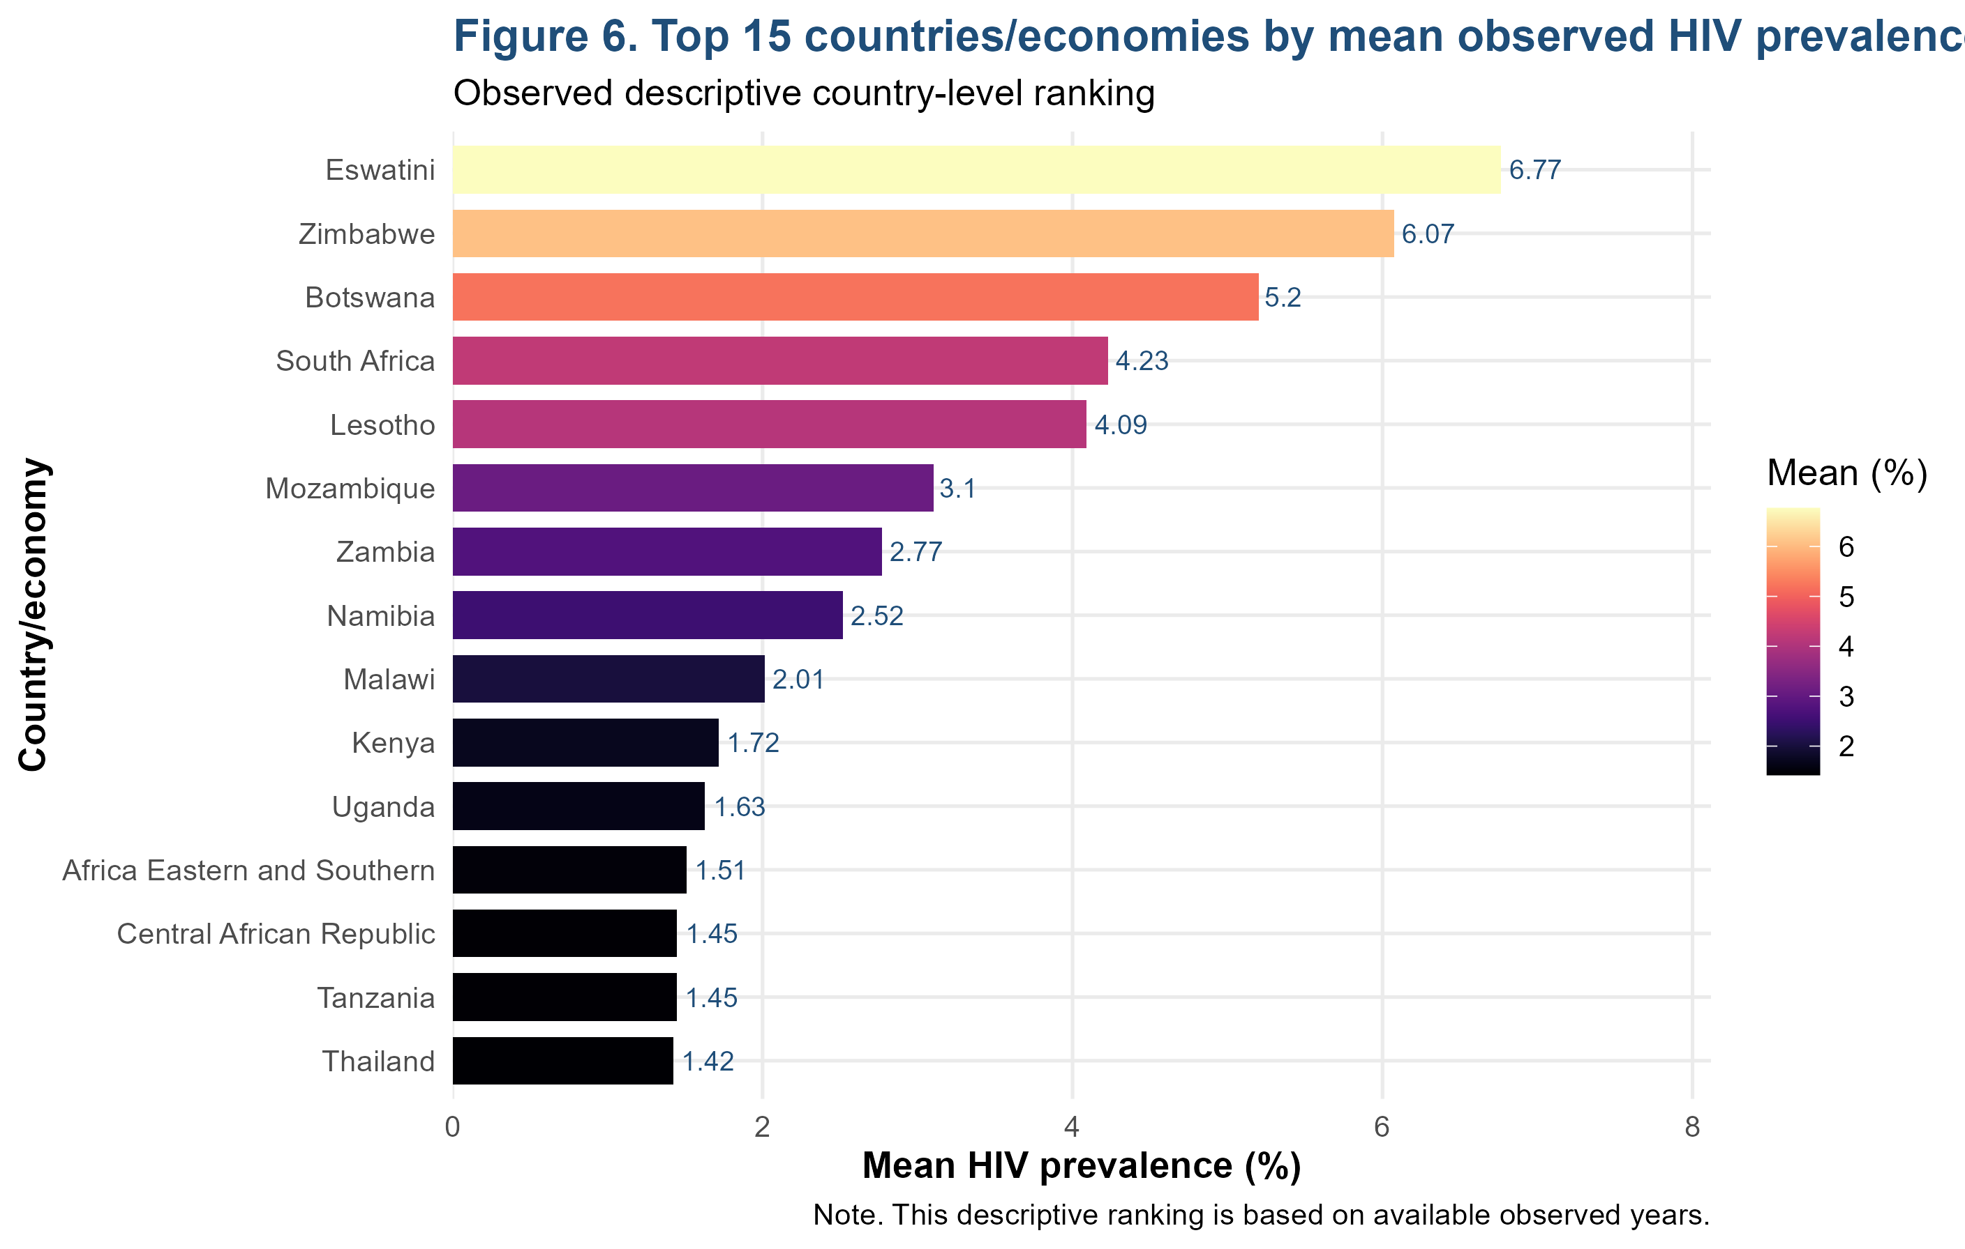Figure 6: Top 15 Countries/ Economies by Mean Observed HIV Prevalence

Eswatini, Zimbabwe, Botswana, South Africa, Lesotho, Mozambique, Zambia, Namibia, Malawi, Kenya, and Uganda are some of the most prevalent locations, which are identified in Figure 6. Such trend is intensely aligned with previous data on the HIV burden concentration in Southern and Eastern Africa (Zuma et al., 2022; Orlando et al., 2025; Gaumer et al., 2023). This novelty is the fact that the ranking of countries is not only being considered but the observed rankings are combined with multilevel modelling to differentiate between descriptive burden and adjusted country-level heterogeneity. Some of the policy directions which should be considered are increased testing of male youth, PrEP scale-up, retention in care, community-based prevention, and the incorporation of HIV testing with sexual and reproductive health programmes.

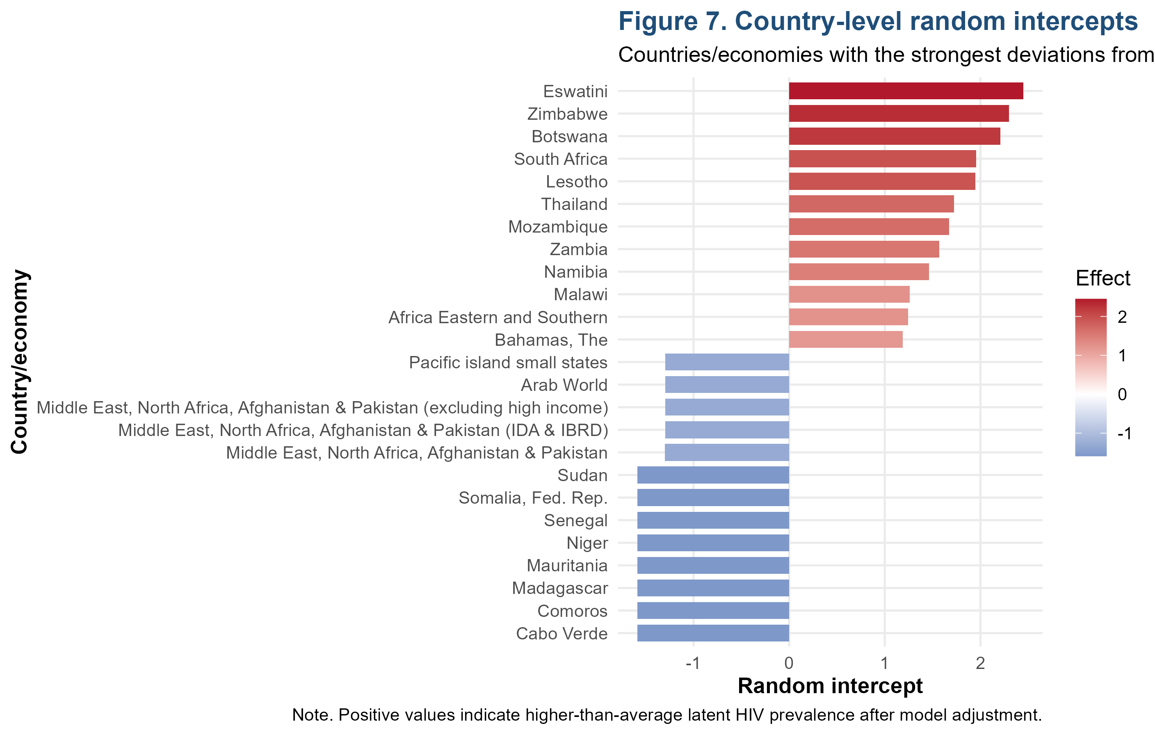Figure 7: Country-Level Random Intercepts

Figure 7 indicates that after adjusting the model, Eswatini, Zimbabwe, Botswana, South Africa, Lesotho, Thailand, Mozambique, Zambia and Namibia have strong, positive country-level random intercepts implying that their latent HIV prevalence is higher than the average. This confirms the fact that there are still countries that are structurally high-burden at accounting regional effects and time. The discovery fills in a significant gap in past pooled research, which tends to obscure country-specific underlying risk. In the case of policy, it implies that regional plans cannot substitute country-specific planning. Countries with high random-intercept needs more radical, protracted and locally specific interventions as opposed to brief, or universal global programmes.

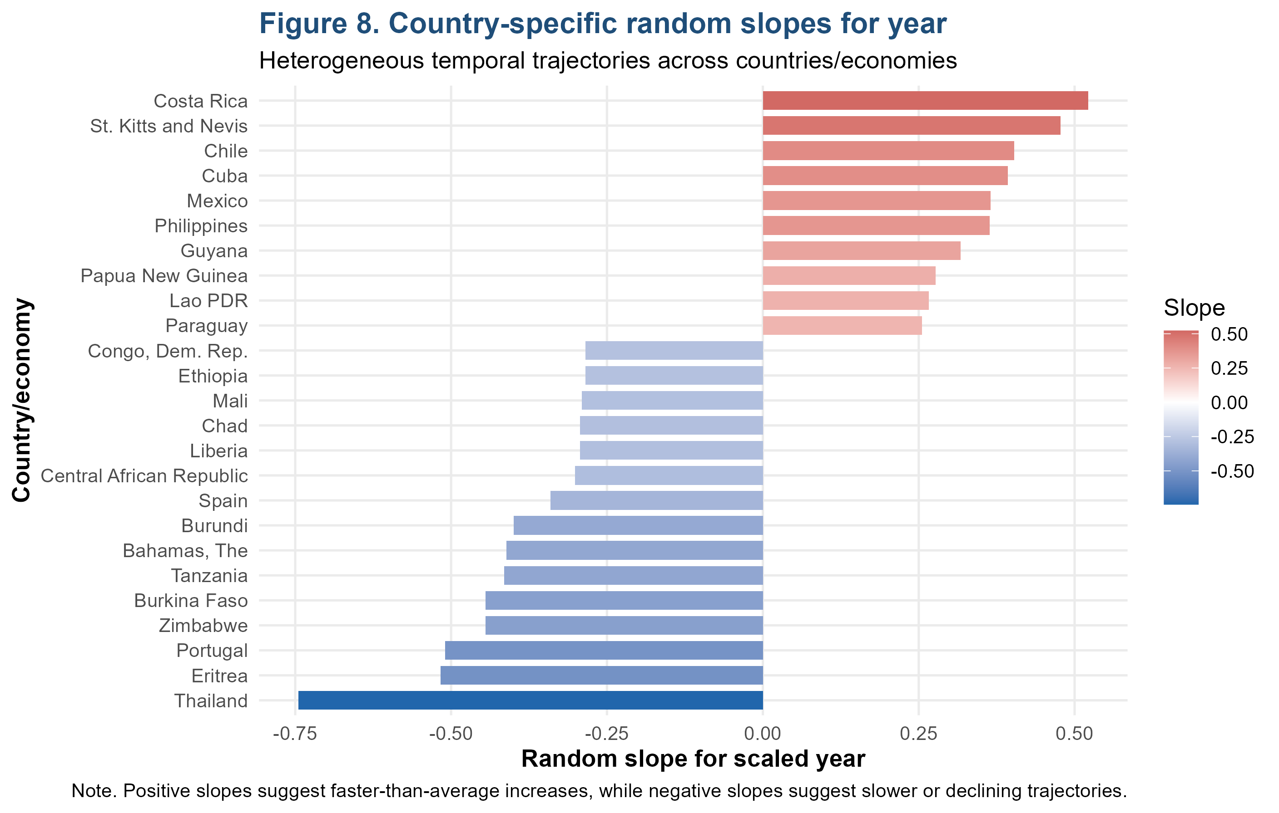Figure 8: Country-Specific Random Slopes for Year

In Figure 8, the country-specific random slopes are provided, and it is observed that there are countries which increased faster than the average and those which declined more strongly. Costa Rica, St. Kitts and Nevis, Chile, Cuba and Mexico had positive slope deviations, whereas Thailand, Eritrea, Portugal, Zimbabwe, Burkina Faso and Tanzania had negative slope deviations. This observation is core to the novelty of the study in that it shows that there is not only a variation in the prevalence at the baseline but also an epidemic pathway. This model has identified dynamic heterogeneity as compared to the previous studies that approximate a single world or regional tendency. What this means is that the SDG 3.3 monitoring must follow both the status quo and the trend of change, since a low-prevalence nation with an increasing trend might also need to be intervened upon early in the prevention.
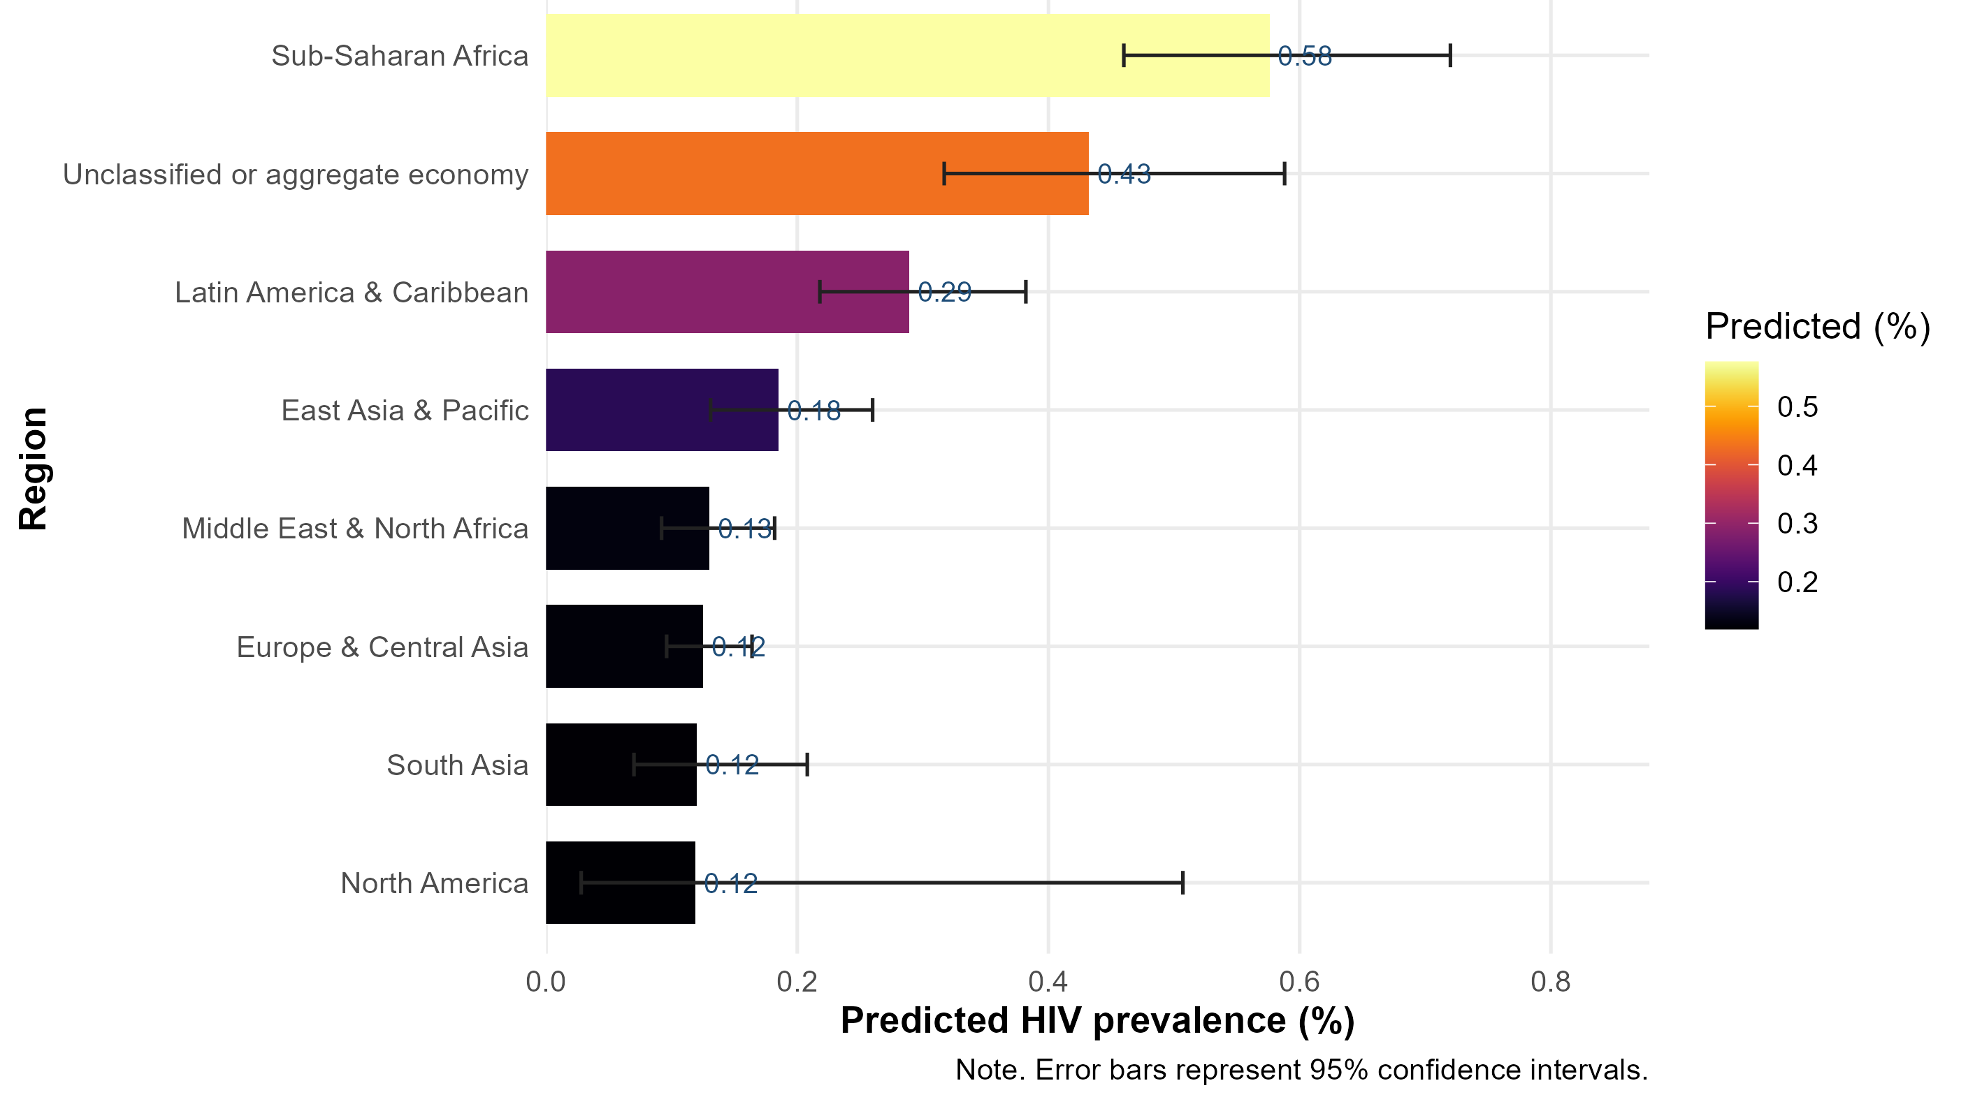Figure 9: Model-Based Regional Predictions

Figure 9 validates the adjusted-regional forecasting trend, where Sub-Saharan Africa is the highest-predicted-prevalence area despite the model adjustment. The narrow range of the confidence interval of North America indicates that there is less data and that the uncertainty prevails, as opposed to the low risk being certain. This figure is directly related to the study objective as it demonstrates that multilevel beta modelling not only gives adjusted prevalence estimates but also uncertainty intervals. The policy implication is that point estimates should not be used solely to guide resource allocation, but uncertainty should also be taken into consideration, especially in situations where the data are scarce. Empowering age- and sex-disaggregated HIV surveillance among young men is thus a key component of SDG 3.3 and SDG 17.

Table 4: Regional model-based predictions with 95% confidence intervals
Region | Predicted_HIV_Prevalence_Percent | Lower_95_CI | Upper_95_CI
Sub-Saharan Africa | 0.576 | 0.460 | 0.720
Unclassified or aggregate economy | 0.432 | 0.317 | 0.588
Latin America & Caribbean | 0.289 | 0.218 | 0.382
East Asia & Pacific | 0.185 | 0.131 | 0.260
Middle East & North Africa | 0.130 | 0.092 | 0.182
Europe & Central Asia | 0.125 | 0.096 | 0.164
South Asia | 0.120 | 0.070 | 0.208
North America | 0.119 | 0.028 | 0.507

Table 4 shows the model-based regional forecast and affirm that Sub-Saharan Africa is the riskiest region and the forecasted prevalence is 0.576% which has a 95% CI of 0.460-0.720. The group of unclassified or aggregate economy was the next with 0.432% followed by Latin America and the Caribbean with 0.289%. The confidence interval was wide in North America, which indicated little information and uncertainty despite having a low point estimate. This study is novel compared to the past researches that tended to report uncooked regional averages, whereas this study reports model-based estimates unadjusted in the form of uncertainty intervals. This difference is significant as it offers more justifiable evidence to prioritization to policymakers, in particular, those related to SDG 3.3, SDG 3.7 on access to sexual and reproductive health, and SDG 17 on enhancing data systems.

In general, the results prove that the incidence of HIV among males aged 15-24 decreases over the years, but at the same time, it is uneven regionally and nationally. Compared to the previous research, the study is better in that it employs a model suitable for bounded, skewed, longitudinal and unbalanced prevalence data, and it breaks down country-level differences into random intercepts and random slopes. This focuses on the identified methodological gaps in the literature: excessive use of pooled or linear models, insufficient modelling of heterogeneity, and inappropriate uncertainty and diagnostics reporting. The key health promotion theme is that world development is true but disproportionate; to achieve the elimination of HIV amongst youth, statistically sensitive, regionally varied, and country-specific measures should be taken, which are consistent with SDG 3.3, SDG 3.7, SDG 10, and SDG 17.

Discussion
The current study offers strong international data on the prevalence of HIV among males aged 1524 in terms of a multilevel beta mixed-effects model that specifically takes into consideration the limited, distorted, and hierarchical nature of the data. The results indicate that the prevalence of HIV among this population is not high by its absolute value but very skewed both regionally and nationally. Descriptive statistics (Table 1) indicate that Sub-Saharan Africa is disproportionately burdened, with an overall mean prevalence of 1.276% and extreme values of 12.1, whereas other countries, like Europe, Central Asia and South Asia have much lower averages. This validates previous epidemiological studies of geographic concentration of HIV burden (Zhang et al., 2022; Rosenberg et al., 2023), but goes beyond the literature by quantifying variability in a statistically suitable distributional model.

A temporal analysis reveals an apparent nonlinear global trend: The prevalence of HIV grew in the early 1990s, reached its peak in the late 1990s and has since then been on a downward trend. The multilevel model validates this declining trend, though the effect of time is statistically significant (OR = 0.952, p =.002), which shows that it would be gradually but steadily improving over time. This is in line with the international development due to increased testing and prevention, as well as antiretroviral therapy coverage (Mody et al., 2024; Bekker et al., 2023). However, continued existence of the regional inequalities implies that such gains are not evenly spread, which supports the necessity to engage in specific interventions.

One of the most important methodological results is that the region-adjusted random-slope beta mixed model was the most appropriate one to model the data because it fitted the data much better than simpler models (Table 2). This proves that the regional setting as well as country-specific time dynamics play an important role in the proper modelling of HIV prevalence. This model unlike the past studies that use pooled or fixed-effect methods, captures the heterogeneity in baseline prevalence as well as rates of change across countries. This is an important step forward, as it demonstrates that when it comes to global epidemics it is easy to lose important distinctions between the patterns on the basis of homogeneous assumptions.

The results of the fixed-effects also point out significant regional disparities. Sub-Saharan Africa has much greater odds of HIV prevalence than the reference (OR = 3.131, p =.001), and Latin America and the Caribbean also have a high level of risk (OR = 1.566, p =.044). Conversely, other parts, like Europe & Central Asia, South Asia, the Middle East, and North Africa, have no significant differences or lower differences. These results are in line with previous studies on the disparities across regions but offer better statistical inference through the use of hierarchical modelling and proper distributional assumptions. These trends are confirmed by model-based predictions (Table 4) with the highest adjusted prevalence (0.576%, 95% CI: 0.4600.720) in Sub-Saharan Africa, then unclassified or aggregate economies (0.432%), then Latin America & Caribbean (0.289%). Confidence intervals bring on board a very critical aspect of uncertainty, which is lacking in descriptive research. This increases the accuracy of the results in making policy decisions.

There are high levels of heterogeneity at the country level. Eswatini, Zimbabwe, Botswana, and South Africa were identified to be high burden settings, as there is the highest prevalence that is observed and model-adjusted. Notably, the estimates of random intercept indicate that there are still countries above the world average concerning the HIV prevalence in spite of controlling the factors of location and time, which implies the structural or systemic factors of the HIV prevalence. Also, the slope estimates (Randomly chosen) show that different countries vary in terms of their temporal patterns, as some of them are declining more rapidly and others are progressing or increasing more slowly. This points to the fact that the overall negative trend in the world conceals a variety of country-specific processes.

The distributional analysis confirms that the HIV prevalence is very skew and concentrated around zero and thus supports the application of beta regression. This combats one of the weaknesses of the past researches where they used linear models to constrained results. Also, residual diagnostics show that the model well represents the mean structure, but there is also a certain amount of variability, which is a natural consequence of the complexity of global HIV data.
All in all, the key results indicate that HIV among young men is decreasing all over the world however it is very heterogeneous both regionally and nationally. The research offers a solid rationale as to why it is necessary to use proper statistical modelling in order to capture these complexities and deliver reliable and policy-relevant findings using multilevel beta mixed-effects modelling.

Summary and Conclusion
The research has substantive and methodological implications for the existing knowledge on the prevalence of HIV among males in the age group of 15-24 years in the global context. Substantively, it validates that although the prevalence of HIV in the world is on the decrease over the years, in-depth variations in regions and countries are still evident. Sub-Saharan Africa is still the epicentre of the epidemic among this age group, and some countries still have high levels of prevalence or are structurally high. The results highlight the importance of long-term and targeted interventions targeting young males, such as increased testing, prevention measures like pre-exposure prophylaxis (PrEP), behavioural interventions, and access to treatment services. To realise Sustainable Development Goal (SDG) 3.3, the goal of eliminating AIDS as a public health threat, an increased effort will be needed in high-burden areas, but with a combination of measures targeting structural inequalities (SDG 10) as well as building health systems and information infrastructure (SDG 17).

This research methodologically contributes to the literature by showing the significance of modelling statistical models with the actual characteristics of epidemiological data. The analysis appropriately includes the limited, skewed, hierarchical nature of HIV prevalence data through a multilevel beta mixed-effects model and the skewed nature of global panels. The random intercepts and slopes enable one to have a subtle explanation of the country-specific risks of the baseline and the dynamics of time, which are major disadvantages of the classic linear and pooled models. This method has more precise estimates, quantifies uncertainty more effectively, and has more inferential validity.

Another significant finding of the study is the need to combine descriptive, predictive and diagnostic analysis in a single modelling format. The regional comparisons, the variations with time, the heterogeneity of the countries, and the predictions made by the models are a complete depiction of the epidemic. This combined methodology makes the findings more useful to the policy makers, researchers and health stakeholders around the globe. Even with the advantage, the study has realised that there is still residual variability and limitation of the data, especially in areas where the observations are not dense. Future studies should build on this framework by adding more covariates, like behavioural, socioeconomic, and health-system covariates and investigating nonlinear, as well as spatial modelling methods. Nevertheless, the recent results have a good empirical and methodological basis for comprehending the HIV dynamics in young males.

To sum up, this study indicates that the world is indeed making progress in curbing the prevalence of HIV in young males, but the progress is uneven. It is necessary to statistically rigorously analyse and take policy action to address this inequality. This research has filled methodological gaps in the literature with solid evidence based on models and is thus useful in the global research on HIV and in combating the epidemic with more effective strategies. To begin with, governments and international health organisations must embrace more specific, data-based HIV programs in young males in high-burden areas, especially in Sub-Saharan Africa. These encompass increasing access and availability to youth-friendly testing services, increasing access to pre-exposure prophylaxis (PrEP) and intensifying school-to-community prevention programmes, as well as incorporating HIV services into sexual and reproductive health services.

Model-based estimates (not raw averages) should be used to geographically prioritise resources to countries and regions with the highest adjusted risk as a direct way of advancing SDG 3.3 to allocate resources efficiently and eliminate inequalities under SDG 10. Second, national health systems need to enhance HIV surveillance and data quality systems through investing in routine, age- and sex-disaggregated data collection, enhancing completeness of reporting, and harmonisation of data systems across regions. The paper demonstrates that uncertainty and heterogeneity partially indicate the lack of data, thus, the improvement of real-time data systems, digital reporting systems, and statistical capabilities will lead to the improvement of monitoring and responsiveness of policies. This would be in line with SDG 17 as it would strengthen the data infrastructure and evidence-based decision-making.

Third, policymakers and researchers ought to institutionalise the use of advanced statistical modelling (e.g., multilevel beta mixed-effects models) of HIV monitoring and evaluation. The models that are based on the limited and stratified nature of epidemiological data should be used to substitute or supplement traditional linear or pooled approaches. The inclusion of these approaches in the national and international reporting systems will enable more effective estimation of trends and identification of country-specific epidemic trends, as well as assessment of intervention effectiveness, which will ultimately enhance strategic planning and long-term efforts to control HIV.

Data Availability
This study used secondary longitudinal data on HIV prevalence among males aged 15–24 years obtained from the World Bank World Development Indicators (WDI) database. The dataset is publicly accessible via the World Bank Open Data platform: https://databank.worldbank.org/source/world-development-indicators.
Disclaimer (Artificial intelligence)
Author(s) hereby declare that NO generative AI technologies such as Large Language Models (ChatGPT, COPILOT, etc.) and text-to-image generators have been used during the writing or editing of this manuscript.

References

Akinrefon, A. A., Emmanuel, R., & Okolo, A. (2023). Log-linear models for HIV/AIDS prevalence in Adamawa State, Nigeria. Fudma Journal of Sciences, 7(3), 103-109.

Bekker, L. G., Beyrer, C., Mgodi, N., Lewin, S. R., Delany-Moretlwe, S., Taiwo, B., ... & Lazarus, J. V. (2023). HIV infection. Nature Reviews Disease Primers, 9(1), 42.

Briceño-Patiño, N., Prieto, M. C., Manrique, P., Calderon-Ospina, C. A., & Gómez, L. (2025). Pharmacokinetic Adaptations in Pregnancy: Implications for Optimizing Antiretroviral Therapy in HIV-Positive Women. Pharmaceutics, 17(7), 913.

Cluver, L., Makangila, G., Hillis, S., Ntwali-N'Konzi, J. P., Flaxman, S., Unwin, J., ... & Stover, J. (2025). Protecting Africa's children from extreme risk: a runway of sustainability for PEPFAR programmes. The Lancet, 405(10490), 1700-1712.
Diksha, L., Ashutosh, K., Musarrat, S., Ashu, R., Neelam, T., Diksha, D., ... & Himanshu, B. (2025). Achieving SDG-3 in India:“Ensuring healthy lives and promoting wellbeing at all ages”. Global Health Economics and Sustainability, 3(1), 243.
Duarte-Anselmi, G., Sanduvete-Chaves, S., López-Arenas, D., & Chacón-Moscoso, S. (2026). Behavioral determinants of condom use and HIV/STI testing in Chile: a theory-driven mixed-methods study. Scientific Reports.

Ford, C. L., Riggs, W. J., Quigley, T., Keifer Jr, O. P., Whitton, J. P., & Valayannopoulos, V. (2023). The natural history, clinical outcomes, and genotype–phenotype relationship of otoferlin-related hearing loss: a systematic, quantitative literature review. Human Genetics, 142(10), 1429-1449.

Gaumer, G., Senthil Kumar, V. S., Crown, W., Jordan, M., Hurley, C., Subramanian, M., & Nandakumar, A. K. (2023). Equity of the HIV epidemic response in 13 African countries. African Journal of AIDS Research, 22(4), 276-289.

Gupta, R., Abdalla, S., Meausoone, V., Vicas, N., Mejía-Guevara, I., Weber, A. M., ... & Darmstadt, G. L. (2022). Effect of imbalanced sampling and missing data on associations between gender norms and risk of adolescent HIV. EClinicalMedicine, 50.

Haddad, C. N., Mahler, D. G., Diaz-Bonilla, C., Hill, R., Lakner, C., & Ibarra, G. L. (2024). The World Bank’s New Inequality Indicator. Policy Research working paper no. WPS, 10796.
Hensen, B., Floyd, S., Phiri, M. M., Schaap, A., Sigande, L., Simuyaba, M., ... & Ayles, H. (2023). The impact of community-based, peer-led sexual and reproductive health services on knowledge of HIV status among adolescents and young people aged 15 to 24 in Lusaka, Zambia: The Yathu Yathu cluster-randomised trial. PLoS medicine, 20(4), e1004203.

Jaman, M. S., Maniruzzaman, M., Rana, M. R. R., Bhuiyan, M. R. H., Akter, L., Ahmad, S., ... & Saifujjaman, M. (2024). Overall Summery of Gulf Country Employees from Bangladesh, Preliminary Evaluation for Abnormal Kidney Liver and Virally Infected Individuals Using Low-cost Tests Like CBC Parameters. Chemical Science International Journal, 33(4), 19-33.
Jaya, I. G. N. M., Handoko, B., Andriyana, Y., Chadidjah, A., Kristiani, F., & Antikasari, M. (2023). Multivariate Bayesian semiparametric regression model for forecasting and mapping HIV and TB risks in West Java, Indonesia. Mathematics, 11(17), 3641.

Kanyemba, R., Govender, K., Dzomba, A., Mashamba, T. P., & Mantell, J. E. (2023). HIV focused sexual risk-reduction interventions targeting adolescent boys and young men in Sub-Saharan Africa: a scoping review. AIDS and Behavior, 27(10), 3356-3391.

Kim, M., Mahmood, M., Estes, L. L., Wilson, J. W., Martin, N. J., Marcus, J. E., ... & Shah, A. (2024). A narrative review on antimicrobial dosing in adult critically ill patients on extracorporeal membrane oxygenation. Critical Care, 28(1), 326.

Kiplagat, J., Tran, D. N., Barber, T., Njuguna, B., Vedanthan, R., Triant, V. A., & Pastakia, S. D. (2022). How health systems can adapt to a population ageing with HIV and comorbid disease. The Lancet HIV, 9(4), e281-e292.

Kokilavani, S., Geethalakshmi, V., Pangayarselvi, J., Bhuvaneeswari, J., Sudhakar, G., Subbulakskmi, S., ... & Bal, S. K. (2023). Beta regression model for predicting development of powdery mildew in black gram. Journal of Agrometeorology, 25(4), 577-582.
Költringer, F. A., Annerstedt, K. S., Boccia, D., Carter, D. J., & Rudgard, W. E. (2023). The social determinants of national tuberculosis incidence rates in 116 countries: a longitudinal ecological study between 2005–2015. BMC public health, 23(1), 337.

Kumah, E., Boakye, D. S., Boateng, R., & Agyei, E. (2023). Advancing the global fight against HIV/Aids: Strategies, barriers, and the road to eradication. Annals of global health, 89(1), 83.

Landovitz, R. J., Scott, H., & Deeks, S. G. (2023). Prevention, treatment and cure of HIV infection. Nature Reviews Microbiology, 21(10), 657-670.

Ledesma, J., Zhang, M., Hay, S. I., Ng, M., Murray, C. J., & Kyu, H. (2023). Global, Regional, and National Burden of Tuberculosis and Multidrug-Resistant Tuberculosis in the Context of HIV/AIDS, 1990–2023: A Systematic Analysis for the Global Burden of Disease Study 2023. AIDS.
Lima, L. V. D., Pavinati, G., Valdivia-Rojas, Y. L., Silva Júnior, J. N. D. B., Sato, A. P. S., Diaz-Quijano, F. A., ... & Magnabosco, G. T. (2025). Temporal trends and regional clusters of tuberculosis-HIV coinfection outcomes in Brazil. Revista de Saúde Pública, 59, e39.
Mobaderi, T., Kazemnejad, A., & Salehi, M. (2025). Clustering and modeling joint-trajectories of HIV/AIDS and tuberculosis mortality rates using bayesian multi-process latent growth model: A global study from 1990 to 2021. BMC Infectious Diseases, 25(1), 330.

Mody, A., Sohn, A. H., Iwuji, C., Tan, R. K., Venter, F., & Geng, E. H. (2024). HIV epidemiology, prevention, treatment, and implementation strategies for public health. The Lancet, 403(10425), 471-492.

Monod, M., Brizzi, A., Galiwango, R. M., Ssekubugu, R., Chen, Y., Xi, X., ... & PANGEA-HIV consortium. (2024). Longitudinal population-level HIV epidemiologic and genomic surveillance highlights growing gender disparity of HIV transmission in Uganda. Nature Microbiology, 9(1), 35-54.

Nwachinemere, O. L., Nyegenye, S., Mwesigwa, A., Bulus, N. G., Gmanyami, J. M., Mukisa, K. A., & Isiko, I. (2025). Trends in HIV-related knowledge, behaviors and determinants of HIV testing among adolescent women aged 15–24 in Nigeria. Tropical Medicine and Health, 53(1), 79.

Orlando, S., Silaghi, L. A., Cicala, M., Lowole, M. W., Massango, C., Lunghi, R., ... & Scarcella, P. (2025). The global response to HIV/AIDS in sub-Saharan Africa: achievements, challenges, and perspectives for the future. Frontiers in Public Health, 13, 1665666.

Phillips, G., Davoudpour, S., Floresca, Y. B., Felt, D., Curry, C. W., Wang, X., ... & Beach, L. B. (2023). Disparities in HIV testing, condom use, and HIV education between transgender and not transgender high school–aged youth: Findings from the 2019 Youth Risk Behavior Survey. Health Education & Behavior, 50(1), 29-40.

Rosenberg, N. E., Shook-Sa, B. E., Liu, M., Stranix-Chibanda, L., Yotebieng, M., Sam-Agudu, N. A., ... & Chi, B. H. (2023). Adult HIV-1 incidence across 15 high-burden countries in sub-Saharan Africa from 2015 to 2019: a pooled analysis of nationally representative data. The lancet HIV, 10(3), e175-e185.

Soogun, A. O., Kharsany, A. B., Zewotir, T., North, D., & Ogunsakin, R. E. (2022). Identifying potential factors associated with high HIV viral load in KwaZulu-Natal, South Africa using multiple correspondence analysis and random forest analysis. BMC Medical Research Methodology, 22(1), 174.

Tian, X., Wang, C., Hao, Z., Chen, J., & Wu, N. (2024). Global, regional, and national burden of HIV and tuberculosis and predictions by Bayesian age-period-cohort analysis: a systematic analysis for the global burden of disease study 2021. Frontiers in Reproductive Health, 6, 1475498.

UNAIDS. (2024). UNAIDS Global AIDS Update 2024: The Urgency of Now: AIDS at a Crossroads. Stylus Publishing, LLC.
Wang, R., Sun, Y., Wang, H., Yu, X., Ma, J., Liu, Z., ... & Huang, Y. (2025). Progress on HIV and other sexually transmitted infections elimination among youth and adults across BRICS-plus countries: results from the global burden of disease study 2021. Journal of Infection and Public Health, 18(2), 102625.

Wang, W., Bursac, Z., & Hu, N. (2026). Joint Modeling of Longitudinal and Survival Data in Public Health and Biomedical Research: A Systematic Review. International Journal of Environmental Research and Public Health, 23(4), 492.

Wang, Y., Jing, W., Liu, J., & Liu, M. (2022). Global trends, regional differences and age distribution for the incidence of HIV and tuberculosis co-infection from 1990 to 2019: results from the global burden of disease study 2019. Infectious Diseases, 54(11), 773-783.

World Health Organization. (2022). Global health sector strategies on, respectively, HIV, viral hepatitis and sexually transmitted infections for the period 2022-2030. World Health Organization.
Zapata, J. P., Rapoport, A., Wescott, A., Gandhi, S., Bergstrom, T. C., Avila, A. A., ... & Schleider, J. L. (2025). Single-session interventions to enhance hiv outcomes among adolescents and young adults: A systematic scoping review and implications for integrating HIV and mental health services. AIDS and Behavior, 29(12), 3981-3998.

Zeleke, E. A., Stephens, J. H., Gesesew, H. A., Gello, B. M., & Ziersch, A. (2024). Acceptability and use of HIV self-testing among young people in sub-Saharan Africa: a mixed methods systematic review. BMC Primary Care, 25(1), 369.

Zhang, J., Ma, B., Han, X., Ding, S., & Li, Y. (2022). Global, regional, and national burdens of HIV and other sexually transmitted infections in adolescents and young adults aged 10–24 years from 1990 to 2019: a trend analysis based on the Global Burden of Disease Study 2019. The Lancet Child & Adolescent Health, 6(11), 763-776.

Zuma, K., Simbayi, L., Zungu, N., Moyo, S., Marinda, E., Jooste, S., ... & Sabssm V Study Group Contributors. (2022). The HIV epidemic in South Africa: key findings from 2017 national population-based survey. International journal of environmental research and public health, 19(13), 8125.

