Comparative In Vitro Antioxidant Potential of Leaf, Bark, and Stem Extracts of Dalbergia latifolia Roxb.

ABSTRACT
Dalbergia latifolia Roxb. is a high-value species known for its phytochemical richness, although the comparative bioactive potential of its different plant parts remains underexplored. The present study evaluated the in vitro antioxidant potential of ethanolic leaf (ELDL), stem (ESDL), and bark (EBDL) extracts of D. latifolia. Phytochemical screening confirmed the presence of major secondary metabolites, including phenolics, flavonoids, tannins, terpenoids, and sterols. Total phenolic and flavonoid contents showed minor, non-significant variation among extracts (p > 0.05), with ELDL showing the highest phenolic content (8.09 ± 1.12 mg GAE/g) and ESDL showing the highest flavonoid content (3.68 ± 0.01 mg QE/g). Antioxidant activity was assessed using total antioxidant capacity (TAC), reducing power assay (RPA), DPPH, and ABTS radical scavenging assays. TAC differed significantly among extracts, with EBDL showing the highest activity (323.83 ± 3.70 mg AAE/g), followed by ESDL and ELDL (p < 0.05). In contrast, RPA values were statistically comparable among extracts (p = 0.1621). In DPPH, ELDL and ESDL showed comparable IC₅₀ values (16.00 ± 0.76 and 16.18 ± 0.18 µg/mL) and significantly stronger activity than EBDL (31.26 ± 3.67 µg/mL; p < 0.0001). Similarly, in ABTS, ELDL and ESDL showed lower IC₅₀ values than EBDL (p < 0.0001), with ELDL comparable to the standard Trolox (p = 0.0563). The findings demonstrate assay-dependent antioxidant variation in D. latifolia, with bark showing stronger total antioxidant capacity and leaf and stem extracts showing superior radical scavenging activity. This study can help understand tissue-specific bioactivity and its therapeutic use to guide extraction as well as spatial isolation and characterization of the phytoconstituents.
Keywords: Dalbergia latifolia Roxb.; phytochemical screening; phenolics and flavonoids; DPPH assay; ABTS assay; IC₅₀; Fabaceae,

- INTRODUCTION.
Oxidative stress is one of the major factors implicated in the progression of severe disease conditions, including inflammatory disorders, impaired tissue repair, and metabolic disorders (Masenga et al., 2023; Rani et al., 2016). A lot of compounds derived from plants are natural antioxidants, having the innate ability to reduce oxidative damage caused by reactive oxygen species and free radicals. They are, hence, much safer alternatives to synthetic drugs and are now being incorporated into herbal therapies for a variety of disease conditions (Lourenço et al., 2019; D.-P. Xu et al., 2017). In this context, plant secondary metabolites such as phenolics and flavonoids are widely recognized for their antioxidant properties (Zahra et al., 2024; Zhang & Tsao, 2016).
The genus Dalbergia from the family Fabaceae consists of several species that are known for their economic as well as medicinal importance. Although many Dalbergia species have been extensively utilized for their timber, they have also been reported to contain diverse classes of secondary metabolites like flavones, chalcones, rotenoids, etc., each contributing to the bioactive, medicinal, and therapeutic potential of these plants (Vasudeva et al., 2009). Several studies on Dalbergia species have reported bioactive constituents with antioxidant potential. For example, Dalbergia sissoo bark extracts have shown strong radical scavenging activity in in vitro assays (Roy et al., 2011).
Dalbergia latifolia Roxb., commonly known as Indian rosewood, is one of the high-quality timber-yielding tree species (Arunkumar et al., 2022). Apart from timber, it has ethnomedicinal significance, where it has been traditionally utilized for a variety of ailments. Various parts of the plant are reported to exhibit anthelmintic, stimulant, stomachic, appetizing, and bitter tonic properties. The species has also been traditionally employed in the treatment of diarrhoea, dyspepsia, obesity, leprosy, worm infections, ulcers, wounds, and veterinary ailments (Almeida & Almeida, 2010; Bhatnagar, 1985; Jain, 1991; Kirtikar & Basu, 1918). Existing studies on the species have identified neoflavonoids such as dalbergin and latifolin, along with other phenolics and flavonoids, which may contribute to its medicinal potential (Masendra et al., 2020). Flavonoids and neoflavonoids from the genus Dalbergia have been linked with antioxidant and anti-inflammatory activity. For example, neoflavonoids from Dalbergia sissoo trunk exudates have shown suppressed nitric oxide production in LPS-stimulated J774.1 cells (Shrestha et al., 2008). Similarly, recent studies on newly isolated neoflavonoids and flavonoid derivatives from roots and heartwood Dalbergia odorifera have also shown strong inhibition of nitric oxide production in LPS-induced RAW 264.7 macrophages models. (Wu et al., 2025; W. Xu et al., 2026). In addition, latifolin, has shown antioxidant activity in skin cell models by reducing ROS accumulation and modulating the stress- related MAPK signalling. It also suppressed TNF-α/IFN-γ-induced inflammatory mediators through regulation of the JAK/STAT and NF-κB signaling pathways (Dong et al., 2023)
Most of these studies, as evident form literature, have focused on isolated plant parts, with limited or no comparison across its parts. It is well known that phytochemicals are variably distributed across different tissues, which influences their biological activity and subsequent utilization. Leaves, bark, and stem tissues often differ in their composition of phenolics, flavonoids, and other secondary metabolites, leading to variation in antioxidant capacity (Drabińska et al., 2021; Lavola et al., 2017).
The leaf, bark, and stem extracts of D. latifolia were predicted to have diverse phytochemical profiles and antioxidant responses across assay platforms based on the tissue-specific distribution of secondary metabolites. The present study, therefore, aims to comparatively assess the phytochemical profile and in vitro antioxidant potential of leaf, bark, and stem extracts of Dalbergia latifolia. By evaluating these parts using multiple antioxidant assays, the study seeks to gain a better understanding of its applicability as a source of natural antioxidants.

- MATERIALS AND METHODS.
  - Chemicals and Reagents.
Sisco Research Laboratories branded 2,2'-azino-bis(3-ethylbenzothiazoline-6-sulfonic acid) (ABTS) and 2,2-diphenyl-1-picrylhydrazyl (DPPH) was used. Every solvent used in phytochemical screening, including petroleum ether, ethanol, methanol, and ethyl acetate, was AR grade. Gallic acid, Trolox, and butylated hydroxy toluene (BHT) were acquired from Merck, while standard quercetin dihydrate (98%) was acquired from SDFCL. SRL or Merck was used to purchase all other common reagents that weren't specified.
  - Plant Collection and Identification.
Dalbergia latifolia was sourced from Yeoor, Thane, and its identity was verified at the Blatter Herbarium, St. Xavier’s College (Autonomous), Mumbai, under specimen number NYD-4235, attributed to N. Y. Das. The collected vegetative parts- bark, stem and leaves., were gently cleaned using light brushing and rinsing, then cut into small pieces and dried in a hot air oven at 40°C for three days. Once fully dehydrated, the parts were ground into a fine powder using a commercial mixer and stored in an airtight container at 4°C until further use.
  - Extract Preparation for Qualitative Analysis.
Crude extracts were prepared using solvents of varying polarity, including petroleum ether, ethyl acetate, ethanol, and methanol. Briefly, 10 g of dried plant powder was added to 100 mL of the respective solvent in an Erlenmeyer flask and kept on an orbital shaker for 48 h under continuous agitation. The extracts were then filtered through Whatman No. 1 filter paper, and the filtrates were directly used for further analysis.
    - Qualitative Phytochemical Analysis.
Analysis was carried out in triplicate following standard protocols (Shaikh & Patil, 2020) to detect the presence of major classes of secondary metabolites in the plant extracts.
Lignin: Addition of gallic acid to the extract resulted in an olive-green color.
Alkaloids: The extract was treated with Dragendorff’s, Mayer’s, and Wagner’s reagents, which produced orange-brown, yellow, and reddish-brown precipitates, respectively.
Flavonoids: Presence of flavonoids was confirmed by multiple tests. In the Shinoda test, addition of magnesium turnings and concentrated HCl produced a pink or scarlet color. In the alkaline reagent test, NaOH produced a yellow color that disappeared upon addition of dilute HCl. The ammonia test resulted in a yellow coloration, and lead acetate (10%) produced a white precipitate.
Phenolic compounds: Addition of iodine solution produced a transient red color. Ferric chloride (5%) gave a dark green or bluish-black color, and potassium dichromate produced a dark coloration, confirming phenolics.
Tannins: Ferric chloride (5%) produced a blue-green or green coloration. Lead acetate (2%) and gelatin (1%) with NaCl (10%) formed white precipitates. Phlobatannins gave a red precipitate upon boiling with HCl.
Terpenoids: Addition of concentrated H₂SO₄ to a chloroform-extract mixture produced a grey coloration. Diterpenes were indicated by an emerald green color upon addition of copper acetate.
Triterpenoids and Sterols: Treatment with concentrated H₂SO₄ produced a yellow color for triterpenoids and a red color for sterols. In Hesse’s test, a pink or red ring at the interface confirmed sterols.
Saponins: Formation of stable froth upon vigorous shaking with water and persistence of foam after addition of NaHCO₃ indicated saponins.
Cardiac glycosides: Baljet’s test (picric acid) produced an orange color, while Keller–Kiliani test resulted in a blue coloration in the acetic acid layer.
Coumarins: Treatment with NaOH followed by HCl produced turbidity, while chloroform and NaOH resulted in yellow coloration.
Quinones: Addition of concentrated HCl produced a green color, while alcoholic KOH resulted in red to blue coloration.
Anthraquinones: Addition of 10% ammonia solution produced a pink to violet or red color.
  - Quantitative Phytochemical analysis.
Seventy percent ethanolic extracts of the leaf, stem, and bark of D. latifolia (designated as ELDL, ESDL, and EBDL, respectively) were prepared for quantitative analysis and antioxidant assays. Briefly, 10 g of dried plant powder from each part was mixed with 70% ethanol in an Erlenmeyer flask and subjected to continuous agitation on an orbital shaker for 48 hours at room temperature. Following extraction, the mixtures were centrifuged at 6000 rpm for 15 minutes, and the supernatants were filtered through Whatman No. 1 filter paper. The filtrates were concentrated under reduced pressure using a rotary vacuum evaporator to remove the solvent completely. The resulting dried extracts were weighed and stored in Eppendorf tubes at 4 °C until further use. The percentage extraction yield of each extract was calculated as:
$$Extractive Yield \left(\%\right)= \frac{Weight of dried extract (g)}{Weight of plant powder (g)} ×100$$
The same extract was used for quantitative as well as antioxidant assays. A stock solution of each extract was prepared at a concentration of 100 mg/mL in 70% ethanol and stored at 4 °C until further use.
    - Determination of Total Phenolics.
The test was conducted using a slightly modified version of the conventional procedure (Singleton et al., 1999). Folin-Ciocalteu's reagent (0.1 mL, 1 N) was combined with 1 millilitre of ethanolic plant extract (conc; 10 mg/mL) dissolved in distilled water, and the mixture was let to stand for fifteen minutes. After adding 5 mL of saturated Na2CO3, the mixture was let to stand at room temperature for 30 minutes. The Shimadzu Double monochromator UV-2700i UV-visible spectrophotometer was used to detect absorbance at 760 nm after 30 minutes. Gallic acid values of 10, 20, 30, and 90 μg/mL were used as standards to create the calibration curve. (Figure 1. A). Gallic acid equivalent (mg GAE/g) is used to express total phenols.
    - Determination of Total Flavonoids.
Total flavonoid content was determined using the aluminium chloride colorimetric method with slight modifications, using quercetin as the reference standard (Chang et al., 2020).. Briefly, 1 mL of ethanolic plant extract at a concentration of 10 mg/mL was mixed with 75 µL of sodium nitrite solution. After 5 min of incubation, 150 µL of 10% aluminium chloride was added, and the reaction mixture was allowed to stand for 6 min. The final volume was adjusted to 2.5 mL using distilled water, followed by the addition of 0.5 mL sodium hydroxide. The absorbance was measured at 510 nm. A quercetin calibration curve was prepared using concentrations ranging from 10 to 100 µg/mL (Figure 1. B), and the total flavonoid content was expressed as mg quercetin equivalents per gram of extract (mg QE/g).

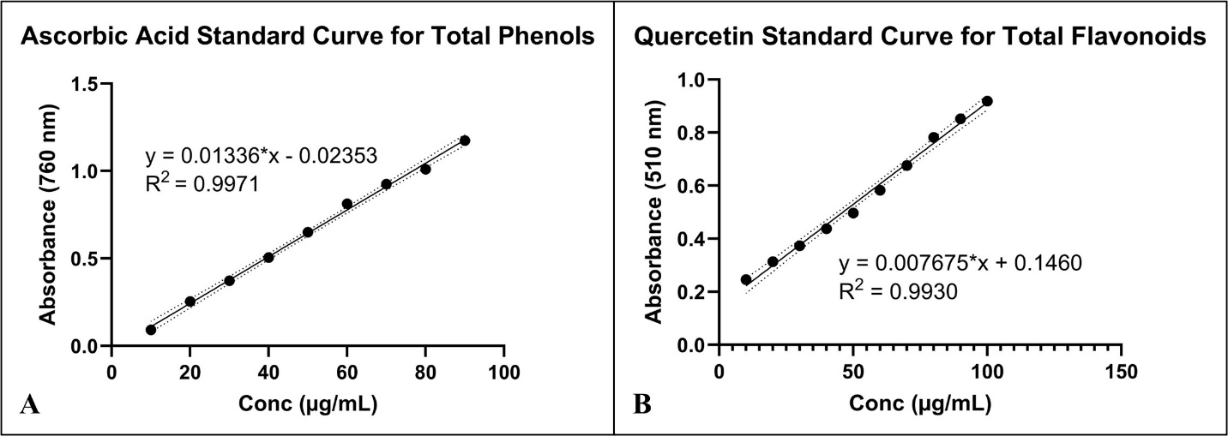
Figure 1. Standard Curves for Estimation of Total Phenols and Flavonoids.

  - In vitro Antioxidant Assays.
    - Total Antioxidant Capacity Assay by Phosphomolybdenum Method.
Total antioxidant capacity was evaluated using the phosphomolybdenum assay with minor modifications to the method described by (P. Prieto et al., 1999).. In brief, 100 µL of plant extract was transferred into a microcentrifuge tube, followed by the addition of 1 mL reagent solution containing 0.6 M sulphuric acid, 4 mM ammonium molybdate, and 28 mM sodium phosphate. The tubes were tightly capped and incubated at 95 °C for 90 min. After incubation, the reaction mixtures were cooled to room temperature, and absorbance was recorded at 695 nm using an ELISA plate reader (SpectraMax iD3) against a reagent blank. Ascorbic acid was used as the standard (Figure 2. A).
    - Reducing Power Assay.
The reducing power of the extracts was determined according to the method of (Oyaizu, 1986), with suitable modifications. One millilitre of extract or standard at different concentrations was mixed with 2.5 mL phosphate buffer (0.2 M, pH 6.6) and 2.5 mL of 1% potassium ferricyanide. The mixture was vortexed thoroughly and incubated at 50 °C for 20 min. After cooling, 2.5 mL of 10% trichloroacetic acid was added, and the mixture was centrifuged at 3000 rpm for 10 min. Then, 2.5 mL of the upper supernatant was collected and mixed with 2.5 mL distilled water and 0.5 mL of 0.1% ferric chloride. Absorbance was measured at 700 nm against a blank, with butylated hydroxy toluene (BHT) used as the reference standard (Figure 2. B).
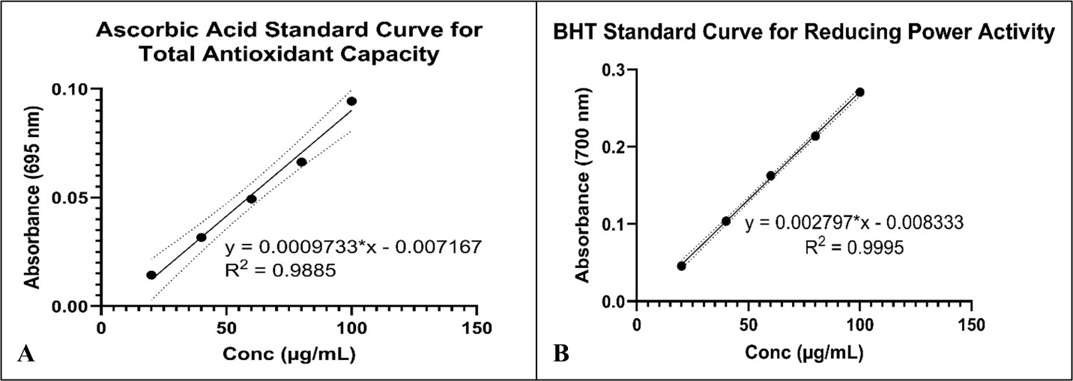
Figure 2. Standard Curves for Estimation of Total Antioxidant Capacity and Reducing Power Activity.

    - DPPH Radical Scavenging Assay.
The free radical scavenging activity of the extracts was determined using a microplate DPPH assay, modified from (J. M. Prieto, 2012) and (Kazi et al., 2025). In each well, 100 µL of extract at the required concentration was mixed with 100 µL of freshly prepared 0.2 mM DPPH solution. The plate was protected from light using aluminium foil and incubated for 30 min at 25 °C. After incubation, absorbance was read at 517 nm. The control contained 70% ethanol instead of extract, while ascorbic acid was used as the positive control. DPPH radical inhibition was calculated using:
$$\% DPPH Inhibition= \frac{Abs. control-Abs. saample}{Abs. control} ×100$$
    - ABTS Radical Scavenging Assay.
ABTS radical scavenging activity was evaluated using a microplate-adapted method based on(Re et al., 1999) with modifications described by (Kazi et al., 2025). The ABTS radical solution was prepared by mixing 5 mL of 7 mM ABTS solution with 88 µL of 140 mM potassium persulfate. The mixture was kept in the dark at 25 °C for 16 h to allow radical formation. Before use, the ABTS working solution was diluted with distilled water in a 1:44 ratio. For the assay, 100 µL of extract or standard at different concentrations was added to each well, followed by 100 µL of diluted ABTS reagent. The plate was maintained at 25 °C, and absorbance was recorded at 734 nm after 6 min using a plate reader. The control contained 100 µL of 70% ethanol instead of sample, and Trolox was used as the reference standard. ABTS radical scavenging activity was calculated using:
$$\% ABTS Inhibition= \frac{Abs. control-Abs. saample}{Abs. control} ×100$$
  - Statistical Analysis.
All experimental observations, including phytochemical screening, total phenolic and flavonoid quantification, and antioxidant evaluations, were carried out in three independent replicates. The obtained data were summarized as mean ± standard deviation. Statistical differences among the extract groups were assessed using one-way ANOVA. Where a significant overall difference was observed, Tukey’s multiple comparison test was applied to identify differences between individual groups. Statistical significance was accepted at p ≤ 0.05. Data organization and statistical processing were performed using MS Excel and GraphPad Prism software.

- RESULTS.
  - Qualitative Phytochemical Analysis.
Qualitative screening of D. latifolia extracts showed clear variation across plant parts and solvents (Table 1). Among the leaf extracts, methanol and ethanol showed the presence of alkaloids, flavonoids, tannins, phenols, diterpenes, sterols, cardiac glycosides, coumarins, quinones, and anthraquinones. Similarly, the methanolic and ethanolic stem extracts mainly showed flavonoids, tannins, phenols, diterpenes, sterols, coumarins, quinones, and anthraquinones. The methanolic and ethanolic bark extracts showed the presence of alkaloids, flavonoids, tannins, phenols, diterpenes, sterols, saponins, cardiac glycosides, and coumarins. Petroleum ether and ethyl acetate extracts showed limited phytochemical presence; however, triterpenoids were detected only in the petroleum ether extract of stem. Saponins were detected in all bark extracts except petroleum ether, while in stem they were observed only in the aqueous extract.
.Table 1 . Preliminary Phytochemical Analysis of Leaf, stem and bark extracts of D. latifolia.
Part | Solvent | Lig | Alk | Fla | Tan | Phe | Dit | Tri | Ste | Sap | CG | Cou | Qui | Ant
Leaf | PE | – | – | – | – | + | + | – | ++ | + | + | – | + | –
 | EA | – | ++ | ++ | – | + | – | – | ++ | – | ++ | – | ++ | –
 | MeOH | ++ | ++ | ++ | ++ | ++ | ++ | – | ++ | – | + | ++ | ++ | ++
 | EtOH | – | ++ | ++ | ++ | ++ | ++ | – | ++ | – | ++ | ++ | ++ | ++
 | Aq | – | + | ++ | ++ | + | – | + | – | – | ++ | + | – | –
Stem | PE | – | – | – | – | – | – | ++ | ++ | – | – | + | + | –
 | EA | – | – | + | – | ++ | – | – | ++ | – | – | + | ++ | –
 | MeOH | – | ++ | ++ | ++ | ++ | ++ | – | ++ | – | – | ++ | ++ | +
 | EtOH | – | – | ++ | ++ | ++ | ++ | – | ++ | – | – | ++ | ++ | +
 | Aq | – | + | ++ | ++ | ++ | – | – | ++ | ++ | – | + | + | –
Bark | PE | – | – | – | – | – | – | – | – | – | – | – | – | –
 | EA | – | – | + | + | + | – | – | ++ | ++ | + | + | – | –
 | MeOH | – | + | + | ++ | ++ | + | – | ++ | + | + | + | – | –
 | EtOH | – | + | + | ++ | ++ | + | – | ++ | + | + | + | – | –
 | Aq | – | + | + | + | + | + | + | – | ++ | + | ++ | – | –
Abbreviations: PE, petroleum ether; EA, ethyl acetate; MeOH, methanol; EtOH, ethanol; Aq, aqueous; Lig, lignin; Alk, alkaloids; Fla, flavonoids; Tan, tannins; Phe, phenols; Dit, diterpenes; Tri, triterpenes; Ste, sterols; Sap, saponins; CG, cardiac glycosides; Cou, coumarins; Qui, quinones; Ant, anthraquinones. Symbols: (+) present; (++) strongly present; (–) absent.

  - Quantitative Analysis.
The extraction yield obtained for quantitative analysis and in vitro antioxidant assays varied among the different plant parts. The highest yield was recorded for ELDL (21.108% w/w), followed by ESDL (13.13% w/w) and EBDL (12.844% w/w). These extracts were further used for quantitative phytochemical estimation and antioxidant assays.
    - Determination Total Phenols.
The total phenolic content (TP) of D. latifolia extracts showed minor variation among the different plant parts (Figure 3.). The leaf extract (ELDL) showed the highest TP value (8.09 ± 1.12 mg GAE/g), followed by the stem extract (ESDL) (7.11 ± 0.34 mg GAE/g) and bark extract (EBDL) (6.72 ± 0.17 mg GAE/g). However, one-way ANOVA showed that the difference in TP among the extracts was not statistically significant (P = 0.1115).
    - Determination of Total Flavonoids.
The total flavonoid content (TF) was also comparable among the extracts (Figure 3.). The stem extract (ESDL) showed the highest TF value (3.68 ± 0.01 mg QE/g), followed by the leaf extract (ELDL) (3.60 ± 0.00 mg QE/g) and bark extract (EBDL) (3.51 ± 0.04 mg QE/g). One-way ANOVA showed a statistically significant difference in total flavonoid content among the extracts (P = 0.000449). Tukey’s post hoc test revealed that ESDL had significantly higher flavonoid content than ELDL (P = 0.0167) and EBDL (P = 0.0004). ELDL also showed significantly higher flavonoid content than EBDL (P = 0.0098). Based on the mean values, the total flavonoid content followed the order ESDL > ELDL > EBDL, with all groups differing significantly from each other.

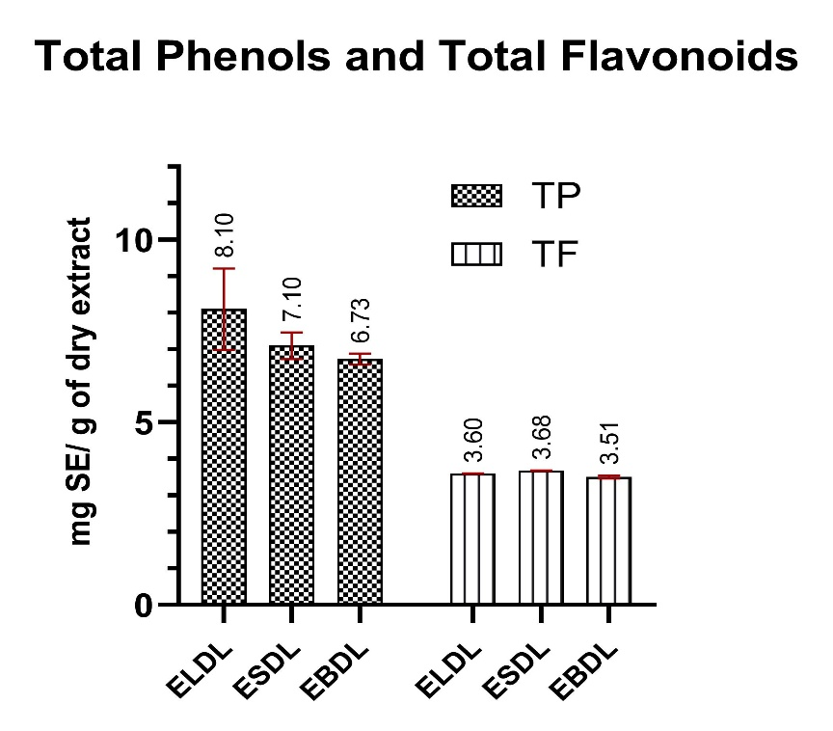
Figure 3. Estimation of Total Phenols and Flavonoids of Dalbergia latifolia extracts.
TP, Total Phenols; TF, Total Flavonoids, SE, Standard equivalents. Values expressed as mean ± SD, n=3.

  - In vitro Antioxidant Assays.
    - Total Antioxidant Capacity Assay (TAC).
The total antioxidant capacity of D. latifolia extracts is presented in Figure 4. The TAC values showed variation among the extracts, with EBDL exhibiting the highest activity (323.83 ± 3.70 mg AAE/g), followed by ESDL (313.33 ± 1.57 mg AAE/g), and ELDL (211.48 ± 3.78 mg AAE/g). One-way ANOVA followed by Tukey’s post hoc test revealed significant differences among the extracts. ELDL showed significantly lower TAC compared to both ESDL (p < 0.0001) and EBDL (p < 0.0001). Additionally, ESDL exhibited significantly lower TAC compared to EBDL (p = 0.0379). EBDL > ESDL > ELDL.

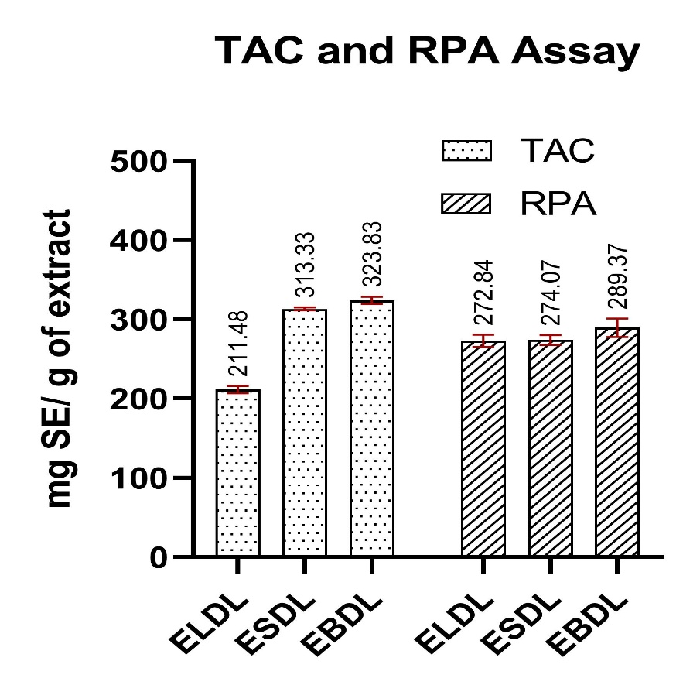
Figure 4. Total Antioxidant Capacity and Reducing Power Activity assays of Dalbergia latifolia extracts.
TAC, Total antioxidant capacity; RPA, Reducing power activity; SE, standard equivalent. Values expressed as mean ± SD, n=3.

    - Reducing Power Assay (RPA).
The reducing power of the extracts is shown in Figure 4. The RPA values were 272.84 ± 6.23 mg BHT/g for ELDL, 274.07 ± 5.09 mg BHT/g for ESDL, and 286.22 ± 9.37 mg BHT/g for EBDL, indicating relatively similar reducing capacities across the extracts. One-way ANOVA revealed no statistically significant differences in reducing power among the extracts (p = 0.1621). These findings indicate that the reducing power of ELDL, ESDL, and EBDL is comparable, with no extract demonstrating significantly stronger or weaker activity than the others.
    - DPPH Radical Scavenging Activity.
The DPPH radical scavenging activity of D. latifolia extracts increased in a concentration-dependent manner (Figure 5). All extracts showed a gradual rise in % inhibition with increasing concentration, reaching a plateau at higher concentrations. The standard (ascorbic acid) achieved comparable inhibition at lower concentrations. ELDL and ESDL exhibited comparable IC₅₀ values (16.00 ± 0.76 µg/mL and 16.18 ± 0.18 µg/mL, respectively), while EBDL showed a higher IC₅₀ value (31.26 ± 3.67 µg/mL). The standard demonstrated an IC₅₀ of 21.68 ± 0.36 µg/mL. One-way ANOVA revealed significant differences among the groups (p < 0.001). Tukey’s post hoc analysis indicated no significant difference between ELDL and ESDL (p = 0.9994). Both ELDL and ESDL showed significantly lower IC₅₀ values compared to the standard (ELDL vs STD, p = 0.0254; ESDL vs STD, p = 0.0297). In contrast, EBDL exhibited significantly higher IC₅₀ values compared to all other groups (ELDL vs EBDL, p < 0.0001; ESDL vs EBDL, p < 0.0001; EBDL vs STD, p = 0.0011). ELDL ≈ ESDL > STD > EBDL.

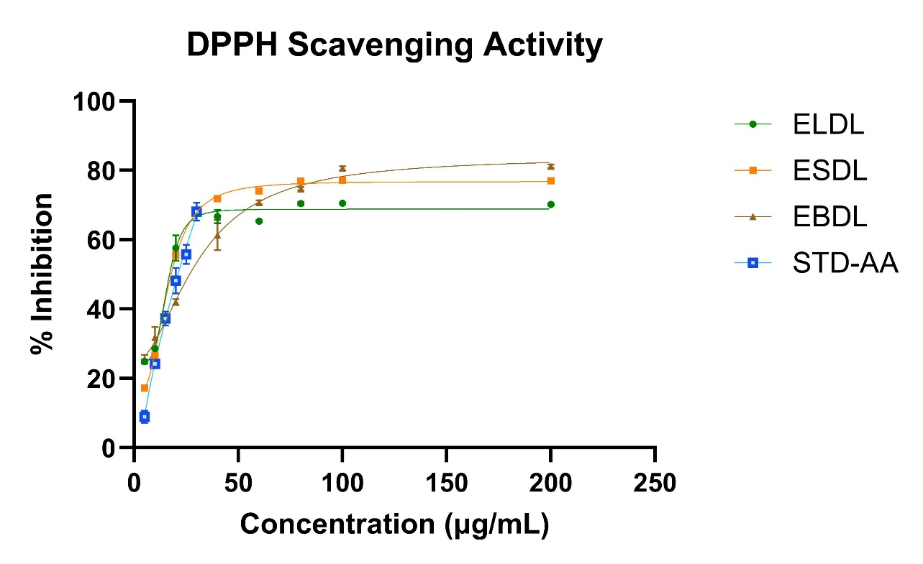
Figure 5. DPPH Scavenging Activity of Dalbergia latifolia extracts.
STD AA- standard ascorbic acid. Values plotted as mean ± SD, n =3.

    - ABTS Radical Scavenging Activity.
The ABTS radical scavenging activity of the extracts also increased with concentration (Figure 6.). EBDL showed a pronounced increase, reaching near-complete inhibition (~100%) at higher concentrations. ELDL and ESDL exhibited comparable activity at lower to moderate concentrations, achieving approximately 70–80% inhibition. The standard (Trolox) demonstrated high scavenging activity at relatively lower concentrations. ELDL and ESDL exhibited IC₅₀ values of 5.53 ± 0.34 µg/mL and 7.33 ± 1.83 µg/mL, respectively, while EBDL showed a higher IC₅₀ value (22.82 ± 0.70 µg/mL). The standard demonstrated the lowest IC₅₀ (2.97 ± 0.26 µg/mL). One-way ANOVA indicated significant differences among the groups (p < 0.001). Tukey’s post hoc test showed no significant difference between ELDL and ESDL (p = 0.2015). ELDL did not differ significantly from the standard (p = 0.0563), whereas ESDL exhibited a significantly higher IC₅₀ compared to the standard (p = 0.0031). Both ELDL and ESDL showed significantly lower IC₅₀ values compared to EBDL (ELDL vs EBDL, p < 0.0001; ESDL vs EBDL, p < 0.0001), and EBDL also showed significantly higher IC₅₀ compared to the standard (p < 0.0001) STD > ELDL ≈ ESDL > EBDL.

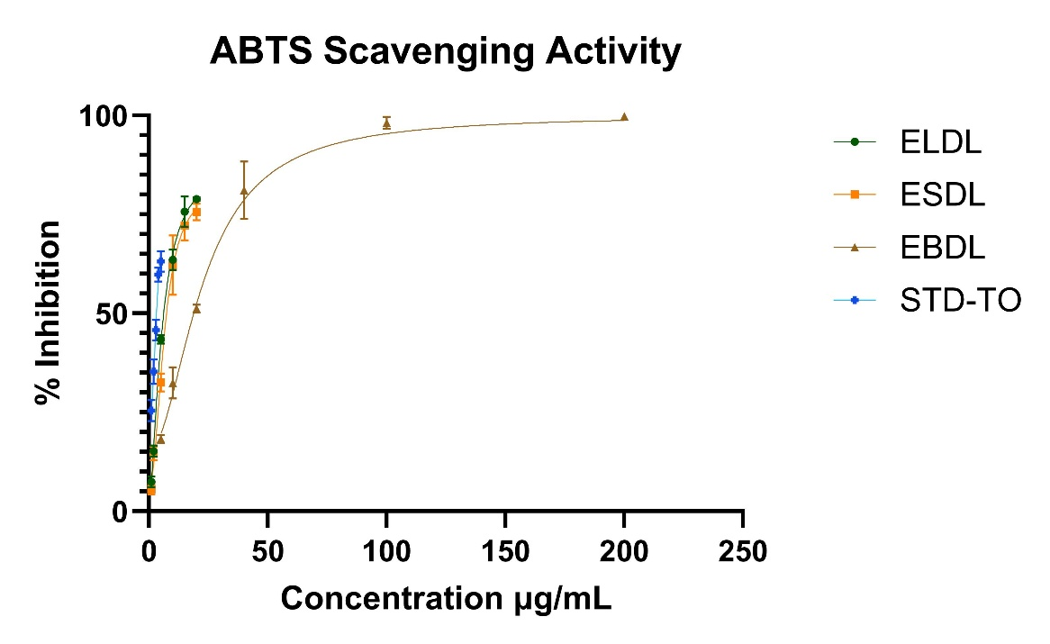
Figure 6. ABTS Scavenging Activity of Dalbergia latifolia extracts.
STD TO- standard Trolox. Values plotted as mean ± SD, n=3.

- DISCUSSION.
Phenolics and flavonoids are important contributors to plant antioxidant activity because their hydroxylated aromatic structures allow them to donate electrons or hydrogen atoms, stabilize radical species, and participate in redox reactions. In Dalbergia latifolia, previous phytochemical reports have identified several phenolic and flavonoid-related compounds, particularly from the wood and heartwood. Reported constituents include dalbergin, latifolin, dalbin, dalbinol, latinone, dalcriodain, and (R)-dalbergione, along with broader classes such as neoflavonoids, benzofurans, rotenoids, and triterpenoids (Deshmukh et al., 2021). A separate study on heartwood neoflavonoids reported dalbergiphenols, dalbergiones, dalbergins, benzophenones, and other neoflavonoid-type compounds from D. latifolia (Masendra et al., 2021). These compounds are relevant because neoflavonoids and related phenolic metabolites are structurally suited for redox activity and may contribute to the antioxidant behaviour observed in the present study.
The preliminary phytochemical screening in the present study showed that ethanolic extracts contained a broader range of secondary metabolites than aqueous extracts, particularly phenolics, flavonoids, tannins, coumarins, sterols, terpenoids, and quinones. This supports the suitability of ethanol for extracting moderately polar phytochemicals from D. latifolia. Quantitatively, total phenolic content showed no significant difference among leaf, stem, and bark extracts, although ELDL recorded the highest value. In contrast, total flavonoid content differed significantly among the extracts, with ESDL showing the highest value, followed by ELDL and EBDL. However, the absolute TF values remained within a narrow range of approximately 3.5–3.7 mg QE/g, suggesting that the statistical difference reflects consistent but small variations among replicates rather than a large biological separation. Therefore, the antioxidant differences observed across assays may not be explained solely by total phenolic or flavonoid quantity. Instead, they are more likely influenced by the specific chemical composition, structural features, polarity, and assay-specific reactivity of individual constituents present in each extract.
The total antioxidant capacity assay showed a clear part-specific pattern, with EBDL exhibiting the highest TAC, followed by ESDL and ELDL. Since TAC reflects the cumulative electron-donating and reducing capacity of the extract, the higher value in EBDL suggests that bark may contain a stronger pool of compounds capable of broad antioxidant reduction. This agrees with (Khalid & Freed, 2011), who reported strong antioxidant activity in ethanolic bark extract of D. latifolia, including DPPH, nitric oxide, and thiocyanate radical inhibition. The strong TAC of bark also aligns with studies where bark extracts showed systemic protective effects in oxidative stress-linked models, including anti-obesity and antidiabetic studies (Khalid et al., 2020; Tiwari & Choudhary, 2021). In contrast, the reducing power assay did not show significant differences among ELDL, ESDL, and EBDL. RPA reflects the ability of extracts to donate electrons and reduce oxidized intermediates, which is biologically relevant to redox balance(Sadeer et al., 2020). The absence of significant difference indicates that reducing capacity is distributed across all three plant parts. Therefore, while EBDL showed the highest TAC, its reducing power was not statistically stronger than leaf or stem extracts. This distinction is important because TAC and RPA do not measure identical antioxidant mechanisms.
The DPPH and ABTS assays provided a different antioxidant pattern. These assays estimate the direct radical scavenging ability of extracts, with lower IC₅₀ indicating stronger scavenging potency (Jaganjac et al., 2021). In DPPH, ELDL and ESDL showed comparable and stronger activity than EBDL, with both extracts also showing lower IC₅₀ values than the standard (Figure 7.). In ABTS, ELDL and ESDL again showed comparable scavenging activity, while EBDL had significantly higher IC₅₀ and therefore weaker scavenging potency. Thus, although EBDL was strongest in TAC, leaf and stem extracts were more effective in direct radical scavenging. This suggests that bark may contribute more to total reducing capacity, while leaf and stem may contain constituents that react more efficiently with DPPH and ABTS radicals.
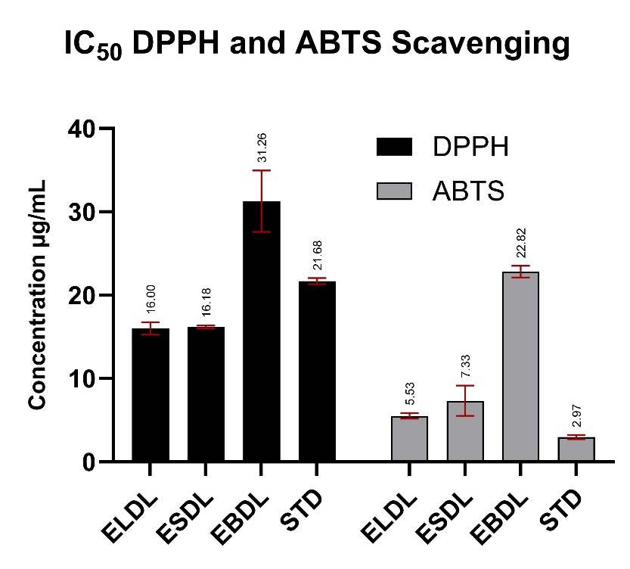
Figure 7. IC₅₀ Values for DPPH and ABTS radicals of Dalbergia latifolia extracts.
Values expressed as mean ± SD, n=3. Significance difference ( p < 0.05).

This assay-dependent variation is scientifically meaningful. TAC gives an estimate of total antioxidant capacity, RPA reflects electron-donating power, while DPPH and ABTS more directly represent free radical neutralization (Jaganjac et al., 2021; Sadeer et al., 2020). Therefore, the present results show that antioxidant activity in D. latifolia is not uniform across plant parts or assay systems. EBDL may be more relevant where broad reducing capacity is required, whereas ELDL and ESDL may be more relevant for rapid radical scavenging. Such variation also explains why single-assay antioxidant evaluation can be misleading.
The present findings are consistent with earlier reports that link D. latifolia bioactivity to oxidative stress modulation. (Nagarathna & Kumari, 2018) reported that D. latifolia leaf extract protected against 5-FU-induced cardiotoxicity by improving antioxidant enzyme status and reducing oxidative injury. This supports the strong radical scavenging activity of ELDL observed in the present study. (Tiwari & Choudhary, 2021) showed that hydroalcoholic bark extract improved antioxidant enzymes such as SOD, CAT, GPx, and GST in diabetic rats, which corresponds well with the strong TAC observed for EBDL. (Khalid et al., 2020) also reported metabolic and histological improvement with bark extract in high-fat diet-induced obesity, further supporting the relevance of bark antioxidant capacity in systemic oxidative stress.
The ethnomedicinal uses of D. latifolia also fit with the current antioxidant findings. Bark has traditionally been used for diarrhoea, dyspepsia, leprosy, obesity, worms, body pain, and as a bitter tonic, stomachic, stimulant, anthelminthic, and spasmogogue. Bark, leaves, and roots are also used for chronic ulcers, polyuria, urinary bladder disorders, leukoderma, wounds, and skin diseases (Almeida & Almeida, 2010; Bhatnagar, 1985; Jain, 1991; Kirtikar & Basu, 1918). Oxidative stress is commonly involved in chronic wounds, inflammatory skin conditions, ulcers, metabolic disorders, and tissue injury (Feng et al., 2022; Masenga et al., 2023; Rani et al., 2016). The high TAC of EBDL may partly support the traditional use of bark in systemic and inflammatory conditions, while the strong DPPH and ABTS scavenging activity of ELDL and ESDL may support the relevance of leaf and stem parts in oxidative injury and skin-related applications. The reported tribal use of stem-derived oil for eczema and bark preparations for severe skin diseases (Bharathiraja et al., 2014) is therefore consistent with the antioxidant potential observed across these plant parts.

- CONCLUSION
Overall, the present study shows that different parts of D. latifolia express different antioxidant strengths. EBDL was superior in total antioxidant capacity, while ELDL and ESDL showed stronger radical scavenging potency in DPPH and ABTS assays. The comparable TP and TF levels suggest that antioxidant activity depends not only on the total amount of phenolics and flavonoids, but also on the specific chemical composition of each extract. However, the present study was limited to ethanolic extracts and selected in vitro antioxidant assays; therefore, the findings should be interpreted within this experimental scope. The active compounds responsible for the observed activity were not individually characterized through HPLC/LC-MS-based profiling, and cellular or in vivo antioxidant responses were not assessed. Further studies involving solvent-fractionated extracts, compound-level identification, samples from different geographical or seasonal conditions, and biological validation models would help establish the therapeutic relevance of D. latifolia more comprehensively.

- FUTURE SCOPE
As these findings strengthen the pharmacological relevance of D. latifolia, it can support further work focused on compound-level profiling, especially of phenolic and neoflavonoid constituents, to identify the metabolites responsible for the observed antioxidant effects. Bioactivity-guided approaches such as TLC bioautography and online HPLC-DPPH, HPLC-ABTS, or HPLC-FRAP assays coupled with mass spectrometry can help separate and identify active compounds. Further confirmation may be carried out using LC-MS/MS, HRMS, and NMR. In silico docking against antioxidant or oxidative stress-related targets can provide preliminary mechanistic insights. Active fractions or purified compounds should then be evaluated in cell-based and in vivo models to confirm efficacy, safety, and therapeutic relevance.

ACKNOWLEGDEGMENTS and Fundings
The authors gratefully acknowledge the Department of Biotechnology (DBT), Ministry of Science and Technology, for funding this project [BT/INF/22/SP41293/2020]. The authors also thank the Assistant Curator, Mr. Praveen Kale and the Director Dr. Rajdeo Singh of the Blatter Herbarium, St. Xavier’s College (Autonomous), Mumbai, for their guidance in plant identification and authentication. Sincere thanks are extended to Ms. Jidnyasa Tare for her valuable assistance in the field for plant collection.
Disclaimer (Artificial intelligence)
Author(s) hereby declare that NO generative AI technologies such as Large Language Models (ChatGPT, COPILOT, etc.) and text-to-image generators have been used during the writing or editing of this manuscript.

- REFERENCES
- Masenga, S. K., Kabwe, L. S., Chakulya, M., & Kirabo, A. (2023). Mechanisms of Oxidative Stress in Metabolic Syndrome. International Journal of Molecular Sciences, 24(9), 7898. https://doi.org/10.3390/ijms24097898
- Rani, V., Deep, G., Singh, R. K., Palle, K., & Yadav, U. C. S. (2016). Oxidative stress and metabolic disorders: Pathogenesis and therapeutic strategies. Life Sciences, 148, 183–193. https://doi.org/10.1016/j.lfs.2016.02.002
- Lourenço, S. C., Moldão-Martins, M., & Alves, V. D. (2019). Antioxidants of Natural Plant Origins: From Sources to Food Industry Applications. Molecules, 24(22), 4132. https://doi.org/10.3390/molecules24224132
- Xu, D.-P., Li, Y., Meng, X., Zhou, T., Zhou, Y., Zheng, J., Zhang, J.-J., & Li, H.-B. (2017). Natural Antioxidants in Foods and Medicinal Plants: Extraction, Assessment and Resources. International Journal of Molecular Sciences, 18(1). https://doi.org/10.3390/ijms18010096
- Zahra, M., Abrahamse, H., & George, B. P. (2024). Flavonoids: Antioxidant Powerhouses and Their Role in Nanomedicine. Antioxidants, 13(8). https://doi.org/10.3390/antiox13080922
- Zhang, H., & Tsao, R. (2016). Dietary polyphenols, oxidative stress and antioxidant and anti-inflammatory effects. Current Opinion in Food Science, Food Microbiology • Functional Foods and Nutrition, 8, 33–42. https://doi.org/10.1016/j.cofs.2016.02.002
- Vasudeva, N., Vats, M., Sharma, S., & Sardana, S. (2009). Chemistry and biological activities of the genus Dalbergia—A review. 307–319.
- Roy, N., Laskar, R. A., Sk, I., Kumari, D., Ghosh, T., & Begum, N. A. (2011). A detailed study on the antioxidant activity of the stem bark of Dalbergia sissoo Roxb., an Indian medicinal plant. Food Chemistry, 126(3), 1115–1121. https://doi.org/10.1016/j.foodchem.2010.11.143
- Arunkumar, A. N., Warrier, R. R., Kher, M. M., & Teixeira da Silva, J. A. (2022). Indian rosewood (Dalbergia latifolia Roxb.): Biology, utilisation, and conservation practices. Trees, 36(3), 883–898. https://doi.org/10.1007/s00468-021-02243-3
- Almeida, S. M., & Almeida, M. R. (2010). Hand book of diseases and their herbal remedies in Maharashtra (Vol. 2). Orient Press Ltd. Mumbai.
- Bhatnagar, S. S. (1985). The Wealth of India: A Dictionary of Indian Raw Materials & Industrial Products, Volume 3 (Vol. 3). Publications & Information Directorate, Council of Scientific & Industrial Research,. https://books.google.com/books/about/The_Wealth_of_India.html?id=EYzd1kVUmZUC
- Jain, S. K. (1991). Dictionary of Indian folk medicine and ethnobotany. Deep Publications,. https://lib.icimod.org/records/btvnb-7q452
- Kirtikar, K. R., & Basu, B. D. (1918). Indian Medicinal Plants (Vol. 2). Lalit Mohan Basu.
- Masendra, M., Irawati, D., Ridlo, A. S., & Lukmandaru, G. (2020). Phenol Contents and Antioxidant Activity of Sonokeling (Dalbergia latifolia Roxb) Wood. Wood Research Journal, 11(1), 27–34. https://doi.org/10.51850/wrj.2020.11.1.27-34
- Shrestha, S. P., Amano, Y., Narukawa, Y., & Takeda, T. (2008). Nitric Oxide Production Inhibitory Activity of Flavonoids Contained in Trunk Exudates of Dalbergia sissoo. Journal of Natural Products, 71(1), 98–101. https://doi.org/10.1021/np070478h
- Wu, W.-Y., Chen, H.-J., Cheng, H.-L., Zhu, Z.-T., Wan, J., Yi, J.-L., & Zhou, X.-M. (2025). Three Novel Flavonoid Derivatives From the Roots of Dalbergia odorifera. Chemistry & Biodiversity, 22(10), e01535. https://doi.org/10.1002/cbdv.202501535
- Xu, W., Zhu, Q., Wang, M., Li, J., Dai, X., Meng, X., Zhang, N., Liu, Y., Chen, L., & Liu, R. (2026). (±)-odoriferols A–E, five pairs of enantiomeric flavonoids and benzofurans from Dalbergia odorifera with anti-inflammatory activity. Phytochemistry, 247, 114837. https://doi.org/10.1016/j.phytochem.2026.114837
- Dong, L., Lee, H., Liu, Z., & Lee, D.-S. (2023). Anti-Skin Inflammatory and Anti-Oxidative Effects of the Neoflavonoid Latifolin Isolated from Dalbergia odorifera in HaCaT and BJ-5ta Cells. International Journal of Molecular Sciences, 24(8), 7371. https://doi.org/10.3390/ijms24087371
- Drabińska, N., Jeż, M., & Nogueira, M. (2021). Variation in the Accumulation of Phytochemicals and Their Bioactive Properties among the Aerial Parts of Cauliflower. Antioxidants, 10(10). https://doi.org/10.3390/antiox10101597
- Lavola, A., Salonen, A., Virjamo, V., & Julkunen-Tiitto, R. (2017). Phytochemical variation in the plant-part specific phenols of wild crowberry (Empetrum hermaphroditum Hagerup) populations. Phytochemistry Letters, Critical Assessment of Small Molecules Identification 2016, 21, 11–20. https://doi.org/10.1016/j.phytol.2017.05.016
- Shaikh, J. R., & Patil, M. K. (2020). Qualitative tests for preliminary phytochemical screening: An overview. International Journal of Chemical Studies, 8(2), 603–608. https://doi.org/10.22271/chemi.2020.v8.i2i.8834
- Singleton, V. L., Orthofer, R., & Lamuela-Raventós, R. M. (1999). Analysis of total phenols and other oxidation substrates and antioxidants by means of folin-ciocalteu reagent. In Methods in Enzymology (Vol. 299, pp. 152–178). Academic Press. https://doi.org/10.1016/S0076-6879(99)99017-1
- Chang, C.-C., Yang, M.-H., Wen, H.-M., & Chern, J.-C. (2020). Estimation of total flavonoid content in propolis by two complementary colometric methods. Journal of Food and Drug Analysis, 10(3). https://doi.org/10.38212/2224-6614.2748
- Prieto, P., Pineda, M., & Aguilar, M. (1999). Spectrophotometric Quantitation of Antioxidant Capacity through the Formation of a Phosphomolybdenum Complex: Specific Application to the Determination of Vitamin E. Analytical Biochemistry, 269(2), 337–341. https://doi.org/10.1006/abio.1999.4019
- Oyaizu, M. (1986). Studies on products of browning reaction. Antioxidative activities of products of browning reaction prepared from glucosamine. The Japanese Journal of Nutrition and Dietetics. https://doi.org/10.5264/eiyogakuzashi.44.307
- Prieto, J. M. (2012). Procedure: Preparation of DPPH Radical, and Antioxidant Scavenging Assay. . Dr Prieto’s DPPH Microplate Protocol, 1–3.
- Kazi, Z., Singh, S., & Lobo, V. (2025). Phytochemical evaluation and in vitro antioxidant potential of Cycas circinalis L. Current Botany, 59–67. https://doi.org/10.25081/cb.2025.v16.9123
- Re, R., Pellegrini, N., Proteggente, A., Pannala, A., Yang, M., & Rice-Evans, C. (1999). Antioxidant activity applying an improved ABTS radical cation decolorization assay. Free Radical Biology & Medicine, 26(9–10), 1231–1237. https://doi.org/10.1016/s0891-5849(98)00315-3
- Deshmukh, V. P., Lunge, M. S., Rajurkar, A. V., Dharkar, N. S., Raut, S. R., & Dhoran, V. S. (2021). Chemical characterization and therapeutics of Dalbergia latifolia Roxb: A review. Journal of Pharmacognosy and Phytochemistry, 10(4), 340–345. https://doi.org/10.22271/phyto.2021.v10.i4d.14174
- Masendra, M., Purba, B. A. V., Irawati, D., & Lukmandaru, G. (2021). Investigation of Flavonoid Extractives and their Contribution to Color of Dalbergia latifolia Roxb Wood. Wood Research Journal, 12(2), 53–60. https://doi.org/10.51850/wrj.2021.12.2.53-60
- Khalid, M., & Freed, S. (2011). In-vitro Assessment of Antioxidant Activity of Dalbergia latifolia Barks Extract Against Free Radicals. https://www.semanticscholar.org/paper/In-vitro-Assessment-of-Antioxidant-Activity-of-Free-Khalid-Freed/939c944084e32c27f82484b9325085fbef36512d
- Khalid, M., Shoaib, A., Akhtar, J., Alqarni, M. H., Badruddeen, Siddiqui, H. H., & Foudah, A. I. (2020). Anti obesity prospective of Dalbergia latifolia (Roxb.) hydroalcoholic bark extract in high fat diet induced obese rats. 3 Biotech, 10(11), 493. https://doi.org/10.1007/s13205-020-02491-z
- Tiwari, A., & Choudhary, N. K. (2021). PHYTOPHARMACOLOGICAL EVALUATION OF DALBERGIA LATIFOLIA ROXB FOR ANTIDIABETIC ACTIVITY AND ITS EFFECT ON LIPID PROFILE AND HEPATIC ENZYMES OF GLUCOSE METABOLISM IN DIABETIC RATS. Journal of Advanced Scientific Research, 12(03 Suppl 2), 95–109. https://doi.org/10.55218/JASR.s2202112312
- Sadeer, N. B., Montesano, D., Albrizio, S., Zengin, G., & Mahomoodally, M. F. (2020). The Versatility of Antioxidant Assays in Food Science and Safety—Chemistry, Applications, Strengths, and Limitations. Antioxidants, 9(8), 709. https://doi.org/10.3390/antiox9080709
- Jaganjac, M., Sredoja Tisma, V., & Zarkovic, N. (2021). Short Overview of Some Assays for the Measurement of Antioxidant Activity of Natural Products and Their Relevance in Dermatology. Molecules, 26(17), 5301. https://doi.org/10.3390/molecules26175301
- Nagarathna, P. K. M., & Kumari, A. (2018). SCREENING OF CARDIOPROTECTIVE AND ANTIOXIDANT ACTIVITY OF “DALBERGIA LATIFOLIA.” Asian Journal of Science and Technology, 9(4), 7897–7904.
- Feng, J., Wang, J., Wang, Y., Huang, X., Shao, T., Deng, X., Cao, Y., Zhou, M., & Zhao, C. (2022). Oxidative Stress and Lipid Peroxidation: Prospective Associations Between Ferroptosis and Delayed Wound Healing in Diabetic Ulcers. Frontiers in Cell and Developmental Biology, 10, 898657. https://doi.org/10.3389/fcell.2022.898657
- Bharathiraja, B., Balaji, S., & Praveenkumar, R. (2014). Folk Medicines A Guide to Folklore Medicinal Herbs of Nilagiri (First Edition). Sams Publishers.

--------X----------------X--------

