Assessment of Hygiene Conditions and Food Safety: Critical Control Points in School Canteens in the Guiriko Region, Burkina Faso

Abstract
Background : School feeding programmes contribute significantly to children’s nutrition, school attendance and educational performance, particularly in low-income settings. However, inadequate hygiene and food safety conditions in school canteens may expose pupils to foodborne diseases and compromise the expected benefits of these programmes.
Aims: To assess the sanitary conditions of school canteens in the Guiriko region, western Burkina Faso.
Study Design: The study used a descriptive cross-sectional design.
Place and Duration of Study: The study was conducted in the Guiriko region, western Burkina Faso, from April to November 2024.
Methodology: Data collection combined a questionnaire survey of 320 canteen cooks (one per selected school), interviews with 22 stakeholders involved in canteen management and oversight, and direct observations of infrastructure, hygiene practices, service modalities and environmental conditions, guided by an HACCP-inspired assessment tool. Schools were selected using stratified random sampling by province and education level, while key informants were recruited through purposive sampling.
Results: The canteens relied mainly on government food supplies (82%), and stocks were insufficient to cover the entire school year. Foodstuffs were mainly packaged in 50-kg polypropylene sacks, 4- and 20-L containers, and metal tins, with differences across education levels and some secondary schools lacking functional canteens. Infrastructure and WASH constraints were substantial, with 54.06% semi-permanent kitchens, 21.88% temporary or improvised kitchens, and 62.19% of water points located more than 50 m away. Meals were mostly distributed in a queue (72.09%) and often consumed outside designated areas, while wastewater was largely discharged into the open (59.30%) and solid waste was commonly burned in the open air (51.16%). The HACCP-based assessment revealed recurrent non-compliances, notably inadequate cleaning, poorly functional handwashing facilities, insufficient food protection, weak separation of raw and cooked foods, and the near absence of routine checks to remove expired products.
Conclusion: School canteens in the Guiriko region provide an essential social function but operate under inadequately controlled sanitary conditions, and sustainable improvement requires strengthening supply continuity, infrastructure/WASH, service organisation, hygiene practices, waste management and routine supervision.
Keywords: school canteens; food safety; HACCP approach; Guiriko region.
1. Introduction
School feeding is now recognised as one of the most transformative interventions at the interface of education, nutrition and social protection. Globally, around 41% of children enrolled in primary school benefited from a school meal in 2022; however, coverage remains substantially lower in low-income countries, where nutritional and social needs are often greatest (WFP, 2023). In sub-Saharan Africa, school feeding programmes play a central role in keeping children in school, alleviating short-term hunger and supporting vulnerable households, yet their sustainability and effectiveness remain closely dependent on local operational realities—particularly organisation, infrastructure, community resources and management capacity (Mainje et al., 2024; Research Consortium for School Health and Nutrition, 2025). Recent policy evidence further underlines that programme performance depends not only on coverage, but also on predictable delivery systems and implementation standards. In sub-Saharan Africa, sustainability is strongly influenced by the robustness of supply chains and local implementation capacity (Mainje et al., 2024), and alignment with broader development goals requires reliable service delivery and minimum operational conditions (Watkins, 2024).
However, the anticipated benefits of school feeding may be undermined when the conditions for storing, preparing, serving and consuming meals do not ensure an adequate level of hygiene. According to the World Health Organization, unsafe food causes approximately 600 million cases of illness and 420,000 deaths each year worldwide, with a disproportionate burden among children (WHO, 2024). In resource-limited settings, risks are amplified by inadequate access to water, poor premises, insufficient cleaning of surfaces, inadequate food protection, limited separation between raw and cooked foods, and weak sanitary supervision (Tohonon et al., 2025; Salvador et al., 2024).
Several authors argue that the school food environment is not limited to the mere availability of meals (Story et al., 2008). It also encompasses storage capacity (Lang et al., 2009), the presence of functional kitchens (Makori et al., 2025), service arrangements (Lalli, 2021), control mechanisms (Paulin, 2002), stakeholders’ knowledge, and the overall quality of the sanitary environment. In Tanzania, Makori et al. (2025) reported substantial shortcomings regarding functional kitchens, dining spaces and hygiene-related knowledge within the school food environment. Similarly, in school catering services, assessments of compliance with the documentary and operational requirements for good hygiene practices within the HACCP system show that implementation gaps remain common, even where formal arrangements exist (Salvador et al., 2024).
Beyond food preparation itself, water, sanitation and hygiene conditions in schools are major determinants of food safety. Recent work in African school settings highlights that access to safe water, the proximity and reliability of water points (WHO/UNICEF JMP, 2025), the condition of sanitation facilities and the availability of handwashing stations strongly shape hygiene practices and the prevention of contamination (Radebe et al., 2025). Furthermore, studies of food handlers in institutional settings indicate that training, educational level, exposure to hygiene guidelines and familiarity with HACCP significantly influence food safety knowledge and practices (Siddiky et al., 2024). These findings are particularly important for school canteens in low- and middle-income countries, where infrastructure may be inadequate and inspections irregular.
In this context, the HACCP approach remains a particularly useful framework, not only for identifying hazards but also for assessing the prerequisite programmes that are essential for achieving a minimum level of sanitary control. In sub-Saharan settings, Tohonon et al. (2025) emphasise that shortcomings in catering services frequently relate to hygiene prerequisite programmes, notably water supply, cleaning and disinfection, workflow organisation, food protection and the preparation environment. The value of this approach is that, even in resource-limited contexts, it helps to identify the most vulnerable links in the preparation and service chain and to guide corrective actions in a pragmatic manner (Tohonon et al., 2025; Salvador et al., 2024).
In Burkina Faso, and more specifically in the Guiriko region, school canteens play an important role in supporting school attendance and reducing pupils’ nutritional vulnerability. The present study highlights that, in this region, sanitary assessments of school canteens remain insufficiently documented in a systematic way, even though decisions concerning equipment, infrastructure, training and inspection require robust field-based evidence. In addition, recent programme guidance stresses that sustainable financing and effective governance are key conditions for maintaining continuity of service and meeting basic operational requirements, including infrastructure and supervision (WFP, 2024).
Against this background, the study aimed to assess the sanitary conditions of school canteens in schools across the Guiriko region. Specifically, it sought to describe canteen organisation and logistics, evaluate infrastructure, water, the preparation environment and hygiene practices, and identify critical non-compliances using the HACCP approach.
2. Methodology
2.1. Study setting and sites
The study was carried out in the Guiriko region, located in western Burkina Faso. This region comprises the provinces of Houet, Kénédougou and Tuy. According to the National Institute of Statistics and Demography, it covers an area of 25,479 km² and includes 33 departments, 483 villages, 45 sectors and an estimated population of 2,239,840 inhabitants in 2022 (INSD, 2022).
From an institutional perspective, the stakeholders considered in this research included the regional education authorities responsible for the supervision and monitoring of school canteens—namely the DREPPNF and the DREPS—Basic Education Circuits (CEB), municipalities involved in local canteen management, school heads, and the body responsible for quality control and diagnostic assessment of food supplies in the region, namely the TECAL SATE consultancy.
The study sites comprised preschool, primary, lower-secondary and upper-secondary schools with a functional school canteen in 2024. Site selection took account of the region’s geographical diversity (urban and rural settings), school population size, variation in infrastructure, and the effective availability of a functional canteen. The location of Guiriko region and its three provinces is showed (Fig 1).
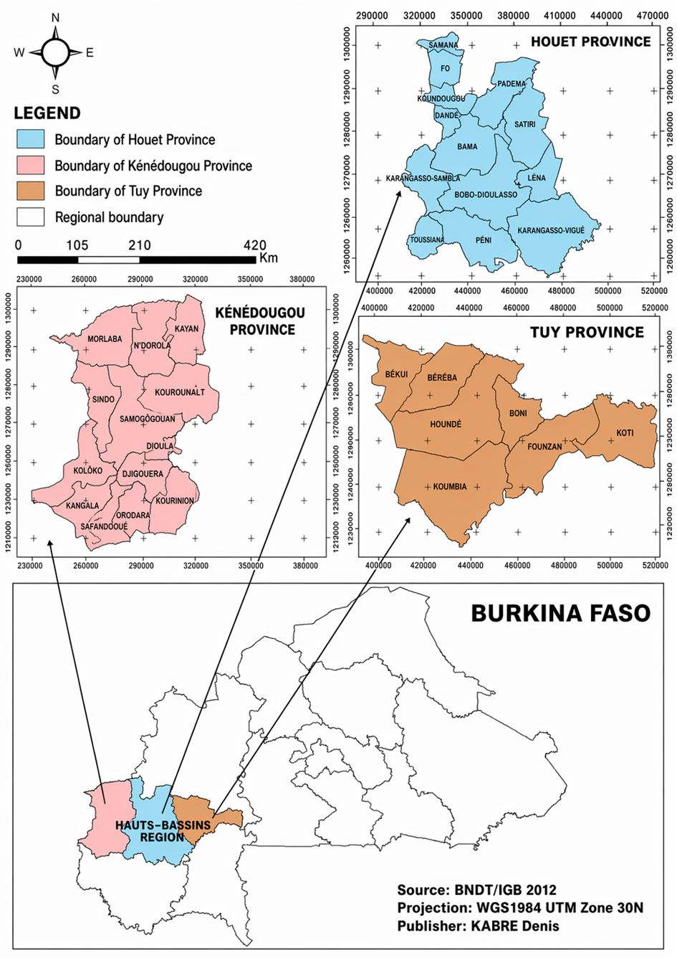

Fig 1: Location of the study sites
2.2. Study design and period
This was a descriptive cross-sectional study conducted over eight (8) months, from April 2024 to November 2024, combining a quantitative survey, direct observations and qualitative interviews.
2.3. Study population and sampling
For the quantitative component, the target population consisted of individuals responsible for preparing and/or distributing meals in schools with a school canteen in the Guiriko region in 2024. In practice, one canteen cook was surveyed per school visited, yielding a total of 320 canteen cooks interviewed across 320 schools.
The qualitative component involved stakeholders engaged in the strategic and operational management of school canteens, including provincial managers, school heads, municipal authorities, CEB managers and the regional body responsible for controlling food supplies.
For the interviews, purposive sampling was used to select participants with in-depth knowledge and/or direct responsibility for school canteen management. In total, 22 key informants were interviewed, drawn from provincial education services, school management, municipalities and CEBs. This selection was intended to capture the main levels of decision-making, management and oversight of the school canteen system in the region.
For the quantitative survey, stratified random sampling was applied. Schools with a canteen were first stratified by province (Houet, Kénédougou and Tuy) and then by education level (preschool, primary and lower-/upper-secondary). Approximately 20% of canteen-equipped schools were subsequently selected within each stratum. Overall, the sample comprised 320 schools, corresponding to 320 canteen cooks surveyed: 36 in preschools, 265 in primary schools and 19 in lower-/upper-secondary schools. The sample size of these structures was estimated using the Taro Yamane formula (Yamane, 1967):
$n=\frac{N}{1+N({e)}^{2}}$
Where: n = sample size; N = total population; e = level of significance (margin of error) and 1 = unite (a constant value)
1.4. Data collection
1.4.1. Interviews with key stakeholders
Structured interviews were first conducted with the regional education authorities to document the overall organisation of the school canteen system. Interviews were then carried out with other stakeholders involved, notably municipalities, education officials, canteen managers, school heads and the food-supply control body, as recommended by UNESCO (2025), the World Food Programme (WFP) (2025) and the World Bank (2025). Discussions focused on food supply arrangements, stock management, supervision mechanisms, training received in food hygiene and the challenges encountered in day-to-day canteen management.
1.4.2. Questionnaire survey of canteen cooks
The quantitative survey was conducted using a questionnaire administered to canteen cooks at the study sites. The questionnaire collected information on: cooks’ profiles; sources of food supplies; packaging and storage conditions; types of meals prepared; preparation and distribution practices; access to water; cleaning practices; waste management; and respondents’ overall assessment of canteen operations.
Questionnaires were digitally captured using the KoboCollect application.
1.4.3. Direct observations and an HACCP-inspired assessment checklist
Direct observations were carried out in the canteens to document actual operating conditions and identify risky practices along the workflow (receipt, storage, preparation/cooking, serving/consumption and waste management). Observation focused on the condition of kitchens and equipment; procedures for receiving, storing and protecting food supplies; cleaning practices for work surfaces and utensils; the availability and functionality of handwashing facilities; separation between raw and cooked foods; and the management of leftovers, wastewater and solid waste. To structure this assessment, an HACCP-inspired checklist was used as a practical tool to appraise compliance with key hygiene prerequisite programmes and to identify critical weaknesses. The checklist included operational items such as labelling and basic conformity at receipt (including date marking), cleanliness and maintenance of storage areas, routine checks to remove expired products, regular cleaning of surfaces and utensils, personal hygiene and the use of appropriate clothing, food protection from dust/insects (e.g., covering foods), and waste storage/disposal practices. Each item was recorded as compliant/non-compliant (yes/no) when feasible, or described qualitatively when contextual information was required, and results were summarised as proportions of compliances/non-compliances for each item.
1.5. Data processing and analysis
Quantitative questionnaire data were exported and processed using Microsoft Excel and SPSS software. Analyses were primarily based on descriptive statistics, including counts, frequencies and percentages, to characterise observed practices and the operating conditions of school canteens. All percentages reported for the questionnaire survey were calculated using the number of valid responses (n) as the denominator, unless otherwise stated. For school-level indicators, the denominator was the total number of surveyed schools with a functional canteen (N = 320). For multiple-response items (e.g., types of containers used by pupils), percentages were calculated per option using N = 320 as the denominator; therefore, totals may exceed 100%. For the HACCP checklist, each item was assessed in all observed canteens (N = 320) and summarised as the proportion compliant/non-compliant. In addition, statistical analysis was used to identify trends and explore associations between hygiene practices and the quality of canteen infrastructure.
2. Results
2.1. General characteristics of the schools and respondents
The survey covered 320 schools with a functional canteen in the Guiriko region, corresponding to 320 canteen cooks interviewed. The schools surveyed were distributed across Houet (51.16%), Tuy (29.07%) and Kénédougou (19.77%). Respondents were predominantly female (89.53%). The most represented age group was 36–59 years (74.42%), followed by 20–35 years (16.28%) and over 60 years (9.3%).
2.2. Organisation and operation of school canteens
Interviews indicated that the operation of school canteens in the Guiriko region relies on an organisational arrangement involving education authorities, local governments, parents’ associations (APE), mothers’ associations (AME) and, in some cases, technical and financial partners. Service delivery is structured around three main stages: stock checking, meal preparation and serving to pupils. Food supplies are generally delivered in a single consignment and then stored in a school warehouse or a designated storeroom. Receipt and stock management involve teachers, school heads, APE and, occasionally, AME. Meal preparation is carried out mainly by cooks who are pupils’ mothers (91%), as well as by women from the local community (9%).
APE play an important role in transporting food supplies, mobilising community support, monitoring stocks and, in some cases, providing financial support to diversify menus, particularly at preschool level. AME are involved in around 35% of cases, mainly in meal preparation and serving. In the municipality of Bobo-Dioulasso, the “Cantines ScoLait’r” initiative supported by GRET also contributes to introducing locally produced dairy products into certain canteens.
2.3. Food supply, types of foodstuffs and logistical constraints
Three main food-supply channels were identified across the surveyed schools: government provision (82%), technical and financial partners (7%), and community contributions or supplies from local producers (11%).
The types of foodstuffs varied by education level. In preschools, distributed items mainly included yellow maize flour, powdered milk, sugar, pearl millet, beans and rice. In primary schools, provisions consisted primarily of rice, beans, cooking oil, cracked maize, tinned tomato products and sardines. In addition, only 20.51% of lower- and upper-secondary schools had functional canteens during the 2023–2024 school year.
Overall, 2,773.586 tonnes of foodstuffs were distributed in 2023–2024 by the government and WFP. Rice accounted for the largest share of distributed quantities (2,039.45 tonnes), followed by beans (474.076 tonnes), oils (218.06 tonnes) and flours (42 tonnes). Quantities of food supplies provided by donor are given in table 1.
Table 1: Quantities of food supplies provided by donor
Food supplies | Donors | Quantity (tonnes) | Percentage (%)
Rice | Government | 1976.6 | 96.92
Rice | WFP | 62.85 | 3.08
Rice | Rice subtotal | 2039.45 | 100
Flours | Government | 42 | 100
Flours | WFP | - | 0
Flours | Flours subtotal | 42 | 100
Beans | Government | 464.826 | 98.05
Beans | WFP | 9.25 | 1.95
Beans | Beans subtotal | 474.076 | 100
Oils | Government | 213.07 | 97.71
Oils | WFP | 4.99 | 2.29
Oils | Oils subtotal | 218.06 | 100
Total |  | 2 773.586
Source: DREPPNF and DREPS annual report (2024)
Interviewed stakeholders also reported several operational constraints, including limited dietary diversity (78%), delays in meal service (46%) and the perceived poor quality of some products (22%). The interviews mentioned delays in food deliveries, notably late government consignments, which led to informal local arrangements. In March 2024, WFP organised a training session for canteen managers from 35 schools on storage, procurement, meal preparation and stock management.
2.4. Packaging, transport, storage and quality control of food supplies
Foodstuffs were packaged in several forms depending on their nature. Cereals and pulses were stored in 50-kg polypropylene sacks, oils in 4-L and 20-L containers, and certain products such as powdered milk, sardines and tomato products in metal tins. Transport was mainly by lorry, with occasional use of tricycles in areas that were harder to access. Deliveries generally followed a route serving schools located along the way.
In the Guiriko region, food supplies were stored in regional and school storerooms, without the use of chemical products or traditional preservation methods. However, observations showed that 36% of storerooms or storage areas were considered defective, 30.33% dirty and 26.67% clean, while 7% of schools had no storage infrastructure.
2.5. Operation of canteen services and continuity of school meals
School canteens generally operated from Monday to Saturday, excluding public holidays (Fig 2).

Fig 2: Variation in school canteen service by day of the week
2.6. Kitchen infrastructure, preparation environment and access to water
The findings highlighted substantial heterogeneity in kitchen infrastructure. More than half of the kitchens were semi-permanent (54.06%), mainly built with banco (adobe/mud bricks). Permanent kitchens made of more durable materials accounted for 24.06%, whereas 21.88% consisted of temporary shelters or improvised spaces.
In addition, 51.16% of kitchens were located away from direct sources of contamination. Access to water was another critical issue. Only 23.13% of canteens had a water point within 20 m, 14.69% had one between 20 and 50 m, while 62.19% had their water source more than 50 m away. Although 94.19% of canteens reported having access to a water source, modes of access varied: the ONEA piped network (44.19%), hand pumps (31.40%) and boreholes (18.60%). The positioning of kitchens in relation to potential sources of contamination is illustrated (Fig 3).
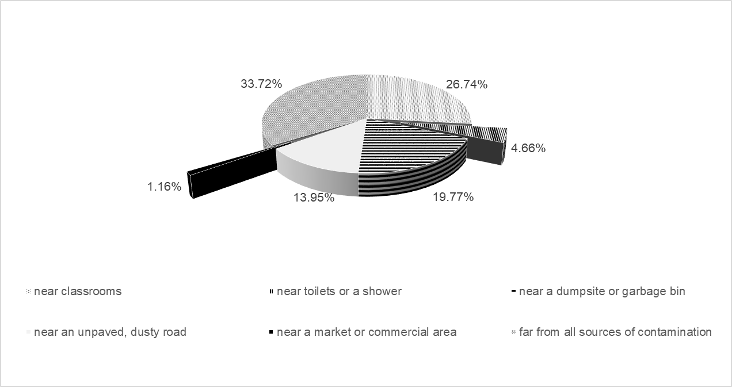
Fig 3: Position of kitchens in relation to sources of contamination
2.7. Cooking fuels and menus served
Wood was the main cooking fuel used for meal preparation in school canteens (76.74%), far ahead of butane gas (17.44%) (Fig 4) and charcoal (5.82%).
The most frequently served meals were the rice-and-beans mixture (58.14%) and “rice gras” (48.84%) (Fig 5). Other foods were also reported, including beans alone, fish, meat and porridge, but less frequently.
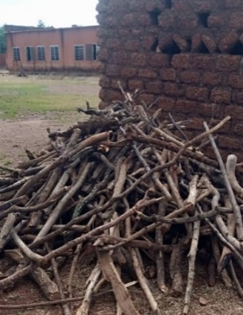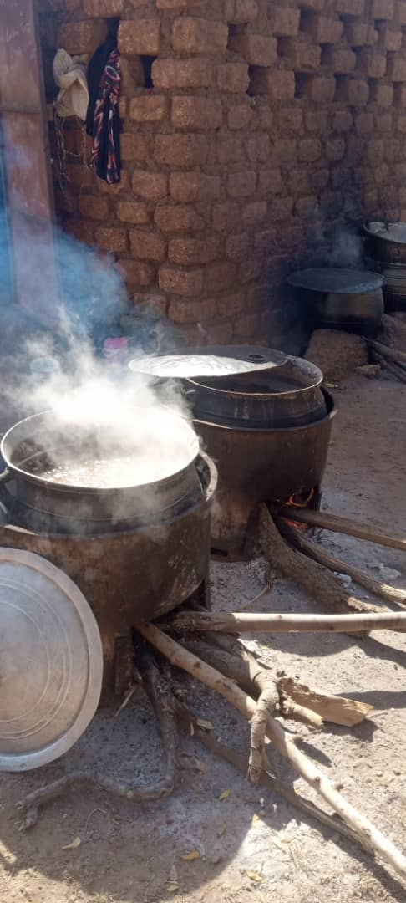  A | 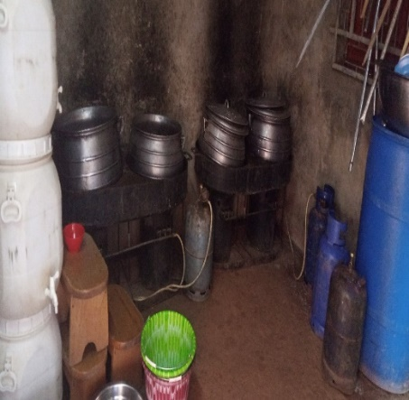  B
Fig 4: Fuels used for meal preparation: (A) wood used for cooking in school canteens; (B) gas used for cooking in school canteens.
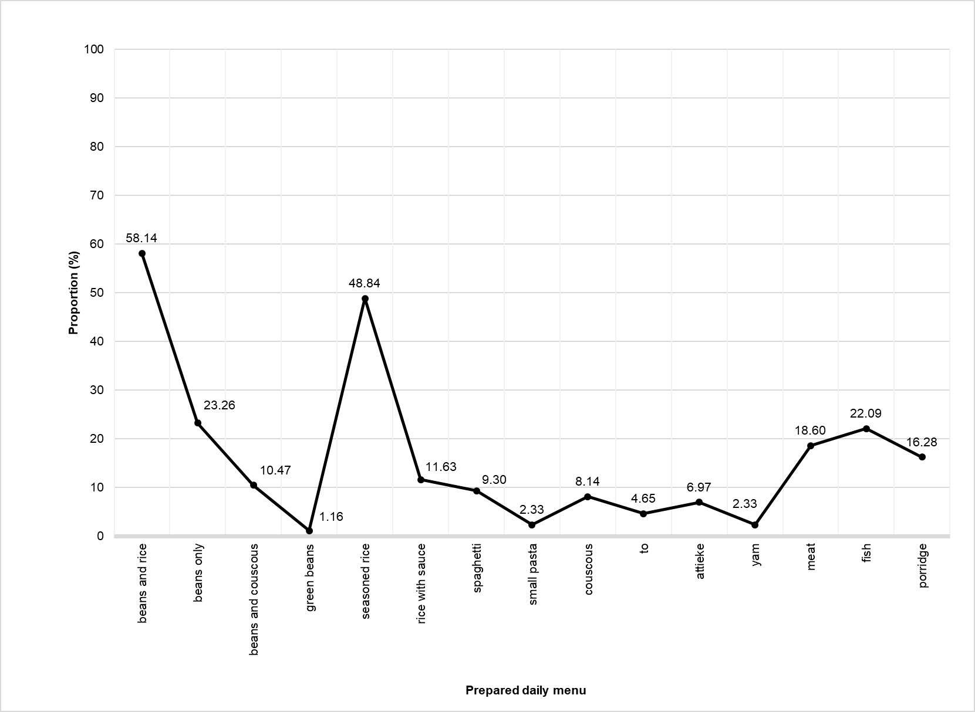
Fig 5: Daily menu in school canteens
2.8. Meal distribution modalities and places of consumption
Meal distribution was mainly organised as a queue (72.09%). Table service accounted for 20.93% of situations, while assisted self-service represented 6.98% of cases.
Meals were predominantly consumed outside areas specifically designated for this purpose. Consumption at home accounted for 42.60% of cases, consumption in the open schoolyard for 23.7%, in classrooms for 19.98%, and in dining halls for only 13.72%.
2.9. Wastewater and solid waste management
Liquid waste management remained largely inadequate. Wastewater was mainly discharged into the open (59.30%), whereas 31.40% was disposed of in a pit and 9.30% in soak pits.
Regarding solid waste, 51.16% was burned in the open air. Other schools reported direct disposal into the environment or the use of bins with collection services. The waste management practices in school canteens are given (Fig 6).
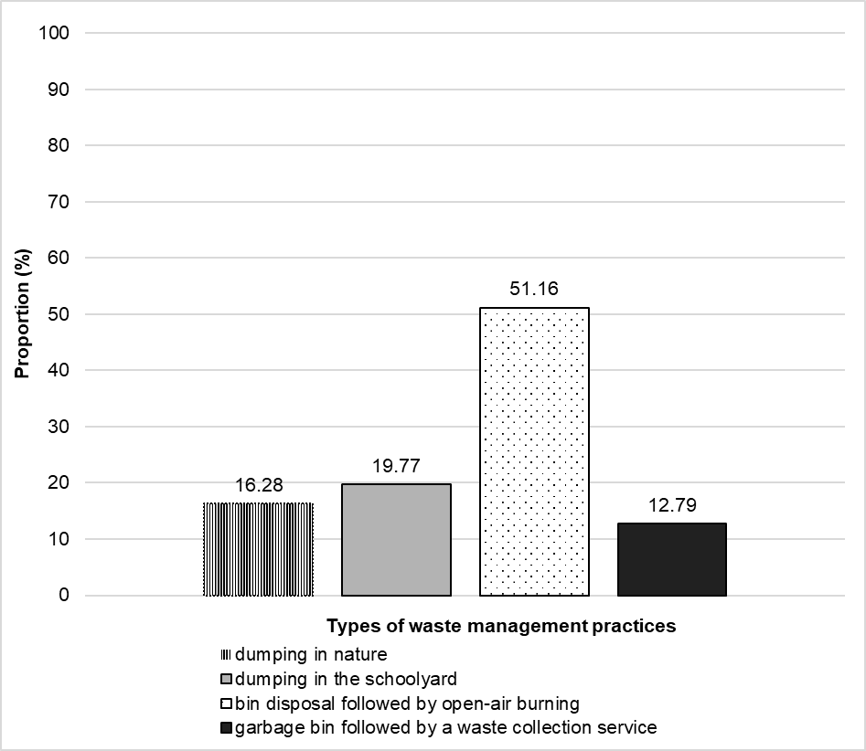
Fig 6: Waste management practices in school canteens
2.10. Hygiene practices, equipment and service conditions
Direct observations showed that the wearing of appropriate clothing and personal protective equipment was not systematic. Gloves and hair coverings were rarely used. Cleaning of work surfaces was inadequate: only 2.33% of canteen cooks reported weekly cleaning and 13.95% reported daily cleaning, whereas 83.72% reported no cleaning, notably due to the absence of a paved work area, particularly in primary schools.
All canteens used aluminium cooking pots. Poorly cleaned utensils were observed, sometimes with food residues from the previous day. Plastic tableware predominated (61.87%) compared with metal tableware (38.13%). During service, meals were sometimes handled in the open air, without sufficient protection against dust and insects, and without the consistent use of gloves or serving tongs. The containers used by pupils were mainly plastic (90.7%) and aluminium (81.4%).
External inspections were infrequent. Overall, 67.44% of schools reported never having received an inspection, whereas 32.56% had received at least one visit. Among inspected schools, 22.09% reported an annual inspection. Despite these limitations, respondents’ overall assessment of canteen operations was relatively favourable: 2.33% rated the system as excellent, 40.70% as good, 15.12% as fairly good, 38.36% as acceptable and 3.49% as poor. The frequency of inspections is given (Fig 7).
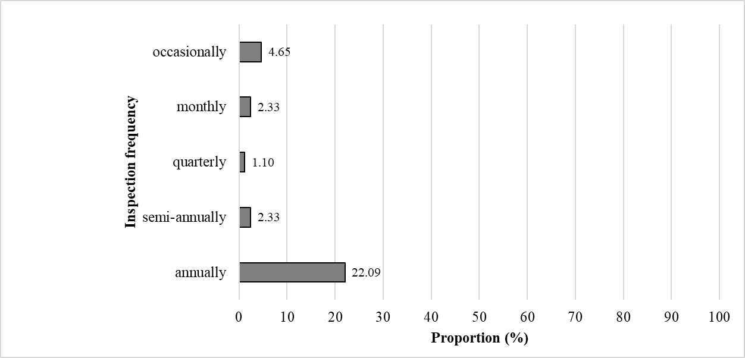
Fig 7: Frequency of inspections
2.11. Summary of non-compliances using the HACCP approach
The synthesis of observations based on the HACCP-inspired checklist highlighted several major non-compliances along the preparation and service chain (table 2). Receipt of foodstuffs and compliance of supplies with standards were insufficient in 76% of cases. Maintenance and cleanliness of storage areas were inadequate in 69% of cases, and routine checks to remove expired products were almost absent (89% non-compliances).
Regular cleaning of work surfaces and utensils was not ensured in 75% of cases, and handwashing systems were poorly functional in 81% of the canteens observed. The wearing of appropriate clothing by staff was rarely observed (75% non-compliances), while personal hygiene was considered inadequate in 77% of cases. Separation between raw and cooked foods was poorly respected (83%), and foods were rarely protected from sources of contamination: 92% non-compliances for maintaining distance from contamination sources and 88% for physical protection of food.
Waste management was also a weak point, with 73% non-compliances for storing waste in covered bins and 76% for keeping waste away from preparation areas. Internal organisation of spaces was judged non-compliant in 80% of cases, as clean and dirty zones were generally not separated. By contrast, some aspects appeared relatively better controlled, notably supply management (82% compliance), food treatment before preparation (100% for washing rice and sorting pulses) and, to a lesser extent, the use of appropriate cleaning products (59%). Nevertheless, material deterioration remained frequent, with 88% compliance regarding the observation of perforated roofs, cracked walls or damaged utensils.

Table 2: Summary of sanitary observations according to HACCP criteria
Observation criteria | Yes (%) | No (%) | Conclusions
Receipt and compliance of food supplies | 24 | 76 | Receipt of food supplies does not sufficiently meet standards
Product labelling (use-by date) | 52 | 48 | Product labelling is only partially complied with
Maintenance and cleanliness of storage areas | 31 | 69 | Storage areas lack cleanliness and adequate maintenance
Routine checks to remove expired products | 11 | 89 | Checks to remove expired products are almost non-existent
Regular cleaning of work surfaces and utensils | 25 | 75 | Cleaning of work surfaces and utensils is rarely carried out
Functional handwashing facilities | 19 | 81 | Handwashing facilities are poorly functional
Use of appropriate clothing by staff | 25 | 75 | The use of appropriate clothing is rarely observed
Personal hygiene (clean hands, short fingernails) | 13 | 77 | Staff personal hygiene is inadequate
Separation of raw and cooked foods | 17 | 83 | Separation between raw and cooked foods is poorly observed
Maintaining distance between food and sources of contamination | 8 | 92 | Foods are not protected from sources of contamination
Food protection (lids, plastic wrap/film) | 12 | 88 | Protection of foods against contamination is often neglected
Storage of waste in covered bins | 27 | 73 | Waste storage is inadequately ensured
Waste storage areas kept away from preparation areas | 24 | 76 | Storage areas are rarely kept away from preparation areas
Internal organisation | 20 | 80 | Non-compliant organisation, with clean and dirty areas not separated
Control of supplies/procurement | 82 | 18 | Spoiled or poorly packaged products are identified
Pre-treatment of foodstuffs before preparation | 100 | 0 | Washing rice before preparation and sorting pulses before cooking
Observed deterioration/damage | 88 | 12 | Perforated roofs, cracked walls, and damaged utensils
Use of appropriate, non-toxic cleaning products | 59 | 41 | Use of appropriate cleaning products is relatively satisfactory
Yes = presence of a problem or = compliance

3. Discussion
The operation of school canteens in the Guiriko region relies primarily on government food provision, with more limited contributions from partners and community inputs. This strong dependence on a centralised supply channel, combined with insufficient stocks to cover the entire school year, exposes the system to service interruptions, limited menu diversification and constrained local coping strategies. This observation aligns with the analyses of Mainje et al. (2024), who note that the sustainability of African school feeding programmes remains highly dependent on the regularity of funding, the robustness of supply chains and the local anchoring of support mechanisms. In the present study, the predominance of poorly diversified menus—particularly rice- and bean-based dishes—reflects these supply constraints and confirms that continuity of service does not necessarily ensure optimal nutritional and sanitary quality of meals. Such irregularities may also encourage local coping strategies, including repetitive menus, prolonged storage and logistical trade-offs, which may increase food safety risk when storage conditions and hygiene are inadequately controlled, consistent with observations reported by Bigson et al. (2020). Recent programme guidance further suggests that predictable financing and stronger governance are critical to reduce supply disruptions and to maintain minimum operational standards, including basic supervision and infrastructure requirements (WFP, 2024).
The results also highlight marked inadequacies in preparation infrastructure. The predominance of semi-permanent kitchens and the non-negligible presence of temporary shelters or improvised spaces indicate a material environment that is not conducive to effective sanitary risk control. Under such conditions, food, utensils and work surfaces are more exposed to dust, pests, adverse weather and cross-contamination. Comparable findings were reported by Makori et al. (2025) in Tanzania, where the lack of functional kitchens and suitable dining spaces constrained the quality of the school food environment. Similarly, Bigson et al. (2020), in the context of the Ghana School Feeding Programme, showed that cooking and serving conditions often remained inadequately controlled owing to insufficient hygiene infrastructure. In the Guiriko region, these shortcomings should be regarded as structural determinants of sanitary risk. These infrastructure gaps interact with WASH constraints, as recent school-based studies highlight that limited access to functional handwashing facilities and reliable water points can directly undermine hygiene behaviours and increase contamination risks (Radebe et al., 2025; WHO/UNICEF JMP, 2025).
The HACCP-inspired assessment indicates that the main shortcomings relate primarily to hygiene prerequisite programmes. The observed non-compliances were mainly related to the cleanliness of storage areas, the lack of routine checks to remove expired foodstuffs, inadequate cleaning of work surfaces, poorly functioning handwashing facilities, irregular use of appropriate clothing, failure to separate raw and cooked foods, and insufficient protection of food against sources of contamination. These findings are consistent with the review by Tohonon et al. (2025), which emphasises that, in catering services in sub-Saharan Africa, deviations from sanitary requirements most often involve hygiene prerequisite programmes, well before full implementation of the HACCP system. This interpretation is also in line with Baş (2007), who previously showed that, in resource-limited settings, the main barriers to HACCP implementation frequently stem from inadequate prerequisite programmes, limited material resources and organisational constraints. In practical terms, this suggests that, in Guiriko canteens, the key challenge is not only the formal application of HACCP, but first and foremost the consolidation of a minimum baseline of good hygiene practices, basic equipment and effective workflow organisation.
The shortcomings observed in staff hygiene, surface cleaning and the use of protective equipment further indicate that food safety depends as much on practical skills as on the material resources available. Abdilahi et al. (2025) showed that food handlers’ practices are strongly influenced by training, the frequency of sanitary inspections, water availability and the level of food safety knowledge. Similarly, Tóth et al. (2024) reported, in institutional kitchens, a substantial gap between staff’s positive self-assessments and the more critical findings from external evaluations, notably regarding personal hygiene, storage, cleaning and disinfection. These observations are consistent with the present results: despite respondents’ generally favourable appraisal of canteen operations, direct observations documented numerous non-compliances. In the same vein, Sibanyoni et al. (2017) previously reported that, in school food services, inadequate training, lack of equipment and certain work constraints promote risky practices. Young et al. (2019) further showed that, although training often improves handlers’ knowledge, sustained translation into good practice also requires equipment, simple routines and an appropriate supervision system. This supports, in the Guiriko region, the need to strengthen practical training for canteen cooks, as well as to establish more regular and structured external supervision. In operational terms, periodic supervision using a short checklist may help to reduce the gap between self-reported practices and observed compliance, and to prioritise feasible corrective actions over time (Tóth et al., 2024).
Wastewater and solid waste management is another weak link in the system. The predominant discharge of wastewater into the open and the frequent open-air burning of solid waste maintain an unsanitary environment around kitchens and serving areas. Such practices promote pests, contaminate the immediate surroundings and maintain indirect sources of contamination. They should be discussed in relation to the non-compliant internal organisation of spaces and the low frequency of external inspections. The Codex Alimentarius General Principles of Food Hygiene emphasise that hazard control relies first and foremost on robust prerequisite programmes covering water supply, cleaning and disinfection, protection against contaminants, safe handling practices and appropriate waste disposal. The findings from the Guiriko region indicate that corrective actions should be prioritised precisely at this level.
Overall, this study shows that sanitary shortcomings in Guiriko school canteens arise from a combination of logistical, infrastructural, behavioural and institutional factors. Sustainable improvement in the safety of school meals therefore cannot rely solely on the availability of food supplies. It requires an integrated approach that strengthens kitchen infrastructure and access to water, ensures the provision of appropriate equipment, improves service organisation, and supports continuous training for the actors directly involved.
Conclusion
Focusing on hygiene conditions and critical food safety control points in school canteens in the Guiriko region, the present study confirms the major social and nutritional role of these services, while highlighting that sanitary conditions remain inadequately controlled. Heavy reliance on public food provision, limited diversification of supplies, precarious kitchen infrastructure, long distances to water points, hygiene shortcomings observed throughout the preparation and serving chain, and poor waste management were the main weaknesses identified. These findings indicate that the safety of school meals depends not only on the availability of food supplies but also on infrastructure quality, effective access to water, service organisation and compliance with key hygiene prerequisite programmes.
It is therefore necessary to complement this diagnostic assessment with targeted microbiological and chemical analyses of food supplies, water and meals, together with health monitoring of pupils, in order to quantify the level of risk and assess the effectiveness of corrective measures.
Operationally, two priority actions emerge: (i) securing continuity and improving diversification of food supplies throughout the school year, notably through strengthened planning and greater mobilisation of local supply channels where feasible; and (ii) making hygiene prerequisite programmes fully operational through standardised minimum investments (protected kitchen, nearby functional water point, handwashing facilities with soap, appropriate containers and lids, and proper waste management), combined with practical training for canteen cooks and routine supervision based on a checklist. These realistic and integrated measures are essential to reduce preventable sanitary risks and sustainably improve the quality of meals served to pupils.
Disclaimer (Artificial Intelligence)
Author(s) hereby declare that NO generative AI technologies such as Large Language Models (ChatGPT, COPILOT, etc) and text-to-image generators have been used during writing or editing of this manuscript.
COMPETING INTERESTS:
Authors have declared that they have no known competing financial interests OR non-financial interests OR personal relationships that could have appeared to influence the work reported in this paper.
ETHICAL APPROVAL AND CONSENT
Because this was a non-interventional observational survey and involved no biological sampling, it did not require ethics committee review and therefore no ethics approval reference number applies. Administrative authorisation was obtained from the relevant educational and local administrative authorities prior to data collection. Participation of respondents (canteen cooks and key stakeholders) was voluntary. Informed consent was obtained after explaining the study objectives, data-collection procedures, the non-mandatory nature of participation and the right to withdraw at any time without consequence. Anonymity and confidentiality were ensured: no personal identifiers were collected, and data were processed and reported only in aggregate form for scientific purposes.
References
- Abdilahi, M. M., Kiruja, J., Ismail, A. S., Ahmed, S. H., Nooh, F., Ahmed, A. S., & Kulmie, A. R. (2025). Food safety practice and its associated factors among food handlers working in food and drinking establishments in Hargeisa, Somaliland. BMC Public Health, 25, 438. https://doi.org/10.1186/s12889-025-21617-7
- Baş, M., Yüksel, M., & Çavuşoğlu, T. (2007). Difficulties and barriers for the implementing of HACCP and food safety systems in food businesses in Turkey. Food Control, 18(2), 124‑130. https://doi.org/10.1016/j.foodcont.2005.09.002
- Bigson, K., Essuman, E. K., & Lotse, C. W. (2020). Food hygiene practices at the Ghana school feeding programme in wa and cape coast cities. Journal of environmental and public health, 2020(1), 9083716. https://doi.org/10.1155/2020/9083716
- Institut national de la statistique et de la démographie (INSD). (2022). Résultats du 5e Recensement général de la population et de l’habitation : Monographie de la région du Guiriko. INSD
- Lalli, G. S. (2021). A review of the English school meal: Progress or a recipe for disaster? Cambridge Journal of Education, 51(3), 339-357. https://doi.org/10.1080/0305764X.2021.1893658
- Mainje, M., Matumba, L., Harvey, J. J. W., Phiri, H., Gama, A. P., Phiri, A., et al. (2024). Long-term sustainability of African school feeding programs, a review. Frontiers in Sustainable Food Systems, 8, 1424354. https://doi.org/10.3389/fsufs.2024.1424354
- Makori, N., Kejo, D., Mshida, H., Bachwenkizi, B., Daudi, Z., Chipungahelo, M., et al. (2025). Assessing the school food environment and its role on healthy eating behaviours among school age children in Dar es Salaam, Tanzania. PLOS ONE, 20(7), e0321702. https://doi.org/10.1371/journal.pone.0321702
- Paulin, G. D. (2002). The changing food-at-home budget: 1980 and 1992 compared. Monthly Labor Review, 125(12), 1-15.
- Radebe, L. C., Mokgobu, M. I., Molelekwa, G. F., & Mokoena, M. M. (2025). Assessment of the status of water, sanitation and hygiene (WASH) services at primary schools in uMfolozi Local Municipality, Kwa-Zulu Natal, South Africa. International Journal of Environmental Research and Public Health, 22(3), 360. https://doi.org/10.3390/ijerph22030360
- Research Consortium for School Health and Nutrition. (2025). Policy insights for national school meals programmes : Annual Research Statements to the members of the School Meals Coalition—2022, 2023, and 2024. Frontiers in Public Health, 13, 1416165. https://doi.org/10.3389/fpubh.2025.1416165
- Salvador, R. Q., Borromeo, C. M. T., Alnas, G. C., Adviento, S. V. M. G., Asuncion, A. C., Limon, M. R., et al. (2024). Safe plates in the school space: Investigating compliance of food safety standards among school-based food service providers. Food and Humanity, 2, 100283. https://doi.org/10.1016/j.foohum.2024.100283
- Sibanyoni, J. J., Tshabalala, P. A., & Tabit, F. T. (2017). Food safety knowledge and awareness of food handlers in school feeding programmes in Mpumalanga, South Africa. Food Control, 73, 1397-1406. https://doi.org/10.1016/j.foodcont.2016.11.001
- Siddiky, A., Mollick, K., Aktarujjaman, M., Islam, F., Mamun, M. A., & Roy, N. (2024). Determinants of food safety knowledge and practices among food handlers in Bangladesh: An institution-based cross-sectional study. Heliyon, 10(4). https://doi.org/10.1016/j.heliyon.2024.e25970
- Story, M., Kaphingst, K., Robinson-O’Brien, R., & Glanz, K. (2008). Creating healthy food and eating environments:policy and environmental approaches. Annu Rev Public Health, (29), 72-253. https://doi.org/10.1146/annurev.publhealth.29.020907.090926
- Tohonon, A. C., Ouétchéhou, R., Hounsou, M., Zannou, O., & Dabadé, D. S. (2025). Food hygiene in Sub-Saharan Africa: A focus on catering services. Food Control, 168, 110938. https://doi.org/10.1016/j.foodcont.2024.110938
- Tóth, A. J., Kajtor, M., Illés, C. B., Dunay, A., Vinogradov, S., Battay, M., et al. (2024). The effectiveness of food safety self-checking systems in institutional catering. Applied Food Research, 4(2), 100488. https://doi.org/10.1016/j.afres.2024.100488
- United Nations Educational, Scientific and Cultural Organization (UNESCO). (2025). Education and nutrition : Learn to eat well—UNESCO Bibliothèque Numérique. https://unesdoc.unesco.org/ark:/48223/pf0000392932
- Watkins, K., Fiala, O., Haag, P. and Zubai, A. (2024) School feeding and the Sustainable Development Goals: An agenda to combat child hunger, boost education, transform food systems and strengthen equity. Report. London: ODI. https://edc.org/sites/default/files/uploads/ODI-SD-School-Feeding-Report.pdf
- World Food Programme (WFP). (2024). Ensuring sustainable financing for school meals in West Africa. WFP. https://schoolfeeding.araa.org/sites/default/files/2024-05/Financing_HGSF_in_West_Africa-May_2024.pdf
- World bank. (2025). Food Security | Food Insecurity Statistics & Solutions. https://www.worldbank.org/en/topic/agriculture/brief/food-security-update
- World Food Programme (WFP). (2023). The State of School Feeding Worldwide 2022. World Food Programme. https://publications.wfp.org/2022/state-of-school-feeding/
- World Food Programme (WFP). (2025). The State of School Feeding Worldwide. World Food Programme. https://www.wfp.org/publications/state-school-feeding-worldwide
- World Health Organization. (2024). Food safety. https://www.who.int/news-room/fact-sheets/detail/food-safety
- World Health Organization (WHO) & United Nations Children’s Fund (UNICEF) Joint Monitoring Programme for Water Supply, Sanitation and Hygiene (JMP). (2025). Guidance note to facilitate country consultation on JMP estimates for drinking water, sanitation and hygiene in schools. WHO/UNICEF JMP. https://washdata.org/reports/jmp-2025-country-consultation-wash-health-care-facilities
- Yamane, T. (1967). Statistics: An Introductory Analysis. 2nd Edition, Harper and Row, New York.
- Young, I., Greig, J., Wilhelm, B. J., & Waddell, L. A. (2019). Effectiveness of food handler training and education interventions: A systematic review and meta-analysis. Journal of Food Protection, 82(10), 1714-1728. https://doi.org/10.4315/0362-028X.JFP-19-108

