Etiological Spectrum of Heart Failure with Reduced Ejection Fraction in a Moroccan Military Hospital: A Comparative Registry Analysis

ABSTRACT

Background: The etiological distribution of heart failure with reduced ejection fraction (HFrEF) varies significantly across regions, reflecting differences in cardiovascular risk factor prevalence, genetic predisposition, and healthcare access. Data from North African military populations are scarce. This study aimed to characterize the etiological spectrum of HFrEF in a Moroccan military hospital and compare findings with major international registries.
Methods: This was a retrospective observational registry study conducted at the Avicenne Military Hospital, Marrakech, Morocco, over a two-year period (2021–2023). Etiologies were systematically classified in 173 consecutive HFrEF patients (left ventricular ejection fraction
<40%) based on clinical history, electrocardiographic findings, echocardiographic pattern, and coronary angiographic results. Descriptive statistics were used, with results expressed as frequencies and percentages for categorical variables and means ± standard deviations for continuous variables.
Results: A total of 173 patients were included (mean age 67.9 ± 8.7 years; 80% male). The dominant cardiovascular risk factors were sedentary lifestyle (85%), smoking (53%), diabetes mellitus (45%), hypertension (33%), and dyslipidemia (33%). Ischemic cardiomyopathy was the predominant etiology (56.6%), followed by idiopathic dilated cardiomyopathy (17.3%), hypertensive cardiomyopathy (11.6%), arrhythmia-induced cardiomyopathy (6.4%), valvular cardiomyopathy (5.8%), and toxic cardiomyopathy (1.7%). Coronary angiography was performed in 118 patients (68.2%), with multivessel disease as the most frequent finding: tritroncoronary involvement in 22%, bitroncoronary in 14%, and single-vessel significant disease in 19%. The left anterior descending artery was the most commonly affected vessel (41%). Compared to international registries, the ischemic etiology burden exceeded that of the Asian JCARE-CARD registry (34.0%) and the African INTER-CHF cohort (13.0%), and aligned with the ESC HF Long-Term Registry (48.6%) and the SwedeHF registry (60.0%).
Conclusion: Ischemic cardiomyopathy dominates the etiological spectrum of HFrEF in this Moroccan military cohort, reinforcing the priority of coronary risk factor management and timely coronary revascularization in prevention strategies. Future multicenter prospective studies across North Africa and expanded access to cardiac MRI are recommended.
Keywords: HFrEF; Etiology; Ischemic cardiomyopathy; Dilated cardiomyopathy; Coronary angiography; Morocco; Military hospital

1. Introduction
Heart failure with reduced ejection fraction (HFrEF), defined by a left ventricular ejection fraction (LVEF) below 40%, represents a leading cause of cardiovascular morbidity and mortality worldwide [1]. The etiology of HFrEF critically influences prognosis, therapeutic strategy, and the likelihood of left ventricular (LV) recovery. In Western countries, ischemic cardiomyopathy secondary to coronary artery disease (CAD) accounts for the majority of HFrEF cases (50–70%), followed by dilated cardiomyopathy (DCM), hypertensive cardiomyopathy, and valvular heart disease [2]. In contrast, non-ischemic etiologies, including idiopathic DCM, inflammatory cardiomyopathies, and toxic causes, predominate in younger populations and certain geographic regions [3].
Coronary artery disease remains the global leading cause of HFrEF due to myocardial ischemia, infarction, hibernation, and adverse ventricular remodeling [1]. Accurate etiological characterization is essential, as ischemic etiology carries distinct prognostic implications and guides specific interventions including coronary revascularization, implantable cardioverter-defibrillators (ICD), and cardiac resynchronization therapy (CRT) eligibility [4]. In North Africa, cardiovascular risk factor burden is rising rapidly, driven by increasing rates of diabetes, hypertension, dyslipidemia, and tobacco consumption. However, regional registry data characterizing the etiological distribution of HFrEF remain scarce, particularly from military hospital settings where specific demographic and occupational risk profiles may differ from the general population [5].
The objective of this study was to systematically characterize the etiological spectrum of HFrEF in a Moroccan military hospital and to compare these findings with major international registries to identify region-specific etiological patterns and their potential determinants.

2. Methods

2.1 Study Design and Setting

This was a retrospective observational registry study conducted at the Cardiology Department of Avicenne Military Hospital, Marrakech, Morocco, from January 2021 to December 2023. All patients admitted with a diagnosis of HFrEF (LVEF <40%) during this period were included.

2.2 Inclusion and Exclusion Criteria

Inclusion criteria: adult patients (≥18 years) with a confirmed first diagnosis of HFrEF based on symptoms, clinical signs, and echocardiographic evidence (LVEF <40%). Patients presenting with cardiogenic shock at admission, HF with mid-range or preserved ejection fraction, or incomplete medical records were excluded. A total of 173 patients met the inclusion criteria.

2.3 Etiological Classification

Etiology was classified based on: (1) clinical history and cardiovascular risk factor profile; (2) ECG findings; (3) echocardiographic pattern (global vs. segmental wall motion abnormality); and (4) coronary angiography results when indicated. Specific definitions applied:
• Ischemic cardiomyopathy: HFrEF in the presence of obstructive CAD (≥50% stenosis in ≥1 major epicardial artery) or documented prior myocardial infarction.
• Idiopathic DCM: global LV dysfunction with dilatation after exclusion of all identifiable causes including ischemic, hypertensive, valvular, and toxic etiologies [6].
• Hypertensive cardiomyopathy: history of sustained hypertension with echocardiographic evidence of LV hypertrophy preceding dilatation.
• Valvular cardiomyopathy: HFrEF attributable to primary severe valvular disease.

• Toxic cardiomyopathy: documented alcohol excess or chemotherapy-related cardiotoxicity.

• Arrhythmia-induced cardiomyopathy: LV dysfunction with a predominant arrhythmic substrate (atrial fibrillation with rapid ventricular rate or frequent ventricular extrasystoles), in the absence of other identifiable causes.

2.4 Statistical Analysis
Descriptive statistics were used. Categorical variables are presented as frequencies and percentages. Continuous variables are presented as means ± standard deviations. Etiological distributions were compared descriptively with published international registry data.

Ethical Considerations

This study was conducted in accordance with applicable ethical principles. Patient data were treated with strict confidentiality and anonymized before analysis. No ethical issues were identified during this work.

3. Results

3.1 Patient Demographics and Cardiovascular Risk Factor Profile

A total of 173 consecutive HFrEF patients were enrolled. The mean age was 67.9 ± 8.7 years (range: 38–92 years). The majority of patients (79%) were between 60 and 79 years of age: 52% were aged 60–69 years and 27% were aged 70–79 years. A marked male predominance was observed, with 138 male patients (80%) versus 35 female patients (20%).
Sedentary lifestyle was the most prevalent cardiovascular risk factor, identified in 85% of patients. Smoking was recorded in 53%, with a higher burden among men. Diabetes mellitus type 2 was present in 45%, of whom 16% were managed with oral antidiabetic agents alone,
15% with insulin therapy, 8% with combined oral agents and insulin, and 6% with dietary measures only. Hypertension was documented in 33%, with the majority on monotherapy (23%). Dyslipidemia was present in 33% based on prior medical diagnosis; however, lipid panel results at the time of admission revealed dyslipidemia in up to 60.7% , suggesting a significant gap in prior detection. Obesity was identified in 8% . No patient had a family history of coronary artery disease.
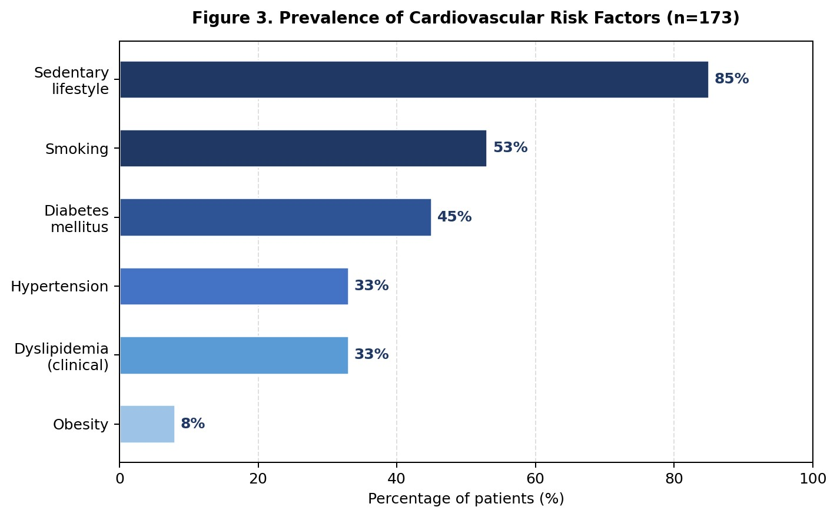

Figure 1. Prevalence of cardiovascular risk factors in the study cohort (n=173).

3.2 Clinical Presentation
Dyspnea was the dominant presenting symptom (98.2%), classified predominantly as NYHA class II (45%) and class III (33%). Chest pain was reported in 50% of patients, peripheral edema in 31.7%, and palpitations in 12.7%. On physical examination, resting heart rate was
60–99 bpm in 75%, bibasilar crackles in 38%, lower limb edema in 31.7%, spontaneous jugular venous distension in 19.6%, and a mitral regurgitation murmur in 17.3%. Left heart failure predominated (68%), with global (biventricular) failure in 32%.
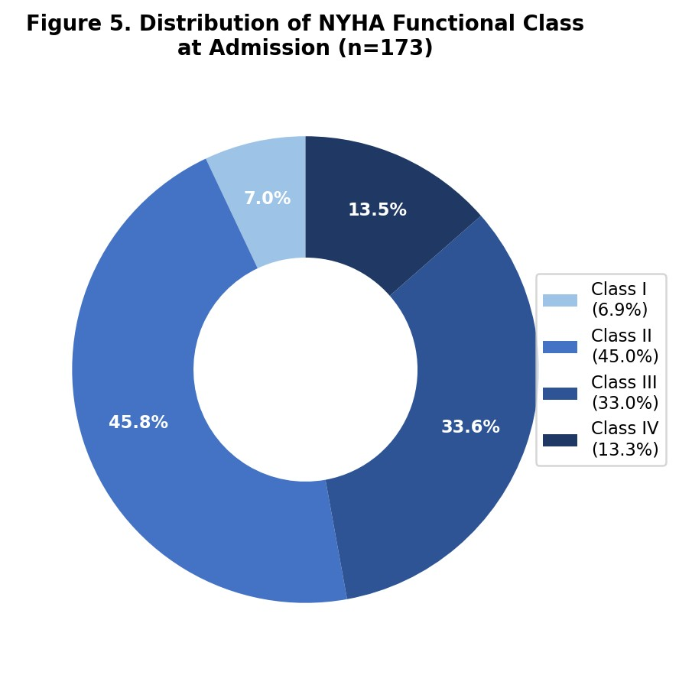

Figure 2. Distribution of NYHA functional class at admission (n=173).

3.3 Echocardiographic Findings
All 173 patients underwent transthoracic echocardiography. The mean LVEF was 32% (range: 13–40%).
Valvular regurgitation was common, identified in 67.6% (117/173): mitral regurgitation in
59.5% (103/173), of whom 12 had mild, 70 moderate, 12 intermediate, and 9 severe degrees; aortic regurgitation in 25.4% (44/173); and tricuspid regurgitation in 15% (26/173).

3.4 Coronary Angiography Findings

Coronary angiography was performed in 118 patients (68.2%), in those where ischemic etiology was clinically suspected based on history, ECG findings, or echocardiographic segmental wall motion abnormalities. Multivessel disease was the most frequent angiographic finding: tritroncoronary disease in 22% (38 patients), bitroncoronary disease in
14% (24 patients), and single-vessel significant disease in 19% (33 patients). Non-obstructive coronary disease was found in 12% (21/118), and intramyocardial bridging in 2%.
Regarding the distribution of coronary lesions, the left anterior descending artery (LAD) was the most commonly involved vessel, with significant stenosis (70–90%) in 41% of patients. The circumflex artery was affected in 27% and the right coronary artery in 26%. Left main involvement (>50% stenosis) was identified in 9.2% of patients (16/173). Regarding lesion topography, LAD stenosis was most frequent at the middle segment (25.4%), followed by the proximal segment (23.1%). Circumflex artery stenosis predominated at the distal segment (17.3%) and the right coronary artery at the second segment (12.7%).
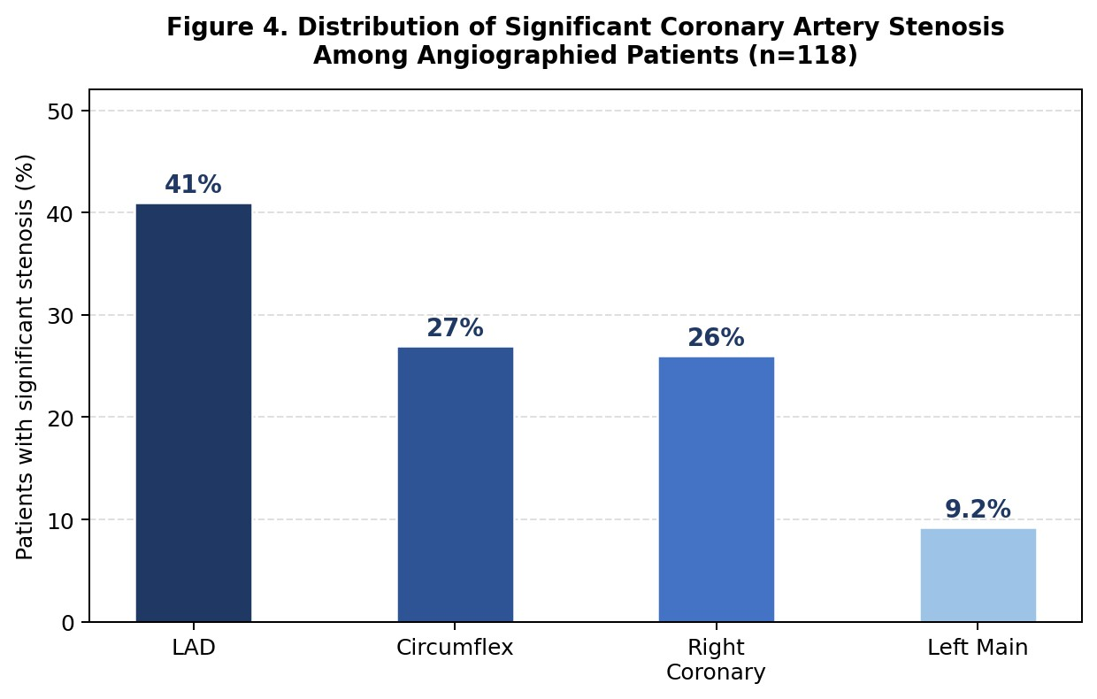

Figure 3. Distribution of significant coronary artery stenosis among angiographied patients (n=118). LAD = left anterior descending artery.

Among the 98 patients with confirmed ischemic cardiomyopathy, 58 (33% of the overall cohort) underwent percutaneous coronary intervention (PCI), and 19 (11%) were referred for coronary artery bypass grafting (CABG). Medical management alone was pursued in the remaining patients, based on clinical judgment and coronary anatomy.

3.5 Etiological Distribution
Ischemic cardiomyopathy was the dominant etiology, identified in 98 patients (56.6%). Idiopathic dilated cardiomyopathy accounted for 30 patients (17.3%), hypertensive cardiomyopathy for 20 patients (11.6%), arrhythmia-induced cardiomyopathy for 11 patients (6.4%), valvular cardiomyopathy for 10 patients (5.8%), toxic cardiomyopathy for 3 patients (1.7%), and metabolic cardiomyopathy (hypocalcemia) for 1 patient (0.6%).
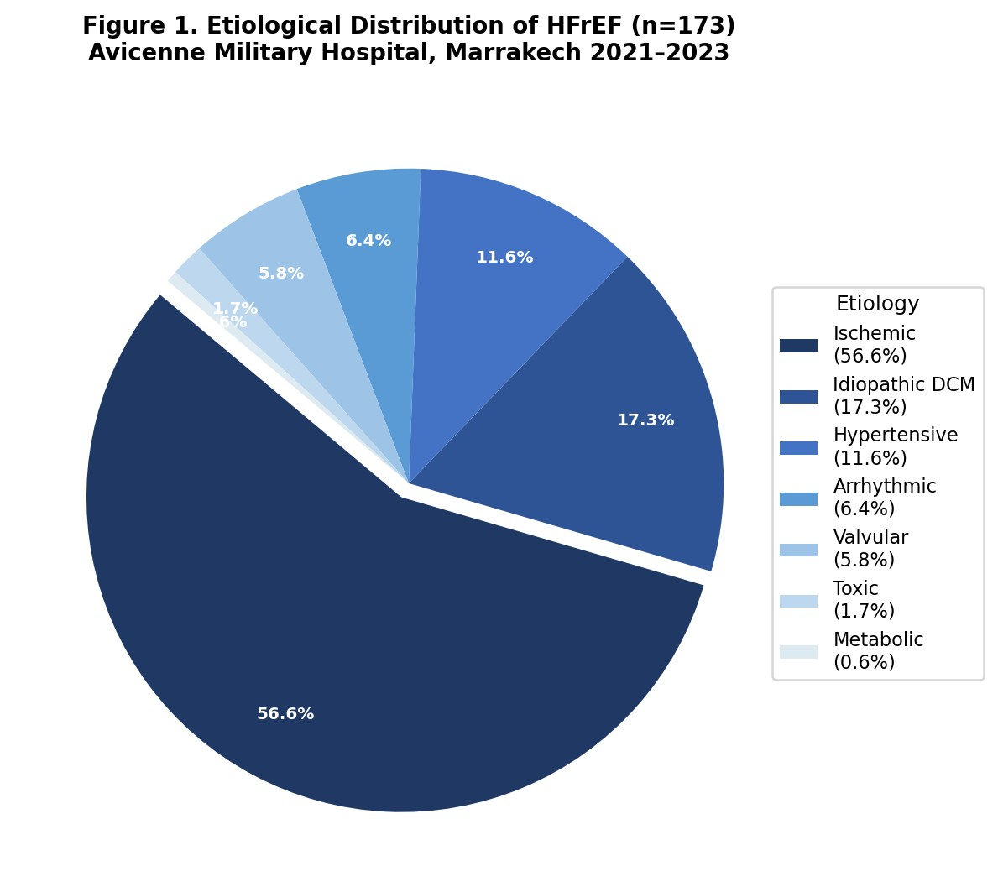

Figure 4. Etiological distribution of HFrEF in the study cohort (n=173). DCM = Dilated Cardiomyopathy.

Table 1. Etiological distribution of HFrEF in the study cohort (n=173).

Etiology | Number of patients | Percentage (%)
Ischemic cardiomyopathy | 98 | 56.6%
Idiopathic dilated cardiomyopathy | 30 | 17.3%
Hypertensive cardiomyopathy | 20 | 11.6%
Arrhythmia-induced cardiomyopathy | 11 | 6.4%
Valvular cardiomyopathy | 10 | 5.8%
Toxic cardiomyopathy | 3 | 1.7%
Metabolic cardiomyopathy (hypocalcemia) | 1 | 0.6%

3.6 Therapeutic Management

All patients received guideline-directed medical therapy. Beta-blockers were prescribed in
87% (predominantly bisoprolol), ACEi in 74%, MRA (spironolactone) in 78%, SGLT2 inhibitors in 33%, and ARNI (sacubitril/valsartan) in 8%. Loop diuretics were used in 54%, statins in 71%, and anticoagulation in 37%. Device therapy was limited: one ICD and two CRT implantations. Among ischemic patients, 58 underwent PCI (33% of the cohort) and 19 were referred for CABG (11%).

Table 2. Comparative etiological distribution of HFrEF across major international registries.

Etiology | Our Study | SwedeHF [7] | ESC HF LT [2] | JCARE-CA RD [8] | INTER-CHF Africa [9]
Ischemic (%) | 56.6 | 60.0 | 48.6 | 34.0 | 13.0
Hypertensive (%) | 11.6 | NR | 4.5 | 21.6 | 45.0
Idiopathic DCM (%) | 17.3 | NR | 35.1 | 15.7 | NR
Valvular (%) | 5.8 | NR | NR | NR | NR
Arrhythmic (%) | 6.4 | NR | NR | NR | NR
Toxic (%) | 1.7 | NR | NR | NR | NR
DCM = Dilated Cardiomyopathy; NR = Not Reported.

4. Discussion

This registry study provides a systematic characterization of the etiological spectrum of HFrEF in a Moroccan military hospital setting. The predominance of ischemic etiology (56.6%), combined with detailed coronary angiographic, echocardiographic, biological, and therapeutic data drawn from the same cohort, positions this work as a valuable regional contribution at a time when North African cardiovascular registry data remain scarce.

4.1 Ischemic Cardiomyopathy: The Dominant Etiology

Ischemic cardiomyopathy was the dominant etiology in our cohort (56.6%), exceeding the ischemic proportion reported in the JCARE-CARD Japanese registry (34.0%) [8] and aligning with the ESC HF Long-Term Registry (48.6%) [2] and the SwedeHF Swedish registry (60.0% in HFrEF) [7]. This predominance is directly attributable to the high cardiovascular risk factor burden observed in our cohort: smoking in 53% and diabetes mellitus type 2 in 45%, synergistically accelerating atherosclerosis and ischemic myocardial injury [10, 11]. A recent meta-analysis across 122 randomized controlled trials (169,855
HFrEF patients) confirmed that ischemic etiology accounts for approximately 57.8% of
HFrEF cases in clinical trial populations, a figure consistent with our registry findings [12].

From a pathophysiological standpoint, the combination of smoking-induced endothelial dysfunction and diabetes-related microvascular disease creates a particularly hostile environment for coronary artery disease progression, leading to adverse ventricular remodeling [11]. The high prevalence of tritroncoronary disease (22%) and bitroncoronary disease (14%) in our angiographic subgroup confirms the severity of coronary burden and explains the depressed mean LVEF of 32% observed in our cohort.
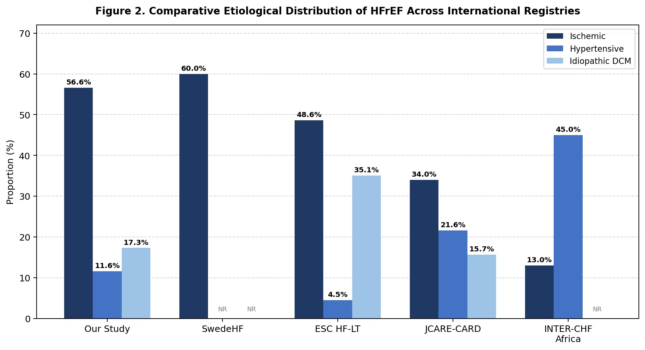

Figure 5. Comparative etiological distribution of HFrEF across major international registries. DCM = Dilated
Cardiomyopathy; NR = Not Reported.

Coronary angiography was performed in 68.2% of our patients. The high rate of tritroncoronary (22%) and bitroncoronary disease (14%) confirms the severity of the coronary burden and justifies a systematic invasive coronary evaluation strategy in HFrEF patients without a clear non-ischemic etiology. As emphasized in the 2021 ESC Heart Failure Guidelines [4], etiological characterization drives therapeutic decision-making. In our series, 33% of the overall cohort underwent PCI and 11% were referred for CABG, reflecting a proactive revascularization approach.
The clinical benefit of revascularization in ischemic HFrEF remains an area of active investigation. The landmark STICH trial demonstrated that CABG in patients with HFrEF (LVEF ≤35%) and significant CAD provides long-term mortality benefits over optimal medical therapy alone, particularly in the extended 10-year follow-up (STICHES) [13]. More recent data from the RevascHeart cohort study (2012–2023), which enrolled 408 patients with HF and LVEF ≤40%, confirmed positive LV remodeling in both revascularized and medically treated groups, though revascularization did not confer a statistically significant mortality advantage over optimal medical therapy in all subgroups, underscoring the need for individualized decision-making [14]. In patients with multivessel disease, studies have shown that selective incomplete revascularization may achieve outcomes comparable to complete revascularization when guided by clinical judgment and functional assessment [15].

4.2 Idiopathic Dilated Cardiomyopathy
The prevalence of idiopathic DCM (17.3%) was lower than that reported by the ESC HF Long-Term Registry (35.1%) [2]. When combined with arrhythmia-induced cardiomyopathy (6.4%), the non-ischemic dilated category totals 23.7%, still below the ESC registry. This discrepancy likely reflects several converging factors. First, limited access to cardiac MRI for tissue characterization may have led to misclassification of certain cases of post-ischemic DCM or inflammatory cardiomyopathy as idiopathic [6]. Second, the lack of routine genetic
testing in our center prevents identification of familial DCM, which is estimated to account for up to 40–60% of apparently idiopathic cases when modern genetic panels are applied [6].
The 2023 ESC Guidelines for the Management of Cardiomyopathies, the first comprehensive dedicated guidelines from ESC on this topic, now emphasize a phenotype-first approach and assign cardiac MRI a Class I recommendation in the diagnostic pathway [16]. Cardiac MRI enables tissue characterization through late gadolinium enhancement (LGE) patterns that distinguish ischemic (subendocardial or transmural) from non-ischemic (mid-wall or epicardial) scar, and identifies inflammatory, infiltrative, and genetic substrates. Expanded access to CMR at our institution could significantly improve etiological precision, reduce the proportion classified as idiopathic, and guide prognostic stratification and ICD eligibility [16].

4.3 Hypertensive Cardiomyopathy

Hypertensive cardiomyopathy was present in 11.6% of our cohort, more than in most Western registries (ESC HF LT: 4.5%) [2] but substantially less than in the Japanese JCARE-CARD registry (21.6%) [8] and far below the INTER-CHF African cohort, where hypertensive etiology predominated at 45% [9]. This reflects the intermediate cardiovascular transition stage of North Africa: hypertension is prevalent (33% in our cohort, consistent with the 41.7% reported in the multicentric Moroccan HF study) [17], but coronary risk factors — particularly high tobacco use — have generated a superimposed ischemic burden that surpasses hypertensive etiology as the primary cause of LV dysfunction.
A growing body of evidence shows that Africa is undergoing a rapid cardiovascular epidemiological transition [18, 19]. While hypertensive heart disease and cardiomyopathies traditionally dominated sub-Saharan African HF registries, ischemic heart disease is now emerging as a significant contributor across the continent. North Africa, and Morocco in particular, demonstrates this transition more acutely due to demographic aging, urbanization, sedentary lifestyle (85% in our cohort), and growing tobacco use.

4.4 Valvular, Arrhythmic, and Toxic Etiologies

Valvular cardiomyopathy (5.8%) was consistent with the proportions observed in general cardiology cohorts, primarily driven by mitral regurgitation and aortic valve disease. Echocardiographic assessment identified mitral regurgitation in 59.5% of all HFrEF patients, though in most cases this represented secondary (functional) mitral regurgitation rather than primary valvular pathology.
Arrhythmia-induced cardiomyopathy (tachycardiomyopathy), identified in 6.4% of our patients, represents a potentially reversible form of HFrEF. Atrial fibrillation with rapid ventricular rate was the predominant substrate. This entity warrants systematic consideration in the diagnostic workup, as rhythm control strategies — pharmacological or interventional (catheter ablation of atrial fibrillation) — may result in partial or complete LV functional recovery.
Toxic cardiomyopathy (1.7%), predominantly related to chemotherapy, was rare in our series. The apparent low prevalence of alcohol-related cardiomyopathy likely reflects underreporting, given the Muslim-majority socio-cultural context where alcohol consumption is generally not disclosed. This represents a limitation for accurate etiological classification and calls for non-judgmental, structured screening approaches.

4.5 Therapeutic Management and Guideline Adherence
Adherence to guideline-directed medical therapy (GDMT) was generally satisfactory. Beta-blockers were prescribed in 87%, ACEi/ARB in 77%, and MRA in 78% of patients, reflecting a triple neurohormonal blockade approach consistent with 2021 ESC HF guidelines [4]. Notably, SGLT2 inhibitors — which received Class I recommendation in HFrEF regardless of diabetes status following the DAPA-HF and EMPEROR-Reduced trials
— were prescribed in 33% of patients, indicating early uptake of this newer therapeutic class in our institution. ARNI (sacubitril/valsartan) prescription remained limited at 8%, likely reflecting access and cost barriers rather than clinical ineligibility.
Device therapy utilization was limited in this cohort (1 ICD, 2 CRT), a pattern commonly observed in resource-limited settings where the procedural infrastructure and cost reimbursement frameworks may not support broad device implantation.
4.6 Comparison with the North African and Moroccan Context

Compared to the multicentric Moroccan HF study, which identified hypertension as the leading risk factor (41.7%), smoking in 36%, and diabetes in 36.7% [17], our military cohort showed a notably higher smoking prevalence (53%) and diabetes prevalence (45%), consistent with the specific occupational and lifestyle profile of the military population. The ischemic predominance in our series (56.6%) contrasts with the generally mixed etiology profile reported in civilian Moroccan centers.
The NATURE-HF Tunisian registry, the largest North African HF registry to date, demonstrated that ischemic etiology was an independent predictor of adverse outcomes (mortality and rehospitalization) in chronic HF [20]. This reinforces the priority of systematic coronary assessment and aggressive risk factor modification in our regional context.

4.7 Limitations

This study has several limitations that must be acknowledged. First, the single-center retrospective design introduces potential selection bias, as the military hospital population is predominantly male and does not represent the broader Moroccan civilian population. Second, limited access to cardiac MRI may have led to underdiagnosis of genetic and inflammatory cardiomyopathies, potentially overestimating the proportion classified as idiopathic DCM. Third, the prevalence of toxic cardiomyopathy may be underestimated due to social desirability bias in reporting alcohol consumption in a Muslim-majority context. Fourth, the retrospective design precludes standardized prospective data collection. Future prospective multicenter studies with standardized protocols, access to cardiac MRI, and extended follow-up are needed to overcome these limitations.

5. Conclusion

This analysis confirms that ischemic cardiomyopathy dominates the etiological spectrum of HFrEF in the Moroccan military hospital setting (56.6%), driven by a high burden of smoking, diabetes, sedentary lifestyle, and dyslipidemia. The high rate of multivessel coronary artery disease on angiography (tritroncoronary disease in 22%) and the severely depressed mean LVEF (32%) underscore the advanced stage of disease at presentation. These findings highlight the critical need for aggressive primary and secondary cardiovascular prevention, systematic coronary artery disease screening, and expanded access to coronary revascularization in this population.
Enhanced diagnostic workup including cardiac MRI should be considered to improve etiological classification, reduce the proportion labeled idiopathic, and guide ICD/CRT eligibility and risk stratification according to the 2023 ESC Cardiomyopathy Guidelines. Guideline-directed medical therapy adherence was satisfactory, although device therapy utilization remains limited and represents a target for improvement. Future multicenter prospective registries across North Africa, combined with broader access to advanced imaging and genetic testing, are needed to better characterize regional etiological patterns and inform evidence-based cardiovascular health policy.

Ethical Approval:

As per international standards or university standards written ethical approval has been collected and preserved by the author(s).

Consent
As per international standards or university standards, patient(s) written consent has been collected and preserved by the author(s).

References

[1] Savarese G, Lund LH. Global public health burden of heart failure. Card Fail Rev.
2017;3(1):7–11. DOI: 10.15420/cfr.2016:25:2

[2] Crespo-Leiro MG, Anker SD, Maggioni AP, et al. European Society of Cardiology Heart Failure Long-Term Registry (ESC-HF-LT): 1-year follow-up outcomes and differences across regions. Eur J Heart Fail. 2016;18(6):613–625. DOI: 10.1002/ejhf.566
[3] Schultheiss HP, Fairweather D, Caforio ALP, et al. Dilated cardiomyopathy. Nat Rev Dis
Primers. 2019;5(1):32. DOI: 10.1038/s41572-019-0084-1

[4] McDonagh TA, Metra M, Adamo M, et al. 2021 ESC Guidelines for the diagnosis and treatment of acute and chronic heart failure. Eur Heart J. 2021;42(36):3599–3726. DOI:
10.1093/eurheartj/ehab368

[5] Damasceno A, Mayosi BM, Sani M, et al. The causes, treatment, and outcome of acute heart failure in 1006 Africans from 9 countries. Arch Intern Med. 2012;172(18):1386–1394. DOI: 10.1001/archinternmed.2012.3310
[6] Pinto YM, Elliott PM, Arbustini E, et al. Proposal for a revised definition of dilated cardiomyopathy, hypokinetic non-dilated cardiomyopathy, and its implications for clinical practice. Eur Heart J. 2016;37(23):1850–1858. DOI: 10.1093/eurheartj/ehv727
[7] Vedin O, Lam CSP, Koh AS, et al. Significance of Ischemic Heart Disease in Patients With Heart Failure and Preserved, Midrange, and Reduced Ejection Fraction: A Nationwide Cohort Study. Circ Heart Fail. 2017;10(6):e003875. DOI:
10.1161/CIRCHEARTFAILURE.117.003875

[8] Tsutsui H, Tsuchihashi-Makaya M, Kinugawa S, Goto D, Takeshita A; JCARE-CARD Investigators. Clinical characteristics and outcome of hospitalized patients with heart failure in Japan. Circ J. 2006;70(12):1617–1623. DOI: 10.1253/circj.70.1617
[9] Dokainish H, Teo K, Zhu J, et al. Heart failure in Africa, Asia, the Middle East and South
America: the INTER-CHF study. Int J Cardiol. 2016;204:133–141. DOI:
10.1016/j.ijcard.2015.11.183
[10] Einarson TR, Acs A, Ludwig C, Panton UH. Prevalence of cardiovascular disease in type 2 diabetes: a systematic literature review of scientific evidence from across the world in
2007–2017. Cardiovasc Diabetol. 2018;17(1):83. DOI: 10.1186/s12933-018-0728-6

[11] Gamrat A, et al. Endothelial Dysfunction: A Contributor to Adverse Cardiovascular Remodeling and Heart Failure Development in Type 2 Diabetes beyond Accelerated Atherogenesis. J Clin Med. 2020;9(7):2090. DOI: 10.3390/jcm9072090
[12] Canepa M, et al. Characterization of ischemic etiology in heart failure with reduced ejection fraction randomized clinical trials: A systematic review and meta-analysis. Eur J Intern Med. 2025;134. DOI: 10.1016/j.ejim.2025.01.024
[13] Velazquez EJ, Lee KL, Jones RH, et al. Coronary-artery bypass surgery in patients with ischemic cardiomyopathy. N Engl J Med. 2016;374(16):1511–1520. DOI:
10.1056/NEJMoa1602001

[14] Blaj-Tunduc IP, Brisc CMI, Brisc CM, et al. The Role of Myocardial Revascularization in
Ischemic Heart Failure in the Era of Modern Optimal Medical Therapy. Medicina.
2025;61(8):1451. DOI: 10.3390/medicina61081451

[15] Acerbo V, Cesaro A, Scherillo G, et al. Understanding the role of coronary artery revascularization in patients with left ventricular dysfunction and multivessel disease. Heart Fail Rev. 2023;28(6):1325–1334. DOI: 10.1007/s10741-023-10335-0
[16] Arbelo E, Protonotarios A, Gimeno JR, et al. 2023 ESC Guidelines for the management of cardiomyopathies. Eur Heart J. 2023;44(37):3503–3626. DOI: 10.1093/eurheartj/ehad194
[17] Haboub M, Mechal H, Cherti M, Doghmi N, Hattaoui M, Bendriss L, Khatouri A, Habbal R. Epidemiology and outcomes of chronic heart failure among Moroccan individuals: A multicentric study. Arch Cardiovasc Dis Suppl. 2021;13(1). DOI:
10.1016/j.acvdsp.2020.10.120

[18] Minja NW, Nakagaayi D, Aliku T, et al. Cardiovascular diseases in Africa in the twenty-first century: Gaps and priorities going forward. Front Cardiovasc Med.
2022;9:1008335. DOI: 10.3389/fcvm.2022.1008335

[19] GBD 2021 CVD Collaborators. Global, Regional, and National Burden of Cardiovascular
Diseases and Risk Factors in 204 Countries and Territories, 1990–2023. J Am Coll Cardiol.
2025. DOI: 10.1016/j.jacc.2025.08.015

[20] Abid L, et al. Epidemiology of heart failure and long-term follow-up outcomes in a north-African population: Results from the NAtional TUnisian REgistry of Heart Failure (NATURE-HF). PLoS ONE. 2021;16(5):e0251658. DOI: 10.1371/journal.pone.0251658

