Epidemiological characteristics and cardiovascular risk factors in HFrEF patients at Military Hospital in Marrakech, Morocco: A Retrospective Study

ABSTRACT

Background: Heart failure with reduced ejection fraction (HFrEF) represents a growing global public health burden, particularly in low- and middle-income countries where cardiovascular risk factors are prevalent and undercontrolled. Data from North Africa and Morocco remain scarce.
Objectives: To describe the epidemiological profile and cardiovascular risk factor distribution of
HFrEF patients hospitalized at a military tertiary center in Marrakech, Morocco.
Methods: Retrospective descriptive study conducted between December 2021 and December 2023, including 173 adult patients hospitalized for HFrEF (LVEF ≤ 40%) at the Cardiology Department of Avicenne Military Hospital. Data were extracted from medical records and analyzed using Microsoft Excel 2019.
Results: The mean age was 67.9 ± 8.7 years (range 38–92), with a strong male predominance (80%). The most prevalent cardiovascular risk factors were sedentary lifestyle (85%), smoking (53%), type 2 diabetes (45%), hypertension (33%), and dyslipidemia (33%). Associated comorbidities included anemia (45%), renal failure (36%), and prior ischemic cardiomyopathy (41.6%). These findings align broadly with international registries while highlighting specificities of the North African context.
Conclusion: HFrEF in Morocco predominantly affects elderly males with multiple modifiable cardiovascular risk factors. This profile underscores the urgent need for comprehensive primary prevention strategies and improved management of hypertension, diabetes, and smoking in the region.
Keywords: Heart failure, reduced ejection fraction, cardiovascular risk factors, epidemiology, Morocco, North Africa, HFrEF

1. Introduction

Heart failure (HF) is one of the leading causes of cardiovascular morbidity and mortality worldwide, affecting an estimated 64.3 million individuals globally [1,2,3]. Among its phenotypes, heart failure with reduced ejection fraction (HFrEF), defined by a left ventricular ejection fraction (LVEF) ≤ 40%, accounts for approximately 50% of all HF cases and carries a particularly poor prognosis [2,4]. HFrEF is characterized by significant neurohormonal activation, progressive ventricular remodeling, and a high risk of hospitalization and sudden cardiac death [1,5].
The epidemiology of HFrEF is shaped by the prevalence and severity of its major risk factors: ischemic heart disease, hypertension, diabetes mellitus, dyslipidemia, and tobacco use [6]. In developed countries, ischemic cardiomyopathy dominates as the primary etiology, while in sub-Saharan Africa and parts of the Middle East and North Africa (MENA) region, hypertensive cardiomyopathy and idiopathic dilated cardiomyopathy are more prevalent [7]. However, the epidemiological transition in countries such as Morocco—characterized by increasing urbanization, sedentary lifestyles, and adoption of Western dietary patterns—has led to a rising burden of metabolic risk factors, including type 2 diabetes and obesity [8][9].
Despite the clinical significance of HFrEF, large-scale epidemiological data from North Africa and Morocco remain limited. Most available evidence comes from international registries such as the ESC-HF-LT in Europe [10], the ASIAN-HF study [11], and the INTER-CHF registry [12], which
collectively highlight significant regional variations in HFrEF prevalence, etiology, and outcomes. Local registry data are essential to inform context-specific prevention and treatment strategies.
The present study aims to describe the epidemiological profile, cardiovascular risk factor distribution, and comorbidity burden of HFrEF patients hospitalized at the Avicenne Military Hospital in Marrakech, Morocco, over a two-year period, and to compare these findings with published international data.

2. Materials and Methods

2.1 Study Design and Population
This was a retrospective descriptive study conducted at the Department of Cardiology, Avicenne
Military Hospital, Marrakech, Morocco, over a 24-month period from December 2021 to December
2023. All patients aged ≥ 18 years with a confirmed discharge diagnosis of HFrEF (LVEF ≤ 40% on transthoracic echocardiography) were eligible for inclusion. Patients presenting with cardiogenic shock at admission, HF with mid-range or preserved ejection fraction, or incomplete medical records were excluded. A total of 173 patients met the inclusion criteria.

2.2 Data Collection and Variables
Data were extracted from standardized hospital records using a pre-designed data collection form. Demographic variables included age, sex, and occupational status. Cardiovascular risk factors assessed included smoking (active or past), type 2 diabetes mellitus (T2DM), arterial hypertension (AHT), dyslipidemia, obesity (BMI ≥ 30 kg/m²), sedentary lifestyle, and family history of coronary artery disease. Comorbidities recorded included anemia (hemoglobin < 12 g/dL in women, < 13 g/dL in men), chronic kidney disease (CKD), chronic obstructive pulmonary disease (COPD), obstructive sleep apnea syndrome (OSAS), prior ischemic cardiomyopathy (CMI), valvular heart disease, rhythm disorders, and malignancy.
Sedentary lifestyle was defined as engaging in less than 150 minutes of moderate-intensity physical activity per week, in accordance with World Health Organization (WHO) physical activity guidelines. It was considered both as a primary independent cardiovascular risk factor and as a potential cofactor potentiating metabolic risk factors such as obesity and type 2 diabetes mellitus.

2.3 Statistical Analysis
Data were entered and analyzed using Microsoft Excel 2019. Quantitative variables were expressed as means ± standard deviations with ranges. Qualitative variables were expressed as absolute frequencies and percentages. Ethical confidentiality standards were maintained throughout the study.

3. Ethical Considerations

This study was conducted in accordance with current ethical principles in force. Patient data were handled with strict confidentiality and anonymized prior to analysis. No ethical issues were identified in the conduct of this work.

4. Results

4.1 Age and Sex Distribution
The study population comprised 173 patients. The mean age was 67.9 ± 8.7 years (range: 38–92 years). The majority of patients (79%) were aged between 60 and 79 years: 52% in the 60–69 age group and 27% in the 70–79 age group. Only 0.5% were under 40 years of age. Male sex predominated markedly, accounting for 138 patients (80%), versus 35 women (20%), yielding a sex ratio of 4:1. This male predominance is substantially higher than that observed in European heart failure registries (approximately 60–65% male) [10,13], which may reflect both the military population characteristics and known sex disparities in cardiovascular risk factor exposure in the North African region.
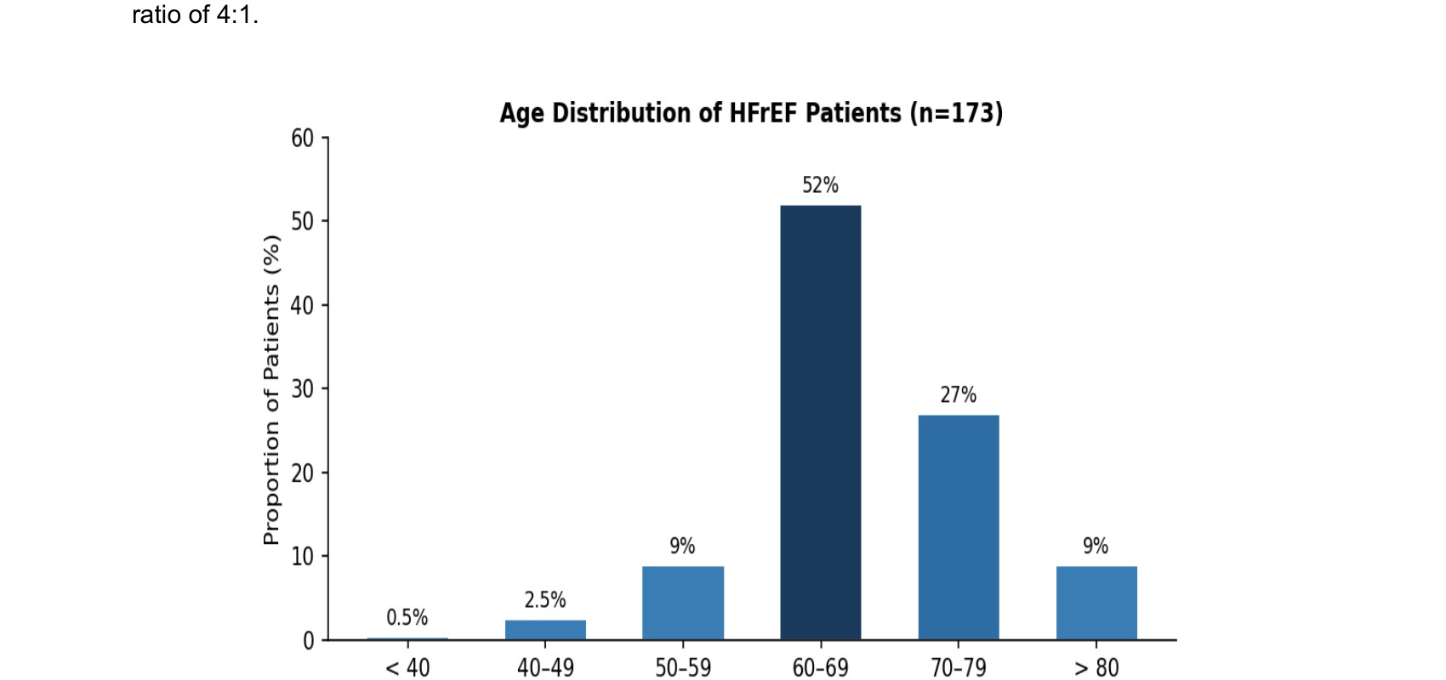

Figure 1. Age distribution of HFrEF patients (n = 173). The 60–69 year group accounts for the largest proportion
(52%).

4.2 Cardiovascular Risk Factors
Table 1 summarizes the distribution of modifiable cardiovascular risk factors. Sedentary lifestyle was the most prevalent risk factor, affecting 147 patients (85%), followed by smoking in 91 patients (53%), type 2 diabetes mellitus (T2DM) in 78 patients (45%), arterial hypertension (AHT) in 58 patients (33%), and dyslipidemia in 57 patients (33%). Obesity (BMI ≥ 30 kg/m²) was found in only 8% of patients, and no patient had a documented family history of coronary artery disease.
The high prevalence of sedentary lifestyle (85%) is particularly notable. This risk factor, defined as less than 150 minutes of moderate-intensity physical activity per week, is recognized as an independent predictor of HFrEF incidence and adverse outcomes [14]. In the context of Morocco, rapid urbanization and the adoption of increasingly sedentary occupational and leisure behaviors have contributed to this trend. Sedentary behavior in this cohort likely operates both as a primary risk factor and as a potentiating cofactor for other metabolic conditions such as T2DM and obesity.
Sex-stratified analysis (Figure 2) revealed that all major cardiovascular risk factors were more prevalent in men, consistent with the overall male predominance of the cohort. Smoking was predominantly a male risk factor (91 male vs. 0 female smokers), consistent with known patterns of tobacco use in Morocco.

Table 1. Distribution of modifiable cardiovascular risk factors in the study population.

Risk Factor | n | %
Sedentary lifestyle | 147 | 85%
Smoking | 91 | 53%
Type 2 Diabetes Mellitus | 78 | 45%
Hypertension | 58 | 33%
Dyslipidemia | 57 | 33%
Obesity (BMI ≥ 30 kg/m²) | 14 | 8%
Family history of CAD | 0 | 0%

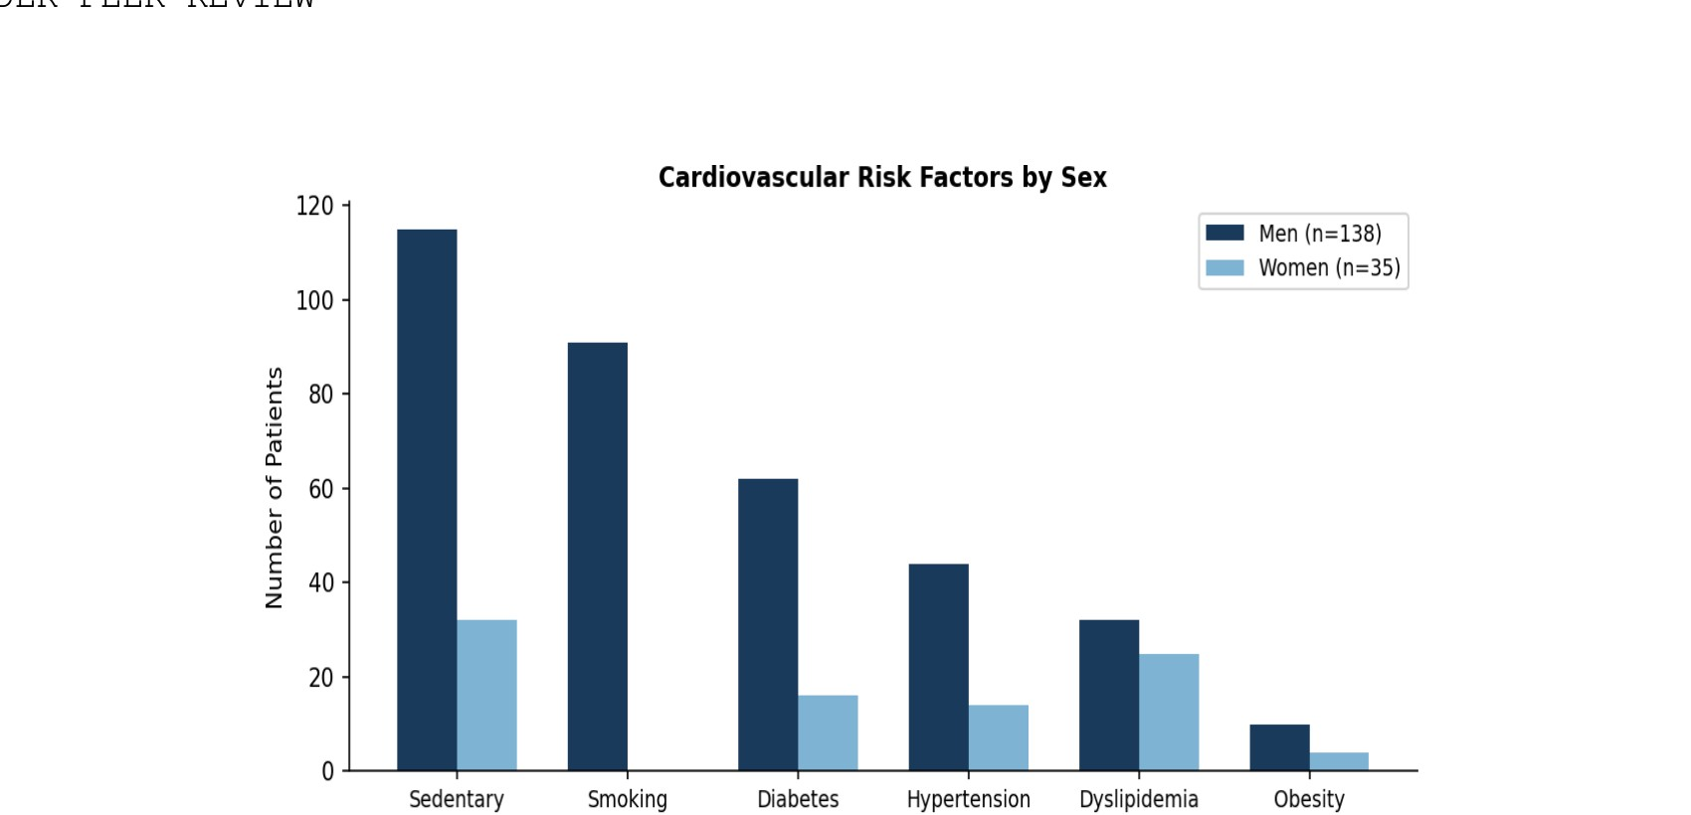

Figure 2. Distribution of modifiable cardiovascular risk factors stratified by sex.

4.3 Comorbidities
The distribution of comorbidities is presented in Table 2. The most frequent comorbidities were anemia (45%), prior ischemic cardiomyopathy (41.6%), renal failure (36%), valvular heart disease (18%), and rhythm disorders (6.3%). COPD and OSAS were present in 4% and 3% of patients, respectively. The simultaneous presence of anemia and renal failure in a substantial proportion of patients creates a complex clinical picture that complicates pharmacological management and is associated with worse prognosis in HFrEF.

Table 2. Distribution of comorbidities in the study population.

Comorbidity | n | %
Anemia (Hb < 12 g/dL women, < 13 g/dL men) | 78 | 45%
Prior ischemic cardiomyopathy (CMI) | 72 | 41.6%
Renal failure (CKD) | 62 | 36%
Valvular heart disease | 31 | 18%
Rhythm disorders | 11 | 6.3%
COPD | 7 | 4%
OSAS | 5 | 3%

5. Discussion

Our study provides a detailed epidemiological characterization of HFrEF in a military hospital setting in Morocco. The mean age of 67.9 years is consistent with data from the ESC-HF-LT registry (mean
66 years) [10] and the INTER-CHF study [12], suggesting that HFrEF predominantly affects the elderly in both Western and MENA populations. However, the striking male predominance observed in our cohort (80%) is notably higher than in European registries (approximately 60–65% male) [10,13], possibly reflecting the military nature of the study population and known sex disparities in risk factor exposure in this region.
The high prevalence of smoking (53%) in our cohort is alarming and aligns with reports from the WHO documenting high tobacco use rates in North Africa [15]. Morocco has one of the higher smoking prevalence rates in the MENA region, with tobacco use disproportionately affecting men. Smoking is a well-established independent risk factor for the development of HFrEF through its pro-atherogenic, pro-inflammatory, and direct cardiotoxic effects. The implementation of comprehensive tobacco cessation programs at both the healthcare and policy level is therefore a public health priority.
The 45% prevalence of T2DM in our cohort is substantially higher than in European cohorts (~30%) [10], reflecting the epidemiological transition in Morocco and the burden of metabolic syndrome in this population. Diabetes mellitus contributes to HFrEF through multiple mechanisms, including diabetic cardiomyopathy, accelerated coronary artery disease, and neurohormonal dysregulation. Improved glycemic control through structured diabetes care programs could therefore have a meaningful impact on HFrEF prevention in this context.
Sedentary lifestyle, affecting 85% of patients, is particularly concerning. Physical inactivity is an independent risk factor for both HF incidence and worse outcomes [14]. In this cohort, sedentary behavior was defined as less than 150 minutes of moderate-intensity physical activity per week per WHO guidelines. It was the single most prevalent risk factor, exceeding smoking and diabetes. This finding underscores the importance of integrating physical activity promotion into cardiovascular prevention programs in Morocco, both as a primary preventive measure and as part of cardiac rehabilitation for established HFrEF.
The co-occurrence of anemia (45%) is well-documented in HFrEF and is associated with worse functional status, increased hospitalization rates, and higher mortality [16]. Iron deficiency anemia, in particular, has emerged as a therapeutic target, with ferric carboxymaltose demonstrating improvements in exercise capacity and quality of life [17].
Renal failure (36%) further complicates management, as it limits use of renin-angiotensin-aldosterone system inhibitors and increases the risk of cardiorenal syndrome [18]. The high prevalence of both anemia and renal failure in this cohort likely reflects the advanced age and high comorbidity burden of the population, and points to the need for integrated cardiorenal management pathways.
Prior ischemic cardiomyopathy was present in 41.6% of patients, making it one of the most common identified etiologies in this cohort. This is consistent with global trends, as ischemic cardiomyopathy remains the leading cause of HFrEF in countries undergoing epidemiological transition [19]. However, it is lower than rates reported in some European registries (~60%) [10], suggesting that other etiologies—including hypertensive and idiopathic dilated cardiomyopathy—remain significant contributors in the Moroccan context.
These findings support the hypothesis that effective HFrEF prevention in Morocco and similar settings must begin with aggressive management of traditional risk factors—particularly smoking cessation programs, improved glycemic control, antihypertensive treatment optimization, and promotion of physical activity at the population level.

6. Limitations

This study has several limitations that should be considered when interpreting the findings. First, the retrospective single-center design inherently limits the completeness of data collection and may be subject to selection bias. Second, the study was conducted at a military hospital, and the predominantly male, active-duty and retired military population may not be fully representative of the general Moroccan population with HFrEF. Third, only descriptive statistics were performed; the absence of inferential statistical analysis (e.g., multivariable logistic regression) limits the ability to identify independent predictors of clinical outcomes.

7. Conclusion

HFrEF at the Avicenne Military Hospital predominantly affects elderly men with multiple modifiable cardiovascular risk factors, particularly sedentary lifestyle, smoking, and diabetes mellitus. These results underscore the importance of primary and secondary cardiovascular prevention programs tailored to the Moroccan context. Future prospective multicenter studies are needed to generate nationally representative data to guide evidence-based policy.

Ethical Approval:

As per international standards or university standards written ethical approval has been collected and preserved by the author(s).

Disclaimer (Artificial intelligence)
Author(s) hereby declare that NO generative AI technologies such as Large Language Models (ChatGPT, COPILOT, etc.) and text-to-image generators have been used during the writing or editing of this manuscript.

References

1. McDonagh TA, Metra M, Adamo M, et al. 2021 ESC Guidelines for the diagnosis and treatment of acute and chronic heart failure. Eur Heart J. 2021;42(36):3599–3726.
2. Savarese G, Lund LH. Global public health burden of heart failure. Card Fail Rev. 2017;3(1):7–11.
3. Savarese G, Becher PM, Lund LH, et al. Global burden of heart failure: a comprehensive and updated review of epidemiology. Cardiovasc Res. 2023;118(17):3272–3287.
4. Ponikowski P, Anker SD, AlHabib KF, et al. Heart failure: preventing disease and death worldwide. ESC Heart
Fail. 2014;1(1):4–25.
5. McDonagh TA, Metra M, Adamo M, et al. 2023 Focused Update of the 2021 ESC Guidelines for the diagnosis and treatment of acute and chronic heart failure. Eur Heart J. 2023;44(37):3627–3639.
6. Roger VL. Epidemiology of heart failure. Circ Res. 2021;128(10):1421–1434.
7. Dokainish H, Teo K, Zhu J, et al. Global mortality variations in patients with heart failure: results from the
International Congestive Heart Failure (INTER-CHF) prospective cohort study. Lancet Global Health.
2017;5(7):e665–e672.
8. Boutayeb A, Boutayeb S. The burden of noncommunicable diseases in developing countries. Int J Equity
Health. 2005;4(1):2.
9. Boutayeb W, Lamlili EN, Boutayeb A. Cardiovascular disease risk factors and burden in Morocco: a systematic review. Int J Environ Res Public Health. 2021;18(21):11357.
10. Crespo-Leiro MG, Anker SD, Maggioni AP, et al. European Society of Cardiology Heart Failure Long-Term
Registry (ESC-HF-LT). Eur J Heart Fail. 2016;18(6):613–625.
11. Lam CS, Teng TK, Tay WT, et al. Regional and ethnic differences among patients with heart failure in Asia:
the Asian sudden cardiac death in heart failure registry. Eur Heart J. 2016;37(40):3141–3153.
12. Dokainish H, Teo K, Zhu J, et al. Heart failure in low- and middle-income countries: background, rationale, and design of the INTERnational Congestive Heart Failure Study (INTER-CHF). Am Heart J.
2015;170(4):627–634.
13. Maggioni AP, Dahlström U, Filippatos G, et al. EURObservational Research Programme: the Heart Failure
Pilot Survey. Eur J Heart Fail. 2010;12(10):1076–1084.
14. Piepoli MF, Hoes AW, Agewall S, et al. 2016 European Guidelines on cardiovascular disease prevention in clinical practice. Eur Heart J. 2016;37(29):2315–2381.
15. WHO. Global Adult Tobacco Survey: Morocco Country Report. Geneva: World Health Organization; 2022.
16. Groenveld HF, Januzzi JL, Damman K, et al. Anemia and mortality in heart failure patients. J Am Coll Cardiol.
2008;52(10):818–827.
17. Ponikowski P, Kirwan BA, Anker SD, et al. Ferric carboxymaltose for iron deficiency at discharge after acute heart failure: a multicentre, double-blind, randomized, controlled trial. Lancet. 2020;396(10266):1895–1904.
18. Damman K, Valente MA, Voors AA, et al. Renal impairment, worsening renal function, and outcome in patients with heart failure: an updated meta-analysis. Eur Heart J. 2014;35(7):455–469.
19. Kobo O, Saada M, Pereg D, et al. Trends and outcomes of heart failure with reduced ejection fraction in the modern era. J Card Fail. 2024;30(1):15–22.

