Growth and biomass yield of lettuce (Lactuca sativa var. Eden) in aquaponic and conventional substrates

ABSTRACT
Background: Lettuce production is essential for food security and urban nutrition in Côte d’Ivoire, but faces challenges related to land scarcity and intensive chemical use. Aquaponics offers a sustainable alternative by combining fish farming and soilless cultivation to enhance productivity with lower environmental impact.
Aims: This study aimed to evaluate the growth performance and biomass yield of lettuce (Lactuca sativa var. Eden) cultivated in an aquaponic system compared with coconut fiber enriched with poultry manure and untreated soil as alternative cultivation substrates.
Study design: A comparative experimental design involving three cultivation systems was used.
Place and Duration of Study: The experiment was conducted at the experimental facilities of the École Normale Supérieure (ENS), Abidjan, Côte d’Ivoire, over a five-week cultivation period after transplanting.
Methodology: Lettuce seedlings were transplanted into three cultivation substrates: an aquaponic system connected to Nile tilapia (Oreochromis niloticus) tanks, coconut fiber enriched with poultry manure, and untreated soil. Growth parameters (plant height, number of leaves, and leaf area) were recorded weekly for four weeks. Fresh and dry biomass yield were measured at harvest. A total of 96 plants per cultivation system were monitored, with biomass assessed on a random sample of 16 plants per treatment. Statistical analyses were performed using the Kruskal-Wallis test followed by Tukey’s test at a 5% significance level.
Results: Significant differences were observed among cultivation systems (p < 0.05). Plants grown in the aquaponic system showed the highest growth performance. Mean fresh biomass yield reached 166.79 g per plant compared with 74.62 g and 38.83 g in coconut fiber enriched with poultry manure and untreated soil, respectively. Dry biomass followed the same trend (11.27 g, 6.25 g, and 1.91 g).
Conclusion: Aquaponics represents a sustainable technique for lettuce production in urban agriculture systems with limited resources.

Keywords: aquaponics, lettuce, Oreochromis niloticus, biomass yield, urban agriculture, cultivation substrates

1. INTRODUCTION
Vegetable crops contribute significantly to food security and income generation, particularly in developing countries such as Côte d’Ivoire (Loudit et al., 2017; Ba & Cantoreggi, 2018). Among these crops, lettuce (Lactuca sativa) plays an important role in supplying urban markets with fresh vegetables. This plant, commonly known as salad, is widely consumed by urban populations because of its high content of vitamins A and C. It contributes to the prevention of certain metabolic diseases such as cardiovascular diseases and diabetes, and may help protect the human body against certain types of cancer (Idogun et al., 2008; Berger et al., 2010).
Despite its importance, lettuce production remains constrained by limited access to arable land due to rapid urbanization and increasing land tenure conflicts (Olanrewaju et al., 2004). To increase vegetable production, farmers often resort to the intensive use of synthetic inputs to improve crop yields (Dembélé et al., 2008). However, this practice can lead to environmental pollution and deterioration of product quality, with potential risks to consumer health. To address these challenges, the adoption of sustainable agricultural production systems is necessary.
According to Alderman (2015), recent technological advances have contributed to significant improvements in the agricultural sector. For example, precision agriculture is transforming farming practices by integrating advanced technologies to increase productivity while reducing environmental impacts (Mulla, 2013). Among these innovations, soilless cultivation techniques such as hydroponics and aeroponics have demonstrated strong potential for market gardening in Côte d’Ivoire, offering advantages such as efficient water use, reduced land requirements, and improved production stability.
In this context, aquaponics represents an innovative and sustainable agricultural production system. This technique, derived from integrated agro-aquaculture systems, combines aquaculture, particularly fish farming, with plant cultivation (Gooley & Gavine, 2003). In this circular system, fish waste is converted into nutrients for plants, while plants contribute to water purification before its recirculation into fish tanks. The combined use of water and nutrients allows the simultaneous production of fish and plants within the same system (Guezi et al., 2020). Aquaponics is therefore considered a promising approach for producing high-quality crops while minimizing environmental impacts (Bouhenni & Chabani, 2018).
The objective of this study was to evaluate the growth and biomass yield of lettuce (Lactuca sativa var. Eden) cultivated in an aquaponic system compared with coconut fiber enriched with poultry manure and untreated soil.

2. MATERIAL AND METHODS
2.1. Material
The biological material used in this study consisted of Nile tilapia (Oreochromis niloticus) obtained from the experimental facilities of the École Normale Supérieure (ENS), Abidjan, and commercial seeds of lettuce (Lactuca sativa var. Eden).

2.2. Methods
2.2.1. Fish production in the aquaponic system
For the experiment, a stocking density of 10 kg m⁻³ of water was maintained (Somerville et al., 2014). The fish were fed three times per day with commercial pellet feed corresponding to approximately 3% of their body weight, in accordance with the recommendations of Somerville et al. (2023).
2.2.2. Production of lettuce seedlings
Seedlings used in the aquaponic system were obtained from germinated lettuce seeds sown in a nursery substrate composed of coconut fiber enriched with poultry manure. The substrate was placed in a seedling tray maintained at a temperature between 20 and 25 °C. Moisture was maintained by spraying tap water regularly every two days. Germination occurred seven days after sowing.
2.2.3. Cultivation of lettuce plants in the aquaponic system
Transplanting was carried out when seedlings had four to five true leaves, approximately four weeks after sowing (Fig. 1).
Seedlings were carefully removed from the germination trays, and their roots were gently washed with tap water to remove residual substrate. Each seedling was then placed in a perforated plastic net cup allowing root contact with circulating nutrient-rich water from the fish tank. Expanded clay balls were added around the seedlings to stabilize the plants inside the cups.
The cups were inserted into PVC growing channels perforated at regular intervals, allowing the roots to remain in continuous contact with the circulating nutrient solution (Fig. 2). Leaves were lightly sprayed with tap water immediately after transplanting to reduce transplant shock.
The experimental design consisted of a homogeneous block containing lettuce plants spaced at 20 cm × 20 cm. A total of 96 lettuce plants were used in the aquaponic system.
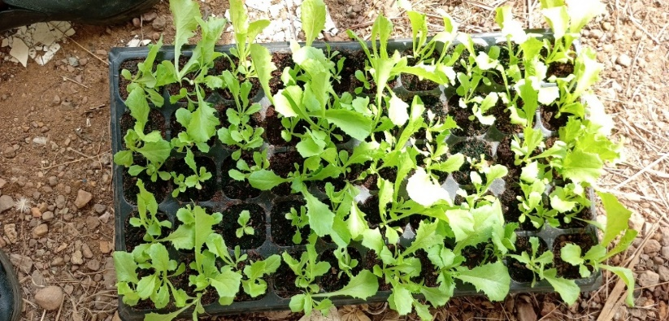
Fig. 1. Four-week-old lettuce seedlings ready for transplanting into the cultivation systems
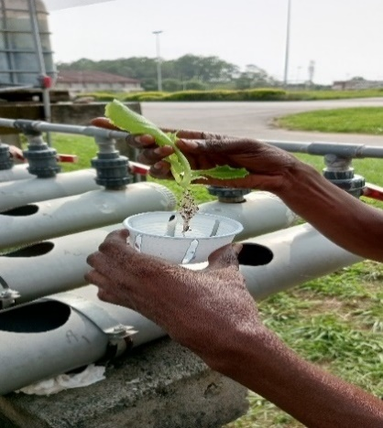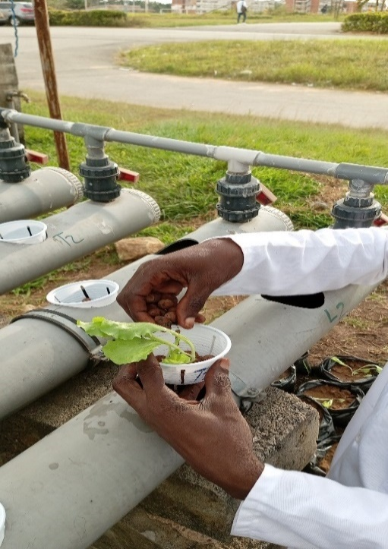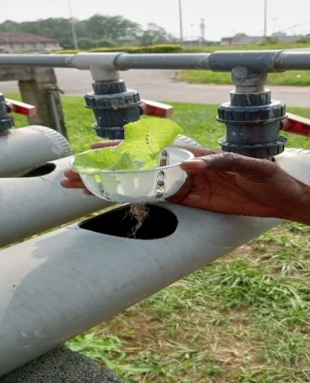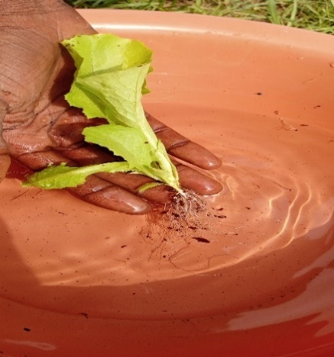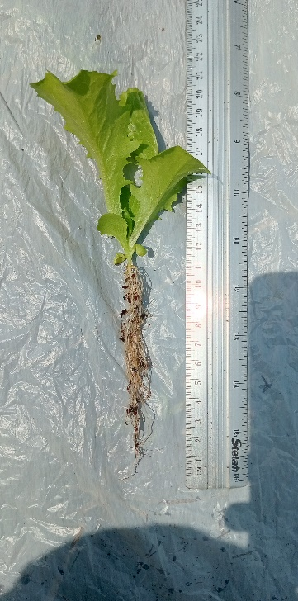
CCCCCC
D
E
A
BBCCCCC
Fig. 2. Steps involved in transplanting lettuce seedlings into aquaponic growing channels
A: Lettuce seedling with roots washed to remove substrate residues before transplanting; B: Cleaned root system of the lettuce seedling prior to placement in the net cup; C: Seedling positioned in a perforated net cup; D: Seedling stabilized with expanded clay balls in the net cup; E: Seedling ready for installation in the aquaponic growing channel with roots extending below the cup.

2.2.4. Cultivation of lettuce plants in alternative substrates
Untreated soil and coconut fiber enriched with poultry manure were used as two additional substrates for comparison. These substrates were placed in polyethylene growing bags. Seedlings of the same variety used in the aquaponic system were transplanted individually into these substrates. The plants were maintained under a shade-house structure and irrigated with tap water when necessary. Maintenance operations consisted mainly of regular watering and manual weeding once per week.

2.2.5. Data collection and measurement of growth and biomass parameters
Data were collected on 96 plants per cultivation system. Measurements began one week after transplanting, once the plants had resumed active growth. Growth parameters were recorded weekly for four consecutive weeks in order to evaluate plant development under the different cultivation conditions.
The parameters measured included:
- plant height, measured using a graduated ruler from the collar to the tip of the highest leaf (Bozena et al., 2023);
- number of leaves per plant, recorded according to the procedure described by Love et al. (2023);
- leaf area, estimated using an empirical formula (length × width × correction factor) as described by Chimi et al. (2023).
At the end of the experimental period (five weeks after transplanting), biomass production was evaluated. Plants were carefully harvested manually, including the entire root system, and separated at the collar into shoot and root fractions using scissors. Harvesting was carried out early in the morning to minimize water loss and preserve leaf freshness.
Fresh biomass was immediately determined using a precision electronic balance (accuracy: 0.0001 g). The samples were then dried in a ventilated oven at 60 °C until constant weight was obtained, corresponding to dry biomass (Love et al., 2023).
For biomass determination, sixteen (16) plants were randomly selected from each cultivation system.

2.2.6. Statistical analysis
Statistical analyses were performed using XLSTAT version 2014 software. Descriptive statistics (means and standard deviations) were calculated for all measured parameters. Differences among cultivation systems were analyzed using the Kruskal-Wallis non-parametric test. When significant differences were observed, Tukey’s honestly significant difference (HSD) test was applied to separate treatment means at the 5% significance level.

3- RESULTS AND DISCUSSION
3.1. Results
3.1.1. Influence of cultivation systems on the plant height in lettuce
The weekly variation in plant height of lettuce (Lactuca sativa var. Eden) under different cultivation systems is presented in Fig. 3. Plant height was consistently greater in the aquaponic system (T1) than in the other substrates throughout the experimental period. From the second week after transplanting (W2), plants grown in the aquaponic system were significantly taller than those cultivated in coconut fiber enriched with poultry manure (T2) and untreated soil (T3). This difference increased progressively over time, indicating faster vegetative growth of lettuce plants under aquaponic conditions.

Fig. 3. Weekly variation in plant height of lettuce (Lactuca sativa var. Eden) under different cultivation systems
T1: aquaponic system; T2: coconut fiber enriched with poultry manure; T3: untreated soil; W0: transplanting date; W1-W4: weeks after transplanting
3.1.2. Influence of cultivation systems on the number of leaves in lettuce
The weekly variation in the average number of leaves per plant under different cultivation systems is presented in Fig. 4. The results showed significant differences among treatments from the first week after transplanting (W1). Plants grown in the aquaponic system (T1) consistently produced the highest number of leaves throughout the experimental period, followed by those cultivated in coconut fiber enriched with poultry manure (T2), whereas plants grown in untreated soil (T3) recorded the lowest values. This trend remained consistent until the end of the observation period, indicating enhanced vegetative development under aquaponic conditions.

Fig. 4. Weekly variation in the number of leaves per plant of lettuce (Lactuca sativa var. Eden) under different cultivation systems
T1: aquaponic system; T2: coconut fiber enriched with poultry manure; T3: untreated soil; W0: transplanting date; W1-W4: weeks after transplanting.

3.1.3. Influence of cultivation systems on leaf area of lettuce
The weekly variation in leaf area of lettuce (Lactuca sativa var. Eden) under different cultivation systems is presented in Fig. 5. From the first week after transplanting (W1), plants grown in the aquaponic system (T1) showed a significantly larger leaf area than those cultivated in the other systems. Plants grown in coconut fiber enriched with poultry manure (T2) exhibited intermediate leaf area values, whereas plants grown in untreated soil (T3) recorded the lowest leaf area throughout the experimental period.

Fig. 5. Weekly variation in leaf area of lettuce (Lactuca sativa var. Eden) under different cultivation systems
T1: aquaponic system; T2: coconut fiber enriched with poultry manure; T3: untreated soil; W0: transplanting date; W1-W4: weeks after transplanting.

3.1.4. Influence of cultivation systems on biomass yield of lettuce
Fresh biomass of lettuce (Lactuca sativa var. Eden) differed significantly among cultivation systems (Fig. 6 and 7). Plants grown in the aquaponic system (T1) produced the highest fresh biomass, with an average value of 166.79 g per plant. Plants cultivated in coconut fiber enriched with poultry manure (T2) showed intermediate fresh biomass values (74.62 g), whereas plants grown in untreated soil (T3) recorded the lowest fresh biomass (38.83 g).
Similarly, dry biomass also varied significantly among cultivation systems (Figure 8). Plants grown in the aquaponic system (T1) accumulated the highest dry biomass (11.27 g per plant), followed by those cultivated in coconut fiber enriched with poultry manure (T2) (6.25 g), whereas plants grown in untreated soil (T3) showed the lowest dry biomass (1.91 g).

Fig. 6. Fresh biomass of lettuce (Lactuca sativa var. Eden) under different cultivation systems
T1: aquaponic system; T2: coconut fiber enriched with poultry manure; T3: untreated soil; Bars represent mean ± standard deviation (n = 16)

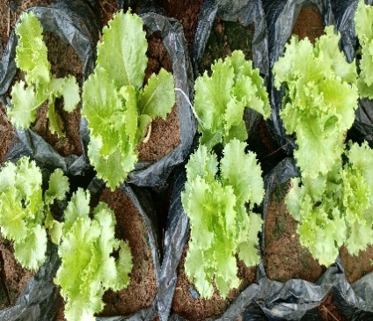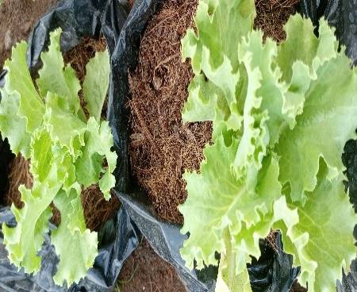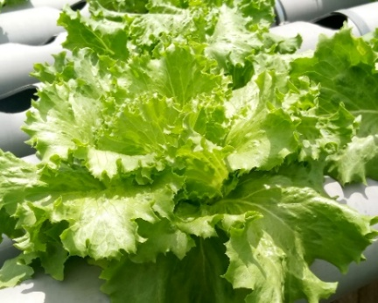
C
B
A
Fig. 7. Visual comparison of lettuce (Lactuca sativa var. Eden) growth after five weeks under different cultivation systems
A: Plants grown in the aquaponic system (T1); B: Plants grown in coconut fiber enriched with poultry manure (T2); C: Plants grown in untreated soil (T3).

3.1.5. Dry biomass of Lettuce plants
The dry biomass indicator, which reflects the amount of material produced by the plant, revealed significant disparities between the cultivation systems tested. Plants grown in aquaponics (T1) showed the highest accumulation of dry biomass (11.27 g), followed by those grown on coconut fiber and poultry manure (T2) with 6.25 g, while those planted in soil (T3) had the lowest value (1.91 g) (Fig. 8).

Fig. 8. Dry biomass of lettuce (Lactuca sativa var. Eden) under different cultivation systems
T1: aquaponic system; T2: coconut fiber enriched with poultry manure; T3: untreated soil; Bars represent mean ± standard deviation (n = 16)

3.2. Discussion
The results obtained in this study revealed significant differences among the three cultivation systems tested (aquaponic system, coconut fiber enriched with poultry manure, and untreated soil) in terms of growth and biomass production parameters of lettuce (Lactuca sativa var. Eden).
The aquaponic system promoted significantly greater vegetative growth, characterized by taller plants, a higher number of leaves, and larger leaf area. This performance can be explained by the continuous availability of nutrients, particularly nitrates derived from the nitrification of fish waste, as well as by a stable and well-oxygenated root environment. The work of Rakocy et al. (2006) supports the results of this study, showing that aquaponic systems provide plants with a balanced and continuous nutrient supply that promotes vigorous growth. Similarly, Somerville et al. (2014) highlighted the effectiveness of this integrated system for producing short-cycle vegetables such as lettuce. Furthermore, Goddek et al. (2015) reported that properly managed aquaponic systems provide optimal conditions for plant growth by reducing stress related to nutrient deficiencies or excesses. In addition, water oxygenation in aquaponic systems improves root development and enhances nutrient uptake efficiency (Endut et al., 2010).
The cultivation system combining coconut fiber with poultry manure resulted in intermediate plant growth performance compared with the aquaponic system and untreated soil. This observation is consistent with the findings of Gruda (2009), who reported that organic substrates can support satisfactory plant growth but require careful nutrient management to maintain stable yields.
Coconut fiber likely promoted root development due to its high porosity and water retention capacity. Previous studies, such as Rodrigo et al. (2018), demonstrated that coconut fiber combined with organic fertilization represents an effective alternative growing medium, particularly in urban and peri-urban agriculture. Poultry manure supplied essential nutrients such as nitrogen, phosphorus, and potassium; however, their availability depends on a relatively slow mineralization process, which may explain the lower growth performance observed compared with the aquaponic system. Similar observations were reported by Edadah et al. (2016), who emphasized that nutrients from organic substrates are released more gradually than those supplied in dissolved form.
In contrast, lettuce cultivated in untreated soil showed the lowest growth performance. This result can be attributed to limited nutrient availability due to the absence of soil amendment. In addition, untreated soils are often subject to physical constraints such as compaction and poor aeration, as well as water limitations caused by rapid drying, which can restrict root development. These findings are consistent with FAO (2013), which reported that nutrient-poor tropical soils generally do not support optimal yields, particularly for short-cycle vegetable crops such as lettuce.
Regarding biomass production, the aquaponic system produced the highest fresh and dry biomass values, reflecting improved plant growth conditions. These results are consistent with those reported by Shete & Verma (2012) and Rakocy et al. (2006), who showed that aquaponic systems enhance plant productivity by improving nutrient availability and reducing water stress. Similarly, Nozzi et al. (2018) reported faster vegetative development of lettuce cultivated in aquaponic systems compared with soil-based cultivation. Yep & Zheng (2019) also demonstrated that aquaponics improves water and nutrient use efficiency while reducing environmental impacts.
Overall, these results indicate that the aquaponic system provides a highly efficient agroecological production environment, combining nutrient recycling, reduced fertilizer inputs, and improved water use efficiency. Although untreated soil showed the lowest performance, the use of coconut fiber enriched with poultry manure represents a promising alternative cultivation substrate, provided that nutrient availability is carefully managed. These findings are consistent with Gravel et al. (2013), who emphasized the importance of substrate selection and nutrient management in soilless cultivation systems.

4. CONCLUSION
This study evaluated the growth and biomass production of lettuce (Lactuca sativa var. Eden) cultivated in an aquaponic system compared with coconut fiber enriched with poultry manure and untreated soil. The results showed that the aquaponic system significantly improved plant height, number of leaves, leaf area, and fresh and dry biomass compared with the other cultivation substrates. The superior performance observed in the aquaponic system highlights its effectiveness as a sustainable farming technique, capable of optimizing resource use through nutrient recycling and reduced reliance on synthetic fertilizers. Coconut fiber, enriched with poultry manure, also yielded satisfactory results and represents a promising alternative substrate, although its use requires proper nutrient management. These findings suggest that aquaponic systems constitute a suitable solution for sustainable lettuce production in urban and peri-urban areas, particularly in regions facing constraints related to land availability and agricultural inputs. Therefore, the adoption of aquaponic cultivation systems could contribute to improving vegetable production and strengthening food security in resource-limited environments.
However, biochemical and chemical analyses would be needed to evaluate the quality of lettuce grown using aquaponics. In addition, a comparison of lettuce production using different aquaponic systems would help us to determine the best system.
Disclaimer (Artificial Intelligence)
Author(s) hereby declare that no generative AI technologies such as Large Language Models (ChatGPT, COPILOT, etc.) and text-to-image generators have been used during the writing or editing of this manuscript.

Ethical Approval
All applicable institutional guidelines for the care and use of experimental animals were followed during the study.

REFERENCES
Alderman, S. (2015). The practicality and sustainability of aquaponic agriculture versus traditional agriculture with emphasis on application in the Middle East, Honors thesis, Texas State University.
Ba, A., & Cantoreggi, N. (2018). Agriculture urbaine et périurbaine (AUP) et économie des ménages agri-urbains à Dakar (Sénégal). International Journal of Environment, Agriculture and Biotechnology, 3(1), 195-207. http://dx.doi.org/10.22161/ijeab/3.1.25
Berger, C. N., Sodha, S. V., Shaw, R. K., Griffin, P. M., Pink, D., & Hand, P. (2010). Fresh fruit and vegetables as vehicles for the transmission of human pathogens. Environmental Microbiology, 12, 2385-2397. https://doi.org/10.1111/j.1462-2920.2010.02297.x
Bouhenni, K. I., & Chabani, R. (2018). Réalisation d’une micro-ferme aquaponique et développement d’une application de gestion commerciale pour les projets d’aquaponie. Master thesis, Université Abou Bekr Belkaid-Tlemcen, Algérie.
Bozena, M., Stanisław, K., & Monika, M. (2023). Growth and quality of leaf lettuce and romaine lettuce in aquaponic systems. Agriculture, 13(2), 1-13. https://doi.org/10.3390/agriculture13040897
Chimi, A. N., Lekeufack, M., Fowoung, D., Fotsa, J. M., Tanetsa, A. E. M., & Edzigui, M. L. T. (2023). Valorisation des eaux usées domestiques en agriculture urbaine par la culture hydroponique de la laitue (Lactuca sativa). Cameroon Journal of Experimental Biology, 17(2), 40-46. DOI:10.4314/cajeb.v17i2.7
Dembélé, A., Oumarou, B., Traore, S. K., Mamadou, K., Coulibaly, D. T., & Abba, T. (2008). The chemical control of pests in truck farming and the quality of vegetables in African urban cities: Health hazards and consumer safety. European Journal of Scientific Research, 20(4), 836-843.
Edadah, N. A., Abdulrazzaq, A. A., & Odah, H. A. (2016). Effect of organic and inorganic fertilizers on growth and yield of lettuce (Lactuca sativa L.). International Journal of Agricultural Science and Research, 2016, 6(4), 11-18.
Endut, A., Jusoh, A., Ali, N., Nik, W.W., & Hassan, A. (2010). A study on the optimal hydraulic loading rate and plant ratios in recirculation aquaponic system. Bioresource Technology, 101, 1511-1517. https://doi.org/10.101 6/j.biortech.2009.09.040
FAO. (2013). Économie des systèmes alimentaires durables: Concepts et tendances. Rome: Organisation des Nations Unies pour l’alimentation et l’agriculture. https://www.fao.org/documents/card/fr/c/3c1691b1-12f3-4f00-bcf8-6b2b0db6aa18
Goddek, S., Adélaïde, B., Mankasingh, U., Ragnarsdottir, K. V., Jijakli, H., & Thorarinsdottir, R. I. (2015). Challenges of sustainable and commercial aquaponics. Sustainability, 7(4), 4199-4224. DOI
10.3390/su7044199
Gooley, G. J., & Gavine, F. M. (2003). Integrated agri-aquaculture systems: A resource handbook for Australian industry development. Barton, ACT: Rural Industries Research and Development Corporation (RIRDC), Publication No. 03/012.
Gravel, V., Dorais, M., & Ménard, C. (2013). Organic potted plants amended with biochar: Its effect on growth and Pythium colonization. Canadian Journal of Plant Science, 93(6), 1217-1227. https://doi.org/10.4141/cjps2013-315
Gruda, N. (2009). Do soilless culture systems influence product quality of vegetables? Journal of Applied Botany and Food Quality, 82(2), 141-147.
https://edoc.hu-berlin.de/server/api/core/bitstreams/d76288d7-b2b9-47bf-951c-365fa76d5ad9/content
Guezi, R., Ben Hadjira, M., Mekhloufi, I., & Faklou, N. E. (2020). Durabilité et particularité d’un système aquaponique. Master thesis, Université Kasdi-Merbah, Ouargla, Algérie.
Idogun, E. S., Famodu, A. A., Olasunkanni, L. A., Osilesi, O., & Adebawo, O. O. (2008). Effects of fruits and vegetables on electrolytes and blood pressure of hypertensive patients in Nigeria. African Journal of Food, Agriculture, Nutrition and Development, 8(3), 349-357. DOI:10.4314/ajfand.v8i3.19197
Loudit, S. M. B., Ndong, A. N., & Francis, F. (2017). Le maraîchage périurbain à Libreville et Owendo (Gabon): Pratiques culturales et durabilité. Cahiers Agricultures, 26, 45002. https://doi.org/10.1051/cagri/2017026
Love, D. C., Uhl, M. S., & Genello, L. (2023). Performance of lettuce in closed-loop aquaponics. Hort Science, 58(6), 719-726.
Mulla, D. J. (2013). Twenty-five years of remote sensing in precision agriculture: Key advances and remaining knowledge gaps. Biosystems Engineering, 114(4), 358-371. http://dx.doi.org/10.1016/j.biosystemseng.2012.08.009
Nozzi, V., Graber, A., Schmautz, Z., Mathis, A., & Junge, R. (2018). Nutrient management in aquaponics: Comparison of three approaches for cultivating lettuce, mint and mushroom herb. Agronomy, 8(3), 27. https://doi.org/10.3390/agronomy8030027
Olanrewaju, B. S., Moustier, P., Mougeot, L. J. A., & Fall, A. S. (2004). Développement durable de l’agriculture urbaine en Afrique francophone: Enjeux, concepts et méthodes. Montpellier: CIRAD; Ottawa: CRDI. https://www.idrc.ca/fr/livres/developpement-durable-de-lagriculture-urbaine-en-afrique-francophone-enjeux-concepts-et
Rakocy, J. E., Masser, M. P., & Losordo, T. M. (2006). Recirculating aquaculture tank production systems: Aquaponics integrating fish and plant culture. Southern Regional Aquaculture Center Publication.
Rodrigo, A. J., Luciano O. G., Fabricio, C. O., Rodrigo C. S., & Elton, A. S. M. (2018). Yield of lettuce grown in aquaponic system using different substrates. Revista Brasileira de Engenharia Agrícola e Ambiental, 22(1), 27-31. DOI: http://dx.doi.org/10.1590/1807-1929/agriambi.v22n1p27-31
Shete, A. P., & Verma, A. K. (2012). Aquaponics: The new integrated farming system. African Journal of Biotechnology, 11(77), 14178-14186.
Somerville, C., Cohen, M., Pantanella, E., Stankus, A., & Lovatelli, A. (2023). Production alimentaire aquaponique à petite échelle : Élevage intégré de poissons et de plantes. FAO Document technique sur les pêches et l’aquaculture No. 589. Rome: FAO.
Somerville, C., Cohen, M., Pantanella, E., Stankus, A., & Lovatelli, A. (2014). Small-scale aquaponic food production: Integrated fish and plant farming. FAO Fisheries and Aquaculture Technical Paper No. 589. Rome: Food and Agriculture Organization of the United Nations.
Yep, B., & Zheng, Y. (2019). Aquaponic trends and challenges: A review. Journal of Cleaner Production, 228, 1586-1599. https://doi.org/10.1016/j.jclepro.2019.04.290

