Transient Velocity Analysis of Three-Phase Immiscible Maxwell Fluids in Clear and Porous Cylindrical Media

Abstract
The transient flow behaviour of three immiscible fractional Maxwell fluids in a cylindrical domain was investigated. The domain comprises a central clear region and two surrounding porous layers. An incompressible and one-dimensional flow is assumed. This flow is driven by a quick, unexpected motion of the cylinder. A viscoelastic memory effect was captured by using fractional relations to formulate the governing equations. These equations are then non-dimensionalised to introduce parameters such as the Reynolds and Darcy numbers, porosity coefficient, and relaxation time. An analytical solution of the resulting system of equations using Olayiwola’s Generalised Polynomial Approximation Method (OGPAM) is presented. Velocity expressions are obtained for each region and used in the analysis of the effects of inertia, permeability, porosity, and viscoelastic memory on the fluid's motion. Graphical summaries using Maple 2018 reveal that velocity increases in the clear region and decreases in the porous layers due to the effect of resistance. Flow velocity is enhanced with the increase in Reynolds and Darcy numbers, while fluid motion in the porous region is aided by higher porosity. The importance of memory effects in viscoelasticity is emphasised as relaxation time significantly influences transient behaviour. The model is physically consistent, as continuity of velocity across interfaces is maintained. The study demonstrates the effectiveness of OGPAM in providing semi-analytical solutions and reducing computational complexity. The study can be applied to biomedical systems, enhanced oil recovery processes, and porous media flow.
Keywords: Transient, Velocity, Analysis, Immiscible, Clear, Porous, Cylindrical.
1. Introduction
Given its wide-ranging applications in research, medicine, geophysics, industry, petroleum engineering, and hydrogeology, the investigation of the concurrent flow of two or more immiscible fluids in porous and transparent media remains of significant importance [1, 24–26]. Such processes are encountered in diverse contexts, including oil recovery, blood flow in capillary vessels, equipment cleaning, the transport of biofilms and mucus within living systems, atmospheric carbon dioxide sequestration, groundwater management, crude oil transport through pipelines, bubble formation in microfluidic systems, and bubble-train flow in various complex porous structures. There are numerous ways for two immiscible fluids to flow, including layers, fingers, encapsulated regimes, and drops [23, 27, 28]. One limitation of investigating the flows of two immiscible fluids is the occurrence of an unknown interface in the region of our interest, such as the interface's transfer from one location to another, even though it occasionally observes severe deformations, such as a breakdown. Yih [5] used the long-wave technique to investigate the linear stability of the viscoelastic two-layered planar Poiseuille and Couette flows. He noted that interfacial Kelvin-Helmholtz instability can result from both density and viscosity stratification. The stability and instability of two-layer or multi-layer immiscible fluid flow have since been investigated by a number of researchers [2-5]. Herve Le Meur [6] examined the existence and uniqueness of the multi-layered Poiseuille/Couette fluid flow in pipes and channels and found that the viscosity ratios and the interpolated Oldroyd derivative parameter are important for a unique solution. In their stability analysis, Kalogirou and Blyth [7] considered Couette–Poiseuille flow of two superposed fluid layers, with surfactants present in the lower layer and adsorbed at the interface. It was observed that the flow remains stable when the thickness ratio is substantially larger than the viscosity ratio, provided that the surfactant exhibits suitable solubility. In [17], a continuum-level formulation was developed for incompressible, simultaneous two-layer flow in porous media, yielding a system of equations relating the seepage velocities of the fluid constituents under conditions where differentiation is well-defined. Furthermore, the study in [18] investigated the characteristics of fully developed fluid flow in porous media, including the case of three-layer simultaneous flow systems. It has been observed that the Reynolds number and Darcy's number play a significant part in the flow velocity. Kim et al. used a hybrid approach to study the two-layered immiscible Couette flow in [8]. The heat transfer and fluid velocity of the two-layer immiscible fluid in the presence of a pressure-type die were examined by Khan et al. in [9]. Power-law fluid, an inelastic fluid, fills the first layer, while Phan-Thien-Tanner fluids, a viscoelastic fluid, fill the second layer. Intriguing results on single-phase fluid flow as well as the simultaneous flow of two or more fluids can be found in [10–16]. Sudaozhi et al. [31] presented a comprehensive investigation of Maxwell fluid flow over a broad range of geometries, including, but not limited to, stretching sheets, vertical plates, inclined plates, cylinders, and channels. The literature further reports a variety of fractional differential operators, such as the Caputo–Fabrizio fractional derivative [19], the Riemann–Liouville fractional integral and derivative [21], the Caputo fractional derivative [21], and the Yang–Srivastava–Machado fractional derivative. The modelling of complex systems using fractional-order differential and integral operators has found applications across numerous scientific disciplines, including geophysics, biology, demography, bioengineering, physics, and mathematics [19]. In science, engineering, and other domains, partial differential equations are the primary source of mathematical models. These models often need to be solved numerically, and in certain unique situations, analytically [2]. In numerous real-world issues involving Cartesian, Cylindrical, and Spherical coordinates, the polynomial approximation approach is used. It is one of the most straightforward and precise techniques for resolving transient conduction problems [29]. The process consists of two steps: first, choosing the appropriate temperature profile estimate, and second, turning a partial differential equation into an ordinary differential equation with time as the independent variable and average temperature as the dependent variable. The dimensionless governing equation is subjected to the procedures in [29].
The simultaneous flow of the three immiscible fractional Maxwell fluids inside the cylindrical domain has been examined in this work. Three concentric, simultaneous cylindrical layers make up the cylindrical domain. The central layer is transparent and has no porosity impact, while the outside two layers are porous. An unstable, incompressible, and one-dimensional, fully developed flow that the boundary wall's motion produces has been examined. Additionally, the linear interfacial fluid-fluid state between two successive layers has been taken into consideration. The system of equations has been nondimensionalised using some set of parameters, and Olayiwola’s Generalized Polynomial Approximation Method (OGPAM) [29] was employed to get analytical solutions for the velocities. The velocity profile for the clear region, the impacts of Reynolds number (Inertia), Darcy number (Permeability), and the porosity coefficient on velocity in the porous regions, the memory effect (Relaxation time) on fluid motion, as well as the interfacial velocity continuity, have been investigated using Maple 2018.

2. Mathematical Formulation
Here we consider the flow of a three-layered upper convective Maxwell, incompressible and immiscible fluid in a domain $r∈(0,h_{1}]∪(h_{1},h_{2}]∪(h_{2},h_{3}]$ inside the cylinder with radius $h=h_{1}$. The flow region is cylindrical with $z-axis$ as a flow direction. Initially, at time $t=0$, the cylinder and the fluid inside are at rest. After this instant, the cylinder moves with velocity $U_{0}\left(h=h_{3}, t\right)=U_{0}f_{1}\left(t\right)$ along the $z$ axis (see figure). The fluids flow is caused by the movement of the cylinder in the direction of the flow. In view of the above description, the equations of motion take this form [30]:
For clear region:
$\left(1+{ℷ_{1}}^{α_{1}}cD_{t}^{α_{1}}\right)\frac{∂u_{1}}{∂t}=-\frac{∂P}{∂r}+\frac{v_{1}}{r}\frac{∂}{∂r}\left(r\frac{∂u_{1}}{∂r}\right)$ (1)
$u_{1}\left(r,0\right)=0, {\left.\frac{∂u_{1}}{∂t}\right|}_{t=0}=0, {\left.\frac{∂u_{1}}{∂r}\right|}_{r=0}=0, { \left.\frac{∂u_{1}}{∂r}\right|}_{r=h_{1}}+{\left.u\right|}_{r=h_{1}}=0$ (2)
For porous region:
$\left(1+{ℷ_{2}}^{α_{2}}cD_{t}^{α_{2}}\right)\frac{∂u_{2}}{∂t}=-\frac{∂P}{∂r}+\frac{v_{2}}{r}\frac{∂}{∂r}\left(r\frac{∂u_{2}}{∂r}\right)-\frac{v_{2}φ}{k}u_{2}$ (3)
$u_{2}\left(r,0\right)=0, {\left.\frac{∂u_{2}}{∂t}\right|}_{t=0}=0, {\left.\frac{∂u_{2}}{∂r}\right|}_{r=0}+{\left.u_{2}\right|}_{r=h_{2}}=0, { \left.\frac{∂u_{2}}{∂r}\right|}_{r=h_{2}}+{\left.u\right|}_{r=h_{2}}=0$ (4)
$\left(1+{ℷ_{3}}^{α_{3}}cD_{t}^{α_{3}}\right)\frac{∂u_{3}}{∂t}=-\frac{∂P}{∂r}+\frac{v_{3}}{r}\frac{∂}{∂r}\left(r\frac{∂u_{2}}{∂r}\right)-\frac{v_{3}φ}{k}u_{3}$ (5)
$u_{3}\left(r,0\right)=0, {\left.\frac{∂u_{3}}{∂t}\right|}_{t=0}=0, {\left.\frac{∂u_{3}}{∂r}\right|}_{r=h_{2}}+{\left.u_{3}\right|}_{r=h_{2}}=0, { \left.u_{3}\right|}_{r=h_{3=h}}=u_{0}f_{1}\left(t\right)$ (6)
$cD_{t}^{α_{2}}σ=\left\{\begin{aligned}\frac{{\dot{σ^{*}}t}^{-α_{i}}}{⌈\left(1-α_{i}\right)}, α_{i}∈\left(0,1\right) \\ \dot{σ^{*}}δ\left(t\right), α_{i}=1\end{aligned}\right.$ (7)
$i=1,2,3 \dot{σ^{*}} =\frac{∂σ^{*}}{∂t}$
3. Solution:
We non-dimensionalise equations (1) to (7) using the following dimensionless variables:
$\acute{r}=\frac{r}{h}, \acute{t}=\frac{U_{0}t}{h}, φ_{1}=\frac{u_{1}}{U_{0}}, φ_{2}=\frac{u_{2}}{U_{0}}, φ_{3}=\frac{u_{3}}{U_{0}} , \acute{P=}\frac{P}{ρU_{0}^{2}}, d_{1}=\frac{h_{1}}{h} , d_{2}=\frac{h_{2}}{h}$ (8)
Equation (1) becomes:
$\left(1+{ℷ_{1}}^{α_{1}}cD_{t}^{α_{1}}\right)\frac{\acute{U_{0}}}{h}\frac{∂φ_{1}}{∂\acute{t}}=-\frac{\acute{{ρU}_{0}}}{ρh}\frac{∂\acute{P}}{∂\acute{r}}+\frac{v_{1}U_{0}}{h^{2}}.\frac{1}{\acute{r}} \frac{∂}{∂\acute{r}}\left(\acute{r}\frac{∂φ_{1}}{∂\acute{r}}\right)$ (9)
$\left(1+{ℷ_{1}}^{α_{1}}cD_{t}^{α_{1}}\right)\frac{∂φ_{1}}{∂\acute{t}}=-\frac{∂\acute{P}}{∂\acute{r}}+\frac{v_{1}}{hU_{0}}.\frac{1}{\acute{r}} \frac{∂}{∂\acute{r}}\left(\acute{r}\frac{∂φ_{1}}{∂\acute{r}}\right)$ (10)
Dropping prime,
$\left(1+{ℷ_{1}}^{α_{1}}cD_{t}^{α_{1}}\right)\frac{∂φ_{1}}{∂t}=-\frac{∂P}{∂r}+\frac{1}{{Re}_{1}}.\frac{1}{r} \frac{∂}{∂r}\left(r\frac{∂φ_{1}}{∂r}\right)$ (11)
Where
${Re}_{1}=\frac{hU_{0}}{v_{1}}$, Reynold number.
Equation (2) becomes:
$U_{0}φ_{1}\left(r,0\right)=0, {\frac{U_{0}^{2}}{h}\left.\frac{∂φ_{1}}{∂\acute{t}}\right|}_{\frac{h}{U_{0}}\acute{t}=0}=0, {\frac{U_{0}}{h}\left.\frac{∂φ_{1}}{∂\acute{r}}\right|}_{h\acute{r}=0}=0, {\begin{aligned} \\ \frac{U_{0}}{h} \left.\frac{∂φ_{1}}{∂\acute{r}}\right|\end{aligned}}_{h\acute{r}=hd_{1}}+{\left.U_{0}φ_{1}\right|}_{h\acute{r}=hd_{1}}=0$
(12)
Dropping primes we have:
$φ_{1}\left(r,0\right)=0, {\left.\frac{∂φ_{1}}{∂t}\right|}_{t=0}=0, {\left.\frac{∂φ_{1}}{∂r}\right|}_{r=0}=0, {\begin{aligned} \\ a\left.\frac{∂φ_{1}}{∂r}\right|\end{aligned}}_{r=d_{1}}+{\left.φ_{1}\right|}_{r=d_{1}}=0$ (13)
Where
$a=\frac{1}{h}$ (14)
Equation (3) becomes:
$\left(1+{ℷ_{2}}^{α_{2}}cD_{t}^{α_{2}}\right)\frac{\acute{U_{0}}}{h}\frac{∂φ_{2}}{∂\acute{t}}=-\frac{\acute{{ρU}_{0}}}{ρh}\frac{∂\acute{P}}{∂\acute{r}}+\frac{v_{2}U_{0}}{h^{2}}.\frac{1}{\acute{r}} \frac{∂}{∂\acute{r}}\left(\acute{r}\frac{∂φ_{2}}{∂\acute{r}}\right)-\frac{v_{2}γU_{0}}{k}φ_{2}$ (15)
That is,
$\left(1+{ℷ_{2}}^{α_{2}}cD_{t}^{α_{2}}\right)\frac{∂φ_{2}}{∂\acute{t}}=-\frac{∂\acute{P}}{∂\acute{r}}+\frac{v_{2}}{h^{2}U_{0}}.\frac{1}{\acute{r}} \frac{∂}{∂\acute{r}}\left(\acute{r}\frac{∂φ_{2}}{∂\acute{r}}\right)-\frac{hv_{2}γ}{kU_{0}}φ_{2}$ (16)
Dropping prime, we have
$\left(1+{ℷ_{2}}^{α_{2}}cD_{t}^{α_{2}}\right)\frac{∂φ_{2}}{∂\acute{t}}=-\frac{∂P}{∂r}+\frac{1}{{Re}_{2}}.\frac{1}{r} \frac{∂}{∂r}\left(r\frac{∂φ_{2}}{∂r}\right)-\frac{γ}{{Re}_{2}Da}φ_{2}$ (17)
Where
${Re}_{2}=\frac{hU_{0}}{v_{2}} Renolds number$ $Da=\frac{k}{h^{2}} Darcey number$ $γ is porosity$
Equation (4) becomes
$U_{0}φ_{2}\left(r,0\right)=0, {\frac{U_{0}^{2}}{h}\left.\frac{∂φ_{2}}{∂\acute{t}}\right|}_{\frac{h}{U_{0}}\acute{t}=0}=0, {\frac{U_{0}}{h}\left.\frac{∂φ_{2}}{∂\acute{r}}\right|}_{h\acute{r}=h_{2}}+{\left.U_{0}φ_{2}\right|}_{h\acute{r}=h_{2}}=0, {\begin{aligned} \\ \frac{U_{0}}{h} \left.\frac{∂φ_{2}}{∂\acute{r}}\right|\end{aligned}}_{h\acute{r}=h_{2}}+{\left.U_{0}φ_{1}\right|}_{h\acute{r}=h_{2}}=0$
(18)
Dropping prime, we have
$φ_{2}\left(r,0\right)=0, {\left.\frac{∂φ_{2}}{∂t}\right|}_{t=0}=0, {a\left.\frac{∂φ_{2}}{∂r}\right|}_{r=d_{1}}+{\left.φ_{2}\right|}_{r=d_{1}}=0, {\begin{aligned} \\ a\left.\frac{∂φ_{2}}{∂r}\right|\end{aligned}}_{r=d_{2}}+{\left.φ_{2}\right|}_{r=d_{2}}=0$ (19)
Equation (5) becomes
$\left(1+{ℷ_{3}}^{α_{3}}cD_{t}^{α_{3}}\right)\frac{\acute{U_{0}}}{h}\frac{∂φ_{3}}{∂\acute{t}}=-\frac{\acute{{ρU}_{0}}}{ρh}\frac{∂\acute{P}}{∂\acute{r}}+\frac{v_{3}U_{0}}{h^{2}}.\frac{1}{\acute{r}} \frac{∂}{∂\acute{r}}\left(\acute{r}\frac{∂φ_{3}}{∂\acute{r}}\right)-\frac{v_{3}γU_{0}}{k}φ_{3}$ (20)
That is
$\left(1+{ℷ_{3}}^{α_{3}}cD_{t}^{α_{3}}\right)\frac{∂φ_{3}}{∂\acute{t}}=-\frac{∂\acute{P}}{∂\acute{r}}+\frac{v_{3}}{hU_{0}}.\frac{1}{\acute{r}} \frac{∂}{∂\acute{r}}\left(\acute{r}\frac{∂φ_{3}}{∂\acute{r}}\right)-\frac{hv_{3}γ}{kU_{0}}φ_{3}$ (21)
Dropping prime, we have
$\left(1+{ℷ_{3}}^{α_{3}}cD_{t}^{α_{3}}\right)\frac{∂φ_{3}}{∂\acute{t}}=-\frac{∂P}{∂r}+\frac{1}{{Re}_{3}}.\frac{1}{r} \frac{∂}{∂r}\left(r\frac{∂φ_{3}}{∂r}\right)-\frac{γ}{{Re}_{3}Da}φ_{3}$ (22)
Where
$${Re}_{3}=\frac{hU_{0}}{v_{3}} Renolds number$$
Equation (6) becomes
$U_{0}φ_{3}\left(\acute{r},0\right)=0, {\frac{U_{0}^{2}}{h}\left.\frac{∂φ_{3}}{∂\acute{t}}\right|}_{\frac{h}{U_{0}}\acute{t}=0}=0, {\frac{U_{0}}{h}\left.\frac{∂φ_{3}}{∂\acute{r}}\right|}_{h\acute{r}=h_{2}}+{\left.U_{0}φ_{3}\right|}_{h\acute{r}=h_{2}}=0, {\left.U_{0}φ_{3}\right|}_{h\acute{r}=h}=U_{0}f_{1}\left(\frac{h\acute{t}}{U_{0}}\right)$ (23)
Dropping prime, we have
$φ_{3}\left(r,0\right)=0, {\left.\frac{∂φ_{3}}{∂t}\right|}_{t=0}=0, {a\left.\frac{∂φ_{3}}{∂r}\right|}_{r=d_{2}}+{\left.φ_{3}\right|}_{r=d_{2}}=0, {\left.φ_{3}\right|}_{r=1}=f\left(t\right)$ (24)
Equation (7) becomes
$cD_{t}^{α_{i}}φ_{i}=\left\{\begin{aligned}\frac{t^{-α_{i}}}{⌈\left(1-α_{i}\right)}\frac{∂φ_{i}}{∂t}, α_{i}∈\left(0,1\right) \\ \\ \\ δ\left(t\right)\frac{∂φ_{i}}{∂t}, α_{i}=1\end{aligned}\right.$ $i=1,2,3$ (25)
Now, we take $α_{i}=1$and pressure gradient $\frac{∂P}{∂t}=β$, then equations (9) to (14) become
$\frac{∂φ_{1}}{∂t}+ℷ_{1}δ\left(t\right)\frac{∂}{∂t}\left(\frac{∂φ_{1}}{∂t}\right)=-β+\frac{1}{{Re}_{1}}.\frac{1}{r} \frac{∂}{∂r}\left(r\frac{∂φ_{1}}{∂r}\right)$ (26)

$φ_{1}\left(r,0\right)=0, {\left.\frac{∂φ_{1}}{∂t}\right|}_{t=0}=0, {\left.\frac{∂φ_{1}}{∂r}\right|}_{r=0}=0, {\begin{aligned} \\ a\left.\frac{∂φ_{1}}{∂r}\right|\end{aligned}}_{r=d_{1}}+{\left.φ_{1}\right|}_{r=d_{1}}=0$ (27)
$\frac{∂φ_{2}}{∂t}+ℷ_{2}δ\left(t\right)\frac{∂}{∂t}\left(\frac{∂φ_{2}}{∂t}\right)=-β+\frac{1}{{Re}_{2}}.\frac{1}{r} \frac{∂}{∂r}\left(r\frac{∂φ_{2}}{∂r}\right)-\frac{γ}{{Re}_{2}Da}φ_{2}$ (28)
$φ_{2}\left(r,0\right)=0, {\left.\frac{∂φ_{2}}{∂t}\right|}_{t=0}=0, {a\left.\frac{∂φ_{2}}{∂r}\right|}_{r=d_{1}}+{\left.φ_{2}\right|}_{r=d_{1}}=0, {\begin{aligned} \\ a\left.\frac{∂φ_{2}}{∂r}\right|\end{aligned}}_{r=d_{2}}+{\left.φ_{2}\right|}_{r=d_{2}}=0$ (29)
$\frac{∂φ_{3}}{∂t}+ℷ_{3}δ\left(t\right)\frac{∂}{∂t}\left(\frac{∂φ_{3}}{∂t}\right)=-β+\frac{1}{{Re}_{3}}.\frac{1}{r} \frac{∂}{∂r}\left(r\frac{∂φ_{3}}{∂r}\right)-\frac{γ}{{Re}_{3}Da}φ_{3}$ (30)
$φ_{3}\left(r,0\right)=0, {\left.\frac{∂φ_{3}}{∂t}\right|}_{t=0}=0, {a\left.\frac{∂φ_{3}}{∂r}\right|}_{r=d_{2}}+{\left.φ_{3}\right|}_{r=d_{2}}=0, {\left.φ_{3}\right|}_{r=1}=f\left(t\right)$ (31)
The governing equations and boundary conditions are:
Region 1: (Clear region)
$ℷ_{1}\frac{∂^{2}φ_{1}}{∂t^{2}}+\frac{∂φ_{1}}{∂t}=-β+\frac{1}{{Re}_{1}}.\frac{1}{r} \frac{∂}{∂r}\left(r\frac{∂φ_{1}}{∂r}\right)$ (32)
$φ_{1}\left(r,0\right)=0, {\left.\frac{∂φ_{1}}{∂t}\right|}_{t=0}=0, {\left.\frac{∂φ_{1}}{∂r}\right|}_{r=0}=0, {\begin{aligned} \\ a\left.\frac{∂φ_{1}}{∂r}\right|\end{aligned}}_{r=d_{1}}+{\left.φ_{1}\right|}_{r=d_{1}}=0$ (33)
$ℷ_{2}\frac{∂^{2}φ_{2}}{∂t^{2}}+\frac{∂φ_{2}}{∂t}=-β+\frac{1}{{Re}_{2}}.\frac{1}{r} \frac{∂}{∂r}\left(r\frac{∂φ_{2}}{∂r}\right)-\frac{γ}{{Re}_{2}Da}φ_{2}$ (34)
$φ_{2}\left(r,0\right)=0, {\left.\frac{∂φ_{2}}{∂t}\right|}_{t=0}=0, {a\left.\frac{∂φ_{2}}{∂r}\right|}_{r=d_{1}}+{\left.φ_{2}\right|}_{r=d_{1}}=0, {\begin{aligned} \\ a\left.\frac{∂φ_{2}}{∂r}\right|\end{aligned}}_{r=d_{2}}+{\left.φ_{2}\right|}_{r=d_{2}}=0$ (35)
$ℷ_{3}\frac{∂^{2}φ_{3}}{∂t^{2}}+\frac{∂φ_{3}}{∂t}=-β+\frac{1}{{Re}_{3}}.\frac{1}{r} \frac{∂}{∂r}\left(r\frac{∂φ_{3}}{∂r}\right)-\frac{γ}{{Re}_{3}Da}φ_{3}$ (36)
$φ_{3}\left(r,0\right)=0, {\left.\frac{∂φ_{3}}{∂t}\right|}_{t=0}=0, {a\left.\frac{∂φ_{3}}{∂r}\right|}_{r=d_{2}}+{\left.φ_{3}\right|}_{r=d_{2}}=0, {\left.φ_{3}\right|}_{r=1}=f\left(t\right)$ (37)
S…ince we have a mix of Neumann $\left(at r=0\right)$ and Dirichlet $\left(at r=1\right)$ conditions, we use case 2 of the OGPAM framework $\left(α_{1}≠0, α_{2}=0\right)$ [32].
OGPAM defines the general parabolic equation as:
$\frac{∂∅}{∂t}=\frac{k}{r^{n}}\frac{∂}{∂r}\left(r^{n}\frac{∂∅}{∂r}\right)+F\left(r,t,∅\right)$ (38)
For these cylindrical cases, $n=1$, the source terms $F$ for each region includes the pressure gradient $β$, the porosity/Darcy resistance $\left(-\frac{γ}{ReDa}φ\right)$ and the second order Maxwell time derivative $\left(-ℷ\frac{∂^{2}φ}{∂t^{2}}\right)$.
We assume OGPAM solution profile of the form:
$φ\left(r,t\right)=A\left(t\right)+B\left(t\right)r+C\left(t\right)r^{2}$ (39)
Using the boundary conditions provided in equations (33), (35) and (37).
At $r=0, \frac{∂φ_{1}}{∂r}=0$and at $r=1, φ_{3}=f\left(t\right)$, where $f\left(t\right)$ is the cylinder velocity.
At $r=d_{1} and r=d_{2}$ the velocities and stresses must be continuous. The polynomial approximation $φ\left(r,t\right)$ are:
$A≈\frac{1}{4}$ if the boundary effects are simplified
$B≈\frac{-1}{12}$ for standard cylindrical geometries
$C≈\frac{-1}{4}$ for standard cylindrical geometries
For region 1:
$k_{1}=\frac{1}{{Re}_{1}}, F_{1}=β-λ_{1}\frac{∂^{2}φ_{1}}{∂t^{2}}$ (40)
Boundary at $r=0$ (symmetry): $α_{1}=1, β_{1}=0, g_{1}\left(t\right)=0$
For region 2:
$k_{2}=\frac{1}{{Re}_{2}}, F_{2}=β-λ_{2}\frac{∂^{2}φ_{2}}{∂t^{2}}-\frac{γ}{{Re}_{2}Da}φ_{2}$ (41)
For region 3:
$k_{3}=\frac{1}{{Re}_{3}}, F_{3}=β-λ_{3}\frac{∂^{2}φ_{3}}{∂t^{2}}--\frac{γ}{{Re}_{3}Da}φ_{3}$ (42)
Outer boundary at $r=1 : α_{2}=0, β_{2}=1, g_{2}\left(t\right)=f\left(t\right)$
According to OGPAM, we must evaluate the following integral for cylindrical geometry $\left(n=1\right)$:
$\frac{n+1}{b^{2}-a^{2}}\int_{a}^{b}{rF\left(r,t,φ\right)dr=p_{1}{\left.φ\right|}_{r=b}+ q_{1}\left(t\right)}$ (43)
For region 1:
We substitute $F_{1}$
$\frac{2}{d_{1}}\int_{0}^{d_{1}}{r\left(β-λ_{1}\frac{∂^{2}φ_{1}}{∂t^{2}}\right)dr=β-λ_{1}\frac{∂^{2}φ_{1}}{∂t^{2}}}$ (44)
Since there is no $φ$ term in the integral,
$p_{1}=0$ (45)
$q_{1}\left(t\right)=β-λ_{1}\frac{∂^{2}φ_{1}}{∂t^{2}}$ (46)
The general solution for the velocity at a boundary or interface $r=b$ is given by the OGPAM formular:
$φ\left(b,t\right)=e^{-\int{p_{1}\left(t\right)dt}}\left(\int{q_{1}\left(t\right)e^{\int{p_{1}\left(t\right)dt}}dt+c}\right)$ (47)
Substituting values for the clear fluid region:
$φ_{1}\left(d_{1},t\right)=\int{\left(β-λ_{1}\frac{∂^{2}φ_{1}}{∂t^{2}}\right)dt+c}$ (48)
Integrating once with respect to $t$:
$φ_{1}\left(d_{1},t\right)+λ_{1}\frac{∂φ_{1}}{∂t}=βt+c_{1}$ (49)
Applying the initial condition $φ_{1}\left(r,0\right)=0$, the solution is:
$φ_{1}\left(d_{1},t\right)=β\left(t-λ_{1}\left(1-e^{\frac{-t}{λ_{1}}}\right)\right)$ (50)
To find the time-dependent coefficients $A_{1}\left(t\right), B_{1}\left(t\right) and C_{1}\left(t\right)$ for the fluid region, we apply the OGPAM polynomial construction to the boundary condition:
$A_{1}\left(t\right)=φ_{1}\left(d_{1},t\right)+\frac{d_{1}^{2}}{4}\left(β-λ_{1}\frac{∂^{2}φ_{1}}{∂t^{2}}\right)$ (51)
$A_{1}\left(t\right)=β\left(t-λ_{1}\left(1-e^{\frac{-t}{λ_{1}}}\right)\right)+\frac{d_{1}^{2}}{16}\left(β^{2}e^{\frac{-t}{λ_{1}}}\right)$ (52)
$B_{1}\left(t\right)=0$ (53)
$C_{1}\left(t\right)=\frac{-1}{4}\left(β-λ_{1}\frac{∂^{2}φ_{1}}{∂t^{2}}\right)$ (54)
$C_{1}\left(t\right)=\frac{-β}{4}-\frac{1}{4}\left(βe^{\frac{-t}{λ_{1}}}\right)$ (55)
From equation (39),
$φ_{1}\left(r,t\right)=A_{1}\left(t\right)+B_{1}\left(t\right)r+C_{1}\left(t\right)r^{2}$ (56)
$φ_{1}\left(r,t\right)=β\left(t-λ_{1}\left(1-e^{\frac{-t}{λ_{1}}}\right)\right)+\frac{d_{1}^{2}}{16}\left(β^{2}e^{\frac{-t}{λ_{1}}}\right)-\frac{β}{4}-\frac{1}{4}\left(βe^{\frac{-t}{λ_{1}}}\right)$ (57)
For region 2: Porous medium ($d_{1}<r≤d_{2}$)
We substitute $F_{2}$
$\frac{2}{{d_{2}}^{2}-{d_{1}}^{2}}\int_{d_{1}}^{d_{2}}{r\left(β-λ_{1}\frac{∂^{2}φ}{∂t^{2}}-\frac{γ}{ReDa}φ\right)dr=\left(β-λ_{1}\frac{∂^{2}φ}{∂t^{2}}\right)-\frac{γ}{ReDa}{\left.φ\right|}_{r=d_{2}}}$ (58)
$p_{2}=\frac{-γ}{{Re}_{2}Da}$ (59)
$q_{2}\left(t\right)=β-λ_{2}\frac{∂^{2}φ_{2}\left(\right)}{∂t^{2}}$ (60)
Substituting, the ODE becomes:
$\frac{∂φ_{2}}{∂t}+k_{p}φ_{2}=β-λ_{2}\frac{∂^{2}φ_{2}}{∂t^{2}}$ (61)
Where
$k_{p}=\frac{γ}{{Re}_{2}Da}$ (62)
Rearranging (61) into a standard ODE:
$λ_{2}\frac{∂^{2}φ_{2}}{∂t^{2}}+\frac{∂φ_{2}}{∂t}+k_{p}φ_{2}=β$ (63)
The solution consists of the particular part $φ_{p}=\frac{β}{k_{p}}$ and the complimentary part $φ_{c}=e^{\frac{-t}{2λ_{2}}}\left(Acos\left(ωt\right)+Bsin\left(ωt\right)\right)$
$φ_{2}\left(d_{2},t\right)=\frac{β}{k_{p}}+e^{\frac{-t}{2λ_{2}}}\left(Acos\left(ωt\right)+Bsin\left(ωt\right)\right)$ (64)
Where
$ω=\frac{\sqrt{4λ_{2}k_{p}-1}}{2λ_{2}}$ (65)
$\frac{d}{dt}φ_{2}\left(d_{2},t\right)=e^{\frac{-t}{2λ_{2}}}\left[-\frac{1}{2λ_{2}}\left(Acos\left(ωt\right)+Bsin\left(ωt\right)\right)-ωAsin\left(ωt\right)+ωBcos\left(ωt\right)\right]$ (66)
$\frac{d^{2}}{{dt}^{2}}φ_{2}\left(d_{2},t\right)=e^{\frac{-t}{2λ_{2}}}\left[\left(\frac{1}{4λ_{2}^{2}}-ω^{2}\right)\left(Acos\left(ωt\right)+Bsin\left(ωt\right)\right)+\frac{ω}{λ_{2}}\left(Asin\left(ωt\right)-Bcos\left(ωt\right)\right)\right]$ (67)
Therefore;
$q_{2}\left(t\right)=β-e^{\frac{-t}{2λ_{2}}}\left[\frac{1+2λ_{2}p_{2}}{2λ_{2}}\left(Acos\left(ωt\right)+Bsin\left(ωt\right)\right)+\frac{\sqrt{-4λ_{2}p_{2}-1}}{2λ_{2}}\left(Asin\left(ωt\right)-Bcos\left(ωt\right)\right)\right]$ (68)
From OGPAM framework;
$C_{2}\left(t\right)=\frac{-1}{4}\left(q_{2}\left(t\right)+p_{2}φ_{2}\left(d_{2},t\right)\right)$ (69)
Substituting the expressions already obtained, we have;
$C_{2}\left(t\right)=\frac{e^{\frac{-t}{2λ_{2}}}}{8λ_{2}}\left[\left(1+4λ_{2}p_{2}\right)\left(Acos\left(ωt\right)+Bsin\left(ωt\right)\right)+\sqrt{-4λ_{2}p_{2}-1}\left(Asin\left(ωt\right)-Bcos\left(ωt\right)\right)\right]$ (70)
$B_{2}\left(t\right)=\frac{φ_{2}\left(d_{2},t\right)-φ_{1}\left(d_{1},t\right)-C_{2}\left(t\right)\left(d_{2}^{2}+d_{1}^{2}\right)}{d_{2}-d_{1}}$ (71)
$B_{2}\left(t\right)=\left(\frac{φ_{2}\left(d_{2},t\right)-φ_{1}\left(d_{1},t\right)}{d_{2}-d_{1}}\right)-\left(d_{2}+d_{1}\right)C_{2}\left(t\right)$ (72)
Substituting equations (50), (64) and (70) into (72) we have;
$B_{2}\left(t\right)=\frac{\frac{-β}{p_{2}}-β\left(t-λ_{1}+λ_{1}e^{\frac{-t}{λ_{1}}}\right)}{d_{2}-d_{1}}+e^{\frac{-t}{2λ_{2}}}\left[\frac{Acos\left(ωt\right)+Bsin\left(ωt\right)}{d_{2}-d_{1}}-\frac{d_{2}+d_{1}}{8λ_{2}}\left(\sqrt{1+4λ_{2}p_{2}}\right)\left(Acos\left(ωt\right)+Bsin\left(ωt\right)\right)+\sqrt{-4λ_{2}p_{2}-1}\left(Asin\left(ωt\right)-Bcos\left(ωt\right)\right)\right]$ (73)
$A_{2}\left(t\right)=φ_{1}\left(d_{1},t\right)-d_{1}\left[\left(\frac{φ_{2}\left(d_{2},t\right)-φ_{1}\left(d_{1},t\right)}{d_{2}-d_{1}}\right)-\left(d_{2}-d_{1}\right)C_{2}\left(t\right)\right]-d_{1}^{2}C_{2}\left(t\right)$
$=φ_{1}\left(d_{1},t\right)-\frac{d_{1}}{d_{2}-d_{1}}\left[\left(φ_{2}\left(d_{2},t\right)-φ_{1}\left(d_{1},t\right)\right)+d_{1}\left(d_{2}+d_{1}\right)C_{2}\left(t\right)\right]-d_{1}^{2}C_{2}\left(t\right)$
$=\frac{d_{2}φ_{1}\left(d_{1},t\right)-d_{1}φ_{2}\left(d_{2},t\right)}{d_{2}-d_{1}}+d_{1}d_{2}C_{2}\left(t\right)$ (74)
Substituting equations (50) and (64) and (70) into (74), we have;
$A_{2}\left(t\right)=\frac{d_{2}β\left(t-λ_{1}+λ_{1}e^{\frac{-t}{λ_{1}}}\right)-d_{1}\left(-\frac{β}{p_{2}}+e^{\frac{-t}{2λ_{2}}}\left(Acos\left(ωt\right)+Bsin\left(ωt\right)\right)\right)}{d_{2}-d_{1}}+\frac{d_{1}d_{2}e^{\frac{-t}{λ_{2}}}}{8λ_{2}}\left[\begin{aligned}\left(1+4λ_{2}p_{2}\right)\left(Acos\left(ωt\right)+Bsin\left(ωt\right)\right) \\ + \\ \sqrt{-4λ_{2}p_{2}-1}\left(Asin\left(ωt\right)-Bcos\left(ωt\right)\right)\end{aligned}\right]$ (75)
$φ_{2}\left(r,t\right)=A_{2}\left(t\right)+B_{2}\left(t\right)r+C_{2}\left(t\right)r^{2}$ (76)
For region 3: Porous medium ($d_{2}<r≤1$)
$p_{3}=\frac{-γ}{{Re}_{3}Da}$ (77)
And
$q_{3}\left(t\right)=β-λ_{3}\frac{∂^{2}φ_{3}\left(1,t\right)}{∂t^{2}}$ (78)
The fluid satisfies the no slip condition with the moving cylinder.
Thus;
$φ_{3}\left(1,t\right)=f\left(t\right)$ (79)
In transient flow problems where a boundary suddenly starts moving to drive the fluid, the standard mathematical representation in dimensionless form is;
$f\left(t\right)=1, t>0$ (80)
Thus,
$φ_{3}\left(1,t\right)=1$ (81)
$q_{3}\left(t\right)=β$ (82)
$C_{3}\left(t\right)=\frac{-1}{4}\left(q_{3}\left(t\right)+p_{3}f\left(t\right)\right)$ (83)
$C_{3}\left(t\right)=\frac{-1}{4}\left(β+p_{3}\right)$ (84)
$B_{3}\left(t\right)=\frac{f\left(t\right)-φ_{2}\left(d_{2},t\right)-C_{3}\left(t\right)\left(1-d_{2}^{2}\right)}{1-d_{2}}$ (85)
Substituting equations (80) and (84) into (85) we have;
$B_{3}\left(t\right)=\frac{1-φ_{2}\left(d_{2},t\right)-\frac{-1}{4}\left(β+p_{3}\right)\left(1-d_{2}^{2}\right)}{1-d_{2}}$ (86)
$A_{3}\left(t\right)=f\left(t\right)-B_{3}\left(t\right)-C_{3}\left(t\right)$ (87)
$A_{3}\left(t\right)=1-B_{3}\left(t\right)-C_{3}\left(t\right)$ (88)
Substituting equations (64), (77) and (84) into (86), we have;
$B_{3}\left(t\right)=\frac{1-k_{p}β-e^{\frac{-t}{2λ_{2}}}\left(Acos\left(ωt\right)+Bsin\left(ωt\right)\right)}{1-d_{2}}+\frac{\left(β{Re}_{3}Da-γ\right)\left(1+d_{2}\right)}{4{Re}_{3}Da}$ (89)
Substituting equations (84) and (89) into (88), we have;
$A_{3}\left(t\right)=1-\frac{1-\left[k_{p}β+e^{\frac{-t}{2λ_{2}}}\left(Acos\left(ωt\right)+Bsin\left(ωt\right)\right)\right]}{1-d_{2}}+d_{2}\left(\frac{γ}{4{Re}_{3}Da}-\frac{β}{4}\right)$ (90)
$φ_{3}\left(r,t\right)=A_{3}\left(t\right)+B_{3}\left(t\right)r+C_{3}\left(t\right)r^{2}$ (91)

4. Results

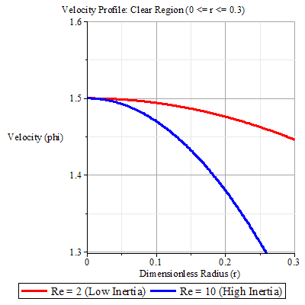
Figure 1: Velocity Profile: Clear Region (0<r<=0.3)

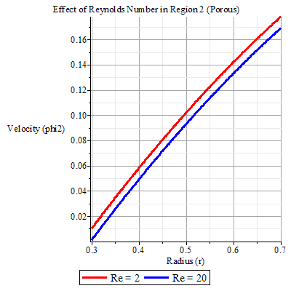
Figure 2: Effect of Reynolds Number in Region 2 (Porous)

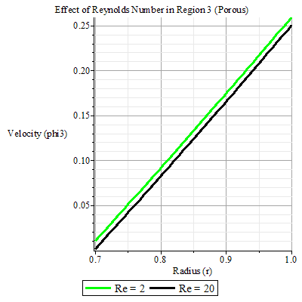
Figure 3: Effect of Reynolds Number in Region 3 (Porous)

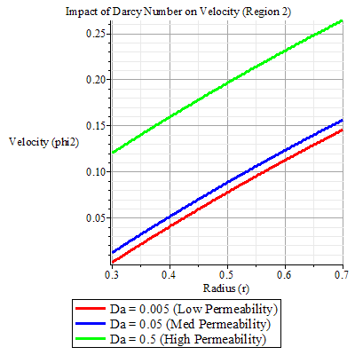
Figure 4: Impact of Darcy Number on Velocity (Region 2)

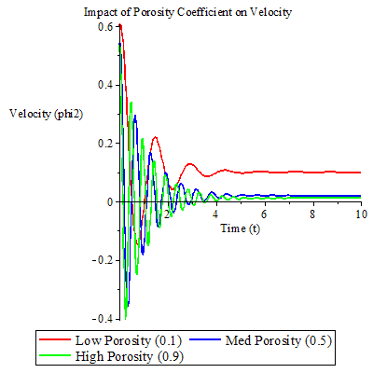
Figure 5: Impact of Porosity Coefficient on Velocity)

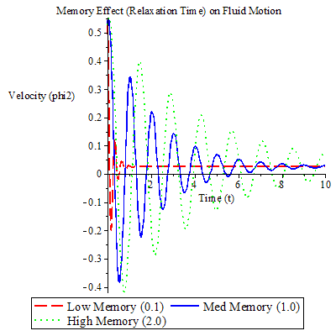
Figure 6: Memory Effect (Relaxation Time) on Fluid Motion

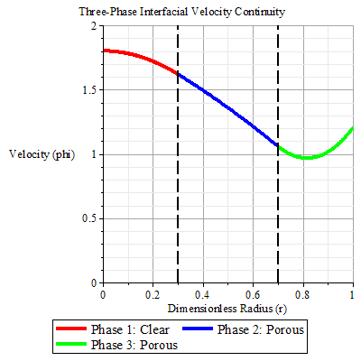
Figure 7: Three Phase interfacial Velocity continuity

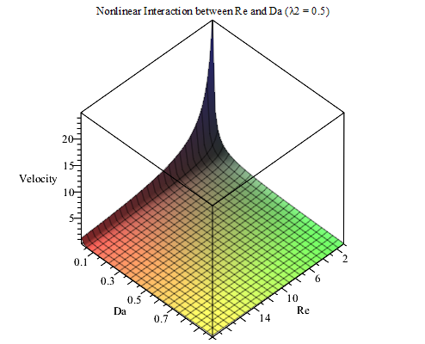
Figure 8: Nonlinear interaction between Re and Da
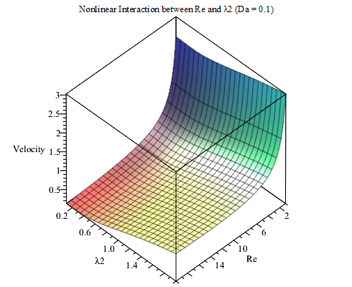
Figure 9:

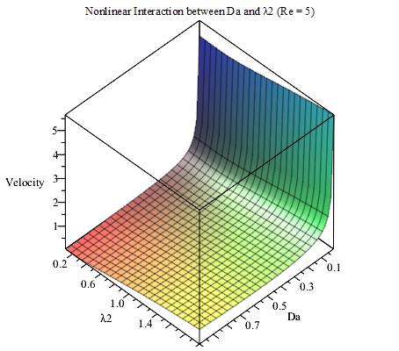
Figure 10

5. Discussion:

Figure 1 displays the velocity distribution across the three regions, a piecewise continuous velocity curve across the radial coordinate $r$. Velocity is maximum at the moving wall (r = 1), it decreases inward due to viscous and porous resistance. The change in curvature at r = d₁ and r = d₂ corresponds exactly to the transition from clear to porous medium, which validates the correct implementation of the Interface conditions.
Figures 2 and 3 display the effect of Reynolds Number (Re), showing multiple curves of velocity against radius for increasing Re. It is observed that the curves shift upward as Re increases, and higher Re imply higher peak velocity near the wall. The slope becomes steeper, indicating increased momentum transport. In the porous regions, the effect is still visible but slightly damped. The curves clearly demonstrate that inertia enhances flow in all regions, but less strongly in porous zones.

Figure 4 displays the effect of Darcy Number (Da) on velocity, with velocity profiles plotted for different Da values. It’s observed that the curves rise as Da increases. Low Da imply strong resistance demonstrated by flatter and suppressed curves. High Da imply reduced resistance as curves approach clear-fluid behaviour. The gap between curves is largest in regions 2 and 3, while Region 1 remains unchanged, signifying no porous effect. This confirms that the Darcy number only influences porous layers.

Figure 5 displays the effect of porosity on velocity. The plot shows t3.hat velocity increases as porosity increases; higher porosity reduces solid matrix obstruction and allows greater fluid mobility. Profiles become less damped in regions 2 and 3; the difference is negligible in region 1. A strong effect appears only after $r>d_{1}$This validates the correct spatial dependence of porosity in the model.

Figure 6 displays the effect of relaxation time. It was observed that a larger relaxation time implies a slower decay of the exponential term and a stronger elastic memory effect. The Curves exhibit a Lag in response, Slight oscillatory or delayed adjustment. This confirms the fractional Maxwell behaviour, distinguishing it from Newtonian flow.

Figure 7 display the interface continuity (r = d₁, d₂) that is, Smooth connection of curves at: $r=d_{1}$ and $r=d_{2}$ showing No jumps or discontinuities in velocity, Slopes may change, but values match, This directly verifies continuity of velocity: $u_{1}=u_{2},u_{2}=u_{3}$. This is a critical validation of the analytical solution.

Figures 8 to 10 display the combined effects of parameters. The plots demonstrate a nonlinear interaction between Inertia (Re), Permeability (Da) and Memory (λ₂). It was observed that high Re + high Da imply maximum velocity, and high λ₂ implies a delayed or moderated response. This confirms that the flow system is multi-parameter sensitive, with competing physical mechanisms.
The plots collectively confirm that the model correctly captures layered flow physics. Each parameter affects specific regions as expected, the analytical solutions (OGPAM) are physically consistent, numerically stable and graphically validated.

6. Conclusion
The transient flow behaviour of three immiscible fractional Maxwell fluids in a cylindrical domain was investigated. Velocity expressions are obtained for each region and used in the analysis of the effects of inertia, permeability, porosity, and viscoelastic memory on the fluid's motion. Graphical summaries using Maple 2018 reveal that velocity increases in the clear region and decreases in the porous layers due to the effect of resistance. Flow velocity is enhanced with the increase in Reynolds and Darcy numbers, while fluid motion in the porous region is aided by higher porosity. The importance of memory effects in viscoelasticity is emphasised as relaxation time significantly influences transient behaviour. The model is physically consistent, as continuity of velocity across interfaces is maintained. Unlike many earlier works that relied purely on numerical methods, the present study employs Olayiwola’s Generalised Polynomial Approximation Method (OGPAM) to derive semi-analytical solutions, reducing computational complexity while preserving physical accuracy. The study can be applied to biomedical systems, enhanced oil recovery processes, and porous media flow.

7. Limitations of the Study
This study is subject to the following limitations arising from the assumptions and mathematical simplifications employed in the formulation and solution of the problem: The flow is assumed to be one-dimensional, axisymmetric, incompressible, and fully developed; three-dimensional effects, turbulence, and secondary flow structures are not considered. The interfaces between the three immiscible fluids are considered to be stable and sharply defined; interfacial deformation, surface tension, mixing, or instability effects that may arise at higher flow rates are not considered. Finally, the study is primarily theoretical and computational, with results validated through Maple-generated simulations only. Experimental validation or comparison with industrial data was not carried out.

Disclaimer (Artificial intelligence)

The author hereby declares that NO generative AI technologies, such as Large Language Models (ChatGPT, COPILOT, etc.) and text-to-image generators, have been used during the writing or editing of this manuscript.

6. References
[1] Satpathi, D.K., Rathish Kumar, B.V. and P. Chandra. Unsteady-state laminar flow of viscoelastic gel and air in a channel: Application to mucus transport in a cough machine simulating trachea. Mathematical and Computer Modelling 38(1-2) (2003) 63-75.
[2] Gin, C., and P. Daripa. Stability results for multi-layer radial Hele-Shaw and porous media flows. Physics of Fluids 27(1) (2015) 012101.
[3] Ward, K., Zoueshtiagh, F. and R. Narayanan. Faraday instability in double-interface fluid layers. Physical Review Fluids 4(4) (2019) 043903.
[4] Papaefthymiou, E.S., and D.T. Papageorgiou. Nonlinear stability in three-layer channel flows. Journal of Fluid Mechanics 829 (2017) R2.
[5] Yih, C.-S. Instability due to viscosity stratification. Journal of Fluid Mechanics 27(2) (1967) 337-352.
[6] Le Meur, H. Non-uniqueness and linear stability of the one-dimensional flow of multiple viscoelastic fluids. ESAIM: Mathematical Modelling and Numerical Analysis 31(2) (1997) 185-211.
[7] Kalogirou, A. and M.G. Blyth. The role of soluble surfactants in the linear stability of two-layer flow in a channel. Journal of Fluid Mechanics 873 (2019) 18-48.
[8] Kim, Y. et al. Numerical study on the immiscible two-phase flow in a nano-channel using a molecular-continuum hybrid method. Journal of Mechanical Science and Technology 33(9) (2019) 4291-4302.
[9] Khan, Z. et al. Flow and heat transfer of two immiscible fluids in double-layer optical fiber coating. Journal of Coatings Technology and Research 13(6) (2016) 1055-1063.
[10] Joseph, D.D. and Y.Y. Renardy. Fundamentals of two-fluid dynamics. Journal of Fluid Mechanics 282 (1995) 405-405.
[11] Ashraf, S. and J. Phirani. Capillary displacement of viscous liquids in a multi-layered porous medium. Soft Matter 15(9) (2019) 2057-2070.
[12] Barannyk, L.L., et al. Nonlinear dynamics and wall touch-up in unstably stratified multilayer flows in horizontal channels under the action of electric fields. SIAM Journal on Applied Mathematics 75(1) (2015) 92-113.
[13] Funahashi, H., Kirkland, K.V., Hayashi, K., Hosokawa, S. and Tomiyama, A. Interfacial and wall friction factors of swirling annular flow in a vertical pipe. Nuclear Engineering and Design 330 (2018) 97-105.
[14] Papaefthymiou, E.S., and D.T. Papageorgiou. Nonlinear stability in three-layer channel flows. Journal of Fluid Mechanics 829 (2017) R2.
[15] Aliyu, M. et al. Interfacial friction in upward annular gas–liquid two-phase flow in pipes. Experimental Thermal and Fluid Science 84 (2017) 90-109.
[16] Hisham, M.D., et al. Analytical and semi-analytical solutions to flows of two immiscible Maxwell fluids between moving plates. Chinese Journal of Physics 56(6) (2018) 3020-3032.
[17] Hansen, A., et al. Relations between seepage velocities in immiscible, incompressible two-phase flow in porous media. Transport in Porous Media 125(3) (2018) 565-587.
[18] Allan, F.M., Hajji, M.A. and M.N. Anwar. The characteristics of fluid flow through multilayer porous media. Journal of Applied Mechanics 76(1) (2009) 1-10.
[19] Caputo, M. and M. Fabrizio. A new definition of fractional derivative without singular kernel. Progress in Fractional Differentiation and Applications 1(2) (2015) 1-13.
[20] Zhou, Y. Existence and uniqueness of fractional functional differential equations with unbounded delay. International Journal of Dynamical Systems and Differential Equations 1(4) (2008) 239-244.
[21] Caputo, M. Linear models of dissipation whose Q is almost frequency independent—II. Geophysical Journal International 13(5) (1967) 529-539.
[22] Xiao-Jun, X.J., Srivastava, H.M. and J.T. Machado. A new fractional derivative without singular kernel. Thermal Science 20(2) (2016) 549-560.
[23] Joseph, D.D., Bai, R., Chen, K.P. and Y.Y. Renardy. Core-annular flows. Annual Review of Fluid Mechanics 29(1) (1997) 65-90.
[24] Bear, J. Dynamics of fluids in porous media. Courier Corporation, 2013.
[25] Dullien, F.A. Porous media: fluid transport and pore structure. Academic press, 2012.
[26] Lake, L.W. Enhanced Oil Recovery, Prentice Hall, Englewood Cliffs. 1989.
[27] Joseph, D.D. and Y. Renardy. Fundamentals of Two-Fluid Dynamics, Part I, Springer-Verlag, New York, 1993.
[28] Joseph, D.D. and Y. Renardy. Fundamentals of Two-Fluid Dynamics, Part II, Springer-Verlag, New York, 1993.
[29] Olayiwola, RO (2022). Solving parabolic equations by Olayiwola’s generalized polynomial approximation method. International Journal of Mathematical Analysis. Mod. 5(3), 24 - 43.
[30] Abdul Rauf & Memoona Naz (2020). Simultaneous flow of Three Immiscible Fractional Maxwell fluids with Clear and Homogeneous Porous Cylinderical Domain. Journal of Applied and Computational Mechanics 6(SI), 1324-1334. DOI: 10.22055/JACM.2020.33464.2230.
[31] K. Sudarmozhi, Ali B.M. Ali, R. Raghavendran, Khayrilla Kurbonov, Gaganjot Kaur, Mirjalol Ismoilov, M.Ijaz Khan (2026). Exploring Maxwell fluid behavior: A systematic review of methods, geometries, and applications. South African Journal of Chemical Engineering 57, 100884. https://doi.org/10.1016/j.sajce.2026.100884.

