Regional Disparities in the Level of Rural Industrial Revitalization in Jiangsu Province

ABSTRACT
Background: Rural industrial revitalization has become a key pathway for agricultural modernization and rural development, particularly in advanced agricultural regions such as Jiangsu Province in China. Existing research emphasizes industrial integration, technological empowerment, and multifunctional agriculture as core drivers of rural transformation.
Aims: This study investigates the spatiotemporal evolution and regional disparities of rural industrial revitalization in Jiangsu Province, aiming to provide empirical evidence for coordinated agricultural policies and balanced rural development in economically advanced agricultural regions.
Study design: A quantitative longitudinal analysis using panel data.
Place and Duration of Study: Thirteen prefecture-level cities in Jiangsu Province, divided into southern, central, and northern regions, from 2013 to 2024.
Methodology: A three-dimensional evaluation framework was established, covering agricultural competitiveness, green support capacity, and livelihood prosperity. The Entropy‑TOPSIS method was applied to quantify the level of rural industrial revitalization. Dagum Gini coefficient decomposition was used to identify the sources of regional disparities, and kernel density estimation was adopted to trace its dynamic evolutionary characteristics.
Results: (1) The provincial revitalization index increased from 0.2680 to 0.5435 (cumulative +102.80%), with the driving force shifting from policy stimulus to endogenous growth. (2) A persistent “high in the south, low in the north” spatial pattern was observed, but regional gaps narrowed markedly, and northern Jiangsu showed strong late-development advantages. (3) Among subsystems, agricultural competitiveness grew the fastest, green support capacity maintained the highest overall level, and livelihood prosperity improved steadily. (4)The overall Gini coefficient declined from 0.1682 to 0.0897, with inter-regional disparity becoming the dominant source. (5) Kernel density estimation revealed a gradual evolution toward high-level equilibrium without multi-polar polarization.
Conclusion: The findings offer robust evidence for narrowing the north-south agricultural development gap and advancing coordinated rural revitalization. Policy implications include strengthening provincial coordination, promoting region-specific strategies, and enhancing green agriculture, industrial competitiveness, and livelihood security to achieve long-term balanced growth.

Keywords: Rural Industrial Revitalization; Entropy-TOPSIS method; Dagum Gini coefficient; kernel density estimation; regional disparity; Jiangsu Province
1. INTRODUCTION

Addressing the challenges of agriculture, rural areas, and farmers requires placing rural industrial revitalization at the core of agricultural transformation. Jiangsu Province, a nationally renowned “land of milk and honey,” is strategically located in the Yangtze River Delta integrated development zone. Its agricultural output, contribution rate of scientific and technological progress, and mechanization level rank among the highest in China, making it one of the most dynamic regions for agricultural economy and urban-rural integration. Hence, analyzing the spatiotemporal patterns and regional disparities of rural industrial revitalization in Jiangsu is critical for advancing agricultural modernization and promoting shared prosperity.

Existing research on rural industrial revitalization can be classified into three categories. The first concerns its definition and characteristics. Scholars generally agree that rural industrial revitalization is a systematic project rooted in agriculture, with farmers as the main actors, industrial integration as the pathway, and modern, green, and efficient development as the goal (Wang, 2024; Liang, 2023). Its essence lies in modernizing traditional agriculture and handicrafts through technological empowerment and resource integration (Zhang & Ding, 2024). Research has focused on the dual-driven model of “specialized industries plus industrial integration,” emphasizing diversified structures and integrated factors (Sheng, 2024; Zhang et al., 2019). Recent studies have extended this to agricultural multi-functionality and industrial optimization (Liu et al., 2024; Wang, 2025), and introduced the “new quality productive forces” perspective to reshape rural industry development (Lei, 2025; Liu, 2025).

Methodologically, performance measurement has shifted from narrow efficiency metrics to multidimensional frameworks balancing productivity, equity, and sustainability. Early indices used enterprise stability or macro-level “industrial prosperity” proxies (Song et al., 2023; Xu et al., 2024), while subsequent models incorporated agricultural core logics of value addition and income generation (Huang et al., 2025; Li & Xiao, 2025). Recent advances introduce carbon-constrained green total factor productivity to align with dual-carbon goals (Liang & Chen, 2024; Cao, 2025). Nevertheless, environmental dimensions remain underweighted, and macro indicators often mismatch county-level implementation.

Empirically, evidence points to a multi-driver mechanism where agency, digital-financial infrastructure, and industrial pathways interact. New rural elites and policy entrepreneurs mobilize resources through network brokerage (Zhang & Zhang, 2025). Digital finance and circulation digitalization have been shown to alleviate credit constraints and empower rural industries, though their effectiveness may depend on local conditions (Zhang & Liu, 2024; Yang & Wang, 2023). Complementary strategies such as agritourism further amplify revitalization through brand building and market expansion (Song et al., 2023; Huang et al., 2025). Nevertheless, digital divides and asymmetries in benefit distribution between capital and farmers call for context‑sensitive policies.

Despite these advances, three gaps remain. First, most measurements are macro and static, overlooking intra-provincial spatial heterogeneity and dynamic evolution. Second, decomposition methods are limited; few studies combine Dagum Gini decomposition with kernel density estimation to trace disparity sources and distributional dynamics over time. Third, policy recommendations are generic, lacking differentiated collaborative pathways tailored to the distinct endowments of regions within Jiangsu Province.

To fill these gaps, this study uses 2013–2024 panel data from 13 prefecture-level cities in Jiangsu Province. A three-dimensional evaluation system is constructed, covering agricultural competitiveness, green support capacity, and livelihood prosperity. The Entropy-TOPSIS method measures the development level of rural industrial revitalization, while the Dagum Gini coefficient and kernel density estimation identify the sources of regional disparities and their dynamic evolution. Specifically, this study addresses three questions: (1) What are the temporal dynamics and spatial patterns of rural industrial revitalization in Jiangsu? (2) How do overall, intra-regional, and inter-regional disparities evolve over time? (3) What are the key drivers of convergence and divergence in regional disparities?

2. MATERIALS AND METHODS
2.1 Study Area
This study uses panel data from 13 prefecture-level cities in Jiangsu Province (2013–2024). Located in the lower reaches of the Yangtze and Huai Rivers, Jiangsu is characterized by flat terrain, a strategic location, and a well-developed water system, including China’s third and fourth largest freshwater lakes (Tai and Hongze). These conditions, together with its fertile and relatively concentrated land, provide excellent natural endowments for agriculture. Based on geographic location and development patterns, the 13 cities are divided into three regions: Southern Jiangsu (Suzhou, Wuxi, Changzhou, Nanjing, Zhenjiang), Central Jiangsu (Yangzhou, Taizhou, Nantong), and Northern Jiangsu (Xuzhou, Huai’an, Suqian, Yancheng, Lianyungang). (Fig. 1).
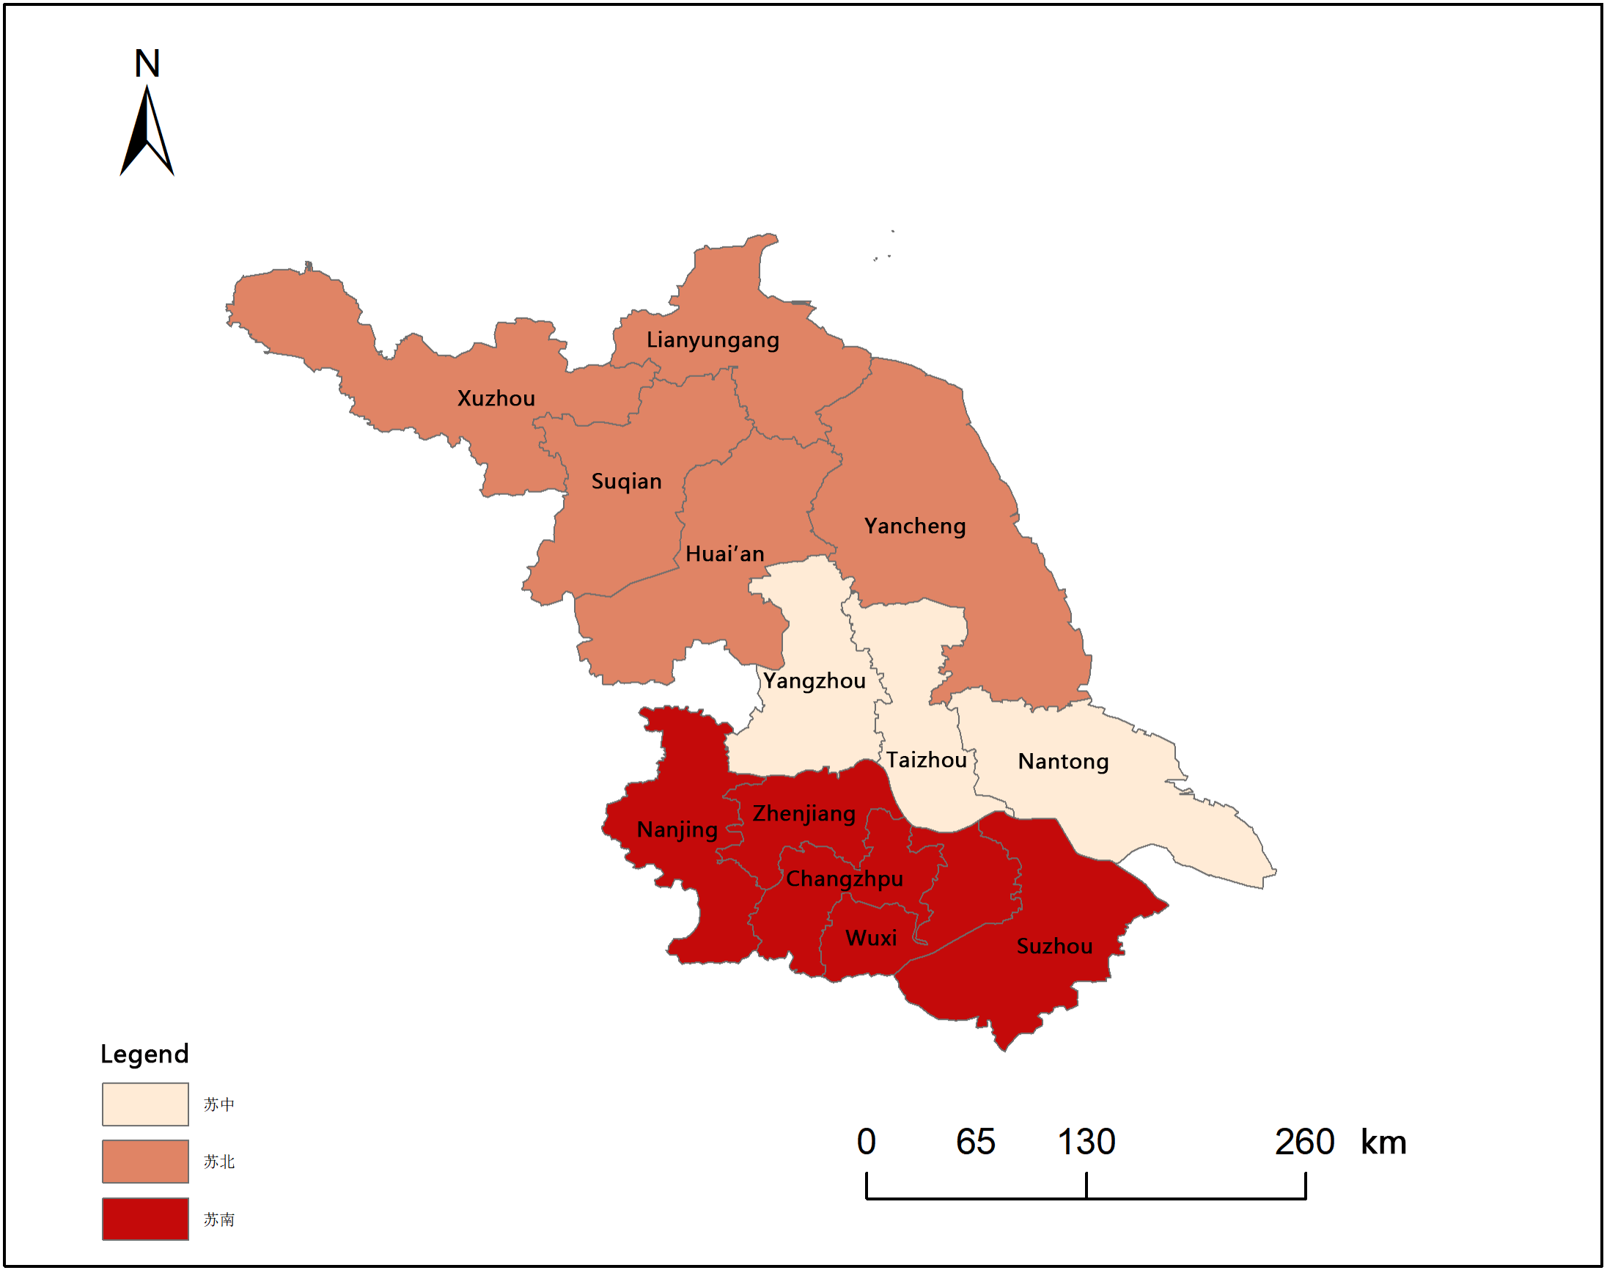
Fig. 1. Study Area and Regional Division

2.2 Indicator System Construction

Based on the theoretical framework of rural industrial revitalization and the "Guidelines on Promoting Rural Industrial Revitalization" issued by the State Council, and drawing on the research findings of Cao Liping (Cao, 2025), this paper constructs three main indicators - industrial competitiveness, green support capability, and livelihood prosperity - to measure the level of rural industrial revitalization in Jiangsu Province. At the same time, the scientificity, rigor, comprehensiveness, as well as the availability and comparability of the data of the indicators are comprehensively considered. Industrial competitiveness includes labor productivity, land productivity, grain labor productivity, the degree of industrial structure optimization, and mechanization level; green support capability includes the intensity of fertilizer and pesticide use and the comprehensive utilization rate of livestock manure; livelihood prosperity includes the income level of rural residents, the urban-rural income ratio, and the rural consumption structure. The specific measurement methods of the secondary indicators are shown in Table 1.

Table 1. Indicator System for Rural Industry Revitalization Level
Primary Indicator | Secondary Indicator | Calculation Method | Unit
Industrial Competitiveness | Labor Productivity (+) | Added value of agriculture, forestry, animal husbandry and fishery / Number of employees in the primary industry | yuan/person
 | Land Productivity (+) | Total agricultural output value / Sown area of crops | yuan/hectare
 | Grain Labor Productivity (+) | Grain output / Number of employees in the primary industry | ton/person
 | Industrial Structure Optimization Degree (+) | Output value of agriculture, forestry, animal husbandry and fishery services / Total output value of agriculture, forestry, animal husbandry and fishery | %
 | Mechanization Level (+) | Total power of agricultural machinery / Number of employees in the primary industry | kW/person
Green Support Capacity | Chemical Fertilizer and Pesticide Use Intensity (-) | Input of chemical fertilizers and pesticides / Sown area of crops | ton/hectare
 | Comprehensive Utilization Rate of Livestock and Poultry Manure (+) | Comprehensive utilization rate of livestock and poultry manure | %
Livelihood and Prosperity Capacity | Income Level of Rural Residents (+) | Per capita disposable income of rural households | yuan
 | Urban-Rural Income Ratio (-) | Per capita disposable income of urban residents / Per capita disposable income of rural residents | /
 | Rural Consumption Structure (-) | Engel's coefficient of rural residents | %

2.3 Entropy-TOPSIS Method

This study uses the entropy-TOPSIS method for evaluation. The entropy method calculates objective weights for the 10 evaluation indicators, avoiding subjective weighting bias (Dagum, 1997; Silverman, 1986). The calculation steps are as follows:
Step 1: Data standardization
Positive indicators:
$$X_{ij}^{'}=\frac{X_{ij}-min\left(X_{ij}\right)}{max\left(X_{ij}\right)-min\left(X_{ij}\right)} (2-1)$$
Negative indicators:
$$X_{ij}^{'}=\frac{max\left(X_{ij}\right)-X_{ij}}{max\left(X_{ij}\right)-min\left(X_{ij}\right)} (2-2)$$
X_{ij} is the value of the j_{th} metric for the i-th sample, where i = 1, 2, 3, …, n and j = 1, 2, 3, …, m
Step 2: Calculate the weights of the samples
$$P_{ij}=\frac{X_{ij}}{\sum_{i=1}^{n}{X_{ij}}} (2-3)$$
Step 3: Calculate the entropy value of the jth metric
$$e_{j}=-k\sum_{i=1}^{n}{P_{ij}×lnP_{ij}} (2-4)$$
where e_{j} lies between 0 and 1.
Step 4: Calculate the difference index
$$g_{j}=1-e_{j} (2-5)$$
Step 5: Calculate the weight coefficients
$$W_{j}=\frac{1-e_{j}}{\sum_{j=1}^{m}{1-e_{j}}}=\frac{g_{j}}{\sum_{j=1}^{m}{g_{j}}} (2-6)$$
Step 6: Calculate the sample’s composite score
$$Z_{i}=\sum_{j=1}^{m}{W_{j}*X_{ij}^{'}} (2-7)$$
For the TOPSIS method, the weighted standardization matrix is first constructed, then the positive and negative ideal solutions are identified. Euclidean distances are calculated, and the relative closeness C_{i} (ranging from 0 to 1) represents the comprehensive level of rural industrial revitalization for each city.

2.4 Dagum Gini Coefficient Decomposition

The Dagum Gini coefficient is used to analyze overall disparities and their sources. This method decomposes the overall Gini coefficient into three components—within-group disparity (G_{w}), net between-group disparity (G_{nb}), and super-variability density (G_{t})—without residuals (Dagum, 1997; Silverman, 1986). The overall Gini coefficient is calculated as:
$$G=\frac{\sum_{\text{j=1}}^{\text{k}}{\sum_{\text{h=1}}^{\text{k}}{\sum_{\text{i=1}}^{\text{nj}}{\sum_{\text{r=1}}^{\text{nh}}{\left|{\text{y}}_{\text{ji}}\text{-}{\text{y}}_{\text{hr}}\right|}}}}}{\text{2}{\text{n}}^{\text{2}}\overline{\text{y}}}\text{ (2-8)}$$
The decomposition gives:
$${\text{G}}_{\text{w}}\text{=}\sum_{\text{j=1}}^{\text{3}}{{\text{G}}_{\text{jj}}{\text{P}}_{\text{j}}{\text{s}}_{\text{j}}\text{ (2-9)}}$$
$${\text{G}}_{\text{nb}}\text{=}\sum_{\text{j=2}}^{\text{3}}{\sum_{\text{h=1}}^{\text{j-1}}{{\text{G}}_{\text{jh}}\text{(}{\text{P}}_{\text{j}}{\text{s}}_{\text{h}}\text{)}{\text{D}}_{\text{jh}}\text{ (2-10)}}}$$
$${\text{G}}_{\text{t}}\text{=}\sum_{\text{j=2}}^{\text{3}}{\sum_{\text{h=1}}^{\text{j-1}}{{\text{G}}_{\text{jh}}\text{(}{\text{P}}_{\text{j}}{\text{s}}_{\text{h}}}\text{)(1-}{\text{D}}_{\text{jh}}}\text{) (2-11)}$$

2.5 Kernel Density Estimation

Kernel density estimation (KDE) is employed to analyze the dynamic evolution of rural industrial revitalization in Jiangsu Province. As a nonparametric method used to estimate the probability density function of data, KDE can mitigate the impact of model specification bias. Given an independent and identically distributed sample set X = x₁, x₂, ..., x_{n}, KDE smooths and weights each data point using the kernel function K_{h}(x) to estimate the probability density function:
$$\hat{\text{f}}\text{(x)=}\frac{\text{1}}{\text{n}}\sum_{\text{i=1}}^{\text{n}}{{\text{K}}_{\text{h}}\text{(x-}{\text{x}}_{\text{i}}\text{)=}\frac{\text{1}}{\text{nh}}\sum_{\text{i=1}}^{\text{n}}{\text{K(}\frac{\text{x-}{\text{x}}_{\text{i}}}{\text{h}}\text{) (2-12)}}}$$
h denotes the bandwidth, control, and function width; K(∙) denotes the kernel function, which satisfies the conditions of symmetry, non-negativity, and integral equal to 1.

2.6 Data Sources

This study draws on the 2018 "Opinions on Implementing the Rural Revitalization Strategy," with the study period (2013-2024) chosen to compare outcomes before and after implementation. Data come from the Statistical Yearbooks of Jiangsu Province and its 13 prefecture-level cities (2014-2025), the China Rural Statistical Yearbook, the EPS data platform, and the China Economic Net database. Missing values were filled using interpolation. GDP figures were deflated using the Consumer Price Index (CPI) with 2013 as the base year.

3. RESULTS AND DISCUSSION

3.1 Temporal Characteristics

Overall, the level of rural industrial revitalization in Jiangsu Province has shown a year-on-year upward trend. The rural industrial revitalization index rose from 0.2680 in 2013 to 0.5435 in 2024, representing a cumulative increase of 102.80% and an average annual compound growth rate of 6.12%, thereby doubling over the study period.
Table 2. Annual Trend of Rural Industry Revitalization Index in Jiangsu Province
year | Mean | Standard Deviation | Minimum | Maximum | Growth Rate(%) | Cumulative Increase
2013 | 0.2680 | 0.0891 | 0.1602 | 0.4318 | - | -
2014 | 0.2937 | 0.0924 | 0.1804 | 0.4674 | 9.59 | +9.59%
2015 | 0.3173 | 0.0976 | 0.1924 | 0.5019 | 8.03 | +18.40%
2016 | 0.3331 | 0.0961 | 0.2275 | 0.5121 | 4.98 | +24.29%
2017 | 0.3671 | 0.1004 | 0.2520 | 0.5386 | 10.21 | +36.98%
2018 | 0.3829 | 0.0983 | 0.2633 | 0.5416 | 4.30 | +42.87%
2019 | 0.4128 | 0.1096 | 0.2805 | 0.6595 | 7.80 | +54.03%
2020 | 0.4221 | 0.1009 | 0.3070 | 0.5802 | 2.25 | +57.50%
2021 | 0.4622 | 0.1042 | 0.3406 | 0.6138 | 9.50 | +72.46%
2022 | 0.4857 | 0.1013 | 0.3714 | 0.6303 | 5.08 | +81.23%
2023 | 0.5108 | 0.1039 | 0.3767 | 0.6444 | 5.17 | +90.60%
2024 | 0.5435 | 0.1056 | 0.4035 | 0.6971 | 6.40 | +102.80%

The growth rate exhibited a pattern of three peaks and two troughs. In 2017, the growth rate reached its first peak at 10.21%, coinciding with the launch of policies to revitalize rural industries; in 2020, the growth rate fell to 2.25%, likely due to the impact of the global public health crisis. Consequently, the rural industrial revitalization in Jiangsu Province from 2013 to 2024 can be divided into three phases: the Initial Exploration Phase (2013–2016), during which momentum for rural industrial revitalization was accumulated, with an average annual growth rate of 7.53% but significant fluctuations; the Accelerated Growth Phase (2017–2020), a period of comprehensive advancement of rural industrial revitalization, with an average annual growth rate of 4.87%; High-Quality Advancement Phase (2021–2024), characterized by an average annual growth rate of 5.55% with diminishing volatility. This indicates that development during this phase prioritizes both quality and efficiency, with growth momentum shifting from policy-driven to endogenous-driven.
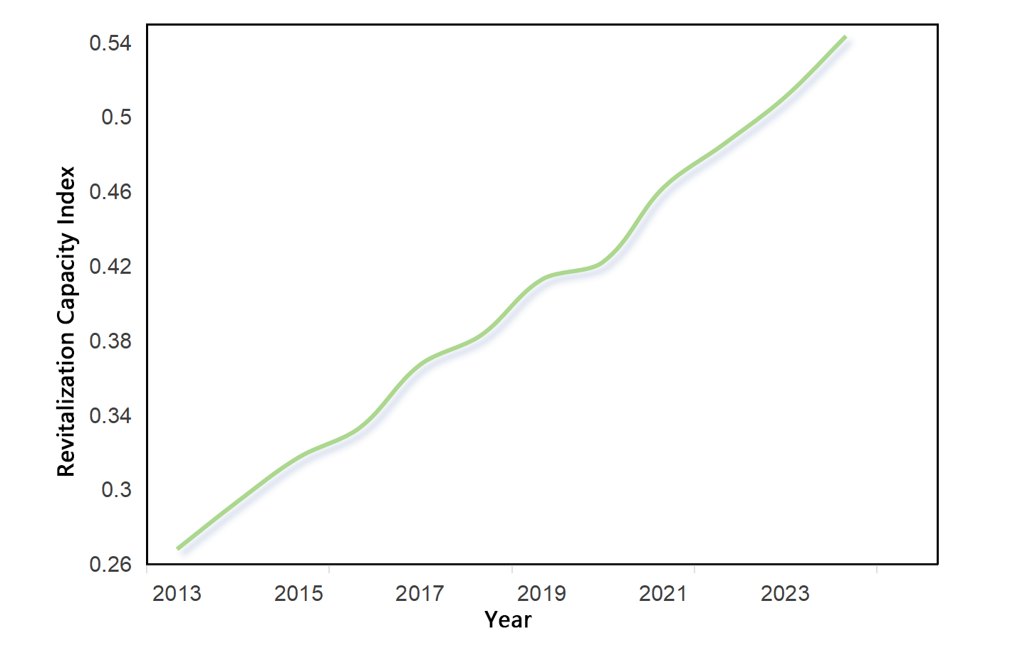
Fig. 2. Temporal Evolution of Rural Industry Revitalization Level in Jiangsu Province (2013-2024)

By region, the rural industrial revitalization index increased in all three areas from 2013 to 2024. Southern Jiangsu consistently maintained the highest level, though its growth rate has slowed in recent years. Northern Jiangsu, while lagging behind in level, experienced faster growth. The regional ranking of revitalization generally aligns with economic development levels. Southern Jiangsu recorded the highest average index but the lowest growth rate. Northern Jiangsu ranked first in growth rate, showing a clear late-mover advantage, followed by Central Jiangsu, while Southern Jiangsu ranked last in growth despite leading in absolute level.
Table 3. Regional Ranking of Rural Industry Revitalization in Jiangsu Province: Mean Index and Growth Rate
Region | Mean | Growth Rate  (%) | Rank by mean | Growth Rate Ranking | Change
Southern Jiangsu | 0.4925 | 0.7869 | 1 | 3 | -2
Central  Jiangsu | 0.3588 | 1.2148 | 2 | 2 | 0
Northern Jiangsu | 0.3320 | 1.3248 | 3 | 1 | +2

3.2 Spatial Distribution Characteristics

To reveal the spatial disparities in rural industrial revitalization among prefecture-level cities, the rural industrial revitalization indices for 2013, 2017, 2021, and 2024 were selected. Using the natural break method, the data were classified into three tiers and visualized using ArcGIS software (Figure 3). Overall, the spatial pattern across the 13 prefecture-level cities exhibits a north-low, south-high characteristic. Suzhou, Wuxi, and Zhenjiang have consistently remained core high-value zones, forming a contiguous high-value cluster. Low-value zones are concentrated in Taizhou, Huai’an, Suqian, and Lianyungang. Notably, Xuzhou has achieved a significant leap in its ranking, and regional disparities are gradually narrowing.

From an intra-regional perspective, the Southern Jiangsu region exhibits a pattern of slow growth at a high level. This is primarily due to the scarcity of land resources and relatively high labor costs in the region, which limit the scope for scale expansion and drive the transformation of agricultural development toward specialization and service-oriented models. As rural industries enter a phase of high-quality development, the returns on various factors of production are diminishing, and the growth rate of the industry is stabilizing.

In contrast to Southern Jiangsu, the Northern Jiangsu region demonstrates rapid growth at a low level. Abundant land resources and lower labor costs have created conditions for the large-scale and mechanized development of agriculture. The region is currently in a critical phase of transition from factor-driven to efficiency-driven growth. Furthermore, supported by the sustained implementation of regional coordination policies such as the North-South Pairing Assistance Program and coastal development initiatives, infrastructure continues to improve, and the region’s advantages in industrial relocation have become increasingly evident. Policies and investments continue to play a strong driving role, thereby rapidly advancing the revitalization of rural industries in Northern Jiangsu.
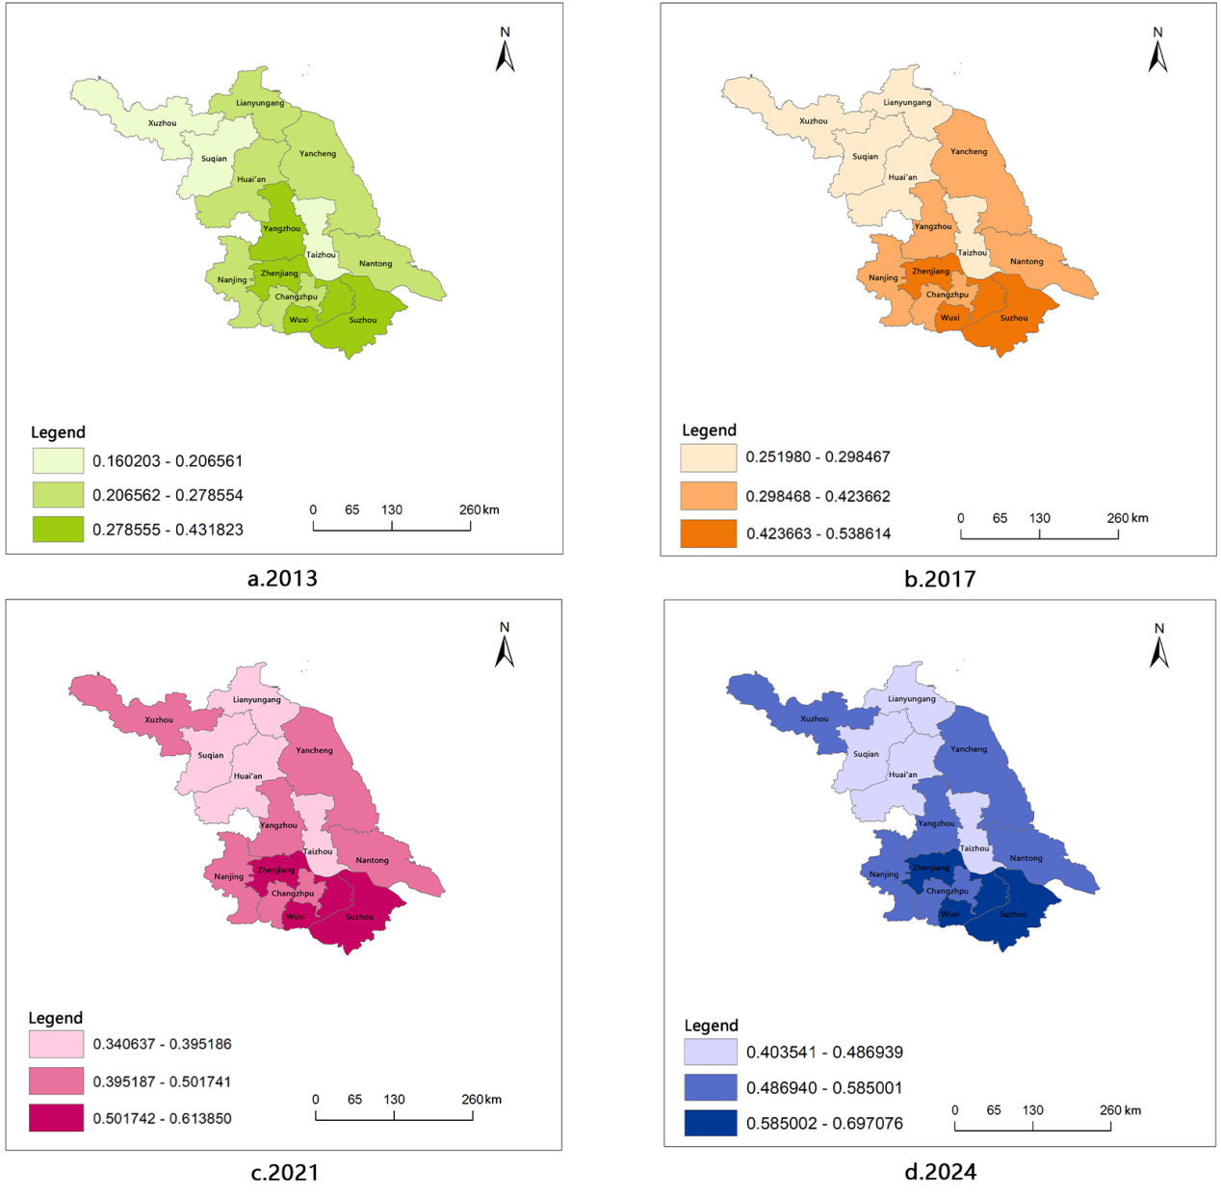
Fig. 3. Spatial Distribution Map of Rural Industry Revitalization (2013-2024)
3.3 Analysis at the Subsystem Level

To further investigate the causes and systemic structure of regional disparities in rural industrial revitalization, the annual scores for the three primary indicators in the industrial revitalization index systems of different regions were averaged, yielding the results shown in Table 4. From a macro perspective in Jiangsu Province, the scores for the three subsystems show an upward trend, with the highest growth rate observed in industrial competitiveness, followed by green support capacity and livelihood prosperity. The leading factor behind the high score in industrial competitiveness is the accelerated process of agricultural modernization and the continuous improvement in mechanization levels, which have enhanced labor productivity. According to Jiangsu Province’s 14th Five-Year Plan for Agricultural Mechanization, the province’s comprehensive mechanization rate for crop cultivation, planting, and harvesting reached 80%, with the mechanization rate for major grain crops reaching 93% (completing the construction of a demonstration province for full mechanization), and the mechanization rate for facility agriculture, animal husbandry, and fisheries reaching 54%. This has facilitated labor transfer and strengthened the endogenous momentum of agricultural production and the rural economy. The enhancement of green support stems from efforts to conserve resources, reduce the use of agricultural inputs, and recycle agricultural waste, guided by the principle of accelerating the comprehensive green transformation of agriculture to promote rural ecological revitalization. By 2024, Jiangsu’s provincial fertilizer and pesticide usage had decreased by 5.9% and 8.5%, respectively, compared to 2020, achieving the “14th Five-Year Plan” targets for fertilizer and pesticide reduction ahead of schedule. Since 2021, Jiangsu has implemented pilot projects for green crop-livestock recycling agriculture for five consecutive years, continuously advancing the resource utilization of livestock manure to address manure management challenges. A total of 11.21 million tons of livestock manure has been processed, with 6.1 million mu of farmland receiving manure-based fertilizer. In pilot areas, the comprehensive utilization rate of livestock manure has remained stable at over 95%.

Looking at growth trends across different regions, the growth rates of subsystems in the Southern Jiangsu region, from highest to lowest, are: people’s livelihood and prosperity, industrial competitiveness, and green support capacity. In both Central and Northern Jiangsu, the order is Industrial Competitiveness, Livelihood Prosperity, and Green Support. The primary difference stems from the fact that Southern Jiangsu has a higher level of economic development and a faster pace of urban-rural integration, resulting in significant increases in rural residents’ income and consumption levels, as well as notable improvements in people’s livelihoods. In contrast, Central and Northern Jiangsu remain in a phase of rapid industrial development and structural adjustment, where improvements in industrial competitiveness are more pronounced, but growth in livelihood prosperity lags behind the pace of industrial development.
Table 4. Comparison of Scores and Growth Rates of the Rural Industry Revitalization Subsystem
Region | Indicator | Industrial Competitiveness | Green Support Capacity | Livelihood and Prosperity Capacity
Southern Jiangsu | Mean | 0.4704 | 0.4806 | 0.4945
 | Growth Rate (Times) | 0.7068 | 0.3533 | 1.1477
Region | Indicator | Industrial Competitiveness | Green Support Capacity | Livelihood and Prosperity Capacity
 | Growth Rate (Times) | 1.9606 | 0.4253 | 1.1174
Southern Jiangsu | Mean | 0.3474 | 0.7136 | 0.3639
 | Growth Rate (Times) | 2.4777 | 0.3749 | 1.2365
Jiangsu | Mean | 0.3843 | 0.5015 | 0.4247
 | Growth Rate (Times) | 1.4172 | 0.6837 | 0.5080

3.4 Regional Disparities

The overall Gini coefficient for rural industrial revitalization in Jiangsu Province from 2013 to 2024 showed a downward trend year by year, decreasing from 0.1682 in 2013 to 0.0897 in 2024, with a cumulative decline of 46.7%. Furthermore, the Gini coefficient for each year was less than 0.2, indicating relatively small overall disparities. This indicates that the overall regional disparities in rural industrial revitalization in Jiangsu Province continued to narrow during the sample period, demonstrating the significant effectiveness of regional coordinated development policies and a sustained improvement in the spatial balance of rural industrial development.
Table 5 Decomposition Results of the Differences in Rural Industrial Revitalization Levels in Jiangsu Province from 2013 to 2024
year | Overall Gini coefficient | Intra-group disparity  Gw​ | Inter-group net disparity Gnb​ | Hyper-variability density Gt​ | Intra-group contribution rate | Inter-group contribution rate | Hyper-variability density contribution rate
2013 | 0.1682 | 0.0711 | 0.0435 | 0.0536 | 0.4227 | 0.2586 | 0.3187
2014 | 0.1641 | 0.0694 | 0.0451 | 0.0496 | 0.4229 | 0.2748 | 0.3023
2015 | 0.1554 | 0.0689 | 0.0472 | 0.0393 | 0.4434 | 0.3037 | 0.2529
2016 | 0.1487 | 0.0523 | 0.0495 | 0.0469 | 0.3517 | 0.3329 | 0.3154
2017 | 0.1403 | 0.0449 | 0.0518 | 0.0436 | 0.3200 | 0.3692 | 0.3108
2018 | 0.1245 | 0.0457 | 0.0471 | 0.0317 | 0.3671 | 0.3783 | 0.2546
2019 | 0.1316 | 0.0531 | 0.0529 | 0.0256 | 0.4035 | 0.4020 | 0.1945
2020 | 0.1107 | 0.0438 | 0.0458 | 0.0211 | 0.3957 | 0.4137 | 0.1906
2021 | 0.1018 | 0.0401 | 0.0470 | 0.0147 | 0.3939 | 0.4617 | 0.1444
2022 | 0.0935 | 0.0327 | 0.0461 | 0.0147 | 0.3497 | 0.4930 | 0.1573
2023 | 0.0891 | 0.0359 | 0.0452 | 0.0080 | 0.4029 | 0.5073 | 0.0898
2024 | 0.0897 | 0.0367 | 0.0482 | 0.0048 | 0.4091 | 0.5373 | 0.0536

Intra-regional disparities have fluctuated downward, with their contribution rate remaining between 32% and 44.34%, making them a significant source of regional disparities. This indicates that imbalances in development among cities within Southern, Central, and Northern Jiangsu have persisted for a long time; however, as the flow of factors, industrial synergy, and the inclusiveness of policies within Jiangsu Province have strengthened, the gaps in rural industrial development within each region have gradually narrowed. The contribution rate of inter-group net disparities has risen significantly year by year, increasing from 25.86% in 2013 to 53.73% in 2024. Since 2019, it has surpassed intra-group disparities to become the primary driver of regional differences. This indicates that the developmental disparities among the three major regions—Southern, Central, and Northern Jiangsu—are becoming increasingly pronounced, and the gap in development levels between these regions has become the core driver of regional disparities in rural industrial revitalization in Jiangsu Province. The hypervariation density and its contribution rate have shown a sustained and rapid decline, dropping from 0.0536 in 2013 to 0.0048 in 2024, with the contribution rate falling from 31.87% to 5.36%. This indicates that the overlap in rural industrial revitalization levels among the three major regions has significantly decreased during the sample period. The regional development pattern has gradually shifted from the early stage of “intermingled highs and lows with a mixed distribution” to one characterized by “clear gradients and stable stratification,” with a substantial reduction in the overlap between high-value cities in low-development regions and low-value cities in high-development regions.
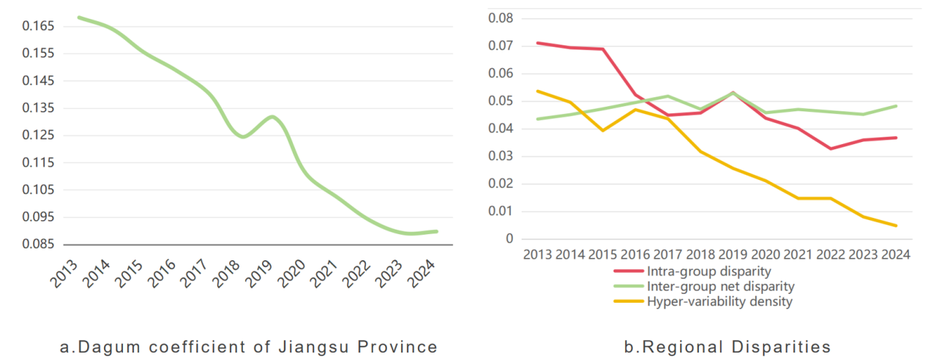
Fig. 4. Overall Gini coefficient gap and sources of disparity in Jiangsu Province

3.5 Dynamic Evolution

This study selected five key time points—2013, 2016, 2019, 2022, and 2024—at three-year intervals to estimate kernel density, with the results shown in Figure 5. In terms of distribution, the kernel density curve shifts to the right year by year. In 2013, the kernel density curve was concentrated in the low range of 0.2–0.3, indicating that rural industrial revitalization was at a relatively low level at the beginning of the study. By 2024, the curve had shifted to the range of 0.5–0.6, indicating a significant improvement in the level of rural industrial revitalization in Jiangsu Province. In terms of distribution shape, the curve’s peak exhibits a declining and gradually flattening trend. In 2013, the curve reached its highest peak with the most concentrated distribution, indicating that development gaps between regions were small in the early stages, with the overall situation characterized by a low-level equilibrium; by 2016, the peak had dropped significantly, the distribution range had expanded, and development speeds across regions began to diverge, with regional disparities becoming apparent; By 2024, the peak of the curve has risen while the distribution width has narrowed, indicating that regional development gaps are gradually converging, with the overall trend evolving toward a high-level equilibrium. In terms of polarization characteristics, the kernel density curve maintains a unimodal state across all years, suggesting that the overall development of rural industrial revitalization in Jiangsu Province is coordinated and progressing relatively smoothly. The slight upward tail observed near 0.4 on the 2013 curve was not due to a bimodal distribution of the data itself, but rather a temporary manifestation of accelerated development in some regions during the early low-level stage. As the curve continued to shift to the right and its shape improved in subsequent years, this phenomenon has completely disappeared.
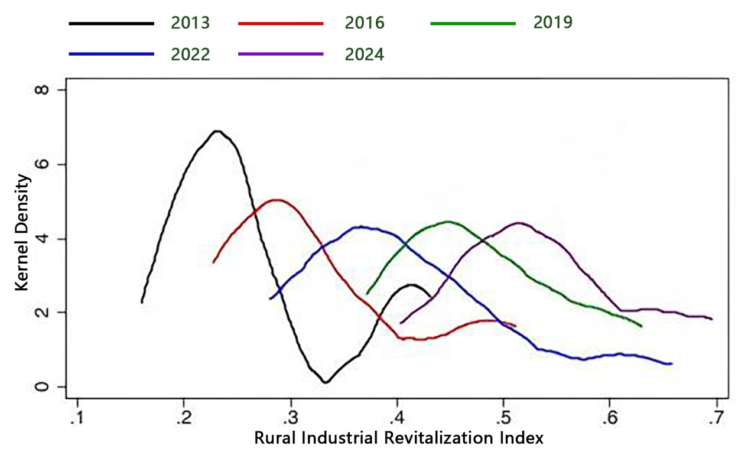

Fig. 5. The evolutionary pattern of the kernel density distribution for rural industrial revitalization
Among the subsystem kernel density distributions, regional disparities are most pronounced in the industrial competitiveness kernel density curve. The kernel density curve for Southern Jiangsu shifts to the right, with a peak between 0.4 and 0.5, indicating that this region is significantly ahead in terms of rural industrial revitalization. The kernel density curves for Central and Northern Jiangsu are concentrated between 0.2 and 0.4, with a flatter profile, reflecting that rural industrial development in these two regions is relatively weak, and that internal disparities are relatively small. This indicates that regional development imbalances are a key factor constraining the coordinated development of rural industrial revitalization in Jiangsu Province, with Southern, Central, and Northern Jiangsu having formed a relatively distinct industrial gradient development pattern.

The nuclear density curve for livelihood prosperity shows a distribution pattern where Northern Jiangsu leads and Southern Jiangsu lags. Among these, the Northern Jiangsu region has the highest peak on the nuclear density curve, concentrated between 0.3 and 0.4, reflecting a significant improvement in the standard of living in rural Northern Jiangsu. The nuclear density curve for Central Jiangsu is at a moderate level, with a relatively balanced internal distribution; the curve for Southern Jiangsu is positioned farthest to the right, extending to 0.7 at its tail, indicating that the overall standard of living in Southern Jiangsu is higher, but internal regional development disparities are more pronounced. Overall, regional disparities in living standards are gradually narrowing, and Northern Jiangsu demonstrates a clear late-mover advantage in the process of achieving common prosperity.

The nuclear density curve for green support capacity also exhibits distinct regional gradients. The curve for Southern Jiangsu has the highest peak, concentrated between 0.4 and 0.5, indicating that the region leads in overall green development with minimal internal variation; the curve for Central Jiangsu is in the middle, with a relatively flat distribution; and the curve for Northern Jiangsu is positioned farthest to the right, with a peak between 0.7 and 0.8, indicating that Northern Jiangsu has shown the most significant improvement in green development, and regional disparities are gradually narrowing. Overall, green support capacity is the dimension with the highest level of development and the strongest regional synergy among the three subsystems.

The kernel density estimation results further reveal that the level of rural industrial revitalization across the province is continuously improving, and regional disparities are steadily converging. At the subsystem level, the development of green support capacity has achieved significant results and exhibits the best balance; industrial competitiveness remains the primary source of regional disparities; and the capacity for improving people’s livelihoods is showing a trend of coordinated development.
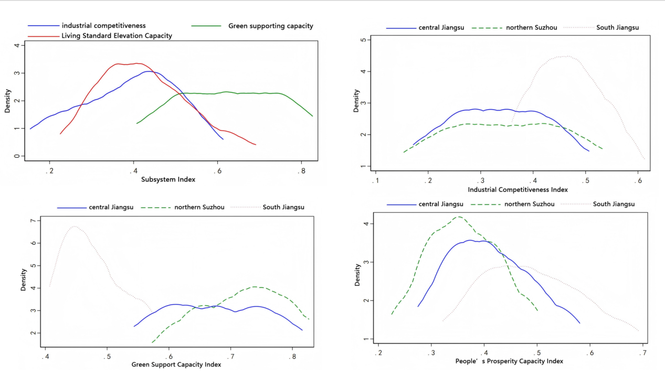
Fig. 6. The evolutionary pattern of the kernel density distribution for the subsystems of rural industrial revitalization
4. CONCLUSION, Recommendation & Limitation

Conclusions

Based on panel data from 13 cities in Jiangsu Province covering the period 2013–2024, this study constructs a comprehensive evaluation system for rural industrial revitalization. By employing the Entropy-TOPSIS method, the Dagum Gini coefficient decomposition method, and kernel density estimation, the study systematically analyzes the spatiotemporal characteristics, regional disparities, and dynamic evolution patterns of rural industrial revitalization in Jiangsu Province. The main conclusions are as follows:

(1) The temporal evolution shows a steady upward trend, with distinct phase differentiation. From 2013 to 2024, the provincial rural industrial revitalization index increased from 0.2680 to 0.5435, representing a cumulative growth of 102.80% and an average annual growth rate of 6.12%, achieving a leapfrog doubling of growth overall. The evolution process can be divided into three major development phases: 2013–2016 was the initial exploration phase; 2017–2020 marked the accelerated growth phase; and 2021–2024 entered the phase of high-quality deepening and advancement. The driving force behind development has gradually shifted from policy-driven to endogenous-driven.

(2) The spatial pattern exhibits a “high in the south, low in the north” distribution, with regional disparities continuing to narrow. The level of rural industrial revitalization follows a gradient pattern of Southern Jiangsu > Central Jiangsu > Northern Jiangsu. Suzhou, Wuxi, and Zhenjiang form the high-value core area, while Northern Jiangsu demonstrates the fastest growth rate and significant late-mover advantages. Cities such as Xuzhou have achieved a significant leap in the gradient, and spatial balance across the province continues to strengthen.

(3) Development of subsystems is divergent, with both weaknesses and strengths coexisting. Industrial competitiveness is growing the fastest and serves as the core driver of rural industrial revitalization across the province; green support capacity is at the highest level, and regional coordination is optimal; people’s livelihood and prosperity are steadily improving, and the urban-rural income gap continues to narrow. Southern Jiangsu leads in people’s livelihood and prosperity, while Central and Northern Jiangsu are characterized by rapid improvements in industrial competitiveness.

(4) Regional disparities are primarily driven by inter-group gaps, with an overall trend toward equilibrium. The overall Gini coefficient decreased from 0.1682 to 0.0897, indicating a significant narrowing of regional disparities. While disparities were initially driven by intra-group gaps, inter-group gaps, and hyper-variation density, the primary driving factor has gradually shifted to net inter-group gaps. Hyper-variation density has declined substantially, and the regional development pattern has shifted from a mixed and intertwined structure to one with clear gradients and stable stratification.

(5) Dynamic Evolution Toward a High-Level Equilibrium: The kernel density curve continued to shift to the right, with the peak first declining and then rising, and the distribution width narrowing. The province gradually shifted from a low-level equilibrium to a high-level equilibrium, without the emergence of multipolar polarization, and overall development remained stable and coordinated.

Policy Recommendations

Based on the spatio-temporal patterns and regional disparities of rural industrial revitalization in Jiangsu Province, policy recommendations are proposed at three levels: provincial coordination, regional synergy, and targeted measures:

(1) Strengthen provincial coordination to promote coordinated revitalization between the north and south. Improve industrial collaboration mechanisms, deepen north-south partnerships, and jointly develop industrial parks to facilitate the orderly transfer of agricultural technology, equipment, talent, and capital to central and northern Jiangsu. Unify provincial green agricultural standards and industrial chain layouts, promote cross-regional co-branding of agricultural products and shared markets, and narrow development gaps between regions.

(2) The Southern Jiangsu region should focus on improving quality and efficiency to lead high-end transformation. Leveraging the advantages of metropolitan areas and urban-rural integration, the region should prioritize the development of premium agriculture, smart agriculture, rural leisure and cultural tourism, and agricultural services to enhance industrial value-added and brand competitiveness. It should accelerate the digital transformation of agriculture and take the lead in demonstrating green, low-carbon development and common prosperity.

(3) The Central Jiangsu region should serve as a bridge between the south and the north, establishing a model of integration. Leveraging its geographical and transportation advantages, the region should prioritize the development of deep processing of agricultural products, logistics and warehousing, and specialty crop and livestock farming, driving deep integration between agriculture and processing, distribution, and e-commerce. It should build a cross-river integrated agricultural demonstration belt to absorb industrial spillover from Southern Jiangsu and drive industrial upgrading in Northern Jiangsu.

(4) The Northern Jiangsu region should expand scale and improve quality to unleash its late-mover advantage. Building on the advantages of land and labor resources, vigorously promote large-scale operations, full mechanization, and green, circular farming and breeding to enhance food security and industrial competitiveness. Improve rural infrastructure and public services, continuously increase farmers’ incomes, and narrow the urban-rural and regional gaps.

(5) Address systemic weaknesses and consolidate long-term support. Continuously improve agricultural science and technology and mechanization levels to strengthen the core engine of industrial competitiveness; strictly implement the reduction of chemical fertilizers and pesticides and the resource utilization of livestock manure to consolidate the advantage of green support; promote farmers’ income growth through multiple channels and optimize consumption structures, using improved living standards to consolidate the endogenous momentum of rural revitalization.

LIMITATIONS

This study has several limitations. First, the indicator system may not fully capture all dimensions of rural industrial revitalization. Second, the analysis is limited to Jiangsu Province, so the findings may not be directly generalizable to other regions. Future research could extend the framework to comparative studies across provinces.

AUTHORS’ CONTRIBUTIONS

Wei Wang designed the research topic and wrote the original draft of the manuscript. Yiyao Chen was responsible for data verification and the production and polishing of figures and tables. Xiangyang Li and Xiaoya Zhou managed the proofreading and collation of the manuscript. All authors read and approved the final manuscript.

REFERENCES
- Wang, X. (2024). Research on the impact of green finance on rural industry revitalization [Master's thesis, Xinjiang Agricultural University]. [In Chinese]
- Liang, S. K. (2023). Research on the impact of rural industry revitalization on farmers' common prosperity [Master's thesis, Zhongnan University of Economics and Law]. [In Chinese]
- Zhang, L., & Ding, X. L. (2024). The effect of rural industry revitalization on the common prosperity of farmers and rural areas. Stat. Inf. Forum, 39(9), 77-92. [In Chinese]
- Sheng, Y. X. (2024). Theoretical origin, scientific connotation and realization path of rural industry revitalization. South. Agric. Mach., 55(22), 96-99. [In Chinese]
- Zhang, L. X., Luo, Q. F., & Wang, Y. N. (2019). Research on the implementation path of rural industry revitalization: A case study of Shandong Yike Modern Agricultural Industrial Park. Teach. Res., (1), 42-50. [In Chinese]
- Liu, S. M., Fan, Q. Q., & Jia, W. (2024). Mechanism explanation and path exploration of industrial integration promoting China's agricultural economic growth. Issues Agric. Econ., (11), 104-112. [In Chinese]
- Wang, R. H. (2025). Mechanism explanation and path exploration of industrial integration promoting China's agricultural economic growth. Shanxi Agric. Econ., (13), 67-69, 99. https://doi.org/10.16675/j.cnki.cn14-1065/f.2025.13.021 [In Chinese]
- Lei, Y. K. (2025). Logic, constraints and realization of new quality productive forces empowering rural industry economic revitalization. Agric. Econ., (7), 17-19. [In Chinese]
- Liu, Z. M. (2025). New quality productive forces empower rural industry revitalization. China Collect. Econ., (21), 1-4. [In Chinese]
- Song, C. Y., Yin, T. T., Li, X. J., et al. (2023). Measurement and driving mechanism of rural industry revitalization from an enterprise perspective: Taking the first three batches of national key rural tourism villages as examples. Prog. Geogr., 42(8), 1453-1467. [In Chinese]
- Xu, R. D., Zhang, J. P., & Ge, Y. (2024). Index construction, measurement evaluation and spatiotemporal evolution of rural revitalization level in China. Planners, 40(8), 43-49. [In Chinese]
- Li, M., & Xiao, H. F. (2025). Impact effect and mechanism of agricultural productive service industry development on rural industry revitalization. Econ. Syst. Reform, (2), 146-154. [In Chinese]
- Huang, D. H., Feng, L., Ding, S. J., et al. (2025). Impact mechanism and spatial spillover effect of agricultural digitalization on rural industry revitalization. Chin. J. Agric. Resour. Reg. Plan., (9), 1-12. [In Chinese]
- Zhang, L., & Liu, C. F. (2024). How does digital inclusive finance empower rural industry revitalization? J. Guizhou Univ. Finance Econ., 42(1), 41-52. [In Chinese]
- Yang, S. G., & Wang, J. (2023). Mechanism and effect of circulation digitalization empowering rural industry revitalization. J. South China Agric. Univ. (Soc. Sci. Ed.), (2), 1-14. [In Chinese]
- Liang, S. K., & Chen, C. B. (2024). Rural industry revitalization and farmers' common prosperity: Theoretical clues and empirical evidence. Rural Econ., (1), 82-92. [In Chinese]
- Cao, L. P. (2025). Research on the impact of rural industry revitalization on agricultural economic growth: A case study of the Yellow River Basin. Chin. J. Agric. Resour. Reg. Plan., (7), 1-14. [In Chinese]
- Zhang, G. R., & Zhang, Y. (2025). Research on the process of new rural elites promoting rural industry revitalization. J. Agro-For. Econ. Manag., 24(2), 174-184. [In Chinese]

