Laboratory-based in vivo exposure of Fall Armyworm (Spodoptera frugiperda) larvae to Ocimum suave extracts
ABSTRACT
The Fall Armyworm (Spodoptera frugiperda) threatens cereal production in sub-Saharan Africa, where reliance on synthetic pesticides poses resistance, health, and sustainability risks. This study evaluated insecticidal and antifeedant efficacy of crude Ocimum suave extracts (water, methanol, dichloromethane, hexane) from leaves, stems, and roots against second-instar FAW larvae under laboratory conditions. Larval mortality and antifeedant activity were recorded at 12, 24, and 48 hours post-treatment, with a synthetic pesticide (Karate) as positive control. Data was analyzed by R software (version 4.3.0), normality was checked using the Shapiro-Wilk test. All O. suave extracts showed significant bioactivity versus the negative control. The aqueous extract exhibited the highest overall efficacy, with robust, dose dependent insecticidal and antifeedant effects, likely due to polar compounds such as phenolics and flavonoids. Methanolic and hexane extracts showed considerable but lesser toxicity. As expected, the synthetic pesticide induced the fastest and highest mortality. Findings indicate that polar bioactive compounds in aqueous O. suave extract effectively inhibit feeding and cause larval death. Thus, Ocimum suave especially as a water extract holds significant potential for managing S. frugiperda within integrated pest management. Further research is needed to identify active compounds, develop stable formulations, and validate field efficacy.
KEYWORDS
Hexane extracts, active compounds, Phenolics, flavonoids, pest management.
INTRODUCTION
Spodoptera frugiperda (J.E. Smith) (Lepidoptera: Noctuidae), commonly known as the fall armyworm (FAW), is a devastating global pest of maize, originating from the Americas (Ahissou et al., 2021). Its strong flight capacity enables rapid spread across diverse regions. After invading Africa in 2016, it quickly disseminated throughout sub-Saharan Africa (SSA), where favourable climatic conditions have created hotspots for its reproduction and infestation (Mulungu & Ng’ombe,2020).
This polyphagous pest affects over 353 plant species but shows a distinct preference for gramineous plants like maize, sorghum, and other cereals (Ortiz-Carreón et al., 2025). The larval stage is the most destructive, causing extensive defoliation and damage to vegetative and reproductive structures, leading to yield losses of 20-50%, and in severe cases, total crop failure (Kumar et al., 2022). In Africa, FAW is estimated to cause annual maize yield losses of 8.3 to 20.6 million metric tonnes, with economic impacts ranging from USD 2.5 to 6.2 billion (Abbas Ali et al., 2025). This pest poses a severe threat to food security, livelihoods, and biodiversity in SSA, necessitating urgent control measures (Kasoma et al., 2021).
Current FAW management strategies include cultural practices, scouting, biological control, and synthetic insecticides (Kumar et al., 2022; Odong et al., 2024; Sisay et al., 2019). However, many farmers rely heavily on synthetic chemicals, which are costly, leave harmful residues, harm beneficial organisms, and drive pesticide resistance (Makgoba et al., 2021; Nyamutukwa et al., 2022). Furthermore, certain classes like organophosphates and carbamates pose significant human health risks (Odong et al., 2024). This highlights the need for sustainable, effective, and eco-friendly alternatives, such as botanical insecticides (Tulashie et al., 2021).
Botanical insecticides, derived from plant extracts, are a promising alternative. Plants produce a diverse array of secondary metabolites as a natural defence against herbivores (Tulashie et al., 2021). The genus Ocimum (basil), family Lamiaceae, is renowned for its essential oils and bioactive compounds, demonstrating insecticidal, antifeedant, repellent, and growth-disrupting effects on various insect pests (Lucy, 2012). Ocimum suave, a relatively understudied species within this genus, has potential for controlling various pests and diseases (Reddy and Chowdary, 2021). Its extracts contain compounds like eugenol, linalool, and various terpenoids, which are responsible for its phytochemical effects (Majid et al.,2020; Tavares et al.,2021) while extracts from O. suave leaves have been used as mosquito repellents and acaricides (Opiyo, 2020), its efficacy against FAW larvae under controlled conditions remains largely unexplored.
Ocimum suave offers significant advantages for pest control: low mammalian and environmental toxicity, reduced risk of resistance, and affordability for farmers, thereby helping to stabilize incomes and protect food supplies in FAW-affected regions (Chowdhary et al., 2018; Liu et al., 2024; Opiyo, 2021; Shikha & Kashyap, 2024). These attributes make it a suitable candidate for integrated pest management (Isman, 2019; Seyoum et al., 2003). Therefore, this study aims to evaluate the insecticidal and antifeedant efficacy of O. suave extracts against FAW larvae under laboratory conditions.
MATERIALS AND METHODS
Study Site
The research was conducted at the entomology laboratory of the Tanzania Agricultural Research Institute (TARI)-Ilonga, Morogoro, Tanzania (Latitude: 6°38'00.0"S, Longitude: 36°52'00.0"E, Altitude: 468 m above sea level).
Plant Material Collection and Crude Extract Preparation
Fresh plant parts (leaves, stems, and roots) of Ocimum suave were collected from Mvomero district. Samples were rinsed with tap water to remove dust (Rioba et al, 2020). The roots and stems were cut into small pieces, and all samples were shade-dried at room temperature for 10-15 days. The dried material was ground into a fine powder using an electric grinder and sieved through a 0.25 mm mesh.
A 100-gram sample of the powdered mixture (leaves, stems, roots) was extracted separately with 1000 ml of methanol, dichloromethane (DCM), n-hexane, and distilled water using the maceration method. Each mixture was stored in a flat-bottom flask, covered with aluminium foil, and macerated for 48 hours at room temperature. The extracts were filtered through cotton wool and cheesecloth. The filtrates were concentrated using a vacuum rotary evaporator, set to the respective solvent's boiling point. Once reduced to one-third of the original volume, the concentrates were transferred to petri dishes for complete solvent evaporation (Alqethami & Aldhebiani, 2021). The dry crude extracts were weighed and stored in glass bottles.
For bioassay, stock solutions were prepared by initially dissolving the crude extract in a small volume of acetone and then diluting with distilled water to a final volume of 100 ml. 1% of the crude methanol was prepared by weighing 1g of dry crude methanol, dissolving it in 3ml of acetone, and then diluting with distilled water to a final volume of 100ml in a volumetric flask The concentrations used in the experiment were 1%, 2%, and 3% (w/v) for each crude extract. The synthetic pesticide Karate (5% EC lambda-cyhalothrin), applied at 2 ml per litre of water, served as the positive control, while distilled water served as the negative control.
Fall Armyworm Rearing
FAW eggs and larvae were collected from local maize fields. Larvae were reared on tender maize leaves until pupation. Pupae were placed in cotton-lined plastic jars, and emerging adults were transferred to rearing cages (Devi, 2024). Adults were fed a 10% (w/v) sugar solution. Egg batches were collected on sterilized glass Petri dishes and monitored for hatching. Neonatal larvae were fed soft maize leaves. To prevent cannibalism, third-instar larvae were isolated in individual plastic Petri dishes for use in bioassays (Mbande, 2023; Abbas Ali et al., 2025).
Laboratory Toxicity Bioassay
The toxicity of four treatments (1%, 2%, and 3% extracts, and a water control) was evaluated. For each replicate, five third-instar larvae, starved for 24 hours, were used. Fresh maize leaf pieces (2 cm x 4 cm) were dipped in the respective extract for 10 minutes, air-dried to remove run-off, and weighed (Devi et al., 2024). A single treated leaf piece was provided to each larva in a Petri dish. After 48 hours, surviving larvae were transferred to untreated food. The uneaten leaf portion was dried and weighed to calculate consumption (Dhanyakumar et al., 2023; Phambala et al., 2020). Treated leaves were replaced daily. The experiment consisted of 14 treatments (4 solvents x 3 concentrations + positive & negative controls), each replicated three times, arranged in a Completely Randomized Design (CRD).
Larval mortality was assessed at 12, 24, and 48 hours post-treatment. Larvae were considered dead if they showed no movement and did not respond to gentle prodding with a needle. Mortality percentage was calculated as:
Mortality% = (Number of dead larvae / Total number of larvae) × 100
Data Analysis
Statistical analyses were performed using R software (version 4.3.0). Data normality was checked using the Shapiro-Wilk test. As both larval mortality and leaf consumption data violated normality assumptions (Mortality: W = 0.924, p = 0.008; Consumption: W = 0.871, p < 0.001), non-parametric tests were used. The Kruskal-Wallis test was applied to determine overall treatment effects, followed by Dunn's post-hoc test with Bonferroni correction for pairwise comparisons. Dose-response relationships for each extract were analysed using separate Kruskal-Wallis tests. Mortality data are presented as mean percentage ± standard error (SE) per replicate (n=5 larvae/replicate, 3 replicates/treatment). Leaf consumption per larva was calculated as (initial leaf weight - final leaf weight) / number of surviving larvae at 48 hours. Statistical significance was set at α = 0.05.
RESULTS
Effect of O. suave Extracts on Larval Mortality
The Kruskal-Wallis test indicated significant differences in larval mortality among treatments (χ² = 19.06, df = 5, p = 0.002). The positive control (KARATE) caused 100% mortality and was significantly more effective than the dichloromethane extract (Z = -3.24, p = 0.009) and the water control (Z = 3.78, p = 0.001). While the methanol and n-hexane extracts caused substantial mortality (53.3-66.7%), their efficacy was not statistically different from the Karate treatment in the post-hoc comparisons, unlike the dichloromethane extract.
Among the plant extracts, the distilled water (DW) extract showed the highest insecticidal activity, with mortality increasing from 40.0 ± 0.0% at 1% to 73.3 ± 6.7% at 3% concentration. It was the only extract to exhibit a significant dose-response relationship (χ² = 6.12, p = 0.047). The n-hexane extract showed optimal efficacy at 2% concentration (66.7 ± 6.7% mortality), which was significantly higher than the water control (Z = 2.73, p = 0.047). Mortality decreased to 60.0 ± 11.5% at the 3% concentration. The methanol extract showed moderate, consistent activity across concentrations (53.3 ± 6.7% to 60.0 ± 11.5%) with no significant dose-response (χ² = 0.22, p = 0.895). The dichloromethane extract performed poorly at lower concentrations (20.0 ± 11.5% at 1% and 2%) but reached 60.0 ± 11.5% at 3%.
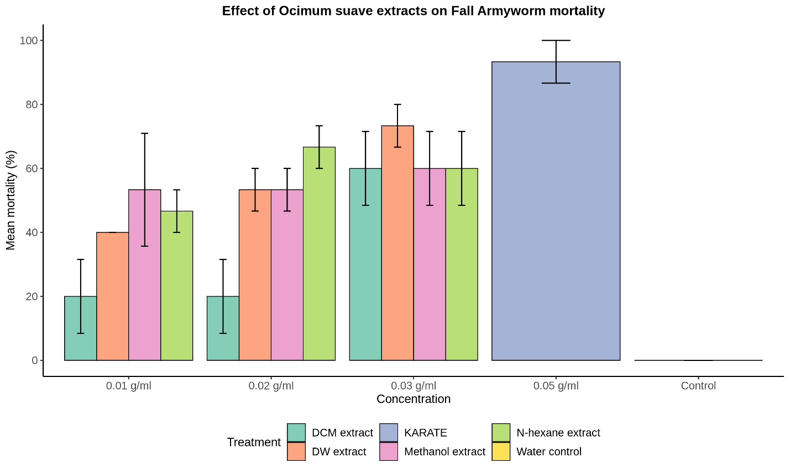
Figure 1. Mean mortality (%) of Spodoptera frugiperda larvae after 48-hour exposure to different concentrations of Ocimum suave extracts. Bars represent mean ± standard error. Different letters above bars indicate significant differences (p < 0.05) based on Dunn's post-hoc test.
Leaf consumption varied significantly among treatments (χ² = 16.23, df = 5, p = 0.006). The water control group consumed the most leaf material (0.584 ± 0.033 g/larva), while Karate-treated larvae consumed the least (0.200 ± 0.000 g/larva) due to rapid mortality.
All plant extracts demonstrated significant antifeedant activity compared to the water control: DW extract (Z = 3.06, p = 0.017), methanol extract (Z = 2.81, p = 0.037), and n-hexane extract (Z = 3.07, p = 0.016). The DW extract at 1% showed the strongest antifeedant effect among surviving larvae (0.700 ± 0.048 g/larva), representing a 40% reduction compared to the control. Notably, leaf consumption increased with the concentration of the DW extract.
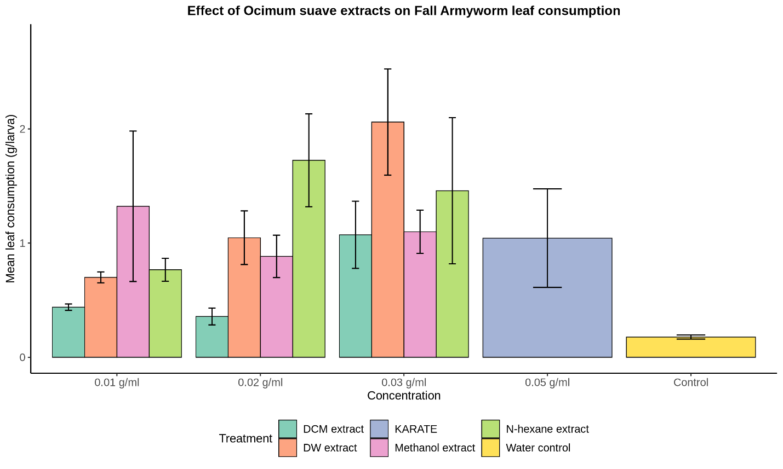Figure 2. Mean leaf consumption (g/larva) by surviving Spodoptera frugiperda larvae after 48-hour exposure to different concentrations of Ocimum suave extracts. Bars represent mean ± standard error. Different letters above bars indicate significant differences (p < 0.05) based on Dunn's post-hoc test.
Extract Efficacy Ranking
Based on combined mortality and antifeedant effects, the efficacy of O. suave extracts was ranked as follows:
- DW extract at 3% (73.3% mortality with significant antifeedant activity).
- n-Hexane extract at 2% (66.7% mortality with significant antifeedant activity).
- Methanol extract at 3% (60.0% mortality with significant antifeedant activity).
- Dichloromethane extract (variable mortality, 20-60%, with limited antifeedant effects).
DISCUSSION
This study demonstrates that O. suave extracts possess both insecticidal and antifeedant properties against S. frugiperda larvae. The aqueous extract exhibited the most promising bioactivity, indicating its potential for integration into sustainable pest management programs. The superior performance of the water extract suggests it effectively retains polar bioactive compounds, such as phenolics, flavonoids, and alkaloids, which are known to be highly effective against insects. Essential oils and purified terpenoids from Ocimum species, including compounds like linalool and eugenol, have been reported to reduce survival and feeding in S. frugiperda (Bibiano et al., 2022; Usseglio et al., 2022). The polarity of the extraction solvent significantly influences the profile of extracted compounds and their subsequent bioactivity. Polar solvents like water efficiently extract phenolic acids and glycosides that often drive antifeedant effects, while non-polar solvents enrich monoterpenes associated with contact toxicity (Chatepa et al., 2024; Onyebuchi et al., 2020). This explains the consistent, dose-dependent efficacy of the water extract and the more variable results from the less polar fractions. The effectiveness of the aqueous extract is particularly advantageous for practical application, as it is safer, cheaper, and easier for farmers to prepare than organic solvent-based extracts (Nyamutukwa et al., 2022).
The results showed a clear dose-dependent response for the aqueous extract, with the highest mortality observed at the 3% concentration. The delayed mortality, which was low at 12 hours but high at 48 hours, indicates that the bioactive compounds in O. suave require time to exert their full effects, possibly through chronic toxicity or ingestion-mediated action (Deng et al., 2013). These bioactive compounds likely interfere with the insect's nervous system by inhibiting enzymes like acetylcholinesterase, leading to paralysis and death, and may also cause physical damage to the digestive tract (Bekele et al., 1996; Opiyo, 2020, 2021). This multi-faceted mode of action creates a robust defence that is difficult for pests to overcome through resistance.
As expected, the synthetic pesticide (Karate) outperformed all plant extracts in terms of speed and completeness of mortality. This aligns with the high potency of synthetic neurotoxins. However, botanical extracts like those from Ocimum can approach the efficacy of synthetics in ingestion bioassays and hold potential as components in mixture or rotation programs to reduce synthetic pesticide use (Bibiano et al., 2022; Usseglio et al., 2022; Silva et al., 2017). The dual insecticidal and antifeedant effects observed are consistent with the multi-target action of plant secondary metabolites, such as monoterpenes and phenylpropanoids, which can act on acetylcholinesterase, GABA receptors, and octopamine receptors (Jankowska et al., 2018; Popescu et al., 2024). This complex action first reduces feeding and mobility, eventually leading to mortality at higher doses or prolonged exposure.
CONCLUSION
The study demonstrates that O. suave extracts, particularly the aqueous extract, are effective against Spodoptera frugiperda larvae, causing significant mortality and reducing leaf consumption in a dose-dependent manner. Although less potent than the synthetic pesticide Karate, the plant extracts offer a valuable, eco-friendly alternative. Given the environmental and health concerns associated with synthetic pesticides, botanical alternatives like O. suave can be integrated into IPM strategies that combine scouting, cultural practices, and biological control. This approach can reduce chemical reliance while protecting crop health. Future research should focus on isolating and identifying the specific bioactive compounds, developing stable formulations, and validating these promising laboratory results under field conditions to ensure practical applicability.
Disclaimer (Artificial Intelligence)
Author(s) hereby declare that NO generative AI technologies such as Large Language Models (ChatGPT, COPILOT, etc.) and text-to-image generators have been used during the writing or editing of this manuscript.
Competing Interests
Authors have declared that no competing interests exist
REFERENCES
Abbas Ali, M., Abd-Elgalil, D. M., S Bakry, M. M., & Mohamed, G. S. (2025). Evaluation of the potential toxicity of plant extracts, pathogenic fungi, and chemical pesticides for the management of Spodoptera frugiperda. 132, 103. https://doi.org/10.1007/s41348-025-01094-1
Ahissou, B. R., Sawadogo, W. M., Bokonon-Ganta, A. H., Somda, I., Kestemont, M. P., & Verheggen, F. J. (2021). Baseline toxicity data of different insecticides against the fall armyworm Spodoptera frugiperda (J. E. Smith) (Lepidoptera: Noctuidae) and control failure likelihood estimation in Burkina Faso. African Entomology, 29(2), 435–444. https://doi.org/10.4001/003.029.0435
Alqethami, A., & Aldhebiani, A. Y. (2021). Medicinal plants used in Jeddah, Saudi Arabia: Phytochemical screening. Saudi Journal of Biological Sciences, 28(1), 805–812. https://doi.org/10.1016/J.SJBS.2020.11.013
Bekele, A. J., Obeng-Ofori, D., & Hassanali, A. (1996). Evaluation of Ocimum suave (Willd) as a source of repellents, toxicants, and protectants in storage against three stored product insect pests.International Journal of Pest Management, 42(2), 139–142. https://doi.org/10.1080/09670879609371983
Bibiano, C. S., Fernandes, L. A., Ugucioni, J. C., de Oliveira, J. L., & Bertolucci, S. K. V. (2022). Toxicity of essential oils and pure compounds of Lamiaceae species against Spodoptera frugiperda and safety for Trichogramma pretiosum. Crop Protection, 158, 106011. https://doi.org/10.1016/j.cropro.2022.106011
Chatepa, L. E. C., Mwamatope, B., Chikowe, I., & Masamba, K. G. (2024). Effects of solvent extraction on the phytoconstituents and in vitro antioxidant activity properties of leaf extracts of the two selected medicinal plants from Malawi. BMC complementary medicine and therapies, 24(1), 317.
Chengfeng L, Jian Y, Jia W, Jia H, Sun X (2020) Molecular and biological characterization of Spodoptera frugiperda multiple nucleopolyhedrovirus field isolate and genotypes from China. Insects 11:777
Chowdhary, K., Kumar, A., Sharma, S., Pathak, R., & Jangir, M. (2018). Ocimum sp.: Source of biorational pesticides.Industrial Crops and Products, 122, 686–701. https://doi.org/10.1016/j.indcrop.2018.05.068
Deng, Y., Cao, M., Shi, D., Yin, Z., Jia, R., Xu, J., Wang, C., Lv, C., Liang, X., He, C., Yang, Z., & Zhao, J. (2013). Toxicological evaluation of neem (Azadirachta indica) oil: Acute and subacute toxicity. Environmental Toxicology and Pharmacology, 35(2), 240–246. https://doi.org/10.1016/j.etap.2012.12.015
Devi, R. (2024) “Biology of Fall Armyworm Spodoptera frugiperda (J.E. Smith) on Maize under Laboratory Conditions”, International Journal of Environment and Climate Change, 14(2), pp. 463–469. doi: 10.9734/ijecc/2024/v14i23961.
Devi, Ragni, Umesh Chandra, Ravi Kumar Rajak, Pankaj Kumar, Sameer Kumar Singh, and Ram Veer. 2024. “Biology of Fall Armyworm Spodoptera Frugiperda (J.E. Smith) on Maize under Laboratory Conditions”. International Journal of Environment and Climate Change 14 (2):463-69. https://doi.org/10.9734/ijecc/2024/v14i23961.
Dhanyakumar O, Ram Kumar P, Ashwitha G, Venkatesan T, Mohan M, Nishtha N, Sivakumar G (2023) Sub-lethal effects of indigenous isolate of Spodoptera frugiperda nucleopolyhedrovirus on fall armyworm growth and reproduction in India. Egypt J Biol Pest Control 33:10
Isman, M. B. (2019). Commercial development of plant essential oils and their constituents as active ingredients in bioinsecticides. Phytochemistry Reviews, 19(2), 235–241. https://doi.org/10.1007/s11101-019-09653-9
Jankowska, M., Rogalska, J., Wyszkowska, J., & Stankiewicz, M. (2017). Molecular targets for components of essential oils in the insect nervous system-a review. Molecules, 23(1), 34.. https://doi.org/10.3390/molecules23010034
Kasoma, C., Shimelis, H., & Laing, M. D. (2021). Fall armyworm invasion in Africa: implications for maize production and breeding. Journal of Crop Improvement, 35(1), 111–146. https://doi.org/10.1080/15427528.2020.1802800
Kumar, R. M., Gadratagi, B. G., Paramesh, V., Kumar, P., Madivalar, Y., Narayanappa, N., & Ullah, F. (2022). Sustainable Management of Invasive Fall Armyworm, Spodoptera frugiperda. Agronomy 2022, Vol. 12, Page 2150, 12(9), 2150. https://doi.org/10.3390/AGRONOMY12092150
Laudien, R., Schauberger, B., Makowski, D., & Gornott, C. (2020). Robustly forecasting maize yields in Tanzania based on climatic predictors. Scientific Reports, 10, 19854. https://doi.org/10.1038/s41598-020-76315-8
Liu, A., Zhang, Y. C., Qi, Y. T., Wang, J. Z., Wang, D., & Du, S. S. (2024). Chemical characterization and insecticidal activities of the essential oils from the different parts of Ocimum gratissimum var. suave (Willd.) Hook. f. Chemistry & Biodiversity, 21(1), e202401218. https://doi.org/10.1002/cbdv.202401218
Lucy, K. M. (2012). Evaluation of sub-chronic toxicity and phytochemical screening of aqueous leaf extract of Ocimum suave (Lamiaceae). [Master’s thesis, Kampala International University, College of Health Sciences]. http://hdl.handle.net/20.500.12306/13601
Majdi, C., Pereira, C., Dias, M. I., Calhelha, R. C., Alves, M. J., Frih, B., Charrouf, Z., Barros, L., Amaral, J. S., & Ferreira, I. C. F. R. (2020). Phytochemical Characterization and Bioactive Properties of Cinnamon Basil (Ocimum basilicum cv. ‘Cinnamon’) and Lemon Basil (Ocimum × citriodorum). Antioxidants 2020, Vol. 9, Page 369, 9(5), 369. https://doi.org/10.3390/ANTIOX9050369
Makgoba, M. C., Tshikhudo, P. P., Nnzeru, L. R., & Makhado, R. A. (2021). Impact of fall armyworm (Spodoptera frugiperda J. E. Smith) on small-scale maize farmers and its control strategies in the Limpopo Province, South Africa. Jàmbá: Journal of Disaster Risk Studies, 13(1), 1016. https://doi.org/10.4102/jamba.v13i1.1016
Mbande, A. (2023). Evolutionary, physiological and phenological responses of Spodoptera frugiperda to climate change.
Mulungu, K., & N. Ng’ombe, J. (2020). Climate Change Impacts on Sustainable Maize Production in Sub-Saharan Africa: A Review. Maize - Production and Use. https://doi.org/10.5772/INTECHOPEN.90033
Mutyambai DM, Niassy S, Calatayud PA, Subramanian S (2022) Agronomic factors influencing fall armyworm (Spodoptera frugiperda) infestation and damage and its co-occurrence with stem borers in maize cropping systems in Kenya. Insects 13:266
Nyamutukwa, S., Mvumi, B. M., & Chinwada, P. (2022). Sustainable management of fall armyworm, Spodoptera frugiperda (J.E. Smith): challenges and proposed solutions from an African perspective. International Journal of Pest Management. https://doi.org/10.1080/09670874.2022.2027549;WGROUP:STRING:PUBLICATION
Odong, T. L., Obongo, I., Ariong, R., Adur, S. E., Adumo, S. A., Onen, D. O., Rwotonen, B. I., & Otim, M. H. (2024). Farmer perceptions, knowledge, and management of Fall Armyworm in maize production in Uganda. Frontiers in Insect Science, 4, 1345139. https://doi.org/10.3389/finsc.2024.1345139
Onkarappa, D., Pandi, R. K., Gopal, A., Thiruvengadam, V., Muthugounder, M., Nayyar, N., & Gopalsamy, S. (2023). Sub-lethal effects of indigenous isolate of Spodoptera frugiperda nucleopolyhedrovirus on fall armyworm growth and reproduction in India. Egyptian Journal of Biological Pest Control, 33(1), 10.
Onyebuchi, C., Kavaz, D., & Ekeuku, S. O. (2020). Effect of extraction temperature and solvent type on the bioactive potential of plant extracts, a review. Food Science and Nutrition, 8(10), 5161–5171.
Opiyo, S. A. (2020). Insecticidal activity of Ocimum suave Willd extracts and compounds against Sitophilus zeamais Motschulsky. Basic Sciences of Medicine, 9(2), 32–37. https://doi.org/10.5923/j.medicine.20200902.03
Opiyo, S. A. (2021). Repellent effects of Ocimum suave extracts and compounds against Prostephanus truncatus Horn. Journal of Chemistry, 11(2), 1–7. https://doi.org/10.5923/j.chemistry.20211102.01
Ortiz-Carreón, F. R., Bernal, J. S., Rojas, J. C., Cruz-López, L., Kolomiets, M. V., & Malo, E. A. (2025). Fall armyworm females choose host plants that are detrimental to their offspring’s performance but young larvae amend their mother’s choices. Entomologia Experimentalis et Applicata, 173(1), 21–31. https://doi.org/10.1111/eea.13512
Phambala, K., Tembo, Y., Kasambala, T., Kabambe, V. H., Stevenson, P. C., & Belmain, S. R. (2020). Bioactivity of common pesticidal plants on Fall Armyworm larvae. Plants, 9(1), 112. https://doi.org/10.3390/plants9010112
Popescu, I. E., Moise, M., & Burducea, M. (2024). Mechanisms of action and administration technologies of essential oils used as green insecticides. Applied Biosciences, 6(2), 68.
Rioba, N. B., Stevenson, P. C., et al. (2020). Opportunities and scope for botanical extracts and products for Fall Armyworm management. Plants, 9(2), 207. https://doi.org/10.3390/plants9020207
Seyoum, A., Kabiru, E. W., Lwande, W., Killeen, G. F., Hassanali, A., & Knols, B. G. J. (2002). Repellency of live potted plants against Anopheles gambiae from human baits in semi-field experimental huts. American Journal of Tropical Medicine and Hygiene, 67(2 Suppl), 191–195. https://doi.org/10.4269/ajtmh.2002.67.191
Shikha, D., & Kashyap, P. (2024). Ocimum species. In harvesting Food from Weeds (pp. 183–215). Wiley. https://doi.org/10.1002/9781119793007.ch6
Silva, S. M., Rodrigues da Cunha, J. P. A., de Carvalho, S. M., Zandonadi, C. H. S., Martins, R. C., & Chang, R. (2017). Ocimum basilicum essential oil combined with deltamethrin to improve the management of Spodoptera frugiperda. Ciência e Agrotecnologia, 41(6), 665–675. https://doi.org/10.1590/1413-70542017416016317
Sisay, B., Simiyu, J., Mendesil, E., Likhayo, P., Ayalew, G., Mohamed, S., Subramanian, S., & Tefera, T. (2019). Fall armyworm, Spodoptera frugiperda infestations in East Africa: Assessment of damage and parasitism. Insects, 10(7), 195. https://doi.org/10.3390/insects10070195
Tavares, W. R., Ferraz, R., & Gomes, C. (2021). Aqueous and ethanolic plant extracts as bio-insecticides, bridging raw data and practice. Molecules, 26(11), 307.
Tulashie, S. K., Adjei, F., Abraham, J., & Addo, E. (2021). Potential of neem extracts as natural insecticide against fall armyworm (Spodoptera frugiperda J. E. Smith) (Lepidoptera: Noctuidae). CasE Studies in Chemical and Environmental Engineering, 4, 100130. https://doi.org/10.1016/j.cscee.2021.100130
Usseglio, V. L., Achimón, F., Brito, V., Zunino, M. P., & Zygadlo, J. A. (2022). Can essential oils be a natural alternative for the control of Spodoptera frugiperda. Plants, 12(1), 3. https://doi.org/10.3390/plants12010003

