Case Report
Acute Pancreatitis Complicated by Rapunzel Syndrome in a Patient with Incomplete Situs Inversus: A Case Report

ABSTRACT
Background: Situs inversus is a rare anatomical anomaly that renders surgical presentations atypical. The association of acute pancreatitis, a gastrointestinal trichobezoar, and Rapunzel syndrome in a patient with situs inversus is exceptional.
Case Report: We report the case of a 17-year-old female patient with unknown situs inversus who presented with biochemical acute pancreatitis that progressed to multiple digestive perforations associated with gastrointestinal trichobezoars fulfilling the criteria for Rapunzel syndrome.
Conclusion: This case highlights the importance of a thorough and multimodal diagnostic evaluation in the setting of acute abdominal symptoms, and the need to anticipate rare complications — particularly Rapunzel syndrome — in patients with congenital anatomical anomalies.
Keywords: Situs inversus; Acute pancreatitis; Trichobezoar; Rapunzel syndrome; Digestive perforation; Surgical emergency

1. Introduction
Situs inversus is a congenital malformation characterized by a mirror-image transposition of the abdominal and thoracic organs, with an estimated incidence of approximately 1 in 10,000 births. This condition can significantly complicate the diagnosis and management of abdominal emergencies, particularly pancreatic disorders and gastrointestinal surgical emergencies.
Acute pancreatitis in this context remains rare but has been described in a few case series. Furthermore, trichobezoars — compacted masses of ingested hair — are uncommon causes of digestive obstruction that can be complicated by ileus, perforation, and pancreatitis, particularly in the setting of Rapunzel syndrome, defined by extension of the trichobezoar beyond the pylorus into the duodenum and jejunum.
We report here an exceptional case of concurrent acute pancreatitis, Rapunzel syndrome, and incomplete situs inversus in an adolescent patient, illustrating the diagnostic and therapeutic challenges inherent to this triple association.

2. Case Report
A 17-year-old female patient with no significant past medical history, unknown to have situs inversus, was admitted to the emergency department with a five-day history of epigastric pain associated with vomiting and obstipation without cessation of flatus, in the context of an afebrile state and general deterioration. Physical examination found a normal shaped patient with a BMI of 21 kg/m² and with no sign of alopecia. Abdominal examination revealed transfixing epigastric tenderness. Laboratory workup showed a moderate elevation of serum lipase greater than three times the upper limit of normal, leukocytosis, and a normal liver function panel.
Initial abdominopelvic CT scan demonstrated a mirror-image arrangement of the abdominal organs consistent with situs inversus. The liver, located in the left hypochondrium, was homogeneous with no focal lesion. The gallbladder was non-distended and homogeneous. Polysplenia was noted. The stomach, located on the right, showed significant stasis with fecaloid content and no identifiable obstructing lesion. The pancreas had no obvious morphological abnormality.
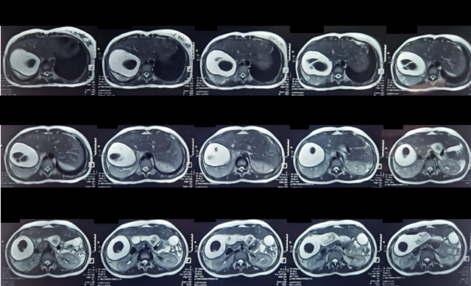
Figure 1 — Initial MRI: mirror-image arrangement of organs consistent with situs inversus
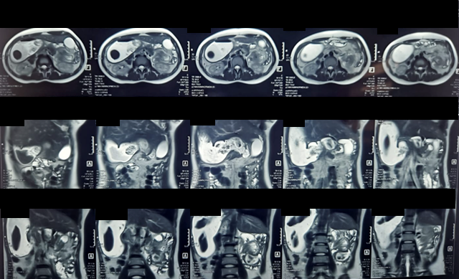
Figure 2 — Initial MRI: gastric stasis and polysplenia
A subsequent pancreaticobiliary MRI confirmed the CT findings and revealed significant gastric stasis proximal to parietal thickening of the digestive tract at the duodenojejunal junction, located in the left flank anterior to the inferior pole of the left kidney, associated with signs of digestive and vascular rotation initially raising concern for intestinal intussusception or mesenteric volvulus. Following collegial review, however, no findings supporting volvulus, intussusception, or significant parietal thickening were confirmed; the vascular axis was preserved and the fecaloid gastric appearance was not corroborated. The working diagnosis was therefore Balthazar grade A acute pancreatitis, with a BISAP score of 1 and biochemical SIRS (Systemic inflammatory response syndrome) criteria consisting of leukocytosis associated with lipase greater than three times normal.
On day 7 of hospitalization, the patient developed bilious vomiting and generalized abdominal rigidity. Laboratory investigations revealed a marked inflammatory syndrome with anemia (hemoglobin: 11 g/dL), leukocytosis (25,000/mm³), and an elevated C-reactive protein level (377 mg/L. An emergency abdominopelvic CT scan showed focal, irregular colonic parietal thickening with a perfusion defect suggestive of perforation, complicated by peritoneal effusion and moderate pneumoperitoneum, with signs of peritoneal irritation and reflex ileus. Gastric content was markedly heterogeneous, consistent with a trichobezoar, in the setting of incomplete situs inversus.
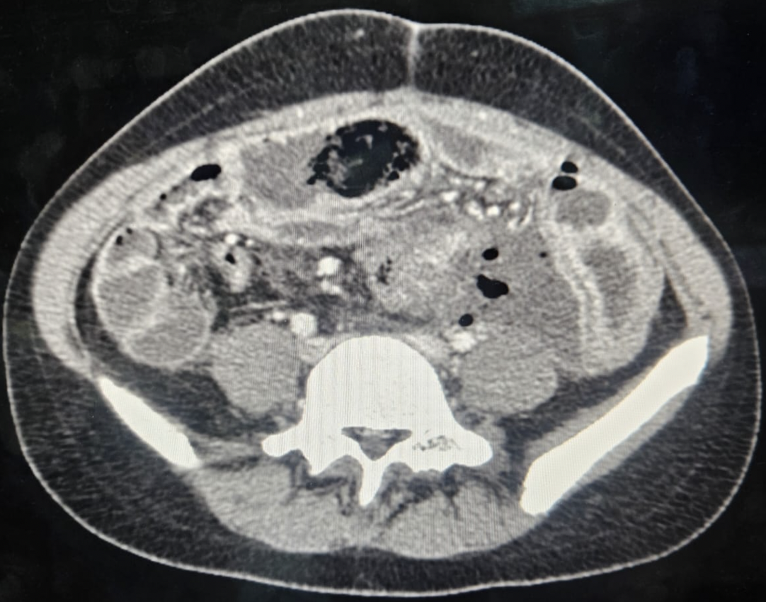
Figure 3 — Emergency repeat CT scan: peritoneal effusion
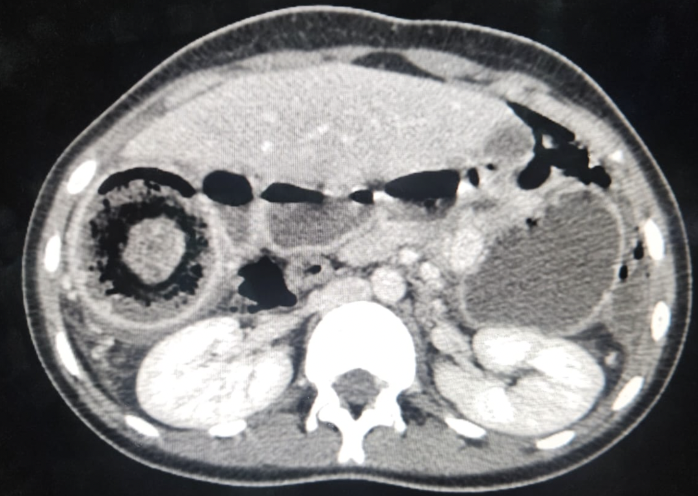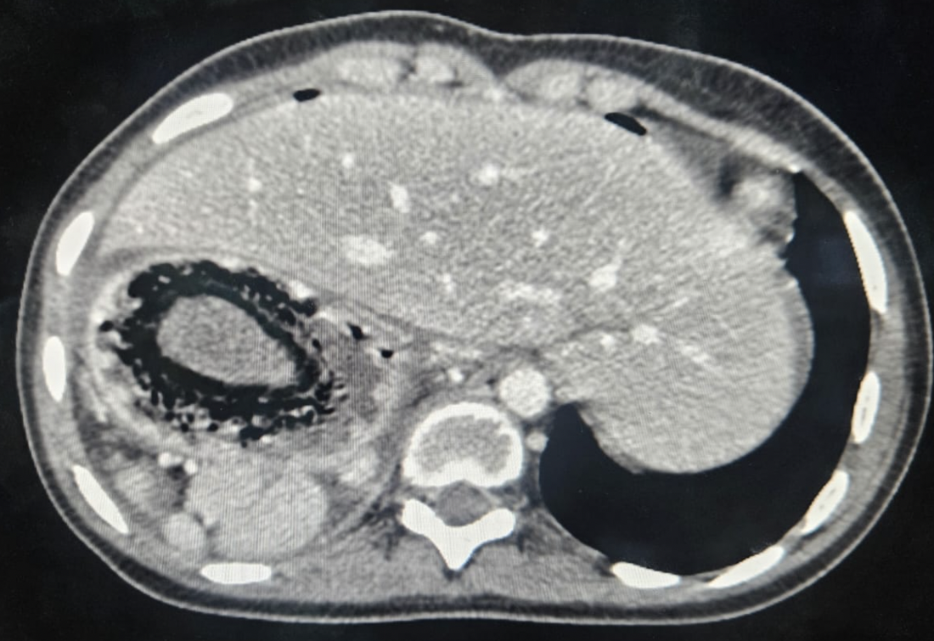
Figure 4 — Emergency repeat CT scan: digestive perforation with pneumoperitoneum and heterogeneous gastric content consistent with trichobezoar
The patient was urgently transferred to the operating theater. Intraoperatively, she developed transient hemodynamic and respiratory instability requiring brief norepinephrine support (4 mg), which was successfully weaned. Surgical exploration revealed abundant feculent peritoneal effusion, a 4 cm perforation of the first jejunal loop with extensive necrosis and gangrenous appearance, and a 5 cm perforation of the fourth portion of the duodenum. Multiple trichobezoars were also identified throughout the stomach and small bowel. These findings were consistent with Rapunzel syndrome, defined by a gastric trichobezoar with duodenal and jejunal extension.
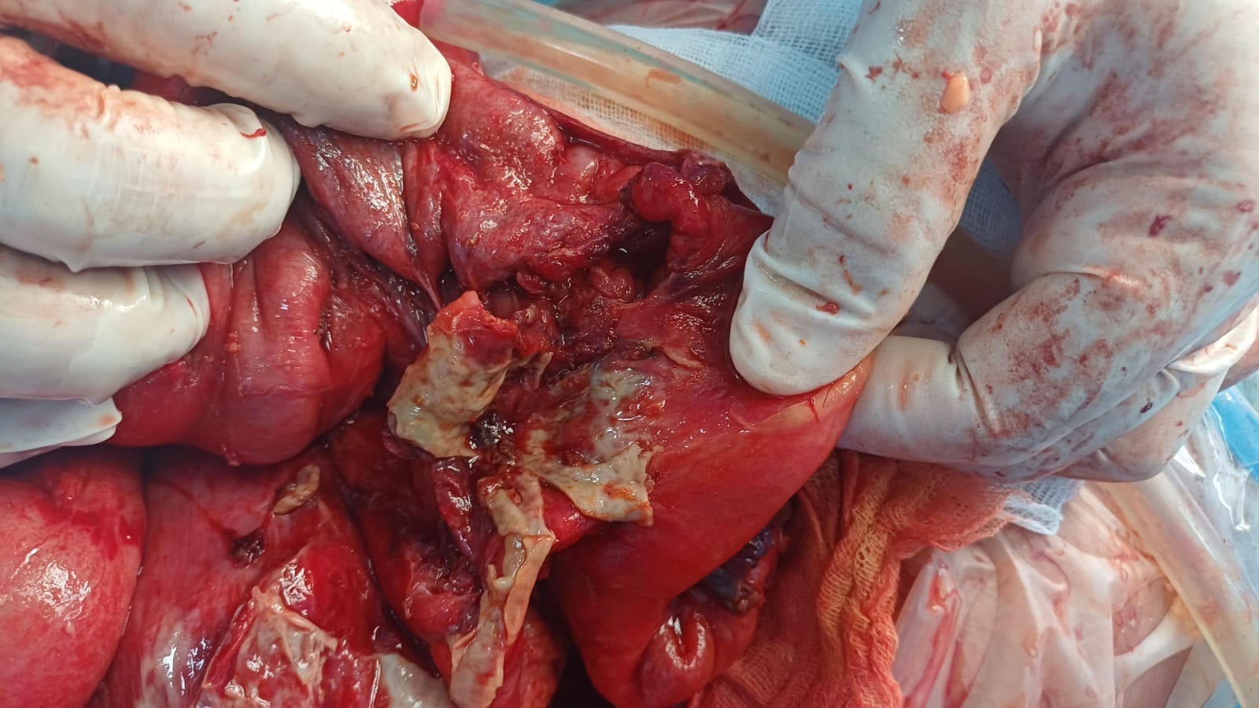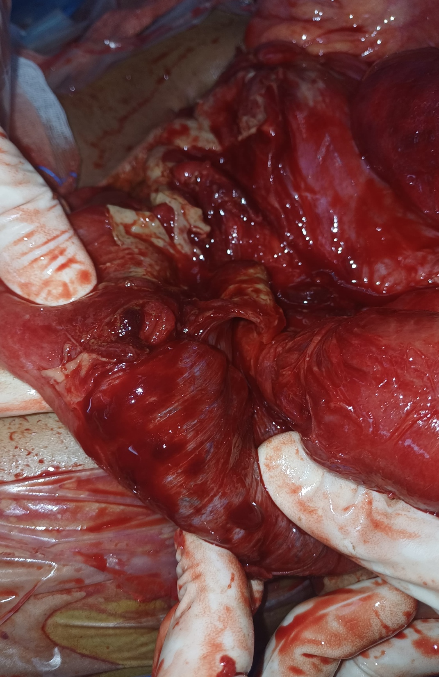
Figure 5 — Intraoperative view: gastric trichobezoar extending into the small bowel (Rapunzel syndrome)

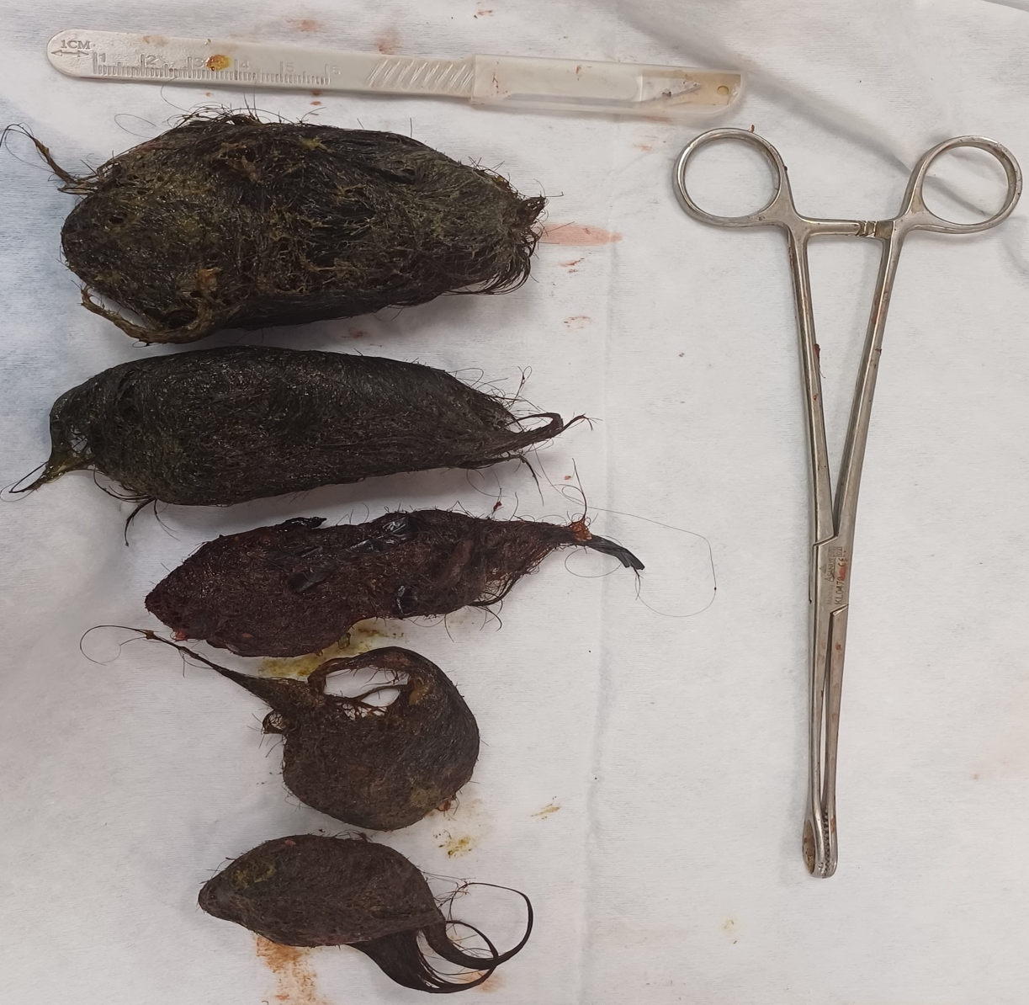
Figure 6 — Macroscopic appearance of the trichobezoar
The postoperative course was marked by a progressive and favorable clinical evolution. Hemodynamic and biological parameters normalized within the first postoperative days. Bowel function gradually resumed, and the patient's pain resolved without further complications. She was transferred from the intensive care unit to the surgical ward on postoperative day 5, and was ultimately discharged in satisfactory clinical condition. A psychiatric assessment was initiated prior to discharge, given the underlying trichophagia, with outpatient follow-up arranged to prevent recurrence.

3. Discussion
Situs inversus, although rare, significantly alters the topography of the abdominal organs, complicating the clinical and radiological interpretation of acute abdominal pain. Several cases of acute pancreatitis associated with situs inversus or polysplenia syndromes have been reported, suggesting that in the absence of common causes such as alcohol or gallstones, aberrant anatomy may obscure underlying etiologies and delay diagnosis^{[1]}. Cases of biliary pancreatitis on situs inversus have been published, with gallstones identified as the causative factor.
Trichobezoars are rare gastrointestinal foreign bodies, accounting for 0.15% of all gastrointestinal foreign bodies^{[2]}. They are typically observed in young females with a history of trichophagia or trichotillomania, with a peak incidence between 10 and 19 years of age and a female predominance in 90% of cases^{[3]}. Their occurrence is classically associated with psychiatric disorders such as Pica syndrome or trichotillomania, or with prior partial gastrectomy^{[4]}. The gastric location is most common: ingested hair adheres to the mucosa and progressively forms a compact mass attached to the gastric wall^{[5]}. When this mass extends into the small bowel beyond the pylorus, or even reaches the transverse colon, the condition is termed Rapunzel syndrome — as was the case in our patient^{[1,6]}.
This condition can remain asymptomatic for extended periods, explaining diagnostic delays of sometimes several years^{[7]}. The clinical presentation is non-specific and includes epigastric pain, nausea, vomiting, bowel habit changes, anorexia, and weight loss^{[7]}. In some cases, the disease presents primarily through a complication such as gastrointestinal bleeding, acute intestinal obstruction, digestive perforation, cholestatic jaundice, or acute pancreatitis attributable to obstruction of the ampulla of Vater by a bezoar extension^{[6,8,9]}. On physical examination, the presence of alopecia patches is an important orienting sign that should prompt a search for trichotillomania^{[7]}. An abdominal mass in the epigastrium or left hypochondrium may be palpated, though inconstant^{[3]}. Laboratory findings may include microcytic hypochromic anemia, leukocytosis, hypoalbuminemia, and deficiencies in ferritin and vitamin B12^{[8]}.
Although the causal link between trichobezoar and pancreatitis is uncommon, several cases of Rapunzel syndrome have been associated with acute pancreatitis, cholangitis, or complete duodenal obstruction^{[6,9]}. Mechanical obstruction at the ampulla of Vater or compression of the biliary and pancreatic ducts by bezoar extensions represent the most plausible pathophysiological mechanisms in our case.
In patients with situs inversus, atypical pain localization and mirror-image interpretation of imaging can delay the correct diagnosis of classic acute conditions such as pancreatitis or obstruction. In our case, the initial MRI did not identify the complications associated with the trichobezoar, underscoring the importance of a multimodal diagnostic workup including upper gastrointestinal endoscopy, particularly when heterogeneous gastric content is observed on imaging. When the diagnosis is suspected, upper gastrointestinal endoscopy is the investigation of choice, both diagnostic and therapeutic for small gastric forms^{[8,10]}. It allows visualization of matted hair, typically discolored by gastric acidity — a pathognomonic finding^{[8,10]}. Abdominal CT typically demonstrates a mass within the bowel lumen composed of air bubbles trapped within heterogeneous dense material molding the bowel wall, with associated inflammatory parietal thickening and contrast enhancement^{[11]}.
Initial management of acute pancreatitis relies on supportive measures. In the event of complications such as ileus, perforation, or suspected obstructive trichobezoar, surgical intervention becomes essential. In Rapunzel syndrome, treatment is always surgical^{[12]}. Extraction is performed via gastrotomy or enterotomy depending on the location, with systematic exploration of the entire gastrointestinal tract to identify multiple lesions^{[6,12]}. In the presence of intestinal necrosis, multiple enterotomies reduce the risk of perforation during extraction. Endoscopic extraction is reserved for small, gastric-only forms^{[12]}. Postoperative psychiatric management is indispensable to prevent recurrence^{[13]}: cognitive-behavioral therapies have demonstrated efficacy in treating trichotillomania and trichophagia^{[15]}, while pharmacological treatment with selective serotonin reuptake inhibitors has shown limited effectiveness^{[14,15]}.
This report has several limitations.It describes a single clinical case, which limits the generalizability of the findings and prevents any statistical extrapolation regarding diagnostic or therapeutic management. The rarity of the association between Rapunzel syndrome and Situs inversus makes comparison with previously published cases difficult. The abnormal anatomy related to situs inversus may also have complicated both clinical examination and radiological interpretation..
The rarity of cases makes it difficult to establish standardized recommendations for this triple association. Larger case series or systematic reviews would be valuable to better characterize the pathophysiological interactions and optimize diagnostic and therapeutic strategies.

4. Conclusion
We report an exceptional case of concurrent acute pancreatitis, Rapunzel syndrome, and incomplete situs inversus in a 17-year-old patient, with a favorable postoperative outcome following prompt surgical management. Situs inversus alters anatomical landmarks and may delay recognition of acute digestive complications, particularly when imaging is interpreted without prior knowledge of the anomaly. Rapunzel syndrome should be systematically considered in the presence of persistent heterogeneous gastric content on imaging in adolescent females, even in the absence of documented psychiatric history. Multimodal imaging — including CT, MRI, and upper gastrointestinal endoscopy — is essential to avoid missing an obstructive trichobezoar before it progresses to life-threatening digestive perforation. Surgical management must be prompt and thorough, with complete exploration of the gastrointestinal tract, and must be accompanied by psychiatric follow-up to prevent recurrence. This case contributes to the growing literature on these rare associations and underscores the need for a rigorous, multidisciplinary diagnostic approach in atypical abdominal emergencies.

Consent
As per international standards or university standards, patient(s) written consent has been collected and preserved by the author(s).

Ethical approval
As per international standards or university standards written ethical approval has been collected and preserved by the authors.

Disclaimer (Artificial Intelligence)
Authors hereby declare that NO generative AI technologies such as Large Language Models (ChatGPT, COPILOT, etc.) and text-to-image generators have been used during the writing or editing of this manuscript.

COMPETING INTERESTS DISCLAIMER:
Authors have declared that they have no known competing financial interests or non-financial interests or personal relationships that could have appeared to influence the work reported in this paper.

References
- Nwokoro, C. C., Amosu, L. O., Babajimi-Joseph, I. A., & Ayomide, K. E. (2025). Incomplete Situs Inversus Presenting as a Case of Neonatal Intestinal Obstruction: Incomplete Situs Inversus. Journal of Health Sciences and Practice, 2(1), 90-94.
- El Boussaadni Y, El Mahjoubi S, El Ouali A, Khannoussi W, Benajiba N. Une cause rare de dysphagie chez l'enfant: le bezoard. Pan Afr Med J. 2014;18:109.
- Hafsa AC, Golli AM, Mekki M, Kriaa S, Belguith M, Nouri A, et al. Giant trichobezoar in children: role of ultrasound and upper gastrointestinal series. J Pediatr Puericult. 2005;18(1):28-32.
- Kakodkar K, Schroeder JW. Pediatric dysphagia. Pediatr Clin North Am. 2013;60(4):969-977.
- Joest K, Mehta S, Kramer L, Khera S. Unexpected biliary obstruction causing pancreatitis and cholangitis with unique MRI findings. Clin Pediatr. 2023;62(5):509–513. doi:10.1177/00099228221134570
- Scott M. et al. "Rapunzel syndrome: Trichobezoar-induced pancreatitis unraveled." JPGN Reports, 2026;7:147–149. doi:10.1002/jpr3.70108.
- Moujahid M, Ziadi T, Ennafae I, Kechna H, Ouzzad O, Elkandry S. A case of gastric trichobezoar. Pan Afr Med J. 2011;9:19.
- Beristain-Silva JL, Cordero-Barberena R, Beristain-Hernández JL. Rapunzel syndrome: A rare cause of abdominal pain. Rev Gastroenterol Mex. 2016 Jul-Sep;81(3):178-9. English, Spanish. doi: 10.1016/j.rgmx.2015.08.005. Epub 2016 Mar 2. PMID: 26949193.
- Adhikari DR, Vankipuram S, Tiwari AR, Chaphekar AP, Satardey RS. Small intestinal obstruction secondary to jejunal trichobezoar removed per anum without an enterotomy: a case report. J Clin Diagn Res. 2015;9(3):PD03-04.
- Ziadi T, En-nafaa I, Lamsiah T, Abilkacem EH, Hanine A, Hoummadi A. An epigastric mass. Rev Med Interne. 2011;32(7):445-446.
- Wang, C. H., & Weng, S. C. (2026). The Diagnostic Challenge of Rapunzel Syndrome: Multimodal Imaging Findings in a Child. Diagnostics, 16(6), 940.
- Teeso, H. G. I., Alian, M. A., & Eltahir, E. A. (2026). Trichobezoar with Rapunzel syndrome: a case report of a 23-year-old female with trichophagia. International Journal of Surgery Case Reports, 138(5), 1987-1990.
- Schulz P. Treatment of psychiatric disorders according to DSM-5 and ICD-10 — Trichotillomania. De Boeck. 2016;F632:562-564.
- Mazine K, Barsosti P, Elbouhaddouti H, Mouaqit O, Benjelloun E, Taleb KA, et al. Gastroduodenal trichobezoar: a case report. Pan Afr Med J. 2018;30:25.
- Daudin M, Calteau M. Trichotillomania: a case report of trichobezoar. Ann Medico-Psychol. 2017;175(9):803-807.

