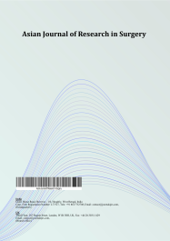
Asian Journal of Research in Surgery

Volume XXX, Issue XX, Page XX-XX, 20YY; Article no.AJRS.158385

Simultaneous Morgagni and Bochdalek Hernias in an Adult: A Rare Case Diagnosed Radiologically and Treated by Laparoscopic Repair

Authors’ Name……………………………………………………

Affiliations……………………………………………………….………………

Authors’ contributions

This work was carried out in collaboration among all authors. ‘Author A’ designed the study, performed the statistical analysis, wrote the protocol, and wrote the first draft of the manuscript. ‘Author B’ and ‘Author C’ managed the analyses of the study. ‘Author C’ managed the literature searches. All authors read and approved the final manuscript.

Article Information

DOI: 10.9734/AJRS/2026/XXXXX

Open Peer Review History:
This journal follows the Advanced Open Peer Review policy. Identity of the Reviewers, Editor(s) and additional Reviewers, peer review comments, different versions of the manuscript, comments of the editors, etc are available here:

Received: DD/MM/20YY
………… Article
Published: DD/MM/20YY

Abstract

Introduction: Diaphragmatic hernias are typically congenital and diagnosed in neonates or infants. Their discovery in adulthood is rare and often incidental (Shankar et al., 2023). The simultaneous presence of a Morgagni hernia and a Bochdalek hernia in an adult is exceptionally uncommon.
Case Presentation: We report the case of a 47-year-old male, with no significant medical history, who presented with prolonged fever, asthenia, anorexia, and weight loss.
Thoracoabdominal computed tomography demonstrated a right anterior diaphragmatic defect containing omental fat and bowel loops, consistent with a Morgagni hernia. Intraoperative laparoscopic exploration subsequently revealed a second anatomically distinct posterolateral diaphragmatic defect compatible with a Bochdalek hernia.
Both were treated successfully by laparoscopic repair. Postoperative recovery was uneventful.
Discussion: Dual diaphragmatic hernias in adults may remain asymptomatic or present with nonspecific gastrointestinal or respiratory symptoms. Computed tomography is the gold standard for diagnosis, enabling precise localization and characterization of the herniated contents (Giuffrida et al., 2023, Schembari et al., 2024, Chandrasekharan et al., 2017). Laparoscopy provides both diagnostic and therapeutic benefits, offering direct visualization of the diaphragm and minimally invasive repair with excellent outcomes (Sioda et al., 2022).
Conclusion: This case underscores the importance of detailed imaging in atypical clinical presentations and highlights the safety and efficacy of laparoscopic management for dual congenital diaphragmatic hernias in adults.

Keywords: Morgagni; bochdalek; adult; diaphragmatic hernia; laparoscopic repair;

1. Introduction

Congenital diaphragmatic hernias (CDH) arise from defective fusion or malformation of the diaphragmatic components during fetal development.

Morgagni hernias result from failure of fusion of the septum transversum with the costal arches anteriorly, whereas Bochdalek hernias arise from incomplete closure of the pleuroperitoneal canals posterolaterally during embryogenesis. They are most commonly diagnosed in the neonatal period, typically presenting with respiratory distress due to pulmonary hypoplasia or visceral herniation (Brown et al., 2011, Brungardt et al., 2021).

However, a minority of cases may remain asymptomatic until adulthood, where diagnosis is often incidental during imaging performed for unrelated symptoms.

Recent studies suggest that the increasing use of thoracoabdominal computed tomography has led to more frequent incidental diagnosis of congenital diaphragmatic hernias in adults, many of which previously remained undetected (Shankar et al., 2023, Schembari et al., 2024).

Morgagni hernias account for approximately 2–5% of congenital diaphragmatic hernias and are located in the anterior parasternal region (Rodríguez Hermosa et al., 2003). In contrast, Bochdalek hernias, which represent the majority of CDH cases in neonates, occur in the posterolateral region of the diaphragm, predominantly on the left.

Although isolated Morgagni and Bochdalek hernias have been extensively described, the coexistence of both defects in the same adult patient remains exceptionally uncommon and represents a significant diagnostic and surgical challenge with very few cases reported in the literature (Horton et al., 2008, Giuffrida et al., 2023). We report a rare case of concomitant right-sided Morgagni and Bochdalek hernias in an adult, identified and successfully repaired through a laparoscopic approach.

2. Case Report

A 47-year-old male with no prior medical history was referred for evaluation of unexplained systemic symptoms. The patient had a body mass index (BMI) of 19 and worked as a military sergeant. There was no history of trauma, chronic cough, or other precipitating factors. The diagnosis was established in May, and surgical repair was performed on October 14.

The patient initially presented with a 15-day history of low-grade fever, progressive fatigue, anorexia, and unintentional weight loss of 5 kg. He was first evaluated by a general practitioner and subsequently referred to a pulmonologist. A chest CT scan revealed a right anterolateral diaphragmatic hernia containing adipose and digestive structures. The patient was then referred to our department for surgical management.

A Posteroanterior chest Radiograph revealed elevation of the right hemi-diaphragm compared to the left, with an abnormal air–fluid level and mottled gas pattern projecting over the right lower thoracic cavity, suggesting intra-thoracic herniation of abdominal contents. (Fig. 1)
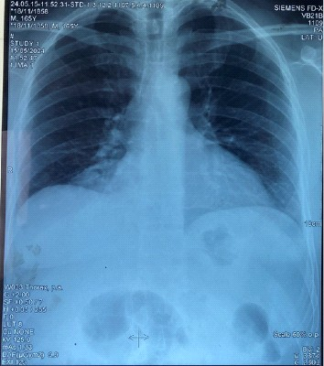

Fig. 1. Posteroanterior chest X-ray showing right-sided diaphragmatic elevation and air fluid level.

The lateral chest view showed a clear right anterior diaphragmatic elevation with a soft-tissue density containing air-filled structures located just behind the sternum and anterior to the cardiac silhouette, while the posterior diaphragmatic contour remains normal. (Fig. 2).

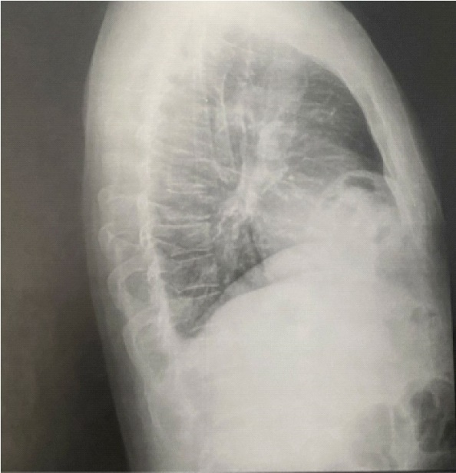

Fig. 2. Lateral chest X-ray showing an anterior mediastinal opacity with air–soft tissue interface

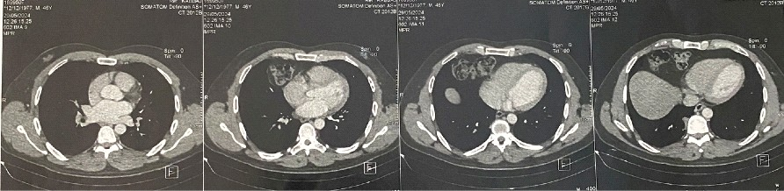

Fig. 3. Axial contrast-enhanced CT scans clearly demonstrate the right anterior diaphragmatic defect (Morgagni hernia) containing omental fat and transverse colon loops, compressing the adjacent right lung base

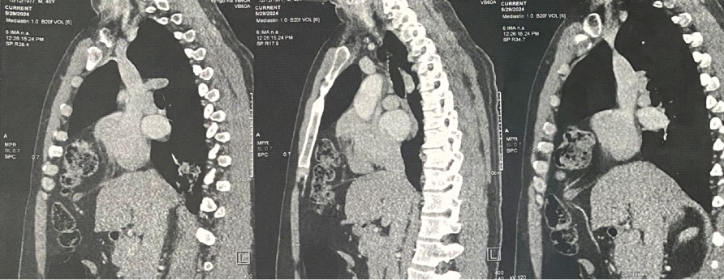

Fig. 4. Sagittal contrast-enhanced CT images showing Morgagni hernia. The defect margins and hernia sac are clearly delineated
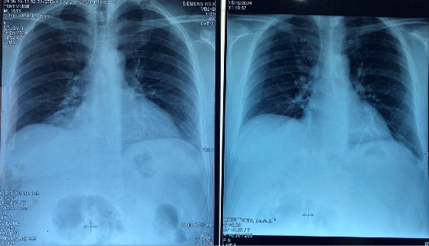

Fig. 5. Comparison of preoperative (left) and postoperative (right) chest radiographs. The postoperative image demonstrates complete resolution of the previously herniated content, with normal diaphragmatic contour and lung expansion and no residual diaphragmatic opacity

A contrast-enhanced thoraco-abdominal computed tomography (CT scan) confirmed the presence of a right-sided anterior diaphragmatic defect containing omental fat and bowel loops without evidence of strangulation or pulmonary compression, consistent with a Morgagni-type diaphragmatic hernia. (Figs. 3, 4).

The right anterior hemi-thorax shows a heterogeneous soft-tissue and air-containing mass located just anterior to the heart and adjacent to the right cardiophrenic angle.

This mass is composed of gas-filled structures consistent with herniated bowel loops, confirming herniation of abdominal contents into the thoracic cavity. The diaphragmatic defect is visible at the right anterior costophrenic junction.

The lung parenchyma remains normally aerated bilaterally, with no pleural effusion or compression atelectasis.

Under general anesthesia with endotracheal intubation, the patient was placed in the supine position. Laparoscopy was performed using a standard four-port technique under pneumoperitoneum maintained at 12 mmHg.

Intraoperative exploration revealed two anatomically distinct right-sided diaphragmatic defects separated by macroscopically normal diaphragmatic tissue: an anterior parasternal defect measuring approximately 2 cm, consistent with a Morgagni hernia, and a second posterolateral defect measuring approximately 1.5 cm, compatible with a Bochdalek hernia.

The anatomical separation of the defects and their topographical locations confirmed the presence of two independent congenital diaphragmatic hernias rather than a single complex defect.

The herniated omentum and bowel loops were carefully reduced into the abdominal cavity, and both defects were repaired independently using non-absorbable interrupted sutures without mesh reinforcement.

Given the small size of the defects, the absence of tension after closure, and the healthy surrounding diaphragmatic tissue, mesh reinforcement was not considered necessary.

Postoperative recovery was uneventful.

The patient remained hemodynamically stable with satisfactory postoperative pain control. The abdomen was soft and non-tender, and surgical dressings were clean and intact.

Bowel function resumed early, with passage of flatus on postoperative day one.

A post-operative chest X-ray showed restoration of the right diaphragmatic contour to its normal position, with clear lung bases and no residual air–fluid levels or mass effect, confirming successful repair. (Fig. 5).

The patient was discharged on postoperative day two with follow-up scheduled in the outpatient clinic.
At fifteen days and three-month follow-up, the patient remained well and fully asymptomatic.

3. Discussion

Congenital diaphragmatic hernias are uncommon developmental anomalies resulting from incomplete fusion of the pleuroperitoneal membranes during embryogenesis. They may occur in isolation or in association with other congenital malformations or chromosomal abnormalities, such as trisomy 21.

While congenital diaphragmatic hernias are typically diagnosed in neonates presenting with respiratory distress, delayed presentations in adulthood have been reported and are often discovered incidentally.

Anatomically, diaphragmatic hernias are classified into two main types:

Bochdalek hernias, which occur posterolaterally and account for the majority of neonatal cases, and Morgagni hernias, located anteriorly through the sternocostal hiatus, typically on the right side.
In adults, Morgagni hernias are usually asymptomatic but may present with vague gastrointestinal or respiratory complaints. Rarely, they may lead to complications such as bowel obstruction or strangulation (Slimi et al., 2024).

Recent reports suggest that adult congenital diaphragmatic hernias may present with highly variable and nonspecific symptoms, including dyspnea, abdominal discomfort, chronic digestive complaints, bowel obstruction, or constitutional symptoms, which may considerably delay diagnosis (Choy and Chiam, 2019, Shah et al., 2024).

Radiological imaging plays a crucial role in diagnosis. Chest X-rays may reveal elevation of the hemidiaphragm or air–fluid levels in the thoracic cavity, whereas computed tomography (CT) provides definitive confirmation by visualizing the herniated fat or bowel loops and identifying the diaphragmatic defect.

Similarly, adult Bochdalek hernias are exceedingly rare and may remain clinically silent until complicated by volvulus, strangulation, or ischemia (Shah et al., 2024).

The simultaneous presence of Morgagni and Bochdalek hernias in a single adult patient is exceptionally rare and poses important diagnostic and intraoperative challenges, particularly when one defect remains occult on preoperative imaging. Only a limited number of similar cases have been reported in the literature.

In our case, the patient presented with nonspecific constitutional symptoms, prompting CT evaluation, which identified a right anterior Morgagni hernia.

The coexisting posterior Bochdalek defect was discovered intraoperatively. This underscores the importance of maintaining a high index of suspicion and conducting meticulous intraoperative exploration when diaphragmatic abnormalities are suspected (Giuffrida et al., 2023)

The posterior defect identified during surgery was not considered an extension or variant of the Morgagni defect because it was spatially separated from the anterior sternocostal defect by intact diaphragmatic tissue. Furthermore, its posterolateral topography corresponded anatomically to a Bochdalek-type congenital defect.

Surgical repair remains the treatment of choice for all Morgagni and Bochdalek hernias, regardless of symptomatology, due to the risk of incarceration or strangulation (Giuffrida et al., 2023, Brown et al., 2011). Laparoscopic and thoracoscopic approaches have largely replaced open repair, offering the advantages of reduced postoperative pain, shorter hospital stay, and quicker recovery.

Recent systematic reviews and multicenter analyses support minimally invasive repair as the preferred approach in stable adult patients because it offers excellent visualization of the diaphragm, reduced postoperative morbidity, shorter hospitalization, and faster functional recovery compared with open surgery (Huang and Fang, 2024, Rathod et al., 2022, Lambert et al., 2023).

The fundamental objectives of surgery are reduction of herniated viscera and closure of the diaphragmatic defect—either by primary suture repair or prosthetic mesh reinforcement in larger or tension-prone defects.
The choice between primary suture repair and prosthetic mesh reinforcement remains debated in the literature. Current evidence suggests that mesh reinforcement should mainly be considered in large defects or when tension-free closure cannot be achieved (Arevalo et al., 2017, Schembari et al., 2024).

In our patient, both hernias were successfully repaired laparoscopically using primary non-absorbable sutures. The small size of the defects and healthy tissue margins obviated the need for mesh placement. The postoperative course was uneventful, with early return of bowel function and discharge on postoperative day two.

In addition to its therapeutic role, laparoscopy provided direct visualization of the diaphragm and enabled identification of the second posterior defect that had not been clearly characterized preoperatively (Sioda et al., 2022). This highlights the diagnostic value of meticulous intraoperative exploration in rare diaphragmatic anomalies.

This case emphasizes the importance of recognizing atypical presentations of congenital diaphragmatic hernias in adults. Early and accurate imaging followed by minimally invasive repair can prevent potentially fatal complications and achieve excellent outcomes, even in rare cases involving multiple defects.

The main limitation of this report is the absence of intraoperative photographic documentation due to technical recording limitations during the procedure.

4. Conclusion

Simultaneous Morgagni and Bochdalek hernias in adulthood represent an exceptionally rare congenital entity. A high index of suspicion is essential when evaluating adults with atypical or nonspecific thoracoabdominal symptoms, as delayed diagnosis can lead to life-threatening complications.

This case highlights the importance of careful radiological evaluation and meticulous intraoperative exploration, as additional diaphragmatic defects may remain undetected preoperatively.

Minimally invasive approaches such as laparoscopy or robot-assisted repairs offer significant advantages, including reduced morbidity, faster recovery, and superior visualization of the diaphragm (Sioda et al., 2022, Schembari et al., 2024).

Consent

Written informed consent was obtained from the patient for this case report. All data were anonymized to preserve confidentiality.

Disclaimer (Artificial Intelligence)

Author(s) hereby declare that NO generative AI technologies such as Large Language Models (ChatGPT, COPILOT, etc) and text-to-image generators have been used during writing or editing of this manuscript.

Competing Interests

Authors have declared that they have no known competing financial interests OR non-financial interests OR personal relationships that could have appeared to influence the work reported in this paper.

References

Arevalo, G., Harris, K., Sadiq, A., Calin, M. L., Nasri, B., & Singh, K. (2017). Repair of Morgagni hernia in adults with primary closure and mesh placement: First robotic experience. Journal of Laparoendoscopic & Advanced Surgical Techniques, 27(5), 529–532. https://doi.org/10.1089/lap.2016.0360
Brown, S. R., Horton, J. D., Trivette, E., Hofmann, L. J., & Johnson, J. M. (2011). Bochdalek hernia in the adult: Demographics, presentation, and surgical management. Hernia, 15(1), 23–30. https://doi.org/10.1007/s10029-010-0699-3
Brungardt, J. G., Nix, Q. A., & Schropp, K. P. (2021). Congenital diaphragmatic hernia: Demographics and 30-day outcomes in adults. The American Surgeon, 87(8), 1341–1346. https://doi.org/10.1177/0003134820960061
Chandrasekharan, P. K., Rawat, M., Madappa, R., Rothstein, D. H., & Lakshminrusimha, S. (2017). Congenital diaphragmatic hernia – A review. Maternal Health, Neonatology and Perinatology, 3(1), 6. https://doi.org/10.1186/s40748-017-0045-1
Choy, K. T., & Chiam, H.-C. (2019). Dyspnoea and constipation: Rare case of large bowel obstruction secondary to an incarcerated Morgagni hernia. BMJ Case Reports, e229507. https://doi.org/10.1136/bcr-2019-229507
Giuffrida, M., et al. (2023). Management of complicated diaphragmatic hernia in the acute setting: A WSES position paper. World Journal of Emergency Surgery, 18(1), 43. https://doi.org/10.1186/s13017-023-00510-x
Horton, J. D., Hofmann, L. J., & Hetz, S. P. (2008). Presentation and management of Morgagni hernias in adults: A review of 298 cases. Surgical Endoscopy, 22(6), 1413–1420. https://doi.org/10.1007/s00464-008-9754-x
Huang, Y.-J., & Fang, Y.-L. (2024). Robot-assisted congenital diaphragmatic hernia repair in adults: A case series. Medicine, 103(43), e39918. https://doi.org/10.1097/MD.0000000000039918
Lambert, J., Shugaba, A., Sheikh, A., & Gill, M. (2023). Synchronous robotic repair of anterior diaphragmatic (Morgagni) hernia & low anterior resection for rectal cancer. Robotics and Computer-Integrated Surgery, 19(1), e2481. https://doi.org/10.1002/rcs.2481
P, M., Shah, I., Sundaran, P. S., & Murugan, G. (2024). Left-sided intra-thoracic ectopic kidney with symptomatic Bochdalek hernia: A case report. Cureus. https://doi.org/10.7759/cureus.65452
Rathod, R. H., Rajan, Y. R., & Potluri, V. (2022). Congenital right diaphragmatic hernia presenting in adult life: A rare case. Cureus. https://doi.org/10.7759/cureus.31168
Rodríguez Hermosa, J. I., et al. (2003). Hernia diafragmática de Morgagni-Larrey en el adulto: análisis de 10 casos. Gastroenterología y Hepatología, 26(9), 535–540. https://doi.org/10.1016/S0210-5705(03)70408-7
Schembari, E., Reitano, E., Sofia, M., Latteri, S., & La Greca, G. (2024). The surgical treatment of Morgagni hernias in adults: A systematic review for the standardization of laparoscopic surgical repair. Updates in Surgery, 76(3), 839–844. https://doi.org/10.1007/s13304-023-01677-3
Shankar, R. B., Amberker, A. B., & Belgundi, V. (2023). An incidental case of Morgagni hernia with beaver tail liver in an adult. Cureus. https://doi.org/10.7759/cureus.49769
Sioda, N., Liu, S., Janowski, C., Gamble, A., Abdo, C., Wakim, A., & Ballecer, C. (2022). A novel approach for the treatment of Morgagni hernias: Robotic transabdominal preperitoneal diaphragmatic hernia repair. Hernia, 26(1), 355–361. https://doi.org/10.1007/s10029-021-02472-y
Slimi, Y., et al. (2024). Previously unrecognized Morgagni’s hernia presenting with bowel obstruction: A rare case report. International Journal of Surgery: Global Health, 7(3). https://doi.org/10.1097/GH9.0000000000000444

Disclaimer/Publisher’s Note: The statements, opinions and data contained in all publications are solely those of the individual author(s) and contributor(s) and not of the publisher and/or the editor(s). This publisher and/or the editor(s) disclaim responsibility for any injury to people or property resulting from any ideas, methods, instructions or products referred to in the content.
__________________________________________________________________________________________
© Copyright (2026): Author(s). The licensee is the journal publisher. This is an Open Access article distributed under the terms of the Creative Commons Attribution License (http://creativecommons.org/licenses/by/4.0), which permits unrestricted use, distribution, and reproduction in any medium, provided the original work is properly cited.

