The Impact of Social Media on Plastic Surgery Practice in Morocco: Ethical, Sociocultural, and Clinical Implications

Abstract

Background:
Social media platforms have profoundly transformed the dissemination of medical information, particularly in visually driven specialties such as plastic and aesthetic surgery. While these platforms provide new opportunities for patient education and professional visibility, they also raise ethical, psychological, and regulatory concerns.

Objective:
To assess the influence of social media on plastic surgery practice in Morocco, with a focus on patient perceptions, professional behaviors, ethical challenges, and regulatory gaps.

Methods:
A cross-sectional, mixed-methods study was conducted in Morocco, combining a narrative literature review with field surveys targeting patients, social media users, and plastic surgeons. Structured questionnaires were used to assess patterns of social media exposure, motivations for seeking aesthetic procedures, perceptions of online medical information, and surgeons’ professional practices. Data were analyzed descriptively.

Results:
Social media emerged as a major source of information influencing patients’ decisions to seek plastic surgery, particularly among young adults and women. Image-based content, including before-and-after photographs and influencer testimonials, strongly shaped aesthetic expectations. Both patients and surgeons expressed concerns regarding misinformation, unrealistic expectations, and the trivialization of surgical risks. Surgeons reported heterogeneous online practices, reflecting the absence of clear national guidelines governing digital medical communication.

Conclusion:
Social media plays a pivotal role in shaping plastic surgery practice in Morocco, acting as both an opportunity and a source of ethical and clinical challenges. The development of a structured ethical and regulatory framework adapted to the Moroccan context is essential to protect patients, preserve professional integrity, and promote responsible digital engagement.

Keywords: Plastic surgery; Social media; Medical ethics; Patient perception;
Introduction

Plastic surgery is a multidisciplinary specialty encompassing reconstructive, reparative, and aesthetic procedures. Initially focused on restoring function and anatomy following trauma, congenital anomalies, or disease, the field has progressively expanded toward aesthetic surgery, addressing psychosocial well-being and quality of life. This dual role places plastic surgery at the crossroads of medicine, psychology, and sociocultural norms.

The rapid expansion of social media platforms has profoundly reshaped the way medical information is produced, disseminated, and consumed. Image-centered platforms such as Instagram, TikTok, and Snapchat are particularly influential in shaping perceptions of beauty and bodily norms. Globally, social media usage has increased exponentially, with Morocco experiencing significant digital penetration, especially among younger populations.

Plastic surgery has become highly visible within this digital environment. Surgeons increasingly use social media to share educational content, communicate with patients, and enhance professional visibility. Simultaneously, influencers and patients publicly document their surgical journeys, often presenting aesthetic procedures as simple, accessible, and
low-risk interventions. Algorithm-driven amplification further reinforces these narratives.[1]

However, growing evidence suggests that excessive exposure to idealized or digitally altered images may negatively affect body image and psychological well-being. Concepts such as “Snapchat dysmorphia” illustrate how filtered representations can distort patients’ expectations and motivations for surgery. These dynamics raise important ethical concerns regarding informed consent, patient autonomy, and professional responsibility.

In Morocco, while general medical ethics are regulated by national laws and professional codes, specific guidelines addressing social media use by physicians remain limited. This regulatory gap exposes both patients and practitioners to potential risks, including misinformation, commercialization of medical acts, and erosion of public trust.[2][3]

This study aims to analyze the influence of social media on plastic surgery practice in Morocco by exploring patient perceptions, surgeon behaviors, and ethical challenges. By combining literature review and field data, it seeks to provide evidence-based insights and contribute to the development of responsible digital medical practices.

Methods

This study was designed as a cross-sectional, descriptive investigation conducted in Morocco in 2025. It aimed to evaluate the influence of social media on plastic surgery practices by examining patient perceptions, user behaviors, and surgeons’ professional attitudes. A mixed-methods approach was adopted, combining a narrative review of the literature with quantitative data collected through structured questionnaires. This design
enabled a comprehensive exploration of both subjective perceptions and observable trends within the Moroccan context.

Study Population

The study population consisted of three distinct groups: patients interested in or having undergone plastic or aesthetic surgery, general social media users exposed to
aesthetic-related content, and plastic surgeons actively practicing in Morocco. This tripartite structure allowed for a comparative analysis of perspectives across key stakeholders involved in or affected by the growing influence of social media in this field.

Patients were recruited during their consultation process in both private and public plastic and aesthetic surgery settings in Morocco. Eligibility criteria included being 18 years of age or older and having either considered or undergone a cosmetic procedure. It is based on a self-administered questionnaire consisting of 11 items, directly inspired by a validated tool used in a similar study in France, in order to ensure comparability of results and consistency of analysis. The questionnaire was designed and distributed using the Google Forms platform, which allowed responses to be collected anonymously, quickly, and securely.
The patient questionnaire explored sociodemographic characteristics, including gender and age group, as well as perceptions of social media influence on decision-making. Additional items assessed the level of trust in social media as a source of medical information, attitudes toward the publication of before-and-after images, and perceptions of Moroccan surgeons in comparison with their international counterparts.

The second group comprised active social media users with exposure to aesthetic or cosmetic surgery content. To encourage participation and preserve anonymity, no identifying demographic data were collected for this group. The questionnaire consisting of 9 items focused on the perceived influence of social media on the consideration of cosmetic procedures, the credibility attributed to online medical content, and perceptions of surgeons’ communication practices. Participants were also asked about their personal experiences in making decisions influenced by digital content, as well as their attitudes toward the dissemination of patient images and the attractiveness of undergoing procedures abroad.

The third group included plastic surgeons practicing in both public and private sectors in Morocco. Inclusion criteria required participants to be formally trained and actively practicing within the country. The questionnaire consisting of 9 items addressed several dimensions, including the perceived benefits and risks of social media use in medical practice, attitudes toward its commercial and promotional aspects, and individual communication practices.

Particular attention was given to ethical considerations, such as the publication of clinical images and the compatibility of these practices with professional standards. The study adhered to the principles of the Declaration of Helsinki and to current Moroccan legislation, particularly Law No. 09-08 on the protection of personal data. Participants were informed of the academic and voluntary nature of the study, and no personal identifying information was collected.

The survey also explored forward-looking perspectives, including the perceived need for stricter regulation and openness to collaboration with digital communication specialists.

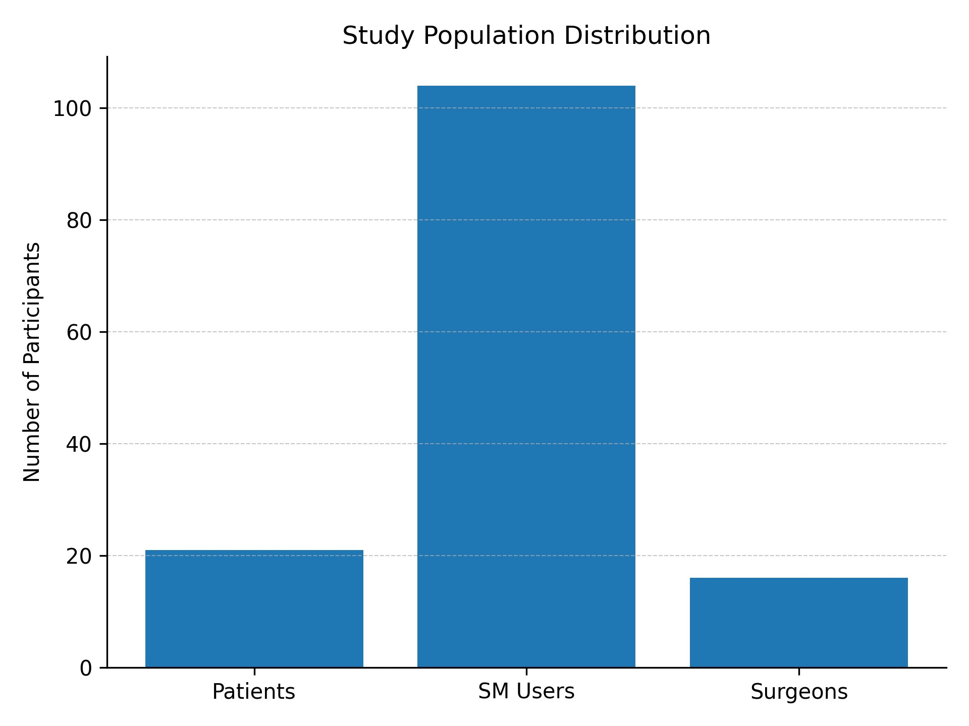

Figure 1 : Diagram of the study population distribution

Data Collection

Data were collected using three structured, self-administered questionnaires distributed online via Google Forms. Each questionnaire was specifically tailored to the target population while maintaining thematic consistency to allow for comparative analysis. The instruments consisted primarily of closed-ended questions and Likert-scale items designed
to quantify perceptions, behaviors, and attitudes related to social media use in the context of plastic surgery.

The questionnaires were disseminated through digital channels, including professional networks and social media platforms, over a defined study period in 2025. Participation was voluntary, and respondents were informed of the study’s objectives prior to completing the survey. No financial or material incentives were provided. The use of online data collection facilitated access to a broader and more diverse sample, particularly among active social media users.

Variables and Measures

The study assessed several key variables across the three groups. Among patients and social media users, primary variables included the frequency and type of social media use, perceived influence on aesthetic perceptions and decision-making, and trust in online medical information. Additional variables included attitudes toward image sharing and perceptions of surgical risks as portrayed on social media.

For surgeons, variables focused on professional practices, including frequency of social media use, type of content shared, and perceived pressures related to digital visibility.
Ethical concerns were assessed through questions addressing the publication of patient images, the commercialization of medical services, and adherence to professional standards. The perceived need for regulatory frameworks and future directions in digital medical communication were also evaluated.

Ethical Considerations

The study was conducted in accordance with established ethical standards for research involving human participants. It adhered to the principles outlined in the Declaration of Helsinki and complied with the provisions of Moroccan Law No. 09-08 on the protection of personal data. All participants were informed of the voluntary and anonymous nature of their participation prior to completing the questionnaire.

Informed consent was obtained electronically from all respondents. No personally identifiable information was collected, and all data were treated with strict confidentiality. The study design respected the principles of autonomy, beneficence, and non-maleficence, ensuring that participants were not exposed to any form of risk or harm.

Data Analysis

Data were analyzed using descriptive statistical methods. Responses were summarized using absolute frequencies and percentages to provide an overview of trends within each study group. Comparative observations were made between patients, social media users, and surgeons to identify convergences and divergences in perceptions and behaviors.

Given the exploratory nature of the study and the relatively small sample size, no inferential statistical tests were performed. Instead, the analysis focused on identifying meaningful patterns and relationships that could inform future research and policy development. The results were subsequently interpreted in light of existing literature to provide contextualized insights into the impact of social media on plastic surgery practice in Morocco.

Results

Most patient respondents were women aged 18–35 years, representing the most active social media users. Instagram and TikTok were identified as the primary platforms
influencing aesthetic perceptions. Visual content—particularly before-and-after images—was reported as the most impactful.

A substantial proportion of patients acknowledged that social media influenced their decision to pursue plastic surgery. Influencer endorsements and testimonials contributed to the normalization of aesthetic procedures and elevated expectations regarding outcomes.

Despite high exposure, many participants questioned the reliability of online information. Surgeons similarly expressed concern regarding misinformation, exaggerated results, and insufficient discussion of risks.
Most surgeons reported having a professional social media presence, primarily for educational and visibility purposes. However, practices varied widely, particularly regarding promotional content and publication of clinical images. The absence of clear national guidelines was frequently cited as a source of uncertainty.

The study population consisted of three distinct groups: patients (n = 21), social media users (n = 104), and plastic surgeons practicing in Morocco (n = 16). Among patients, the majority were female (85.7%) and predominantly aged between 18 and 35 years (66.7%), reflecting the demographic most actively engaged with social media platforms. Similarly, Instagram users were largely female (72%), with a comparable age distribution, while plastic surgeons showed a more balanced gender distribution but were generally older, with the majority aged between 36 and 50 years.

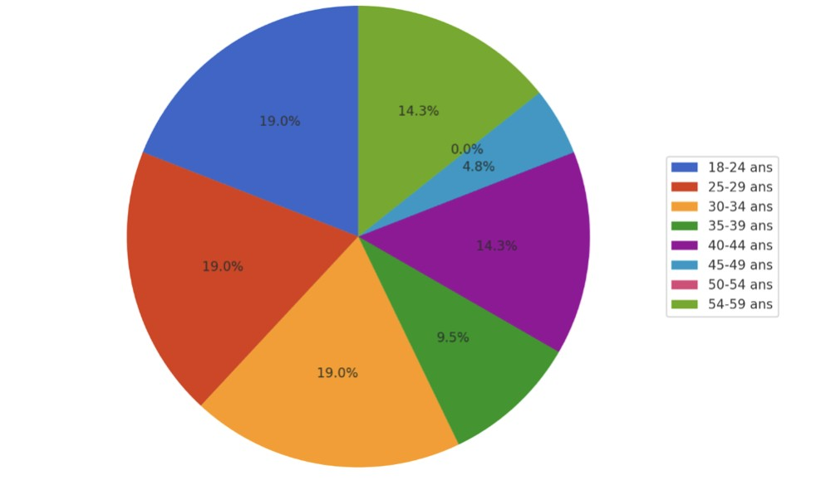

Figure 2 : Histogram of the distribution by age group

Social media usage patterns revealed a high level of exposure to aesthetic content across all groups. Among patients, 76% reported consulting Instagram prior to their first surgical consultation, highlighting the platform’s role as a primary informational resource. TikTok was also frequently cited (52%), followed by YouTube (19%) and Snapchat (14%). Among
general social media users, 98% acknowledged that these platforms significantly influenced their perception of beauty, while 88% reported daily exposure to aesthetic-related content. Notably, 62% indicated that such exposure contributed to increased dissatisfaction with their physical appearance.

From the surgeons’ perspective, 75% reported receiving patient consultations influenced by social media on at least a weekly basis. Additionally, 81% indicated regular professional use of social media, primarily for educational purposes and increasing visibility. However, 62.5%
reported feeling pressure to publish before-and-after images, reflecting the competitive and visual nature of online medical communication.

The influence of social media on decision-making was particularly pronounced among patients. A substantial 81% reported that social media directly influenced their decision to consider or undergo plastic surgery. Furthermore, 71% expressed expectations of achieving results identical to those observed online, suggesting a strong impact of curated and idealized visual content. Despite this, a paradox emerged: while 66.7% accepted the publication of patient images in principle, 85.7% refused the public sharing of their own photographs, indicating a tension between the need for visual reassurance and concerns about privacy and social stigma.

Among social media users, 74% reported following aesthetic influencers, and 59% believed that social media tends to minimize the risks associated with surgical procedures. At the same time, 67% expressed doubts regarding the reliability of online medical information, highlighting a critical awareness despite high exposure.

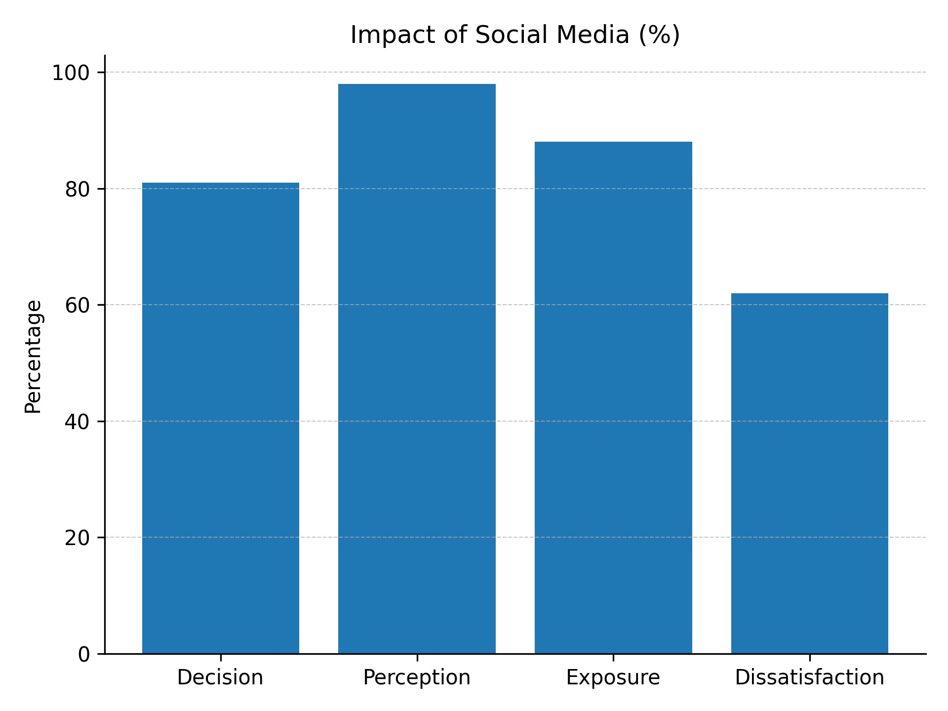

Figure 3 : Diagram of the impact of social media on patients

Plastic surgeons unanimously (100%) acknowledged the presence of commercial pressures associated with social media use. Additionally, 69% reported ethical concerns related to patient influence, and an overwhelming majority (93.8%) supported the establishment of national regulations governing digital medical communication. Professional practices varied considerably, ranging from purely educational content (31%) to promotional strategies including before-and-after images (69%), reflecting the absence of standardized guidelines.

Overall, the findings demonstrate a pervasive influence of social media on aesthetic perceptions and surgical decision-making in Morocco. This influence is characterized by high exposure, significant behavioral impact, and a complex interplay between trust, skepticism, and ethical concerns.

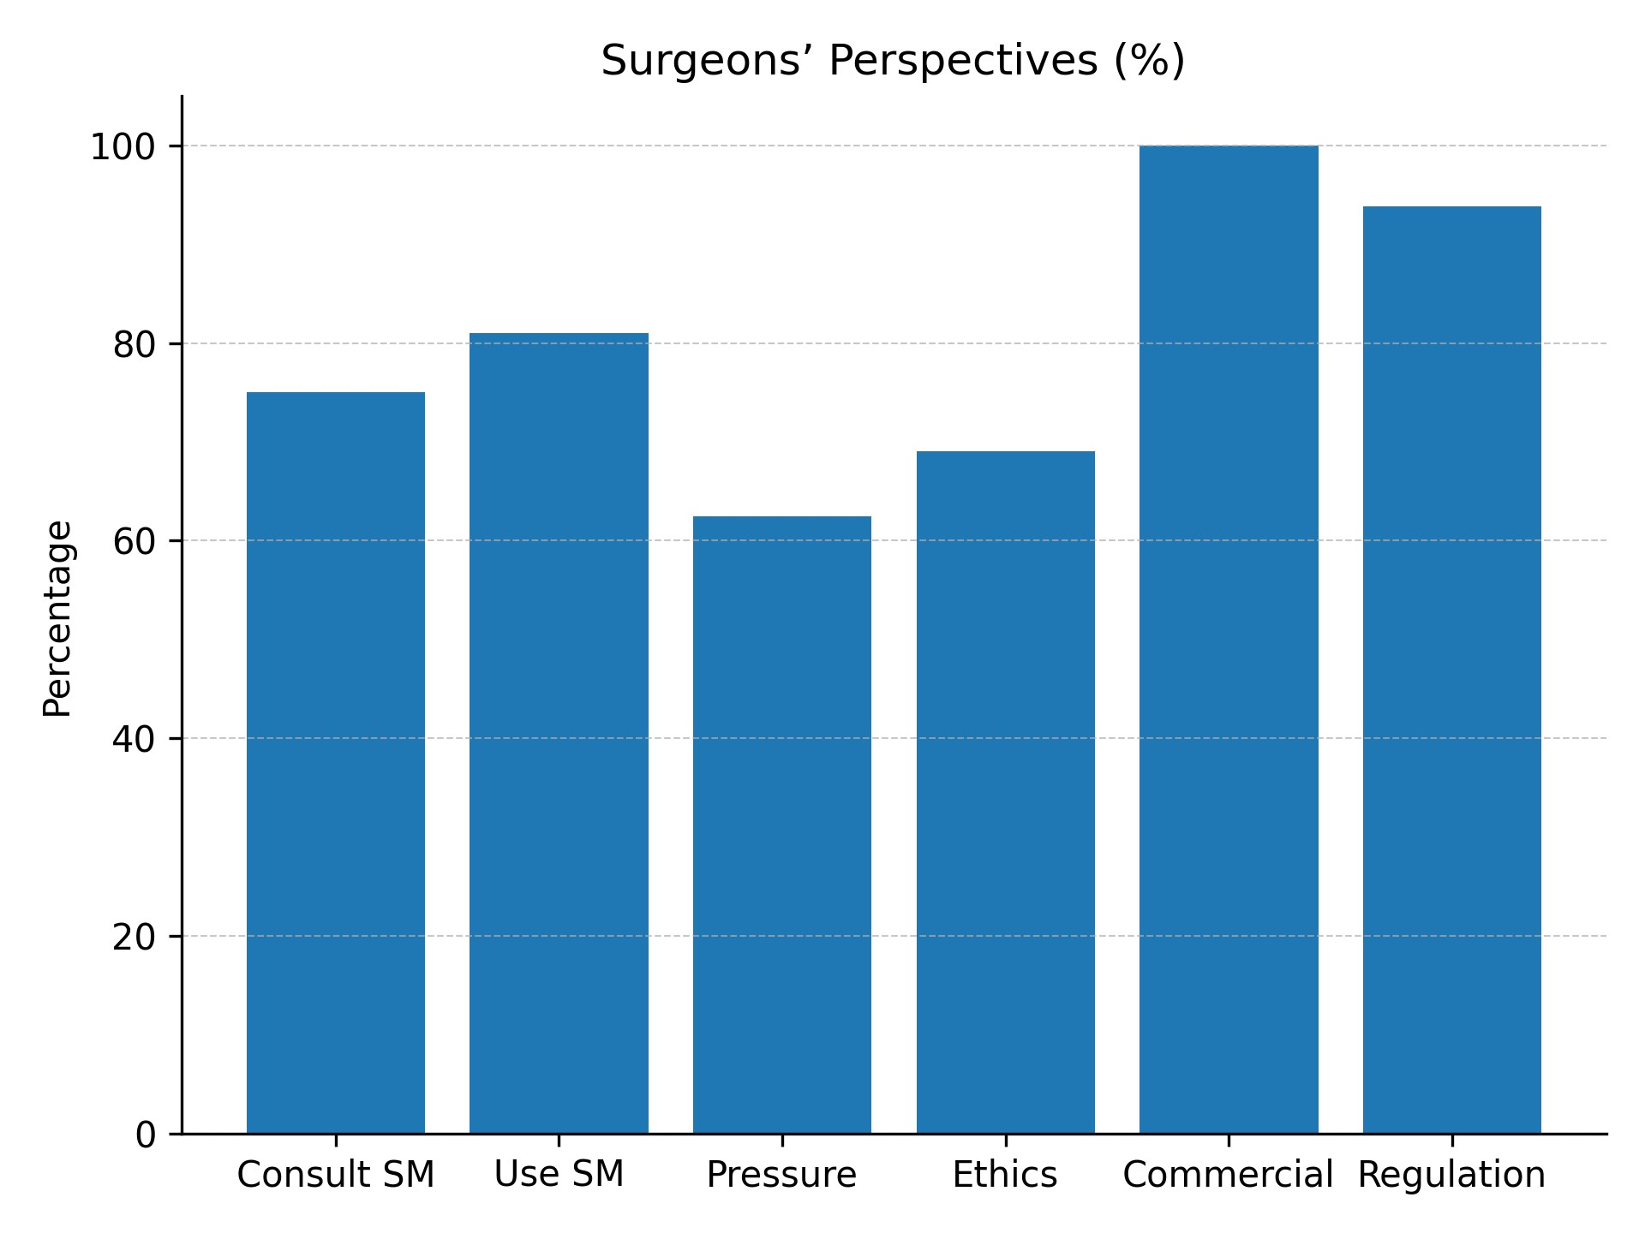

Figure 4 : Diagram of surgeon’s perspective

Discussion

This study of Moroccan patients reveals trends comparable to international data while highlighting specific sociocultural features. The sample was predominantly female (85.7%) and young (57% aged 18–34), consistent with global patterns of higher female representation in aesthetic surgery, while also showing demand among those >50 years (14.3%).

The findings of this study confirm that social media has become a central determinant in shaping perceptions, expectations, and behaviors related to plastic surgery in Morocco. These results are consistent with international literature, which identifies social media as both a powerful educational tool and a potential source of misinformation and psychological vulnerability (Hopkins et al., 2020; Mironica et al., 2024).[4][5]

One of the most striking observations is the extent to which social media influences patient decision-making. In this study, 81% of patients acknowledged its role in their decision to pursue aesthetic procedures. This aligns with previous research demonstrating that visual platforms such as Instagram and TikTok play a critical role in normalizing cosmetic interventions and promoting idealized standards of beauty (DataReportal, 2024; ISAPS,
2022). However, unlike traditional medical consultations, social media content is often unregulated, curated, and influenced by commercial interests, which may distort patients’ expectations.
The discrepancy between high exposure and low trust is particularly noteworthy. While the majority of participants reported frequent interaction with aesthetic content, a significant proportion (67%) questioned its reliability. This ambivalence reflects a growing awareness among users regarding misinformation, yet it does not appear sufficient to mitigate its behavioral impact. Similar findings have been reported in global studies, where patients continue to rely on social media despite recognizing its limitations (Moorhead et al., 2013).

Another important finding concerns the psychological impact of social media exposure. A majority of users reported increased body dissatisfaction, supporting the hypothesis that repeated exposure to idealized or digitally altered images negatively affects self-perception. This phenomenon has been described in the literature as “Snapchat dysmorphia,” where individuals seek surgical procedures to resemble filtered versions of themselves (Mironica et al., 2024). In the Moroccan context, this effect may be further amplified by sociocultural factors, including societal expectations related to appearance and marriage.

The paradoxical attitudes toward image sharing also deserve attention. While patients recognize the value of before-and-after images in informing their decisions, most are reluctant to share their own images publicly. This reflects deeply rooted cultural norms regarding privacy, modesty, and social judgment. Such findings highlight the importance of culturally sensitive approaches to medical communication, particularly in societies where public exposure may carry significant social implications.

From the surgeons’ perspective, the study reveals a complex and often cautious engagement with social media. Although many practitioners acknowledge its benefits in terms of visibility and patient education, there is widespread concern regarding its commercialization and ethical implications. The fact that all surveyed surgeons perceive social media as commercially driven underscores the tension between professional ethics and market dynamics. These concerns are consistent with previous studies emphasizing the risks of transforming medical practice into a consumer-oriented service.[6]

The lack of clear national guidelines appears to be a major contributing factor to the heterogeneity observed in professional practices. In contrast to countries where regulatory frameworks for digital medical communication are more developed, Moroccan practitioners operate in a relatively unstructured environment. [7]This regulatory gap not only exposes patients to potential misinformation but also places physicians in ethically ambiguous situations.

Importantly, the perception that Moroccan surgeons lag behind their international
counterparts in digital communication reflects both a challenge and an opportunity. While this perception may undermine patient confidence, it also highlights the potential for developing structured, ethical, and culturally adapted communication strategies. International organizations such as the World Health Organization have emphasized the importance of digital health governance, particularly in rapidly evolving technological environments [8].

Taken together, these findings suggest that Morocco is at a critical juncture in the integration of social media into medical practice. The challenge lies in balancing the undeniable benefits of these platforms—such as increased accessibility and patient engagement—with the need to protect patients from misinformation, unrealistic expectations, and psychological harm.[9]
To address these issues, several measures should be considered. First, the development of national guidelines for social media use in medical practice is essential. Such guidelines should define ethical boundaries, regulate promotional content, and ensure the protection of patient privacy[10][11]. Second, efforts should be made to enhance patient education, particularly regarding the limitations and risks of aesthetic procedures. Finally, encouraging surgeons to prioritize educational over promotional content may help restore trust and reinforce the integrity of the profession.[12]

Limitations

This study has several limitations that should be acknowledged. The cross-sectional design and self-reported data limit causal inference and generalizability. The majority of evidence is correlational, preventing any firm conclusions about causality between social media use and attitudes toward plastic surgery.Nevertheless, this study provides important exploratory insight into an under-researched area.

Conclusion

Plastic surgery in Morocco is increasingly shaped by the rapid expansion of social media, which has transformed how information is accessed, shared, and interpreted. This study demonstrates that social media plays a significant role in influencing patient decisions and expectations, despite widespread concerns regarding the reliability of online content. At the same time, practitioners express substantial ethical concerns, particularly related to commercialization, misinformation, and the pressures associated with digital visibility.[13]

These findings highlight persistent tensions between visibility and credibility, transparency and privacy, and digital innovation and professional ethics. While Morocco benefits from an existing legal framework governing medical practice and data protection, the absence of specific guidelines for digital communication remains a critical gap.

International organizations such as the American Society of Plastic Surgeons and the International Society of Aesthetic Plastic Surgery advocate for responsible, educational, and ethically grounded use of social media. Adapting such principles to the Moroccan context could support the development of clear and culturally appropriate standards.

Ultimately, social media represents both a strategic opportunity and a source of risk for plastic surgery in Morocco. Establishing a structured, ethical, and balanced regulatory framework will be essential to ensure patient protection, maintain professional integrity, and support the sustainable evolution of the field.[14]

Consent
As per international standards or university standards, respondents’ written consent has been collected and preserved by the author(s).

Ethical Approval:

As per international standards or university standards written ethical approval has been collected and preserved by the author(s).

Disclaimer (Artificial intelligence)
Author(s) hereby declare that NO generative AI technologies such as Large Language Models (ChatGPT, COPILOT, etc.) and text-to-image generators have been used during the writing or editing of this manuscript.

References

1. « Digital 2024: Global Overview Report — DataReportal – Global Digital Insights ».

https://datareportal.com/reports/digital-2024-global-overview-report

2. « Digital 2024: Morocco — DataReportal – Global Digital Insights ». Consulté le: 10 septembre 2025. [En ligne]. Disponible sur:
https://datareportal.com/reports/digital-2024-morocco https://datareportal.com/reports/digital-2024-global-overview-report

3. International Society of Aesthetic Plastic Surgery (ISAPS). Global Survey 2022.

4. Hopkins ZH, Moreno C, Secrest AM. Influence of social media on cosmetic procedure interest. J Clin Aesthet Dermatol. 2020;13(1):28–31.

5. Mironica A, Popescu CA, George D, et al. Social media influence on body image and cosmetic surgery considerations: a systematic review. Cureus. 2024;16(7):e65626.

6. Schoenbrunner A, Gosman A, Bajaj AK. Framework for the creation of ethical and professional social media content. Plast Reconstr Surg. 2019;144(1):118e–125e.

7. Moorhead SA, Hazlett DE, Harrison L, et al. Uses, benefits, and limitations of social media for health communication. J Med Internet Res. 2013;15(4):e85.

8. World Health Organization. Global Strategy on Digital Health 2020–2025. WHO;
2021.

9. « Social Media and Body Image Concerns: Current Research and Future Directions | Request PDF », ResearchGate, août 2025, doi: 10.1016/j.copsyc.2015.09.005.

10. O. Shauly, T. Marxen, P. Goel, et D. J. Gould, « The New Era of Marketing in Plastic
Surgery: A Systematic Review and Algorithm of Social Media and Digital Marketing
», Aesthetic Surg. J. Open Forum, vol. 5, p. ojad024, févr. 2023, doi:
10.1093/asjof/ojad024.

11. « Global Survey 2022: Full Report and Press Releases ». https://www.isaps.org/discover/about-isaps/global-statistics/global-survey-2022-full-re port-and-press-releases/

12. R. J. Rohrich, E. Dayan, et A. S. Xue, « Social Media in Plastic Surgery: The Future
Is Now? », Plast. Reconstr. Surg., vol. 148, no 5S, p. 125S-126S, nov. 2021, doi:
10.1097/01.prs.0000794940.66507.3f.

13. « Global Survey 2021: Full Report and Press Releases ». https://www.isaps.org/discover/about-isaps/global-statistics/global-survey-2021-full-re port-and-press-releases/

14. S. A. Moorhead, D. E. Hazlett, L. Harrison, J. K. Carroll, A. Irwin, et C. Hoving, « A new dimension of health care: systematic review of the uses, benefits, and limitations of social media for health communication », J. Med. Internet Res., vol. 15, no 4, p. e85, avr. 2013, doi: 10.2196/jmir.1933.

