Case Report
Periureteral Abdominal Heterotopic Ossification Causing Hydronephrosis After Colonic Surgery: A Rare Postoperative Complication

Abstract
Abdominal heterotopic ossification (AHO) is a rare postoperative complication characterised by ectopic bone formation within soft tissues following surgical trauma. Although most commonly described in the abdominal wall or mesentery, involvement of retroperitoneal structures such as the ureter remains exceptional and may lead to significant functional impairment.
We report the case of a 68-year-old female with a history of left-sided colonic adenocarcinoma complicated by postoperative peritonitis requiring multiple reoperations and stoma creation. During follow-up for metastatic disease, imaging revealed severe left ureterohydronephrosis associated with serpiginous hyperdense material adjacent to the ureter, as well as calcified tissue along the previous midline incision. The differential diagnosis included malignant obstruction and dystrophic calcification. An exploratory laparotomy was performed for colonic continuity restoration and etiological assessment of the ureteral obstruction. Intraoperatively, mature heterotopic ossification was identified in both the abdominal wall and periureteral region. While parietal ossification was successfully excised, periureteral dissection was deemed hazardous due to the risk of ureteral injury.
This case highlights the diagnostic challenges and surgical implications of AHO, particularly in oncologic patients with complex postoperative courses. Chronic inflammation, repeated surgical trauma, and tumour-related molecular signalling pathways may contribute to ectopic bone formation. Awareness of this rare entity is essential to optimise preoperative planning and reduce operative morbidity.
- Pathophysiology: The precise mechanism is not fully understood, but it is believed to involve the metaplastic transformation of pluripotent mesenchymal cells into osteoblasts in response to trauma, inflammation, ischemia, or infection.

Keywords
Heterotopic ossification; colonic surgery; colorectal cancer; ureter; postoperative complications
Introduction
Abdominal heterotopic ossification (AHO) is a rare complication, typically occurring after major abdominal surgeries. Heterotopic ossification (HO) is a bone formation in a tissue other than the skeletal system. It is a pathological condition that might be observed during the healing process of abdominal incisions in the midline. HO is classified as neurogenic HO, traumatic HO and myositis ossificans progressiva (12,13). HO is twice as common in males versus females, but it is noted that females older than 65 years old have an increased risk of developing HO (14). AHO may involve the abdominal wall, mesentery, or, more rarely, pelvic structures. Diagnosis is often made intraoperatively due to nonspecific imaging findings.
- Diagnosis: Diagnosis is challenging and usually confirmed through imaging (CT scans showing bone density in the urinary tract) and histopathology. It is often found in patients with a history of multiple laparotomies or complex surgeries.

We report a case where heterotopic ossification complicated the surgical management of colonic continuity restoration following a double-barrel stoma.
Case Presentation
A 68-year-old female patient with a history of hypertension and dyslipidaemia was treated for a left-sided colonic adenocarcinoma. Two years ago, she underwent a cholecystectomy and a left colectomy. Histopathology revealed a moderately differentiated adenocarcinoma (pT3N1Mx).
The postoperative course was complicated by two reoperations:
- On postoperative day 3 (POD 3), she developed peritonitis due to an anastomotic leak, requiring a colostomy.
- On POD 10, necrosis of the stoma necessitated a second surgery, resulting in an atypical stoma configuration.
Follow-up imaging revealed a left ureteral stricture at the iliac-pelvic junction, causing severe upstream ureterohydronephrosis in contact with spontaneously hyperdense, serpiginous material (Figure 1). A suspicious hepatic lesion was also noted. Additionally, hyperdense material was observed in the abdominal wall at the midline incision site (Figure 2).
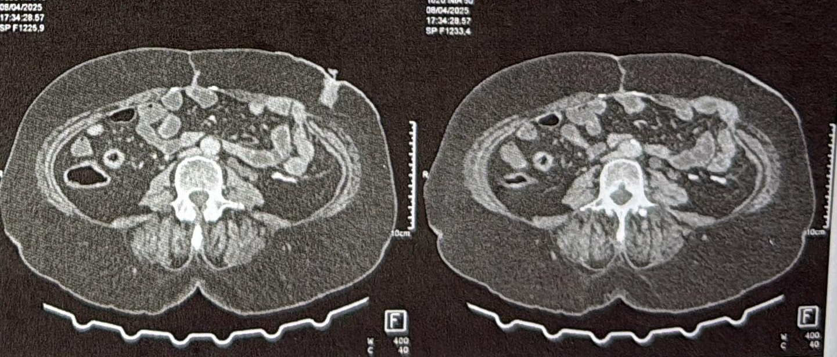
Figure 1: Serpiginous hyperdense material adjacent to the left ureter
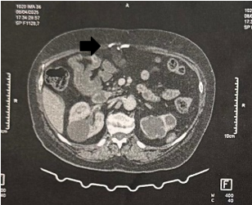
Figure 2: Hyperdense material in the abdominal wall at the site of the previous midline incision
The patient received multiple lines of chemotherapy for liver metastasis (XELOX + bevacizumab, then XELIRI + bevacizumab).
The patient's case was discussed in a multidisciplinary case conference, and the decision was made to perform an exploratory laparotomy to investigate the aetiology of the left ureterohydronephrosis, which could be related to peritoneal carcinomatosis, to simultaneously restore colonic continuity, and to perform hepatic metastasis surgery at a later stage.
Currently, the exploratory laparotomy and colonic continuity restoration were performed via a midline incision. Intraoperative findings included:
- Two hepatic nodules (segments IV and VIII),
- Parietal heterotopic ossification at the site of the previous incision (resected and sent for anatomo-pathology examination) (Figure 3),
- Extensive periureteral ossification, rendering dissection hazardous.
The procedure included colonic continuity restoration and creation of a protective ileostomy.
What has been done for ureteric obstruction and ureterohydronephrosis?
- Management: Due to the severe, encased nature of the bone in the urinary tract, treatment often requires surgical intervention, such as nephrectomy or, in some cases, ureterolysis or reconstruction.
- Medical Treatment: Non-steroidal anti-inflammatory drugs (NSAIDs), such as indomethacin, or bisphosphonates are sometimes used to prevent further bone formation.
- Conservative Therapy: In cases where the condition is detected early or is asymptomatic, observation or supportive care may be chosen.

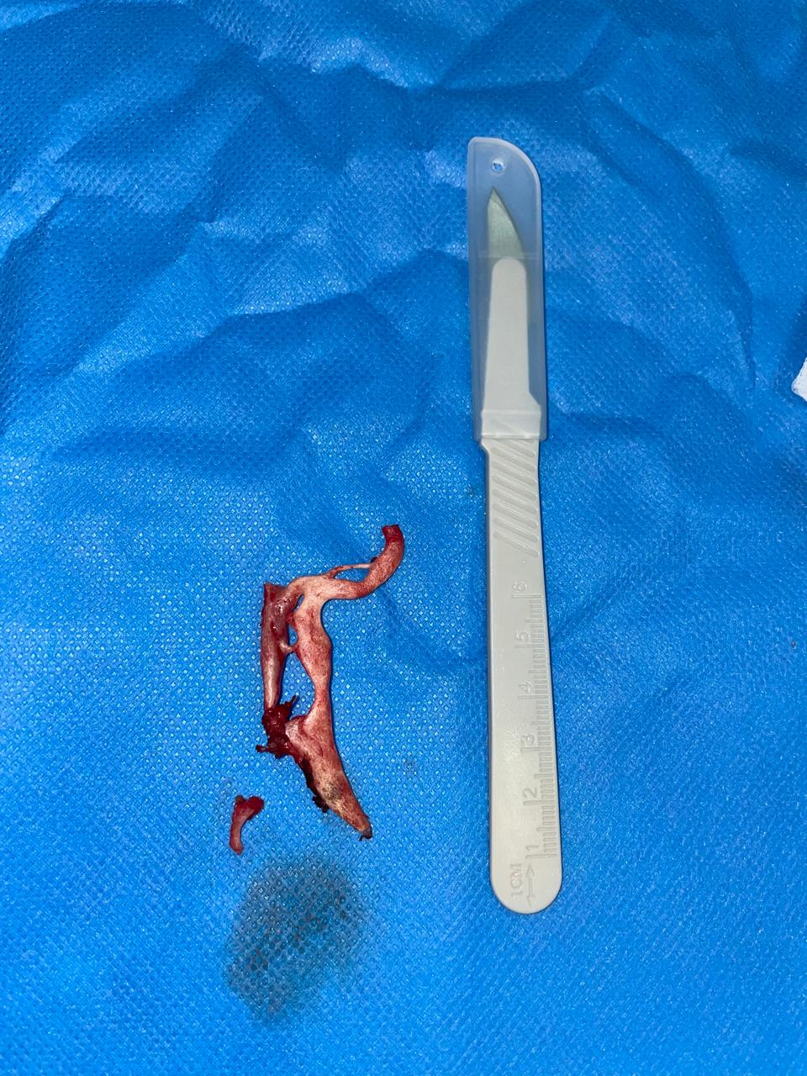
Figure 3: Heterotopic ossification focus in the abdominal wall at the site of the previous midline incision

Discussion
Abdominal heterotopic ossification (AHO) represents an uncommon but increasingly recognised postoperative complication characterised by the formation of mature lamellar bone in soft tissues where bone normally does not exist. While heterotopic ossification is well described in orthopaedic and neurologic settings, its occurrence in the abdominal cavity remains rare. Most reported cases involve the abdominal wall and mesentery (1,2), with occasional descriptions following complex abdominal surgery (3). Periureteral involvement is exceedingly uncommon.
The true incidence of AHO is difficult to establish, as many cases remain asymptomatic and are discovered incidentally during reoperation or imaging performed for unrelated reasons. The majority of reported cases occur after major gastrointestinal surgery, particularly procedures complicated by infection, peritonitis, or repeated reinterventions (1,3). In this context, our case fits the typical clinical pattern: multiple laparotomies, severe intra-abdominal inflammation, and prolonged tissue injury.
Pathophysiological Considerations:
The pathogenesis of AHO reflects an aberrant wound-healing response. Three elements are generally required for heterotopic bone formation:
- Presence of osteogenic precursor cells
- Inductive inflammatory stimuli
- A permissive microenvironment
Mesenchymal stem cells residing in muscle, fascia, or connective tissue may undergo osteogenic differentiation under inflammatory conditions. Bone morphogenetic proteins (BMPs), especially BMP2, BMP4, and BMP9, play a central role in this differentiation cascade via SMAD-dependent transcription pathways (5,6). These proteins are frequently upregulated in injured tissues.
Pro-inflammatory cytokines such as TNF-α and IL-1β amplify cellular recruitment and enhance osteogenic signalling (6,8). Hypoxia, common in inflamed or ischemic tissues, further potentiates this process through activation of hypoxia-inducible factors, which interact with BMP and mTOR pathways (7). The Wnt/β-catenin pathway, essential in skeletal development, is also frequently activated in ectopic ossification (5,6).
Alkaline phosphatase, CPK, CRP, ESR and urinary excretion of PGE2, Hydroxyproline and collagen metabolites will be useful in the diagnosis.
Recent immunological studies have emphasised the contribution of IL-17–producing T cells and macrophage modulation in initiating osteogenic cascades (8). These findings reinforce the concept that heterotopic ossification represents a dysregulated inflammatory–repair response rather than a purely mechanical phenomenon.
In our patient, several strong predisposing factors were present: repeated surgical trauma, anastomotic leak with peritonitis, prolonged inflammatory state, and local tissue ischemia. Together, these factors likely created a highly permissive microenvironment for ectopic osteogenesis.
Periureteral Localization and Diagnostic Challenges
Periureteral ossification is particularly rare. Only isolated case reports describe pelvic or retroperitoneal heterotopic ossification causing ureteral compression (3). Its clinical significance lies in the potential for progressive ureteral obstruction leading to hydronephrosis and renal impairment.
In this case, CT imaging described “serpiginous hyperdense material” adjacent to the left ureter. However, imaging findings were nonspecific. AHO may appear as linear or plaque-like calcifications along surgical scars or adjacent to viscera (2,4). Early lesions may show subtle soft-tissue density changes before maturation into organised lamellar bone.
Differential diagnoses include dystrophic calcification, suture granuloma, foreign-body reaction, tumoral calcification, and peritoneal metastases. As highlighted in a Moroccan series (4), conventional imaging techniques often fail to clearly identify heterotopic ossification preoperatively. Although bone scintigraphy may detect metabolically active lesions earlier, it remains infrequently used in abdominal cases.
Surgical Implications
From a surgical perspective, heterotopic ossification may significantly increase operative complexity. Abdominal wall involvement can complicate re-entry through previous incisions, as ossified plaques are frequently embedded in dense fibrotic scar tissue (2). Mesenteric ossification may present as rigid masses mimicking neoplasia (1,10).
In our patient, parietal ossification was successfully excised and confirmed histologically. However, periureteral ossification posed a substantial risk. Dissection in this region carried potential danger of ureteral injury and vascular compromise. Given the oncologic context and primary objective of restoring intestinal continuity, aggressive resection of the periureteral lesion was deemed unsafe.
Literature suggests that complete excision is indicated when heterotopic ossification causes significant functional impairment (4). However, conservative management may be appropriate when resection carries excessive morbidity risk.

Oncologic Microenvironment and Ectopic Ossification
The coexistence of metastatic colorectal cancer raises the question of a possible interaction between neoplasia and ectopic bone formation. Although evidence remains limited, tumour microenvironment signalling pathways overlap significantly with osteogenic pathways.
Colorectal cancer has been shown to activate BMP/SMAD and Wnt/β-catenin pathways within tumour stroma (11). Takahashi et al. demonstrated ectopic bone formation within colorectal tumours associated with epithelial–mesenchymal transition and BMP signalling activation (11). This overlap suggests that tumour-derived cytokines and growth factors may enhance osteogenic differentiation in susceptible tissues.
Additionally, systemic chemotherapy and anti-angiogenic therapy (e.g., bevacizumab) may alter wound healing and tissue remodelling, potentially influencing ossification dynamics. While causality cannot be established, the oncologic background may have contributed to persistent pro-osteogenic signalling in this patient.
Prevention and Medical Management
In orthopaedic surgery, NSAIDs such as indomethacin and localised radiotherapy are used as prophylaxis against heterotopic ossification. Pharmacologic inhibition of BMP signalling has also demonstrated experimental efficacy (9). However, no standardised prophylactic strategy exists for abdominal heterotopic ossification.
Given the rarity of AHO and the lack of prospective data, medical prevention remains empirical. Moreover, in oncologic patients receiving chemotherapy, the risks of NSAID use must be carefully evaluated.

Prognosis and Follow-Up
AHO is generally benign and slow-growing. Recurrence after excision appears uncommon but has been reported (10). Long-term monitoring should focus on renal function, stability of ossified lesions, and absence of progressive obstruction.
In this case, multidisciplinary follow-up involving surgery, oncology, and urology is essential, particularly due to the documented ureterohydronephrosis and metastatic disease.

Conclusion
Although rare, abdominal heterotopic ossification should be considered in patients with a history of multiple abdominal surgeries, especially when unexplained calcifications are seen on imaging. Involvement of critical structures, such as the ureter, can lead to serious complications like ureterohydronephrosis or renal loss. Early recognition may facilitate surgical planning and reduce morbidity.
Consent
As per international standards or university standards, patient(s) written consent has been collected and preserved by the author(s).
Ethical Approval:

As per international standards or university standards written ethical approval has been collected and preserved by the author(s).

COMPETING INTERESTS DISCLAIMER:
Authors have declared that they have no known competing financial interests OR non-financial interests OR personal relationships that could have appeared to influence the work reported in this paper.
Disclaimer (Artificial intelligence)

Author(s) hereby declare that NO generative AI technologies such as Large Language Models (ChatGPT, COPILOT, etc.) and text-to-image generators have been used during the writing or editing of this manuscript.

References:

1 Bénard P, et al. Heterotopic mesenteric ossification. Gastroenterol Clin Biol. 2004. https://doi.org/10.1016/S0399-8320(04)94875-0
2 El Khoury A, et al. Heterotopic ossification of the abdominal wall. J Chir Visc. 2022. https://doi.org/10.1016/j.jchirv.2022.07.115
3 Maïga M, et al. Post-surgical abdominal heterotopic ossification: two case reports. Mali Médical. 2012. https://www.malimedical.org/2012/44b.pdf
4 Toubkal I. Rare postoperative abdominal ossification. Hassan II University Casablanca; 2021. https://toubkal.imist.ma/handle/123456789/28383
5 Kaplan FS, et al. The biology of heterotopic ossification. Bone. 2004;35(2):351–363.
6 Ranganathan K, et al. Heterotopic ossification: basic science principles and clinical correlates. J Bone Joint Surg Am. 2015;97(13):1101–1111.
7 Wang Y, et al. Hypoxia and BMP signaling interactions in trauma-induced ossification. J Bone Miner Res. 2016;31(9):1652–1665.
8 Convente MR, et al. Immune system modulation of BMP-induced heterotopic ossification. J Clin Invest. 2015.
9 Yu PB, et al. Pharmacologic inhibition of BMP signaling prevents heterotopic ossification. Nat Med. 2008.
10 Meyers C, et al. Mesenteric heterotopic ossification: a rare cause of postoperative abdominal mass. Ann Surg. 2013;258(6):e108–e110.
11 Takahashi Y, et al. Ectopic bone formation in colorectal cancer: potential involvement of epithelial–mesenchymal transition and bone morphogenetic protein signaling. Pathol Int. 2016;66(7):400–407
12 Akıncı, O., Kutluk, F., Cin, S., Ertürk, S., Yüceyar, S., & Perek, A. (2022). Heterotopic ossification of the anterior abdominal wall. Turkish journal of surgery, 38(2), 208–210. https://doi.org/10.47717/turkjsurg.2022.4008
13 Singh, S., Morshed, S., Motamedi, D., Kidane, J., Paul, A., Hsiao, E. C., & Wentworth, K. L. (2022). Identification of risk factors in the development of heterotopic ossification after primary total hip arthroplasty. Journal of Clinical Endocrinology & Metabolism, 107(9), e3944–e3952. https://doi.org/10.1210/clinem/dgac249
14 Sun, E., & Hanyu-Deutmeyer, A. A. (2023). Heterotopic ossification. In StatPearls. StatPearls Publishing. https://www.ncbi.nlm.nih.gov/books/NBK519029/

