Factors Associated with Poor Utilization of Hospital Delivery Services among Women of Childbearing Age in Birnin Ruwa, Zamfara State, Nigeria

Abstract
Background: Maternal mortality remains unacceptably high in sub-Saharan Africa, with Nigeria contributing significantly to the global burden. Despite the availability of healthcare facilities, poor utilization of hospital delivery services persists among rural women. This study assessed factors responsible for poor utilization of hospital delivery services, in Birnin Ruwa, Gusau, Zamfara State.
Methods: A descriptive cross-sectional research design was adopted. A sample of 171 women of childbearing age (15–49 years) who had given birth at least once was selected using Multi stage sampling. Data were collected using a structured questionnaire and analyzed using SPSS version 25. Descriptive statistics including frequencies, percentages, and mean scores were computed.
Results: The findings revealed that only 29.2% of respondents utilized hospital delivery services, while 46.8% previously delivered at home. Major factors identified included high cost of delivery services (mean=3.93), preference for Traditional Birth Attendants (mean=3.80), transportation difficulties (mean=3.77), long distance to health facilities (mean=3.75), lack of adequate hospital equipment (mean=3.68), lack of privacy (mean=3.67), limited availability of female healthcare workers (mean=3.66), past negative experiences (mean=3.59), and negative attitudes of healthcare workers (mean=3.57). Despite these barriers, respondents demonstrated positive perceptions of hospital delivery, acknowledging it as safer (mean=4.11) and complication-preventive (mean=4.07). Key strategies identified included reducing delivery costs (mean=4.29), free/subsidized maternity services (mean=4.27), improving healthcare worker attitudes (mean=4.26), strengthening facility equipment (mean=4.25), community health education (mean=4.24), and improving transportation (mean=4.20).
Conclusion: Poor utilization of hospital delivery services is influenced by economic, cultural, and health system-related factors. Multifaceted interventions addressing financial barriers, cultural sensitivities, and healthcare quality are urgently needed.
Keywords: Hospital delivery; home delivery; traditional birth attendant; childbearing age; utilization.

1. Introduction
Maternal health remains a major global public health priority, particularly in developing countries where maternal morbidity and mortality rates remain unacceptably high. The World Health Organization (WHO, 2023) reports that approximately 287,000 women die annually from pregnancy and childbirth-related complications, with sub-Saharan Africa accounting for nearly 70% of these deaths. A significant proportion of these deaths could be prevented through access to and utilization of skilled birth attendance and hospital delivery services (UNICEF, 2024).
In Nigeria, maternal mortality remains one of the highest globally, with an estimated 512 maternal deaths per 100,000 live births according to the 2023 Nigeria Demographic and Health Survey (NDHS, 2023). The NDHS further reported that only 39% of women in rural northern Nigeria deliver in health facilities compared to 78% in urban areas. This disparity contributes substantially to Nigeria's poor maternal health outcomes (NDHS, 2023).
Evidence shows that many pregnant women continue to rely on Traditional Birth Attendants (TBAs) and home delivery, especially in rural northern communities, due to factors such as cultural norms, financial constraints, limited access to health facilities, and negative attitudes of healthcare workers (BMC Public Health, 2024; Zamfara State Ministry of Health, 2024). Studies have shown that even when women receive adequate antenatal care, many still choose home delivery due to cultural preferences, cost, distance, negative attitudes of healthcare workers, and the perception that TBAs offer more empathetic and personalized care (BMC Women's Health, 2023).
Recent evidence underscores that maternal education and household income remain the most powerful predictors of facility-based delivery in Nigeria. Women with higher levels of education, particularly post-secondary education, have significantly higher odds (OR=5.39) of utilizing skilled delivery services compared to those with no formal education (Abdulraheem et al., 2025). In Zamfara State, where rates of formal education among women are among the lowest in the country, this lack of educational empowerment severely hampers healthcare accessibility (Akor et al., 2024). Furthermore, women from wealthier households and those with fewer children are more likely to seek hospital care, while poverty continues to force women in low-income communities toward unskilled home births (Olubodun et al., 2025; Sani et al., 2026).
Socio-cultural norms continue to play a pivotal role in shaping health-seeking behaviors in Northern Nigeria. In Zamfara State, deep-seated cultural preferences and religious interpretations often lead women to favor traditional birth attendants or spiritual healing over formal medical care (IBRAHIM, 2025). A major barrier identified in recent studies is the lack of female autonomy; many women in Zamfara cannot seek medical help without explicit permission from their husbands or mothers-in-law (Oyedele, 2023; Yankuzo & Okeshola, 2024). Additionally, early marriage and specific religious beliefs regarding modesty and the "naturalness" of childbirth further decrease the likelihood of utilizing hospital services (IBRAHIM, 2025; Oyedele, 2023)
Physical distance to health facilities and the lack of reliable transport remain critical obstacles. In Nigeria, women who have access to motorized transport (vehicles or bikes) have over ten times higher odds of utilizing skilled birth attendance compared to those who must travel as pedestrians (Abdulraheem et al., 2025). In some rural areas in Nigeria, women often travel between 10 to 15 kilometers—a journey that can take 2 to 3 hours—to reach the nearest maternal health facility, leading to a marked decline in patronage (Akor et al., 2024). These geographic delays are frequently fatal during obstetric emergencies like postpartum hemorrhage or prolonged labor (Carlos et al., 2025).
The perceived quality of facility-based care significantly influences a woman’s decision to deliver in a hospital. Recent qualitative inquiries in Nigeria highlight that the negative attitudes of healthcare workers, lack of privacy, and inadequate medical equipment erode trust in the formal health system (Alhaji et al., 2025; Olubodun et al., 2025). In many cases, women prefer TBAs not just for cultural reasons, but because they perceive TBAs to be more empathetic and respectful than hospital staff (Carlos et al., 2025). Furthermore, the lack of essential drugs and the relocation of medical personnel from rural health facilities have further diminished the availability of quality maternal care in underserved areas (Akor et al., 2024).
Specifically in Zamfara State, persistent security challenges have emerged as a primary barrier to maternal health utilization. The region has faced significant bandit attacks and abductions, which have led to the destruction of rural health infrastructure and the massive relocation of healthcare personnel (Akor et al., 2024). Fear of insecurity prevents many women from traveling to hospitals, especially at night when labor often begins, forcing them to rely on unskilled attendants in their immediate, and often safer, home environment (Akor et al., 2024; Yankuzo & Okeshola, 2024).

In Zamfara State, the situation is particularly concerning. According to the Zamfara State Ministry of Health (2024), the majority of maternal deaths in rural communities are associated with home deliveries managed by unskilled attendants. In Birnin Ruwa, anecdotal evidence and local health records suggest that most women still prefer TBAs or home births. While TBAs provide comfort and cultural familiarity, their inability to manage obstetric complications places mothers and infants at significant risk.
The Health Belief Model (Rosenstock, 1974; Rosenstock et al., 1988) provides a theoretical framework for understanding health-seeking behaviors. This model suggests that individuals are more likely to utilize health services when they perceive themselves as susceptible to a condition, perceive the condition as serious, believe that the benefits of action outweigh the barriers, and feel confident in their ability to take action. This study applies this framework to understand women's decisions regarding hospital delivery.
While several studies have examined skilled birth utilization in Nigeria, limited localized evidence addresses the specific factors influencing hospital delivery decisions in Birnin Ruwa. This study therefore sought to: (1) identify factors responsible for poor utilization of hospital delivery services; (2) examine women's perceptions toward hospital delivery; and (3) identify strategies to improve utilization of hospital delivery services among women of childbearing age in Birnin Ruwa, Gusau Local Government Area, Zamfara State.

II. Methodology
Study Design and Setting
This study adopted a descriptive cross-sectional research design. The study was conducted in Birnin Ruwa, located in Gusau Local Government Area of Zamfara State, Nigeria. The community is predominantly inhabited by Hausa and Fulani ethnic groups, with Islam as the predominant religion. Major occupations include farming, trading, and small-scale businesses. The community has one Primary Health Centre (Shagari PHC) providing basic maternal and child health services, yet many women continue to deliver at home.
Target Population and Sample Size
The target population comprised all women of childbearing age (15–49 years) residing in Birnin Ruwa who had given birth at least once, estimated at 300 women. The sample size was determined using Yamane's formula.
n = N / [1 + N(e)²] = 300 / [1 + 300(0.05)²] = 300 / 1.75 = 171.43 ≈ 171
Sampling Technique
A multi-stage sampling technique was employed to select the 171 respondents. this ensuring that every eligible woman within the target population had a known and equal chance of participation. Inclusion criteria were: women aged 15–49 years, residents of Birnin Ruwa for at least six months, had given birth at least once, available and willing to participate the selection process was systematically executed across three successive stages:
Stage 1: Selection of Geographical Clusters: The Birnin Ruwa community was first stratified into its distinct geographical zones (settlements and streets). From these, a predetermined number of zones were randomly selected using simple random sampling (via a balloting system) to ensure unbiased spatial representation.
Stage 2: Selection of Households: Within each of the selected zones, proportional allocation was used to determine the required number of respondents relative to the zone's population density. Households were then selected using Systematic Random Sampling. A sampling interval (k) was calculated for each zone: k$=\frac{N}{n}$
(Where N is the estimated total number of households in the zone and n is the allocated sample size for that zone). The index household was determined via a random start, with every kth household selected thereafter.
Stage 3: Selection of Individual Respondents: In each selected household, a census of eligible occupants was conducted. If only one woman met the inclusion criteria, she was automatically recruited. In cases where multiple eligible women resided within the same household, simple random sampling (lottery method) was used to select a single respondent, thereby minimizing intra-household clustering bias
Data Collection Instrument
Data were collected using a structured questionnaire. Responses were measured on a 5-point Likert scale: Strongly Agree (SA=5), Agree (A=4), Undecided (U=3), Disagree (D=2), and Strongly Disagree (SD=1).
Data Collection Procedure
Face-to-face questionnaire were administered with the help of trained female research assistants. Respondents completed questionnaires on the spot to ensure high retrieval rates. Data collection occurred over a period of two weeks.
Data Analysis
Data were analyzed using Statistical Package for Social Sciences (SPSS) Version 25. Descriptive statistics including frequencies, percentages, and mean scores were computed. A mean score of ≥2.5 was considered as agreement/positive perception, while <2.5 indicated disagreement/negative perception.

III.Results
Table 1: Socio-Demographic Characteristics of Respondents (N=171)
Variable | Frequency | Percentage
Age Group
15-19 years | 20 | 11.7
20-24 years | 35 | 20.5
25-29 years | 45 | 26.3
30-34 years | 40 | 23.4
35 years and above | 31 | 18.1
Marital Status
Single | 18 | 10.5
Married | 130 | 76.0
Divorced | 10 | 5.8
Widowed | 13 | 7.6
Education
No formal education | 60 | 35.1
Primary | 45 | 26.3
Secondary | 40 | 23.4
Tertiary | 26 | 15.2
Occupation
Housewife | 70 | 40.9
Trader | 45 | 26.3
Business woman | 35 | 17.5
Civil servant | 16 | 9.4
Others | 10 | 5.8

Table 1 presents the socio-demographic characteristics of the 171 respondents. The largest age group was 25–29 years (26.3%), followed by 30–34 years (23.4%) and 20–24 years (20.5%). The majority were married (76.0%), with 10.5% single, 7.6% widowed, and 5.8% divorced. Educational attainment showed that 35.1% had no formal education, 26.3% had primary education, 23.4% had secondary education, and only 15.2% had tertiary education. Regarding occupation, 40.9% were housewives, 26.3% were traders, 17.5% were businesswomen, 9.4% were civil servants, and 5.8% engaged in other occupations.

Table 2: Factors Responsible for Poor Utilization of Hospital Delivery (N=171)
Item | SA n(%) | A n(%) | U n(%) | D n(%) | SD n(%) | Mean (x̄)
Poor attitude of healthcare workers discourages hospital delivery | 60(35.1) | 50(29.2) | 10(5.8) | 30(17.5) | 21(12.3) | 3.57
Cost of hospital delivery discourages me from using the facility | 70(40.9) | 60(35.1) | 10(5.8) | 20(11.7) | 11(6.4) | 3.93
Transportation to the hospital during labour is difficult to access | 65(38.0) | 55(32.2) | 12(7.0) | 25(14.6) | 14(8.2) | 3.77
Long distance to the hospital prevents me from delivering there | 68(39.8) | 50(29.2) | 10(5.8) | 25(14.6) | 18(10.5) | 3.75
Limited availability of female health workers affects my decision | 55(32.2) | 60(35.1) | 15(8.8) | 25(14.6) | 16(9.4) | 3.66
Past negative experiences in the hospital reduce my willingness | 50(29.2) | 65(38.0) | 12(7.0) | 24(14.0) | 20(11.7) | 3.59
Preference for Traditional Birth Attendants influences my choice | 72(42.1) | 50(29.2) | 8(4.7) | 25(14.6) | 16(9.4) | 3.80
Lack of privacy in hospitals discourages me from delivering there | 58(33.9) | 60(35.1) | 10(5.8) | 25(14.6) | 18(10.5) | 3.67
Lack of adequate hospital equipment discourages hospital delivery | 62(36.3) | 55(32.2) | 12(7.0) | 22(12.9) | 20(11.7) | 3.68

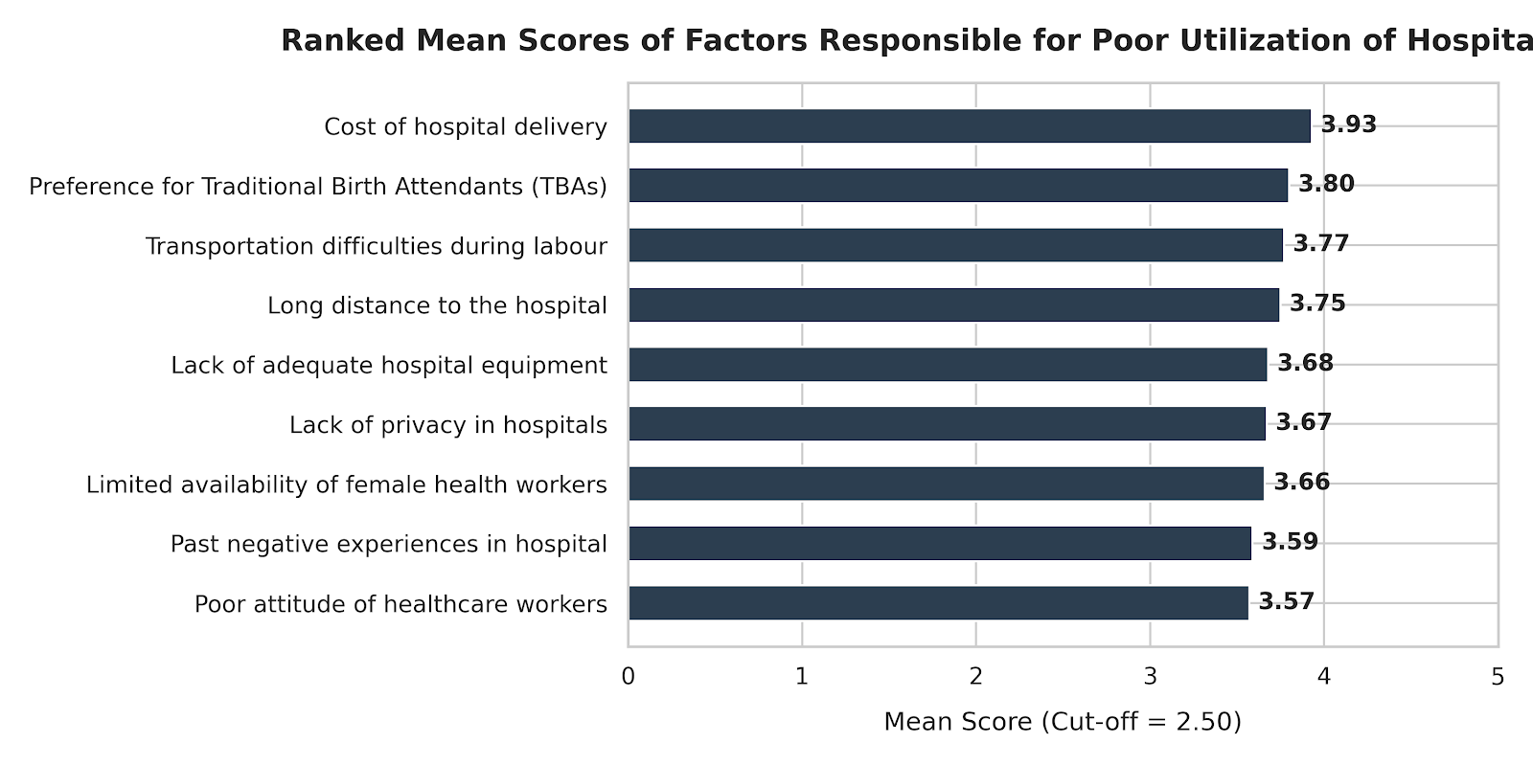

Fig 1- ranked mean scores of factors responsible for poor utilization of hospital

Table 2 presents the factors influencing poor utilization of hospital delivery services. All identified factors had mean scores above the 2.5 cut-off point, indicating respondent agreement. The cost of hospital delivery emerged as the most prominent factor (mean=3.93), followed by preference for Traditional Birth Attendants (mean=3.80), transportation difficulties (mean=3.77), long distance to health facilities (mean=3.75), lack of adequate hospital equipment (mean=3.68), lack of privacy (mean=3.67), limited availability of female healthcare workers (mean=3.66), past negative experiences (mean=3.59), and poor attitude of healthcare workers (mean=3.57).

Table 3: Perception of Women Toward Hospital Delivery (N=171)
Item | SA n(%) | A n(%) | U n(%) | D n(%) | SD n(%) | Mean (x̄)
Hospital delivery is safer than home delivery | 80(46.8) | 60(35.1) | 10(5.8) | 12(7.0) | 9(5.3) | 4.11
Hospital delivery helps prevent complications during labour | 75(43.9) | 65(38.0) | 8(4.7) | 13(7.6) | 10(5.8) | 4.07
Skilled health workers provide better care than TBAs | 70(40.9) | 68(39.8) | 10(5.8) | 12(7.0) | 11(6.4) | 4.02
I feel comfortable delivering in the hospital | 50(29.2) | 60(35.1) | 15(8.8) | 30(17.5) | 16(9.4) | 3.57
Childbirth is a natural process that doesn't require hospital care | 65(38.0) | 50(29.2) | 10(5.8) | 30(17.5) | 16(9.4) | 3.60
Hospitals respect my cultural and religious beliefs | 45(26.3) | 55(32.2) | 20(11.7) | 30(17.5) | 21(12.3) | 3.43
Fear of male healthcare workers affects my perception | 60(35.1) | 50(29.2) | 12(7.0) | 25(14.6) | 24(14.0) | 3.58
Information received during ANC influences my perception | 78(45.6) | 60(35.1) | 8(4.7) | 15(8.8) | 10(5.8) | 4.06

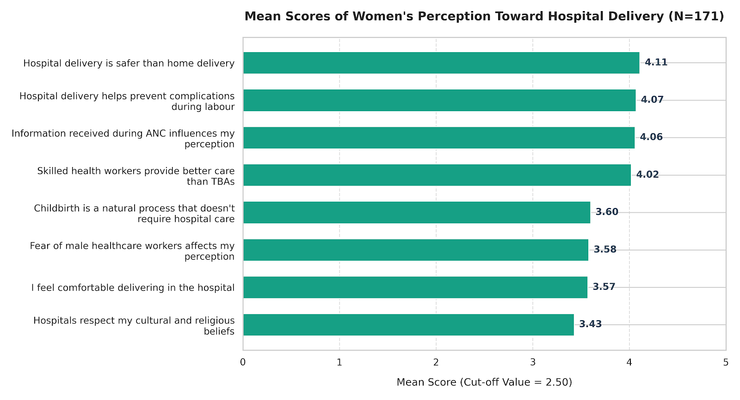
Fig 2- mean scores of women’s perception toward hospital delivery (N=171)

Table 3 shows that respondents generally demonstrated positive perceptions of hospital delivery, with all items recording mean scores above 2.5. Strongest agreement was for "Hospital delivery is safer than home delivery" (mean=4.11), followed by "Hospital delivery helps prevent complications during labour" (mean=4.07), and "Information received during ANC influences my perception" (mean=4.06). However, concerns remained regarding comfort (mean=3.57), fear of male healthcare workers (mean=3.58), cultural/religious respect (mean=3.43), and the belief that childbirth is a natural process not requiring hospital care (mean=3.60).

IV. Discussion
This study examined factors associated with poor utilization of hospital delivery services among women of childbearing age in Birnin Ruwa, Zamfara State. The finding that only 29.2% of respondents utilized hospital delivery services is consistent with the NDHS (2023) report showing that only 39% of women in rural northern Nigeria deliver in health facilities. This low utilization rate is alarming given the WHO's emphasis that 75% of maternal deaths are preventable with skilled birth attendance (WHO, 2023).
The cost of hospital delivery emerged as the most significant barrier (mean=3.93). This finding aligns with studies by Ojo and Balogun (2022) in Ibadan and Asante and Owusu (2021) in Ghana, which identified financial constraints as major determinants of home delivery. In Birnin Ruwa, where 40.9% of respondents were housewives with limited independent income, delivery costs—including informal fees, medication, and supply costs—likely present insurmountable barriers. This finding supports the Health Belief Model's construct of perceived barriers, suggesting that when financial costs outweigh perceived benefits, health-seeking behavior is compromised.
Preference for Traditional Birth Attendants (mean=3.80) reflects the deep cultural integration of TBAs in rural Nigerian communities. This finding corroborates Umar and Ibrahim (2024) in Sokoto State and the IJOIMR (2024) study in Rivers State, which found that TBAs remain preferred due to trust, cultural alignment, affordability, and availability in emergencies. While TBAs provide culturally congruent care, their limited obstetric skills pose significant risks for complications such as postpartum hemorrhage and prolonged labor.
Transportation difficulties (mean=3.77) and long distance to health facilities (mean=3.75) represent structural barriers consistent with findings from Singh et al. (2023) in India and Bello et al. (2023) in Kano State. In Birnin Ruwa, poor road networks and lack of affordable emergency transport mean that women in labour may face life-threatening delays. The WHO recommends that all women have access to emergency obstetric care within two hours, yet this standard is rarely met in rural Zamfara.
Healthcare system factors including inadequate equipment (mean=3.68), lack of privacy (mean=3.67), limited female healthcare workers (mean=3.66), past negative experiences (mean=3.59), and poor healthcare worker attitudes (mean=3.57) collectively erode trust in facility-based care. These findings align with Okafor et al. (2021) in Anambra State and Abdullahi and Musa (2024) in Katsina State. In conservative Muslim communities, the presence of female healthcare workers is particularly important for maintaining modesty and comfort during childbirth.
Despite these barriers, respondents demonstrated positive perceptions of hospital delivery, acknowledging its safety (mean=4.11) and ability to prevent complications (mean=4.07). This paradox—positive perceptions coexisting with low utilization—suggests that cognitive awareness does not automatically translate into behavior change when structural and cultural barriers persist. This finding is consistent with Adebayo et al. (2021) in Edo State and Robinson and Hayes (2021) in Canada.
However, contradictory beliefs persisted, with respondents agreeing that childbirth is a natural process not requiring hospital care (mean=3.60) and expressing fear of male healthcare workers (mean=3.58). These findings reflect the influence of traditional birth narratives and religious/cultural norms that may conflict with biomedical models of childbirth. Suleiman et al. (2023) in Bauchi State reported similar cultural influences on delivery choices.
Encouragingly, antenatal care information was found to positively influence perception (mean=4.06), highlighting the critical role of health education. This finding supports Umar and Shehu (2021) in Abuja and reinforces the importance of ANC as a platform for promoting facility delivery.
Regarding strategies, respondents strongly endorsed reducing delivery costs (mean=4.29) and providing free/subsidized maternity services (mean=4.27). These findings align with Rahman and Sultana (2023) in Bangladesh and Davis and Miller (2023) in Atlanta, demonstrating that financial interventions effectively increase facility delivery rates. Nigeria's existing National Health Insurance Scheme and free maternal health policies require stronger implementation at grassroots levels.
Improving healthcare worker attitudes (mean=4.26) reflects respondents' desire for respectful, empathetic care. Erikson and Lindstrom (2021) in Sweden demonstrated that respectful maternity care training significantly improves facility delivery outcomes. Similarly, community health education (mean=4.24) emerged as a priority, consistent with Waziri et al. (2023) in rural Nigeria, who found that community-based health education increased facility birth uptake.
Structural improvements including better transportation (mean=4.20), improved equipment (mean=4.25), increased female healthcare workers (mean=4.17), and ensured privacy (mean=4.18) address the multidimensional nature of barriers to hospital delivery. These findings support Adamu et al. (2025), who recommended transport-linked referral strategies, and Yusuf and Ahmad (2024), who advocated for facility readiness improvements in Zamfara State.

V. Conclusion
This study concludes that poor utilization of hospital delivery services among women of childbearing age in Birnin Ruwa is influenced by a complex interplay of economic, cultural, and health system-related factors. Although women demonstrate positive perceptions of hospital delivery and acknowledge its benefits, financial constraints, cultural preferences for TBAs, transportation difficulties, and healthcare system deficiencies continue to drive low utilization rates. The gap between positive perception and actual behavior highlights the need for interventions that address not only knowledge but also structural and cultural barriers.

LIMITATION
The study was cross-sectional and restricted strictly to a rural community Birnin Ruwa in Gusau LGA with a small sample size (N = 171). Consequently, the findings reflect localized structural and cultural dynamics and cannot be broadly generalized to all Northern Nigeria
Self-Reporting and Recall Bias: Data collection relied entirely on face-to-face structured questionnaires regarding past delivery choices. This approach is susceptible to recall bias (women misremembering details of past deliveries) or social desirability bias (respondents giving answers they believe the female research assistants want to hear)

Consent: Written informed consent was obtained from all participants.

Ethical Approval
Ethical approval was obtained from the Head of Mai Unguwar Birnin Ruwa,

DECLARATION
Disclaimer (Artificial intelligence)

Author(s) hereby declare that NO generative AI technologies such as Large Language Models (ChatGPT, COPILOT, etc.) and text-to-image generators have been used during the writing or editing of this manuscript.

References

- Abdulraheem, F. A., Raimi, M. O., & Ononokpono, D. N. (2025). Who delivers safely? The hidden role of transport and education in Nigeria’s maternal health crisis [Preprint].
- Akor, L., Dajo, U., & Anthony-Ekpe, H. (2024a). Impact of insecurity on access to maternal health services by women of reproductive age in selected rural communities in Zamfara State, Nigeria. Asian Journal of Research in Social Sciences and Humanities.
- Akor, L., Dajo, U., & Anthony-Ekpe, H. (2024b). The impact of socio-demographic variables on maternal healthcare accessibility among women of reproductive age in Zamfara State, Nigeria. Journal of Public Health and Primary Care.
- Alhaji, M. M., Umar, L., Yusuf, M. A., et al. (2025). Supply and demand barriers to PHC maternal care services uptake: Qualitative and behavioural insights from Gombe State, Nigeria. BMC Pregnancy and Childbirth, 25, Article 939. https://doi.org/10.1186/s12884-025-07212-0
- Carlos, A. M., Amadu, M. A., Okonofua, F., et al. (2025). Improving maternal health outcomes through skilled birth attendance in hard-to-reach communities of Adamawa State, Nigeria. Journal of Global Health Reports.
- Ibrahim, M. (2025). Impact of sociocultural beliefs on maternal health-seeking behavior among women of reproductive age in Zamfara State. Asian Journal of Research and Reports in Gynaecology and Obstetrics, 9.
- Ibrahim, m. (2025). Impact of sociocultural beliefs on maternal health-seeking behavior among women of reproductive age in zamfara state. Gusau journal of sociology, 4(4), 130–137. Https://doi.org/10.57233/gujos.v4i4.09
- Maiwada, a. M., rahman, n. A. A., rahman, s. A., & ahmad, s. A. (2016). Health care seeking behavior of pregnant women in gusau metropolis of zamfara state, northern nigeria. Journal of health and social sciences, 1, 1–10.
- Maiwada, a. M., rahman, n. A. A., rahman, s. A., mamat, n. M., & a-baba, t. (2016). Health care seeking behavior of pregnant women in gusau metropolis of zamfara state, northern nigeria.
- Musa, i. (2025). Impact of sociocultural beliefs on maternal health-seeking behavior among women of reproductive age in zamfara state. Asian journal of research and reports in gynaecology and obstetrics.
- Olubodun, T., Owolabi, O., Adejugbe, O., et al. (2025). Patterns of utilization and determinants of maternal health services among women residing in low-income communities in Lagos State, Nigeria. PLOS Global Public Health. https://doi.org/10.1371/journal.pgph.0004862
- Oyedele, O. K. (2023). Disparities and barriers of health facility delivery following optimal and suboptimal pregnancy care in Nigeria: Evidence of home births from cross-sectional surveys. BMC Health Services Research, 23, Article 482. https://doi.org/10.1186/s12913-023-09433-4
- Sani, J., Halane, S., Ahmed, M. M., et al. (2026). Sociodemographic determinants of health facility delivery among women in Nigeria: A cross-sectional study using 2018 NDHS data. Health Science Reports, 9.
- Sinaï, i., anyanti, j., khan, m., daroda, r., & oguntunde, o. (2017). Demand for women’s health services in northern nigeria: a review of the literature [review of demand for women’s health services in northern nigeria: a review of the literature]. African journal of reproductive health, 21(2), 96–108. African journals online. Https://doi.org/10.29063/ajrh2017/v21i2.11
- Sinaï, i., anyanti, j., khan, m., quadri, f., & adewuyi, a. (2017). Demand for women’s health services in northern nigeria: a review of the literature. African journal of reproductive health, 21, 96–108. Https://doi.org/10.29063/ajrh2017.v21i2.11
- Yankuzo, k. I. (2022). Patronage of maternal healthcare services and associated factors in a rural community of zamfara state, nigeria. International journal of innovative medicine and health research, 10, 44–55.
- Yankuzo, k. I. (2022). Patronage of maternal healthcare services and associated factors in a rural community of zamfara state, nigeria. Ibom journal of social issues, 11(3). Https://doi.org/10.36108/ijsi/2202.11.0320
- Yankuzo, K. I., & Okeshola, F. B. (2024). Patronage of antenatal care services in Zamfara State, Nigeria. International Journal of Innovative Medicine and Health Research, 12.

