DISPERSION PATTERN OF MOUNDS OF Macrotermes bellicosus (ISOPTERA: TERMITIDAE) AND CHEMICAL COMPOSITION OF MOUND AND SURROUNDING SOILS IN SOME AREAS OF ZURU L. G. A., KEBBI STATE-NIGERIA

Abstract
Termite mounds significantly modify soil properties and ecosystem processes, making them important contributors to soil fertility, vegetation patterns, and land productivity in tropical landscapes.This study was conducted to assess the mound dispersion of Macrotermes bellicosus, as well as the mineral composition and physical characteristics of termite mounds and their surrounding soils in selected locations within Zuru Local Government Area of Kebbi State. Six locations—Dabai, Rikoto, Rafin Zuru, Manga, Senchi, and Ushe—were selected for the study. Termite mounds were surveyed across different land types, specifically upland and fadama areas. In each land type, two plots measuring 100 × 20 m² were established, and the number of termite mounds was determined by direct counting. Results showed that mound dispersion of M. bellicosus varied significantly (P < 0.05) with land type. Mound density was significantly higher in shaded areas, with a mean value of 37.00, compared to sun-exposed areas with a mean value of 28.00. However, no significant difference (P > 0.05) was observed across the study locations. Land type had a significant influence (P < 0.05) on mound distribution in all locations. Various mound shapes were identified, including conical, irregular, spherical, and dome-shaped structures. Furthermore, the mineral element composition was significantly higher in termite mound soils than in the surrounding soils across the study area. These findings suggest that termite mounds are nutrient-rich and can enhance soil fertility, thereby promoting plant growth and improving crop yield.
Key words: Upland, Fadama, Macrotermes bellicosus, mound dispersion, mound morphology, soil fertility

INTRODUCTION
Termite mounds are among the most conspicuous, edifying and ecologically significant landscape features in tropical and savanna ecosystems. Mound-building termites play a vital role in soil modification through the selective excavation, transport, and deposition of soil particles, clay minerals, and organic materials. These activities result in the formation of termite mounds whose physical, chemical, and biological properties often differ greatly from those of the surrounding soils. Consequently, termite mounds influence soil fertility, hydrological processes, vegetation distribution, and overall ecosystem functioning, with important implications for land management and agricultural productivity (Sileshi, et al., 2010)
Macrotermes bellicosus is one of the most dominant and widely distributed species across the West African savanna zone among mound-building termites. This species is particularly known for constructing large, permanent epigeal mounds, characterized by complex internal structures, including chambers, galleries, ventilation shafts, and fungal combs Bandiya (2012) and Tilahun et al. (2012). These internal structures facilitate the cultivation of symbiotic fungi (Termitomyces spp), which contribute significantly to organic matter decomposition and nutrient cycling within the mound environment. As a result of these biological activities, mound soils of M. bellicosus are often enriched in clay, calcium carbonate, exchangeable cations, and organic matter compared to adjacent top soils (Abe, 2009; Mujinya et al., 2013; Tilahun et al., 2012).
In Nigeria, M. bellicosus has been widely reported as a key ecosystem engineer, particularly within the savanna regions (Shindi et al., 2019). Studies conducted across northern Nigeria indicate that soils derived from termite mounds exhibit improved nutrient status, altered texture, and enhanced fertility potential compared to surrounding soils (Aiki et al., 2013; Shindi et al., 2019; Bandiya, (2012) and Bandiya and Yahaya, 2020), termite mounds are abundant and form prominent features of the landscape. Termite mound soils are richer in nutrients, they have higher clay content, and exhibit different physico-chemical properties compared to adjacent soils (Abe, 2009; Mujinya et al., 2013; Shindi et al., 2019; Bandiya and Yahaya, 2020). However, despite their visibility and ecological relevance, systematic information on mound dispersion patterns and the physico-chemical properties of mound soils and surrounding soils, and recognizing importance of M. bellicosus in modifying soil properties and influencing savanna ecosystems, there is limited information on mound dispersion patterns and the chemical composition of mound soils and surrounding soils in the study area. This lack of specific data hampers efforts to quantify the contribution of termite activity to soil fertility enhancement and limits the effective utilization of termite mound materials as potential soil amendment.
Previous studies conducted in other parts of Nigeria and Africa have demonstrated that termite mound soils are richer in nutrients, have higher clay content, and exhibit different physic-chemical properties compared to adjacent soils (Abe, 2009; Mujinya et al., 2013; Shindi et al., 2019; Bandiya and Yahaya, 2020). However, the magnitude of these differences, spatial variation, and their relationship with mound dispersion in the study area remain largely undocumented. This knowledge gap necessitates a focused investigation to generate baseline data that will support sustainable soil management, agricultural productivity, and land-use in the study area.
MATERIALS AND METHODS

Study area

The study was conducted in some selected study locations of Zuru Local Government Area of Kebbi State viz: Dabai, Rafin Zuru, Rikoto, Manga, Senchi and Ushe. The areas were purposefully selected because of the population and widespread of mounds across each landscape. Zuru L.G.A is located in Guinea–Sudan savanna ecological zone of Nigeria and lies approximately between latitudes 11°15′N and 11°35′N and longitudes 4°45′E and 5°15′E. The Area occupies an estimated land area of about 461,884 km² and is situated at the south-eastern part of Kebbi State (Madu and Ibrahim, 2022). The climate of the area is characterized by two distinct seasons; wet season which last from April to October and a dry season from November to March. The mean annual rainfall ranges between 850 and 1200 mm, while average temperatures vary from 24°C to about 39°C. The area also experiences Harmattan conditions between November and March, characterized by low temperatures and dry, dusty winds (Madu and Ibrahim, 2022). The vegetation of the Area is predominantly tropical savanna woodland, consisting of grasses, shrubs, and scattered deciduous trees such as Parkia biglobosa, Vitellaria paradoxa, and Daniellia oliveri (Aiki et al., 2013). The soils are generally sandy loam to sandy clay loam, moderately deep, well drained, and suitable for agricultural activities. These soil characteristics favour termite mound construction and persistence (Eguakun, 2021). Zuru L.G.A is divided into six districts m administratively: Dabai, Rafin Zuru, Rikoto, Manga, Senchi and Ushe. The estimated population of the area is about 165,547 (Lange, 2009. And Mamman et al., 2000)
Sampling and Sample size

The sampling of mounds was carried out between the months of October, 2025 to March, 2026, in the selected study areas. . The selection of plots was based on accessibility from the road and widespread of mounds across each landscape in the study locations. The selected areas were; Dabai, Rikoto, Rafin Zuru, Manga, Senchi and Ushe. In each location of the study four (4) sample plots measuring 100 × 20 m² were selected, two (2) Upland and two (2) Fadama

Sampling Design
Sampling of termite mounds was carried out over a period of six months in areas with high mound population. In each selected site, sample plots measuring 100 × 20 m² were established. The plots were laid out along accessible transects to ensure ease of movement and adequate coverage of the landscape. Within each plot, all visible Macrotermes bellicosus mounds were identified and counted to determine mound density and dispersion. The selection of plots was based on accessibility, safety, and the widespread occurrence of termite mounds across each landscape unit.
Determination of Mound Dispersion and Physical Characteristics
Termite mounds dispersion was assessed using a systematic transect walk method. Researcher walked along each established transect on foot and recorded the number of mounds encountered within each plot. Mound density was calculated as the number of mounds per unit area. Height was measured from the base to the apex using a measuring tape. Shapes such as irregular, dome-shaped, conical, or spherical were determined through direct observation and recorded according to the methods described by Bandiya, (2012) and Shindi et al. (2019)
Collection of soil Samples
Soil samples were collected from both termite mounds and surrounding soils within each sample plot. For mound soils, samples were collected from the exposed outer portion of the mound after scraping off the surface debris to avoid contamination, this was done in three (3) replicates, three mounds per plot. For surrounding soils, samples were collected at a distance of approximately 2 m away from the base of the mound to serve as compare samples and depth of 5cm per collection point. Each sampling point, about 1.0 kg of soil was collected using a clean soil auger/hoe. Samples were placed in labeled polythene bags indicating site location, sample type (mound or surrounding soils), and date of collection. Samples were air-dried, gently crushed, and passed through a 2.0 mm sieve to remove coarse materials before analysis according to the methods described by Bandiya, (2012) and Shindi et al. (2019)

Determination of soil properties

Soil samples were collected for chemical analyses; two plots each from Upland and Fadama. During soil sampling; samples from mounds and the surrounding soils were collected, 2 meters away from the mound. Exposed parts of mounds were scraped off and 1.0 Kg of soil samples was collected from each point separately. Samples were sun-dried, ground and sieved through 2.0 mm sieve, packaged in bags labeled and taken to Soil Science Laboratory of the Faculty of Agriculture Usmanu Danfodiyo University Sokoto for the analyses according to the methods described by A.O.A.C. (2000).

Data collection
Data collected during field survey included mound dispersion which was by counting the mound is both land type, as well as mound shapes across the selected study locations. Data from soil samples; both mounds and surrounding soils (Upland and Fadama) were collected separately. These soil samples were also analyzed separately in Agricultural chemical laboratory, Faculty of Agriculture Usmanu Danfodiyo University Sokoto.

Data Analysis

The data collected were subjected to descriptive statistical analysis, including the calculation of means and standard errors. Analysis of variance (ANOVA) was used to compare termite mound soils with the surrounding soils. All analyses were performed using StatView Statistical Analysis Software (SAS, 2002), and mean differences were separated using the least significant difference (LSD) test at the 5% level of significance.

RESULTS

Results shows that two plots were selected for study in each land type and location of the study. In Dabai two plots were selected in upland and Fadama respectively, so also in all selected locations of the study as shown below in Figure 1. Mound dispersion was also observed across the locations of the study, where shaded areas and sun-exposed areas was observed, from the results it was found that mounds were distributed in all locations of the study both upland and fadama, where results shows that base on land type upland have more mounds with a mean of 37.00 in the shaded areas compare to the Sun-exposed areas which have a mean of 28.00 in upland. While in fadama area also more mounds where found in shaded areas with a mean of 29.00 and 22.00 in sun-exposed areas across the study area as showed in Figure 2. Fadama area therefore have more mounds in the shaded areas compare to the Sun-exposed areas.

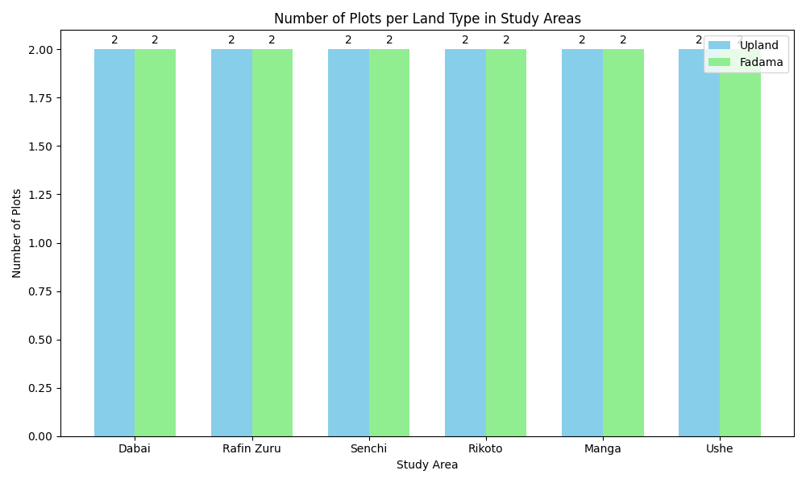Figure 1: Number of selected plots land type in study locations
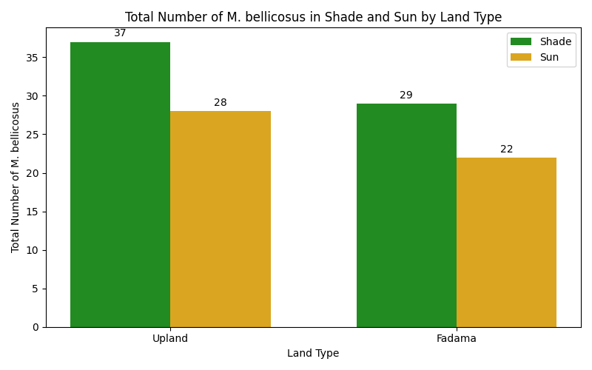Figure 2: Total Number of M. bellicosus in Shade and Sun by land type in study area
From the results the mean number of irregular mounds was found to be the highest in both land types with 3.25 ± 0.30 in upland and 3.17 ± 0.21 in Fadama. Conical mounds recorded 3.00 ± 0.27 in upland and 2.75 ± 0.21 in Fadama. Dome-shaped mounds had mean values of 2.00 ± 0.32 in upland and 2.33 ± 0.33 in Fadiman, while spherical mounds recorded the lowest means of 1.50 ± 0.28 and 1.33 ± 0.19 respectively (table 1). Generally from the result it is clear that mounds have different shapes in all location of study.

Table 1: Mean and Standard Error of Mound Shapes per Land Type
Land Type | Irregular | Conical | Dome | Spherical
Upland | 3.25 ± 0.30 | 3.00 ± 0.27 | 2.00 ± 0.32 | 1.50 ± 0.28
Fadama | 3.17 ± 0.21 | 2.75 ± 0.21 | 2.33 ± 0.33 | 1.33 ± 0.19
The results revealed significant differences (p ≤ 0.05) in most soil physicochemical properties across land types and sampling positions Dabai. Termite mound soils generally enhanced soil nutrient status compared to surrounding soils. In Upland environments, mound soils recorded significantly higher copper (Cu) and iron (Fe), indicating strong nutrient accumulation associated with termite activity. However, surrounding soils showed higher zinc (Zn), suggesting possible redistribution or leaching of micronutrients. In Fadama conditions, mound soils exhibited significantly higher phosphorus (P), potassium (K), and sodium (Na), reflecting enhanced nutrient mobility under moist conditions. Surrounding soils in Fadama areas showed relatively lower nutrient levels, except for iron (Fe), which remained relatively high. Calcium (Ca) did not show significant differences across treatments, indicating relative stability across land types and sampling positions. Generally, termite mounds act as nutrient enrichment zones in both Upland and Fadama ecosystems. Fadama environments promote the availability of mobile nutrients, while Upland environments show stronger accumulation of certain elements such as Fe and Cu.
Table 2: Mean ± Standard Error (SE) of mineral composition across land types

Mineral | Upland mound | Upland Surrounding | Fadama Mound | Fadama Surrounding
P | 0.971 ± 0.002 | 0.953 ± 0.002 | 0.926 ± 0.003 | 0.898 ± 0.006
Ca | 0.867 ± 0.044 | 0.833 ± 0.033 | 0.833 ± 0.044 | 0.833 ± 0.033
K | 1.890 ± 0.020 | 1.827 ± 0.023 | 1.837 ± 0.023 | 1.723 ± 0.017
Na | 1.160 ± 0.030 | 1.103 ± 0.013 | 1.233 ± 0.013 | 1.127 ± 0.023
Zn | 0.0283 ± 0.0003 | 0.0233 ± 0.0003 | 0.1170 ± 0.0006 | 0.0340 ± 0.0006
Cu | 0.1240 ± 0.0006 | 0.1093 ± 0.0003 | 0.1300 ± 0.0006 | 0.1200 ± 0.0006
Fe | 24.453 ± 0.0003 | 20.163 ± 0.0003 | 17.444 ± 0.0006 | 18.101 ± 0.001

Note. Values are presented as mean ± standard error (SE).

Table 3: ANOVA summary of mineral parameters across land types (p ≤ 0.05)

Parameter | Significance | Interpretation
P | Significant | Upland mound highest
Ca | Not significant | Similar across groups
K | Significant | Upland mound highest
Na | Significant | Fadama mound highest
Zn | Significant | Fadama mound highest
Cu | Significant | Fadama mound highest
Fe | Significant | Upland mound highest

Note. Significance is determined at p ≤ 0.05.

From the results significant variation is revealed (p ≤ 0.05) in most soil properties across land types and sampling positions in Rikoto. Termite mound soils generally exhibited higher nutrient concentrations compared to surrounding soils. In Upland conditions, mound soils recorded significantly higher phosphorus (P), potassium (K), and iron (Fe), indicating strong nutrient accumulation due to termite activity. Surrounding soils consistently showed lower nutrient levels, reflecting reduced biological enrichment. In Fadama areas, mound soils had significantly higher sodium (Na), zinc (Zn), and copper (Cu), suggesting that moisture conditions enhance micronutrient availability and mobility. However, calcium (Ca) showed no significant difference across treatments, showing relative stability across environments. In all, termite mounds act as nutrient hotspots in both Upland and wetland ecosystems, with more pronounced micronutrient enrichment observed under wetland conditions. The variability observed in surrounding soils reflects heterogeneous soil characteristics and possible environmental inconsistencies.
Table 4: Mean (± SE) and LSD mean separation of mineral parameters across land types
(p ≤ 0.05)

Parameter | Upland Mound | Upland Surrounding | Fadama Mound | Fadama Surrounding
P | 0.971 ± 0.002ᵃ | 0.953 ± 0.002ᵇ | 0.926 ± 0.003ᶜ | 0.898 ± 0.006ᵈ
Ca | 0.867 ± 0.044ᵃ | 0.833 ± 0.033ᵃ | 0.833 ± 0.044ᵃ | 0.833 ± 0.033ᵃ
K | 1.890 ± 0.020ᵃ | 1.827 ± 0.023ᵇ | 1.837 ± 0.023ᵇ | 1.723 ± 0.017ᶜ
Na | 1.160 ± 0.030ᵇ | 1.103 ± 0.013ᶜ | 1.233 ± 0.013ᵃ | 1.127 ± 0.023ᵇᶜ
Zn | 0.0283 ± 0.0003ᶜ | 0.0233 ± 0.0003ᵈ | 0.1170 ± 0.0006ᵃ | 0.0340 ± 0.0006ᵇ
Cu | 0.1240 ± 0.0006ᵇ | 0.1093 ± 0.0003ᶜ | 0.1300 ± 0.0006ᵃ | 0.1200 ± 0.0006ᵇ
Fe | 24.453 ± 0.0003ᵃ | 20.163 ± 0.0003ᵇ | 17.444 ± 0.0006ᵈ | 18.101 ± 0.001ᶜ

Note. Means sharing the same letter within a row are not significantly different at p ≤ 0.05 using the Least Significant Difference (LSD) test.

Phosphorus (P) concentrations varied significantly across locations, land types, and sampling positions. In most locations, Fadama mound soils recorded the highest P values, indicating enhanced nutrient availability under moist conditions. Termite mound soils consistently showed higher phosphorus levels compared to surrounding soils, confirming the role of termite activity in nutrient enrichment. However, some locations (e.g., R/Zuru) showed high variability in wetland surrounding soils due to possible data inconsistencies. Generally, phosphorus distribution suggests that both termite activity and moisture significantly influence P availability. Calcium (Ca) showed moderate variation across locations, with Upland mound soils generally recording higher Ca concentrations compared to other treatments. This indicates that calcium, being a relatively stable nutrient, accumulates more in termite mounds under dry conditions. In contrast, fadama soils exhibited slightly lower Ca levels, likely due to leaching effects. In some locations, differences were not statistically significant, suggesting that calcium distribution is less influenced by land type compared to other nutrients. Termite mounds contribute to Ca enrichment, especially in upland ecosystems.

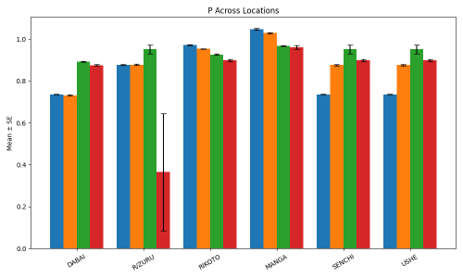

Fig 3: Phosphorus (P) content across different locations showing mean ± SE values for four sampled plots

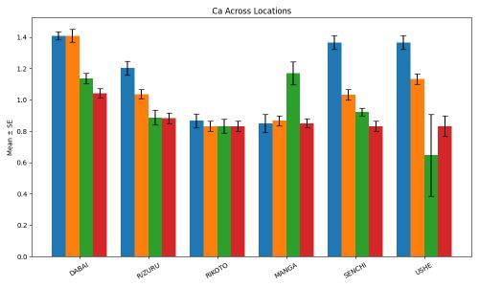

Fig 4: Calcium (Ca) content across different locations showing mean ± SE values for four sampled plots

DISCUSSION
The six areas surveyed during study in the selected study area include; Dabai, R/Zuru, Rikoto, Manga, Senchi and Ushe Macrotermes bellicosus mounds were found everywhere in the study area, with more number of mounds in the shaded than in sun-exposed areas. This was in agreement with Krishna (2015) findings, who reported that termite species are abundant in the tropics and mounds are relatively abundant and easy to count and the densities of the large mounds, usually less than 10/ha⁻¹, while smaller mounds may approach 100/ha⁻¹. As observed by Edosomwan, et al., (2025). Their abundance could be due to soil type and vegetation as well as individual activities in the mound; From the results these mounds have different shapes and characteristics base on location and land type this was in conformity with Bandiya, (2012), Orhue et al. (2007); Abe et al. (2009) who reported 3-10 mounds per hectare (ha⁻¹) for Macrotermes bellicosus species. During the study, mounds were noted to be widely dispersed all over the study area. Land type, upland was observed to have more mounds than fadama, while more mounds were in the shaded areas than the sun-exposed areas this was confirmed by Edosomwan, et al., (2025), Orhure et al. (2007) and Adekayode and Ojunkoya (2009) who said that, mounds are distributed widely in the tropics. The dispersion of mounds can be deduced to fact of favorable conditions and vegetation for termites to build their mounds in shaded areas in study locations. This was also supported by Longair, (2004) and Edosomwan, et al., (2025) who said that mounds are more built in tropical areas. Minerals elements such as sodium (Na), in all the locations of study, and land type, differed significantly in mound soils compare surrounding. While in case of land type, upland have more calcium (0.867± 0.044) content than fadama 0.8333±0.0444), potassium and sodium were higher in fadama land than dry land. Soil type mound soils had more content of calcium than the surrounding soils, potassium, sodium were all higher in mound soils than the surrounding soils, and this was similar to Frageria and Baligar (2004). The results of exchangeable bases in mound and surrounding soils suggest that the difference between them is not significant though mounds are higher than the surrounding soils. Phosphorus (P), Zinc (Zn), Copper (Cu) and Iron (Fe) both in upland and fadama also soil type that is mound soils and the surrounding soils in locations of study showed variation. In case of land type phosphorus was observed to have more value content in upland than fadama, while fadama has more zinc than in the upland and copper was observed to be higher in fadama than in the upland, but it have higher iron value compare to fadama. Soil type showed that, phosphorus, zinc, copper and iron were higher in content in upland than in fadama in all the sample plots. This was in conformity with Holt and Lepage (2000) findings, who reported that the result of phosphorus and mineral elements in mound soils is more when compared to surrounding soils. The results suggested that the difference between locations, land type upland and fadama as well as mound and surrounding soil was of no significant difference. It is believed that the modification in mound soil is as the result of termites’ feaces and foraging activities as well as decomposition of termites that might have died and foraged materials added in the content of phosphorus and mineral elements in mound soil. Studies showed that mound soils have more nutrients than the surrounding soils. This was similar to Gosling et al., (2012) who said that mound soils are generally more fertile than other soil. Jouquet, et al., (2011) and Erpenbach et al., 2013) also reported that mound soils have been found to contain more water than their surroundings, a clear advantage for plant growth in savannahs. (Jouquet et al. (2011) and Erpenbach et al. 2013). They further supported this observation by more recent studies, that termite mound soils often retain more moisture than the surrounding soils, providing a clear advantage for plant growth in savanna ecosystems, which also promote and support agricultural activities.

Conclusion
In conclusion, termite mounds are widely distributed across all study locations and contain nutrient-rich compositions that can support agricultural activities in the area. Exchangeable bases such as potassium (K), sodium (Na), and calcium (Ca) were found in higher concentrations in the mounds than in the surrounding soils, although the results indicated no significant difference (P < 0.05). This pattern was consistent in both upland and fadama areas. The presence of these nutrients in mound soils may be attributed to termite feces, saliva, and the incorporation of organic carbon with sand during mound construction. Generally, termite mounds were observed throughout the sampled plots and are generally rich in nutrients.

COMPETING INTERESTS
The authors have no competing interests to declare.
ACKNOWLEDGEMENTS
The authors greatly appreciate the support of TETFUND Nigeria under grant number: TETF/DR&D/CE/UNI/ZURU/ IBR/2025/VOL.1.
Disclaimer (Artificial intelligence)

Author(s) hereby declare that NO generative AI technologies such as Large Language Models (ChatGPT, COPILOT, etc.) and text-to-image generators have been used during the writing or editing of this manuscript.

REFERENCES
Abe, S. S. (2009). Physico-chemical properties of termite mounds and surrounding soils in the savanna of West Africa. African Journal of Ecology, 47(3), 337–343.

Abe, S. S. (2011). Soil modification by the mound-building termite Macrotermes bellicosus and its implications for nutrient dynamics. Soil Research, 49(4), 278–286.

Adekayode and Ojunkoya (2009). Comparative study of clay and organic matter content of

termite mounds and surrounding soils, African Crop Science Conference Proceedings,

Uganda 9: 378-384.

Aiki, I. P., Majeed, Q., Bandiya, H. M., Ibrahim, N. D., and Suleiman, M. A. (2013). A survey of termite species found within Zuru Local Government Area of Kebbi State, Nigeria. International Journal of Applied Research and Technology, 2(9), 45–52.
Association of Official Analytical Chemists (AOAC). (2000). Official methods of analysis (17th ed.). AOAC International.

Bandiya, H. M. (2012). Studies on the abundance and Bionomics and control of African mound-

building termite Macrotermes bellicosus (Smeathman) (Isoptera: Termitidae) in selected

Local Government Areas of Sokoto State, PhD Thesis unpubished, 8-34p.

Bandiya, H. M., and Yahaya, A. (2020). Chemical properties of soils from mounds of Macrotermes species and surrounding soils in northern Nigeria. Direct Research Journal of Agriculture and Food Science, 8(6), 176–183.

Dangerfield, J.M., McCarthy, T. S. and Ellery, W. N. (1998).The mound-building termite

Macrotermesmichaelseni as an ecosystem engineer.Journal of Tropical Ecology 14-507-520.

Edosomwan, N. L. Edosomwan, E. U., Oke, O. (2025). Physical and Chemical Characteristics
of Termite Mounds and Associated Soils in Tropical Forest-Savanna Transitional Area of
Southern Nigeria. Indian Journal of Agricultural Research. 46(4): 338 - 343. Retrieved
from https://arccjournals.com/journal/indian-journal-of-agriculturalresearch/ARCC395
Erpenbach, A., Bernhardt-Römermann, M., Wittig, R., & Thiombiano, A. (2013). Termite
mounds as an important source of soil nutrients and vegetation structure in West African
savannas. Journal of Arid Environments, 90, 55–62.

Eguakun, P. E. (2021). Chemical composition of termite (Isoptera) mounds and surrounding soils

in selected savanna ecosystems of Nigeria. IIARD Journal of Environmental Sciences, 7(3),

22–31.

Frageria, N.K. and Baligar, V.C. (2004). Properties of termite mound soils and responses of rice

and bean to N. P and K fertilization on such soils. Common.Soil Science. Plant Anal.,

35:15-16

Gosling, C.M., Cromsigt, J. P. G. M., Mpanza, N. and Olff, H. (2012).Effects of erosion from mounds of different termite genera on distinct functional grassland types in an African savannah.Ecosystems 15: 128-139.

Holt, J. A. and Lepage, M. (2000). Termites and Soil Properties, Termites, In: Evolution Society, Symbiosis and ecology, Abe, T. (Eds). Kluver Academia Publisher, Boston, M. A. 389-407p.
Jouquet, P., Traoré, S., Choosai, C., Hartmann, C., & Bignell, D. (2011). Influence of termites on
ecosystem functioning: Ecosystem services provided by termites. European Journal of
Soil Biology, 47(4), 215–222.
Jouquet, P., Traoré, S., Choosai, C., Hartmann, C., and Bignell, D. (2016). Influence of termites on ecosystem functioning: Ecosystem services provided by termites. European Journal of Soil Biology, 73, 215–224.

Krishna, K. (2015). “Termites” Encyclopaedia Britannica. Retrieved 11 September, 2015.

Longair, R. W. (2004). “Tusked Males, Male Dimorphism and Nesting Behaviour in a Sub-Social Afro Tropical Wasp”, Synagris cormute and Weapons and Dimorphism in the Genus (Hymenptera: vespidea; eumeniae), Journal of the Kansas Entomological Society, 77 (44): 528-557.
Lange, D. (2009). Vegetation characteristics of the Guinea–Sudan savanna zone of Nigeria. Savanna Ecology Journal, 4(1), 14–27.

Mamman, A.B., J. O.Oyebanji and S. W. Peters (2000). In: Nigeria A people united, a future

assured (survey) Calaba, Gabumo publishing Company. Pp 6-7

Madu, A. O., and Ibrahim, M. A. (2022). Spatial distribution of termite mounds and implications for land use in Kebbi State, Nigeria. Journal of Environmental Geography, 15(2), 89–98.
Mujinya, B. B., Mees, F., Boeckx, P., and Van Ranst, E. (2013). Clay mineralogy and chemical properties of termite mounds in tropical environments. Geoderma, 192, 304–315.
Orhue, E. R.; Uzu, O. F. and Osaigbovo, U. V. (2007). Influence of Activities of Termites on
somePhysical and Chemical Properties of Soils under Different Land Use Patterns : A
Review, International journal of Soil Science, 2: 1-14.

SAS Institute Inc. (2002). SAS/STAT user’s guide (Version 9). SAS Institute Inc.
Shindi, H. A., Musa, M. A., and Abdullahi, U. (2019). Effects of termite activity on soil fertility
in savanna ecosystems of northern Nigeria. Nigerian Journal of Soil Science, 29(1), 67–75.

Sileshi, G. W., Nyeko, P., Nkunika, P. O. Y., Sekematte, B. M., Akinnifesi, F. K., and Ajayi, O. C. (2010). Integrating ethno-ecological and scientific knowledge of termites for sustainable termite management and crop production in Africa. Ecology and Society, 15(4), 48.
Tilahun, A., Kebede, F., and Yamoah, C. (2012). Quantifying nutrient storage in Macrotermes termite mounds and implications for soil amendment. Soil Biology and Biochemistry, 54, 110–116.

