Original Research Article

Simultaneous Estimation of Liraglutide and Preservative Phenol In Injectable Dosage Form By Validated Stability-Indicating RP-HPLC Method

Abstract
Aim: To develop and validate a simple, precise, accurate and stability-indicating reverse phase high-performance liquid chromatography method for simultaneous estimation of Liraglutide and Phenol in injectable dosage form.
Study Design: An experimental analytical study aimed at the development and validation of a stability-indicating RP-HPLC method.
Place and Duration of Study: The study was carried out in the pharmaceutical analysis laboratory during the period of dissertation research work.
Methodology: Simultaneous estimation of Liraglutide and Phenol was achieved via chromatographic separation on a C18 column under optimized mobile phase conditions. Standard and sample solutions were prepared and analyzed using reverse phase high-performance liquid chromatography. The method was validated as per ICH guidelines, including specificity, linearity, accuracy, precision, robustness and sensitivity (LOD/LOQ). Forced degradation studies were performed under acidic, alkaline, oxidative, thermal and photolytic stress conditions to evaluate the stability-indicating nature of the method.
Results: Liraglutide and Phenol showed well resolved peaks with retention times of 8.586 min and 3.265 min respectively. The method exhibited linearity in the concentration range of 30–90 µg/mL for Liraglutide and 27.50–82.50 µg/mL for Phenol, with correlation coefficients of 0.993 and 0.996 respectively. System suitability parameters were within acceptable limits, with a percentage relative standard deviation below 2%, theoretical plates above 2000, and a tailing factor below 2%. Moreover, forced degradation studies demonstrated that degradants from the major analytes did not interfere in the analysis
Conclusion: This study confirms that the developed method is reliable, precise and efficient. It is suitable for the routine quality control and stability studies of Liraglutide injectable containing Phenol as a preservative.
Keywords: Liraglutide; Phenol; Reverse phase high-performance liquid chromatography; Method validation; Stability-indicating method; Injectable dosage

1. INTRODUCTION
1.1 Introduction to diseases
Diabetes mellitus is a metabolic disease that results in chronic hyperglycaemia through the malfunction of insulin secretion, action, or both [1]. It continues to be one of the most common metabolic diseases worldwide, presenting a major public health concern as a result of its increasing prevalence and associated complications [1]. Of the total clinical cases, type 2 diabetes mellitus (T2DM) accounts for 90-95%, and is closely associated with debilitating complications, including cardiovascular disease, nephropathy, neuropathy and retinopathy. This disease requires constant monitoring of blood glucose levels and the administration of targeted pharmacological therapy for optimal management [1].
Diabetes is characterised by disruption of glucose homeostasis due to insulin resistance or reduced insulin secretion, leading to elevated blood glucose [1,2]. Treatment approaches now combine lifestyle changes with cutting-edge drug therapy to maintain optimal glucose levels and slow the disease's progression [1,2]. From the broad range of therapeutic options, including biguanides, DPP-4 inhibitors, and SGLT2 inhibitors, Glucagon-like peptide-1 (GLP-1) receptor agonists, such as Liraglutide , are essential therapies because of their efficacy [2,3].
But the chronic nature of diabetes therapy requires that these drugs are safe, potent and reliable [2,3]. Liraglutide is a complex peptide injectable that is highly susceptible to degradation and stresses. Moreover, these products are often formulated with a preservative, such as Phenol, for multi-dosing. Simultaneous analysis of the peptide and preservative, particularly in the presence of degradation products is a challenging task that is not sufficiently covered by the pharmacopoeial methods. Thus, this study is justified by the need to develop and validate a stability-indicating RP-HPLC method. This method is needed for quality control purposes to ensure that the drug provided to the patient remains safe and potent throughout the product's lifespan.
1.2 The introduction to Analytical Method
Pharmaceutical analysis is significant in the verification of quality, safety and effectiveness of pharmaceutical products. The identification, quantification, and purity evaluation of drug substances in bulk and dosage forms are developed by analytical techniques. Chromatography is one of the methods of analysis that have gained significant importance due to its sensitivity, specificity, reproducibility and broad use in the pharmaceutical analysis. [4,5]
Chromatography is founded on the separation of components between the stationary and the mobile phases. According to the separation mechanism, chromatographic techniques fall under adsorption and partition chromatography. One of the most widely applied analytical methods in pharmaceutical analysis is the High Performance Liquid Chromatography (HPLC) which is capable of giving precise and repeatable separation of compounds under controlled conditions. [4–6]
1.3 High Performance Liquid Chromatography
High Performance Liquid Chromatography (HPLC) is a sophisticated method of analyzing a mixture to separate, identify and determine the quantity of compounds in a mixture. It works based on the concept of the differential partitioning of the analytes between the stationary and the mobile phases under a high pressure, which produces efficient separation with a better level of resolution. [4,8]
The most commonly used mode in pharmaceutical analysis is the reverse phase HPLC (RP-HPLC) where the stationary phase is non-polar and the mobile phase polar. The benefits of this approach include the ability to analyze fast, at high resolution, sensitive, and applicable to a large variety of pharmaceutical compounds. The parameters of system suitability that are employed to analyze the performance of the chromatography and provide the reliability of the methods include retention time, resolution, theoretical plates and asymmetry factor. [4,9]
1.4 Uses of HPLC in Pharmaceutical Analysis
HPLC is widely employed in the pharmaceutical industry in quality control assay determination, impurity profiling, dissolution studies, and bioanalytical studies. It is also applicable in stability studies whereby the degradation products are isolated and their quantity determined accurately. Stability-indicating methods of analysis have been specifically developed to identify degradation products free of interfering excipients or impurities. [7,10]
Stress tests are forced degradation studies conducted under hydrolysis, oxidation, heat, and photolysis stress conditions to determine intrinsic drug stability. These tests are useful in determining degradation pathways and assist in the development of formulations, shelf-life and regulatory conformity as per ICH standards. [10–16]
1.5 Method Validation
Validation of analytical methods assures that an analytical procedure developed is appropriate to its purpose. The parameters of validation used under the ICH Q2(R2) and USP requirements are specificity, accuracy, precision, linearity, detection limit, quantitation limit, range, and robustness. These parameters would make sure that the developed method of analysis gives reliable and reproducible results when used in the normal analysis. [17,18]
Specificity shows that the method is capable of analyzing analyte response when impurities and excipients are present, and accuracy and precision show proximity and consistency of the results. Linearity is used to ensure proportional response to concentration and robustness is used to assess performance of the method in the presence of small changes in analytical conditions. [17,18]
2. EXPERIMENTAL WORK
Instrumentation and apparatus used are enlisted in Table 1.
Table 1. List of Instruments and apparatus
Sr.  No. | Name of Instrument/Apparatus | Manufacturer
1. | UV Spectrophotometer | Shimadzu UV-1700 double-beam UV-VIS spectrophotometer  Software: UV Probe
2. | HPLC | Make: Shimadzu  Model:- LC 2010 CHT  Injector: 100μL fixed loop.  Detector: UV Detector  Software: LC Solution
3. | Analytical balance | Sartorius Analytical Balance  Accuracy: 0.001 g
4. | pH Meter | Lab India Digital pH Meter
5. | Melting Point Apparatus | Lab Junction Melting Point  Apparatus
6. | Ultrasonic Bath | Athena Technology
7. | Hot Air Oven | Patel Scientific
8. | FT-IR | Agilent Cary 630 FTIR Spectrometer  Software: MicroLab Expert
9. | Micropipette | Eppendorf

2.1. REAGENTS AND CHEMICALS
The following reagents and chemicals were used during the analytical work & enlisted in Table 2.
Table 2. Reagents and Chemicals
Sr. No. | Chemical/ Reagent | Grade | Manufacturer
1. | Methanol | HPLC | Merck Life Science Pvt. Ltd
2. | Acetonitrile | HPLC | Merck Life Science Pvt. Ltd
3. | Water | HPLC | Merck Millipore, India
4. | Potassium dihydrogen phosphate | AR | Merck Life Science Pvt. Ltd
5. | Sodium hydroxide (NaOH) | AR | Merck Life Science Pvt. Ltd
6. | Hydrochloric acid (HCl) | AR | Merck Life Science Pvt. Ltd
7. | Hydrogen peroxide (H₂O₂) | AR | Merck Life Science Pvt. Ltd

2.2 PROCUREMENT OF DRUGS
Liraglutide was procured from the Shipla Pharma Lifescience for the present study and the other Phenol used in the formulation and analytical work was procured from Sigma-Aldrich.

2.3 DRUG IDENTIFICATION
The identication of drug Liraglutide as well as Phenol was done by performing the melting point, IR spectroscopy and UV spectrophotometric determination.

2.3.1 Melting point determination
Melting point of Liraglutide and Phenol was determined using the capillary method. In this small quantity is taken and filled into the capillary and placed in the melting point apparatus, heated slowly and temperature at which it started melting was noted. [19]

2.3.2 IR Spectral Determination
Here IR spectroscopy was also used to conform the identity of the drug. A small quantity of finely powdered samples of Liraglutide and Phenol was taken and thoroughly mixed with the dry potassium bromide (KBr). The mixture was compressed into the transparent disc using hydraulic press. Now the prepared disc was placed in the IR spectrophotometer and scanned over the range of IR that is 4000-400cm-1.[6,20]
2.3.3 UV Spectral determination
UV spectrophotometric analysis was carried out to determine the absorption maxima of Liraglutide and Phenol. Solution of Liraglutide (20 µg/mL) and Phenol (20 µg/mL) were prepared in methanol. The solution were scanned in the wavelength range of 200-400 nm using Shimadzu UV-1700 double beam spectrophotometer with UV probe software.[6,20]

2.4 PREPARATION OF SOLUTIONS

2.4.1 Buffer Solution Preparation
For the preparation of buffer accurately weighed 2.72gm of potassium dihydrogen phosphate was transferred into 1L water. The required pH was adjusted using diluted orthophosphoric acid. Mixed it and Sonicated for 10 min for proper dissolution, filtered with 0.45µ filter under vacuum.[19,20]

2.4.2 Mobile Phase Preparation

Mobile phase-A: 100 % Buffer (2.72 gm of potassium dihydrogen phosphate in 1000 mL water sonicate to dissolve and adjust Ph-3.0 with orthophosphoric acid.

Mobile phase-B:- Acetonitrile

2.4.3 Diluent

Water and acetonitrile was taken as diluent (50:50).

2.4.4 Standard Stock Solution Preparation

2.4.4.1 Phenol Stock Solution (550 µg/mL)

About 55 mg of working standard was accurately weighed and then transferred into 100 mL of volumetric flask in that 70 mL of diluent was added. Further for proper dissolution sonicated for around 15 min and diluent was added to makeup the volume.

2.4.4.2 Liraglutide Stock Solution (600 µg/mL)
About 60 mg of working standard was accurately weighed and then transferred into 100 mL of volumetric flask in that 70 mL of diluent was added. Further for proper dissolution sonicated for around 15 min and diluent was added to make up the volume.

2.4.4.3 Mixed Standard Solution (55 µg/mL Phenol + 60 µg/mL Liraglutide)
About 1mL of Phenol stock solution and 1mL of Liraglutide stock solution was pipette out into 10 mL of volumetric flask. Further diluent was added to make up the volume. Now this solution was used a standard solution.

2.4.4.4 Sample preparation – Victoza Injection (Label claims Phenol 5.5 mg/mL, Liraglutide 6 mg/mL
)
Sample solution containing (55 µg/mL Phenol + 60 µg/mL Liraglutide ) for this 1 mL of sample (equivalent to 5.5 mg Phenol+ 6 mg Liraglutide ) was accurately weighed and transferred into 10 mL of volumetric flask, 7 mL of diluent was added and sonicated for around 5 min. Further the diluent was added and volume was makeup. Further dilute 1mL to 10mL with diluent and mixed.

2.5 FORCED DEGRADATION STUDY
Forced degradation studies were carried out under different stress conditions in accordance with the ICH Q1A (R2) guidelines.
Different stress condition here performed were acidic, alkaline, oxidative, thermal and photolytic environments.. [11,16]

2.5.1 Preparation of Hydrochloric acid (HCl) solution (0.5N)
For preparing 0.5 N Hydrochloric acid, 4.2 mL of concentrated HCl was precisely weighed and placed into 100 mL of volumetric flask. The volume was adjusted to the mark with distilled water and mixed.

2.5.2 Preparation of Sodium Hydroxide (NaOH) solution (0.5N)

For preparing 0.5 N Sodium Hydroxide, 2 g of NaOH was precisely weighed and placed into 100 mL of volumetric flask. The volume was adjusted to the mark with distilled water and mixed.

2.5.3 Preparation of Hydrogen Peroxide (H2O2) solution (10%)
Now 10% H2O2 solution was prepared by transferring 3.3mL of 30% H2O2 into 100mL volumetric flask and volume made up to mark by distilled water and mixed.

2.5.4 Forced degradation study

2.5.4.1 Acid degradation
For acid degradation study, 1mL of each stock solution of (API and the sample) solution was transferred into 10 mL of volumetric flask. Into this 0.5mL of 0.5N HCl was added and kept for 1 hours at room temperature. After this reaction, the solution was cooled and neutralized with 0.5mL of 0.5N NaOH. Finally volume was made with the diluent and chromatogram was recorded.[11]

2.5.4.2 Base degradation
For alkali degradation study, 1mL of each stock solution of (API and the sample) solution was transferred into 10 mL of volumetric flask. Into this 0.5mL of 0.5N NaOH was added and kept for 30 minutes at room temperature. After this reaction, the solution was cooled and neutralized with 0.5mL of 0.5N HCl. Finally volume was made with the diluent and chromatogram was recorded.[11]

2.5.4.3 Oxidative stress degradation
For oxidative degradation study, 1mL of each stock solution of (API and sample) solution was transferred into 10 mL of volumetric flask. Into this 10% H2O2 was added and kept for 2 hours at room temperature. After this volume was made with the diluent and chromatogram was recorded.[11,16]

2.5.4.4 Thermal degradation
For thermal degradation study, both were weighed accurately and placed in petri dish. The dish was kept in the hot air oven at 50 ºC for about 24 hours. After cooling it, the sample was taken and diluent was added upto the mark from this 1 mL was taken in 10 mL volumetric flask and chromatogram was taken. [16]

2.5.4.5 Photolytic degradation
For photolytic degradation study, sample and standard solutions were kept in sunlight for 24 hours. Finally volume was made with the diluent and chromatogram was recorded. [16]
2.6 METHOD VALIDATION

2.6.1 System Suitability Study

As part of assessing system reliability and accuracy, six repeat injections were carried out according to the analysis procedure. The area of the analyte at the highest point of each injection was recorded and theoretical plates and tailing factor were calculated to evaluate the efficiency of the chromatography and the shape of the peak.[18]

2.6.2 Specificity

Specificity of the developed analytical method was evaluated in terms of comparing the chromatograms of diluent, mobile phase, individual standard solutions of Liraglutide (60 μg/mL) and Phenol (55 μg/mL) and also in terms of the combined standard solution of both the analytes, i.e. Liraglutide (60 μg/mL) and Phenol (55 μg/mL). The chromatographic profiles have been considered to ensure that there were no interfering peaks at the retention times of the analytes and both components were well resolved.[17]

2.6.3 Linearity

Detector response linearity of Liraglutide and Phenol was determined by preparing working standard solutions within a range of concentration that represented 50-150% of target concentration. All the solutions were loaded into the HPLC system and the peak area of all the analytes noted. Concentration vs. analyte peak response was plotted to obtain a calibration curve and correlation coefficient and y-intersect of the regression equation were calculated to determine the linear relationship between concentration and detector response.[17,18]

Solution were prepared by taking mL from the standard stock solutions (0.3, 0.45, 0.6, 0.75 & 0.9mL) which were diluted in 10 mL volumetric flask and volume was make up. The calibration curve were constructed and correlation coefficient, slope and y-intercept was calculated.

2.6.4 LOD and LOQ

The data obtained on the repeatability studies were statistically used to obtain the limit of detection (LOD) and limit of quantification (LOQ) of Liraglutide and Phenol. The following equations were used to calculate these parameters using the standard deviation of the intercept and the average slope of the calibration curve

LOD = 3.3 × (σ/ S)

LOQ = 10 × (σ/ S)

Where:

σ = standard deviation of the slope.

S = average slope of the calibration curve

The estimated minimum detectable and quantifiable concentration of each of the analytes under the established chromatographic conditions was determined based on the calculated values.[17]

2.6.5 Precision

Precision are generally considered as Intermediate (Intraday), Reproducibility (Interday) and Repeatability. It is calculated as in terms of the %RSD.[17,18]

Repeatability

The repeatability of the method was checked by injecting a standard solution (60 μg/mL Liraglutide and 55 μg/mL Phenol) 6 times under the same chromatographic conditions. The highest areas were recorded to each injection and percent relative standard deviation (%RSD) was determined to determine the consistency of the method.

A. Intraday Precision

The intraday precision was evaluated by subjecting the standard solution with the two analytes into the analysis process three times in a day. The highest areas of each injection were noted and the percent relative standard deviation was calculated to assess the accuracy of the procedure in a day.

B. Interday Precision

The interday accuracy was obtained through injection of the same standard solution on three days under the same analytical conditions. Each analysis was measured on the peak areas, and the reproducibility of the method on varying days was determined by calculating the percentage of relative standard deviation.

Acceptance criteria: % RSD for six preparations should not more than 2.0.

2.6.6 Accuracy

The validity of the developed method used to analyze the data was tested on the level of concentration of 50, 100, and 150 by means of placebo addition technique. Liraglutide (0.3mg, 0.6mg &0.9mg), and Phenol (0.275mg, 0.55mg & 0.825mg) known quantities of the standard solutions were measured and added into the placebo matrix. All of the concentrations were performed in a triplicate fashion and the percent recovery was calculated by comparing the peak areas of the recovery samples to those of their respective standard solutions.[17]

Acceptance criteria: Individual determination percentage recovery within any level should not be below 98.0% to 102.0%.

2.6.7 Robustness

Sensitivity of the technique was tested by the introduction of intentional small changes in the chosen chromatographic parameters and determining their impact on the analytical performance of Liraglutide and Phenol. The alteration of the analyte response and the system suitability parameters were closely followed under the changed conditions.

The robustness experiment involved the changing of the flow rate by 10 %, organic phase ratio by 2% and column temperature by 5%. The comparison of the chromatographic responses obtained under modified conditions with those obtained under optimized method parameters was done to confirm the reliability of the method.[17,18]

Acceptance criteria: %RSD was calculated and checked that not exceeding 2%.

2.6.8 Assay

The RP-HPLC method developed to optimally run chromatography was used to assay Liraglutide and Phenol in the formulation. The labeled concentration of the formulation equivalent was made up of 6 mg/mL of Liraglutide and 5.5mg/mL of Phenol and the sample solution was prepared, and then diluted appropriately based on the analytical procedure. The ready sample and standard solutions were pumped into the HPLC system, and the area of peaks were measured of the two analytes.[17]

The calculation of the assay involved the comparison of the peak area of the sample and the respective standard solution and the results were reported as a percentage of the labeled claim of each analyte.
Acceptance criteria: The assay of each analyte is expected to lie within the acceptable range of 98.0% to 102.0% of that amount labeled.
3. RESULTS & DISCUSSIONS
3.1. Liraglutide
The IR spectrum of the drug sample was taken in the wavenumber range of 400-4000 cm -1. The spectrum that was obtained was closely monitored and typical functional group peaks were noted. This was compared to the reference IR spectrum to ascertain the identity of the drug. The spectral matching was used to show the presence of the expected functional groups. Figure 2 refers to the resultant spectra for the comparison.
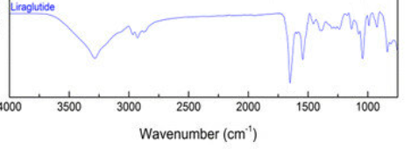
Figure 1. Reference IR Spectra of Liraglutide ^{[22]}
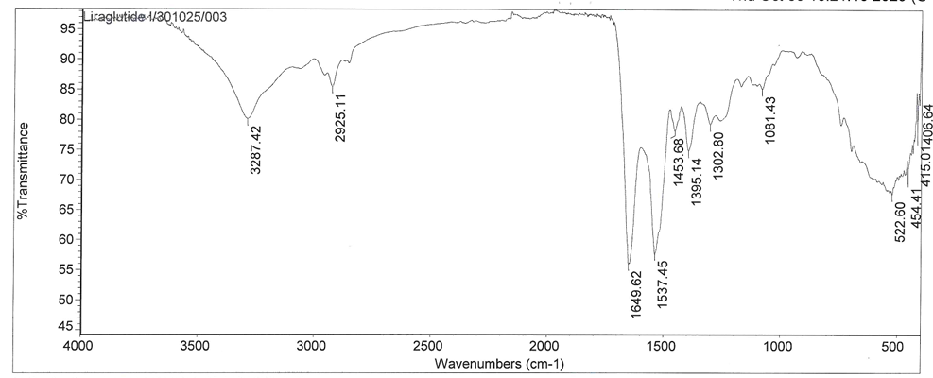
Figure 2. Sample IR Spectra of Liraglutide

3.2 Phenol
The IR spectrum of the drug sample was taken in the wavenumber range of 400-4000 cm -1. The spectrum that was obtained was closely monitored and typical functional group peaks were noted. This was compared to the reference IR spectrum to ascertain the identity of the drug. The spectral matching was used to show the presence of the expected functional groups. Figure 3 refers to the resultant spectra for the comparison.
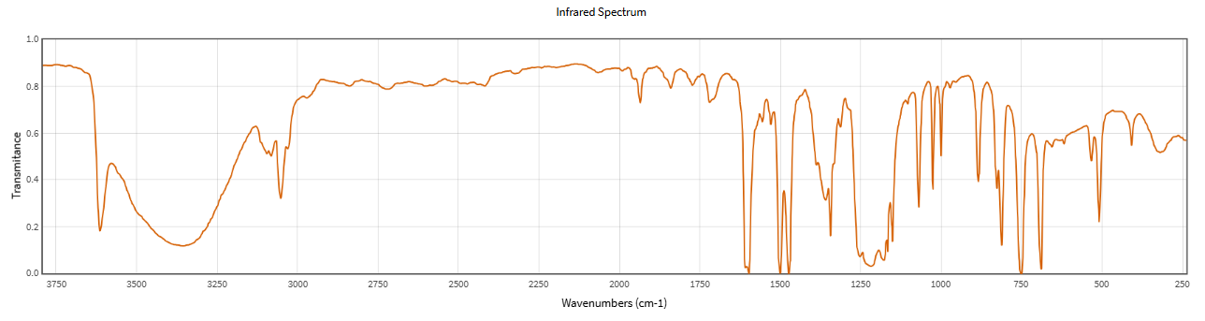
Figure 3. Reference IR Spectra of Phenol ^{[23]}

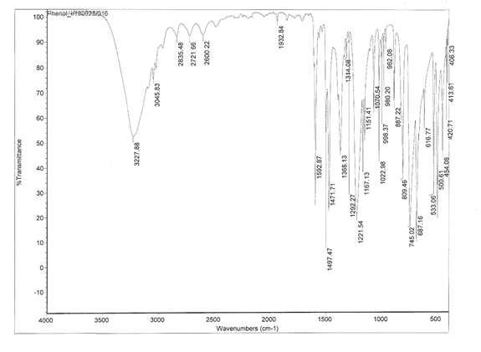

Figure 4. Sample IR Spectra of Phenol

3.3. UV Study
Liraglutide and Phenol are also identified by performing analysis using Shimadzu UV-1700 Double beam UV Spectrophotometer using UV Probe software. [Table 3], Overlay spectra is shown in figure 5, in which the isobestic point which is required in the estimation of the method development is also shown.
Table 3: Wavelength maxima of Liraglutide and Phenol
Solvent | Liraglutide | Phenol
Solvent | Observed λ _{max} | Observed λ _{max}
Methanol | approx. 220nm | 270nm

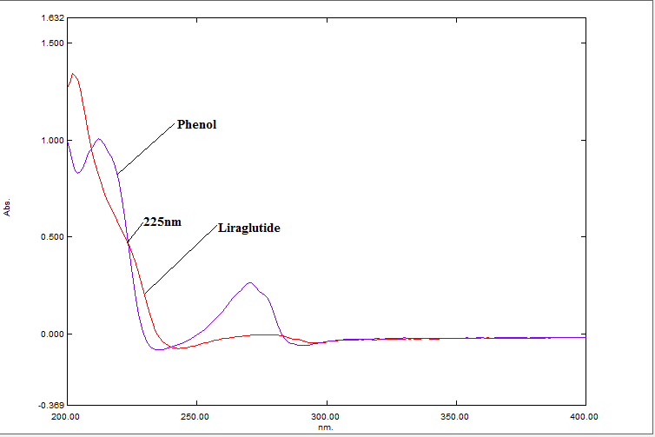
Figure 5 Overlay UV spectra of Liraglutide and Phenol
For the simultaneous estimation of the drugs here 225nm wavelength was selected as the detection wavelength as seen in the Figure 5.

3.4. DEVELOPMENT OF RP-HPLC METHOD

3.4.1 Optimized chromatographic conditions
The mobile phase composition was finalized after multiple trials to get good resolution, peak shape and retention of analytes. A gradient elution was chosen as it gave better separation than the isocratic mode. In this mode, the concentration of acetonitrile was increased and the concentration of the buffer was decreased over the analysis time. This modification resulted in better peak shape, shorter time and complete elution of components. The optimized chromatographic conditions are given in Table 4.
Table 4. RP-HPLC Optimized chromatographic conditions
Chromatographic Parameter | Optimize Condition
Mode of elution | Gradient
Stationary Phase | YMC Triart C18(150 mm x 4.6 mm x 5 µ)
Mobile Phase | Buffer:Acetonitrile
  Time | MP-A | MP-B
  0 | 50 | 50
  10 | 30 | 70
  10.1 | 50 | 50
  15 | 50 | 50
Flow rate | 1.0 mL/Min
Injection Volume | 10 µL
Column Temperature | 30ºC
Run Time | 15 minutes
Detection Wavelength | 225 nm

3.5 FORCED DEGRADATION STUDY
Forced Degradation studies are done to check the stability of drug and confirm that the analytical method (RP-HPLC) can detect changes in the drug
Liraglutide exhibited significant degradation under acidic and oxidative (peroxide) stress conditions, indicating its susceptibility to hydrolytic and oxidative degradation pathways.
In contrast, Phenol remained relatively stable under acidic and oxidative conditions, demonstrating its inherent chemical stability.
However, Phenol showed comparatively higher degradation under thermal stress, suggesting sensitivity to elevated temperature.
The degradation products were well separated from the main peaks, and peak purity analysis confirmed the specificity of the method.
These results demonstrate that the developed analytical method is stability-indicating and suitable for routine stability evaluation of both Liraglutide and Phenol.

3.5.1 Acid Degradation
Individual standard drugs and injectable formulation were also subjected to the acid degradation study to determine the stability of the drugs in acidic conditions. Hydrochloric acid was used on the samples, and the samples were subjected to controlled time and temperature to cause degradation. This was followed by neutralization of the samples (where necessary), dilution of samples and the analysis of the samples by the developed chromatographic procedure. The chromatograms were monitored to determine changes in the area of the peaks and the formation of degradation products. Chromatograms of individual standard drugs after the treatment with acid are presented in Figure 6 and Figure 7. The chromatogram of stressed injectable formulation is shown in figure 8. The comparison substantiates the indication of stability of the method.
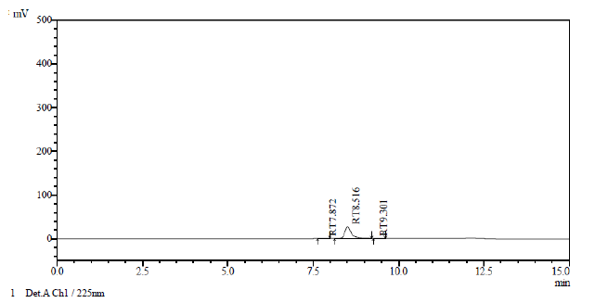
Figure 6. RP-HPLC Chromatogram of Acid Degradation for Liraglutide Std.
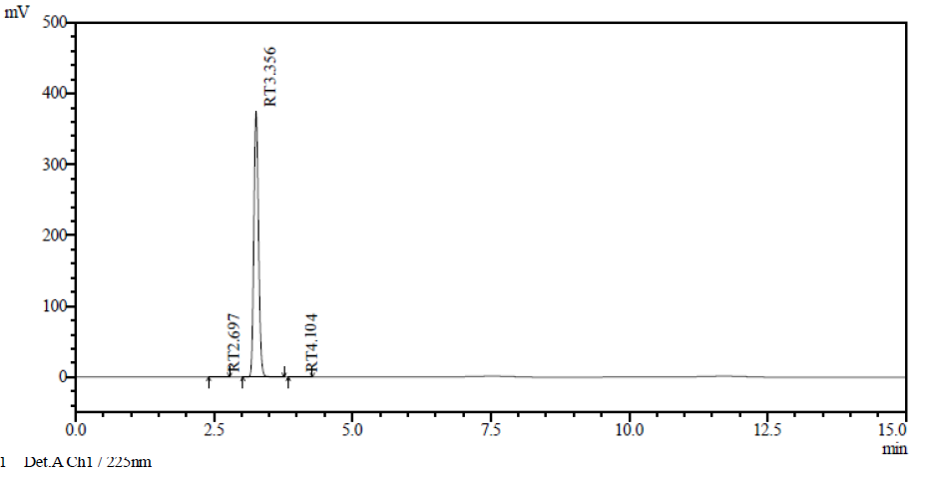
Figure 7. RP-HPLC Chromatogram of Acid Degradation for Phenol Std.
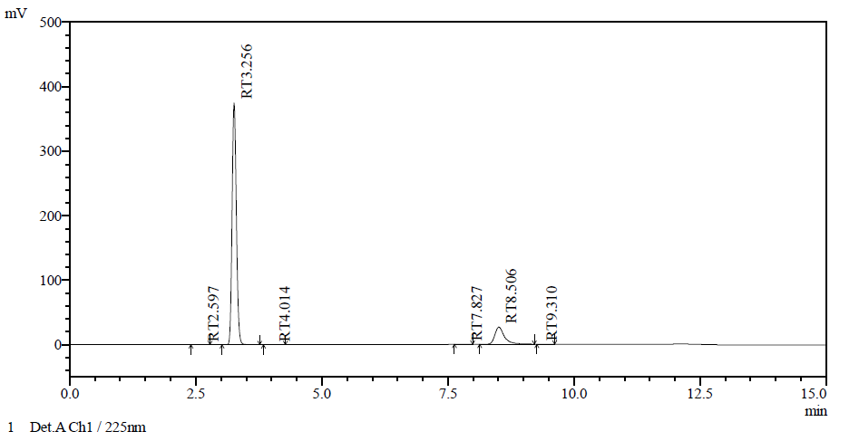
Figure 8. RP-HPLC Chromatogram of Acid Degradation for Injectable Sample

3.5.2 Alkali Degradation
The degradation evaluation of both the individual standard drugs and the injectable formulation was carried out to determine stability of both under alkaline conditions. Adequate level of sodium hydroxide was added to the samples and they were kept under constant time and temperature to cause degradation. Following the stress period, the samples were neutralized (where necessary), diluted accordingly and subjected to the developed chromatographic method. The chromatograms were observed to monitor the change in the area of the peaks, shape of the peaks and the appearance of the degradation products. Figure 9 and Figure 10 are the chromatograms of each of the standard drugs when treated with the base and Figure 11 is the chromatogram of the stressed injectable formulation. The stability-indicating ability of the method is proved by the comparison of these chromatograms.
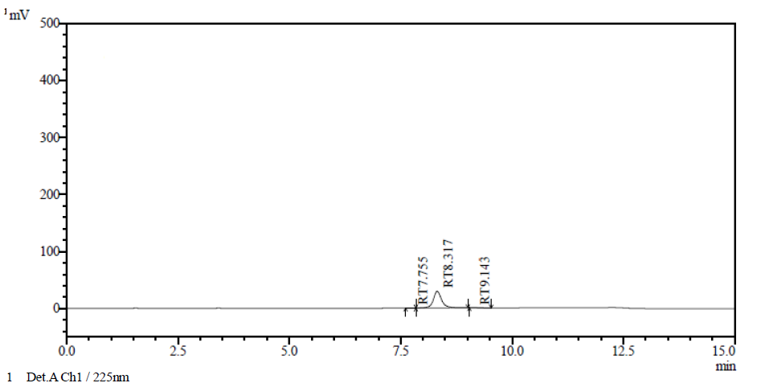
Figure 9. RP-HPLC Chromatogram of Alkali Degradation for Liraglutide Std.

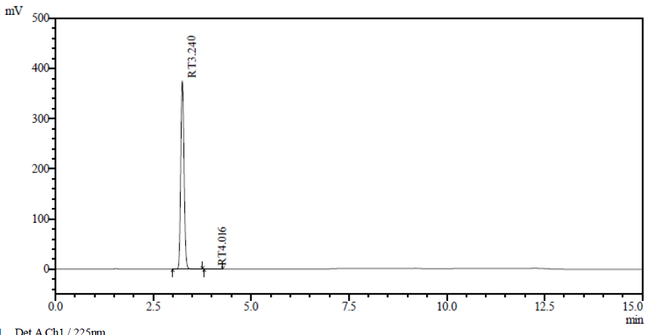
Figure 10. RP-HPLC Chromatogram of Alkali Degradation for Phenol Std.
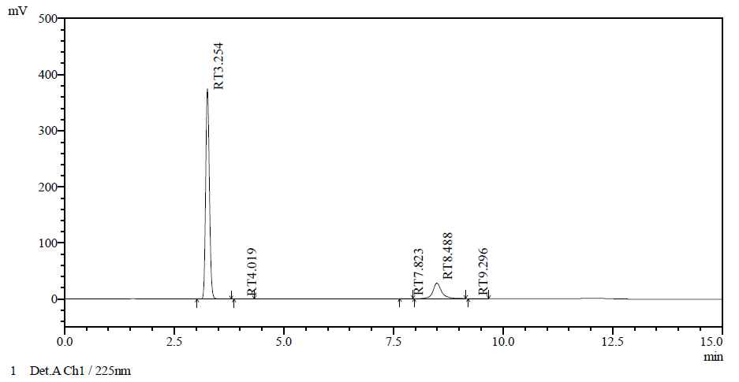
Figure 11. RP-HPLC Chromatogram of Alkali Degradation for Injectable Sample

3.5.3 Oxidative Degradation
Oxidative degradation experiment was conducted on the standard drugs individually and on the injectable formulation to determine the stability of standard drugs to oxidation and injection stability of the injectable formulation. To cause degradation the samples were processed with an appropriate oxidizing agent, e.g., hydrogen peroxide and held under controlled conditions. The samples were diluted and the analysis was done in accordance with the developed chromatographic method, after the stress period. The chromatograms were registered to see the alterations in the peak area and the appearance of degradation products. Figure 12 and Figure 13 are the chromatograms of the separate standard drugs following the oxidative treatment. Figure 14 represents the chromatogram of stressed injectable formulation, which proves stability-indicating nature of the method.
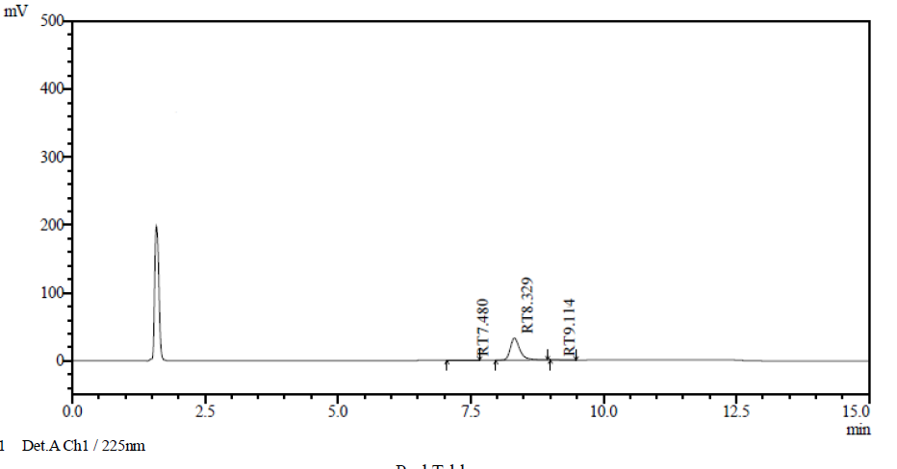
Figure 12. RP-HPLC Chromatogram of Oxidative Degradation for Liraglutide Std.
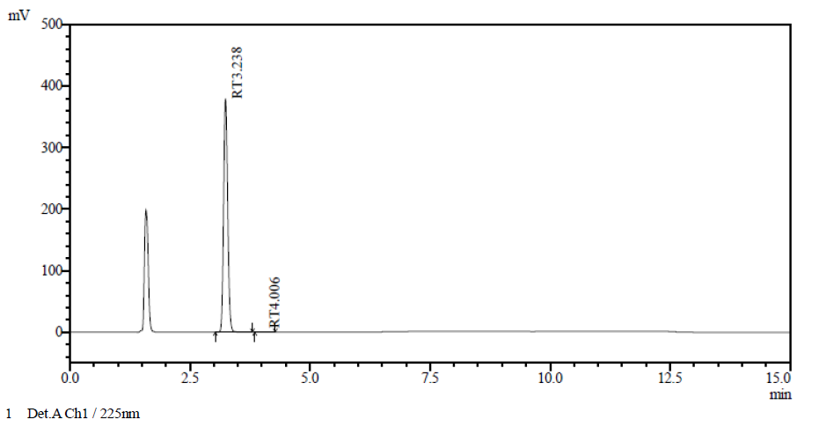
Figure 13. RP-HPLC Chromatogram of Oxidative Degradation for Phenol Std.
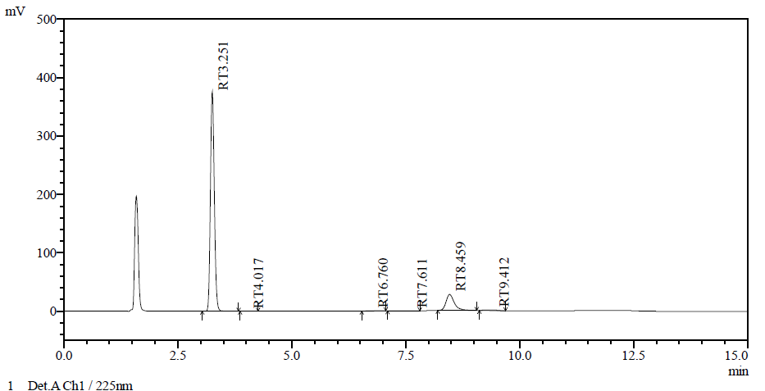
Figure 14. RP-HPLC Chromatogram of Oxidative Degradation for Injectable Sample

3.5.4 Thermal Degradation
The thermal degradation test was conducted on individual standard drugs and injectable formulation to determine their stability at high temperatures. To degrade the samples, a certain amount of time in a given temperature was subjected to the samples. The samples were cooled and diluted properly after the stress period and the developed chromatographic method was used to analyze samples. To monitor the change in the area of the peaks and the degradation products, the chromatograms were documented. Figure 15 and Figure 16 illustrate the chromatogram of each of the standard drugs after thermal treatment, and Figure 17 is used to display the chromatogram of the stressed injectable formulation. The stability-indicating property of the method is verified by the comparison.
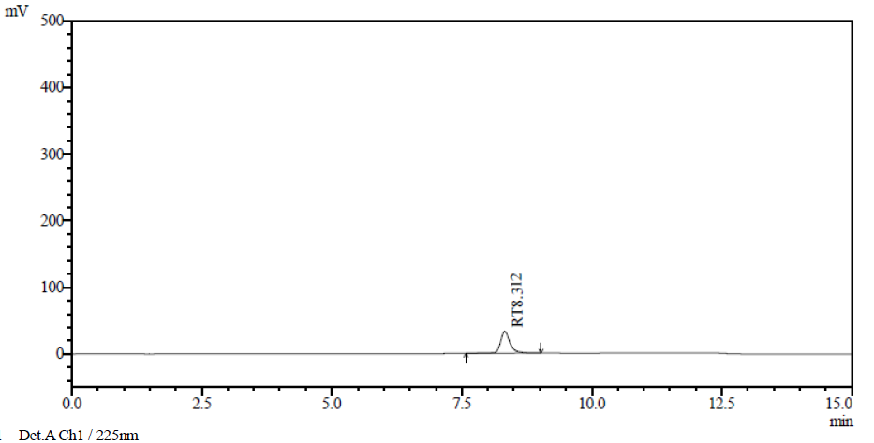
Figure 15. Thermal Degradation Chromatogram for Liraglutide Std.
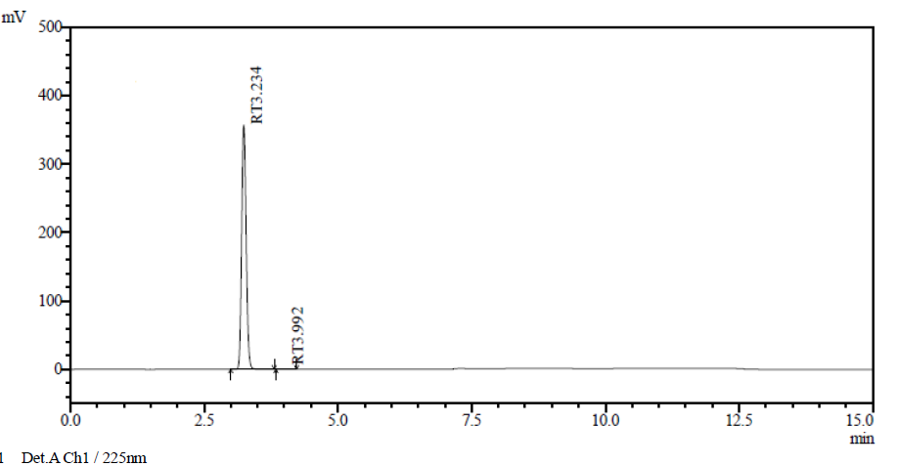
Figure 16. Thermal Degradation Chromatogram for Phenol Std.
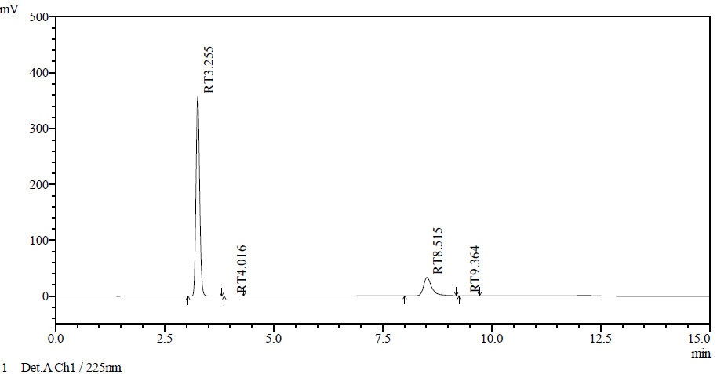
Figure 17. Thermal Degradation Chromatogram for Injectable Sample

3.5.5 Photolytic Degradation
The photolytic degradation test was conducted on the individual standard drugs and injectable formulation to test their stability at the conditions of light exposure. The samples were left in the UV or sunlight over a set period of time in order to cause degradation. Dilution of the samples and application of the developed chromatographic method were performed after the stress period. The chromatograms were noted to monitor variation of peak area and development of degradation products. Figure 18 and Figure 19 are the chromatograms of the individual standard drugs before photolytic treatment whereas Figure 20 is a chromatogram of the stressed injectable formulation. The stability-signing character of the approach is validated by the comparison.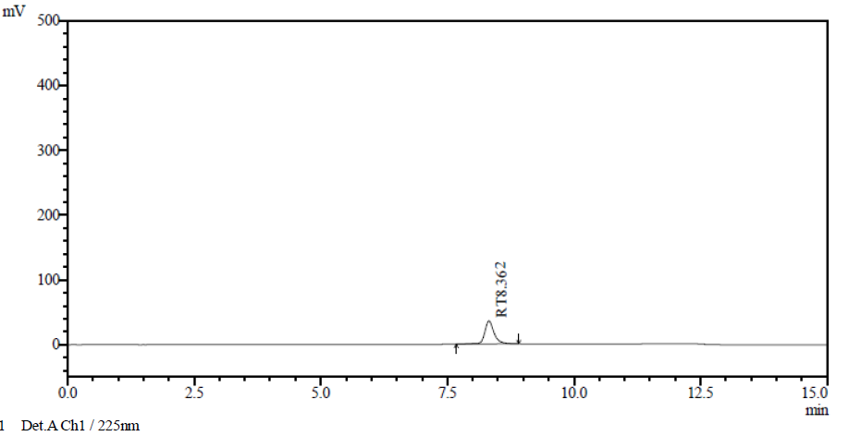
Figure 18. RP-HPLC Chromatogram of Photolytic Degradation for Liraglutide Std.
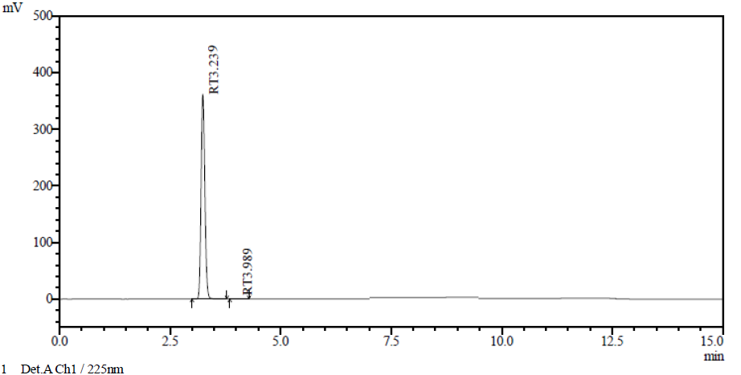
Figure 19. RP-HPLC Chromatogram of Photolytic Degradation for Phenol Std.
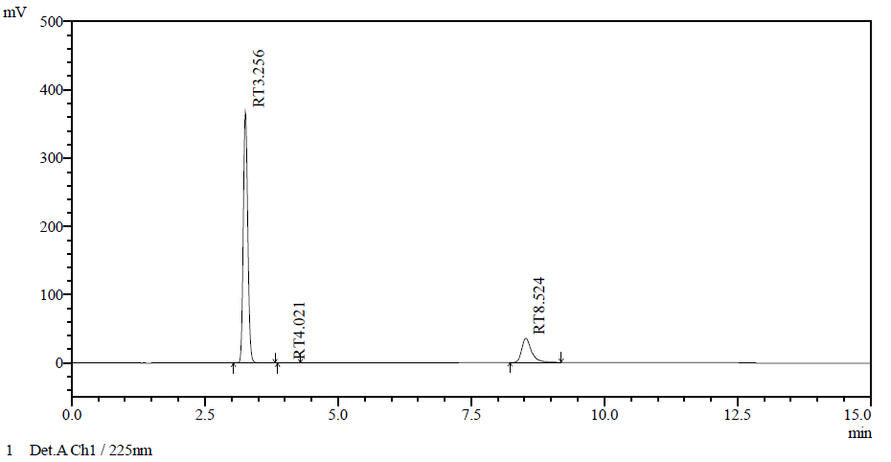
Figure 20. RP-HPLC Chromatogram of Photolytic Degradation for Injectable Sample
The conditions used for the stability/stressed studies of Liraglutide and Phenol are given in Tables 5 and 6. These studies were conducted under different stress conditions like acidic, basic, oxidative, thermal and photolytic to assess the stability of API and sample.
The percentage of degradation was determined by comparing the peak area of the stressed samples with respective standard (unstressed) solutions. This allowed the determination of percentage degradation of API and sample. This enables a better understanding of the degradation profile and stability of Liraglutide and Phenol, and a comparison of the API and sample under the same stress conditions.

Table 5. Forced Degradation condition for Liraglutide
Liraglutide
As such | Sample area | 431486 | API Area | 444358
Condition | Sample |  | API
Condition | Area | %Degradation | Area | %Degradation
Acid | 371780 | 13.8 | 381780 | 14.1
Base | 385970 | 10.5 | 385625 | 13.2
Peroxide | 360577 | 16.4 | 369886 | 16.8
Thermal | 425005 | 1.5 | 438275 | 1.4
Photo | 427163 | 1.0 | 440895 | 0.8

Table 6. Forced Degradation condition for Phenol
Phenol
As such | Sample area | 2261488 | API Area | 2226085
Condition | Sample |  | API
Condition | Area | %Degradation | Area | %Degradation
Acid | 2239645 | 1.0 | 2209645 | 0.7
Base | 2246735 | 0.7 | 2210542 | 0.7
Peroxide | 2249849 | 0.5 | 2206846 | 0.9
Thermal | 2126985 | 5.9 | 2085320 | 6.3
Photo | 2187120 | 3.3 | 2136164 | 4.0

At last discussion shows the comparative assessment of API and sample degradation profiles (Tables 5 and 6) demonstrates the method's capability to monitor the chemical stability of Liraglutide and Phenol simultaneously. The high recovery percentages and clear resolution of degradation peaks justify the method's use for evaluating product shelf-life and formulation compatibility.

3.6 VALIDATION OF RP-HPLC METHOD

3.6.1 System Suitability Study
The suitability tests on the system were conducted before method validation to ensure proper functioning, reliability, and performance of the HPLC system. These tests ensure that the chromatographic system can give accurate and reproducible results. The results obtained were within all the stipulated acceptance criteria such as theoretical plates exceeding 2000 which means that the column was well performing. The tailing was observed to be less than 2 with acceptable peak symmetry and the resolution was also more than 2 with the peaks being well separated. Moreover, the %RSD of six replicate injections was below 2 which indicates excellent precision as shown in Table 7.
Table 7. System Suitability Study for Liraglutide and Phenol
Sr. No. | System suitability parameter | Liraglutide |  | Phenol
Sr. No. | System suitability parameter | Mean ± SD (n=6) | %RSD | Mean ± SD  (n=6) | %RSD
1 | Retention time | 8.586 ± 0.111 | 0.12 | 3.265 ± 0.001 | 0.03
2 | Theoretical plates (N) | 11653 ± 42.613 | 0.36 | 6108 ± 37.835 | 0.61
3 | Tailing factor (T_{f}) | 1.45 ± 0.00 | 0.00 | 1.18 ± 0.00 | 0.00
4 | Resolution (Rs) | 21.933 ± 0.0816 | 0.37 | 0.00 | 0.00
5 | Peak Area | 446397 ± 699.963 | 0.15 | 2272194 ± 751.688 | 0.03

3.6.2 Specificity
The specificity of the method was carried out to check the accurate measurement of the analytes, Liraglutide and Phenol, in the presence of excipients and other interfering substances present in the formulation. This was investigated by comparing the chromatograms of the blank, standard and sample solutions for the presence of any interfering peaks at the retention times of Liraglutide and Phenol.
The chromatograms showed that the peaks of Liraglutide and Phenol were sharp, well resolved and free from interference caused by excipients, degradation or any other products. There were no co-eluting peaks or additional peaks observed at the same retention times of the analytes in the sample, compared to the standard.
These results demonstrate the selectivity and specificity of the method for the simultaneous analysis of Liraglutide and Phenol. The lack of interference and adequate separation of peaks clearly demonstrate the specificity of the method as depicted in Fig. 21, 22 and 23.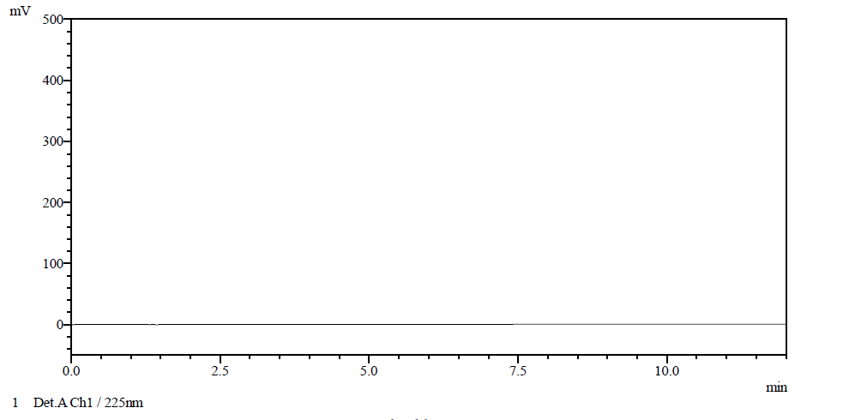
Figure 21. Chromatogram of Diluent
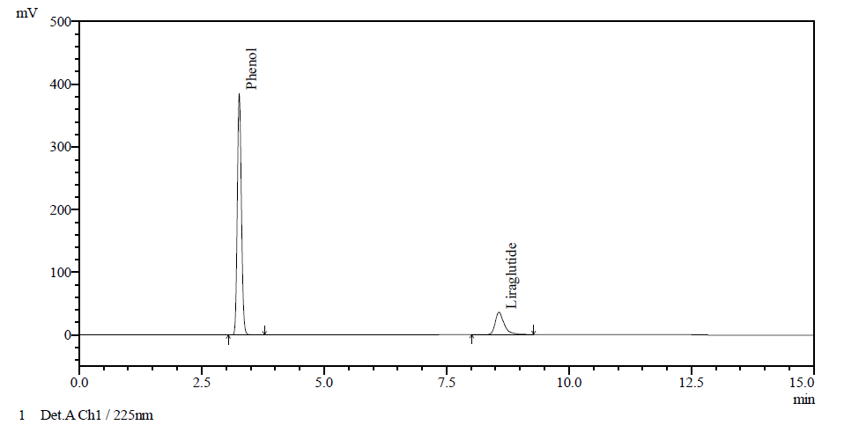
Figure 22. Chromatogram of Liraglutide and Phenol Standard
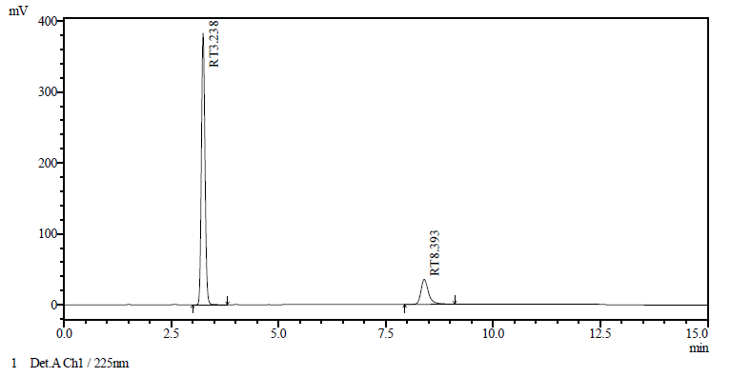
Figure 23. Chromatogram of Liraglutide and Phenol Sample

3.6.3 Linearity
The linearity of the method was assessed by preparing five concentrations of Liraglutide and Phenol solutions. The chosen range for Liraglutide was 30-90 µg/mL and for Phenol 27.50-82.50 µg/mL to cover the anticipated concentration range of the method.
Calibration curves using the mean peak areas vs. concentration were plotted for each drug. The correlation coefficients of Liraglutide and Phenol were 0.993 and 0.996, respectively, suggesting a good linearity between the analyte concentration and the response over the investigated range.
Furthermore, the overlay of the calibration curves showed proportional responses for both the drugs at all concentration levels, proving the method's reliability. Tables 8 and 9 provide the results of linearity evaluation, and Figures 24, 25 and 26 show the calibration curves and their overlay.
Table 8. Linearity data of Liraglutide
Sr. No | Liraglutide
Sr. No | Conc. (µg/mL) | Mean Area ± SD | % RSD
1 | 30.00 | 222315 ± 556.49 | 0.25
2 | 45.00 | 325166 ± 132.94 | 0.04
3 | 60.00 | 439775 ± 111.72 | 0.02
4 | 75.00 | 551167 ± 78.489 | 0.01
5 | 90.00 | 648571 ± 395.27 | 0.06

Table 9. Linearity data of Phenol
Sr. No | Phenol
Sr. No | Conc. (µg/mL) | Mean Area ± SD | % RSD
1 | 27.50 | 1069090 ± 135.06 | 0.0126
2 | 41.25 | 1621492 ± 28.284 | 0.0017
3 | 55.00 | 2212247 ± 12051 | 0.5448
4 | 68.75 | 2669665 ± 245.37 | 0.0092
5 | 82.50 | 3193492 ± 2447.3 | 0.0766

Figure 24. Calibration Curve of Liraglutide

Figure 25. Calibration Curve of Phenol
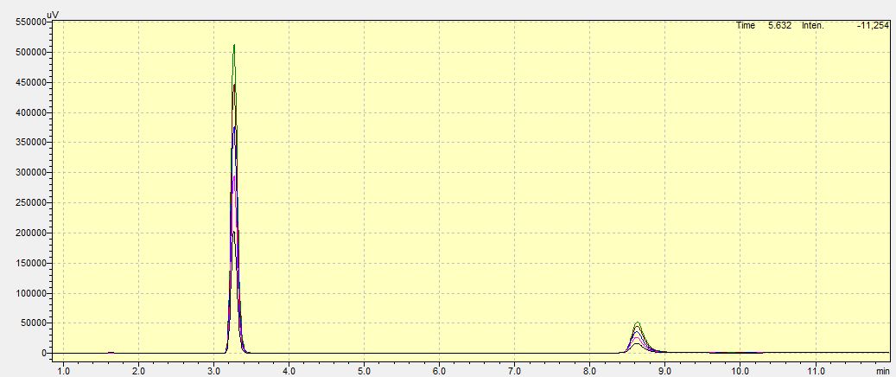
Figure 26. Overlay chromatogram of linearity

3.6.4 Precision

3.6.4.1 Repeatability

The repeatability indicates the consistency of the system under same operating conditions. So here as six injections of the standard solution of the both the drugs were taken and result obtained were within the acceptance criteria that is below 2%RSD, which is shown in Table 10. At end which shows good repeatability of the RP HPLC method.

3.6.4.2 Intraday precision

From this it is evaluated to determine the consistency of the method in same day in identical conditions. Three times the sample was analysed and peak was recorded, %RSD was calculated and results found here were within the limit which indicates that the method is precise and shows accurate results given in Table 11.

3.6.4.3 Interday precision
Interday precision was tested to determine the reproducibility of the analysis technique on other days using identical chromatographic conditions. Liraglutide and Phenol were injected on three days in standard solutions. The peaks areas were measured and compared. Table 12 indicates that the values of the % RSD were within the acceptable limits. These results confirm the reproducibility and reliability of the method.
Table 10: Repeatability data for Liraglutide and Phenol
Liraglutide |  |  | Phenol
Sr.no. | Conc. (μg/mL) | Peak Area  (n=6) | Conc. (μg/mL) | Peak Area  (n=6)
1 | 60 | 447614 | 55 | 2273093
2 | 60 | 446736 | 55 | 2270808
3 | 60 | 446272 | 55 | 2272474
4 | 60 | 446209 | 55 | 2272219
5 | 60 | 445913 | 55 | 2272271
6 | 60 | 445643 | 55 | 2272299
7 | Mean | 446398 | Mean | 699.963
8 | SD | 699.963 | SD | 751.688
9 | % RSD | 0.16 | % RSD | 0.03

Table 11: Intraday precision study of Liraglutide and Phenol
Liraglutide | Sr. No | Concentration (µg/mL) | Mean ± SD (n=3) | %RSD
Liraglutide | 1 | 30 | 203263 ± 1467.19 | 0.72
Liraglutide | 2 | 60 | 441214 ± 1746.02 | 0.40
Liraglutide | 3 | 90 | 649398 ± 774.93 | 0.12
Phenol | Sr. No | Concentration (µg/mL) | Mean ± SD (n=3) | %RSD
Phenol | 1 | 27.5 | 1172632 ± 3286.35 | 0.28
Phenol | 2 | 55.0 | 2228711 ± 18095.37 | 0.81
Phenol | 3 | 82.5 | 3093809 ± 766.92 | 0.02

Table 12: Interday precision study of Liraglutide and Phenol
Liraglutide
Sr. No | Concentration (µg/mL) | Mean ± SD (n=3) | %RSD
1 | 30 | 202256 ± 1834.41 | 0.91
2 | 60 | 463120 ± 4043.99 | 0.87
3 | 90 | 672429 ± 10760.01 | 1.60
Phenol
Sr. No | Concentration (µg/mL) | Mean ± SD (n=3) | %RSD
1 | 27.5 | 1176824 ± 16086.52 | 1.37
2 | 55.0 | 2280417 ± 3936.91 | 0.17
3 | 82.5 | 3109901 ± 39593.87 | 1.27

3.6.5 Accuracy
Accuracy of the method was confirmed by recovery study at three levels (50%, 100% and 150%).

Table 13. Accuracy data for Liraglutide and Phenol
Liraglutide
Sr. No. | Accuracy Level | Amount added (mg) | Amount Recovered (mg) | %Recovery | Mean %Recovery | %RSD
1 | 50% | 0.3 | 0.299 | 99.78 | 100.26 | 0.64
2 | 50% | 0.3 | 0.303 | 101.00 | 100.26 | 0.64
3 | 50% | 0.3 | 0.300 | 100.00 | 100.26 | 0.64
1 | 100% | 0.6 | 0.600 | 100.00 | 101.04 | 0.81
2 | 100% | 0.6 | 0.608 | 101.33 | 101.04 | 0.81
3 | 100% | 0.6 | 0.609 | 101.50 | 101.04 | 0.81
1 | 150% | 0.9 | 0.887 | 98.60 | 98.40 | 0.31
2 | 150% | 0.9 | 0.886 | 98.44 | 98.40 | 0.31
3 | 150% | 0.9 | 0.882 | 98.00 | 98.40 | 0.31
Phenol
Sr. No. | Accuracy Level | Amount added (mg) | Amount Recovered (mg) | %Recovery | Mean %Recovery | %RSD
1 | 50% | 0.275 | 0.275 | 100.00 | 99.63 | 0.40
2 | 50% | 0.275 | 0.273 | 99.27 | 99.63 | 0.40
3 | 50% | 0.275 | 0.274 | 99.63 | 99.63 | 0.40
1 | 100% | 0.550 | 0.553 | 100.54 | 100.24 | 0.30
2 | 100% | 0.550 | 0.551 | 100.18 | 100.24 | 0.30
3 | 100% | 0.550 | 0.550 | 100.00 | 100.24 | 0.30
1 | 150% | 0.825 | 0.828 | 100.36 | 99.63 | 0.63
2 | 150% | 0.825 | 0.819 | 99.27 | 99.63 | 0.63
3 | 150% | 0.825 | 0.819 | 99.27 | 99.63 | 0.63

The accuracy of the developed method was determined by standard addition (placebo spiking) method to check the closeness of the estimated value to the true value. The experiment was performed at three different concentration levels (50%, 100%, and 150% of the target concentration) for Liraglutide and Phenol.

This process involves spiking the placebo (containing all other excipients except the active ingredients) with known amounts of Liraglutide and Phenol standards. Triplicate analysis was performed for each level to establish the accuracy and precision of the method. The % recovery for each concentration level was determined by comparing the peak area with the respective standard solution.

The results showed that the % recovery for Liraglutide ranged between 98.40% to 101.04%, and for Phenol it ranged between 99.63% to 100.24%. It was observed that the values lie within the accepted range, which suggests that there is no interference from excipients and the method can accurately quantify the analytes.

These results demonstrate that the proposed method is accurate, precise and can be applied to the routine analysis of Liraglutide and Phenol in drug products. The accuracy results are shown in Table 13.

3.6.6 LOD and LOQ
The LOD and LOQ of Liraglutide and Phenol were determined using equations as per ICH guidelines. These parameters show how sensitive the developed method of analysis is. Table 14 gives the calculated values. The results demonstrate that the method is sufficiently sensitive for the detection and quantification of both analytes.
Table 14. LOD and LOQ of Liraglutide and Phenol
Liraglutide | Phenol
LOD = 3.3*σ/S  = 3.3 x 15566  7190.1  = 7.144 µg/mL | LOD = 3.3*σ/S  = 3.3 x 37799  38523.5  = 3.238 µg/mL

Liraglutide | Phenol
LOD = 3.3*σ/S  = 3.3 x 15566  7190.1  = 7.144 µg/mL | LOD = 3.3*σ/S  = 3.3 x 37799  38523.5  = 3.238 µg/mL

LOD and LOQ were calculated mathematically. The result for the LOD of the Liraglutide was found 7.144 µg/mL and Phenol was found 3.238 µg/mL.
Whereas the LOQ for the same Liraglutide was found 21.649 µg/mL and Phenol was found 9.812 µg/mL. this results confirms that the method developed is suitable and sensitive.

3.6.7 Robustness
The robustness of the developed method was tested to assess the stability of the method under minor, intentional changes of the chromatographic conditions. This was achieved by introducing small variations in key parameters, including column temperature, flow rate and the percentage of the organic phase in the mobile phase.
These parameters were deliberately varied within a small range around the optimal point and the effect of the variations on system suitability parameters, namely retention time, peak area, resolution and peak symmetry was assessed. These deliberate changes did not affect the chromatographic performance and the results obtained were within the acceptable range.
The lack of noticeable effect on the results of analysis under varied conditions confirms that the method is robust. This ensures that slight variations during routine analysis will not impact the accuracy and precision of the method. The results of robustness study are shown in Table 15.
Table 15. Robustness study for Liraglutide and Phenol
Liraglutide
Sr. No. | Area at temp.  -5º C | Area at temp.  +5º C | Area at flow rate  -10% | Area at flow rate  +10% | Area at organic phase  -2% | Area at organic phase  +2%
1 | 438927 | 440541 | 496004 | 404828 | 442227 | 437927
2 | 438558 | 440140 | 493194 | 403758 | 442177 | 440099
3 | 439499 | 439727 | 492063 | 406452 | 441104 | 431100
Mean | 438995 | 440136 | 493754 | 405013 | 441836 | 436375
%RSD | 0.10 | 0.10 | 0.40 | 0.30 | 0.10 | 1.10
Theoretical plates | 10459 | 12814 | 12156 | 11206 | 9088 | 14790
Tailing Factor | 1.42 | 1.47 | 1.51 | 1.39 | 1.45 | 1.44
Phenol
Sr. No. | Area at temp.  -5º C | Area at temp.  +5º C | Area at flow rate  -10% | Area at flow rate  +10% | Area at organic phase  -2% | Area at organic phase  +2%
1 | 2217704 | 2200662 | 2454443 | 2008162 | 2216241 | 2197831
2 | 2218306 | 2204491 | 2452646 | 2007678 | 2216951 | 2201139
3 | 2216973 | 2201681 | 2455821 | 2009045 | 2218685 | 2200809
Mean | 2217661 | 2202278 | 2454303 | 2008295 | 2217292 | 2199926
%RSD | 0.03 | 0.10 | 0.10 | 0.03 | 0.10 | 0.10
Theoretical plates | 6167 | 6003 | 6676 | 5688 | 6039 | 6354
Tailing Factor | 1.2 | 1.21 | 1.16 | 1.2 | 1.19 | 1.19

The overall % RSD for all variations was below 2%, confirming the robustness of the proposed method.

3.6.8 Assay of Injectable formulation
The developed RP-HPLC method was used to perform the assay of the drugs with the optimized chromatographic conditions. The results of the assays done which is shown in table 16 were compared to the label claim of the injectable formulation. The values of the percentage assay were observed to be within acceptable range of 98.0% to 102.0%. This means that the procedure is accurate and reliable in quantifying the drugs. The fact that the results were consistent also shows that the method is specific, precise, and robust. Therefore, the invented technique can be used to do routine analysis.
Table 16: Assay of Liraglutide and Phenol
Drug | Label Claim | Amount Found | Assay (%)  Mean ± SD | %RSD
Liraglutide | 6.0 mg | 5.90 | 98.40 ± 0.212 | 0.21
Phenol | 5.5 mg | 5.39 | 98.10 ± 0.070 | 0.10

4. CONCLUSION:
The reverse phase high-performance liquid chromatography technique developed was discovered to be easy, specific, exact and stability-indicative in simultaneous estimation of Liraglutide and Phenol in injectable dosage form. The procedure exhibited acceptable linearity, preciseness, accuracy and strength over the validated concentration range. The results of studies conducted on stress degradation were found to assure effective separation of analytes and degradation products, which implies that the method can be used in stability analysis. Thus, the suggested approach may be effectively implemented in order to carry out routine quality control analysis of Liraglutide injectable formulation with Phenol.

LIST OF ABBREVIATIONS:

Abbreviations Full Form
ACN Acetonitrile
API Active Pharmaceutical Ingredient
AR Analytical Reagent
Cmax Maximum Plasma Concentration
DPP-4 Dipeptidyl Peptidase-4
EP European Pharmacopoeia
FDA Food and Drug Administration
FD Forced Degradation
FT-IR Fourier Transform Infrared Spectroscopy
GLP-1 RA Glucagon-Like Peptide-1 Receptor Agonist
HCl Hydrochloric Acid
HPLC High Performance Liquid Chromatography
ICH International Council for Harmonisation
IP Indian Pharmacopoeia
IR Infrared Spectroscopy
IU International Unit
LC Liquid Chromatography
LOD Limit of Detection
LOQ Limit of Quantitation
mL Milliliter
mM Millimolar
MP Mobile Phase
NaOH Sodium Hydroxide
nm Nanometer
pH Potential of Hydrogen
ppm Parts Per Million
RSD Relative Standard Deviation
RP-HPLC Reverse Phase High Performance Liquid Chromatography
Rt Retention Time
SD Standard Deviation
TLC Thin Layer Chromatography
tR Retention Time
UV Ultraviolet
UV-VIS Ultraviolet Visible Spectroscopy
USP United States Pharmacopeia
WHO World Health Organization
w/v Weight per Volume
v/v Volume per Volume
µg Microgram
µL Microliter
µm Micrometer
mL Milliliter

CONSENT: Not applicable

ETHICAL APPROVAL: There was no ethical approval required, as human and animals are not involve.

COMPETING INTERESTS DISCLAIMER:
Authors have declared that they have no known competing financial interests OR non-financial interests OR personal relationships that could have appeared to influence the work reported in this paper.

Disclaimer (Artificial intelligence)

Author(s) hereby declare that NO generative AI technologies such as Large Language Models (ChatGPT, COPILOT, etc.) and text-to-image generators have been used during the writing or editing of this manuscript.

REFERENCES
- Cleveland Clinic. Diabetes.(2024) Available:https://my.clevelandclinic.org/health/diseases/7104-diabetes Accessed 2025 Oct 4.
- Diabetes.co.uk. Diabetes medication: Antidiabetic drugs. (2023) Available:https://www.diabetes.co.uk/diabetes-medication/antidiabetic-drugs.htmL Accessed 2025 Oct 4.
- Pharmacist Opinions. Antidiabetic drug classification. (2022) Available:https://www.pharmacistopinions.com/antidiabetic-drug-classification/ Accessed 2025 Oct 4.
- Introduction to Modern Liquid Chromatography. Snyder LR, Kirkland JJ, Dolan JW. Introduction to modern liquid chromatography. 3rd ed. Hoboken: Wiley; 2010.
- Handbook of Pharmaceutical Analysis by HPLC. Ahuja S, Dong MW. Handbook of pharmaceutical analysis by HPLC. San Diego: Elsevier Academic Press; 2005.
- Principles of Instrumental Analysis. Skoog DA, Holler FJ, Crouch SR. Principles of instrumental analysis. 7th ed. Boston: Cengage Learning; 2017.
- Analytical Method Development and Validation. Swartz ME, Krull IS. Analytical method development and validation. Boca Raton: CRC Press; 2012.
- SlideShare. Instrumentation of HPLC. 2016. Available:https://www.slideshare.net/slideshow/instrumentation-of-hplc-69314042/69314042 Accessed 2025 Oct 4.
- Ravisankar P, Anusha S, Supriya K, Kumar UA. Fundamental chromatographic parameters. International Journal of Pharmaceutical Sciences Review and Research. 2019;55(2):46-50.
- Iram F, Iram H, Iqbal A, Husain A. Forced degradation studies. Journal of Analytical and Pharmaceutical Research. 2016;3(6):00073.
- Baertschi SW, Alsante KM. Pharmaceutical stress testing. 2nd ed. New York: CRC Press; 2011:1-42.
- International Council for Harmonisation. Impurities in new drug substances Q3A. 2002
- International Council for Harmonisation. Impurities in new drug substances Q3A (R2). 2006
- International Council for Harmonisation. Impurities in new drug products Q3B. 2003
- International Council for Harmonisation. Impurities in new drug products Q3B (R2). 2006
- International Council for Harmonisation. Stability testing of new drug substances and products Q1A. 2003
- International Council for Harmonisation. ICH Q2 (R2): Validation of analytical procedures. Geneva; 2023. Available:https://www.ich.org/page/quality-guidelines Accessed 2025 Oct 4.
- United States Pharmacopeia. USP general chapter <1225> validation of compendial procedures. Rockville; 2023. Available:https://www.uspnf.com/ Accessed 2025 Oct 4.
- Indian Pharmacopoeia. Indian Pharmacopoeia. New Delhi: Government of India, Ministry of Health and Family Welfare; 2022
- Elementary Organic Spectroscopy. Sharma YR. Elementary organic spectroscopy: Principles and chemical applications. New Delhi: S Chand; 2013
- United States Pharmacopeia. United States Pharmacopeia. General chapter <621> chromatography. Rockville: United States Pharmacopeial Convention; 2024
- Salles G, Pereira F, Pacheco Soares C, Marciano F, Hölscher C, Webster T, Lobo A. A novel bioresorbable device as a controlled release system for protecting cells from oxidative stress from Alzheimer’s disease. Molecular Neurobiology. 2017;54:1-12. doi:10.1007/s12035-016-0200-0.
- National Institute of Standards and Technology. Phenol FT-IR spectrum. NIST Chemistry WebBook, SRD 69. (2023) Available:https://webbook.nist.gov/chemistry/ Accessed 2025 Oct 4.

