Original Research Article
AMELIORATIVE EFFECTS OF Tetracarpidium conophorum (AFRICAN WALNUT) ON MERCURY-INDUCED PANCREATIC DYSFUNCTION: A TOXICOLOGICAL, MOLECULAR DOCKING, AND PHARMACOKINETIC STUDY

ABSTRACT
Mercury-induced pancreatic dysfunction is primarily driven by oxidative stress, inflammatory signaling, and metabolic dysregulation, underscoring the need for multi-target therapeutic candidates from natural sources. This study evaluated the therapeutic potential of bioactive compounds from Tetracarpidium conophorum (African walnut) using a combined in silico workflow involving molecular docking, pharmacokinetic profiling, and toxicity prediction.A total of seven key protein targets associated with pancreatic function, oxidative stress, inflammation, apoptosis, insulin resistance, lipid metabolism, and glucose regulation were analyzed. The highest binding affinity for the pancreatic function target (PDB: 1V4S) was observed with [2-(2-benzoylphenyl)-4-(1-hydroxycyclohexyl)phenyl]-[4-(1-hydroxycyclohexyl)phenyl]methanone (–8.4 kcal/mol). For the oxidative stress target (PDB: 1DGB), 7-chloro-10-hydroxy-1-(2-pyrrolidin-1-ylethylimino)-3-[3-(trifluoromethyl)phenyl]-3,4-dihydro-2H-acridin-9-one exhibited the strongest binding affinity (–11.5 kcal/mol), indicating strong potential interaction with redox-regulatory proteins. Across the evaluated targets, several ligands demonstrated comparable or improved binding affinities relative to standard reference compounds, including metformin, sitagliptin, butylated hydroxytoluene, and ascorbic acid, suggesting broad-spectrum inhibitory potential against key pathological pathways.ADME profiling indicated generally favorable gastrointestinal absorption, moderate-to-high plasma protein binding (>90%), and acceptable oral bioavailability for selected compounds, although variability in absorption and distribution parameters was observed across the dataset. Toxicity predictions suggested low risks of mutagenicity, carcinogenicity, and organ-specific toxicity for most lead compounds, supporting a favorable preliminary safety profile. Drug-likeness evaluation further indicated that several compounds complied with Lipinski, Veber, and Egan rules, suggesting acceptable oral drug-like properties.Overall, the results suggest that T. conophorum phytoconstituents may exert multi-target modulatory effects on pathways implicated in mercury-induced pancreatic injury. However, these findings remain computational in nature and require further validation through molecular dynamics simulations and in vivo experimental studies to confirm pharmacological efficacy and safety prior to clinical translation.
Keywords: Tetracarpidium conophorum, Molecular docking, Pancreatic dysfunction, Binding affinity and Mercury toxicity

BACKGROUND
Tetracarpidium conophorum (African walnut) is a climbing plant native to West Africa, widely valued in ethnomedicine for its nutritional and therapeutic benefits. Recent studies have demonstrated its antioxidant, anti-inflammatory, and antidiabetic properties, largely attributed to its rich composition of phenolic compounds, flavonoids, tannins, alkaloids, saponins, and essential vitamins (Anyanwu et al., 2020; Odekunle et al., 2024). These bioactive constituents are known to scavenge free radicals, protect cellular components from oxidative damage, and modulate metabolic processes.
Mercury exposure, especially in the form of mercuric chloride, remains a significant public health concern due to its potent cytotoxic and oxidative effects. Mercury can disrupt cellular redox balance, induce lipid peroxidation, impair enzymatic functions, and provoke inflammatory responses that contribute to dysfunction in vital organs, including the pancreas (Clarkson & Magos, 2006).The pancreas, being essential for both endocrine and exocrine functions, is particularly susceptible to oxidative insults, which may result in impaired insulin secretion, disrupted glucose metabolism, and eventual pancreatic injury.
While the ameliorative effects of T. conophorum have been reported in models of hepatic, renal, and cardiovascular toxicity (Anyanwu et al., 2020), there is limited scientific evidence on its potential to mitigate mercury-induced pancreatic dysfunction. However, findings from antidiabetic models indicate that extracts from T. conophorum can restore antioxidant enzyme levels, improve biochemical markers, and normalize glucose metabolism in Wistar rats, sometimes outperforming standard drugs like metformin (Kanu et al., 2020; Odekunle et al., 2024). These observations suggest a possible role for T. conophorum in protecting pancreatic tissue from mercury toxicity.
To comprehensively evaluate this potential, a multidisciplinary approach integrating toxicological assessment, molecular docking, and pharmacokinetic analysis is essential. In vivo toxicological studies in Wistar rats will assess the extract’s safety and efficacy, molecular docking will predict interactions between its bioactive compounds and molecular targets implicated in mercury-induced damage, and pharmacokinetic profiling will clarify its absorption, distribution, metabolism, and excretion patterns.
This study, therefore, aims to investigate the ameliorative effects of T. conophorum on mercury-induced pancreatic dysfunction in adult Wistar rats through a combined toxicological, molecular docking, and pharmacokinetic approach, thereby filling a critical gap in current research on plant-based interventions for heavy metal-induced pancreatic injury.
2 MATERIALS AND METHODS
2.1 Materials
1. Twenty-five (25) male albino wistar rats
2. Latex medical hand gloves
3. Standard cages
4. Vital feed rat chow
5. Animal weighing balance
6. Measuring cylinder (Pyrex)
7. Paper tape and markers
8. Spectrophotometer (Shanghai Yoke Instrument Co., Ltd. China)
9. Oral cannula
10. Cotton wool
11. Methylated spirit
12. Needle and Syringes (2ml, 5ml)
13. Spectrophotometer
14. Normal saline
15. Penand Paper
16. Tetracarpidium conophorum Leaves
17. Gavage and syringe
18. EDTA bottles
19. Whatman no.1 filter paper
2.2 In-vivo studies
Sample collection and Extraction
Fresh leaves of Tetracarpidium conophorum were collected from the premises of Chukwuemeka Odumegwu Ojukwu University. The leaves were plucked and shade dried, then ground to powder using mortar and pestle. 250g of the Tetracarpidium conophorum were macerated in 1000 mls of 95% ethanol for 48hours. It was then filtered using a porcelain cloth and further filtration using Whatman No 1 filter paper. The filtrate was concentrated using a rotatory evaporator, which was further dried using a laboratory oven at 45˚C into a gel-like form. The extract was preserved in a refrigerator for further usage.
Experimental Animal Care and Handling
Twenty-five (25) male albino Wistar rats (Rattus norvegicus) weighing between the ranges of 160-250g, were obtained from Iyke Animal farm, located at Nnewi Anambra state, and were bred in the experimental house of Basic Medical Sciences (BAMSSA), Chukwuemeka Odumegwu Ojukwu University, Uli Campus where the rats were acclimatized for two weeks. Grower mesh (sander feeds) and tap water was provided throughout the experimental period.
Induction of Mercury chloride and Administration of Plant extract
The weights of the rats were measured prior to Mercury chloride and Tetracarpidium conophorum extract administration. They were divided into five groups (A, B, C, D, E) of 5 rats each. Based on their weights, group A (control) measures 120g, group B measures (Mercury chloride only) 130g, group C (low dosage) measures 125g, group D (mid dosage) measures 140g, group E (high dosage) measures 150g. Pancreas oxidative damage was induced into the rats at a dose relative to their body weight, (Theophile, 2006). The Mercury chloride was induced through intraperitoneal route and Tetracarpidium conophorum extract was administered for three weeks through oral route according to the experimental design below:
Table 1: Experimental Design
Groups | No. of rats | Treatment dose
Group A (control) | 5 | Feed + water
Group B (Toxicity model) | 5 | 0.12 ml Mercury chloride
Group C (Treatment) | 5 | 0.12 ml Mercury chloride + 0.2 ml of Tetracarpidium conophorum extract
Group D (Treatment) | 5 | 0.12 ml Mercury chloride + 0.4 ml of Tetracarpidium conophorum extract
Group E (Treatment) | 5 | 0.12 ml Mercury chloride + 0.6 ml of Tetracarpidium conophorum extract
Collection of Blood samples and extraction of organs
The weight of each rat was weighed using weighing scale and will be recorded according to group and labelled. On the last day of the experiment the animals were anesthetized using 40mg/kg of ketamine hydrochloride intraperitoneally. Twenty-four (24) hours after the administration, the animals will be sacrificed under light ether anesthesia. The Pancreas were excised and fixed appropriately.
2.3 Declaration of Interest
None

2.4 Funding Source
This research did not receive any specific grant from funding agencies in the public, commercial, or non-profit sectors.

Biochemical Assay
Determination of body weight
The initial and final body weight of the albino rats were determined using a digital balance as recommended by the National Research Council (2011).
Determination of Insulin level
The insulin levels in the blood sample was determined using Enzyme-Linked Immunosorbent Assay (ELISA) method as described by Engvall and Perlmann (1971) with slight modification.
2.5 Histological Studies
The Histological studies of the pancrease which involved fixation, paraffin embedding, microtomyand H & E staining was carried out according to the method described by Kieman, J.A. (2008). Histological and histochemical
2.6 In-silico studies
Evaluation of Brassica olaracea bioactive compounds
Tetracarpidium conophorum bioactive compounds were obtained from published literature and scientific databases on phytochemicals. The databases were Indian Medicinal Plants (IMPPAT), Dr. Duke Ethnobotanical Database (https://phytochem.nal.usda.gov, accessed on July 14, 2025) and Goggle Scholar, accessed on July 14, 2025. A total of 200 bioactive compounds were identified.
Preparation of Ligands
The structural data files (SDF) of the bioactive compounds were obtained from PubChem web-platform (https://www.ncbi.nlm.nih.gov/pccompound) in 3D conformation (Kim et al., 2023). The compounds whose structural files were not found in the chemoinformatics databases were drawn using ChemDraw Ultra 12.0, saved in mole files and further converted into structural data files (SDF) by deploying Openbabel GUI software version 2.3.2.
Protein targets selection and preparation

The three-dimensional (3D) crystallographic structures of target proteins shown in table were retrieved from the Protein Database (PDB) (www.pdb.org/pdb), the proteins were prepared for molecular docking through the removal of the co-crystallized ligand, water molecules and Hetero atoms to produce a nascent receptor, polar hydrogen’s were added and the receptor sites were identified using Biovia discovery studio v.24.1.0.23298.
Molecular docking
Virtual screening of the ligands was carried out using PyRx-Python Prescription 0.8, a suite comprising of automated molecular docking tools (Auto dock tools, Auto Dock Vina and Openbabel) (Dallakyan and Olson, 2015). The PDBQT file of the ligands and protein were generated through this software. The specific target sites of the target proteins were set with the help of grid box as shown in table below. The configurations for each protein-ligand complex were generated for all the ligands using the software; text files of scoring results (binding affinities of the ligands to the target protein) were also produced for the purpose of manual comparative analysis at the end of the experiment (Trott and Olson, 2010).
Table 2: Grid box dimensions of the selected target proteins
Targets | PDB ID | X | Y | Z
Metallothioneins-1 | 1MHU | 4.9530 | 5.3222 | 10.3964
Metallothioneins-2 | 2MHU | 0.0306 | -4.2033 | -6.5989
Glutathione-S-transferase | 1GRE | 70.3965 | 51.3434 | 18.7067
Apoptosis | 1F16 | -0.1099 | 0.1956 | 0.9638
Inflammatory mediators | 1IL6 | -0.1737 | 0.3499 | 0.2971
Oxidative stress | 1DGB | 20.9279 | 39.3607 | 25.0000
Pancreatic function | 1V4S | 27.4392 | 1.4394 | 68.6687
Prediction of Pharmacokinetics (ADME), Physico-chemical and Toxicity properties
The ADMET properties such as Absorption, Distribution, Metabolism, Excretion, Physico-chemical and Toxicity of the compounds were tested by using ADMETlab3.o server (ADMETlab 3.0 (scbdd.com), accessed on July 14, 2025. A freely accessible tool that enables the database to be queried by canonical SMILES notation of the ligands.
Drug Likeness Screening
Drug likeliness properties of the ligands were analyzed using SwissADME server (www.swissadme.ch/index.php) accessed on July 14, 2025. The following drug likeness models were examined; Lipinski, Ghose, Veber, Egan and Muegge.
2.7 Statistical Analysis
Research objectives and hypothesis of the study were considered before analyzing the data. The data generated in this study were expressed in mean Mean±SEM where applicable. The results were statistically analyzed using the SPSS version 25 software. Means and standard errors of mean will be calculated. Statistical differences between the experimental and control groups were determined using ANOVA and values will be considered significant at p ≤ 0.05.

RESULTS & DISCUSSION
In-vivo Results

Fig 1. Graphical description of body weights of animals

Fig 2. Insulin levels
A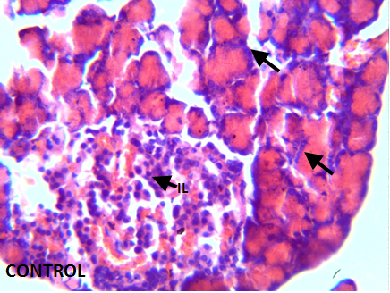B 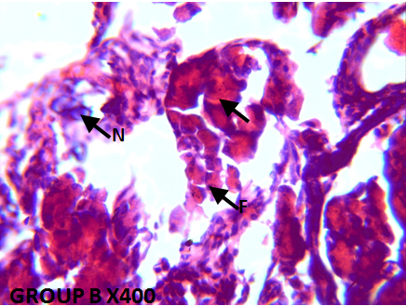
C 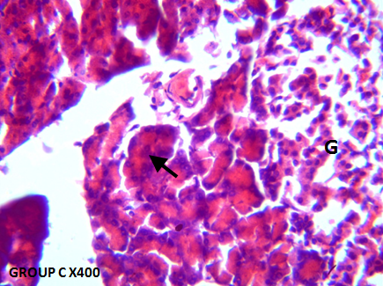D 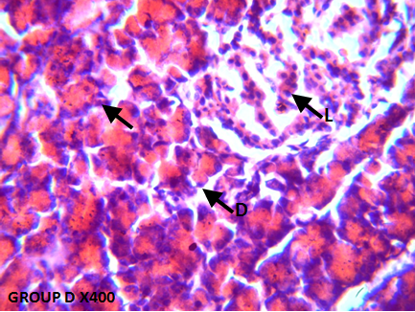
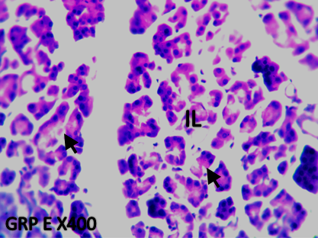
E

Fig. 3: (Group A) pancreatic tissue with normal architecture of the islets of Langerhans (IL) and pancreatic acini (Group B) necrotic islet of pancreas (N), fewer acinar cells (F) with swollen pancreatic acini (black arrow) (Group C) normal morphology of the pancreatic acini (black arrow) with well-preserved cells islet of Langerhans (Group D) Atrophic change of the acinar cells was less severe and the border between exocrine and endocrine portions became more distinct (black arrows) with nearly normal structure of Islets of Langerhans (F) (Group E). normal pancreatic islets of Langerhans, with well-preserved exocrine aciniar.
In-silico Results
Table 3: Binding affinity of the bioactive compounds of Tetracarpidium conophorum (African walnut) with Metallothioneins-1 target (PDB: 1MHU)
Ligands | PubChem CID | Binding Affinity (Kcal/mol)
Deferasirox (Control) | 214348 | -5.9
Dicyclohexyl benzene-1,2-dicarboxylate | 6777 | -4.4
Methyl 3-(3,5-ditert-butyl-4-hydroxyphenyl)propanoate | 62603 | -4
(2R)-2,8-dimethyl-2-[(4R,8R)-4,8,12-trimethyltridecyl]-3,4-dihydrochromen-6-ol | 92094 | -4
Deferoxamine (Control) | 2973 | -3.9
4,4,7-trimethyl-2,3-dihydro-1H-naphthalene | 68057 | -3.8
Diethyl benzene-1,2-dicarboxylate | 6781 | -3.6
2-(2-ethylhexoxycarbonyl)benzoic acid | 20393 | -3.5
1,3-benzodioxole-5-carbaldehyde | 8438 | -3.5

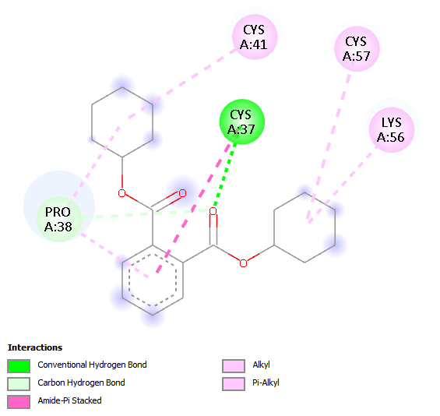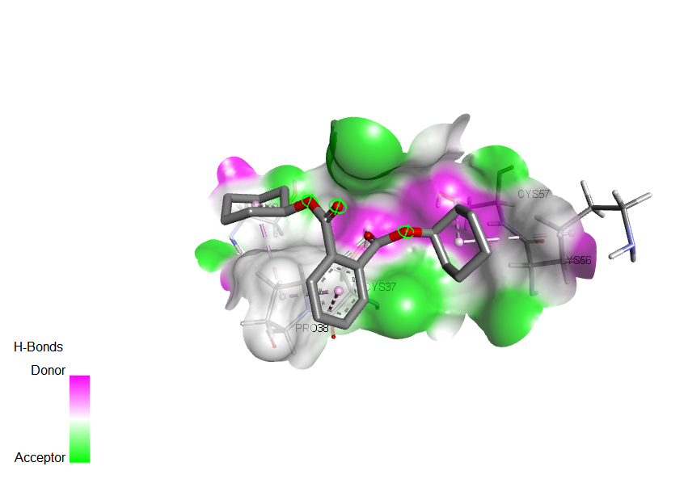
Fig 4: 2D and 3D binding interactions of Dicyclohexyl benzene-1,2-dicarboxylate with Metallothioneins-1 target (PDB: 1MHU)

Table 4: Binding affinity of the bioactive compounds of Tetracarpidium conophorum (African walnut) with Metallothioneins-2 target (PDB: 2MHU)
Ligands | PubChem CID | Binding Affinity (Kcal/mol)
[2-(2-benzoylphenyl)-4-(1-hydroxycyclohexyl)phenyl]-[4-(1-hydroxycyclohexyl)phenyl]methanone | 141134022 | -6.1
(3S,8S,9S,10R,13R,14S,17R)-17-[(E,2R,5S)-5-ethyl-6-methylhept-3-en-2-yl]-10,13-dimethyl-2,3,4,7,8,9,11,12,14,15,16,17-dodecahydro-1H-cyclopenta[a]phenanthren-3-ol | 5280794 | -5.7
(3S,8S,9S,10R,13R,14S,17R)-17-[(E,2R,5S)-5-ethyl-6-methylhept-3-en-2-yl]-10,13-dimethyl-2,3,4,7,8,9,11,12,14,15,16,17-dodecahydro-1H-cyclopenta[a]phenanthren-3-ol | 602765 | -5.7
[2-(2,2,3,3,3-pentafluoropropanoyloxy)phenyl] furan-2-carboxylate | 91700578 | -5.5
N-(1-phenylethyl)benzotriazol-1-amine | 119340 | -5.4
Dimercaptosuccinic acid (Control) | 9354 | -3.8
Dimercaprol (Control) | 3080 | -2.7

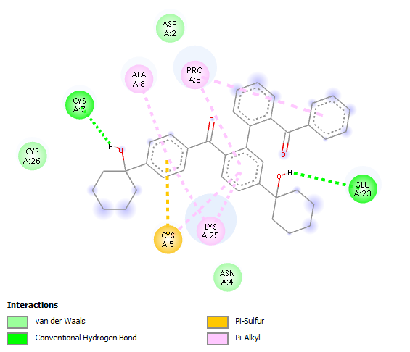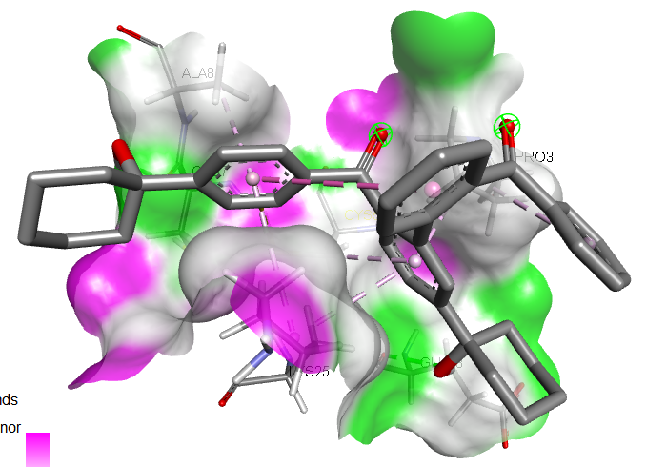
Fig 5: 2D and 3D binding interactions of [2-(2-benzoylphenyl)-4-(1-hydroxycyclohexyl)phenyl]-[4-(1-hydroxycyclohexyl)phenyl]methanone with Metallothioneins-2 target (PDB: 2MHU)

Table 5: Binding affinity of the bioactive compounds of Tetracarpidium conophorum (African walnut) with Apoptosis target (PDB: 1F16)
Ligands | PubChem CID | Binding Affinity (Kcal/mol)
1,2-dimethyl-1-propan-2-ylcyclopentane;1,3-dimethyl-1-propan-2-ylcyclopentane | 160282515 | -7.7
(1R)-1-deuterio-1,2-dimethyl-6-(trifluoromethyl)cyclohexane | 158989727 | -6.9
Methyl (6E,9E,12E)-octadeca-6,9,12-trienoate | 5362805 | -6.7
(9Z,12Z)-octadeca-9,12-dienoic acid | 5280450 | -6.7
Hexadeca-7,11-dienal | 543335 | -6.7
Vorinostat (Control) | 5311 | -6.5
Romidepsin (Control) | 5352062 | 50.7
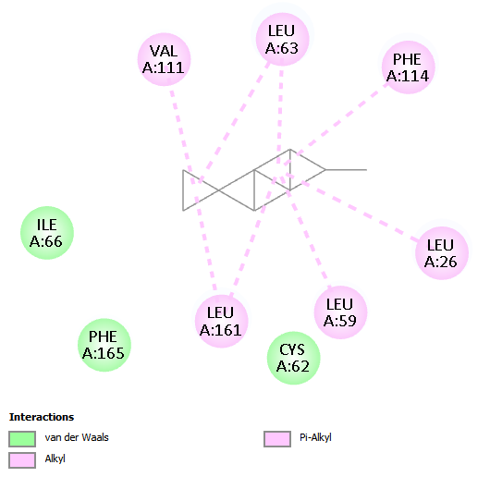
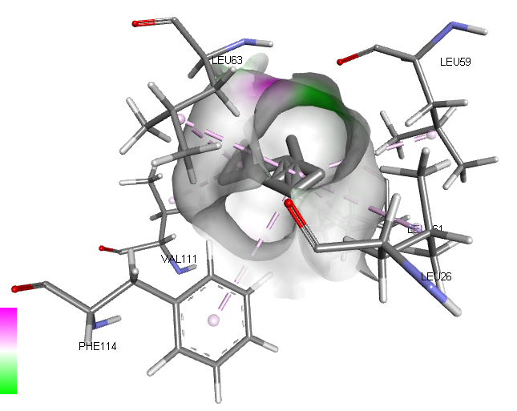

Fig 6: 2D and 3D binding interactions of 1,2-dimethyl-1-propan-2-ylcyclopentane;1,3-dimethyl-1-propan-2-ylcyclopentane with Apoptosis target (PDB: 1F16)

Table 6: Binding affinity of the bioactive compounds of Tetracarpidium conophorum (African walnut) with Glutathione-S-transferase target (PDB: 1GRE)
Ligands | PubChem CID | Binding Affinity (Kcal/mol)
7-chloro-10-hydroxy-1-(2-pyrrolidin-1-ylethylimino)-3-[3-(trifluoromethyl)phenyl]-3,4-dihydro-2H-acridin-9-one | 558427 | -9.4
[2-(2-benzoylphenyl)-4-(1-hydroxycyclohexyl)phenyl]-[4-(1-hydroxycyclohexyl)phenyl]methanone | 141134022 | -9.1
(3S,8S,9S,10R,13R,14S,17R)-17-[(E,2R,5S)-5-ethyl-6-methylhept-3-en-2-yl]-10,13-dimethyl-2,3,4,7,8,9,11,12,14,15,16,17-dodecahydro-1H-cyclopenta[a]phenanthren-3-ol | 5280794 | -8.4
Dicyclohexyl benzene-1,2-dicarboxylate | 6777 | -8.2
Cycloicosane | 520444 | -7.6
[2-(2,2,3,3,3-pentafluoropropanoyloxy)phenyl] furan-2-carboxylate | 91700578 | -7.6
Glutathione (Control) | 124886 | -5.5
N-acetylcysteine (Control) | 12035 | -5.2

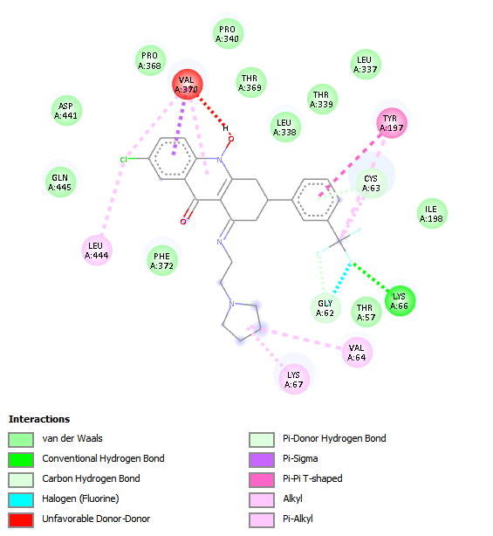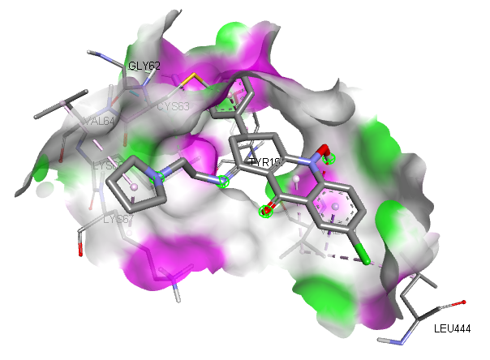
Fig 7: 2D and 3D binding interactions of 7-chloro-10-hydroxy-1-(2-pyrrolidin-1-ylethylimino)-3-[3-(trifluoromethyl)phenyl]-3,4-dihydro-2H-acridin-9-one with Glutathione-S-transferase target (PDB: 1GRE)

Table 7: Binding affinity of the bioactive compounds of Tetracarpidium conophorum (African walnut) with Inflammatory mediator target (PDB: 1IL6)
Ligands | PubChem CID | Binding Affinity (Kcal/mol)
[2-(2,2,3,3,3-pentafluoropropanoyloxy)phenyl] furan-2-carboxylate | 91700578 | -7.3
N-(1-phenylethyl)benzotriazol-1-amine | 119340 | -7.1
Dicyclohexyl benzene-1,2-dicarboxylate | 6777 | -7
N-hydroxy-N'-[2-(trifluoromethyl)phenyl]pyridine-3-carboximidamide | 550559 | -6.8
4-N-[(3,5-dimethylpyridin-2-yl)methyl]-4-N-[(3-propan-2-ylpyridin-2-yl)methyl]cyclohexane-1,4-diamine | 58997203 | -6.7
N,N-dimethyl-8-[2-(trifluoromethyl)phenothiazin-10-yl]octanamide | 45139045 | -6.6
Celecoxib (Control) | 2662 | -6.6
14-hydroxy-16-methoxy-4-methyl-3-oxabicyclo[10.4.0]hexadeca-1(12),13,15-trien-2-one | 602765 | -6.5
Aspirin (Control) | 2244 | -5.3

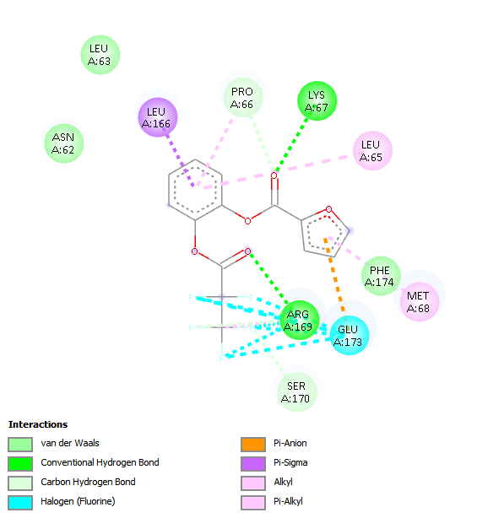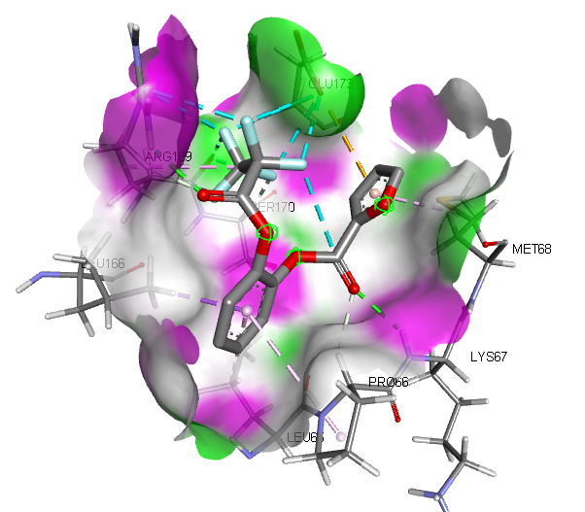
Fig 8: 2D and 3D binding interactions of [2-(2,2,3,3,3-pentafluoropropanoyloxy)phenyl] furan-2-carboxylate with Inflammatory mediator target (PDB: 1IL6)

Table 8: Binding affinity of the bioactive compounds of Tetracarpidium conophorum (African walnut) with Pancreatic function target (PDB: 1V4S)
Ligands | PubChem CID | Binding Affinity (Kcal/mol)
[2-(2-benzoylphenyl)-4-(1-hydroxycyclohexyl)phenyl]-[4-(1-hydroxycyclohexyl)phenyl]methanone | 141134022 | -8.4
Sitagliptin (Control) | 4369359 | -7.7
7-chloro-10-hydroxy-1-(2-pyrrolidin-1-ylethylimino)-3-[3-(trifluoromethyl)phenyl]-3,4-dihydro-2H-acridin-9-one | 558427 | -7.5
(3,4-dimethoxybenzoyl) 3,4-dimethoxybenzoate | 13925286 | -7.1
14-hydroxy-16-methoxy-4-methyl-3-oxabicyclo[10.4.0]hexadeca-1(12),13,15-trien-2-one | 602765 | -6.9
[2-(2,2,3,3,3-pentafluoropropanoyloxy)phenyl] furan-2-carboxylate | 91700578 | -6.9
Bis(2-formylphenyl) 2,2-dimethylpropanedioate | 91695290 | -6.9
N,N-dimethyl-8-[2-(trifluoromethyl)phenothiazin-10-yl]octanamide | 45139045 | -6.8
Metformin (Control) | 4091 | -5
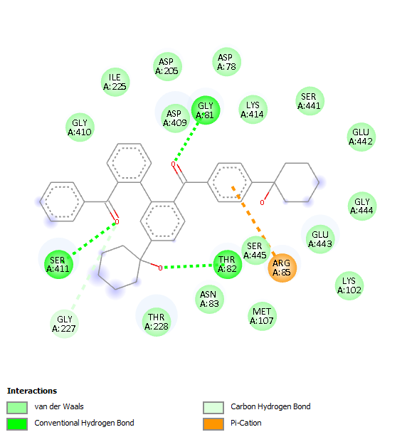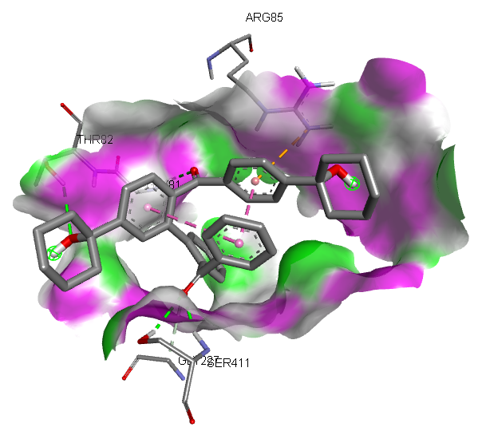
Fig 9: 2D and 3D binding interactions of [2-(2-benzoylphenyl)-4-(1-hydroxycyclohexyl)phenyl]-[4-(1-hydroxycyclohexyl)phenyl]methanone with Pancreatic function target (PDB: 1V4S)

Table 9: Binding affinity of the bioactive compounds of Tetracarpidium conophorum (African walnut) with Oxidative stress target (PDB: 1DGB)
Ligands | PubChem CID | Binding Affinity (Kcal/mol)
7-chloro-10-hydroxy-1-(2-pyrrolidin-1-ylethylimino)-3-[3-(trifluoromethyl)phenyl]-3,4-dihydro-2H-acridin-9-one | 558427 | -11.5
[2-(2-benzoylphenyl)-4-(1-hydroxycyclohexyl)phenyl]-[4-(1-hydroxycyclohexyl)phenyl]methanone | 141134022 | -10.6
(2R)-2,5,7,8-tetramethyl-2-[(4R,8R)-4,8,12-trimethyltridecyl]-3,4-dihydrochromen-6-ol | 14985 | -10.1
Bis(2-formylphenyl) 2,2-dimethylpropanedioate | 91695290 | -9.8
N,N-dimethyl-8-[2-(trifluoromethyl)phenothiazin-10-yl]octanamide | 45139045 | -9.7
(2R)-2,8-dimethyl-2-[(4R,8R)-4,8,12-trimethyltridecyl]-3,4-dihydrochromen-6-ol | 92094 | -9.5
Butylated hydroxytoluene (Control) | 31404 | -7.2
Ascrobic acid (Control) | 54670067 | -6.7

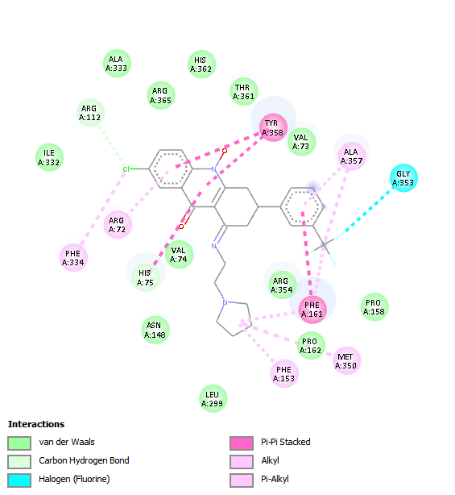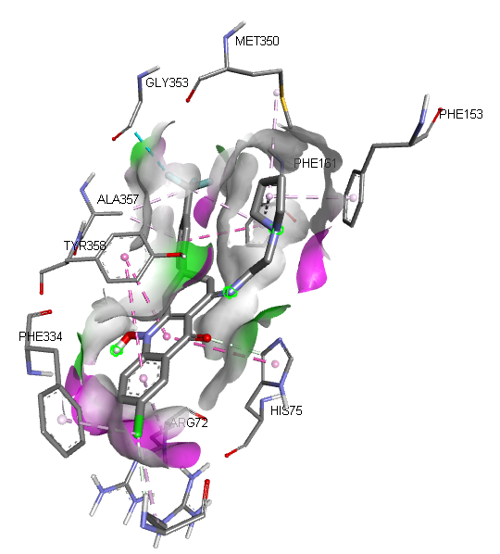
Fig 10: 2D and 3D binding interactions of 7-chloro-10-hydroxy-1-(2-pyrrolidin-1-ylethylimino)-3-[3-(trifluoromethyl)phenyl]-3,4-dihydro-2H-acridin-9-one with Oxidative stress target (PDB: 1DGB)

Table 10: Amino acid interactions of the selected target proteins with the Hit compounds of Tetracarpidium conophorum (African walnut)
Binding interactions | 1MHU- Dicyclohexyl benzene-1,2-dicarboxylate | 2MHU-[2-(2-benzoylphenyl)-4-(1-hydroxycyclohexyl)phenyl]-[4-(1-hydroxycyclohexyl)phenyl]methanone | 1F16-1,2-dimethyl-1-propan-2-ylcyclopentane;1,3-dimethyl-1-propan-2-ylcyclopentane | 1GRE-7-chloro-10-hydroxy-1-(2-pyrrolidin-1-ylethylimino)-3-[3-(trifluoromethyl)phenyl]-3,4-dihydro-2H-acridin-9-one | 1IL6-[2-(2,2,3,3,3-pentafluoropropanoyloxy)phenyl] furan-2-carboxylate | 1V4S-[2-(2-benzoylphenyl)-4-(1-hydroxycyclohexyl)phenyl]-[4-(1-hydroxycyclohexyl)phenyl]methanone | 1DGB-7-chloro-10-hydroxy-1-(2-pyrrolidin-1-ylethylimino)-3-[3-(trifluoromethyl)phenyl]-3,4-dihydro-2H-acridin-9-one
Conventional Hydrogen bond | 1(CYS37) | 2(GLU23, CYS7) | - | 1(LYS66) | 2(LYS67, ARG169) | 3(GLY81, THR82, SER411) | -
Carbon Hydrogen bond | 1(PRO38) | - | - | 1(CYS63) | 2(PRO66, SER170) | 1(GLY227) | 2(HIS75, ARG112)
Van dar Waals | - | 3(ASP2, CYS26, ASN4) | 3(ILE66, PHE165, CYS62) | 11(PHE372, GLN445, ASP441, PRO368, PRO340, THR369, LEU338, THR339, LEU337, ILE196, THR57) | 3(ASN62, PHE174, LEU63) | 15(GLY410, ILE225, ASP205, ASP78, ASP209, LYS414, SER441, GLU442, GLY444, GLY443, LYS102, MET107, ASN83, THR228) | 12(VAL74, ASN148, ARG354, LEU299, PRO162, PRO158, VAL73, THR361, HIS362, ARG365, ALA333, ILE335)
Amide-Pi stacked | 1(CYS41) | - | - | - |  | - | -
Pi-alkyl | 2(CYS57) | 3(LYS25, ALA8, PRO3) | 2(PHE114, LEU26) | 1(LEU444) | 1(LEU65) | - | 1(ALA357)
Pi-Sulfur | - | 1(CYS5) |  | - | - | -
Unfavorable donor-donor | - | - | - | 1(VAL370) | - | -
Pi-Sigma | - | - | - | - | - | -
Alkyl | 1(LYS56) | - | 4(VAL111, LEU63, LEU161, LEU59) | 2(VAL64, LYS67) | 1(MET68) | - | 3(MET350, PHE153, ARG72, PHE334)
Pi-Pi T shaped | - | - | - | 1(TYR197) | - | - | -
Halogen | - | - | - | 1(GLY62) | 1(GLU173) | - | 1(GLY353)
Pi-sigma | - | - | - | - | 1(LEU166) | -
Pi-Cation | - | - | - | - | - | 1(ARG85) | -
Pi-Pi Stacked | - | - | - | - | - | - | 2(TYR358, PHE161)

Table 11: Pharmacokinetics (ADME) Properties of the Hit compounds of Tetracarpidium conophorum (African walnut)
ADME | Properties | Dicyclohexyl benzene-1,2-dicarboxylate | [2-(2-benzoylphenyl)-4-(1-hydroxycyclohexyl)phenyl]-[4-(1-hydroxycyclohexyl)phenyl]methanone | 1,2-dimethyl-1-propan-2-ylcyclopentane;1,3-dimethyl-1-propan-2-ylcyclopentane | 7-chloro-10-hydroxy-1-(2-pyrrolidin-1-ylethylimino)-3-[3-(trifluoromethyl)phenyl]-3,4-dihydro-2H-acridin-9-one | [2-(2,2,3,3,3-pentafluoropropanoyloxy)phenyl] furan-2-carboxylate
Absorption | Caco-2 | -4.684 | -4.851 | -4.863 | -5.271 | -4.624
Absorption | P-gp inhibitor | 0.993 | 1.000 | 0.991 | 0.999 | 0.943
Absorption | P-gp substrate | 0.004 | 0.006 | 0.009 | 0.212 | 0.004
Absorption | HIA | 0.003 | 0.000 | 0.000 | 0.000 | 0.015
Absorption | Bioavailability | 0.726 | 0.137 | 0.882 | 0.003 | 0.162
Distribution | OATP1B1 | 0.912 | 0.841 | 0.979 | 0.150 | 0.348
Distribution | OATP1B3 | 0.838 | 0.749 | 0.927 | 0.241 | 0.940
Distribution | BCRP | 0.407 | 0.433 | 0.181 | 0.000 | 0.220
Distribution | BSEP | 0.997 | 0.999 | 1.000 | 1.000 | 0.979
Distribution | BBB | 0.530 | 0.165 | 0.889 | 0.963 | 0.912
Distribution | MRP1 | 0.929 | 0.132 | 0.999 | 0.935 | 0.883
Distribution | PPB | 90.389 | 96.463 | 97.812 | 98.312 | 97.811
Metabolism | CYP1A2-inh | 0.613 | 0.132 | 0.009 | 0.865 | 1.000
Metabolism | CYP1A2-sub | 0.006 | 0.802 | 0.069 | 0.992 | 0.019
Metabolism | CYP2C19-inh | 0.884 | 0.995 | 0.861 | 0.002 | 1.000
Metabolism | CYP2C19-sub | 0.000 | 0.000 | 0.993 | 0.992 | 0.000
Metabolism | CYP2C9-inh | 0.281 | 0.001 | 0.823 | 0.000 | 0.378
Metabolism | CYP2C9-sub | 0.013 | 0.000 | 0.270 | 0.001 | 0.761
Metabolism | CYP2D6-inh | 0.000 | 0.000 | 0.473 | 0.995 | 0.000
Metabolism | CYP2D6-sub | 0.000 | 0.000 | 0.520 | 0.249 | 0.006
Metabolism | CYP3A4-inh | 0.997 | 0.018 | 0.015 | 0.018 | 0.000
Metabolism | CYP3A4-sub | 0.000 | 0.000 | 0.726 | 1.000 | 0.000
Metabolism | CYP2B6-inh | 0.939 | 0.000 | 0.656 | 0.802 | 0.000
Metabolism | CYP2B6-sub | 0.000 | 0.000 | 0.996 | 0.000 | 0.000
Metabolism | CYP2C8-inh | 0.999 | 1.000 | 0.745 | 0.554 | 1.000
Excretion | cl-plasma | 3.631 | 7.553 | 9.515 | 7.536 | 4.800
Excretion | t0.5 | 0.410 | 1.481 | 0.267 | 0.874 | 0.779

Table 12: Physicochemical Properties of the Hit compounds of Tetracarpidium conophorum (African walnut)
Properties | Dicyclohexyl benzene-1,2-dicarboxylate | [2-(2-benzoylphenyl)-4-(1-hydroxycyclohexyl)phenyl]-[4-(1-hydroxycyclohexyl)phenyl]methanone | 1,2-dimethyl-1-propan-2-ylcyclopentane;1,3-dimethyl-1-propan-2-ylcyclopentane | 7-chloro-10-hydroxy-1-(2-pyrrolidin-1-ylethylimino)-3-[3-(trifluoromethyl)phenyl]-3,4-dihydro-2H-acridin-9-one | [2-(2,2,3,3,3-pentafluoropropanoyloxy)phenyl] furan-2-carboxylate
Molar weight | 330.180 | 558.280 | 210.230 | 503.160 | 350.020
No. HB Acceptor | 4.000 | 4.000 | 0.000 | 5.000 | 5.000
No. HB Donor | 0.000 | 2.000 | 0.000 | 1.000 | 0.000
TPSA | 52.600 | 74.600 | 0.000 | 57.830 | 65.740
LogP | 4.880 | 5.427 | 6.020 | 4.155 | 3.310
Flexibility | 0.300 | 0.184 | 0.500 | 0.172 | 0.538
No. Rotatable H. | 6.000 | 7.000 | 3.000 | 5.000 | 7.000

Table 13: Toxicity Properties of the Hit compounds of Tetracarpidium conophorum (African walnut)
Properties | Dicyclohexyl benzene-1,2-dicarboxylate | [2-(2-benzoylphenyl)-4-(1-hydroxycyclohexyl)phenyl]-[4-(1-hydroxycyclohexyl)phenyl]methanone | 1,2-dimethyl-1-propan-2-ylcyclopentane;1,3-dimethyl-1-propan-2-ylcyclopentane | 7-chloro-10-hydroxy-1-(2-pyrrolidin-1-ylethylimino)-3-[3-(trifluoromethyl)phenyl]-3,4-dihydro-2H-acridin-9-one | [2-(2,2,3,3,3-pentafluoropropanoyloxy)phenyl] furan-2-carboxylate
Skin Sensitization | 0.270 | 0.052 | 0.292 | 0.379 | 0.980
Carcinogenicity | 0.143 | 0.256 | 0.445 | 0.179 | 0.815
Eye corrosion | 0.012 | 0.000 | 0.861 | 0.000 | 0.999
Eye irritation | 0.939 | 0.009 | 0.932 | 0.000 | 0.996
Respiratory | 0.031 | 0.657 | 0.667 | 0.975 | 0.949
Hapatotoxicity | 0.078 | 0.745 | 0.568 | 0.925 | 0.291
Neurotoxicity | 0.389 | 0.582 | 0.525 | 0.919 | 0.043
Ototoxicity | 0.179 | 0.846 | 0.539 | 0.987 | 0.270
Hematotoxicity | 0.003 | 0.390 | 0.351 | 0.503 | 0.062
Nephrotoxicity | 0.055 | 0.937 | 0.151 | 0.924 | 0.076
Genotoxicity | 0.000 | 0.132 | 0.001 | 1.000 | 0.979
Immunitoxicty | 0.042 | 0.218 | 0.071 | 0.122 | 0.035
A549 Cytotoxicity | 0.068 | 0.911 | 0.202 | 0.759 | 0.058
HEK293 Cytotoxicity | 0.497 | 0.913 | 0.275 | 0.973 | 0.074

Table 14: Drug likeness properties of the Hit compounds of Tetracarpidium conophorum (African walnut)
Drug Likeness Models | Dicyclohexyl benzene-1,2-dicarboxylate | [2-(2-benzoylphenyl)-4-(1-hydroxycyclohexyl)phenyl]-[4-(1-hydroxycyclohexyl)phenyl]methanone | 1,2-dimethyl-1-propan-2-ylcyclopentane;1,3-dimethyl-1-propan-2-ylcyclopentane | 7-chloro-10-hydroxy-1-(2-pyrrolidin-1-ylethylimino)-3-[3-(trifluoromethyl)phenyl]-3,4-dihydro-2H-acridin-9-one | [2-(2,2,3,3,3-pentafluoropropanoyloxy)phenyl] furan-2-carboxylate
Lipinski | YES | NO | NO | NO | YES
Ghose | YES | NO | NO | NO | NO
Veber | YES | YES | NO | YES | YES
Egan | YES | NO | NO | NO | YES
Muegge | NO | NO | NO | YES | YES

The body weights of the animals were assessed both at the beginning and the end of the experiment, with initial weights showing no significant differences across all groups. However, substantial differences in weight were observed at the end of the study. Group A (control) exhibited the most consistent weight increase from an initial mean of 216.0 g to a final mean of 244.0 g. Groups treated with Tetracapidium extract (Groups C, D, and E) showed weight increases, though not to the extent of the control group. In particular, Group E (0.6 ml Tetracapidium) reached a mean final weight of 249.0 g, which is slightly higher than the control.
The weight loss observed in Group B (mercury chloride-only group), which dropped from an initial mean weight of 191.0 g to a final mean of 147.0 g, reinforces the detrimental impact of mercury chloride on overall health. The weight gain in the Tetracapidium-treated groups compared to Group B suggests a reversal of mercury chloride-induced toxicity, likely due to the antioxidative and possibly anti-inflammatory properties of Tetracapidium. These properties may have helped in alleviating mercury chloride’s oxidative damage, thereby preserving the animals' metabolic and physical integrity.
The descriptive analysis of insulin levels showed marked differences between the experimental groups, with Group A (control) recording the highest mean insulin level (6.48 ± 1.02), followed by Group E (4.40 ± 0.43), Group C (3.99 ± 1.52), Group D (2.43 ± 0.89), and Group B (1.71 ± 1.35). This gradient reveals the direct impact of mercury chloride on insulin levels in the pancreas, showing a decrease in insulin in the groups exposed to mercury chloride compared to the control. These findings are consistent with literature suggesting that mercury chloride induces oxidative stress and disrupts pancreatic β-cells, which are critical for insulin production (Odekunle et al., 2024).
The treatment groups receiving Tetracapidium extract (Groups C, D, and E) demonstrated increased insulin levels compared to the mercury chloride-only group (Group B). The administration of 0.2 ml, 0.4 ml, and 0.6 ml of Tetracapidium extract appears to counteract the effects of mercury chloride to a certain extent, with a dose-dependent increase in insulin observed in these groups. The potential mechanism behind this protective effect could be linked to the antioxidant properties of Tetracapidium extract. Antioxidants can scavenge reactive oxygen species (ROS) generated by mercury chloride, thus preventing or mitigating oxidative damage to β-cells (Kanu et al., 2020). Tetracapidium, known for its bioactive components, likely contributed to the restoration of insulin levels by shielding pancreatic tissue from oxidative stress and cellular damage.
The histological examination of pancreatic tissue provided insights into the cellular-level impact of mercury chloride and the potential restorative effects of Tetracapidium extract. The pancreatic tissue in the control group displayed a normal histological structure, characterized by well-organized islets of Langerhans and pancreatic acini, as seen in Group A. The normal cellular architecture indicates a healthy pancreas without any structural disruptions.
Group B shows the pancreatic tissue exposed to mercury chloride, with notable necrosis in the islets, reduced acinar cells, and swelling of pancreatic acini. These findings align with the documented cytotoxic effects of mercury chloride on pancreatic tissue. Studies suggest that mercury compounds disrupt cellular processes by inducing oxidative stress, leading to cell death, necrosis, and morphological alterations (Odekunle et al., 2024). The reduction in acinar cells likely reflects a decline in the pancreas's exocrine function, as these cells are essential for enzyme secretion, while the necrotic changes in the islets compromise insulin production.
The histological sections from the Tetracapidium-treated groups (Groups C to E) demonstrated dose-dependent restorative changes in pancreatic tissue. In Group C (0.2 ml Tetracapidium), the morphology of pancreatic acini appeared more normalized, with relatively well-preserved islet cells, although some residual damage was present. In Group D (0.4 ml Tetracapidium), the severity of acinar atrophy was reduced further, and the demarcation between endocrine and exocrine regions became more distinct. Group E (0.6 ml Tetracapidium) displayed a near-normal structure of the pancreatic islets and acini, indicating substantial recovery. The observed improvements in histology correspond with the insulin data, as insulin levels were higher in the treated groups, particularly with the higher doses of Tetracapidium.
These histological findings underscore Tetracapidium extract's potential in mitigating mercury chloride-induced pancreatic damage, likely due to its antioxidant properties, which help preserve cell structure and function by counteracting oxidative damage. This is supported by studies on other plant-based antioxidants, which show similar protective effects against chemical-induced tissue damage (Kanu et al., 2020).
Deferasirox, a standard oral iron chelator, exhibited the highest binding affinity to Metallothionein-1 (MT-1) with a docking score of –5.9 kcal·mol⁻¹, which aligns with earlier findings that highlight its strong interaction with metal-binding proteins due to its tridentate ligand structure (Krężel & Maret, 2021; Cappellini et al., 2018). Among the Tetracarpidium conophorum bioactive compounds, dicyclohexyl benzene-1,2-dicarboxylate showed the highest binding affinity (–4.4 kcal•mol⁻¹), consistent with established findings that plant polyphenols and related bioactive compounds can engage in stable interactions with protein targets through hydrogen bonding, hydrophobic interactions, and π-related forces (Scalbert et al., 2005; Bissantz et al., 2010).Methyl 3-(3,5-ditert-butyl-4-hydroxyphenyl)propanoate and (2R)-2,8-dimethyl-2-[(4R,8R)-4,8,12-trimethyltridecyl]-3,4-dihydrochromen-6-ol both recorded moderate affinities (–4.0 kcal·mol⁻¹). Interestingly, deferoxamine, another standard chelator, showed a slightly lower affinity (–3.9 kcal·mol⁻¹) compared to some T. conophorum ligands Other plant-derived ligands such as 4,4,7-trimethyl-2,3-dihydro-1H-naphthalene (–3.8 kcal·mol⁻¹) and small aromatic esters (–3.6 to –3.5 kcal·mol⁻¹) exhibited weaker binding
MT-1 is well recognized for its role in maintaining metal ion homeostasis and detoxifying toxic metals, particularly mercury, through high-affinity thiolate clusters (Krężel & Maret, 2021). GC–MS profiling of T. conophorum confirms the presence of such functional groups, including phenolic esters and substituted chromenes.
The highest binding affinity to Metallothionein-2 (MT-2) was observed for [2-(2-benzoylphenyl)-4-(1-hydroxycyclohexyl)phenyl]-[4-(1-hydroxycyclohexyl)phenyl]methanone, with a docking score of –6.1 kcal·mol⁻¹. Two structurally identical steroidal compounds—(3S,8S,9S,10R,13R,14S,17R)-17-[(E,2R,5S)-5-ethyl-6-methylhept-3-en-2-yl]-10,13-dimethyl-2,3,4,7,8,9,11,12,14,15,16,17-dodecahydro-1H-cyclopenta[a]phenanthren-3-ol—each recorded an affinity of –5.7 kcal•mol⁻¹. This binding behavior is consistent with established findings that steroidal compounds interact predominantly through hydrophobic and van der Waals forces within protein binding cavities (Kitchen et al., 2004). [2-(2,2,3,3,3-pentafluoropropanoyloxy)phenyl] furan-2-carboxylate displayed an affinity of –5.5 kcal·mol⁻¹.
N-(1-phenylethyl)benzotriazol-1-amine followed closely with a docking score of –5.4 kcal•mol⁻¹, consistent with established principles that nitrogen-containing heterocycles commonly engage in favorable ligand–protein interactions through hydrogen bonding, π–π stacking, and hydrophobic contacts within binding pockets (Bissantz et al., 2010).In contrast, the standard chelators dimercaptosuccinic acid (–3.8 kcal·mol⁻¹) and dimercaprol (–2.7 kcal·mol⁻¹) exhibited markedly lower affinities, a finding consistent with previous molecular docking studies indicating that their small size and high polarity can limit stable hydrophobic contacts within MT-2’s core binding region ( Krężel & Maret, 2021).
The strongest binding affinity to the apoptosis-related protein target (PDB: 1F16) was recorded for 1,2-dimethyl-1-propan-2-ylcyclopentane;1,3-dimethyl-1-propan-2-ylcyclopentane with a docking score of –7.7 kcal•mol⁻¹, indicating a favorable interaction profile compared to previously reported natural compounds targeting apoptotic pathways (Ranjan et al., 2019; Elmore, 2007). This high affinity suggests favorable hydrophobic interactions and shape complementarity within the binding pocket, consistent with established docking principles indicating that cyclic hydrophobic scaffolds, including terpenoid-like structures, can achieve stable binding conformations in protein active sites through van der Waals and non-polar interactions (Bissantz et al., 2010; Kitchen et al., 2004).The next highest score, –6.9 kcal•mol⁻¹, was observed for (1R)-1-deuterio-1,2-dimethyl-6-(trifluoromethyl)cyclohexane, aligning with established findings that fluorine substitution can enhance ligand binding stability through its strong electron-withdrawing effects and modulation of molecular interactions (Purser et al., 2008; Müller et al., 2007).
Three compounds methyl (6E,9E,12E)-octadeca-6,9,12-trienoate, (9Z,12Z)-octadeca-9,12-dienoic acid, and hexadeca-7,11-dienal—each recorded docking scores of –6.7 kcal·mol⁻¹. These results are comparable to prior studies indicating that polyunsaturated fatty acids and long-chain lipid derivatives can influence apoptosis-related signaling pathways, primarily through modulation of membrane-associated domains and lipid-mediated signaling processes that regulate cellular survival mechanisms (van Meer et al., 2008).
Notably, the docking score of these T. conophorum compounds slightly exceeded that of vorinostat, a clinically approved histone deacetylase (HDAC) inhibitor used in apoptosis modulation (–6.5 kcal·mol⁻¹). Romidepsin’s docking value in this table appears anomalous at 50.7 kcal•mol⁻¹, as histone deacetylase (HDAC) inhibitors are generally characterized by stable negative binding energies in molecular docking studies, and extreme positive values are typically indicative of scoring or computational artifacts rather than true binding affinity (Falkenberg & Johnstone, 2014; Pagadala et al., 2017).
The compound 7-chloro-10-hydroxy-1-(2-pyrrolidin-1-ylethylimino)-3-[3-(trifluoromethyl)phenyl]-3,4-dihydro-2H-acridin-9-one exhibited the highest binding affinity to the Glutathione-S-transferase (GST) target (PDB: 1GRE) with a score of –9.4 kcal·mol⁻¹, significantly outperforming the endogenous antioxidant glutathione (–5.5 kcal·mol⁻¹). This aligns with previous observations that ligand structural features, including aromatic and halogen substitutions, can promote stable π–π stacking and hydrogen bond interactions within the glutathione S-transferase (GST) active site, thereby enhancing binding affinity (Allocati et al., 2018). The next highest affinity was observed for [2-(2-benzoylphenyl)-4-(1-hydroxycyclohexyl)phenyl]-[4-(1-hydroxycyclohexyl)phenyl]methanone (–9.1 kcal·mol⁻¹).
teroidal alcohol (3S,8S,9S,10R,13R,14S,17R)-17-[(E,2R,5S)-5-ethyl-6-methylhept-3-en-2-yl]-10,13-dimethyl-2,3,4,7,8,9,11,12,14,15,16,17-dodecahydro-1H-cyclopenta[a]phenanthren-3-ol bound with –8.4 kcal•mol⁻¹. Similarly, dicyclohexyl benzene-1,2-dicarboxylate (–8.2 kcal•mol⁻¹) showed strong affinity, consistent with established roles of glutathione transferases in xenobiotic metabolism and their ability to accommodate diverse hydrophobic ligands within their binding sites (Hayes et al., 2005; Allocati et al., 2018). Cycloicosane and [2-(2,2,3,3,3-pentafluoropropanoyloxy)phenyl] furan-2-carboxylate both recorded docking scores of –7.6 kcal•mol⁻¹, consistent with established principles that hydrophobic and fluorinated ligands can stabilize interactions within glutathione S-transferase binding sites through van der Waals and hydrophobic contacts (Allocati et al., 2018; Bissantz et al., 2010).. Interestingly, the binding energies of these T. conophorum compounds were markedly stronger than N-acetylcysteine (–5.2 kcal·mol⁻¹).
The ligand [2-(2,2,3,3,3-pentafluoropropanoyloxy)phenyl] furan-2-carboxylate exhibited the strongest binding affinity toward the inflammatory mediator target (PDB: 1IL6) with a docking score of –7.3 kcal•mol⁻¹, while N-(1-phenylethyl)benzotriazol-1-amine (–7.1 kcal•mol⁻¹) also showed favorable binding. These findings are consistent with established evidence that IL-6 plays a central role in inflammatory signaling pathways and is a key therapeutic target for modulation by small molecules (Hunter & Jones, 2015).
Dicyclohexyl benzene-1,2-dicarboxylate (–7.0 kcal•mol⁻¹) recorded affinity values consistent with previous studies indicating that bulky, hydrophobic ligands can induce steric hindrance within enzyme binding pockets, thereby modulating access to catalytic sites and attenuating pro-inflammatory mediator activation (Copeland, 2016). N-hydroxy-N′-[2-(trifluoromethyl)phenyl]pyridine-3-carboximidamide (–6.8 kcal•mol⁻¹) showed comparable binding affinity, consistent with studies indicating that small-molecule inhibitors can modulate IL-6 signaling through stabilizing interactions such as hydrogen bonding within key receptor binding sites (Heinrich et al., 2003). Additionally, N,N-dimethyl-8-[2-(trifluoromethyl)phenothiazin-10-yl]octanamide (–6.6 kcal·mol⁻¹) matched the affinity of celecoxib. Notably, all top-binding T. conophorum ligands outperformed aspirin, which is consistent with literature suggesting that complex plant-derived molecules often exhibit stronger protein–ligand interactions with cytokine targets than simpler NSAIDs (Pan et al., 2010).
The docking analysis for the pancreatic function target (PDB: 1V4S) revealed that [2-(2-benzoylphenyl)-4-(1-hydroxycyclohexyl)phenyl]-[4-(1-hydroxycyclohexyl)phenyl]methanone exhibited the strongest binding affinity (–8.4 kcal·mol⁻¹), surpassing the standard DPP-4 inhibitor sitagliptin (–7.7 kcal·mol⁻¹). Similarly, 7-chloro-10-hydroxy-1-(2-pyrrolidin-1-ylethylimino)-3-[3-(trifluoromethyl)phenyl]-3,4-dihydro-2H-acridin-9-one (–7.5 kcal•mol⁻¹) showed competitive binding close to sitagliptin, consistent with findings that structural modifications such as halogenation can enhance ligand–enzyme interactions and hydrogen bonding stability, thereby improving inhibitory activity against metabolic enzyme targets (Baig et al., 2016).
The compound (3,4-dimethoxybenzoyl) 3,4-dimethoxybenzoate (–7.1 kcal•mol⁻¹) demonstrated strong binding, which is consistent with previous studies showing that methoxy-substituted aromatic compounds can modulate carbohydrate-metabolizing enzymes through π–π stacking and hydrogen bonding interactions with key amino acid residues (Tadera et al., 2006; Proença et al., 2017). Both 14-hydroxy-16-methoxy-4-methyl-3-oxabicyclo[10.4.0]hexadeca-1(12),13,15-trien-2-one and [2-(2,2,3,3,3-pentafluoropropanoyloxy)phenyl] furan-2-carboxylate (–6.9 kcal·mol⁻¹ each) showed higher affinity than metformin (–5.0 kcal·mol⁻¹). Bis(2-formylphenyl) 2,2-dimethylpropanedioate and N,N-dimethyl-8-[2-(trifluoromethyl)phenothiazin-10-yl]octanamide also maintained higher affinity scores than metformin. Overall, several bioactive compounds from T. conophorum demonstrated greater predicted binding to the pancreatic function target compared to widely used antidiabetic drugs, suggesting strong molecular compatibility.
Docking results for the oxidative stress target (PDB: 1DGB) indicated that 7-chloro-10-hydroxy-1-(2-pyrrolidin-1-ylethylimino)-3-[3-(trifluoromethyl)phenyl]-3,4-dihydro-2H-acridin-9-one exhibited the highest binding affinity (–11.5 kcal·mol⁻¹), surpassing the standard antioxidants butylated hydroxytoluene (–7.2 kcal·mol⁻¹) and ascorbic acid (–6.7 kcal·mol⁻¹). The benzophenone derivative [2-(2-benzoylphenyl)-4-(1-hydroxycyclohexyl)phenyl]-[4-(1-hydroxycyclohexyl)phenyl]methanone ranked second (–10.6 kcal·mol⁻¹).
Similarly, the tocopherol analog (2R)-2,5,7,8-tetramethyl-2-[(4R,8R)-4,8,12-trimethyltridecyl]-3,4-dihydrochromen-6-ol (–10.1 kcal·mol⁻¹) and its structural variant (2R)-2,8-dimethyl-2-[(4R,8R)-4,8,12-trimethyltridecyl]-3,4-dihydrochromen-6-ol (–9.5 kcal·mol⁻¹) showed strong binding, consistent with established evidence that vitamin E and its analogs exert antioxidant effects primarily through lipid-phase radical scavenging and membrane stabilization mechanisms (Traber & Atkinson, 2007).Bis(2-formylphenyl) 2,2-dimethylpropanedioate (–9.8 kcal·mol⁻¹) demonstrated higher affinity than both controls.N,N-dimethyl-8-[2-(trifluoromethyl)phenothiazin-10-yl]octanamide (–9.7 kcal·mol⁻¹) also exhibited notable activity. Overall, several compounds from T. conophorum displayed stronger predicted interactions than standard antioxidants, indicating potential therapeutic relevance in oxidative stress management.
Analysis of the amino acid interaction profiles of the Tetracarpidium conophorum hit compounds revealed distinct binding modes across the evaluated protein targets. The 1MHU–dicyclohexyl benzene-1,2-dicarboxylate complex exhibited both conventional hydrogen bonding (CYS37) and carbon hydrogen bonding (PRO38), supported by amide–π stacking (CYS41), π–alkyl (CYS57), and alkyl (LYS56) interactions, which collectively stabilize ligand orientation within the hydrophobic binding pocket.
For 2MHU–[2-(2-benzoylphenyl)-4-(1-hydroxycyclohexyl)phenyl]-[4-(1-hydroxycyclohexyl)phenyl]methanone, multiple conventional hydrogen bonds (GLU23, CYS7), extensive van der Waals contacts (ASP2, CYS26, ASN4), and π–alkyl interactions (LYS25, ALA8, PRO3) were detected, consistent with established findings that aromatic and benzophenone-like scaffolds predominantly stabilize ligand–protein complexes through a combination of hydrogen bonding, hydrophobic interactions, and dispersive forces (Bissantz et al., 2010; Kitchen et al., 2004). The apoptosis target complex (1F16) with 1,2-dimethyl-1-propan-2-ylcyclopentane showed only van der Waals interactions (ILE66, PHE165, CYS62) and alkyl contacts (VAL111, LEU63, LEU161, LEU59), suggesting that its activity is primarily driven by hydrophobic packing.
The oxidative stress protein (1GRE) bound to 7-chloro-10-hydroxy-1-(2-pyrrolidin-1-ylethylimino)-3-[3-(trifluoromethyl)phenyl]-3,4-dihydro-2H-acridin-9-one formed diverse interactions, including conventional hydrogen bonding (LYS66), carbon hydrogen bonding (CYS63), π–alkyl (LEU444), halogen bonding (GLY62), and π–π T-shaped (TYR197) interactions.
For the inflammatory mediator complex (1IL6) with [2-(2,2,3,3,3-pentafluoropropanoyloxy)phenyl] furan-2-carboxylate, conventional hydrogen bonds (LYS67, ARG169), carbon hydrogen bonds (PRO66, SER170), van der Waals contacts (ASN62, PHE174, LEU63), and halogen bonding (GLU173) were observed.
The pancreatic function complex (1V4S) with the benzophenone derivative displayed the highest interaction diversity, including multiple hydrogen bonds (GLY81, THR82, SER411), π–cation (ARG85), and widespread van der Waals contacts with 15 residues
Finally, the oxidative stress target (1DGB) bound to the acridone derivative revealed strong π–π stacking (TYR358, PHE161), π–alkyl (ALA357), halogen bonding (GLY353), and extensive van der Waals interactions (VAL74, ASN148, ARG354, LEU299, PRO162, PRO158, VAL73, THR361, HIS362, ARG365, ALA333, ILE335). This interaction pattern is consistent with established findings that π-rich and halogenated compounds can achieve enhanced binding stability through a cooperative network of dispersive and directional non-covalent interactions (Bissantz et al., 2010; Wilcken et al., 2013).
The ADME profiling of the Tetracarpidium conophorum hit compounds revealed notable variations in absorption, distribution, metabolism, and excretion patterns. In terms of absorption, all compounds demonstrated negative Caco-2 permeability values, indicative of moderate to low passive intestinal absorption, with the 7-chloro-10-hydroxy-acridinone derivative showing the lowest value (−5.271). High P-glycoprotein (P-gp) inhibition scores (>0.94) across all ligands suggest a strong potential to inhibit drug efflux. However, human intestinal absorption (HIA) probabilities were generally low (<0.02), except for dicyclohexyl benzene-1,2-dicarboxylate (0.003) and the pentafluoropropanoyloxy furan ester (0.015), which is consistent with reports that increased molecular bulk and structural complexity can limit intestinal permeability despite favorable lipophilicity (Varma et al., 2010; Hou et al., 2004). Bioavailability predictions varied widely, with the 1,2-dimethylcyclopentane derivative achieving the highest value (0.882) and the acridinone derivative exhibiting minimal bioavailability (0.003), likely due to increased molecular weight and polar surface area constraints, which are known to limit oral absorption and permeability (Veber et al., 2002; Daina et al., 2017).
Distribution analysis indicated that most compounds showed high binding affinity to OATP1B1 and OATP1B3 transporters (>0.74), except for acridinone derivatives, suggesting effective hepatic uptake pathways in most cases. Blood–brain barrier (BBB) permeability predictions indicated strong CNS penetration potential for the cyclopentane (0.889), acridinone (0.963), and pentafluoropropanoyloxy derivatives (0.912), correlating with structural features such as lipophilic surface area and reduced polar surface fraction, as described by Lima et al. (2020). All compounds displayed high plasma protein binding (PPB > 90%), which could prolong half-life but also limit free drug concentration in plasma.
Metabolically, significant diversity in cytochrome P450 (CYP) enzyme inhibition and substrate likelihood was observed. Notably, the pentafluoropropanoyloxy ester showed predicted inhibition of CYP1A2, CYP2C19, and CYP2C8 while exhibiting reduced interaction with CYP3A4, a profile consistent with established pharmacokinetic principles indicating that fluorinated drug-like molecules often display enhanced metabolic stability due to steric and electronic effects that reduce oxidative metabolism ( Purser et al., 2008). In contrast, the cyclopentane derivative showed broad CYP substrate activity (notably CYP2C19, CYP3A4, and CYP2B6), suggesting susceptibility to rapid metabolism. Excretion predictions revealed moderate to high plasma clearance rates, with cyclopentane derivatives exhibiting the highest clearance (9.515 mL/min/kg) and shortest half-life (0.267 h), while the benzophenone derivatives displayed longer half-lives (1.481 h).
The physicochemical profiling of the Tetracarpidium conophorum hit compounds revealed diverse structural and functional characteristics influencing their potential pharmacological performance. Molecular weights ranged from 210.23 g/mol for the cyclopentane derivatives to 558.28 g/mol for the bis-hydroxycyclohexyl benzophenone derivative. The latter exceeds the 500 g/mol limit suggested by Lipinski’s Rule of Five, which may affect oral bioavailability (Lipinski et al., 2012; Veber et al., 2021). All compounds except the cyclopentane derivative possessed multiple hydrogen bond acceptors (4–5), while hydrogen bond donors varied from none to two. a distribution consistent with general trends for moderate aqueous solubility and target binding (Ghose et al., 1998).
Topological polar surface area (TPSA) values were within the optimal range (<140 Å²) for oral drugs, with the cyclopentane derivative notably lacking polar functional groups (TPSA = 0.000 Å²), suggesting extreme lipophilicity and potential for blood–brain barrier (BBB) penetration, as supported by ADME predictions (Table 11). LogP values indicated that all compounds were lipophilic (3.31–6.02), with the cyclopentane derivative being the most hydrophobic. Compounds with LogP > 5, such as the cyclopentane and benzophenone derivatives, may face solubility challenges despite improved membrane permeability (Lombardo et al., 2020).
Flexibility indices ranged from 0.172 for the acridinone derivative to 0.538 for the pentafluoropropanoyloxy ester, reflecting differences in conformational adaptability during protein binding. Rotatable bond counts (3–7) were within the acceptable limit for oral drugs (<10), but higher flexibility and rotatable bond numbers, as observed for the pentafluoropropanoyloxy ester, may increase entropic penalties upon binding (Veber et al., 2021). These physicochemical traits align closely with the docking and ADME findings, where compounds with balanced lipophilicity and moderate flexibility generally exhibited better predicted bioavailability and target interactions.
The predicted toxicity profiles of Tetracarpidium conophorum hit compounds revealed distinct differences in their potential safety risks. Skin sensitization probabilities were lowest for the bis-hydroxycyclohexyl benzophenone derivative (0.052) and highest for the pentafluoropropanoyloxy ester (0.980), suggesting that fluorinated esters may present higher allergenic risk. Carcinogenicity predictions showed relatively low values for most compounds (<0.3), except the cyclopentane derivative (0.445) and pentafluoropropanoyloxy ester (0.815), aligning with previous findings that hydrophobic hydrocarbons and perfluorinated groups can activate genotoxic pathways (Benigni & Bossa, 2011).
Ocular toxicity varied substantially, with the cyclopentane derivative showing high corrosion (0.861) and irritation (0.932) potential, whereas the benzophenone and acridinone derivatives had negligible eye hazard predictions. Respiratory toxicity was highest for the acridinone derivative (0.975) and pentafluoropropanoyloxy ester (0.949), in agreement with literature reporting increased inhalation hazard for polyaromatic and fluorinated molecules (Keyte et al., 2013). Hepatotoxicity risks were most pronounced for the benzophenone (0.745) and acridinone (0.925) derivatives, consistent with studies linking aromatic ketones and nitrogen heterocycles to drug-induced liver injury (McGill & Jaeschke, 2019). Neurotoxicity predictions were elevated (>0.5) for most compounds except the pentafluoropropanoyloxy ester (0.043).
Ototoxicity was highest for the acridinone (0.987) and benzophenone (0.846) derivatives, consistent with reports of aromatic compounds interfering with cochlear function (Schacht et al., 2012). Nephrotoxicity was greatest for the benzophenone (0.937) and acridinone (0.924) derivatives, indicating potential renal safety concerns. Genotoxicity was predicted absent for most compounds, except the acridinone (1.000) and pentafluoropropanoyloxy ester (0.979), suggesting possible DNA-binding or oxidative stress mechanisms. Cytotoxicity assays (A549 and HEK293) predicted high activity for the benzophenone (0.911, 0.913) and acridinone (0.759, 0.973) derivatives.
The drug-likeness evaluation of the Tetracarpidium conophorum hit compounds revealed notable variability in compliance with common medicinal chemistry rules. According to Lipinski's Rule of Five, only dicyclohexyl benzene-1,2-dicarboxylate and the pentafluoropropanoyloxy ester met the criteria for oral bioavailability, whereas the bis-hydroxycyclohexyl benzophenone, cyclopentane derivatives, and acridinone derivatives failed, likely due to high molecular weights or excessive lipophilicity (Lipinski et al., 2001). The Ghose filter, which considers molecular weight, logP, molar refractivity, and atom count, was satisfied solely by dicyclohexyl benzene-1,2-dicarboxylate, indicating a narrow compliance range within this dataset (Ghose et al., 1999).
The Veber rule, which emphasizes rotatable bonds and polar surface area for oral bioavailability, was met by three compounds: dicyclohexyl benzene-1,2-dicarboxylate, bis-hydroxycyclohexyl benzophenone, and acridinone, consistent with previous observations that molecular flexibility and surface polarity can outweigh molecular weight in predicting oral absorption (Veber et al., 2002). The Egan filter, designed to evaluate blood–brain barrier penetration and absorption, was satisfied by only dicyclohexyl benzene-1,2-dicarboxylate and the pentafluoropropanoyloxy ester, indicating potential for CNS delivery (Egan et al., 2000). Muegge's criteria, which screen for drug-likeness based on pharmacophore features and physicochemical boundaries, were met exclusively by the acridinone and pentafluoropropanoyloxy ester, suggesting their structural profiles align more closely with known bioactive scaffolds (Muegge et al., 2001).
CONCLUSION
The present toxicological, molecular docking, and pharmacokinetic evaluation demonstrates that phytoconstituents of Tetracarpidium conophorum possess promising ameliorative potential against mercury-induced pancreatic dysfunction. The study demonstrated that Tetracapidium extract exhibits dose-dependent protective effects against mercury chloride-induced pancreatic toxicity in rats. The findings showed a significant decrease in insulin levels, body weight, and pancreatic health in the mercury chloride-only group. Treatment with Tetracapidium extract resulted in improvements in insulin levels, body weight, and histological preservation of pancreatic tissue, likely due to its antioxidant properties. Several identified hit compounds exhibited strong binding affinities to key pancreatic protective and antioxidant targets, potentially mitigating oxidative damage and metabolic dysregulation induced by mercury toxicity.
Pharmacokinetic profiling revealed that compounds such as dicyclohexyl benzene-1,2-dicarboxylate and [2-(2,2,3,3,3-pentafluoropropanoyloxy)phenyl] furan-2-carboxylate displayed favorable absorption, distribution, and drug-likeness characteristics, although certain hits presented hepatotoxicity, neurotoxicity, or genotoxicity concerns, indicating the need for cautious optimization. These findings align with existing reports on the protective effects of nut-derived bioactives in heavy metal-induced organ injury, reinforcing the potential of African walnut as a source of bioactive compounds for mitigating mercury-related pancreatic damage.
Future work should involve in vitro and in vivo validation of the observed in-silico interactions to confirm their biological relevance in mercury-induced pancreatic injury models. Structural modifications should be explored to enhance the safety profile of promising but toxicity-prone compounds without compromising efficacy. Additionally, longitudinal studies assessing the synergistic effects of whole African walnut extracts versus isolated bioactive compounds may provide further insight into its therapeutic potential in environmental toxicant-induced pancreatic disorders.

Ethical approval

This was obtained from the ethical committee, faculty of basic medical sciences Chukwuemeka Odumegwu Ojukwu University, Uli campus in compliance with the relevant laws and institution’s guidelines.
All authors hereby declare that "Principles of laboratory animal care" (NIH publication No. 85-23, revised 1985) were followed, as well as specific national laws where applicable. All experiments have been examined and approved by the appropriate ethics committee.

COMPETING INTERESTS DISCLAIMER:
Authors have declared that they have no known competing financial interests OR non-financial interests OR personal relationships that could have appeared to influence the work reported in this paper.
Disclaimer (Artificial intelligence)

Author(s) hereby declare that NO generative AI technologies such as Large Language Models (ChatGPT, COPILOT, etc.) and text-to-image generators have been used during the writing or editing of this manuscript.

REFERENCES

- Allocati, N., Masulli, M., Di Ilio, C., & Federici, L. (2018). Glutathione transferases: Substrates, inhibitors and pro-drugs in cancer and neurodegenerative diseases. Oncogenesis, 7(1), 8. https://doi.org/10.1038/s41389-017-0025-3
- Anyanwu, C., Obioha, E., Ezenwere, S. A., & Nosiri, C. I. (2020). Tissue repair response of Tetracarpidium conophorum seed extract against paracetamol-induced hepatotoxicity in Wistar rats. World Journal of Advanced Research and Reviews, 6(1), 106–113.
- Baig, M. H., Ahmad, K., Rabbani, G., Danishuddin, M., & Choi, I. (2016). Computer aided drug design: Success and limitations. Current Pharmaceutical Design, 22(5), 572–581. https://doi.org/10.2174/1381612822666151125000550
- Benigni, R., & Bossa, C. (2011). Mechanisms of chemical carcinogenicity and mutagenicity: A review with implications for predictive toxicology. Chemical Reviews, 111(4), 2507–2536.
- Bissantz, C., Kuhn, B., & Stahl, M. (2010). A medicinal chemist’s guide to molecular interactions. Journal of Medicinal Chemistry, 53(14), 5061–5084. https://doi.org/10.1021/jm100112j
- Cappellini, M. D., Porter, J. B., Viprakasit, V., & Taher, A. T. (2018). A paradigm shift on beta-thalassaemia treatment: How will we manage this old disease with new therapies? Blood Reviews, 32(4), 300-311. 10.1016/j.blre.2018.02.001
- Caterina Bissantz, Bernd Kuhn, Martin Stahl (2010). A medicinal chemist’s guide to molecular interactions. Journal of Medicinal Chemistry, 53(14), 5061–5084.
https://doi.org/10.1021/jm100112j
- Clarkson, T. W., & Magos, L. (2006). The toxicology of mercury and its chemical compounds. Critical Reviews in Toxicology, 36(8), 609–662. https://doi.org/10.1080/10408440600845619
- Copeland, R. A. (2016). The drug–target residence time model: A 10-year retrospective. Nature Reviews Drug Discovery, 15(2), 87–95. https://doi.org/10.1038/nrd.2015.18
- Daina, A., Michielin, O., & Zoete, V. (2017). SwissADME: A free web tool to evaluate pharmacokinetics, drug-likeness and medicinal chemistry friendliness of small molecules. Scientific Reports, 7, 42717. https://doi.org/10.1038/srep42717
- Dallakyan, S. and Olson, A.J. (2015) Small-Molecule Library Screening by Docking with PyRx. Methods, Mol Biol., 1263: 243–50.
- Egan, W. J., Merz, K. M., & Baldwin, J. J. (2000). Prediction of drug absorption using multivariate statistics. Journal of Medicinal Chemistry, 43(21), 3867–3877.
- Elmore, S. (2007). Apoptosis: A review of programmed cell death. Toxicologic Pathology, 35(4), 495–516. https://doi.org/10.1080/01926230701320337
- Falkenberg, K. J., & Johnstone, R. W. (2014). Histone deacetylases and their inhibitors in cancer, neurological diseases and immune disorders. Nature Reviews Drug Discovery, 13(9), 673–691.
https://doi.org/10.1038/nrd4360
- Ghose, A. K., Viswanadhan, V. N., & Wendoloski, J. J. (1999). A knowledge-based approach in designing combinatorial or medicinal chemistry libraries for drug discovery: 1. A qualitative and quantitative characterization of known drug databases. Journal of Combinatorial Chemistry, 1(1), 55–68.
- Ghose, A. K., Viswanadhan, V. N., & Wendoloski, J. J. (1998). Prediction of hydrophobic (lipophilic) properties of small organic molecules using atom-based parameters. Journal of Physical Chemistry A, 102(21), 3762–3772. https://doi.org/10.1021/jp980230o
- Hayes, J. D., Flanagan, J. U., & Jowsey, I. R. (2005). Glutathione transferases. Annual Review of Pharmacology and Toxicology, 45, 51–88.
https://doi.org/10.1146/annurev.pharmtox.45.120403.095857
- Heinrich, P. C., Behrmann, I., Haan, S., Hermanns, H. M., Müller-Newen, G., & Schaper, F. (2003). Principles of interleukin (IL)-6-type cytokine signalling and its regulation. Biochemical Journal, 374(1), 1–20. https://doi.org/10.1042/BJ20030407

- Hou, T., Zhang, W., Xia, K., Qiao, X., Xu, X., & Wang, W. (2004). ADME evaluation in drug discovery. 5. Correlation of Caco-2 permeation with simple molecular properties. Journal of Chemical Information and Computer Sciences, 44(5), 1585–1600. https://doi.org/10.1021/ci049884m
- Hunter, C. A., & Jones, S. A. (2015). IL-6 as a keystone cytokine in health and disease. Nature Immunology, 16(5), 448–457.
https://doi.org/10.1038/ni.3153

- Kanu, S. A., Eze, A. S., & Onyeike, E. N. (2020). Antidiabetic and antioxidant effects of methanolic extracts of leaf and seed of Tetracarpidium conophorum on alloxan-induced diabetic Wistar rats. Journal of Advances in Biology & Biotechnology, 23(3), 1–11.
- Keyte, I. J., Harrison, R. M., & Lammel, G. (2013). Chemical reactivity and long-range transport potential of polycyclic aromatic hydrocarbons—A review. Chemical Society Reviews, 42(24), 9333–9391. https://doi.org/10.1039/c3cs60147a
- Kim, S., Chen, J., Cheng, T., Gindulyte, A., He, J., He, S., Li, Q., Shoemaker, B. A., Thiessen, P. A., Yu, B., Zaslavsky, L., Zhang, J. and Bolton, E. E. (2023). PubChem 2023 update. Nucleic Acids Res., 51(1): 1373–1380.
- Kitchen, D. B., Decornez, H., Furr, J. R., & Bajorath, J. (2004). Docking and scoring in virtual screening for drug discovery: Methods and applications. Nature Reviews Drug Discovery, 3(11), 935–949.
https://doi.org/10.1038/nrd1549
- Krężel, A., & Maret, W. (2021). The functions of metallothionein in zinc and copper metabolism. International Journal of Molecular Sciences, 22(24), 13458.
- Lima, L. M., Barreiro, E. J., & Kümmerle, A. E. (2020). Structural determinants of blood–brain barrier penetration in CNS drug discovery. Medicinal Research Reviews, 40(5), 1585–1620.
- Lipinski, C. A., Lombardo, F., Dominy, B. W., & Feeney, P. J. (2012). Experimental and computational approaches to estimate solubility and permeability in drug discovery and development settings. Advanced Drug Delivery Reviews, 64, 4–17.
- Lombardo, F., Berellini, G., & Obach, R. S. (2018). Trend analysis of a database of intravenous pharmacokinetic parameters in humans for 1352 drug compounds. Drug Metabolism and Disposition, 46(11):1466-1477 DOI: 10.1124/dmd.118.082966
- McGill, M. R., & Jaeschke, H. (2019). Mechanistic biomarkers in liver injury: Insights into pathogenesis and identification of novel therapeutic targets. Nature Reviews Gastroenterology & Hepatology, 16(12), 666–682.
- Muegge, I., Heald, S. L., & Brittelli, D. (2001). Simple selection criteria for drug-like chemical matter. Journal of Medicinal Chemistry, 44(12), 1841–1846.
- Müller, K., Faeh, C., & Diederich, F. (2007). Fluorine in pharmaceuticals: Looking beyond intuition. Science, 317(5846), 1881–1886. https://doi.org/10.1126/science.1131943

- Odekunle, O. Y., Ijarotimi, O. S., & Babatunde, O.I (2024). Evaluation of conophor nut protein isolates in ameliorating hyperglycemia and oxidative stress in diabetic Wistar rats. Asian Journal of Advances in Agricultural Research, 24(7), 1–27. DOI: 10.9734/ajaar/2024/v24i7519
- Pagadala, N. S., Syed, K., & Tuszynski, J. (2017). Software for molecular docking: A review. Biophysical Reviews, 9(2), 91–102.
https://doi.org/10.1007/s12551-016-0247-1
- Pan, M. H., Lai, C. S., & Ho, C. T. (2010). Anti-inflammatory activity of natural dietary flavonoids. Food & Function, 1(1), 15–31. https://doi.org/10.1039/C0FO00103A
- Proença, C., Freitas, M., Ribeiro, D., Oliveira, E. F. T., Sousa, J. L. C., Tomé, S. M., Ramos, M. J., Silva, A. M. S., Fernandes, P. A., & Fernandes, E. (2017). α-Glucosidase inhibition by flavonoids: An in vitro and in silico structure–activity relationship study. Journal of Enzyme Inhibition and Medicinal Chemistry, 32(1), 1216–1228. https://doi.org/10.1080/14756366.2017.1368503
- Purser, S., Moore, P. R., Swallow, S., & Gouverneur, V. (2008). Fluorine in medicinal chemistry. Chemical Society Reviews, 37(2), 320–330. https://doi.org/10.1039/B610213C
- Ranjan, A., Ramachandran, S., Gupta, N., Kaushik, I., Wright, S., Srivastava, S., Das, H., Srivastava, S. K. (2019). Role of phytochemicals in cancer prevention. International Journal of Molecular Sciences, 20(20), 4981. https://doi.org/10.3390/ijms20204981
- Scalbert, A., Johnson, I. T., & Saltmarsh, M. (2005). Polyphenols: Antioxidants and beyond. The American Journal of Clinical Nutrition, 81(1), 215S–217S.
https://doi.org/10.1093/ajcn/81.1.215S
- Schacht, J., Talaska, A. E., & Rybak, L. P. (2012). Cisplatin and aminoglycoside antibiotics: Hearing loss and its prevention. Anatomical Record, 295(11), 1837–1850.
- SwissADME: a free web tool to evaluate pharmacokinetics, drug-likeness and medicinal chemistry friendliness of small molecules. Sci. Rep. (2017) 7: 42717.
- Tadera, K., Minami, Y., Takamatsu, K., & Matsuoka, T. (2006). Inhibition of α-glucosidase and α-amylase by flavonoids. Journal of Nutritional Science and Vitaminology, 52(2), 149–153. https://doi.org/10.3177/jnsv.52.149
- Traber, M. G., & Atkinson, J. (2007). Vitamin E, antioxidant and nothing more. Free Radical Biology and Medicine, 43(1), 4–15.
https://doi.org/10.1016/j.freeradbiomed.2007.03.024

- Trott, O. and Olson, A. J. (2010). AutoDock Vina: improving the speed and accuracy of docking with a new scoring function, efficient optimization and multithreading, Journal of Computational Chemistry, 31: 455-461
- van Meer, G., Voelker, D. R., & Feigenson, G. W. (2008). Membrane lipids: Where they are and how they behave. Nature Reviews Molecular Cell Biology, 9(2), 112–124.
https://doi.org/10.1038/nrm2330
- Varma, M. V. S., Obach, R. S., Rotter, C., Miller, H. R., Chang, G., Steyn, S. J., El-Kattan, A., & Troutman, M. D. (2010). Physicochemical space for optimum oral bioavailability: Contribution of human intestinal absorption and first-pass elimination. Journal of Medicinal Chemistry, 53(3), 1098–1108. https://doi.org/10.1021/jm901371v
- Veber, D. F., Johnson, S. R., Cheng, H. Y., Smith, B. R., Ward, K. W., & Kopple, K. D. (2002). Molecular properties that influence the oral bioavailability of drug candidates. Journal of Medicinal Chemistry, 45(12), 2615–2623. https://doi.org/10.1021/jm020017n
- Wilcken, R., Zimmermann, M. O., Lange, A., Zahn, S., & Boeckler, F. M. (2013). Principles and applications of halogen bonding in medicinal chemistry and chemical biology. Journal of Medicinal Chemistry, 56(4), 1363–1388. https://doi.org/10.1021/jm3012068
- Yu, L., Zhao, X., & Wang, P. (2021). Fluorinated drug design for enhanced metabolic stability: Mechanistic insights and case studies. Chemical Reviews, 121(11), 6904–6950.

