Case Report
A RARE CASE OF NEONATAL MUMPS IN A HEALTH FACILITY IN SOUTH-SOUTH NIGERIA

ABSTRACT
Background: Mumps is a vaccine-preventable disease that primarily affects young children and adolescents. In Africa, the incidence of mumps has continued to rise, even as rates have declined globally. In Nigeria, the incidence is reported to be 3 per 1000 children. However, there are no incidence rates available for neonatal mumps.
Aim: The study aims to report a case of Neonatal Mumps, which is scarcely reported in Africa and previously unreported in Nigeria.
Case presentation: We report a case of neonatal mumps infection in a 2-week-old Nigerian female, who presented with high fever and swelling of both parotid glands. The mother recalled a mild febrile illness a few weeks before delivery. The patient recovered well, with parotitis resolving before discharge.
Conclusion: Neonatal mumps is uncommon and usually benign, primarily affecting infants born to unimmunized mothers. Thus, clinicians should maintain a high suspicion for mumps in neonates with fever and bilateral parotid swelling, emphasising the need for mumps vaccination.
Key words: neonate, mumps, neonatal mumps, parotitis

INTRODUCTION
Mumps is an acute disease of children, and could occur in neonates, as well as young adults. It is a self-limiting, systemic viral illness that is mainly characterised by swelling of the parotid salivary glands, or, less commonly, other salivary glands, and can eventually lead to unilateral orchitis, aseptic meningitis, respiratory distress syndrome and myocarditis (Defendi, 2025; WHO, 2024). Global incidence rates have been on the decline since the introduction of the MMR (Mumps, Measles and Rubella) vaccine in the 1990s and because worldwide variations exist in vaccination take-up, reported estimates of affected cases similarly differ (Defendi, 2025). However, the incidence of mumps in Africa has seen a significant upward trend from about 94,491 in 2020 to 317,304 cases in 2023.(WHO, 2023) The surge is attributed to low vaccine coverage, as most African nations do not include the mumps vaccine in their routine immunisation schedules. (Gobe et al., 2026). In Nigeria, the true incidence of mumps is unknown, and data on neonatal mumps have not been reported plausibly due to the fact that it is largely underrecognized.
Neonatal Mumps is caused by the Rubulavirus (genus: Orthorubulavirus) of the Paramyxovirus family, and is spread vertically from an infected, non-immunised mother to the foetus in utero, or horizontally in the immediate postnatal period (Defendi, 2025; Gothard, 2013). It manifests as fever, parotid swelling, restlessness, and poor feeding in the neonate; and although mostly self-limited, neonatal mumps could become complicated and require prolonged hospitalisation (Gothard, 2013; Lacour et al., 1993). Clinical diagnosis is usually based on parotid swelling, whilst laboratory diagnosis is based on isolation of the virus on culture or detection of viral nucleic acid, or presence of mump-specific IgM antibodies through tests such as Enzyme-Linked Immunosorbent Assay (ELISA), immunofluorescence assay, as well as other ancillary tests (Centers for Disease Control and Prevention (CDC), 2008; Niizuma et al., 2004). Treatment is often conservative in neonates, and isolation and admission are indicated for the treatment of complicated cases (Lacour et al., 1993). Although mumps remains vaccine-preventable (and routine vaccinations have indeed proven highly effective), outbreaks still occur, and mother-to-child transmission is commonly reported in non-immunised mothers.
Therefore, our finding of a case of Neonatal mumps in a Nigerian neonate serves as a critical sentinel event, exposing significant gaps in maternal immunity and the continued exclusion of mumps from the National Expanded Programme on Immunisation in Nigeria (WHO, 2026). While typically self-limiting in older cohorts, infection in newborns carries a heightened risk of severe complications. Clinically, although the case we report presented with the ‘classic parotitis’, the frequent absence of these features in neonates often leads to diagnostic delays and the mismanagement of cases as bacterial sepsis. Consequently, these rare occurrences underscore the need for a high index of suspicion by the attending clinician.
CASE PRESENTATION
A 2-week-old female neonate presented at the outpatient clinic of a secondary health facility in Southern Nigeria with complaints of fever and poor feeding of 2 days' duration, and bilateral jaw swelling and vomiting for a day before presentation.
The fever was high grade, intermittent, and transiently relieved by paracetamol given by the mother at home. Bilateral jaw swelling was of insidious onset, gradually increasing in size and painful, and the baby had two bouts of non-bilious, non-bloody, non-projectile, post-prandial, small-volume vomiting.
The patient was delivered 2-weeks earlier via an emergency caesarean section on account of a non-reassuring foetal status and was subsequently managed for perinatal asphyxia and discharged after 5 days. Nil history of jaw swelling (mumps) in mother nor known contact with a mumps patient. Mother vaguely recalled a history of fever before her delivery.
Antenatal care was at a peripheral hospital, and the antenatal period was said to be mostly uneventful.
Mother and father are 28 years old and 32 years old, respectively. Both are commercial traders with a secondary level of education.
The baby had already received BCG, OPV₀, and HBV₀ as appropriate for age, according to the National Programme for Immunisation at the time of presentation.
Her clinical examination findings revealed that she was febrile (38.5 °C), not pale, anicteric, capillary refill time was < 2 secs, moist buccal mucosa, not in respiratory distress and had no significant lymph node swellings or dysmorphic features.
Anthropometry: weight: 3kg, length: 45cm, occipitofrontal circumference: 33.5cm.
HEENT examination revealed bilateral firm, mildly tender masses – 3cm x 3cm over the parotid area, mobile, not adherent to the overlying skin, with nil hyperemia over swelling, but a hyperemic Stensen's duct. Abdominal examination was notable for a 2cm non-tender hepatomegaly. Other systemic examinations were nil of note. She was admitted as a case of Neonatal Mumps with ? Neonatal Malaria.
A full blood count done showed Packed cell volume of 45%, Haemoglobin of 15g/dl, total white cell count of 8.0 x 10⁹/L with relative Lymphocytosis (56%). Band forms were negative, and the Malaria Parasite thick film microscopy showed a (+) of Plasmodium falciparum. Erythrocyte Sedimentation Rate (ESR) was elevated. Ultrasonographic scan of the parotid glands (Figure 1) revealed moderately enlarged glands with increased colour flow on Doppler (Figure 2).
The child received intravenous Artesunate (3 doses), intravenous Ceftriaxone daily for 5 days, and the mother was encouraged to continue exclusive breastfeeding with cold pack application over the parotid swelling.
By the 5th day of admission, fever and vomiting had resolved, and parotid swelling was gradually receding. The patient was discharged on oral antibiotics and antimalarials, recovered completely, and remained stable at follow-up.
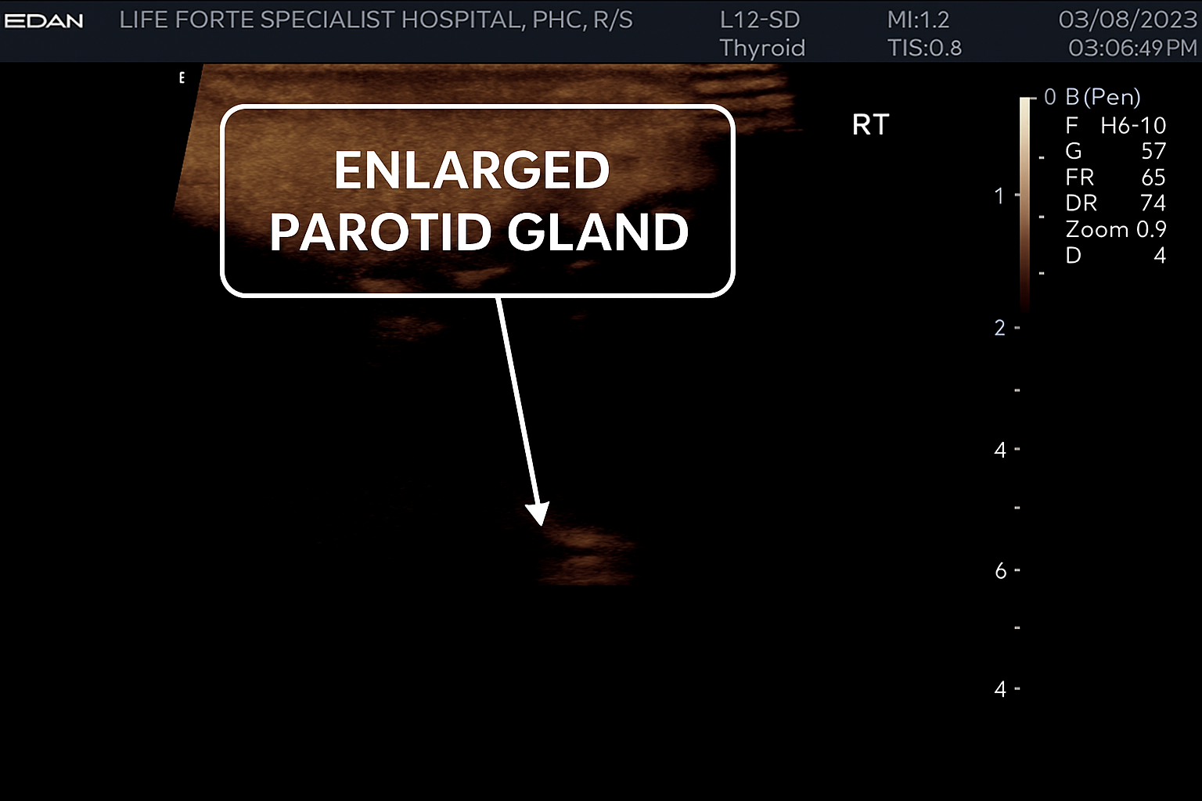
Figure 1: USG showing enlarged parotid gland, which appears as a broad, relatively homogeneous echogenic structure just beneath the skin.
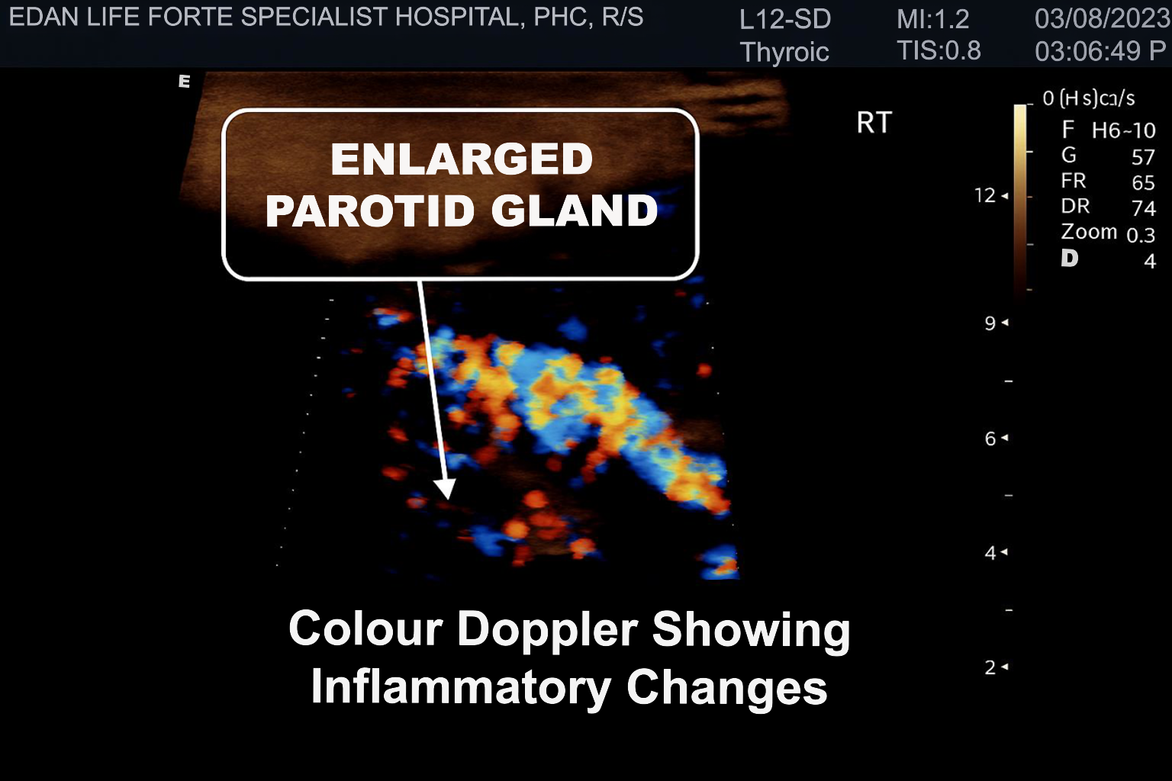
Figure 2: USG demonstrating diffuse, prominent colour flow within the gland in keeping with parotitis
DISCUSSION
Mumps primarily affects children aged 5 to 14 years and is rarely seen in newborns (Defendi, 2025). This has been well-documented in the literature, with few epidemiological studies and case reports on neonatal mumps (Sahdev et al., 2011). A study done in Rivers State, South Nigeria, reported an incidence of 3 per 1000 children, of which none was in the neonatal period, supporting its rarity (Okari et al., 2025). This rarity is likely due to the passive immunity provided to the foetus in utero through the mother’s vaccination (Defendi, 2025; Sato et al., 1979). Consequently, cases of neonatal or congenital mumps are expected to be more common among unvaccinated mothers who may contract mumps during pregnancy (Schwarz, 2017). It is known that women infected during pregnancy with certain pathogens and viruses, such as coxsackie virus, echovirus, measles, and mumps, can transmit these infections across the placenta to the foetus (Ornoy & Tenenbaum, 2006; WHO, 2024).
In a case of congenital mumps reported by Takashaki et al., it was noted that the mother had been diagnosed with mumps 4 weeks and 5 days before delivery (Takahashi et al., 1998). This observation is supported by another report, which described a case of neonatal mumps complicated by severe respiratory distress in the newborn (Groenendaal et al., 1990). The mother's symptoms included a self-limited febrile illness occurring approximately 2 weeks before delivery. This was similar to the history provided by the mother of our index patient.
Additionally, a case reported by Lacour and colleagues noted that the mother developed bilateral parotitis starting on the day of delivery (Lacour et al., 1993). It has also been reported that neonatal mumps infection can be acquired postnatally (Sahdev et al., 2011).
In yet another study by Ray and Fulginiti, where three isolated cases of neonatal mumps were reported, there was a clear pattern of maternal mumps preceding neonatal infection (Jones et al, 1980). Case 1 reported parotid swelling in a neonate born to a mother actively febrile with clinical mumps at the time of delivery, but no complications. Case 2 reported fever, cough, and poor feeding in a 7-day-old neonate born to a mother who had clinical mumps and fever at the time of delivery, and developed hypoxia and respiratory complications after 3 days of admission. Case 3 reported an asymptomatic neonate born to a mother with symptomatic mumps (Jones et al., 1980).
In our index patient, the mother claimed to have been fully immunised in her childhood. Yet, our patient’s mother could not have received any immunisation against mumps because the MMR vaccine is not part of the Nigerian EPI schedule, and the country only recently, in 2026, introduced the Measles-Rubella vaccine (WHO, 2026). Before this, infants received a single measles vaccine. She was vaguely aware of a self-limiting febrile illness a few weeks before delivery. In countries where it is administered, the maternal MMR vaccine, received in infancy, has resulted in the incidence of mumps during pregnancy declining; nevertheless, vaccine immunity may wane over time (Sahdev et al., 2011), which makes adequate history taking imperative to identify such cases.
Mumps in neonates has varied presentations; mostly fever, parotid swelling, poor feeding and restlessness, as demonstrated in the cases reported above (Jones et al., 1980). Our index case presented with fever, poor feeding, parotid swelling and vomiting, which was in keeping with the classical presentation of mumps in the neonatal period.
On the contrary, few cases have been reported where the neonate did not present with a parotid swelling, as expected. Such a case was reported in Switzerland, where the neonate presented with fever, splenomegaly and thrombocytopenia (Lacour et al., 1993). In another case reported by Reman et al, the neonate presented with fever, cough, tachypnea and hepatomegaly (Reman et al., 1986). Thus, highlighting the need for thorough history taking and a high index of suspicion.
Other cases have been reported in abortuses and stillbirths whose mothers were actively infected with mumps, and mumps virus infection was the cause of intra-uterine foetal deaths following autopsy. These were reported by Kurtz et al and Ni J et al., respectively (Kurtz et al., 1982; Ni et al., 1997). In both cases, viral cultures for mumps in foetal tissues, direct immunofluorescence and Polymerase Chain Reaction (PCR) for mumps viral genomes carried out confirmed mumps virus infection (Kurtz et al., 1982; Ni et al., 1997).
Existing literature has demonstrated that clinical mumps in neonates often has a benign course (Sahdev et al., 2011), as was observed in our index patient. However, despite the generally mild natural history of mumps infection in neonates, reports have demonstrated significant complications, particularly respiratory in nature, that can manifest in neonatal mumps. The commonest complications documented were Mumps pneumonia (Groenendaal et al., 1990; Sahdev et al., 2011), Persistent pulmonary hypertension of the newborn (PPHN) (Sahdev et al., 2011; Takahashi et al., 1998), pulmonary haemorrhage (Takahashi et al., 1998), and thrombocytopenia (Lacour et al., 1993).
Groenendaal et al reported a neonate with severe respiratory distress needing immediate ventilation (Groenendaal et al., 1990). Autopsy showed bilateral pneumo-thoraces, pneumopericardium, and viral-like interstitial pneumonia (Groenendaal et al., 1990). Sahdev and his colleagues described a neonate with fever, cyanosis, and respiratory distress requiring ventilation. Echocardiography indicated pulmonary hypertension (Sahdev et al., 2011). Takahashi et al reported a similar mumps case with severe distress and pulmonary hypertension (Takahashi et al., 1998). Jones et al observed hypoxia and respiratory issues after three days, with chest X-ray showing bilateral infiltrates (Jones et al., 1980). However, these were not present in our index patient.
Neonatal mumps often presents with cardiac issues, involving recurrent cough, tachypnea, cyanosis, and cardiogenic shock due to myocarditis (Kadivar et al., 2008). Similar cases include a report by Baandrup U et al with severe heart failure and death, and an autopsy case by Ni J et al showing endocardial elastosis (Baandrup & Mortensen, 1984; Ni et al., 1997).
Due to the cardiac and pulmonary complications, mumps pneumonia, PPHN, and myocarditis should be considered in neonates with severe respiratory distress, especially if maternal exposure is suspected (Groenendaal et al., 1990; Kurtz et al., 1982; Takahashi et al., 1998). Treatment may include high-frequency ventilation, nitric oxide, and surfactant (Jones et al., 1980; Takahashi et al., 1998). Diagnosis involved clinical assessment, mumps IgM/IgG, immunofluorescence, PCR, viral cultures, and supportive tests like blood work, ultrasound, echocardiography, chest X-ray, and ESR (Kurtz et al., 1982; Sahdev et al., 2011; Sato et al., 1979; Takahashi et al., 1998). Our case was primarily clinical, with some supportive tests, limited by resource constraints.
Our patient recovered well and was discharged after five days without complications. Outcomes can vary from full recovery to sequelae or death (Kurtz et al., 1982; Sahdev et al., 2011; Sato et al., 1979; Takahashi et al., 1998).
^{CONCLUSION}
This study highlights the importance of paediatricians and general practitioners maintaining a high level of suspicion for neonatal mumps and their potential complications, particularly in infants who present with fever and parotid swelling, especially when there is a suspicion of maternal exposure.
Additionally, it is crucial to advocate for the incorporation of mumps vaccination into the Expanded Programme on Immunisation in Nigeria. Routine vaccination has proven highly effective in reducing the incidence of mumps.
In the broader context of clinical practice and public health, it is acknowledged that low-resource settings face challenges regarding consistent vaccine uptake. These challenges can include access limitations, socio-cultural biases, misinformation, and individual concerns about vaccine safety. Despite these issues, mumps vaccinations should still be included in routine immunisation schedules.
In the interim, the authors emphasise the importance of complementary preventive strategies. These strategies include early recognition of symptoms, infection control measures, optimising maternal health, and strengthening caregiver education. Moreover, priority should be given to individualised patient counselling and shared decision-making between healthcare providers and caregivers, particularly in areas with low vaccine uptake.
LIMITATION OF STUDY
The Authors of this case report explicitly acknowledge the limitation of the lack of virologic confirmation due to the resource constraints in our locale.
Ethical Approval:
As per international standards or university standards written ethical approval has been collected and preserved by the author(s).
Consent
Written Consent was obtained from patient caregivers for publishing this case report.

Disclaimer (Artificial intelligence)
The author (s) hereby declare that NO generative AI technologies such as Large Language Models (ChatGPT, COPILOT, etc.) and text-to-image generators have been used during the writing or editing of this manuscript.
REFERENCES
Baandrup, U., & Mortensen, S. A. (1984). Fatal mumps myocarditis. Acta Medica Scandinavica, 216(3), 331–333. https://doi.org/10.1111/j.0954-6820.1984.tb03813.x
Centers for Disease Control and Prevention (CDC). (2008). Updated recommendations for isolation of persons with mumps. MMWR. Morbidity and Mortality Weekly Report, 57(40), 1103–1105.
Defendi, G. (2025, February 6). Mumps: Practice Essentials, Background, Etiology. Mumps. https://emedicine.medscape.com/article/966678-overview
Gobe, I., Mogowa, T., Kadimo, K., Tlhakanelo, J. T., & Motswaledi, M. (2026). Mumps disease and vaccination in Africa: A scoping review. Human Vaccines & Immunotherapeutics, 22(1), 2657111. https://doi.org/10.1080/21645515.2026.2657111
Gothard, P. (2013). Mumps. In Principles of Medicine in Africa. (pp. 398–399). Cambridge University Press.
Groenendaal, F., Rothbarth, P. H., van den Anker, J. N., & Spritzer, R. (1990). Congenital mumps pneumonia: A rare cause of neonatal respiratory distress. Acta Paediatrica Scandinavica, 79(12), 1252–1254. https://doi.org/10.1111/j.1651-2227.1990.tb11421.x
Jones, J. F., Ray, C. G., & Fulginiti, V. A. (1980). Perinatal mumps infection. The Journal of Pediatrics, 96(5), 912–914. https://doi.org/10.1016/s0022-3476(80)80577-4
Kadivar, M., Sadighi, M., Kiani, A., & Kocharian, A. (2008). Mumps Myocarditis as a Case of Neonatal Cardiogenic Shock. (Pt 159-162). Acta Medica Iranica, 46(2).
Kurtz, J. B., Tomlinson, A. H., & Pearson, J. (1982). Mumps virus isolated from a fetus. BMJ, 284(6314), 471–471. https://doi.org/10.1136/bmj.284.6314.471
Lacour, M., Maherzi, M., Vienny, H., & Suter, S. (1993). Thrombocytopenia in a case of neonatal mumps infection: Evidence for further clinical presentations. European Journal of Pediatrics, 152(9), 739–741. https://doi.org/10.1007/BF01953989
Ni, J., Bowles, N. E., Kim, Y. H., Demmler, G., Kearney, D., Bricker, J. T., & Towbin, J. A. (1997). Viral infection of the myocardium in endocardial fibroelastosis. Molecular evidence for the role of mumps virus as an etiologic agent. Circulation, 95(1), 133–139. https://doi.org/10.1161/01.cir.95.1.133
Niizuma, T., Terada, K., Kosaka, Y., Daimon, Y., Inoue, M., Ogita, S., Kataoka, N., & Tanaka, K. (2004). Elevated serum C-reactive protein in mumps orchitis. The Pediatric Infectious Disease Journal, 23(10), 971. https://doi.org/10.1097/01.inf.0000141742.19198.b9
Okari, T., Onubogu, U. C., & Tella-Editang, S. A. (2025). Incidence and Seasonal Pattern of Mumps Parotitis in a Paediatric Clinic, Nigeria. Asian Journal of Research in Infectious Diseases, 16(3), 47–53. https://doi.org/10.9734/ajrid/2025/v16i3430
Ornoy, A., & Tenenbaum, A. (2006). Pregnancy outcome following infections by coxsackie, echo, measles, mumps, hepatitis, polio and encephalitis viruses. Reproductive Toxicology, 21(4), 446–457. https://doi.org/10.1016/j.reprotox.2005.12.007
Reman, O., Freymuth, F., Laloum, D., & Bonte, J. F. (1986). Neonatal respiratory distress due to mumps. Archives of Disease in Childhood, 61(1), 80–81. https://doi.org/10.1136/adc.61.1.80
Sahdev, S., Roth, P., & Arroyo, S. E. (2011). Congenital Mumps Pneumonia and Persistent Pulmonary Hypertension. Pediatric Infectious Disease Journal, 30(3), 272. https://doi.org/10.1097/INF.0b013e318209ec46
Sato, H., Albrecht, P., Reynolds, D. W., Stagno, S., & Ennis, F. A. (1979). Transfer of measles, mumps, and rubella antibodies from mother to infant. Its effect on measles, mumps, and rubella immunization. American Journal of Diseases of Children, 133(12), 1240–1243. https://doi.org/10.1001/archpedi.1979.02130120032005
Schwarz, E. R. (2017). Consequences of perinatal infections with rubella, measles, and mumps. Current Opinion in Virology, 27, 71–77. https://doi.org/10.1016/j.coviro.2017.11.009
Takahashi, Y., Teranishi, A., Yamada, Y., Yoshida, Y., Hashimoto, K., Sakamoto, Y., Morikawa, H., Giddings, J., & Yoshioka, A. (1998). A case of congenital mumps infection complicated with persistent pulmonary hypertension. American Journal of Perinatology, 15(7), 409–412. https://doi.org/10.1055/s-2007-993967
WHO. (2023). Mumps reported cases and incidence. https://immunizationdata.who.int/global/wiise-detail-page/mumps-reported-cases-and-incidence?CODE=AFR%26YEAR= Accessed on April 30th, 2026.
WHO. (2024). Mumps virus vaccines: WHO Position Paper, March 2024. https://www.who.int/publications/i/item/who-wer-9911-115-133. Accessed on April 30th, 2026.
WHO. (2026). Nigeria accelerates measles–rubella elimination with second phase campaign in the South. WHO Regional Office for Africa. https://www.afro.who.int/countries/nigeria/news/nigeria-accelerates-measles-rubella-elimination-second-phase-campaign-south. Accessed on April 30th, 2026.

