Molecular Characterization of Fungal Communities Associated with Postharvest Spoilage of Irvingia gabonensis Fruits and Seeds
Abstract
Irvingia gabonensis is an economically important fruit tree native to the tropical rainforest regions of West and Central Africa. However, microbial infestation during postharvest storage significantly threatens its quality, safety, and shelf life. This study aimed to identify and molecularly characterize fungal pathogens associated with postharvest spoilage of I. gabonensis fruits and seeds. Fruits and seeds of I. gabonensis were obtained from Sagana Market (Mile 1) and Creek Road Market in Port Harcourt, Rivers State, Nigeria. Fungi were isolated and purified on potato dextrose agar (PDA). Genomic DNA was extracted from pure cultures using the ZymoBIOMICS DNA MicroPrep Kit. Polymerase chain reaction (PCR) amplification of the internal transcribed spacer (ITS) region was performed, and amplicons were sequenced using the Sanger sequencing method. The obtained sequences were aligned and compared with reference sequences in the National Center for Biotechnology Information (NCBI) database. Phylogenetic analysis was conducted to determine genetic relationships.Phylogenetic analysis revealed eight distinct fungal strains associated with postharvest deterioration of I. gabonensis. The seed samples yielded Aspergillus awomori (JTF1), Penicillium choerospondiatis (JTF2), Talaromyces pinophilus (JTF3), Trametes polyzona (JTF4), Aspergillus flavus (JTF5), and Lentinus squarrosulus (JTF6). The fruit samples yielded Penicillium citrinum (JTF7) and Trametes polyzona (JTF8).The findings demonstrate that I. gabonensis fruits and seeds harbor diverse fungal pathogens that may contribute to postharvest spoilage. Their presence raises concerns regarding food safety and potential public health risks associated with consumption.
Keywords
African Bush Mango, Deoxyribonucleic Acid, Fungi, Irvingiaceae, PCR, Sequencing, Ogbono, Irvingia gabonensis
1.0 INTRODUCTION
Fruits are important components of human nutrition, providing essential nutrients and bioactive compounds that reduce the risk of cardiovascular diseases, aid in diabetes management, and delay the onset of chronic illnesses ¹. Beyond their nutritional benefits, fruits hold cultural significance and are incorporated into religious and traditional ceremonies worldwide. Postharvest diseases, particularly those caused by fungi, are major contributors to fruit spoilage, responsible for losses of approximately 50% of the total production, with fungal invasion accounting for approximately 70% of the deterioration ². Fungal pathogens induce physiological and biochemical changes in fruits, including tissue rot and reduced shelf life, by utilizing sugars, proteins, lipids, and vitamins ³. Toxin-producing fungi have been identified and isolated from spoiled fruits by previous researchers ⁴. In addition to compromising fruit quality, some spoilage fungi produce mycotoxins that pose significant health risks to consumers. Toxin-producing fungi have been identified and isolated from spoiled fruits in previous studies⁴.
Irvingia gabonensis (Aubry-Lecomte ex. O'Rorke) Baill is commonly known as African mango, African bush mango, bush mango, dika nut, dika bread tree, dikka, odika, ogbono, iba-tree, or sweet bush mango. Irvingia gabonensis (Aubry-Lecomte ex. O'Rorke) Baill is widely known by several common names, including African mango, African bush mango, bush mango, dika nut, dika bread tree, dikka, odika, ogbono, iba-tree, and sweet bush mango. ⁵. It has also been reported that I. gabonensis (the sweet variety of Irvingia spp) pulp is used to make jam, jelly and juice ⁶. The seeds, valued for their nutritional and medicinal properties, contain soluble dietary fibre and bioactive compounds that may help regulate blood sugar, improve lipid profiles, and support renal and hepatic functions ⁴. Typically, the fruits are harvested from trees or the ground, softened or processed immediately, and the seeds are sun-dried for preservation, enabling storage for over one year ⁷.
Both fruits and seeds are crucial for food security and nutrition, particularly in rural regions of West and Central Africa. In Nigeria, the seeds are commonly used as a staple soup condiment ⁸. However, they are highly susceptible to postharvest fungal contamination. Previous studies have reported that seeds sold in Nigerian markets are often colonized by spoilage fungi such as Aspergillus flavus and A. parasiticus, which produce aflatoxins that are harmful to human health ⁹. This contamination not only reduces product quality but also poses significant public health risks and threatens food security in the country.
Although fungal contamination of fruits and seeds is well documented, comprehensive characterization of the mycoflora associated with I. gabonensis, particularly using both morphological and molecular approaches, remains limited. Accurate identification of fungal pathogens is essential to understand their diversity, prevent spoilage, and minimize health risks. Molecular tools, including polymerase chain reaction (PCR) and DNA sequencing, have become indispensable for uncovering hidden microbial diversity, providing precise classification, and enabling the rapid identification of microbial species ¹⁰. DNA-based analysis focusing on the internal transcribed spacer (ITS) region is particularly effective for the accurate and timely identification of spoilage-causing fungi.
This study aimed to isolate, identify, and characterize the mycoflora associated with the fresh fruits and dried seeds of I. gabonensis using morphological and molecular techniques. The findings provide valuable information on fungal diversity and their potential impact on fruit quality and consumer health, thereby proffering strategies to mitigate postharvest losses, and simultaneously promote food safety and security.
2.0 MATERIALS & METHODS
2.1 Study Area and Sample Collection
Irvingia gabonensis fruits with disease symptoms were sourced from Sangana local market in Mile 1 while the diseased seeds were obtained from Creek Road market, Port Harcourt, Rivers State, Nigeria (lat. 4.7924° N, long. 7.0010° E) and Creek Road market (Lat. 4.7588° N, long. 7.0261° E) in September 2024, respectively.

A total of 20 fruits and 45 seeds were placed in separate Ziploc bags and transported to the Regional Centre for Biotechnology and Bioresources Research (RCBBR) Laboratory, University of Port Harcourt, Choba, Rivers State, Nigeria. Upon arrival, the samples were washed with distilled water to remove adhering contaminants and endophytic organisms before being cultured at the RCBBR laboratory. DNA extraction, purification, and sequencing of the PCR products were performed at MyAfroDNA, Port Harcourt, Rivers State, Nigeria. The Irvingia gabonensis fruit and seeds used in this study are presented in Figure 1.

2.2 Sample used for the study
The Irvingia gabonensis fruits and seeds used in this study are presented in Figure 1. The Irvingia gabonensis fruits are medium-sized and spherical with yellow-green skins, typical of the species morphology. However, the fruit shows prominent dark, irregular patches, indicative of possible disease, bruising, or fungal contamination, suggesting compromised fruit quality and potential microbial activity on the rind. The seeds were pale to light brown and flattened, with visible signs of discoloration and surface speckling indicative of internal contamination or deterioration associated with the affected fruits.

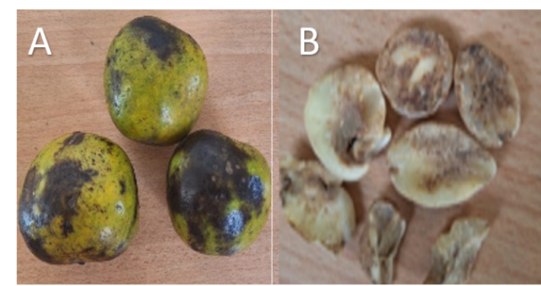
Figure 1: Diseased Irvingia gabonensis fruits and seeds used in the study. A: fruit; B: seeds.

2.3 Isolation of Fungi from Irvingia gabonensis Fruits and Seeds
Fungal organisms were isolated from the visibly damaged fruits of Irvingia gabonensis. Segments of the affected area or tissues of the diseased fruits were cut out using a sterile scalpel and treated with a 1% sodium hypochlorite solution for 3 min, washed with distilled water, and then placed at the centre of the Petri dishes containing potato dextrose agar (PDA). Petri dishes were incubated for 7 days and the plates were observed for morphological characteristics including colour, texture, and colony formation ¹¹. Frequent re-isolation was performed to preserve the purity of the strains. Freshly made PDA was used to grow the pure isolates, which were incubated at 28±2°C for seven days, and then stored at 4°C before DNA extraction.

2.4 DNA extraction, PCR & Sequencing
DNA extraction was performed using the ZymoBIOMICS DNA Microprep Kit (Zymo Research, USA) with the ZR Bashing Beads at MyAfroDNA Laboratory in Port Harcourt, Nigeria. Samples were transferred into the bead bashing tube, and bead beating was performed using a vortex mixer for optimal cell lysis. Subsequent steps, including lysis, DNA binding, washing, and elution, were performed according to the manufacturer’s instructions. Eluted DNA was maintained at -20°C until further analysis. DNA concentration and purity were determined using a Nanodrop spectrophotometer (Thermo Fisher Scientific, USA). Absorbance readings at 260 nm were used to calculate DNA concentration, while the 260/280 nm and 260/230 nm ratios were assessed for purity. The eluted DNA was either processed immediately or stored at -20°C for downstream applications.
2.5 Fungi DNA isolation
Fungal DNA was amplified using the internal transcribed spacer (ITS) region with the universal primer pair ITS1 (Forward: 5′-CTTGGTCATTTAGAGGAAGTAA-3′) and ITS4 (Reverse: 5′-TCCTCCGCTTATTGATATGC-3′). The PCR reaction mixture consisted of DNA template (2 µL), forward and reverse primers (1 µL each), and PCR master mix (4 µL), with nuclease-free water added to make up the final reaction volume. The thermal cycling conditions included an initial denaturation step, followed by 35 cycles of denaturation, annealing, and extension, and a final extension step. The amplified PCR products were visualized using agarose gel electrophoresis.
2.6 Gel Electrophoresis
Gel electrophoresis, a common method for separating DNA based on length was performed to visualize the quality of the amplicons generated by PCR. A 2% agarose gel was prepared by dissolving 0.6g of agarose powder in 30 ml 1X Tris-Borate-EDTA (TBE) buffer. Safe Green dye (30 µl) was added for visibility of the bands. Wells were made on the gel using a comb and PCR products (4 µl) were loaded into the wells with a DNA marker loaded into the first lane of the well. Electrophoresis was performed, and the gel was visualized using a UV transilluminator (Clever Scientific, England). Positive bacterial samples were expected to show a band size of approximately 300-500bp following the partial 16S PCR or 200-420bp following partial ITS PCR.
2.7 Sanger sequencing
For Sanger sequencing, PCR products were purified, and sequencing reactions were set up using the BigDye™ Direct Cycle Sequencing Kit (Applied Biosystems Thermo Fisher Scientific, USA). Sequencing primers tagged with M13 sequencing primers, were employed. Sequencing reactions were purified and loaded onto a Genetic Analyzer for capillary electrophoresis. The sequencing data obtained were then analyzed to confirm and identify the species. The resulting sequences were subjected to a BLAST search on the NCBI database to reveal the species identity of the isolates. ITS sequences were then deposited in GenBank for the assignment of accession numbers.
2.8 Phylogenetic analysis
The evolutionary history was inferred using the Neighbor-Joining method. An optimal tree was used. The percentage of replicate trees in which the associated taxa clustered together in the bootstrap test (1000 replicates) is shown next to the branches. The tree was drawn to scale, with branch lengths in the same units as the evolutionary distances used to infer the phylogenetic tree. The evolutionary distances were computed using the Jukes-Cantor method and are expressed in terms of base substitutions per site. Evolutionary analyses were conducted using MEGA X ¹².
3.0 RESULTS
3.2 Cultural and microscopic characterization of the fungal isolates
Eight fungal isolates (JTF1–JTF8) showed distinct cultural and microscopic variability. Colony morphologies ranged from black or green cottony growth to green lawn-like or white fluffy textures, with reverse pigmentation varying from yellow and brown to milk-white and pink. Microscopically, all isolates possessed septate hyphae; however, there were significant differences in conidial development. Isolates JTF1, JTF2, JTF3, JTF6, JTF7 produced conidia with distinct arrangements, including round heads, columnar clusters, chain-like bunches, and canoe-like shapes. Meanwhile, isolates JTF4, JTF5, JTF8 showed spores without visible conidia.
Table 1: Colonial and microscopic characteristics of the fungal isolates
Isolate ID | Cultural Morphology | Microscopic Morphology | Macroscopic characteristics | Microscopic characteristics
JTF1 | 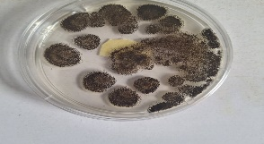 | 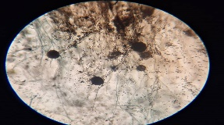 | Black cottony growth with white radial periphery and yellow reverse | Spetate hyphae, round conidia head. Spores present.
JTF2 | 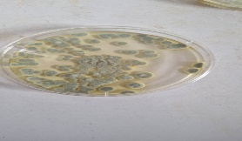 | 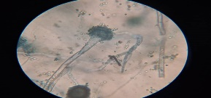 | Green cottony growth with white periphery and brown reverse | Septate hyphae, colunly conidia head. Spores present.
JTF3 | 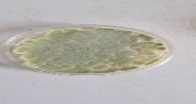 | 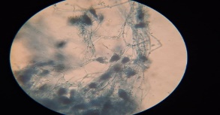 | Green lawny growth with brown reverse | Septate branching hyphae with chainlike bunched conidia spores present.
JTF4 | 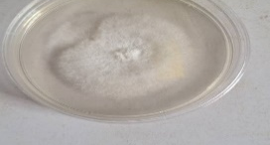 | 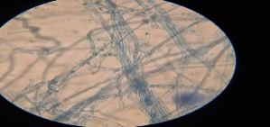 | White fluffy growth with milk colour reverse | Septate branching hyphae. Present of spores. No conidia
JTF5 | 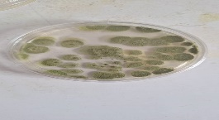 | 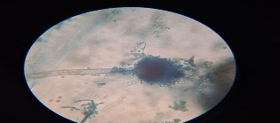 | Green cottony growth with brown reverse | Septate hyphae, present of spores. No conidia.
JTF6 | 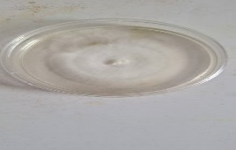 | 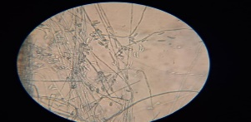 | White fluffy growth with pink reverse | Sept branching hyphae, canoelike conidia. Spores present.
JTF7 | 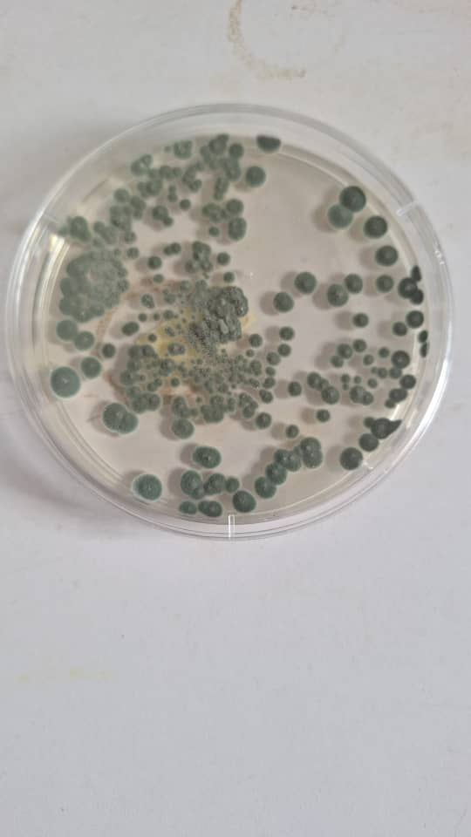 | 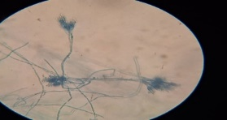 | Green lawnly growth with wrinkled white periphery and brown reverse. | Septate branching hyphae with chainlike bunched conidia spores present
JTF8 | 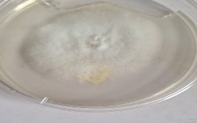 | 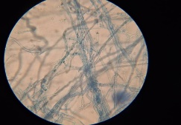 | White fluffy growth with milk colour reverse | Septate branching hyphae. Present of spores. No conidia

jLegend: Isolates JTF1-JTF6 were recovered from seed while JTF7-JTF8 were recovered from the fruits.

2.3 High quality DNA from fungal isolates
High quality DNAs were extracted from all samples. Spectrophotometric analysis indicated the following concentrations: JTF1: 14.2, JTF2: 37.2, JTF3: 105.4, JTF4: 33.5, JTF5: 19.4, JTF6: 1.1, JTF7: 48.4 and JTF8: 39.2. Agarose gel electrophoresis displayed distinct and sharp bands, confirming the integrity of the extracted DNA.
2.4 Fungal DNA successfully detected via PCR
PCR amplification of the target DNA successfully amplified the ITS regions of the fungal DNA. Agarose gel electrophoresis of the PCR products revealed distinct bands at the expected size of ~200-420bp for ITS. The uniformity and intensity of the bands indicated robust amplification. Gel electrophoresis results confirmed the quality and size of the PCR products. Bands corresponding to the expected sizes were observed, validating the specificity of the amplification.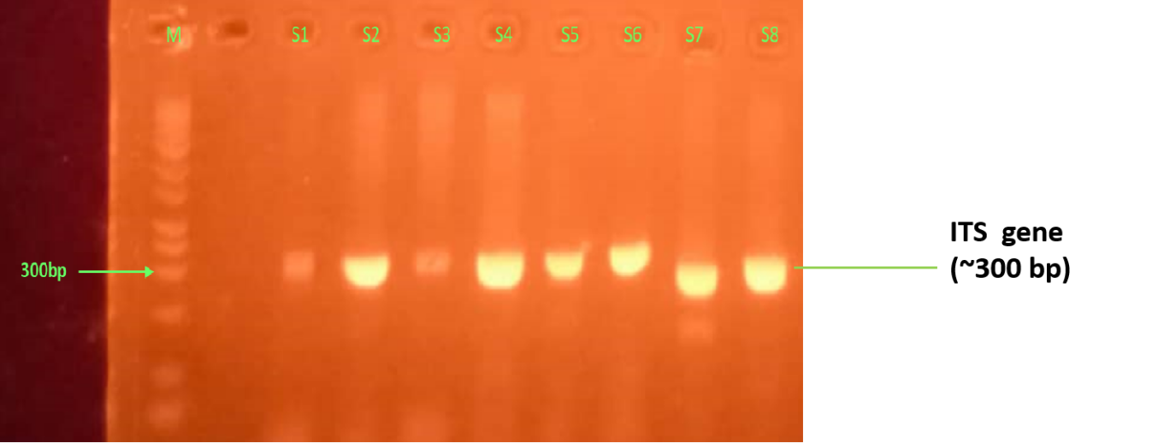
Figure 2. Representative gel of fungi positive samples. Lane M is 100 bp Ladder, samples positive for are indicated with a band size of ~300bp. Lanes S1 to S8 represent isolates JTF1-JTF8.
2.5 Phylogenetic tree analysis of the ITS gene sequences retrieved from fungal isolates
Phylogenetic tree analysis placed the isolates into various fungal genera. JTF1 falls within a mixed Eurotiales clade containing Aspergillus and Penicillium. This is closely related to Aspergillus awamori and Penicillium viridicatum (moderate bootstrap ≥50%), suggesting an Aspergillus-related lineage. JTF2 clustered within Penicillium and was closely related to P. choerospondiatis and P. umkhoba strains (bootstrap 63%) and positioned among plant-associated Penicillium species. JTF3 was placed in Talaromyces, closely related to T. pinophilus and T. sayulitensis (bootstrap ≥65%), confirming its membership in this plant/soil-associated lineage. JTF4 was grouped with Trametes polyzona (bootstrap 59–80%), a ligninolytic white-rot basidiomycete. JTF5 falls firmly within the Aspergillus flavus species complex (bootstrap 100%), confirming its identity as a soil and postharvest fungus. JTF6 aligned with Lentinus squarrosulus (bootstrap 56–88%), a saprobic basidiomycete associated with wood decay. JTF7 clustered in the Penicillium citrinum complex (bootstrap 100%), confirming its identity as a widely distributed plant-associated fungus. JTF8 was strongly associated with Trametes polyzona (bootstrap 78%), similar to JTF4, indicating ligninolytic potential.
Phylogenetic tree analysis revealed that the recovered isolates belonged to different fungal genera. The evolutionary relationships of the isolates with closely related reference sequences retrieved from GenBank are shown in Figure 3a–h.
Isolate JTF1 clustered within a mixed Eurotiales clade containing Aspergillus and Penicillium species (Fig. 3a). The isolate showed close relatedness to Aspergillus awamori and Penicillium viridicatum, with moderate bootstrap support (≥50%), suggesting that JTF1 belongs to an Aspergillus-related lineage within Eurotiales.
The isolate JTF2 was grouped within the genus Penicillium and clustered closely with Penicillium choerospondiatis and Penicillium umkhoba strains (Fig. 3b) with a bootstrap value of 63%. This placement indicates that the isolate belongs to plant-associated Penicillium species.
The phylogenetic tree also placed JTF3 within the genus Talaromyces (Fig. 3c). The isolate clustered closely with Talaromyces pinophilus and Talaromyces sayulitensis with bootstrap support ≥65%, confirming its affiliation with this plant- and soil-associated fungal lineage.
Isolate JTF4 was positioned within the Trametes polyzona clade (Fig. 3d), with bootstrap values ranging from 59% to 80%. This clustering indicates that the isolate belongs to a ligninolytic white-rot basidiomycete commonly associated with wood decomposition.
Similarly, JTF5 clustered strongly within the Aspergillus flavus species complex (Fig. 3e) with a bootstrap value of 100%, confirming its identity as Aspergillus flavus, a fungus commonly associated with soil, plant materials, and postharvest contamination.
Isolate JTF6 aligned with Lentinus squarrosulus reference strains (Fig. 3f) with bootstrap support ranging from 56% to 88%, indicating its close relationship with this saprobic basidiomycete involved in lignocellulosic degradation.
The phylogenetic analysis also showed that JTF7 clustered within the Penicillium citrinum complex (Fig. 3g) with strong bootstrap support (100%), confirming its identity as Penicillium citrinum, a widely distributed fungus associated with plants, soil, and stored products.
Finally, JTF8 clustered strongly with Trametes polyzona reference sequences (Fig. 3h) with a bootstrap value of 78%, similar to isolate JTF4, suggesting that this isolate also belongs to a ligninolytic basidiomycete with potential roles in wood decay and organic matter decomposition.

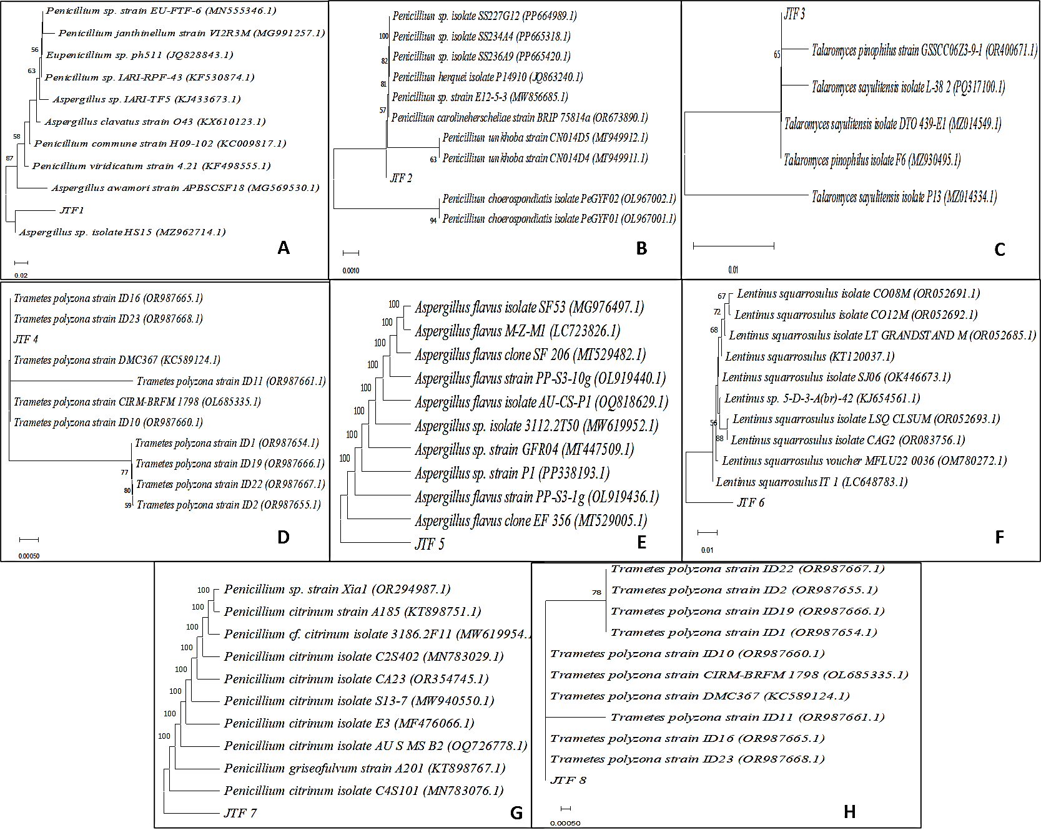
Figure 3. Neighbor-Joining phylogenetic tree of fungal isolates with Genbank related taxa (500 bootstrap replicates).

4.0 Discussion
Fungal contamination is a major issue in the preservation of fruits and stored seeds. Despite their ecological significance, the accurate identification of fungi remains challenging because morphological characteristics are often ambiguous and may not reliably reflect true evolutionary relationships, particularly at the species level. Furthermore, pathogen genomics involves the study of the genetic material of organisms and is crucial in plant pathology for understanding the pathogens responsible for postharvest losses. By analyzing pathogen genomes, researchers can identify virulence factors, resistance genes, and infection mechanisms, enabling the development of targeted diagnostics, treatments, and preventive strategies that enhance plant disease management, nutrition and food security.
The study revealed several fungal organisms associated with post-harvest spoilage of fruits and seeds of I. gbonensis. The result of the nucleotide sequence analysis revealed 8 fungi associated with the postharvest spoilage of seeds and fruits of African bush mango. Aspergillus awomori, Penicillium choerospondiatis, Talaromyces pinophilus, Trametes polyzona, Aspergillus flavus, and Lentinus squarrosulus were found in the seeds, whereas the fruits contained Penicillium citrinum and Trametes polyzona. Similar findings have been reported from mycological investigations of Irvingia gabonensis seeds and fruits sold in Nigerian markets, where several studies have demonstrated that I. gabonensis kernels displayed for sale were contaminated with spoilage fungi ^{9,13}.
The findings of this study align with earlier reports on fungal spoilage of Irvingia species. ¹⁴ identified Rhizopus stolonifer, Aspergillus flavus, Aspergillus niger, and Penicillium italicum in rotted seeds while ¹⁵ reported the isolation of Aspergillus, Penicillium, Rhizopus, and Mucor from fruits of both Irvingia gabonensis and I. wombolu.
The genus Aspergillus comprises several important plant pathogens that affect crops both in the field and postharvest and they have been commonly associated with diseases such as corn ear rot, cotton boll rot, peanut yellow mold, black mold of onion and garlic, and fruit rots of grapes, pomegranates, olives, citrus, and apples ¹⁶. In addition to causing pre and post-harvest diseases, many strains produce significant quantities of toxic compounds known as mycotoxins, which are toxic to mammals when consumed ¹⁷.A number of significant plant diseases, including corn ear rot, cotton boll rot, peanut yellow mold, black mold of onions and garlic, and fruit rots of grapes, pomegranates, olives, citrus, and apples, are frequently linked to the genus Aspergillus¹⁶. Many strains not only cause preharvest and postharvest contamination and diseases, but they also produce large amounts of toxic chemicals called mycotoxins that are hazardous to mammals when ingested^{17.}
Oğuz (2017) reported that A. flavus produces aflatoxins (B1, B2), with reported carcinogenicity, hepatotoxicity, teratogenicity, suppression of the immune system, alteration of DNA structure, hepatitis, hemorrhage, and renal lesions in humansOğuz (2017) indicated that A. flavus synthesizes aflatoxins (B1, B2), which are associated with carcinogenicity, hepatotoxicity, teratogenicity, immune system suppression, DNA structural change, hepatitis, bleeding, and kidney lesions in humans.
. In 2021, a study of ⁸reported Aspergillus flavus as the most prevalent fungus associated with seeds. ¹⁹ isolated Aspergillus flavus and Penicillium sp. from ogbono seed, which is similar to the findings of this study.
Aspergillus awamori was previously classified as a member of the black Aspergillus group (black kōji) used in the fermentation of awamori and shōchū; however, based on international taxonomic studies conducted in 2013, the black kōji employed in these fermentations is now formally recognized as Aspergillus luchuensis ²⁰. Aspergillus awomori has been reported to contaminate and cause postharvest spoilage in fruits and seeds as well as mycotoxin production ^{21,22}. However, Aspergillus awamori has been widely utilized for beneficial industrial, agricultural, and veterinary purposes. Aspergillus awomori inoculation enhances plant growth and stress tolerance by improving root and shoot development, increasing biomass accumulation, promoting the uptake of essential minerals (K, Ca, and Mg), reducing sodium accumulation, and elevating antioxidant enzyme activities (SOD, POD and CAT), thereby mitigating oxidative stress in plants ²³. ²⁴ reported that incorporating A. awomori and A. niger into broiler diets can enhance growth performance and improve meat quality.
Aspergillus awomori (MTCC-548) can be effectively utilized to decolorize and detoxify wastewater containing Rose Bengal Dye, offering an eco-friendly and sustainable solution for industrial effluent treatment ²⁵.
The genus Penicillium, comprising over 200 species, is one of the largest and most diverse groups of fungi and is particularly well known as a source of antibiotics. Species of Penicillium are ubiquitous, occurring in almost all habitats, and exhibit beneficial, neutral, or harmful interactions with plants, existing in both epiphytic and endophytic associations with plants. Penicillium choerospondiatis is a notable pathogen responsible for significant postharvest losses, particularly in Phyllanthus emblica fruits, also known as amla or Indian gooseberry ²⁶. The primary health risk associated with P. choerospondiatis is likely indirect, resulting from food spoilage and reduced availability of nutritious fruit. While specific mycotoxins from P. choerospondiatis have not been documented, many Penicillium species produce harmful secondary metabolites ^{27.} This study represents the first report of P. choerospondiatis associated with postharvest spoilage of Irvingia gabonensis seeds, highlighting its potential role in fruit deterioration and food safety concerns emphasizing its possible contribution to fruit spoilage and food safety issues
.
Talaromyces pinophilus, formerly designated Penicillium pinophilum, is a filamentous fungus known for producing biomass-degrading enzymes such as α-amylase ²⁸, cellulase, xylanase, and α-galactosidase ²⁹. Fungal strains belonging to the genus Talaromyces and the family Trichocomaceae, Formerly called Penicillium pinophilum, Talaromyces pinophilus is a filamentous fungus that produces enzymes that break down biomass, including cellulase, xylanase, α-amylase ²⁸, and α-galactosidase ²⁹. strains of fungi from the family Trichocomaceae and genus Talaromyces,
T. pinophilus synthesizes a variety of bioactive secondary metabolites, including terpenoids, alkaloids, polyketides, tetraenes, esters, lactones, and furanosteroids ^{30,31}. Studies have shown that T. pinophilus produces gibberellic acid (GA), a plant hormone that promotes growth and stimulates GA accumulation in Triticum aestivum. When used as an endophytic inoculant in sewage sludge-amended soils, it enhances plant growth parameters, photosynthetic pigments, osmolytes (soluble proteins, sugars, and total amino acids), enzymatic antioxidants (catalase, superoxide dismutase, and peroxidase), and essential mineral uptake (K, Ca, Mg), while reducing Na, the Na/K ratio, and heavy metals (Cd, Ni, Cu, Zn) in both growth media and plant tissues ³². The fungus is also a known producer of funicone-like compounds, including pinophilones A and B, which exhibit cytotoxic and antiproliferative effects on human cells ³³ It reduces Na, the Na/K ratio, and heavy metals (Cd, Ni, Cu, Zn) in both growth media and plant tissues while increasing plant growth parameters, photosynthetic pigments, osmolytes (soluble proteins, sugars, and total amino acids), enzymatic antioxidants (catalase, superoxide dismutase, and peroxidase), and essential mineral uptake (K, Ca, and Mg) in sewage sludge-amended soils ³². Additionally, the fungus is known to produce chemicals that resemble funicones, such as pinophilones A and B, which have antiproliferative and cytotoxic effects on human cells ³³.
. While these metabolites have potential pharmaceutical applications, their presence in food may pose toxicological risks, warranting their evaluation as potential mycotoxins ³³. Additionally, T. pinophilus produces medically useful metabolites such as 3-O-methylfunicone, which inhibits mesothelioma cell motility 34, and Talaromycolides 1–3, 5, and 11, which inhibit the growth of methicillin-resistant Staphylococcus aureus h ³⁰. Talaromyces pinophilus has shown potential as a biological control agent, with strain HD25G2, isolated from healthy wheat seeds, significantly inhibiting Fusarium culmorum, a major causal agent of root and crown rot in soft wheat ³⁵. This study is the first to report the identification and association of T. pinophilus with postharvest spoilage of Irvingia gabonensis seeds, highlighting its potential role in both fungal diversity and fruit spoilage in Nigerian markets.
There are no reports of Trametes polyzona as a pathogen causing postharvest rot of Irvingia gabonensis. However, ³⁶ reported that T. polyzona was the most prevalent fungus in spoiled apple samples from Nigeria, highlighting its role in the spoilage of fruits. Similarly, ³⁷ stated T. polyzona in the African staple food, Garri. However, ³⁸ reported the potential use of T. polyzona as a biopreservative for tomatoes, where its extracts inhibited spoilage bacteria and extended the shelf life. Despite these beneficial applications, T. polyzona poses health risks, as it has been reported to cause serious pulmonary infections in immunocompromised individuals ³⁹. This study represents the first report of Trametes polyzona associated with I. gabonensis seeds and fruit.
Lentinus squarrosulus, a white-rot basidiomycete of the Polyporaceae family that grows on decaying tropical wood; is an edible and medicinal mushroom, rich in protein, fiber, B vitamins, and minerals, low in fat, and presents minimal toxicological risk ⁴⁰. Acute toxicity studies in rats have shown no adverse effects at doses up to 5,000 mg/kg body weight ⁴¹, supporting its safety for consumption. This study represents the first report of Trametes polyzona associated with I. gabonensis seeds.
Penicillium citrinum is a food-contaminating ascomycete known for producing large amounts of the nephrotoxic mycotoxin citrinin, which has detrimental effects on the kidneys and immune system ⁴² and may contribute to antibiotic resistance due to its antimicrobial properties. In addition to citrinin, P. citrinum produces various extrolites, including tanzawaic acids A–D, ACC, mevastatin, quinocitrinines A and B, quinolactacins, asteric acid, and compactin ⁴³.Although generally a contaminant, it can cause serious pulmonary infections in critically ill or immunocompromised individuals. This study represents the first report of Trametes polyzona associated with the postharvest spoilage of I. gabonensis fruits.
Postharvest spoilage significantly affects the storage stability and market quality of Irvingia gabonensis fruits and seeds, particularly under tropical environmental conditions. Factors such as high moisture content, poor storage facilities, inadequate drying, and mechanical damage during handling enhance fungal growth and accelerate deterioration of stored produce ^{44;45}. In addition, prolonged storage and unfavorable environmental conditions have been reported to increase fungal colonization and reduce the shelf life and overall quality of agricultural products during postharvest handling ^{46.}
5.0 Conclusion
This study provides a detailed molecular characterization of fungi associated with postharvest fruits and seeds of Irvingia gabonensis, revealing a diverse mycobiota dominated by Aspergillus, Penicillium, Talaromyces, Trametes, and Lentinus. Seeds were more heavily colonized than fruits, highlighting their increased susceptibility to fungal contamination during storage. The identification of toxigenic species such as Aspergillus flavus and Penicillium citrinum highlights potential food safety risks. At the same time, the detection of fungi with known industrial and biotechnological applications reflects the ecological complexity of postharvest fungal communities. Importantly, this study reveals several fungi for the first time in association with I. gabonensis, thereby expanding current knowledge of its postharvest mycobiota. These findings highlight the need to develop improved postharvest handling, storage, and monitoring strategies to mitigate fungal spoilage, reduce health risks, and enhance food security in West Africa.

Acknowledgements
The authors acknowledge Dr. Victor Ezebuiro and Dr. Soala Minimah of the Regional Centre for Biotechnology and Bioresources Research, University of Port Harcourt, Rivers State, Nigeria, for their technical assistance and valuable contributions to the successful completion of this study.
Competing Interests Disclaimer:
The authors declare that they have no known competing financial interest, non-financial interest, or personal relationships that could have appeared to influence the work reported in this paper.
Disclaimer (Artificial intelligence)
Author(s) hereby declare that NO generative AI technologies such as Large Language Models (ChatGPT, COPILOT, etc.) and text-to-image generators have been used during the writing or editing of this manuscript.

REFERENCES
1.Abobatta, W F (2021). Nutritional and healthy benefits of fruits. Biomedical Journal of Scientific & Technical Research, 40(2), 31979–31983
2.Hernández-Guerrero SE, Balois-Morales R, Bautista-Rosales PU, López-Guzmán GG, Berumen-Varela G, Palomino-Hermosillo YA, Jiménez-Zurita JO, Bello-Lara EJ, León-Fernández AE 2020 Identification of fungal pathogens of mango and soursop fruits using morphological and molecular tools and their control using papaya and soursop leaf and seed extracts. International Journal of Agronomy 2020: 1–15.
3.Djellout, N C, Baika, K, Bamebarek, H, & Benaissa, A (2020). Microbial soft rot of cultivated fruits and vegetables. Algerian Journal of Biosciences, 1(2), 37-45
4.Pavathi D, Reddy VK 2020 Studies on postharvest diseases of vegetables and fruits of three markets in Warangal town, Telangana State, India. Journal of the Indian Botanical Society 99(1–2): 37.
Resource Announcements, 8(4), e01419-18. https://doi.org/10.1128/MRA.01419-18
5.Hassan, Y R, El-Shiekh, R A, El Hefnawy, H M, & Michael, C G (2024). Irvingia gabonensis Baill. (African mango): A comprehensive review of its ethnopharmacological significance, unveiling its long-standing history and therapeutic potential. Journal of Ethnopharmacology, 326, 117942. https://doi.org/10.1016/j.jep.2024.117942
6.Okoro, B C, Effiong, M U, & George, E K (2025). From waste to resource: Production and utilization of Irvingia fruit pulp in Yenagoa, Nigeria. Ayden Journal of Agriculture and Allied Studies, 13(3), 1-19
7.Chuku, E C, & Aggrey, H (2017). Fungi associated with seeds of Irvingia gabonensis and their effect on shelf life. International Journal of Agriculture and Earth Science, 3(8), 67
8.Okobiebi, B O, & Ezennia, J N (2021). Identification of fungi associated with Irvingia gabonensis (ogbono) seeds spoilage in Benin City, Nigeria. Journal of Applied Sciences and Environmental Management, 25(5), 779-782. https://doi.org/10.4314/jasem.v25i5.13
9.Iyayi IM, Adewumi ERK, Nassang AL 2010 Microbial spoilage of Irvingia kernels in Benin City, Nigeria. Archives of Applied Science Research 2(5): 168–176.
10.Zhang, Y, Ma, A, Gao, L, Peng, H, Jia, Y, & Sun, B (2021). Research progress in molecular identification technology for microbial resources. Chinese Journal of Engineering Science, 23(5), 89–93. https://www.engineering.org.cn/ch/journal/ssca
11.Mulkay, P A, Aranguren, M, & Herrera, O (2010). Diagnóstico de las enfermedades fungosas de mayor incidencia durante la poscosecha de la papaya (Carica papaya L.), el mango (Mangifera indica L.) y el aguacate (Persea americana Miller) en tres localidades frutícolas de Cuba. Revista CitriFrut, 27(2), 23-30
12.Kumar S, Stecher G, Li M, Knyaz C, Tamura K 2018 MEGA X: Molecular Evolutionary Genetics Analysis across computing platforms. Molecular Biology and Evolution 35(6): 1547-1549.
13.Frimpong, G K, Adekunle, A A, Ogundipe, O T, Solanki, K M, Sadhasivam, S, & Sionov, E (2019). Identification and toxigenic potential of fungi isolated from Capsicum peppers. Microorganisms, 7(9), 303. https://doi.org/10.3390/microorganisms7090303
14.Emiri, U N, & Enaregha, E (2021). Effects of pathogenic fungal infection on the nutrient and anti-nutrient constituents of postharvest Irvingia gabonensis (ogbono) seeds. Knowex Food and Agriculture, 2(1), 1-10. https://doi.org/10.17501/2682728X.2021.2101
15.Etebu E 2012 Postharvest pathology and phytochemicals of Irvingia gabonensis (Aubry-Lecomte ex O’Rorke) fruits and wastes. Agricultural Science Research Journal 2(6): 285-294.
16.Zakaria, L (2024). An overview of Aspergillus species associated with plant diseases. Pathogens, 13(9), 813. https://doi.org/10.3390/pathogens13090813
17.Agrios GN 2005 Plant pathology. 5th edition. Elsevier Academic Press, London, 922 pp.
18.Oğuz, H (2017). Mycotoxins and their importance. Turkiye Klinikleri Journal of Veterinary Sciences – Pharmacology and Toxicology, 3(2), 113-119
19.Fashogbon, R O, Popoola, B M, Aforijiku, S, Oyekanmi, A E, Uloko, O R, & Olanbiwoninu, A (2022). Microbial analysis and detection of aflatoxin from Irvingia gabonensis kernels sold in Oyo Town, Oyo State, Nigeria. African Journal of Biotechnology, 21(12), 559-570. https://doi.org/10.5897/AJB2022.17469
20.Hong, S B, Lee, M, Kim, D H, Varga, J, Frisvad, J C, Perrone, G, Gomi, K, Yamada, O, Machida, M, Houbraken, J, & Samson, R A (2013). Aspergillus luchuensis, an industrially important black Aspergillus in East Asia. PLoS ONE, 8(5), e63769. https://doi.org/10.1371/journal.pone.0063769
21.Ogbonna, A C, Okezie, C E, & Onyeji, G C (2022). Fungi associated with postharvest deterioration of ogbono (Irvingia gabonensis) seeds. Journal of Food Protection, 85(3), 450-458
22.Frisvad, J C, Hubka, V, Ezekiel, C N, Hong, S B, Nováková, A, Chen, A J, & Houbraken, J (2019). Taxonomy of Aspergillus series Nigri and mycotoxin production. Studies in Mycology, 94, 1-150. https://doi.org/10.1016/j.simyco.2019.01.001
23.Ali R, Gul H, Hamayun M, Rauf M, Iqbal A, Shah M, Hussain A, Bibi H, Lee IJ 2021 Aspergillus awamori ameliorates the physicochemical characteristics and mineral profile of mung bean under salt stress. Chemical and Biological Technologies in Agriculture 8: 9.
24.Saleh AA, Eid YZ, Ebeid TA, Kamizono T, Ohtsuka A, Hayashi K 2011. Effects of feeding Aspergillus awamori and Aspergillus niger on growth performance and meat quality in broiler chickens. Journal of Poultry Science 48(3): 201–206.
25.Purewal SS 2014 Biodegradation efficiency of Aspergillus awamori (MTCC-548) against Rose Bengal: a toxic dye for human corneal epithelium. Kavaka 43: 32-34.
26.Lai, D, Wang, D, Qin, J, Zhuang, Q, Shao, X, & Xiao, W (2026). Inhibitory effects and mechanisms of physcion against Penicillium choerospondiatis, a serious pathogen in Phyllanthus emblica fruits. Pesticide Biochemistry and Physiology, 216, 106804. https://doi.org/10.1016/j.pestbp.2025.106804
27.Wang, X-C, Zhang, Z-K, & Zhuang, W-Y (2023). Species diversity of Penicillium in southwest China with discovery of forty-three new species. Journal of Fungi, 9(12), 1150. https://doi.org/10.3390/jof9121150
28.Xian L, Wang F, Luo X, Feng YL, Feng JX 2015 Purification and characterization of a highly efficient calcium-independent α-amylase from Talaromyces pinophilus strain 1-95. PLoS ONE 10(3): e0121531.
29.Visser, E M, Falkoski, D L, de Almeida, M N, Maitan-Alfenas, G P, & Guimarães, V M (2013). Production and application of an enzyme blend from Chrysoporthe cubensis and Penicillium pinophilum with potential for hydrolysis of sugarcane bagasse. Bioresource Technology, 144, 587–594
30.Zhai, M M, Li, J, Jiang, C X, Shi, Y P, Di, D L, Crews, P, Xu, F, & Sun, H D (2015). Talaromycolides A–C, novel phenyl-substituted phthalides isolated from the green Chinese onion-derived fungus Talaromyces pinophilus AF-02. Journal of Agricultural and Food Chemistry, 63, 9558-9564. https://doi.org/10.1021/acs.jafc.5b04649
31.Li, C X, Zhao, S, Zhang, T, Xian, L, Liao, L S, Liu, J L, Zhang, W, & Chen, Y (2017). Genome sequencing and analysis of Talaromyces pinophilus provide insights into biotechnological applications. Scientific Reports, 7(1), 1-10
32.El-Shahir, A A, El-Tayeh, N A, Ali, O M, Abdel Latef, A A H, & Loutfy, N (2021). The effect of endophytic Talaromyces pinophilus on growth, absorption, and accumulation of heavy metals of Triticum aestivum grown on sandy soil amended by sewage sludge. Plants, 10(12), 2659. https://doi.org/10.5197/j.2044-0588.2020.042.015
33.Salvatore, M M, DellaGreca, M, Andolfi, A, & Nicoletti, R (2022). New insights into chemical and biological properties of funicone-like compounds. Toxins, 14(7), 466. https://doi.org/10.3390/toxins14070466
34.Buommino, E, Baldi, A, Nicoletti, R, Capasso, R, Casolaro, V, Maffia, M, & Panno, M L (2012). Cell-growth and migration inhibition of human mesothelioma cells induced by 3-O-methylfunicone from Penicillium pinophilum and cisplatin. Investigational New Drugs, 30, 1343-1351. https://doi.org/10.1007/s10637-012-9803-0
35.Bennacer, A, Sahir-Halouane, F, Alvarez, M, Oukali, Z, Bennacer, N E H, Foughalia, A, & Delgado, J (2025). Talaromyces pinophilus strain HD25G2 as a novel biocontrol agent of Fusarium culmorum, the causal agent of root and crown rot of soft wheat. Journal of Fungi, 11(8), 588. https://doi.org/10.3390/jof11080588
36.Olumuyiwa, E O, Ajetunmobi, M T, Adeniji, O F, & Ogunyemi, A K (2025). Morphological and molecular identification of fungi isolated from spoilt apples in Ota metropolis. BMC Microbiology, 25, Article 360. https://doi.org/10.1186/s12866-025-02345-2

37.Ezekiel, C N, Oyedele, O A, Kraak, B, Ayeni, K I, Sulyok, M, Houbraken, J, Frisvad, J C, & Krska, R (2020). Fungal diversity and mycotoxins in low-moisture content ready-to-eat foods in Nigeria. Frontiers in Microbiology, 11, 615. https://doi.org/10.3389/fmicb.2020.00615
38.Adongbede, E M, Jaiswal, Y S, Davis, S S, Randolph, P D, Huo, L N, & Williams, L L (2020). Antioxidant and antibacterial activity of Trametes polyzona (Pers.) Justo. Food Science and Biotechnology, 29, 27-33. https://doi.org/10.1007/s10068-019-00677-5
39.Gauthier, A, Jaubert, J, Traversier, N, Lemant, J, Balu, L, Garcia-Hermoso, D, Welti, S, Favel, A, Picot, S, & Hoarau, G (2017). Trametes polyzona, an emerging filamentous basidiomycete in Réunion Island. Mycoses, 60(6), 412-415. https://doi.org/10.1111/myc.12609
40.Ugbogu, E A, Dike, E D, Okoro, B C, Adurosakin, O E, Ibe, C, Uche, M E, Nosiri, C I, Agim, C, Nwaru, E C, Rahman, M A, & Iweala, E E J (2024). Lentinus squarrosulus: Nutritional composition, phytochemistry, health-promoting activities and toxicity profile. Food and Humanity, 2, Article 100296. https://doi.org/10.1016/j.foodhum.2024.100296
41.Ugbogu, E A, Akubugwo, I E, Ude, V C, Gilbert, J, & Ekeanyanwu, B (2019). Toxicological evaluation of phytochemical characterized aqueous extract of wild dried Lentinus squarrosulus (Mont.) mushroom in rats. Toxicological Research, 35(2), 181–190. https://doi.org/10.5487/TR.2019.35.2.181
42.Schmidt-Heydt, M, Stoll, D, & Geisen, R (2019). Whole-genome sequencing of the fungus Penicillium citrinum reveals the biosynthesis gene cluster for the mycotoxin citrinin. Microbiology
43.Houbraken, J A M P, Frisvad, J C, & Samson, R A (2010). Taxonomy of Penicillium citrinum and related species. Fungal Diversity, 44, 117-133. https://doi.org/10.1007/s13225-010-0047-z
44. Adebayo-Tayo, B. C., Odu, N. N., Michael, M. U., & Okonko, I. O. (2019). Fungi associated with postharvest spoilage of agricultural products and their effects on quality deterioration. International Journal of Food Science and Biotechnology, 4(2), 45–53.
45. Kumar, V., Sharma, A., & Gupta, N. (2021). Postharvest fungal spoilage of fruits and vegetables and management strategies: A review. Journal of Food Quality, 2021, 1–12.
46. Sharma, P., Singh, R., & Kaur, M. (2022). Influence of storage conditions on fungal deterioration and shelf life of agricultural produce. Food Microbiology and Safety Journal, 18(3), 144–152.

