A rare case of Anti-metabotropic Glutamate Receptor 1 (mGluR1) Antibody-Associated Autoimmune Encephalitis in a school going age child related to nursing experience
ABSTRACT
Background: Autoimmune encephalitis (AE) encompasses a group of central nervous system inflammatory disorders mediated by autoimmune mechanisms, characterized by diverse clinical manifestations including psychiatric abnormalities, cognitive impairment, and motor deficits. Anti-metabotropic glutamate receptor 1 (mGluR1) antibody-associated AE is a rare subtype, typically presenting with acute or subacute cerebellar ataxia. Clinical nursing management poses significant challenges, particularly in pediatric patients due to their limited expressive ability and low cooperation.
Case Presentation: This study reports the case of a 6-year-old boy admitted with fever and headache, accompanied by gait instability, involuntary eye movements, and abnormal behaviors (e.g., licking the floor). The patient was diagnosed with anti-mGluR1 antibody-mediated autoimmune encephalitis via cranial MRI and cerebrospinal fluid antibody testing, with concurrent complications of acute bronchitis and mesenteric lymphadenitis. The patient underwent immunotherapy (immunoglobulin and glucocorticoids), antiepileptic treatment, and comprehensive nursing interventions, including safety protection, symptom management, rehabilitation training, and psychological support.
Conclusion: Following systematic treatment and nursing care, the patient was discharged in stable condition. At the 15-month follow-up, the patient exhibited stable emotions, agile responses, and restored motor functions, having successfully returned to school. The long-term prognosis was favorable.
Keywords: Autoimmune encephalitis; anti-metabotropic glutamate receptor 1 (mGluR1); child; nursing care

Introduction
Autoimmune encephalitis (AE) is a collective term for a group of encephalitis mediated by autoimmune mechanisms. The main clinical manifestations include psychiatric and behavioral abnormalities, cognitive impairment, recent memory decline, epileptic seizures, speech disturbance, movement disorders, involuntary movements, decreased consciousness and coma, and autonomic dysfunction ^{[1]}. Among them, the anti-mGluR1 antibody-mediated subtype is relatively rare and special. As metabotropic glutamate receptor 1 (mGluR1) is critical for cerebellar motor learning, when anti-mGluR1 antibodies block glutamate (Glu)-mediated cellular functions in cerebellar cortical Purkinje cells expressing mGluR1, clinical symptoms of acute or subacute cerebellar ataxia may occur ^{[2]}. Pediatric patients present considerable challenges to clinical nursing due to limited expressive ability, rapid disease progression, and low compliance with nursing cooperation. In February 2024, our department admitted one child with anti-mGluR1 antibody-mediated autoimmune encephalitis. Favorable nursing outcomes were achieved through targeted comprehensive nursing interventions. The nursing process and experience are summarized as follows.
1 Case Presentation
A 6-year-old male child was admitted at on February 6, 2024, due to fever for 6 days and headache for half a day.Six days prior to admission, the child developed fever without obvious inducement, with a maximum temperature of 37.4 °C and slight rhinorrhea. He was treated with oral Kanggan Granules and Xiao'er Chaigui Tuire Granules for 2 days at a local hospital, with poor efficacy. The fever peak rose to 38.5 °C, accompanied by intermittent abdominal pain, predominantly periumbilical. He then received oral cefaclor and azithromycin plus topical application therapy for 2 days at a local clinic. During medication, he had one non‑projectile vomiting episode with a small amount of gastric content, and persistent recurrent fever with a peak of 39.5 °C.He visited our hospital’s outpatient clinic on February 4, 2024. Chest anteroposterior and lateral radiographs suggested bronchitis, and intravenous ceftriaxone was administered for anti‑infection therapy for 2 days, with persistent recurrent fever.Half a day prior to admission, the child presented paroxysmal headache (unclear character and location) and intermittent abdominal pain (mainly periumbilical). Headache and abdominal pain were aggravated during fever and relieved after defervescence. He was re‑evaluated in our hospital; B‑ultrasound, routine blood test and other examinations temporarily excluded pediatric surgical acute abdomen. The child was then admitted for further diagnosis and treatment.
Physical Examination:Temperature: 38.6 °C, Pulse: 121 beats per minute (bpm), Respiration: 24 breaths per minute, Height: 126 cm, Weight: 20 kg, Body Mass Index (BMI): 12.6 kg/m².The child had normal development, clear consciousness but poor general condition. He was irritable and restless, yet responded appropriately to questions. Pupils were equal and round bilaterally with brisk light reflex. No rash or jaundice was observed. Lips were pink, and pharyngeal congestion was present. Auscultation revealed coarse breath sounds in both lungs. Heart rhythm was regular with normal heart sounds; no murmurs were heard in any valve auscultation areas.The abdomen was soft and flat, with positive periumbilical tenderness but no rebound tenderness. Liver and spleen were not palpable below the costal margins. Bowel sounds were normal. Neck was supple without rigidity. Knee reflexes were present. Babinski sign was negative; Brudzinski and Kernig signs were not elicited. Neurological examinations including ataxia, pain, temperature, and tactile sensation could not be completed due to poor cooperation.
Auxiliary routine:
Laboratory findings:white blood cell count 13.91×10⁹/L, neutrophil ratio 0.789, lymphocyte ratio 0.133, monocyte ratio 0.07; red blood cell count 3.87×10¹²/L, hemoglobin 112 g/L, platelet count 273×10⁹/L.Erythrocyte sedimentation rate (ESR): 35 mm/h.Interleukin-6 (IL-6): 16.79 pg/ml.Antistreptolysin O (ASO): 360 IU/ml.Procalcitonin (PCT): 0.108 ng/ml.Serum amyloid A (SAA): 329.91 mg/L.Neuron-specific enolase (NSE): 20.4 ng/ml.Peripheral blood smear: increased proportion of band neutrophils, coarser cytoplasmic granules and vacuolar degeneration were visible; mature red blood cells were slightly heterogeneous in size; platelets were scattered.
Neuroimaging:B-ultrasonography: enlarged mesenteric lymph nodes (21.8×4.4 mm).
Cranial magnetic resonance imaging (MRI) + diffusion-weighted imaging (DWI): thickened mucosa of bilateral maxillary sinuses.Contrast-enhanced cranial MRI: patchy slightly low signal intensity was observed in the left cerebellar hemisphere on T1WI sequence compared with the contralateral side.
Cerebrospinal fluid (CSF): next-generation sequencing (NGS) was negative; nucleated cell count 542×10⁶/L, mainly segmented neutrophils; protein 1040 mg/L; anti-metabotropic glutamate receptor 1 (mGluR1) antibody IgG positive,titer1:10.
Electroencephalogram (EEG): the background activity was significantly slowed in the whole brain during wakefulness. The bilateral occipital regions were dominated by continuous medium-amplitude delta rhythm at about 1.2–3 Hz, with occasional basic rhythm at about 7–8 Hz and irregular waveform.
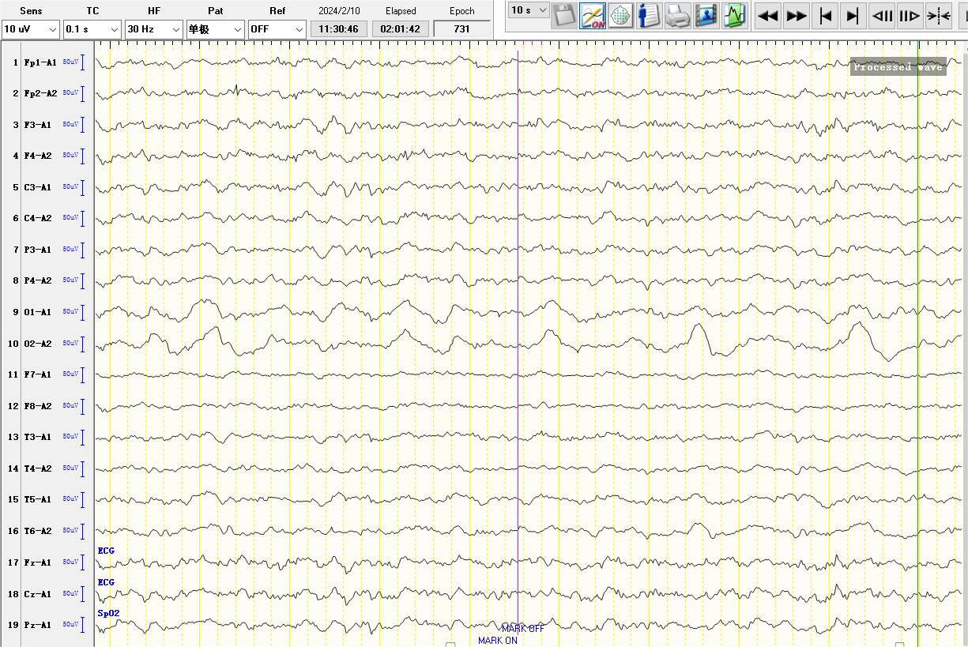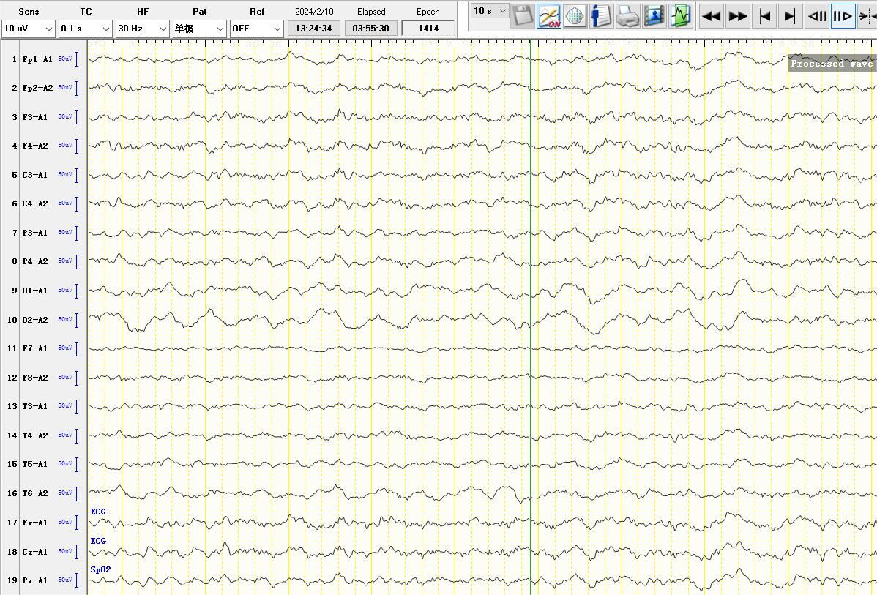
Figure 1 EEG revealed abnormal electroencephalogram
During the current course of disease, the patient was conscious, with intermittent rightward eye deviation, one episode of generalized convulsion, and recurrent fever. Fever was accompanied by headache and abdominal pain. The patient presented with severe irritability, paroxysmal crying, and unsteady gait, accompanied by transient diplopia. There was no cough, wheezing, or vertigo. His oral intake and night sleep were acceptable, and bowel and bladder functions were normal. The patient had a history of perianal abscess in infancy and was diagnosed with adenoid hypertrophy at another hospital.
Final Diagnosis:Comprehensive analysis led to the diagnosis of:Autoimmune encephalitis (mGluR1 antibody-associated);Acute bronchitis;Acute mesenteric lymphadenitis;Streptococcal infection;Vitamin D deficiency;Hyponatremia; Hypercholesterolemia.
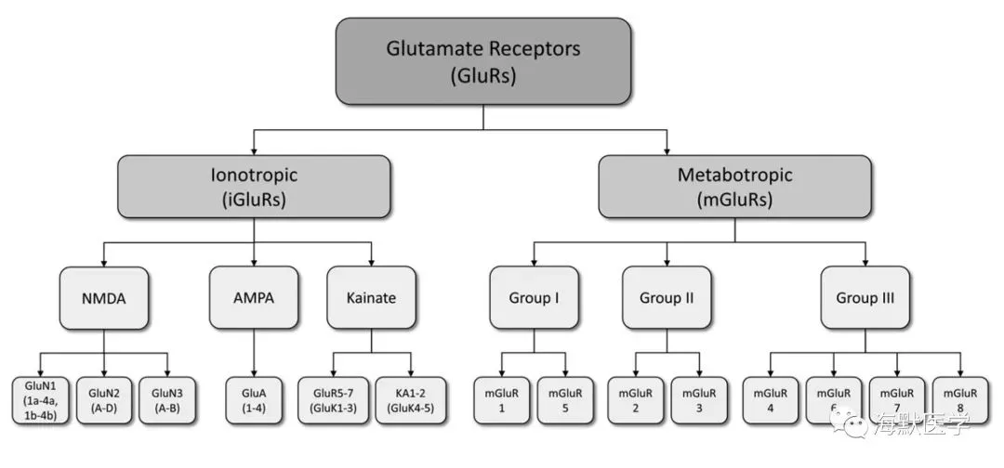
Figure 2 Overview of Glutamate Receptors and Their Subunits in the Central Nervous System (Adapted from Rousseaux)
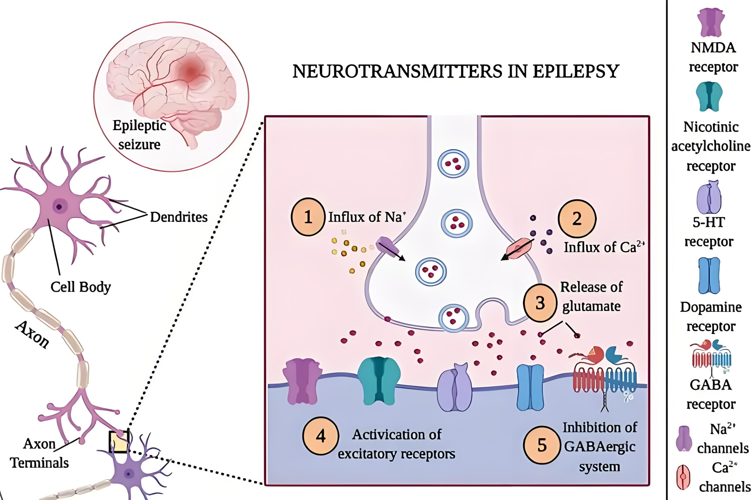
Figure 3 Major neurotransmitters involved in epilepsy
（Akyuz E, et al. Revisiting the role of neurotransmitters in epilepsy: An updated review. Life Sciences, 2021, 265: 118826.）
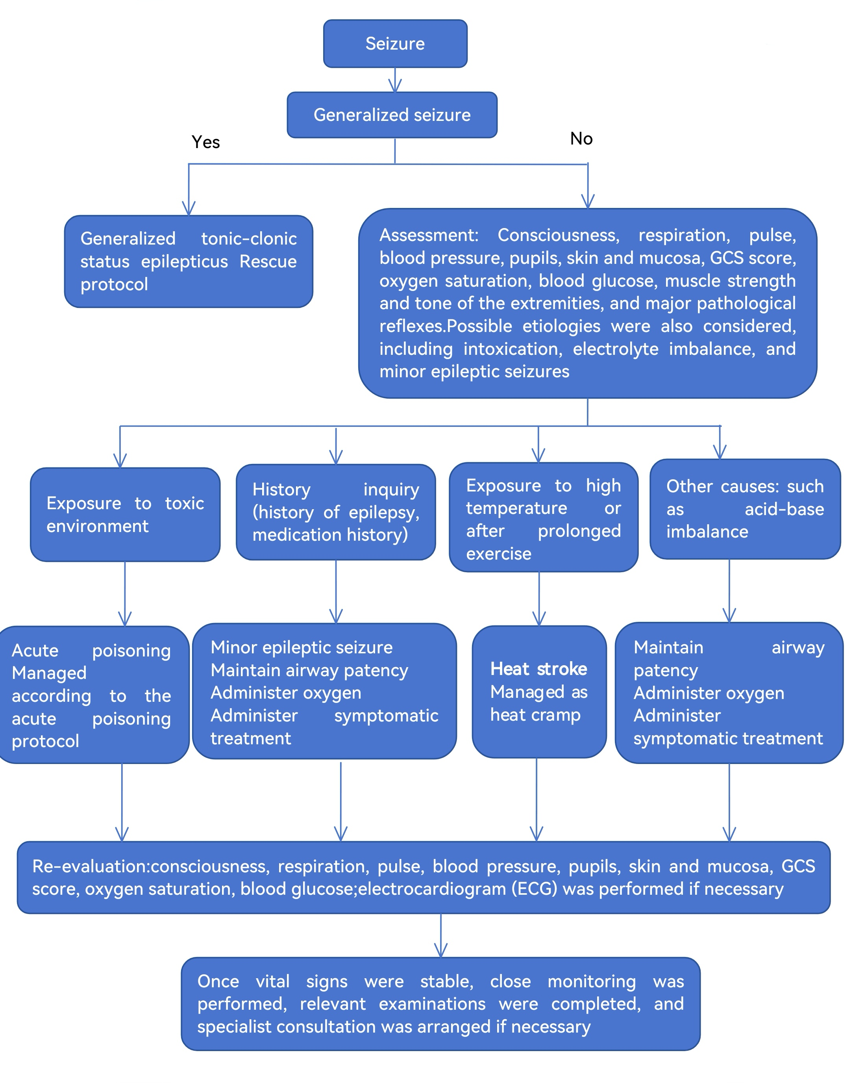
Figure 4 Management Protocol for Seizure
2 Treatment and Outcome
After a period of treatment and nursing, the child’s mood became stable, with no abnormal behaviors such as licking the floor. He could respond appropriately to questions, paroxysmal events were significantly reduced, and he was able to walk with assistance, though with slight unsteadiness. The patient was then discharged.
3 Nursing Interventions
3.1 Nursing for Impaired Physical Activity and Safety Protection
3.1.1 Basic Safety Protection
Muscle strength, muscle tone, balance, gait and coordination function were evaluated. The child presented with cerebellar ataxia and abnormal behaviors. Bilateral bed rails were raised throughout the bedridden period, non-slip mats and soft cushions were placed on the floor beside the bed to prevent collision injuries.24-hour special supervision was provided; the child was strictly prohibited from getting out of bed alone. Slow and gentle assistance was given during turning, sitting up and walking to avoid dizziness or falls caused by sudden posture changes.For abnormal behaviors such as floor licking, the child’s attention was diverted timely. If necessary, restraints were applied when the child was awake and emotionally stable, with soft pillows placed at the restraint sites to ensure proper tightness.Restraints were released every 2 hours, and assessment of skin injury, local blood supply and emotional state was performed at least every 4 hours, with detailed nursing records documented ^{[3–4]}.
3.1.2 Limb Function Training
After the condition was stabilized (i.e., involuntary movements and convulsions were controlled), family members were instructed to assist with passive limb training, including limb flexion-extension, rotation and muscle massage,15–20 minutes per session, twice daily, to promote blood circulation, prevent muscle atrophy and joint stiffness.Once the child could sit up independently, he was assisted to practice balance with the help of bed rails, and gradually transitioned to walking with support.Continuous protection was provided during training, and intensity was adjusted according to the child’s tolerance to avoid discomfort induced by overexertion.
3.2 Nursing for Involuntary Movements and Eye Care
3.2.1 Symptom Monitoring and Intervention
The frequency, duration, and precipitating factors of involuntary movements of the eyes and head were closely observed, documented, and promptly reported to the attending physician for treatment adjustment.During episodes, stimulation from strong light and noise was avoided; the ward was kept quiet and dim to reduce external interference. The child was gently comforted and informed that the symptoms were caused by the disease, so as to relieve fear and prevent symptom aggravation due to anxiety.
3.2.2 Eye Protection
Frequent eye rubbing during episodes may easily cause ocular mucosal injury. Special supervision was provided during attacks to gently stop excessive eye rubbing; if necessary, sterile gauze eye patches were applied to prevent hand contact with the eyes.The eyes were cleaned with normal saline twice daily, with gentle manipulation to avoid compression on the eyeballs. The eyes were monitored for redness, swelling, increased secretions, or other signs of infection, and abnormalities were managed promptly.
3.3 Prevention and Emergency Nursing for Seizures
3.3.1 Preventive Nursing
Combined with electroencephalogram monitoring results, the characteristics of the child’s seizures were evaluated. Immunotherapy and antiepileptic drugs were administered according to medical orders to prevent trauma and alert against status epilepticus ^{[5]}.Emergency equipment such as an opener, tongue depressor, and aspirator was routinely prepared at the bedside. Family members were informed of common precipitating factors of seizures to avoid stimulation, maintain emotional stability, and ensure adequate sleep.
3.3.2 Emergency Nursing
When the child developed sudden generalized convulsions, he was immediately placed in a supine position with the head turned to one side. The collar and belt were loosened to maintain a patent airway.Restrictive force on limbs was avoided to prevent fracture or dislocation. Dangerous objects nearby were removed.The emergency procedure was activated and the physician was notified. Vital signs and consciousness were continuously monitored, and seizure onset time, duration, and manifestations were recorded.After convulsion relief, oral secretions were cleaned, and the child was comforted. Subsequent discomforts such as headache and fatigue were observed^{[6]}.Consciousness and vital signs were monitored every 30 minutes within 2 hours after the seizure until the child was fully awake .
3.4 Nursing for Headache, Visual Disturbance and Emotional Management
3.4.1 Nursing for Headache and Visual Disturbance
Mannitol was infused on time according to medical orders, and adverse reactions such as nausea and vomiting were closely observed. The child was instructed to maintain a comfortable position and reduce head movement to relieve headache.
Given the presence of blurred vision and diplopia, reading, watching TV, playing with mobile phones and other activities were avoided to reduce ocular burden. Assistance and support were strengthened during daily activities to prevent falls and injuries caused by poor vision. Improvement of headache and visual symptoms was evaluated regularly.
3.4.2 Emotional and Abnormal Behavior Intervention
The child was irritable and prone to crying; therefore, nursing care was provided with a gentle and patient attitude. Attention was diverted through storytelling, playing with toys and playing soft music to relieve negative emotions.For unclear articulation, communication with the child was conducted at a slow speed, assisted with gestures and facial expressions to facilitate understanding. The child was encouraged to express himself slowly and given affirmation and encouragement to enhance communication confidence, so as to prevent aggravated irritability caused by poor expression.For abnormal behaviors such as floor licking, the child was not blamed or criticized; the behavior was stopped timely and the child was guided to normal activities. Family members were informed that such behaviors resulted from central nervous system dysfunction caused by the disease, so as to avoid excessive anxiety or scolding the child.
3.5 Medication Nursing and Condition Monitoring
3.5.1 Nursing for Immunosuppressive Therapy
Before initial administration, thorough health education was provided to ensure the child and his family understood the treatment plan and potential adverse drug reactions ^{[7]}.Intravenous immunoglobulin and methylprednisolone sodium succinate were infused strictly in accordance with medical orders.The initial infusion rate of intravenous immunoglobulin was controlled at 1 mL/min. After 30 minutes of observation without allergic reactions such as rash, fever or dyspnea, the rate was gradually adjusted to 2–3 mL/min.Discomforts including chest distress, palpitations and nausea were closely monitored during infusion. The infusion line was flushed with normal saline after completion.For oral prednisone, family members were instructed to administer the drug on an empty stomach in the early morning to reduce gastrointestinal irritation, and it could be taken with milk if needed.Blood glucose and electrolytes were monitored regularly, and adverse reactions related to hormones such as abdominal pain, abdominal distension and rash were observed closely.
3.5.2 Comprehensive Condition Monitoring
Temperature management is one of the key points in nursing patients with autoimmune encephalitis ^{[8]}. Axillary temperature monitoring was preferred ^{[8]}.Symptomatic interventions were actively implemented when the child’s temperature was abnormal to maintain the target temperature ^{[8]}, so as to improve neurological prognosis.When pharmacological cooling alone is ineffective, surface physical cooling is recommended as the first‐line method. Parents may assist with physical cooling measures such as antipyretic patches and warm water sponge bathing; however, alcohol sponging is contraindicated. During the cooling process, vital signs, consciousness, and skin condition should be observed and recorded every 30–60 minutes until the target temperature is reached, to prevent complications including arrhythmia, coagulopathy, shivering, and frostbite ^{[8-9]}.Dynamic evaluation of disease changes was performed. Continuous electrocardiographic monitoring was used to monitor heart rate, rhythm, respiration, blood pressure and SpO₂.Consciousness (GCS score) ^{[10]}, pupil size and light reflex were assessed every 30 minutes.Headache, visual disturbance and involuntary movements were evaluated hourly with detailed documentation.Once confusion, unequal pupils, abnormal respiratory rhythm, frequent involuntary movements or recurrent convulsions occurred, the physician was notified immediately to guard against severe complications such as brain herniation and respiratory failure.The recovery of physical activity including gait, muscle strength, muscle tone and limb coordination was evaluated regularly.The relief of headache, blurred vision and diplopia was continuously observed.Language communication was dynamically assessed by monitoring the clarity of articulation.
Emotional state and episodes of abnormal behaviors were recorded to evaluate the effect of emotional intervention.Routine blood tests, electrolytes, liver and renal function were re-examined periodically.Nutritional indicators including body weight and serum albumin were monitored to assess nutritional status and internal environment stability.
3.6 Nutritional Support, Oral and Skin Care
3.6.1 Nutritional Support
The child’s eating ability was evaluated. Due to irritability and unclear articulation, a semi-liquid diet was provided at the initial stage, assisted by family members with slow and small frequent feedings to avoid choking.The child was encouraged to eat independently with easy-to-grasp tableware, and patient guidance was given to ensure adequate intake of protein, vitamins and other nutrients.Body weight, routine blood test and electrolytes were monitored regularly to assess nutritional status and adjust the diet plan timely.
3.6.2 Oral and Skin Care
Oral cleaning with normal saline was performed twice daily. The child was instructed to rinse mouth with warm water after meals to prevent food residue and oral infection.In view of floor-licking behavior, the frequency of oral care was increased, and oral mucosa was observed for erosion or ulceration.The bed unit was kept clean and dry. Frequent position changes were encouraged to prevent pressure injury.
3.7 Family Health Education and Psychological Nursing
3.7.1 Psychological Counseling
Active communication was conducted with parents. The etiology, specific symptoms, treatment plan and key nursing points were explained in plain language.Parents were informed that although the disease is rare, symptoms can be effectively controlled through standardized treatment and nursing, so as to relieve parental anxiety.Parents were encouraged to express concerns, and questions were answered timely. Rehabilitation information of similar cases was shared to enhance their confidence in treatment.Meanwhile, parents were informed that abnormal behaviors and irritability were caused by the disease, to avoid anxiety or self-blame.
3.7.2 Health Education
Comprehensive health education was provided before discharge, including administration, dosage, adverse reaction monitoring and withdrawal precautions of oral prednisone, emphasizing that the dose should not be reduced or discontinued without medical advice.Regular re-examinations of blood routine, liver and renal function, and antibody levels were recommended.Family members were instructed to master home limb rehabilitation training and first aid procedures for seizures, and key points of daily safety protection were emphasized.Strenuous exercise, emotional excitement and infection should be avoided. Medical attention should be sought immediately if headache, unsteady gait, convulsions or other symptoms occur.Parents were guided to pay attention to the child’s psychological state, provide more companionship and encouragement, and help the child gradually restore normal social and motor abilities.
3.8 Discharge Follow-up
The child was discharged on February 29, 2024, with stable condition.1-month follow-up: The child had occasional involuntary eye movements, with clear pronunciation and independent walking, but still required assistance when going up and down stairs.2-month follow-up: The child presented occasional synchronous upward and downward involuntary movements of both eyes and head, about 80–90 times per minute, lasting 4–5 minutes each episode. During episodes, the child complained of eye pain and blurred vision, but remained conscious with appropriate responses, no crying, irritability, screaming, dizziness, headache, or neck stiffness. Symptoms were relieved after gentle comfort.4-month follow-up: Involuntary eye movements gradually disappeared, and the child could move freely.7-month follow-up: No abnormal behaviors or movements were observed.15-month follow-up: The child was emotionally stable, responsive, and fully active. He was in the first grade with satisfactory academic performance.
4 Discussion
Anti-mGluR1 antibody-mediated autoimmune encephalitis is a rare subtype of autoimmune encephalitis, typically characterized clinically by cerebellar ataxia. However, this pediatric patient presented with distinctive symptoms, including involuntary eye and head movements, abnormal behavior, gait instability, and convulsions. Furthermore, the child's limited verbal expression, significant emotional lability, and poor cooperation with care further increased the difficulty and risk of nursing management.The core of this nursing care lay in the precise identification of the child’s specific symptoms, the formulation of individualized and comprehensive nursing interventions targeting multi-dimensional nursing problems, and the strengthening of symptom monitoring, safety protection, symptomatic nursing, and psychological support. Close monitoring of disease changes was the key to timely adjustment of the nursing plan, especially for sudden symptoms such as involuntary movements and convulsions, which required early identification and intervention to prevent complications.Targeted nursing measures were adopted for specific symptoms, such as ocular discomfort caused by involuntary movements and safety risks induced by abnormal behaviors, which not only relieved the child’s discomfort but also ensured nursing safety. Meanwhile, emphasis was placed on psychological nursing for the child and his family. Through effective communication and health education, negative emotions were alleviated, a favorable doctor-nurse-patient relationship was established, and the child’s recovery was promoted.
In clinical nursing of such rare cases, medical-nursing communication and multidisciplinary collaboration should be strengthened to accumulate nursing experience and improve the ability to care for specific disease symptoms. Meanwhile, nursing procedures should be optimized according to the physical and psychological characteristics of children, with attention to nursing details, so as to provide comprehensive, high-quality, and individualized nursing services and provide a reference for the nursing of similar cases.
5Conclusion
Although the clinical manifestations of this pediatric patient with anti-mGluR1 antibody-mediated autoimmune encephalitis were complex and rare, early and precise identification of specific symptoms (such as cerebellar ataxia, involuntary movements and abnormal behaviors), together with comprehensive nursing interventions centered on safety protection, symptom management, rehabilitation training and psychological support, could effectively control the disease condition and prevent complications.
Systematic health guidance and long-term follow-up after discharge showed that the patient's neurological function recovered well with a favorable long-term prognosis.
This case indicates that for rare pediatric autoimmune encephalitis, individualized meticulous nursing and multidisciplinary collaboration are the keys to promoting recovery and improving long-term quality of life.

Informed Consent: Written informed consent was obtained from the patient's parents/legal guardians for this case report and any accompanying images.

Ethical Approval:

As per international standards or university standards written ethical approval has been collected and preserved by the author(s).
Disclaimer (Artificial intelligence)
Author(s) hereby declare that generative AI technologies such as Large Language Models, etc. have been used during the writing or editing of manuscripts. This explanation will include the name, version, model, and source of the generative AI technology and as well as all input prompts provided to the generative AI technology
Details of the AI usage are given below:
AI technology (e.g., DouBao、QianWen) was used solely for the purpose of improving the readability and language of the manuscript. The authors reviewed and edited the content as needed and take full responsibility for the content of the publication.

References
[1] Neuroinfectious Diseases and Cerebrospinal Fluid Cytology Group, Neurology Branch of Chinese Medical Association. Chinese expert consensus on the diagnosis and treatment of autoimmune encephalitis (2022 edition). Chinese Journal of Neurology, 2022, 55(9):931-949.
[2] Sakashita K, Nishida K, Takenaka Y, et al. Favorable outcome with intravenous immunoglobulin therapy in late-onset anti-mGluR1 encephalitis: a case report and literature review[J]. Case Reports in Neurology, 2022, 14(3):494-500.
[3] Schizophrenia Collaborative Group, Psychiatric Branch of Chinese Medical Association. Expert consensus on psychiatric management of patients with agitation[J]. Chinese Journal of Psychiatry, 2017, 50(6):401-410.
[4] Garriga M, Pacchiarotti I, Kasper S, et al. Assessment and management of agitation in psychiatry: expert consensus[J]. The World Journal of Biological Psychiatry, 2016, 17(2):86-128.
[5] Gillinder L, Warren N, Hartel G, et al. EEG findings in NMDA encephalitis – a systematic review[J]. Seizure, 2019, 65:20-24.
[6] Youth Committee of the Chinese Anti-Epilepsy Association, Chinese Anti-Epilepsy Association. Expert consensus on the principles of pre-hospital rapid epileptic seizure termination. Epilepsy Magazine, 2025, 11(5): 379-383. doi: 10.7507/2096-0247.202506010.
[7] Bo L, Wang J, Zhang YJ, et al. Chinese expert consensus on nursing care of patients with autoimmune encephalitis[J]. Chinese Nursing Research, 2023, 37(12):2069-2077.
[8] Chinese Medical Association, Pediatric Infectious Disease Group; Chinese Nutrition Society, Nutrition and Health Food Branch; Chinese Association of Maternal and Child Health, Professional Committee of Child Development and Disease. Expert consensus on whole-process management of fever in children (2026 edition). Natl Med J China. 2026;106(12):1099-1124. DOI: 10.3760/cma.j.cn112137-20251023-02747.
[9] Neurocritical Care Group, Neurology Branch of Chinese Medical Association. Chinese expert consensus on the construction of neurological intensive care unit[J]. Chinese Journal of Neurology, 2014, 47(4):269-273.
[10] Dong XY, Zheng DM, Nao JF. Clinical characteristics and factors associated with short-term prognosis in adult patients with autoimmune encephalitis of non-neoplastic etiology[J]. Neurological Sciences, 2019, 40(8):1567-1575.

