Long-Run Price Convergence and Market Efficiency in Selected Selected Cryptocurrencies: A Cointegration and Vector Error Correction Model Approach

Original Research Article

Abstract
This study investigates long-run price convergence and weak-form market efficiency among major cryptocurrencies using daily closing prices for Bitcoin (BTC), Ethereum (ETH), Binance Coin (BNB), Solana (SOL), and Ripple (XRP) from April 11, 2020 to August 30, 2025. Unit root tests (ADF, PP, and DF-GLS) indicate that all price series are non-stationary in levels but stationary in first differences, confirming that they are integrated of order one, I(1). Johansen cointegration tests provide evidence of one cointegrating relationship (r ≤ 1) at the 5% significance level (trace statistic = 72.10 > 69.82), indicating a shared long-run equilibrium among the five cryptocurrencies. A Vector Error Correction Model (VECM) with rank one reveals statistically significant error-correction coefficients for all assets, with adjustment speeds of α = 0.005 for BTC, 0.007 for ETH, 0.013 for BNB, 0.017 for SOL, and 0.008 for XRP, implying slow and heterogeneous convergence toward equilibrium. The cointegration spread is highly persistent, with an estimated autoregressive coefficient of ρ = 0.995, corresponding to a half-life of approximately 151 days. Weak-form market efficiency tests based on Ljung-Box statistics and AR(1) regressions indicate that BTC and XRP exhibit return behavior consistent with weak-form efficiency, while ETH, BNB, and SOL display statistically significant short-run predictability. Overall, the results suggest that major cryptocurrency markets are strongly integrated in the long run but exhibit partial weak-form efficiency, with limited long-horizon diversification benefits and slow equilibrium adjustment.

Keywords: Cryptocurency, Cointegration, Market Efficiency, Price convergence, Long-run, Half-life, VECM

1. Introduction
The emergence of cryptocurrencies represents a structural innovation in monetary architecture, characterized by algorithmic issuance rules and distributed ledger validation mechanisms that operate outside traditional central bank frameworks. Built on blockchain technology, these digital assets operate through decentralized networks that validate transactions without centralized intermediaries (Nakamoto, 2008). Since the introduction of Bitcoin in 2008, the cryptocurrency ecosystem has expanded dramatically, attracting investors, researchers, and policymakers across the globe. As of 2025, thousands of cryptocurrencies exist with a total market capitalization that has periodically approached $4 trillion (CoinMarketCap, 2025; Crowdfund Insider, 2025; World Bank, 2025).
Despite their rapid growth, cryptocurrency markets remain characterized by high volatility and strong speculative dynamics (Yahaya, Oyinloye & Adams 2022). One commonly observed feature of these markets is the tendency for major cryptocurrencies to exhibit co-movements in price. When the price of a dominant asset such as Bitcoin experiences large fluctuations, other cryptocurrencies often respond in a similar direction. This raises an important question regarding whether such co-movements reflect temporary correlations or deeper structural relationships in long-run (Adams, Asemota & Ibrahim, 2024).
The econometric concept of cointegration provides a rigorous framework for examining long-run equilibrium relationships among non-stationary time series (Engle & Granger 1987; Johansen 1988). If cryptocurrency prices are cointegrated, their individual price paths may wander over time but remain linked through a stable long-run equilibrium. Deviations from this equilibrium would be corrected through an error-correction mechanism. Understanding whether cryptocurrencies share common long-run relationship has important implications for financial markets. From a portfolio perspective, cointegration may limit the diversification benefits of holding multiple cryptocurrencies. From a systemic standpoint, strong interdependencies may increase the potential for shocks originating in one asset to propagate throughout the broader cryptocurrency market. Hence, persistent and predictable reversion toward a common equilibrium if present might point to temporary inefficiencies that sophisticated traders could exploit until transaction costs and frictions dissipate such opportunities (Lo & MacKinlay, 1988; Campbell, Lo, & MacKinlay, 1997; Adams & Olive, 2024).
This study seeks to examine the long-run price convergence and weak-form market efficiency among major cryptocurrencies using daily closing prices for Bitcoin (BTC), Ethereum (ETH), Binance Coin (BNB), Solana (SOL), and Ripple (XRP) from April 11, 2020 to August 30, 2025.
2. Literature Review
The study of long-run relationships among financial assets has long been central to financial econometrics. Cointegration theory, introduced by (Engle & Granger, 1987) and later extended by (Johansen, 1988), provides the theoretical basis for examining equilibrium relationships among non-stationary time series. In the context of cryptocurrency markets, cointegration analysis has gained increasing attention as researchers attempt to understand whether digital assets behave independently or as components of an interconnected system. Early studies often focused on Bitcoin alone, but more recent research has examined broader cryptocurrency networks.
Several empirical studies provide evidence of long-run relationships among cryptocurrencies. Aysan et al. (2021) analyzed daily prices of nine major cryptocurrencies and found multiple cointegrating relationships, indicating persistent long-run interdependencies. Similarly, (Keilbar & Zhang (2021) developed a time-varying cointegration framework showing that the strength of these relationships changes over time, particularly during periods of market stress. Other research emphasizes the role of structural breaks and regime shifts. Arık (2025) applied Fourier-based cointegration methods to account for gradual structural changes in cryptocurrency markets and found significant long-run equilibrium relationships among leading digital assets. Gabriel & Kunst (2024) further demonstrated that cointegration spreads among major cryptocurrencies can be exploited through statistical arbitrage strategies. Another important dimension of the literature concerns the relationship between cointegration and market efficiency. According to the Efficient Market Hypothesis (Fama, 1970), asset prices should fully reflect available information. However, if deviations from cointegrating relationships systematically predict future returns, this may indicate the presence of temporary inefficiencies.
3. Materials and Methods
  - Data
This study used secondary data to examine the long-run relationships and market efficiency among selected cryptocurrencies. The daily closing price secondary data was chosen because it provides reliable, high-quality historical price series that are widely used in academic research on financial markets, allowing for replicability and consistency across studies. The primary variables analyzed are the daily closing prices (in USD) of five major cryptocurrencies: Bitcoin (BTC), Ethereum (ETH), Solana (SOL), Ripple (XRP), and Binance Coin (BNB). Daily closing prices represent the final traded price of each asset at the end of the trading day (23:59 UTC) and serve as the key variable. The sample period spans from April 11, 2020, to August 30, 2025, yielding 1,973 observations for each cryptocurrency. This period was selected because it covers significant market cycles, including the post-COVID bull run (2020 - 2021), the 2022 bear market, the 2024 Bitcoin halving, the subsequent recovery phase and institutional adoption (e.g., spot ETF approvals).
3.2 Unit Root Test
The stationarity test constitutes a fundamental prerequisite in cointegration analysis. Before proceeding to test for long-run equilibrium relationships among non-stationary time series, it is essential to establish the stationarity of each variable, typically via unit-root procedures such as the Augmented Dickey-Fuller (ADF) test (Dickey & Fuller, 1979). This preliminary verification ensures that spurious regression problems are avoided and that the cointegration framework remains statistically valid. The test statistic is:
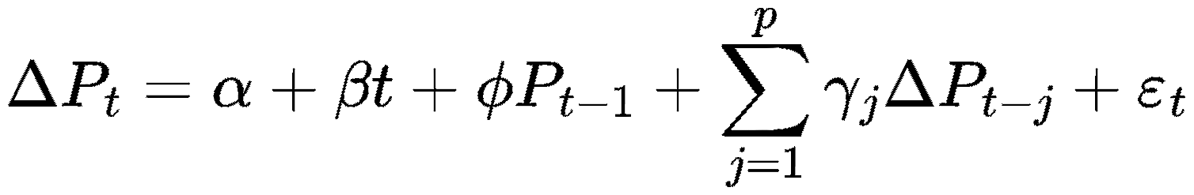 (1)
Where p is the number of lagged difference terms included.
3.3 Engle-Granger Two-Step Method
One of the most widely approaches for testing cointegration is the Engle-Granger two-step method, originally proposed by (Engle and Granger, 1987). This approach is particularly useful when examining the long-run relationship between two non-stationary time series. For each altcoin X_{t}​ against Bitcoin Y_{t}, we test whether a stable long-run equilibrium exists and, if so, quantify short-run error correction.
Let (Y_{t},X_{t})^{T} be jointly integrated of order one:
- Y_{t} ∼ I(1), X_{t} ∼ I(1) with ΔY_{t}, ΔX_{t} stationary.
- Under cointegration there exists (c,θ) such that the equilibrium error is:
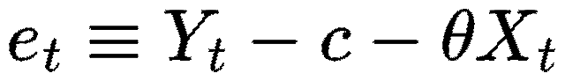 is I(0). (2)
Unlike standard unit root tests, the critical values for the Engle-Granger residual test differ because the distribution of the residuals is not the same as that of a typical time series. Engle & Yoo, (1987) provided specific critical values for this test. For example, with over 200 observations and two variables, the critical values are approximately:

Table 1: Significance level of Engle-Granger cointegration test
Significance Level | Critical Value
1% | -4.00
5% | -3.37
10% | -3.02

The Engle-Granger test depends on which variable you regress on which (normalization), thus can miss structural breaks, and only handles two series at a time. Even though BTC is the first cryptocurrency, we want a result that doesn’t depend on choosing BTC as dependent variable.

3.4 Johansen’s Cointegration Method
When dealing with multiple variables or systems with potentially several cointegrating vectors, the Johansen Cointegration method is preferable due to its ability to detect multiple long-run relationships simultaneously. Introduced by (Johansen, 1991), this method uses maximum likelihood estimation to determine whether multiple time series share one or more cointegrating relationships. Johansen’s approach includes two test statistics: the maximum eigenvalue test and the trace test.
The Johansen test is built upon a vector autoregression (VAR) framework, which models the linear interdependencies among multiple time series. The test statistic is:
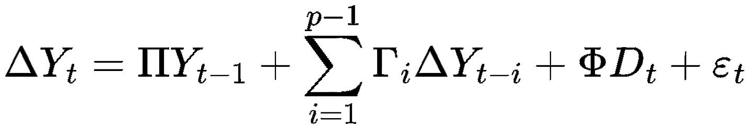 (3)
Where the two matrix can be decompose as:
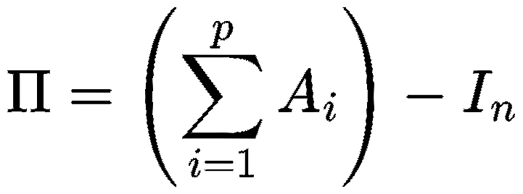 (4)
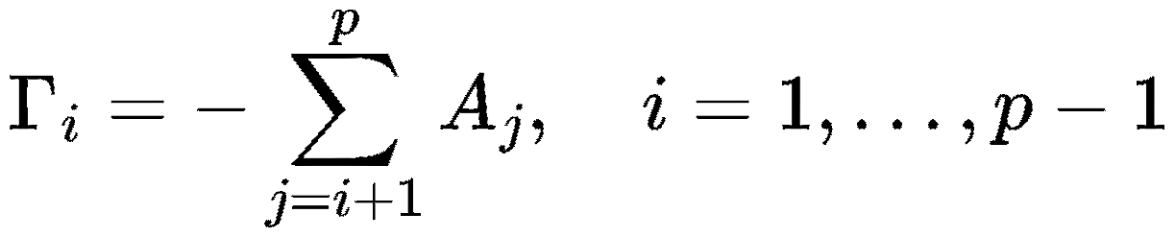 (5)
Where p is the number of lags, (4) and (5) which are two matrices. The matrix Γ captures short-run dynamics, while Π contains information on the long-run relationships between variables.
For the Rank cases and cointegration we let rank (Π) = r ∈ {0,…,n}.
- r = 0: no cointegration; the system is a VAR in first differences;
- r = n: Y_{t}​ is stationary; VAR in levels suffices; and
- 0 < r < n: there exist n × r full column-rank matrices α,β such that Π=αβ′. Then β′Y_{t} ​ are the r cointegrating relations, and α contains the error-correction speeds.
If each element of Y_{t}​ is I(1) and rank (Π) = r > 0, then there exists a VECM as above with β′Y_{t} ∼ I(0). Conversely, if β′Y_{t} is I(0) for some full-rank β, the DGP admits such a VECM
The Johansen test focuses on the rank r of the matrix Π, which corresponds to the number of cointegrating vectors. The rank is equal to the number of non-zero eigenvalues of Π. The test employs two statistics: the trace statistic and the maximum eigenvalue statistic.
The trace test evaluates the null hypothesis that the number of cointegrating vectors is less than or equal to r against the alternative that it is greater than r. It is computed as:
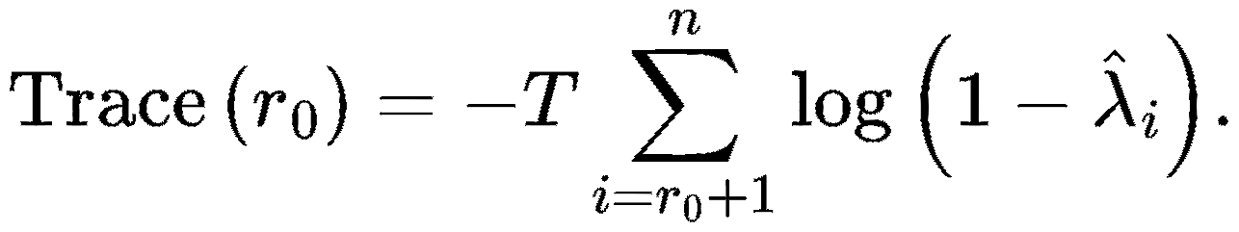 (6)
Where T is the sample size, and λ are the ordered eigenvalues.
The maximum eigenvalue test, on the other hand, tests the null hypothesis that there are r cointegrating vectors against the alternative of r+1, calculated as:
 (7)

3.5 Vector Error Correction Model (VECM)
When the cointegration tests confirm the existence of one or more cointegrating relationships among the variables, the Vector Error Correction Model (VECM) becomes a powerful tool for modeling how quickly and through which channels they correct both the short-term dynamics and long-term equilibrium relationships simultaneously. The VECM provides:
- long-run relations via cointegrating vectors (β);
- speeds and directions of correction via loadings (α); and
- short-run spillovers via lagged differences (Γ_{i}​).
The VECM is essentially a reformulation of a Vector Autoregressive (VAR) model that incorporates error correction terms to capture deviations from the long-run equilibrium.
If we start with a levels VAR(p):
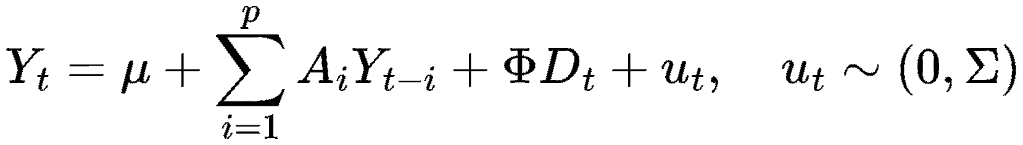 (8)
Reparametrize to the VECM in (12):
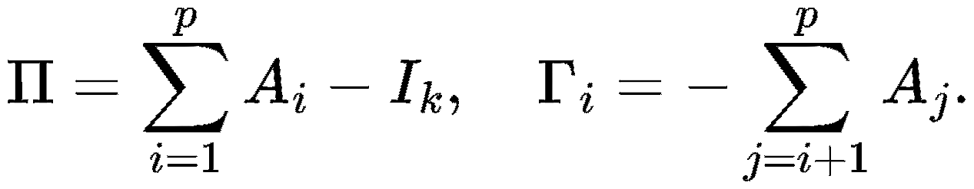 (9)
Γi​: short-run propagation. If Γ_{ETH←BTC} (2) ≠ 0, BTC returns at t−2 help explain ETH’s return at t.
ΠY_{t−1}​: mean-reverting force. If Π ≠ 0, some linear combination of prices pulls returns back toward equilibrium.
If 0 < rank (Π) = r <, then;
The Johansen cointegration test focuses on the matrix Π, which can be decomposed as follows:
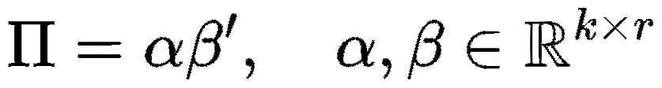 (10)
where β is a matrix containing the cointegrating vectors that represent the long-run equilibrium relationships between the variables, and α is a matrix of adjustment coefficients that measure how quickly variables correct deviations from this equilibrium (Brooks, 2008).
The coefficient of Π deteremine the system feedback.
- If β′α < 0, the error term mean-reverts.
- If β′α > 0, it would explode
3.6 The Error-Correction Terms (ECTs)
The Error Correction Term (ECT) is the component that represent how much of the disequilibrium from the previous period is corrected in the current period. the ECT is:
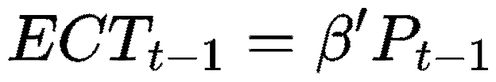 (11)
Where P_{t} is the vector of prices and β is the cointegrating vector which represents the disequilibrium (deviation from the long-run cointegration relationship) at time t−1.
3.7 Weak-Exogeneity in the VECM.
Weak exogeneity refers to variables that do not adjust to restore long-run equilibrium, meaning their error-correction coefficients are statistically insignificant or restricted to zero.
Formally, recall the VECM representation in (12):
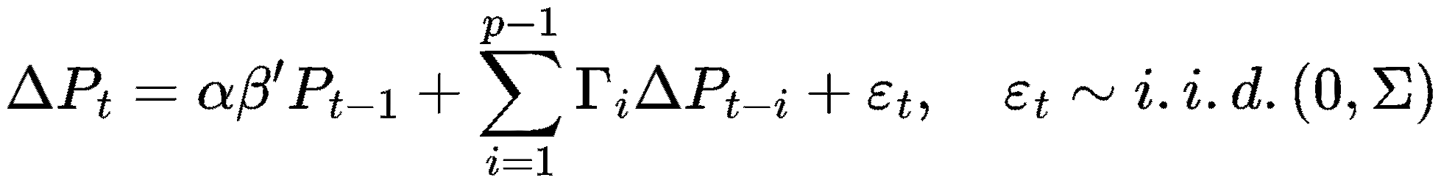
A variable P_{it}​ is said to be weakly exogenous with respect to the parameters of interest (typically β). If the corresponding adjustment coefficient in α is zero:

3.8 Half-life of deviations

When a cointegration spread z_{t} = β′Y_{t​} (for r = 1) moves away from equilibrium, we are interested in how fast does it come back? The speed at which he came back is summarize as the half-life (HL). It is the expected number of sampling periods for ∣z_{t}∣ to fall by 50% after a small shock.
For an AR(1) with root ρ, the expected magnitude decays geometrically. The half-life is
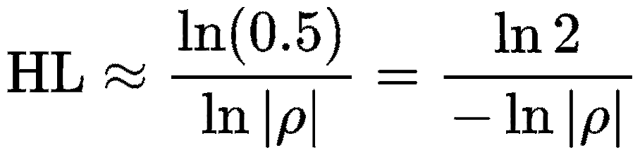 (12)
When ρ is close to 1, −ln ∣ρ ∣ ≈ 1−ρ and
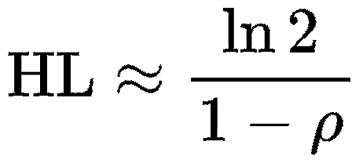 (13)
Ciaian, Rajcaniova, & Kancs (2018) emphasize, when a series exhibits statistically significant coefficients both in the short-run error correction terms (α) and in the long-run cointegrating vectors (β), it suggests a strong causal influence on the dependent variable. This implies that changes in one cryptocurrency’s price can have both immediate and sustained effects on another’s price, reflecting interconnected market behavior.

3.9 Efficient Market Hypothesis (EMH)
The Efficient Market Hypothesis (EMH), introduced by (Fama, 1970), posits that asset prices fully reflect all available information at any time, making it impossible to consistently achieve abnormal returns. EMH is categorized into three forms: Weak-form, semi strong-strong and strong-form.
- Weak-form efficiency: This is a situation where prices reflect all past market data, rendering technical analysis ineffective.
One of the ways to determine this is by Portmanteus serial-correlation test (Ljung-Box):
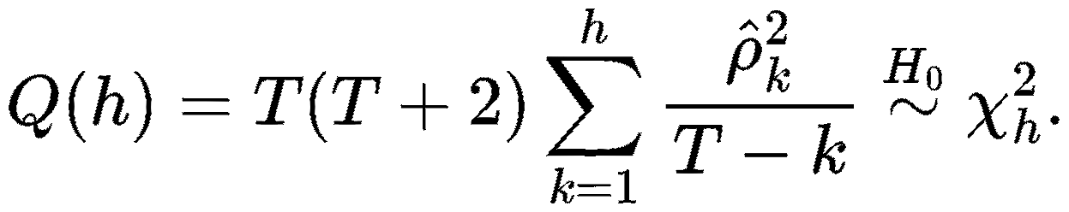 (14)
_{k}​ is the sample autocorrelation of returns at lag k. If returns are not linearly predictable, these should be jointly close to zero. A large Q(h) rejects weak-form efficiency (linear predictability) at horizon h.
This study focuses exclusively on testing the weak form of the efficient market hypothesis for the selected cryptocurrencies. In contrast, testing the semi-strong form would require comprehensive event studies around public announcements (e.g., regulatory news, protocol upgrades, or macroeconomic releases. The strong form, involving private/insider information, is practically untestable without access to non-public data. Prior empirical studies on cryptocurrency efficiency (e.g., Urquhart, 2016; Nadarajah & Chu, 2017; Asemota, Bello & Adams, 2025; Vidal-Tomás et al., 2023) predominantly focus on the weak form for these reasons, providing a consistent benchmark for comparison.

4. Result
Table 2: Descriptive Statistic of Cryptocurrencies Returns.
 | BTC | ETH | BNB | SOL | XRP
Mean | 0.00141 | 0.00169 | 0.00209 | 0.00273 | 0.00137
Median | 0.00063 | 0.00161 | 0.00182 | 0.00002 | 0.00075
Maximum | 0.0176026 | 0.219406 | 0.55265 | 0.3844 | 0.54447
Minimum | -0.17252 | -0.3052 | -0.3839 | -0.5481 | -0.5495
Std. Dev. | 0.03085 | 0.04131 | 0.04246 | 0.0650 | 0.0536
Skewness | -0.099 | -0.234 | 0.939 | -0.223 | 0.760
Kurtosis | 6.711 | 7.608 | 26.554 | 10.092 | 22.65
Jarque-Bera | 1127.28 | 1751.81 | 45632.53 | 4125.09 | 31794.00
Probability | 0.0000 | 0.0000 | 0.0000 | 0.0000 | 0.0000
Observation | 1973 | 1973 | 1973 | 1973 | 1973

Table 2 summarize the descriptive statistics of daily returns for BTC, ETH, XRP, BNB, and SOL over the sample period, comprising 1,973 daily observations for each asset. Across all cryptocurrencies, the mean returns are all positive indicating that price increase throughout the period of observation.
4.1 Time Plots of Cryptocurrency Prices
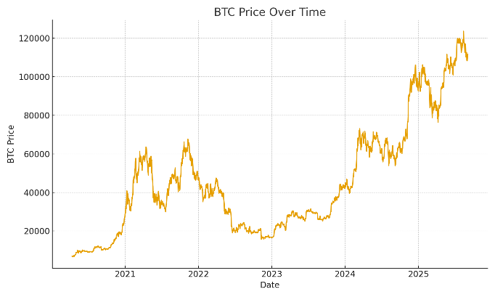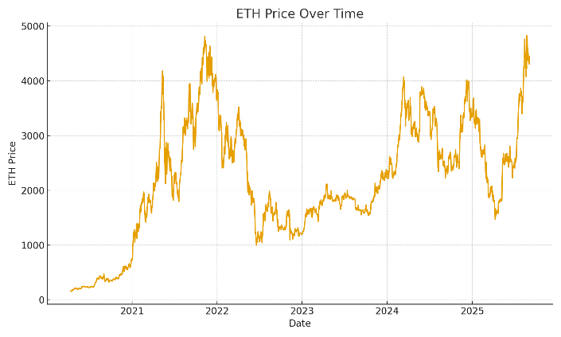

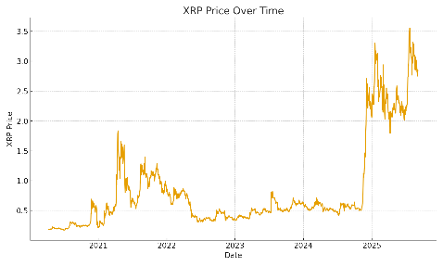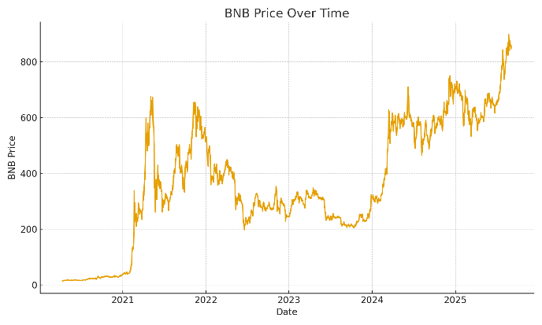
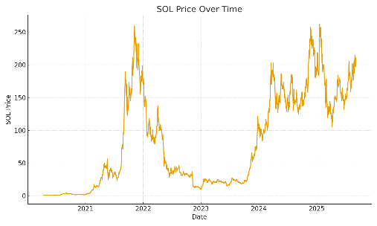
Figure 1: Time plot of the five cryptocurrencies

4.2: Unit Root Test Results
Table 3: ADF Unit Root test for each of the cryptocurrency.
 | t-Statistic (at level) | p-Value | K (lags) | First Difference | p-value | K (lags)
BTC | -0.455 | 0.897 | 13 | -11.322 | 0.000 | 12
ETH | -1.851 | 0.356 | 17 | -10.891 | 0.000 | 16
BNB | -1.067 | 0.731 | 5 | -20.774 | 0.000 | 4
SOL | -1.331 | 0.617 | 5 | -20.000 | 0.000 | 4
XRP | -0.868 | 0.799 | 21 | -9.489 | 0.000 | 20

Table 3 shows the unit root test for the five cryptocurrencies under consideration. Results for the level series show that for BTC, ETH, BNB, SOL, and XRP their ADF (–0.455 to –1.856) are much higher than the 5% critical threshold, with corresponding p-values well above 0.05. Thus, the null hypothesis of a unit root cannot be rejected in levels. However, after first differencing, the ADF statistics become highly negative and p-values are zeros, this provides clear evidence that the null hypothesis of a unit root is rejected at the 5% level in first differences, confirming that BTC, ETH, BNB, SOL, and XRP are stationary after first differencing
4.3 Engle-Granger Cointegration Test Results
Table 4: Residual-Based Engle–Granger Cointegration Test.
Pairs | Engle-Granger statistic | 5%Critical value | P-values | Number of obs.
BTC-ETH | -1.054 | -3.37 | 0.867 | 1973
BTC-BNB | -1.550 | -3.37 | 0.353 | 1973
BTC-SOL | -1.612 | -3.37 | 0.497 | 1973
BTC-XRP | -3.292 | -3.37 | 0.150 | 1973

Table 4 reports the ADF result of l(0) on the residual series using BTC as the dependent variable. In every case the test statistic is less than the 5% critical value of -3.37 and the p-value exceeds level of significant = 0.05. Consequently, the null hypothesis of no cointegration is accepted for all pairs. This implies that BTC and the selected cryptocurrencies do not exhibit a stable long-run equilibrium relationship over the study period. Consequently, any short-run deviations between the series are unlikely to converge back to a common long-run path. Since Engle-Granger method is pairwise and normalization-dependent (results can vary with which asset is set as the dependent variable) and can be sensitive to structural breaks; we therefore complement these pairwise tests with system-wide Johansen procedures to assess whether a multivariate long-run relationship exists across the full set of cryptocurrencies.
4.4: Johansen Cointegration Test Results
In table 5 the trace test rejects the null hypothesis at r ≤ 0 with a statistic of 72.104 against the 5% critical value 69.819 (trace = 72.104 > 69.819, p = 0.0037). The results indicate that the cryptocurrencies under study share a long-run equilibrium relationship. The null hypothesis is not rejected at r ≤ 1 (trace = 42.286 < 47.856, p = 0.1085). Following the Pantula principle (Pantula, 1989), the appropriate cointegration rank is therefore determined to be r = 1. Accordingly, the subsequent analysis proceeds with r ≤ 1. With five I(1) prices and one cointegrating vector (r), the system has one stationary long-run equilibrium relation (a single β⊤y_{t}) and four common stochastic trends; i.e., the assets do not drift independently, but move around a single equilibrium spread.

Table 5: Johansen Cointegration Test (Trace Statistic Results)
r | Eigenvalue | Trace Statistic | Critical level 0.05 | Prob
0 | 0.0185 | 72.104 | 69.819 | 0.0037
1 | 0.0119 | 42.286 | 47.856 | 0.1085
2 | 0.0064 | 21.067 | 29.797 | 0.3846
3 | 0.0031 | 9.896 | 15.495 | 0.4724
4 | 0.0010 | 1.021 | 3.841 | 0.1712

4.5: VECM Estimation Results
Given the existence of a single cointegrating relationship in Table 6, a VECM with rank r = 1 was estimated. The cointegrating vector was normalized on Bitcoin. Normalizing on BTC, the cointegrating relation loads negatively on BNB, SOL and XRP and positively on ETH. The estimated long-run relationship represents equilibrium linkages among the cryptocurrency. Table 7 shows the results show that the adjustment coefficients for all the cyyptocurency. They are all statistically significant at the 5% level. This indicates that each cryptocurrency responds systematically to the previous period’s disequilibrium, confirming the presence of an active error-correction mechanism. This also implying that none of the variables is weakly exogenous.
The scalar β′α is negative (− 0.00469), confirming that the cointegration error is mean-reverting. Hence, despite a positive α for Bitcoin, the overall system exhibits stable long-run dynamics, with equilibrium restored through asymmetric adjustment across cryptocurrencies.

Table 6: Long-Run Cointegrating Vectors (β) from the VECM
Cryptocurency | Cointegrating vector (β)
BTC | 1
ETH | 0.687
BNB | -0.457
SOL | -0.312
XRP | -0.418

Table 7: Speed of Adjustment (α) in the VECM
Variable | Coefficient (α) | Std. Error | t-Statistics | Prob. | Decision
BTC | 0.00507 | 0.00189 | 2.687 | 0.0072 | Significant
ETH | 0.00726 | 0.00523 | 2.874 | 0.0040 | Significant
BNB | 0.01264 | 0.00432 | 4.932 | 0.0000 | Significant
SOL | 0.01679 | 0.00641 | 4.215 | 0.0000 | Significant
XRP | 0.00801 | 0.00472 | 2.410 | 0.0159 | Significant

4.6 Half-Life
Table 8: Half-Life of the Cointegration Spread
ρAR(1) | HL
0.9954 | 151.15

Table 8 show the result of the half-life decay. The persistence of deviations from the long-run equilibrium was further examined by estimating an AR(1) process for the cointegration spread. The estimated autoregressive coefficient is ρ = 0.9954, which is very close to unity, indicating a high degree of persistence in the adjustment process. This implies that shocks to the long-run equilibrium dissipate slowly over time rather than being corrected immediately. Consistent with this result, the implied half-life of adjustment is approximately 151 days.

4.7 Weak-form Efficient Market Hypothesis Results
The ADF results provide consistent evidence that all five cryptocurrency price series are non-stationary in levels but stationary in first differences, this satisfies the precondition for weak-form efficiency under the random walk model.
Using daily log-returns for BTC, ETH, BNB, SOL, and XRP in study period, the study tested weak-form efficiency via the Ljung-Box portmanteau statistic at horizons h =10 and 20 and a simple AR(1) regression​ to gauge one-step linear predictability.

Table 9: Diagnostic Tests for Weak-Form Market Efficiency
Coin | Q(10) | Prob. (10) | Q(20) | Prob. (20) | ϕ_AR1 | P-Value ϕ | Weak Form Efficiency
BTC | 15.50 | 0.115 | 24.65 | 0.215 | -0.0311 | 0.167 | Accepted
ETH | 25.32 | 0.004 | 40.05 | 0.005 | -0.0430 | 0.056 | Rejected
BNB | 50.07 | 0.000 | 63.99 | 0.000 | -0.0679 | 0.002 | Rejected
SOL | 19.84 | 0.031 | 40.64 | 0.004 | -0.0509 | 0.023 | Rejected
XRP | 12.29 | 0.266 | 25.20 | 0.194 | -0.0291 | 0.196 | Accepted
Overall, the consistency of these results across both lag lengths indicates that the weak-form efficiency conclusions are robust to the choice of lag order, with BTC and XRP exhibiting informational efficiency, while ETH, BNB, and SOL display statistically significant short-run return predictability. This same Result of Ljung-Box test was also confirm by The AR(1). Overall, BTC and XRP are consistent with weak-form EMH in our sample, ETH, BNB and SOL show clear statistical violations of weak-form efficiency. Semi-strong/strong-form EMH would require event-study or insider-advantage tests those data are beyond the scope of this study.

5. Conclusion
This study provides empirical evidence on the long-run integration, short-run dynamics, and market efficiency of major cryptocurrencies Bitcoin (BTC), Ethereum (ETH), Binance Coin (BNB), Solana (SOL), and Ripple (XRP) using daily log price data. Johansen cointegration tests indicate the presence of at least one cointegrating relationship among the five assets, confirming that their prices share a common stochastic trend over the sample period. This implies that deviations from the long-run equilibrium are not permanent and tend to dissipate over time, reflecting a high degree of market integration among large-cap cryptocurrencies.
The estimated Vector Error Correction Model (VECM) reveals statistically significant but small error-correction coefficients across all assets, indicating gradual adjustment toward the long-run equilibrium. Solana and Binance Coin exhibit relatively faster speeds of adjustment, while Bitcoin adjusts more slowly, consistent with its dominant market position and deep liquidity. The small magnitudes of the adjustment coefficients suggest that disequilibria are corrected only gradually rather than instantaneously. This finding is reinforced by the high persistence of the cointegration spread, with an estimated autoregressive coefficient close to unity and an implied half-life of approximately 151 days, indicating slow but stable mean reversion. Together, these results highlight the presence of long-run equilibrium forces alongside substantial short-run inertia in cryptocurrency prices.
Overall, the findings indicate that major cryptocurrency markets are tightly linked in the long run, exhibit slow and asymmetric adjustment in the short run, and display informational efficiency that is incomplete rather than absolute. These conclusions are specific to the assets, data frequency, and sample period considered, and future research may extend the analysis to alternative horizons, higher-frequency data, or models that explicitly account for structural breaks and regime shifts.

6. Limitations
Despite providing useful evidence on cryptocurrency market integration and efficiency, this study is subject to several limitations.
First, the analysis focuses only on five major cryptocurrencies (BTC, ETH, BNB, SOL, and XRP). Although these assets represent a large share of the cryptocurrency market, the findings may not generalize to smaller or emerging cryptocurrencies, which may exhibit different dynamics and levels of efficiency.
Second, the study relies on daily data and therefore may not fully capture high-frequency market behavior, intraday volatility, or rapid information transmission that are common in cryptocurrency markets. Using higher-frequency data could provide deeper insights into short-run adjustments and market efficiency.
Third, the Engle–Granger and Johansen cointegration approaches assume stable long-run relationships over the sample period. Cryptocurrency markets, however, are highly volatile and subject to structural breaks arising from regulatory changes, macroeconomic shocks, technological developments, and market crises. Such breaks may affect the stability of the estimated cointegrating relationships and VECM parameters.
Fourth, the Vector Error Correction Model (VECM) employed in the study is linear in nature and may not adequately capture possible nonlinearities, regime shifts, or asymmetric adjustments that often characterize cryptocurrency markets. More advanced nonlinear or regime-switching models may provide additional insights into market dynamics.
Fifth, the weak-form efficiency analysis is based primarily on the Ljung–Box test and AR(1) regression. While these methods are useful for detecting linear dependence in returns, they may not identify nonlinear predictability, volatility clustering, or time-varying inefficiencies that are common in financial time series.
Finally, the results are sample-period dependent. Cryptocurrency markets evolve rapidly, and relationships observed during the study period may change under different market conditions. Therefore, caution should be exercised when generalizing the findings beyond the selected time frame

Disclaimer (Artificial intelligence)

Author(s) hereby declare that NO generative AI technologies such as Large Language Models (ChatGPT, COPILOT, etc.) and text-to-image generators have been used during the writing or editing of this manuscript.

Reference
- Adams, S.O., Asemota. O. J. and Ibrahim, A. A. (2024). Asymmetric GARCH Type Models and LSTM for Volatility Characteristics Analysis of Nigeria Stock Exchange Returns, American Journal of Mathematics and Statistics, 4(2), 17-32. https://doi.org/10.5923/j.ajms.20241402.01
- Adams, S.O. and Olive, P.I. (2024). Modelling and forecasting of Nigeria Crude Oil Price Volatility from 2006-2023: An Application of the GARCH Models, Journal of Science and Technology, 17(1), 94 – 107. https://doi.org/10.30880/jst.2025.17.01.010
- Arık, E. (2025). A cointegration relationship between cryptocurrencies and financial instruments under structural breaks. Uluslararası İktisadi ve İdari İncelemeler Dergisi, 46, 201–216. https://doi.org/10.18092/ulikidince.1538837
- Asemota, O.J., Bello, M. Adams, S.O. (2025). Forecasting Nigeria's Oil Price Volatility: A Comparative Analysis of GARCH Models and Heston's Stochastic Models, American Journal of Applied Statistics and Economics (AJASE), 4(1), 32 – 48. https://doi.org/10.54536/ajase.v4i1.4693
- Aysan, A. F., Khan, U., & Topuz, S. (2021). Cointegration and dynamic connectedness of cryptocurrencies during COVID-19. Research in International Business and Finance, 56, 101360. https://doi.org/10.1016/j.ribaf.2021.101360
- Binance Coin (BNB): https://coinmarketcap.com/currencies/bnb/historical-data/
- Bitcoin (BTC): https://coinmarketcap.com/currencies/bitcoin/historical-data/
- Brooks, C. (2008). Introductory econometrics for finance (2nd ed.). Cambridge University Press.
- Campbell, J. Y., Lo, A. W., & MacKinlay, A. C. (1997). The econometrics of financial markets. Princeton University Press.
- Ciaian, P., Rajcaniova, M., & Kancs, D. (2018). Virtual relationships: Short- and long-run evidence from Bitcoin and altcoin markets. Journal of International Financial Markets, Institutions and Money, 52, 173–195.
- CoinMarketCap. (2025). Cryptocurrency statistics and market capitalization data. https://coinmarketcap.com
- Crowdfund Insider. (2025). Global crypto market approaches $4 trillion in capitalization. https://www.crowdfundinsider.com
- Dickey, D. A., & Fuller, W. A. (1979). Distribution of the estimators for autoregressive time series with a unit root. Journal of the American Statistical Association, 74(366), 427–431.
- Engle, R. F., & Granger, C. W. J. (1987). Co-integration and error correction: Representation, estimation, and testing. Econometrica, 55(2), 251–276.
- Engle, R. F., & Yoo, B. S. (1987). Forecasting and testing in co-integrated systems. Journal of Econometrics, 35(1), 143–159.
- Ethereum (ETH): https://coinmarketcap.com/currencies/ethereum/historical-data/
- Fama, E. F. (1970). Efficient capital markets: A review of theory and empirical work. Journal of Finance, 25(2), 383–417.
- Gabriel & Kunsk. (2024). Cointegrated portfolios and volatility modeling in the cryptocurrency market. ZBW – Leibniz Information Centre for Economics. https://www.econstor.eu/handle/10419/286589
- Johansen, S. (1988). Statistical analysis of cointegration vectors. Journal of Economic Dynamics and Control, 12(2–3), 231–254.
- Johansen, S. (1991). Estimation and hypothesis testing of cointegration vectors in Gaussian vector autoregressive models. Econometrica, 59(6), 1551–1580.
- Keilbar, G., & Zhang, Y. (2021). On cointegration and cryptocurrency dynamics. Digital Finance, 3(1), 1–23. https://doi.org/10.1007/s42521-021-00027-5
- Lo, A. W., & MacKinlay, A. C. (1988). Stock market prices do not follow random walks: Evidence from a simple specification test. Review of Financial Studies, 1(1), 41–66.
- Nadarajah, S., & Chu, J. (2017). On the inefficiency of Bitcoin. Economics Letters, 150, 6–9.
- Nakamoto, S. (2008). Bitcoin: A peer-to-peer electronic cash system. https://bitcoin.org/bitcoin.pdf
- Pantula, S. G. (1989). Testing for unit roots in time series data. Econometric Theory, 5(2), 256–271.
- Ripple (XRP): https://coinmarketcap.com/currencies/xrp/historical-data/
- Solana (SOL): https://coinmarketcap.com/currencies/solana/historical-data/
- Urquhart, A. (2016). The inefficiency of Bitcoin. Economics Letters, 148, 80–82.
- Vidal-Tomás, D., Ibáñez, A., & Farinós, J. E. (2023). Weak-form efficiency of cryptocurrency markets revisited. Finance Research Letters, 52, 103437.
- World Bank. (2025). Global economic prospects: Digital assets and financial stability. World Bank Group.
- Yahaya, H. U., Oyinloye, J. S., & Adams, S. O. (2022). Modeling and forecasting cryptocurrency returns and volatility: An application of GARCH models. Universal Journal of Finance and Economics, 2(1), 71–90. https://doi.org/10.31586/ujfe.2022.497

