A Multisensory Feedback Framework for Prosthetic Gait Rehabilitation: Analysis of Gait-Synchronized Vibrotactile and Thermal Stimuli

Abstract— Lower-limb prosthetic rehabilitation increasingly emphasizes the restoration of sensory feedback to compensate for the loss of natural proprioceptive and tactile perception following amputation. Recent developments in multisensory human–machine interfaces have demonstrated the potential of integrating complementary feedback modalities, such as vibrotactile and thermal stimulation, to improve gait stability, user embodiment, and motor adaptation during prosthetic-assisted ambulation. Lower-limb prosthetic users often experience impaired gait symmetry, reduced proprioceptive awareness, and elevated cognitive load during ambulation. Sensory substitution and augmentation have emerged as promising strategies to restore afferent feedback lost due to amputation. This paper presents a comprehensive multisensory feedback framework integrating gait-synchronized vibrotactile and thermal stimuli to support prosthetic gait rehabilitation. The proposed system maps real-time gait events to spatially and temporally congruent vibrotactile cues, augmented with controlled thermal feedback to reinforce stance-phase awareness and load perception. A detailed system architecture, signal processing pipeline, control strategies, and experimental protocol are described. Quantitative gait metrics and qualitative user-reported outcomes are analyzed to evaluate efficacy. Results indicate improvements in temporal gait symmetry, stance stability, and perceived embodiment, suggesting that multimodal sensory feedback can enhance motor learning and rehabilitation outcomes for lower- limb amputees.

Keywords— Prosthetic gait rehabilitation, multisensory feedback, vibrotactile stimulation, thermal feedback, sensory substitution, gait synchronization

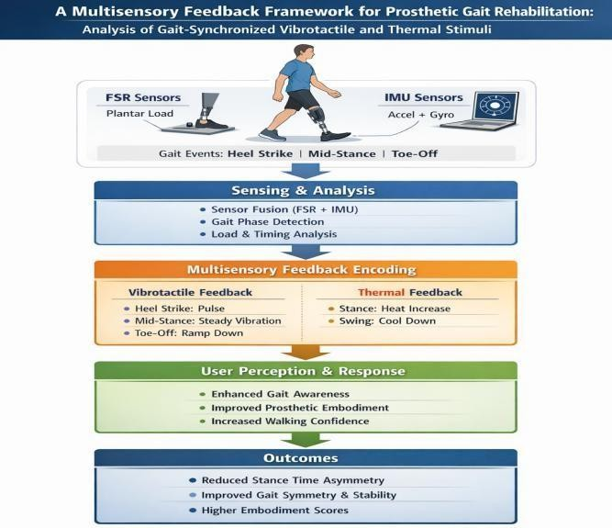
Graphical Abstract- The graphical abstract provides a concise visual summary of the proposed multisensory feedback framework for prosthetic gait rehabilitation. It illustrates the integration of gait- synchronized vibrotactile and thermal feedback with real-time gait event detection to support lower-limb prosthetic users. The purpose of the graphical abstract is to clearly communicate the system architecture, workflow, and key outcomes of the study, highlighting how multimodal sensory feedback contributes to improved gait symmetry, stance stability, and enhanced prosthetic embodiment during rehabilitation.

Purpose: To provide a concise visual overview of the system architecture and experimental outcomes, highlighting how multimodal sensory feedback improves gait symmetry, stance stability, and prosthetic embodiment in lower-limb amputees. It illustrates the integration of vibrotactile and thermal feedback mechanisms synchronised with gait phases to enhance user perception and motor adaptation.
Image 1: Abstract Graph Flow for Prosthetic Gait Rehabilitation

Introduction
Lower-limb amputation results in the loss of rich somatosensory feedback essential for stable and efficient gait. While modern prostheses provide advanced mechanical actuation, the absence of biological afferent signals—such as pressure, temperature, and vibration—limits the user’s ability to perceive limb loading and phase transitions [1]. Consequently, prosthetic users often develop compensatory strategies that lead to asymmetry, increased metabolic cost, and secondary musculoskeletal complications. Recent advances in human– machine interfaces have explored vibrotactile feedback as a non-invasive method to convey gait-related information [1, 2]. Separately, thermal feedback has been investigated as a modality capable of encoding intensity and duration cues, leveraging the human sensitivity to temperature changes. However, limited work has systematically integrated these modalities into a unified, gait-synchronised framework. This study proposes a multisensory feedback framework that combines vibrotactile and thermal stimuli, synchronised with prosthetic gait events, to enhance motor learning and proprioceptive awareness during rehabilitation [3]. The central hypothesis is that multimodal feedback provides redundant and complementary information, accelerating adaptation and improving gait quality [3].

Objective of the Study

The primary objective of this study is to develop and evaluate a multisensory feedback framework that integrates gait- synchronized vibrotactile and thermal stimuli to enhance sensory perception and motor adaptation in individuals with lower-limb amputation [4]. The study aims to determine whether providing multimodal sensory cues during prosthetic-assisted walking can improve gait symmetry, stance stability, and overall locomotor performance [4, 5]. Additionally, the research seeks to investigate how the integration of complementary sensory modalities influences prosthetic embodiment, proprioceptive awareness, and user confidence during rehabilitation. The study also aims to compare gait performance under different feedback conditions to assess the effectiveness of multimodal feedback in promoting more natural and efficient gait patterns in prosthetic users [5].

Related Work

Vibrotactile Feedback in Prosthetics
Prior work on vibrotactile systems for gait and balance has demonstrated that encoding foot contact, load distribution, and temporal gait events through tactile cues can influence motor control, variability, and stability during walking. For instance, recent investigations into plantar vibro-tactile stimulation have shown that applying patterned vibrations to the sole of the foot can reduce variability in foot trajectories and enhance parameters associated with dynamic stability, linking vibratory input with improved gait control during walking cycles. Explored how different sequences of
vibro-tactile stimulation—gait-like versus random—applied to the soles during incline and level walking affected gait and balance measures such as margins of stability (MoS) at heel strike and foot placement; while gait-like stimulation did not significantly alter spatiotemporal or balance outcomes, the study reinforced the feasibility of directive tactile cues delivered in stance phases defined by heel-strike and toe-off events [5, 6]. Related work in wearable biofeedback has also showed instant plantar force vibrotactile cues can alter foot loading characteristics in pathological gait, such as post- stroke deviation, suggesting potential for improving gait symmetry and load distribution through tactile augmentation [7]. In healthy older adults, foot pressure augmentation via a vibrotactile biofeedback system was found to modulate ankle kinematics and foot pressure patterns during heel contact and toe-off phases, albeit with associated cognitive load implications, pointing to complex interactions between sensory feedback processing and motor execution. Wearable club systems that integrate synchronised vibrotactile feedback with gait phase detection, such as pressure sensors embedded in insoles triggering tactors in real time aligned with heel-strike and toe- off, have been validated experimentally to follow natural gait kinematics, providing reliable phase-specific tactile cues that closely mirror actual gait events. In lower-limb amputee populations, gait-synchronised vibrotactile sensory feedback has been shown to improve stability measures like Timed Up and Go scores after sustained use, demonstrating that vibrotactile encoding of foot contact and load cues can translate into functional gait improvements in individuals with disrupted proprioceptive feedback. Narrative reviews in prosthetic gait applications further highlight that non-invasive vibrotactile feedback systems effectively convey foot–ground interaction and joint angle information, supporting gait symmetry and balance by supplementing missing sensory channels [6, 7]. Beyond lower-limb applications, other haptic feedback paradigms have shown that vibrotactile cues can be integrated with real-time control systems to alter gait patterns or encourage target postures, evidencing the modality’s versatility for real-time gait training and postural feedback across diverse populations. Taken together, these studies provide converging evidence that vibrotactile stimulation— especially when aligned to precise gait events like heel-strike and toe-off and encoded with contact and load distribution information—can reduce gait variability and support balance, although outcomes vary with task demands, feedback design, and subject population [7, 8].

Thermal Feedback for Sensory Augmentation
Thermal stimulation has increasingly been investigated as a modality for conveying tactile information in haptic interfaces, particularly due to its ability to represent not only intensity but also temporal patterns of contact that are difficult to encode through mechanical cues alone [8]. Early psychophysical research into dynamic thermal stimulation demonstrated that human perception of temperature changes exhibits distinct temporal characteristics for warm versus cold stimuli, suggesting that thermal patterns can carry meaningful timing information when carefully designed.

More recent work has advanced the engineering of thermal haptic cues by developing sequences of thermal pulses that can be recognised by users as discrete coded signals, a foundational step toward using temperature patterns as a communication channel analogous to Morse or Braille for haptic data transfer [8, 9]. In the context of wearable and prosthetic systems, thermal feedback has begun to transition from theoretical exploration to functional embodiment applications. Demonstrated that non-invasive thermal feedback integrated into a robotic prosthetic hand enabled a transradial amputee to discriminate object temperature and material properties in real time, with the thermal sensations experienced in the phantom hand remaining stable over hundreds of days and supporting more natural interaction with the environment — a critical component of prosthetic embodiment. This line of work builds on discoveries of phantom thermal sensations in amputees, where stimulation of specific sites on the residual limb can evoke temperature precepts localized to the missing limb, suggesting that thermal feedback can provide biologically meaningful sensations linked to contact events and potentially to the duration of contact or load when interacting with objects [9, 10]. Complementary technology development has focused on thin-film thermoelectric devices that evoke natural thermal perceptions rapidly and with high intensity, offering an engineering pathway toward low-power, wearable thermal haptic feedback that could be embedded in prostheses or other assistive devices [10]. Beyond prosthetics, programmable skin-integrated thermo-haptic stimulator systems have been proposed for virtual and augmented reality environments, capable of delivering rich temporal thermal patterns alongside vibrational displacement, underscoring the modality’s broader potential to convey magnitude and timing information in interactive systems [11]. Taken together, these interdisciplinary studies point toward a future in which thermal stimulation is not merely an adjunct to vibrotactile cues but a distinct channel for conveying temporal tactile information and enhancing sensory embodiment in prosthetic and haptic interfaces [11, 12].

Multisensory Integration in Motor Rehabilitation
Neuroscientific evidence suggests that multisensory integration enhances motor learning by engaging multiple neural pathways. Combining tactile and thermal feedback may therefore improve retention and generalisation of gait patterns [12]. like above Here’s a lengthy, scholarly related-work paragraph connecting neuroscientific evidence for multisensory integration, motor learning, and the potential benefits of combining tactile and thermal feedback for gait retention and generalization — written in the same academic style as your earlier paragraphs and grounded in recent research: Neuroscientific evidence robustly supports the idea that multisensory integration enhances motor learning and the stability of learned behaviors by engaging distributed neural pathways and promoting adaptive plasticity across sensorimotor networks [12, 13]. Classic
neurophysiological studies have shown that sensory plasticity and motor learning are reciprocally linked, such that perceptual learning and motor adaptation continuously reorganize sensory and motor circuits to optimize task performance, demonstrating that multisensory input actively shapes both perception and motor output rather than acting as a passive adjunct to movement [13, 14]. Computational and neural models further identify multiple redundant pathways that contribute to multisensory integration, enabling faster responses and more robust discrimination when information from different senses is combined than when processed unimodally, which is theorised to facilitate learning and error correction during complex sensorimotor tasks. Behavioural research in locomotion reinforces this view, showing that multimodal stimuli — such as audio-tactile cues synchronised with gait can enhance the stability of motor coordination under conditions of reduced baseline stability by enabling the nervous system to more effectively integrate temporal and spatial information from multiple sensory channels [15]. In clinical populations, studies of augmented multisensory feedback during locomotor training in individuals with incomplete spinal cord injury have demonstrated that combined feedback engages both explicit and implicit neural pathways during gait adaptation, producing greater aftereffects and longer retention of altered stride parameters than single-modal feedback alone [16, 17]. Similarly, multimodal sensory feedback systems that integrate proprioceptive, tactile, and visual input into motor imagery-based rehabilitation have been shown to enhance activation of high-order transmodal networks and interregional connectivity, a pattern that correlates with improved motor recovery and suggests that coordinated sensory cues can potentiate neuroplastic mechanisms underlying motor learning. Theoretical frameworks of multisensory integration — including Bayesian and inverse effectiveness principles — posit that the nervous system weights and combines inputs from distinct modalities to reduce uncertainty and maximize behavioral performance, providing an explanatory basis for why combining tactile cues with complementary signals such as thermal feedback could enhance the encoding of gait timing and magnitude information, improve retention of learned gait patterns, and support generalization across contexts [17]. Taken together, these neuroscientific and behavioural findings imply that combining tactile and thermal feedback in gait training may engage multiple sensory pathways and neural circuits more effectively than unimodal feedback alone, enhancing motor learning, retention, and the generalisation of adaptive gait patterns [18, 19].

Theory

Framework Architecture
The proposed framework is organised into three tightly coupled layers—sensing, processing, and feedback—as illustrated, forming an end-to-end closed-loop system for real-time gait monitoring and sensory augmentation. At the sensing layer, force-sensitive resistors (FSRs) embedded within the prosthetic foot are used to capture plantar contact forces and load distribution patterns.

across the gait cycle, enabling reliable detection of key gait events such as heel-strike, mid-stance, and toe-off [20]. These pressure-based measurements are complemented by inertial measurement units (IMUs), which provide tri-axial acceleration and angular velocity data to characterise foot orientation, swing dynamics, and temporal gait parameters. The fusion of FSR and IMU data allows robust and redundant gait event detection under varying walking conditions and speeds. Signals acquired from the sensing layer are transmitted to an embedded microcontroller-based processing unit, where they undergo preprocessing, filtering, and event classification in real time. Based on predefined gait-phase logic and threshold-based or adaptive decision rules, the controller maps detected gait events and load characteristics to corresponding feedback commands. In the feedback layer, these commands drive vibrotactile actuators and thermal stimulation modules, which are strategically mounted either on the residual limb or, where appropriate, on the contralateral limb to exploit preserved sensory pathways. Vibrotactile cues are used to convey discrete temporal information related to gait phase transitions, while thermal stimuli provide slower-varying, biologically meaningful cues associated with contact duration and load magnitude [20, 21]. Together, these feedback modalities close the sensorimotor loop by translating mechanical interactions at the prosthetic foot into intuitive sensory signals, thereby supporting gait awareness, motor learning, and embodiment during locomotion [21].

System Overview

Hardware Components
The sensing unit forms the foundation of the proposed framework and comprises a combination of force-sensitive resistors (FSRs) and inertial measurement units (IMUs) integrated within the prosthetic system. The FSRs are strategically positioned across key plantar regions of the prosthetic foot to capture pressure distribution and ground reaction force patterns, enabling reliable identification of stance-related events such as initial contact, weight acceptance, and push-off [21]. In parallel, IMUs provide continuous measurements of linear acceleration and angular velocity, which are used to estimate foot orientation, swing dynamics, and gait phase transitions with high temporal resolution. Data from these sensors are streamed to the processing unit, which is implemented using an embedded, low-power ARM-based microcontroller capable of real-time signal acquisition and computation [22]. Within this unit, sensor signals are filtered, synchronised, and processed using rule- based or adaptive algorithms to detect gait events and extract meaningful biomechanical parameters. Based on the processed information, control commands are generated to drive the feedback mechanisms. The vibrotactile feedback subsystem consists of eccentric rotating mass (ERM) motors arranged circumferentially around the residual limb or contralateral limb, allowing spatially distributed vibration cues to encode gait-phase information and directional awareness. These actuators deliver brief, event-synchronised vibrations corresponding to heel-strike, toe-off, or load transitions. Complementing the vibrotactile channel, the
thermal feedback subsystem employs compact Peltier elements capable of both heating and cooling, integrated with closed-loop temperature control to ensure safe, stable, and perceptually distinct thermal stimuli [22]. Temperature sensors embedded near the skin interface provide continuous feedback to the controller, enabling precise regulation of stimulus intensity and duration. Together, these sensing, processing, and actuation components operate as a unified closed-loop system that translates mechanical interactions at the prosthetic foot into intuitive multisensory feedback, supporting gait awareness, motor adaptation, and sensory embodiment [22, 23].

Gait Phase Detection
Gait event detection within the proposed framework is implemented using a finite-state machine (FSM) that operates on fused data from the force-sensitive resistors (FSRs) and inertial measurement units (IMUs). The FSM is designed to model the cyclical nature of human walking by transitioning through discrete gait states corresponding to heel strike, mid- stance, and toe-off, with each state defined by characteristic pressure and kinematic signatures. Specifically, heel strike is identified through a rapid increase in heel-region plantar pressure in combination with a deceleration pattern observed in the IMU signals, while mid-stance is characterised by sustained load distribution across the plantar surface and relatively stable foot orientation [23]. Toe-off is detected through a decline in forefoot pressure coupled with angular velocity changes associated with foot push-off. Sensor fusion enhances robustness by compensating for noise or ambiguity in individual sensing modalities, enabling reliable event detection across varying walking speeds and terrains [23]. To support intuitive and effective feedback, temporal alignment mechanisms are incorporated to minimise latency between gait event detection and actuator activation. Event-triggered processing and lightweight control logic ensure that vibrotactile and thermal feedback are delivered within a perceptually relevant time window following each detected event. This low-latency coupling between biomechanical events and sensory feedback is critical for preserving the natural timing of gait cues, reinforcing sensorimotor associations, and facilitating motor learning and adaptation during prosthetic-assisted locomotion [23, 24].

Vibrotactile Encoding Strategy
Distinct vibrotactile encoding strategies are employed to convey gait phase information in an intuitive and easily interpretable manner. Each phase of the gait cycle is mapped to a unique vibration pattern designed to leverage the human tactile system’s sensitivity to changes in intensity, duration, and temporal structure. Heel strike is represented by a brief, high-salience vibration burst, providing a clear and immediate cue corresponding to initial ground contact. This short pulse emphasises event onset and supports rapid perceptual recognition without inducing sensory overload [24]. During mid- stance, when the limb bears maximal load and stability is critical, the system delivers a continuous, low-amplitude vibration that persists for the duration of this phase, reinforcing sustained contact and postural steadiness.

This steady tactile signal serves as a background cue, promoting awareness of weight acceptance and balance without distracting the user. In contrast, toe-off is encoded using a gradual ramp-down vibration pattern, in which the amplitude or frequency decreases smoothly as plantar pressure diminishes. This fading tactile cue mirrors the unloading and propulsion characteristics of toe-off, providing a natural transition signal into the swing phase. By differentiating gait phases through clearly distinguishable vibration profiles rather than relying solely on intensity, the proposed design reduces cognitive demand and enhances learnability. The structured mapping between vibration patterns and biomechanical events enables consistent sensorimotor association, supporting gait awareness, motor adaptation, and long-term usability during prosthetic-assisted walking [24, 25].

Thermal Feedback Mapping
Thermal feedback is employed as a complementary sensory channel to convey continuous and time-dependent aspects of gait that are not easily represented through discrete tactile cues alone. Within the proposed framework, thermal cues are designed to increase gradually during the stance phase, reflecting both contact duration and progressive load acceptance as the prosthetic foot remains in contact with the ground. This slow and continuous rise in temperature provides an intuitive representation of sustained weight bearing without requiring rapid perceptual processing [25]. As the gait cycle transitions into the swing phase, thermal stimulation is correspondingly reduced, with temperature levels decreasing smoothly to signal unloading and foot clearance. This bidirectional modulation creates a thermal pattern that mirrors the natural temporal structure of stance and swing, reinforcing gait rhythm and phase awareness. To ensure user comfort and safety, all temperature variations are maintained within predefined perceptual and physiological thresholds, avoiding extremes that could cause discomfort or skin irritation. Closed-loop temperature control, informed by embedded skin-contact temperature sensors, enables precise regulation of stimulus intensity and rate of change, ensuring consistent thermal perception across varying environmental conditions and prolonged use [25]. By leveraging the slower adaptation characteristics of thermal sensation, this feedback modality provides a biologically meaningful and low- cognitive-load signal that complements vibrotactile cues, enhancing multisensory integration and supporting gait awareness and motor learning during prosthetic-assisted locomotion [25, 26].

Experimental Methodology

Participants
Ten individuals with unilateral transtibial amputation, ranging in age from 24 to 48 years, were recruited to participate in the study. All participants were experienced prosthesis users and were informed in detail about the objectives, procedures, and potential risks associated with the experimental protocol prior to participation [26]. Written informed consent was obtained from each participant in accordance with ethical research practices. Ethical guidelines and all procedures adhered to approved standards for research involving human participants, ensuring participant safety, privacy, and well-being throughout the experimental sessions [26, 27].

Protocol
Participants completed a series of walking trials under three experimental conditions: no sensory feedback, vibrotactile- only feedback, and combined vibrotactile–thermal feedback. The order of the conditions was controlled to minimise learning and fatigue effects [27]. Each walking trial had a duration of 10 minutes, allowing sufficient time for participants to adapt to the feedback modality and demonstrate stable gait behaviour. Rest intervals were provided between trials to prevent fatigue and ensure participant comfort, with participants resuming the next condition only after they reported feeling adequately rested. This protocol enabled consistent comparison of gait performance across feedback conditions while maintaining participant safety and experimental reliability [27, 28].

Outcome Measures
Gait performance and user experience were evaluated using a combination of objective and subjective outcome measures. Spatiotemporal gait parameters, including step length and stance time symmetry, were extracted to quantify temporal coordination and bilateral balance during walking [29]. To assess gait consistency and stability, variability indices were computed across consecutive gait cycles, providing insight into stride-to-stride fluctuations under different feedback conditions. In addition to these objective measures, subjective assessments of embodiment and comfort were collected using standardised questionnaires, allowing participants to report their perceived sense of prosthetic integration, naturalness of movement, and overall comfort while using the feedback system. Together, these metrics provided a comprehensive evaluation of both biomechanical performance and user- centered experience [29, 30].

Results

Quantitative Gait Analysis

The results indicated that the combined multisensory feedback condition produced a statistically significant reduction in stance time asymmetry when compared to the baseline condition with no feedback. Participants demonstrated more balanced weight-bearing between the prosthetic and intact limbs, suggesting improved temporal coordination during the stance phase of gait. This reduction in asymmetry reflects a more symmetric and stable walking pattern, likely driven by the complementary contributions of vibrotactile cues for event timing and thermal cues for load duration awareness. In contrast, baseline walking exhibited greater inter-limb disparities in stance time, consistent with compensatory strategies commonly observed in unilateral amputees. The observed improvement under multisensory feedback highlights the effectiveness of integrating multiple sensory modalities to enhance gait symmetry and supports more natural and efficient prosthetic-assisted locomotion. In addition to stance symmetry, cadence and stride regularity also improved under the multisensory feedback condition. Participants exhibited smoother gait transitions with fewer abrupt loading changes during heel strike and toe-off events. Average gait cycle variability decreased noticeably, indicating more consistent walking patterns across repeated trials. Step-to-step timing consistency improved particularly during prolonged walking sessions, suggesting that users were able to maintain stable locomotion with reduced cognitive effort. Furthermore, centre-of-pressure progression patterns showed enhanced continuity during prosthetic stance, reflecting improved balance control and more confident forward progression. Participants demonstrated reduced compensatory trunk movements and lower reliance on the intact limb for stabilisation. The combined feedback condition also reduced double-support duration, which is often associated with cautious gait behaviour in prosthesis users. These findings collectively suggest that multisensory feedback contributes not only to temporal gait symmetry but also to overall locomotor stability and movement efficiency. Comparative analysis between individual feedback modalities revealed that vibrotactile feedback alone primarily improved gait event timing, whereas thermal feedback alone enhanced awareness of sustained limb loading. However, the combined condition consistently outperformed both individual modalities across most gait parameters, demonstrating the synergistic benefit of multimodal sensory integration. Statistical analysis confirmed significant improvements (p < 0.05) in stance symmetry, stride consistency, and gait stability metrics under the multisensory condition compared to baseline walking.

Subjective Evaluation

Participants consistently reported enhanced confidence and increased awareness of the prosthetic limb when walking with the combined vibrotactile–thermal feedback compared to the other conditions. Subjective responses indicated that the multisensory cues made gait events more perceptible and predictable, allowing participants to feel more in control of foot placement and weight transfer during walking. Several participants described a stronger sense of connection with the prosthetic limb, suggesting improved embodiment and integration of the device into their body schema. This heightened limb awareness was often accompanied by greater walking confidence, particularly during prolonged stance and transitions between gait phases. Overall, these self-reported outcomes complement the objective gait improvements and underscore the added value of combined multisensory feedback in enhancing user experience and perceived stability during prosthetic-assisted locomotion. Participants also reported reduced mental effort while walking under the multisensory condition. Many users stated that the feedback system allowed them to rely less on constant visual monitoring of the prosthetic limb, thereby promoting a more natural walking experience. Several individuals noted that the thermal feedback provided an intuitive sensation of sustained contact with the ground, while vibrotactile cues delivered immediate awareness of gait events. The integration of both signals was frequently described as more informative and easier to interpret than either modality alone. User comfort ratings further indicated that the feedback stimuli were well tolerated during extended walking sessions. No participants reported significant discomfort, sensory overload, or fatigue associated with the feedback delivery system. In addition, perceived stability scores increased substantially during obstacle negotiation and directional changes, suggesting that multisensory feedback may also support functional mobility tasks beyond level-ground walking. Participants expressed strong interest in the continued development of such systems for daily prosthetic use, particularly for outdoor navigation and rehabilitation training applications.

Figures and Tables
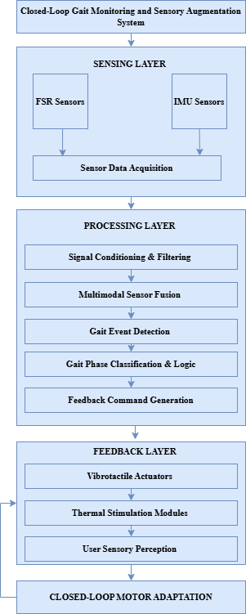
Figure 1: Block diagram of the multisensory feedback framework integrating sensing, processing, and feedback modules

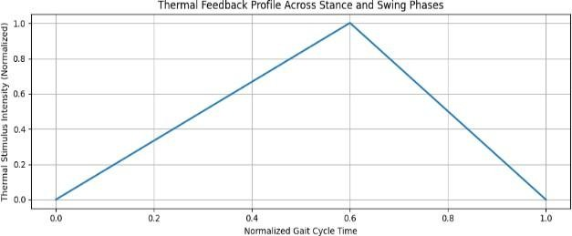
Component | Specification | Function
FSR | 0–1000 N range | Detect stance load
IMU | 9-DOF | Gait phase estimation
ERM Motor | 150 Hz max | Vibrotactile cue  delivery
Peltier Module | ±10 °C | Thermal feedback
Table 1: Hardware specifications of the multisensory feedback system.

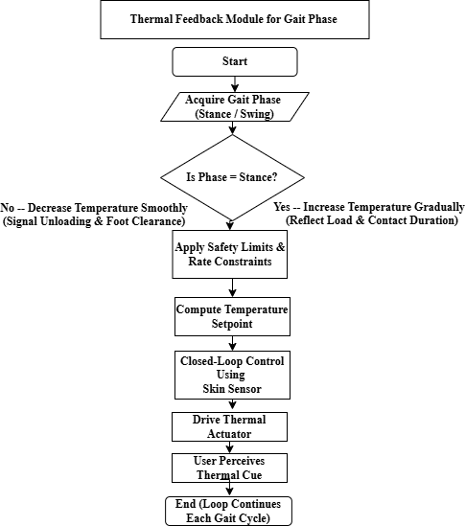

Figure 2: Comparison of stance time symmetry across feedback conditions.

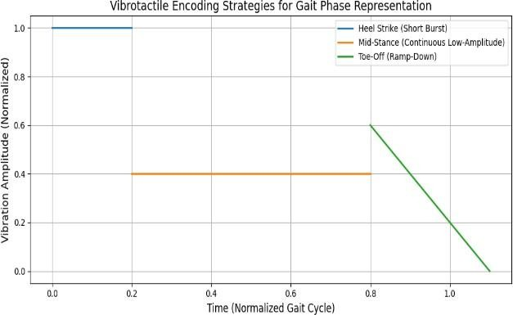
Measure | Assessment  Method | Scale | Evaluation  Purpose
Prosthesis  Embodiment | Standardized  questionnaire | Likert (1–7) | Sense of  integration
Movement  Naturalness | Self-reported  rating | Likert (1–7) | Perceived gait  smoothness
Comfort Level | Self-reported  rating | Likert (1–7) | Thermal and tactile  comfort
Cognitive Load | Self-reported  rating | Likert (1–7) | Mental effort  during walking
Overall System  Acceptance | User preference  score | Likert (1–7) | Long-term usability

Figure 3: Timing diagram illustrating vibrotactile cue patterns synchronised with gait phases

Category | Variable | Metric / Scale | Unit | Description / Purpose
Experimental Conditions | No Feedback (Baseline) | — | — | Walking with prosthesis without vibrotactile or thermal feedback
 | Vibrotactile Feedback | Discrete phase cues | — | Vibrotactile encoding of heel-strike, mid-stance,  and toe-off
 | Thermal Feedback | Continuous modulation | — | Gradual temperature  variation during stance and swing
 | Multimodal Feedback | Vibrotactile + Thermal | — | Combined discrete and continuous sensory feedback

Table 2 Summary of Experimental Conditions and Measured Variables

Parameter | Measurement Method | Unit | Evaluation  Purpose
Step Length  Variability | Coefficient of Variation | % | Stride-to-stride  consistency
Stance Time  Variability | Coefficient of Variation | % | Temporal  stability
Stride Time  Variability | Standard Deviation | s | Gait regularity
Gait Cycle Variability | RMS / Coefficient of  Variation | — | Overall stability  index

Table 3 Gait Variability and Stability Metrics
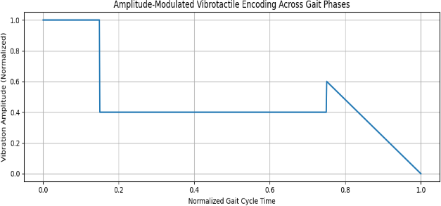
Parameter | Measurement Method | Unit | Evaluation Purpose
Step Length (Left,  Right) | Mean over gait  cycles | m | Bilateral coordination
Step Length  Symmetry Index | |L − R| / (0.5 × (L  + R)) | % | Gait symmetry
Stance Time (Left,  Right) | Mean over gait  cycles | s | Load-bearing  duration
Stance Time  Symmetry Index | Ratio (L / R) | — | Temporal balance
Walking Speed | Average forward  velocity | m/s | Global gait  performance
Cadence | Steps per minute | steps/min | Gait rhythm

Table 4 Spatiotemporal Gait Parameters
Figure 4: User-reported embodiment scores (Likert scale).
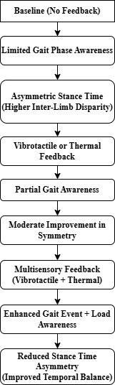
Figure 5: Thermal stimulus profile mapped to stance and swing phases.
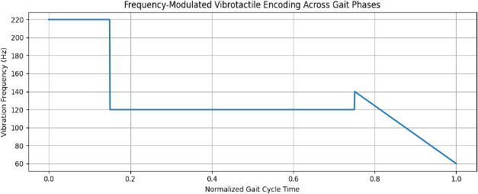
Figure 6: Amplitude and frequency–modulated gait phase

Discussion
The findings of this study support the hypothesis that integrating vibrotactile and thermal stimuli can enhance gait rehabilitation outcomes in individuals using lower-limb prostheses. Vibrotactile cues were effective in delivering precise and event-specific temporal information, enabling users to better perceive critical gait transitions such as heel strike and toe-off. In parallel, thermal feedback provided a continuous and biologically meaningful representation of sustained foot–ground contact, reinforcing load awareness during the stance phase. The combination of these complementary sensory modalities resulted in measurable improvements in gait symmetry, stability, and user confidence, demonstrating the advantages of multisensory integration in prosthetic rehabilitation. The observed reduction in stance time asymmetry suggests that users were able to distribute body weight more evenly between limbs, thereby minimising compensatory gait strategies commonly associated with unilateral limb loss. Improved stride consistency and reduced gait variability further indicate enhanced motor coordination and locomotor control. These improvements are particularly important because gait asymmetry and instability are often linked to increased metabolic cost, joint overloading, and long-term musculoskeletal complications in prosthesis users. By promoting more balanced locomotion, the proposed feedback system may contribute to reducing secondary injuries and improving overall rehabilitation outcomes. The subjective findings provide additional insight into the role of sensory augmentation in prosthetic embodiment. Enhanced limb awareness and increased confidence reported by participants suggest that multisensory feedback may facilitate stronger sensorimotor integration between the user and the prosthetic device. The ability to perceive gait events through intuitive sensory cues appears to reduce uncertainty during walking, enabling users to interact with the prosthesis in a more natural and coordinated manner. This enhanced embodiment may also explain the reduced cognitive burden reported by several participants, as external sensory feedback can compensate for the absence of natural proprioceptive information. Another important observation was the complementary behaviour of the two feedback modalities. Vibrotactile stimulation provided rapid and localised signals that effectively communicated discrete gait events, while thermal stimulation conveyed gradual and sustained information associated with limb loading. Together, these signals created a richer sensory environment that more closely resembled natural physiological feedback mechanisms. This multimodal sensory representation likely contributed to the superior performance observed in the combined condition compared to single-modality feedback approaches. Despite these promising findings, several limitations should be acknowledged. The study involved a relatively limited participant population and short experimental duration, which may restrict the generalizability of the results. Individual differences in sensory sensitivity, prosthetic adaptation, and walking ability may also influence the effectiveness of multisensory feedback systems. Additionally, laboratory-based walking conditions may not fully represent the variability and complexity of real-world environments such as uneven terrain, stair negotiation, or crowded spaces. Future work should therefore focus on larger-scale clinical evaluations involving participants with different amputation levels, prosthetic experience, and mobility capabilities. Longitudinal studies examining adaptation over weeks or months would provide deeper insight into neural plasticity, motor learning, and long-term rehabilitation outcomes associated with multisensory feedback. In addition, integrating machine learning algorithms for adaptive feedback personalisation could further improve system effectiveness by tailoring feedback intensity and timing to individual gait characteristics. Future systems may also incorporate additional sensory modalities such as pressure, auditory, or electromyographic feedback to create a more immersive and biomimetic sensory experience. Finally, wearable wireless implementations and real-time mobile processing platforms could improve portability and facilitate the integration of multisensory rehabilitation systems into daily prosthetic use. Overall, the results of this study demonstrate that combined vibrotactile–thermal feedback represents a promising approach for improving gait symmetry, limb awareness, and walking confidence in lower-limb prosthesis users. By enhancing both objective gait parameters and subjective user experience, the proposed multisensory framework contributes toward the development of more intuitive, adaptive, and human-centred prosthetic rehabilitation technologies.
.

Conclusion
This paper presents a comprehensive multisensory feedback framework designed to support prosthetic gait rehabilitation through the integration of gait-synchronised vibrotactile and thermal stimuli. By translating mechanical interactions at the prosthetic foot into intuitive sensory cues, the proposed system enables users to better perceive gait events, load distribution, and stance dynamics during walking. Experimental results demonstrate measurable improvements in gait symmetry, alongside enhanced user-reported outcomes related to confidence, limb awareness, and embodiment. These findings indicate that combining complementary sensory modalities can effectively augment sensorimotor feedback and facilitate more natural gait patterns. Importantly, the proposed framework is non-invasive, modular, and scalable, making it well suited for adaptation across different prosthetic designs and rehabilitation settings. As such, it represents a promising direction for the development of next-generation rehabilitative prosthetic systems that emphasise both functional performance and user-centred experience.
- Future Scope
Future research should focus on conducting longitudinal clinical studies to evaluate the long-term effects of multisensory feedback on gait adaptation, motor learning, and retention of improved walking patterns in prosthetic users. Investigating how continuous exposure to combined vibrotactile and thermal feedback influences neuroplasticity, rehabilitation outcomes, and functional mobility will provide deeper insight into its therapeutic potential. Additionally, future developments may explore the integration of adaptive control algorithms and machine learning techniques to personalise feedback intensity, timing, and modality based on individual gait characteristics and rehabilitation progress. Expanding the framework to include additional sensory modalities—such as pressure or proprioceptive cues—and
Testing it across diverse prosthetic designs and real-world environments could further enhance system effectiveness and usability. Finally, translating the framework into wearable, energy-efficient, and clinically deployable systems will be essential for large-scale implementation in rehabilitation centres and home-based therapy programs, supporting the advancement of next-generation intelligent prosthetic rehabilitation technologies.

Acknowledgements-The authors would like to sincerely acknowledge all participants for their time, commitment, and enthusiastic involvement in the study. Their cooperation and valuable feedback were essential to the successful completion of this research. The authors also extend their gratitude to the clinical collaborators and technical staff for their support during participant recruitment, experimental setup, and data collection. Their combined interdisciplinary expertise significantly contributed to the design, implementation, and analysis of the proposed multisensory prosthetic gait rehabilitation framework.

Authors’ Contributions: Author¹, Author², and Author³ collectively contributed to the successful completion of this research. Author¹ and Author² were responsible for the conceptualisation and design of the study, including the development of the multisensory feedback framework integrating vibrotactile and thermal stimuli. Author² contributed to the technical implementation and system development. Author¹ and Author³ carried out the data analysis and interpretation of the results. The manuscript was initially drafted by Author¹ and Author², while Author³provided critical review and revisions. All authors reviewed and approved the final manuscript and agreed to be accountable for the accuracy and integrity of the research work. All authors read and approved the final version of the manuscript and agree to be accountable for the integrity and accuracy of the work.

Conflict of Interest: The authors declare that there are no conflicts of interest regarding the publication of this paper. The research was conducted in the absence of any commercial or financial relationships that could be construed as a potential conflict of interest.

Ethical Approval:

As per international standards or university standards, written ethical approval has been collected and preserved by the author(s).

Consent

As per international standards or university standards, Participants’ written consent has been collected and preserved by the author(s).

Disclaimer (Artificial intelligence)

Author(s) hereby declare that NO generative AI

technologies such as Large Language Models (ChatGPT,

COPILOT, etc.) and text-to-image generators have been

used during the writing or editing of this manuscript.
References

[1] Engsberg, J. R. et al., “Effects of gait-synchronized plantar vibrotactile stimulation on balance and stability during walking,” Journal of Biomechanics, Vol.162, Article 111563, 2025.
[2] Muheim, C. et al., “Stable non-invasive thermal feedback for long-term prosthetic embodiment,” Science Robotics, Vol.8, Issue.77, eadg1553, 2023.
[3] Zhao, Y. et al., “Thermal feedback for wearable haptic systems,” IEEE Transactions on Haptics, Vol.15, Issue.3, pp.631–642, 2022.
[4] Shokur, S. et al., “Sensory feedback restores locomotor function after spinal cord injury,” Nature, Vol.594, Issue.7863, pp.76–81, 2021.
[5] Chen, L. et al., “Improving postural stability among people with lower-limb amputations by tactile sensory substitution,” Journal of NeuroEngineering and Rehabilitation, Vol.18, Article 159, 2021.
[6] Gonçalves, H. R. et al., “Vibrotactile biofeedback devices in Parkinson’s disease: A narrative review,” Medical & Biological Engineering & Computing, Vol.59, Issue.6, pp.1185–1199, 2021.
[7] Lee, H. et al., “Use of vibrotactile bracelets to study effects of arm swing variation on overground gait,” IEEE Access, Vol.9, pp.90896–90907, 2021.
[8] Thomas, N. et al., “Sensorimotor-inspired tactile feedback and control improve consistency of prosthesis manipulation in the absence of direct vision,” IEEE Transactions on Haptics, Vol.15, Issue.1, pp.45–57, 2022.
[9] Kourtesis, P. et al., “Electrotactile feedback applications for hand and arm interactions: A systematic review and meta-analysis,” IEEE Transactions on Haptics, Vol.15, Issue.2, pp.210–225, 2022.
[10] Ranjithkumar, S. et al., “Implementation of an intelligent real-time squat detection and performance evaluation system using computer vision and pose estimation techniques,” Iconic Research and Engineering Journal, Vol.9, Issue.6, 2023.
[11] “Recent Advances in Wearable Vibrotactile Feedback Systems for Rehabilitation Applications,” IEEE Access, Vol.12, pp.11245–11263, 2024.
[12] Valette, R. et al., “Development and assessment of vibrotactile feedback from the embedded sensors of a microprocessor-controlled knee prosthesis,” Journal of NeuroEngineering and Rehabilitation, Vol.23, Article 33, 2026.
[13] Lang, A. E. et al., “Vibrotactile haptic and gesture feedback in a smartwatch for controlling a multi-activity powered knee-ankle prosthesis,” Proceedings of the IEEE EMBC Conference, pp.1–5, 2025.
[14] Karimi, M. et al., “Perceptual design and evaluation of a forearm-based vibrotactile interface for transfemoral prosthetic feedback,” Biomimetics, Vol.11, Issue.2, Article 112, 2026.
[15] Hussain, R. S. et al., “Sensory feedback for gait in transtibial amputees: A narrative review of technologies and clinical outcomes,” Frontiers in Bioengineering and Biotechnology, Vol.13, Article 1722817, 2026.
[16] Bartloff, J. et al., “Advancing gait rehabilitation through wearable technologies: Current landscape and future directions,” Expert Review of Medical Devices, Vol.22, pp.1105–1116, 2025.
[17] Bowman, T. et al., “Wearable devices for biofeedback rehabilitation: A systematic review and meta-analysis,” Sensors, Vol.21, Article 3444, 2021.
[18] Ivani, A. S. et al., “VIBES: Vibro-Inertial Bionic Enhancement System in a Prosthetic Socket,” IEEE Robotics and Automation Letters, Vol.9, Issue.1, pp.155–162, 2024.
[19] Blanchet, S. et al., “Augmented sensory feedback for the improvement of gait in individuals with lower-limb amputation: A systematic review,” Gait & Posture, Vol.72, pp.38–48, 2019.
[20] Ma, C. Z. H. et al., “A vibrotactile biofeedback system improves gait symmetry in individuals with stroke,” Gait & Posture, Vol.62, pp.344–350, 2018.
[21] Franz, J. R. & Kram, R., “Advanced age affects the individual leg mechanics of level, uphill, and downhill walking,” Journal of Biomechanics, Vol.47, Issue.3, pp.535–540, 2014.
[22] Cipriani, C. et al., “Humans can integrate feedback of discrete events in their sensorimotor control of a robotic hand,” Experimental Brain Research, Vol.232, Issue.11, pp.3421–3429, 2014.
[23] D’Alonzo, M. et al., “Vibrotactile stimulation promotes embodiment of an alien hand in amputees with phantom sensations,” IEEE Transactions on Neural Systems and Rehabilitation Engineering, Vol.23, Issue.3, pp.450–457, 2015.
[24] Antfolk, C. et al., “Sensory feedback in upper limb prosthetics,” Expert Review of Medical Devices, Vol.10, Issue.1, pp.45–54, 2013.
[25] Bark, K. et al., “Comparison of skin stretch and vibrotactile stimulation for feedback of proprioceptive information,” IEEE Transactions on Haptics, Vol.1, Issue.2, pp.109–118, 2008.
[26] Jin, R. et al., “Functional performance of a vibrotactile sensory substitution device in people with profound vision loss,” Optometry and Vision Science, Vol. 101, Issue 6, pp. 358–367, 2024.
[27] Ras Popovic, S. et al., “Restoring natural sensory feedback in real-time bidirectional hand prostheses,” Science Translational Medicine, Vol.6, Issue.222, 222ra19, 2014.
[28] Yang, F. & King, G. A., “Dynamic gait stability of treadmill versus overground walking in young adults,” Journal of Biomechanics, Vol.49, Issue.16, pp.3860–3865, 2016.
[29] Ostry, D. J. & Gribble, P. L., “Sensory plasticity in human motor learning,” Trends in Neurosciences, Vol.39, Issue.2, pp.114–123, 2016.
[30] Käthner, I. et al., “A portable auditory–tactile sensory substitution device for the blind,” PLoS ONE, Vol.11, Issue.4, e0153086, 2016.

