Case Report

A Six-Case Series of Pelvic Bone Tumor Resection with Limb Preservation: Prosthetic Reconstruction, Osteosynthesis, and Conservative Surgical Approaches

ABSTRACT
Background: Pelvic bone tumors are rare, complex lesions whose management is challenging due to delayed diagnosis, intricate anatomy, and proximity to critical neurovascular structures, requiring multimodal imaging, biopsy confirmation, and individualized surgical resection with reconstruction when needed.
Aims: To report the diagnostic and therapeutic features of six patients managed for pelvic bone tumors in a Moroccan tertiary orthopedic unit, highlighting surgical approaches, reconstructive choices, functional outcomes, and specific challenges in a resource-limited setting.
Study Design: Retrospective descriptive case series.
Place and Duration of Study: Department of Orthopedic Surgery and Traumatology, Mohammed VI University Hospital, Tangier, Morocco, January 2023 – December 2025.
Methodology: Six patients (5 women, 1 man; mean age 35.7 years; range 16–67) operated for histologically confirmed pelvic bone tumors. Data on clinical presentation, multimodal imaging, histological diagnosis, neoadjuvant and adjuvant treatments, surgical resection type (Enneking–Dunham classification), reconstructive strategy, complications, functional outcomes (MSTS score), and follow-up were collected via REDCap database.
Results: Histological subtypes: Ewing sarcoma (n=3), chondrosarcoma (n=1), intraosseous cavernous hemangioma with aneurysmal changes (n=1), bone metastasis from breast carcinoma (n=1). Mean diagnostic delay: 17 months. All patients underwent limb-sparing surgery. Reconstructions: ilio-femoral ice-cream cone prosthesis (n=1), plate osteosynthesis (n=2), cement + T-plate (n=1), hernia mesh filling (n=1), no reconstruction (n=1). Four patients (67%) in complete remission (7 months to 2 years follow-up). One death from Ewing sarcoma metastatic relapse. One locoregional recurrence (metastatic carcinoma). Functional recovery satisfactory in survivors.
Conclusion: Limb-preserving pelvic surgery is achievable across diverse histological subtypes and reconstructive needs in a resource-limited Moroccan tertiary center, though conclusions are necessarily limited by the small and heterogeneous sample size. The 17-month mean diagnostic delay remains the primary obstacle in the Moroccan context. Multidisciplinary tumor boards, improved imaging access, and national referral networks are essential.
Keywords: pelvic bone tumors; internal hemipelvectomy; limb preservation; prosthetic reconstruction; ice-cream cone prosthesis; Ewing sarcoma; chondrosarcoma; Enneking–Dunham classification;
1. INTRODUCTION
Pelvic bone tumors represent a heterogeneous group of rare lesions arising from the skeletal constituents of the pelvic ring — the ilium, ischium, pubis, and sacrum. Their anatomical location, which serves weight-bearing, locomotion, and visceral protection, makes both diagnosis and treatment particularly challenging [1]. Proximity of major neurovascular structures, biological variability across histological subtypes, and insidious symptom onset consistently lead to delayed presentation at locally advanced stages [2].
The imaging workup is central to management: plain radiography provides initial orientation; CT delineates osseous architecture and matrix; MRI maps medullary involvement, extra-osseous extension, and neurovascular relationships; bone scintigraphy or PET-CT completes systemic staging. Definitive diagnosis always rests on image-guided or open biopsy, planned with surgical resection trajectory in mind [3,4].
Wide surgical resection with histologically clear margins (R0) remains the cornerstone of curative treatment, directly correlated with local control and survival. Chemotherapy is indispensable in Ewing sarcoma; chondrosarcoma is primarily managed surgically given its chemoresistance; radiotherapy plays an adjuvant role in selected cases. The Enneking–Dunham anatomosurgical classification divides the pelvis into four zones — Zone I (ilium), Zone II (periacetabular), Zone III (ischiopubic ramus), Zone IV (sacrum) — guiding resection planning and reconstructive decision-making [5,6,7].
Reconstructive options after acetabular or combined pelvic resections include endoprostheses (saddle prosthesis, ice-cream cone, custom implants), proximal femoral autografts, allografts, arthrodesis, and non-reconstruction in selected cases. Anract et al. emphasized that the less anatomically complex the reconstruction, the lower the risk of infection and mechanical failure; iliac wing or obturator ring resections rarely require bony reconstruction [8]. Local recurrence rates after pelvic sarcoma resection range from 17% to 45% in published series [1,8], reflecting the inherent difficulty of achieving wide margins in this region.
In resource-limited settings such as Morocco, additional barriers — delayed access to advanced imaging, limited specialized surgical infrastructure, and incomplete follow-up adherence — further compromise outcomes. We report here six patients managed for pelvic bone tumors between January 2023 and December 2025 at a Moroccan tertiary center, analyzing the spectrum of histological entities, surgical approaches, reconstructive strategies, complications, and short-term outcomes.
2. MATERIAL AND METHODS
2.1 Study Design and Setting
Retrospective, descriptive, single-center case series. Department of Orthopedic Surgery and Traumatology, Mohammed VI University Hospital, Tangier, Morocco. Study period: January 2023 – December 2025.
2.2 Inclusion and Exclusion Criteria
Included: patients operated for histologically confirmed primary or secondary pelvic bone tumor; age ≥15 years; documented ≥6 months postoperative follow-up. Excluded: incomplete records; tumors not requiring surgery; insufficient follow-up.
2.3 Data Collection
Data retrieved from the ENOVA Santé electronic medical records and the department's oncology database. A standardized REDCap form captured: demographics, clinical presentation, multimodal imaging, Enneking–Dunham topography, biopsy type, histological diagnosis and grade, MDT decisions, neoadjuvant/adjuvant therapies, resection type, reconstructive technique, operative time, blood loss and transfusion, postoperative complications, Huvos–Rosen necrosis grading, MSTS functional score, oncological outcome, and follow-up.
2.4 Ethical Considerations
Conducted in accordance with the Declaration of Helsinki (2013). Institutional authorization obtained from Mohammed VI University Hospital, Tangier, Morocco. Written informed consent collected from all patients or guardians for clinical data recording and publication of images. Patient anonymity strictly maintained.
2.5 Statistical Analysis
Descriptive analysis only: proportions and arithmetic means. No inferential statistical testing was required given the case-series design.
3. RESULTS
3.1 Epidemiological Data and Diagnostic Delay
The cohort comprised five women and one man. Mean age was 35.7 years (range 16–67). Mean diagnostic delay from symptom onset to specialized consultation was 17 months (range: 1 month – 5 years). The clinical, radiological, and histological data for all six cases are summarized in Table 1.
3.2 Clinical Presentation
Pelvic or iliac pain was the universal presenting symptom (6/6), frequently associated with partial lower-limb functional impairment (4/6). Weight loss was noted in two cases. No neurological compression signs were detected at initial examination. A palpable mass was present in only one case.
3.3 Imaging and Tumor Topography
All patients underwent plain pelvic radiography revealing osteolytic lesions. CT and MRI provided complementary information. PET-CT was performed in Case 2, confirming hypermetabolism without distant metastases. Enneking–Dunham zones: Type I (ilium) in 2 cases; Type I+II in 1; Type II+III in 1; Type I+II+III in 1; Type IV (sacrum) in 1.
3.4 Histological Distribution
Histological subtypes: Ewing sarcoma (n=3, Cases 2–4), chondrosarcoma Grade II (n=1, Case 5), intraosseous cavernous hemangioma with aneurysmal changes (n=1, Case 1), and periacetabular bone metastasis from breast carcinoma (n=1, Case 6). CT-guided percutaneous biopsy was the primary approach in four patients. Ewing sarcoma was confirmed by CD99/FLI-1 immunopositivity and FISH-confirmed EWSR1 rearrangement in all three cases [18]. Chondrosarcoma diagnosis rested on the sacral location, bicellular architecture, and nuclear atypia, classified Grade II.
3.5 Surgical Strategy and Resection Types
All six patients underwent limb-sparing surgery after MDT discussion (Table 2). Type I resections (Cases 1, 3, 4) targeted the ilium without acetabular involvement. Case 1 required no reconstruction (acetabular joint and pelvic ring integrity maintained). Cases 3 and 4 used plate stabilization. Case 2 (Type II+III, Ewing sarcoma) received navigation-assisted hemipelvectomy with ice-cream cone ilio-femoral prosthetic reconstruction. Case 5 (sacral chondrosarcoma, Type IV) was performed using a patient-specific 3D-printed cutting guide. Case 6 (breast metastasis) underwent intralesional palliative resection with cement + T-plate reconstruction.
3.6 Adjuvant Therapies
All three Ewing sarcoma patients received VDC-IE or VAC-IE multiagent chemotherapy with G-CSF support [23]. Histological response ranged from Grade IV (complete necrosis, Case 4) to Grade I (14% necrosis, Case 2). Chondrosarcoma received adjuvant radiotherapy at 60 Gy/30 fractions.
3.7 Complications and Outcomes
Surgical complications included: hemorrhagic instability (n=2), hemorrhagic shock with 10-day ICU stay (Case 5, 2,000 mL blood loss), pelvic lymphocele (Case 2), and infected hernia mesh requiring revision (Case 5). Four patients (67%) are in complete remission. One patient died from Ewing sarcoma relapse (Case 2). One patient (Case 6) developed locoregional recurrence and was lost to follow-up. Functional outcomes, complications, and follow-up are detailed in Tables 2 and 3.

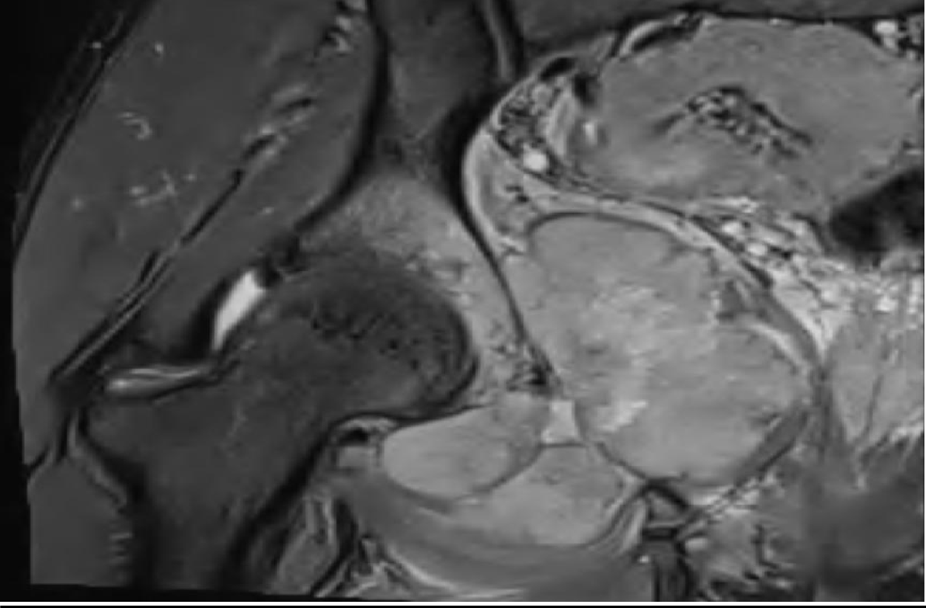  Fig. 1A – MRI STIR coronal: large hyperintense mass (92×54 mm) at right cotyle and ischion with medullary infiltration and cortical breach. | 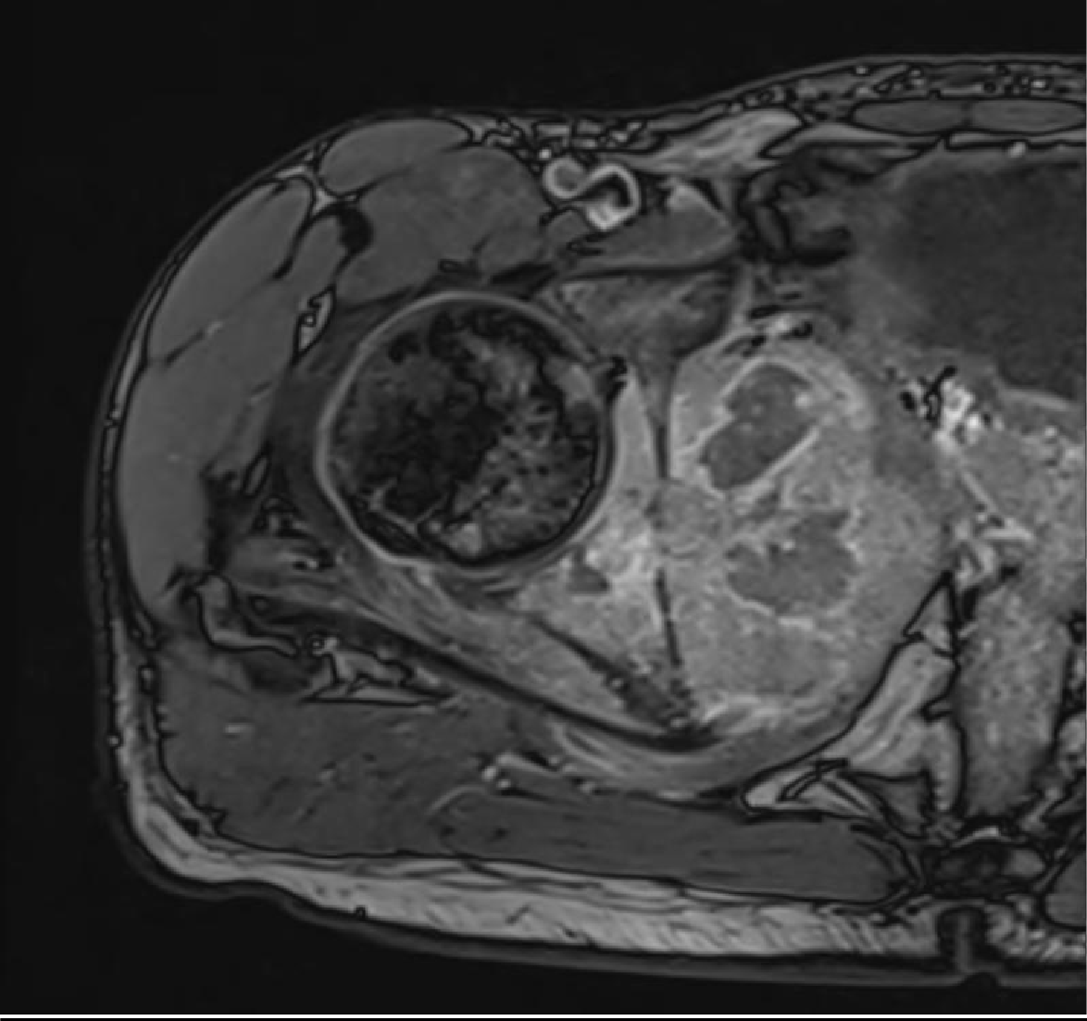  Fig. 1B – MRI T1 post-gadolinium axial: heterogeneous soft-tissue mass infiltrating coxo-femoral joint and periacetabular muscles. | 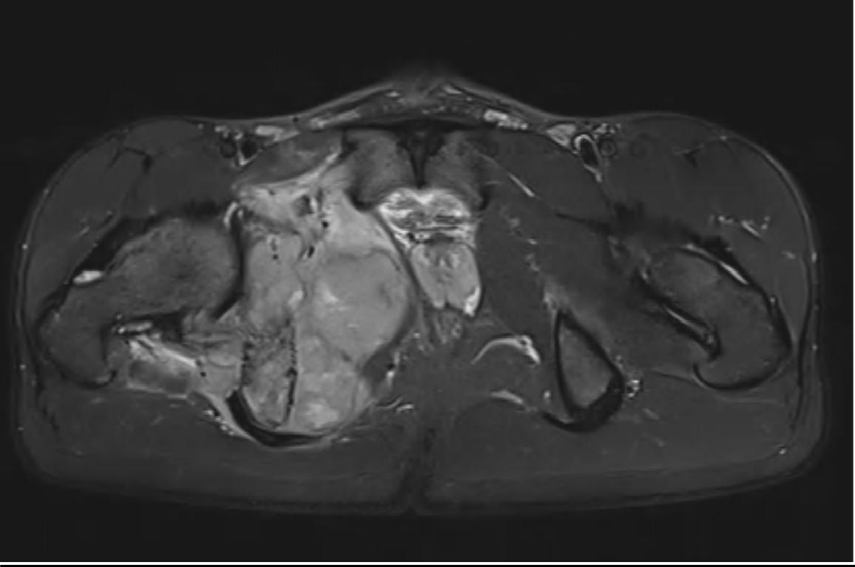  Fig. 1C – MRI STIR axial: large hyperintense mass at right cotyle and ischion with medullary infiltration and cortical breach.
Figure 1. Case 2 – Ewing Sarcoma, right periacetabular zone (Type II+III). Preoperative imaging.

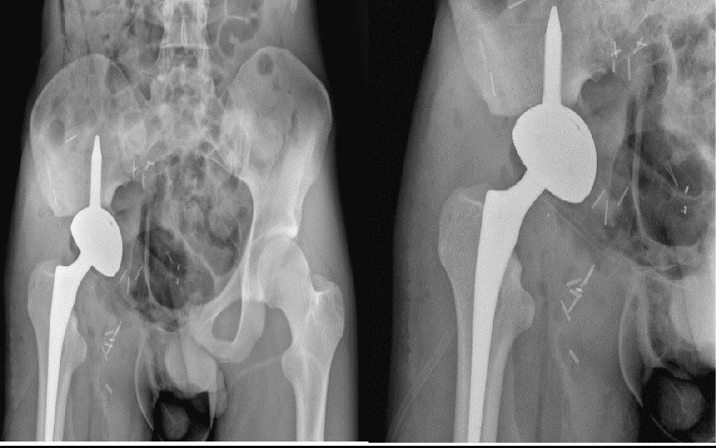
Figure 2. Case 2 – Postoperative imaging after Type II+III internal hemipelvectomy with ice-cream cone ilio-femoral prosthesis / ice-cream cone ilio-femoral prosthesis in place. The cone stem is anchored in the residual posterior iliac column; the femoral component articulates with a modular femoral stem.

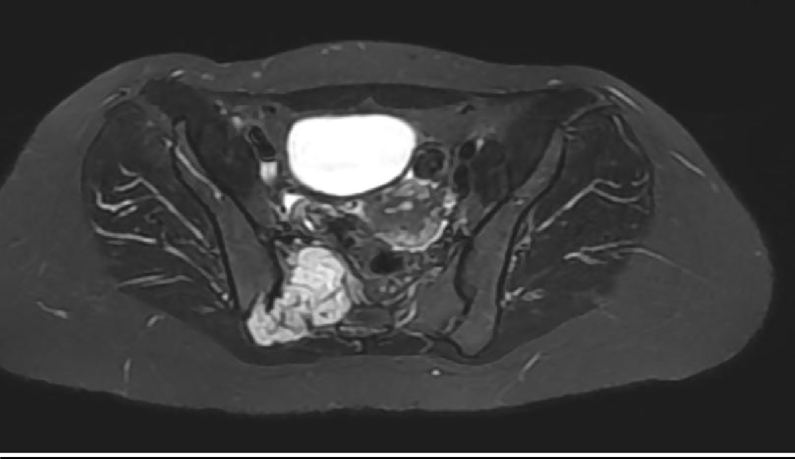  Fig. 3A – MRI STIR axial: right sacral mass 108×61×42 mm with high signal intensity and invasion of piriformis muscle. | 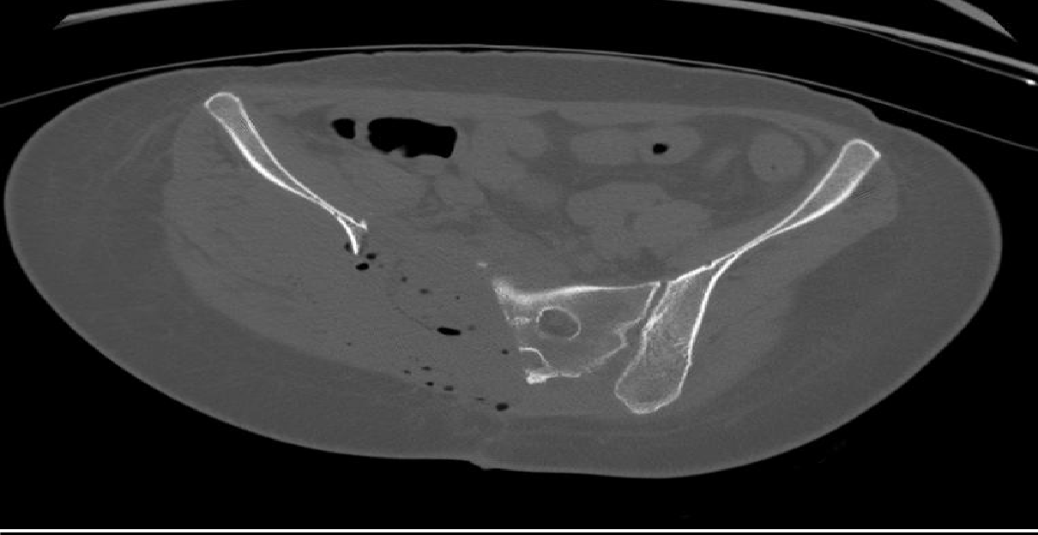  Fig. 3B – CT osseous window axial: destructive sacral lytic lesion with cortical breach and soft-tissue extension. | 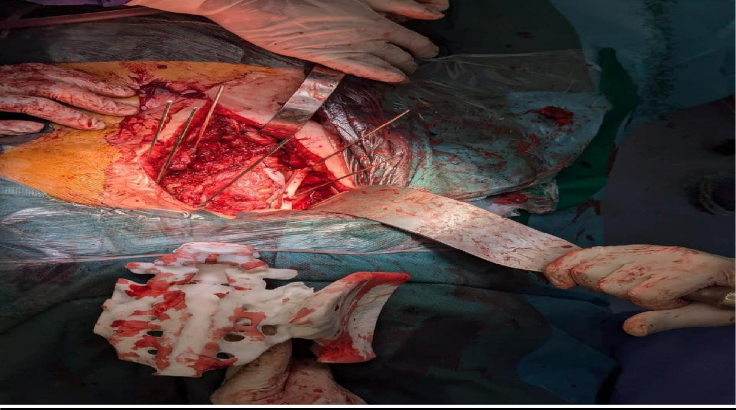  Fig. 3C – Intraoperative: 3D-printed patient-specific cutting guide applied to sacral osteotomy plane, ensuring the planned 7 mm margin around the tumor.
Figure 3. Case 5 – Grade II sacral chondrosarcoma (Type IV). Preoperative imaging and 3D-printed cutting guide.
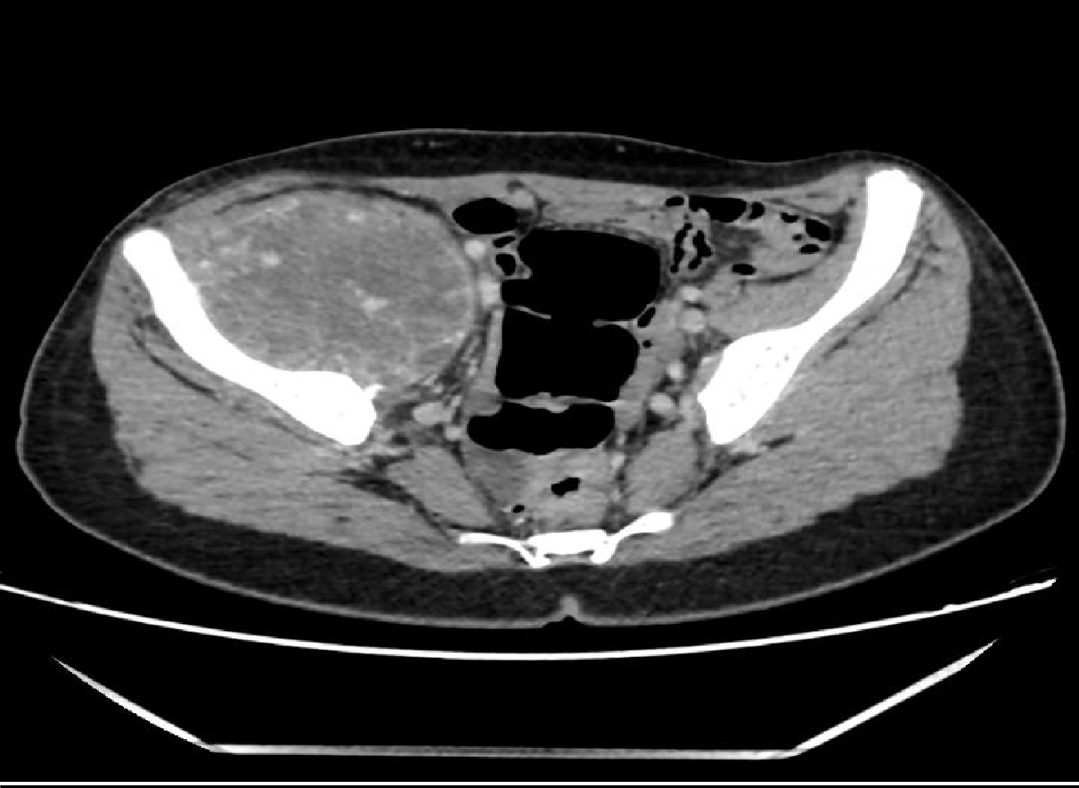  Fig. 4A – CT axial (portal phase): aggressive osteolytic mass 78×91 mm of the right ilium with hypervascularized content and local soft-tissue invasion. | 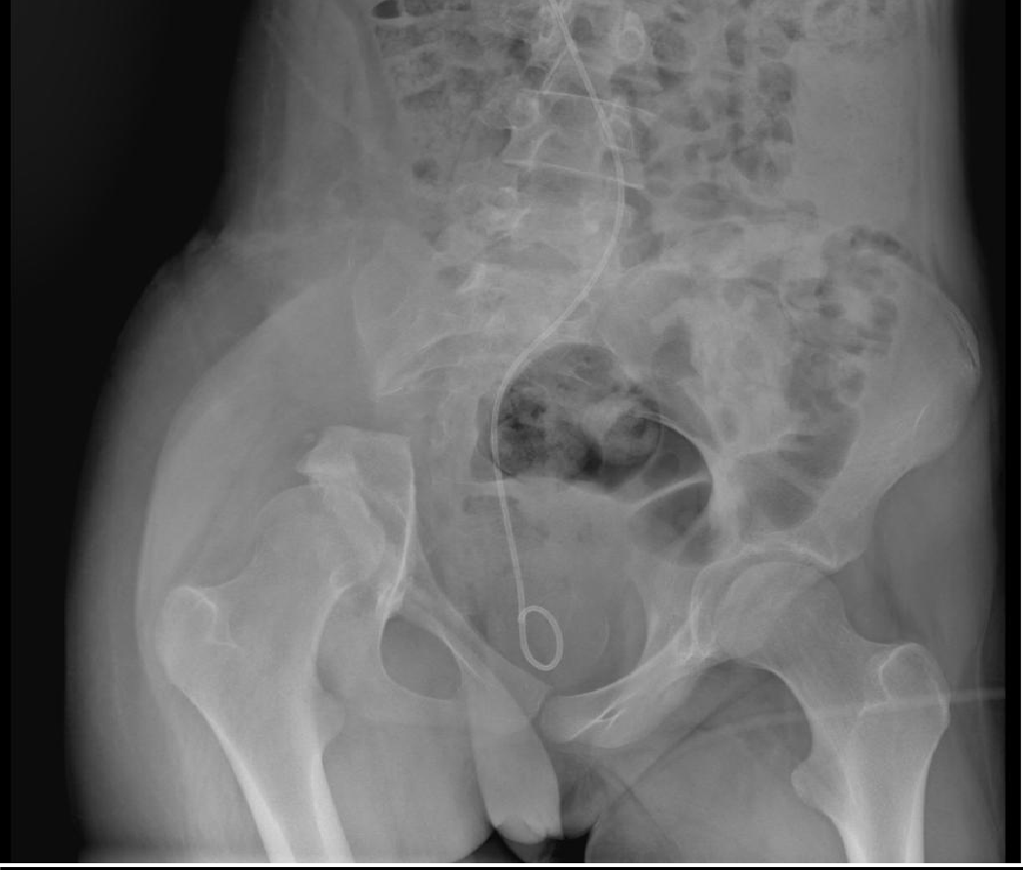  Fig. 4B – Postoperative AP pelvic X-ray: periacetabular osseous defect after Type I internal hemipelvectomy without reconstruction. No osteosynthesis material visible. Double-J ureteral stent visible.
Figure 4. Case 1 – Aneurysmal bone cyst / cavernous hemangioma (Type I+II). Preoperative CT and postoperative X-ray (no reconstruction).

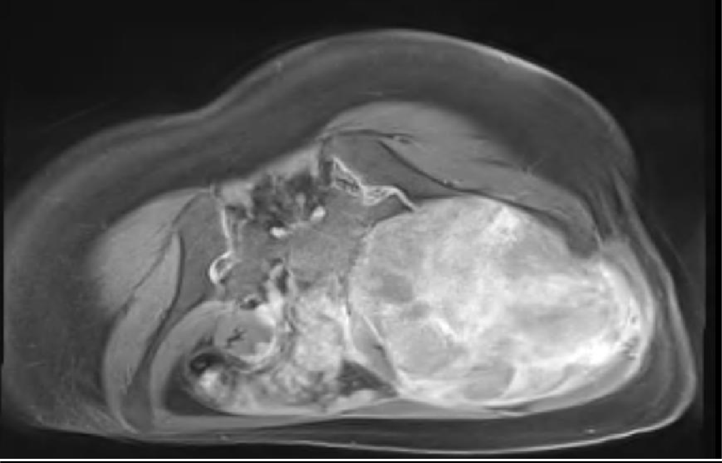  Fig. 5A – MRI T1+Gd axial (preoperative): large iliac tumor 128×127×162 mm compressing and displacing iliac vessels and iliopsoas muscle. Following 3 cycles of neoadjuvant VAC-IE chemotherapy, lesion showed partial regression. | 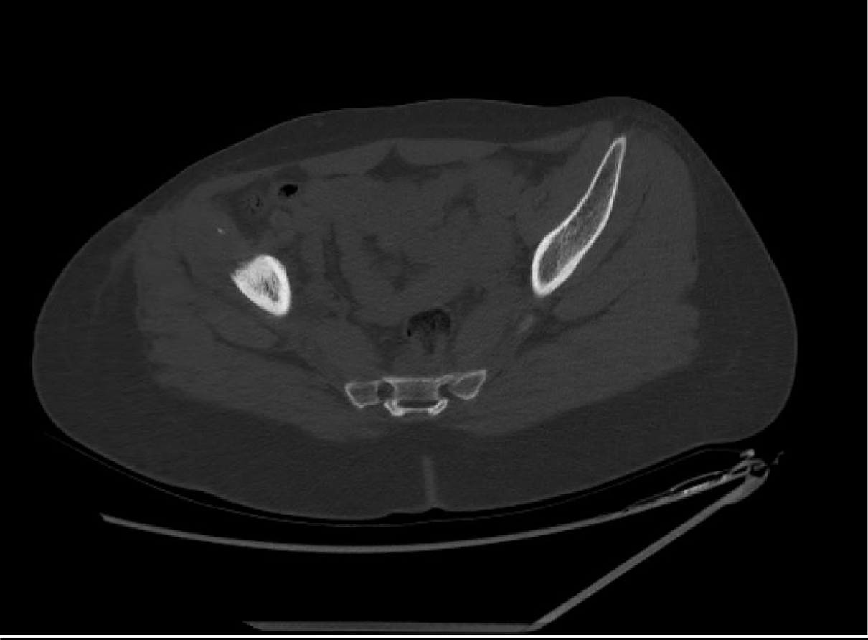  Fig. 5B – Postoperative CT axial: visceral plate osteosynthesis in situ after iliac crest osteotomy and tumor resection. No residual tumor mass. Complete histological necrosis (Huvos Grade IV) confirmed at final pathology.
Figure 5. Case 4 – Ewing Sarcoma, right ilium (Type I). Preoperative MRI and postoperative CT (osteosynthesis plate).

Table 1. Clinical, radiological, and histological data for all six cases.
Case | Age/Sex | Symptom Duration | Chief Complaint | Imaging Findings | Enneking–Dunham Zone | Biopsy Type | Histological Diagnosis | Tumor Grade
1 | 16/F | 7 mo | Right iliac pain + swelling | X-ray: osteolytic right ilium. CT: 78×91 mm. MRI: progression 121×115×161 mm | I + II | CT-guided + open | Intraosseous cavernous hemangioma with aneurysmal changes | Benign
2 | 20/M | 10 mo | Right hip pain + functional impairment | X-ray: osteolytic cotyle + ischion. MRI: 92×54 mm. PET-CT: hypermetabolic | II + III | Open biopsy | Ewing sarcoma (CD99+, FLI-1+; EWSR1) | High grade
3 | 48/F | 5 yr | Right pelvic pain | X-ray+CT+MRI: osteolytic right ilium 85×65×50 mm, soft tissue extension | I | CT-guided | Ewing sarcoma (CD99+, FLI-1+; EWSR1) | High grade
4 | 28/F | 7 mo | Right pelvic pain (postpartum) | X-ray + MRI: 128×127×162 mm, iliac vessel displacement | I | CT-guided + IHC | Ewing sarcoma (CD99+) | High grade
5 | 35/F | 4 mo | Pelvic pain + functional impairment + 8 kg weight loss | CT+MRI: sacral mass 108×61×42 mm | IV (sacrum) | CT-guided | Well-differentiated chondrosarcoma grade II | Grade II
6 | 67/F | 1 mo | Left pelvic pain + partial functional impairment | CT: periacetabular lytic lesion + pathological fracture 30×25×31 mm | I+II+III | Open biopsy | Bone metastasis from breast carcinoma | Metastatic
Table 2. Neoadjuvant therapy, surgical resection, reconstruction, postoperative histology, and adjuvant treatment.
Case | Neoadjuvant Therapy | Resection Type | Reconstruction | Op. Time / Transfusion | Postop Histology & Margins | Adjuvant Therapy
1 | None | Internal hemipelvectomy Type I | None | 311 min / 2 RBC | Cavernous hemangioma; clear margins | None
2 | VDC-IE × 4 | Hemipelvectomy Type II+III (navigation) | Ice-cream cone prosthesis | 480 min / 3 RBC + 3 FFP | Ewing sarcoma 11 cm; Huvos Grade I; margins <1 mm | VDC-IE × 10 + RTH 50.4 Gy
3 | VAC-IE × 4 | Hemipelvectomy Type I | Double-face abdominal plate | 150 min / none | Ewing sarcoma 8 cm; Huvos Grade II; clear margins | VAC-IE × 7 + RTH 50 Gy
4 | VAC-IE × 3 | Iliac crest osteotomy + resection | Visceral plate osteosynthesis | 120 min / none | Complete necrosis (Huvos Grade IV); 5 mm; R0 | VAC-IE × 4 + RTH 50 Gy
5 | None | Hemipelvectomy Type IV (3D guide) | Hernia mesh | 356 min / 2000 mL; 10 RBC + 10 FFP + 12 Plt | Chondrosarcoma Grade II; clear margins (5 mm) | RTH 60 Gy/30 fr
6 | None | Intralesional (palliative) | Cement + T-plate | 120 min / none | Metastatic carcinoma; palliative | Palliative RTH 60 Gy + chemo
Table 3. Complications, oncological outcomes, follow-up, and functional results.
Case | Surgical Complications | Adjuvant Toxicities | Oncological Outcome | Follow-up | Functional Outcome (MSTS)
1 | Postop reactive depression | N/A | Complete remission; no recurrence | 7 months | Autonomous ambulation; satisfactory MSTS
2 | Pelvic lymphocele; reactive depression | Peripheral neuropathy (vincristine) | Bone metastases at 8 months. Death 09/08/2025 | 12 months | Progressive deterioration prior to death
3 | Hemodynamic instability; 1-day ICU | None significant | Complete remission at 2 years | 2 years | Ambulation with intermittent cane; good MSTS
4 | None | Neutropenia (G-CSF controlled); stable pulmonary micronodules | Complete remission at 2 years | 2 years | Near-normal ambulation; excellent MSTS
5 | Hemorrhagic shock (10-day ICU); infected mesh → surgical revision | Grade 3 radiodermatitis; radiation proctitis; lymphedema; neuropathic pain | No local recurrence at last follow-up | 1 year | Ambulation with cane; progressive recovery
6 | None immediate | Not specified | Locoregional recurrence at 1 year; lost to follow-up | 1 year | Transient improvement after surgery
4. DISCUSSION
4.1 Diagnostic Delay
The 17-month mean diagnostic delay observed in this series substantially exceeds the 3–12 months reported in international series [11,12]. Laitinen et al. documented a median delay of approximately 10 months in a European cohort [15], while Wurtz et al. similarly noted significant delays specifically for pelvic sarcomas in a North American context [12]. Our prolonged delay reflects three converging factors: limited access to advanced imaging outside university centers, insufficient primary care awareness of pelvic sarcoma warning signs, and the deep anatomical location of these tumors, which delays clinical detection. This finding is consistent with reports from other African countries with similar healthcare infrastructure [19]. Improving primary care referral pathways and expanding MRI capacity at regional facilities represent the most impactful interventions to address this critical gap.
4.2 Histological Spectrum and Diagnostic Challenges
The histological heterogeneity of this series mirrors the known diversity of pelvic bone tumors, which may include primary sarcomas, benign aggressive lesions, and metastatic disease within the same anatomical region [1,15]. The case of intraosseous cavernous hemangioma with aneurysmal changes (Case 1) illustrates the diagnostic pitfalls inherent to this region: initial imaging showed an aggressive osteolytic pattern indistinguishable from a malignant lesion, requiring correlation between imaging, percutaneous biopsy, and open biopsy before committing to resection. This radio-histological discordance, although rare, underscores the importance of systematic pre-resection biopsy and MDT discussion prior to any major pelvic surgery. Ewing sarcoma represented the most frequent entity (50%), consistent with its predilection for young patients with pelvic primary tumors [18,29].
4.3 Surgical Strategy and Reconstructive Choices
All six patients underwent limb-sparing surgery, reflecting the feasibility of conservative pelvic oncological surgery even in a resource-limited context when multimodal planning is available. The choice of reconstruction was guided by zone involvement, degree of acetabular compromise, patient performance status, and tumor biology. For Type I iliac resections without acetabular involvement (Cases 1, 3, 4), the pelvic ring continuity could be maintained with plate stabilization or without reconstruction, consistent with the principle described by Anract et al. that non-acetabular iliac resections do not require bony reconstruction [8]. The ice-cream cone ilio-femoral prosthesis (Case 2) provided immediate mechanical stability after Type II+III periacetabular resection, an approach supported by Fujiwara et al. who demonstrated improved margin accuracy with navigation-assisted periacetabular resection [20]. The use of a 3D-printed patient-specific cutting guide for the sacral chondrosarcoma (Case 5) allowed precise osteotomies with 5 mm margins in a region with high hemorrhagic risk, illustrating the growing role of additive manufacturing in pelvic oncological surgery [21].
4.4 Chemotherapy Response and Oncological Outcomes
The prognostic significance of neoadjuvant chemotherapy response was clearly illustrated in this series. Case 4, with Huvos Grade IV complete necrosis and 5 mm R0 margins, remains in complete remission at 2 years. In contrast, Case 2, with Grade I poor histological response and margins under 1 mm, experienced early metastatic relapse and death at 12 months, directly replicating the dose-response relationship described by Wunder et al. [24]. These observations reinforce the current ESMO/EURACAN guidelines advocating for neoadjuvant chemotherapy response assessment as the primary stratification tool for adjuvant planning in Ewing sarcoma [31]. The chemoresistance of chondrosarcoma remains its defining challenge; surgery with wide margins and adjuvant radiotherapy for sacral locations constitutes the only validated treatment approach [16,25].
4.5 Complications
The complication profile of this series is consistent with published benchmarks for internal hemipelvectomy. Ogura et al. reported wound complications in over one-third of patients undergoing pelvic sarcoma resection, with infection rates of 10–50% depending on reconstruction type [26]. The infected hernia mesh in Case 5 reflects the known limitations of non-biological fillers in sacral defects, a contaminated field with poor vascularization following radiotherapy. Hemorrhagic complications (Cases 3 and 5) are expected given the proximity of major pelvic vessels and the hypervascular nature of certain tumors; the 10-day ICU stay in Case 5 with 2,000 mL blood loss illustrates the physiological cost of these procedures. Psychological morbidity (reactive depression in 2 of 6 patients, 33%) aligns with published prevalence data for bone sarcoma survivors [28], highlighting the need to integrate psychological support into routine oncological follow-up.
4.6 Contextual Challenges and Practical Implications
This series demonstrates that complex pelvic oncological surgery including navigation, 3D planning, and diverse reconstructive strategies is achievable at a Moroccan tertiary center. However, several structural improvements are essential to improve outcomes at the population level: (1) training primary care physicians to identify and promptly refer patients with chronic unexplained pelvic pain; (2) establishing formalized referral pathways from peripheral hospitals to university orthopedic oncology units; (3) expanding CT-guided biopsy and MRI capacity at regional hospitals; and (4) implementing structured long-term follow-up programs of 5–10 years. International guidelines unanimously recommend management of pelvic sarcomas in expert multidisciplinary centers with dedicated tumor boards [31].
4.7 Limitations
Several important limitations must be acknowledged. The small sample size (n=6) and retrospective single-center design preclude any generalizable conclusions. Histological heterogeneity means that no two cases share an identical clinical trajectory, limiting direct comparisons. Follow-up duration is variable and insufficient for definitive oncological assessment in most cases, particularly for the three Ewing sarcoma patients given the known risk of late relapse. The absence of a validated MSTS score in all patients limits functional outcome analysis. These observations should be considered hypothesis-generating and illustrative rather than conclusive evidence.
5. CONCLUSION
Pelvic bone tumors encompass a heterogeneous spectrum requiring individualized, multidisciplinary management. This six-case series demonstrates that limb-preserving surgery — encompassing ice-cream cone prosthesis, plate osteosynthesis, 3D-guided sacral resection, and non-reconstruction — is technically achievable across different histological subtypes at a Moroccan tertiary center, with satisfactory functional recovery in surviving patients. These findings are necessarily preliminary given the small and heterogeneous sample, but they support the feasibility of this surgical approach in resource-limited settings. Histological response to neoadjuvant chemotherapy and quality of surgical margins remain the primary oncological determinants. A 17-month mean diagnostic delay is the most critical challenge identified. Strengthening multidisciplinary infrastructure, imaging access, and referral networks remains an essential priority for pelvic oncology in Morocco.
CONSENT
Written informed consent was obtained from all patients or legal guardians for clinical data and images. Documentation is available upon editorial request.
DISCLAIMER (ARTIFICIAL INTELLIGENCE)
Author(s) hereby declare that NO generative AI technologies such as Large Language Models (ChatGPT, COPILOT, etc.) and text-to-image generators have been used during the writing or editing of this manuscript.
ETHICAL APPROVAL
Ethical Approval was conducted in accordance with the Declaration of Helsinki (2013). Institutional authorization obtained from Mohammed VI University Hospital, Tangier, Morocco.
REFERENCES
1. Aydinli U, Ozturk C, Yalcinkaya U, et al. (2004). Limb-sparing surgery for primary malignant tumours of the pelvis. Acta Orthopaedica Belgica, 70(5), 489–498.
2. Campanacci M. (1990). Bone and Soft Tissue Tumors. 2nd ed. Springer. [Seminal reference; no contemporary equivalent.]
3. Mintz DN, Hwang S. (2014). Bone tumor imaging, then and now. HSS Journal, 10(3), 230–239.
4. Leflot L, Ducou Le Pointe H, Lenoir M, et al. (2005). Bonnes pratiques en imagerie dans les tumeurs osseuses. EMC Rhumatologie-Orthopédie, 2(1), 59–79.
5. Deloin X, Dumaine V, Biau D, et al. (2009). Pelvic chondrosarcomas: surgical treatment options. Orthopaedics & Traumatology: Surgery & Research, 95(6), 393–401.
6. Tsuda Y, Evans S, Stevenson JD, et al. (2019). Surgical margin width and outcome in pelvic chondrosarcoma. Clinical Orthopaedics and Related Research, 477(11), 2432–2440.
7. Enneking WF, Dunham WK. (1978). Resection and reconstruction for primary neoplasms involving the innominate bone. JBJS American, 60(6), 731–746. [Original classification; seminal reference.]
8. Anract P, Biau D, Babinet A, Tomeno B. (2014). Reconstructions du bassin après résection tumorale chez l'adulte. Bulletin du Cancer, 101(2), 184–194.
9. Han I, Lee YM, Cho HS, et al. (2010). Outcome after surgical treatment of pelvic sarcomas. Clinics in Orthopedic Surgery, 2(3), 160–166.
10. Shi Q, Guo W, Ji T, Tang X. (2024). Lumbar functional evaluation of pelvic bone sarcomas after resection. Cancer Medicine, 13(11), e7282.
11. Kotrych D, Ciechanowicz D, Pawlik J, et al. (2023). Delay in diagnosis of primary bone tumors. Ortopedia Traumatologia Rehabilitacja, 25(1), 9–22.
12. Wurtz LD, Peabody TD, Simon MA. (1999). Delay in diagnosis and treatment of primary bone sarcoma of the pelvis. JBJS American, 81(3), 317–325. [Foundational reference on diagnostic delay in pelvic sarcoma.]
13. Letaief F, Khrouf S, Yahiaoui Y, et al. (2020). Prognostic factors in high-grade localized osteosarcoma: the Tunisian experience. Journal of Orthopaedic Surgery Hong Kong, 28(3).
14. Morbée L, Vereecke E, Laloo F, et al. (2022). MR imaging of the pelvic bones: current and cutting-edge techniques. Journal of the Belgian Society of Radiology, 106(1).
15. Laitinen MK, Parry MC, Morris GV, Jeys LM. (2023). Pelvic bone sarcomas, prognostic factors, and treatment: a narrative review. Scandinavian Journal of Surgery, 112(3), 206–215.
16. Breden S, Stephan M, Knebel C, et al. (2024). Chondrosarcoma of the pelvis: a review of 77 cases. Diagnostics, 14(19), 2166.
17. Williams AE, Ho JW, Sundaram N. (2024). Bone biopsies: practical considerations and technical tips. Seminars in Interventional Radiology, 41(5), 444–454.
18. Mata Fernández C, Sebio A, Orcajo Rincón J, et al. (2024). Clinical practice guidelines for Ewing sarcoma treatment (GEIS). Clinical and Translational Oncology, 27(3), 824–836.
19. Zomalhèto Z, Biaou O, Yekpe P, et al. (2015). Profil des tumeurs osseuses malignes primitives à Cotonou (Bénin). Journal Africain du Cancer, 7.
20. Fujiwara T, Kaneuchi Y, Stevenson J, et al. (2021). Navigation-assisted pelvic resections for periacetabular chondrosarcomas. European Journal of Surgical Oncology, 47(2), 416–423.
21. Ould Slimane M, Thong P, Perez A, et al. (2016). Apport de l'imagerie 3D naviguée en chirurgie de résection tumorale osseuse pelvienne. Revue de Chirurgie Orthopédique et Traumatologique, 102.
22. Chimutengwende-Gordon M, Coomber R, Peat F, et al. (2022). Harrington plus reconstruction for pelvic and acetabular metastases. Journal of Bone Oncology, 33, 100414.
23. Ewing Sarcoma Treatment (PDQ®) – NCI. (2025). https://www.cancer.gov/types/bone/hp/ewing-treatment-pdq
24. Wunder JS, Paulian G, Huvos AG, et al. (1998). Histological response to chemotherapy as predictor of outcome in Ewing sarcoma. JBJS American, 80(7), 1020–1033. [Seminal prognostic reference.]
25. Hogendoorn PCW, Athanasou N, Bielack S, et al. (2010). Bone sarcomas: ESMO clinical practice guidelines. Annals of Oncology, 21(Suppl 5), v204–v213.
26. Ogura K, Boland PJ, Fabbri N, Healey JH. (2020). Rate and risk factors for wound complications after internal hemipelvectomy. Bone & Joint Journal, 102-B(3), 280–284.
27. Schmid MP, Harrabi S, Herfarth K, et al. (2022). Particle therapy in pelvic Ewing sarcoma. Cancers, 14(24), 6045.
28. Suhag A, Sharma KK, Tiwari SK, et al. (2024). Health-related quality of life and psychological concerns among sarcoma survivors. ecancermedicalscience.
29. Brown JM, Rakoczy K, Tokson JH, et al. (2022). Ewing sarcoma of the pelvis: clinical features and overall survival. Cancer Treatment and Research Communications, 33, 100634.
30. Lehner B, Bollmann J, Geisbüsch A, et al. (2025). Functional outcomes after internal hemipelvectomy for primary sarcoma of the bony pelvis. Diagnostics, 15(12), 1452.
31. Strauss SJ, Frezza AM, Abecassis N, et al. (2021). Bone sarcomas: ESMO–EURACAN–GENTURIS clinical practice guideline. Annals of Oncology, 32(12), 1520–1536.

