Review Article

Critical Minerals in the Energy Transition: Risks, Resilience, and Resource Security

Abstract
The transition to low-carbon energy systems has significantly increased the strategic importance of critical minerals. Technologies such as electric vehicles, renewable energy systems, and energy storage solutions rely heavily on minerals including lithium, cobalt, nickel, copper, graphite, and rare earth elements. This growing dependence has shifted global energy systems from being fuel-intensive to material-intensive. As a result, the energy transition is now closely linked to the availability, accessibility, and sustainability of critical mineral resources. Despite rapidly rising demand, critical mineral supply chains remain vulnerable. Production and processing are highly concentrated in a limited number of countries, creating systemic risks related to supply disruptions, geopolitical tensions, and market volatility. Factors such as resource nationalism, trade restrictions, and strategic competition further intensify these risks. In addition, environmental, social, and governance (ESG) challenges associated with mining and processing activities pose constraints on sustainable supply expansion. This review synthesizes current knowledge on the risks and resilience of critical mineral supply systems within the context of the energy transition. It highlights key vulnerabilities across the value chain and examines the role of geopolitical dynamics in shaping resource security. The study also evaluates strategic pathways to enhance resilience, including supply diversification, recycling and circular economy approaches, technological innovation, and international cooperation. The findings emphasize that achieving long-term resource security requires an integrated and balanced approach that aligns economic, environmental, and geopolitical considerations. Strengthening resilient and sustainable critical mineral supply chains will be essential for ensuring a secure, equitable, and efficient global energy transition.
Keywords: Critical Minerals, Energy Transition, Supply Chain Risk, Geopolitical Dynamics, Resource Security

1. Introduction
The global transition toward low-carbon energy systems is reshaping the strategic importance of mineral resources. Unlike conventional fossil fuel-based systems, which rely on energy-dense fuels, modern clean energy technologies depend heavily on a diverse suite of materials. Critical minerals such as lithium, cobalt, nickel, copper, graphite, and rare earth elements are essential for enabling electrification, renewable energy deployment, and large-scale energy storage systems (International Energy Agency, 2024; Reich & Simon, 2025). As a result, the energy transition is increasingly defined not only by energy flows but also by material availability and supply security. The global transition from fossil fuel-based systems to low-carbon energy technologies has substantially increased the demand for critical minerals due to their essential role in batteries, electric vehicles, renewable energy systems, and advanced technological applications. Unlike conventional fossil fuel resources, critical minerals are characterized by supply chain vulnerabilities, geopolitical dependencies, uneven resource distribution, and sustainability concerns. Therefore, effective critical mineral management has emerged as a key scientific and policy challenge for ensuring resource security and supporting a sustainable energy transition.
The rapid expansion of clean energy technologies has led to a substantial rise in demand for these minerals. Electric vehicles, wind turbines, and solar photovoltaic systems require significantly higher material inputs compared to conventional technologies (Lee et al., 2024; Månberger, 2023). In particular, battery technologies are driving unprecedented demand growth. Lithium, cobalt, nickel, and graphite are fundamental components of lithium-ion batteries, which underpin both electric mobility and grid-scale energy storage (Watari et al., 2023; Calderon et al., 2024). Projections indicate that demand for key battery minerals may increase several-fold by 2040, reflecting the accelerating pace of decarbonization efforts (Drexhage et al., 2023; International Energy Agency, 2024). This shift represents a broader transformation from fuel-intensive to material-intensive energy systems (Nijnens et al., 2023).
Despite this rapid demand growth, the supply of critical minerals remains constrained by structural and geographic factors. Global supply chains are characterized by significant concentration in both extraction and processing stages. While mining activities are distributed across several regions, refining and processing capacities are heavily concentrated in a few countries (Figure 1), particularly in downstream segments (Blengini et al., 2017; International Energy Agency, 2024). For instance, cobalt production is largely dominated by the Democratic Republic of Congo, while rare earth processing and graphite supply are heavily controlled by China (Siddiqui, 2025; Bhuwalka et al., 2025). Such concentration creates systemic vulnerabilities, as disruptions in key regions can propagate across the entire supply chain. Recent studies highlight that the dominance of a small number of countries significantly increases exposure to supply shocks, price volatility, and strategic competition (McCaffrey et al., 2023; Hegeman & Zhou, 2025).
Geopolitical dynamics further intensify these risks. Critical minerals are increasingly viewed as strategic assets within global economic and security frameworks. Governments are adopting policies to secure access to these resources, including export controls, trade restrictions, and domestic processing mandates (Ali et al., 2024; Sen et al., 2026). The rise of resource nationalism and strategic stockpiling reflects growing concerns over supply security and geopolitical influence (Zhang, 2026). In addition, political instability in resource-rich regions introduces further uncertainty, particularly in areas where governance frameworks remain weak (Gorman and Dzombak, 2018). These developments are transforming mineral supply chains into arenas of geopolitical competition, where access to resources is closely linked to technological and economic leadership.
Alongside these structural and geopolitical challenges, environmental and social considerations play a critical role in shaping the future of critical mineral supply. Mining and processing activities can result in land degradation, water stress, biodiversity loss, and greenhouse gas emissions (Franks et al., 2022; Sovacool et al., 2023). Life-cycle assessments emphasize the need to minimize environmental impacts across the entire value chain, from extraction to end-use applications (Elshkaki & Graedel, 2013; Wei et al., 2025). Social issues, including labor conditions and community impacts, further highlight the importance of responsible sourcing and governance (Ali et al., 2025). These environmental, social, and governance (ESG) constraints can limit the pace of supply expansion, thereby influencing long-term resource availability.
In this context, resilience has emerged as a key concept in critical mineral supply systems. Resilience refers to the capacity of supply chains to anticipate, absorb, and recover from disruptions while maintaining functionality. Building resilience requires a combination of strategies, including supply diversification, technological innovation, recycling, and international collaboration (Zhang, 2026; Sen et al., 2026). At the same time, achieving resource security demands a balanced approach that integrates economic efficiency with environmental sustainability and social responsibility.
This review examines the evolving role of critical minerals in the energy transition through the lens of risks, resilience, and resource security. It synthesizes recent literature to identify key vulnerabilities in global supply chains, analyzes the influence of geopolitical and ESG factors, and evaluates strategic pathways for developing resilient and sustainable mineral systems. Literature for this review was collected through a structured search of major scientific databases including Scopus, Web of Science, Google Scholar, and ScienceDirect. Keywords such as 'critical minerals', 'energy transition', 'resource security', 'supply chain resilience', and 'geopolitical risks' were used individually and in combination. Priority was given to recent peer-reviewed articles, reports from international organizations, and relevant policy documents to ensure comprehensive and up-to-date coverage of the topic. The interrelationship between energy transition, mineral demand, supply risks, geopolitical dynamics, ESG constraints, and resilience strategies is illustrated in Figure 2.
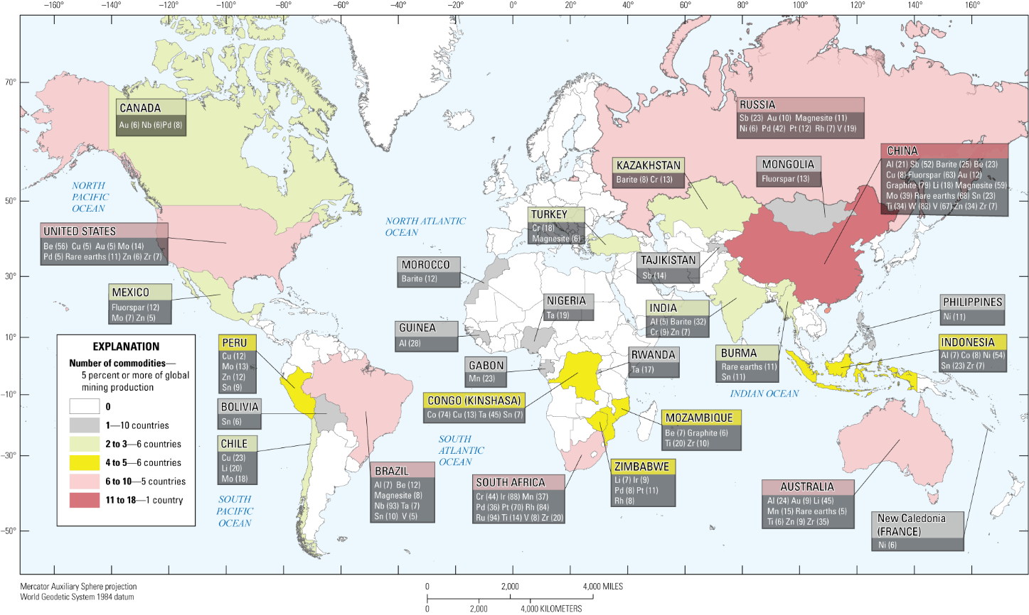
Figure. 1Map of the world showing each country’s share of global mining production of select mineral commodities, including critical minerals (for which data were available), copper, gold, and molybdenum (Source: Chung et al., 2025).

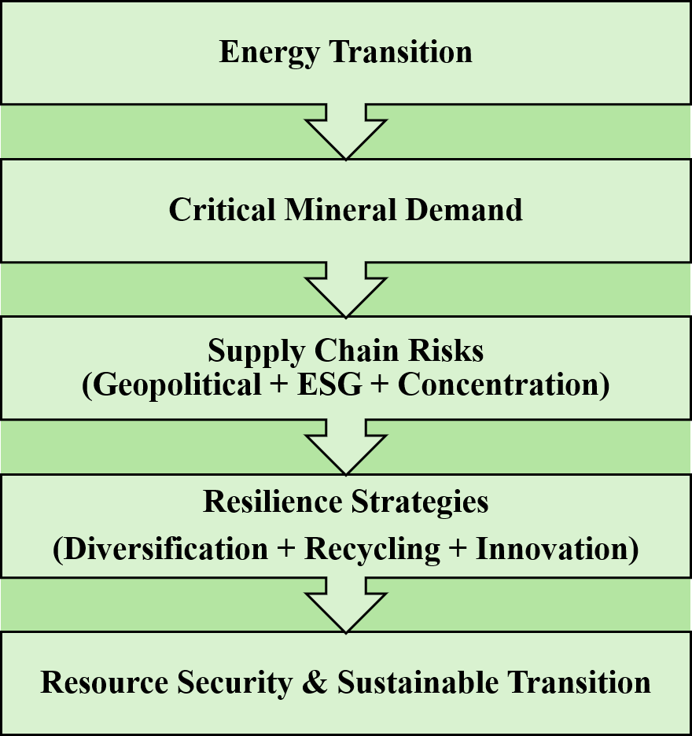
Figure 2. Integrated framework showing the relationship between energy transition, critical mineral demand, supply risks, ESG constraints, geopolitical dynamics, and resilience strategies (Modified after International Energy Agency, 2024; Ali et al., 2024; Sen et al., 2026).
2. Critical Mineral Demand and Material Intensity in the Energy Transition
The global energy transition is fundamentally increasing the demand for critical minerals due to the material-intensive nature of clean energy technologies. Unlike fossil fuel-based systems, which rely primarily on energy-dense fuels, low-carbon technologies require a wide range of mineral inputs to enable electrification, storage, and grid expansion (International Energy Agency, 2024; Calderon et al., 2024). This shift represents a structural transformation in energy systems, where material availability becomes as important as energy generation capacity.
Electric vehicles (EVs) are among the largest drivers of critical mineral demand. Lithium-ion batteries, which power EVs and energy storage systems, depend heavily on lithium, cobalt, nickel, and graphite. Recent assessments indicate that EVs require approximately five to six times more mineral inputs than conventional internal combustion engine vehicles (IEA, 2024; Elshkaki & Graedel, 2013). The rapid expansion of battery manufacturing capacity, supported by global decarbonization policies, has significantly accelerated demand for these materials (Reich & Simon, 2025; Watari et al., 2023).
Renewable energy technologies further contribute to this growing demand. Wind turbines require rare earth elements such as neodymium and dysprosium for permanent magnets, while solar photovoltaic systems depend on silicon, silver, and copper (Liang et al., 2023). Grid infrastructure expansion, essential for integrating renewable energy, also requires large quantities of copper and aluminum (Lee et al., 2024). These factors collectively increase the mineral intensity of modern energy systems.
Quantitative projections highlight the scale of this transformation. According to the International Energy Agency (2024), demand for lithium could increase by more than seven times by 2040 under net-zero scenarios. Similarly, demand for cobalt and nickel is expected to grow substantially, driven by battery technologies and energy storage deployment (Drexhage et al., 2023; Wei et al., 2025). Rare earth elements are also projected to experience strong demand growth due to their critical role in wind energy systems (Siddiqui, 2025). The projected demand growth and strategic applications of major critical minerals associated with clean energy technologies are summarized in Table 1.
Despite these trends, uncertainties remain regarding future demand trajectories. Technological advancements, such as alternative battery chemistries and material substitution, may alter demand patterns (Paltsev, 2017). For example, lithium iron phosphate (LFP) batteries reduce reliance on cobalt and nickel, potentially easing supply pressures. At the same time, improvements in material efficiency and recycling could moderate primary resource demand (Harper et al., 2019; Watari et al., 2025).
Another important consideration is the time lag between demand growth and supply response. The development of new mining projects typically requires long lead times, often exceeding 10–15 years, due to exploration, permitting, and infrastructure constraints (Tilton et al., 2018; Menezes Cunha et al., 2026). This delay creates a structural mismatch between rapidly increasing demand and relatively slow supply expansion.
Recent studies also emphasize that the energy transition may not necessarily lead to an overall increase in total mining volumes compared to fossil fuel systems, but rather a shift in the types of materials required (Nijnens et al., 2023). However, this transition still poses significant challenges in terms of resource availability, processing capacity, and supply chain coordination.
Overall, the rising demand for critical minerals underscores the need for integrated resource planning. Understanding material intensity and demand dynamics is essential for anticipating supply risks and designing resilient strategies. As the energy transition accelerates, ensuring a stable and sustainable supply of critical minerals will remain a key challenge for policymakers, industry stakeholders, and researchers alike.
3. Global Supply Chain Structure and Concentration: Implications for Risk and Resilience
Critical mineral supply chains are inherently complex, multi-layered, and geographically uneven. They involve interconnected stages, including exploration, extraction, processing, refining, and end-use manufacturing. While upstream mining activities are relatively dispersed across regions, downstream processing and refining are highly concentrated, creating structural asymmetries that significantly influence supply security (International Energy Agency, 2024; Blengini et al., 2017).
One of the defining characteristics of critical mineral supply systems is the disproportionate concentration of processing capacity. For several key minerals, a small number of countries dominate refining and value addition. China, for instance, accounts for a substantial share of global processing capacity for rare earth elements, graphite, and battery materials, often exceeding 60–90% depending on the mineral (Siddiqui, 2025; Hegeman & Zhou, 2025). Similarly, cobalt production is heavily concentrated in the Democratic Republic of Congo, while lithium supply is dominated by Australia and Chile (IEA, 2024). This concentration creates critical chokepoints in global supply chains. The major stages of the global critical mineral supply chain and associated concentration hotspots are illustrated in Figure 3.
Such structural concentration amplifies systemic risks. Disruptions in a single country or region—whether due to political instability, regulatory changes, or environmental constraints—can have cascading effects across global markets. Recent analyses show that the top three producing countries often control a majority share of supply for many critical minerals, increasing vulnerability to supply shocks (McCaffrey et al., 2023; Helbig et al., 2021). This risk is particularly acute in downstream stages, where diversification remains limited.
Another key feature of supply chains is their long development timelines and capital intensity. Establishing new mining and processing facilities requires substantial investment, regulatory approvals, and infrastructure development. Lead times often extend beyond a decade, limiting the ability of supply systems to respond quickly to sudden demand surges (Tilton et al., 2018; Menezes Cunha et al., 2026). This lag contributes to price volatility and supply uncertainty, especially during periods of rapid energy transition.
In addition to geographic concentration, logistical and technological dependencies further complicate supply chains. Many critical minerals require specialized processing technologies and complex chemical treatments. These processes are often proprietary or region-specific, creating barriers to entry for new producers (Reich & Simon, 2025; Zhang, 2026). As a result, even when new mining projects are developed, the absence of local processing capacity can limit their contribution to global supply resilience.
Recent research also highlights the role of embedded material flows and indirect dependencies. For example, critical minerals are often traded as intermediate or finished products rather than raw materials, obscuring the true extent of supply concentration (McCaffrey et al., 2023). This lack of transparency reduces market efficiency and complicates risk assessment.From a resilience perspective, these structural characteristics underscore the importance of supply chain diversification and regional balancing. Efforts are underway in several regions, including the European Union, the United States, and India, to develop domestic processing capabilities and reduce reliance on external suppliers (Sen et al., 2026; Ali et al., 2024). Strategic investments in refining infrastructure, coupled with supportive policy frameworks, are critical for enhancing supply chain resilience.
Furthermore, digitalization and advanced technologies are emerging as important tools for improving supply chain efficiency and transparency. Technologies such as artificial intelligence, blockchain, and real-time monitoring systems can enhance traceability, optimize resource allocation, and reduce operational risks (Ali et al., 2025; Yin, 2023). These innovations can play a key role in strengthening adaptive capacity within mineral supply systems.
Despite these advancements, achieving a fully resilient supply chain remains challenging. Structural dependencies, geopolitical competition, and environmental constraints continue to shape the dynamics of critical mineral markets. Therefore, a holistic approach that integrates economic, technological, and policy dimensions is essential. The concentration of production and processing capacity for selected critical minerals and their associated supply risks are presented in Table 1.
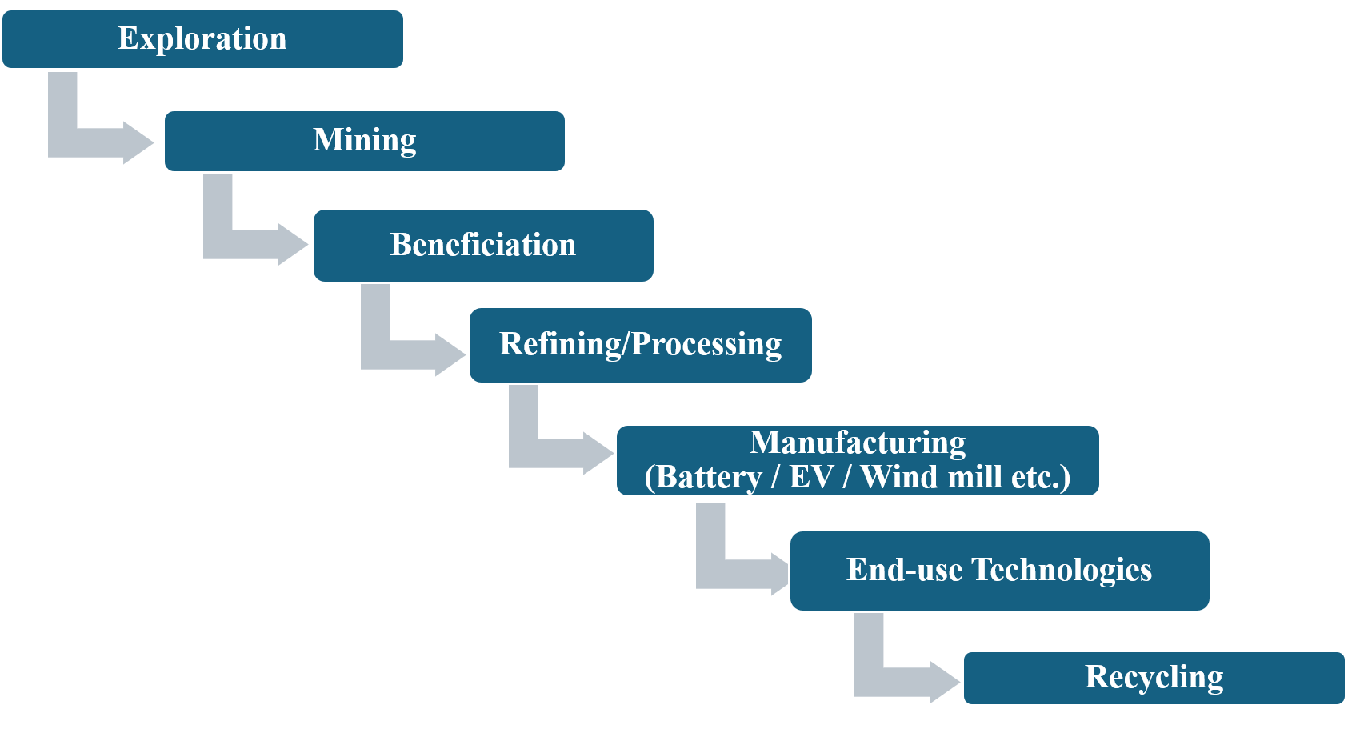
Figure 3. Simplified global critical mineral supply chain highlighting major production and processing concentration hotspots (After IEA, 2024; Siddiqui, 2025; Zhang, 2026).
Table 1. Global production and processing concentration of selected critical minerals and associated supply risks.
Mineral | Top Producing Country | Share (%) | Processing Dominance | Risk Level | References
Cobalt | DRC | ~70% | China | High | International Energy Agency (2024)
Lithium | Australia, Chile | ~75% | China | High | International Energy Agency (2024)
Rare Earths | China | ~60% mining, >85% processing | China | Very High | Siddiqui (2025)
Nickel | Indonesia | ~40% | China | Medium–High | Zhang (2025)
Graphite | China | ~65% | China | Very High | Bhuwalka et al. (2025)

4. Geopolitical Risks and Strategic Competition in Critical Minerals
Geopolitical dynamics have become a defining factor in the global critical mineral landscape. As demand for these materials accelerates, nations are increasingly recognizing their strategic importance for energy security, technological leadership, and economic stability. This shift has transformed critical minerals from conventional commodities into geopolitical assets, shaping international relations and trade policies (Reich & Simon, 2025; Sen et al., 2026; Sahoo and Mishra, 2026).
One of the most prominent features of this evolving landscape is the rise of resource nationalism. Resource-rich countries are implementing policies to maximize domestic value addition and reduce dependence on external actors. For example, Indonesia has imposed export restrictions on nickel ore to promote domestic processing and strengthen its position in the global battery supply chain (Zhang, 2026). Similarly, several countries in Africa and Latin America are revisiting mining regulations to increase state participation and local benefits (Ali et al., 2024). While these measures support national interests, they also introduce uncertainties in global supply chains.
Another critical dimension is the growing concentration of processing and refining capacity, particularly in China. China’s dominance in rare earth processing and battery material refining gives it significant leverage over global supply chains (Siddiqui, 2025; Hegeman & Zhou, 2025). This concentration raises concerns among importing nations, especially in the context of geopolitical tensions and strategic competition. In response, countries such as the United States and members of the European Union are actively pursuing policies to diversify supply sources and develop domestic processing capabilities (Sen et al., 2026).
Trade dependencies further exacerbate geopolitical risks. Many advanced economies rely heavily on imports for critical minerals, creating vulnerabilities to supply disruptions. For instance, the European Union depends on external suppliers for a large share of its rare earth and battery mineral requirements. Such dependencies can be exploited during periods of political or economic conflict, leading to supply insecurity and price volatility (Siddiqui, 2025).
Political instability in resource-rich regions adds another layer of complexity. The Democratic Republic of Congo, which accounts for a significant portion of global cobalt production, faces governance challenges, conflict risks, and infrastructure limitations (Ali et al., 2025). These factors increase the likelihood of supply disruptions and raise concerns about ethical sourcing. Similar risks exist in other regions where regulatory uncertainty and weak institutional frameworks hinder stable mineral production.al
In recent years, strategic stockpiling and bilateral agreements have emerged as key tools for managing geopolitical risks. Countries are building reserves of critical minerals to buffer against supply disruptions. At the same time, international partnerships and alliances are being formed to secure long-term access to resources. Initiatives such as critical mineral alliances and supply chain agreements reflect a shift toward cooperative strategies, although competition remains strong (Ali et al., 2024; Sen et al., 2026).
Technological competition is also intensifying. Nations are investing in advanced processing technologies, battery innovation, and material substitution to reduce strategic dependencies (Paltsev, 2017; Sahoo, 2024; Reich & Simon, 2025). Control over technology and intellectual property is becoming as important as control over raw materials, further complicating the geopolitical landscape.
Recent studies emphasize that geopolitical risks are not limited to physical supply disruptions. They also include market manipulation, regulatory changes, and information asymmetry, which can influence pricing and investment decisions (Zhang, 2026; Yin, 2023). These risks highlight the need for greater transparency and coordination in global mineral markets.
From a resilience perspective, addressing geopolitical risks requires a combination of diversification, diplomacy, and strategic planning. Diversifying supply sources reduces dependence on single regions, while international cooperation can help stabilize markets and promote responsible sourcing practices. Strengthening governance frameworks and enhancing transparency are equally important for reducing uncertainty.
5. ESG Constraints and Sustainability Challenges in Critical Mineral Supply Chains
The rapid expansion of critical mineral production to support the energy transition is accompanied by significant environmental, social, and governance (ESG) challenges. While these minerals are essential for enabling low-carbon technologies, their extraction and processing raise concerns regarding sustainability, resource efficiency, and ethical sourcing. As a result, ESG considerations have become central to discussions on long-term resource security and supply chain resilience.
5.1 Environmental Constraints
Mining and processing of critical minerals are associated with substantial environmental impacts. These include land degradation, deforestation, water depletion, and biodiversity loss. For example, lithium extraction in arid regions often requires large volumes of water, leading to water stress and ecological imbalance. Similarly, rare earth processing generates hazardous waste and chemical by-products that require careful management (Franks et al., 2022; Sovacool et al., 2023).
In addition, mineral processing is energy-intensive and contributes to greenhouse gas emissions. This creates a paradox in which clean energy technologies rely on processes that themselves have significant environmental footprints. Life-cycle assessment (LCA) studies emphasize the importance of evaluating environmental impacts across the entire value chain—from extraction to end-use (Elshkaki & Graedel, 2013; Wei et al., 2025). Recent research suggests that improving energy efficiency and adopting low-carbon processing technologies can significantly reduce these impacts (Smerigan & Shi, 2025).
5.2 Social and Ethical Challenges
Social dimensions of critical mineral supply chains are equally significant. Mining activities often occur in regions with weak governance frameworks, leading to issues such as poor labor conditions, child labor, and community displacement. The cobalt sector in the Democratic Republic of Congo is a well-documented example where artisanal mining raises ethical and human rights concerns (Ali et al., 2025; Sovacool et al., 2023).
Local communities are frequently affected by land acquisition, environmental degradation, and limited economic benefits. These challenges can lead to social conflicts and project delays, further affecting supply stability. Ensuring community engagement, fair compensation, and inclusive development is therefore essential for sustainable resource extraction (Tost, 2025; Ali et al., 2025).
5.3 Governance and Regulatory Challenges
Governance plays a critical role in shaping the sustainability and transparency of critical mineral supply chains. Weak regulatory frameworks, lack of enforcement, and limited market transparency can increase risks related to corruption, illegal mining, and supply chain opacity (Blengini et al., 2017).
At the same time, stringent environmental regulations and lengthy permitting processes in some regions can delay project development, creating supply bottlenecks. Balancing regulatory rigor with efficient project approvals is therefore a key challenge for policymakers (Tilton et al., 2018; Menezes Cunha et al., 2026).
Recent initiatives emphasize the importance of traceability and responsible sourcing. Digital technologies, including blockchain and AI-based monitoring systems, are being explored to improve transparency and accountability across supply chains (Yin, 2023; Ali et al., 2025). These tools can help track material flows and ensure compliance with ESG standards.
5.4 Implications for Supply Risk and Resilience
ESG constraints are not only ethical concerns but also critical determinants of supply risk. Environmental restrictions, social opposition, and governance failures can delay or disrupt mining operations, thereby affecting global supply chains. Increasingly, investors and stakeholders are incorporating ESG criteria into decision-making, influencing project viability and financing (Sovacool et al., 2023; Reich & Simon, 2025).
To enhance resilience, it is essential to integrate sustainability into supply chain strategies. This includes adopting cleaner production technologies, strengthening regulatory frameworks, and promoting responsible sourcing practices. Circular economy approaches, such as recycling and urban mining, can further reduce environmental pressures and improve resource efficiency (Harper et al., 2019; Watari et al., 2025).
6. Strategic Pathways for Resilient and Secure Critical Mineral Supply Chains
The growing demand for critical minerals, combined with structural supply constraints, geopolitical risks, and ESG challenges, underscores the urgent need for integrated and forward-looking strategies. Building resilient and secure supply chains is not a single-dimensional task; rather, it requires coordinated efforts across technological, economic, and policy domains. This section outlines key strategic pathways to enhance resilience and ensure long-term resource security.
6.1 Supply Diversification and Regional Development
One of the most effective approaches to reducing supply risk is diversification. Expanding mining and processing activities across multiple geographic regions can reduce dependence on a limited number of countries. Emerging economies with untapped mineral resources present significant opportunities for diversification. At the same time, strengthening domestic exploration and production capacities can enhance national resource security (International Energy Agency, 2024; Sen et al., 2026).
Recent policy initiatives in regions such as the European Union and the United States emphasize the development of local supply chains and strategic partnerships with resource-rich countries (Ali et al., 2024). However, diversification must be accompanied by investments in infrastructure, skilled workforce development, and regulatory frameworks to ensure long-term viability.
6.2 Technological Innovation and Material Efficiency
Technological innovation plays a crucial role in reducing dependence on critical minerals. Advances in battery technologies, such as lithium iron phosphate (LFP) and solid-state batteries, are reducing reliance on scarce materials like cobalt and nickel (Paltsev, 2017; Reich & Simon, 2025). Similarly, improvements in material efficiency and product design can lower overall mineral consumption.
Automation, artificial intelligence, and digitalization are also transforming mining and processing operations. These technologies improve efficiency, reduce operational risks, and enhance resource recovery rates (Ali et al., 2025; Yin, 2023). Innovation in extraction and refining processes can further enable the utilization of lower-grade ores and previously uneconomic deposits.
6.3 Recycling, Urban Mining, and Circular Economy
Recycling represents a critical pathway for reducing pressure on primary resources. End-of-life products, particularly lithium-ion batteries and electronic waste, contain significant quantities of valuable minerals. Recovering these materials through recycling and urban mining can improve resource efficiency and reduce environmental impacts (Harper et al., 2019; Watari et al., 2025).
The development of circular economy models is gaining increasing attention. Designing products for recyclability, improving collection systems, and investing in advanced recycling technologies are key components of this approach. Although current recycling rates for many critical minerals remain low, future potential is substantial as the volume of end-of-life materials increases. The integration of circular economy approaches and resilience pathways for sustainable critical mineral systems is conceptualized in Figure 4.
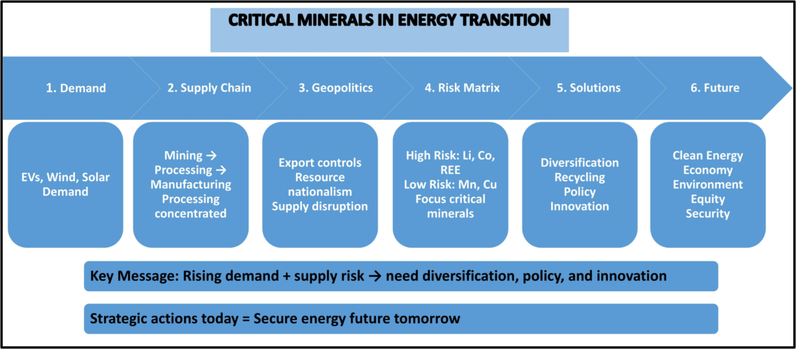
Figure 4: Circular economy and resilience pathways for sustainable critical mineral supply chains.

6.4 Strategic Stockpiling and Market Stabilization
Strategic stockpiling is an important tool for managing short-term supply disruptions. By maintaining reserves of critical minerals, countries can buffer against sudden shocks caused by geopolitical tensions or market volatility. In addition, improving market transparency and data availability can enhance price stability and reduce uncertainty (Zhang, 2026; Siddiqui, 2025).
International coordination in stockpiling strategies can further strengthen resilience, particularly for minerals with highly concentrated supply chains.
6.5 International Cooperation and Policy Frameworks
Global cooperation is essential for ensuring stable and sustainable supply chains. Bilateral and multilateral agreements can facilitate access to resources, promote technology transfer, and support responsible mining practices. Initiatives focused on critical mineral alliances and supply chain partnerships are increasingly shaping global resource governance (Ali et al., 2024; Sen et al., 2026).
Policy frameworks must also address ESG considerations. Transparent regulations, environmental standards, and social safeguards are necessary to ensure sustainable resource development. Harmonizing standards across countries can reduce trade barriers and improve supply chain efficiency.
6.6 Integration of ESG and Responsible Sourcing
Embedding ESG principles into supply chain strategies is critical for long-term resilience. Responsible sourcing practices, certification systems, and traceability mechanisms can enhance transparency and accountability. Digital tools such as blockchain can support real-time tracking of material flows and ensure compliance with sustainability standards (Yin, 2023; Ali et al., 2025).
Investors and stakeholders are increasingly prioritizing ESG performance, influencing project financing and development. Companies that adopt sustainable practices are more likely to achieve long-term stability and social acceptance.
1
7. Conclusion
The global energy transition is not only a technological shift but also a profound transformation in how resources are sourced, managed, and valued. Critical minerals now stand at the center of this transition. They enable the deployment of clean energy technologies, yet their supply systems remain exposed to significant risks.
This review highlights that the challenges associated with critical minerals are deeply interconnected. Rapidly rising demand, geographic concentration of supply, geopolitical tensions, and ESG constraints collectively shape the vulnerability of global supply chains. These factors do not operate in isolation. Instead, they interact in complex ways, amplifying uncertainties and influencing long-term resource security.
A key insight emerging from this study is that resilience must be treated as a core principle, not an afterthought. Building resilient supply chains requires more than increasing production. It demands diversification of supply sources, development of domestic capabilities, and strengthening of international partnerships. Technological innovation, particularly in material efficiency and substitution, offers opportunities to reduce dependency on scarce resources. At the same time, recycling and circular economy approaches provide a pathway to decouple growth from resource extraction.
Equally important is the integration of environmental, social, and governance considerations into resource strategies. Sustainable mining practices, responsible sourcing, and transparent governance frameworks are essential for ensuring that the energy transition does not create new environmental and social burdens. In this context, resilience and sustainability must go hand in hand.
The distinct nature of critical mineral management compared with conventional fossil fuel systems emphasizes the need for integrated strategies involving sustainable extraction, recycling, resource efficiency, and resilient supply chains. Addressing these challenges is essential for ensuring long-term sustainability and achieving global decarbonization objectives."
This review has certain limitations that should be acknowledged. The analysis primarily focuses on major high-demand critical minerals and may not comprehensively cover low-volume or emerging minerals. In addition, data availability and limited transparency in global supply-chain networks may introduce uncertainties in assessing market dynamics and resource security patterns.
Looking ahead, the future of the energy transition will depend on how effectively the global community manages critical mineral systems. Strategic foresight, policy coordination, and technological advancement will be crucial in addressing emerging risks. A fragmented approach will not be sufficient. Instead, a coordinated, multi-dimensional strategy that aligns economic priorities with environmental and social goals is required.
Disclaimer (Artificial intelligence)

The authors hereby declare that generative AI technologies, including Large Language Models (such as ChatGPT, Copilot, etc.), were used only to assist in language refinement, grammar correction, and improving the clarity of the manuscript. All scientific interpretations, analyses, conclusions, and the final content of the manuscript remain the sole responsibility of the authors. No AI-generated images, data, results, or scientific interpretations were used in this study.

References
- Ali, S., Hale, T., Moutinho, V., Bleischwitz, R., Primmer, E., Svobodova, K., Christman, P. and Kulczycka, J., 2024. Critical Materials and Minerals Sourcing Laws Require Scientific Interface. Available at SSRN 5044276. https://doi.org/10.2139/ssrn.5044276
- Ali, M.A., Ali, M.I.M. and Osman, A.A., 2025. AI-driven mining 4.0: A systematic review of smart, sustainable, and autonomous technologies across the mining lifecycle. Current Journal of Applied Science and Technology, 44(6), pp.125-139. https://doi.org/10.9734/cjast/2025/v44i64564
- Bhuwalka, K., Ramachandran, H., Narasimhan, S., Yao, A., Frohmann, J., Peiseler, L., Chueh, W., Boies, A., Davis, S.J. and Benson, S., 2025. Securing the supply of graphite for batteries. arXiv preprint arXiv:2503.21521. https://doi.org/10.48550/arXiv.2503.21521
- Blengini, G.A., Nuss, P., Dewulf, J., Nita, V., Peirò, L.T., Vidal-Legaz, B., Latunussa, C., Mancini, L., Blagoeva, D., Pennington, D. and Pellegrini, M., 2017. EU methodology for critical raw materials assessment: Policy needs and proposed solutions for incremental improvements. Resources Policy, 53, pp.12-19. https://doi.org/10.1016/j.resourpol.2017.05.008
- Calderon, J.L., Smith, N.M., Bazilian, M.D. and Holley, E., 2024. Critical mineral demand estimates for low-carbon technologies: What do they tell us and how can they evolve? Renewable and Sustainable Energy Reviews, 189, p.113938. https://doi.org/10.1016/j.rser.2023.113938
- Chung, J., Xun, S. and Textoris, S.D., 2025. Global maps of critical mineral production in 2023 (No. 2025-3038). US Geological Survey. https://doi.org/10.3133/fs20253038
- Drexhage, J., Fabregas, T.P., Hund, K., La Porta, D. and Laing, T., 2023. Minerals for Climate Action. World Bank.
- Elshkaki, A. and Graedel, T.E., 2013. Dynamic analysis of the global metals flows and stocks in electricity generation technologies. Journal of Cleaner Production, 59, pp.260-273. https://doi.org/10.1016/j.jclepro.2013.07.003
- Franks, D.M., Keenan, J., Tonda, E. and Kariuki, A., 2022. Mineral resource governance and the global goals: an agenda for international collaboration. Summary of the UNEA 4/19 Consultations.
- Gorman, M.R. and Dzombak, D.A., 2018. A review of sustainable mining and resource management: Transitioning from the life cycle of the mine to the life cycle of the mineral. Resources, Conservation and Recycling, 137, pp.281-291. https://doi.org/10.1016/j.resconrec.2018.06.001
- Harper, G., Sommerville, R., Kendrick, E., Driscoll, L., Slater, P., Stolkin, R., Walton, A., Christensen, P., Heidrich, O., Lambert, S. and Abbott, A., 2019. Recycling lithium-ion batteries from electric vehicles. nature, 575(7781), pp.75-86. https://doi.org/10.1038/s41586-019-1682-5
- Harpprecht, C., Sacchi, R., Naegler, T., van Sluisveld, M., Daioglou, V., Tukker, A. and Steubing, B., 2025. Future environmental impacts of global iron and steel production. Energy & Environmental Science, 18(16), pp.8009-8028.
- Hegeman, P. and Zhou, L., 2025. Towards a sustainable supply of graphite: a geological way forward. Earth Science, Systems and Society, 5(1).https://doi.org/10.1144/esss2024-014
- Helbig, C., Bruckler, M., Thorenz, A. and Tuma, A., 2021. An overview of indicator choice and normalization in raw material supply risk assessments. Resources, 10(8), p.79. https://www.mdpi.com/2079-9276/10/8/79
- Hund, K., La Porta, D., Fabregas, T.P., Laing, T. and Drexhage, J., 2020. Minerals for climate action.
- International Energy Agency, 2024. Global critical minerals outlook 2024. IEA, Paris https://www. iea. org/reports/global-critical-minerals-outlook-2024, Licence: CC BY, 4.
- Lee, T., Yao, Y., Graedel, T.E. and Miatto, A., 2024. Critical material requirements and recycling opportunities for US wind and solar power generation. Journal of Industrial Ecology, 28(3), pp.527-541. https://doi.org/10.1111/jiec.13479
- Liang, Y., Kleijn, R. and Van der Voet, E., 2023. Increase in demand for critical materials under IEA Net-Zero emission by 2050 scenario. Applied Energy, 346, p.121400. https://doi.org/10.1016/j.apenergy.2023.121400
- Månberger, A., 2023. Critical raw material supply matters and the potential of the circular economy to contribute to security. Intereconomics, 58(2), pp.74-78.
- McCaffrey, D.M., Nassar, N.T., Jowitt, S.M., Padilla, A.J. and Bird, L.R., 2023. Embedded critical material flow: The case of niobium, the United States, and China. Resources, Conservation and Recycling, 188, p.106698. https://doi.org/10.1016/j.resconrec.2022.106698
- Menezes Cunha, J.V., Pirard, E. and Drnek, T., 2026. Resource accessibility and depletion assessments: bridging the gap between geospheric and anthropospheric mineral resources. Mineral Economics, pp.1-13. https://doi.org/10.1007/s13563-026-00599
- Nijnens, J., Behrens, P., Kraan, O., Sprecher, B. and Kleijn, R., 2023. Energy transition will require substantially less mining than the current fossil system. Joule, 7(11), pp.2408-2413. https://doi.org/10.1016/j.joule.2023.10.005
- Reich, M. and Simon, A.C., 2025. Critical minerals. Annual Review of Earth and Planetary Sciences, 53(1), pp.141-168. https://doi.org/10.1146/annurev-earth-040523-023316
- Paltsev, S., 2017. Energy scenarios: The value and limits of scenario analysis. Wiley Interdisciplinary Reviews: Energy and Environment, 6(4). https://doi.org/10.1002/wene.242.
- Sahoo, J., 2024. Data Mining Prior to Earth Mining: A Sustainable Approach for Mineral Exploitation. JGSR, Vol. 9, No.2, pp.161. https://doi.org/10.56153/g19088-024-0198-60
- Sahoo, J., Mishra, P.K., 2026. Critical minerals in India: Strategic importance, resource potential, and sustainable development challenges. Vistas in Geological research: visions in geological sciences-2026 Department of Geology Utkal University, Bhubaneswar, Odisha 20 (01), PP 164-170. ISBN: 978-93-5692-788-9
- Sen, A., Jamasb, T. and Toba, N., 2026. The Emerging Global Market for Energy Transition Critical Minerals: Competition, Cooperation, or Cartelisation?. In Critical Minerals Supply Chains Security and Resiliency in the ASEAN, Vol. 1: Lessons from Economics and Finance (pp. 55-81). Singapore: Springer Nature Singapore. https://doi.org/10.13140/RG.2.2.14340.03209
- Siddiqui, K., 2025. Rare Earth Critical Minerals: Geopolitics, Supply Chains, and Emerging Tensions. World Financial Review.
- Smerigan, A. and Shi, R., 2025. Advancing the economic and environmental sustainability of rare earth element recovery from phosphogypsum. Environmental Science & Technology, 59(37), pp.19755-19767. https://doi.org/10.1021/acs.est.5c04952
- Sovacool, B.K., Brugger, H., Brunzema, I., Dańkowska, A., Wemyss, D., Vernay, A.L., Betz, R., Avelino, F., de Geus, T., Dembek, A. and Duetschke, E., 2023. Social innovation supports inclusive and accelerated energy transitions with appropriate governance. Communications Earth & Environment, 4(1), p.289. https://doi.org/10.1038/s43247-023-00952-w
- Tilton, J.E., Crowson, P.C., DeYoung Jr, J.H., Eggert, R.G., Ericsson, M., Guzmán, J.I., Humphreys, D., Lagos, G., Maxwell, P., Radetzki, M. and Singer, D.A., 2018. Public policy and future mineral supplies. Resources Policy, 57, pp.55-60. https://doi.org/10.1016/j.resourpol.2018.01.006
- Tost, M., 2025. Lessons from assessing sustainability in the mining and resources sector. In The Routledge Handbook of Global Sustainability Education and Thinking for the 21st Century (pp. 200-217). Routledge India. https://doi.org/10.4324/9781003171577-16
- Vekasi, K., 2023. Securing supply chain resiliency for critical rare earth metals. In Critical Minerals, the Climate Crisis and the Tech Imperium (pp. 45-68). Cham: Springer Nature Switzerland. https://doi.org/10.1007/978-3-031-25577-9_3
- Watari, T., Cabrera Serrenho, A., Gast, L., Cullen, J. and Allwood, J., 2023. Feasible supply of steel and cement within a carbon budget is likely to fall short of expected global demand. Nature Communications, 14(1), p.7895. https://doi.org/10.1038/s41467-023-43684-3
- Watari, T., Fishman, T., Wieland, H. and Wiedenhofer, D., 2025. Global stagnation and regional variations in steel recycling. Resources, Conservation and Recycling, 220, p.108363. https://doi.org/10.1016/j.resconrec.2025.108363
- Wei, F., Zou, Z., Xiao, Z., Lin, Z., Zhang, B., Tian, G. and Zhang, C., 2025. A Critical Bottleneck in Energy Transition: Quantitative Predictions and Potential Strategies for Lithium Resource Depletion. https://doi.org/10.21203/rs.3.rs-6962776/v1
- Yin, W., 2023. Identifying the pathways through digital transformation to achieve supply chain resilience: an fsQCA approach. Environmental Science and Pollution Research, 30(4), pp.10867-10879. https://doi.org/10.1007/s11356-022-22917-w
- Zhang, H., 2026. Resilience of critical transition minerals supply chain in the context of strategic rivalry: implications for the national policy and regulatory frameworks. Journal of Energy & Natural Resources Law, 44(1), pp.67-93. https://doi.org/10.1080/02646811.2025.2495920

