Metamorphic Index Minerals as Exploration Vectors: Linking Metamorphic P–T Evolution to Orogenic Gold and Volcanogenic Massive Sulfide Mineralization

Abstract
Index minerals provide critical insights into the pressure–temperature (P–T) evolution of metamorphic terrains and play an increasingly important role in predictive mineral exploration. These minerals form only within specific thermodynamic conditions and therefore serve as reliable indicators of metamorphic grade and fluid evolution. In mineral exploration, the distribution of index minerals helps delineate metamorphic gradients, identify hydrothermal alteration halos, and vector toward concealed ore deposits. This study presents a comprehensive review of the application of index minerals in mineral exploration, emphasizing their role in orogenic gold and volcanogenic massive sulfide (VMS) systems. Using documented case studies from the Abitibi Greenstone Belt and the Broken Hill deposit within the Curnamona Province, the research examines how mineral assemblages such as garnet, staurolite, kyanite, sillimanite, and gahnite can guide exploration targeting. The study also evaluates limitations including retrograde metamorphism and compositional constraints, while highlighting emerging technologies such as hyperspectral spectroscopy and machine learning in mineral detection and exploration modeling. The findings demonstrate that the integration of classical metamorphic mineralogy with modern geospatial and spectral technologies significantly enhances the efficiency of mineral exploration programs.
Keywords: Index minerals, metamorphic grade, mineral exploration, hydrothermal alteration, vectoring, metamorphic petrology

1. Introduction
Mineral exploration relies heavily on understanding the geological processes responsible for the concentration of economically valuable elements within the Earth's crust. One of the most powerful tools available to exploration geologists in metamorphic terranes is the identification and interpretation of index minerals. Index minerals are minerals that form under specific pressure–temperature (P–T) conditions and therefore act as indicators of metamorphic grade (Spear, 1993). Their occurrence provides valuable information about the thermal and tectonic history of geological terrains. The growing global demand for critical minerals has intensified interest in advanced exploration approaches capable of identifying deeply buried or metamorphosed ore systems (International Energy Agency [IEA], 2024).
The concept of index minerals originates from classical metamorphic petrology, where progressive metamorphism produces characteristic mineral assemblages that correspond to increasing metamorphic grades. In pelitic rocks, a typical Barrovian metamorphic sequence includes chlorite, biotite, garnet, staurolite, kyanite, and sillimanite, each defining a metamorphic isograd marking the first appearance of that mineral in the rock record (Yardley, 1989). These mineral transitions reflect major dehydration reactions that release fluids capable of transporting metals within the crust.
In economic geology, these metamorphic reactions are particularly important because they are often associated with fluid generation and metal mobilization. During regional metamorphism, devolatilization reactions in sedimentary and volcanic rocks release aqueous fluids enriched in metals such as gold, copper, lead, and zinc. These fluids migrate along structural pathways and precipitate ore minerals under favorable physicochemical conditions (Phillips & Powell, 2010). Consequently, mapping metamorphic mineral assemblages provides a means of identifying zones of fluid generation and focusing exploration toward areas with higher mineralization potential.
Index minerals therefore function as natural indicators of the “thermal architecture” of mineral systems. Exploration geologists frequently use them to trace metamorphic gradients, locate hydrothermal alteration zones, and identify favorable structural corridors for mineral deposition. In many mineral provinces, the distribution of index minerals correlates strongly with ore-forming environments. For example, orogenic gold deposits commonly occur near the greenschist–amphibolite facies transition, while high-grade metamorphosed base-metal deposits may be associated with sillimanite- or granulite-facies assemblages (Groves et al., 1998).
Recent advances in mineral exploration have expanded the role of index minerals beyond traditional field mapping. Modern exploration workflows increasingly integrate mineralogical data with geochemical datasets, geophysical surveys, and remote sensing technologies. Portable spectrometers operating in the short-wave infrared (SWIR) range allow rapid identification of alteration minerals in the field, while machine learning algorithms analyze large geospatial datasets to identify prospective exploration targets.
Given these developments, index mineralogy remains an essential bridge between theoretical metamorphic petrology and applied mineral exploration. This research therefore reviews the role of index minerals in predictive exploration, examining how metamorphic indicators can be used to locate ore-forming environments and improve exploration targeting.

2. Methodology
This research adopts a qualitative review methodology based on the synthesis of published geological literature, economic geology case studies, and exploration industry reports. Peer-reviewed journals, textbooks on metamorphic petrology, and technical reports on mineral exploration were analyzed to evaluate the role of index minerals in exploration targeting.
The methodological approach involved three main stages. First, foundational theoretical frameworks on metamorphic phase equilibria and index mineral stability were examined using established petrological studies. This provided the thermodynamic basis for interpreting mineral assemblages and metamorphic zoning patterns.
Second, case studies from well-documented mineral provinces were analyzed to assess the practical application of index minerals in mineral exploration. Particular attention was given to the Abitibi Greenstone Belt, which hosts numerous Archean orogenic gold deposits, and the Broken Hill deposit within the Curnamona Province, a globally significant Pb–Zn–Ag mineral system. Geological maps, mineral assemblage data, and exploration strategies from these regions were reviewed.
Third, emerging technologies used in modern exploration, including hyperspectral mineral detection and machine learning based prospectivity modeling, were evaluated to understand how they enhance index mineral analysis. The integration of mineralogical, geochemical, and geophysical datasets was examined as a framework for predictive exploration modeling.
3. Results and Discussion

3.1 Index Minerals and Metamorphic Zoning
Regional metamorphism produces systematic mineralogical changes in response to increasing temperature and pressure conditions. In pelitic rocks, metamorphic reactions generate a sequence of index minerals that define progressive metamorphic zones. The classical Barrovian sequence includes chlorite, biotite, garnet, staurolite, kyanite, and sillimanite (Yardley, 1989). Each of these minerals (Table 1) represents a specific range of metamorphic conditions and marks an isograd, which is the boundary where a mineral first appears in a rock sequence.
Table 1 : Index mineral stability ranges, metamorphic significance, and exploration relevance in metamorphic terranes
Index / Indicator Mineral | Ore Deposit Type | Geological Significance | Exploration Relevance | Key References
Garnet | Orogenic gold | Marks prograde metamorphism and fluid-producing reactions near the greenschist–amphibolite transition | The “garnet-in” isograd can help identify zones of metamorphic fluid generation favorable for gold mineralization | Phillips & Powell (2010); Groves et al. (1998)
Staurolite | Orogenic gold | Indicates higher-grade metamorphic conditions and dehydration reactions in pelitic rocks | Useful for defining deeper metamorphic zones linked to fluid release and structurally focused gold systems | Spear (1993); Phillips & Powell (2010)
Kyanite | Orogenic gold / high-grade metamorphic systems | Reflects elevated pressure conditions in deeper crustal levels | Helps constrain crustal level and metamorphic gradient in gold-bearing terranes | Yardley (1989); Spear (1993)
Sillimanite | Broken Hill-type Pb–Zn–Ag / high-grade metamorphic base-metal deposits | Indicates high-temperature metamorphic overprint of sulfide-bearing sequences | Useful in identifying metamorphosed exhalative or sediment-hosted massive sulfide terranes | Spry et al. (2000); Walters (1998)
Gahnite | Broken Hill-type Pb–Zn–Ag / metamorphosed massive sulfide deposits | Zn-rich spinel commonly developed in metamorphosed Zn-rich systems | A robust pathfinder mineral in rocks, soils, and stream sediments for concealed Zn–Pb–Ag mineralization | Spry et al. (2000); Sandhaus & Craig (1986)
Andalusite | Epithermal / porphyry / high-sulfidation systems | Indicates low-pressure, high-temperature metamorphic or hydrothermal conditions | Commonly used to identify shallow intrusive and acidic alteration environments | Hedenquist et al. (2000); Lang & Baker (2001)
Pyrophyllite | High-sulfidation epithermal / advanced argillic alteration zones | Reflects acidic, high-sulfidation hydrothermal alteration | Strong vector toward hydrothermal upflow zones and mineralized centers | Arribas (1995); Sillitoe (2010)
White mica (sericite, muscovite) | Porphyry Cu–Au, orogenic gold, intrusion-related gold | Records hydrothermal alteration and fluid-rock interaction | Widely used in SWIR and mineral chemistry studies for vectoring toward ore centers | Halley et al. (2015); Yang et al. (2011)
Chlorite | VMS, porphyry, orogenic gold | Common alteration mineral in distal to proximal hydrothermal halos | Used to define alteration gradients and fluid pathways around mineral systems | Lypaczewski et al. (2016); Walshe (1986)
Biotite | Porphyry Cu–Au / intrusion-related gold | Indicates potassic alteration and/or increasing metamorphic grade | Important vector toward fertile intrusive centers and hydrothermal cores | Sillitoe (2010); Hart (2005)
Apatite | Porphyry Cu–Au / fertile intrusive systems | Records volatile content and magma fertility | Useful for discriminating fertile from barren magmatic systems | Piccoli & Candela (2002); Mao et al. (2016)
Zircon | Porphyry Cu–Au / magmatic-hydrothermal systems | Preserves redox and fertility signals in magmatic systems | Useful in assessing magma oxidation state and ore-forming potential | Ballard et al. (2002); Lu et al. (2016)

These isograds reflect dehydration reactions such as the breakdown of chlorite and muscovite, which release water-rich fluids into the surrounding rocks. These fluids are capable of transporting metals and forming hydrothermal ore deposits. As a result, the spatial distribution of metamorphic zones often corresponds to zones of fluid generation and metal transport. Mapping these zones therefore allows exploration geologists to reconstruct the thermal structure of mineral systems and identify areas where ore formation is most likely to occur.
The conceptual model (Figure 1) illustrates how metamorphic processes contribute to the formation and localization of mineral deposits within the continental crust. It integrates metamorphic petrology, structural geology, and hydrothermal fluid flow to explain the spatial distribution of mineralization. Progressive metamorphism from greenschist to amphibolite and higher-grade facies results in dehydration reactions that release metamorphic fluids from deep crustal source zones. These fluids migrate upward through major faults and shear zones, forming hydrothermal alteration halos characterized by minerals such as chlorite, white mica, and pyrophyllite. The model highlights the spatial association between the greenschist–amphibolite facies transition and the formation of orogenic gold deposits, while deeper high-grade metamorphic environments are linked to base-metal mineralization such as volcanogenic massive sulfide (VMS) systems. Index minerals including chlorite, biotite, garnet, staurolite, kyanite, and sillimanite delineate metamorphic isograds and serve as exploration guides for identifying zones of fluid generation and potential mineralization. Recent studies demonstrate that mineral chemistry and metamorphic index mineral zonation remain powerful tools for vectoring toward concealed mineral systems in high-grade metamorphic terranes (Baswani,et al., 2022; Rukhlov et al., 2024).
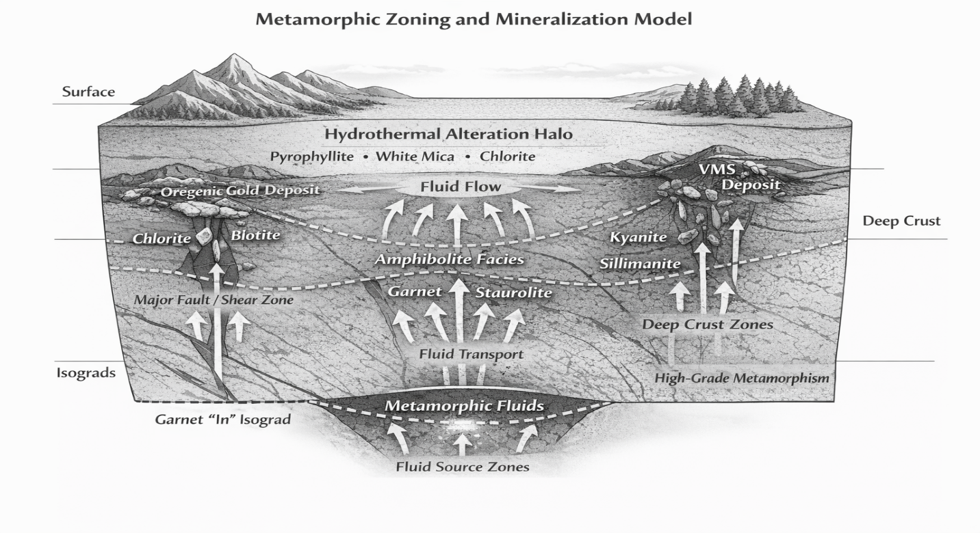
Figure 1. Conceptual metamorphic zoning and mineralization model illustrating the relationship between metamorphic facies, fluid generation, structural conduits, and ore deposition

3.2 Orogenic Gold Systems in the Abitibi Greenstone Belt
The Abitibi Greenstone Belt (Figure 2)is one of the most productive gold provinces in the world and hosts major mining camps such as Timmins and Val-d’Or. Studies have shown that many of the region’s gold deposits formed near the boundary between greenschist and amphibolite facies metamorphism (Phillips & Powell, 2010). The Abitibi Subprovince forms the southeastern portion of the Superior Province and constitutes the largest greenstone belt of the Canadian Shield, extending approximately 700 km by 300 km. Its early volcano–plutonic development occurred between ~2750 and 2690 Ma (Corfu, 1993; Ayer et al., 2002). In the southern Abitibi Belt, the stratigraphy is dominated by metavolcanic rocks of the Blake River, Piché, and Malartic groups, which range from ultramafic to felsic compositions and exhibit both tholeiitic and calc-alkaline geochemical affinities (Goodwin, 1982; Corfu, 1993; Daigneault et al., 2002; McNicoll et al., 2014).
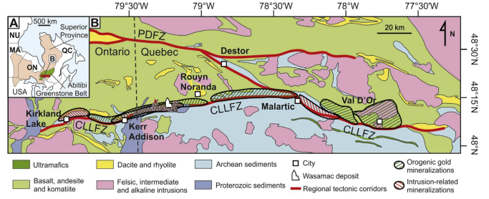
Figure 2: The Abitibi Greenstone Belt ("Abitibi Belt"), in the Superior Province of the Canadian Shield (after Robert, 2001)
The structural evolution of the southern Abitibi Belt involves multiple deformation phases. The earliest event (D1) produced east–west trending folds and localized thrusting associated with north–south shortening between ~2687 and 2680 Ma (Robert, 2001). This deformation coincided with the emplacement of late tonalite–trondhjemite intrusions dated at ~2685 Ma (Corfu et al., 1991; Sutcliffe et al., 1993). Subsequent uplift and erosion led to the deposition of Timiskaming-type fluvial–alluvial sediments between ~2676 and 2670 Ma, contemporaneous with the emplacement of early syn-tectonic alkaline plutons (Corfu et al., 1991; Ayer et al., 2005).
Later tectonic events include north-over-south thrusting (D2), followed by dextral transpression and localized renewed thrusting (D3) between ~2673 and 2660 Ma (Robert, 2001; Daigneault et al., 2004). These deformation phases are responsible for the development of the Cadillac–Larder Lake Fault Zone (CLLFZ), a major crustal-scale structure associated with regional gold mineralization. Evidence of post-deformational uplift and extensional movement around ~2660 Ma has been documented in the Malartic segment, while continued tectonic activity along the CLLFZ persisted until ~2643 Ma, as indicated by the emplacement of the Lamotte Pluton (Daigneault et al., 2004).
The tectonic evolution of the Abitibi Greenstone Belt remains debated. Plate tectonic models propose that its crustal architecture formed through oblique plate convergence during a ~60 Ma polyphase deformation history (Daigneault et al., 2004). Alternatively, some studies attribute Archean crustal formation and deformation to mantle-driven or gravity-controlled processes within a hotter early Earth lithosphere (Thébaud & Rey, 2013; Bédard & Harris 2014). Metamorphic conditions across the belt range from sub-greenschist to lower amphibolite facies, with metamorphism occurring between ~2677 and 2643 Ma (Jolly, 1978; Powell et al., 1995; Dubé & Gosselin, 2007). The transition from chlorite-bearing greenschist assemblages to garnet- and biotite-bearing amphibolite assemblages corresponds to dehydration reactions that release significant volumes of metamorphic fluids. These fluids are thought to transport gold along major fault systems where pressure and temperature changes trigger gold precipitation. The appearance of garnet in metamorphic rocks therefore represents a key exploration marker known as the “garnet-in” isograd. Exploration geologists often map this boundary to identify zones of maximum fluid flux. Rocks located near this transition commonly host structurally controlled quartz veins containing gold mineralization.

3.3 The Broken Hill Pb–Zn–Ag Deposit
Another important example of index mineral application occurs in the Broken Hill deposit (figure 3) within the Curnamona Province. This deposit represents a metamorphosed sediment-hosted massive sulfide system that underwent granulite-facies metamorphism.
The mineral assemblage associated with the Broken Hill deposit includes garnet, sillimanite, and gahnite, a zinc-rich spinel mineral. Gahnite is particularly significant because it is chemically stable and resistant to weathering. As a result, it can be preserved in stream sediments and transported away from its original source.
Exploration geologists have used the distribution of gahnite in sediment samples to trace the stratigraphic horizon that hosts the Broken Hill ore bodies. Even where the ore itself is not exposed at the surface, the presence of gahnite provides a reliable pathfinder mineral indicating proximity to mineralization (Spry et al., 2000).
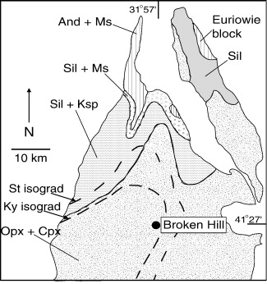
Figure 3 Metamorphic zonation map of the Broken Hill and Euriowie domains, illustrating prograde zones characterized by And + Ms, Sil + Ms, Sil + Ksp, and Opx + Cpx assemblages, as well as retrograde staurolite (St) and kyanite (Ky) isograds. Adapted from Phillips (1980), Stevens et al. (1988), and Frost et al. (2005). Abbreviations: And, andalusite; Cpx, clinopyroxene; Ksp, K-feldspar; Ms, muscovite; Opx, orthopyroxene; Sil, sillimanite.

3.4 Link Between Metamorphic P–T Evolution and Orogenic Gold and VMS Mineralization
Metamorphic pressure–temperature (P–T) evolution exerts a major control on both orogenic gold and volcanogenic massive sulfide (VMS) systems (Figure 4), although the role of metamorphism differs between them. In orogenic gold systems, prograde metamorphism is widely regarded as an active ore-forming process because dehydration of hydrous and carbonated rocks during burial and orogenesis releases H₂O–CO₂-rich fluids capable of transporting gold and sulfur (Groves et al., 1998; Phillips & Powell, 2010). These fluids are commonly generated most efficiently near the greenschist- to amphibolite-facies transition, where devolatilization reactions intensify and major shear zones provide pathways for focused fluid flow and gold deposition (Groves et al., 1998; Phillips & Powell, 2010).
Accordingly, reconstruction of metamorphic gradients is important in gold exploration because index minerals such as garnet, staurolite, and kyanite help delineate the crustal levels and thermal regimes associated with fluid production and structural focusing (Spear, 1993; Yardley, 1989). Orogenic gold deposits are closely associated with regionally metamorphosed terranes formed during compressional to transpressional deformation, and many models relate gold deposition to syn- to late-metamorphic fluid flow within convergent or collisional orogens (Goldfarb et al., 2005; Groves et al., 1998).
In contrast, VMS deposits originate as submarine hydrothermal sulfide accumulations, so metamorphism does not generally form the original ore body. Instead, subsequent metamorphic P–T evolution modifies the deposit through recrystallization, remobilization, deformation, and overprinting of primary hydrothermal alteration assemblages (Franklin et al., 2005; Spry et al., 2000). In medium- to high-grade terranes, minerals such as garnet, sillimanite, cordierite, and especially gahnite may become more reliable exploration guides than the original sulfides because they can survive deformation and weathering and preserve the metamorphic signature of the mineral system (Spry et al., 2000; Walters, 1998).
This relationship is especially important in Broken Hill-type and other metamorphosed Zn-rich sulfide systems, where gahnite-bearing rocks and meta-exhalites are widely used as pathfinders to concealed mineralization (McClenaghan et al., 2015; Spry et al., 2000). Meta-exhalites are recognized exploration guides to ore, and gahnite chemistry has been shown to provide useful vectors toward metamorphosed Pb–Zn–Ag systems (McClenaghan et al., 2015; Spry et al., 2000).
Metamorphic P–T evolution links metamorphism to mineralization in two principal ways: for orogenic gold, metamorphism is a fluid-generating and ore-forming process; for VMS systems, metamorphism is primarily an ore-modifying and exploration-signature-enhancing process. Therefore, reconstructing P–T paths is essential not only for understanding ore genesis, but also for identifying the most prospective parts of deformed and metamorphosed terranes (Goldfarb et al., 2005; Phillips & Powell, 2010; Spry et al., 2000).
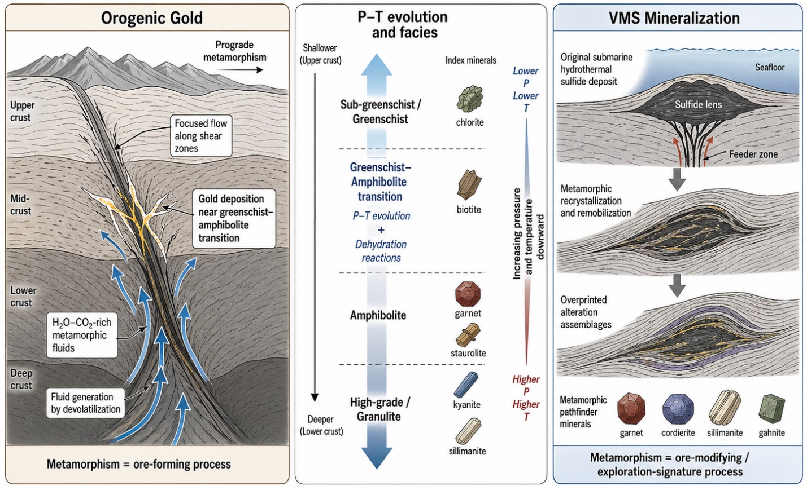
Figure 4 Link between metamorphic P-T evolution and Orogenic Gold and VMS mineralization

3.4 Exploration Vectoring Using Alteration Minerals
In addition to metamorphic index minerals, hydrothermal alteration minerals also play an important role in exploration vectoring (Table 2). Minerals such as andalusite, pyrophyllite, and white mica commonly form in high-temperature acidic hydrothermal environments.
These minerals are particularly important in volcanic-hosted massive sulfide (VMS) and porphyry systems, where they form alteration halos surrounding hydrothermal vents. Mapping these minerals can therefore help exploration geologists locate the central zones of hydrothermal activity where ore deposition occurred.
Table 2. Mineral-chemical indicators commonly used in mineral exploration.
Index / Indicator Mineral | Ore Deposit Type | Geological Significance | Exploration Relevance | Key References
Garnet | Orogenic gold | Marks prograde metamorphism and fluid-producing reactions near the greenschist–amphibolite transition | The “garnet-in” isograd can help identify zones of metamorphic fluid generation favorable for gold mineralization | Phillips & Powell (2010); Groves et al. (1998)
Staurolite | Orogenic gold | Indicates higher-grade metamorphic conditions and dehydration reactions in pelitic rocks | Useful for defining deeper metamorphic zones linked to fluid release and structurally focused gold systems | Spear (1993); Phillips & Powell (2010)
Kyanite | Orogenic gold / high-grade metamorphic systems | Reflects elevated pressure conditions in deeper crustal levels | Helps constrain crustal level and metamorphic gradient in gold-bearing terranes | Yardley (1989); Spear (1993)
Sillimanite | Broken Hill-type Pb–Zn–Ag / high-grade metamorphic base-metal deposits | Indicates high-temperature metamorphic overprint of sulfide-bearing sequences | Useful in identifying metamorphosed exhalative or sediment-hosted massive sulfide terranes | Spry et al. (2000); Walters (1998)
Gahnite | Broken Hill-type Pb–Zn–Ag / metamorphosed massive sulfide deposits | Zn-rich spinel commonly developed in metamorphosed Zn-rich systems | A robust pathfinder mineral in rocks, soils, and stream sediments for concealed Zn–Pb–Ag mineralization | Spry et al. (2000); Sandhaus & Craig (1986)
Andalusite | Epithermal / porphyry / high-sulfidation systems | Indicates low-pressure, high-temperature metamorphic or hydrothermal conditions | Commonly used to identify shallow intrusive and acidic alteration environments | Hedenquist et al. (2000); Lang & Baker (2001)
Pyrophyllite | High-sulfidation epithermal / advanced argillic alteration zones | Reflects acidic, high-sulfidation hydrothermal alteration | Strong vector toward hydrothermal upflow zones and mineralized centers | Arribas (1995); Sillitoe (2010)
White mica (sericite, muscovite) | Porphyry Cu–Au, orogenic gold, intrusion-related gold | Records hydrothermal alteration and fluid-rock interaction | Widely used in SWIR and mineral chemistry studies for vectoring toward ore centers | Halley et al. (2015); Yang et al. (2011)
Chlorite | VMS, porphyry, orogenic gold | Common alteration mineral in distal to proximal hydrothermal halos | Used to define alteration gradients and fluid pathways around mineral systems | Lypaczewski et al. (2016); Walshe (1986)
Biotite | Porphyry Cu–Au / intrusion-related gold | Indicates potassic alteration and/or increasing metamorphic grade | Important vector toward fertile intrusive centers and hydrothermal cores | Sillitoe (2010); Hart (2005)
Apatite | Porphyry Cu–Au / fertile intrusive systems | Records volatile content and magma fertility | Useful for discriminating fertile from barren magmatic systems | Piccoli & Candela (2002); Mao et al. (2016)
Zircon | Porphyry Cu–Au / magmatic-hydrothermal systems | Preserves redox and fertility signals in magmatic systems | Useful in assessing magma oxidation state and ore-forming potential | Ballard et al. (2002); Lu et al. (2016)

3.5 Limitations in the Use of Index Minerals
Despite their significant utility in metamorphic petrology and mineral exploration, several factors constrain the reliability and interpretation of index minerals. One of the primary limitations is the strong dependence on bulk rock composition. The development of index minerals is not solely controlled by pressure–temperature (P–T) conditions but also by the availability of essential chemical components within the protolith. Consequently, rocks subjected to identical metamorphic conditions may develop different mineral assemblages if their bulk compositions differ, potentially leading to misinterpretation of metamorphic grade (Spear, 1993; Bucher & Grapes, 2011).
Another critical limitation arises from retrograde metamorphism, which occurs during the cooling and exhumation of metamorphic rocks. During this stage, fluid infiltration commonly promotes the replacement of high-grade minerals by lower-grade assemblages such as chlorite, sericite, or epidote. This overprinting can partially or completely obliterate peak metamorphic mineral signatures, thereby obscuring the original P–T history and complicating exploration interpretations (Yardley, 1989; Winter, 2010).
In addition, structural deformation plays a significant role in modifying the spatial distribution of metamorphic zones. Processes such as folding, faulting, and shearing can juxtapose rocks of contrasting metamorphic grades, disrupt original isograds, and produce complex geological architectures. As a result, accurate interpretation of index mineral distributions requires integration with detailed structural analysis to distinguish between primary metamorphic patterns and tectonic overprints (Fossen, 2016; Passchier & Trouw, 2005). These limitations highlight the need for a multidisciplinary approach, combining mineralogical, geochemical, and structural data, to ensure robust interpretation of index minerals in mineral exploration.

3.6 Emerging Technologies in Index Mineral Detection
Recent advances in mineral exploration increasingly combine classical metamorphic petrology with modern digital exploration technologies. Machine-learning-based prospectivity modeling now integrates geological, geochemical, geophysical, and hyperspectral datasets to improve prediction of concealed ore systems (Zuo, et al., 2023; Amirajlo et al., 2026). Similarly, advances in hyperspectral and SWIR spectroscopy enable rapid identification of alteration minerals and metamorphic index assemblages in both field and remote sensing applications (Peyghambari & Zhang, 2021; Koerting et al., 2024). Recent work on mineral chemistry indicators further demonstrates the growing importance of garnet, gahnite, apatite, zircon, and white mica chemistry in predictive exploration targeting (Baswani et al., 2022; Rukhlov et al., 2024). These developments are expected to significantly improve discovery efficiency in metamorphosed and concealed mineral systems over the coming decade.

4. Conclusion
Index minerals remain fundamental tools in mineral exploration because they provide reliable indicators of metamorphic conditions and fluid evolution within geological terrains. Their occurrence allows geologists to reconstruct metamorphic gradients, identify zones of fluid generation, and locate favorable environments for ore deposition.
Case studies from the Abitibi Greenstone Belt and the Broken Hill demonstrate how index mineral mapping can significantly improve exploration targeting. Minerals such as garnet, staurolite, sillimanite, and gahnite serve as valuable pathfinders that help locate concealed ore deposits.
Although challenges such as retrograde metamorphism and compositional constraints exist, advances in hyperspectral mineral detection and machine learning based exploration models are enhancing the reliability of mineral vectoring techniques. The integration of classical metamorphic mineralogy with modern analytical technologies is therefore expected to play an increasingly important role in future mineral exploration programs.
Disclaimer (Artificial intelligence)
Author(s) hereby declare that NO generative AI technologies such as Large Language Models (ChatGPT, COPILOT, etc.) and text-to-image generators have been used during the writing or editing of this manuscript.

References
Amirajlo, P., Hassani, H., Pour, A.B & Habibkhah, N (2026). Ensemble machine learning strategies for mineral prospectivity mapping under data scarcity. Sci Rep 16, 9171. https://doi.org/10.1038/s41598-026-40125-1
Arribas, A. (1995). Characteristics of high-sulfidation epithermal deposits, and their relation to magmatic fluid. Mineralogical Association of Canada Short Course Series, 23, 419–454.

Ayer, J.A., Thurston, P.C., Bateman, R., Dubé, B., Gibson, H.L., Hamilton, M.A., Hathway, B., Hocker, S.M., Houlé, M.G., Hudak, G., Ispolatov, V.O., Lafrance, B., Lesher, C.M., MacDonald, P.J., Péloquin, A.S., Piercey, S.J., Reed, L.E., Thompson, P. H.,( 2005). Overview of results from the Greenstone Architecture Project: Discover Abitibi Initiative. Ontario Geological Survey; Open File Report 6154, p. 146.
Ayer, J. A., Amelin, Y., Corfu, F., Kamo, S., Ketchum, J., Kwok, K., & Trowell, N. (2002). Evolution of the southern Abitibi greenstone belt based on U-Pb geochronology: Autochthonous volcanic construction followed by plutonism, regional deformation and sedimentation. Precambrian Research, 115(1), 63–95.
Ballard, J. R., Palin, M. J., & Campbell, I. H. (2002). Relative oxidation states of magmas inferred from Ce(IV)/Ce(III) in zircon: Application to porphyry copper deposits of northern Chile. Contributions to Mineralogy and Petrology, 144(3), 347–364.
Baswani, S.R., Mishra, B.P., Mahapatro, S.N., Meshram, T., Pati, P., Shareef, M., Korakoppa, M., Mishra, M., Raza, M.A., Roy, S. and Randive, K. (2022). Petrochemical evaluation of gahnite from volcanogenic massive sulfide deposits in Betul belt, Central India: Insight from petrography and in‐situ trace element geochemistry. Geological Journal, 57(11), pp.4508-4528.
Bédard, J. H., & Harris, L. B. (2014). Neoarchean disaggregation and reassembly of the Superior craton. Geology, 42(11), 951-954.
Bucher, K., & Grapes, R. (2011). Petrogenesis of metamorphic rocks (8th ed.). Springer.
Corfu, F. (1993). The evolution of the southern Abitibi greenstone belt in light of precise U-Pb geochronology. Econ. Geol. 88 (6), 1323–1340.
Corfu, F., Jackson, S.L., Sutcliffe, R.H. (1991). U–Pb ages and tectonic significance of late alkalic magmatism and non-Archean sedimentation in the Timiskaming Group, southern Abitibi belt, Ontario. Canadian Journal of Earth Sciences 28 (4), 489–503.
Daigneault, R., Mueller, W.U., Chown, E.H. (2002). Oblique Archean subduction: accretion and exhumation of an oceanic arc during dextral transpression, Southern Volcanic Zone, Abitibi Subprovince Canada. Precambrian Res. 115 (1), 261–290.
Dube, B., & Gosselin, P. (2007). Greenstone-hosted quartz-carbonate vein deposits. Mineral Deposits of Canada: A synthesis of major deposit-types, district metallogeny, the evolution of geological provinces, and exploration methods. Geol. Assoc. Can. Miner. Deposits Div. Spec. Publ. 5, 49–73.
Fossen, H. (2016). Structural geology (2nd ed.). Cambridge University Press.
Franklin, J. M., Gibson, H. L., Jonasson, I. R., & Galley, A. G. (2005). Volcanogenic massive sulfide deposits. In J. W. Hedenquist, J. F. H. Thompson, R. J. Goldfarb, & J. P. Richards (Eds.), Economic geology 100th anniversary volume (pp. 523–560). Society of Economic Geologists.
Frost, B.R., Swapp, S.M. and Gregory, R.W., 2005. Prolonged existence of sulphide melt in the Broken Hill orebody, New South Wales, Australia. Canadian Mineralogist, 43, 479-494
Goldfarb, R. J., Baker, T., Dubé, B., Groves, D. I., Hart, C. J. R., & Gosselin, P. (2005). Distribution, character, and genesis of gold deposits in metamorphic terranes. In J. W.
Goodwin, A. M. (1982). Archean volcanism in southwestern Abitibi belt, Ontario and Quebec: Form, composition, and development. Canadian Journal of Earth Sciences, 19(6), 1140–1155.
Groves, D. I., Goldfarb, R. J., Gebre-Mariam, M., Hagemann, S. G., & Robert, F. (1998). Orogenic gold deposits: A proposed classification in the context of their crustal distribution and relationship to other gold deposit types. Ore Geology Reviews, 13(1–5), 7–27.
Halley, S., Dilles, J. H., & Tosdal, R. M. (2015). Footprints: Hydrothermal alteration and geochemical dispersion around porphyry copper deposits. Society of Economic Geologists Newsletter, 100, 1–17.
Harris, L. B., & Bédard, J. H. (2014). Crustal evolution and deformation in a non-plate-tectonic Archean Earth: Comparisons with Venus. In: Evolution of Archean Crust and Early Life (pp. 215–291).
Hart, C. J. R. (2005). Classifying, distinguishing and exploring for intrusion-related gold systems. In Proceedings of the New Zealand Minerals Conference (pp. 125–133).
Hedenquist, J. W., Arribas, A., Jr., & Gonzalez-Urien, E. (2000). Exploration for epithermal gold deposits. In S. G. Hagemann & P. E. Brown (Eds.), Gold in 2000 (pp. 245–277). Society of Economic Geologists.
Hedenquist, J. F. H. Thompson, R. J. Goldfarb, & J. P. Richards (Eds.), Economic geology 100th anniversary volume (pp. 407–450). Society of Economic Geologists.
International Energy Agency. (2024). Global critical minerals outlook 2024. IEA Publications. https://www.iea.org/reports/global-critical-minerals-outlook-2024
Jolly, W. T. (1978). Metamorphic history of the Archean Abitibi belt. Geological Survey of Canada.
Koerting, F., Asadzadeh, S., Hildebrand, J.C., Savinova, E., Kouzeli, E., Nikolakopoulos, K., Lindblom, D., Koellner, N., Buckley, S.J., Lehman, M. and Schläpfer, D. (2024). VNIR-SWIR imaging spectroscopy for mining: insights for hyperspectral drone applications. Mining, 4(4), pp.1013-1057.
Lang, J. R., & Baker, T. (2001). Intrusion-related gold systems: The present level of understanding. Mineralium Deposita, 36(6), 477–489.
Large, R. R., Danyushevsky, L., Hollit, C., Maslennikov, V., Meffre, S., Gilbert, S., Bull, S., Scott, R., Embo, P., Thomas, H., Singh, B., & Foster, J. (2009). Gold and trace element zonation in pyrite using a laser imaging technique: Implications for the timing of gold in orogenic and Carlin-style sediment-hosted deposits. Economic Geology, 104(5), 635–668.
Lu, Y.-J., Loucks, R. R., Fiorentini, M., McCuaig, T. C., Evans, N. J., Yang, Z.-M., Hou, Z.-Q., Kirkland, C. L., Parra-Avila, L. A., & Kobussen, A. (2016). Zircon composition as a pathfinder for porphyry Cu–Au deposits. Economic Geology, 111(8), 2023–2041.
Lypaczewski, P., Rivard, B., Peter, J. M., & McClenaghan, M. B. (2016). The mineral chemistry of chlorite as a tool for exploration in volcanogenic massive sulfide systems. Ore Geology Reviews, 72, 120–136.
Mao, M., Rukhlov, A. S., Rowins, S. M., Spence, J., & Coogan, L. A. (2016). Apatite trace element compositions: A robust new tool for mineral exploration. Economic Geology, 111(5), 1187–1222.
McClenaghan, S. H., Lentz, D. R., Cabri, L. J., & McFarlane, C. R. M. (2015). Major and trace element chemistry of gahnite as an exploration guide to Broken Hill-type Pb-Zn-Ag mineralization in the Broken Hill domain, New South Wales, Australia. Journal of Geochemical Exploration, 159, 1–21.
Passchier, C. W., & Trouw, R. A. J. (2005). Microtectonics (2nd ed.). Springer.
Peyghambari, S., & Zhang, Y. (2021). Hyperspectral remote sensing in lithological mapping, mineral exploration, and environmental geology: an updated review. Journal of Applied Remote Sensing, 15(3), 031501-031501.
Phillips, G. N., & Powell, R. (2010). Formation of gold deposits: A metamorphic devolatilization model. Journal of Metamorphic Geology, 28(6), 689–718.
Phillips, G.N. (1980). Water activity changes across an amphibolite-granulite facies transition, Broken Hill, Australia. Contributions to Mineralogy and Petrology, 75, 377-386.
Piccoli, P. M., & Candela, P. A. (2002). Apatite in igneous systems. In M. J. Kohn, J. Rakovan, & J. M. Hughes (Eds.), Phosphates: Geochemical, geobiological, and materials importance (pp. 255–292). Mineralogical Society of America.
Powell, W.G., Carmichael, D.M., Hodgson, C.J. (1995). Conditions and timing of metamorphism in the southern Abitibi greenstone belt, Quebec. Can. J. Earth Sci. 32 (6), 787–805.
Robert, F., & Poulsen, K. H. (2001). Orogenic gold: The geology and geochemistry of a deposit type. Reviews in Economic Geology, 14, 233–275.
Rukhlov, A. S., Ootes, L., Creaser, R. A., Cunningham, Q. F., de Waal, F. S., & Wenger, D. K. (2024). British Columbia carbonatites revisited: New whole rock Sr-Pb-Nd isotopic insights and drainage prospectivity trends. Geological Fieldwork, 2025-01.
Sandhaus, D. J., & Craig, J. R. (1986). Gahnite in the metamorphosed base metal sulfide deposits of the Virginia district, Minnesota: Implications for exploration. Economic Geology, 81(2), 493–499.
Sillitoe, R. H. (2010). Porphyry copper systems. Economic Geology, 105(1), 3–41.
Spear, F. S. (1993). Metamorphic phase equilibria and pressure-temperature-time paths. Mineralogical Society of America.
Spry, P. G., Peter, J. M., & Slack, J. F. (2000). Meta-exhalites as exploration guides to ore. Reviews in Economic Geology, 11, 163–201.
Stevens, B.P.J., Barnes, R.G., Brown, R.E., Stroud, W.J. and Willis, I.L., 1988. The Willyama Supergroup in the Broken Hill and Euriowie Blocks, New South Wales. Precambrian Research, 40-41, 297-327.
Sutcliffe, R. H., Barrie, C. T., & Beauchoue, G P. (1993). Plutonism in the southern Abitibi Subprovince: A tectonic and petrogenetic framework. Economic Geology, 88(6), 1359–1375.
Thébaud, N., & Rey, P. F. (2013). Archean gravity-driven tectonics on hot flooded continents: Controls on long-lived mineralized hydrothermal systems away from continental margins. Precambrian Research, 229, 93–104.
Walters, S. G. (1998). Regional metamorphism of the Broken Hill orebody, Australia. Economic Geology, 93(7), 1053–1063.
Walshe, J. L. (1986). A six-component chlorite solid solution model and the conditions of chlorite formation in hydrothermal and geothermal systems. Economic Geology, 81(3), 681–703.
Winter, J. D. (2010). Principles of igneous and metamorphic petrology (2nd ed.). Pearson.
Yang, K., Huntington, J. F., Gemmell, J. B., & Scott, K. M. (2011). Spectral characteristics of white mica in hydrothermal systems: Implications for exploration. Ore Geology Reviews, 43(1), 111–124.
Yardley, B. W. D. (1989). An introduction to metamorphic petrology. Longman Scientific & Technical.
Zuo, R., Xiong, Y., Wang, Z., Wang, J., & Kreuzer, O. P. (2023). A new generation of artificial intelligence algorithms for mineral prospectivity mapping. Natural Resources Research, 32(5), 1859-1869.

