METAMORPHIC EVOLUTION AND MINERALIZATION OF THE PAN-AFRICAN OROGEN IN THE NIGERIAN BASEMENT COMPLEX: A TECTONOMETAMORPHIC SYNTHESIS

ABSTRACT
The Nigerian Pan-African Orogen represents a medium pressure–temperature (Barrovian-type) collisional terrane formed during Neoproterozoic continent–continent convergence associated with the assembly of Gondwana. This study presents an integrated petrological, structural, thermobarometric, and metallogenic synthesis of the orogen, based on compiled data from 47 independent peak metamorphic estimates across multiple study areas. Five deformational phases (D₁–D₅) are recognized, including early nappe stacking and prograde metamorphism (D₁), peak collision and Barrovian metamorphism (D₂), transpressional exhumation (D₃–D₄), and post-collisional stabilization (D₅). The Nigerian Basement Complex exhibits a dual lithotectonic character involving reworked Archean–Paleoproterozoic crust and Neoproterozoic supracrustal Schist Belts, reflecting polycyclic evolution. Rare-metal pegmatites and orogenic gold are interpreted as late- to post-collisional mineral systems associated with structural conduits developed during exhumation. Reconstruction of pressure–temperature–time–deformation (P–T–t–d) paths suggests a coherent relationship between deformation, metamorphism, and mineralization. Comparative analysis with global collisional belts, including the Scottish Highlands, Himalayas, Arabian–Nubian Shield, and East African Orogen, supports classification of the Nigerian belt as a Barrovian-type collisional system, offering a process-based model for exploration and tectonic interpretation. However, interpretations are based on compiled secondary datasets and therefore depend on the spatial coverage and analytical consistency of existing studies.
Keywords: Pan-African Orogeny, Nigerian Basement Complex, Trans-Saharan Orogenic Belt, thermobarometry, clockwise P-T path

1.0 INTRODUCTION
Regional metamorphism represents one of the most fundamental processes of continental crustal evolution, recording the physical and chemical transformations associated with burial, heating, deformation, and exhumation under varying pressure–temperature (P–T) conditions (Yardley & Warren, 2021; Brown, 2014). Metamorphic rocks, particularly pelitic and mafic lithologies, preserve mineral assemblages, reaction textures, and compositional zoning that collectively constrain the pressure–temperature–time–deformation (P–T–t–d) evolution of orogenic systems (Spear, 1993; Brown, 1998 Winter, 2014). These records provide critical insights into tectonic processes such as crustal thickening, lithospheric shortening, and subsequent exhumation, thereby forming the basis for reconstructing geodynamic histories. Regional geological relationships illustrated in Figures 1 and 2 demonstrate the spatial association between major lithotectonic units and Pan-African structural trends. The alignment of these structures with the broader Trans-Saharan Orogenic Belt supports the interpretation of the Nigerian Basement Complex as part of a large-scale collisional system extending across West Africa.
The concept of metamorphic facies and facies series offers a globally applicable framework for interpreting metamorphic conditions and tectonic environments. Among these, medium pressure–temperature (P/T) Barrovian-type metamorphism is characteristic of continental collision zones, typically associated with geothermal gradients of approximately 20–30°C/km and progressive index mineral sequences from chlorite through biotite, garnet, staurolite, kyanite, and sillimanite (Miyashiro, 1961, 1973; England & Thompson, 1984). Classic examples of Barrovian metamorphism are well documented in the Caledonian orogen of the Scottish Highlands and the Himalayan orogen, where detailed petrological and thermobarometric studies have established coherent P–T–t–d trajectories linked to crustal thickening and thermal relaxation (Dempster, 1985; Hodges, 2000; Kohn, 2014). These global analogues provide essential benchmarks for evaluating metamorphic belts in other collisional settings.
The Pan-African Orogeny (ca. 800–500 Ma) represents one of the most extensive Neoproterozoic tectonothermal events in Earth history and is closely associated (Figure 1) with the assembly of the supercontinent Gondwana (Stern et al., 2004; Meert & Lieberman, 2008). Rather than a single synchronous event, the Pan-African system comprises a network of interconnected mobile belts formed through ocean closure, arc accretion, terrane amalgamation, and terminal continent–continent collision (Ajibade et al., 1987; Woakes, et al., 1987; Caby, 2003; Abdelsalam et al., 2002; Toteu et al., 2004). These belts extend across Africa, Arabia, and parts of South America, forming a globally significant orogenic system that includes the Arabian–Nubian Shield, the East African Orogen, and the Brasiliano belts.
Within this framework, the Nigerian Basement Complex constitutes a key segment of the Trans-Saharan Orogenic Belt and preserves an extensive record of Pan-African tectonometamorphic evolution (Rahaman, 1988; Dada, 2008; Ferré et al., 2002). Lithologically, the basement is composed of three principal units: (i) the Migmatite–Gneiss Complex (MGC), representing reworked Archean–Paleoproterozoic crust; (ii) Neoproterozoic Schist Belts, comprising metasedimentary and metavolcanic sequences metamorphosed under greenschist to amphibolite facies conditions; and (iii) the Older Granite Suite, consisting of syn- to post-collisional granitoids and associated pegmatites. This dual lithotectonic architecture reflects both crustal inheritance and Neoproterozoic crustal addition, consistent with polycyclic evolution in collisional orogens.
Thermobarometric studies across the Nigerian Basement Complex indicate peak metamorphic conditions of approximately 600–700°C and 8–12 kbar, corresponding to burial depths of 30–45 km and geothermal gradients characteristic of Barrovian metamorphism (England & Thompson, 1984; Spear, 1993; Ekwueme & Kröner, 1998). The predominance of kyanite-bearing assemblages and the absence of high-pressure minerals such as glaucophane or lawsonite further support classification of the Nigerian Pan-African belt within the medium P/T facies series (Miyashiro, 1994). Structural analyses reveal polyphase deformation involving early nappe stacking, peak collisional shortening, and late transpressional shearing, reflecting progressive crustal thickening and subsequent exhumation (Ajibade & Wright, 1989; Dewey et al., 1986).
Beyond its tectonometamorphic significance, the Nigerian Pan-African Orogen hosts economically important mineralization, including rare-metal pegmatites enriched in lithium, tantalum, niobium, and tin, as well as orogenic gold deposits (Garba, 2000; Goodenough et al., 2014). These mineral systems are closely linked to late- to post-collisional processes, particularly fluid migration and melt segregation along structurally controlled pathways during exhumation (Groves et al., 1998; Goldfarb et al., 2005; Phillips & Powell, 2010). The spatial and temporal association between deformation, metamorphism, and mineralization underscores the importance of integrated tectonometamorphic models in understanding mineral system evolution.
Although numerous studies have examined individual aspects of the Nigerian Basement Complex including metamorphic petrology, structural geology, and mineralization, these investigations are often regionally constrained and rarely integrated into a unified tectonometamorphic framework. Furthermore, comparison with other segments of the Pan-African Orogen and global collisional belts remains limited. This lack of integration hinders comprehensive understanding of the Nigerian segment within the broader context of Neoproterozoic orogenesis and reduces its predictive value for mineral exploration.
This study addresses these gaps by integrating petrological, structural, thermobarometric, geochronological, and metallogenic data into a coherent framework for interpreting the evolution of the Nigerian Pan-African Orogen. Specifically, the objectives are to: (i) classify the Nigerian Pan-African belt within the Miyashiro metamorphic facies series; (ii) reconstruct representative pressure–temperature–time–deformation (P–T–t–d) paths; (iii) evaluate structural and metamorphic controls on rare-metal pegmatite and orogenic gold mineralization; and (iv) compare the Nigerian belt with global Barrovian-type collisional orogens. By presenting an integrated P–T–t–d–metallogenic synthesis, this study contributes to a broader understanding of polycyclic crustal evolution and tectono-metallogenic processes within the Pan-African system.

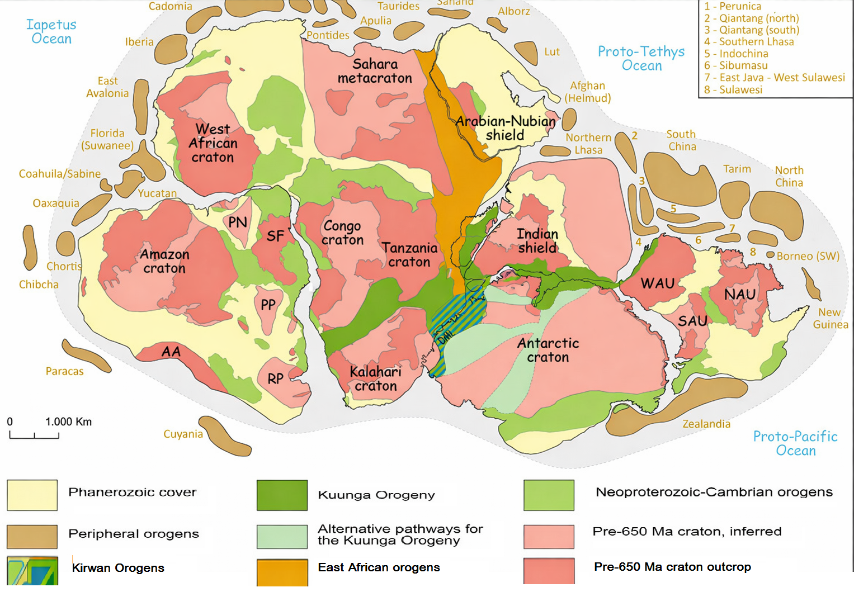
Figure 1 Major cratons and mobile belts of Gondwana configuration at ca. 500 Ma

Figure 1 Gondwana configuration at ca. 500 Ma showing major cratons and mobile belts. Modified after Gomes et al. (2025), Schmitt et al. (2018), Meert (2003), and Goscombe et al. (2020). Peripheral orogens based on Ruban et al. (2007), Nance et al. (2012), Metcalfe, (2013), and Mueller et al. (2014). Pathway A is illustrated after Meert, 2003; B and C after Fitzsimons, 2003 and Mulder et al. 2019. Abbreviations: AA – Arequipa-Antofalla, DML – Dronning Maud Land, NAU – North Australia, PN – Paranapanema, PR – Parnaíba, RP – Río de La plata, SAU – South Australia, SF – São Francisco, WAU – West Australia.

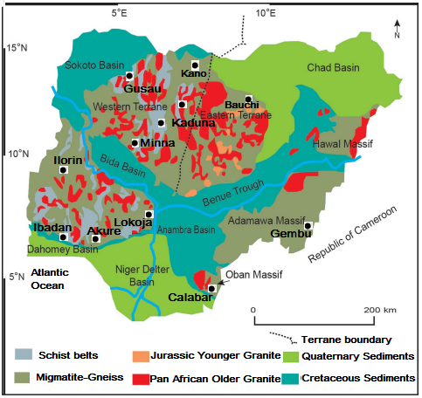
Figure 2 The Basement Geology of Nigeria (Modified from Wright, 1985; Rahaman, 1988; Obaje, 2009)

2. MATERIALS AND METHODS
This study adopts a qualitative, synthesis-based methodological framework to reconstruct the pressure–temperature–time–deformation (P–T–t–d) evolution of the Nigerian Basement Complex within the Miyashiro metamorphic facies classification. The approach integrates systematic literature review, structured data compilation, and comparative tectonometamorphic analysis.
A targeted literature search was conducted using combinations of keywords including “Pan-African Orogeny,” “Nigerian Basement Complex,” “thermobarometry,” “P–T path,” “Barrovian metamorphism,” and “rare-metal pegmatite.” Only peer-reviewed studies presenting original petrological, thermobarometric, geochronological, or structurally constrained mineralization data were included.
Thermobarometric data were compiled into a structured dataset including lithology, mineral assemblages, pressure–temperature estimates, and uncertainties. Data reliability was evaluated based on analytical methods, internal consistency, and compatibility with experimental phase equilibria. Preference was given to studies using multiple thermobarometric approaches.
Metamorphic facies classification follows Eskola (1920) and Miyashiro (1961, 1973). Pressure–temperature paths were reconstructed from mineral assemblages and reaction textures. Comparative analysis with global Barrovian belts was used to contextualize interpretations. This synthesis does not involve new analytical data but provides an integrated framework for interpreting tectonometamorphic evolution

3.0 RESULTS AND DISCUSSION

3.1 Regional Metamorphic Framework and Thermobarometric Consistency
The compilation of 47 independent thermobarometric estimates across the Nigerian Basement Complex defines a coherent regional metamorphic framework characterized by medium pressure–temperature (P/T) conditions. Peak metamorphic conditions of approximately 600–700°C and 8–12 kbar correspond to burial depths of 30–45 km and geothermal gradients of ~18–25°C/km, consistent with Barrovian-type metamorphism (England & Thompson, 1984; Spear, 1993; Johannes & Holtz, 1996).
Despite variations in lithology, analytical techniques, and spatial distribution of study areas, the dataset shows a broadly consistent pressure–temperature range across both the Migmatite–Gneiss Complex and the Schist Belts. Such internal consistency suggests that metamorphism was regionally controlled by large-scale tectonic processes rather than localized thermal anomalies. However, minor variability in P–T estimates likely reflects differences in structural level, metamorphic overprinting, and methodological approaches used in individual studies (Garba, 2000, 2003; Toteu et al., 2004; Obiora & Ukaegbu, 2019).
The dominance of kyanite-bearing assemblages across multiple study areas further supports classification within the medium P/T Barrovian facies series (Miyashiro, 1994; Ekwueme & Kröner, 1998; Toteu et al., 2001). The absence of high-pressure index minerals such as glaucophane or lawsonite excludes blueschist affinity, while the limited occurrence of andalusite or cordierite suggests that low P/T Buchan-type conditions were not regionally significant. These observations collectively indicate that the Nigerian Pan-African Orogen developed under tectonic conditions typical of continental collision.
The compiled thermobarometric dataset (Table 1) demonstrates a consistent range of peak metamorphic conditions across the Nigerian Basement Complex, despite variations in lithology and analytical approach. The clustering of data within the amphibolite to granulite facies fields supports a regionally coherent Barrovian metamorphic regime. Comparable datasets from collisional belts such as the Scottish Highlands and Himalayan Orogen similarly show tight clustering of pressure–temperature estimates, reflecting large-scale tectonic control on metamorphism (Dempster, 1985; Hodges, 2000).
Table 1. Systematic Compilation of Thermobarometric Data from the Nigerian Basement Complex
No. | Study Area | Lithotectonic Unit | Peak Temp (°C) | Peak Pressure (kbar) | Facies | Constraint Type | Key Reference(s)
1 | Ilesha–Ife | Schist Belt | 550–650 | 6–9 | Amphibolite | Regional inference | Rahaman (1988); Onyeagocha & Ekwueme (1990)
2 | Igarra | Schist Belt | 500–620 | 5–8 | Amphibolite | Regional inference | Rahaman (1988)  Onyeagocha & Ekwueme (1990)
3 | Zungeru | Schist Belt | 450–580 | 4–7 | Greenschist–Amphibolite | Regional inference | Onyeagocha & Ekwueme (1990)
4 | Kushaka | Schist Belt | 520–640 | 6–8 | Amphibolite | Regional inference | Onyeagocha & Ekwueme (1990)
5 | Birnin Gwari | Schist Belt | 480–600 | 4–7 | Greenschist–Amphibolite | Regional inference | Onyeagocha & Ekwueme (1990)
6 | Anka | Schist Belt | 450–550 | 4–6 | Greenschist | Regional inference | Onyeagocha & Ekwueme (1990)
7 | Maru | Schist Belt | 470–590 | 5–7 | Greenschist–Amphibolite | Regional inference | Onyeagocha & Ekwueme (1990)
8 | Egbe–Isanlu | Schist Belt | 500–620 | 5–8 | Amphibolite | Regional inference | Onyeagocha & Ekwueme (1990)
9 | Keffi | Schist Belt | 610–630 | 6–8 | Amphibolite | Direct thermobarometry | Ugwuonah (2017)
10 | Okene | Migmatite–Gneiss Complex | 600–700 | 7–10 | Upper Amphibolite | Regional synthesis | Obaje (2009)
11 | Lokoja | Migmatite–Gneiss Complex | 620–720 | 8–11 | Upper Amphibolite | Regional synthesis | Obaje (2009)
12 | Kaduna | Migmatite–Gneiss Complex | 700–800 | 8–12 | Granulite | Direct petrologic evidence | Ferre & Caby (2007)
13 | Bauchi | Migmatite–Gneiss Complex | 700–780 | 9–12 | Granulite | Direct granulite study | Ferre & Caby (2007)
14 | Zaria | Migmatite–Gneiss Complex | 650–750 | 8–11 | Amphibolite–Granulite | Direct granulite evidence | Ferre & Caby (2007)
15 | Ikare | Migmatite–Gneiss Complex | 650–750 | 8–11 | Amphibolite–Granulite | Direct mineral chemistry | Rahaman & Ocan 1988; Oziegbe et al. (2021)
16 | Ibadan | Migmatite–Gneiss Complex | 600–700 | 7–9 | Amphibolite | Regional inference | Rahaman (1988)
17 | Obudu | Eastern Basement | 750–800 | 9–12 | Granulite | Mineral chemistry & Direct thermobarometric constraints | Ekwueme (2003)
18 | Mambilla Plateau | Eastern Basement | 650–750 | 8–11 | Amphibolite–Granulite | Regional synthesis | Obaje (2009)
19 | Minna | Migmatite–Gneiss Complex | 600–700 | 8–10 | Upper Amphibolite | Regional synthesis | Obaje (2009)
20 | Ilorin | Migmatite–Gneiss Complex | 610–690 | 7–9 | Amphibolite | Regional inference | Rahaman (1988)

3.2 Pressure–Temperature Path Evolution and Tectonic Implications
Reconstruction of pressure–temperature (P–T) paths from mineral assemblages and reaction textures indicates a predominantly clockwise P–T trajectory. This evolution is characterized by rapid pressure increase during burial (D₁–D₂), attainment of peak pressure prior to peak temperature, and subsequent near-isothermal decompression followed by cooling during exhumation.
This P–T path topology is widely regarded as diagnostic of collisional orogens, where crustal thickening is followed by conductive heat redistribution within overthickened lithosphere (England & Thompson, 1984; Thompson & England, 1984). The delay between peak pressure and peak temperature reflects thermal relaxation processes driven by radiogenic heating and conductive heat transfer, a pattern observed in many medium P/T metamorphic belts (Spear, 1993).
Comparable clockwise P–T paths have been documented in the Scottish Highlands (Dempster, 1985) and the Himalayan Orogen (Hodges, 2000; Kohn, 2014), where crustal thickening during continental collision produces similar thermal and metamorphic evolution. The close correspondence between Nigerian and global P–T trajectories suggests that the tectonothermal evolution of the Nigerian Pan-African Orogen was governed by processes common to collisional systems worldwide. Peak conditions of 600–700°C at 8–12 kbar correspond to geothermal gradients of approximately 18–25°C/km (Spear, 1993), consistent with the Medium P/T Barrovian facies series (Miyashiro, 1994). These gradients are significantly higher than those typical of blueschist terranes (5–10°C/km) and lower than those of Buchan terranes (40–60°C/km). Partial Barrovian index mineral progressions are preserved in individual belts. The Ilesha Schist Belt preserves garnet → staurolite → kyanite zones (Rahaman, 1988; Onyeagocha & Ekwueme 1990)), while the Obudu area records kyanite → sillimanite progression in migmatitic gneisses (Ekwueme & Kröner, 1998).
The pressure–temperature scatter plot (Figure 3) reveals a clear positive correlation between temperature and pressure, consistent with progressive burial heating during crustal thickening. This trend is characteristic of Barrovian metamorphism and contrasts with the steeper gradients observed in Buchan-type terrains or the low-temperature gradients typical of blueschist facies environments. Similar P–T distributions have been documented in other collisional orogens, reinforcing the interpretation of a medium P/T tectonic regime.

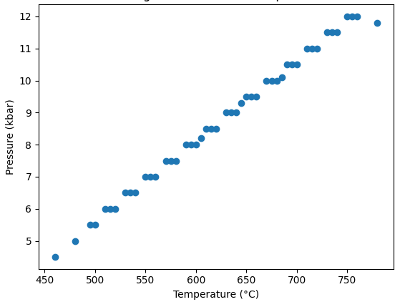
Figure 3 The P–T scatter plot summarizing the 47 peak metamorphic estimates of the Nigerian basement Complex. A clear positive P–T trend consistent with Barrovian-type metamorphism

3.3 Structural Evolution and P–T–t–d Relationships
The structural architecture of the Nigerian Basement Complex records a polyphase deformational history that is closely linked to its metamorphic evolution. The progression from D₁ nappe stacking and early burial, through D₂ peak collisional deformation and regional foliation development, to D₃–D₄ transpressional shearing and exhumation, reflects a continuous tectonic evolution consistent with collisional orogeny (Ajibade & Wright, 1989; Dewey et al., 1986).
The integration of structural observations with thermobarometric data enables the construction of a coherent pressure–temperature–time–deformation (P–T–t–d) framework. Peak metamorphism during D₂ corresponds to maximum crustal thickening, while D₃–D₄ deformation reflects progressive exhumation accompanied by retrograde metamorphism. This structural–metamorphic coupling is a defining characteristic of collisional belts, where deformation not only drives burial and exhumation but also controls fluid flow and mineralization pathways (Groves et al., 1998; Černý et al., 2005; Goldfarb et al., 2005; Cox et al., 2001; Bucher & Grapes, 2011). Finally, D₅ marks post-collisional stabilization, expressed by strike-slip faults, fractures, and final cooling and cratonization of the basement (Vorhies & Ague, 2011; Turner, 1981).
The final deformational stage (D₅) represents post-collisional stabilization of the Nigerian Pan-African Orogen, characterized by progressive cooling, uplift, and crustal re-equilibration. This stage follows the major transpressional deformation and mineralization events associated with D₃–D₄ and reflects the transition from an active orogenic system to a stable continental crust.
Structurally, D₅ is expressed by brittle deformation features, including strike-slip faults, normal faults, and joint systems, indicating a shift from ductile to brittle rheological behavior during continued exhumation. Metamorphic conditions during this stage are constrained to low-grade greenschist facies, with temperatures generally below 350°C, reflecting post-peak cooling and erosion of the orogenic crust.
This stage is also associated with thermal relaxation of the lithosphere and the cessation of major tectonometamorphic activity. Sedimentary basin development in adjacent regions may reflect post-orogenic extensional adjustments and crustal thinning. Similar late-stage stabilization processes have been documented in other collisional belts, including the Himalayan Orogen and the Scottish Highlands, where post-orogenic cooling and erosion mark the final stages of orogenic evolution (Hodges, 2000; Holdsworth et al., 2001; Oliver, 2001, Powell & Holland, 2010).
Although D₅ is not directly associated with significant mineralization, its role in exhumation and preservation of earlier-formed mineral deposits is critical. The stabilization of the crust during this stage ensures the retention of structurally controlled mineral systems formed during earlier deformation phases, thereby influencing present-day mineral exploration potential.

The integrated P–T–t–d diagram (Figure 4) illustrates the temporal relationship between deformation, metamorphism, and mineralization. The progression from crustal thickening (D₁–D₂) through decompression (D₃) to late-stage fluid activity (D₄) highlights the dynamic evolution of the orogen. The D₅ stage corresponds to the final segment of the P–T–t–d trajectory, where cooling and decompression culminate in low-temperature greenschist facies conditions and tectonic quiescence. Comparable tectonometamorphic trajectories have been documented in collisional belts worldwide, where peak metamorphism is followed by exhumation and mineralization along structurally controlled pathways (England & Thompson, 1984; Groves et al., 1998). The correlation framework presented in Table 2 provides a systematic linkage between deformation phases, metamorphic conditions, and metallogenic processes. The temporal alignment of D₃–D₄ deformation with gold mineralization and pegmatite emplacement is consistent with global models in which fluid migration and melt segregation occur during exhumation in collisional orogens (Goldfarb et al., 2005; Phillips & Powell, 2010).
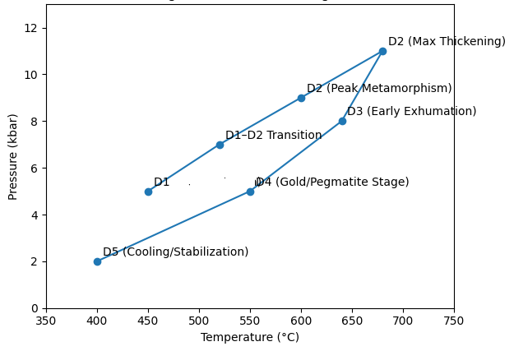
Figure 4 The graphical P–T–t–d evolution diagram showing: A clockwise P–T path, Progressive pressure increase during D₁–D₂ crustal thickening, Peak metamorphism during D₂, Decompression during D₃ exhumation, Late-orogenic fluid activity during D₄ (gold–pegmatite stage) and Final cooling and stabilization during D₅

Table 2. P–T–t–d (Pressure–Temperature–time–deformation) Correlation Framework for the Nigerian Pan-African Orogen
Deformation Phase | Approx. Age (Ma) | Pressure (kbar) | Temperature (°C) | Metamorphic Stage | Tectonic Regime | Structural Style | Metallogenic Significance | Key References
D₁ | ~650–620 | 5–8 | 450–600 | Prograde (greenschist → amphibolite) | Early convergence; subduction-related burial | Recumbent folds; S₁ foliation; nappe stacking | Limited mineralization; initial devolatilization begins | Turner (1983); Ajibade & Dewey et al. (1986)
D₂ | ~620–600 | 8–12 | 600–700 (locally to 750+) | Peak Barrovian metamorphism | Continental collision; maximum crustal thickening (30–45 km) | Isoclinal folds; pervasive N–S S₂ foliation; mineral lineation | Syn-tectonic granitoids; partial melting and migmatization in MGC | England & Thompson (1984); Spear (1993); Dada (2008); Hodges (2000)
D₃ | ~600–580 | 6–9 | 500–650 | Early retrograde; decompression | Oblique convergence; transpression; onset of exhumation | Ductile shear zones; mylonites; transcurrent fabrics | Channelized metamorphic fluids; initiation of auriferous quartz veining; pegmatite emplacement | Groves et al. (1998); Goldfarb et al. (2005); Černý et al. (2005); Cox et al. (2001)
D₄ | ~580–540 | 2–5 | 350–500 | Retrograde (amphibolite → greenschist) | Late-orogenic uplift; brittle–ductile transition | Reactivated thrusts; brittle–ductile shear zones; extensional fractures | Peak orogenic gold deposition; LCT pegmatite dyke swarms | Goodenough et al. (2014); Garba (2000); Groves et al. (1998)
D₅ | ~540–500 | <3 | <350 | Cooling and stabilization | Post-collisional relaxation; strike-slip faulting | Brittle faults; fractures; joint systems | Minor hydrothermal remobilization; structural reactivation | Dewey et al. (1986); Hodges (2000); Dada (2008)

3.4 Global Comparisons within the Pan-African System
Placing the Nigerian Pan-African Orogen within a broader global framework highlights both shared characteristics and regional distinctions. In the Arabian–Nubian Shield, Neoproterozoic tectonics involved juvenile arc accretion followed by continental collision, producing extensive granitoid magmatism and associated mineralization (Stern et al., 2004). In contrast, the Nigerian Basement Complex shows a stronger imprint of crustal reworking, as evidenced by inherited Archean–Paleoproterozoic zircon populations and widespread migmatization (Bruguier et al., 1994; Dada, 2008).
The East African Orogen records high-grade metamorphism and large-scale thrusting associated with continental convergence (Kusky et al., 2003), whereas the Nigerian segment is dominated by medium P/T Barrovian conditions, suggesting variations in thermal regime and crustal thickness across the Pan-African system. Similarly, the Brasiliano belts of South America exhibit comparable clockwise P–T paths and structural evolution, reinforcing the global consistency of collisional processes during Gondwana assembly (Meert & Lieberman, 2008).
These comparisons (Table 3) indicate that while the Nigerian Pan-African Orogen shares fundamental characteristics with other segments of the Pan-African system such as crustal thickening, Barrovian metamorphism, and late-orogenic mineralization, it is distinguished by its strong polycyclic crustal inheritance and the abundance of rare-metal pegmatites. This broader perspective strengthens interpretation of the Nigerian Basement Complex as part of a globally interconnected Neoproterozoic tectonic system.

Table 3. Global Comparisons within the Pan-African System and Analogous Collisional Orogens
Orogenic Belt / Region | Tectonic Setting | Metamorphic Characteristics | P–T Conditions | Structural Style | Metallogenic Features | Key References
Nigerian Pan-African Orogen | Continent–continent collision within Trans-Saharan Belt | Medium P/T Barrovian metamorphism; kyanite-bearing assemblages; migmatization | ~600–700°C; 8–12 kbar | Polyphase deformation (D₁–D₅); transpressional shear zones | Rare-metal pegmatites (Li–Ta–Nb–Sn); orogenic gold | Rahaman (1988); Dada (2008); Ekwueme & Kröner (1998)
Arabian–Nubian Shield | Juvenile arc accretion followed by collision | Low- to medium-grade metamorphism; widespread granitoid magmatism | ~500–700°C; 4–10 kbar | Accretionary terranes; arc-related deformation | Gold mineralization; base metals; granitoid-associated systems | Stern et al. (2004)
East African Orogen | Continental collision between East and West Gondwana | High-grade metamorphism (amphibolite–granulite facies) | ~650–800°C; 8–14 kbar | Large-scale thrusting; crustal thickening | Limited gold; high-grade metamorphic terrains | Kusky et al. (2003)
Brasiliano Orogen (South America) | Neoproterozoic continental collision (Gondwana assembly) | Barrovian metamorphism; polyphase deformation | ~550–750°C; 6–12 kbar | Fold–thrust belts; transpressional regimes | Pegmatites; Sn–Nb–Ta mineralization | Meert & Lieberman (2008)
Scottish Highlands (Caledonian Orogen) | Paleozoic continent–continent collision | Classic Barrovian metamorphic zonation | ~500–700°C; 6–10 kbar | Fold–thrust belts; regional foliation | Limited economic mineralization | Dempster (1985); Droop & Moazzen, (2007)
Himalayan Orogen | Active continent–continent collision (India–Asia) | Medium to high-grade metamorphism; inverted metamorphic sequences | ~600–800°C; 8–14 kbar | Major shear zones; channel flow; exhumation structures | Orogenic gold (localized); metamorphic fluids | Hodges (2000); Kohn (2014)

3.5 Metallogenic Implications and Fluid–Structure Interaction
The spatial and temporal distribution of mineralization within the Nigerian Basement Complex is closely linked to its tectonometamorphic evolution. Rare-metal pegmatites and orogenic gold deposits are predominantly associated with late- to post-collisional deformation phases (D₃–D₄), highlighting the importance of structural controls on fluid flow and melt emplacement.
Rare-metal pegmatites are interpreted to derive from highly fractionated granitic melts generated during crustal anatexis under high-grade metamorphic conditions (Černý et al., 2005; Goodenough et al., 2014). Rare-metal pegmatites occur as structurally controlled dykes parallel to D₂–D₃ fabrics (Dada et al., 1995; Okunlola, 2005; Okunlola & Jimba, 2006). Their emplacement along shear zones and fractures suggests that structural pathways played a critical role in focusing melt migration during exhumation. They are internally zoned and enriched in Li, Rb, Cs, Sn, Ta, Nb, and Be, with K/Rb ratios of 10–50, indicative of extreme fractionation (Černý et al., 2005). Geochronology indicates emplacement between 530–500 Ma, 30–70 Myr after peak metamorphism (Matheis & Caen-Vachette, 1983; Akintola et al., 2012), consistent with post-collisional thermal relaxation (England & Thompson, 1984).
Orogenic gold mineralization, by contrast, is associated with metamorphic fluids generated during devolatilization reactions at depth. These fluids, typically low-salinity and CO₂-bearing, are transported along transcurrent shear zones and precipitate gold under greenschist facies conditions (Groves et al., 1998; Goldfarb et al., 2005; Phillips & Powell, 2010). Gold mineralization is spatially associated with D₃ shear zones (Garba, 2000, 2003). Hydrothermal alteration assemblages (sericite + chlorite + epidote) indicate formation at 350–450°C and 2–4 kbar. Fluid inclusion studies reveal low-salinity, CO₂-bearing aqueous fluids with homogenization temperatures of 250–350°C and trapping pressures of 2–3 kbar (Garba, 2003). These characteristics match global orogenic gold systems (Groves et al., 1998; Goldfarb et al., 2005) and are consistent with metamorphic devolatilization during collisional thickening (Phillips & Powell, 2010). The Nigerian deposits display characteristics consistent with global orogenic gold systems, indicating that similar fluid–rock interaction processes operated during Pan-African tectonism.
This coupling between deformation, metamorphism, and mineralization is widely recognized in collisional orogens and provides a predictive framework for mineral exploration (Cox et al., 2001). In the Nigerian context, zones of intense deformation and late-stage structural reactivation represent key targets for both pegmatite-hosted rare metals and shear zone-hosted gold deposits.

3.6 Tectono-Metamorphic and Metallogenic Evolution Model
The conceptual model presented in Figure 5 synthesizes the integrated pressure–temperature–time–deformation (P–T–t–d) evolution of the Nigerian segment of the Pan-African Orogeny and explicitly links tectonic processes with metamorphism and mineralization. The model is derived from the compiled thermobarometric dataset, petrostructural relationships, and geochronological constraints discussed in preceding sections, and it is intended as a synthesis-based representation of regional trends rather than a site-specific reconstruction.

3.6.1 D₁: Pre- to Early Collisional Stage (Burial and Nappe Stacking)
The model initiates with D₁ deformation, representing early convergence marked by crustal shortening, nappe stacking, and progressive burial of supracrustal sequences. Subduction-related processes and arc magmatism likely preceded terminal collision, although direct evidence for high-pressure oceanic assemblages is limited in the Nigerian sector. Metamorphic conditions during this stage are constrained to low- to medium-grade greenschist facies, reflecting relatively low geothermal gradients typical of early burial (Spear, 1993). Structurally, this phase is characterized by recumbent folding and the development of early foliation (S₁), which forms the foundational fabric for subsequent deformation.

3.6.2 D₂: Peak Collisional Stage (Crustal Thickening and Barrovian Metamorphism)
D₂ represents the principal collisional phase, during which maximum crustal thickening and peak metamorphic conditions were attained. Thermobarometric estimates of ~600–700°C and 8–12 kbar correspond to burial depths of approximately 30–45 km, consistent with continent–continent collision and lithospheric doubling (England & Thompson, 1984). The dominance of kyanite-bearing assemblages confirms medium P/T Barrovian metamorphism (Miyashiro, 1994). Regionally pervasive S₂ foliation and tight to isoclinal folding reflect intense compressional deformation. The temporal lag between peak pressure and peak temperature observed in the P–T paths is attributed to conductive heat redistribution within thickened crust, a feature widely recognized in collisional orogens.

3.6.3 D₃: Late-Collisional Transpression and Exhumation
Following peak metamorphism, the orogen entered a phase of transpressional deformation (D₃), marking the onset of exhumation. This stage is characterized by near-isothermal decompression, as recorded by mineral reaction textures and compositional zoning patterns. Ductile shear zones developed during this phase served as major pathways for fluid migration and played a critical role in redistributing heat and mass within the crust. Metamorphic conditions transitioned from amphibolite to lower amphibolite facies, reflecting decreasing pressure while temperatures remained relatively elevated. The structural style shifts from compressional to oblique-slip kinematics, indicating a change in tectonic regime during late-stage convergence.

3.6.4 D₄: Post-Collisional Fluid Flow, Magmatism, and Mineralization
D₄ represents a post-collisional stage characterized by continued exhumation, fluid infiltration, and magmatic activity. This phase is particularly significant from a metallogenic perspective. Rare-metal pegmatites, enriched in Li–Ta–Nb–Sn, are interpreted to originate from highly fractionated melts generated during crustal anatexis, which were emplaced along structurally controlled pathways (Černý et al., 2005; Goodenough et al., 2014).
Simultaneously, orogenic gold mineralization is associated with metamorphic fluids produced during devolatilization reactions at depth. These fluids migrated along shear zones and fractures, precipitating gold under greenschist facies conditions (Groves et al., 1998; Goldfarb et al., 2005; Phillips & Powell, 2010). The temporal overlap between deformation, fluid flow, and mineralization highlights the importance of tectonic structures as conduits for both melt and fluid transport. The model therefore emphasizes strong coupling between deformation and metallogenesis during late-orogenic stages.

3.6.5 D₅: Post-Orogenic Stabilization and Thermal Relaxation
The final stage (D₅) reflects post-collisional stabilization of the orogenic system, characterized by cooling, uplift, and erosion. Structural deformation transitions from ductile to brittle regimes, with the development of faults and joint systems. Metamorphic conditions are constrained to low-temperature greenschist facies (<350°C), indicating progressive thermal relaxation of the crust.
Although D₅ is not directly associated with significant mineralization, it plays a critical role in the preservation and exposure of mineral deposits formed during earlier stages. The cessation of major tectonometamorphic activity and stabilization of the crust mark the transition to a stable continental setting within the assembled Gondwana.

3.6.6 Integrated P–T–t–d–Metallogenic Evolution
Collectively, the model illustrates a coherent evolutionary sequence involving (i) crustal thickening and burial, (ii) peak Barrovian metamorphism, (iii) transpressional exhumation, (iv) late-stage fluid and melt migration associated with mineralization, and (v) post-orogenic stabilization. The reconstructed clockwise P–T path, combined with polyphase deformation and structurally controlled mineralization, is consistent with established models for collisional orogens (England & Thompson, 1984; Dewey et al., 1986).
While the Nigerian Pan-African Orogen shares key characteristics with other collisional belts, the model highlights the significant influence of polycyclic crustal inheritance on its tectonometamorphic evolution. The presence of reworked Archean–Paleoproterozoic crust not only influences metamorphic gradients but also plays a role in melt generation and metallogenic specialization.

3.6.7 Model Limitations and Applicability
It is important to note that the conceptual model presented in Figure 5 is based on compiled datasets from multiple studies and therefore represents a generalized regional framework. Variations in local geological conditions, analytical methods, and data availability may result in deviations from the model at specific locations. Nevertheless, the model provides a useful synthesis for understanding the coupled evolution of tectonics, metamorphism, and mineralization in the Nigerian Basement Complex and offers a framework for comparison with other segments of the Pan-African Orogen.

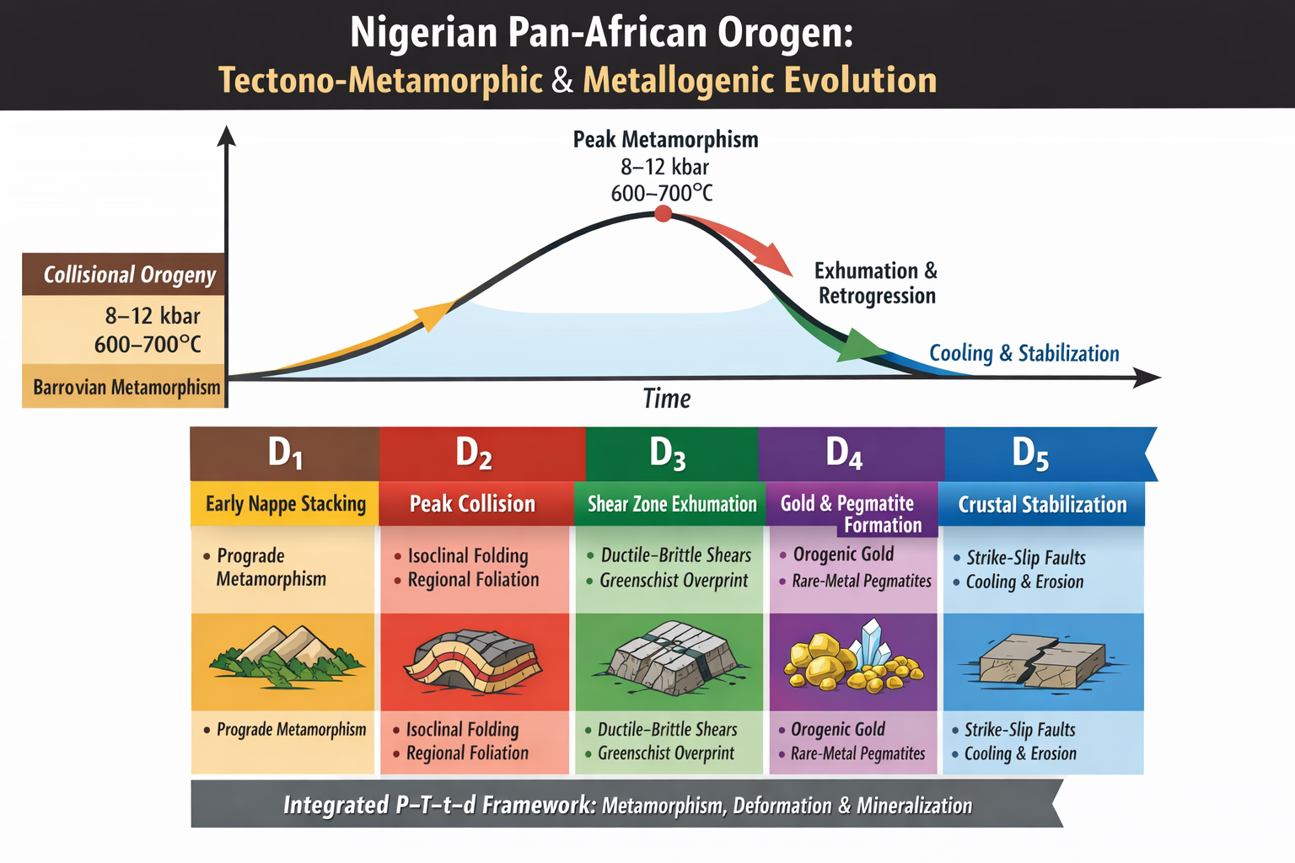
Figure 5 The Nigerian Pan-African orogeny: Tectono-metamorphic and metallogenic Evolution

3.7 Implications for Collisional Orogen Models
The integrated tectono-metamorphic and metallogenic synthesis developed for the Nigerian segment of the Pan-African Orogeny provides several insights that are relevant to broader models of collisional orogenesis. By combining thermobarometric constraints, structural evolution, and mineralization patterns within a unified P–T–t–d framework, the Nigerian example offers an opportunity to evaluate how classical collisional models apply to polycyclic Precambrian terranes and how local crustal inheritance modifies these frameworks.

3.7.1 Validation of Barrovian Collisional Models
The predominance of medium pressure–temperature (P/T) metamorphism, characterized by peak conditions of ~600–700°C and 8–12 kbar, supports the applicability of Barrovian facies series models to the Nigerian Pan-African belt (Miyashiro, 1994; Spear, 1993). These conditions, together with the reconstructed clockwise P–T paths, are consistent with the canonical model of continental collision involving crustal thickening followed by thermal relaxation (England & Thompson, 1984; Thompson & England, 1984).
The similarity of these metamorphic trajectories to those documented in the Scottish Highlands and the Himalayan Orogen suggests that the fundamental processes governing collisional metamorphism namely burial, radiogenic heating, and subsequent exhumation operate consistently across both Phanerozoic and Neoproterozoic orogens (Dempster, 1985; Pattison, 1992; Hodges, 2000). The Nigerian case therefore reinforces the general validity of Barrovian models as a global framework for interpreting medium P/T metamorphic belts.

3.7.2 Role of Crustal Inheritance in Collisional Systems
While the overall tectonometamorphic evolution aligns with established collisional models, the Nigerian Basement Complex highlights the significant influence of pre-existing crustal architecture. The presence of reworked Archean–Paleoproterozoic crust within the Migmatite–Gneiss Complex demonstrates that continental collision in this region did not occur within a purely juvenile system but involved substantial reactivation of older lithosphere (Dada, 2008; Bruguier et al., 1994).
This contrasts with segments of the Pan-African system such as the Arabian–Nubian Shield, where Neoproterozoic crustal growth is dominated by juvenile arc accretion (Stern et al., 2004). The Nigerian example therefore suggests that collisional orogen models must explicitly account for variations in crustal inheritance, as these influence metamorphic gradients, melt generation, and structural evolution. In particular, the presence of fertile, reworked continental crust may enhance partial melting and promote the formation of rare-metal pegmatites, thereby linking tectonic evolution with metallogenic specialization.

3.7.3 Structural Controls and Transpressional Exhumation
The transition from early compressional deformation (D₁–D₂) to late-stage transpressional shearing (D₃–D₄) observed in the Nigerian Pan-African Orogen underscores the importance of oblique convergence and strain partitioning in collisional systems. This structural evolution is consistent with models of transpressional orogens, where crustal shortening is accommodated by a combination of thrusting and strike-slip motion (Dewey et al., 1986).
The role of shear zones in facilitating exhumation and fluid migration further supports the concept that deformation is a primary control on both metamorphic evolution and mineralization (Bucher & Grapes, 2011). Similar structural regimes have been documented in the Himalayas and other collisional belts, where major shear zones act as conduits for heat and fluid transfer during exhumation (Hodges, 2000). The Nigerian example therefore reinforces the need to incorporate transpressional dynamics into collisional orogen models, particularly in regions characterized by oblique plate convergence.

3.7.4 Coupling Between Metamorphism and Metallogenesis
One of the most significant implications of this study is the strong coupling between tectonometamorphic processes and mineralization. The temporal association of rare-metal pegmatites and orogenic gold deposits with late- to post-collisional deformation phases (D₃–D₄) supports global models in which fluid flow and melt migration are driven by exhumation-related processes (Groves et al., 1998; Goldfarb et al., 2005; Phillips & Powell, 2010).
In this context, the Nigerian Pan-African Orogen provides further evidence that mineral systems in collisional belts are not randomly distributed but are structurally controlled and temporally linked to specific stages of orogenic evolution. The concentration of mineralization along shear zones highlights the importance of permeability architecture in controlling fluid pathways and metal transport (Sandiford & Powell, 1991).. This observation has broader implications for mineral exploration, suggesting that late-stage deformation zones in collisional orogens represent key targets for both orogenic gold and pegmatite-hosted rare metals.

3.7.5 Variability within the Pan-African System
Comparison of the Nigerian Pan-African Orogen with other segments of the Pan-African system, such as the East African Orogen and the Arabian–Nubian Shield, indicates that while the overall tectonic framework is broadly consistent, significant regional variability exists. Differences in metamorphic grade, structural style, and crustal composition reflect variations in tectonic setting, convergence dynamics, and pre-existing lithospheric conditions (Kusky et al., 2003; Stern et al., 2004).
The Nigerian segment, characterized by medium P/T Barrovian metamorphism and strong crustal reworking, represents one end-member within the Pan-African spectrum. This variability suggests that collisional orogen models should be viewed as flexible frameworks rather than rigid templates, with local geological context playing a critical role in shaping tectonometamorphic evolution.

3.7.6 Implications for Global Orogenic Processes
Taken together, the Nigerian Pan-African Orogen supports several key aspects of collisional orogen models: (i) crustal thickening leading to Barrovian metamorphism, (ii) clockwise P–T evolution driven by burial and thermal relaxation, (iii) structural control of exhumation through transpressional shear zones, and (iv) coupling between deformation and mineralization. At the same time, it highlights the importance of crustal inheritance and regional variability in modifying these processes.
These findings suggest that while global models provide a robust framework for understanding collisional orogenesis, their application to specific regions requires careful consideration of local geological conditions. The Nigerian example therefore contributes to refining collisional orogen models by demonstrating how polycyclic crustal evolution and metallogenic processes can be integrated within a unified tectonometamorphic framework.
4.0 CONCLUSION
This study presents an integrated synthesis of the tectono-metamorphic and metallogenic evolution of the Nigerian segment of the Pan-African Orogeny within the Nigerian Basement Complex. By combining compiled thermobarometric data, petrostructural relationships, and literature-constrained geochronology within a unified pressure–temperature–time–deformation (P–T–t–d) framework, the study clarifies how deformation, metamorphism, and mineralization are coupled during Neoproterozoic continental collision.
Thermobarometric synthesis indicates peak conditions of ~600–700°C and 8–12 kbar, corresponding to burial depths of ~30–45 km and geothermal gradients typical of medium P/T (Barrovian) metamorphism. The prevalence of kyanite-bearing assemblages and the absence of high-pressure blueschist indicators support classification of the orogen within the Barrovian facies series. Reconstructed clockwise P–T paths—characterized by peak pressure preceding peak temperature—are consistent with crustal thickening followed by thermal relaxation in collisional settings.
A five-stage deformational history (D₁–D₅) is recognized: (i) early convergence and nappe stacking (D₁), (ii) peak collisional shortening and regional metamorphism (D₂), (iii) transpressional deformation and the onset of exhumation (D₃), (iv) late- to post-collisional fluid flow and magmatism associated with mineralization (D₄), and (v) post-orogenic stabilization, cooling, and brittle deformation (D₅). Integration of these stages within a P–T–t–d–metallogenic model demonstrates that structural evolution exerts first-order control on both metamorphic conditions and the timing and localization of mineral systems.
From a metallogenic perspective, rare-metal pegmatites (Li–Ta–Nb–Sn) and orogenic gold are temporally linked to D₃–D₄ exhumation and are spatially associated with shear zones and fracture networks that act as conduits for melt and fluid migration. This relationship supports global models in which mineralization in collisional orogens is structurally controlled and closely tied to late-stage tectonic processes. Although D₅ is not directly mineralizing, it is critical for exhumation and preservation of earlier-formed deposits.
Comparison with other segments of the Pan-African system and comparable collisional belts indicates that the Nigerian orogen shares key features with well-studied examples such as Barrovian metamorphism, clockwise P–T evolution, and structurally controlled mineralization while also exhibiting distinctive characteristics related to strong polycyclic crustal inheritance. This inheritance influences melt generation, structural segmentation, and metallogenic specialization, underscoring the importance of pre-existing lithospheric architecture in shaping orogenic outcomes.
Overall, the results support a synthesis-based interpretation in which the Nigerian Pan-African Orogen represents a classic medium P/T collisional system formed during the assembly of Gondwana, but one that is significantly modified by reworking of older continental crust. The integrated framework developed here provides a coherent basis for linking tectonics, metamorphism, and mineralization and offers a practical guide for mineral exploration, particularly in targeting late-stage shear zones and structurally controlled pathways.
It is acknowledged that the conclusions are constrained by the availability and heterogeneity of published datasets, including variations in analytical methods and spatial coverage. Future work involving new mineral chemistry, phase equilibrium modeling, and high-resolution geochronology will be essential to refine the proposed model and to better resolve local-scale variations within the orogen.
Disclaimer (Artificial intelligence)
Author(s) hereby declare that NO generative AI technologies such as Large Language Models (ChatGPT, COPILOT, etc.) and text-to-image generators have been used during the writing or editing of this manuscript.

REFERENCES
Abdelsalam, M. G., Liégeois, J. P., & Stern, R. J. (2002). The Saharan Metacraton. Journal of African Earth Sciences, 34(3–4), 119–136.
Ajibade, A. C., Woakes, M., & Rahaman, M. A. (1987). Proterozoic crustal development in the Pan-African regime of Nigeria. In A. Kröner (Ed.), Proterozoic Lithospheric Evolution (pp. 259–271). American Geophysical Union.
Ajibade, A. C., & Wright, J. B. (1989). The Togo-Benin-Nigeria Shield: Evidence of crustal aggregation in the Pan-African belt. Tectonophysics, 165(1–4), 125–129.
Akintola, A. I., Ikhane, P.R., Okunlola, O.A., Akintola, G.O., & Adekoya, A. A. (2012). Geochemical features of the Precambrian Pan-African Pegmatites of Ijebu-Ife Area, Southwestern Nigeria. Environment, Ecology & Management, 1(1), 38-61
Brown, M. (1998). Unpairing metamorphic belts: P-T paths and a tectonic model for the Ryoke Belt, southwest Japan. Journal of Metamorphic Geology, 16(1), 3–22.
Brown, M. (2014). The contribution of metamorphic petrology to understanding lithosphere evolution and geodynamics. Geoscience Frontiers, 5(4), 553–569.
Bruguier, O., Dada, S., & Lancelot, J. R. (1994). Early Archean component (>3.5 Ga) within a 3.05 Ga orthogneiss from northern Nigeria: U-Pb zircon evidence. Earth and Planetary Science Letters, 125(1–4), 89–103.
Bucher, K., & Grapes, R. (2011). Petrogenesis of Metamorphic Rocks (8th ed.). Springer-Verlag.
Caby, R. (2003). Terrane assembly and geodynamic evolution of central-western Hoggar: A synthesis. Journal of African Earth Sciences, 37(3–4), 133–159.
Černý, P., Blevin, P. L., Cuney, M., & London, D. (2005). Granite-related ore deposits. Economic Geology 100th Anniversary Volume, 337–370.
Cox, S. F., Knackstedt, M. A., & Braun, J. (2001). Principles of structural control on permeability and fluid flow in hydrothermal systems. In J. P. Richards & R. M. Tosdal (Eds.), Structural controls on ore genesis (Reviews in Economic Geology, Vol. 14). Society of Economic Geologists. https://doi.org/10.5382/Rev.14.01
Dada, S. S. (2008). Proterozoic evolution of the Nigeria–Boborema province. In R. J. Pankhurst, R. A. J. Trouw, B. de Brito Neves, & M. J. de Wit (Eds.), West Gondwana: Pre-Cenozoic correlations across the South Atlantic region (Geological Society, London, Special Publications, Vol. 294, pp. 121–136). Geological Society of London. https://doi.org/10.1144/SP294.7
Dada, S. S., Briqueu, L., Harms, U., Lancelot, J. R., & Matheis, G. (1995). Charnockitic and monzonitic Pan-African series from north-central Nigeria: trace-element and Nd, Sr, Pb isotope constraints on their petrogenesis. Chemical Geology, 124(3-4), 233-252.
Dempster, T. J. (1985). Uplift patterns and orogenic evolution in the Scottish Dalradian. Journal of the Geological Society, 142(1), 111–128.
Dewey, J. F., Hempton, M. R., Kidd, W. S. F., Saroglu, F., & Şengör, A. M. C. (1986). Shortening of continental lithosphere: The neotectonics of Eastern Anatolia—a young collision zone. Geological Society, London, Special Publications, 19(1), 1–36.
Droop, G. T., & Moazzen, M. (2007). Contact metamorphism and partial melting of Dalradian pelites and semipelites in the southern sector of the Etive aureole. Scottish Journal of Geology, 43(2), 155-179.
Ekwueme, B. N., & Kröner, A. (1998). Single zircon evaporation ages from the Oban Massif, southeastern Nigeria. Journal of African Earth Sciences, 26(2), 195–205.
England, P. C., & Thompson, A. B. (1984). Pressure—temperature—time paths of regional metamorphism I. Heat transfer during the evolution of regions of thickened continental crust.
Eskola, P. (1920). The mineral facies of rocks. Norsk Geologisk Tidsskrift, 6, 143–194.
Ferré, E.C. and Caby, R. (2007). Granulite facies metamorphism and charnockite plutonism: example from the Neoproterozoic Belt of northern Nigeria. Proceedings of the Geologists' Association – Geological Society of London of London, 118, 1, 47-54.
Ferré, E., Gleizes, G., & Caby, R. (2002). Obliquely convergent tectonics and granite emplacement in the Trans-Saharan belt of Eastern Nigeria: A synthesis. Precambrian Research, 114(3–4), 199–219.
Fitzsimons, I.C.W., 2003, Proterozoic basement provinces of southern and southwestern Australia, and their correlation with Antarctica: Geological Society, London, Special Publications, 206 (1) 93–130.
Garba, I. (2000) Origin of Pan African Mesothermal Gold Mineralization at Bin Yauri, Nigeria. The Journal of African Earth Sciences, 33, 433-449.
Garba, I. (2003). Geochemical discrimination of newly discovered rare-metal bearing and barren pegmatites in the Pan-African (600±150 Ma) basement of northern Nigeria. Applied Earth Science, 112(3), 287–292.
Goldfarb, R.J., Baker, T., Dubé, B., Groves, D.I., Hart, C.J.R. and Gosselin, P. (2005) Distribution, Character, and Genesis of Gold Deposits in Metamorphic Terran. In: Hedenquist, J.W., Thompson, J.F.H., Goldfarb, R.J. and Richards, J.P., Eds., One Hundredth Anniversary Volume, Society of Economic Geologists, 405-450.
Gomes, I. V., Schmitt, Renata. S., Rosenbaum, G., Armistead, S. E., & Mussili, J. V. S. (2025). The triple orogenic junction of central Gondwana. International Geology Review, 67(12), 1533–1560. https://doi.org/10.1080/00206814.2025.2457564.
Goodenough, K. M., Lusty, P. A. J., Roberts, N. M. W., Key, R. M., & Garba, A. (2014). Post-collisional Pan-African granitoids and rare metal pegmatites in western Nigeria: Age, petrogenesis and the 'pegmatite conundrum'. Precambrian Research, 249, 138-151.
Goscombe, B., Foster, D.A., Gray, D., and Wade, B., (2020). Assembly of central Gondwana along the Zambezi Belt: Metamorphic response and basement reactivation during the kuunga orogeny: Gondwana Research, 80, 410–465.
Groves, D. I., Goldfarb, R. J., Gebre-Mariam, M., Hagemann, S. G., & Robert, F. (1998). Orogenic gold deposits: A proposed classification in the context of their crustal distribution and relationship to other gold deposit types. Ore Geology Reviews, 13(1–5), 7–27.
Hodges, K. V. (2000). Tectonics of the Himalaya and southern Tibet from two perspectives. Geological Society of America Bulletin, 112(3), 324–350.
Holdsworth, R.E., Hand, M., Miller, J.A. & Buick, I.S., (2001). Continental reactivation and reworking: An introduction. In: Miller, J.A., Holdsworth, R.E., Buick, I.S. & Hand, M. (eds.) Continental Reactivation and Reworking. Geological Society, London, Special Publications, 184, 1–12.
Johannes, W., & Holtz, F. (1996). Petrogenesis and Experimental Petrology of Granitic Rocks. Springer-Verlag.
Kohn, M. J. (2014). Himalayan metamorphism and its tectonic implications. Annual Review of Earth and Planetary Sciences, 42, 381–419.
Kusky, T. M., Abdelsalam, M., Stern, R. J., & Tucker, R. D. (2003). Evolution of the East African and related orogens, and the assembly of Gondwana. Precambrian Research, 123(2–4), 81–85.
Meert, J.G. (2003) A Synopsis of Events Related to the Assembly of Eastern Gondwana. Tectonophysics, 362, 1-40. https://dx.doi.org/10.1016/S0040-1951(02)00629-7
Meert, J.G., and Lieberman, B.S., (2008). The Neoproterozoic assembly of Gondwana and its relationship to the Ediacaran–Cambrian radiation: Gondwana Research, 14 (1–2) 5–21.
Metcalfe, I., 2013, Gondwana dispersion and Asian accretion: Tectonic and palaeogeographic evolution of eastern tethys: Journal of Asian Earth Sciences, 66, 1–33
Miyashiro, A. (1961). Evolution of metamorphic belts. Journal of Petrology, 2(3), 277–311.
Miyashiro, A. (1973). Metamorphism and Metamorphic Belts. George Allen & Unwin.

Miyashiro A., (1994). Metamorphic Petrology. London: UCL Press

Mueller, P.A., Heatherington, A.L., Foster, D.A., Thomas, W.A., and Wooden, J.L., (2014). The suwannee suture: Significance for Gondwana-laurentia terrane transfer and formation of Pangaea: Gondwana Research, 26, (1) 365–373.

Mulder, J.A., Halpin, J.A., Daczko, N.R., Orth, K., Meffre, S., Thompson, J.M., and Morrissey, L.J., (2019). A multiproxy provenance approach to uncovering the assembly of East Gondwana in Antarctica: Geology, 47(7) 645–649.
Nance, R.D., Gutiérrez-Alonso, G., Keppie, J.D., Linnemann, U., Murphy, J.B., Quesada, C., Strachan, R.A., and Woodcock, N.H. (2012). A brief history of the Rheic Ocean: Geoscience Frontiers, 3 (2), 125–135.
Obaje, N. G. (2009). Geology and Mineral Resources of Nigeria. Berlin: Springer.
https://doi.org/10.1007/978-3-540-92685-6
Obiora, S. C., & Ukaegbu, V. U. (2019). Petrology and tectonic setting of the Pan-African basement rocks in the Kaduna area, north-central Nigeria. Journal of African Earth Sciences, 152, 79–94.
Okunlola, O. A. (2005). Metallogeny of tantalum-niobium mineralization of Precambrian pegmatites of Nigeria. Mineral Wealth, 137, 38–50.
Okunlola, O. A., & Jimba, S. (2006). Compositional trends in relation to Ta-Nb mineralization in the Keffi pegmatite, central Nigeria. Journal of Mining and Geology, 42(2), 113–122.
Oliver, G. J. H. (2001). Reconstruction of the Grampian episode in Scotland: Its place in the Caledonian Orogeny. Tectonophysics, 332(1–2), 23–49.
Onyeagocha, A. C., & Ekwueme, B. N. (1990). Temperature-pressure distribution patterns in metamorphosed rocks of the Nigerian Basement Complex – a preliminary analysis. Journal of African Earth Sciences (and the Middle East), 11(1–2), 83–93.
Oziegbe, E.J., Ocan, O.O., Costin, G., Horváth, P., Geochemistry and Mineral Chemistry of Pelitic Gneiss of Ikare Area, Southwestern Nigeria, HELIYON, https://doi.org/10.1016/ j.heliyon.2021.e08543.
Pattison, D. R. M. (1992). Stability of andalusite and sillimanite and the Al₂SiO₅ triple point: Constraints from the Ballachulish aureole, Scotland. The Journal of Geology, 100(4), 423–446.
Phillips, G. N., & Powell, R. (2010). Formation of gold deposits: A metamorphic devolatilization model. Journal of Metamorphic Geology, 28(6), 689–718.
Powell, R., & Holland, T. J. B. (2010). Using equilibrium thermodynamics to understand metamorphism and metamorphic rocks. Elements, 6(5), 309–314.
Rahaman, M. A. (1988). Recent advances in the study of the basement complex of Nigeria. In Kogbe, C. A. (Ed.), Precambrian Geology of Nigeria (pp. 11–41).
Rahaman, M. A.& Ocan, O.(1988). The nature of granulite facies metamorphism in ikare area, southwestern nigeria. In: Oluyide, P. O. et al. (eds) Precambrian Geology of Nigeria, Geological Survey of Nigeria Publication, Kaduna, 157–163.

Ruban, D.A., Al-Husseini, M.I., and Iwasaki, Y., (2007). Review of Middle East Paleozoic plate tectonics: GeoArabia, 12 (3) 35–56.
Sandiford, M., & Powell, R. (1991). Some remarks on high-temperature—low-pressure metamorphism in convergent orogens. Journal of Metamorphic Geology, 9(3), 333–340.
Schmitt, R.S., Fragoso, R.A., and Collins, A.S., (2018). Suturing gondwana in the Cambrian: The orogenic events of the final amalgamation, in Siegesmund, S., Basei, M.A.S., Oyhantçabal, P., and Oriolo, S., eds. Geology of Southwest Gondwana: Springer International Publishing, Cham, pp. 411–432.
Spear, F. S. (1993). Metamorphic Phase Equilibria and Pressure-Temperature-Time Paths. Mineralogical Society of America.
Stern, R. J., Johnson, P. R., Kröner, A., & Yibas, B. (2004). Neoproterozoic ophiolites of the Arabian-Nubian shield. Developments in Precambrian Geology, 13, 95-128.
Thompson, A. B., & England, P. C. (1984). Pressure—temperature—time paths of regional metamorphism II. Their inference and interpretation using mineral assemblages in metamorphic rocks. Journal of Petrology, 25(4), 929–955.
Toteu, S. F., Van Schmus, W. R., Penaye, J., & Michard, A. (2001). New U-Pb and Sm-Nd data from north-central Cameroon and its bearing on the pre-Pan-African history of central Africa. Precambrian Research, 108(1–2), 45–73.
Toteu, S. F., Penaye, J., & Poudjom Djomani, Y. H. (2004). Geodynamic evolution of the Pan-African belt in central Africa with special reference to Cameroon. Canadian Journal of Earth Sciences, 41(1), 73-85.
Turner, D. C. (1983). Upper Proterozoic schist belts in the Nigerian sector of the Pan-African province of West Africa. Precambrian Research, 21(1-2), 55-79.
Turner, F. J. (1981). Metamorphic Petrology: Mineralogical, Field, and Tectonic Aspects (2nd ed.). McGraw-Hill.
Ugwuonah, E. N. (2017). Metamorphic P–T evolution of garnet–staurolite–biotite pelitic schist from Keffi area, north-central Nigeria. Journal of African Earth Sciences, 129, 473–487.
Vorhies, S. H., & Ague, J. J. (2011). Pressure-temperature evolution and thermal regimes in the Barrovian zones, Scotland. Journal of the Geological Society, 168(5), 1147-1166.
Winter, J.D. (2014) Principles of Igneous and Metamorphic Petrology: Pearson New International Edition. Pearson Education Limited, Harlow, UK.
Woakes, M., Rahaman, M. A., & Ajibade, A. C. (1987). Some metallogenetic features of the Nigerian basement. Journal of African Earth Sciences, 6(5), 655-664.
Yardley, B. W. D., & Warren, C. (2021). An Introduction to Metamorphic Petrology (2nd ed.). Cambridge University Press.

