Optimisation and Adsorption Modelling of Chromium (Cr³⁺) Removal from Brewery Effluent using Sustainable African Pear (Dacryodes edulis) seed-based Activated Carbon: An Experimental and Predictive Modelling Approach

ABSTRACT:
The astronomical rise in global industrial activity has led to an exponential surge in wastewater containing toxic heavy metals, posing serious risks to public health, aquatic ecosystems, and the environment. Brewery effluent, in particular, carries elevated levels of Chromium (Cr³⁺), a harmful pollutant that threatens water quality and aquatic life. Effective wastewater treatment is therefore essential for environmental sustainability, with adsorption standing out as one of the most reliable removal techniques. This study investigates activated carbon produced from African pear seeds (Dacryodes edulis), an abundantly available agricultural by-product, as a low-cost, locally sourced adsorbent for the removal of Cr³⁺ from brewery wastewater. The activated carbon (APSAC) was prepared by carbonising the seed material at 500°C, chemically impregnating it with 30% H₂SO₄, and activating it at 600°C for two hours. Proximate analysis, FTIR spectroscopy, and scanning electron microscopy were employed to evaluate its physicochemical properties, functional groups, and surface morphology. Batch adsorption experiments assessed the impact of contact time (15–75 min), Cr³⁺ concentration (5–25 mg/L), and adsorbent dosage (0.5–2.5 g) on % Cr³⁺ removal performance. An optimal chromium removal efficiency of 99.98% and adsorption capacity of 5.9988 mg/g were recorded at a concentration of 15 mg/L, a dosage of 0.5 g, and a contact time of 45 minutes. Equilibrium data were best represented by the Sips isotherm model (R² = 0.6812), with surface adsorption and chemisorption identified as dominant mechanisms. Kinetic analysis revealed that the pseudo-first-order model provided the best fit, confirming surface diffusion as the prevailing transport mechanism over intra-particle diffusion. These findings confirm APSAC as a highly effective adsorbent for heavy metal removal from industrial wastewater.
Keywords: Chromium, Cr3+ adsorption, Brewery wastewater, African pear seed activated carbon, Adsorption Kinetics, Isotherm modelling, Process optimisation.

1. Introduction
Industrial effluent refers to wastewater that is released from processing industries into water bodies due to industrial operations such as mining, chrome-electroplating, leather-tanning, pigment, dye-manufacturing, ceramic manufacturing, breweries, food processing, oil exploration, and pharmaceuticals (Adepoju et al., 20216a; Adepoju et al., 20216b; Juturu et al., 2025; Kanu and Achi, 2021; Okon et al., 2024; Okon, 2017; Saad et al., 2024; Ukpong et al., 2020). In a standard brewery facility, significant quantities of wastewater are produced as a by-product of routine operations and this wastewater usually contains various heavy metals including Chromium, Cadmium, Copper, Lead, Nickel, and Iron which in most cases exceeds the permissible limit of 0.05-1.0 mg/L according to International Regulatory Organizations such as the World Health Organization (WHO), Environmental Protection Agency (EPA) (Enitan-Folami et al., 2015; Gupta et al., 2021, Okon et al., 2024). The continuous release of these effluents into nearby water bodies such as oceans, rivers, lakes and streams poses health risks to several rural community dwellers who rely on the receiving waterbodies as their primary sources of domestic water and the consumption of these water can result to severe health related issues such as cancer, kidney failure, metabolic acidosis, oral ulcers, renal failure, and stomach damage in rodents; thus, possibly forcing the residents of affected communities to leave thereby disrupting the socio-economic activities of the community. Furthermore, the indiscriminate discharge of these effluents poses a threat to the aquatic ecosystem due to the toxic and non-biodegradable properties of heavy metals and Total Dissolved Solids (TDS), which impede sunlight penetration and oxygen levels in aquatic environments (Duruibe et al., 2007; Vido et al., 2021). Breweries and other industrial operations may be required to contribute to community sustainability efforts as a result of their ongoing pollution discharge, leading to additional costs for the company (Akpan and Umana, 2022). Various conventional techniques are available for the removal of these heavy metals, such as chemical precipitation (Akinterinwa and Adebayo, 2018), floatation (Abu Tawila et al., 2019), ion exchange (Lisbania et al., 2023), membrane filtration (Denise et al., 2013), and adsorption (Ukpong et al., 2024a). These methods exhibit several limitations. Chemical precipitation generates substantial quantities of sludge, flotation involves high initial capital investment, ion exchange may lead to environmental contamination during the regeneration process, and membrane filtration is often associated with membrane fouling. Among these approaches, adsorption is considered particularly advantageous owing to its operational simplicity, cost-effectiveness, environmentally benign nature, and potential for reuse and regeneration (Eda and Canan, 2015). Activated carbon has been extensively employed in a wide range of applications, including its use as an adsorbent in chromatographic separation processes, the removal of colour and odour in sugar refining, the treatment of industrial effluents for the removal of dyes and heavy metals, and the remediation of oil spills. Furthermore, considerable attention has been directed towards the utilisation of inexpensive and readily available agricultural wastes, such as coconut shell, coconut coir, orange peel, rice husk, peanut husk, and sawdust, as alternative adsorbents for the removal of heavy metals from wastewater(Adepoju et al., 20216a; Adepoju et al., 20216b; Ukpong et al., 2024a).
Thus, the aim of this study is to evaluate the potential of utilising African Pear Seed Activated Carbon (APSAC) as a precursor for the effective removal of Chromium ion (Cr³⁺) from brewery effluents.
2. Experimental Methods
2.1 Materials
African pear seeds used for the preparation of activated carbon were locally sourced from Ikot Akpaden, Mkpat Enin L.G.A, Akwa Ibom State, Nigeria. The chemical activator Sulphuric acid (H₂SO₄) was purchased from a chemical store in Uyo, Akwa Ibom State, Nigeria and the Brewery effluent was gotten from Champions Breweries PLC Uyo, Akwa Ibom State.
2.2 Preparation of Adsorbent
The African pear seeds obtained were washed thoroughly with distilled water until impurities were removed and subsequently sun-dried for 3days. The sun-dried seeds were crushed to a smaller particle size and further dried to constant weight in the laboratory oven (MODEL DHG) at 100^{O}C for 4hrs. The dried precursor was carbonised in a muffle furnace (GALLENKAMP 220/240) at a carbonisation temperature of 600^{O}C for 2 hrs and thereafter impregnated the carbonised samples with 40% Conc. Sulphuric acid H₂SO₄ for 24hrs, and then finally activated in a muffle furnace at an activation temperature of 500^{O}C for 4 hrs. The prepared sample was thoroughly washed with distilled water until a neutral pH of 7.0 was reached, dried at 100^{O}C for 4hrs and sieved to the desired particle size of 250µm and finally stored in an airtight sample container for further use.
2.3 Proximate Analysis of Adsorbent
The physicochemical properties of the prepared adsorbent APSAC was determined using the standard ASTM procedures and methods for proximate analysis as presented by (Ukpong et al., 2024b) where the moisture content was determined by using the standard test method of ASTM D 2867, the volatile matter content was determined according to the standard test method of ASTM D 2865, the ash content was determined according to the standard test method of ASTM D 2866, the bulk density was determined according to the standard method of ASTM D 2854-96, pH was determined using the standard method of ASTM D 3838-80.

2.4 Characterisation of Adsorbent
Scanning electron microscope (SEM) micrographs of the prepared adsorbent APSAC were obtained using the SEM machine (JEOL JSM-6300F), and Fourier transform infrared spectroscopy (FTIR) of APSAC was done using an FTIR Spectrometer (Perkin-Elmer SPECTRUM-2000) where the procedures were conducted as illustrated by Ukpong et al. (2024b).
2.5 Batch adsorption experiment
Batch adsorption experiments were carried out to study the varying effect of initial Chromium ion (Cr³⁺) concentration, adsorbent dosage and contact time on the adsorption of (Cr³⁺) onto African pear seed activated carbon (APSAC). Each experimental study was carried out by measuring 200 mL of each metal ion solution containing varying initial concentrations into a 250 mL beaker, and a varying mass of the adsorbent was added to the solution. The mixture was agitated in an orbital shaker (Rotamax 120, Reidolph) at 150 rpm and a temperature of 25^{O}C for different contact times as reported in this book to attain equilibrium.. The resulting mixture was subsequently filtered using Whatman No. 14 filter paper, and the residual concentration of metal ions was determined using an Atomic Absorption Spectrometer (AAS) (Unicam Thermo/Solar System, Model 2009). The quantity of metal ions adsorbed was then calculated. Experimental parameters, including initial metal ion concentration (5–25 mg/L), adsorbent dosage (0.5–2.5 g), and contact time (15–75 min), were systematically investigated in order to determine the optimum conditions for the maximum adsorption of Cr³⁺ ions from 200 mL of aqueous solution using the selected adsorbent. For each batch experimental run, the amount of Chromium ion (Cr³⁺) was determined using Equations 1, 2, and 3, respectively.
(1)
(2)
(3)
where C_{o} = initial concentration of solution (mg/L), C_{e} = equilibrium concentration (mg/L), C_{t} = concentration of solution at time, t, (mg/L), V = volume of the solution (mL) and M = mass of adsorbent used (g).
A pictorial illustration of the experimental procedure for the batch adsorption process, characterization and proximate analysis is shown in Figure 1.
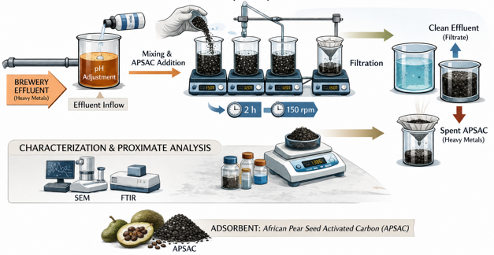
Figure 1: Experimental Procedure for the Batch Adsorption Process.
2.6 Experimental Design
The experiment was designed using Design Expert version 10, with Central Composite Design (CCD) in order to optimize the adsorption capacity and % removal of Chromium ion (Cr³⁺) from the brewery wastewater. The experiment was designed using three factors and five levels which generated 15 experimental runs each and the three independent factors were adsorbent dosage, contact time and initial concentration as shown in Table 1.
Table 1: Three independent factors.
Factors | Name | Type | Minimum | Maximum
A | Initial Concentration (mg/L) | Numeric | 5.0 | 25.0
B | Adsorbent dosage (g) | Numeric | 0.5 | 2.5
C | Contact time (mins) | Numeric | 15 | 75

Response Surface Methodology (RSM) was performed to determine the relationship between the batch adsorption process parameters (such as adsorbent dosage, initial concentration of metal ion and contact time) and the adsorption capacity and % removal of Chromium ion (Cr³⁺) as well as determine the optimal process conditions. The design of experiments (D.O.E) table generated to obtain the optimum conditions for adsorption is shown in Table 2.
Table 2: Design of Experiment Data Table for the removal of Chromium (Cr³⁺) ion.
Run | Factor 1  A: Contact Time (mins) | Factor 2  B: Initial Concentration (mg/L) | Factor 3  C: Adsorbent Dosage (g) | Response 1  Adsorption Capacity (mg/g) | Response 2  % Removal of Chromium (Cr³⁺) ion (%)
1 | 30 | 20 | 2 | 1.9997 | 99.985
2 | 60 | 10 | 2 | 0.9992 | 99.92
3 | 30 | 20 | 1 | 3.9998 | 99.995
4 | 45 | 15 | 0.5 | 5.9988 | 99.98
5 | 30 | 10 | 1 | 1.999 | 99.95
6 | 15 | 15 | 1.5 | 1.99947 | 99.9733
7 | 75 | 15 | 1.5 | 1.99987 | 99.9933
8 | 45 | 5 | 1.5 | 0.666533 | 99.98
9 | 45 | 15 | 2.5 | 1.19992 | 99.9933
10 | 60 | 20 | 2 | 1.9997 | 99.985
11 | 30 | 10 | 2 | 0.9995 | 99.95
12 | 45 | 25 | 1.5 | 3.3332 | 99.996
13 | 45 | 15 | 1.5 | 1.99853 | 99.9267
14 | 60 | 10 | 1 | 1.9994 | 99.97
15 | 60 | 20 | 1 | 3.999 | 99.975

3. Results and Discussion
3.1 Characterisation of Adsorbent
Table 3: Physico-chemical Properties of Adsorbent.
Physical Properties | APSAC
Moisture Content % | 3.28
Volatile Matter % | 1.04
Ash Content % | 1.28
Ph | 7.02
Bulk Density (g/cm³) | 0.332
Fixed Carbon (%) | 86.0

The proximate analysis was carried out to determine the physico-chemical properties of the prepared adsorbent, APSAC, as shown in Table 3. ASPAC had a low ash content of 1.28%, which implies that it can be used to produce high-yield and porous carbon. According to Aznar et al., 2011), the typical range of values of ash content for commercial activated carbon (CAC) should be <10 %, due to its influence on the overall activity of activated carbon during reactivation. According to Saleem (2024), an increase in ash content causes a decrease in adsorptive properties of activated carbons, and the presence of ash inhibits surface development of the activated carbon. Also, high ash content is an undesirable property in activated carbon since it reduces the mechanical strength of carbon and alters surface chemistry; thus affects the adsorptive capacity. ASPAC had a low moisture content of 3.28%, which implies that it maximised the available pore volume for adsorption and that the activation and drying process was effective in removing physically bound water; thus improving the adsorption capacity per unit mass of the adsorbent. Similar observations have been reported in activated carbon prepared from agro-biomass, where low moisture content enhances adsorption efficiency due to improved pore accessibility. A typical commercial activated carbon used for water treatment process is expected to possess moisture content below 5-10% to ensure efficient adsorption performance (Saleem, 2024; Ukpong et al., 2024b). The volatile matter content was 1.04%, which shows that there was significant development of the pore structure and chemical stability of ASPAC, which invariably led to an increase in the adsorption capacity. It also indicates that the thermal treatment during carbonisation and activation effectively removed unstable organic compounds, leaving behind a more stable carbon matrix suitable for adsorption processes. Similar trends have also been reported for activated carbons derived from lignocellulosic precursors, where the removal of volatile compounds enhances the development of a porous structure. ASPAC had a bulk density of 0.332g/cm³ which is within the standard range of >0.25g/cm³ for activated carbons used for water treatment processes. This implies that the adsorbent possessed adequate sinking behaviour in water and effective contact with the pollutant (Cr³⁺) during adsorption. Also, ASPAC had a fixed carbon of 86%, which implies greater carbon purity and a well-developed carbon framework, better pore development and higher adsorption capacity for contaminants such as heavy metals, dyes and organic compounds, etc.
3.2 Surface Morphology Analysis of the Adsorbent
The surface morphology of African Pear Seed Activated Carbon (APSAC) was examined before and after adsorption experiments using scanning electron microscopy (SEM). Figure 2(a) and Figure 2(b) present the SEM micrographs before and after adsorption, respectively. Figure 2(a) (pristine APSAC) revealed a highly porous structure featuring irregular cavities, numerous pores, and interpore bridges, which provided a large specific surface area conducive to adsorbate entrapment. Such well-developed porous networks with uneven cavities and rough surfaces are characteristic of biomass-derived activated carbons, enhancing adsorption capacity by offering abundant active sites (Bouzgarrou et al., 2025; Fatiha et al., 2022). The carbon framework consists of hexagonal arrangements of carbon atoms forming microcrystalline graphitic-like domains, which is also typical of activated carbons (Bouzgarrou et al., 2025). Figure 2(b), the spent APSAC displayed adsorbate deposition, resulting in partial pore blockage, smoother surface regions in areas of coverage, and localised increased roughness, confirming uniform ion/molecule uptake through mechanisms such as dipole-dipole interactions, electrostatic attraction, and surface complexation (Bouzgarrou et al., 2025; Dhahri et al., 2022). Comparable porous morphologies, including well-developed cavities and interconnected pores, have been reported in activated carbons derived from coconut shells, palm kernel shells, and similar biomass precursors following chemical or physical activation (El Maguana et al., 2019).

Figure 2(b): SEM Analysis after adsorption.

Figure 2(a): SEM Analysis before adsorption.

3.3 FT-IR Analysis of the Adsorbent
The FT-IR spectra of African pear seed activated carbon (APSAC) before and after Cr³⁺ adsorption revealed the presence of several peaks which are sub-divided into five regions indicating the presence of different functional groups within the wavelength of 600-4000 cm⁻¹ as shown in Figure 3(a) and Figure 3(b). The comparison of both spectra further revealed significant changes in functional group vibrations; thus, confirming the occurrence of adsorption and the participation of surface functional groups as shown in Table 4.
The adsorbent (APSAC) before adsorption shown a dominant signature of exhibiting a broad -OH (~3400 cm⁻¹), strong C=O at 1712 cm⁻¹, C-O at 1211 cm⁻¹ and O-H out-of-plane at 918 cm⁻¹ which is highly characteristic of a carboxylic acid-bearing material obtained from a biomass-derived adsorbent.
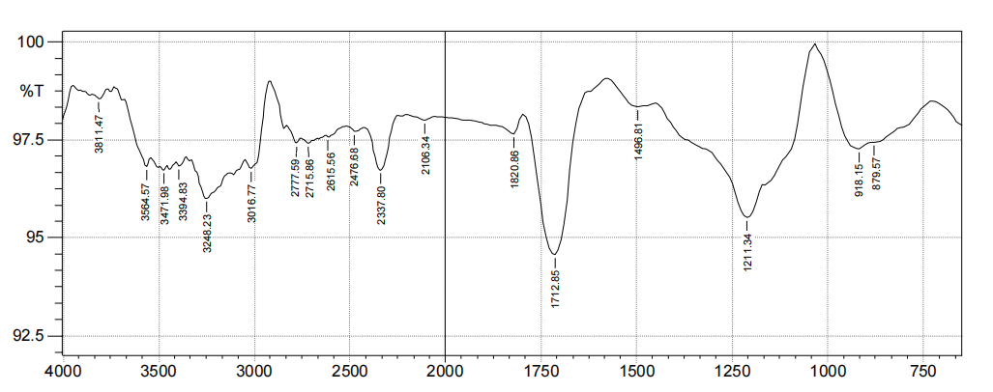
Figure 3(a): FTIR analysis before adsorption.
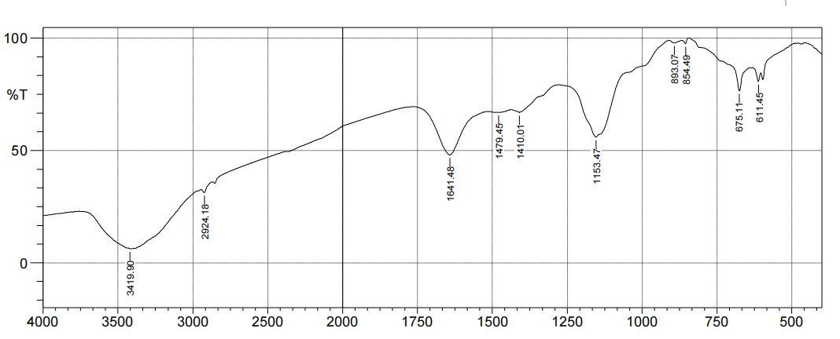
Figure 3(b): FTIR analysis after adsorption.
Also, the adsorbent (APSAC) after adsorption could be said to be a Hydroxy-rich organic or hybrid material containing metal oxide nanoparticles with a surface -OH group, which indicates the removal of heavy metallic ions (such as Cr³⁺, Zn²⁺, Fe²⁺) etc. Also, the absence of a carbonyl group peak (1700-1750 cm⁻¹) showed that Esters, carboxylic acids and Ketones were not major components; thus, resulting in their removal.
Table 4: FT-IR of Adsorbents.
Functional groups present in the Adsorbents | Absorption peaks of APSAC before Adsorption (cm⁻¹) | Absorption peaks of APSAC after Adsorption (cm⁻¹)
-OH stretching of the Alcohol group | 3811.47 | -
hydrogen-bonded –OH stretching of Alcohol or Carboxylic acid or Phenol | 3564.57–3248.23 | 3419.90
=C-H stretching of Aromatic groups | 3016.77
asymmetric C-H stretching of Aliphatic CH₂/CH₃ groups | - | 2924.18
asymmetric C-H stretching of Aldehyde group | 2777.59 – 2715.86 | -
-OH stretching of the Carboxylic acid group | 2615.56 | -
S-H stretching or P-H/Carboxylic acid –OH group | 2476.68 | -
C≡C stretching of Alkyne group | 2106.34 | -
C=O stretching of Aryl Carbonate group | 1820.86 | -
C=O stretching of Carboxylic acid group | 1712.85 | -
moderate C=C stretching of Alkene or N-H bending of primary Amine/Amide groups | - | 1641.48
C=C stretching of Aromatic ring or -NH bending | 1498.81
C-H bending of Aliphatic Methylene (-CH₂) group | - | 1479.45
C-H bending or O–H in-plane bending of Alcohol/Carboxylate group | - | 1410.01
C-O-C stretching of ethers, esters or C-O stretching of Carboxylic acid groups | 1211.34 | 1153.47
O-H out-of-plane bending of Carboxylic acid dimer confirmation | 918.15 | -
C-H out-of-plane bending of Aromatic ring substitution | 879.57 | 893.07-854.49
C-X or Metal oxide stretching of Halide or Inorganic components | - | 675.11-611.45

These results further elucidate that chromium adsorption onto APSAC occurs through a combination of physical adsorption and chemisorption mechanisms which is in tandem with recent studies on biomass-based activated carbons (Ibrahim et al., 2020; Saad et al., 2024; Younas et al., 2023).
3.4 Response Surface Methodology Model for Removal Efficiency
The Response Surface Methodology (RSM) experimental results of the adsorption studies for the removal of Chromium ion (Cr³⁺) from brewery effluent using African pear seed activated carbon are presented in Table 2. Three variables (initial concentration, adsorbent dosage and contact time) were used to determine the percentage removal and adsorption capacity of Chromium ion (Cr³⁺). The varying values of the percentage removal indicated that the process parameters had a significant effect on the adsorption process. The maximum Chromium ion (Cr³⁺) percentage removal of 99.98% was observed at an initial concentration of 15 mg/L, an adsorbent dosage of 0.5g in 45 minutes, which also corresponds to a maximum adsorption capacity of 5.9988 mg/g. This significant adsorption capacity and percentage adsorption showed how effective APSAC can be in treating heavy metals present in brewery wastewater.

3.5 Analysis of Variance (ANOVA) for the Adsorption Capacity of Chromium ion (Cr³⁺).
The result of the analysis of variance for chromium removal using African pear seed activated carbon (APSAC) is presented in Table 5. The significance of the model was determined at an F-value of 16.64 with a corresponding p-value of 0.0032, which was significant when compared to percentage removal. The parameter B² showed high significance, and B, C, A, AB, BC and C² showed mild significance, having coefficients that are less than 0.5, while AC and A² were insignificant. The fitness of the model was expressed by the coefficient of determination (R²) obtained as 0.9677. The adequate precision value of 14.2002, which is greater than 4, indicated the desirability of the model and its adequate signal-to-noise ratio, as shown in Table 6. The multiple regression analysis of the experimental data gave a Quadratic model equation shown in Equation 4.
(4)

Table 5: ANOVA Table for the Adsorption Capacity of Chromium ion (Cr³⁺).
Source | Sum of Squares | df | Mean Square | F-value | p-value | Significance
Model | 27.47 | 9 | 3.05 | 16.64 | 0.0032 | Significant
A - Contact Time | 0.0018 | 1 | 0.0018 | 0.0101 | 0.9240
B - Initial Concentration | 0.3309 | 1 | 0.3309 | 1.80 | 0.2370
C - Adsorbent Dosage | 1.34 | 1 | 1.34 | 7.28 | 0.0428
AB | 1.012E-07 | 1 | 1.012E-07 | 5.519E-07 | 0.9994
AC | 1.250E-09 | 1 | 1.250E-09 | 6.814E-09 | 0.9999
BC | 0.4999 | 1 | 0.4999 | 2.72 | 0.1597
A² | 0.0032 | 1 | 0.0032 | 0.0173 | 0.9004
B² | 0.0032 | 1 | 0.0032 | 0.0174 | 0.9001
C² | 1.92 | 1 | 1.92 | 10.49 | 0.0230
Residual | 0.9172 | 5 | 0.1834
Cor Total | 28.39 | 14

Table 6: Fit Statistics.
Model Summary
Metric | Value
Std. Dev. | 0.4283
Mean | 2.35
C.V. % | 18.26
R² | 0.9677
Adjusted R² | 0.9095
Predicted R² | 0.7012
Adeq Precision | 14.2002

3.6 The interactive effect of process parameters on the % removal of Chromium (Cr³⁺).
The interactive effects of adsorbent dosage, initial chromium concentration, and contact time on Cr³⁺ removal efficiency and adsorption capacity were analysed using response surface methodology (RSM), as illustrated in Figures 4(a), 4(b) and 4(c). Figure 4(a) shows that the percentage removal of Cr³⁺ ions increased with increasing adsorbent dosage due to the availability of a larger number of active adsorption sites, while a decrease in removal efficiency was observed at higher initial chromium concentrations as a result of increased competition among Cr³⁺ ions for limited binding sites. This antagonistic interaction between dosage and concentration is consistent with the RSM optimisation results, which identified adsorbent dosage as a statistically significant positive factor and initial concentration as a negative factor influencing chromium removal (Ukpong et al., 2024a). Figure 4(b) demonstrates a synergistic interaction between adsorbent dosage and contact time, with Cr³⁺ removal increasing rapidly at lower contact times before gradually approaching a plateau. This trend reflects the progressive occupation of available adsorption sites until equilibrium is attained, corroborating the kinetic results where pseudo-first-order behaviour dominated the initial adsorption stage. Furthermore, Figure 4(c) indicates that maximum chromium removal was achieved at low initial concentrations and extended contact times, conditions that closely correspond to the optimum operational region predicted by the RSM model. The levelling-off observed at longer contact times confirms equilibrium saturation, consistent with diffusion analysis that identified film diffusion as the controlling mass transfer mechanism (Abuilaiwi, 2020; Naushad et al., 2013). Collectively, these findings validate the RSM-predicted optimal conditions and demonstrate strong agreement between statistical optimization, kinetic behaviour, and mass transfer limitations.

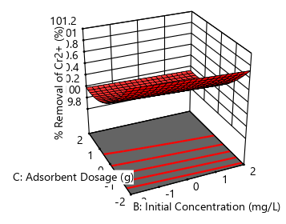
Figure 4(a): 3D plot of the interactive effects of adsorbent dosage and initial concentration on percentage removal.

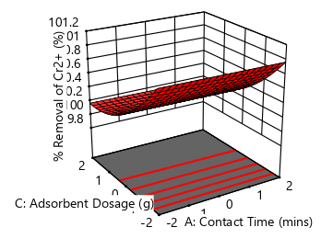
Figure 4(b): 3D plot of the interactive effects of adsorbent dosage and contact time on percentage removal.

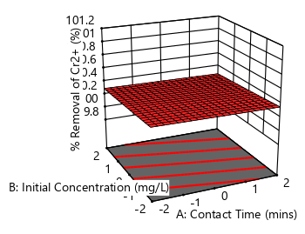

Figure 4(c): 3D plot of the interactive effects of contact time and initial concentration on percentage removal.

3.7 The interactive effect of process parameters on adsorption capacity of APSAC.
The effects of the adsorbent dosage and initial concentration of Chromium (Cr³⁺) on the adsorption capacity are shown in Figure 5(a), indicating adsorption capacity to be increasing significantly with an increase in initial concentration at a fixed adsorbent dosage. This indicates that higher solute concentrations enhance adsorption efficiency. Also, from Figure 5(b), adsorption capacity remained nearly constant as contact time increased, irrespective of adsorbent dosage. Thus, implying that equilibrium was quickly achieved and additional time did not have any significant effect on the adsorption process. Figure 5(c) showed that adsorption capacity increased with initial concentration, confirming that higher solute concentrations provided a greater driving force for adsorption. (Abuilaiwi, 2020; Naushad et al., 2013).

Figure 5(a): 3D plot of the interactive effects of adsorbent dosage and initial concentration on adsorption capacity.

Figure 5(b): 3D plot of the interactive effects of adsorbent dosage and contact time on adsorption capacity.

Figure 5(c): 3D plot of the interactive effects of contact time and initial concentration on adsorption capacity.

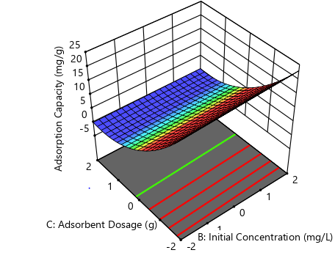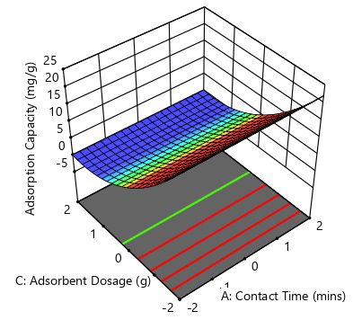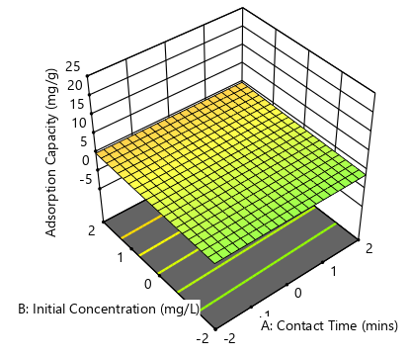

3.8 Adsorption Isotherm
The equilibrium behaviour of chromium adsorption onto African pear seed activated carbon (APSAC) was analysed using the Langmuir, Freundlich, Sips, and Redlich–Peterson isotherm models. As shown in Table 7, the Langmuir model yielded a maximum monolayer adsorption capacity (Qₘ = 5.517 mg·g⁻¹) and a Langmuir constant (B = 261.448 L·mg⁻¹), with a correlation coefficient (R² = 0.6778), indicating a moderate fit and suggesting partial conformity to monolayer adsorption assumptions (Foo & Hameed, 2010; Younas et al., 2023). However, the Freundlich model produced an intensity parameter (n = 2.095) and a Freundlich constant (K_{f} = 37.36 L·mg⁻¹), implying unfavourable adsorption under the studied conditions and highlighting the limitations of assuming ideal surface heterogeneity.
In contrast, the Sips isotherm provided the best fit to the experimental data (R² = 0.6812), with parameters Qₘₛ = 4.672 mg·g⁻¹, Kₛ = 2079.61 L·mg⁻¹, and β = 1.3006, confirming the heterogeneous nature of the APSAC surface and the presence of adsorption sites with varying affinities (Zewail and Yousef, 2015; Oussalah et al., 2024a). The Redlich–Peterson model exhibited an R² value of 0.571 in comparison to that of the Langmuir model but substantially lower than that of the Sips model. The superior performance of the Sips model is consistent with the kinetic results, where pseudo-first-order behaviour dominated with a strong pseudo-second-order contribution, indicating concurrent physical adsorption and chemisorption. Furthermore, the predominance of film diffusion observed in the Boyd model analysis supports the inference of heterogeneous surface adsorption controlled by external mass transfer resistance. Collectively, the agreement between equilibrium, kinetic, and diffusion analyses confirms that chromium adsorption onto APSAC proceeds via a heterogeneous, multi-mechanism process rather than ideal monolayer adsorption.
Table 7: Adsorption Isotherm Models for the removal of Chromium (Cr³⁺).
Isotherm Models | Non-linear equations | Parameters | Results
Langmuir Model |  | q_{m} | 5.517
 |  | B | 261.448
 |  | R² | 0.6778
Freundlich Model |  | k_{f} | 37.3586
 |  | N | 2.09477
 |  | R² | 0.655
Sips Model
 |  | K_{s} | 2079.61
 |  | β | 1.3006
 |  | q_{ms} | 4.67179
 |  | R² | 0.6812
Redlich-Peterson Model |  | A | 408.072
 |  | B | 0.79449
 |  | β | 6.07991
 |  | R² | 0.57085

3.9 Adsorption Kinetic Studies
The adsorption kinetics of Cr³⁺ ions onto African pear seed activated carbon (APSAC) were evaluated using pseudo-first-order (PFO), pseudo-second-order (PSO), intra-particle diffusion, and Boyd kinetic models. The kinetic parameters summarised in Table 8 reveal that the PFO model provided the best fit to the experimental data, with a correlation coefficient (R² = 0.82) slightly higher than those obtained for the PSO and intra-particle diffusion models. This finding suggests that the adsorption process was primarily governed by surface adsorption mechanisms (Jianlong and Xuan, 2020). The PFO rate constant (K₁ = 8.3524 × 10⁻⁵ g/mg·min) and equilibrium adsorption capacity (qₑ = 695.65 mg/g) further support the dominance of physical adsorption during the uptake of chromium ions (Younas et al., 2023; Ibrahim et al., 2020). Although the PSO model also showed a high correlation coefficient (R² = 0.8198), its lower equilibrium adsorption capacity (qₑ = 419.58 mg·g⁻¹) with PSO rate constant (K₂ = 3.3134 x 10⁻⁷) indicates that chemisorption was not the sole rate-controlling mechanism (Abdulrazak et al., 2016). Nevertheless, the strong agreement of the PSO model suggests that chemical interactions, involving electron sharing or exchange between Cr²⁺ ions and APSAC, also contributed to the adsorption process, in agreement with recent reports (Juturu et al., 2025; Oussalah et al., 2024a; Younas et al., 2023).
Table 8: Adsorption Kinetic Models for the removal of Chromium (Cr³⁺).
Kinetic Models | Non-linear equations | Parameters | Results
Pseudo-first order kinetic model |  | K₁ | 8.3524x10⁻⁵
Pseudo-first order kinetic model |  | q_{e} | 695.65
Pseudo-first order kinetic model |  | R² | 0.821
Pseudo-Second order kinetic model |  | K₂ | 3.3134x10⁻⁷
Pseudo-Second order kinetic model |  | q_{e} | 419.581
Pseudo-Second order kinetic model |  | R² | 0.8198
Intra-particle Diffusion kinetic model |  | K_{ip} | 0.41883
Intra-particle Diffusion kinetic model |  | C | 0
Intra-particle Diffusion kinetic model |  | R² | 0.72713
Boyd Model |  | q_{e} |  | 5.9988
Boyd Model |  | R² |  | 0.632

Bulut et al. (2008) postulated that a linear diffusion plot passing through the origin indicates intra-particle diffusion control, whereas deviation from the origin reflects the influence of film diffusion. Recent studies have reaffirmed this criterion, emphasising that non-zero intercepts in intra-particle diffusion and Boyd plots signify the presence of boundary layer resistance and multi-step mass transfer processes (Ibrahim et al., 2020; Oussalah et al., 2024b). In the present study as shown in Figure 6, the linear Boyd model plots did not pass through the origin (i.e, deviated from linearity at the origin), thereby confirming that the adsorption process for Cr³⁺ adsorption onto African pear seed activated carbon (APSAC) was predominantly controlled by film diffusion rather than intra-particle diffusion, as well as played a significant role in governing the overall adsorption rate (Ukpong et al., 2024b). This behaviour is indicative of variations in mass transfer resistance during the initial and intermediate stages of adsorption, highlighting the dynamic nature of the adsorption mechanism. This outcome underscores the importance of external mass transfer resistance in the adsorption of chromium ions from brewery effluent and has important implications for the design, scale-up, and optimisation of adsorption systems intended for industrial wastewater treatment.

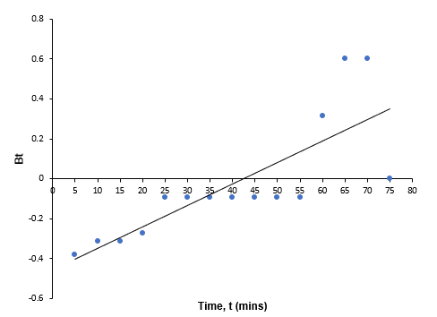
Figure 6: The plot of Boyd model for the removal of Chromium (Cr³⁺) onto APSAC.

4. Conclusion
This study optimised the adsorption of Cr³⁺ from brewery wastewater using African pear seed activated carbon (APSAC) through Response Surface Methodology. APSAC was prepared and characterised using FTIR and SEM analysis, and the effects of contact time, adsorbent dosage, and initial chromium concentration were evaluated using a Central Composite Design by carrying out batch adsorption experiments. Maximum chromium removal of 99.98% was achieved at 15 mg/L initial concentration, 0.5 g adsorbent dosage, and 45 minutes contact time. Adsorption efficiency increased with dosage and contact time but decreased with higher initial concentration, reaching equilibrium at longer times. The Sips isotherm model best described the adsorption process, with surface adsorption and chemisorption identified as dominant mechanisms. The high R² values of 0.821 confirm the reliability of the developed models and demonstrate APSAC’s effectiveness for heavy metal removal from wastewater. Hence, the use of African pear seed activated carbon was discovered to be beneficial and effective in the removal of Chromium ion (Cr³⁺) from industrial wastewater such as brewery effluents.
Abbreviations
RSM Response Surface Methodology
APSAC African Pear Seed Activated Carbon
FT-IR Fourier transform infra-red spectrophotometer
SEM Scanning electron microscope
TDS Total Dissolved Solids
ASTM American Standard for Testing and Materials
CCD Central Composite Design
D.O.E Design of Experiment
CAC Commercial Activated Carbon
ANOVA Analysis of Variance
PFO Pseudo-First-Order
PSO Pseudo-Second-Order
Declarations:
Acknowledgments
Authors appreciate the efforts of the technical staff of Chemical Engineering Department and the Botany Department, Akwa Ibom State University, Nigeria for the assistance provided during the laboratory research work.
Author Contributions
Ukpong Anwana Abel: Conceptualization, Methodology, Data Curation, Validation, Formal Analysis, Writing- Original Draft Preparation, Review and Editing.
Uzono Romokere Isotuk: Formal Analysis, Investigation, Resources, Project Administration, Funding Acquisition.
Okon Godwin Okon: Brewery Effluent Collection and Analysis, Validation, Investigation, Resources, Supervision.
Antia Ukponobong: Brewery Effluent Collection and Analysis, Investigation, Resources, Writing – Original Draft Preparation.
Okon Joseph Etim: Brewery Effluent Collection and Analysis, Investigation, Resources, Project Administration, Funding Acquisition.
Akwayo Iniobong Job: Characterisation and Formal Analysis, Investigation, Resources, Project Administration, Funding Acquisition.
Umoren Godwin Ani: Experimental Analysis, Data Collection and Analysis, Data Curation, Validation.
Ebong Ekemini Paul: Experimental Analysis, Data Collection and Analysis, Data Curation, Validation.
All the authors have read and agreed to the published version of the manuscript.
Disclaimer (Artificial intelligence)
Author(s) hereby declares that NO generative AI technologies such as Large Language Models (ChatGPT, COPILOT, etc.) and text-to-image generators have been used during the writing or editing of this manuscript.
REFERENCES
Abdulrazak, S., Sulyman, Y., Bello, H., Akanni, A., Abdulraheem O., & Muktari, M. (2016). Tannery Wastewater Treatment Using Activated Carbon From Moring Oleifera Pods. 9. 2319-2399.
Abuilaiwi, A. F. (2020). Removal of Cadmium (II), Chromium (III), and Lead (II) Heavy Metal Ions from Water by Graft Copolymerization of Acrylonitrile onto Date Palm Fiber Using H₂O₂/Fe⁺⁺ as an Initiator. International Journal of Polymer Science. (8):1-15. https://doi.org/10.1155/2020/1239267
Abu Tawila, Z. M., Ismail, M. S., Abu Amr, S.S., & Abou Elkhair, E. K. (2019). A novel efficient bioflocculant QZ-7 for the removal of heavy metals from industrial wastewater. RSC Adv., 9 (48): 27825-27834.
Adepoju, T.F., Ukpong, A.A. and Eyibio, U.P. (2016a). A Statistical Approach to Optimization of Congo Red Dye Removal (CRDR) via Coconut Shell Activated Carbon (CSAC). International Journal of Computational and Theoretical Chemistry.
https://doi.org/10.11648/j.ijctc.20160402.11
Adepoju, T.F., Uzono, R.I. and Akwayo, I.J. (2016b). Modelling and Optimization of Congo-Red Dye from Waste Water using Agricultural Waste. Journal of Chemical, Environmental and Biological Engineering, 1(1): 13-18. https://doi.org/10.11648/j.jcebe.20170101.11
Akinterinwa, A., and Adebayo, I. (2018). Chemical Precipitation Approach to The Removal of Heavy Metals from Wastewater for Discharge into Sanitary Sewerage. International Journal of Chemistry, 1: 2581-7760.
Akpan, U. & Umana, U. (2022). Characterization of physico-chemical properties and heavy metal concentrations of surface water receiving effluent from champion breweries plc in Uyo, Akwa Ibom State, Nigeria. Global Sustainability Research. 1: 5-13.
Al-Ghouti, M. & Da’ana, D. (2020). Guidelines for the use and interpretation of adsorption isotherm models: A review. Journal of Hazardous Materials. 393. 122383.
Bouzgarrou, S.M., Jedli, H., Hassani, R., Sabi, E., Khan, A.H., Slimi, K. (2025). Experiments and physical Investigation on the adsorption of methylene on activated carbon. Scientific Reports. 15, 45075. https://doi.org/10.1038/s41598-025-31120-z
Bulut, Y., Tez, Z., & Ceylan, M. (2008). Removal of heavy metals from aqueous solution by sawdust adsorption. Journal of Environmental Sciences, 20(5), 537–544. https://doi.org/10.1016/S1001-0742(08)62092-3
Denise A., Sueli I. & Terezinha E. M. (2013). Surfactant Modified Zeolite from Cyclone Ash as Adsorbent for Removal of Reactive Orange 16 from Aqueous Solution American. Journal of Environmental Protection. 1 (1), 1-9.
Dhahri, R.; Yılmaz, M.; Mechi, L.; Alsukaibi, A.K.D.; Alimi, F.; Ben Salem, R.; Moussaoui, Y. (2022). Optimization of the Preparation of Activated Carbon from Prickly Pear Seed Cake for the Removal of Lead and Cadmium Ions from Aqueous Solution. Sustainability, 14, 3245. https://doi.org/10.3390/su14063245
Eda, K., & Canan, A. (2015). Preparation, structural evaluation and adsorptive properties of activated carbon from agricultural waste biomass. Advanced Powder Technology, 26 (3): 811-818.
El Maguana, Y., Elhadiri, N., Bouchdoug, M., Benchanaa, M. and Jaouad, A. (2019). Activated Carbon from Prickly Pear Seed Cake: Optimization of Preparation Conditions Using Experimental Design and Its Application in Dye Removal. International Journal of Chemical Engineering, 2019: 12. https://doi.org/10.1155/2019/8621951
Enitan-Folami, A., Adeyemo, J., Kumari, S., Swalaha, F., & Bux, F. (2015). Characterization of brewery wastewater composition. International Journal of Environmental and Ecological Engineering, 9: 1073-1076.
Fatiha, B., Sami, K. and Mounira K. (2022). Efficient removal of Cr (VI) from aqueous solution using activated carbon synthesized from silver berry seeds: modelling and optimization using central composite design. Biomass Conversion and Biorefinery, 14:7087–7101. https://doi.org/10.1007/s13399-022-03041-8.
Foo, K. Y., & Hameed, B. H. (2010). Insights into the modeling of adsorption isotherm systems. Chemical Engineering Journal, 156(1), 2–10. https://doi.org/10.1016/j.cej.2009.09.013
Gottipati, R. (2012). Preparation and Characterization of Microporous Activated Carbon from Biomass and Its Application in the Removal of Chromium (VI) from Aqueous Phase (pp. 1-242). Department of Chemical Engineering, National Institute of Technology.
Gupta, G., Khan, J. and Singh, N. K. (2021). Application and efficacy of low-cost adsorbents for Metal removal contaminated water: A review. Materials Today: Proceedings, 43(5): 2958-2964.
Ibrahim, Y., Naddeo, V., Banat, F. and Hasan, S.W. (2020). Preparation of novel Polyvinylidene Fluoride (PVDF)- Tin (IV) Oxide (SnO2) ion exchange mixed matrix membranes for the removal of heavy metals from aqueous solutions. Separation and Purification Technology, 250, 117250. https://doi.org/10.1016/j.seppur.2020.117250.
Jianlong W. & Xuan G. (2020). Adsorption kinetic models: Physical meanings, applications, and solving methods. Journal of Hazardous materials 390, 122156.
Juturu, R., Vinayagam, R., Murugesan, G. and Selvaraj, R. (2025). Enhanced adsorptive removal of chromium (VI) ions from wastewater with phosphorus-doped magnetite-carbon composite: advanced statistical physics modelling and kinetic studies. Environmental, Development and Sustainability, Springer. 10 (1007): 1-27.
https://doi.org/10.1007/s10668-025-07015-4.
Kanu, I., & Achi, O. K. (2021). Industrial effluents and their impact on water quality of receiving rivers in Nigeria. Journal Of Applied Technology in Environmental Sanitation, 1 (1): 75-86.
Lisbania, V., Mohammad S. N., Edwin E., Marta-Lena A., & Farid A. (2023). Adsorption of heavy metals on natural zeolites: A review. Chemosphere. 328, 138508.
Naushad, M., Ahamad, T., Alothman, Z. A., Shar, M. A., AlHokbany, N. S. Alshehri, S. M. (2015). Synthesis, characterization and application of curcumin formaldehyde resin for the removal of Cd²⁺ from wastewater: Kinetics, isotherms and thermodynamic studies. Journal of Industrial and Engineering Chemistry. 29(25):78-86.
https://doi.org/10.1016/j.jiec.2015.03.019
Okon O. G, Uzono R. I, Ukpong A. A., Archibong B. F.,Okon J. E., Antia U. E., Eberefe G. J., Emmanuel A. I. (2024). “Heavy Metals Analysis of Breweries Effluent used in Soil Cultivated with Glycine Max (L.) Merr. Accessions with Biochar Augmentation. Sumerianz Journal of Biotechnology, 7(4): 61-67. https://doi.org/10.47752/sjb.74.61.67
Okon, O. G. (2017). Bioaccumulation of Heavy Metals in Cucurbita maxima Duch. and Telfairia occidentalis Hook. F. Grown on Crude Oil Polluted Soil. American Journal of Agricultural Science. 4(4): 88-93
Oussalah, H., Benamar, A., & Kouider, M. (2024a). Adsorption kinetics and diffusion mechanisms for aqueous contaminants: Evaluating film and intra-particle diffusion. Journal of Materials and Environmental Science, 13(5), 526–543.
Oussalah, H., Benamar, A., & Kouider, M. (2024b). Advanced equilibrium modeling of adsorption processes on heterogeneous adsorbents. Journal of Materials and Environmental Science, 13(5), 526–543.
Saad, E.M., Abd-Elhafiz, M.F., Ahmed, E.M. and Markeb, A.A. (2024). Hexavalent Chromium ion removal from wastewater using novel nanocomposite based on the impregnation of zero-valent iron nanoparticle into polyurethane foam. Scientific Reports, 14:5387. https://doi.org./10.1038/s41598-024-55803-1.
Saleem, M. (2024). Sustainable production of activated carbon from indigenous Acacia etbaica tree branches employing microwave induced and low temperature activation. Heliyon. (10)-e2413. https://doi.org/10.1016/j.heliyon.2024.e24113
Ukpong, A. A., Edekhe, G. I. and Asuquo, E. O. (2024a). The adsorption studies for the removal of Lead (Pb²⁺) from paint industrial wastewater using avocado seed activated carbon (ASAC). International Journal of Research and Scientific Innovation (IJRSI), 1(11): 414-425. https://doi.org/10.51244/IJRSI.2024.1101032
Ukpong, A. A., Gumus, R. H. and Oboh, I. O. (2020). Adsorption Studies of Oil Spill Clean-up Using Coconut Coir Activated Carbon (CCAC). American Journal of Chemical Engineering. 8(2): 36-47. https://doi.org/10.11648/j.ajche.20200802.11
Ukpong, A. A., Otu, G. E., Oboh, I. O., Uzono, R. I., Akwayo, I. J. and Inyang, U. I. (2024b). Enhanced Hydrophobicity and Oleophilicity of Modified Activated Carbons Derived from Agro-Wastes Biomass for the Removal of Crude Oil from Aqueous Medium. American Journal of Chemical Engineering. 12(4): 80-96.
https://doi.org/10.11648/j.ajche.20241204.11
Vido, K., Spector, D., Lagniel, G., Lopez, S., Toledano, M. B. and Labarre, J. (2001). Analysis of the Cadmium Response in Saccharmyces cerevisiae. Journal of Biological Chemistry, 276, 8469.
Younas, F., Bibi, I., Afzal, M., Al-Misned, F., Niazi, N., Hussain, K., Shahid, M., Shakil, Q., Ali, F., & Wang, H. (2023). Unveiling Distribution, Hydrogeochemical Behaviour and Environmental Risk of Chromium in Tannery Wastewater. Water. 15. 391.
Zewail, T. M., and Yousef, N. S. (2015). Kinetic study of heavy metal ions removal by ion exchange in batch conical air spouted bed. Alexandria Engineering Journal, 54(1), 83–93. https://doi.org/10.1016/j.aej.2014.11.008

