Original Research Article

Preparation and characterization of sodium, copper and zinc based soaps from cottonseed oil and evaluation of their antimicrobial activity against a few plant pathogens

.
ABSTRACT

Crude Cottonseed oil obtained from kernels of cotton seeds is not suitable for human consumption because it contains toxic phenolic compounds. In the present investigation, soaps of sodium, copper, and zinc were prepared using non-refined crude cottonseed oil by saponification and metathesis methods. The final products were characterized by Infrared spectral analysis, and the metal content in the soap samples was determined using a Flame photometer and an Atomic Absorption Spectrophotometer. X-ray diffraction analysis of copper soap revealed that these surfactants have moderate crystallinity with a crystallite particle size of around 15 nm as calculated by the Scherrer Equation. Antimicrobial activity of each synthesized material was studied on the fungi Phytophthora, Fusarium, and bacterial species such as Erwinia and Clavibacter at different dilutions ranging from 0.5% to 5% w/v soap solution. Sodium and zinc Soap had prominent antimicrobial activity ranging from 8 mm to 13 mm of zone of inhibition against fungal strains, at the concentration of 1%-5% w/v. Sodium salts are water-soluble and eco-friendly in nature; hence, the synthesis of these kinds of derivatives from non-edible crude cottonseed oil could help in developing fungicides that are less toxic and more cost-effective in nature.

Keywords: Cottonseed oil, Zinc Soaps, Phytophthora, Fusarium, Scherrer Equation, Antimicrobial activity

1. INTRODUCTION

Cottonseed oil is extracted from the seed kernels of the cotton plant (Gossypium Malvaceae family ) after removal of lint i.e. valuable textile fibre. Crude cottonseed oil is dark brown in color, has a slight, unpleasant odor, and contains a toxic phytochemical compound called Gossypol, due to which crude Cottonseed oil is non-edible and not considered safe for human consumption(Ibanga O. Isaac, 2013, M.I. Hassen et al. 2022, Remadevi & Gordon, 2022, Sam, 2024). Gossypol is a polyphenolic compound that is known to interfere with biological processes and mainly acts as a disruptor of Endocrine glands especially the reproductive organs like the Testis in males, inhibiting spermatogenesis. It is also known to affect cardiovascular organs and vital organs like kidney, liver and spleen. Because of these pharmacological issues use of cottonseed oil for making food items is usually limited and it can be consumed only after bleaching and refining of crude oil, which ensures the removal of toxic compounds. However crude oil can be used for the making of products like soap because this oil has good saponification value and rich in unsaturated fatty acids which makes it ideal for making soaps and other products of topical applications(Komarnytsky, 2025) .Further, water-soluble sodium soaps can be used to derive other metallic soaps by replacing alkali metals with transition or non-transition metals. These metallic soaps are of pivotal use and depending on their biological activity metallic soaps can find application as a pesticide/fungicide in agricultural fields. Phytophthora infestans is a well-known plant pathogen responsible for causing Late Blight disease in potato and tomato(Iqbal, 2012).This fungus was responsible for Irish famine in 19th century. Phytophthora destroys the leaves and edible tubers of Potato plant and causes problems in most of the parts of Europe and Asia.
Fusarium solani is another fungus known to cause massive destruction in Soybean plants. It is responsible for Sudden death in Soybeans (SDS) and causes diseases like Damping off, Root rot etc. in plants. F. Solani is known to cause diseases in human as well. It causes skin infections and Dermal Keratitis which can lead to severe damage of the cornea in immune-compromised people.(Maryam Rahimi Kakolaki & Shekarforoush,2023,Kang et al., 2025).Erwinia amylovora is a gram-negative bacteria responsible for rotting of Pears, Pomegranates and Apples causing Fire blight in fruits of the family Rosaceae (Khaled H. Arafat et al., 2015; Schmidt et al., 2025).Clavibacter michiganensis a gram-positive bacteria is known to cause Canker disease in tomato and it also causes bacterial wilt in potatoes.(Oloyode et al, 2017, Atiq, 2022)
In past various researchers have explored different type of plant extracts to determine the antimicrobial action of natural products on these pathogens, so as to formulate eco-friendly pesticides which are less toxic and more eco-friendly in nature. (J. lqbal M. et al, 2000, Rachel I. Ndala Patrick A. Ndakidemi, 2019; Dawen DE Okechalu BO Dapiya H and Kutshik RJ, 2023; Sharma et al., 2024; Amal Hari et al, 2024, Zhou et al., 2025).
Our aim is to synthesize and characterize metallic sodium, copper and zinc based soaps from unrefined inedible cottonseed Oil, its characterization and assessment of biocidal activity against harmful plant pathogens.

2. MATERIALS AND METHODS

2.1 Preparation of Sodium Soap
In a clean beaker crude cottonseed oil was measured and small quantity of animal charcoal was added to remove any colored impurities and oil was heated on a hot plate along with continuous stirring, after few minutes oil was removed from hot plate and immediately filtered over glasswool . A very slight color change was observed and cottonseed oil again became brown on cooling and exposure to air. 20 grams of this oil was transferred to another clean and dry beaker and placed in steam bath for heating. Once oil attained a temperature above 60ºC, a concentrated lye solution prepared by mixing sodium hydroxide pellets in distilled water was gradually added in hot oil along with continuous stirring to ensure proper mixing of lye and oil. After complete addition of lye, soap mixture was stirred and heated for another 30 minutes to maximize the speed of saponification reaction. Crude soap mixture was transferred into petridish to mold it into the solid soap (fig.1 a). After 48 hours a thick solid soap was formed. Sodium hydroxide acts as a refining agent that removes color generating free fatty acids on saponification, due to which the soap color eventually changes to white yellow ,crude soap was washed with small quantity of distilled water to remove excess of sodium hydroxide. This soap was left for drying and hardening purpose for another 7 days (fig. 1b). Weight of soap was recorded and yield was noted (Table1).

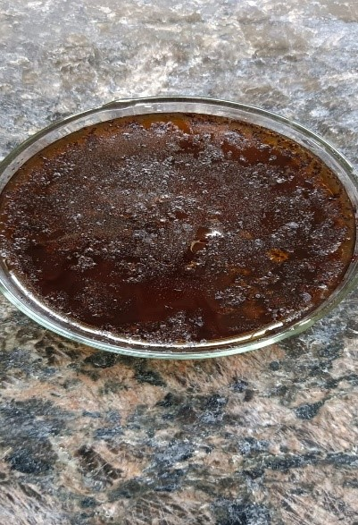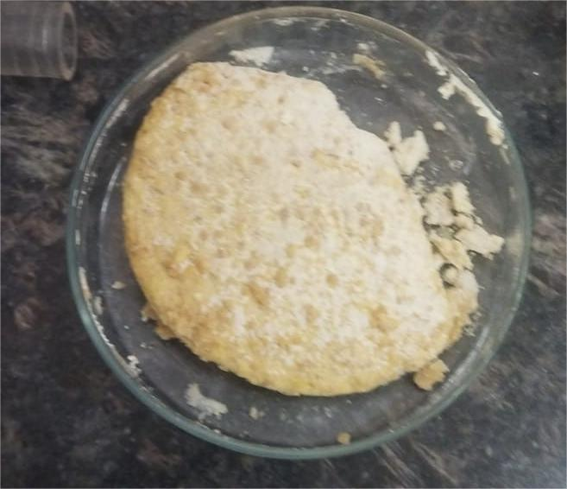

Fig. 1(a) Oil after Saponification (b) Solid soap after washing and drying

2.2 PREPARATION OF METALLIC SOAPS OF COPPER AND ZINC
A mass of 5 gm of Sodium soap was added in a round bottom flask and dissolved in warm 25 mL absolute ethanol (99.9% AR Grade).The pH of solution was adjusted between 7-8 by adding few drops of dil. H₂SO₄. A water condenser was placed on the mouth of RBF and solution was refluxed in steam bath till a clear solution was obtained. 5 % solution of copper sulphate (AR Grade) in distilled water was added gradually from the top of the condenser and mixture was refluxed for 2-3 hours(Joseph et al., 2015)..A dark green thick layer was formed along the sides of flask and on the top of mixture. The reaction mixture was left over-night; crude product was filtered off dried and recrystallized by using petroleum ether. Similarly, zinc based soap was prepared by using 5 % zinc sulphate Solution (AR Grade)(Charoen Nakason Azizon Kaesaman, 2025). Each product was completely dried by rinsing with absolute ethanol and acetone, yield of dry product was recorded (Table 1).

2 RCOONa + CuSO₄ (RCOO)₂Cu + Na₂SO₄

2RCOONa + ZnSO₄ (RCOO)₂Zn + Na₂SO₄

Above reaction proceeds in forward direction because metallic soaps of copper and zinc are hydrophobic, water insoluble, less reactive and thermodynamically more stable than it’s corresponding sodium derivative.

2.3 DETERMINATION OF pH (Tarun et al., 2014)
The pH of all the synthesized products was noted by using a pH meter well-calibrated by using standard buffer solution of 4.0, 7.0 and 9.2 pH. A mass of 1 gm of the sodium soap sample was dissolved in warm distill water and diluted up to 100 mL. This solution was cooled up to 25ºC.Glass electrode of pH meter was immersed in soap solution carefully without generating bubbles and value of pH was noted. For pH of metallic soaps one gram of dry product was suspended in distilled water and kept overnight, then pH was determined by using pH meter(Table 1) .

2.4 DETERMINATION OF MELTING POINT
The melting point of each soap sample was determined by using a Digital Melting point apparatus. Few milligrams of each sample was filled in a capillary tube and immersed in silicon oil. The sample was heated with the help of an electrical heater and the temperature at which the sample liquified and became transparent was recorded (Table 1) .

2.5 DETERMINATION OF METAL CONTENT IN SOAP SAMPLES (G H Jeffery J Mendham R C Denney, 1989)
In Sodium Soap sample amount of Sodium (in %) was determined by using Digital Flame Photometer. 1% Sodium soap solution was prepared by dissolving 0.1gm of soap sample in 10 mL deionized water. Metal content in Cu and Zn soap was determined by using Atomic Absorption Spectrophotometer (AAS) Technique. 0.5 gm sample was dissolved in fuming HNO3 mixed with few drops of perchloric acid and diluted in a 100 mL volumetric flask with deionized water. Metal content in each sample was expressed in terms of % w/w (Table 1) .

Table No. 1 Yield/pH/Melting Point/Metal Content Value

S.No. | Sample | Input of Reactant (in g) | Output of Product (in g) | % Yield | pH | Melting Point | % of Metal
1 | Sodium Soap | 20 | 30.30 | 151.5 % | 10.10 | 130 ºC | 6.71 %
2 | Copper Soap | 5 | 2.7 | 54% | 5.00 | 100 ºC | 9.62 %
3 | Zinc Soap | 5 | 2.9 | 58% | 6.93 | 80 ºC | 7.14 %

2.6 DETERMINATION OF ALKALINITY OF SODIUM SOAP (IN TERMS OF % OF NaOH w/w) (Juzer Ali Rangwala, 2014)
In order to determine the total alkalinity content of soap standard titrimetric method was followed. 5 grams of dry soap was weighed in a petridish and transferred in a Round Bottom flask, 50 mL of neutralized ethanol was added and mixture was refluxed till a clear solution was obtained. Approximately 1N H₂SO₄ was prepared by dissolving 98% AR H₂SO₄ in distilled water and diluting in a 250 mL standard volumetric flask. Exact normality of acid standard was determined by titrating it against standard 1N Na₂CO₃ solution using methyl orange indicator. Now solution of soap in alcohol was titrated against H₂SO₄ using phenolphthalein indicator. Alkalinity of sodium soap is calculated in terms of % of NaOH w/w.
2.7 CHARACTERIZATION BY USING FTIR TECHNIQUE (Shah, 2017)
Formation of Soap was confirmed by recording the Fourier Transform InfraRed spectrum of cottonseed Oil and dry soap samples. Interpretation of Spectrum was done by using Origin software and with the help of standard literature.
2.8 CHARACTERIZATION OF COPPER SOAP BY X RAY DIFFRACTION(Corbeil M-C, 2002)
X-ray Diffraction of copper soap from cottonseed oil was recorded, analysis of data was done by using Origin software. Peak Positions were used to determine interplanar spacing d from Braggs equation and crystallite particle size was calculated by using Scherrer equation.

2.9 STUDY OF ANTIMICROBIAL ACTIVITY ON PLANT PATHOGENS (Shema Khan, 2017, Jain et al., 2020, Lavanya & Jagathy, 2021)
Antimicrobial activity of prepared soap samples was studied on pathogenic fungi Phytophthora infestans, Fusarium solani and pathogenic bacteria Erwinia amylovora and Clavibacter michiganensis. All microbial strains were ATCC cultures and procured from Himedia Laboratories Pvt.Ltd. India. Soap solution or stock solution was prepared by dissolving samples in Dimethyl Sulphoxide (DMSO) solvent at a concentration equivalent to 10% w/v. Serial dilutions of 5%, 2%, 1% and 0.5% w/v were prepared from the stock solution and antimicrobial activity was studied on Muller-Hinton Agar plates for bacterial culture and Potato Dextrose Agar Plates for fungal cultures. Results were noted in the form of Zone of Inhibition after incubation at 37 degree Celsius. For bacterial samples, observations were recorded after 24 hours, whereas for fungal samples, results were recorded after 5 days.

3. results and discussion

3.1 Calculation of Total Alkalinity of Sodium Soap

N_{A} x V_{A} = N_{B} x V_{B}
Where, N_{A} = Normality of acid i.e. H₂SO₄
N_{B}= Normality of base i.e. Na₂CO₃= 1N
V_{A} = Volume of acid (Burette Reading at End Point) = 13.5 mL
V_{B} = Volume of base i.e. Na₂CO₃ = 20 mL

N_{A} = 1 x 20/13.5 = 1.48 N H₂SO₄

N_{H2SO4} x V_{H2SO4} = N_{NaOH} x V_{NaOH}

Volume of Titre (Soap solution) i.e. NaOH = 50 mL
Volume of Titrant H₂SO₄ at end point = 5.5 mL
1.48 x 5.5 = N_{NaOH} x 50
N_{NaOH} = 0.1628 N
N_{NaOH} x Equivalent wt. of NaOH = Conc. in g/L
0.1628 x 40 = 6.512 g/L
1L or 1000 mL contains 6.512 g NaOH
50 mL contains 6.512/1000 x 50 = 0.3256 g NaOH

% of NaOH = weight of NaOH in soap sample (in g) x 100/ weight of sample (in g)
% of NaOH = 0.3256 x 100/5.10 = 6.384 % w/w
Sodium soap obtained from unrefined cottonseed oil had a metal content of around 6-7 % and free caustic alkalinity of around 6.3% which is in agreement with the flame photometric estimation and explains the pH value close to 10 in aqueous solution. Moderately alkaline soap tends to have antifungal activity because it hydrolyzes the cell wall of fungi, further rupturing the plasma membrane and causing denaturation of proteins by breaking the peptide bonds between amino acids.

3.2 FTIR Analysis of Oil and Soap samples

FTIR of crude cottonseed oil reveals the presence of a sharp peak at 1744 cm⁻¹ i.e. characteristic of C=O stretching in triglyceride esters. However, in the FTIR spectra of Sodium soap this peak has completely disappeared instead a very sharp peak was observed at 1559.67 cm⁻¹ which confirmed the cleavage of the triglyceride ester and the formation of a bond between the sodium ion and the carboxylate ion . Sodium soap exhibits a broad band in between 3300-3400 cm⁻¹, which indicates the presence of intermolecular H bonding in Glycerol, a by-product of saponification, and also traces of water residue used as a solvent (Kemp, 1991,Robert M. Silverstein David J.Kieme, 2005, Adeyemi, 2022 ) In the FTIR spectrum of copper soap a strong peak was observed at 1586.93 cm⁻¹ due to asymmetric stretching vibration of carboxylate group another peak is observed at 1416.18 cm⁻¹ due to symmetric stretching of COO group, difference between ʋ_{as} and ʋ_{s} is 170.75 cm⁻¹ which indicates the mode of bridging bidentate in Copper (II) complex with fatty acid ligands(Nordin et al., 2015) Cu²⁺ ion is more electronegative in nature as compared to the Na⁺ ion, hence bond between the cupric ion and the carboxylate anion is more covalent in nature, which results in the shifting of characteristic peaks at higher wave numbers. Results of FTIR are also in alignment with a significant difference in the melting point of sodium and copper soap. While sodium soap, being more ionic in nature, had a higher melting point of 130ºC as compared to copper soap with melting point of 100ºC. Copper soap was found to be slightly acidic in nature. This soap has a poor solubility in polar solvents like water and ethanol and forms a suspension on stirring in water. The FTIR spectrum of zinc Soap had a sharp peak at 1533.84 cm⁻¹. This is characteristic of asymmetric C=O stretching in zinc carboxylate compounds and assures the successful replacement of zinc ion by the Sodium ion. Sharp peak at 1397.53 cm⁻¹ was observed due to symmetric stretching in carboxylate group. Peak at 1454.92 cm⁻¹ is due to bending vibrations of methylene groups, part of fatty acid chain (M. Qadir, 2017,Bivian-Castro et al., 2023 ) .

3.3 XRD Analysis of Copper based Soap
X-Ray diffraction of Copper Soap (fig.2) revealed interplanar spacing from the range of 8.247 Aº to 1.743 Aº at different diffraction angles. Average Interplanar distance is 4.130 Aº. In copper soap, fatty acid chains of varying chain lengths are bonded to cupric ions through electrostatic force of attraction and co-ordinate bonds TABLE No.2 .These fatty acid chains form a lamellar or layered structure and the value of interplanar spacing depends upon the orientation and length of fatty acid chain surrounding the cupric ion. Longer fatty acid chains tend to have larger values of d spacing. Sharp crystalline peak at 2θ= 35.5 radians is due to close proximity of two copper atoms in dimeric structure, it has d value of 2.52 Aº which is in close agreement with literature reported value of 2.60 Aº and further confirms the formation of paddle wheel like dimer in copper carboxylate complexes. Each copper atom is surrounded by four oxygen atoms from carboxylate bridging ligands (Hermans et al., 2015 ,Russo et al., 2023; YetgİN et al., 2023 ) On the basis of XRD analysis, crystallinity of sample was found out to be approximately 50.22% and average crystallite particle size of 14.54 nm TABLE No.3. Thus, on the basis of XRD data it can be suggested that copper based soaps are nanomaterials with small crystalline zones and are synthesized as a mixture of copper salts of different fatty acids, forming a semi-crystalline composite.

TABLE No. 2 Calculation of d by Braggs Equation (nλ=2dsinθ)
n=1, λ= 1.5406 Aº, θ= Peak Positions from XRD
S.No. | 2 θ  (in radians) | θ (in radians) | d (in Angstrom)
1 | 10.71853 | 5.359265 | 8.247280516
2 | 13.70147 | 6.850735 | 6.457741687
3 | 22.33692 | 11.16846 | 3.976884636
4 | 27.88501 | 13.94251 | 3.196953974
5 | 33.24059 | 16.6203 | 2.693094855
6 | 35.50891 | 17.75446 | 2.526084362
7 | 52.45204 | 26.22602 | 1.743102163
8 | 16.39092 | 8.19546 | 5.403698835
9 | 30.46945 | 15.23473 | 2.93141642

Average d spacing = 4.130695 A^{º}
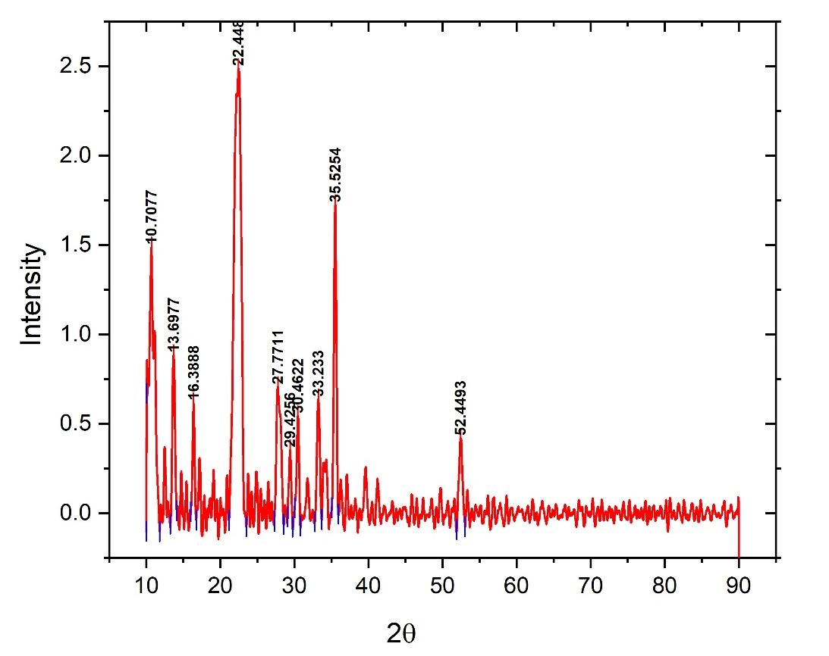
Fig.2 XRD of Copper Soap

3.3.1 Calculation of percentage Crystallinity from XRD Data
% Crystallinity = Area under the crystalline peaks x 100
Total Area of crystalline + Amorphous peaks
Area under the crystalline peaks = 7.71513
Total Area of crystalline + Amorphous peaks = 15.36166
% Crystallinity = 7.71513/15.36166 x 100 = 50.22328
3.3.2 Calculation of Crystallite Particle Size by Scherrer Equation
Crystallite Size was calculated by using Scherrer Equation as follows
D = K.λ/β.cosθ
Where D= Crystallite Size in nanometer , λ= Wavelength of X- Ray used 0.15406 nm
K = Scherrer Constant (taken as 0.9),
β = FWHM (Full Width Half Maxima) in Radians, θ= Peak Positions from XRD in Radians

Table No.3 Calculation of Crystallite Particle Size by Scherrer Equation
S.No. | 2 θ  (in radians) | θ (in radians) | FWHM | Crystallite size (in nm)
1 | 10.72571 | 5.362855 | 1.03933 | 7.610205614
2 | 13.70588 | 6.85294 | 0.41372 | 19.06490497
3 | 22.3352 | 11.1676 | 1.04157 | 7.482802493
4 | 27.88837 | 13.94419 | 0.64052 | 12.03737314
5 | 33.2445 | 16.62225 | 0.4403 | 17.28891565
6 | 35.50812 | 17.75406 | 0.44117 | 17.14970612
7 | 30.45862 | 15.22931 | 0.37579 | 20.39783764
8 | 52.45225 | 26.22613 | 0.46498 | 15.32642218
Average Crystallite Size = 14.5447 nm

Based on FTIR studies and XRD analysis, the proposed structure for the synthesized copper soap(Norazzizi Nordin et al 2015) is as follows:

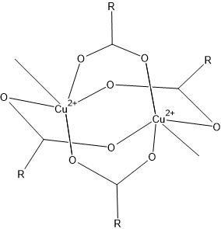

Fig.3 Proposed structure of copper carboxylate (Paddle wheel Dimer structure)
3.4 Antimicrobial activity of cottonseed oil and metallic soaps on Plant Pathogens
Zinc soap forms a neutral suspension in water, but shows good solubility in Dimethyl Sulphoxide (DMSO), owing to its high spread-ability and diffusion capacity Zinc soaps exhibited remarkable antifungal activity in Phytophthora (Zone of inhibition of 7-12 mm@ dilution of 1-5 % w/v), Fusarium (Zone of inhibition of 7-13 mm@ dilution of 1-5 % w/v) (fig.4) and antibacterial activity in Erwinia (Zone of inhibition of 7-12 mm@ dilution of 1-5 % w/v) (fig.5) TABLE No.4-6 .Except for the Phytophthora (Zone of inhibition of 8-14 mm@ dilution of 1-5 % w/v) copper soap was not able to generate any antimicrobial activity in agar medium. Copper soap has very limited solubility in aprotic polar solvent like DMSO and tends to precipitate out at room temperature. Pure cottonseed Oil has antimicrobial effect in Clavibacter ( 5-7 mm @ dilution of 2-5 % w/v) however, there was no zone of inhibition in case of solid soaps TABLE No.7. Clavibacter is a gram-positive bacteria having a thick peptidoglycan layer in its outermost part of cell wall due to which it is difficult for solute particles of metallic soap to enter the bacterial cell. Moreover, negatively charged techoic acid neutralizes the positively charged metal ion trapping them inside the peptidoglycan due to which metal ions in soaps have limited access to the cell membrane. Solubility in the solvent medium has a prominent effect on the biological activity of the sample because more soluble salts tend to bind easily with the cell wall/plasma membrane of microorganisms. As soaps are known to form colloidal solutions, the soap sample acts as the dispersed phase and the solvent as the dispersion medium. These soap molecules form micellar aggregates and bind to the microorganisms. Long fatty acid chains are attracted towards lipids of the cell membrane and hence can cross the biological barrier, releasing metal ions inside the microbe. Accumulation of metal ions like copper/zinc generates radicals like peroxides or Reactive Oxygen Species (ROS), which attack essential proteins and cell organelles like ribosomes, mitochondria etc. This ultimately leads to the disruption of living cells exhibiting antimicrobial effects.

TABLE No.4 Results of in vitro antimicrobial activity (sensitivity or MIC) of the test sample at 4 different concentrations against ATCC bacterial culture P. infestense (ATCC-4127)
S.N. | Sample Code | Antimicrobial Efficacy as Zone of Inhibition (in mm) at different sample concentrations
S.N. | Sample Code | 5% | 2% | 1% | 0.5%
1. | Cottonseed oil | 14 mm | 10 mm | 8 mm | nil
2. | Copper based | 14 mm | 11 mm | 8 mm | nil
3. | Sodium based | 10 mm | 7 mm | nil | nil
4. | Zinc Based | 12 mm | 10 mm | 7 mm | nil

TABLE No.5 Results of in vitro antimicrobial activity (sensitivity or MIC) of the test sample at 4 different concentrations against ATCC fungi culture F. solani (ATCC-14523)
S.N. | Sample Code | Antimicrobial Efficacy as Zone of Inhibition (in mm) at different sample concentrations
S.N. | Sample Code | 5% | 2% | 1% | 0.5%
1. | Cottonseed oil | 8 mm | nil | nil | nil
2. | Copper based | nil | nil | nil | nil
3. | Sodium based | 7 mm | nil | nil | nil
4. | Zinc Based | 13 mm | 10 mm | 7 mm | nil

Table No.6 Results of in vitro antimicrobial activity (sensitivity or MIC) of the test sample at 4 different concentrations against E.amylovora (ATCC-49946)

S.N. | Sample Code | Antimicrobial Efficacy as Zone of Inhibition (in mm) at different sample concentrations
S.N. | Sample Code | 5% | 2% | 1% | 0.5%
1. | Cottonseed oil | nil | nil | nil | nil
2. | Copper based | Nil | nil | nil | nil
3. | Sodium based | nil | nil | nil | nil
4. | Zinc Based | 12 mm | 8 mm | nil | nil

Table No.7 Results of in vitro antimicrobial activity (sensitivity or MIC) of the test sample at 4 different concentrations against C. michiganesis (ATCC-10202)
S.N. | Sample Code | Antimicrobial Efficacy as Zone of Inhibition (in mm) at different sample concentrations
S.N. | Sample Code | 5% | 2% | 1% | 0.5%
1. | Cottonseed Oil | 7 mm | 5 mm | nil | nil
2. | Copper based | nil | nil | nil | nil
3. | Sodium based | nil | nil | nil | nil
4. | Zinc Based | nil | nil | nil | nil

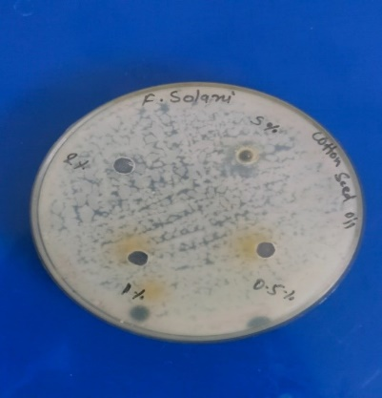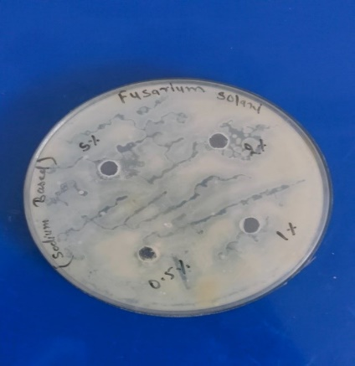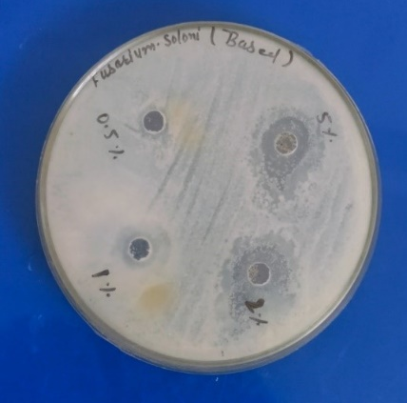
(a) (b) (c)

Fig.4 Antifungal activity on Fusarium solani (a) CottonSeed Oil (b) Sodium Soap (c) Zinc Soap

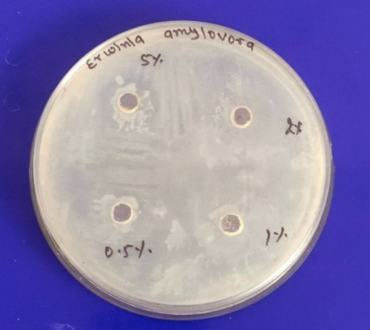

Fig.5 Antibacterial activity of Zinc Soap on Erwinia Amylovora

4. Conclusion

Sodium, copper and zinc based soaps prepared from unrefined cottonseed oil have prominent antimicrobial activity on plant pathogen such as Phytophthora and Fusarium. Sodium soaps are water-soluble, less toxic and economical alternatives that are eco-friendly in nature. Zinc soaps showed good antimicrobial activity on all microbes except Clavibacter. These soaps are biodegradable in nature, as few bacteria are prone to consume long-chain fatty acids as a substrate over a period of time; hence, fungicides derived from metallic soaps have less chances of bio-accumulation and further study of the toxicity of these soap materials could help in developing sustainable alternatives of pesticides/fungicides that are harmful to environment.
Disclaimer (Artificial intelligence)
Author(s) hereby declare that NO generative AI technologies such as Large Language Models (ChatGPT, COPILOT, etc.) and text-to-image generators have been used during the writing or editing of this manuscript.

References

- Ibanga O. Isaac, O. D. E.,(2013). Fatty Acid Composition of Cottonseed Oil and its Application in Production and Evaluation of Biopolymers. American Journal of Polymer Science,3(2), 13-22. 10.5923/j.ajps.20130302.02
- Hassen et al, (2022). Physico-chemical and GC-MS Analysis of Gossypium hirsutum (Cotton Seed) Oil. Journal of Applied Life Sciences International, 25 (3), 25-39. 10.9734/JALSI/2022/v25i330293
- Remadevi, R.; Gordon, S. (2022) Investigation of the Physiochemical Structure and UV Absorption Properties of Cottonseed Hull and Kernel. Modern Applied Science, 16 (3), 1-8 10.5539/mas.v16n3p1
- Sam, E. O. et al (2022). Extraction and Determination of Physiochemical Properties of Oil from Cotton Seed. International Journal of Engineering and Modern Technology (2024), 10 (10), 71-83. 10.56201/ijemt.v10.no10.2024.pg71.83
- Komarnytsky, J. G. (2025), Cottonseed oil composition and its application to skin health and personal care. Frontiers in Pharmacology 12. 10.3389/fphar.2025.1559139
- Iqbal, M.(2012), Late Blight of Potato p. 1.
- Maryam Rahimi Kakolaki, A. O.; Shekarforoush (2023) In vitro antifungal activity of barberry fruit extract (Berberis sp.) against Fusarium spp. Journal of horticulture and postharvest research 7, 47-60. 10.22077/jhpr.2023.6783.1333
- Kang, M.; Wu, Y.; Shi, Q.; Wang, Z.; Zhang, Y.; Chen, K.; Xu, X.; Zhou, M.; Liang, Q.; Lu, X.,(2025), Antifungal susceptibility and clinical efficacy of chlorhexidine combined with topical ophthalmic medications against Fusarium species isolated from corneal samples. Frontiers in cellular and infection microbiology 15, 1532289. 10.3389/fcimb.2025.1532289
- Khaled H. Arafat; Shaheen A. Hanan; Rabab, A.-E.-A. M.,(2015). Antibacterial Activity Of Antagonistic Bacteria And Plant Extract On Erwinia amylovora, the Pathogen Of Fire Blight Disease In Egypt. International Journal of Phytopathology, 4 (2), 73-79.
- Schmidt, S. G.; Alstott, E. T.; Paulsen, A. A.; Slack, S. M.; Yuan, X. (2025). Identification of Streptomycin-Resistant Erwinia amylovora in Iowa. Plant disease 109 (1), 43-48. 10.1094/PDIS-06-24-1177-SC
- Oloyode A.R. et al,(2017).Antimicrobial Activities of Bio-Synthesized Silver Nanoparticles on Strains of Clavibacter Michiganensis subsp. michiganensis Journal of Science and Technology 37 (2), 1-10. http://dx.doi.org/10.4314/just.v37i2.1
- Atiq, M.,(2022). Determination of Antibacterial Potency of Different Chemicals Towards Bacterial Canker of Tomato Caused by Clavibacter michiganensis Subsp. Michiganensis. Agricultural Sciences Journal 4 (2), 63-73. 10.56520/asj.v4i2.186
- Javed Iqbal Mirza et al.,(2000) In Vitro Antifungal Activity of Neem Products Against Phytophthora infestans. Pakistan Journal of Biological Sciences 3 (5), 824-828.
- Rachel I. Ndala, E. R. M., Patrick A. Ndakidemi (2019). Different Plant Extracts against Phytophthora infestans (Mont.) de Bary in Tomato in Vitro. American Journal of Plant Sciences 10, 698-708.10.4236/ajps.2019.104050
- Dawen DE, A. C., Okechalu BO, Dapiya H and Kutshik RJ,(2023). In vitro and in vivo efficacy of plant extracts in the control of late blight disease of potato caused by Phytophthora infestans Mont. De Bary in Nigeria. International Journal of Plant Pathology and Microbiology 3 (2), 13-19.
- Sharma, S.; Roy, R.; Prasad, H.; Kumar, B.; Kumar, A.; Kumari, N.; Dobhal, S.; Kumar, R.,(2024) Phytochemical analysis and antifungal activity of Mentha against Phytophthora infestans. South African Journal of Botany 172, 501-514. 10.1016/j.sajb.2024.07.037
- Amal Hari et al., (2024). Chemical composition, antioxidant properties, and antifungal activity of wild Origanum elongatum extracts against Phytophthora infestans. Frontiers in Plant Science 1-13. 10.3389/fpls.2024.1278538
- Zhou, Q.; Wang, J.; Zhang, H.; Wang, X.; Mu, R.; Lan, Q.; Su, X.; Tian, Y. (2024). The Inhibitory Effects and Mechanisms of Carvacrol and Cinnamaldehyde Against Erwinia amylovora in Pears. Plant Pathology 74 (8), 2319-2334. 10.1111/ppa.70025
- Joseph, B. O.; Kazeem, A. A.; Labunmi, L., (2015) Synthesis and characterization of copper metal soaps from Thevetia peruviana and Hura crepitans seed oils. Scientific Research and Essays 10 (23), 649-654. 10.5897/sre2015.6216
- Charoen Nakason, Pornpot N., Azizon Kaesaman,(2025). Transforming waste cooking oil into zinc soap: a sustainable approach to multifunctional additives for enhancing natural rubber composites. Journal of Polymer Research 32 (176), 1-17. 10.1007/s10965-025-04392-2
- Tarun, J.; Susan, J.; Suria, J.; Susan, V. J.; Criton, S.,(2014). Evaluation of pH of Bathing Soaps and Shampoos for Skin and Hair Care. Indian journal of dermatology 59 (5), 442-446. 10.4103/0019-5154.139861
- G H Jeffery, J. B., J Mendham, R. C. Denney (1989) Vogel's Textbook of Quantitative Chemical Analysis. 5th ed.; Longman Scientific & Technical: United Kingdom, p. 906.
- Juzer Ali Rangwala, G. S. (2014). Synthesis of Medicinal Soap from Non-Edible (Jatropha Oil) and Study of its Quality Parameters including Antimicrobial Activity. Research Journal of Chemical Sciences 4 (4), 58-62.
- Shah, S. N.,(2017). FTIR characterization and physicochemical evaluation of cottonseed oil. Pakistan Journal of Analytical & Environmental Chemistry 18 (1), 46-53. 10.21743/pjaec/2017.06.04
- Corbeil M-C, R. L. (2002). X-ray powder diffraction data for selected metal soaps. Powder Diffraction 17 (1), 52-60. https://doi.org/10.1154/1.1431950
- Shema Khan, R. S. (2017). Antifungal Activities of Copper Surfactants Derived from Neem (Azadirachta indica) and Karanj (Pongamia pinnata) Oils: A Pharmaceutical Application. Global Journal of Pharmacy & Pharmaceutical Sciences 3 (4), 01-06.
- Jain, S.; Sharma, R.; Sharma, A. K (2020). Solid State Kinetics, Spectroscopic, Thermal Degradation and Fungicidal Studies of Biodegradable Copper Surfactants Derived from Lauric Acid. Anti-Infective Agents 18 (1), 59-71. 10.2174/2211352517666190514074750
- Lavanya, K.; Jagathy, K.(2021).Antibacterial Effect of Biosynthesized Zinc Oxide Nanoparticles against Erwinia amylovora and Induction of Crop Growth. Journal of Pharmaceutical Research International 262-270. 10.9734/jpri/2021/v33i54A33745
- Kemp, W.(1991). Organic Spectroscopy. Third ed.; Red Globe Press London: New York, pp. XXII,393
- Robert M. Silverstein, F. X. W., David J.Kiemle, Infrared Spectroscopy.(2005). In Spectrometric Identification of Organic Compounds, John Wiley & Sons: New York, pp 72-108.
- Adeyemi, A. F. (2022). Evaluation of Sodium and Potassium Soaps Prepared from Beeswax: Adding Value to Material. International Journal of Chemistry and Materials Research 10 (1), 1-10. 10.18488/64.v10i1.3076
- Nordin, N.; Samad, W. Z.; Liew, K. H.; Yarmo, M. A.; Yusop, M. R.; Othman, M. R. (2015) X-Ray Diffraction, Spectroscopic and Morphological Studies of Electrochemically Synthesized Copper(II) Palmitate Complex. Advanced Materials Research 1087, 96-100. 10.4028/www.scientific.net/AMR.1087.96
- Qadir M.A., (2017). Copper(II) Carboxylate Containing Paddle Wheel Structure: Synthesis and Crystal Structure. Oriental Journal of Chemistry 33 (2), 968-970. 10.13005/ojc/330249
- Bivian-Castro, E. Y.; Flores-Alamo, M.; Escudero, R.; Gomez-Vidal, V.; Segoviano-Garfias, J. J. N.; Castaneda-Contreras, J.; Saavedra-Arroyo, Q. E. (2023) Synthesis and Characterization of a New Cu(II) Paddle-Wheel-like Complex with 4-Vinylbenzoate as an Inorganic Node for Metal-Organic Framework Material Design. Materials 16 (13).10.3390/ma16134866
- Hermans, J. J.; Keune, K.; van Loon, A.; Iedema, P. D. (2015). An infrared spectroscopic study of the nature of zinc carboxylates in oil paintings. Journal of Analytical Atomic Spectrometry 30 (7), 1600-1608. 10.1039/c5ja00120j
- Russo, S.; Brambilla, L.; Thomas, J. B.; Joseph, E. (2023). But aren’t all soaps metal soaps? A review of applications, physico-chemical properties of metal soaps and their occurrence in cultural heritage studies. Heritage Science 11 (1). 10.1186/s40494-023-00988-3
- Yetgin, S.; Egbuchunam, T. O.; Okieimen, F.; GÖKkuŞ, K.; GÜNey, K. (2023). Characterization of Divalent Metal Soaps of Cannabis Sativa Seed Oil. Gazi University Journal of Science 36 (3), 1292-1300. 10.35378/gujs.979962
- Norazzizi Nordin, W. Z. S., Muhammad Rahimi Yusop, Mohamed Rozali Othman (2015) Synthesis And Characterization Of Copper(II) Carboxylate With Palm-Based Oleic Acid By Electrochemical Technique. Malaysian Journal of Analytical Sciences 19 (1), 236-243.

