Synthesis, Characterization and Molecular Docking Study of Erlotinib Linked 1,2,3-Triazole Derivatives

Abstract
A novel series of Erlotinib-linked 1,2,3-triazole derivatives 4(a–g) was designed and synthesized via Cu(I)-catalyzed azide–alkyne cycloaddition (click chemistry). The synthesized compounds were structurally confirmed using ¹H and ¹³C NMR spectroscopy. Considering the pharmacological relevance of triazole scaffolds, molecular docking studies were performed against the mycobacterial enoyl-acyl carrier protein reductase (InhA, PDB ID: 4TZK), a validated target for antitubercular drug discovery. All compounds exhibited favorable binding affinities, supported by key hydrogen bonding and hydrophobic interactions within the active site. Furthermore, 100 ns molecular dynamics (MD) simulations demonstrated the stability of protein–ligand complexes, as evidenced by RMSD, RMSF, and interaction analyses. The results suggest that these hybrids represent promising scaffolds for further antitubercular optimization.
Keywords: Erlotinib; 1,2,3-Triazole; Click Chemistry; Molecular Docking; InhA; Molecular Dynamics

GRAPHICAL ABSTRACT

Introduction
Infectious diseases remain a major global health challenge, driven by a wide range of pathogenic microorganisms, including bacteria, fungi, and viruses. Among these, tuberculosis (TB), caused by Mycobacterium tuberculosis, continues to be a leading cause of morbidity and mortality worldwide [1]. According to the World Health Organization TB report, approximately 1.23 million deaths were attributed to TB in 2024, including 150,000 among individuals with HIV [2]. TB remains the leading cause of death from a single infectious agent and is among the top ten causes of death globally. In the same year, an estimated 10.7 million people developed TB, comprising 5.8 million men, 3.7 million women, and 1.2 million children. Despite its global presence across all age groups, multidrug-resistant TB (MDR-TB) continues to pose a serious public health and health security threat, with only about 40% of affected individuals receiving appropriate treatment.
Nitrogen-containing heterocycles, particularly azoles, represent an important class of compounds exhibiting diverse biological activities, including antifungal, antibacterial, antimalarial, anti-inflammatory, and antitubercular effects [3,4]. Recent studies, such as those by Wang et al., have highlighted triazine–triazole derivatives as promising α-glucosidase inhibitors [5]. Additionally, N-phenylacetamide and phenoxy acid derivatives have been reported to exhibit a wide spectrum of pharmacological activities, including anticancer [6], antiviral [7], antitubercular [8], anti-inflammatory [9], hypoglycaemic [10], antibacterial [11], antioxidant [12], and multidrug resistance-reversing properties. Similarly, Bali et al. described acetophenone-based piperazine derivatives as potential antipsychotic agents [13].
Collectively, these findings suggest that structural motifs such as acetylphenoxymethyl, triazole, and N-phenylacetamide frameworks possess significant pharmacological potential [14]. In continuation of our ongoing efforts toward the synthesis of biologically active molecules [15], we report herein the design and synthesis of novel Erlotinib-linked 1,2,3-triazole derivatives. Furthermore, molecular docking studies were performed to evaluate their interaction with the bacterial enzyme enoyl-acyl carrier protein reductase (InhA), a key target in antitubercular drug development.

2. Materials and Methods
- Chemistry
For the synthesis of the title compounds, we have used purchased Erlotinib Hydrochloride (1). The diazotization of substituted anilines 1(a-g) followed by reaction with sodium azide gives the corresponding substituted azidobenzenes 2(a-g) with great yields (Scheme 1). The click reaction of Erlotinib Hydrochloride alkyne (1) and substituted azidobenzenes 2(a-g) synthesized by in presence of CuSO₄.5H₂O and sodium ascorbate in THF and water was performed to furnish corresponding triazole derivatives 4(a-g) in good yields as depicted in Scheme 2. The structures of all target compounds were confirmed by nuclear magnetic resonance (¹H NMR and ¹³C NMR).

Scheme-1: Synthesis of Substituted azidobenzenes Scheme 2: Synthesis of Erlotinib Linked 1,2,3-Triazole Derivatives

Entry | Triazole derivatives | Yield  (%)ª | M. P. (ºC)
4a |  | 87 | 97-100
4b |  | 90 | 84-87
4c |  | 85 | 88-90
4d |  | 82 | 130-133
4e |  | 83 | 91-96
4f |  | 90 | 105-107
4g |  | 90 | 86-88
Table 1. Physical properties of Erlotinib linked 1,2,3-triazole derivatives

2. General procedure for synthesis of 6,7-bis(2-methoxyethoxy)-N-(3-(1-phenyl-1H-1,2,3-triazol-4-yl)phenyl)quinazolin-4-amine derivatives

Erlotinib hydrochloride alkyne (1, 10 mmol) and substituted azidobenzenes 2(a–g, 10 mmol) were dissolved in a mixture of THF and water. To this reaction mixture, CuSO₄·5H₂O and sodium ascorbate were added as the catalytic system, and the reaction was stirred at room temperature. The progress of the reaction was monitored by thin-layer chromatography (TLC).

Upon completion, the solvent was removed under reduced pressure. The resulting residue was poured into crushed ice, leading to the formation of a solid precipitate. The solid was filtered, washed thoroughly with water, and dried. The crude products were further purified by recrystallization from ethanol to afford the corresponding 1,2,3-triazole derivatives 4(a–g) in good yields (82–90%).

3. Spectral Data
6,7-bis(2-methoxyethoxy)-N-(3-(1-(3-nitrophenyl)-1H-1,2,3-triazol-4-yl)phenyl) quinazolin-4-amine (4a) : ¹H NMR (600 MHz, DMSO-d₆): δ 9.54 (s, 1H), 9.50 (s, 1H), 8.73 (t, J = 2.1 Hz, 1H), 8.40 (d, J = 12.4 Hz, 2H), 8.31 (s, 1H), 8.27 (d, J = 7.5 Hz, 1H), 7.89 – 7.84 (m, 3H), 7.59 (d, J = 7.8 Hz, 1H), 7.45 (t, J = 7.9 Hz, 1H), 7.15 (s, 1H), 4.22 (d, J = 25.9 Hz, 4H), 3.69 (d, J = 36.0 Hz, 4H), 3.29 (s, 3H), 3.27 (s, 3H); ¹³C NMR (150Hz, DMSO-d₆): 156.85, 154.08, 153.39, 149.05, 148.58, 147.44, 140.66, 137.69, 132.08, 130.63, 129.67, 126.39, 123.60, 122.91, 121.02, 120.60, 119.54, 115.07, 109.42, 108.65, 103.66, 70.60, 70.53, 68.83, 68.51, 58.87, 58.82.
N-(3-(1-(2-fluorophenyl)-1H-1,2,3-triazol-4-yl)phenyl)-6,7-bis(2-methoxyethoxy) quinazolin-4-amine (4b) : ¹H NMR (600 MHz, DMSO-d₆): δ 9.52 (s, 1H), 9.01 (s, 1H), 8.41 (s, 1H), 8.29 (s, 1H), 7.94 – 7.76 (m, 3H), 7.63 – 7.49 (m, 3H), 7.46 – 7.36 (m, 2H), 7.15 (s, 1H), 4.27 – 4.18 (m, 4H), 3.73 – 3.64 (m, 4H), 3.29 (s, 3H), 3.27 (s, 3H); ¹³C NMR (150Hz, DMSO-d₆): 156.84, 155.21, 154.09, 153.40, 148.56, 147.39, 140.63, 131.87, 130.75, 129.60, 126.55, 126.07, 123.39, 122.73, 121.07, 119.47, 117.74, 117.61, 109.45, 108.68, 103.70, 70.60, 70.53, 68.84, 68.50, 58.87, 58.81.
N-(3-(1-(4-fluorophenyl)-1H-1,2,3-triazol-4-yl)phenyl)-6,7-bis(2-methoxyethoxy )quinazolin-4-amine (4c) : ¹H NMR (600 MHz, DMSO-d₆): δ 9.63 (s, 1H), 9.22 (s, 1H), 8.47 (s, 1H), 8.28 (s, 1H), 8.04 – 7.76 (m, 4H), 7.77 (d, J = 7.6 Hz, 1H), 7.42 (dt, J = 12.5, 8.3 Hz, 3H), 7.16 (s, 1H), 4.31 – 4.15 (m, 4H), 3.75 – 3.62 (m, 4H), 3.29 (s, 3H), 3.27 (s, 3H); ¹³C NMR (150 Hz, DMSO-d₆): 162.97, 161.34, 156.97, 156.95, 154.20, 153.10, 148.66, 147.79, 140.46, 133.70, 130.94, 129.62, 122.87, 122.81, 120.44, 119.60, 117.35, 117.19, 108.31, 103.78, 70.58, 70.52, 68.86, 68.56, 58.88, 58.82.
N-(3-(1-(2-chlorophenyl)-1H-1,2,3-triazol-4-yl)phenyl)-6,7-bis(2-methoxyethoxy )quinazolin-4-amine (4d) : ¹H NMR (600 MHz, DMSO-d₆): δ 9.52 (s, 1H), 8.98 (s, 1H), 8.41 (s, 1H), 8.30 (s, 1H), 7.84 (d, J = 10.6 Hz, 2H), 7.75 – 7.69 (m, 2H), 7.60 – 7.51 (m, 3H), 7.42 (t, J = 7.9 Hz, 1H), 7.15 (s, 1H), 4.26 – 4.17 (m, 4H), 3.74 – 3.64 (m, 4H), 3.29 (s, 3H), 3.27 (s, 3H); ¹³C NMR (150Hz, DMSO-d₆): 156.85, 154.08, 153.39, 148.57, 147.43, 146.98, 140.63, 135.02, 131.07, 130.88, 129.60, 129.12, 129.00, 128.95, 124.18, 122.66, 121.03, 119.47, 109.43, 108.65, 103.71, 70.60, 70.53, 68.84, 68.51, 58.87, 58.82.
N-(3-(1-(2-bromophenyl)-1H-1,2,3-triazol-4-yl)phenyl)-6,7-bis(2-methoxyethoxy) quinazolin-4-amine (4e) : ¹H NMR (600 MHz, DMSO-d₆): δ 9.53 (s, 1H), 8.95 (s, 1H), 8.41 (s, 1H), 8.30 (s, 1H), 7.90 – 7.79 (m, 3H), 7.67 (dd, J = 7.8, 1.5 Hz, 1H), 7.57 (t, J = 7.7 Hz, 2H), 7.50 (t, J = 8.6 Hz, 1H), 7.42 (t, J = 7.9 Hz, 1H), 7.15 (s, 1H), 4.25 – 4.17 (m, 4H), 3.73 – 3.65 (m, 4H), 3.29 (s, 3H), 3.27 (s, 3H); ¹³C NMR (150Hz, DMSO-d₆): 156.86, 154.09, 153.38, 148.57, 147.39, 146.91, 140.62, 136.71, 134.13, 132.57, 130.93, 129.60, 129.48, 129.23, 124.19, 122.63, 121.01, 119.46, 109.43, 108.63, 103.71, 99.99, 70.60, 70.53, 68.84, 68.51, 58.87, 58.82.
N-(3-(1-(4-bromophenyl)-1H-1,2,3-triazol-4-yl)phenyl)-6,7-bis(2-methoxyethoxy) quinazolin-4-amine (4f) : ¹H NMR (600 MHz, DMSO-d₆): δ 9.53 (s, 1H), 9.27 (s, 1H), 8.41 (s, 1H), 8.28 (s, 1H), 7.86 (dd, J = 16.5, 7.6 Hz, 4H), 7.76 (d, J = 8.8 Hz, 2H), 7.56 (d, J = 7.6 Hz, 1H), 7.43 (t, J = 7.9 Hz, 1H), 7.15 (s, 1H), 4.22 (d, J = 24.8 Hz, 4H), 3.69 (d, J = 34.8 Hz, 4H), 3.29 (s, 3H), 3.27 (s, 3H); ¹³C NMR (150Hz, DMSO-d₆): 156.85, 154.08, 153.39, 148.57, 147.96, 147.43, 140.62, 136.31, 133.31, 130.81, 129.61, 122.78, 122.37, 121.81, 121.00, 120.18, 119.47, 109.42, 108.65, 103.67, 70.59, 70.53, 68.83, 68.50, 58.87, 58.81.
6,7-bis(2-methoxyethoxy)-N-(3-(1-(2-methoxyphenyl)-1H-1,2,3-triazol-4-yl)phenyl) quinazolin-4-amine (4g) : ¹H NMR (600 MHz, DMSO-d₆): δ 9.52 (s, 1H), 8.84 (s, 1H), 8.40 (s, 1H), 8.26 (s, 1H), 7.88 – 7.81 (m, 2H), 7.59 (dd, J = 21.0, 7.7 Hz, 2H), 7.48 (t, J = 7.9 Hz, 1H), 7.49 (t, J = 7.9 Hz, 1H), 7.26 (d, J = 8.2 Hz, 1H), 7.15 (s, 1H), 7.09 (t, J = 7.6 Hz, 1H), 4.22 (d, J = 25.5 Hz, 4H), 3.89 (s, 3H), 3.69 (d, J = 34.6 Hz, 4H), 3.29 (s, 3H), 3.27 (s, 3H); ¹³C NMR (150Hz, DMSO-d₆): 156.87, 154.07, 153.40, 152.31, 148.55, 147.44, 146.66, 140.56, 131.38, 131.20, 129.51, 126.42, 126.20, 123.93, 122.53, 121.35, 121.03, 119.42, 113.48, 109.44, 108.66, 103.72, 68.83, 68.50, 58.87, 58.51, 56.64.

4. Computational Study
4.1 Molecular Docking Study
Structure-based drug discovery benefits greatly from the use of molecular docking simulation. It makes it possible to study how the chemical derivatives interact with the target protein binding site. [16,17] The ability of multidrug-resistant (MDR) bacteria to withstand several drugs makes them a serious hazard to public health. Two primary mechanisms are responsible for this resistance: efflux pumps and enzymatic modification of target proteins. Membrane proteins called efflux pumps actively move antibiotics out of bacterial cells, lowering the drug's intracellular concentration and potency. Bacteria possess the ability to expel a wide range of therapeutic agents through efflux mechanisms, thereby reducing their susceptibility to antimicrobial treatment. Conversely, the modification or suppression of specific enzymes can diminish resistance to antibiotics such as fluoroquinolones. Furthermore, mutations in genes encoding target proteins may enhance resistance by inducing structural alterations that hinder effective antibiotic binding [18]. The molecular docking study was conducted using the Glide program (Grid-Based Ligand Docking with Energetics; Schrödinger, LLC, New York, NY, USA, 2018). The three-dimensional crystal structure of mycobacterial enoyl-acyl carrier protein reductase (InhA) complexed with its inhibitor (PDB code: 4TZK) was retrieved from the RCSB Protein Data Bank and subsequently refined using the Protein Preparation Wizard. The refinement process involved correction of experimental inaccuracies, including the removal of crystallographically resolved water molecules that were not conserved in ligand interactions, addition of missing hydrogen atoms and side chains, assignment of atom types and force field charges using OPLS-2005, creation of disulphide bonds, identification of atom and residue overlaps, and energy minimisation of the prepared structure until the average root mean square deviation (RMSD) of non-hydrogen atoms converged to 0.3 Å.
Subsequently, the active-site geometry and physicochemical properties required for docking were defined using the receptor grid generation panel. Residues located within a 10.0 Å radius of the co-crystallised ligand were selected, and a grid box of dimensions 10 × 10 × 10 Å was generated around the centroid of the native ligand. The two-dimensional ligand structures were sketched using the build panel in Maestro and converted into energy-minimised three-dimensional conformations using the ligand preparation module. This optimisation procedure included assignment of appropriate protonation states and atom types, calculation of partial atomic charges according to the OPLS-2005 force field, and final energy minimisation until the average RMSD converged to 0.001 Å, thereby generating low-energy conformations suitable for docking studies. Flexible molecular docking was subsequently performed using the extra precision scoring function (GlideXP) to determine the binding orientations of the bioactive compounds and evaluate their binding affinities towards InhA. The resulting docking poses were analysed using the Pose Viewer utility within Maestro to identify the most significant thermodynamic interactions between the ligands and the active-site residues of the target enzyme.
Molecular docking study revealed that all the bioactive ERLOTINIB-1,2,3-trazole derivatives 4(a-g) could recognize the binding site of InhA and got deeply embedded in it engaging in a network of bonded and non-bonded interactions. They have produced an average docking score (Glide Score) of -2.93 with an average binding energy (Glide energy) of -44.57 kcal/mol signifying a promising binding affinity towards the target. Furthermore, to gain a more detailed insight into the most significant interactions guiding the ligand-receptor binding, a per-residue interaction analysis was performed between these molecules and the active site residues. The prepared protein structure revealed a well-defined active site comprising key residues such as SER13, ILE15, ILE16, THR17, ARG49, and HIS93. Docking results indicated that all synthesized compounds exhibited favorable binding within the active pocket, with an average Glide score of −2.93 and binding energy of −44.57 kcal/mol.
Key Interactions
- Hydrogen bonding: SER13, THR17, ARG49, HIS93
- Hydrophobic interactions: ILE15, ILE16, ILE50, VAL92
- Electrostatic interactions: ARG49 and HIS93
These interactions suggest strong ligand stabilization within the binding cavity. Notably, compound 4g exhibited the most favourable binding conformation, indicating its potential as a lead molecule.

Binding Site Identification
The prepared receptor structure obtained after protein preparation and active-site refinement revealed a well-defined binding pocket composed mainly of residues SER13, ILE15, ILE16, THR17, ARG49, ILE50, GLN30, VAL92 and HIS93 located within chain A of the protein. These residues form a compact hydrophobic and polar microenvironment suitable for ligand accommodation and stabilization. The presence of polar residues (SER, THR, ARG, GLN, HIS) together with hydrophobic residues (ILE, VAL, LEU) suggests that the binding pocket supports mixed hydrophobic–hydrogen bonding interactions, which is characteristic of kinase and receptor-binding domains
Ligand–Protein Interaction Analysis
Docking simulations revealed that the designed ligands occupied the active pocket deeply and adopted a stable conformation within the catalytic region. The binding orientation indicates that the triazole-linked scaffold fits well into the receptor cavity and interacts with key residues responsible for ligand recognition.
Hydrogen Bonding Interactions
Hydrogen bonding is a major stabilizing force in ligand binding. The docking pose indicates that ligands establish strong hydrogen bond interactions with the following residues:
- SER13 and THR17: These residues provide hydroxyl groups that act as hydrogen bond donors/acceptors, stabilizing the ligand near the entrance of the binding pocket.
- ARG49: The guanidinium side chain enables strong electrostatic and hydrogen bond interactions, anchoring the ligand firmly in the catalytic site.
- HIS93: The imidazole ring contributes to hydrogen bonding and π–interaction stabilization within the pocket. These interactions indicate strong ligand anchoring and contribute significantly to binding affinity.
Hydrophobic Interactions
Hydrophobic residues surrounding the ligand create a favorable non-polar environment that enhances van der Waals interactions: Key hydrophobic residues:
- ILE15 and ILE16
- ILE50
- VAL92
- LEU74 (near pocket region)
These residues form a hydrophobic cage that stabilizes the aromatic and aliphatic portions of the ligands. Hydrophobic interactions play a critical role in:
- Increasing ligand residence time
- Improving binding affinity
- Enhancing conformational stability
Electrostatic and π-Interactions
The presence of ARG49 and HIS93 suggests possible electrostatic and π–cation interactions between the ligand aromatic rings and charged residues. Such interactions are often associated with strong and selective receptor binding.
Binding Mode Interpretation
The docking results indicate a deep pocket binding mode, where:
- Polar pharmacophoric groups orient toward polar residues (SER, THR, ARG, HIS)
- Aromatic and hydrophobic moieties occupy the hydrophobic cavity (ILE, VAL, LEU)
This dual interaction pattern confirms the structure–activity compatibility of the designed triazole derivatives with the receptor binding site.
Implications for Biological Activity
The observed interaction pattern strongly supports the potential biological activity of the designed compounds:
- Stable hydrogen bonding → strong receptor affinity
- Hydrophobic pocket fitting → enhanced binding stability
- Electrostatic anchoring → improved selectivity
Such interaction profiles are typically associated with effective inhibition of receptor activity, suggesting that the synthesized derivatives may act as promising inhibitors

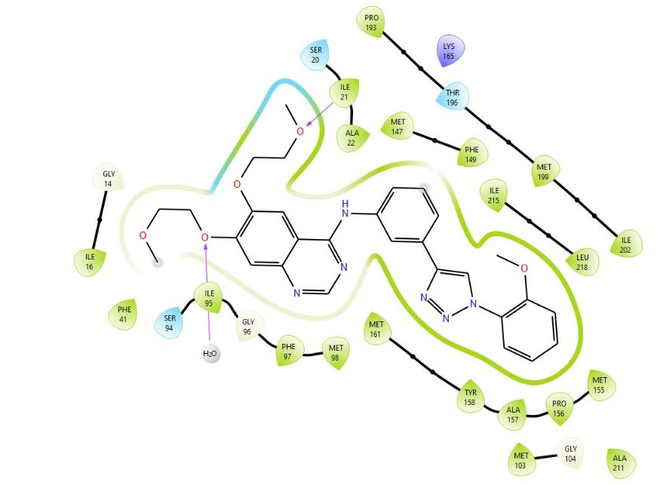

Figure 1. Binding pose of 4g into the active site of mycobacterial enoyl ACP reductase (InhA).
Conclusion of Docking Study The molecular docking investigation demonstrates that the binding designed ligands show favorable within the active site of the target protein. The interaction network involving hydrogen bonds, hydrophobic contacts, and electrostatic interactions indicates strong binding affinity and structural compatibility. Overall, the docking study supports the hypothesis that the synthesized triazole derivatives possess promising potential for further biological evaluation and drug development. The lowest energy docked conformation of 4g showed that the compound could snuggly fit into the active site of mycobacterial enoyl ACP reductase (InhA) with an excellent binding affinity (Glide score of -2.93 and Glide binding energy 44.57 kcal/mol) at the coordinates close to the native ligand engaging in a series of steric and electrostatic interactions (Fig. 1).

4.2 MD Simulation
A 100 ns molecular dynamics (MD) simulation was performed using the Desmond package to evaluate the structural stability and binding behaviour of the protein–ligand complex (PDB ID: 4TZK). The simulation was conducted under an NPT ensemble at 300 K. The solvated system contained: Total atoms: 19,261, Protein residues: 269 (Chain A), Ligand atoms: 70 (C₂₉H₃₀N₆O₅), Water molecules: 5,048, Neutralizing ions: Na⁺ (17), Cl⁻ (13), the ligand possesses 13 rotatable bonds, indicating moderate conformational flexibility that necessitates dynamic stability evaluation.
5.Result and Discussion
Protein Stability
The protein RMSD remained within the acceptable range (~1–3 Å), indicating, proper equilibration of the protein structure, absence of major conformational drift, and maintenance of the native fold throughout 100 ns. Stable RMSD convergence suggests the system reached equilibrium and the simulation duration was sufficient for reliable analysis. Ligand Stability in Binding Pocket

Ligand RMSD (Lig-fit-Prot)

Evaluates ligand movement relative to the protein backbone observation indicating, ligand RMSD remained comparable to protein RMSD. And no major deviation or drift from the binding site was observed that interprets, the ligand remained firmly anchored in the active site, indicating a stable binding mode throughout the trajectory.

Flexibility (Protein RMSF)

Root Mean Square Fluctuation (RMSF) identifies flexible and rigid regions of the protein. Indicates, higher fluctuations were observed in terminal regions (N- and C-termini)., secondary structure regions (α-helices and β-sheets) exhibited low fluctuation, and residues interacting with the ligand showed reduced flexibility. These observation indicating the ligand binding stabilized the binding pocket residues, indicating strong protein–ligand interactions.

Protein Secondary Structure Stability

The Secondary Structure Elements (SSE) during simulation shows distribution, α-helix: 29.62%, β-strand: 13.31% and the total SSE: 42.93%. The SSE distribution remained consistent during the simulation. These indicates No major unfolding or structural distortion occurred, confirming structural integrity of the protein under simulation conditions.

Ligand Flexibility Analysis (Ligand RMSF)
Ligand RMSF evaluates fluctuations of individual ligand atoms shows most ligand atoms exhibited low fluctuation and Higher fluctuations occurred in peripheral flexible fragments, that interpretate the core scaffold remained rigid and firmly bound., Flexible substituents adapted to the binding pocket environment and this behaviour is typical for ligands showing stable binding.
Protein–Ligand Interaction Analysis
Hydrogen Bonding

Hydrogen bonds were consistently maintained throughout the simulation. That signify Key determinant of binding specificity and Enhances ligand recognition and stability these shows Persistent hydrogen bonding indicates strong polar interactions within the binding pocket.

Hydrophobic Interaction
The ligand shows following interactions, π–π stacking, π–cation interactions and Non-specific hydrophobic contacts. These interactions contributed significantly to ligand stabilization by: Reducing solvent exposure and Enhancing binding affinity
Ionic Interactions
Ionic contacts between oppositely charged residues and ligand atoms were observed and suggest the long-range electrostatic stabilization and reinforcement of ligand anchoring
Water Bridge Interactions
Water-mediated hydrogen bonds were detected and suggest the stabilize ligand orientation and bridge gaps between ligand and protein residues. Water bridges often play a crucial role in drug binding and receptor recognition. Interaction Timeline Analysis, The interaction timeline revealed. Continuous contacts throughout 100 ns, Multiple residues interacting simultaneously, Persistent interaction network. That Interpretate the ligand maintained long-term interactions with key residues, confirming stable binding over the entire trajectory. Ligand Conformational Analysis (Torsion Profile) The torsion analysis of 13 rotatable bonds showed:
- Ligand adopted energetically favourable conformations
- No excessive torsional strain detected
- Stable conformational adaptation to the binding pocket
This confirms the ligand does not require high-energy conformations to remain bound.
Ligand Physicochemical Properties During Simulation
List 1 : Several ligand properties remained stable
Property | Significance
Radius of gyration | Maintained compactness
Intramolecular H-bonds | Internal stability
Molecular surface area | Structural consistency
SASA | Stable solvent exposure
PSA | Maintained polarity
These results indicate no unfolding or instability of the ligand during simulation.
Overall Interpretation
The 100 ns MD simulation demonstrates that: The protein structure remained stable., The ligand stayed firmly bound in the active site., Key interactions were maintained throughout the simulation., The ligand adopted energetically favorable conformations., No structural instability or dissociation was observed.

6.Conclusion
The MD simulation confirms that the studied ligand forms a stable and persistent complex with the target protein. The combination of hydrogen bonding, hydrophobic interactions, ionic contacts, and water bridges collectively stabilizes the complex. These findings strongly support the potential of the ligand as a promising candidate for further optimization and biological evaluation. The MD simulation confirms that the studied ligand forms a stable and persistent complex with the target protein. The combination of hydrogen bonding, hydrophobic interactions, ionic contacts, and water bridges collectively stabilizes the complex. These findings strongly support the potential of the ligand as a promising candidate for further optimization and biological evaluation.
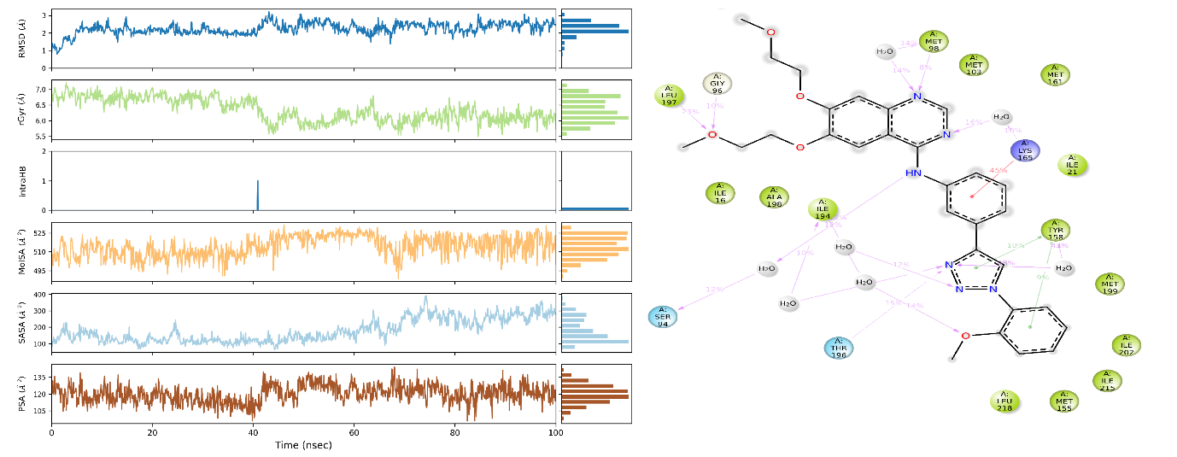
Figure- 2:- Ligand RMSF and Ligand-Protein Contacts

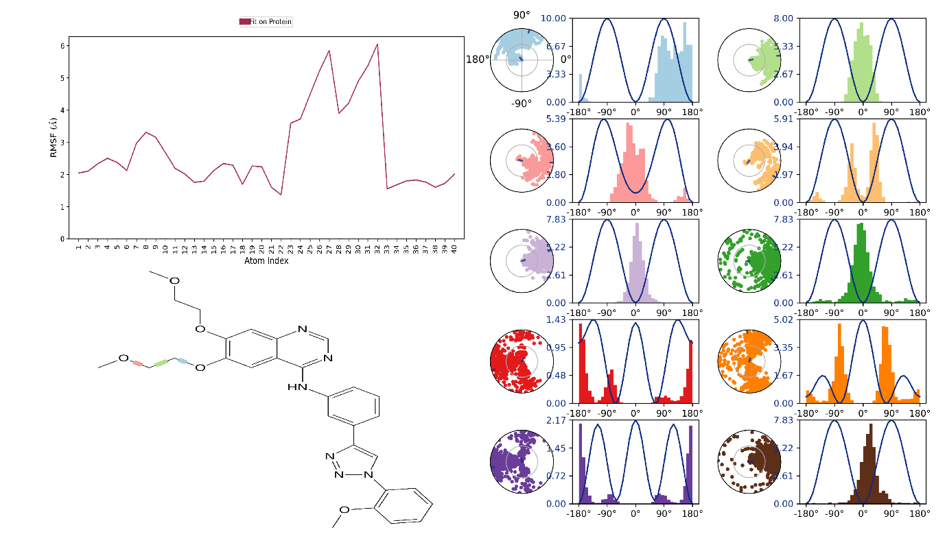
Fig-3:- Ligand Torsion Profile
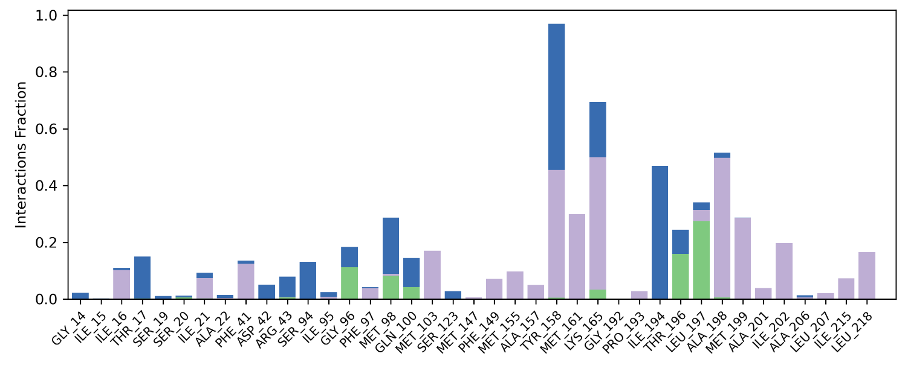

Fig-4:- Protein-Ligand interactions fraction

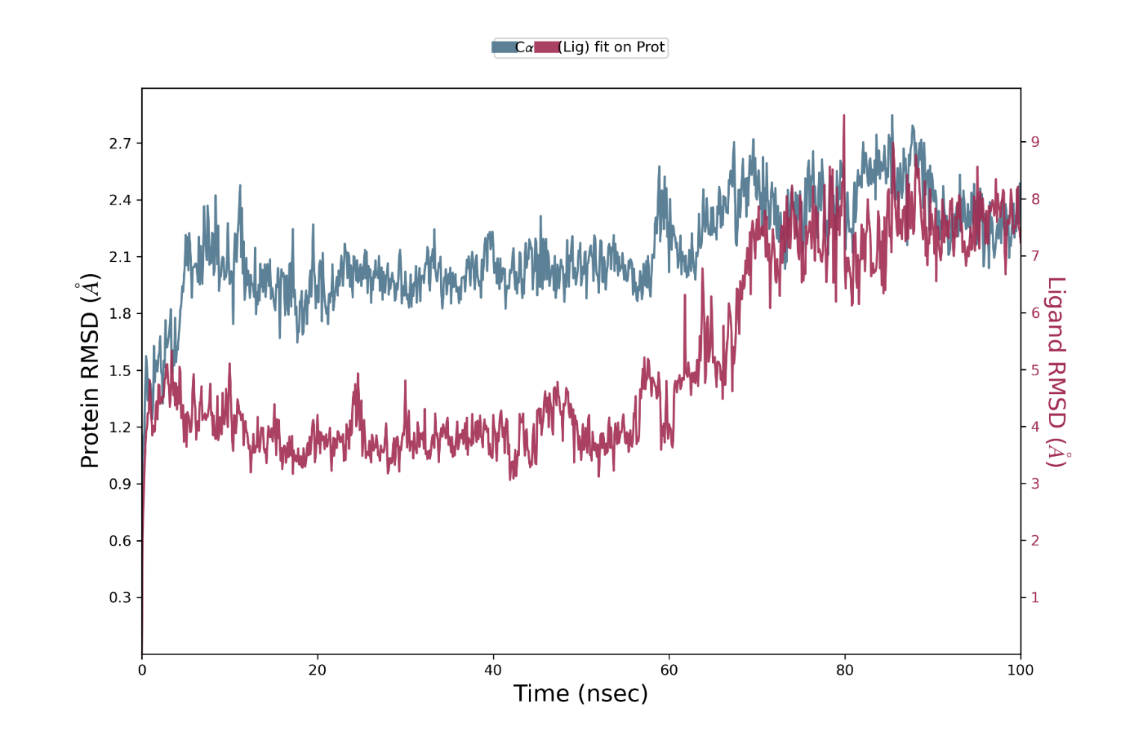
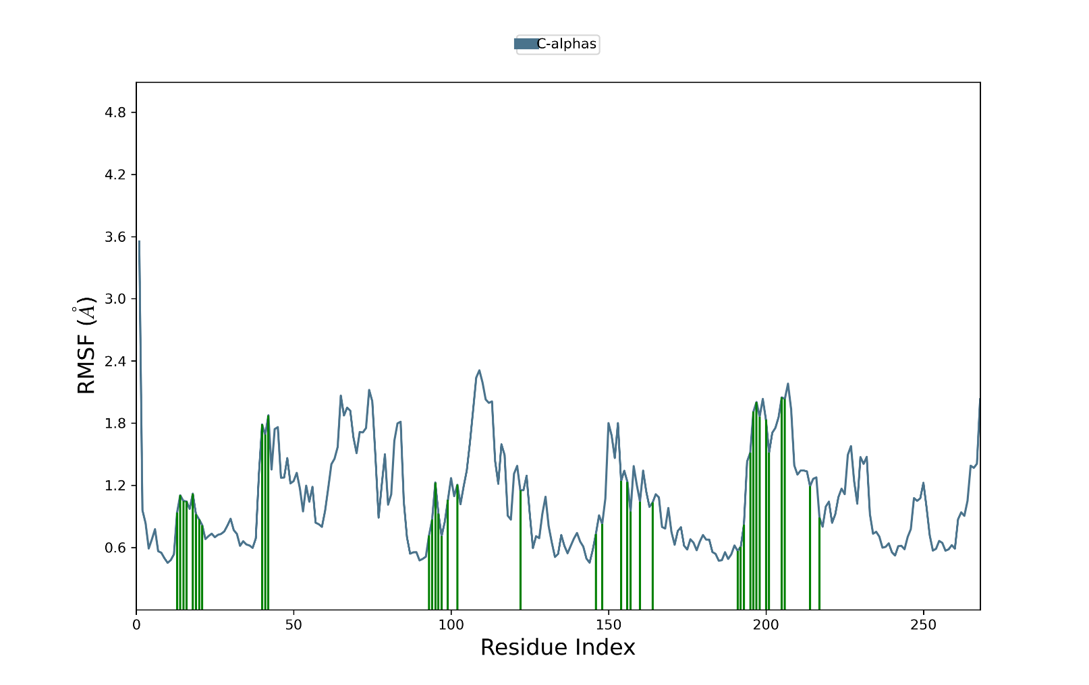
Fig-5:- Protein RMSF
Fig-6 Protein-Ligand Contact in respect to RMSD
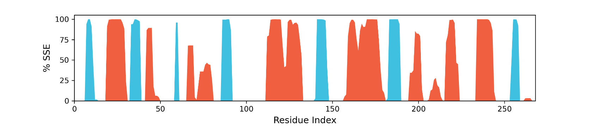
Fig-7: Protein Secondary Structure

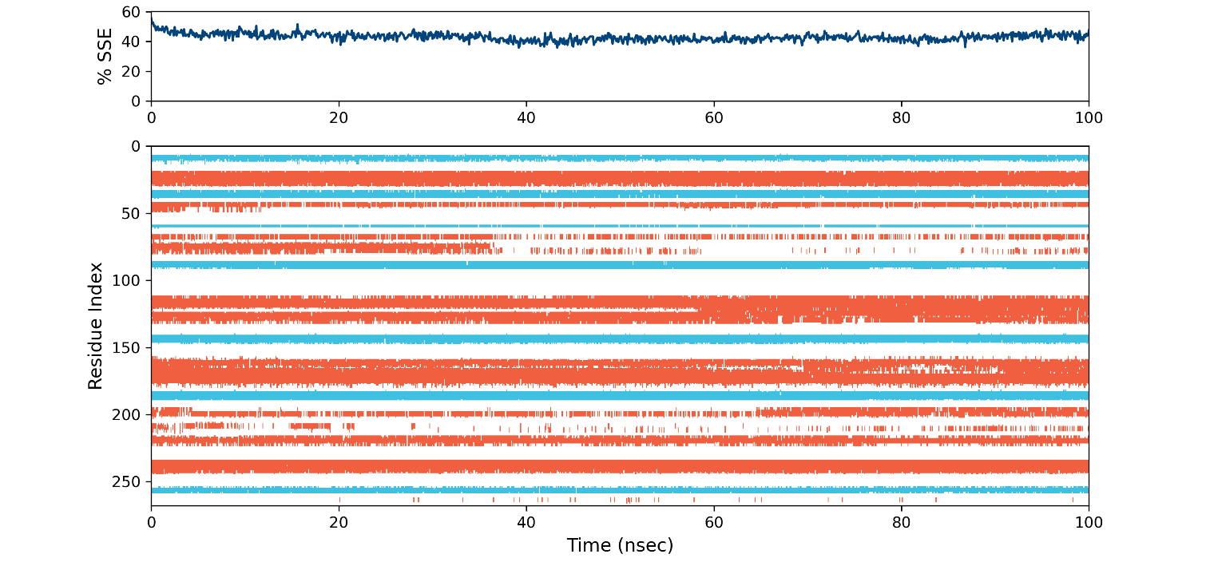

Fig-8: Protein-Ligand residue index

Disclaimer (Artificial intelligence)

Author(s) hereby declare that NO generative AI technologies such as Large Language Models (ChatGPT, COPILOT, etc.) and text-to-image generators have been used during the writing or editing of this manuscript.

Reference:
- (a)Ming‑Rui Sun MR, Jia‑Yin Xing JY, Xiao‑Tian Li XT, Ren Fang R, Yang Zhang Y, Zhao‑Li Li ZL, Ning‑Ning Song NN. Recent advances in research on Mycobacterium tuberculosis virulence factors and their role in pathogenesis. J Microbiol Immunol Infect. 2025, 58, 5, 497-507, (b)Singh P, Anand A, Kumar V. Recent developments in biological activities of chalcones: A mini review. European journal of medicinal chemistry. 2014;85:758-77.
- WHO Report on Tuberculosis 2025.
- (a) Xu C, Yang N, Yu H and Wang X. Synthesis of new triazole derivatives and their potential applications for removal of heavy metals from aqueous solution and antibacterial activities. Front. Chem. 12:1473097. 2024.1473097 (b) Phatak PS, Bakale RD, Dhumal ST, Dahiwade LK, Choudhari PB, Siva Krishna V, Sriram D, Haval KP. Synthesis, antitubercular evaluation and molecular docking studies of phthalimide bearing 1, 2, 3-triazoles. Synthetic communications. 2019;49(16):2017-28. (c) Muluk MB, Dhumal ST, Phatak PS, Rehman NN, Dixit PP, Choudhari PB, Mane RA, Haval KP. Synthesis, antimicrobial activity, and molecular docking study of formylnaphthalenyloxymethyl‐triazolyl‐N‐phenylacetamides. Journal of Heterocyclic Chemistry. 2019;56(9):2411-8. (d) Badar AD, Sulakhe SM, Muluk MB, Rehman NN, Dixit PP, Choudhari PB, Bondle GM, Haval KP. Synthesis, antimicrobial evaluation and Docking study of novel thiosemicarbazone clubbed with 1, 2, 3-triazoles. Current Bioactive Compounds. 2021;17(6):12-21. (e) Alam, M. M., Alsenani, N. I., Elhenawy, A. A., Hussien, R. A., Althagafi, S. H., Alqurashi, E. A., Nazreen, S. Unveiling the potential of zingerone-1,2,3-triazole derivatives as dual anticancer and COX-2 inhibitor: design, synthesis, and biological assessments. Future Medicinal Chemistry, 2026 1–16.
- (a) Raman APS, Aslam M, Awasthi A, Ansari A, Jain P, Lal K, Bahadur I, Singh P, Kumari K. An updated review on 1,2,3-/1,2,4-triazoles: synthesis and diverse range of biological potential. Mol Divers. 2025 29(1):899-964.(b)Patil PS, Kasare SL, Haval NB, Khedkar VM, Dixit PP, Rekha EM, Sriram D, Haval KP. Novel isoniazid embedded triazole derivatives: Synthesis, antitubercular and antimicrobial activity evaluation. Bioorganic & medicinal chemistry letters. 2020;30(19):127434. (c) Badar AD, Sulakhe SM, Muluk MB, Rehman NN, Dixit PP, Choudhari PB, Rekha EM, Sriram D, Haval KP. Synthesis of isoniazid‐1, 2, 3‐triazole conjugates: Antitubercular, antimicrobial evaluation and molecular docking study. Journal of Heterocyclic Chemistry. 2020;57(10):3544-57.
- (a) Soltaninejad A, Shirzad H, Panji M, Motevaseli E, Amin Mousavinezhad S, Kalbasi S, Benzimidazole-phenoxy-1,2,3-triazole-benzyl Derivatives as the New Potent α-glucosidase Inhibitors: Design, Synthesis, In Vitro, and In Silico Biological Evaluations, Current Organic Synthesis. 2025,22,6, e15701794335556. (b) Wang G, Peng Z, Wang J, Li X, Li J. Synthesis, in vitro evaluation and molecular docking studies of novel triazine-triazole derivatives as potential α-glucosidase inhibitors. European journal of medicinal chemistry. 2017;125:423-9.(c) Wang G, Peng Z, Wang J, Li J, Li X. Synthesis and biological evaluation of novel 2, 4, 5-triarylimidazole–1, 2, 3-triazole derivatives via click chemistry as α-glucosidase inhibitors. Bioorganic & medicinal chemistry letters. 2016;26(23):5719-23. (d) Ashwini N, Garg M, Mohan CD, Fuchs JE, Rangappa S, Anusha S, Swaroop TR, Rakesh KS, Kanojia D, Madan V, Bender A. Synthesis of 1, 2-benzisoxazole tethered 1, 2, 3-triazoles that exhibit anticancer activity in acute myeloid leukemia cell lines by inhibiting histone deacetylases, and inducing p 21 and tubulin acetylation. Bioorganic & medicinal chemistry. 2015 ;23(18):6157-65.
- (a) Pawar CD, Sarkate AP, Karnik KS, Shinde DB. Egyp J Bas App Sci 2017, 4, 310;(b) Kulabaş. (b) Kulabaş N, Tatar E, Özakpınar ÖB, Özsavcı D, Pannecouque C, De Clercq E, Küçükgüzel İ. Synthesis and antiproliferative evaluation of novel 2-(4H-1, 2, 4-triazole-3-ylthio) acetamide derivatives as inducers of apoptosis in cancer cells. European Journal of Medicinal Chemistry. 2016 ;121:58-70.
- Lima Filho ED, Mattos M, Chaves OA, de Freitas CS, de OL Desmarais M, Ribeiro RC, de Souza AS, Ferreira VF, Souza TM, da Silva FD. Antiviral profile of 4-Amino-1H-1, 2, 3-Triazole-1, 2-naphthoquinones as SARS-CoV-2 inhibitors: Synthesis, in vitro and in silico evaluation. Journal of Molecular Structure. 2026 Mar 17:145985
- (a) Narkedimilli VK, Allaka TR, Balli R, Bhoomandla S, Purumandla SR, Venkateswarlu K. Design, synthesis, in vitro and in silico studies of 1, 2, 3-triazole incorporated tetrazoles as potent antitubercular agents. Journal of Molecular Structure. 2025 Apr 15;1327:141242. (b) Emmadi NR, Bingi C, Kotapalli SS, Ummanni R, Nanubolu JB, Atmakur K. Synthesis and evaluation of novel fluorinated pyrazolo-1, 2, 3-triazole hybrids as antimycobacterial agents. Bioorganic & Medicinal Chemistry Letters. 2015;25(15):2918-22.
- (a) Kumar A, Alam MS, Hamid H, Chugh V, Tikla T, Kaul R, Dhulap A, Sharma SK. Design and synthesis of anti–inflammatory 1, 2, 3–triazolylpyrrolobenzodiazepinone derivatives and impact of molecular structure on COX–2 selective targeting. Journal of Molecular Structure. 2023 Jan 15;1272:134151. (b)Turan-Zitouni G, Yurttaş L, Kaplancıklı ZA, Can ÖD, Demir Özkay Ü. Synthesis and anti-nociceptive, anti-inflammatory activities of new aroyl propionic acid derivatives including N-acylhydrazone motif. Medicinal Chemistry Research. 2015;24(6):2406-16.
- Nikalje AP, Deshpande D, Une HD. Facile synthesis and in vivo hypoglycemic activity of novel 2, 4-thiazolidinedione derivatives. European Journal of Experimental Biology. 2012;2(2):343-53.
- (a) Neeraja P, Srinivas S, Mukkanti K, Dubey PK, Pal S. 1H-1, 2, 3-Triazolyl-substituted 1, 3, 4-oxadiazole derivatives containing structural features of ibuprofen/naproxen: Their synthesis and antibacterial evaluation. Bioorganic & Medicinal Chemistry Letters. 2016;26(21):5212-7. (b) Parikh K, Joshi D. Synthesis and evaluation of 2-(5-(aryl)-1, 3, 4-oxadiazol-2-ylthio)-N-(3-(trifluoromethyl) phenyl) acetamides and N-(4-chloro-3-fluorophenyl)-2-(5-(aryl)-1, 3, 4-oxadiazol-2-ylthio) acetamides as antimicrobial agents. Journal of Chemical Sciences. 2014;126(3):827-35. (c) Hou W, Zhang G, Luo Z, Li D, Ruan H, Ruan BH, Su L, Xu H. Identification of a diverse synthetic abietane diterpenoid library and insight into the structure-activity relationships for antibacterial activity. Bioorganic & Medicinal Chemistry Letters. 2017 ;27(24):5382-6. (d) Jyothi M, Khamees HA, Patil SM, Ramu R, Khanum SA. Microwave-assisted synthesis, characterization, docking studies and molecular dynamic of some novel phenyl thiazole analogs as xanthine oxidase inhibitor. Journal of the Iranian Chemical Society. 2022;19(9):3919-33.
- (a) Kumar R, Kaur M, Bahia MS, Silakari O. Synthesis, cytotoxic study and docking based multidrug resistance modulator potential analysis of 2-(9-oxoacridin-10 (9H)-yl)-N-phenyl acetamides. European Journal of Medicinal Chemistry. 2014;80:83-91. (b) Lee K, Roh SH, Xia Y, Kang KW. Synthesis and biological evaluation of phenoxy-N-phenylacetamide derivatives as novel P-glycoprotein inhibitors. Bulletin of the Korean Chemical Society. 2011;32(10):3666-74.
- Bali A, Sharma K, Bhalla A, Bala S, Reddy D, Singh A, Kumar A. Synthesis, evaluation and computational studies on a series of acetophenone based 1-(aryloxypropyl)-4-(chloroaryl) piperazines as potential atypical antipsychotics. European journal of medicinal chemistry. 2010 ;45(6):2656-62.
- (a) Dhumal ST, Deshmukh AR, Khillare LD, Arkile M, Sarkar D, Mane RA. Synthesis and antitubercular activity of new thiazolidinones with pyrazinyl and thiazolyl scaffolds. Journal of Heterocyclic Chemistry. 2017;54(1):125-30. (b) Dhumal ST, Deshmukh AR, Bhosle MR, Khedkar VM, Nawale LU, Sarkar D, Mane RA. Synthesis and antitubercular activity of new 1, 3, 4-oxadiazoles bearing pyridyl and thiazolyl scaffolds. Bioorganic & Medicinal Chemistry Letters. 2016 ;26(15):3646-51.(c) Tailor JH, Patel PC, Malik GM. Synthesis, characterization and antimicrobial activity of 2-(11-oxodibenzo [b, f][1, 4] thiazepin-10 (11H)-yl)-N (substituted phenyl) acetamide derivatives. Indian Journal of Chemistry-Section B Organic and Medicinal Chemistry. 2014;53:1263-8.
- (a) Haval KP, Argade NP. Synthesis of natural fimbrolides. Synthesis. 2007;2007(14):2198-202. (b) Haval KP, Argade NP. General strategy for the synthesis of natural and unnatural dialkylmaleic anhydrides. The Journal of Organic Chemistry. 2008;73(17):6936-8. (c) Deore PS, Haval KP, Gadre SR, Argade NP. A Concise account of the chemistry of valuable Alkyl (methyl) maleic anhydrides. Synthesis. 2014;46(20):2683-700. (d) Shinde NV, Dhake AS, Haval KP. Towards the first total synthesis and anticancer screening of polycarponin C: a cyclic octapeptide. Oriental Journal of Chemistry. 2016(1):515. (e) Shinde NV, Dhake AS, Haval KP. First total synthesis and biological screening of cyclic tetrapeptides from Onychocola sclerotica. Der Pharma Chemica. 2015;7(11):251-7.
- (a) Shaikh MH, Subhedar DD, Khedkar VM, Jha PC, Khan FA, Sangshetti JN, Shingate BB. 1, 2, 3-Triazole tethered acetophenones: Synthesis, bioevaluation and molecular docking study. Chinese Chemical Letters. 2016;27(7):1058-63. (b) Zou Y, Zhao Q, Liao J, Hu H, Yu S, Chai X, Xu M, Wu Q. New triazole derivatives as antifungal agents: Synthesis via click reaction, in vitro evaluation and molecular docking studies. Bioorganic & medicinal chemistry letters. 2012;22(8):2959-62.
- (a) Meng XY, Zhang HX, Mezei M, Cui M. Molecular docking: a powerful approach for structure-based drug discovery. Current computer-aided drug design. 2011;7(2):146-57. (b) Miao Z, Yaru Si, Meiting S, Haijie D, Hongzong Si, Integrative 3D-QSAR, network pharmacology, molecular docking and dynamics simulations reveal 1,2,3-triazole antimalarial leads. Available at SSRN: https://ssrn.com/abstract=5788979 or http://dx.doi.org/10.2139/ssrn.5788979
- Nikaido H. Multidrug resistance in bacteria. Annual review of biochemistry. 2009;78(1):119-129

