Effect of Lamivudine Administration on Serum Corticosterone Levels in Adult Male Wistar Rats

Abstract
Background: Lamivudine is a nucleoside reverse transcriptase inhibitor widely used in the management of Human Immunodeficiency Virus (HIV) infection and chronic Hepatitis B virus disease. Although considered relatively safe, accumulating evidence suggests that prolonged exposure to nucleoside analogues may induce mitochondrial dysfunction and oxidative stress, which could potentially affect endocrine regulation, particularly the hypothalamic–pituitary–adrenal (HPA) axis. Given the central role of glucocorticoids in metabolic homeostasis and stress adaptation, evaluating the effects of Lamivudine on adrenal function is of considerable importance. Objective: This study investigated the effect of graded doses of Lamivudine on serum corticosterone levels and adrenal gland histology in adult male Wistar rats. Methods: Sixteen adult male Wistar rats aged 8–10 weeks were randomly assigned into four groups (n = 4). Group A served as control and received distilled water, while Groups B, C, and D received Lamivudine at doses of 100 mg/kg, 200 mg/kg, and 400 mg/kg respectively for 30 consecutive days via oral gavage. Serum corticosterone levels were measured using enzyme-linked immunosorbent assay (ELISA). Adrenal glands were harvested for histological evaluation using hematoxylin and eosin staining. Data were analyzed using one-way analysis of variance (ANOVA) followed by least significant difference (LSD) post hoc test, with statistical significance set at p ≤ 0.05. Results: A mild dose-dependent increase in serum corticosterone levels was observed in Lamivudine-treated groups compared to control; however, these differences were not statistically significant (p ≥ 0.05). Histological examination revealed increased lipid accumulation within the zona fasciculata of treated groups, indicating enhanced steroidogenic activity. No evidence of cellular degeneration, necrosis, or architectural distortion was observed. Conclusion: Lamivudine administration may lead to mild activation of the HPA axis without causing significant endocrine disruption. The findings suggest that Lamivudine is relatively safe with respect to adrenal function, although subtle biochemical and histological changes indicate the possibility of subclinical effects that warrant further investigation, particularly in long-term exposure scenarios.

Keywords: Lamivudine, corticosterone, adrenal gland, oxidative stress, HPA axis, Wistar rats

Introduction
Antiretroviral therapy (ART) has revolutionized the management of Human Immunodeficiency Virus (HIV) infection and chronic Hepatitis B virus disease, transforming them from life-threatening conditions into manageable chronic illnesses^{¹,2}. The success of ART is largely attributed to combination therapy, which targets different stages of viral replication to suppress viral load effectively and prevent disease progression³. Among the various classes of antiretroviral agents, nucleoside reverse transcriptase inhibitors (NRTIs) remain a fundamental component of most first-line treatment regimens due to their efficacy, accessibility, and relatively favourable safety profile¹⁻³.
Lamivudine (3TC), a cytidine analogue, is one of the most widely prescribed NRTIs in both HIV and Hepatitis B virus management⁴. It functions by inhibiting the viral reverse transcriptase enzyme, leading to premature termination of viral DNA synthesis and suppression of viral replication⁵. Because of its low cost, oral bioavailability, and generally good tolerability, Lamivudine has been extensively used in long-term therapeutic protocols, often for extended periods in combination with other antiretroviral agents⁴.
Despite its clinical benefits, increasing attention has been directed toward the potential long-term toxicological effects of NRTIs, and one of the major concerns associated with this drug class is mitochondrial dysfunction⁶. NRTIs have been reported to inhibit mitochondrial DNA polymerase-γ, an enzyme essential for mitochondrial DNA replication and maintenance⁶. This inhibition can lead to mitochondrial DNA depletion, impaired oxidative phosphorylation, reduced ATP production, and subsequent cellular dysfunction^{5,6}.
A critical consequence of mitochondrial impairment is the excessive production of reactive oxygen species (ROS), which results in oxidative stress⁷. Oxidative stress occurs when there is an imbalance between the generation of free radicals and the capacity of antioxidant defense systems to neutralize them. When prolonged, oxidative stress can damage lipids, proteins, and nucleic acids, thereby disrupting normal cellular function and contributing to tissue injury and organ dysfunction⁵.
Importantly, oxidative stress has been increasingly implicated in endocrine dysregulation, particularly involving the hypothalamic–pituitary–adrenal (HPA) axis⁸. The HPA axis is a central neuroendocrine system responsible for maintaining homeostasis and coordinating the body’s response to stress⁹. Activation of this axis begins with the secretion of corticotropin-releasing hormone (CRH) from the hypothalamus, followed by adrenocorticotropic hormone (ACTH) release from the anterior pituitary gland, ultimately stimulating glucocorticoid production from the adrenal cortex⁸⁻¹⁰.
In rodents, corticosterone is the primary glucocorticoid hormone and plays a vital role in regulating metabolism, immune responses, and stress adaptation⁹. Its secretion is tightly controlled through negative feedback mechanisms involving the hypothalamus, pituitary gland, and adrenal cortex⁹⁻¹⁰. Disruption of this regulatory axis may lead to altered stress responses, metabolic imbalance, and immune dysfunction⁸.
The adrenal cortex, particularly the zona fasciculata, is highly dependent on mitochondrial function for steroid hormone biosynthesis¹¹. The rate-limiting step in glucocorticoid production involves the transport of cholesterol into mitochondria, where it is converted into pregnenolone, the precursor of all steroid hormones is mitochondrial-dependent, any disruption in mitochondrial integrity can significantly affect corticosterone synthesis¹².
Previous studies have demonstrated that oxidative stress can influence adrenal steroidogenesis in a dose-dependent manner, by stimulating adaptive glucocorticoid secretion in mild oxidative stress, while severe oxidative stress can impair enzymatic activity and lead to reduced hormone synthesis⁸. This dual effect highlights the complexity of redox regulation in endocrine tissues and suggests that pharmacological agents capable of inducing oxidative stress may have indirect effects on hormonal balance¹³.
In addition to peripheral adrenal effects, oxidative stress can also influence central components of the HPA axis¹⁴. Reactive oxygen species have been shown to modulate hypothalamic neurons responsible for CRH secretion, thereby indirectly affecting ACTH release and downstream glucocorticoid production¹⁵. This indicates that oxidative imbalance may alter endocrine function at multiple regulatory levels⁸.
Although Lamivudine is generally considered less toxic compared to other NRTIs, emerging evidence suggests that it may still contribute to oxidative stress under certain conditions^{5,16}. Experimental studies have reported alterations in antioxidant enzyme activity, increased lipid peroxidation, and mild histological changes in various tissues following Lamivudine exposure¹⁶. Similarly, Lamivudine has been reported to produce a dose- and time-dependent alterations in hepatic enzymes (ALT, AST, and ALP) in albino rats, suggesting possible liver enzyme disruption and potential hepatocellular effects with prolonged exposure¹⁷. Lamivudine, as an NRTI, can alter mitochondrial activity and lipid metabolism by increasing lipid accumulation and reducing mitochondrial function in microglial cells, suggesting potential cellular metabolic disturbances associated with prolonged exposure¹⁸. Furthermore, in a combined therapy involving Lamivudine as part of HAART aggravates oxidative hepatorenal damage by depleting glutathione, increasing lipid peroxidation, and enhancing nitrosative stress through dysregulation of the ADA/XO pathway, indicating increased oxidative toxicity in liver and kidney tissues under combination treatment was reported¹⁹. However, its specific effects on adrenal function and corticosterone regulation remain insufficiently explored.
Given the widespread and often lifelong use of Lamivudine in clinical practice, understanding its potential endocrine effects is essential. The adrenal gland is a critical organ in stress regulation and metabolic control; therefore, even subtle alterations in its function may have physiological significance if sustained over time.
Therefore, this study aimed to investigate the effect of graded doses of Lamivudine on serum corticosterone levels and adrenal gland histology in adult male Wistar rats. By combining biochemical and histological approaches, the study seeks to provide a clearer understanding of whether Lamivudine has any measurable impact on adrenal endocrine function under experimental conditions..
Materials and Methods
Experimental Animals
Sixteen adult male Wistar rats aged 8–10 weeks and weighing between 150–200 g were used for this study. The animals were procured and housed at the Animal facility of College of Health Sciences, Nnamdi Azikiwe University Awka, Nnewi Campus. They were housed under controlled environmental conditions, including a temperature of 22–25°C, relative humidity of 50–60%, and a 12-hour light/dark cycle. Standard pellet diet and distilled water were provided ad libitum.
Experimental Design
The animals were randomly divided into four groups (n = 4 per group):
Group A (Control): Received distilled water
Group B: Received 100 mg/kg Lamivudine
Group C: Received 200 mg/kg Lamivudine
Group D: Received 400 mg/kg Lamivudine
The sample size was consistent with similar experimental toxicology studies and was considered sufficient to detect biologically relevant trends¹⁷.
Acute Toxicity Test for Lamivudine
An acute toxicity (LD₅₀) study was conducted using the method as described by Lorke (1983), to evaluate the safety profile and determine the median lethal dose of Lamivudine in experimental rats. The outcome of the acute toxicity study provided essential information on the safety margin of Lamivudine and was subsequently used to guide the selection of safe and appropriate experimental doses administered to the various treatment groups in the main study.
Drug Administration
Lamivudine was administered orally once daily for 30 consecutive days using an oral gavage to ensure accurate dosing. Oral administration was chosen to simulate the clinical route of drug intake in humans and to ensure consistent dosing. The dosage selection was based on previous experimental studies and the outcome of the acute toxicity study.
Sample Collection
Blood samples were collected at the end of the experimental period via ocular puncture under anesthesia. The animals were anesthetized using Katemine (50 mg/kg) injection intraperitoneally. This dosage was selected to ensure rapid onset of anesthesia, loss of consciousness, and complete abolition of pain perception and reflex responses.
Following anesthesia, blood samples were obtained through ocular puncture using a capillary tube. The collected blood was transferred into plain sample bottles and allowed to clot. Serum was subsequently separated by centrifugation at 3000 rpm for 10 minutes and stored at −20°C until further biochemical analysis.
Hormonal Assay
Serum corticosterone levels were measured using a commercially available ELISA kit, which provides high sensitivity and specificity for hormone quantification. The assay is based on antigen-antibody interaction and allows for accurate measurement of corticosterone concentration.
Histological Analysis
Following blood collection, adrenal glands were carefully dissected, fixed in 10% formalin, and processed using standard histological techniques. Tissue sections were stained with hematoxylin and eosin and examined under a light microscope for structural changes, including cellular integrity, lipid accumulation, and tissue organization.
Statistical Analysis
Data were expressed as mean ± standard error of mean (SEM). Statistical analysis was performed using one-way analysis of variance (ANOVA) followed by least significant difference (LSD) post hoc test. Differences were considered statistically significant at p ≤ 0.05. Results

Serum Corticosterone Levels

Lamivudine-treated groups showed a mild increase in corticosterone levels compared to control; however, no statistically significant differences were observed as shown below . Table 1: Serum Corticosterone Levels.
Group | Corticosterone (pg/mg protein)
Control | 11.992 ± 2.684
100 mg/kg | 13.116 ± 3.938
200 mg/kg | 13.785 ± 3.489
400 mg/kg | 13.807 ± 2.462
Data was analyzed using ANOVA followed by post Hoc LSD comparison and values were considered significant at p≤0.05 *=significant comparison with group A.

There were no statistically significant differences in serum corticosterone levels between groups (p > 0.05), confirming that Lamivudine did not significantly alter corticosterone secretion (Table 2).
Table 2: Multiple Comparison of Serum Corticosterone Between Groups (Post Hoc Analysis).
Comparison | Mean Difference | P-value
A vs B | -1.124 | 0.822
A vs C | -1.793 | 0.634
A vs D | -1.815 | 0.629
B vs C | -0.669 | 0.895
B vs D | -0.691 | 0.888
C vs D | -0.022 | 0.999
Values are expressed as MEAN±SEM. Significant differences were determined using Tukey’s LSD test. * = statistical significance at p≤0.05.

Histological Findings
100x 400x
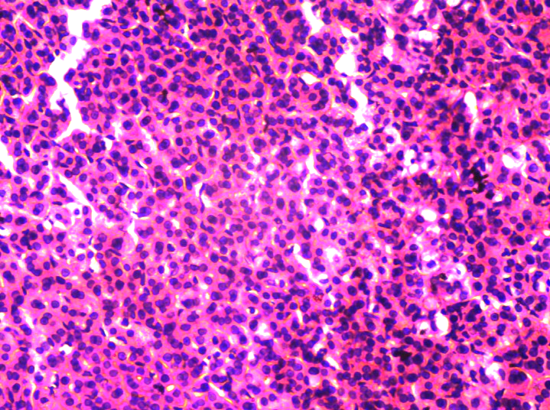
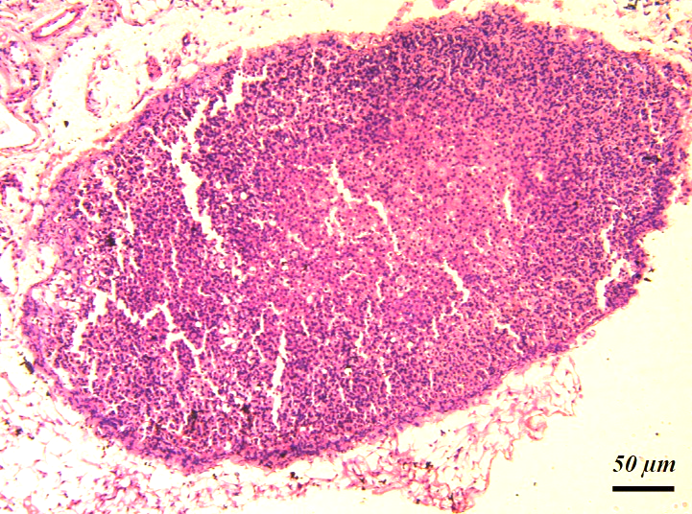
Plate 1: Effect of Lamivudine on Adrenal gland Tissue Histology, Group A (Control) H&E.
100x 400x
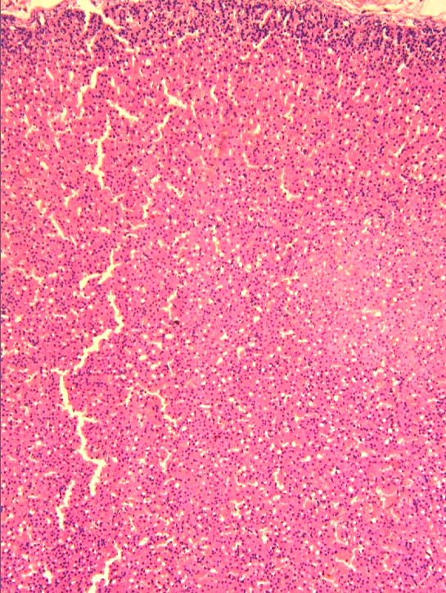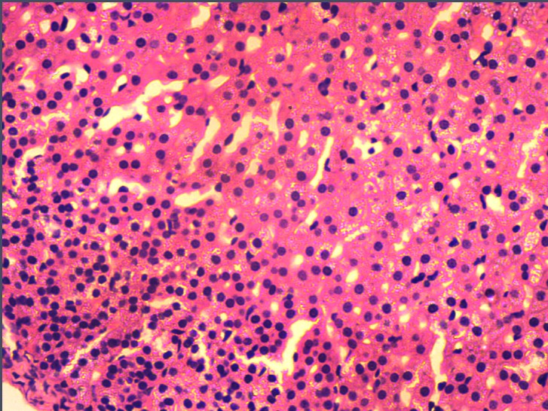
50 µm
Plate 2: Effect of Lamivudine on Adrenal Gland Tissue Histology, Group B (100mg/kg of LamivudineH&E).

100x 400x
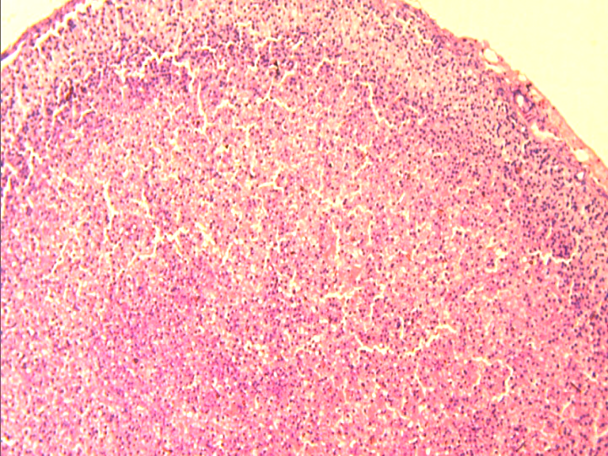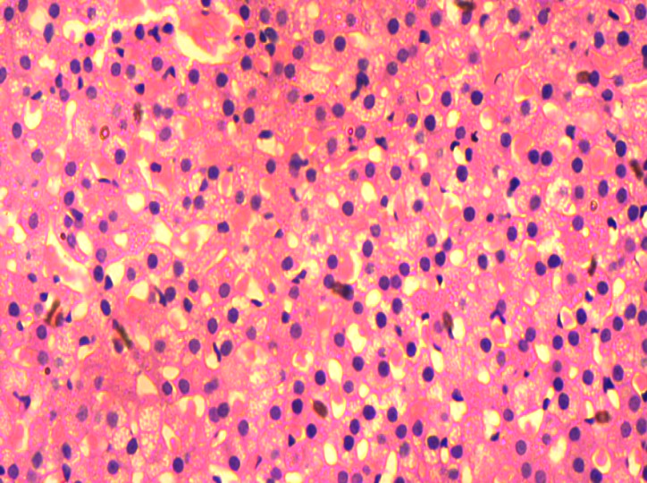
50 µm
Plate 3: Effect of Lamivudine on Adrenal Gland Tissue Histology, Group C (200mg/kg of Lamivudine H&E).
100x 400x
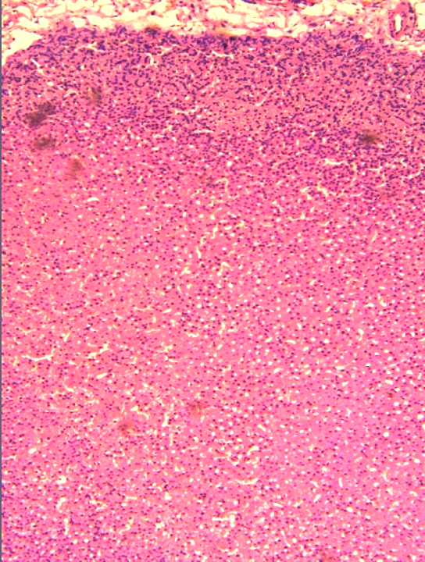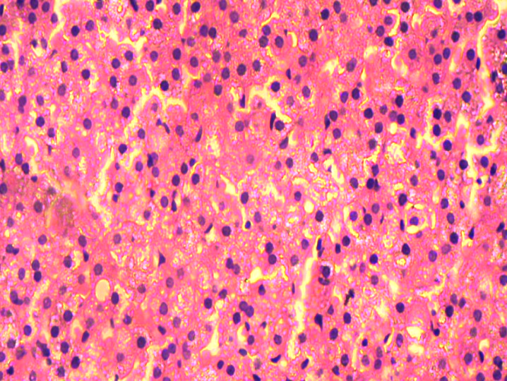
50 µm
Plate 4: Effect of Lamivudine on Adrenal Gland Tissue Histology, Group D (400mg/kg of Lamivudine H&E).
Histological examination of adrenal tissues revealed increased lipid droplets within the zona fasciculata cells in Lamivudine-treated groups when compared with control group. This finding suggests enhanced steroidogenic activity. However, no evidence of cellular degeneration, necrosis, or structural distortion was observed, indicating preserved adrenal integrity.

Discussion
The present study evaluated the effect of Lamivudine on adrenal corticosterone secretion and demonstrated a mild, dose-dependent increase that was not statistically significant. This suggests that Lamivudine exerts only minimal influence on adrenal endocrine function under the conditions of this study.
The slight elevation in corticosterone levels observed across the treated groups may indicate a mild activation of the HPA axis. The HPA axis is a central component of the neuroendocrine stress response system, and even weak pharmacological or environmental stressors can stimulate its activity, leading to increased glucocorticoid secretion²². In this context, Lamivudine administration may have acted as a mild physiological stressor, triggering adaptive endocrine responses aimed at maintaining homeostasis. Such adaptive activation is often transient and does not necessarily translate into pathological dysfunction²².
A plausible mechanism for this response involves oxidative stress. Nucleoside reverse transcriptase inhibitors, including Lamivudine, have been reported to interfere with mitochondrial DNA polymerase-γ, resulting in impaired mitochondrial replication and function^{5,6}. This dysfunction promotes excessive generation of reactive oxygen species (ROS), which contributes to oxidative stress and cellular signalling alterations⁷.
Oxidative stress can directly influence adrenal steroidogenesis by affecting mitochondrial integrity, which is essential for glucocorticoid synthesis^{5,6}. The zona fasciculata of the adrenal cortex relies heavily on mitochondrial cholesterol transport as the rate-limiting step in corticosterone production²³. Therefore, even mild mitochondrial disturbances induced by Lamivudine may subtly affect steroid hormone synthesis without causing structural damage.
In addition, oxidative stress is known to exert complex effects on endocrine regulation, depending on its intensity and duration, oxidative stress may either enhance or suppress steroidogenesis^{24,25}. Mild oxidative stress can activate adaptive signalling pathways that temporarily increase glucocorticoid secretion as part of a compensatory survival mechanism, conversely, chronic or severe oxidative stress may impair adrenal function by damaging steroidogenic enzymes and cellular structures^{24,26}. The findings of the present study, which show increased corticosterone levels without statistical significance or tissue damage, suggest that Lamivudine may induce only a low-level oxidative stimulus insufficient to overwhelm adrenal compensatory mechanisms.
Furthermore, oxidative stress may influence the central regulation of the HPA axis¹⁴. Reactive oxygen species have been shown to modulate hypothalamic neurons responsible for corticotropin-releasing hormone (CRH) secretion, thereby indirectly affecting downstream ACTH and corticosterone production¹⁵. This central effect provides an additional pathway through which Lamivudine-induced oxidative imbalance could contribute to the observed hormonal trends.
Histological findings from this study revealed increased lipid droplets within the zona fasciculata of Lamivudine-treated groups. Lipid droplets serve as intracellular cholesterol reservoirs necessary for steroid hormone synthesis, and their accumulation may indicate increased steroidogenic activity or altered lipid mobilization within adrenal cortical cells²⁵. However, the absence of necrosis, inflammation, or architectural distortion suggests preserved adrenal structural integrity.
Despite these histological and biochemical trends, the absence of statistically significant differences indicates that the HPA axis maintained effective regulatory control. The endocrine system is characterized by strong feedback mechanisms, particularly negative feedback mediated by glucocorticoids, which stabilize hormone levels even under mild stress conditions^{27,28}. This regulatory efficiency likely prevented any measurable endocrine imbalance in this study.
Furthermore, Lamivudine is considered to have relatively low mitochondrial toxicity compared to other nucleoside analogues, as it may exhibit antioxidant or protective effects under certain experimental conditions, reducing oxidative damage in specific tissues²⁹. This dual role may explain the minimal endocrine disruption observed in this study.
The findings therefore indicate that Lamivudine has limited impact on corticosterone regulation, suggesting relative safety regarding adrenal endocrine function under the conditions of this experiment.
Conclusion
Lamivudine administration resulted in a mild, non-significant increase in serum corticosterone levels, suggesting slight activation of the HPA axis without significant endocrine disruption. Histological findings indicate increased steroidogenic activity without structural damage. Overall, Lamivudine appears to be relatively safe with respect to adrenal function, although further studies are required to evaluate long-term effects.
Study Limitations
This study has some limitations. The sample size was relatively small, which may reduce statistical power. Additionally, only corticosterone levels were assessed, and other markers of HPA axis activity were not evaluated. Future studies should include larger sample sizes, longer exposure durations, and additional biochemical parameters.
Ethical Considerations
All experimental protocols were approved by the Animal Research Ethics Committee of Nnamdi Azikiwe University, Awka (Reference Number: NAU/AREC/2025/0167; issued 6th November, 2025) and conducted in accordance with the National Institutes of Health (NIH) guidelines for the care and use of laboratory animals²⁰.

COMPETING INTERESTS DISCLAIMER:
Authors have declared that they have no known competing financial interests OR non-financial interests OR personal relationships that could have appeared to influence the work reported in this paper.
Disclaimer (Artificial intelligence)

Author(s) hereby declare that NO generative AI technologies such as Large Language Models (ChatGPT, COPILOT, etc.) and text-to-image generators have been used during the writing or editing of this manuscript.

References
- Łupina, K., Nowak, K., Lorek, D., Nowak, A., Romac, A., Głowacka, E., & Janczura, J. (2025). Pharmacological advances in HIV treatment: From ART to long-acting injectable therapies. Archives of Virology, 170(9), 195. https://doi.org/10.1007/s00705-025-06381-8⁠
- Sedibe, A., Sibiya, N., Nyakudya, T., & Gamede, M. (2025). The impact of recent HIV non-nucleoside reverse transcriptase inhibitors and nucleoside reverse transcriptase inhibitors-based regimens on metabolic health outcomes: A narrative review. Biochemistry and Biophysics Reports, 44, 102345. https://doi.org/10.1016/j.bbrep.2025.102345⁠
- Foka, F. E. T., & Mufhandu, H. T. (2023). Current ARTs, virologic failure, and implications for AIDS management: A systematic review. Viruses, 15(8), 1732. https://doi.org/10.3390/v15081732
- Katherine, T., Fritz, K., Pellegrini, M. V., & Parmar, M. (2024). Lamivudine. In StatPearls. Treasure Island (FL): StatPearls Publishing. https://www.ncbi.nlm.nih.gov/books/NBK559252/
- Iorjiim, W. M., Omale, S., Etuh, M. A., Ubani, A., Alemika, E. T., & Gyang, S. S. (2022). Senescence and oxidative stress toxicities induced by lamivudine and tenofovir in Drosophila melanogaster. Annales Pharmaceutiques Françaises, 80(6), 864–875. https://doi.org/10.1016/j.pharma.2022.02.006⁠
- Haynes, J., Joshi, A., Larue, R. C., Eisenmann, E. D., & Govindarajan, R. (2024). Nucleoside reverse transcriptase inhibitor (NRTI)-induced neuropathy and mitochondrial toxicity: Limitations of the poly-γ hypothesis and the potential roles of autophagy and drug transport. Pharmaceutics, 16(12), 1592. https://doi.org/10.3390/pharmaceutics16121592
- Costa, B., Gouveia, M. J., & Vale, N. (2024). Oxidative stress induced by antivirals: Implications for adverse outcomes during pregnancy and in newborns. Antioxidants, 13(12), 1518. https://doi.org/10.3390/antiox13121518⁠
- Patani, A., Balram, D., Yadav, V. K., Lian, K.-Y., Patel, A., & Sahoo, D. K. (2023). Harnessing the power of nutritional antioxidants against adrenal hormone imbalance-associated oxidative stress. Frontiers in Endocrinology, 14, 1271521. https://doi.org/10.3389/fendo.2023.1271521⁠
- Gutierrez Nunez, S., Peixoto Rabelo, S., Subotic, N., Caruso, J. W., & Knezevic, N. N. (2025). Chronic stress and autoimmunity: The role of HPA axis and cortisol dysregulation. International Journal of Molecular Sciences, 26(20), 9994. https://doi.org/10.3390/ijms26209994⁠
- Herman, J. P., McKlveen, J. M., Ghosal, S., Nagarkatti, M., Nagarkatti, P. S., & colleagues contributing to HPA axis regulation chapter (2023). Regulation of the hypothalamic–pituitary–adrenal stress response. Comprehensive Physiology, 13(1), 1–34.
- Berger, I., Werdermann, M., Bornstein, S. R., & Steenblock, C. (2019). The adrenal gland in stress – adaptation on a cellular level. Journal of Steroid Biochemistry and Molecular Biology, 190, 198–206. https://doi.org/10.1016/j.jsbmb.2019.04.006⁠
- Bassi, G., Sidhu, S. K., & Mishra, S. (2021). The expanding role of mitochondria, autophagy and lipophagy in steroidogenesis. Cells, 10(8), 1851. https://doi.org/10.3390/cells10081851
- Mladenov, M., Sazdova, I., Hadzi-Petrushev, N., Konakchieva, R., & Gagov, H. (2025). The role of reductive stress in the pathogenesis of endocrine-related metabolic diseases and cancer. International Journal of Molecular Sciences, 26(5), 1910. https://doi.org/10.3390/ijms26051910⁠
- Trifunovic, S., Stevanovic, I., Milosevic, A., Ristic, N., Janjic, M., Bjelobaba, I., Savic, D., Bozic, I., Jakovljevic, M., Tesovic, K., Laketa, D., & Lavrnja, I. (2021). The function of the hypothalamic–pituitary–adrenal axis during experimental autoimmune encephalomyelitis: Involvement of oxidative stress mediators. Frontiers in Neuroscience, 15, 649485. https://doi.org/10.3389/fnins.2021.649485⁠
- Kageyama, K., Iwasaki, Y., & Daimon, M. (2021). Hypothalamic regulation of corticotropin-releasing factor under stress and stress resilience. International Journal of Molecular Sciences, 22(22), 12242. https://doi.org/10.3390/ijms222212242
- Edagha, I. A., Ekanem, A. U., Usoh, I. F., Umoh, V. A., Ataben, M. M., & Akpan, A. A. (2022). Brain antioxidants and hippocampal alterations following antiretroviral combinations in Wistar rats. IBRO Neuroscience Reports, 12, 210–216.
- Asuelimen, S., & Gabriel, B. O. (2020). Effect of lamivudine on selected hepatic enzymes (alanine aminotransferase, alkaline phosphatase, aspartate aminotransferase) in albino rats. https://doi.org/10.13140/RG.2.2.26674.43202⁠
- Lipke, K., Kubis-Kubiak, A., & Piwowar, A. (2023). The influence of nucleoside reverse transcriptase inhibitors on mitochondrial activity, lipid content, and fatty-acid-binding protein levels in microglial HMC3 cells. Pharmaceuticals, 16(12), 1661. https://doi.org/10.3390/ph16121661⁠
- Hamed, M. A., Aremu, A. O., & Akhigbe, R. E. (2021). Concomitant administration of HAART aggravates anti-Koch-induced oxidative hepatorenal damage via dysregulation of glutathione and elevation of uric acid production. Biomedicine & Pharmacotherapy, 111309. https://doi.org/10.1016/j.biopha.2021.111309⁠
- NIH. (2011). Guide for the Care and Use of Laboratory Animals. 8th Edition, Institute for Laboratory Animal Research, Division on Earth and Life Studies, National Research Council of the National Academies Press, Washington DC, 1-246.
- Lorke, D. (1983). A new approach to practical acute toxicity testing. Archives of Toxicology, 54(4), 275–287. DOI: 10.1007/BF01234480
- Sheng, J. A., Bales, N. J., Myers, S. A., Bautista, A. I., Roueinfar, M., Hale, T. M., & Handa, R. J. (2021). The hypothalamic-pituitary-adrenal axis: Development, programming actions of hormones, and maternal–fetal interactions. Frontiers in Behavioral Neuroscience, 14, 601939. https://doi.org/10.3389/fnbeh.2020.601939⁠
- Aderhold, A., & Alexaki, V. I. (2025). Lipid metabolism in the adrenal gland. Frontiers in Endocrinology, 16, 1577505. https://doi.org/10.3389/fendo.2025.1577505⁠
- Rotimi, D. E., Ojo, O. A., & Adeyemi, O. S. (2024). Atrazine exposure caused oxidative stress in male rats and inhibited brain–pituitary–testicular functions. Journal of Biochemical and Molecular Toxicology, 38(1), e23579. https://doi.org/10.1002/jbt.23579⁠
- Navarro, B. F., Aguayo, A. A. C., Gómez, Y. L. T., Alfaro, M. C., & Torner, L. (2024). Early life stress influences oxidative stress enzyme activities in liver, heart, kidney, suprarenal glands, and pancreas in male and female rat pups. Antioxidants, 13(7), 802. https://doi.org/10.3390/antiox13070802⁠
- Forrester, S. J., Kikuchi, D. S., Hernandes, M. S., Xu, Q., & Griendling, K. K. (2018). Reactive oxygen species in metabolic and inflammatory signaling. Circulation Research, 122(6), 877–902. https://doi.org/10.1161/CIRCRESAHA.117.311401⁠
- Gjerstad, J. K., Lightman, S. L., & Spiga, F. (2018). Role of glucocorticoid negative feedback in the regulation of HPA axis pulsatility. Stress, 21(5), 403–416. https://doi.org/10.1080/10253890.2018.1470238⁠
- Lockett, J., Inder, W. J., & Clifton, V. L. (2024). The glucocorticoid receptor: Isoforms, functions, and contribution to glucocorticoid sensitivity. Endocrine Reviews, 45(4), 593–624. https://doi.org/10.1210/endrev/bnae008⁠
- Rafi, S., Maqbool, T., Sarwar, M., Qureshi, Z. H., Nasreen, M., Naz, S., Atif, M., & Azhar, M. M. (2024). Hepatoprotective potential of lamivudine through activation of gamma-glutamyltransferase and down-regulation of p53 in HepG2 cells. International Journal of Chemical and Biochemical Sciences, 25(19), 1139–1147. https://www.iscientific.org/Journal.html

