OCCUPATIONAL STRUCTURE TRANSFORMATION IN MATHURA DISTRICT (1991–2011)

ABSTRACT
The occupational structure significantly influences multiple dimensions of a region’s population, including the composition of the workforce, dependency burden, patterns of employment, and levels of unemployment. It constitutes a fundamental component of population composition, as it reflects the distribution of economically active and inactive groups within a particular area or country. Moreover, the occupational structure provides a comprehensive representation of the proportion of working and non-working populations, thereby serving as an important indicator of the socio-economic characteristics and developmental status of a region. This current research paper aims at analyzing the evolving trends of occupational structure for the period from 1991 to 2011 in Mathura district using block-wise data from the Census of India. Four broad occupational groups such as cultivators, agricultural laborers, and workers engaged in household industries and other workers have been considered for the purpose of this analysis. Analysis of occupational trends shows that there is a declining trend among the category of cultivators and a growing trend of agricultural laborers that indicates the increasing tendency of the people to earn their livelihood through wage labor in agriculture. In addition to this, the percentage share of household industry workers and other workers also shows a rising trend.

KeyWord- Occupational Structure, Work Participation Rate, Location Quotient (LQ), Cultivators, Agricultural Laborers, Regional Disparities.

Introduction
The concept of occupation is a very complex phenomenon. It is one of the most important characteristics of the population composition of a region, and it directly influences the social and economic conditions of livelihood. It also gives information regarding manpower and the nature and level of its utilization (Jaffe and Stewart, 1951). Occupation has been defined as “that specific activity with a market value which an individual continually pursues with the purpose of obtaining a steady flow of income; this activity also determines the social position of individuals” (Sharma, 2022).
Occupational structure of a country refers to the distribution or division of its population according to different occupations. An understanding of the occupational structure of a population therefore warrants comprehension of the composition of its working force. An analysis of the working force provides a useful tool to social scientists not only for measuring the level of social and economic development an area has attained (Maitra, 1969) but also for formulating future plans for mobilizing its manpower (Chandna and Sidhu, 1980; Oesch, and Piccitto, 2019). Moreover, the extent of participation in work is, on the one hand, an index of the social and economic structure of a society (Radhakrishna and Vijayalakshmi, 1974) and, on the other hand, a function of the age structure and the socio‑economic and political compulsions of a society (Sarkar, 2019).
The occupational structure influences many aspects of the population of any region, including the working force, dependency load, employment, and unemployment. It is a key component in the manifestation of the population composition of a region and provides a true picture of the ratio of the working and non‑working population in an area or a country. Therefore, the occupational structure also influences the socio‑economic development and future progress of a region or country (Sharma, 2016). The significance of occupational structure of a region lies in the fact that it explicitly reveals the socio‑economic characteristics of the people inhabiting that particular region or country. Hence, it is one of the important measures of socio‑economic development of the country (Fernandez-Macias, 2012).
Occupational structure is the distribution or division of the working population in different sectors based on occupations. It is one of the key elements in the manifestation of the population composition of a region (Chandana, 2010). Occupational structure is playing an important role in the socio‑economic activities in the region and is one of the most significant social features that impacts human life (Kumar, Kumar and Singh, 2016). The study of occupational structure of the population is an important tool that assesses the ratio of the entire working and non‑working population and presents a clear picture of the entire workforce (Kumari and Kumar, 2024). The socio‑economic development of any region depends on the number of individuals who are economically active, and it is one aspect of population structure that shows how the population is engaged in various economic activities (Karthikesan et al., 2018). The occupational changes of a nation refer to the percentage of its workforce employed in various economic activities (Rina and Godara, 2020 and Kaushik & Kaushik, 2021). An analysis of the working force provides a useful tool to social scientists not only for measuring the level of social and economic development an area has attained but also for formulating future plans for mobilizing its manpower (Singh, 2015). In light of various perspectives, Mathura district has been selected as the study area due to its diverse occupational structure and socio-economic characteristics.
Objectives of the study
The primary objectives of the present study are to examine the occupational structure of main workers at the block level and to assess the degree of specialization within specific occupational categories. It is important to note that individuals who are engaged in any economically productive activity for a minimum of 183 days in a year are classified as “main workers.”
Data Base
The present study is based on data obtained from the Census of India. Information from three consecutive census years—1991, 2001, and 2011—has been utilized, with data collected from the District Statistical Handbooks corresponding to these years. It is essential to mention that in 1991, nine occupational groups were used to classify workers. On the other hand, the four main occupations have been identified in 2001 and 2011 censuses. For consistency purposes and ease of comparison between the three censuses, the classification of workers according to the occupational category has been made using the four occupational categories, similar to those used in the later two censuses. These categories include (i) Cultivators, (ii) Agricultural Laborers, (iii) Household Industries, and (iv) Others Workers.
According to the Census of India, the term Cultivator refers to an individual involved in the cultivation of land, either owned by him or leased out from the government or other private organizations on the basis of wages. Cultivation means the activity of looking after and directing the process of ploughing, sowing, reaping, and producing crops. One who merely gets rent for his land but does not cultivate it himself is not considered a cultivator. Agricultural Laborer means a person who works on the lands belonging to others in exchange for wages. These agricultural workers do not run the risks of cultivation and do not own or lease any lands they work upon. Household Industry Worker refers to a person employed in an industry run by one or more persons belonging to the same household, either within their own premises in the case of rural areas, or within the premises of their own house in urban areas. Such industrial units are characterized by small-scale production, processing, servicing, repairing, or manufacture and are not established according to the pattern of registered factories as per the Factories Act. Employment of members of the household forms the primary basis of classification of household industry. Other Workers encompass all those who are working in any occupation except agriculture, agriculture labor, or household industry (Census of India 2011).
Methodology
The development block has been chosen as the primary unit for the analysis. In order to find out the share of workers among different occupations, the data has been expressed in percentage terms. Furthermore, the Location Quotient (LQ) for each category has been determined. It is useful in finding out the degree of specialization regarding a particular economic activity in a development block as compared to the district as a whole.
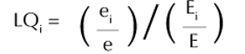
Location Quotient can be calculated using the following formula:

Where:
LQ is the Location Quotient for the particular activity in the particular block;
e_{i} is the number of employees in the ith occupational category of the particular block;
e is the total number of workers in the particular block;
E_{i} is the number of employees in the ith occupational category in the particular district; and
E is the total number of workers in the particular district.
Location Quotient assumes values between less than 1 and more than 1 and implies specialization at different degrees. When LQ is more than 1, it means that the block is specialized in the activity. If LQ is equal to 1, it implies that the share of the activity in the particular block coincides with the share of the activity in the particular district. When LQ is less than 1, it means that the particular block has low specialization in the activity.
STUDY AREA
Mathura district, which is the location for this study, is found in the western part of Uttar Pradesh. It is found within the parallels of latitude 27º14’ north to 27º58’ north and longitude 77º17’ east to 77º58’ east occupying an area of 3340 sq. km. (Fig. 1). It borders Haryana state and Aligarh district in the north, Agra district in the south, Hathras district in the east and state of Rajasthan in the west. Five tehsils have been identified in the district; they are Chhata, Mathura Mahavan, Goverdhan and Mant. Each tehsil is further sub-divided into ten blocks: Nandgaon, Chhata, Chaumha, Goverdhan, Mathura, Farah, Baldeo, Mant, Nohjheel and Raya. In terms of its physical features, Mathura district is part of the Indo-Gangetic plain and has flat plain and fertile soils. It occupies the drainage basin of River Yamuna, which flows in the middle of the district from north to south direction. Total population of Mathura is 2.55 million out of which 53.67 % are males and 46.33 % are females according to the latest Census (2011). Total literacy rate in district is 70.36 % which is below than the national average of 74.04 % (2011), and male literacy rate 81.97 % and literacy rate among female is 56.89%. According to the 2011 Census data for Mathura district in Uttar Pradesh, the total number of workers was 840,939, comprising 635,142 male workers and 205,797 female workers. This forms 33.01% of the total population in the district, which are 2,547,184. Among the total number of workers, 75.54% were males, while 24.46% were females. There was a great disparity between male and female workers. In this category, the main workers accounted for 70.7%, and the marginal workers formed 29.3%. The area economically wise is quite advanced due to efficient agricultural practices and industries. It is also developed as far as tourism is concerned.
Results and Discussion
The paragraphs below describe the changes that occur in work participation rates, occupation structure, and specialization within the various occupational categories in the district blocks.
Work Participation Rate
According to the census done in 2011, there is a fairly low work participation rate within the district under study, especially when compared to the average participation rate of the state, which is 32.93%, and that of the nation, which is 39.80%. This shows that there are fewer people who are actively working in order to meet their basic requirements. One of the major characteristics in the above work participation rate is the great disparity in participation rates in relation to gender. Although females constitute nearly half of the total population, their work participation rate is only 22.13%, which is substantially lower than that of males at 42.07% (Table.1).
The occupational pattern of the Mathura district (2011) reflects the imbalanced distribution between workers and non-workers, and there exists an enormous difference between men and women in terms of occupation. In the entire district, 34.36% of the people were found to be workers, while the number of people belonging to the non-workers category was 65.64%. Among the two categories of workers, i.e., main and marginal, the first one comprised 23.12% of the total population, followed by marginal workers who contributed 11.24% (Fig. 2).
One interesting point that can be observed in the table is the extreme gap between male participation and female participation in the work sector. The former is high for all the blocks, i.e., around 45–47%, while the latter is lower in comparison to the former, being mostly below 25%. For example, the total number of female workers in Chaumuha was 32.29%, while it was 12.77% for Mathura block, due to the influence of cities in the region and lack of involvement of women in economic activities. Likewise, the percentage of females falling in the non-worker category was very high, e.g., more than 80% in Raya, Govardhan, and Mathura (Fig. 3).
Spatial variations are also observable among blocks. The blocks of Chaumuha (40.56%) and Nandgaon (36.44%) have relatively more worker participation than Mathura (30.14%) and Farah (31.40%). The presence of marginal workers is relatively high in blocks such as Mat (13.70%) and Baldeo (13.02%), reflecting the use of seasonal labor due to possible agricultural activities.
On the whole, the above data reveals low work participation, high dependency on male labor force, and relatively higher percentage of non-worker population, particularly females. The data suggests that some factors such as low literacy of females, socio-cultural barriers, and lack of employment options might be responsible for these occupational structures of the district.
Variations in Occupational Structure
The occupational structure shows varying composition across the study area (Table 2).
Cultivators
The tables presented below indicate changes in the occupational structure in relation to cultivators within the Mathura district during the period 1991 to 2011, along with the Location Quotient (LQ).
Another important trend identified is the consistent decrease in the proportion of farmers in almost all blocks from 1991 to 2011. For example, a notable decline can be seen in blocks such as Nandgaon, which went from 64.36% in 1991 to 46.51% in 2011; Chhata, which saw a drop from 61.78% to 43.71%; and Chaumuha, where the proportion fell from 66.68% to 44.12%. A similar trend can be seen in Raya and Mathura blocks, where the former dropped from 50.15% to 31.42%, and the latter declined from 51.20% to 26.61%. At the district level, there was a slight increase from 45.33% in 1991 to 49.00% in 2001
The Location Quotient (LQ) results further support this interpretation. For instance, most blocks had location quotients greater than one in 1991, meaning they had more cultivators than the district average (e.g. Govardhan, 1.39, Baldeo 1.36, and Chaumuha 1.33). By 2011, several blocks had location quotients below one (Mat 0.80, Raya 0.80, Mathura 0.80, and Farah 0.89), implying less specialization in cultivation. The same case was observed for blocks with location quotients below one since cultivators continued decreasing in number. Nevertheless, some blocks had persistent agriculture specialization; e.g. Govardhan retained its high LQ of 1.39 in 1991 to 1.36 in 2011, indicating sustained agricultural core block (Fig. 5). In the same period, blocks Nandgaon and Chhata retained their LQ above one.
One other interesting observation is that there is spatial variation in occupation change. Those blocks near urban centers experience quicker decreases in cultivators, hence lower LQs. In contrast, relatively rural blocks maintain a higher reliance on agriculture. On the whole, the findings show how there has been a gradual evolution of the economy of the district, with decreased reliance on farming activities and greater diversification of livelihood options. With regard to the LQ data, it becomes quite evident that even though some blocks remain agriculturally specialized, most other areas of the district have started shifting towards non-agriculture occupations.
Agricultural Labor
From an examination of the data, it becomes apparent that there has been substantial evolution of the employment profile of agricultural labor in the Mathura district during the period under consideration. In terms of percentage share, the data shows an overall rise in the share of agricultural labor from 18.95 percent in 1991 to 21.30 percent in 2001, followed by further growth to 26.99 percent in 2011. The rising trend is indicative of increasing landlessness and subdivisions of land, thereby leading to agricultural wage labor.
Spatial variation exists at the block-level too. There are blocks like Mat, Raya, Nohjhil, and Baldeo that demonstrate a steady rise in agricultural laborers in the past three decades. For example, there is an outstanding rise from 21.00% in 1991 to 39.06% in 2011 for Baldeo, which implies severe agricultural pressure on its residents. It can even cause marginalization of farmers living in Baldeo village. Likewise, Mat and Nohjhil are also rising above district average in terms of agricultural workers in 2011, which can be associated with dependency on farm-based income. At the same time, the percentage of agricultural laborers is declining in Mathura block, from 28.01% to 17.79%.
The further validation of the above interpretation is made possible through the Location Quotient (LQ) analysis where the distribution of agricultural labor ers compared with the district average is examined (Fig. 6). The LQ analysis reveals that Baldeo (1.51 in 2011), Mat (1.19), and Raya (1.05) are examples of the blocks having LQ values more than 1 showing high degree of specialization for agricultural labor while other blocks such as Nandgaon (0.82), Chaumuha (0.78), and Mathura (0.72) have LQ values less than 1 representing their lesser specialization for agricultural labor.
Further, Baldeo represents one such example whose LQ value shows consistent growth from 1.16 (1991) to 1.51 (2011). It therefore stands out as a core of agriculture labor er concentration. The general trend in Mathura District appears to be gradual transformation from the economy dominated by cultivators to an economy based upon agricultural labor.
Household Industries
The above figures depict the changing composition of household industry workers in the Mathura district during the three censuses (1991, 2001, 2011). In general, it is clear that there has been an increase in the percentage of household industry workers in the Mathura district with a rise from 2.35% in 1991 to 5.23% in 2011, which suggests diversification in rural occupation outside agriculture. This indicates the development of household-based small scale economic activity like handicraft industries, food processing, etc. which helps to provide employment opportunities.
On the block-wise basis, the major upward trend can be observed in many blocks. The blocks that have shown maximum upward trends are Raya, Mat, and Nohjhil. For example, Raya has risen significantly from 2.03% in 1991 to 8.59% in 2011 and has emerged as the highest contributing block for 2011, Mat block has grown from 1.75% in 1991 to 6.52% in 2011 and Nohjhil from 1.59% to 6.03%. It suggests that development in household industries has taken place in these blocks (Fig. 7). In contrast, blocks like Govardhan and Mathura show either irregular or less growth trends.
Location Quotient (LQ) analysis gives further insight into regional specialization. If the value of LQ is greater than one, it implies that the specialization level of that area exceeds the average district level. In the year 1991, only one block called Baldeo had specialization in household industries, with an LQ value of 1.04, whereas all other blocks had an LQ value less than one, which shows low levels of development of household industries in these blocks. In the years 2001 and 2011, there was a significant increase in the number of blocks whose LQ exceeded 1.0, including Raya (1.70), Mat (1.21), Nohjhil (1.17), and Baldeo (1.13).
On the other hand, blocks like Nandgaon, Chaumuha, and Govardhan continued to show an LQ less than one, signifying their relatively weaker position in this industry. As can be seen, there is a trend of increased specialization in household industries in this district, moving from low to moderate levels. In general, the data reveals that household industries are becoming an important additional source of livelihood as the economy is gradually diversifying away from agriculture in the district of Mathura.
Other Workers
As revealed by the above data, there has been a change in the composition of the other workers group in terms of various blocks of Mathura district from 1991 to 2011. Location Quotient has been computed to measure the level of specialization of other workers relative to that of the whole district.
The major trend seen from the above table is that the share of other workers has been consistently increasing over time. From 1991 to 2001, the share of other workers dropped in Mathura district from 33.37 percent to 25.70 percent; however, the share once again rose to 31.20 percent in 2011.
In the case of blocks, the highest development can be observed in Mathura block, which has recorded a sharp increase from 19.04% in 1991 to 51.40% in 2011. High LQ values (0.60; 2.22 and 1.80) for this block suggest growing specialization. Hence, it is the primary location of non-agriculture occupations because of factors such as urbanization, industry, and service sector development. In the same way, increasing trends are observed in Raya and Govardhan blocks with figures of 35.07% and LQ values above one after 2001 (Fig. 8), signifying specialization.
On the contrary, there are some blocks that exhibit moderate increase in shares but with LQ values below one in most periods, thus suggesting that even though the percentage of other workers is growing, specialization has not been achieved by these blocks yet. These blocks include Nandgaon, Chhata, Chaumuha, Baldeo, and Nohjhil. The case of Nandgaon, for example, has recorded an increase from 14.48% in 1991 to 26.99% in 2011 with low LQ (0.37 - 0.81).
One of such cases is Mat block, whose percentage (35.59%) and LQ (1.14) was very high in 1991, indicating that there existed strong specialization at first, then there was a decline in 2001 followed by recovery in 2011. This implies structural instability or changes in occupational trends. The same is applicable to the case of Farah block,
where there has been a consistent increase in percentage, but the values of LQ have been varying, implying inconsistency in specialization. Overall, the occupational structure is undergoing a process of gradual transformation in the study region, where non-agriculture occupations are becoming increasingly important; however, the process is uneven in space, where urban and semi-urban
Conclusion and Recommendations:
The analysis of occupational structure in different blocks of Mathura district for the period between 1991 and 2011 depicts an obvious trend of transition from an agriculturally-oriented economy to one having diversified occupation profile. Cultivators form a diminishing proportion of the population in almost all blocks (e.g., Nandgaon - 64.36% to 46.51%, Raya - 54.60% to 28.42%). This may be attributed to fragmented holdings, use of machinery, and unprofitability of conventional agriculture practices. On the other hand, agricultural labor ers have shown an increase in numbers, in particular in blocks such as Baldeo and Mat, signifying their transition from being owners of land to earning wages through agricultural jobs. There has been some increment in the proportion of household industry workers, mainly in Raya and Mat, implying the creation of small scale rural industries. But the most notable increment has taken place in case of 'other workers' (Mathura block: 19.04% to 51.40%), owing to urbanisation and emergence of the services sector in the region. The same conclusion can be drawn from LQ calculations, with many blocks showing lower specialisation in cultivation and higher specialisation in non-farm occupations.
The balanced and sustainable development calls for the strengthening of rural non-farming employment avenues through the promotion of agro-based industries and small-scale industrialization in such blocks where there has been a significant increase in dependence on farm labor. There should be skill development and vocational training programs for the labor force to shift successfully to secondary and tertiary activities. On the other hand, there must be an improvement in agricultural output through modern methods of agriculture, irrigation, and financing. There should be no negative effect of diminishing number of cultivators on the rural economy. More emphasis must be given on those blocks with higher concentration of agricultural labor force (Baldeo and Mat blocks) to avoid disguised unemployment and poverty. Also, efforts must be made for infrastructure development and urbanization to help 'other workers'.

Disclaimer (Artificial intelligence)

Author(s) hereby declare that NO generative AI technologies such as Large Language Models (ChatGPT, COPILOT, etc.) and text-to-image generators have been used during the writing or editing of this manuscript.

References
- Census of India. (2011). District Census Handbook: Mathura, Part XII-A. Directorate of Census Operations, Uttar Pradesh.
- Chandana, R. C. (2010). Geography of Population: Concepts, Determinants and Patterns (pp. 308–331). New Delhi: Kalyani Publishers.
- Chandna, R. C., & Sidhu, M. S. (1980). Introduction to Population Geography. New Delhi: Kalyani Publishers.
- Fernandez-Macias, E. (2012). Job polarization in Europe: Transformations in Employment Structure and Job Quality (1995-2007). Work and Occupations, 39, 157-182.
- Jaffe, A. J., & Stewart, C. D. (1951). Manpower resources and utilization: Principles of working force analysis. New York: John Wiley & Sons.
- Karthikesan, K., Emayavaramban, V., Kanndasan, K., & Vinoothakanna, S. (2018). Geographical assessment of occupational structure in Nagapattinam district, Tamil Nadu. Research Review International Journal of Multidisciplinary, 3(10), 565–571.
- Kaushik, A. K. and Kaushik, K. (2012), Gender Gap in Literacy Rate in Mathura District, U.P. A geographical study, European Journal of Business and Social Sciences, Vol. 1, No.9, pp. 95-107 (PDF) Gender Gap in Literacy: A Study of Indian Scenario. Available from:https://www.researchgate.net/publication/281375728_Gender_Gap_in_Literacy_A_Study_of_Indian_Scenario [accessed May 14 2026].
- Kaushik, K., & Kaushik, A. K. (2021). The Occupational Structure of Rural Workers in Mathura District, Uttar Pradesh. National Geographical Journal of India, 67(3), 294–307. Retrieved from https://ngji.in/index.php/ngji/article/view/134
- Khadke, P. A., Kharat, R. U., & Kamble, K. R. (2019). Occupational Transformation in Aurangabad City. International Journal of Research in Engineering IT and Social Science, Vol. 9, No.3, pp. 25–32. https://www.researchgate.net/publication/331673963_Changing_Occupational_Structure_in_Auragnabad_City
- Krishnamurthy, J. (1978). Characteristics of the employment situation in India. Demography India, Vol. 7, No.1-2, p. 147.
- Kumar, P., Kumar, N., & Singh, J. (2016). Occupational changes in the rural population: A study of Jaunpur district, Uttar Pradesh. Uttar Bharat Bhoogol Patrika, 46(2), 17-25. https://www.semanticscholar.org/paper/Changing-Pattern-Of-Occupational-Structure-In-A-Kumari-Kumar/150de71d8e96e9ad139f2948a15309745ebd5bcc
- Kumari, S., & Kumar, A. (2024). Geographical analysis of changing occupational patterns in Katihar district. International Journal of Creative Research Thoughts, 12(2), 28–36.
- Maitra, P. (1969). Occupational change and industrialization in India (1901–1961). In M. K. Chaudhari (Ed.), Trends of Socio-Economic Change in India (pp. 414–427). Shimla: Indian Institute of Advanced Study.
- Oesch, D. and G. Piccitto (2019). "The Polarization Myth: Occupational Upgrading in Germany, Spain, Sweden, and the UK, 1992–2015." Work and Occupations. 46 (4): 441-469.
- Office of the Registrar General & Census Commissioner, India. (2011). Census of India 2011: Primary Census Abstract. New Delhi: Ministry of Home Affairs, Government of India. https://censusindia.gov.in/census.website/
- Patidar, H., & Singh, M. B. (2010). Occupational Structure of Tribal Population in South-East Rajasthan: A Geographical Analysis. National Geographical Journal of India, 56(1), 31–42.
- Radhakrishna, M., & Vijayalakshmi, V. (1974). Labor force demographic structure in Andhra Pradesh. Manpower Journal, 10(2), 86–98. chrome-extension://efaidnbmnnnibpcajpcglclefindmkaj/https://www.isec.ac.in/wp-content/uploads/2023/09/Journal-5-1.pdf
- Rai, G., & Kumari, B. (2012). Occupational structure of Chiraigaon Development Block, Varanasi district. National Geographical Journal of India, 58, 34–40.
- Reddy, A. A., & Kumar, P. (2009). Occupational pattern of workers in rural Andhra Pradesh. Journal of Indian School of Political Economy, 18(1–2), 77–91.
- Rina, & Godara, R. (2020). Study of Occupational Structure: A Case Analysis of Panchkula District. Shodh Sanchar Bulletin, 10(39), 123–130. https://www.researchgate.net/publication/353377986_An_Analysis_of_Occupational_Structure_A_Case_Study_of_Panchkula_District
- Sarkar, S. (2019). Employment Change In Occupations in Urban India: Implications for Wage Inequality. Development and change, 50(5), 1398-1429.
- Sharma, S. (2016). Employment, Wages and Inequality in India: An Occupations and Tasks Perspective.
- Sharma, S. (2022). “Trends in Employment and Wages of Female and Male Workers in India: A Task-Content-of-Occupations Approach.” Asian Development Review, 39(1), 169–199. https://doi.org/10.1142/S0116110522500020
- Singh, R. P. (2015). Spatial Pattern of Occupational Structure in Haryana. Paripex – Indian Journal of Research, 4(6), 418–420.
- Verma, K., & Rai, V.(2022). Changes in Occupational Structure of Population in Ballia district: A Geographical study. National Geographical Journal of India, 66(2), 136–149. Retrieved from https://www.ngji.in/index.php/ngji/article/view/4

Table 1. Work Participation Rate in Mathura District, 2011 (In Percentage)
S.No. | Blocks | Person |  |  |  | Male |  |  |  | Female
S.No. | Blocks | Main Worker | Marginal Worker | Total Workers | Non Worker | Main Worker | Marginal Worker | Total Workers | Non Worker | Main Worker | Marginal Worker | Total Workers | Non Worker
1 | Nandgaon | 25.61 | 10.83 | 36.44 | 63.57 | 37.23 | 8.32 | 45.55 | 54.44 | 12.00 | 13.75 | 25.75 | 74.25
2 | Chhata | 22.56 | 12.77 | 35.33 | 64.67 | 35.80 | 9.53 | 45.33 | 54.66 | 7.09 | 16.54 | 23.63 | 76.37
3 | Chaumuha | 27.70 | 12.86 | 40.56 | 59.45 | 38.86 | 8.70 | 47.56 | 52.44 | 14.54 | 17.75 | 32.29 | 67.71
4 | Nohjhil | 22.35 | 12.12 | 34.47 | 65.53 | 34.20 | 11.60 | 45.80 | 54.20 | 8.71 | 12.72 | 21.43 | 78.57
5 | Mat | 22.36 | 13.70 | 36.06 | 63.95 | 34.47 | 13.16 | 47.63 | 52.37 | 8.38 | 14.32 | 22.70 | 77.30
6 | Raya | 22.48 | 11.15 | 33.63 | 66.36 | 35.66 | 10.54 | 46.20 | 53.79 | 7.23 | 11.86 | 19.09 | 80.91
7 | Govardhan | 21.94 | 10.75 | 32.69 | 67.32 | 35.29 | 10.07 | 45.36 | 54.65 | 6.50 | 11.53 | 18.03 | 81.96
8 | Mathura | 22.53 | 7.61 | 30.14 | 69.86 | 37.05 | 8.08 | 45.13 | 54.87 | 5.70 | 7.07 | 12.77 | 87.23
9 | Farah | 21.90 | 9.50 | 31.40 | 68.60 | 35.90 | 9.22 | 45.12 | 54.88 | 5.89 | 9.82 | 15.71 | 84.29
10 | Baldeo | 23.83 | 13.02 | 36.85 | 63.16 | 35.62 | 11.44 | 47.06 | 52.93 | 10.00 | 14.87 | 24.87 | 75.14
 | District | 23.12 | 11.24 | 34.36 | 65.64 | 35.95 | 10.05 | 46.00 | 53.99 | 8.22 | 12.63 | 20.85 | 79.15
Source: Table 31: Number and Percentage of Main Workers, Marginal Workers, and Non Workers by Sex in C. D. blocks, 2011 (District census Handbook, Census of India, 2011, p.52)

Table 2. Ocupational Structure of Population in Mathura District, 2011 (In Percentage)
S.No | Block | Cultivators |  |  | Agriculture Laborers |  |  | Household Industrial Workers |  |  | Other Workers
S.No | Block | 1991 | 2001 | 2011 | 1991 | 2001 | 2011 | 1991 | 2001 | 2011 | 1991 | 2001 | 2011
1 | Nandgaon | 64.36 | 56.20 | 46.51 | 20.01 | 20.40 | 23.52 | 1.15 | 2.70 | 2.98 | 14.48 | 20.80 | 26.99
2 | Chhata | 61.78 | 55.80 | 43.71 | 23.20 | 17.40 | 23.39 | 1.37 | 3.00 | 4.73 | 13.65 | 23.80 | 28.17
3 | Chaumuha | 66.68 | 59.00 | 44.12 | 19.09 | 20.40 | 24.91 | 1.31 | 3.10 | 4.99 | 12.92 | 17.50 | 25.98
4 | Nohjhil | 62.01 | 51.70 | 39.50 | 17.25 | 22.00 | 28.00 | 1.59 | 3.00 | 6.03 | 19.15 | 23.30 | 26.47
5 | Mat | 45.52 | 47.60 | 30.76 | 17.14 | 25.60 | 33.91 | 1.75 | 5.10 | 6.52 | 35.59 | 21.70 | 28.81
6 | Raya | 54.60 | 41.90 | 28.42 | 19.20 | 23.10 | 27.92 | 2.03 | 5.50 | 8.59 | 24.17 | 29.50 | 35.07
7 | Baldeo | 59.59 | 49.30 | 33.61 | 21.00 | 26.10 | 39.06 | 2.41 | 4.20 | 5.53 | 17.00 | 20.50 | 21.80
8 | Govardhan | 60.08 | 51.60 | 43.36 | 23.29 | 23.10 | 23.69 | 1.75 | 3.80 | 3.63 | 14.88 | 21.50 | 29.32
9 | Mathura | 51.20 | 35.60 | 26.61 | 28.01 | 14.10 | 17.79 | 1.75 | 5.01 | 4.20 | 19.04 | 45.31 | 51.40
10 | Farah | 48.93 | 44.70 | 34.64 | 26.48 | 19.00 | 28.80 | 2.13 | 5.30 | 4.69 | 22.47 | 31.00 | 31.87
 | District | 45.33 | 49.00 | 36.58 | 18.95 | 21.30 | 26.99 | 2.35 | 4.10 | 5.23 | 33.37 | 25.70 | 31.20
Source: Compiled from Census of India, District Census Handbook, Mathura (1991, 2001 & 2011), Primary Census Abstract, Directorate of Census Operations, Uttar Pradesh.
Table 3. Location Quotient of Main Ocupational in Mathura District
S.No | Block | Cultivators |  |  | Agriculture Laborers |  |  | Household Industrial Workers |  |  | Other Workers
S.No | Block | 1991 | 2001 | 2011 | 1991 | 2001 | 2011 | 1991 | 2001 | 2011 | 1991 | 2001 | 2011
1 | Nandgaon | 1.00 | 1.17 | 1.20 | 0.90 | 0.98 | 0.82 | 0.40 | 0.67 | 0.55 | 0.37 | 0.82 | 0.81
2 | Chhata | 1.01 | 1.14 | 1.17 | 1.10 | 0.82 | 0.84 | 0.51 | 0.74 | 0.89 | 0.36 | 0.93 | 0.88
3 | Chaumuha | 1.11 | 1.04 | 1.03 | 0.92 | 0.83 | 0.78 | 0.50 | 0.66 | 0.82 | 0.35 | 0.59 | 0.70
4 | Nohjhil | 1.12 | 0.90 | 1.08 | 0.90 | 0.89 | 1.03 | 0.65 | 0.63 | 1.17 | 0.56 | 0.78 | 0.84
5 | Mat | 0.90 | 0.91 | 0.80 | 0.98 | 1.13 | 1.19 | 0.79 | 1.17 | 1.21 | 1.14 | 0.79 | 0.88
6 | Raya | 0.95 | 0.80 | 0.80 | 0.97 | 1.02 | 1.05 | 0.81 | 1.27 | 1.70 | 0.69 | 1.08 | 1.15
7 | Baldeo | 1.13 | 1.04 | 0.97 | 1.16 | 1.27 | 1.51 | 1.04 | 1.06 | 1.13 | 0.53 | 0.82 | 0.73
8 | Govardhan | 1.16 | 1.38 | 1.36 | 1.30 | 1.42 | 0.99 | 0.77 | 1.22 | 0.80 | 0.47 | 1.09 | 1.07
9 | Mathura | 0.99 | 0.91 | 0.80 | 1.56 | 0.84 | 0.72 | 0.77 | 1.54 | 0.89 | 0.60 | 2.22 | 1.80
10 | Farah | 0.94 | 0.82 | 0.89 | 1.47 | 0.81 | 0.99 | 0.93 | 1.17 | 0.85 | 0.70 | 1.09 | 0.95
Source: Computed by the researcher using data obtained from District Census Handbook, Mathura (1991, 2001 & 2011), Census of India, Directorate of Census Operations, Uttar Pradesh.

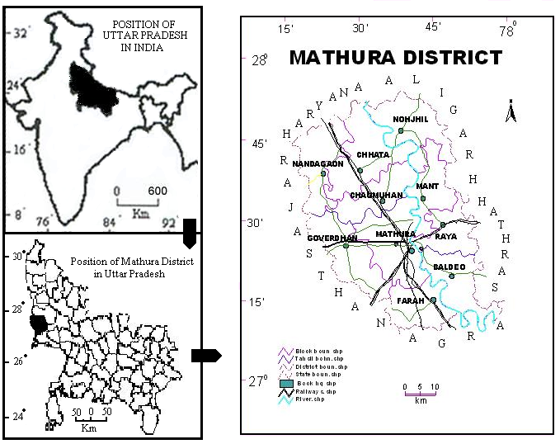
LOCATION OF MATRURA DISTRICT WITH IN INDIA

Source: Census of India. (2011). District Census Handbook: Mathura, Uttar Pradesh (Part XII-B).
Fig.1

Fig. 2

Fig. 3

Fig. 4

Mathura District: - Location Quotient of Cultivators
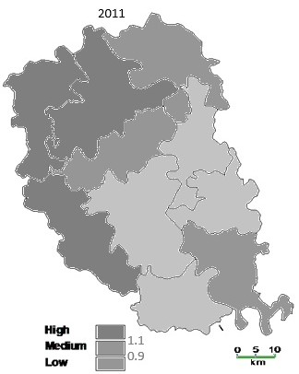
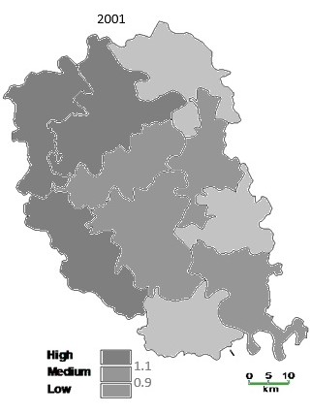
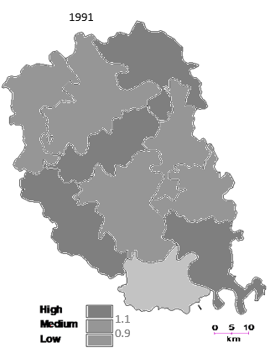
Fig. 5
Mathura District: - Location Quotient of Agricultural Laborers
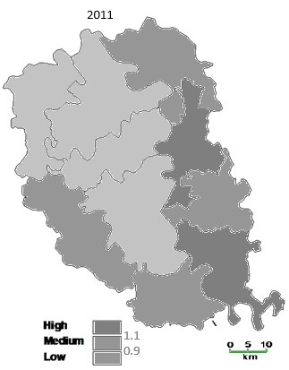
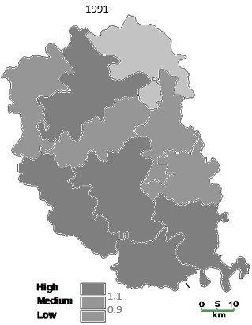
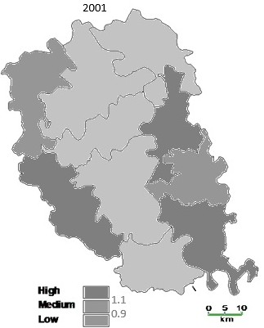
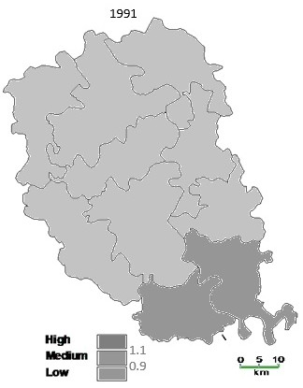
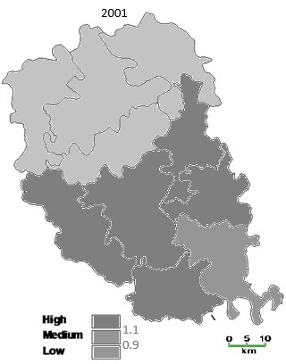
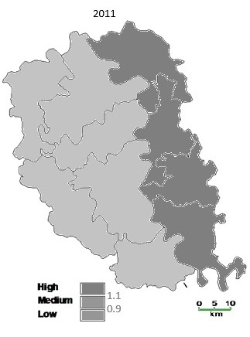
Fig. 7
Mathura District: - Location Quotient of Household Industry Workers
Fig. 6
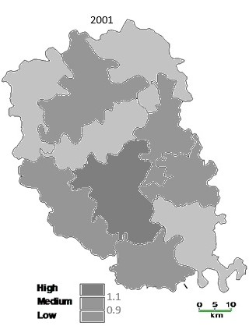
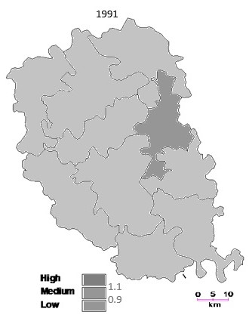
Mathura District: -Location Quotient of Household Other Workers
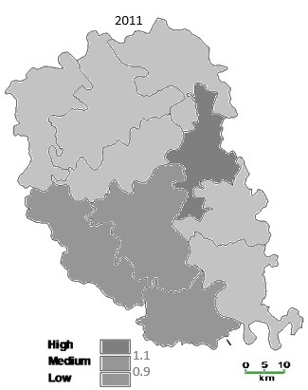
Fig. 8

