An Image-Based Zooplankton Identification Key

.
ABSTRACT

Background: Zooplankton are also known to be excellent bioindicators of the health status of any aquatic environment. Environmental factors such as rainfall, pH, temperature, and nutrient availability influence zooplankton abundance and diversity.
Aim: This study investigates spatial variation in zooplankton species composition across four man-made reservoirs.
Place and Duration of Study: Sampling for zooplankton species was carried out in four reservoirs in Jos North Local Government Area, Jos, Plateau State. Sampling was done from April 2022 to March 2024.
Methodology: Zooplankton samples were examined under a light microscope, and images were captured using a digital microscope camera at the Applied Hydrobiology Laboratory, University of Jos.

Results: Sixty-two photomicrographs of some common zooplankton in these Jos Plateau reservoirs revealed four groups of zooplankton, namely: Protozoa (7 species), Rotifers (29 species), Cladocerans (15 species) and Copepods (11 species), with rotifers being the most diverse.
Conclusion: The study concludes that Rotifers were the most diverse group, indicating their ecological importance in these reservoirs. The photomicrographs generated provide valuable resources for teaching and future research.

Keywords: zooplankton species, photomicrographs, reservoirs, Jos Plateau state.

1. INTRODUCTION
Plankton (phytoplankton and zooplankton) are among the prominent natural live foods for fish and other aquatic organisms. Aquatic ecosystems, either freshwater or marine habitat, harbor many microscopic, free floating or drifting invertebrate species of animals known as zooplankton from which fish derive their nourishment (Khan & Rahman, 2025). These organisms are diverse but the major groups of zooplankton include rotifers, cladocerans, copepods, aquatic insects and molluscs. These live foods contain 50% of the nutritional need of fish growth (Bolorunduro, 2002). Zooplankton are also very important in reservoir ecology because they play the role of herbivores, predators, and prey in an aquatic ecosystem, thereby transferring energy up to the tertiary level in the food chain (FAO, 1996; Dejen et al., 2004; Ghantaloo et al., 2011). They are also known to be excellent bio-indicators of the health status of any aquatic environment. Zooplankton serve as sensitive bioindicators for monitoring ecological health and trophic status of freshwater bodies. Their population dynamics often reflect changes in environmental conditions such as eutrophication, organic pollution, and seasonal fluctuations in physicochemical parameters like dissolved oxygen, pH, temperature and nutrient concentrations (Jarupala et al., 2025). Since they occur naturally, they are a cheap food resource which can be cultured deliberately in large quantity to feed fish fry in the hatchery and adult fish in production ponds thereby reducing the high cost of fish feed and overall production. Zooplankton exhibit distinct advantages over artificial feeds; their natural and diverse nutritional profile aligns closely with the needs of ornamental fish juveniles, offering essential fatty acids, proteins, vitamins, and minerals crucial for healthy growth (Mehran et al., 2025). Early Studies on zooplankton identification by Jeje and Fernando (1986) published a practical guide to identifying Nigerian zooplankton, covering Cladocera, Copepoda, and Rotifera. Species composition studies have identified various zooplankton species in Nigerian water bodies, including the study of Akindele & Adeniyi (2013) in Opa Reservoir, which revealed 31 species belonging to four major classes (Protozoa, Copepoda, Cladocera, and Rotifera). Obot et al (2020) worked in the Stubbs Creek and encountered 9 species belonging to 6 taxonomic groups, with Maxillopoda being the most abundant. Usman, et al. (2022) discovered 11 species, with Brachionidae being the dominant family in Alau Reservoir. There are several environmental factors such as rainfall, pH, temperature, and nutrient availability, that influence zooplankton abundance and diversity (Oyedapo, 2025; Oparaku et al., 2022; Sun et al., 2023). Regional Studies on Zooplankton identification have been conducted in various regions of Nigeria, including Southwest Nigeria, studies on Ogunpa and Ona Rivers which revealed associations between zooplankton and environmental factors (Akin-Oriola, 2003). In Southeastern Nigeria, research on Stubbs Creek identified 9 species of zooplankton (Obot et al. 2020).
The study of zooplankton assemblage and diversity in reservoirs in Jos has suffered neglect. Zooplankton assemblages in Jos Plateau reservoirs remain poorly studied, with many species existing in the wild but under-documented and underutilised. Several studies have been done in this area in several reservoirs in other part of the country but work done on zooplankton on the Jos plateau is patchy while photomicrographs of zooplankton from this area is completely absent.

2. material and methods

2.1 Study Area
The Jos plateau is a high land area in north central of Nigeria which covers an area of about 8,600km² and lies between latitudes 8º30’and 10º10’N and longitudes8º20’and 9º30’E (Ali, 2010). The study site comprises of four reservoirs in the Jos North Local Government Area of Plateau State, Nigeria. The reservoirs are named Kogigirin, Lamingo, Liberty and Tolemache. Kogingirin is on latitude 8º56’ East and 9º55’ North, Lamingo dam is on latitude 8º57’ East and 9º55’ North, Liberty dam is on latitude 8º55’ East and 9º53’ North, Tolemache is on latitude 8º58’ East and 9º54’ north. The four reservoirs, river distributaries, access roads and the major settlements can be seen on the map. Kogigirin, Lamingo, Liberty and Tolemache have elevations of 1285 m, 1306m, 1275m and 1295m respectively above sea level.
Kogingirin is located in the hilly area of Nabor gwom village popularly called Etobaba with X and Y coordinates as 492935.5 and 1097574respectively. Tolemache is located in Tolemache village on the way out of Jos University Teaching Hospital (JUTH) through the second gate with x and y coordinates of 496650.1 and 1093889 respectively, Liberty is located in Laminga village on the way to the Jos University Teaching Hospital through the main gate with x and y coordinates as 492386.7 and1093951 respectively; while Lamingo is located behind the Leadership Training Centre, Shere hills village, Jos with x and y coordinates of 494731.9 and 1095977 respectively.

2.2 Zooplankton collection
Monthly sampling was carried out for a period of two years from April 2022 to March 2024, covering both wet and dry seasons. Sampling was carried out between 6-7 noon. Zooplankton samples were collected by filtering 100 litres of surface water through plankton net of 60 micrometer mesh size and 25 cm in diameter. Plankton net was also towed both vertically and horizontally for ten minutes in the reservoirs. The filtrate was concentrated by decanting for each station and 10% formalin added to each sample bottle to preserve the organisms. The bottles were covered and properly labelled at each location. The samples were transported in ice coolers the Fishery and Aquaculture Laboratory, Department of zoology, University of Jos for onward enumeration.

2.3 ENUMERATION OF ZOOPLANKTON
Zooplankton samples were allowed to settle for about 48 hours. The 100ml filtrate was then decanted to 10 ml. 1ml subsample of the concentrated zooplankton suspension was pipetted into an Immuno-Cell Black Teflon printed counting slide (series 6 walls, 10mm, 61.100.86) and observed under an Olympus ordinary light microscope. All the zooplankton observed were counted and identified to generic and species levels using various taxonomic keys provided by Jeje and Fernando (1986), Shiel (1995), Yamaguchi and Bell (2007), Papa et al. (2012) and Snook (2013).

3. results and discussion

RESULTS
The result of this study is shown in microphitographs. There are four groups of zooplankton represrentted in plates; a total of seven protozoa species are presented in Plates 1-7. Rotifers are shown in Plates 8 – 37 making a total of 29 rotifers. Fifteen Cladocerans are presented on Plates 38-53. Eleven copepods are shown on Plates 54-65. Rotifers are the most numerous with 44.6% of occurrence while protozoa had the list occurrence with 10.7% .
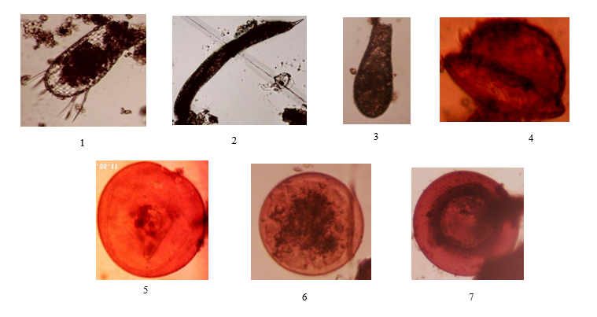

Plates 1-7: Protozoa:1 Euglypha acanthaphora. 2. Euglena sp. 3. Difflugia oblonga, 4. Arcella sp.
5. Arcella discoides 6. Arcella vulgaris 7. Arcella sp.

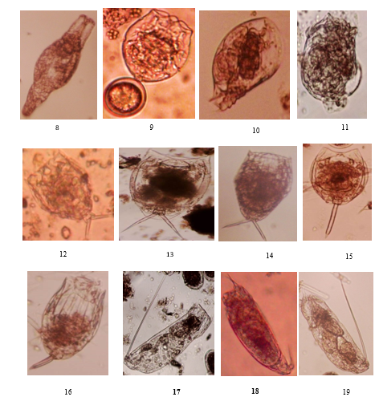
Plates 8-19: Rotifers
8. Philodina sp. 9. Pompholyx sulcate 10. Colurella uncinata 11. Conochilus unicornis 12. Brachionus angularis 13. Lecane unguculata 14. Lecane nitida 15. Lecane cornuta 16. Lecane hamate 17. Trichocerca gracilis 18. T. similis grandis 19. T. cylindrica
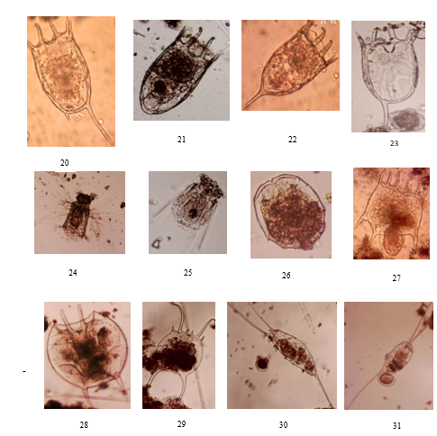

Plates 20-31: Rotifers : 20. Keratella tropica 21. K. tecta 22. K. cochlearis 23. K. valga 24. Polyarthra vulgalaris 25. Polyarthra remata26. Brachionus angularis 27. Platyias quadricornis 28. Brachionus patalus 29. B. falcatus 30. Filinia opoliensis 31. F. longiseta with egg
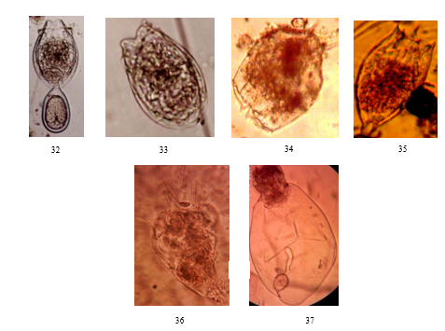

Plates 32-37: Rotifers
32. Anuraeopsis navicula 33. A. fissa 34. Brachionus caudatus 35. Testidunella tridentata 36. Hexarthra mira 37. Asplanchna brightwelli

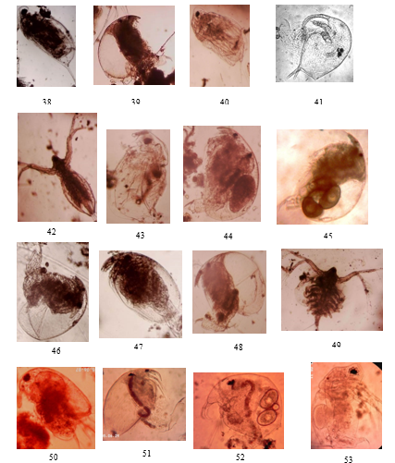
Plates 38-53: Cladocerans: 38. Daphnia longispina 39. Chydorus sp. 40. Ceriodaphnia sp 41. Bosmina longirostris 42. Diaphanosoma brachyurum 43. Ceriodaphnia cornuta 44. Alona rectangula 45. Chydorus sp. 46. Alonella excisa 47. Alona karua 48. Chydorus sp. 49. Diaphanosoma birgei 50. Macrothrix sp 51. Pleuroxus hamatus 52. Bosmina cerogoni 53. Moina micrura.

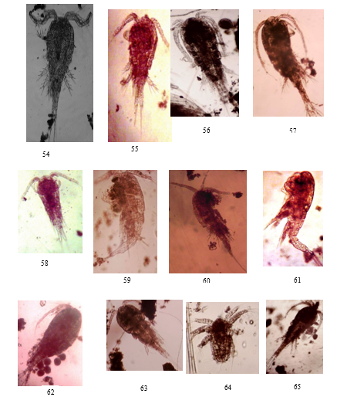
Plate 54-65: copepods;54. Thermocyclops neglectus 55. Microcyclops varicans 56. Mesocyclops edax 57. Eurocyclops agilis 58. Arctodiaptomus dorsalis 62. Tropocyclops prasinus 63. Cyclops sp 64. Nauplius 65. Microcyclops varicans

DISCUSSION
The zooplankton assemblage in the four selected reservoirs in Jos Plateau comprised of many species typical of other reservoirs and other water bodies in Nigeria, Africa and temperate, zones when compared with the extensive work done by Jeje and Fernando (1986), Shiel (1995), Davies and Otene, (2009) just to mention a few. Temperate species like Keratella cochlearis, Polyyarthra vulgaris, Polyarthra sulcata, Asplanchna spp., Bosminia longirostris, encountered in reservoirs in Turkey (Bozkurt and Dural, 2005; Demir, 2005; Bozkurt and Sagat, 2008) were also encountered in these reservoirs on the Jos Plateau. Therefore, the zooplankton encountered in this study are a combination of both tropical and temperate species. This may be due to the unique wide range of temperature prevailing on the Jos Plateau ranging from 4℃ to 33℃ as recorded by Ufodike & Garba (1991), Oyedapo (2025).
Of the four major groups of zooplankton identified in this study, rotifers were found to be highest followed by cladocerans then copepod while protozoa had the lowest representation in terms of number and species richness. The reservoirs are highly resourceful in zooplankton live food. These organisms can be isolated, cultured and used to feed fish fries as cheaper alternatives to artemia thereby lowering the cost of production. Considering the fact that tropical water bodies are known to be low in species composition, high species composition recorded is therefore a warning sign to stake-holders indicative of the eutrophic trophic status the reservoirs.
This image-based checklist is Novel for zooplankton on the Jos Plateau. This study provides the first image-based checklist of zooplankton species in Jos Plateau reservoirs, filling a significant gap in regional limnological research. The only zooplankton checklist was published in 1983 by Khan and Ejike with a total of 16 species did not have pictures of the organisms. The images of these organisms could serve as baseline information for subsequent researchers who wish to identify zooplankton particularly in the field of limnology and hydrobiology. In addition, these pictorial images could serve a visual aid for classroom teaching.

4 CONCLUSION
This study has successful established the presence of zooplankton species in these reservoirs, protozoa, Rotifers, Cladocerans and copepods are the major groups of zooplankton identified in this study. Sixty-two photomicrographs of these organism go further to confirm high diversity and how resourceful these water bodies are in zooplankton species. Farmers and researchers who wish to exploit them for use in their farms can easily identify them with the aid of these photomicrographs.

Disclaimer (Artificial intelligence)

Author(s) hereby declare that NO generative AI technologies such as Large Language Models (ChatGPT, COPILOT, etc.) and text-to-image generators have been used during the writing or editing of this manuscript.

REFERENCES
Akindele, E. O., & Adeniyi, I, F. (2013). A study of the physicochemical water quality, hydrology and zooplankton fauna of Opa reservoir catchment area, Ile-Ife, Nigeria. African Journal of Environmental Science and Technology, 5, 192-203.

Akin-Oriola, G. A. (2003). Zooplankton associations and environmental factors in Ogunpa and Ona rivers, Nigeria Revista De Biología Tropical. 51(2), 391-398.
Bolorunduro, P. I. (2002). Feed formulation and feeding practices in fish culture. National Agricultural Extention and Research Liason Services, Amadu Bello University, Zaria. Extension Bulletin no.152, Fish Series No.7.
Bozkurt, A., & Dural, M. (2005). Vertical Migration of Zooplankton in Topboĝazi Dam Lake (Hatay). Turkish Journal of Aqua Life, 3(4), 104-109.
Davies, O. A., & Otene, B. B. (2009). Zooplankton community of Minichinda stream, Port Harcourt, Rivers State, Nigeria. European Journal of Scientific Research, 26, 490-498.
Demir, N. (2005). Zooplankton of two water reservoirs in Central Anatolia: composition and seasonal cycle. Turkish Journal of Zoology, 29(1), 9-16.
Jeje, C. Y., & Fernando, C. H. (1986). A practical guide to the identification Nigeria zooplankton. New Bussa, Nigeria: Kainji Lake Research Institute.
Khan, M. A., & Ejike, C. (1983). Limnology and plankton periodicity of Jos Plateau Water Reservoir, Nigeria, West Africa. Hydrobiologia, 114, 189-199.
Ufodike, E. B. C., & Garba, A, J. (1991). Diurnal Dynamics in Physico-chemical Parameters of a Productive Highland Fish Pond. Journal of Aquatic Sciences, 9, 7-11.
Obot, O. I., David, G. S., & Ekpo, I. E. (2020). Zooplankton Assemblages of a Tropical Coastal Creek, South-Eastern Nigeria. Ecologia, 10, 63-70.
Oparaku, N. F., Andong, F. A., Nnachi, I. A., Okwuonu, E. S., Ezeukwu, J. C. & Ndefo, J. C. (2022). The effect of physicochemical parameters on the abundance of zooplankton of River Adada, Enugu, Nigeria. Journal of Freshwater Ecology, 37, (1), 33–56.
Oyedapo, F. A. (2025). Ecological study of zooplankton community in four reservoirs in Jos North Local Government Area, Plateau State, Nigeria. PhD thesis in the Department of Zoology, University of Jos, Nigeria.
Papa, R. D. S., Tordesillas, D. T. T., & Mamaril, A. C. (2012). An Updated Taxonomic Account of Limnetic Crustacean Zooplankton in Lake Taal, Philippines. Philippine Journal of Science, 141 (2), 243-252.
Shiel, R. J. (1995). A guide for identification of rotifers, cladocerans and copepods of Australian inland waters. Identification Guide No. 3, Thurgoona, Albury: Murray-Darling Freshwater Centre, Co-operative Research Centre for Freshwater Ecology. 144pp.

Snook, H. (2013). An image-based key to the zooplankton of North Carolina. US Environmental Protection Agency Region 1 Laboratory Manual, UNH Centre for Freshwater Biology, 8th edition: version 5.0.
Usman, A., Hassan, M. Z. Abdullahi A.I., Modu, B. M. Solomon, S.G. Fada, A. Mukhtar, A.H. & Ghoshu E. L. (2022). Composition, abundance and diversity indices of zooplankton in Lake Alau, Borno State Nigeria. Arid-zone Journal of Basic & Applied Research 1(1), 210-220.
Yamaguchi, E., & Bell, C. (2007). Zooplankton Identification Guide. Georgia, USA: The University of Georgia Marine Education Center and Aquarium. Retrieved 28th August, 2014. http://www.marex.uga.edu/aquarium.
Jarupala, L. S., Ganesh, G., Subhashini, P., Suhasini, G., Raju, P., & Raveendar, B. (2025). Comparative Study on Seasonal Zooplankton Diversity in Two Urban Reservoirs of Warangal District, Telangana, India. International Journal of Environment and Climate Change, 15(7), 311–319. https://doi.org/10.9734/ijecc/2025/v15i74931
Mehran, R., Rather, M. A., Chesti, A., Wani, F. F., & Maqbool, M. (2025). Effect of Mixed Zooplankton (Daphnia/Moina) on the Growth Performance and Survival of Hemigrammus caudovitatus (Albino Buenos Aires Tetra). Journal of Scientific Research and Reports, 31(8), 100–110. https://doi.org/10.9734/jsrr/2025/v31i83355
Khan, N. S., & Rahman, M. S. (2025). Zooplankton in Aquaculture: A Perspective on Nutrition and Cost‐Effectiveness. Aquaculture Research, 2025(1). https://doi.org/10.1155/are/5347147
Sun, X., Zhang, H., Wang, Z., Huang, T., Tian, W., & Huang, H. (2023). Responses of Zooplankton Community Pattern to Environmental Factors along the Salinity Gradient in a Seagoing River in Tianjin, China. Microorganisms, 11(7), 1638. https://doi.org/10.3390/microorganisms11071638
‌

