Dynamics of Emotional Intelligence (E.I.), Students’ Professional Competencies and Practical Proficiency in Pharmacy Education
ABSTRACT
Pharmacy education has evolved beyond technical knowledge, emphasising the importance of communication, professionalism, and patient-centred care. Emotional intelligence has emerged as an important factor influencing healthcare students’ professional competencies and practical performance in clinical settings. This study examined the relationship between emotional intelligence (EI), professional competencies, and practical proficiency among pharmacy students in a private university in the Philippines. Guided by Goleman’s Emotional Intelligence Model, the Ability Model, and Experiential Learning Theory, the study explored how emotional and professional competencies are associated with students’ practical performance in pharmacy education. A quantitative descriptive-correlational research design was employed involving 100 third- and fourth-year pharmacy students. Data were collected using standardised and structured survey questionnaires assessing emotional intelligence, professional competencies, and practical proficiency. Findings revealed that respondents demonstrated high levels of emotional intelligence (M = 4.09, SD = 0.452), professional competencies (M = 4.18, SD = 0.426), and practical proficiency (M = 4.28, SD = 0.527). Empathy emerged as the strongest emotional intelligence domain (M = 4.36), while communication (M = 4.42) and medication safety and risk management (M = 4.35) obtained the highest ratings under professional competencies and practical proficiency, respectively. Significant positive relationships were found between emotional intelligence and professional competencies (r = .388, p < .001), emotional intelligence and practical proficiency (r = .441, p < .001), and professional competencies and practical proficiency (r = .660, p < .001). Regression analysis further showed that emotional intelligence and professional competencies jointly explained 47.6% of the variance in practical proficiency (R² = .476, F = 44.534, p < .001). The findings suggest that emotional intelligence and professional competencies are significantly associated with students’ practical readiness in pharmacy education. The study highlights the value of integrating emotional intelligence development into pharmacy curricula to support students’ professional growth and clinical preparedness.
Keywords: emotional intelligence, professional competencies, practical proficiency, pharmacy education, pharmacy students
.
1 INTRODUCTION
Pharmacy education has undergone substantial transformation in response to the increasing complexity of healthcare systems and the expanding responsibilities of pharmacists in patient-centred care. Contemporary pharmacy practice now extends beyond medication dispensing and technical knowledge, requiring pharmacists to demonstrate effective communication, clinical decision-making, ethical judgment, collaboration, and leadership skills in diverse healthcare environments (Anderson & Arakawa, 2021; Atkinson, 2022). As healthcare delivery becomes increasingly interdisciplinary and patient-focused, pharmacy education institutions are expected to prepare students not only with scientific competence but also with the interpersonal and professional attributes necessary for effective clinical practice (Rushworth et al., 2024). Within this evolving healthcare landscape, emotional intelligence (EI) has emerged as an important factor influencing professional effectiveness and performance among healthcare practitioners. Emotional intelligence refers to the ability to recognise, understand, regulate, and appropriately utilise emotions in oneself and others (Goleman, 1995). In healthcare settings, emotional intelligence has been associated with improved communication, empathy, teamwork, stress management, adaptability, and patient-centred care (Antonopoulou, 2024; Hashmi, 2024). Previous studies suggest that emotionally intelligent healthcare professionals are better equipped to manage high-pressure clinical situations, establish therapeutic relationships with patients, and collaborate effectively within multidisciplinary teams (Cavaness et al., 2020; Shamsi et al., 2024).
In pharmacy education, emotional intelligence is increasingly recognised as a valuable component of professional development. Pharmacy students are expected to interact effectively with patients, healthcare professionals, and peers while simultaneously managing academic demands and clinical responsibilities. Studies have shown that emotional intelligence may support students’ academic resilience, leadership engagement, communication competence, and psychological well-being (Ibrahim & Kadi, 2021; Shengyao et al., 2024). Furthermore, emotional intelligence has been linked to improved empathy, self-regulation, and professional behaviour, which are essential qualities in pharmacy practice and healthcare delivery (Butler et al., 2022; Deniz et al., 2024). Alongside emotional intelligence, professional competencies and practical proficiency are essential outcomes in pharmacy education. Professional competencies encompass the knowledge, skills, attitudes, ethical practice, communication abilities, and leadership capabilities required for effective pharmacy practice (Fuller et al., 2024; International Pharmaceutical Federation, 2022). Meanwhile, practical proficiency refers to students’ ability to appropriately apply pharmaceutical knowledge and clinical skills in laboratory and healthcare settings (Boursicot et al., 2021). The development of these competencies is critical in ensuring students’ readiness for professional responsibilities and safe patient care. Modern pharmacy education, therefore, emphasises experiential learning, simulation-based instruction, and clinical exposure to strengthen students’ practical and professional preparedness (Alhassan et al., 2022; Levett-Jones et al., 2023).
Existing literature has demonstrated significant relationships between emotional intelligence and various educational and professional outcomes among healthcare students. Previous studies have associated emotional intelligence with academic achievement, stress tolerance, communication effectiveness, empathy, and leadership skills (Akinbobola & Ojo, 2022; Butler et al., 2022). Similarly, research in pharmacy education highlights the importance of professional competencies and experiential learning in improving students’ practical readiness and clinical confidence (Morello & Fricovsky, 2025; Yoshioka-Maeda & Naruse, 2021). However, much of the current literature primarily focuses on isolated aspects of emotional intelligence or academic performance, with limited studies comprehensively examining its relationship with both professional competencies and practical proficiency among pharmacy students. Moreover, despite the growing international interest in emotional intelligence within healthcare education, there remains limited empirical evidence in the Philippine context exploring how emotional intelligence relates to pharmacy students’ professional competencies and practical proficiency. Existing local and international studies have largely emphasised academic outcomes, leadership, or psychological well-being, while fewer investigations have examined the combined predictive influence of emotional intelligence and professional competencies on students’ practical readiness for clinical and laboratory responsibilities (Gutierrez & Salenga, 2024). This gap highlights the need for further research that integrates emotional, professional, and practical dimensions within pharmacy education. Understanding the relationship among emotional intelligence, professional competencies, and practical proficiency is important in strengthening pharmacy education and preparing future pharmacists for increasingly complex healthcare environments. Identifying the emotional and professional factors associated with students’ practical readiness may help educational institutions develop more holistic instructional strategies and student development programs that support both technical competence and interpersonal effectiveness.
Hence, this study aimed to determine the relationship between emotional intelligence, professional competencies, and practical proficiency among pharmacy students in a private university in the Philippines. Specifically, the study sought to assess the levels of emotional intelligence, professional competencies, and practical proficiency, examine the relationships among these variables, and determine whether emotional intelligence and professional competencies significantly predict practical proficiency among the respondents.
2 THEORETICAL FRAMEWORK
A strong theoretical foundation supports the integration of emotional intelligence (EI) in pharmacy education. Daniel Goleman’s model emphasises key domains such as self-awareness, self-regulation, motivation, empathy, and social skills, which are essential in enhancing communication, teamwork, and ethical practice among pharmacy students. Emotional intelligence, defined as the ability to perceive, understand, regulate, and utilise emotions effectively, has been shown to influence academic performance, interpersonal relationships, and clinical decision-making. Similarly, the Ability Model of Emotional Intelligence explains EI as a set of cognitive abilities that include perceiving, using, understanding, and managing emotions. These competencies support effective decision-making and interpersonal interactions, which are critical in healthcare settings. The model also suggests that emotional intelligence can be developed through training and deliberate practice. Complementing these frameworks, David Kolb’s Experiential Learning Theory highlights the role of concrete experience, reflection, and active experimentation in developing practical skills, particularly through clinical simulations and hands-on activities. In addition, the Competency-Based Education framework emphasises the development of essential knowledge, skills, and attitudes required for effective pharmacy practice. Furthermore, Howard Gardner’s theory of multiple intelligences underscores the importance of interpersonal and intrapersonal intelligences, which are closely linked to emotional intelligence. Collectively, these theories support the premise that emotional intelligence enhances professional competencies and, in turn, improves practical proficiency, enabling pharmacy students to effectively apply their knowledge in real-world clinical settings.

3 METHODOLOGY
3.1 Research Design

This study employed a quantitative descriptive-correlational research design to examine the relationship between emotional intelligence, professional competencies, and practical proficiency among pharmacy students. Descriptive-correlational designs are appropriate in determining relationships among variables without manipulating the research environment (Bermudo, 2010, as cited in Samson & Yango, 2023).

3.2 Research Subjects
The study was conducted in a private university in the Philippines offering a Bachelor of Science in Pharmacy program. The respondents consisted of third- and fourth-year pharmacy students who were selected because they had already undergone professional pharmacy courses, laboratory activities, and clinical-related learning experiences relevant to the study variables. A total of 100 pharmacy students participated in the study. The sample size was considered adequate for correlational and regression analyses, allowing sufficient statistical power to examine the relationships among the variables. A purposive sampling technique was employed to ensure that only respondents with relevant academic exposure and clinical training experiences were included in the study.
Participants were included in the study if they were officially enrolled as third- or fourth-year pharmacy students during the conduct of the study and had completed or were currently taking professional pharmacy courses involving laboratory and clinical components. Students who were not enrolled during the data collection period or who failed to complete the survey questionnaire were excluded from the study.
3.3 Instrumentation and Validation
The study utilised a structured survey questionnaire consisting of three sections: emotional intelligence, professional competencies, and practical proficiency. The emotional intelligence section was adapted from established emotional intelligence frameworks grounded in Goleman’s Emotional Intelligence Model and related emotional intelligence literature. The instrument measured dimensions such as self-awareness, self-regulation, motivation, and empathy using a five-point Likert scale ranging from 1 (“Strongly Disagree”) to 5 (“Strongly Agree”). The professional competencies questionnaire was researcher-developed based on the International Pharmaceutical Federation (FIP) Global Competency Framework for Pharmacy Education and related pharmacy education literature (International Pharmaceutical Federation, 2022; Fuller et al., 2024). The instrument was designed to assess competencies relevant to pharmacy education, including communication, leadership, ethical practice, clinical application, and patient-centred care. The practical proficiency instrument was likewise researcher-developed and constructed based on pharmacy laboratory competencies, clinical performance indicators, simulation-based learning outcomes, and existing literature on pharmacy practice readiness and experiential learning (Boursicot et al., 2021; Alhassan et al., 2022). The instrument assessed students’ perceived proficiency in applying pharmaceutical knowledge and skills in laboratory and clinical settings, including medication safety, prescription interpretation, patient counselling, and clinical problem-solving. All items in the professional competencies and practical proficiency instruments were measured using a five-point Likert scale ranging from 1 (“Strongly Disagree”) to 5 (“Strongly Agree”).
To establish content validity, the research instruments were subjected to expert validation by professionals with expertise in pharmacy education, research methodology, and psychology. The validators evaluated the instruments in terms of clarity, relevance, organisation, appropriateness of content, and alignment with the objectives of the study. Revisions were made based on the recommendations and feedback provided by the validators to improve the overall quality and comprehensibility of the instruments. A pilot test was conducted among pharmacy students who were not included in the actual study sample to assess the reliability and internal consistency of the instruments. The instruments demonstrated acceptable to high internal consistency, indicating that the items were reliable measures of the constructs being studied.
3.4 Data Gathering Procedure
Before data collection, the researcher secured approval and obtained clearance to ensure the study complied with established ethical research standards. Permission to conduct the study was secured from the Dean of Graduate Studies, followed by the approval of the research adviser. Upon endorsement, a formal referral letter signed by the adviser was addressed to the Program Head of the Pharmacy Department to facilitate coordination with the target respondents. Data were collected using a structured survey questionnaire administered through Google Forms to ensure efficient and timely distribution and retrieval of responses. Participation was voluntary, and respondents were able to complete the survey electronically at their convenience. They were provided with an informed consent form explaining the purpose of the study and their right to withdraw at any time without penalty or consequence. Respondents were given approximately 10 minutes to complete the questionnaire. To ensure confidentiality and anonymity, respondents were not required to provide personally identifiable information such as names or student numbers. All responses were treated with strict confidentiality and were used solely for academic and research purposes. The collected data were securely stored in password-protected files accessible only to the researcher and were handled in accordance with data protection and privacy principles. The cleaned dataset was then forwarded to a statistician for appropriate statistical analysis. The data-gathering period was conducted over two weeks to allow adequate time for participation and to obtain a sufficient sample size.

3.6 Treatment and Analysis of Data
The statistical treatments employed in the study were selected based on the specific objectives of the research. Weighted mean and standard deviation were utilised to describe the levels of emotional intelligence in terms of self-awareness, self-regulation, motivation, and empathy; professional competencies in terms of clinical application, communication, ethical practice, and leadership; and practical proficiency in terms of clinical skills, laboratory skills, patient care performance, and medication safety and risk management. To examine the relationships among the variables, Pearson’s r moment correlation coefficient was used to determine the association between emotional intelligence and professional competencies, emotional intelligence and practical proficiency, and professional competencies and practical proficiency. Furthermore, multiple regression analysis was employed to assess the predictive power of emotional intelligence and professional competencies on the respondents’ level of practical proficiency.

4 RESULTS
4.1 Level of Emotional Intelligence
Table 1 presents the overall level of emotional intelligence among pharmacy students across the domains of self-awareness, self-regulation, motivation, and empathy. The findings indicate that an overall high level of emotional intelligence, as reflected by the overall weighted mean of 4.09 (SD = 0.452), indicates that students generally possess strong emotional competencies in understanding, managing, and applying their emotions in academic, social, and clinical settings.
Among the domains, empathy obtained the highest weighted mean of 4.36 (SD = 0.550) and was interpreted as very high, suggesting that the respondents exhibit exceptional ability to understand, recognise, and respond appropriately to the emotions of others. The following domain is motivation with a weighted mean of 4.12 (SD = 0.733). These results highlight that students demonstrate resilience, determination, and a growth-oriented mindset, key qualities that support success in demanding pharmacy education and practice (Fian et al., 2025). Subsequently, self-awareness has a weighted mean of 4.04 (SD = 0.611) and is interpreted as high. The findings imply that students demonstrate a well-developed internal awareness that supports effective interpersonal behaviour, which is an essential competency in pharmacy practice (Butler et al., 2022). Lastly, self-regulation, with an average weighted mean of 3.84 (SD = 0.596). This indicates that students are generally capable of managing their emotions, maintaining composure under pressure, and responding appropriately in academic and clinical situations (Antonoupoulou, 2024).

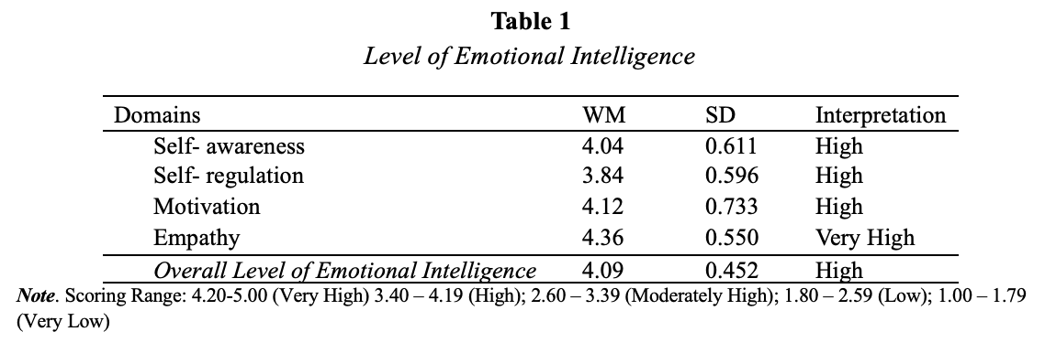

4.2 Level of Professional Competencies
Table 2 presents the overall level of professional competencies among pharmacy students across the domains of clinical application, communication, ethical practice, and leadership. The findings reveal that the respondents demonstrated an overall high level, as reflected by the overall weighted mean of 4.18 (SD = 0.426), indicating that students are competent but still developing in applying clinical knowledge and demonstrating clinical skills.
Among the domains, communication comes first with an average weighted mean of 4.42 (SD = 0.506), indicating that students possess excellent communication skills in both academic and clinical pharmacy settings. They are highly capable of clearly explaining medication instructions, responding effectively to patient concerns, using simple and understandable language, and collaborating with other healthcare professionals. Next is ethical practice with an average weighted mean of 4.36 (SD = 0.580) and interpreted as very high. This indicates that students consistently uphold ethical principles and professional standards in both academic and clinical settings. Clinical application, with an average weighted mean of 4.03 (SD = 0.614), interpreted as high, suggests that students generally demonstrate a strong ability to apply pharmaceutical knowledge in real clinical situations, supporting safe and effective patient care. This highlights students’ strength in patient-centred decision-making and therapeutic judgment. Other competencies, such as interpreting prescriptions, identifying drug interactions, recommending therapies, and integrating theoretical knowledge, also reflect solid clinical skills (Luib et al., 2022).
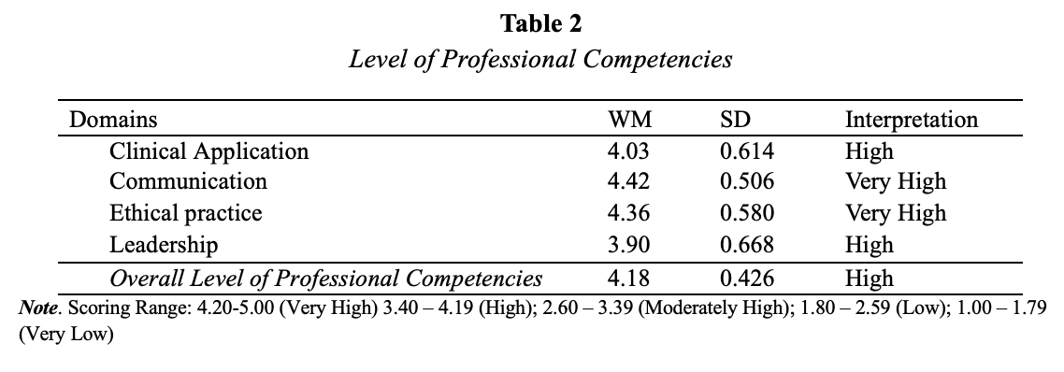

4.3 Level of Practical Proficiency
Table 3 presents the overall level of practical proficiency among pharmacy students across the domains of clinical and laboratory skills, patient care performance, and medication safety and risk management. The findings reveal that the respondents demonstrated an overall very high level of practical proficiency with a weighted mean of 4.28 (SD = 0.527). These suggest that students demonstrate strong and well-developed skills in applying pharmaceutical knowledge in both clinical and practice-based settings.
Among the domains, medication safety and risk management had scored the highest with an average weighted mean of 4.35 (SD = 0.616), interpreted as very high. This indicates that students have a strong awareness of patient safety principles and consistently apply safe practices in pharmaceutical care. These results highlight strong vigilance, accountability, and commitment to minimising medication-related risks. Subsequently, patient care performance has an average weighted mean of 4.31 (SD = 0.630) and is interpreted as very high. This suggests that students are highly competent in delivering patient-centred pharmaceutical care in both academic and clinical settings. Lastly, clinical and laboratory skills, with an average weighted mean of 4.17 (SD = 0.665), interpreted as high, indicate that students are generally capable of applying both clinical and laboratory knowledge effectively in pharmacy practice.
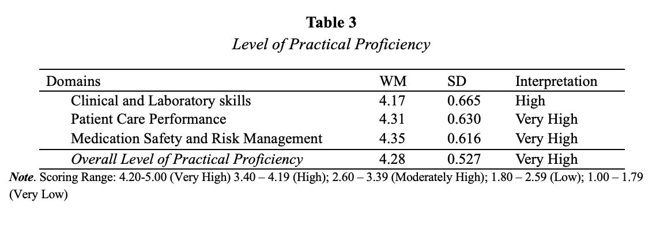
4.4. Emotional Intelligence and Professional
Table 4 shows a weak positive correlation between emotional intelligence and professional competencies (r = 0.388), indicating that as emotional intelligence increases, professional competencies also tend to improve, although the relationship is relatively limited in strength. This falls under the weak correlation category based on Ferrer et al. (2025). However, the relationship is statistically significant (p < .001), meaning the association between the two variables is not due to chance. This confirms that emotional intelligence is significantly related to professional competencies among the respondents.
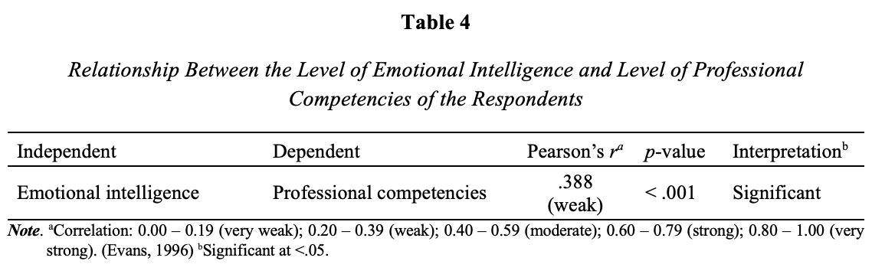

4.5. Emotional Intelligence and Practical Proficiency
Table 5 shows a moderate positive correlation between emotional intelligence and practical proficiency (r = 0.441). This indicates that as the level of emotional intelligence increases, the level of practical proficiency also tends to increase. The relationship falls within the moderate range, suggesting a meaningful and more substantial association compared to weaker correlations. Moreover, the relationship is statistically significant (p < .001), meaning that the association is not due to chance and provides sufficient evidence that emotional intelligence is significantly related to practical proficiency among the respondents.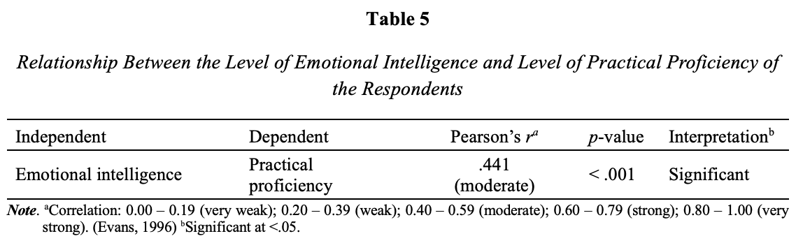
4.6 Professional Competency and Practical Proficiency
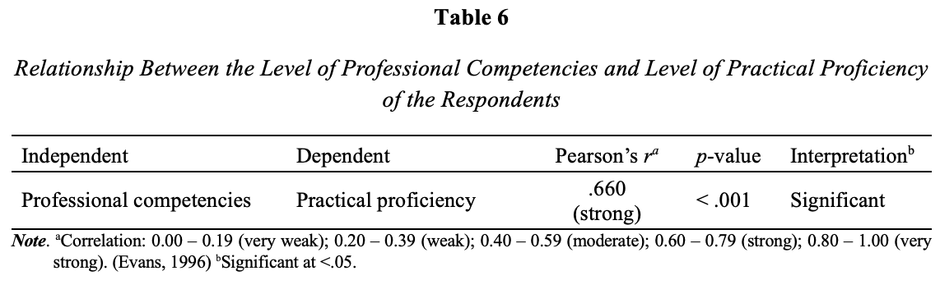
Table 6 shows a strong positive correlation between professional competencies and practical proficiency (r = 0.660). This indicates that higher levels of professional competencies are associated with higher levels of practical proficiency among the respondents. The relationship falls within the strong correlation range, suggesting a substantial and meaningful connection between the two variables. Additionally, the relationship is statistically significant (p < .001), meaning that the observed association is not due to chance and provides strong evidence of a significant relationship between professional competencies and practical proficiency.

4.7 Regression Analysis of the predictive power of the level of emotional intelligence and the level of professional competencies
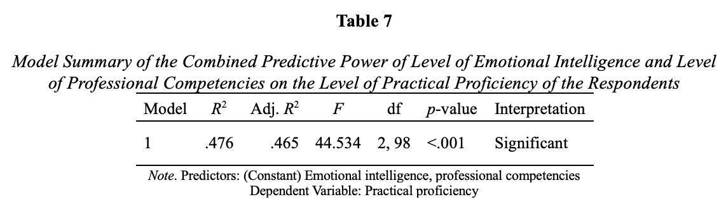
Table 7 shows that the combined influence of emotional intelligence and professional competencies significantly predicts practical proficiency among private school pharmacy students. The model produced an R² value of 0.476 and an adjusted R² of 0.465, indicating that approximately 47.6% of the variance in practical proficiency is explained by these two predictors. This suggests a substantial contribution of both variables in shaping students’ practical performance. Furthermore, the model is statistically significant (F = 44.534, p < .001), confirming that the regression model provides a good fit and that the relationship between the predictors and practical proficiency is not due to chance.

4.8 Predictive Power of Level of Emotional Intelligence and Level of Professional Competency
The results show that both emotional intelligence and professional competencies are significant predictors of practical proficiency among private school pharmacy students. Emotional intelligence has a positive and significant effect on practical proficiency (B = 0.254, β = 0.218, p = .007), indicating that higher emotional intelligence is associated with improved practical performance, although its influence is relatively modest (Cavaness et al., 2020). In contrast, professional competencies show a stronger and more substantial effect (B = 0.711, β = 0.575, p < .001), indicating that they are the dominant predictor of practical proficiency. This means that improvements in professional competencies result in a greater increase in practical performance compared to emotional intelligence.
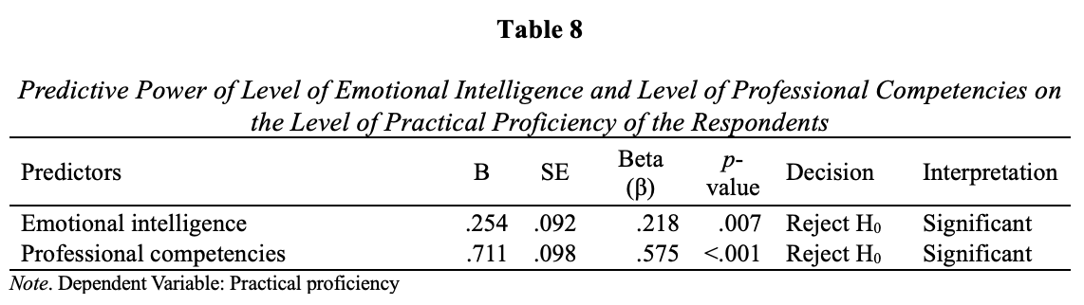
4.9 Action Plan
The action plan, Project ELEVATE, is developed in response to the findings of the study on the Dynamics of Emotional Intelligence (E.I), Students’ Professional Competencies, and Practical Proficiency in Pharmacy Education. The results indicate that while students exhibit high to very high levels across these domains, there are specific areas—such as self-regulation, leadership, and certain clinical and laboratory skills—that require further enhancement. Additionally, the significant relationships among emotional intelligence, professional competencies, and practical proficiency highlight the need for a more integrated and holistic developmental approach.

5 DISCUSSIONS
This study examined the relationship between emotional intelligence, professional competencies, and practical proficiency among pharmacy students. The respondents demonstrated a high level of emotional intelligence, reflecting their strong capacity to effectively perceive, understand, and manage emotions in both personal and professional contexts. These results strongly align with established global research in organisational psychology and human behaviour, stating that students with a high level of emotional intelligence possess strong mental resilience, viewing personal setbacks as temporary hurdles rather than permanent failures (Collamar, 2025). Subsequently, the respondents demonstrated a high level of professional competency, indicating that they are confident in applying pharmaceutical knowledge in clinical settings. The results mirror key trends in modern pharmacy education while contrasting with gaps between self-efficacy and objective practice. The results align closely with a longitudinal study done by Morello and Fricovsky (2025), stating that structured clinical programs effectively generate robust pharmaceutical knowledge and students’ self-confidence. Furthermore, the respondents exhibit a high level of practical proficiency, which suggests that they demonstrate strong and well-developed competencies in applying pharmaceutical knowledge in both clinical and laboratory settings. The result strongly supports the study by Yoshioka & Naruse (2021) that highlights that when institutions explicitly bridge practical proficiency, such as laboratory-focused tasks and simulated clinical practice, students demonstrate high practice-readiness across healthcare settings.
Emotional intelligence contributes to the development of professional competencies; however, other factors such as academic training, clinical exposure, and practical experience also play significant roles in shaping the respondents’ competencies. According to the results, respondents with higher emotional intelligence are more likely to demonstrate better practical skills, highlighting the importance of integrating emotional intelligence into pharmacy education and training programs. Respondents who demonstrate higher levels of competencies, such as clinical application, communication, ethical practice, and leadership, are more likely to perform effectively in practical settings. The result resonates with the study made by Butler et al. (2022) that emotional intelligence significantly influences a student’s academic success, stress tolerance, and ability to provide compassionate, competent, patient care. These findings suggest that emotional intelligence may support students’ ability to function effectively in high-pressure clinical environments. Lastly, respondents’ emotional intelligence and professional competency jointly and significantly predict their level of practical proficiency, explaining a substantial portion of its variance and indicating a strong model fit. This supports the study made by Almogbel et al. (2024), which states that a statistical multivariate regression equation, where the different domains of emotional intelligence combined with professional experience, has been able to predict superior execution of workplace performance, minimising errors in patient counselling and managing medication accurately.

Despite the valuable findings of the study, several limitations should also be acknowledged. First, the findings may have limited generalizability due to the specific population, which is the pharmacy students and the setting involved. Second, the use of self-reported data may introduce response bias, as the participants’ answers may be influenced by personal interpretation. Additionally, the use of Google Forms as the primary data collection tool limited direct researcher supervision during questionnaire completion, which may have resulted in varied interpretations of survey items and potentially affected the accuracy and consistency of the responses. It is hoped that the results of this study will contribute to scholarly discourse and guide future research endeavours involving emotional intelligence, professional competency, and practical proficiency in addressing similar issues with broader populations and settings.

6 CONCLUSION
The findings of the study revealed that pharmacy students demonstrated generally high levels of emotional intelligence, professional competencies, and practical proficiency. Significant positive relationships were observed among these variables, indicating that students with higher emotional intelligence also tended to exhibit stronger professional competencies and practical proficiency. Likewise, higher levels of professional competencies were associated with better practical proficiency. The regression analysis further showed that emotional intelligence and professional competencies were significant statistical predictors of practical proficiency. However, these findings should be interpreted as associative rather than causal, as the study employed a correlational research design. Thus, while the variables were found to be significantly related, the results do not establish direct cause-and-effect relationships. The findings of the study highlight the importance of fostering both emotional intelligence and professional competencies in pharmacy education, as these factors are associated with students’ readiness for clinical and practical responsibilities. In response, the study proposes PROJECT ELEVATE (Enhancing Learning, Emotional Intelligence, and Values to Advance Therapeutic Excellence in Pharmacy Education) as a supportive intervention aimed at strengthening areas that require further development through targeted educational and professional enhancement activities.

Consent

In addition, only students who voluntarily agreed to participate and provided informed consent prior to participation were included in the study.

Disclaimer (Artificial intelligence)
Author(s) hereby declare that NO generative AI technologies such as Large Language Models (ChatGPT, COPILOT, etc.) and text-to-image generators have been used during the writing or editing of this manuscript.

REFERENCES
- Aghabarary, M., & Khedmatizare, M. (2025). Emotional intelligence as a predictor of clinical competence in nursing students. BMC Research Notes, 18(1), 25.
- Ahamad, H., Alam, O., Sultana, N., & Misbahuzzaman, K. (2025). Senior Management and Corporate Environmental Behaviors in Manufacturing Industries of Bangladesh. Corporate Social Responsibility and Environmental Management, 32(6), 8369-8389.
- Ahmed, A., Saqlain, M., Tanveer, M., Blebil, A. Q., Dujaili, J. A., & Hasan, S. S. (2021). The impact of clinical pharmacist services on patient health outcomes in Pakistan: a systematic review. BMC Health Services Research, 21(1), 859.
- Ahmed, K.K., Younus, M.M., Al-Jumaili, A.A. (2024). Pharmacy Education, Practice, and Research in Iraq. In: Al-Worafi, Y.M. (eds) Handbook of Medical and Health Sciences in Developing Countries. Springer, Cham. https://doi.org/10.1007/978-3-030-74786-2_478-1
- Akanni, Abimbola A. & Obi, Irene & Oduaran, Choja. (2022). Occupational Stress, Emotional Intelligence, and Psychological Well-being of Nurses in Government-Owned Hospitals. European Review Of Applied Sociology. 15. 21-29. 10.2478/eras-2022-0003.
- Akinbobola, T., & Ojo, M. (2022). Emotional intelligence as a correlate of academic performance in pharmacy students. African Journal of Pharmacy Education, 15(2), 45–52.
- Alam, J., Haseen, M. A., Hasan, A., Sarfraz, M., & Rahman, S. Z. (2025). Clinical Outcomes and In-hospital Mortality Rate following Heart Valve Replacements at a Tertiary-care Hospital. Exploratory Research and Hypothesis in Medicine, 10(4).
- Al-Ahmadi, H., & Al-Rahomi, A. (2021). Emotional intelligence and its impact on performance: A study of healthcare professionals. Journal of Healthcare Leadership, 13, 111–120. https://doi.org/10.2147/JHL.S301234
- Alaaddin, R. N., Ibrahim, N. K., & Kadi, M. (2021). Leadership skills and their associated factors among pharmacy students at Umm Al-Qura University, Makkah, Saudi Arabia. Journal of Pharmaceutical Research International, 33(50A), 63-76. DOI: 10.9734/JPRI/2021/v33i50A33383
- Al-Azayzih, A., Al-Kubaisi, K. A., Abdel-Qader, D. H., Al Mazrouei, N., Beshir, S. A., & Elnour, A. A. (2025). Community pharmacists’ perception of knowledge, attitudes, and practices toward oral health promotion: A Cross-sectional study on the influence of training, demographics, and resources in the UAE. Plos one, 20(6), e0323193.
- Alhassan, A., Rumman, A. A., & Al-Dabbagh, Z. (2022). High fidelity clinical simulation in pharmacy education: An integrative review. Saudi Pharmaceutical Journal, 30(12), 1735–1745. https://doi.org/10.1016/j.jsps.2022.10.005
- Almansour, A. M. (2023). The level of emotional intelligence among Saudi nursing students: A cross-sectional study. Belitung nursing journal, 9(5), 471.
- Almogbel, Y. S., Alsalloum, M. A., Almadi, R. S., Almazyad, A. A., Garwan, Y. M., & Alregaibah, R. A. (2024). Relationship between pharmacists’ emotional intelligence and job performance: a cross-sectional study in Saudi Arabia. Pharmacy, 12(5), 145.
- ALmegewly, W. H., Rawdhan, A., Saleh, M., Alrimal, M., Alasmari, R., Alhamad, S., ... & Abdelaliem, S. M. F. (2022). Correlation between emotional intelligence and academic achievement among undergraduate nursing students. International Journal of Africa Nursing Sciences, 17, 100491.
- Alsharif, A. (2023). The Impact of Subtitles and Language Proficiency on L2 Incidental Vocabulary Acquisition by Saudi University Students (Doctoral dissertation, Macquarie University).
- Alshammari, T. K., Alkhodair, A. M., Alhebshi, H. A., Rogowska, A. M., Albaker, A. B., Al-Damri, N. T., ... & Alshammari, M. A. (2022). Examining anxiety, sleep quality, and physical activity as predictors of depression among university students from Saudi Arabia during the second wave of the COVID-19 pandemic. International Journal of Environmental Research and Public Health, 19(10), 6262.
- Anderson, S., Main, PAE. Evidence for continuing professional development standards for regulated health practitioners in Australia: a systematic review. Hum Resour Health 21, 23 (2023). https://doi.org/10.1186/s12960-023-00803-x
- Anderson, C., & Arakawa, N. (2021). Pharmacy education development. Pharmacy, 9(4), 163. https://doi.org/10.3390/pharmacy9040163
- Andres, F. (2025). The role of emotional intelligence in self-awareness and well-being. In Development of Self-Awareness and Wellbeing: Global Learning Challenges in a Shifting Society (pp. 1-46). IGI Global Scientific Publishing.
- Antonopoulou, H. (2024). The value of emotional intelligence: Self-awareness, self-regulation, motivation, and empathy as key components. Technium Education and Humanities, 8, 78-92.
- Atkinson, J. (2022). Advances in pharmacy practice: A look towards the future. Pharmacy, 10(5), 125. https://doi.org/10.3390/pharmacy10050125
- Bae, S., Kim, J., & Lee, Y. (2024). Self-regulation mediates the relationship between stress and quality of life in shift-working healthcare professionals: Behavioral clustering insights. Healthcare, 12(9), 180. https://doi.org/10.3390/healthcare12090180
- Bearman, C., Hayes, P., Kuhn, M., Penney, G., McLennan, J., Butler, P., & Flin, R. (2025). The current state and future needs of decision making: knowledge, practice, tools, and training options.
- Beheshti, I. (2025). Brain Age: A Promising Biomarker for Understanding Aging in the Context of Cognitive Reserve. medRxiv, 2025-01.
- Beni, M. D. (2026). Against (theory-neutral) method (in consciousness science). Neuroscience of Consciousness, 2026(1), niag003.
- Biju, A., Wanat, M. A., El-Desoky, R., Vu, C., & Varkey, D. (2023). Evaluation of student emotional intelligence at various points in a pharmacy curriculum. Currents in Pharmacy Teaching and Learning, 15(6), 573–580. https://doi.org/10.1016/j.cptl.2023.06.005
- Borycki, E. M., & Kushniruk, A. W. (2025). Cognitive-socio-technical theory: application and use in health informatics. In Research Handbook on Health Information Systems (pp. 45-59). Edward Elgar Publishing.
- Boursicot, K., Kemp, S., Wilkinson, T., Findyartini, A., Canning, C., Cilliers, F., & Fuller, R. (2021). Performance assessment: Consensus statement and recommendations from the 2020 Ottawa Conference. Medical Teacher, 43(1), 58-67.
- Bru-Luna LM, Martí-Vilar M, Merino-Soto C, Cervera-Santiago JL. Emotional Intelligence Measures: A Systematic Review. Healthcare (Basel). 2021 Dec 7;9(12):1696. doi: 10.3390/healthcare9121696. PMID: 34946422; PMCID: PMC8701889.
- Brunstein, J. C., & Heckhausen, H. (2025). Achievement motivation. In Motivation and action (pp. 227-312). Cham: Springer Nature Switzerland.
- Butler, L., Park, S. K., Vyas, D., Cole, J. D., Haney, J. S., Marrs, J. C., & Williams, E. (2022). Evidence and strategies for including emotional intelligence in pharmacy education. American Journal of Pharmaceutical Education, 86(10), 8674. https://doi.org/10.5688/ajpe8674
- Cavaness, K., Picchioni, A., & Fleshman, J. W. (2020). Linking emotional intelligence to successful health care leadership: the big five model of personality. Clinics in colon and rectal surgery, 33(04), 195-203.
- Cleary, T. J., Konopasky, A., & LaRochelle, J. (2025). Evaluating the instructional strategies influencing self-regulated learning in clinical clerkship years: A mixed studies review. Teaching and Learning in Medicine, 37(1), 45–58. https://doi.org/10.1080/10401334.2025.2468953
- Collamar, Claire. (2025). Mastering Emotional Intelligence: A Path to Personal and Professional Growth. European Journal of Personality. 1. 4. 10.5281/zenodo.14876658.
- Cox, Kathleen M., "IMPACT OF EMOTIONAL INTELLIGENCE ON INTERPROFESSIONAL TEAMWORK, INTERPROFESSIONAL COMMUNICATION, AND INTERPROFESSIONAL LEADERSHIP" (2022). Nursing Theses and Dissertations. Paper 132.
http://hdl.handle.net/10950/3850
- Credé, M., & Harms, P. D. (2021). Three cheers for descriptive statistics—and five more reasons why they matter. Industrial and organizational psychology, 14(4), 486-488.
- Crisp, H., Tavabie, O., Enever, Y., Allen, R., Silverman, M., Acevedo, J., ... & Mehta, G. (2024). Decompensated Liver Cirrhosis Research Network (UK-CLIF): Building consensus for hepatology trials in the UK. NIHR open research, 4, 69.
- de Almeida, C. V., & Belim, C. (2021). Health professionals' communication competences as a light on the patient pathway: the assertiveness, clarity, and positivity (ACP) model. International Journal of Applied Research on Public Health Management (IJARPHM), 6(1), 14-29.
- Deniz, E. U., Ceylan, C., Eren, R., & Memiş, O. B. (2024). Advancing empathy and emotional intelligence among pharmacy students: A comparative mixed-methods study with peer role-play simulation intervention. Currents in Pharmacy Teaching and Learning, 16(8), 102112. https://doi.org/10.1016/j.cptl.2024.102112
- Dharmarajlu, S. M., & Anuratha, M. D. (2025). Evaluating the Self-Care Efficacy and Needs of Cancer Patients Experiencing Chemotherapy Side Effects. Advancements in Life Sciences, 12(1), 127-133.
- Dunlosky, J., & Metcalfe, J. (2025). Metacognitive awareness of pharmacists at different stages of the educational continuum: A comparative study. Frontiers in Education, 10, 1503034. https://doi.org/10.3389/feduc.2025.1503034
- El Alami, L., Aggya, J. A., & Oulahsene, M. S. (2025). A Comparative Analytical Study of Educational Legislation in Europe and the Arab World. Contemporary Studies Journal in Education and Psychology, 1(2).
- El-Awaisi, A., Rayan, M., Al-Khater, D. M., Stewart, D., Al-Hamdani, M., Jaam, M., & Diab, M. I. (2025). Behavioral Determinants of Leadership Engagement in Health Profession Students: A Cross-Sectional Study Using the Theoretical Domains Framework (TDF). Journal of Healthcare Leadership, 509-526.
- El-Ibiary, S. Y., Yam, L., & Lee, K. C. (2017). Assessment of burnout and associated risk factors among pharmacy practice faculty in the United States. American Journal of Pharmaceutical Education, 81(4), 75. https://doi.org/10.5688/ajpe81475
- Emmerling, R. J., & Cherniss, C. (2025). Emotional intelligence in the workplace. Consulting Psychology Journal, 77(3), 209.
- Epstein, C. F. (2022). Women's place: Options and limits in professional careers. Univ of California Press.
- Eichbaum, Q., & Bleakley, A. (2025). Re-visioning intercultural relational empathy. Advances in Health Sciences Education, 1-15.
- Ferrer, J. G. Clinical Competence, Practice Readiness, and Transition-to-Practice Outcomes Among New Graduate Nurses: A Systematic Literature Review.
- Ferrero, M., Vadillo, M. A., & León, S. P. (2021). A valid evaluation of the theory of multiple intelligences is not yet possible: Problems of methodological quality for intervention studies. Intelligence, 88, 101566. https://doi.org/10.1016/j.intell.2021.101566
- Frank, J. R., Snell, L. S., & Sherbino, J. (Eds.). (2021). CanMEDS 2025: Physician Competency Framework. Royal College of Physicians and Surgeons of Canada.
- Fuller, K. A., Kennedy, M. J., & Malcom, D. R. (2024). Core competency framework for pharmacists and longitudinal professional development. American Journal of Pharmaceutical Education, 88(2), 100654.
- Goleman, D. (1995). Emotional intelligence: Why it can matter more than IQ. Bantam Books.
- Gonzales, M. (2022). Emotional Intelligence for students, parents, teachers, and school leaders. A Handbook for the Whole School Community.
- Graham, M. R., & Hardinger, K. L. (2025). Intrinsic motivation and learning strategies: Their impact on pharmacy students' academic performance and standardized exams. Medical Research Archives, 13(4). https://esmed.org/MRA/mra/article/view/6448
- Gudi, N., Konapur, R., John, O., Sarbadhikari, S., & Landry, M. (2021). Telemedicine supported strengthening of primary care in the WHO South East Asia region: lessons from the COVID-19 pandemic experiences. BMJ Innov, 7(3), 580-585.
- Gutiérrez, M., & Salenga, R. (2024). The Comparative Analysis of Pharmacy Education: Benchmarking the Philippine Model Against Asian-Pacific Approaches. Interprofessional Journal of Health Sciences, 22(1).
- Hagger, M. S. (2025). Psychological determinants of health behavior. Annual Review of Psychology, 76(1), 821-850.
- Halpern, J., Montemayor, C., & Fairweather, A. (2022). In principle, obstacles for empathic AI: why we can’t replace human empathy in healthcare. AI & society, 37(4), 1353-1359.
- Hampton, J. M., Ward, E. C., Morrison, L., Sosnowski, K., Banham, J., Libera, M., ... & Day, M. A. (2025). The development and feasibility of a psychologist-led screening and modular-based psychological intervention in an Australian intensive care unit: A pilot study. Australian Critical Care, 38(6), 101301.
- Hashmi, A. M. (2024). Impact of emotional intelligence on professional performance and stress resilience among healthcare practitioners. Cureus, 16(2), e54321. https://doi.org/10.7759/cureus.54321
- Hemmler, Y. M., & Ifenthaler, D. (2024). Self-regulated learning strategies in continuing education: A systematic review and meta-analysis. Educational Research Review, 45, 100629.
- Hobeika, Eva & Hallit, Souheil & Sacre, Hala & Obeid, Sahar & Hajj, Aline & Salameh, Pascale. (2020). Factors Associated with Empathy Among Community Pharmacists in Lebanon. Journal of Pharmaceutical Policy and Practice. 13. 10.1186/s40545-020-00237-z.
- Hojat, M., Maio, V., Pohl, C. A., & Gonnella, J. S. (2023). Clinical empathy: definition, measurement, correlates, group differences, erosion, enhancement, and healthcare outcomes. Discover Health Systems, 2(1), 8.
- Huy, N. D., Thuy, B. T. P., & Van, D. T. (2025). Pharmacists’ attitudes, perceptions, and preferences regarding continuing education: A cross-sectional study in Vietnam. JMIR Medical Education, 11, e77013. https://doi.org/10.2196/77013
- Ibrahim, N. K., & Kadi, M. (2021). Emotional intelligence and its relationship to leadership, depression, anxiety, and stress among pharmacy students, Makkah, Saudi Arabia. Journal of Pharmaceutical Research International, 32(43), 9–21. https://doi.org/10.9734/jpri/2020/v32i4331061
- Indrasvari, J. F., Purnomo, J. D., & Adiatama, A. (2025). Motivational skills as a predictor of academic resilience in higher education. Journal of Applied Psychology and Education, 12(1), 45–58.
- International Pharmaceutical Federation. (2022). FIP global competency framework for educators & trainers in pharmacy. FIP. https://www.fip.org/file/5235
- Kan, R. Y., & Lim-Ratnam, C. (2026). Affordances of an in-between space of learning to foster professionalism. Studies in Higher Education, 51(2), 228-240.
- Karia, A., & Kurup, S. (2022). Social empathy in healthcare: A critical review. Journal of Medical Humanities, 43(1), 89–102.
- Kozubal, M., Szuster, A., & Wielgopolan, A. (2023). Emotional regulation strategies in daily life: the intensity of emotions and regulation choice. Frontiers in psychology, 14, 1218694.
- Lailaturrahmi, L., Caliph, S., Vu, T., & Larson, I. (2026). Teaching clinical skills online in pharmacy education: a scoping review. Currents in Pharmacy Teaching and Learning, 18(5), 102607.
- Larose-Pierre, M., Cleven, A. J., Renaud, A., Hughes, J. A., McQuade, B., Griffin, B. L., & Johnson, C. (2023). Reevaluating core elements of emotional intelligence in professional identity formation for inclusion in pharmacy education. American Journal of Pharmaceutical Education, 87(6), 100082.
- Levett-Jones, T., Cant, R., & Lapkin, S. (2023). Simulation-based education for developing empathy in healthcare students: A systematic review. Nurse Education Today, 120, 105650. https://doi.org/10.1016/j.nedt.2022.105650
- Liu, J., Fan, Y., Wang, J., Tao, C., & Chen, M. (2022). A model-scale experimental and theoretical study on a mineral oil-immersed battery cooling system. Renewable Energy, 201, 712-723.
- London, M., Sessa, V. I., & Shelley, L. A. (2023). Developing self-awareness: Learning processes for self-and interpersonal growth. Annual review of organizational psychology and organizational behavior, 10(2023), 261-288.
- Lyng, H. B., Macrae, C., Guise, V., Haraldseid-Driftland, C., Fagerdal, B., Schibevaag, L., & Wiig, S. (2022). Capacities for resilience in healthcare: a qualitative study across different healthcare contexts. BMC SHealth services Research, 22(1), 474.
- Machado, P. T., Eicher, M., Delouane-Abinal, A., Kupferschmid, S., & Roulin, M. J. (2025). Clarification and development of advanced practice roles in a Swiss French university hospital: an action research study. BMC SHealth Services Research, 25(1), 119.
- Maldonado, D., & Stewart, J. (2024). Comparing the evolution of self-regulated learning behaviors to academic performance, personality, and self-efficacy in the introductory physics classroom.
- Martini, N., Sajtos, L., Idio, L., Kaur, M., Sweeney, N., Zhang, C., & Scahill, S. (2024). The future of pharmacy work: How pharmacists are adapting to and preparing for technology infusion. Exploratory Research in Clinical and Social Pharmacy, 14, 100472. https://doi.org/10.1016/j.rcsop.2024.100472
- Marchi, G., Chaabouni, M., Bakiri, K., Munavvar, M., & Juul, A. D. (2026). ERS Congress 2025: highlights from the Clinical Techniques, Imaging and Endoscopy Assembly. ERJ Open Research, 12(1), 01564-2025.
- Mayer, J. D., Caruso, D. R., Sitarenios, G., & Escobar, M. R. (2024). How many emotional intelligence abilities are there? An examination of four measures of emotional intelligence. Emotion, 24(3), 567–585. https://doi.org/10.1037/emo0001234
- Medina, M. S., & Melchert, R. B. (2023). Affective domain learning in pharmacy education: A roadmap for the future. American Journal of Pharmaceutical Education, 87(1), 8910.
- Medina, M. N. (2017). Training motivation and satisfaction: The role of goal orientation and offshoring perception. Personality and Individual Differences, 105, 287-293.
- Melhuish, K., Austin, C. K., Gleason, J., & Lai, Y. (2026). Quantitative Measures in Undergraduate Mathematics Education: A Review of Instruments and Validity Evidence. International Journal of Research in Undergraduate Mathematics Education, 1-29.
- Merkebu, J., Soh, M., Loncharich, M., Hawks, M. K., Costello, J. A., Shapiro, M., ... & Zheng, B. (2025). Emotions and clinical reasoning in medical education and clinical practice: a scoping review. Academic Medicine, 10-1097.
- Mertens, S., Meyfroodt, K., & Schollaert, E. (2025). Leader Humility and Affective Commitment: A Cross‐Sectional Study Among Hospital Nursing Teams. Journal of Advanced Nursing, 81(8), 4746-4757.
- Miller, W. (2026). Integrating Motivational Interviewing With Cognitive Behavioral Therapy. Psychotherapy for the Advanced Practice Psychiatric Nurse: A How-To Guide for Evidence-Based Practice.
- Morello, C. M., & Fricovsky, E. S. (2025). Long-Term Impact of Sustained Knowledge, Confidence, and Clinical Application Following a First-Year Student Pharmacist Diabetes Self-Care Education Program. Pharmacy, 13(2), 42. https://doi.org/10.3390/pharmacy13020042
- Mylrea, M. F., Senadheera, S., & Wheeler, A. (2025). Exploring pharmacy students' perceptions of feedback and self-reflection in patient counseling simulations: Implications for professional development. Pharmacy Education, 25(1), 12196583. https://doi.org/10.1080/2331186X.2025.2498183
- Ohmori, T., Maeda, K., Hiraoka, A., Pak, K., Ohtani, A., Yanagino, Y., ... & Miyagawa, S. (2026). Clinical Value of the Flow-Adjusted Pressure Gradient in Patients Undergoing Surgical Aortic Valve Replacement. The Journal of Thoracic and Cardiovascular Surgery.
- Park, M. E., & Byon, K. K. (2025). Transformational leadership and perceived performance of taekwondo athletes: Leader trust as a mediator. Social Behavior and Personality: an international journal, 53(3), 1-10.
- Porter, A. L., Frenzel, J. E., & Siodlak, M. M. (2022). Assessment of a two-school collaborative telepharmacy simulation. Currents in Pharmacy Teaching and Learning, 14(2), 215-221.
- Reeves, J. J., Goldhaber, N., Hollandsworth, H., Cox, K., Dumitru, A. M., Zhao, B., ... & Clary, B. (2025). Leveraging Lean methodology to improve compliance with work-hour restrictions. JAMA Surgery, 160(2), 200-208.
- Robinson, L. E., Valido, A., Drescher, A., Woolweaver, A. B., Espelage, D. L., LoMurray, S., & Dailey, M. M. (2023). Teachers, stress, and the COVID-19 pandemic: A qualitative analysis. School mental health, 15(1), 78-89.
- Rodrigues, T. F., Silva, R., Fernández-Aranda, F., & Machado, P. P. (2024). Emotion regulation, eating psychopathology, and putative transdiagnostic psychological processes: findings from an exploratory network analysis in a college sample. Nutrients, 16(20), 3452.
- Romanelli, M., Taddeo, F., Turchi, G. P., & Iudici, A. (2025). State of the art on the main intervention methodologies in the field of emergency psychology: a systematic review. Frontiers in Psychology, 16, 1597897.
- Roodbeen, R., Vreke, A., Boland, G., Rademakers, J., van den Muijsenbergh, M., Noordman, J., & van Dulmen, S. (2020). Communication and shared decision-making with patients with limited health literacy: helpful strategies, barriers, and suggestions for improvement reported by hospital-based palliative care providers. PloS one, 15(6), e0234926.
- Ruble, M. J., Cole, J. D., Jacoby, J. L., Smith, A. B., Duka, S., Kincaid, H., & Quinn, J. F. (2024). Longitudinal assessment of empathy and burnout across a single pharmacy class cohort. American Journal of Pharmaceutical Education, 88(1), 100604.
- Rushworth, G, Paul Forsyth, Andrew Radley, Catherine Duggan, Rod Sampson, Scott Cunningham, Barry Maguire, A Pharmacist Clinician Model as part of a collaborative clinical workforce: A philosophical critique, Research in Social and Administrative Pharmacy, Volume 20, Issue 9, 2024, Pages 918-925, ISSN 1551-7411, https://doi.org/10.1016/j.sapharm.2024.06.006.
- Rutter, L. A., Norton, D. J., & Brown, T. A. (2021). Visual attention toward emotional stimuli: Anxiety symptoms correspond to distinct gaze patterns. Plos one, 16(5), e0250176.
- Ryan, R. M., Duineveld, J. J., Di Domenico, S. I., Ryan, W. S., Steward, B. A., & Bradshaw, E. L. (2022). We know this much is (meta-analytically) true: A meta-review of meta-analytic findings evaluating self-determination theory. Psychological Bulletin, 148(11-12), 813.
- Safarlı, E. (2021). The Importance of Emotional Intelligence in Interpersonal Relationships: A Study on Pilots in the Context of Daniel Goleman’s Emotional Intelligence Model. International Journal of Business and Economic Studies, 3(Human Resources Management Special Issue), 76-90. https://doi.org/10.54821/uiecd.931546
- Salam, S., Beshir, S., Sana, S., Hussain, F., & Shahiwala, A. (2025). Fostering empathy and social responsibility in pharmacy students through experiential service-learning: A qualitative study. Pharmacy Practice, 24(4). https://doi.org/10.18549/PharmPract.2025.4.3275
- Salenga, R. Gutiérrez, M., (2024). The Comparative Analysis of Pharmacy Education: Benchmarking the Philippine Model Against Asian-Pacific Approaches. Interprofessional Journal of Health Sciences, 22(1).
- Sameera, V., Bindra, A., & Rath, G. P. (2021). Human errors and their prevention in healthcare. Journal of Anaesthesiology Clinical Pharmacology, 37(3), 328-335.
- Sanchez, J. M. (2024). Integrating measurement uncertainty analysis into laboratory education for the development of critical thinking and practical skills. Journal of Chemical Education, 101(11), 4783-4789.
- Shamsi, A., Al-Sharif, A., & Al-Hassan, M. (2024). The role of emotional intelligence in authentic leadership among healthcare professionals. Leadership in Health Services, 37(1), 112–128.
- Sharma, D., Pandey, H., Khandelwal, V., & Walker, R. C. (2025). A decade of business and professional communication quarterly: A PRISMA-guided systematic review. Business and Professional Communication Quarterly, 88(2), 199-222.
- Shengyao, Y., Xuefen, L., Jenatabadi, H. S., Samsudin, N., Chunchun, K., & Ishak, Z. (2024). Emotional intelligence impact on academic achievement and psychological well-being among university students: the mediating role of positive psychological characteristics. BMC psychology, 12(1), 389.
- Shorey, S., & Ng, E. D. (2021). The use of virtual reality simulation among nursing students and registered nurses: A systematic review. Nurse education today, 98, 104662.
- Sibarani, M. (2024). Exploring the role of self-awareness, self-integrity, self-regulation, and ethics education in the students' ethics compliance: Evidence from Indonesia. International Journal of Ethics Education, 9(2), 283–305. https://doi.org/10.1007/s40889-024-00188-y
- Stonier, P. D., & Jones, S. A. (2025). Professional Competencies and Capabilities in the Development of Medicines: PD Stonier, SA Jones. Pharmaceutical medicine, 39(4), 225-234.
- Suleiman, A. K., & Ming, L. C. (2025). Transforming healthcare: Saudi Arabia's vision 2030 healthcare model. Journal of pharmaceutical policy and practice, 18(1), 2449051.
- Taylor, J., & Francis, K. (2025). The role of self-regulated learning in clinical pharmacy education: A systematic review. Journal of Pharmacy Practice and Research, 55(2), 112–125.
- Taylor, J., Smith, L., & Brown, R. (2025). Impact of artificial intelligence on the future of clinical pharmacy and human-centric proficiency. Journal of Clinical Pharmacy and Therapeutics. Advance online publication.
- Tian, Z., Ma, Y., Sun, Y., Zhu, Q., Zheng, R., Guan, Y., & Zhang, X. (2025). Effectiveness of Acceptance and Commitment Therapy on Reducing Depression and Anxiety in Older Adults: A Systematic Review and Meta‐Analysis. Journal of Psychiatric and Mental Health Nursing, 32(3), 643-655.
- Thobani, S., & Anwar, K. (2024). Empathy and self-regulation: Key drivers for patient-centered care. Journal of Interprofessional Education & Practice, 34, 100678.
- Tungol, J. R. (2023). Psychological well-being and social connection in post-pandemic education. Philippine Journal of Educational Psychology, 15(2), 67–80.
- Ulutas, E., Ceylan, C., & Eren, R. (2024). Communication barriers in pharmacy practice: The role of emotional intelligence. Patient Education and Counseling, 118, 104567.
- Valdivia, C. D. V. (2022). Niveles de inteligencia emocional en estudiantes de la carrera de psicología de una universidad pública peruana: Levels of emotional intelligence in psychology students at a Peruvian public university. Revista de la Facultad de Medicina Humana, 22(3).
- Ventura, S. C., & Midões, C. M. (2025). Effective Communication in Healthcare and Pharmacy Care in the Digital Era. In Technological Approaches to Medical and Pharmaceutical Education (pp. 157-184). IGI Global Scientific Publishing.
- Waddington, J. (2023). Early foreign language education: play as a site for child agency. Journal of multilingual and Multicultural development, 1-15. https://doi.org/10.1080/01434632.2023.2290095
- Wang, Y., Zhang, M., Roehrich, J. K., Ma, R., & Zhai, Y. (2026). Scaling emerging healthcare technology: managing paradoxical tensions in a connected health platform. Journal of Operations Management, 72(2), 233-256.
- Williams, Z. (2021). Daniel Goleman’s emotionally intelligent contribution to organizational theory. Journal of management and innovation, 7(1).
- Wright, C. F., Campbell, P., Eberhardt, R. Y., Aitken, S., Perrett, D., Brent, S., ... & Firth, H. V. (2023). Genomic diagnosis of rare pediatric disease in the United Kingdom and Ireland. New England Journal of Medicine, 388(17), 1559-1571.
- Yango, A. R., Bermudo, P. J. V., & Quendangan, E. B. (2019). College Students’ Attitude towards the Internet as a Communication Medium and Level of Utilization of the English Language in the Classroom. Open Journal of Social Sciences, 7(07), 10-4236.
- Yengyao, S., Phrakhru, S., & Siriporn, P. (2024). The mediating role of motivation in the relationship between emotional intelligence and academic resilience. Educational Sciences, 14(3), 215. https://doi.org/10.3390/educsci14030215
- Yoshioka-Maeda, K., & Naruse, K. (2021). Effectiveness of Health Guidance Simulation in Community Settings for Public Health Nursing Students: A Preliminary Study. SAGE Open Nursing, 7, 23779608211001355. https://doi.org/10.1177/2377960821100135
- Yotarak, N., Kunawaradisai, N., Jinatongthai, P., Pitchayajittipong, C., & Supapaan, T. S. (2025). Effects of a remote counseling telepharmacy program on patients with pulmonary tuberculosis. Pharmacia, 72, 1-10.
- Zhylin, M., Zhylina, V. V., Bondarevych, S., Kokorina, Y., & Tatianchykov, A. (2024). Genetic basis of emotional regulation: integrative analysis of behavioral and neurobiological data
- Zimmerman, B. J. (2002). Achieving self-regulation: The trial and triumph of adolescence.

