Original Research Article

Environmental Attitudes and Water Conservation Practices Among Rural Households in San Juan, Sta. Maria, Davao Occidental: Implications for Sustainable Resource Management

ABSTRACT

Aims: This study investigated the correlation between environmental attitudes and water conservation practices within rural households in Barangay San Juan, Sta. Maria, Davao Occidental. It aimed to profile respondents, evaluate their environmental attitudes, identify water-conservation practices, and perform an empirical analysis of the relationships among these variables.
Study design: A quantitative descriptive-correlational design was used. Data were collected through a structured survey questionnaire and analyzed using descriptive statistics (frequency, percentage, mean, standard deviation) and inferential statistics using the Pearson Product-Moment Correlation Coefficient.
Place and Duration of Study: San Juan, Sta. Maria, Davao Occidental, Philippines, from March and April 2026.
Methodology: We included 232 households through simple random sampling; most respondents were female (69.2%) and aged 31–40 years (30.2%). Data were gathered using a structured Likert-scale questionnaire covering socio-demographics, environmental attitudes (7 items), and water conservation practices (7 items). Data were analyzed using descriptive statistics, while Pearson r and tests of significant difference were applied at a 0.05 level of significance.
Results: Respondents were mostly aged 31–40 (30.2%), female (69.2%), with elementary (45.3%) or high school education (42.7%), primarily engaged in farming (60.3%), and living in households of 3–5 members (52.6%). Environmental attitudes were moderate to high (M = 4.02, SD = 0.66), while water conservation practices were high (M = 4.15, SD = 0.62). Strong agreement was noted on protecting natural resources (M = 4.10) and educating family members on water conservation (M = 4.18). Inferential analysis showed a significant relationship between environmental attitudes and water conservation practices (p < 0.05), indicating that higher environmental awareness corresponds to better conservation behavior.
Conclusion: Environmental attitudes significantly influence water conservation practices; strengthening environmental education, community participation, and sustainable water management is essential for responsible and long-term water sustainability.

Keywords: environmental attitudes, water conservation practices, water resource management, environmental awareness, water sustainability, rural households

1. INTRODUCTION
Water is a fundamental natural resource, essential for all life and sustainable living (World Health Organization, 2021), forming a major part of all living organisms and recognized as one of the most vital resources for humanity (Jabeen et al., 2020). Although water is abundant and essential for sustainable living, about 70% of the Earth’s surface is covered by it. Approximately 97% of the Earth’s water is contained in the oceans, while only about 2.5% is freshwater, most of which is stored in ice or underground, leaving less than 1% readily available for human use (Stephens et al., 2020). The goal of Sustainable Development Goal (SDG) 6 by 2030 is to ensure that water supply and sanitation are available to all people in a sustainable and timely manner (United Nations, n.d.).

Water is a key resource for sustainable development as it is a prerequisite to human survival, socioeconomic development, energy generation, agricultural production, and ecosystem health. It is also important for adapting to climate change as it connects people and the natural world (United Nations, 2023). Water is essential, but water shortages have become a major global issue that threatens human health, food security, economic growth, and the environment. The Earth has a lot of water, but only a small percentage of that water is fresh water available for human consumption (U.S. Geological Survey, n.d.). Hence, water conservation is a very important global objective. With population growth, climate change, and overuse, the world's limited water supplies are under increasing pressure. This highlights the importance of good and long-term water management plans.

Water and sanitation problems remain severe globally. According to the World Health Organization and UNICEF, 2.1 billion people still lack safely managed drinking water, and 3.4 billion people do not have safely managed sanitation, including 354 million who practice open defecation [7]. These alarming figures underscore the need to address water access and hygiene as part of efforts to improve public health and make development more sustainable.

Water security remains a major challenge in the Philippines. Millions of Filipinos still lack reliable access to safe water (Agbon, 2025). In many areas, water demand consistently exceeds supply. Additionally, hundreds of towns and cities across the country are labeled "waterless," meaning many people have limited access to clean water. The Department of Environment and Natural Resources reports that managing water resources in the Philippines is difficult due to environmental damage, inadequate infrastructure, and an unequal distribution of freshwater resources (DENR, 2022).

Recent studies in the Philippines emphasize the growing importance of sustainable water management, household water conservation, and the role of local government units (LGUs) and water providers in addressing water-related challenges. A study by Frontiers in Water found that rural communities in Bontoc, Philippines, experience water supply inadequacy and unequal distribution due to water scarcity, population growth, and inefficient water management systems. The study highlighted the importance of cooperation between households and LGUs in promoting water conservation and improving water supply services. A technical study in the Davao Region highlights that water scarcity and supply inefficiencies in rural areas require structured water distribution systems supported by LGUs and national programs such as SALINTUBIG. It stresses that proper planning and government coordination are critical to ensuring safe and adequate access to water in communities. Moreover, Salinas (2025) emphasizes that household water conservation is strongly influenced by environmental attitudes and awareness. Watershed studies in the Philippines highlight the importance of integrated modeling and local water governance systems (Perez et al., 2025). Furthermore, broader water sustainability research supports the need for stronger LGU participation and policy coordination in addressing water management challenges (Farfán Chilicaus et al., 2025). These findings show that water scarcity is not only a global issue but also a serious problem in many communities, especially in rural and underserved areas.

Rural households are especially important for water conservation and resource management (Foster, 2024). Many rural areas in the Philippines depend on natural water sources like rivers, groundwater, and rain for their daily needs and farming. Behavioral frameworks indicate that water conservation is influenced by capability, opportunity, and motivation, highlighting both internal and external determinants of behavior (Addo et al., 2018). Environmental knowledge strengthens the relationship between attitudes and actual conservation practices, facilitating the translation of awareness into action. Moreover, socio-demographic characteristics such as age, gender, and education are determinants of water consumption behavior. Social and cultural norms can encourage or hinder sustainability (Journal of Environmental Management, 2022).

Recent studies emphasize integrated behavioral, social, and structural approaches. One study highlights social norms and policy support (Fielding et al., 2019), while other studies show that awareness campaigns and feedback mechanisms enhance conservation behavior. Habits have a contribution to long-term water conservation practices (Dolnicar and Grun, 2020), and also community participation and shared responsibility in improving outcomes (Marzo et al., 2023).

The connections between how people in Barangay San Juan, Sta. Maria, Davao Occidental, feels about the environment and how they save water, needs to be looked at. San Juan is a barangay in the municipality of Santa Maria in the province of Davao Occidental (PhilAtlas, n.d.). It is a community that is geographically isolated and far away, and getting to basic resources is still hard. Most of the people who live there get most of their water for their homes and farms from natural springs. Agricultural water use remains largely traditional, with farmers relying on basic flood or manual irrigation methods and no observed use of modern systems such as drip or sprinkler irrigation. These low-technology practices reflect limited water-use efficiency, as distribution depends mainly on farmer practice rather than water-saving technologies. This context is important in assessing household water conservation and agricultural water management in the area.

Even though there are natural sources of water nearby, the community is used to not having enough water. Water shortages are common when it is hot and dry for a long time. Sometimes the supply is cut off for several hours. When that happens, it does not just change the way families do things at home; it also changes the way they farm, which is something many families rely on. Because of this weakness, it is even more important for people to use water wisely and adopt conservation practices that can help them get through these shortages.

Environmental attitudes such as awareness of water conservation, a sense of responsibility for water usage, and a commitment to safeguarding natural resources significantly influence community resource management. Singha et al. (2022) stressed that awareness is the most dominant factor, linking attitudes and responsibility to actual conservation practices. However, despite the persistent issue of water scarcity in Barangay San Juan, there is a surprising lack of empirical research investigating how residents' environmental attitudes influence their water conservation behaviors.

This study sought to fill the research void regarding the impact of environmental attitudes on water conservation practices among rural households in Barangay San Juan. The study aims to ascertain if favorable environmental attitudes correlate with sustainable water usage by evaluating residents' attitudes and practices, thereby offering insights for the formulation of localized strategies that enhance effective resource management.

  - Statement of the Problem

How do environmental attitudes influence water conservation practices among rural households in Barangay San Juan?

  - Objectives of the Study

The primary aims of the study were to determine the correlation between environmental attitudes and water conservation practices within households in Barangay San Juan, Sta. Maria, Davao Occidental. The study specifically aimed to:

  - To determine the socio-demographic profile of rural households in Barangay San Juan.
  - To determine the environmental attitudes of rural households in Barangay San Juan.
  - To identify the water conservation practices adopted by households; and
  - To determine the relationship between environmental attitudes and water conservation practices among rural households in San Juan, Sta. Maria, Davao Occidental.

  - Scope and Delimitation of the Study

This study is delimited to the assessment of the socio-demographic profile, environmental attitudes, and water conservation practices of rural households in Barangay San Juan, Sta. Maria, Davao Occidental. It focuses on respondents’ socio-demographic characteristics, environmental awareness and responsibility, and household water conservation practices.
The study is limited to selected environmental behavior indicators and does not include other areas such as waste management, energy use, or policy evaluation. It also excludes institutional stakeholders and does not assess the implementation or effectiveness of environmental programs.
In addition, the relationship between environmental attitudes and water conservation practices is based on self-reported survey data collected at a single point in time, and therefore does not establish causality or capture long-term behavioral changes.
Lastly, the study is confined to Barangay San Juan; hence, findings are context-specific and not intended for broad generalization, but may contribute to the scientific literature on environmental behavior and sustainable water use in rural settings.

1.4 Significance of the Study

Residents of Barangay San Juan

The study will help people understand how their views on the environment affect how they save water, which will lead to more responsible and long-lasting water use in their daily lives.

Local Government Units (LGUs)

The results can be used to make and carry out water management policies, conservation programs, and community interventions that are specific to the needs of rural areas.

The Department of the Environment and Natural Resources (DENR)

The study could help the agency strengthen environmental awareness campaigns and develop ways to encourage sustainable water resource management at the local level.
Policy Makers

The results can offer empirical evidence to inform the development of policies and programs aimed at enhancing water security, especially in geographically isolated and water-deficient communities.

Schools and Teachers

Teachers can use the study as a reference for teaching about the environment and sustainability. It can help students understand how important it is to save water.

Non-Governmental Organizations

Organizations that care about the environment and rural development might use the results to create community-based programs that promote good environmental attitudes and long-lasting habits.

Future Researchers

This study will provide a valuable reference for subsequent research on environmental attitudes, water conservation, and rural resource management, and may facilitate further investigations in analogous contexts.

  - Theoretical Framework

Theory of Planned Behavior (TPB), which is the foundation of this research, holds that behavioral intention—which is shaped by attitudes, subjective standards, and perceived behavioral control—influences behavior (Warner and Diaz, 2021). Attitudes represent assessments of behavior, subjective norms pertain to social influence, and perceived control denotes the capacity to execute the behavior (Han, 2021).
TPB is widely applied in environmental research, particularly in explaining water conservation. One study employs and amplifies the theory of planned behavior with connectedness to water (Decision Lab, n.d.). The study of Gibson et al. (2023) shows that positive attitudes, supportive norms, and strong perceived control increase water-saving intentions

The Theory of Planned Behavior (TPB) complements VBN by explaining how environmental attitudes manifest in real conduct, influenced by subjective standards along with perceived behavioral management (ScienceFrontier, n.d.). Recent applications of TPB in environmental studies demonstrate that attitudes, social pressure, and perceived ability significantly predict conservation intentions and behaviors, particularly in water use contexts (McCarthy, 2025).

The combination of the TPB and VBN theories allows us to understand the reasons for water-saving more holistically from the perspective of rational choice and moral motivation. These perspectives jointly account for the ways in which environmental attitudes and values influence the uptake of sustainable water-saving techniques in families.

2. METHODOLOGY

2.1 Study Design

This study utilized a quantitative, descriptive-correlational research design through a survey method. The quantitative method was employed to collect data on environmental attitudes and water conservation practices in households. The descriptive part was meant to talk about the respondents' social and demographic traits, their views on the environment, and how much they practiced water conservation.
Also, a correlational design was used to examine the relationship between environmental attitudes and water conservation practices. This design is good because it lets the researcher see if there is a strong link between variables without changing them.

2.2 Study Area

The research was carried out in Barangay San Juan, Sta. Maria, Davao Occidental. San Juan is on the island of Mindanao at about 6.4073, 125.4215. The height at these coordinates is thought to be 454.3 meters (1,490.5 feet) above sea level. The barangay is a rural, isolated community with both agricultural and residential areas. There are nine sitios in it: Sitios Proper 1 and 2, Quiobay, Langaran, Kiliwit, Ilian, Tugal, Ulayan, and Malaygan. Most of the people who live there depend on farming and small-scale business activities for their income. The nine sitios were chosen as places to study.

A GIS-based mapping approach was used to present the geographical context of the study. A base map of the Philippines was utilized to locate Mindanao, with further delineation of the Davao Region and Davao Occidental Province. The municipality of Sta. Maria, particularly San Juan, was georeferenced and marked to clearly identify the exact study area. This spatial representation provides a visual understanding of the location and supports the analysis of rural household water conservation practices within a defined geographic context.

Geographically, Barangay San Juan is situated within the municipality of Sta. Maria, Davao Occidental. It is considered one of the most remote areas in the municipality, making accessibility relatively limited. The barangay can be reached primarily through local transportation routes, particularly by motorcycles, as the terrain does not accommodate large vehicles such as trucks and is only passable by small four-wheeled vehicles.

The community has a tropical climate with clear rainy and dry seasons. These seasons have a big effect on how much water is available and how much water households use. The area's residents have low incomes, different levels of education, and depend on natural resources. This makes it a good place to study people's attitudes toward the environment and their water-saving habits.

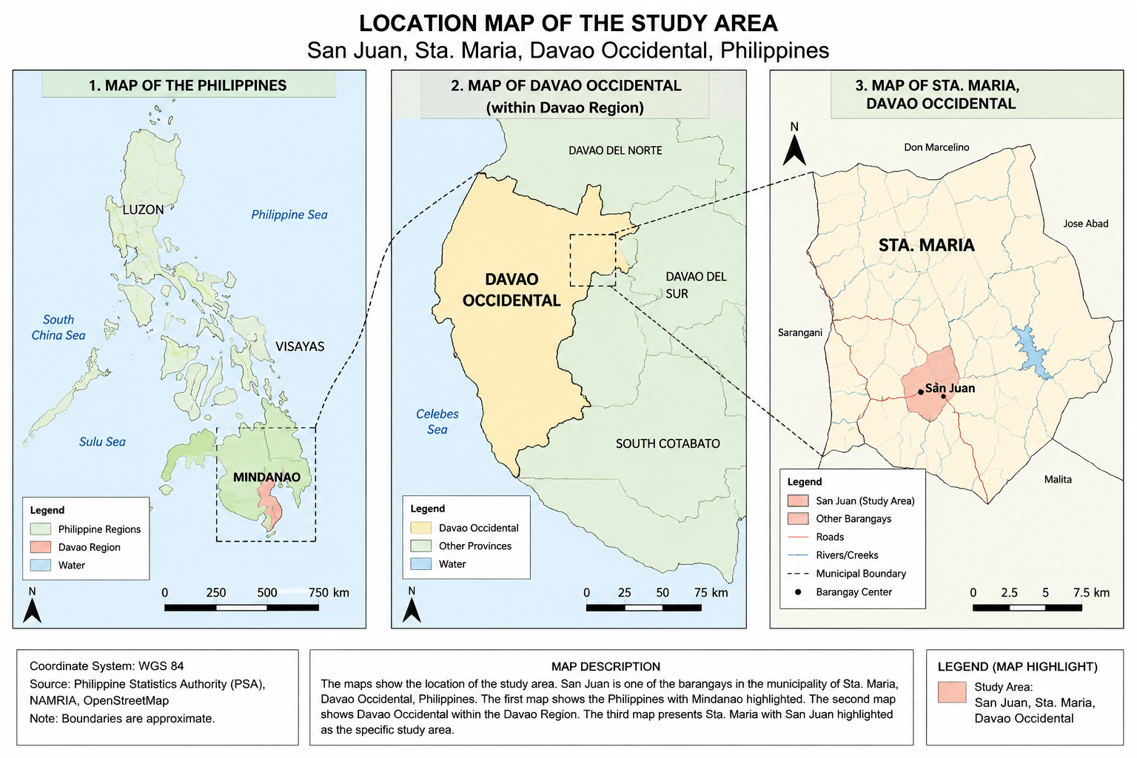

Figure 1: Location Map of the Study Area

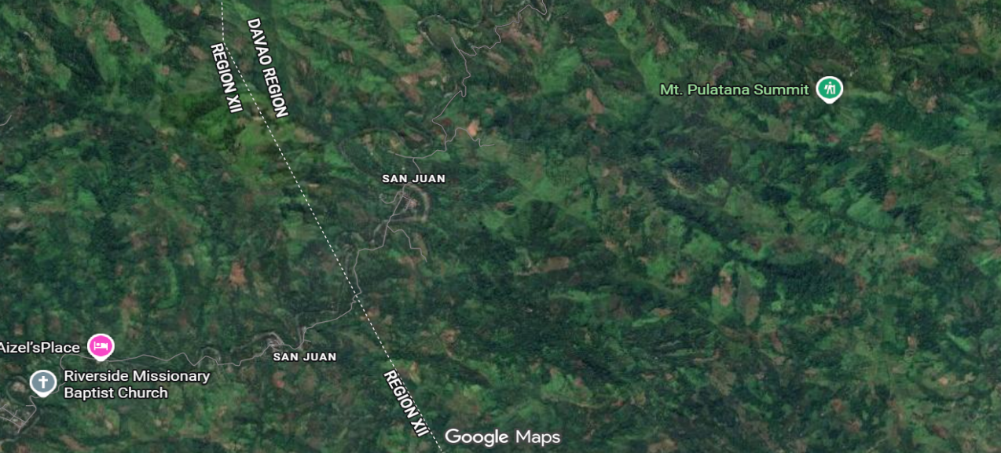

Fig. 2: Map of Barangay San Juan, Sta. Maria, Davao Occidental

2.3 Population of the Study

The study's respondents were selected from the nine sitios of Barangay San Juan, which has a total of 552 households. We used simple random sampling to select 232 households to participate in the study. There were 40 (17%) respondents from Proper 1, 37 (16%) from Proper 2, 28 (12%) from Ilian, 26 (11%) from Quiobay, 23 (9.9%) from Malaygan, 22 (9.4%) from Tugal, 20 (8.9%) each from Kiliwit and Ulayan, and 16 (6.9%) from Langaran. 30.2% of respondents were between 31 and 40. 69.2% of respondents were women, and 30.8% were men. Farming is the main way most families earn money, but some also run small stores out of their homes to earn extra income. Most respondents (45.3%) had only elementary or high school, and only a small number (12.1%) had gone to college. Most families had between three and five people living in them.

2.4 Sample Size

The sample size was calculated using Slovin’s Formula:
$$n=\frac{N}{1+N(e^{2})}$$

Thus, 232 households were selected as respondents.

2.5 Sampling Technique

The researcher utilized simple random sampling to guarantee fairness, objectivity, and representativeness in the selection of respondents. Simple random sampling makes sure that "each member of the population has an exactly equal chance of being selected,” thereby reducing selection bias and making the research findings more reliable (Thomas, 2023). It is a common method in quantitative research because it gives everyone an equal chance to be chosen and makes sure that the sample is representative, especially in populations that are mostly the same (Noor et al., 2022).

A full list of households was made, and each one was given a number from 1 to 552. Using the RAND() function in Microsoft Excel, random numbers were made, and the first 232 households were picked.To ensure representation across the barangay, the sample was proportionally distributed across the nine sitios.

Table 1 Sample distribution per sitio

Sitio/Purok | Total Households | Sample Size (n)
Langaran | 39 | 16
Kiliwit | 48 | 20
Quiobay | 62 | 26
Ilian | 67 | 28
Proper 1 | 95 | 40
Proper 2 | 89 | 37
Tugal | 51 | 22
Ulayan | 46 | 20
Malaygan | 55 | 23
Total | 552 | 232

*Total sample size (n = 232) was proportionally allocated across the nine sitios based on household population.

2.6 Research Instrument

The researcher utilized a structured survey questionnaire comprising three sections as the principal instrument for data collection. The first part asked people about their age, gender, job, level of education, and number of people living in their home. The second part used a Likert scale (Strongly Agree to Strongly Disagree) to measure people's attitudes toward the environment, focusing on their awareness, concern, and responsibility for environmental issues. The third part used a Likert scale (Always to Never) or frequency-based responses to measure water conservation practices. These included behaviors such as reusing water, fixing leaks, and participating in conservation activities.

To ensure accuracy, the questionnaire was tested for content validity and reliability using Cronbach's alpha. A coefficient of 0.70 or higher was considered acceptable. This process showed that the tool was both valid and reliable for measuring people's feelings about the environment and their water-saving behaviors.

2.7 Data Collection Procedure

The researcher sent a formal letter to the barangay officials of Barangay San Juan requesting permission to conduct the study. Upon approval, the researcher worked with local officials to hand out the questionnaires. The chosen respondents were visited, and the study's purpose was explained prior to securing their informed consent. The questionnaires were given out and then collected after they were filled out. All of the answers were checked for accuracy and completeness.

2.8 Ethical Consideration

This study adhered to ethical principles in research involving human participants. Prior to data collection, respondents were informed about the purpose and nature of the study, and informed consent was obtained. Participation was voluntary, and respondents were free to refuse or withdraw at any time without any consequence. Anonymity and confidentiality were strictly maintained by ensuring that no personal identifiers were collected, and all responses were coded and used solely for academic purposes. The study also ensured respect for participants’ privacy, dignity, and well-being throughout the research process, with data securely handled to prevent unauthorized access.

2.9 Data Analysis

The researcher used Microsoft Excel and SPSS to systematically organize, code, and analyze the data we collected.

Descriptive statistics were employed to analyze the data. Frequency and percentage showed the demographic profile of the respondents, while mean and standard deviation showed their attitudes toward the environment and their water-saving habits.

The Pearson Product-Moment Correlation Coefficient (r) was employed for inferential analysis to evaluate the strength and direction of the relationship between environmental attitudes and water conservation practices. The significance level for all statistical tests was established at 0.05.

3. RESULTS AND DISCUSSION

3.1 Socio-demographic Profile of the Respondents from each Household in San Juan

Descriptive analysis is crucial for providing information about variables in a dataset and allows for data visualization. Socio-demographic data assists in identifying the environmental attitudes that affect respondents' water conservation behaviors. The demographic profile of the household members in San Juan is shown in Figures 3 to 8. The findings show that 232 households were randomly selected from the nine sitios of Barangay San Juan. The results show that the respondents were spread out across the nine sitios. Proper 1 had the most (17.0%), followed by Proper 2 (16.0%), Ilian (12.0%), and Quiobay (11.0%). Malaygan, Tugal, Kiliwit, Ulayan, and Langaran were the other sitios that contributed smaller but still significant amounts. Langaran had the fewest respondents (6.9%).

Most of the respondents who answered were between the ages of 31 and 40 (30.2%), followed by those between the ages of 41 and 50 (27.6%) and those between the ages of 51 and 60 (22.4%). The age group with the fewest people was 20 to 30 (19.8%). This means that most of the people who answered are in their middle adulthood, a time when people are often very involved in decision-making and running their homes.

The data also show that 69.2% of respondents were women, while only 30.8% were men. This indicates that women, especially mothers, are more engaged in household duties and were more accessible to participate in the study. Their prevalence in the sample underscores their crucial function in overseeing household resources and practices.

With respect to educational attainment, the majority of respondents had elementary (45.3%) and high school education (42.7%), while only a small percentage (12.1%) reached tertiary level. Notably, none of the respondents reported having no formal education. This indicates that while basic education is common among respondents, access to higher education remains limited, which may affect their awareness and understanding of environmental and water conservation practices.

Most respondents said farming was their main source of income (60.3%), followed by businesses that provide a living (23.7%) and jobs that pay a salary (16.0%). This pattern shows that most households in the community rely on farming for food, while others run small businesses or work for pay to make ends meet.
Most respondents said their households had 3–5 members (52.6%), followed by 6–8 members (42.2%). Only a small number (5.2%) said their household had fewer than two members. This means that most households are medium- to large-sized, which could affect how much water and other resources they use, especially in environmental practices.

Thus, the findings indicate that the majority of the respondents are middle-aged women with elementary to high school educational attainment, primarily engaged in farming, and living in moderately sized households. These socio-demographic characteristics provide important insight into the respondents’ environmental attitudes and water conservation practices. The predominance of farming as a source of livelihood suggests a direct dependence on natural resources, particularly water, which may influence their awareness of environmental preservation and sustainable water use. Likewise, their educational background may shape the extent of their knowledge and understanding of conservation practices, while household size may affect patterns of water consumption and management within the home.

These findings establish a contextual basis for examining how respondents’ socio-demographic profiles relate to their environmental attitudes and water conservation behaviors. Understanding these characteristics is essential in interpreting the behavioral patterns observed in the study and in identifying factors that may contribute to the promotion of sustainable environmental practices within the community.

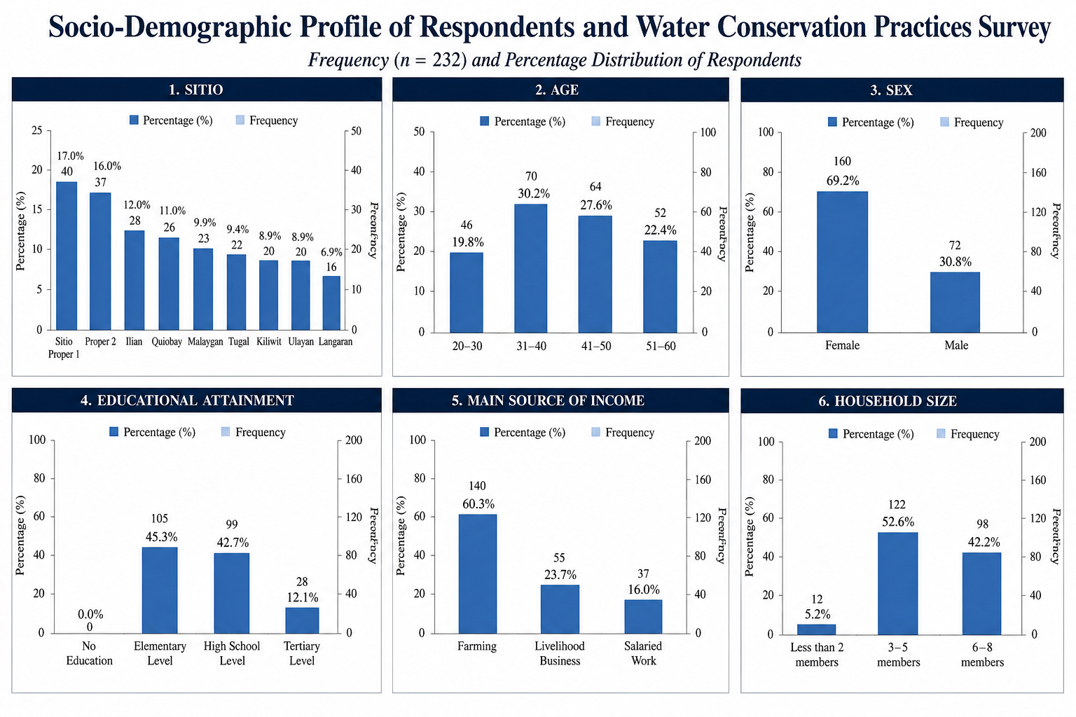

Figure 3. Sitios of San Juan

Figure 4. Age

Figure 5. Sex

Figure 6. Educational Attainment

Figure 7. Main Source of Income

Figure 8. Household size

3.2 Environmental Attitudes

Seven items assessing awareness, responsibility, and prioritization of environmental protection were used to measure the respondents’ environmental attitudes. Overall, the respondents obtained a mean score of 4.02 (SD = 0.66), indicating a generally moderate to high level of environmental awareness and positive environmental attitudes. This suggests that most respondents demonstrate favorable views toward environmental protection and sustainability practices.
As shown in Figure 4, respondents expressed concern about environmental problems in their community, with a mean score of 4.00 (SD = 0.65). This indicates that they are generally aware of existing environmental issues and recognize the need for sustainable practices. Similarly, the highest mean score was recorded for the belief that protecting natural resources is important for future generations (M = 4.10, SD = 0.60), suggesting strong recognition of long-term sustainability and intergenerational responsibility.
In addition, respondents showed agreement that water is a valuable resource that should be used responsibly (M = 4.05, SD = 0.62), reflecting a strong understanding of water conservation principles. Likewise, the importance of environmental education also received a high mean score (M = 4.08, SD = 0.61), indicating that respondents value knowledge and awareness as key drivers of sustainable behavior. These findings suggest that environmental awareness in the community is reinforced by an appreciation for learning and information dissemination.
On the other hand, slightly lower mean scores were observed for the perception that human activities negatively affect the environment (M = 3.95, SD = 0.70) and for personal responsibility in environmental protection (M = 3.90, SD = 0.68). While still within the moderate to high range, these results suggest that although respondents are generally aware of environmental issues, their sense of individual responsibility and personal action may vary. This may indicate a gap between environmental awareness and consistent behavioral commitment.
Overall, the results imply that respondents possess a generally positive environmental attitude, characterized by awareness of environmental issues, recognition of the importance of conservation, and support for environmental education. However, the slightly lower scores on personal responsibility suggest that while awareness is strong, individual behavioral engagement may still need to be strengthened.

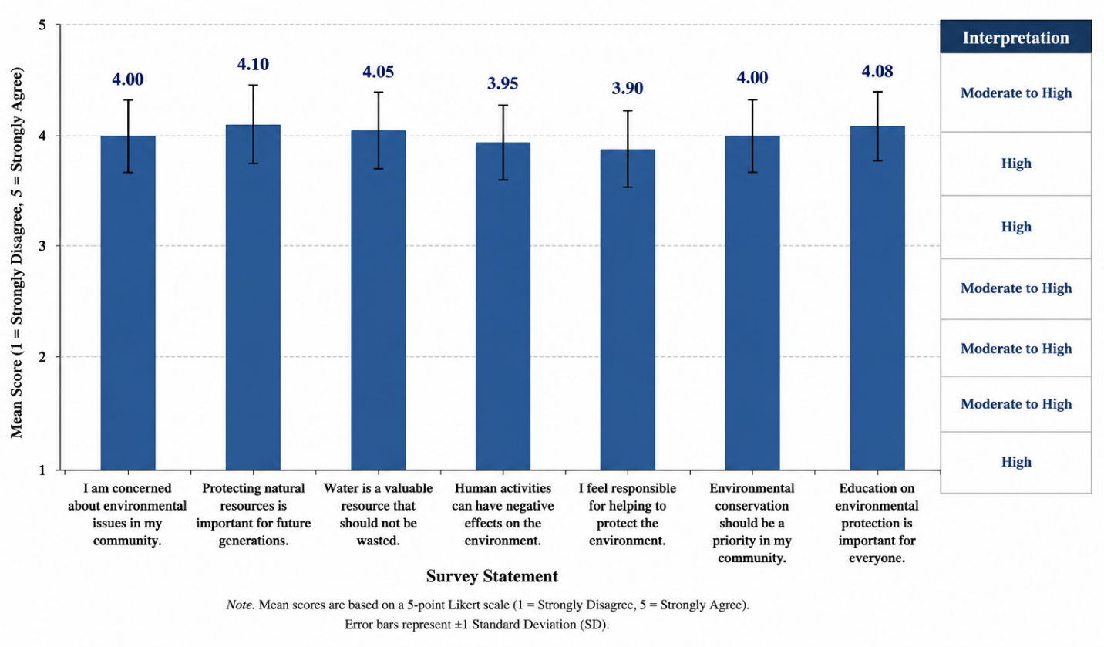
Figure 9. Environmental attitudes of respondents

3.3 Water Conservation Practices

Water conservation practices were assessed using seven indicators covering household and community-level behaviors. The overall mean score was 4.15 (SD = 0.62), indicating a high level of engagement in water conservation practices among respondents.

Results (Figure 10) show consistently high adherence to key water-saving behaviors, including turning off faucets while brushing or washing hands (M = 4.20, SD = 0.60), reflecting strong daily conservation habits. Respondents also reported teaching family members water-saving practices (M = 4.18, SD = 0.60), highlighting strong intra-household participation and shared responsibility in promoting conservation. Avoidance of water wastage during dishwashing or laundry (M = 4.15, SD = 0.59) and prompt repair of leaking pipes (M = 4.12, SD = 0.61) further indicate consistent household-level engagement in preventing water loss.

Efficient water use in gardening and cleaning (M = 4.08, SD = 0.64) and regular rainwater collection (M = 4.05, SD = 0.63) reflect adaptive water-use strategies, although these remain relatively basic conservation methods. Community participation in water conservation activities (M = 4.02, SD = 0.65) indicates involvement of local stakeholders such as households, barangay officials, and community members in conservation initiatives, although engagement appears less consistent compared to household practices.

Overall, the findings suggest that water conservation in San Juan is sustained through both household discipline and stakeholder participation, including families, community members, and local actors involved in promoting awareness and conservation efforts. While household practices remain the strongest driver, stakeholder involvement through community programs and shared responsibility supports and reinforces these behaviors. However, reliance on basic water storage and rainwater collection indicates that some practices are still low-technology responses to water management challenges.

These results show that water-saving behaviors are not solely individual actions but are also influenced by social support systems, family education, and stakeholder involvement, which collectively contribute to sustaining conservation practices in the community.

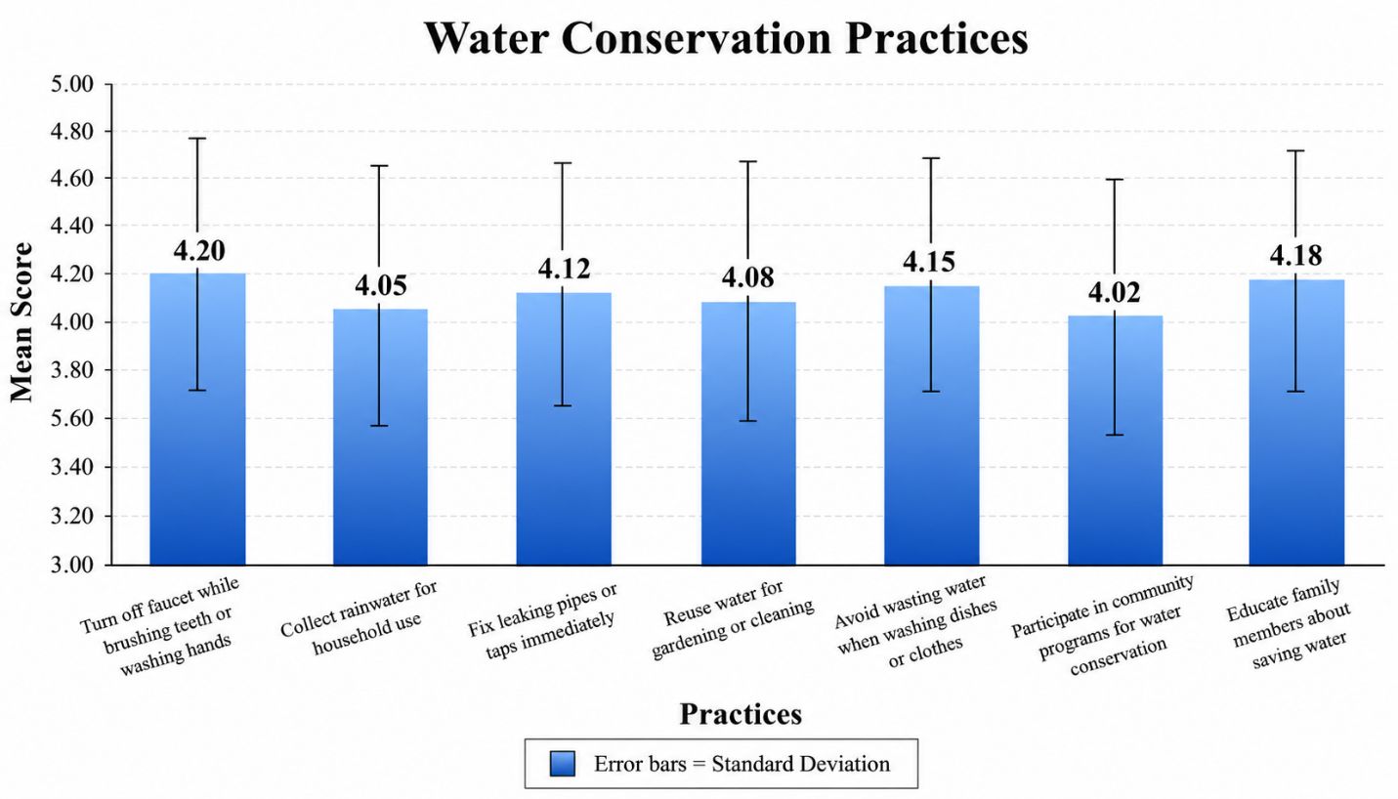
Figure 10 Water conservation practices of respondents

*M = mean; SD = standard deviation. Interpretation is based on the study’s scale for water conservation practices.

3.4 Correlation between Environmental attitudes and Water Conservation Practices

The Pearson Product-Moment Correlation analysis revealed a moderate to strong positive relationship between environmental attitudes and water conservation practices (r ≈ 0.65, p < 0.05). This indicates that respondents with more favorable environmental attitudes tend to engage more in water conservation behaviors. Since the p-value is less than the 0.05 level of significance, the relationship is statistically significant.

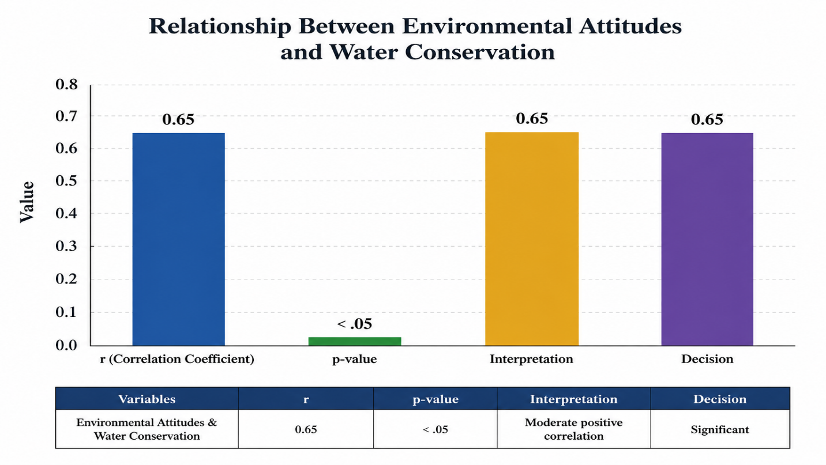

Figure 11. Correlation between environmental attitudes and water conservation practices (n = 232)

4. Conclusion

The goal of this study was to examine how people's attitudes toward the environment and their water-saving habits were related in Barangay San Juan, Sta. Maria, Davao Occidental. The main results are as follows:

The residents of Barangay San Juan exhibit moderate to high environmental attitudes and actively engage in water conservation practices such as turning off faucets, repairing leaks, harvesting rainwater, and promoting water-saving habits within households.

A statistically significant moderate positive relationship was identified between environmental attitudes and water conservation practices (r ≈ 0.65, p < 0.05), indicating that higher environmental awareness is associated with greater adoption of sustainable behaviors. However, this relationship suggests that attitudes alone do not fully determine behavior, as practical, social, and structural factors also play a role.

These findings are consistent with the study of Granda et al. (2024), which reported that environmental attitudes significantly predict household water conservation behavior although contextual and socio-demographic factors may also shape actual practices.

According to the Davao Occidental Provincial Government (n.d.), environmental sustainability and watershed protection are integral components of the province’s development agenda, emphasizing the need for effective water resource management and community participation in conservation efforts. In relation to the findings of the study, this highlights the importance of strengthening local water conservation programs and environmental policies to promote sustainable water utilization among residents. The significant relationship between environmental attitudes and water conservation practices suggests that increasing environmental awareness, together with collaborative efforts among local government units, community organizations, and households, can contribute to the long-term protection and sustainability of water resources within the province.
Overall, the study underscores the need for continued environmental education, strengthened policy enforcement, and active stakeholder engagement to promote sustainable water management practices in Barangay San Juan, Sta. Maria, Davao Occidental, Philippines.

Disclaimer (Artificial intelligence)

Author(s) hereby declare that NO generative AI technologies such as Large Language Models (ChatGPT, COPILOT, etc.) and text-to-image generators have been used during the writing or editing of this manuscript.

REFERENCES

- World Health Organization. (2021) A global overview of national regulations and standards for drinking-water quality. World Health Organization.
- Jabeen, S., Mahmood, Q., & Nawab, B. (2020). High Economic Impacts of Poor Water and Sanitation in Various Communities In Pakistan (An Environmental Economic Perspective). Central Asian Journal of Environmental Science and Technology Innovation, 1 (1), 53-60.
- Stephens, G. L., Slingo, J. M., Rignot, E., Reager, J. T., Hakuba, M. Z., Durack, P. J., Worden, J., & Rocca, R. (2020). Earth’s water reservoirs in a changing climate.
- United Nations. (n.d.). Peace, dignity, and equality on a healthy planet. https://www.un.org/en/global-issues/water
- United Nations World Water Assessment Program. (2023). The United Nations world water development report 2023: Partnerships and cooperation for water. UNESCO. https://www.unesco.org
- U.S. Geological Survey. (n.d.). How much water is there on Earth? https://www.usgs.gov/special-topics/water-science-school/science/how-much-water-there-earth

- World Health Organization, & United Nations Children’s Fund (UNICEF). (2025). Progress on household drinking-water, sanitation and hygiene 2000–2024: Special focus on inequalities. World Health Organization. https://www.who.int/publications/i/item/9789240115149
- Agbon, A. D. (2025). Securing tomorrow’s water: Insights on groundwater, surface water, and the role of water districts in the Philippines (Discussion Paper No. 2025-50). Philippine Institute for Development Studies. https://doi.org/10.62986/dp2025.50
- Department of Environment and Natural Resources. (2022) National water resources status report. https://denr.gov.ph
- Magwilang, E. B., Paredes, A. L. Y., Armas, F. C., Bugnay, H. G. P., & Dagupen, R. D. (2023). Challenges faced by the municipal water works management in improving water supply adequacy and distribution in Bontoc, Philippines. Frontiers in Water, 5, 1212361. https://doi.org/10.3389/frwa.2023.1212361
- Mendoza, D. D., Millado, J. J., & Gingatan, B. (2023). Design of level II water distribution system in Ugpaan, Boston, Davao Oriental. University of Mindanao Repository.
- Salinas, J. P. (2025). Sustainable water consumption practices among household consumers: A systematic literature review. Advances in Research, 26(4), 480–489. https://doi.org/10.9734/air/2025/v26i41427
- Perez, M. E. C., Pernia, J. B. D., Futalan, C. C. M., Ligaray, M. V., & Choi, A. E. S. (2025). Integrated modeling approaches to enhance water sustainability in Philippine watersheds: A review of its applications and limitations. Chemical Engineering Transactions, 120, 157–162.https://doi.org/10.3303/CET25120027
- Farfán Chilicaus, G. C., Cruz Salinas, L. E., Silva León, P. M., et al. (2025). Circular economy and water sustainability: Systematic review of water management technologies and strategies (2018–2024). Sustainability, 17(14), 6544. https://doi.org/10.3390/su17146544
- Foster, T. (2024). The influence of seasonality and multiple water source use on household water service levels. Cleaner Water. https://doi.org/10.1016/j.clwat.2024.100012
- Addo, I. Y., Thoms, M., & Parsons, M. (2018). Household water use and conservation behavior: A meta-analysis. Water Policy, 20(5), 1032–1054. https://doi.org/10.2166/wp.2018.179
- Journal of Environmental Management. (2022) Psychological determinants of household water conservation behavior in Japan. Journal of Environmental Management, 304, 114218. https://doi.org/10.1016/j.jenvman.2022.114218
- Fielding, K. S., Spinks, A., Russell, S., Mankad, A., & Price, J. (2019).
Water conservation in the home: Psychological and contextual determinants of residential water use.
Journal of Environmental Management, 231, 108–117.
https://doi.org/10.1016/j.jenvman.2018.10.104
- Dolnicar, S., Hurlimann, A., & Grün, B. (2020).
Water conservation behavior: Views of Australian households.
Journal of Environmental Management, 256, 109936.
https://doi.org/10.1016/j.jenvman.2019.109936
- Marzo, R. R., Chen, H., Anuar, H., & Abdul Wahab, M. K. (2023). Effect of community participation on sustainable development. Frontiers in Environmental Science.
https://doi.org/10.3389/fenvs.2023.1268036
- PhilAtlas. (n.d.). San Juan, Santa Maria, Davao Occidental. https://www.philatlas.com/mindanao/r11/davao-occidental/santa-maria/san-juan.html
- Singha, B., Eljamal, O., Karmaker, S. C., Maamoun, I., & Sugihara, Y. (2022). Water conservation behavior: Exploring the role of social, psychological, and behavioral determinants. Journal of Environmental Management, 317, 115484. https://doi.org/10.1016/j.jenvman.2022.115484
- Warner, L. A., & Diaz, J. M. (2021). Amplifying the Theory of Planned Behavior with connectedness to water. Journal of Agricultural Education and Extension, 27(2), 229–253. https://doi.org/10.1080/1389224X.2020.1844771
- Han, H. (2021). Theory of planned behavior in environmental research: A review and meta-analysis. Journal of Environmental Management, 292, 112764. https://doi.org/10.1016/j.jenvman.2021.112764
- The Decision Lab. (n.d.). Theory of planned behavior. https://thedecisionlab.com/reference-guide/psychology/theory-of-planned-behavior
- Gibson, K. E., Lamm, A. J., Lamm, K. W., & Holt, J. (2023).
Integrating the Theory of Planned Behavior and motivation to explore residential water-saving behaviors. Water, 15(17), 3034.
https://doi.org/10.3390/w15173034
- ScienceFrontier. (n.d.). The influence of attitudes, subjective norms and perceived behavioral control. https://sciencefrontier.org/article/the-influence-of-attitudes-subjective-norms-and-perceived-behavioral-control-
- McCarthy, P. (2025, June 18). Understanding the theory of planned behavior and its implications on decision-making. Dr Paul McCarthy. https://www.drpaulmccarthy.com/post/understanding-the-theory-of-planned-behavior-and-its-implications-on-decision-making

- Thomas, L. (2023). Simple random sampling: Definition, steps & examples. Scribbr. https://www.scribbr.com/methodology/simple-random-sampling/
- Noor, S., Tajik, O., & Golzar, J. (2022). Simple random sampling. International Journal of Emerging Life Sciences, 1(2), 78–82.
- Granda, L., Moya-Fernández, P. J., Soriano-Miras, R. M., & González-Gómez, F. (2024). Pro-environmental behaviour in household water use: A gender perspective. Sustainable Water Resources Management, 10, 49. https://doi.org/10.1007/s40899-023-01027-6
- Davao Occidental Provincial Government. (n.d.). Provincial Environment and Natural Resources Office. Davao Occidental Provincial Government. https://davaooccidental.gov.ph/provincial-environment-and-natural-resources-office

APPENDIX

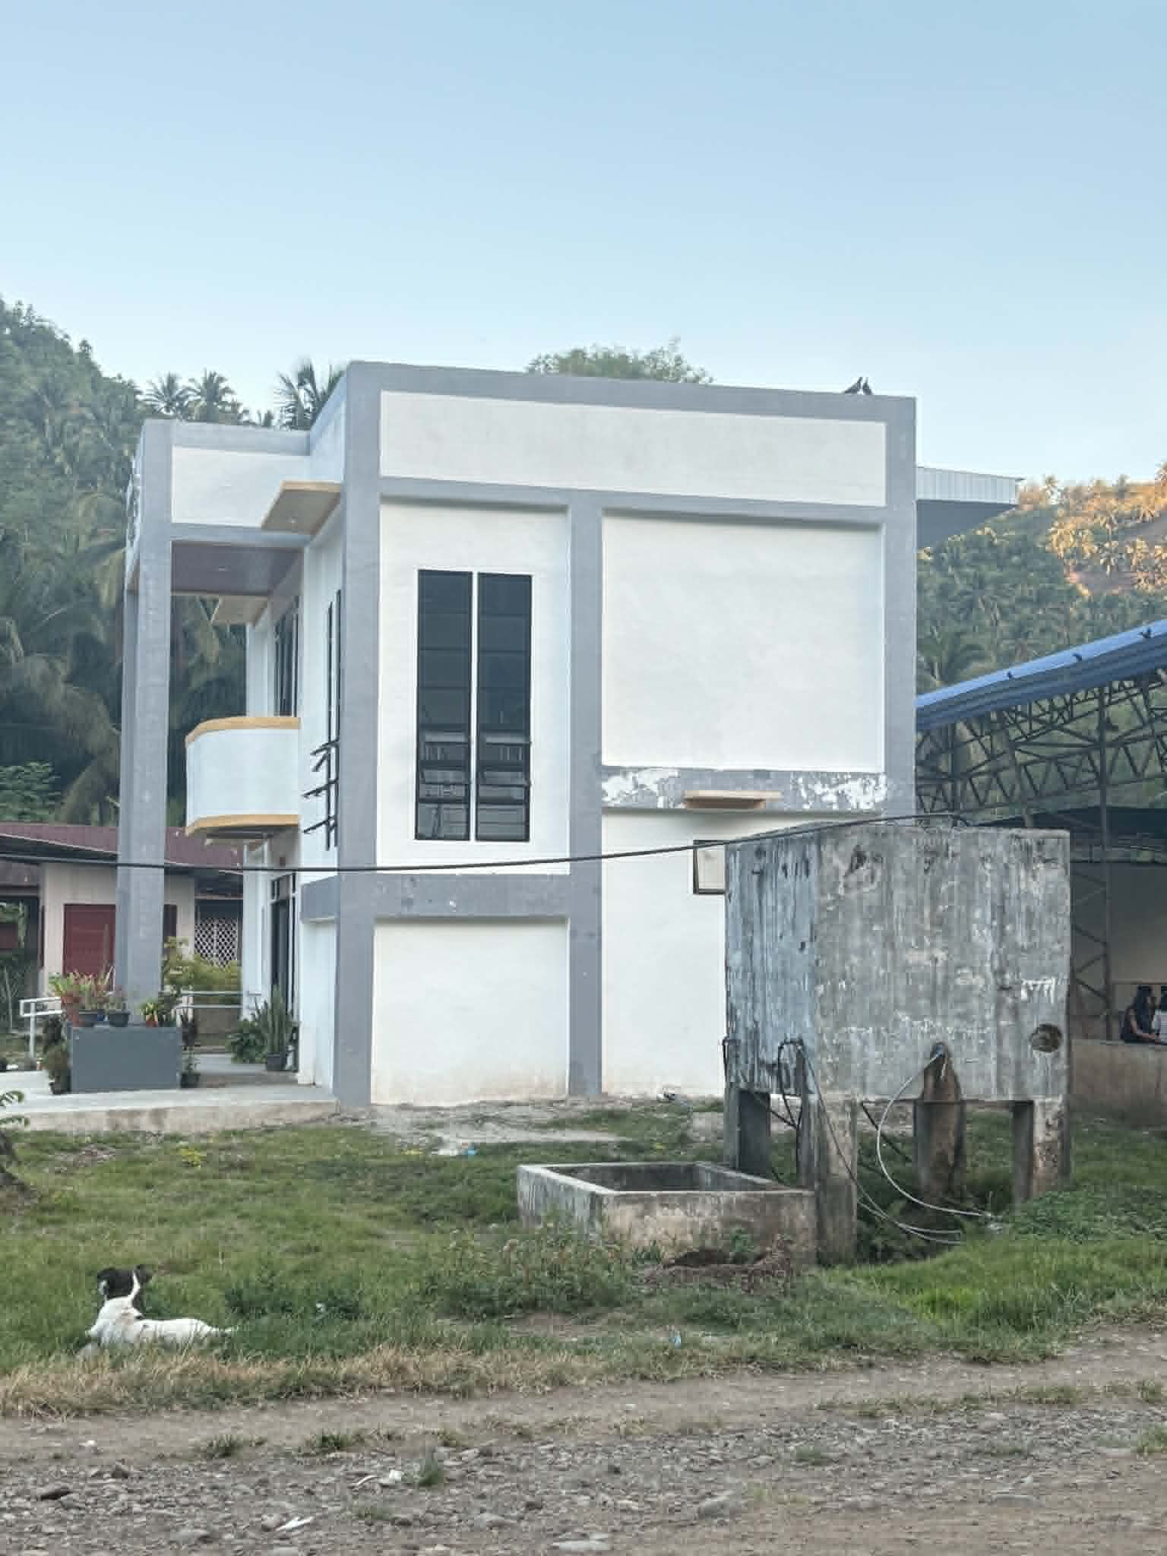
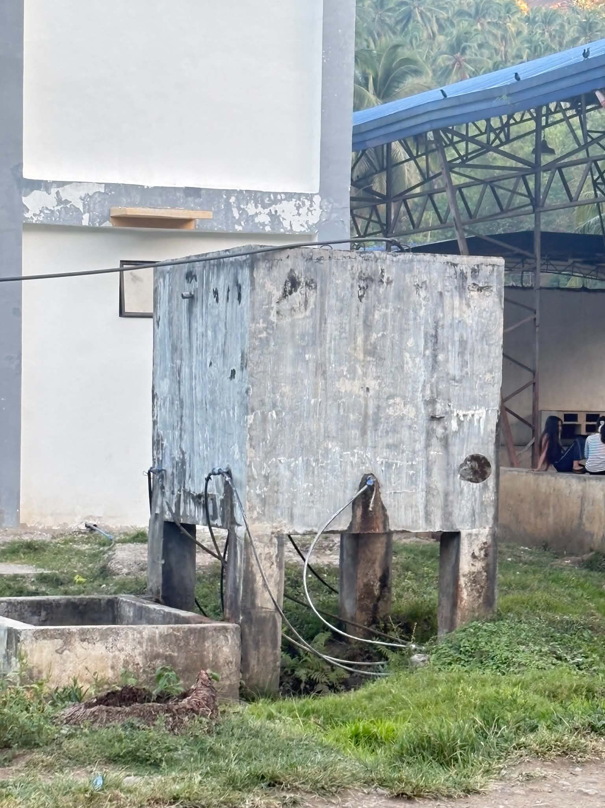
Household water storage system in the study area

