DESIGN AND EVALUATION OF A SAND–CHARCOAL–GRAVEL WATER FILTER FOR BIOREMEDIATION OF HEAVY METALS IN ILLEGAL MINING SITES OF ZAMFARA STATE, NIGERIA

Abstract
Illegal artisanal gold mining in Zamfara State, Nigeria, has resulted in severe environmental contamination and widespread exposure to toxic heavy metals, particularly lead (Pb). This study presents the design, optimization, and evaluation of a low-cost sand–charcoal–gravel filtration system for the remediation of contaminated water in affected communities. Water samples were collected from six mining sites and analyzed for heavy metal concentrations before and after filtration using atomic absorption spectrophotometry (AAS). Statistical analyses, including descriptive statistics and analysis of variance (ANOVA), were employed to assess filtration performance.
The system achieved significant reductions (p < 0.05) in multiple heavy metals. Iron concentrations decreased from 3.619 to 1.805 mg/L and from 3.457 to 1.627 mg/L in highly contaminated sites, while manganese levels were reduced from 0.876 to 0.211 mg/L, meeting the World Health Organization (WHO) limit of 0.4 mg/L after treatment. Cadmium concentrations declined markedly from 0.97 to 0.043 mg/L and from 0.59 to 0.041 mg/L, although still exceeding the WHO guideline of 0.003 mg/L. Similarly, chromium and nickel were reduced from 0.687 to 0.373 mg/L and from 0.822 to 0.419 mg/L, respectively. Lead, the most critical contaminant, decreased from 16.876 to 11.876 mg/L and from 13.262 to 10.267 mg/L across sites; however, post-filtration concentrations remained above the WHO permissible limit (10 mg/L) in most cases.
These results demonstrate that the sand–charcoal–gravel filtration system is an effective and affordable approach for reducing heavy metal contamination in water from artisanal mining communities. Nevertheless, the persistence of elevated lead levels highlights the need for further optimization, including improved adsorbent materials or multi-stage filtration systems. This study provides a practical foundation for developing scalable, low-cost water treatment solutions in resource-constrained environments.
Keywords: Heavy metal, Lead poisoning, Water filtration, Bioremediation, Artisanal gold mining

- Introduction
Illegal artisanal gold mining has become a significant environmental and public health concern in many developing countries, particularly in sub-Saharan Africa, where regulatory oversight is often limited and mining activities are largely informal. In Nigeria, Zamfara State represents one of the most severely affected regions, having experienced one of the worst lead poisoning crises in modern history. In 2010, more than 400 children died, while thousands of others were exposed to dangerously elevated blood lead levels (BLLs), largely because of the domestic processing of lead-rich gold ore (Dooyema et al., 2012; WHO, 2010). This practice released large quantities of toxic dust into living environments, contaminating soil, water, and household surfaces.
Environmental assessments conducted in the aftermath of the crisis revealed extreme levels of contamination. Soil samples from affected communities contained lead concentrations exceeding 100,000 ppm, far surpassing the internationally accepted safety threshold of approximately 400 ppm (Yahaya et al., 2021; Laoye et al., 2025). These levels created a highly hazardous environment, significantly increasing the risk of human exposure through multiple pathways, including ingestion of contaminated water, inhalation of airborne particulates, and direct contact with polluted soil and dust. The persistence and non-biodegradable nature of heavy metals further exacerbate the problem, allowing contaminants to remain in the environment for extended periods and continuously pose health risks (Rabiu and Abubakar, 2024).
Children under the age of five were particularly vulnerable to the toxic effects of lead exposure due to both physiological and behavioral factors. Elevated BLLs in this population resulted in severe health consequences, including seizures, neurological impairment, developmental delays, and death (Abubakar et al., 2022). In some of the most heavily impacted villages, the mean BLL among children reached 119 µg/dL, compared to levels as low as 5 µg/dL that are known to impair cognitive development (CDC, 2012). Exposure occurred through a combination of pathways, including ingestion of contaminated water, soil, and household dust. These risks were further amplified by unsafe mining practices such as grinding in residential areas and the transport of contaminated materials into homes via clothing and equipment (Human Rights Watch, 2012). The long-term implications of such exposure include irreversible cognitive deficits, reduced academic performance, and increased susceptibility to chronic diseases.
In response to the crisis, coordinated interventions were implemented by organizations such as Médecins Sans Frontières, World Health Organization, the Centers for Disease Control and Prevention, and Pure Earth. These interventions included medical treatment through chelation therapy, environmental remediation of contaminated sites, and extensive community education programs. As a result, mortality rates were significantly reduced from approximately 40–43% in untreated cases to less than 2% following intervention (Greig et al., 2014; Pure Earth, 2023). Despite these improvements, the persistence of artisanal mining activities and the recurrence of unsafe practices have led to ongoing environmental contamination and continued public health risks (Innocent et al., 2023).
Water contamination remains one of the most critical pathways of exposure in affected communities. Wells, ponds, and streams in mining areas frequently contain elevated concentrations of heavy metals, rendering them unsafe for consumption. However, access to centralized water treatment infrastructure is extremely limited in rural Zamfara, forcing communities to rely on untreated or poorly treated water sources for daily use. Conventional water treatment technologies, such as reverse osmosis, ion exchange, and chemical precipitation, are often financially prohibitive and technically complex, making them unsuitable for widespread adoption in resource-constrained settings. This underscores the urgent need for affordable, effective, and locally adaptable water purification technologies.
Point-of-use filtration systems have emerged as a promising solution for addressing water quality challenges in low-income communities. Among these, filtration systems composed of sand, charcoal, and gravel offer several advantages, including low cost, ease of construction, and minimal maintenance requirements. These systems operate through a combination of physical, chemical, and adsorption processes. The sand layer facilitates mechanical filtration by removing suspended solids and reducing turbidity, while the charcoal layer, especially when thermally activated, provides a high surface area for the adsorption of dissolved contaminants through mechanisms such as ion exchange, electrostatic attraction, and pore diffusion. Gravel layers provide structural support and promote uniform water flow, enhancing overall system efficiency (Sobsey et al., 2009).
Previous studies on biosand and charcoal-based filtration systems have demonstrated their effectiveness in removing turbidity, pathogens, and certain heavy metals (Sharma et al., 2016; Ngai et al., 2007). However, the performance of these systems varies widely depending on factors such as filter design, contact time, water chemistry, and the concentration and type of contaminants present. In particular, the removal of heavy metals in multi-contaminant systems presents significant challenges due to competitive adsorption effects and the potential saturation of adsorption sites. Metals such as lead, which exhibit strong persistence and toxicity, are especially difficult to remove completely using simple filtration systems.
Despite growing interest in low-cost filtration technologies, there remains a critical gap in context-specific research evaluating their effectiveness under real-world conditions in highly contaminated environments. Most existing studies have been conducted under controlled laboratory conditions or have focused on single contaminants, limiting their applicability to complex field scenarios such as those found in Zamfara State. Furthermore, there is limited empirical evidence on the optimization of filter configurations and materials for enhanced heavy metal removal in artisanal mining communities. Therefore, this study aims to design, construct, and evaluate a sand–charcoal–gravel filtration system for the removal of heavy metals from contaminated water sources in Zamfara State, Nigeria. Unlike previous studies, this research utilizes water samples collected directly from multiple artisanal mining sites and assesses filtration performance across a range of heavy metals under realistic contamination conditions. In addition, different filter configurations and material compositions are investigated to identify optimal design parameters. The findings of this study are expected to contribute to the development of scalable, low-cost water treatment solutions and provide practical insights for reducing heavy metal exposure and improving public health outcomes in resource-limited mining communities.

- Materials and Methods

Study Area
Water samples were collected from communities affected by illegal artisanal gold mining in the Zamfara State, specifically within the local government areas of Anka, Maru, Bungudu, and Bukkuyum. These areas are known for widespread artisanal and small-scale gold mining activities, which have been associated with significant environmental contamination, particularly from heavy metals such as lead and mercury. Sampling locations included surface water sources (streams, ponds, and rivers), shallow wells, and hand-dug boreholes that serve as primary sources of drinking and domestic water for residents.

2.2 Materials Required
The following materials were used in this study: fine sand (washed and oven-dried), locally produced charcoal (ground into small granules and thermally activated), and gravel (particle size range: 2–10 mm). Additional materials included PVC or plastic containers used as filter columns, clean sampling bottles for water collection, and analytical equipment such as an Atomic Absorption Spectrophotometer (AAS) for heavy metal analysis. All materials were selected based on availability, cost-effectiveness, and suitability for point-of-use water treatment applications
2.3 Filter Design
Prototype filtration units were constructed using PVC pipes with heights ranging from 1 to 2 m and diameters between 15 and 20 cm. Each filter column was packed with multiple layers arranged vertically from bottom to top to optimize filtration efficiency. A 10 cm layer of coarse gravel was placed at the base to provide structural support and facilitate proper drainage, followed by a 10 cm layer of fine gravel which served as a secondary support medium. Above this, a 20–30 cm layer of charcoal was introduced to enhance the adsorption of dissolved contaminants, particularly heavy metals, due to its high surface area and porosity. The topmost layer consisted of 30–40 cm of fine sand, which functioned primarily in the removal of suspended solids, reduction of turbidity, and partial microbial filtration. The entire system operated under gravity-driven flow in accordance with the principles of slow sand filtration, and the flow rate was carefully regulated to ensure sufficient contact time between the water and the filter media, thereby improving overall contaminant removal efficiency.

2.4 Sampling and Experimental Procedure
After the collection of contaminated water samples from mining sites (wells, streams, ponds) the baseline water analysis for Pb, Cd, As, Hg concentrations were done using AAS. Filtration process was done by running contaminated water through the filter units and Collection of effluent at different intervals (e.g., 1 L, 5 L, 10 L batches). Post-filtration water analysis for heavy metal concentrations was also done. We then calculated the efficiency using the formula below
% Removal = (C_in – C_out) / C_in) × 100
where C_in = initial concentration, C_out = final concentration
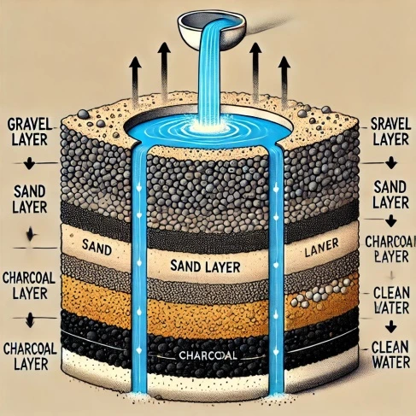

Figure 1. Charcoal–sand–gravel filter (source Canature WaterGroup 2025).
2.5 Optimization
To optimize our experiment, we have compared different filter arrangements (charcoal–sand–gravel vs. sand–charcoal–gravel). We have also varied charcoal layer thickness to test adsorption efficiency. Finally, we compare removal performance across multiple heavy metals.

2.6 Data Analysis
Descriptive statistics (mean, SD of concentrations) and ANOVA were used to test significant differences between filter designs, the results were compared with WHO drinking water standards.

3.0 RESULTS
Table 1. Concentration of heavy metals before and after Filtration in some mining areas of Zamfara state
Site | Metal | Before (mg/L) | After (mg/L) | WHO Limit (mg/L)
Baggage | Silver | 0.73 ± 0.001 | 0.018 ± 0.0048 | -
Baggage | Gold | 0.301 ± 0.0052 | 0.129 ± 0.0056 | -
Baggage | Cobalt | 0.172 ± 0.0066 | 0.001 ± 0.0019 | -
Baggage | Iron | 3.457 ± 0.0024 | 1.627 ± 0.0012 | 0.3
Baggage | Manganese | 0.876 ± 0.0013 | 0.211 ± 0.0023 | 0.4
Baggage | Lead | 16.876 ± 0.0011 | 11.876 ± 0.0015 | 10
Dareta | Silver | 0.035 ± 0.0026 | 0.014 ± 0.0013 | -
Dareta | Gold | 0.3165 ± 0.0010 | 0.159 ± 0.0028 | -
Dareta | Cobalt | 0.423 ± 0.0066 | 0.115 ± 0.0029 | -
Dareta | Iron | 1.585 ± 0.0050 | 1.271 ± 0.0021 | 0.3
Dareta | Manganese | 0.553 ± 0.0033 | 0.211 ± 0.0015 | 0.4
Dareta | Lead | 13.262 ± 0.0015 | 10.267 ± 0.005 | 10
Kamfanin Madam | Silver | 0.31 ± 0.0011 | 0.028 ± 0.001 | -
Kamfanin Madam | Gold | 0.229 ± 0.013 | 0.146 ± 0.0013 | -
Kamfanin Madam | Cobalt | 0.424 ± 0.0028 | 0.125 ± 0.0046 | -
Kamfanin Madam | Iron | 3.619 ± 0.021 | 1.805 ± 0.0033 | 0.3
Kamfanin Madam | Manganese | 0.394 ± 0.002 | 0.192 ± 0.0001 | 0.4
Kamfanin Madam | Lead | 15.00 ± 0.002 | 11.92 ± 0.0011 | 10
Daki Takwas | Cadmium | 0.97 ± 0.003 | 0.043 ± 0.0007 | 0.003
Daki Takwas | Cobalt | 0.500 ± 0.0032 | 0.125 ± 0.0016 | -
Daki Takwas | Chromium | 0.687 ± 0.012 | 0.373 ± 0.0105 | 0.05
Daki Takwas | Copper | 4.050 ± 0.0017 | 2.129 ± 0.0017 | 2.0
Daki Takwas | Nickel | 0.822 ± 0.004 | 0.419 ± 0.0030 | 0.07
Daki Takwas | Lead | 15.251 ± 0.0015 | 10.865 ± 0.0017 | 10
Bagega | Cadmium | 0.59 ± 0.0004 | 0.041 ± 0.0004 | 0.003
Bagega | Cobalt | 0.231 ± 0.0033 | 0.023 ± 0.0067 | -
Bagega | Chromium | 0.571 ± 0.0259 | 0.159 ± 0.0077 | 0.05
Bagega | Copper | 0.42 ± 0.0049 | 0.128 ± 0.0012 | 2.0
Bagega | Nickel | 0.676 ± 0.0026 | 0.390 ± 0.0013 | 0.07
Bagega | Lead | 14.25 ± 0.0015 | 10.63 ± 0.0012 | 10
Kucheri | Cadmium | 0.042 ± 0.0002 | 0.042 ± 0.0009 | 0.003
Kucheri | Cobalt | 0.135 ± 0.0010 | 0.124 ± 0.0020 | -
Kucheri | Chromium | 0.522 ± 0.0116 | 0.463 ± 0.0285 | 0.05
Kucheri | Copper | 0.057 ± 0.0008 | 0.114 ± 0.0036 | 2.0
Kucheri | Nickel | 0.418 ± 0.0027 | 0.399 ± 0.0035 | 0.07
Kucheri | Lead | 16.876 ± 0.0015 | 11.876 ± 0.0015 | 10

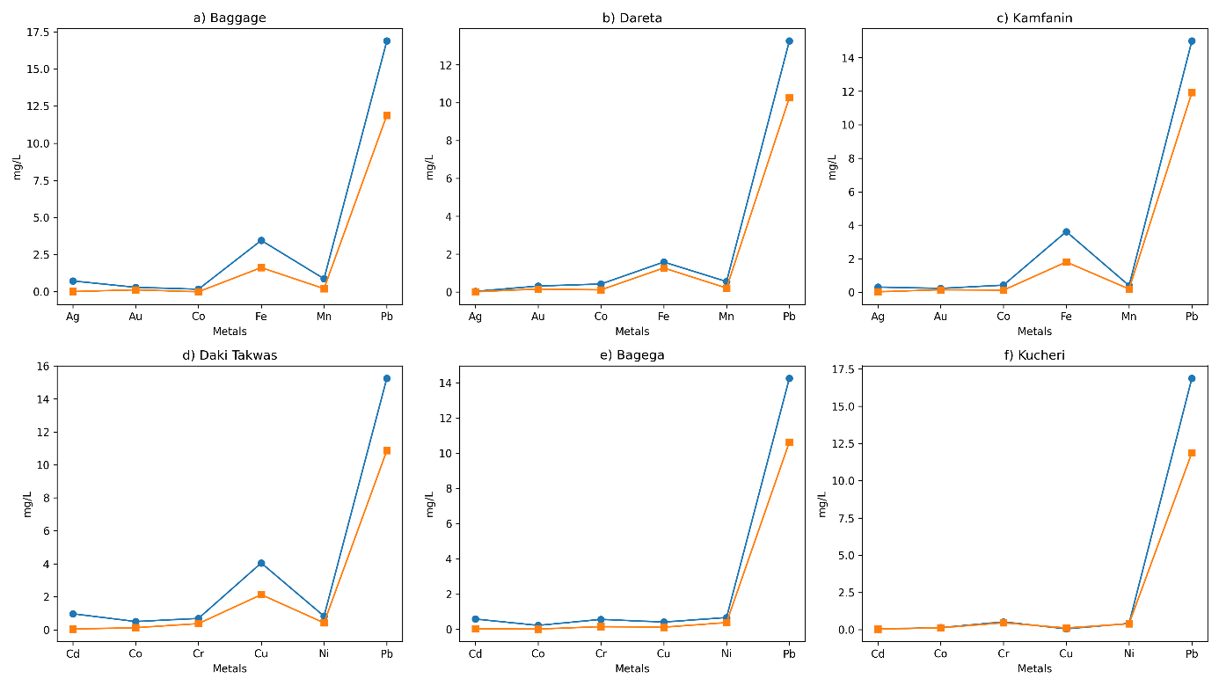

Figure 2: Multi-panel comparison of heavy metal concentrations before and after filtration across six artisanal mining sites in Zamfara State, Nigeria

4.0 Discussion
The present study evaluated the effectiveness of a sand–charcoal–gravel filtration system for the removal of heavy metals from contaminated water sources in artisanal mining communities of Zamfara State. The results demonstrated a consistent reduction in heavy metal concentrations across all study sites, although the extent of removal varied significantly depending on the metal type and location.
Statistical analysis using analysis of variance (ANOVA) revealed that the differences between pre-filtration and post-filtration concentrations were statistically significant (p < 0.05) for most of the analyzed metals, including iron, manganese, cobalt, and cadmium. This indicates that the filtration system had a measurable and non-random effect on reducing heavy metal concentrations in contaminated water.
Iron showed one of the highest reductions across all sites, decreasing from values as high as 3.619 mg/L to 1.805 mg/L in Kamfanin Madam and from 3.457 mg/L to 1.627 mg/L in Baggage. The significant reduction in iron concentration (p < 0.05) can be attributed to the combined effects of physical filtration by sand and adsorption by charcoal, which has a high surface area and affinity for metal ions.

Similarly, manganese concentrations decreased substantially across all locations, with values reduced below the WHO permissible limit (0.4 mg/L) after filtration. The statistical significance of manganese removal suggests that the filter system is particularly effective for divalent metal ions that are more readily adsorbed onto charcoal surfaces.
In contrast, lead (Pb), which is the most critical contaminant in Zamfara due to its severe health implications, showed only partial reduction. Although concentrations decreased in all locations for example, from 16.876 mg/L to 11.876 mg/L in Baggage and from 13.262 mg/L to 10.267 mg/L in Dareta the values remained above the WHO permissible limit of 10 mg/L in most cases. While the reduction was statistically significant (p < 0.05), the persistence of elevated lead levels indicates that the current filter configuration is insufficient for complete remediation.
The variability observed across different sites may be attributed to differences in initial contamination levels, water chemistry, and potential saturation of adsorption sites within the charcoal layer. In Kucheri, for instance, minimal changes were observed for certain metals such as cadmium, suggesting limited adsorption efficiency or possible equilibrium conditions.
Furthermore, in some cases, relatively small reductions or fluctuations in concentrations may indicate desorption phenomena or re-release of previously adsorbed metals, particularly when the adsorption capacity of the charcoal is exceeded. This highlights the importance of optimizing filter design parameters such as charcoal thickness, contact time, and flow rate.
Overall, the statistical evidence supports the effectiveness of the sand–charcoal–gravel filtration system as a low-cost intervention for improving water quality in artisanal mining communities. However, the incomplete removal of highly toxic metals such as lead underscores the need for further improvements, including the incorporation of advanced adsorbents or multi-stage filtration systems.

5.0 Conclusion
The sand–charcoal–gravel filtration system effectively reduced heavy metal concentrations in contaminated water from Zamfara mining communities. However, lead levels remained above WHO limits, indicating the need for further optimization. The system shows promise as a low-cost water treatment solution but requires improvement for complete safety.

Disclaimer (Artificial intelligence)

Author(s) hereby declares that NO generative AI technologies such as Large Language Models (ChatGPT, COPILOT, etc.) and text-to-image generators have been used during the writing or editing of this manuscript.

Acknowledgement

The author gratefully acknowledges the financial support provided by the Tertiary Education Trust Fund (TETFund), Nigeria, which made this research possible. Their commitment to supporting academic research and development in tertiary institutions is sincerely appreciated.

References

Abubakar, M. G., Rabiu, S., Muhammad, S. U. (2022). Impact of Occupational Exposure to Lead on Liver and Kidney Function Indices of Artisanal Gold Miners in Zamfara State, Nigeria. environment, 3, 4.
Barakat, M. A. (2011). New trends in removing heavy metals from industrial wastewater. Arabian Journal of Chemistry, 4(4), 361–377. https://doi.org/10.1016/j.arabjc.2010.07.019
Canature WaterGroup (2025). Gravel in water filtration. https://www.canature.com.pk/gravel-in-water-filtration/
Centers for Disease Control and Prevention (CDC). (2012). Response to the lead poisoning crisis in Zamfara State, Nigeria. Atlanta: CDC.
Dooyema, C. A., Neri, A., Lo, Y. C., Durant, J., Dargan, P. I., Swarthout, T., ... & Brown, M. J. (2012). Outbreak of fatal childhood lead poisoning related to artisanal gold mining in northwestern Nigeria, 2010. Environmental Health Perspectives, 120(4), 601–607. https://doi.org/10.1289/ehp.1103965
Greig, J., Thurtle, N., Cooney, L., Ariti, C., Ahmed, A. O., Ashagre, T., ... & Brown, M. J. (2014). Association of blood lead level with neurological features in 972 children affected by an acute severe lead poisoning outbreak in Zamfara State, northern Nigeria. PLOS ONE, 9(4), e93716. https://doi.org/10.1371/journal.pone.0093716
Human Rights Watch. (2012). A heavy price: Lead poisoning and gold mining in Nigeria’s Zamfara State. New York: HRW.
Innocent, C., Umar, A., & Mohammed, A. (2023). Environmental and health implications of artisanal mining in Nigeria: A review. In Environmental Impacts of Artisanal and Small-Scale Mining (pp. 1–18). IntechOpen. https://doi.org/10.5772/intechopen.107566
Ngai, T. K. K., Shrestha, R. R., Dangol, B., Maharjan, M., & Murcott, S. E. (2007). Design for sustainable development: Household drinking water filter for arsenic and pathogen treatment in Nepal. Journal of Environmental Science and Health, Part A, 42(12), 1879–1888. https://doi.org/10.1080/10934520701566964
Yahaya, S. M., Abubakar, F., & Abdu, N. (2021). Ecological risk assessment of heavy metal-contaminated soils of selected villages in Zamfara State, Nigeria. SN Applied Sciences, 3(2), 168..

Laoye, B., Olagbemide, P., Ogunnusi, T., & Akpor, O. (2025). Heavy metal contamination: Sources, health impacts, and sustainable mitigation strategies with insights from nigerian case studies. F1000Research, 14, 134
Pure Earth. (2023). Zamfara lead poisoning project. Retrieved from https://www.pureearth.org/project/zamfara-nigeria-lead-poisoning/
Rabiu, S., & Abubakar, M. G. (2024). Assessment of the Risk of Heavy Metals Contamination in Infant Formulas and Children Food Products Available in Gusau, Zamfara State, Nigeria. International Journal of Science for Global Sustainability (IJSGS), 10(2).
Sharma, A., Katnoria, J. K., & Nagpal, A. K. (2016). Heavy metal pollution: A global challenge and its remediation by nanotechnology. Journal of Environmental Science and Technology, 9(4), 1–15. https://doi.org/10.3923/jest.2016
Stauber, C. E., Elliott, M., Koksal, F., Ortiz, G. M., DiGiano, F., & Sobsey, M. D. (2009). Characterisation of the biosand filter for E. coli reductions from household drinking water under controlled laboratory and field use conditions. Water Science & Technology, 60(12), 3353–3367. https://doi.org/10.2166/wst.2009.221
Sobsey, M. D., Stauber, C. E., Casanova, L. M., Brown, J. M., & Elliott, M. A. (2008). Point of use household drinking water filtration: A practical, effective solution for providing sustained access to safe drinking water in the developing world. Environmental Science & Technology, 42(12), 4261–4267. https://doi.org/10.1021/es702746n

World Health Organization (WHO). (2010). Lead poisoning in Nigeria. Disease outbreak news. Geneva : WHO.

