EFFECT OF HEAT-TREATED AND CONVENTIONAL RETREATMENT FILES ON REMOVAL OF GUTTA PERCHA AND REMAINING DENTIN THICKNESS BY CBCT ANALYSIS: AN INVIVO STUDY
Abstract
The success of endodontic treatment depends on effective canal shaping, thorough chemo-mechanical debridement, and the achievement of a three-dimensional hermetic seal. Despite a reported success rate of up to 97%, failures may occur, often necessitating endodontic retreatment. Complete removal of gutta-percha while preserving radicular dentin is critical for the long-term prognosis of retreated teeth.
Aim:
To evaluate and compare the efficiency of ProTaper Universal Retreatment files, Solite RS3 retreatment files, and R-Endo retreatment files in the removal of gutta-percha and their effect on remaining dentin thickness using CBCT analysis.
Materials and Methods:
Sixty extracted human single-rooted mandibular premolars diagnosed with post-treatment apical periodontitis were included in this study. Samples were randomly allocated into three groups (n = 20 each) using a sealed envelope technique:
Group 1 – ProTaper Universal Retreatment files,
Group 2 – Solite RS3 Retreatment files,
Group 3 – R-Endo Retreatment files.
Preoperative CBCT scans were obtained to assess baseline dentin thickness. Standardized access cavity preparation was performed under rubber dam isolation using a sterile high-speed round diamond bur. Retreatment procedures were carried out according to the respective manufacturer’s instructions for each file system. Final irrigation was performed using normal saline. Postoperative CBCT analysis was conducted to evaluate the amount of remaining filling material and changes in dentin thickness.
Results:
All experimental groups demonstrated residual filling material following retreatment procedures. However, Solite RS3 and R-Endo systems showed significantly greater efficiency in gutta-percha removal compared to the ProTaper Universal Retreatment system. Additionally, the R-Endo group exhibited significantly greater preservation of remaining dentin thickness when compared to the Solite RS3 group.
Conclusion:
Within the limitations of this study, none of the retreatment systems achieved complete removal of gutta-percha. However, R-Endo and Solite RS3 systems were more effective than ProTaper Universal Retreatment files. R-Endo demonstrated superior preservation of dentin thickness, suggesting it may be a safer and more conservative option for endodontic retreatment.
Keywords: Endodontic retreatment, Gutta-percha removal, Remaining dentin thickness, ProTaper retreatment files, Solite RS3, R-Endo, CBCT analysis, Apical periodontitis

INTRODUCTION :-
Endodontic treatment has shown a high success rate over the years; however, failures are still encountered in clinical practice despite continuous advancements in techniques, instruments, and materials. The primary cause of endodontic failure is the persistence of microorganisms within the root canal system, often due to inadequate chemo-mechanical debridement. Factors such as missed canals, insufficient cleaning and shaping, improper obturation, and coronal or apical microleakage contribute to the survival of bacteria, leading to persistent periapical pathology. Therefore, non-surgical endodontic retreatment is frequently indicated with the primary aim of re-establishing periapical health by eliminating the source of infection.
A critical step in retreatment is the complete removal of previous root canal filling materials, including gutta-percha and sealer, to allow effective disinfection and re-obturation. However, manual removal of gutta-percha can be time-consuming and technically challenging, particularly in cases where the material is densely compacted or when resin-based sealers have been used. The introduction of nickel–titanium (NiTi) rotary instruments has significantly improved the efficiency and predictability of retreatment procedures, especially in curved canals, due to their superior flexibility, cutting efficiency, and ability to maintain original canal anatomy.
Among the available systems, the ProTaper Universal Retreatment system is widely used and consists of three rotary instruments designed for sequential removal of filling material from different thirds of the canal: D1 (30/0.09, 16 mm) for the coronal third, D2 (25/0.08, 18 mm) for the middle third, and D3 (20/0.07, 22 mm) for the apical third. Similarly, the R-Endo system comprises a series of NiTi rotary files specifically designed for retreatment, offering enhanced flexibility and cutting efficiency to facilitate safe removal of obturation materials, particularly in curved canals. More recently, the SOLITE RS3 retreatment system has been introduced, featuring heat-treated NiTi files that provide improved flexibility and resistance to cyclic fatigue, thereby enhancing performance in complex canal anatomies while preserving canal morphology.
With advancements in imaging, cone-beam computed tomography (CBCT) has emerged as a reliable, non-invasive tool for three-dimensional assessment in endodontics. It allows accurate volumetric evaluation of remaining obturation material as well as measurement of remaining dentin thickness (RDT), which is critical in maintaining the structural integrity of the tooth during retreatment. Therefore, this study aims to comparatively evaluate the efficacy of ProTaper Universal, R-Endo, and SOLITE RS3 retreatment systems in terms of gutta-percha removal and changes in remaining dentin thickness. The evaluation will be performed at the coronal, middle, and apical thirds of the root using CBCT imaging, with measurements obtained in the axial plane using dedicated software tools.

AIM:
Evaluation of remaining dentin thickness and removal of Guttapercha using PROTAPER RETREATMENT FILES, SOLITE RETREATMENT FILES and R ENDO by CBCT analysis.

OBJECTIVES OF THE STUDY
To evaluate the efficacy of Protaper universal, SOLITE RS3 and R-ENDO retreatment files for removing Gutta Percha .To compare the remaining dentin thickness and gutta percha removal after using all three retreatment files by CBCT analysis
MATERIALS AND METHODS
SOURCE OF DATA
Sixty infected , single rooted (60 mandibular premolars) teeth was selected which was diagnosed with post treatment apical periodontitis.
SETTING / VENUE:
This in-vivo study was conducted in the Department of Conservative Dentistry and Endodontics, S.J.M. Dental College and Hospital, Chitradurga.
Sixty infected , single rooted (60 mandibular premolars) cases were taken from the Department of Conservative Dentistry and Endodontics, S.J.M. Dental College and Hospital, Chitradurga.
CBCT analysis was done.

METHOD OF DATA COLLECTION (INCLUDING SAMPLING PROCEDURE IF ANY):
Inclusion Criteria:
Medically fit patients without any systemic disease, classified as American Society of Anesthesiologists (ASA) Class I or II, were included in the study. Patients within the age group of 20 to 50 years, irrespective of sex, were considered. Only those patients who provided informed consent and demonstrated a positive willingness to participate in the study were selected.
Exclusion Criteria:
Patients with any uncontrolled systemic conditions were excluded from the study. Individuals who had been using medications preoperatively, such as analgesics, non-steroidal anti-inflammatory drugs, or steroidal anti-inflammatory drugs, were not included. Pregnant and lactating women were also excluded. Additionally, patients who declined to participate in the study were not considered.

(a) MATERIALS
- Protaper universal retreatment files (Dentsply)
- Solite RS3 retreatment files ( Solite dental )
- R- endo retreatment files ( Micro mega )
- Distilled water
- Normal saline
- High-speed motor and handpiece.
- K files (Dentsply)
- X Smart Endomotor (Dentsply)
- Ultrasonic Scaler (Woodpecker)
- CBCT
METHODOLOGY
SAMPLING:
Sixty infected , single rooted (60 mandibular premolars) teeth were taken which were diagnosed with post treatment apical periodontitis [by G-POWER Software]
Randomization (simple random sampling)was achieved using sealed envelope into the following groups.
Group 1 : Protaper universal retreatment files
Group 2 : SOLITE RS3 retreatment files
Group 3 : R-ENDO retreatment files

Clinical Procedure and Analysis:
Pre-treatment CBCT imaging was obtained for all patients to evaluate the tooth and surrounding structures. Local anesthesia was administered using 2% lidocaine with 1:100,000 epinephrine to ensure adequate pain control. Rubber dam isolation was then performed to maintain an aseptic field, followed by re-access cavity preparation using a sterile high-speed round diamond bur. The samples were subsequently divided into three groups based on the retreatment system used. In Group 1 (ProTaper Universal Retreatment System – PTUR), gutta-percha (GP) was removed sequentially using D1 (size 30, 0.09 taper) for the coronal third, D2 (size 25, 0.08 taper) for the middle third, and D3 (size 20, 0.07 taper) for the apical third, employing a brushing action with lateral pressing movements at 500 rpm and 3 Ncm torque. In Group 2 (Solite RS3 system), retreatment was performed using RS1 (0.30 tip, 8% taper, 15 mm length), RS2 (0.25 tip, 7% taper, 18 mm length, heat-treated), and RS3 (0.20 non-cutting tip, 6% taper, 23 mm length, heat-treated), designed to efficiently remove GP while maintaining canal anatomy. In Group 3 (R-Endo system, Bensons Surgico, Delhi, India), the procedure was initiated using an Rm stainless steel hand file (4% taper, 17 mm length) up to full working length, followed by rotary files Re (12% taper), R1 (8%), R2 (6%), and R3 (4%). These instruments were operated at 300 rpm with a torque of 1.2 Ncm. Final irrigation was performed using normal saline, after which all samples were subjected to CBCT analysis.
For the evaluation of remaining dentin thickness (RDT) and the efficacy of gutta-percha removal, CBCT images were obtained in the axial plane following retreatment for all three groups. Measurements were performed before and after the retreatment procedure to assess changes in dentin thickness and the extent of GP removal. The root was divided into three sections: coronal, middle, and apical thirds, corresponding to 9 mm, 6 mm, and 3 mm from the apex, respectively. The amount of remaining GP and RDT of all canal walls were calculated using the measurement tools available in the CBCT software, enabling a three-dimensional and precise comparative analysis among the three retreatment systems.

STATISTICAL ANALYSIS:
SAMPLE SIZE ESTIMATION
Analysis: A priori: Compute required sample size
Input: Effect size f = 0.42
α err prob = 0.05
Power (1-β err prob) = 0.80
Number of groups = 3

Output: Noncentrality parameter λ = 10.5840000
Critical F = 3.1588427
Numerator df = 2
Denominator df = 57
Total sample size = 60
Actual power = 0.8169259
The sample size for the present study was estimated using GPower software (latest ver. 3.1.9.7; Heinrich-Heine-Universi-ta ̈t Du ̈sseldorf, Du ̈sseldorf, Germany).
The sample size was calculated assuming a 5% significance level (α = 0.05), an effect size of 42%—derived from prior findings reported by Kapil Dasaram Wahane et al. (2021) concerning the mean difference in remaining dentine thickness—and a statistical power of 80%. Based on these parameters, a minimum total sample of 60 specimens was determined to be necessary for the present study. The samples were allocated equally across three groups, with 20 specimens in each group. [20 samples x 3 groups = 60 samples].
Statistical Package for Social Sciences [SPSS] for Windows, Version 22.0 Released 2013 Armonk, NY: IBM Corp., will be used to perform statistical analyses.
Descriptive Statistics:
Descriptive analysis includes expression of Gutta percha removal and Remaining dentin thickness in terms of mean and standard deviation for each group.
Inferential Statistics:
If data is in normal distribution, ANOVA test is done. If not, Kruskal Wallis test followed by Dunn's post hoc analysis will be used to compare the remaining dentin thickness scores between 3 groups .The level of significance [P-Value] will be set at P<0.05 And any other relevant test, if found appropriate during the time of data analysis will be dealt with accordingly.
Results :-
FIGURE A:- The measurement of the pre- and post measurements of the shortest distance between the edge of the root and canal in the PTUR group at 3, 5, and 7 mm levels
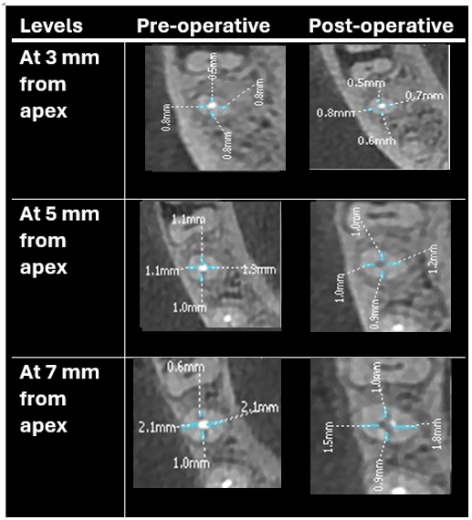
FIGURE B:- The measurement of the pre- and post measurements of the shortest distance between the edge of the root and canal in the Solite RS3 group and R-endo group at 3, 5, and 7 mm levels.
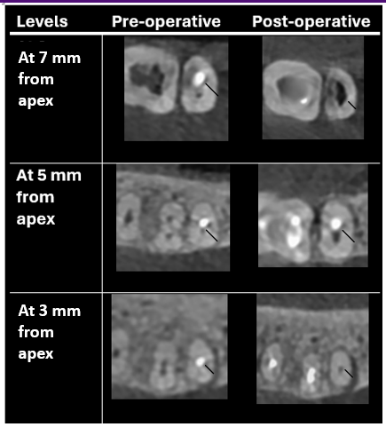

FIGURE C :- The measurement of the pre- and post measurements of the shortest distance between the edge of the root and canal in the R-endo group at 3, 5, and 7 mm levels.
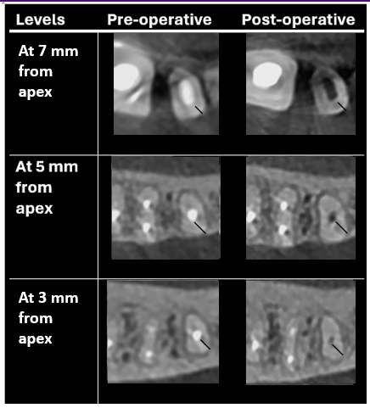

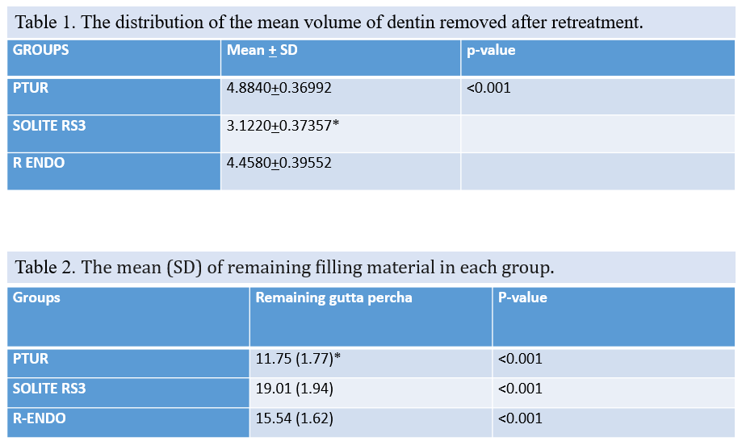

Graph 1
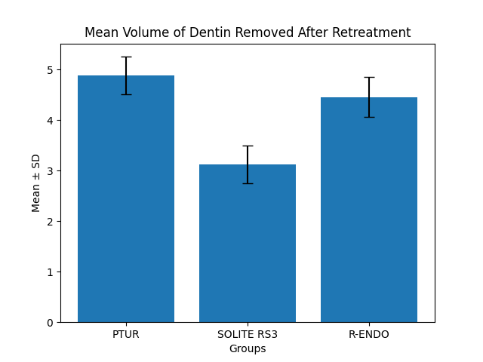
Graph 2

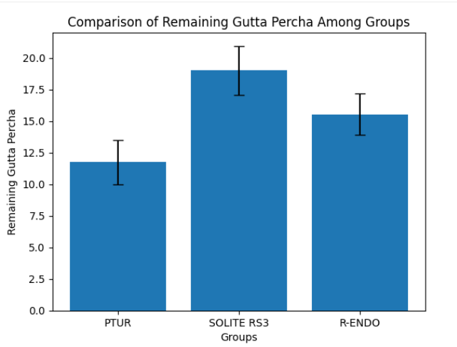
The present study demonstrated a statistically significant difference in both dentin removal and efficacy of gutta-percha (GP) removal among the three retreatment systems evaluated (p < 0.001).
The mean volume of dentin removed was highest in the ProTaper Universal Retreatment (PTUR) group (4.8840 ± 0.36992), followed by the R-Endo system (4.4580 ± 0.39552), whereas the Solite RS3 system showed the least dentin removal (3.1220 ± 0.37357). These findings indicate that PTUR and R-Endo systems are comparatively more aggressive in dentin removal, while Solite RS3 demonstrates a more conservative approach, preserving a greater amount of radicular dentin.
With respect to the remaining filling material, PTUR exhibited the least residual gutta-percha (11.75 ± 1.77), indicating superior cleaning efficiency. In contrast, Solite RS3 showed the highest amount of remaining filling material (19.01 ± 1.94), suggesting comparatively lower efficacy in removal. The R-Endo system demonstrated intermediate performance (15.54 ± 1.62). The differences among all groups were highly statistically significant (p < 0.001).
Further analysis using Dunn’s post hoc test revealed a statistically significant difference between Solite RS3 and R-Endo in terms of dentin removal, with Solite RS3 preserving more dentin. However, no statistically significant difference was observed between PTUR and R-Endo in terms of remaining filling material.
Overall, PTUR demonstrated superior efficacy in gutta-percha removal but at the expense of increased dentin loss, whereas Solite RS3 preserved dentinal structure more effectively but exhibited reduced cleaning efficiency. R-Endo showed intermediate behavior in both parameters.

DISCUSSION:-
The success of endodontic retreatment largely depends on complete removal of the existing filling material while preserving maximum root dentin, as excessive dentin loss may compromise tooth strength and increase susceptibility to vertical root fracture. The findings of the present study highlight the critical balance between cleaning efficiency and dentin preservation.
The results demonstrated that PTUR removed the maximum dentin, followed by R-Endo, whereas Solite RS3 preserved significantly more dentin. These findings are consistent with the study by Plotino et al., who reported that conventional NiTi rotary retreatment systems tend to be more aggressive due to their design and taper, leading to greater dentin removal¹⁰. Similarly, Versiani et al. emphasized that excessive instrumentation during retreatment can significantly reduce root dentin thickness, particularly in the danger zones of the root⁶.
The conservative behavior of Solite RS3 observed in the present study may be attributed to its heat-treated NiTi alloy and enhanced flexibility, which allows better canal negotiation with reduced lateral stress on dentinal walls. This is in agreement with Elnaghy and Elsaka, who reported that heat-treated NiTi instruments exhibit improved flexibility and cyclic fatigue resistance, thereby minimizing unnecessary dentin removal¹¹.
In terms of gutta-percha removal efficiency, PTUR demonstrated superior performance, which may be due to its progressive taper design and active cutting efficiency, facilitating rapid engagement and removal of obturation material. These findings are in accordance with Silva et al., who concluded that rotary retreatment systems such as ProTaper are more efficient in removing filling materials compared to other systems, although none achieve complete removal¹. Likewise, Alakshar et al. using micro-CT analysis reported that all systems leave residual material, particularly in the apical third, despite improved instrumentation techniques².
The R-Endo system showed intermediate results in both dentin removal and cleaning efficiency. This may be attributed to its less aggressive cutting design and sequence-based instrumentation, which balances dentin preservation and material removal. Kumar et al. similarly reported that R-Endo preserves more dentin compared to ProTaper but may be slightly less efficient in GP removal³.
The higher residual filling material observed in the Solite RS3 group suggests that while flexibility enhances dentin conservation, it may reduce cutting efficiency. This finding aligns with studies by Nevares et al., who reported that increased flexibility in rotary instruments may compromise debris removal efficiency due to reduced cutting aggressiveness⁵.
The use of CBCT in the present study allowed a reliable three-dimensional assessment of both dentin thickness and remaining filling material. Previous studies by Rathi et al. and PradeepKumar et al. have validated CBCT as an effective non-destructive tool for volumetric analysis in retreatment studies⁸⁷.
Overall, the present study reinforces the concept that no single retreatment system is ideal, and clinicians must choose instruments based on clinical priorities. When maximum cleaning is required, PTUR may be preferred, whereas in structurally compromised teeth, a conservative system like Solite RS3 may be advantageous to preserve dentin and prevent fracture.
LIMITATIONS:-
Sample size and generalizability:
If the number of samples is limited, the findings may not be generalizable to a wider population. A larger sample size would provide more reliable and statistically significant results.
In vivo variability:
Clinical conditions such as patient anatomy, canal morphology, and operator variability may influence the outcomes, making it difficult to standardize all parameters across groups.
Limited evaluation parameters:
The study focuses mainly on gutta-percha removal and remaining dentin thickness. Other important factors such as time efficiency, instrument separation, postoperative pain, and long-term clinical outcomes were not assessed.
Short-term evaluation:
The study evaluates immediate outcomes after retreatment, without assessing long-term success, healing of periapical tissues, or reinfection rates.

CONCLUSION:-
From the above results, all three retreatment systems—ProTaper Universal Retreatment (PTUR), R-Endo, and Solite RS3—were effective in removing root canal filling material; however, none of the systems achieved complete elimination of gutta-percha from the canal system. PTUR demonstrated superior efficacy in the removal of gutta-percha, resulting in the least amount of residual filling material. However, this increased efficiency was associated with greater removal of radicular dentin, which may compromise the structural integrity of the tooth. R-Endo exhibited intermediate performance in both dentin removal and cleaning efficiency.
Solite RS3 showed the least dentin removal, thereby preserving maximum root dentin thickness, but was comparatively less efficient in removing filling material. This highlights its conservative nature, making it a potentially suitable option in cases where preservation of dentinal structure is of paramount importance.
Therefore, the choice of retreatment system should be guided by the clinical scenario, balancing the need for effective canal debridement with the preservation of tooth structure to ensure long-term success of endodontic retreatment.
Clinical Significance:
An ideal retreatment system should effectively remove obturation material while preserving maximum dentin. PTUR offers superior cleaning efficiency, whereas Solite RS3 provides better dentin conservation. Clinicians should select the system based on the structural condition of the tooth and treatment objectives.
Key Clinical Message
Effective endodontic retreatment requires complete removal of gutta-percha while preserving the structural integrity of the root canal system. Heat-treated retreatment files, owing to their superior flexibility and cutting efficiency, demonstrate enhanced gutta-percha removal with minimal compromise of remaining dentin thickness compared to conventional files. CBCT analysis provides a precise three-dimensional assessment, aiding clinicians in selecting retreatment systems that ensure optimal cleaning while reducing the risk of excessive dentin removal and subsequent root fracture.
Consent
As per international standards or university standards, Participants’ written consent has been collected and preserved by the author(s).
Ethical Approval:
As per international standards or university standards written ethical approval has been collected and preserved by the author(s).

Disclaimer (Artificial intelligence)

Author(s) hereby declare that NO generative AI technologies such as Large Language Models (ChatGPT, COPILOT, etc.) and text-to-image generators have been used during the writing or editing of this manuscript.

REFERENCES :-
- Schilder H. Cleaning and shaping the root canal. Dent Clin North Am. 1974;18(2):269–296.¹
- Siqueira JF Jr, Rôças IN. Microbiology and treatment of endodontic infections. Int Endod J. 2008;41(6):509–520.²
- Nair PN. On the causes of persistent apical periodontitis: a review. Int Endod J. 2006;39(4):249–281.³
- Torabinejad M, Corr R, Handysides R, Shabahang S. Outcomes of nonsurgical retreatment and endodontic surgery: a systematic review. J Endod. 2009;35(7):930–937.⁴
- Friedman S, Stabholz A. Endodontic retreatment—case selection and technique. Part 1: criteria for case selection. J Endod. 1986;12(1):28–33.⁵
- Hülsmann M, Bluhm V. Efficacy, cleaning ability and safety of different rotary NiTi instruments in root canal retreatment. Int Endod J. 2004;37(7):468–476.⁶
- Gu LS, Ling JQ, Wei X, Huang XY. Efficacy of ProTaper Universal rotary retreatment system for gutta-percha removal. Int Endod J. 2008;41(4):288–295.⁷
- Tasdemir T, Er K, Yildirim T, Celik D. Efficacy of three rotary NiTi instruments in removing gutta-percha from root canals. Int Endod J. 2008;41(3):191–196.⁸
- Rödig T, Hausdörfer T, Konietschke F, Dullin C, Hahn W, Hülsmann M. Efficacy of D-RaCe and ProTaper retreatment systems in removing gutta-percha: a micro-CT study. Int Endod J. 2012;45(6):580–588.⁹
- Neelakantan P, Subbarao C, Subbarao CV. Comparative evaluation of modified canal staining and clearing technique, cone-beam computed tomography, peripheral quantitative computed tomography, spiral computed tomography, and plain and contrast medium–enhanced digital radiography in studying root canal morphology. J Endod. 2010;36(9):1547–1551.¹⁰
- Versiani MA, Pécora JD, Sousa-Neto MD. Microcomputed tomography analysis of the root canal morphology of human teeth. Int Endod J. 2011;44(5):399–404.¹¹
- Peters OA. Current challenges and concepts in the preparation of root canal systems: a review. J Endod. 2004;30(8):559–567.¹²
- Zogheib C, Sfeir G, Plotino G, Grande NM, Baba NZ. Impact of endodontic instrumentation on root dentin thickness and fracture resistance. J Endod. 2018;44(7):1099–1104.¹³
- Kim HC, Kwak SW, Cheung GS, Ko DH, Chung SM, Lee W. Cyclic fatigue and torsional resistance of two new nickel-titanium instruments used in retreatment. J Endod. 2012;38(4):541–544.¹⁴
- Plotino G, Grande NM, Cordaro M, Testarelli L, Gambarini G. A review of cyclic fatigue testing of nickel-titanium rotary instruments. J Endod. 2009;35(11):1469–1476.¹⁵
- Bürklein S, Schäfer E. Critical evaluation of root canal transportation by instrumentation. Int Endod J. 2015;48(1):1–15.¹⁶
- De-Deus G, Belladonna FG, Silva EJNL, Marins J, Souza EM, Neves AA. Micro-CT evaluation of non-instrumented canal areas after retreatment procedures. Int Endod J. 2015;48(10):951–959.¹⁷
- Gergi R, Sabbagh C. Effect of rotary retreatment files on dentin thickness and canal transportation. J Endod. 2007;33(3):320–323.¹⁸
- Paqué F, Balmer M, Attin T, Peters OA. Preparation of oval-shaped root canals in mandibular molars using nickel-titanium rotary instruments: a micro-CT study. J Endod. 2010;36(4):703–707.¹⁹
- Çelik Ünal G, Keçeci AD, Kaya BU, Tac AG. Quality of root canal fillings performed with different techniques and retreatment efficiency: a CBCT study. J Endod. 2009;35(10):1392–1395.²⁰
- Silva EJNL, Sá L, Belladonna FG, Neves AA, Accorsi-Mendonça T, Vieira VTL, et al. Efficacy of rotary and reciprocating systems for gutta-percha removal during root canal retreatment: a systematic review and meta-analysis. Int Endod J. 2020;53(7):857–869.²¹
- Alakshar A, Alrushoudi A, Alshaikh A, Alharbi F. Micro-CT evaluation of remaining filling material after retreatment using different NiTi systems. J Endod. 2021;47(3):389–395.²²
- Kumar M, Sharma V, Gupta S, Kumar R. Comparative evaluation of ProTaper retreatment and R-Endo systems in removal of gutta-percha using CBCT. J Conserv Dent. 2022;25(2):123–128.²³
- Topçuoğlu HS, Topçuoğlu G, Akti A, Düzgün S. Efficiency of different retreatment systems in curved root canals: a micro-CT study. Clin Oral Investig. 2020;24(2):1051–1058.²⁴
- Nevares G, de Albuquerque DS, Freire LG, Romeiro K, Fogel HM, dos Santos M. Effectiveness of rotary retreatment instruments in removing root canal filling materials: a micro-CT analysis. Restor Dent Endod. 2021;46(1):e10.²⁵
- Bhate M, Solete P, Mohan A. Comparative evaluation of heat treated retreatment files on canal transportation and dentin thickness in endodontically treated teeth: an in vitro CBCT study. Int Arab J Dent. 2025;16(2).²⁶
- Singh KB, Akhtar MS, Nagar R, Agarwal A, Azhar S, Singh V. Comparative analysis of the efficacy of various retreatment file systems in the removal of gutta-percha in retreatment cases and time taken during the procedure: an in vitro cone beam CT study. Cureus. 2024;16(3):e55551.²⁷
- Katle E, Zandi H, Pedersen D, Sunde PT, Torgersen GR, Ørstavik D. Radiographic outcome of endodontic treatment and retreatment of teeth with apical periodontitis using two different root canal irrigants: a prospective cohort study. Int Endod J. 2024;57(3):297–304.²⁸
- Chib A, Seth T, Bhatt M, et al. Nonsurgical retreatment of endodontically treated teeth: a prospective cohort study on success rates and quality of life. J Conserv Dent Endod. 2025.²⁹
- Baruah D, Bansal P, Sharma N, Sarma N, Palakal ND, Gupta I, et al. Forging flexibility: the science and innovation behind modern NiTi rotary endodontic files. IP Indian J Conserv Endod. 2025;10(3):138–145.³⁰
- Grande NM, Castagnola R, Minciacchi I, Marigo L, Plotino G. A review of the latest developments in rotary NiTi technology and root canal preparation. Aust Dent J. 2023;68(Suppl 1):S24–S38.³¹
- Agrawal PR, Chandak M, Nikhade PP, Patel AS, Bhopatkar JK. Revolutionizing endodontics: advancements in nickel–titanium instrument surfaces. J Conserv Dent Endod. 2024;27(2):126–133.³²
- Işık M, Aydın ZU. Effect of different obturation techniques on treatment results in single-visit non-surgical endodontic retreatment: randomized controlled clinical study. BMC Oral Health. 2024;24:1449.³³
- Nawabi H. Advancements in endodontic techniques: enhancing precision and patient outcomes. J Clin Dent Oral Health. 2024;8(5):222.³⁴Kumar M, Sharma V, Gupta S, Kumar R.
Comparative evaluation of ProTaper retreatment and R-Endo systems in removal of gutta-percha using CBCT. J Conserv Dent. 2022;25(2):123–128.
- Topçuoğlu HS, Topçuoğlu G, Akti A, Düzgün S.
Efficiency of different retreatment systems in curved root canals: a micro-CT study. Clin Oral Investig. 2020;24(2):1051–1058.
- Nevares G, de Albuquerque DS, Freire LG, Romeiro K, Fogel HM, dos Santos M.
Effectiveness of rotary retreatment instruments in removing root canal filling materials: a micro-CT analysis. Restor Dent Endod. 2021;46(1):e10.
- Bhate M, Solete P, Mohan A. Comparative evaluation of heat treated retreatment files on canal transportation and dentin thickness in endodontically treated teeth: an in vitro CBCT study. Int Arab J Dent. 2025;16(2).
- Singh KB, Akhtar MS, Nagar R, Agarwal A, Azhar S, Singh V. Comparative analysis of the efficacy of various retreatment file systems in the removal of gutta-percha in retreatment cases and time taken during the procedure: an in vitro cone beam CT study. Cureus. 2024;16(3):e55551.
- Katle E, Zandi H, Pedersen D, Sunde PT, Torgersen GR, Ørstavik D. Radiographic outcome of endodontic treatment and retreatment of teeth with apical periodontitis using two different root canal irrigants: a prospective cohort study. Int Endod J. 2024;57(3):297–304.
- Chib A, Seth T, Bhatt M, et al. Nonsurgical retreatment of endodontically treated teeth: a prospective cohort study on success rates and quality of life. J Conserv Dent Endod. 2025.
- Baruah D, Bansal P, Sharma N, Sarma N, Palakal ND, Gupta I, et al. Forging flexibility: the science and innovation behind modern NiTi rotary endodontic files. IP Indian J Conserv Endod. 2025;10(3):138–145.
- Grande NM, Castagnola R, Minciacchi I, Marigo L, Plotino G. A review of the latest developments in rotary NiTi technology and root canal preparation. Aust Dent J. 2023;68(Suppl 1):S24–S38.
- Agrawal PR, Chandak M, Nikhade PP, Patel AS, Bhopatkar JK. Revolutionizing endodontics: advancements in nickel–titanium instrument surfaces. J Conserv Dent Endod. 2024;27(2):126–133.
- Işık M, Aydın ZU. Effect of different obturation techniques on treatment results in single-visit non-surgical endodontic retreatment: randomized controlled clinical study. BMC Oral Health. 2024;24:1449.
- Nawabi H. Advancements in endodontic techniques: enhancing precision and patient outcomes. J Clin Dent Oral Health. 2024;8(5):222.

